ABSN-4027 - [QF][Garments] Loss line is not created correctly on the invoice
Environment | Prerequisites
Version: 9.07.00.UNF19  DBServerName= abs-srv20.internal.abslbs.com  DBSID=CUST24  DBUser=UNFDEV  DBPassword= UNFDEV  Environment=Test | - Module:  - System setting

Contents
Retest after fix 1
Test Case 1 – Quit product from PLPC 1
Test Case 2 – Quit WI - Loss Charge inv. line (Extended = N) 3
Test Case 3 – Quit WI - Loss Charge inv. line (Extended = Y) 6
Test Case 4 – Have an WI with an existing loss charge attached. Afterward Quit WI 8
Test Case 5 – Replacement & Decrease WI on WI 11
Test Case 6 – Quit Product from PLPC + Quit Wearer 15
Test Case 7 – Quit Wearer + Quit WI 18
Test Case 8 – Quit WI + Decrease of Inventory 20

Retest after fix

Test Case 1 – Quit product from PLPC
Expected behavior: The user should see only Loss Charge Garments - Product list per Customer Inactive lines if multiple wearers have the same garment in their WI
Hash: 14fd539ff715
- PLCP DLG: Find a customer with active garments
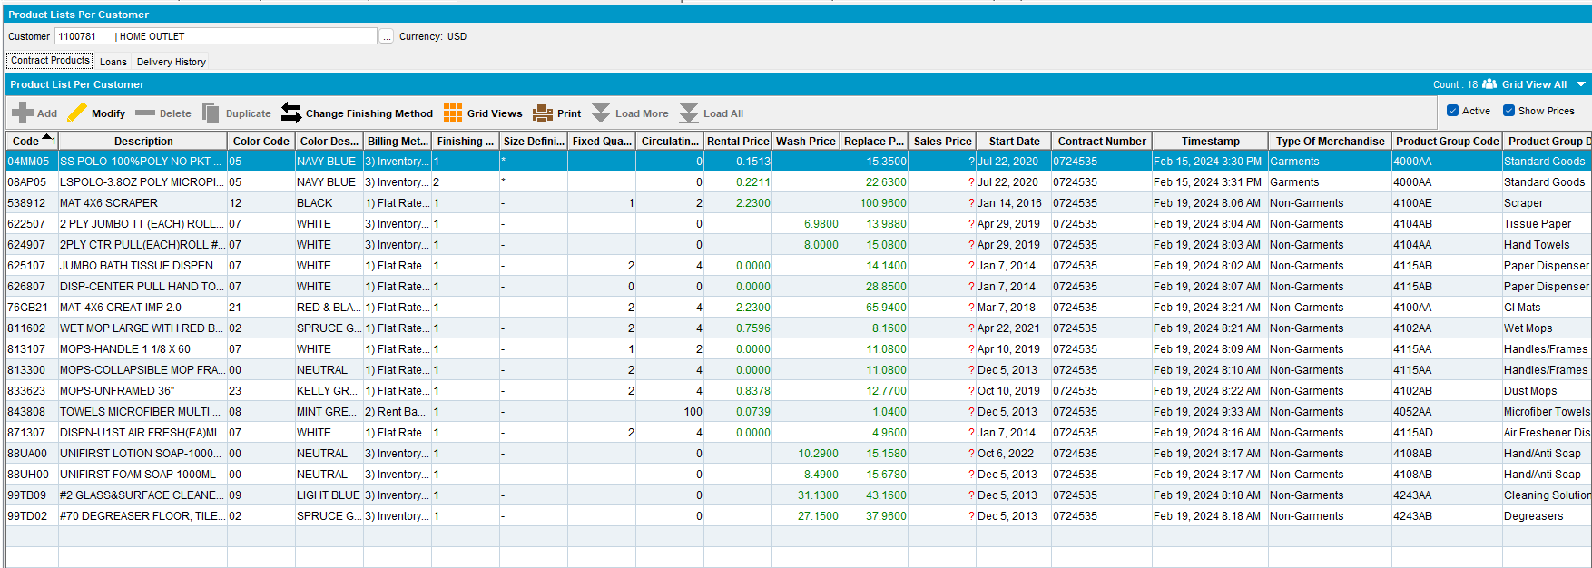
- Set an End Date to one of the products in the list(making it inactive)
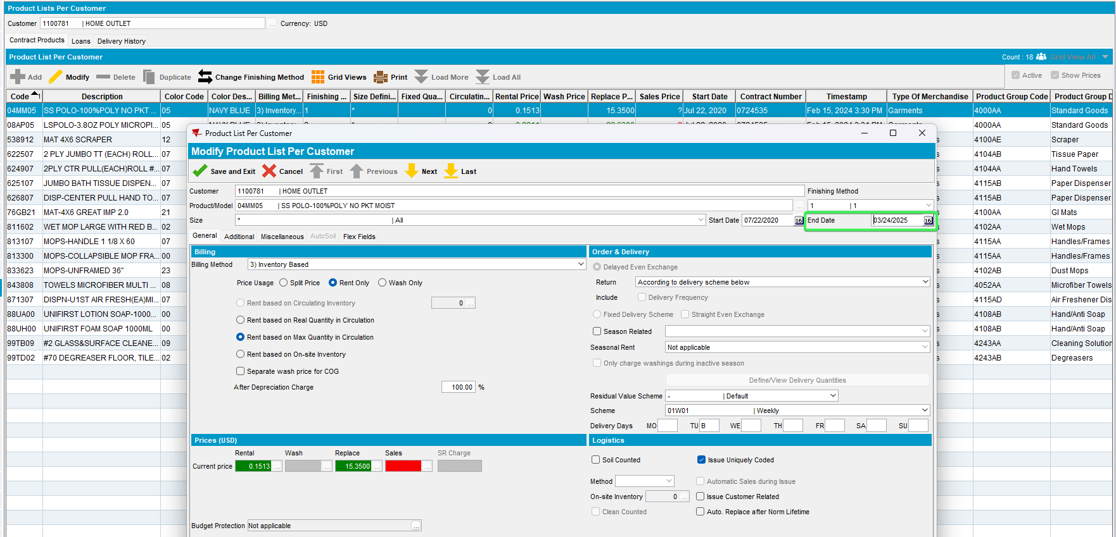
- RSC: Create a new RC on which this customer is present that is greater than the inactive date set at the previous step
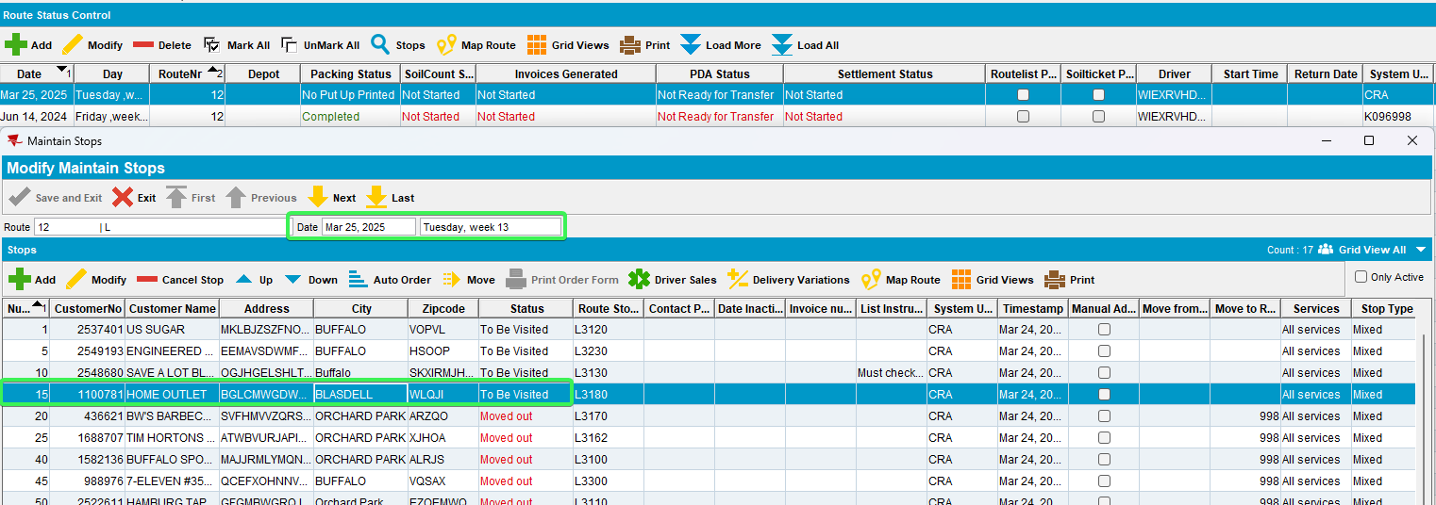
- Generate invoices for this route and customer
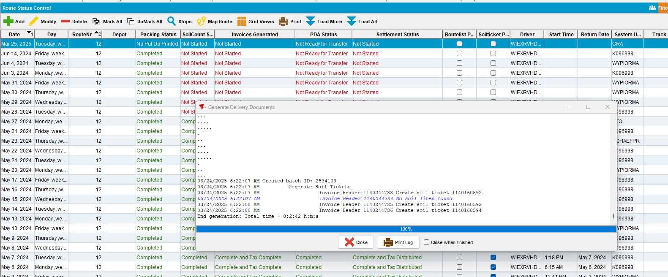
- Maintain Invoices: Select the date and route and check the invoice generated for your customer
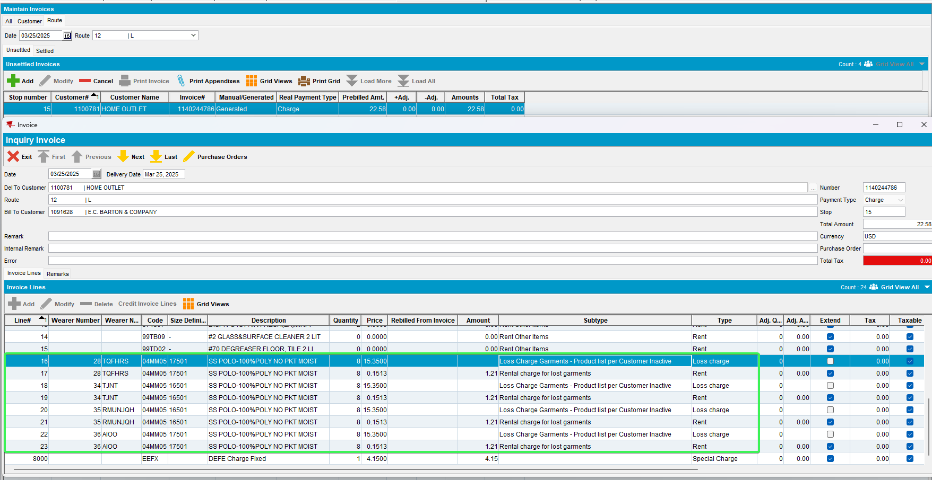
Tested OK

Test Case 2 – Quit WI - Loss Charge inv. line (Extended = N)
Expected behavior: The user should see only Loss Charge Garments - Wearer Inventory Inactive line
Hash: 14fd539ff715
- Wearers DLG: Find a customer with Wearers and WI
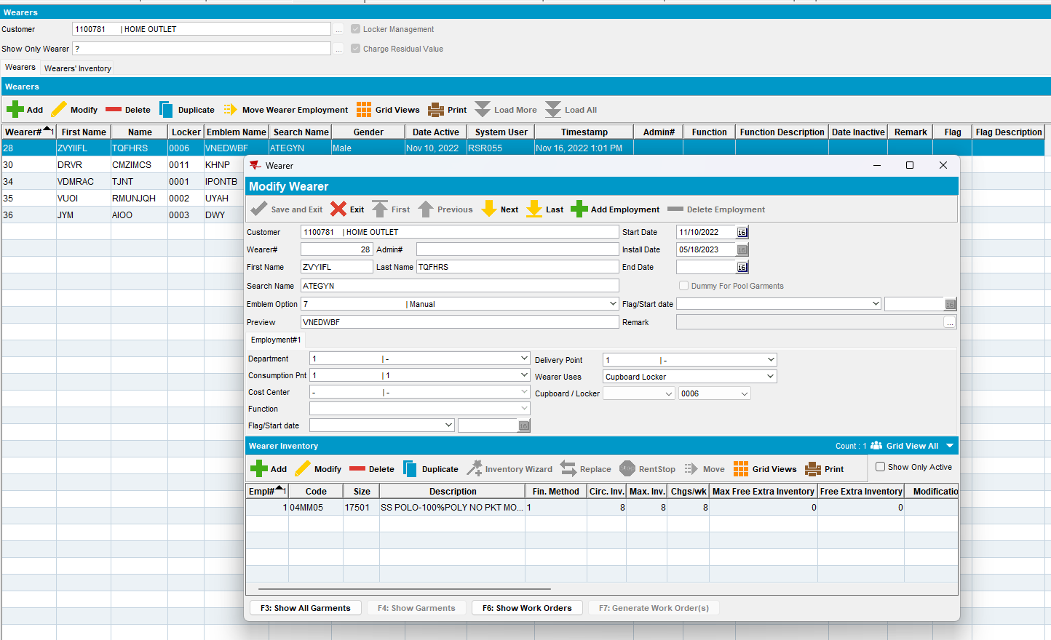
- Quit a WI of a wearer
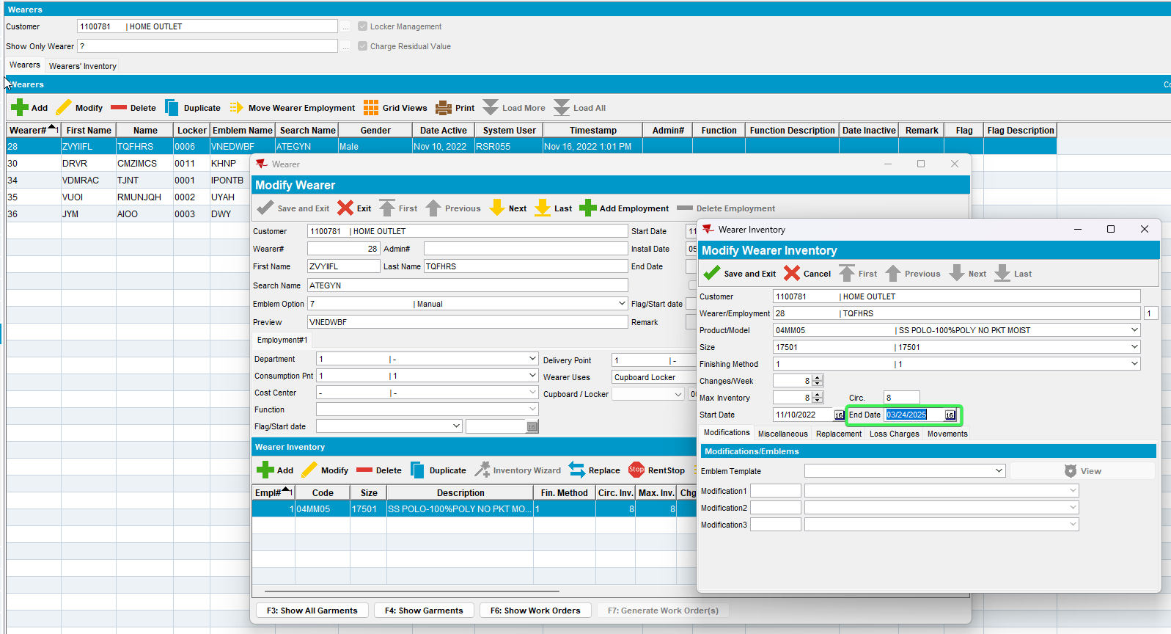
- RSC: Create a new RC on which this customer is present that is greater than the inactive date set at the previous step
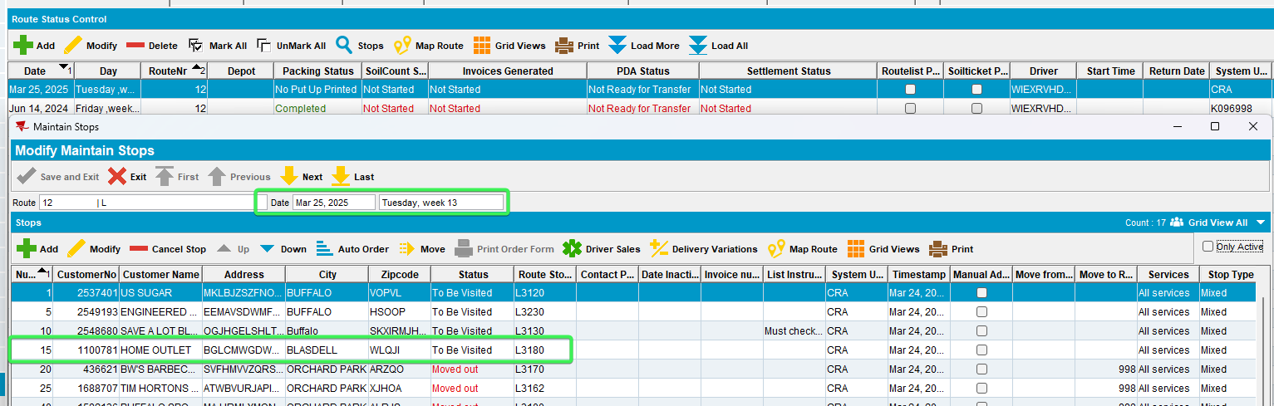
- Generate invoices for this route and customer
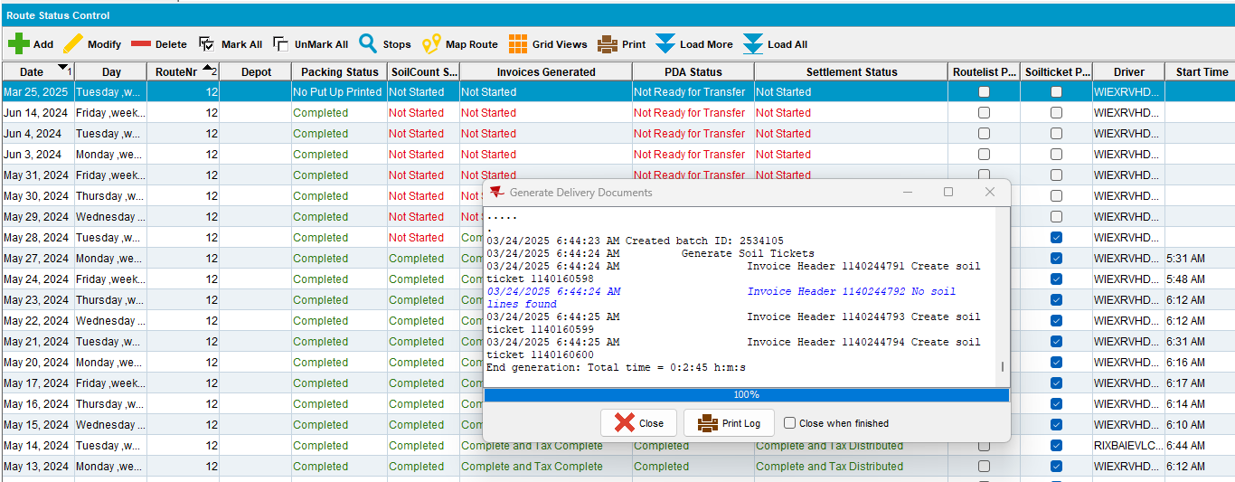
- Maintain Invoices: Select the date and route and check the invoice generated for your customer
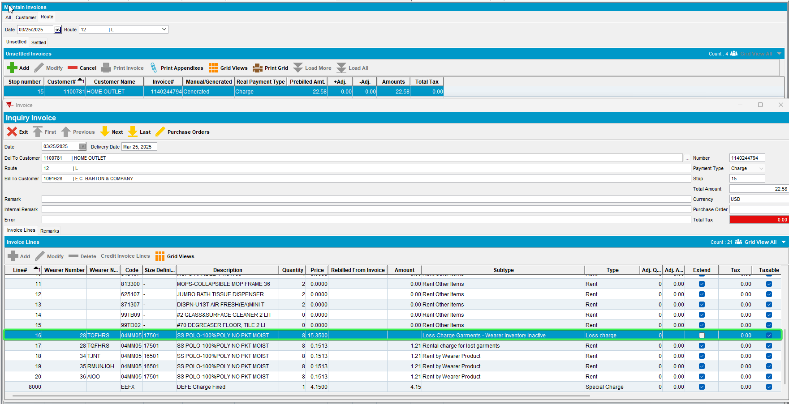
Tested OK

Test Case 3 – Quit WI - Loss Charge inv. line (Extended = Y)
Expected behavior: The user should see only Loss Charge Garments - Wearer Inventory Inactive
Hash: 14fd539ff715
- Wearers DLG: Find a customer with Wearers and WI
- Quit a WI of a wearer
- RSC: Create a new RC 3+ weeks in the future on which the customer is present
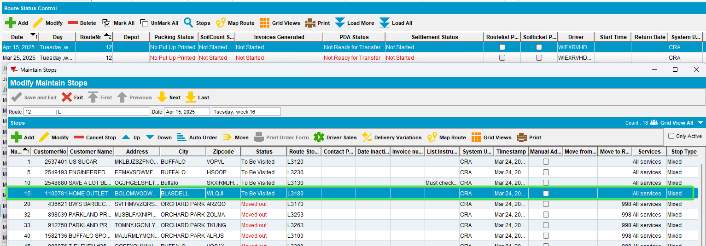
- Generate invoices for this route and customer
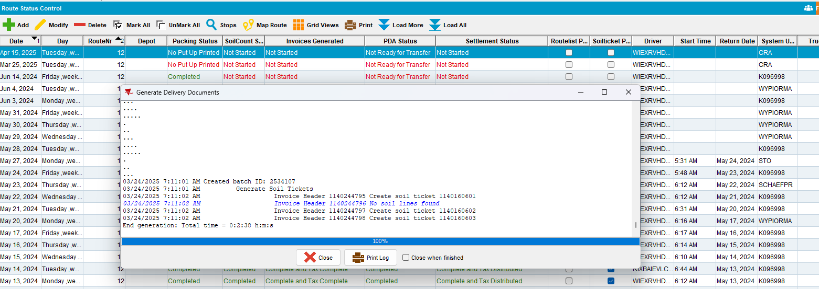
- Maintain Invoices: Select the date and route and check the invoice generated for your customer
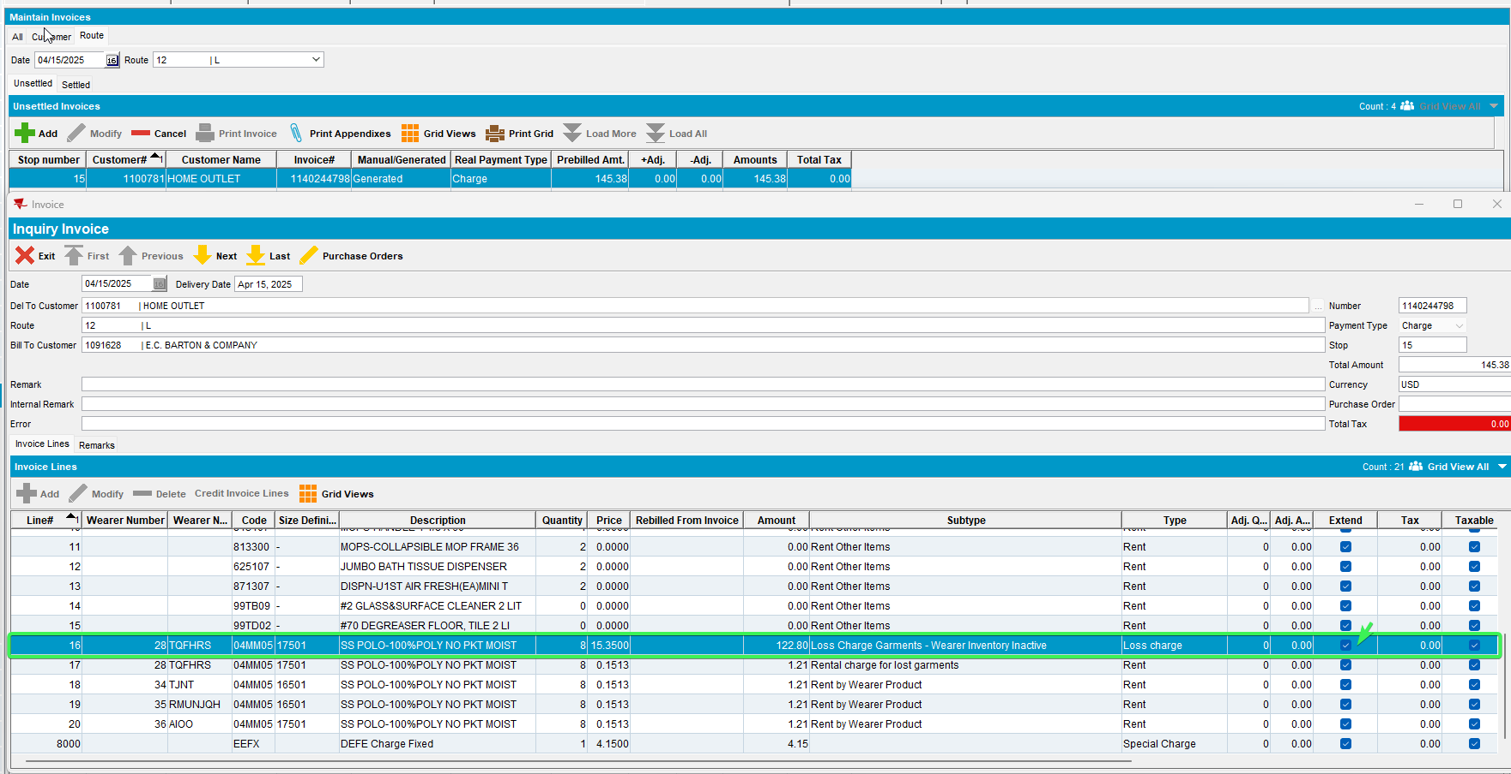
Tested OK

Test Case 4 – Have an WI with an existing loss charge attached. Afterward Quit WI
Hash: 14fd539ff715
Expected Behavior: There is only one Loss Charge Line of Loss Charge Garments – Wearer Inventory Inactive

- Wearers DLG: Decrease the WI of a wearer
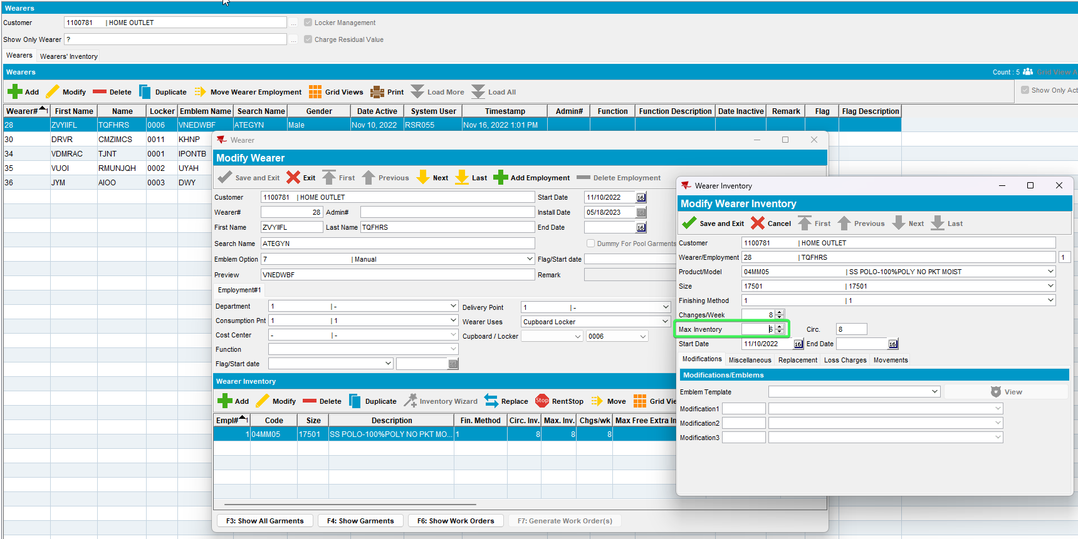
- RSC: Create a new RC on which this customer is present for the current week
- Generate invoices for this route and customer
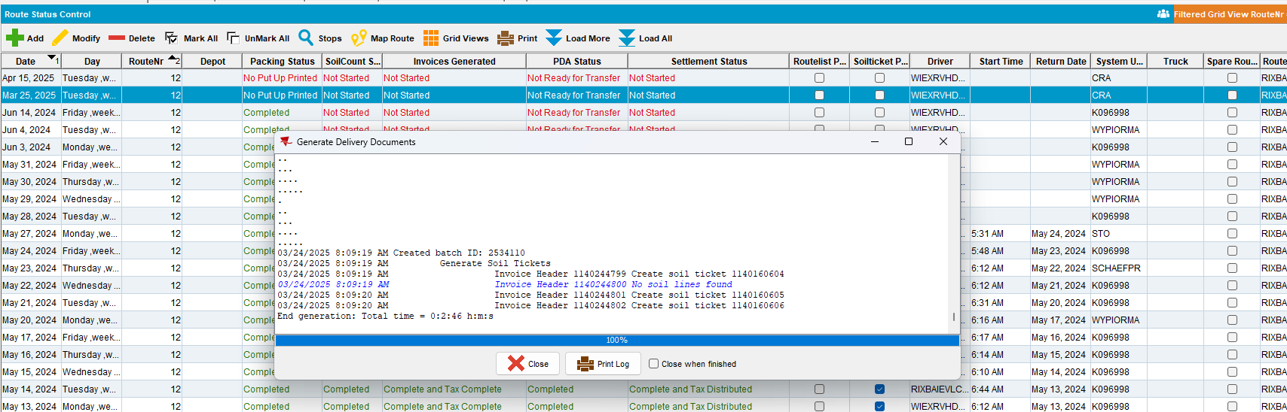
- Maintain Invoices DLG: Check that the Customer has a line of Loss Charge Garments Decrease Max Inventory
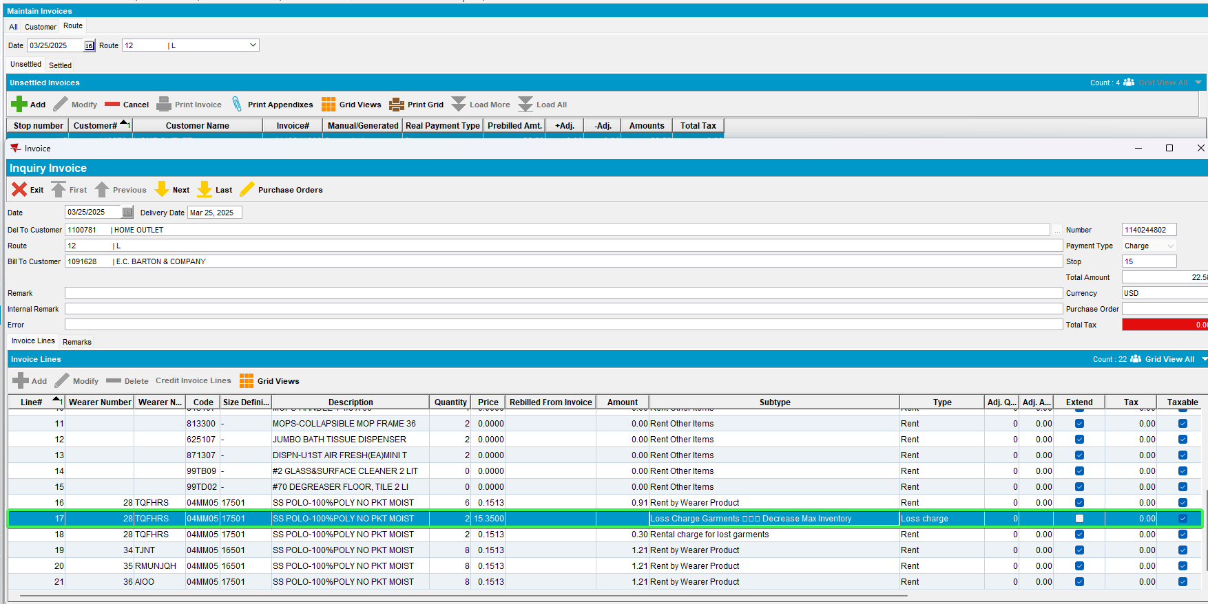
- Wearers DLG: Quit the WI that was previously decreased
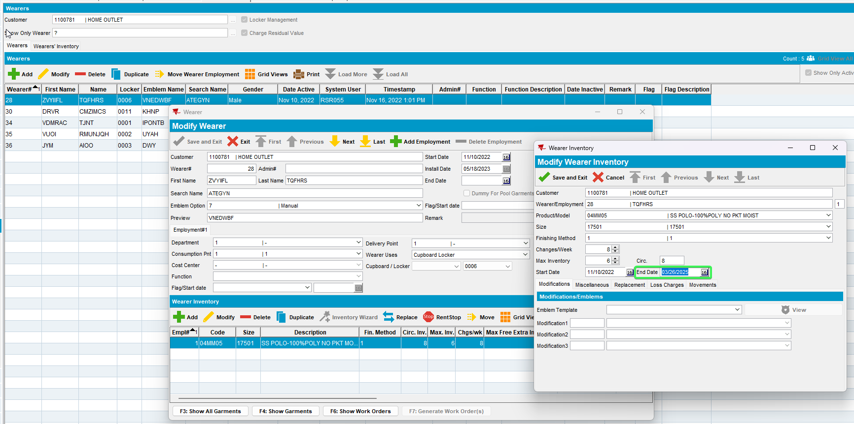
- RSC: Add a new route for next week and generate invoices
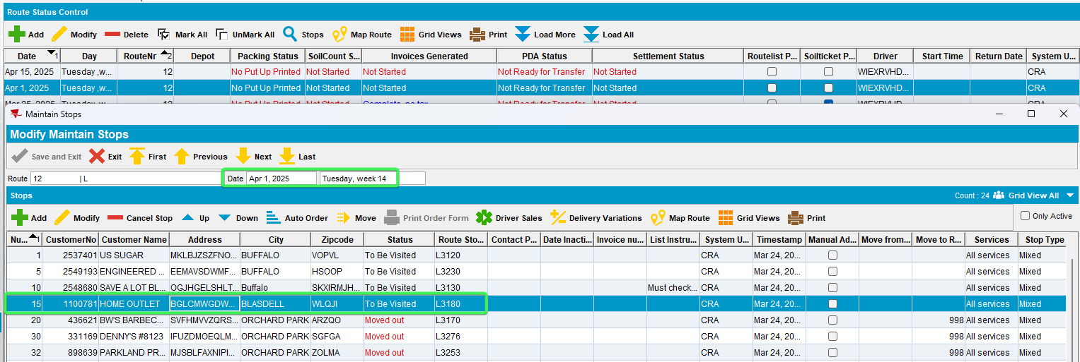
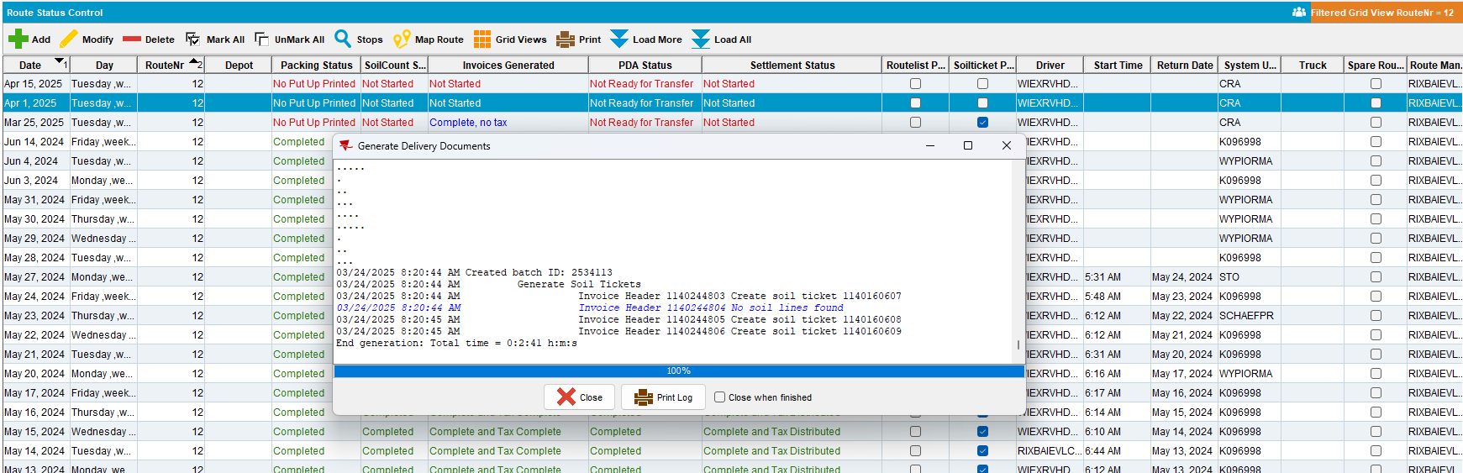
- Maintain Invoices: Check that the Loss Charge Line is now changed to Loss Charge Garments – Wearer Inventory Inactive for the whole quantity
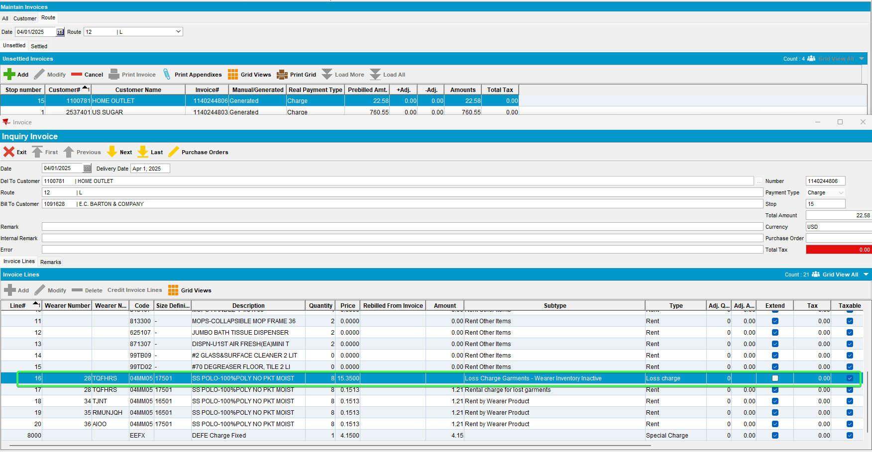
Tested OK

Test Case 5 – Replacement & Decrease WI on WI
Hash: 14fd539ff715
Expected Behavior: The user should see both loss charge inv. lines on the invoice: loss charge replacement + loss charge DOI
- Wearers DLG: Have a customer with wearers and WI
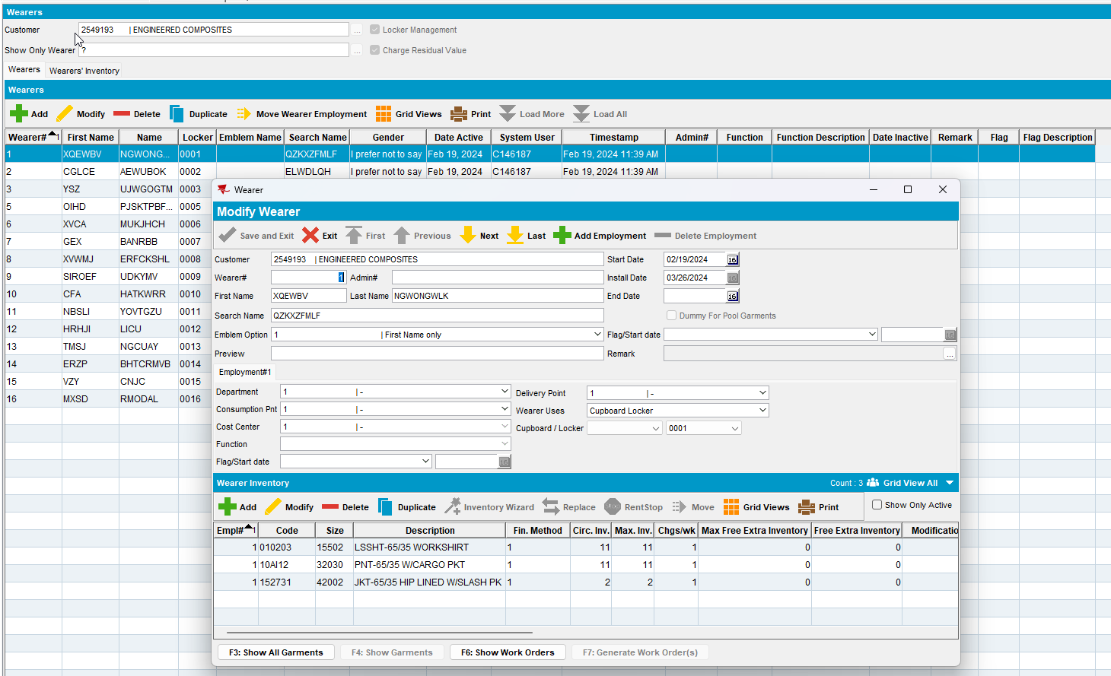
- For one of the WI perform a Replacement action
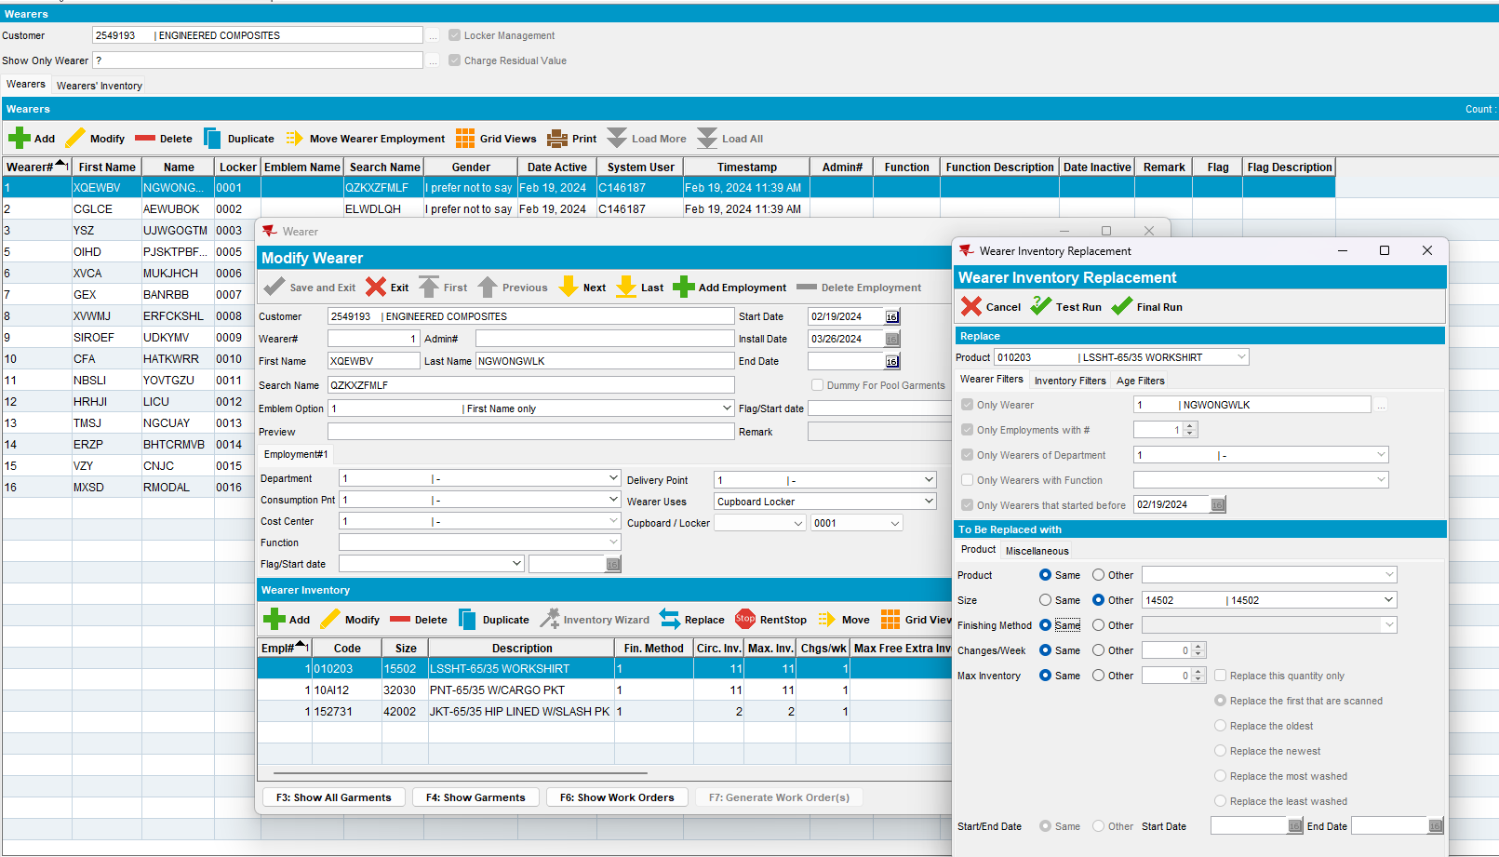
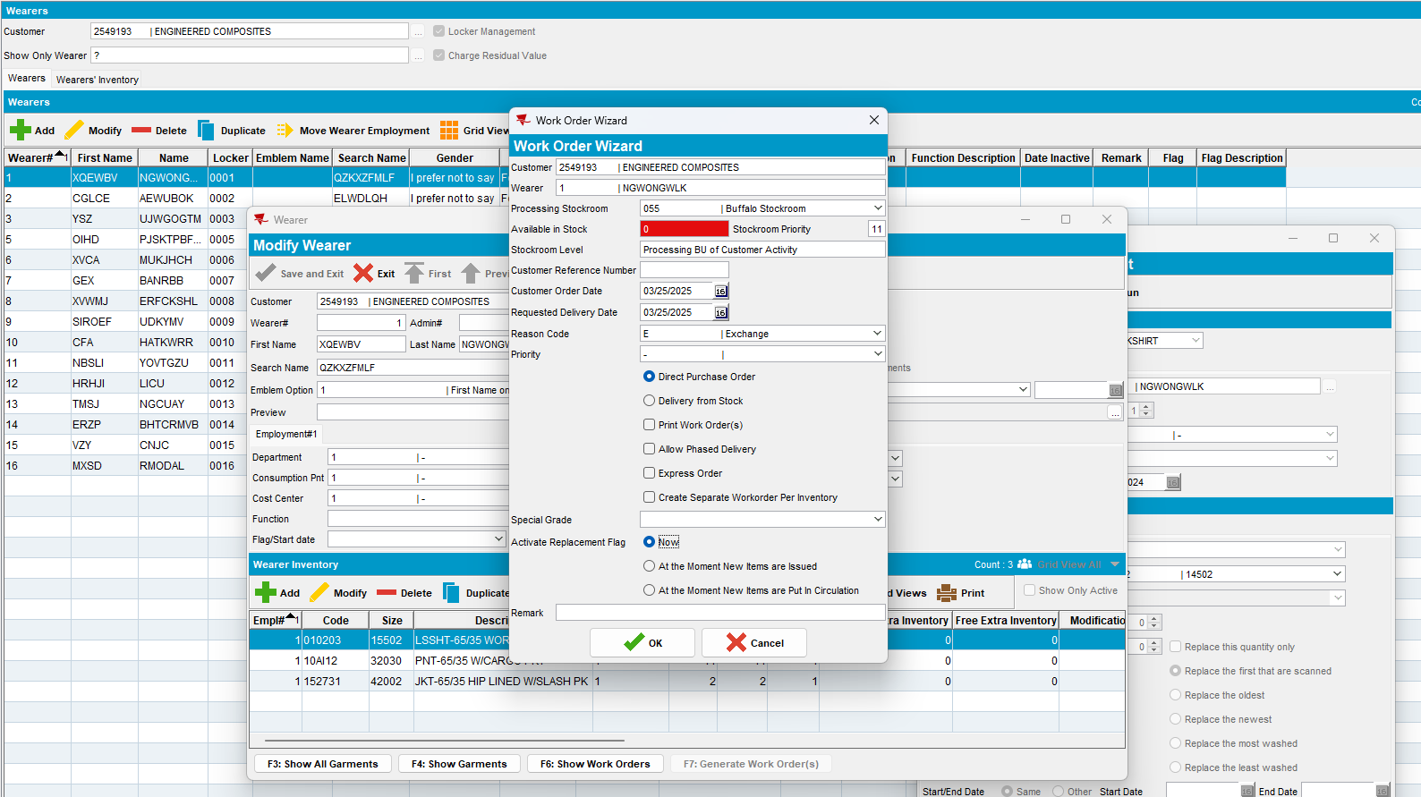
- Issue Word Order DLG: Issue the items
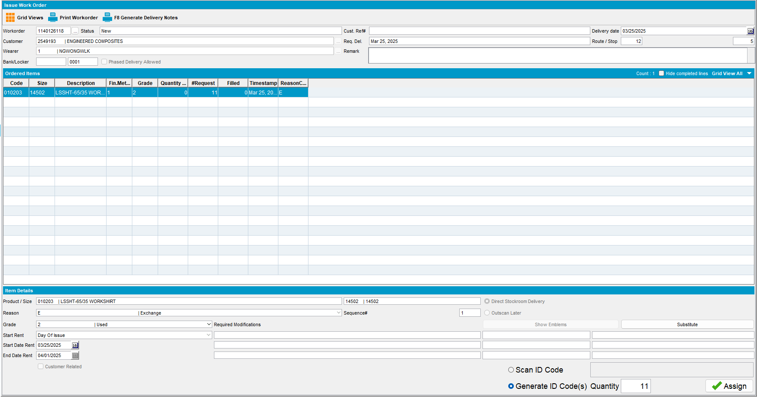
- Wearers DLG: For the new garments perform a Decrease of Inventory
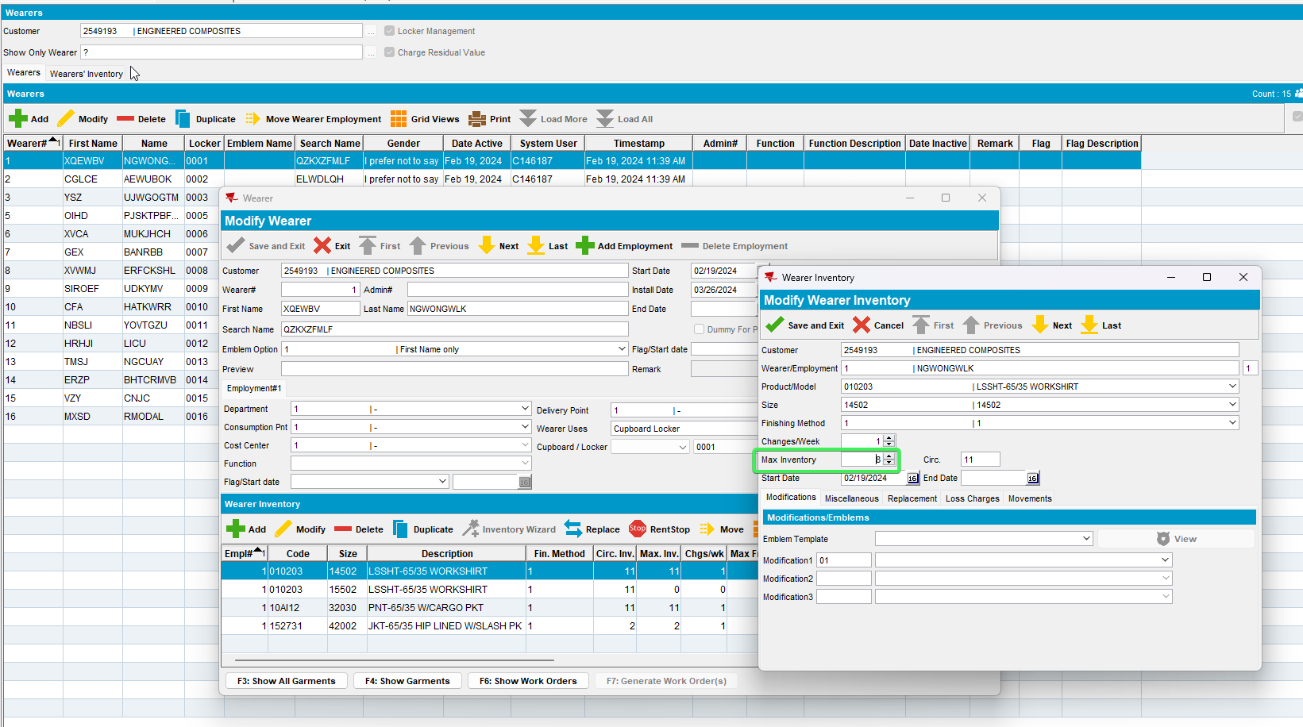
- RSC: Generate Invoices for the route and customer
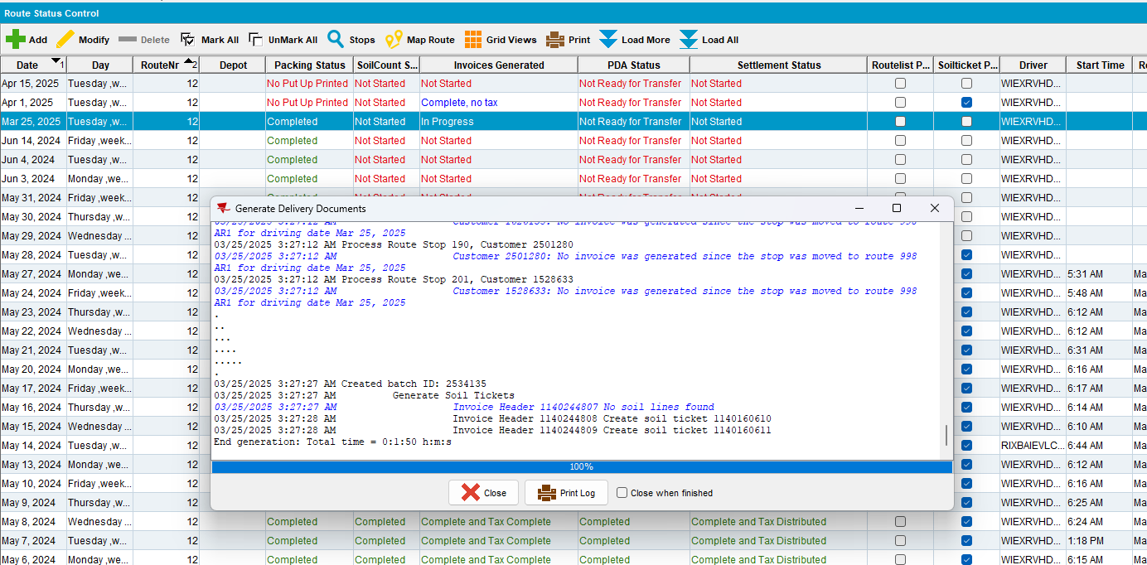
- Maintain Invoices DLG: Go to the invoice generated for your customer and see that you have both a Loss Charge Garments - Replacement line and a Loss Charge Garments – Decrease Max Inventory line
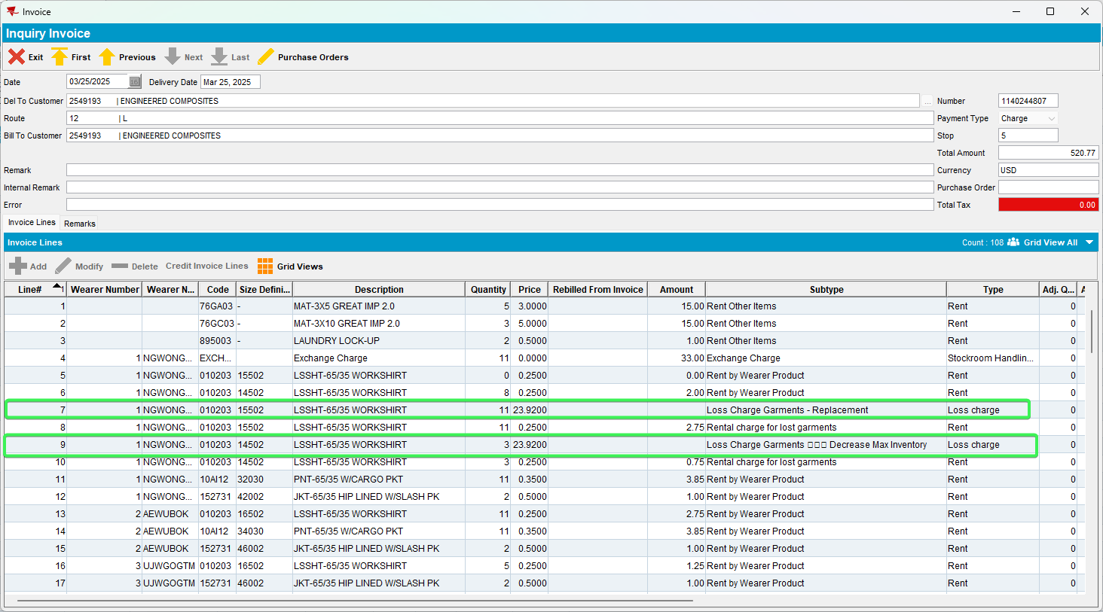
Tested OK

Test Case 6 – Quit Product from PLPC + Quit Wearer
Hash: 14fd539ff715
Expected Behavior: Loss Charge Garments - Product list per Customer Inactive inv. line has higher priority and should be the only one displayed on the invoice

- PLCP DLG: Find a customer with active garments
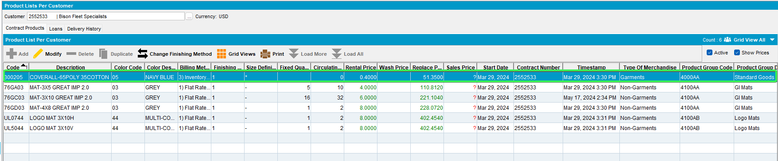
- Set End Date for today to one of the products in the list (making it inactive)
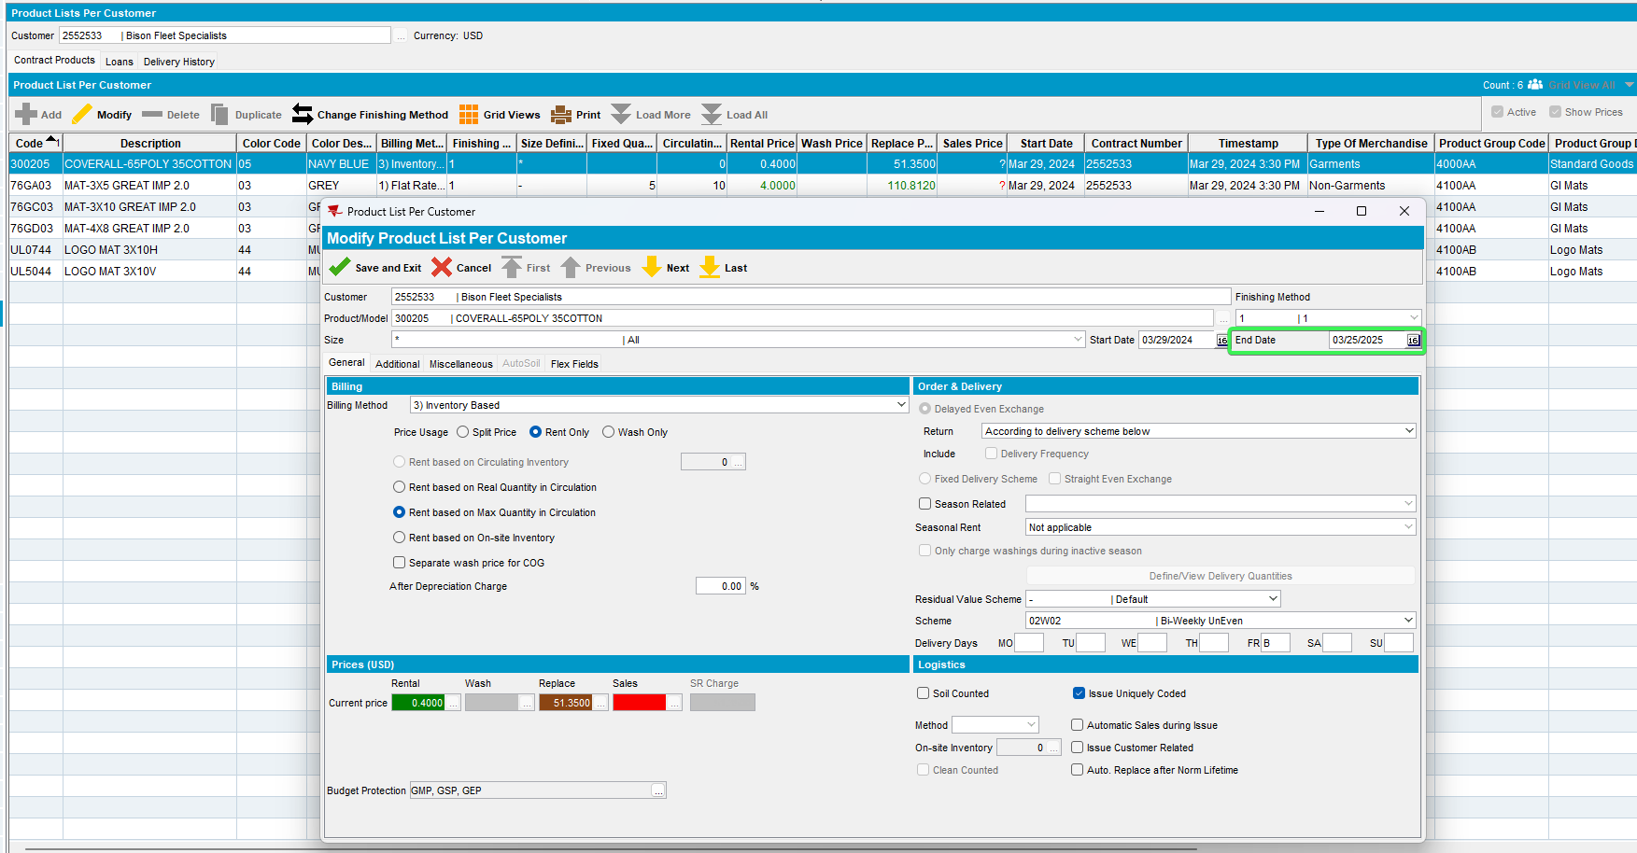
- Wearers DLG: Find a wearer with the product ended earlier
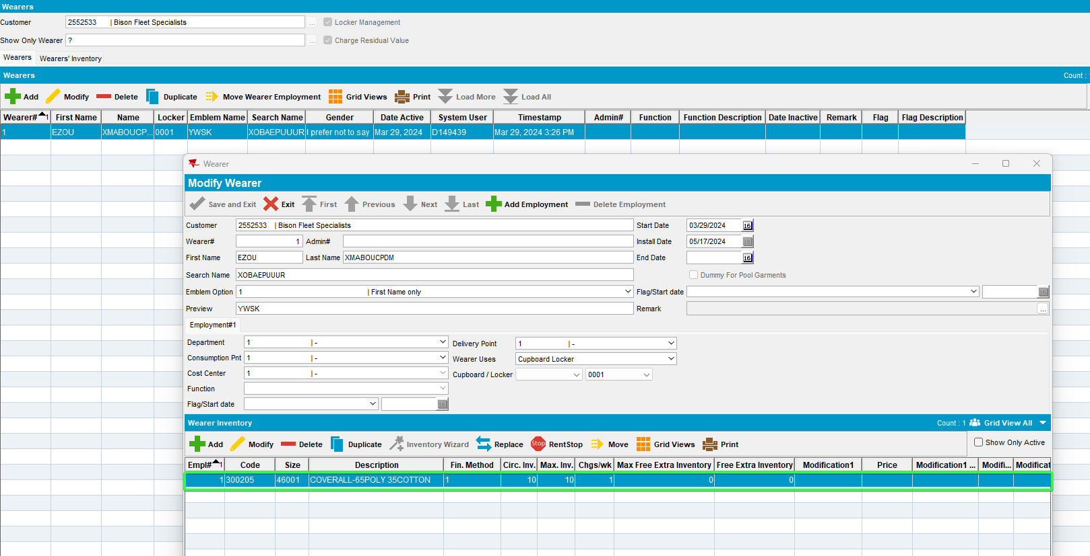
- Set an End Date for today for this wearer
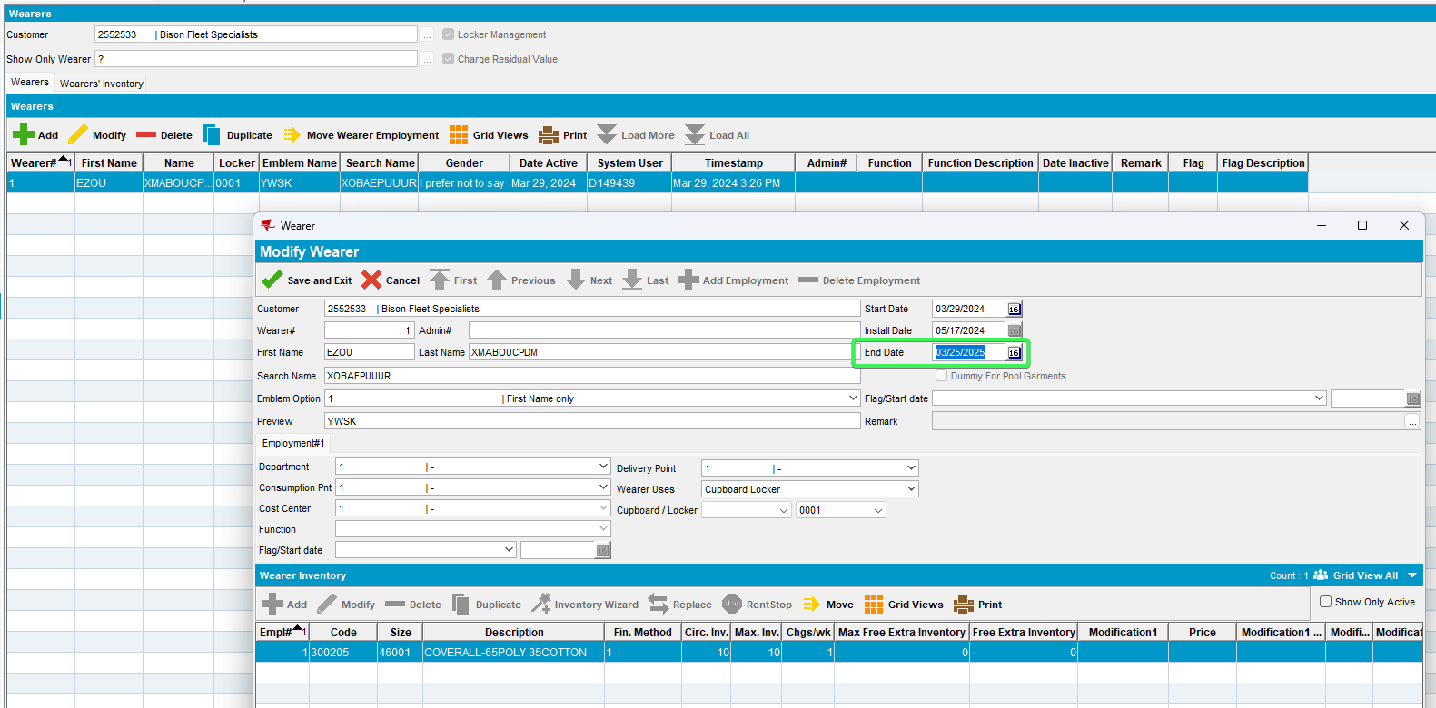
- RSC: Create a new RC with this customer on it
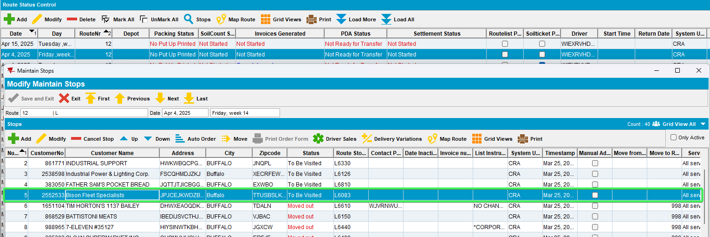
- Generate invoices
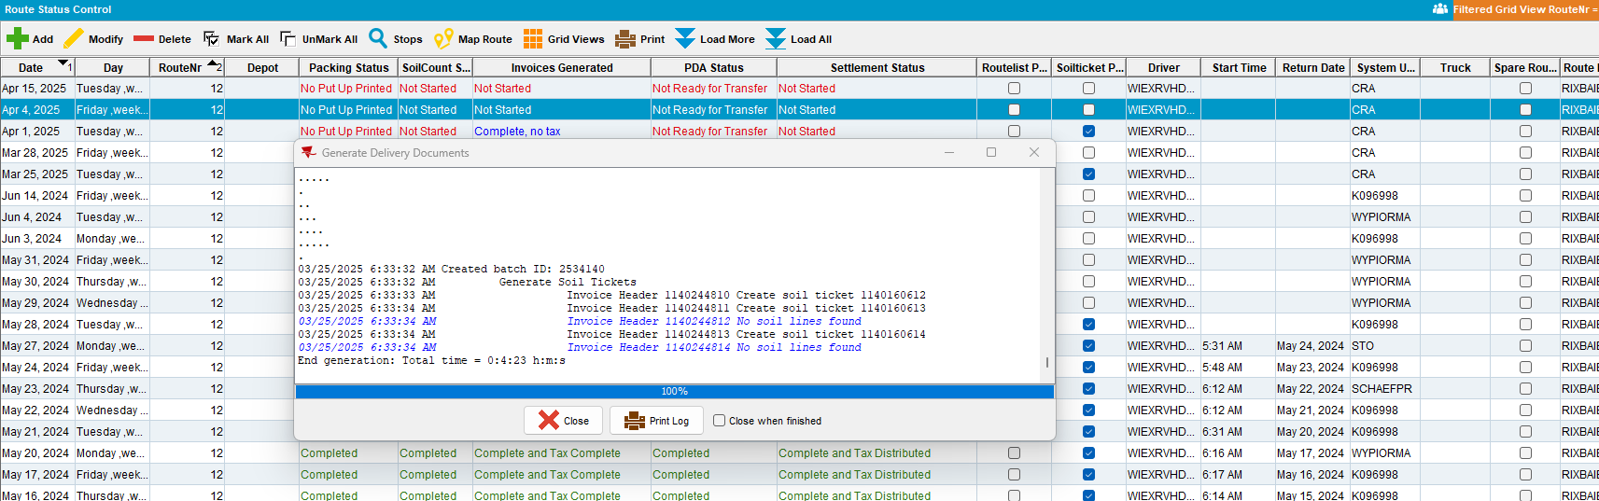
- Maintain Invoices DLG: See that the only Loss Charge Line present is Loss Charge Garments – Product list per Customer Inactive
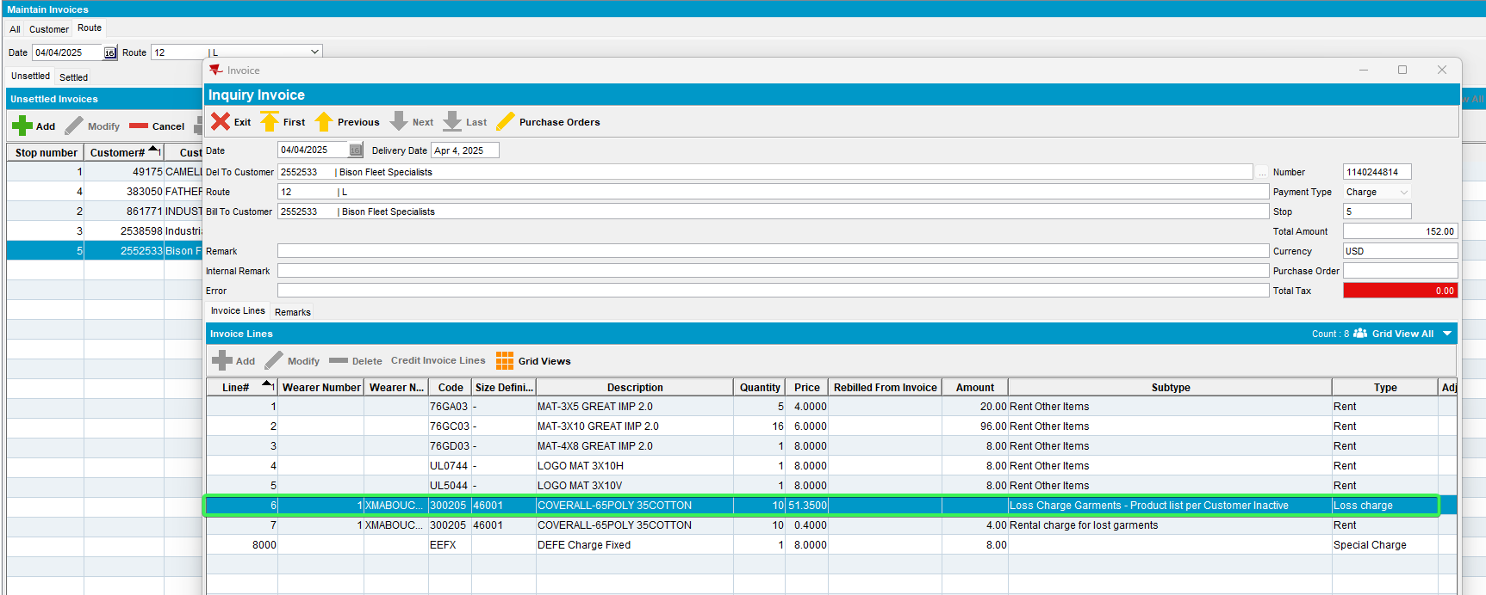
Tested OK

Test Case 7 – Quit Wearer + Quit WI
Hash: 14fd539ff715
Expected Behavior: Loss Charge Garments - Wearer Inactive inv. has higher priority and will be the only one on the invoice

- Wearers DLG: Find a customer with Wearers and WI
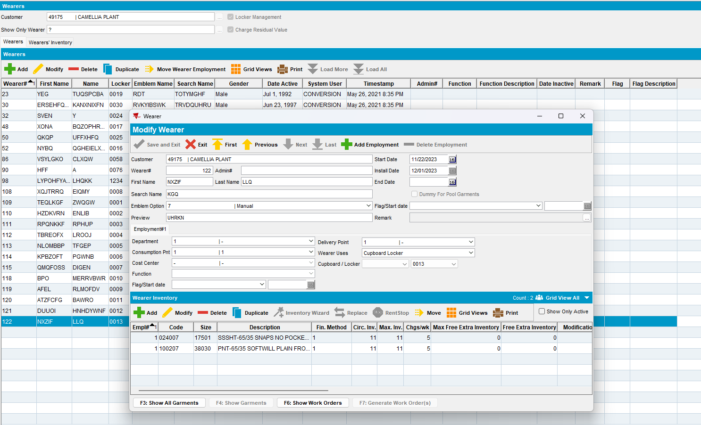
- Set an end date of today for a Wearer
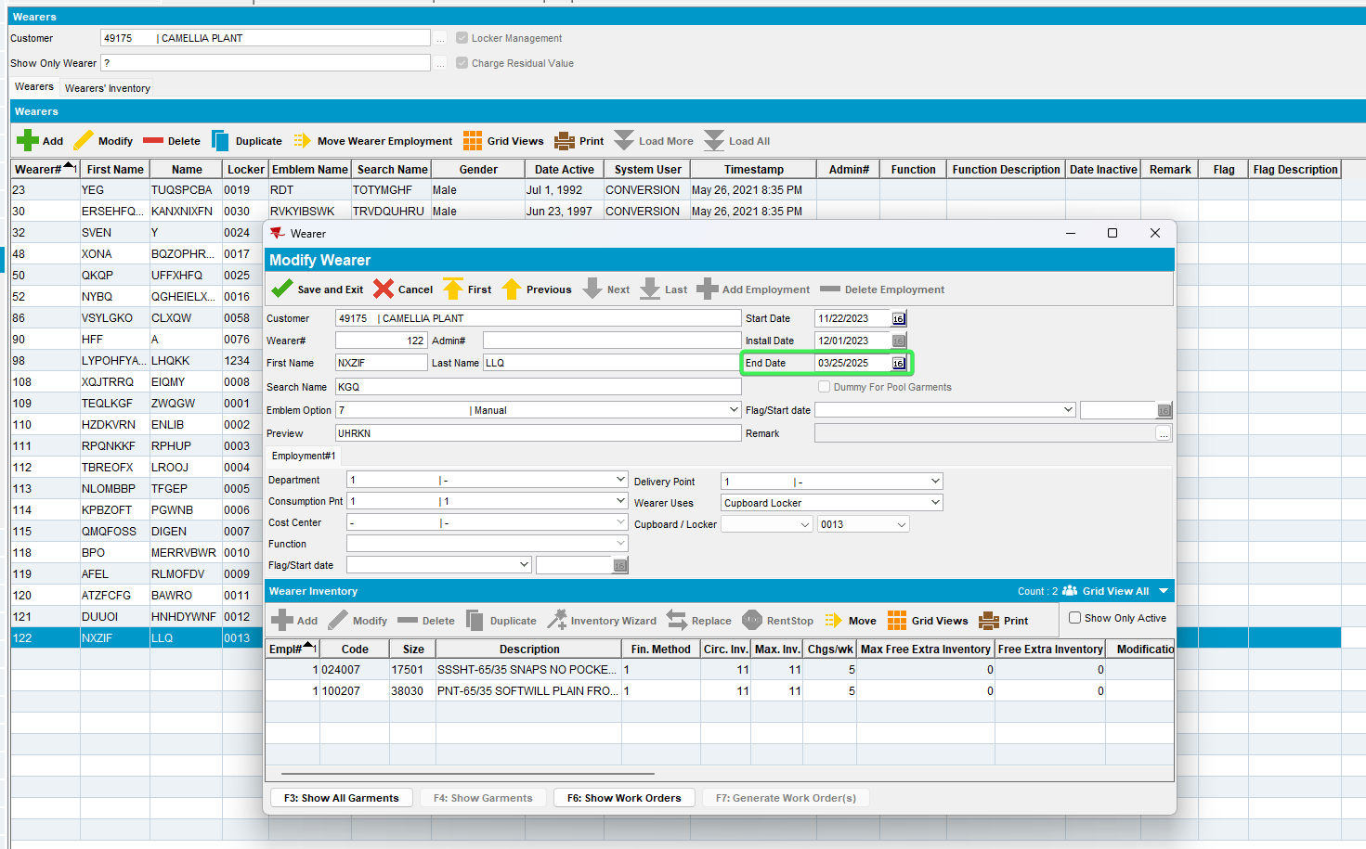
- Set an end date of today for a WI of the same Wearer
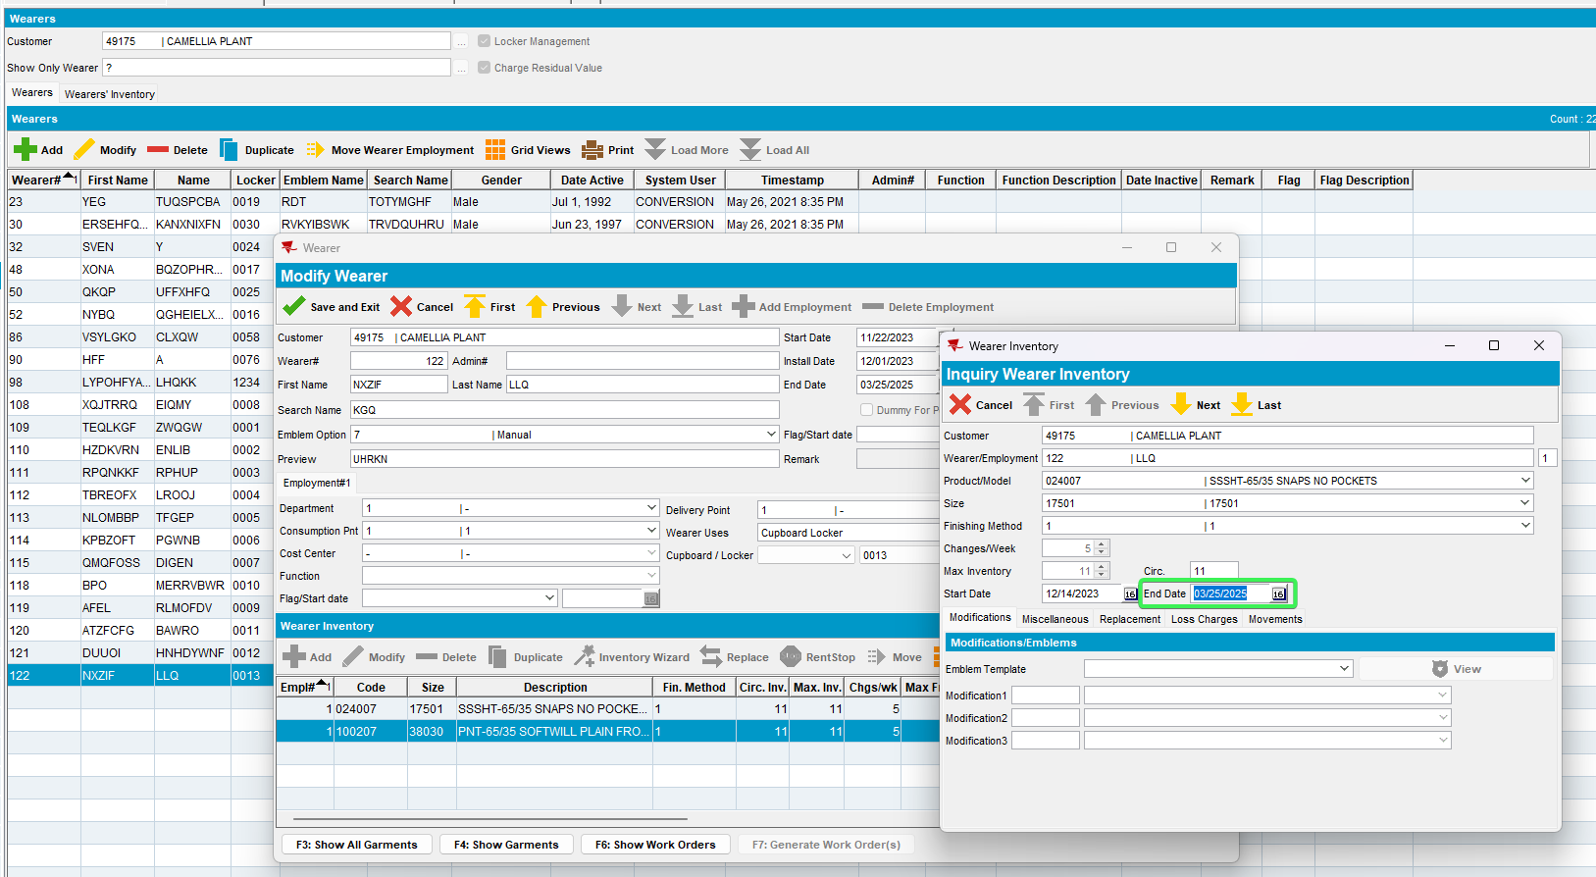
- RSC: Generate invoices for this customer
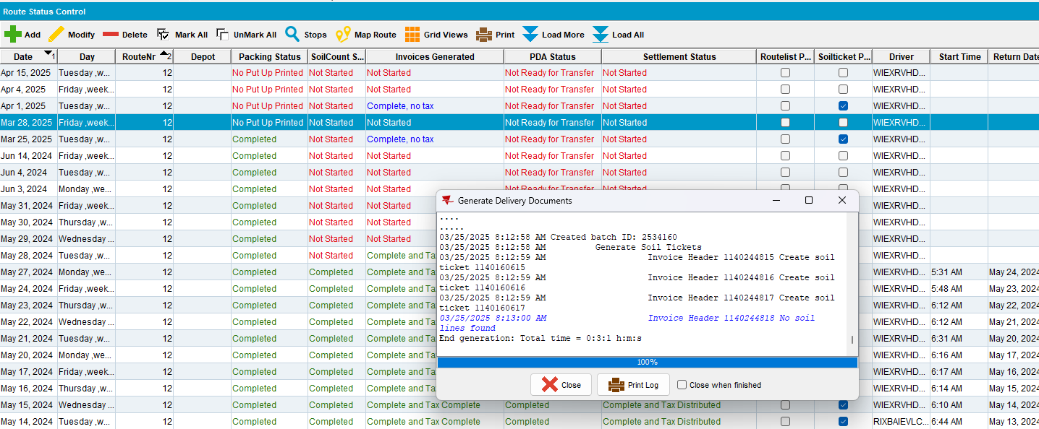
- Maintain Invoices: Check that Loss Charge Garments - Wearer Inactive inv. has higher priority and will be the only one on the invoice
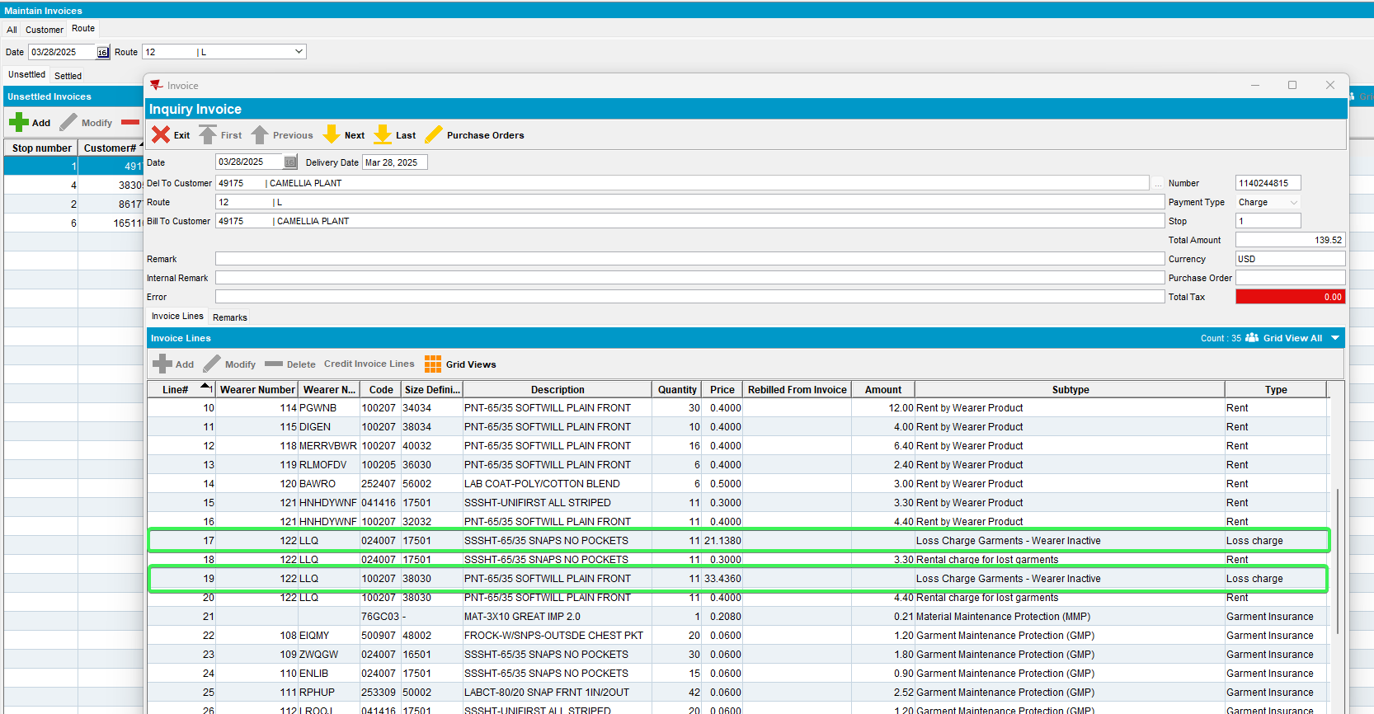
Tested OK

Test Case 8 – Quit WI + Decrease of Inventory
Hash: 14fd539ff715
Expected Behavior: Loss Charge Garments - Wearer Inventory Inactive should be displayed on the invoice

- Wearers DLG: Find a customer with Wearers and WI
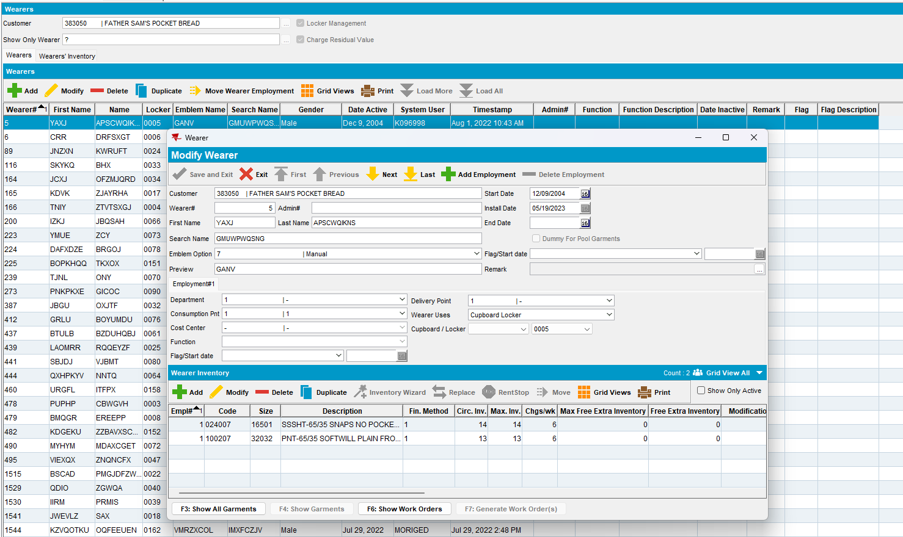
- Quit a WI of a wearer
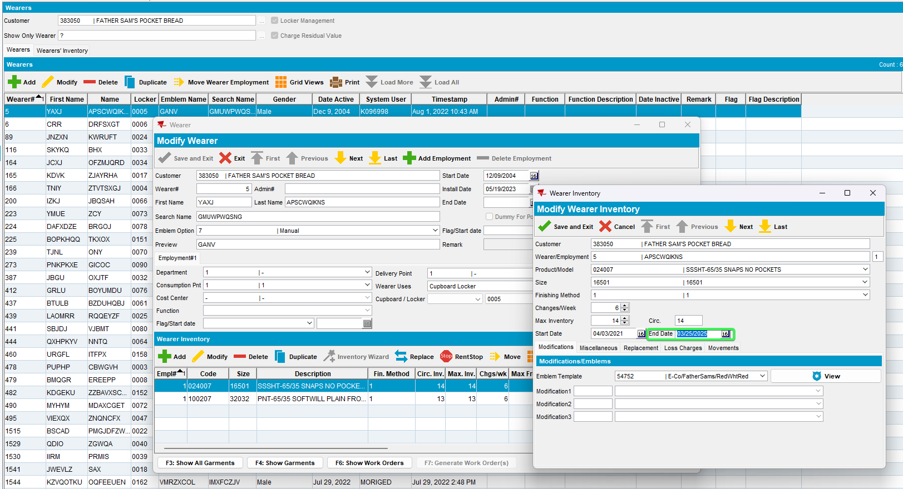
- Perform a decrease of inventory for the same WI
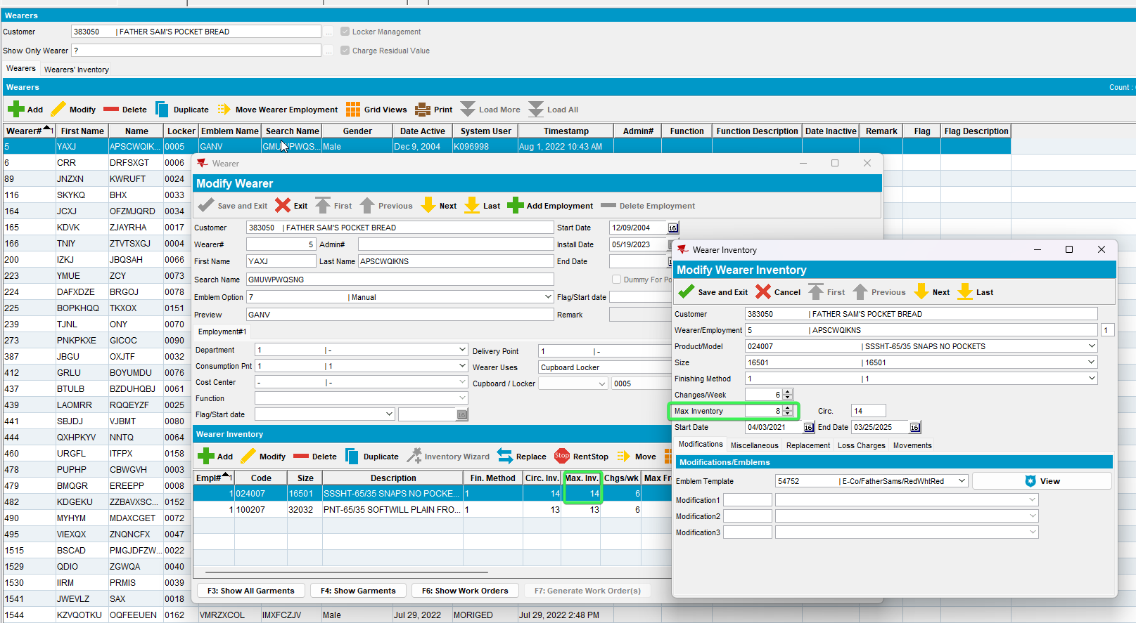
- RSC: Generate invoices for this customer
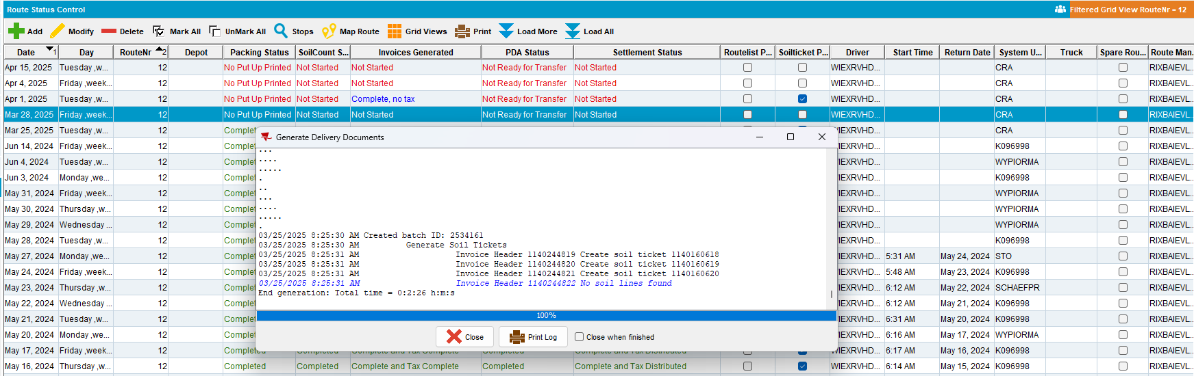
- Maintain Invoices: Check that Loss Charge Garments - Wearer Inventory Inactive is the only loss charge present on the invoice for Wi which was ended.
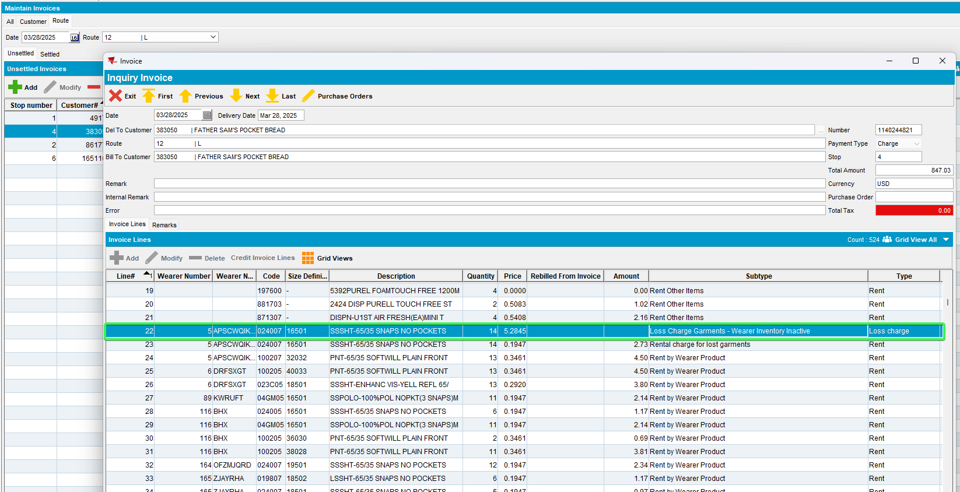
Tested OK

