ABSN-3991 Unable to replace a wearer inventory to its original size after replacing it with a different size if the inventory contains non unique items

Environment | Prerequisites
Version:9.07.00  DBServerName=abs-SRV20.internal.abslbs.com  DBSID=CUST24  DBUser=UNFDEV  DBPassword=UNFDEV  Environment=Test | - Module:  - System setting

Contents
ABSN-3991 Unable to replace a wearer inventory to its original size after replacing it with a different size if the inventory contains non unique items 1
Test after fix 1
Test Case 1 – WI A full replacement by B & WI B full replacement by A, all non-unique items - Tested OK 1
Test Case 2 – WI A full replacement by B & WI B full replacement by A, mixed items - Tested OK 5

Test after fix

Test Case 1 – WI A full replacement by B & WI B full replacement by A, all non-unique items - Tested OK
Expected behavior: Should be able to replace the WI back to its original size
Hash: a70c227
- Have a WI A with all non-unique items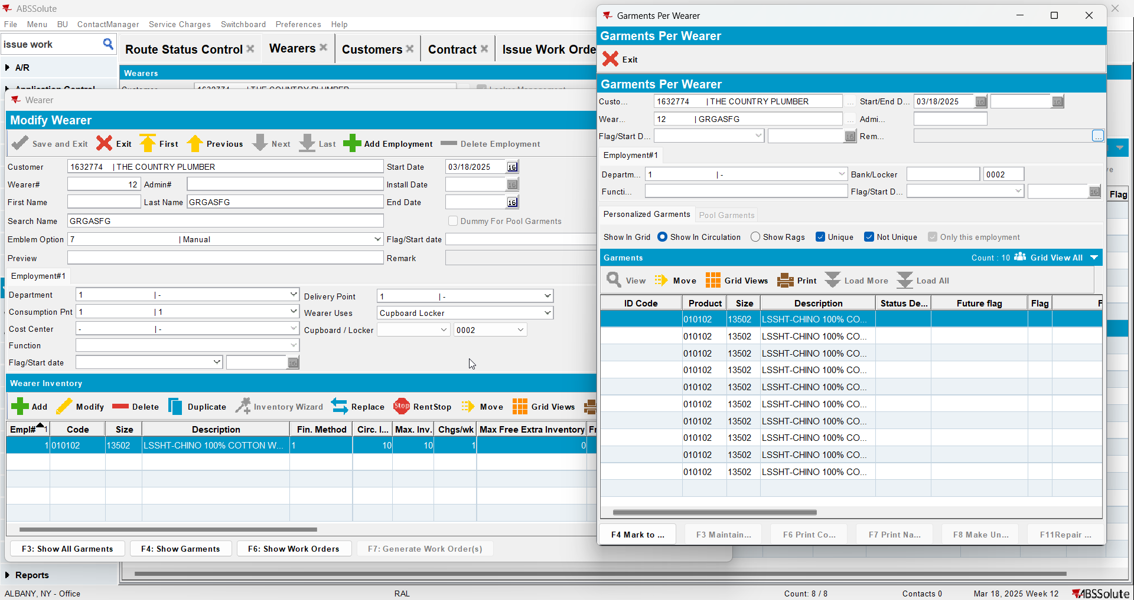
- Replace WI A changing just the size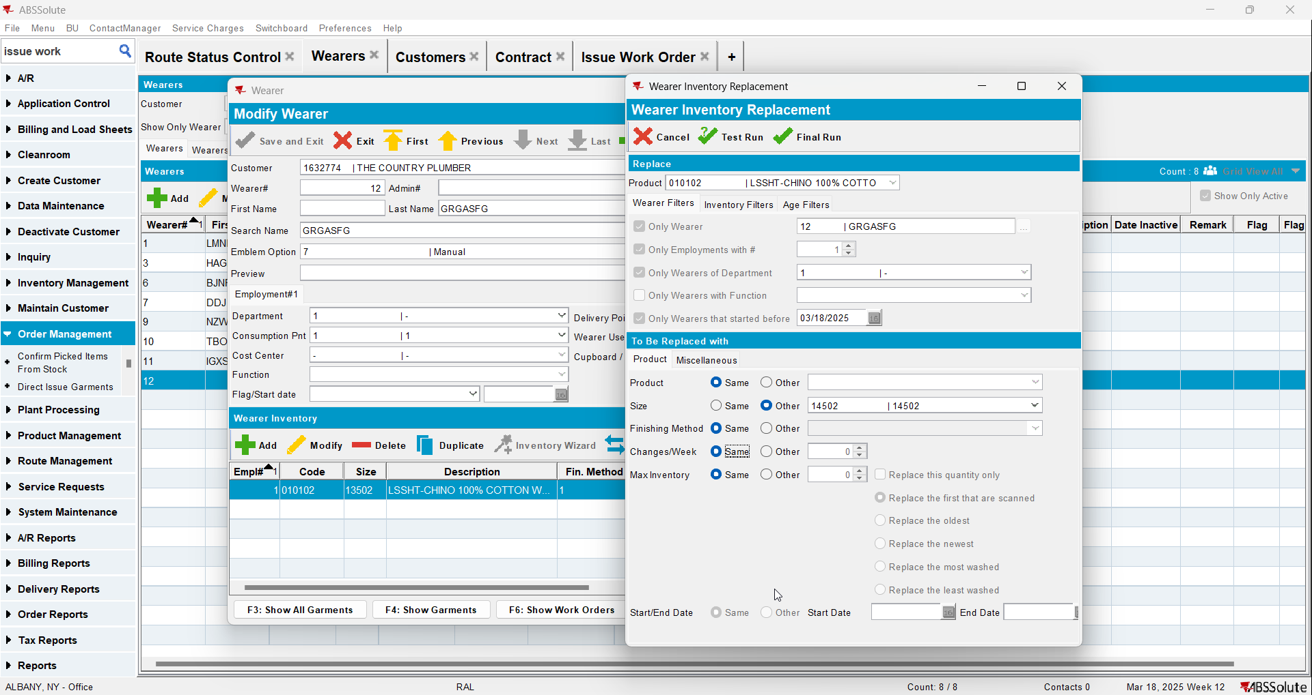
- Issue the WO 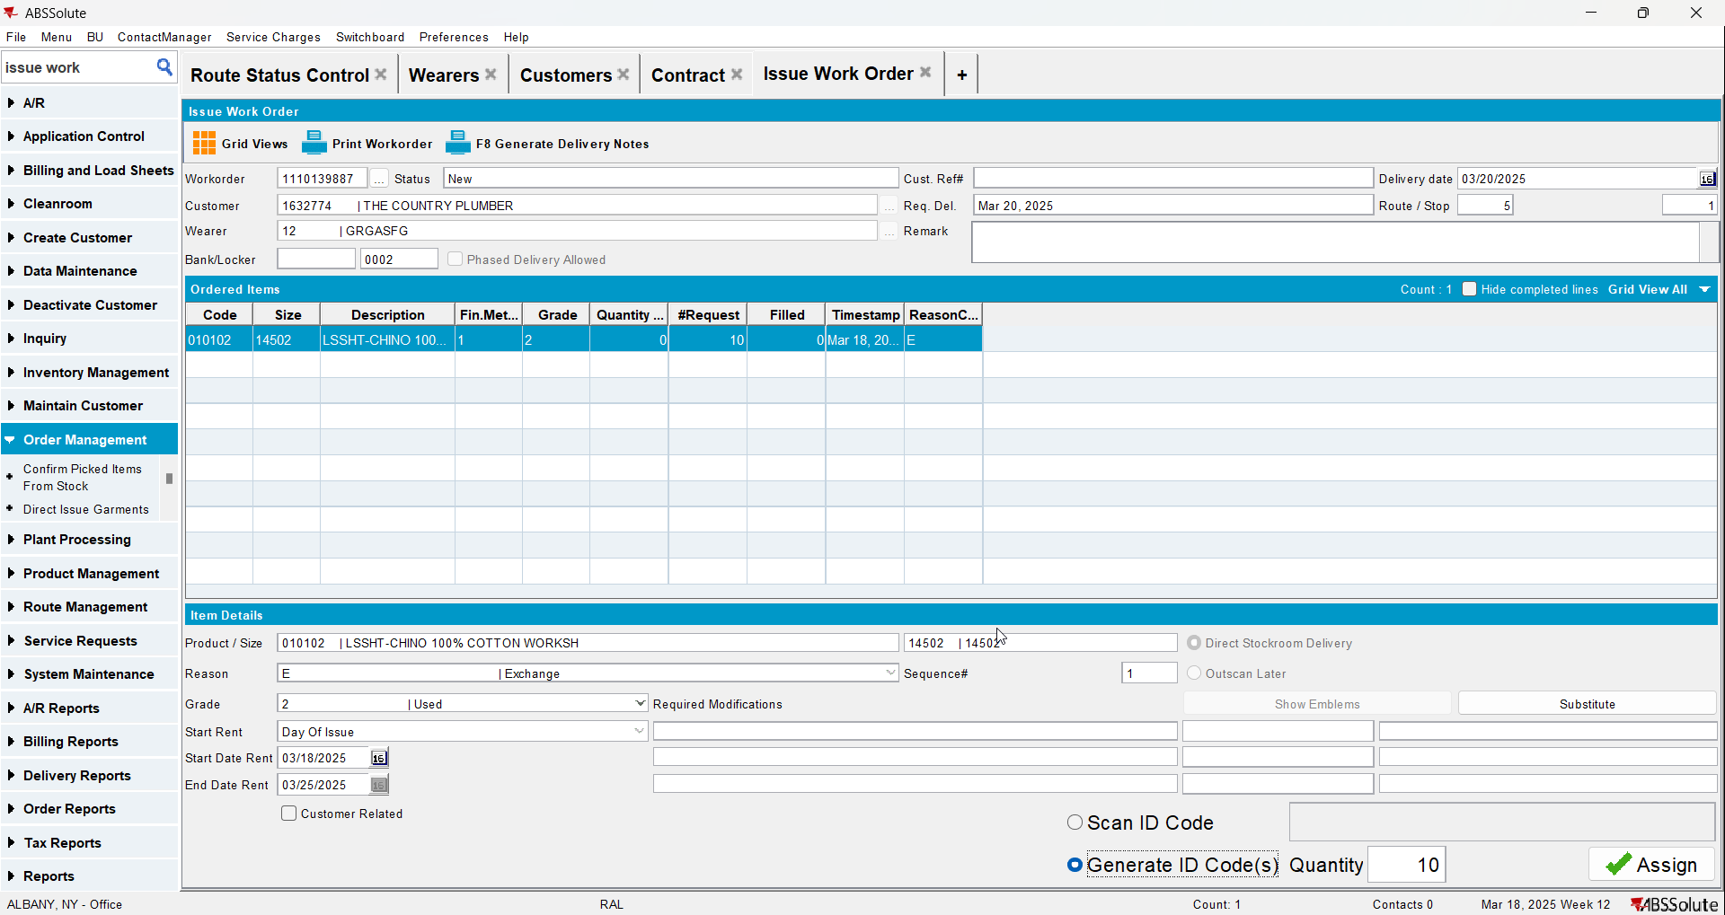
- Generate invoices and settle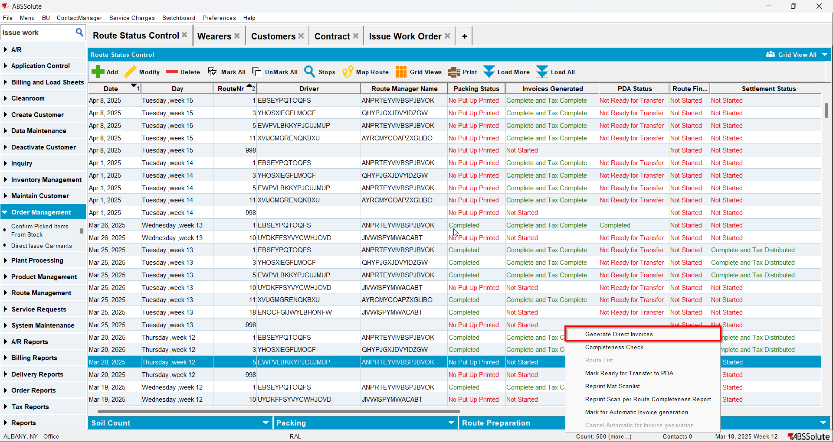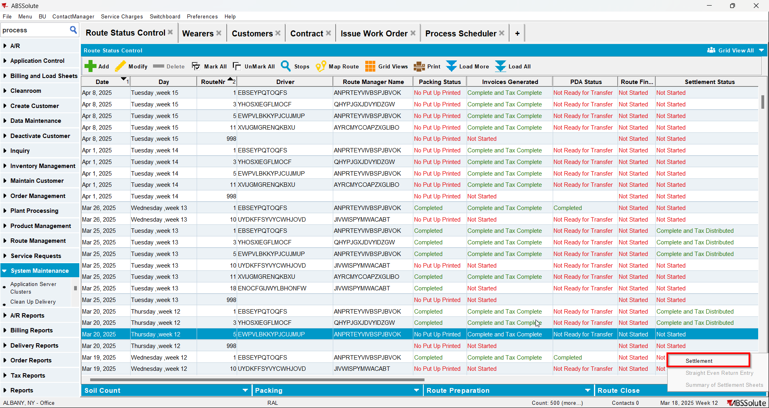
- Replace WI B back to its original size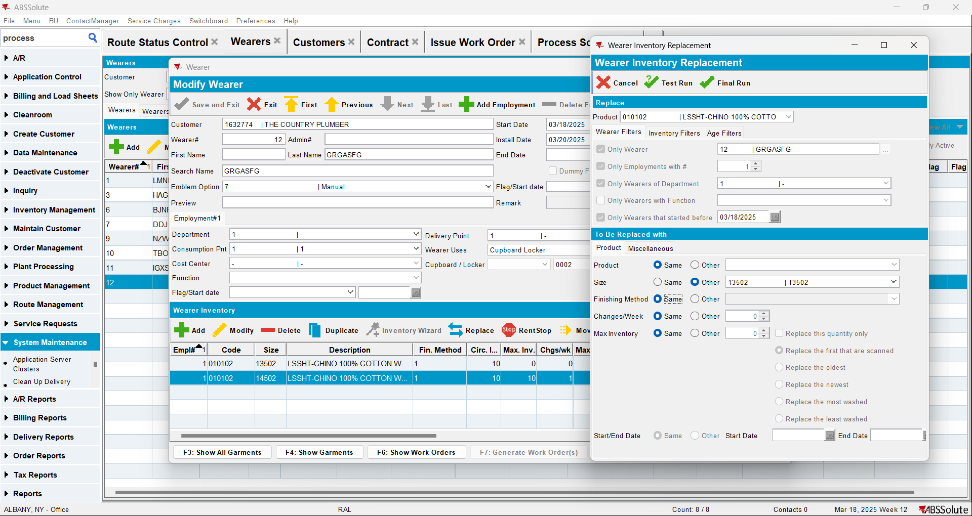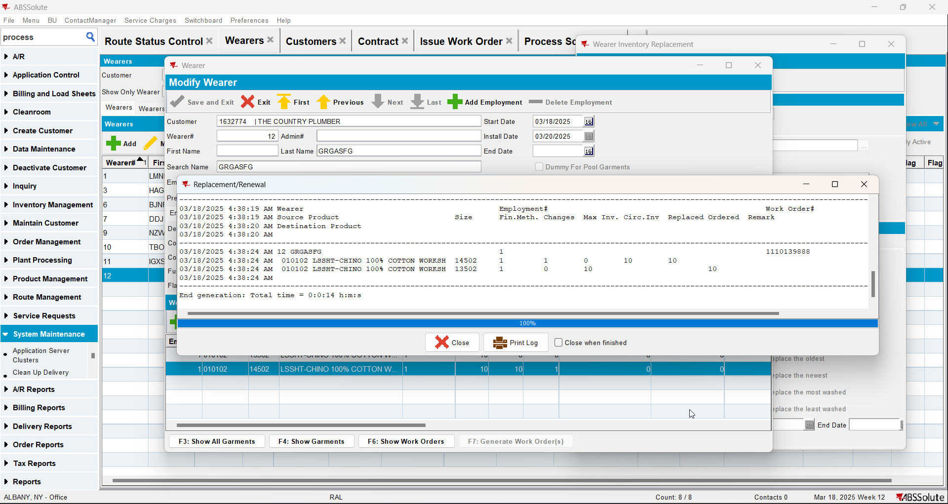

Test Case 2 – WI A full replacement by B & WI B full replacement by A, mixed items - Tested OK
Expected behavior: Should be able to replace the WI back to its original size
Hash: a70c227
- Have a WI A with mixed items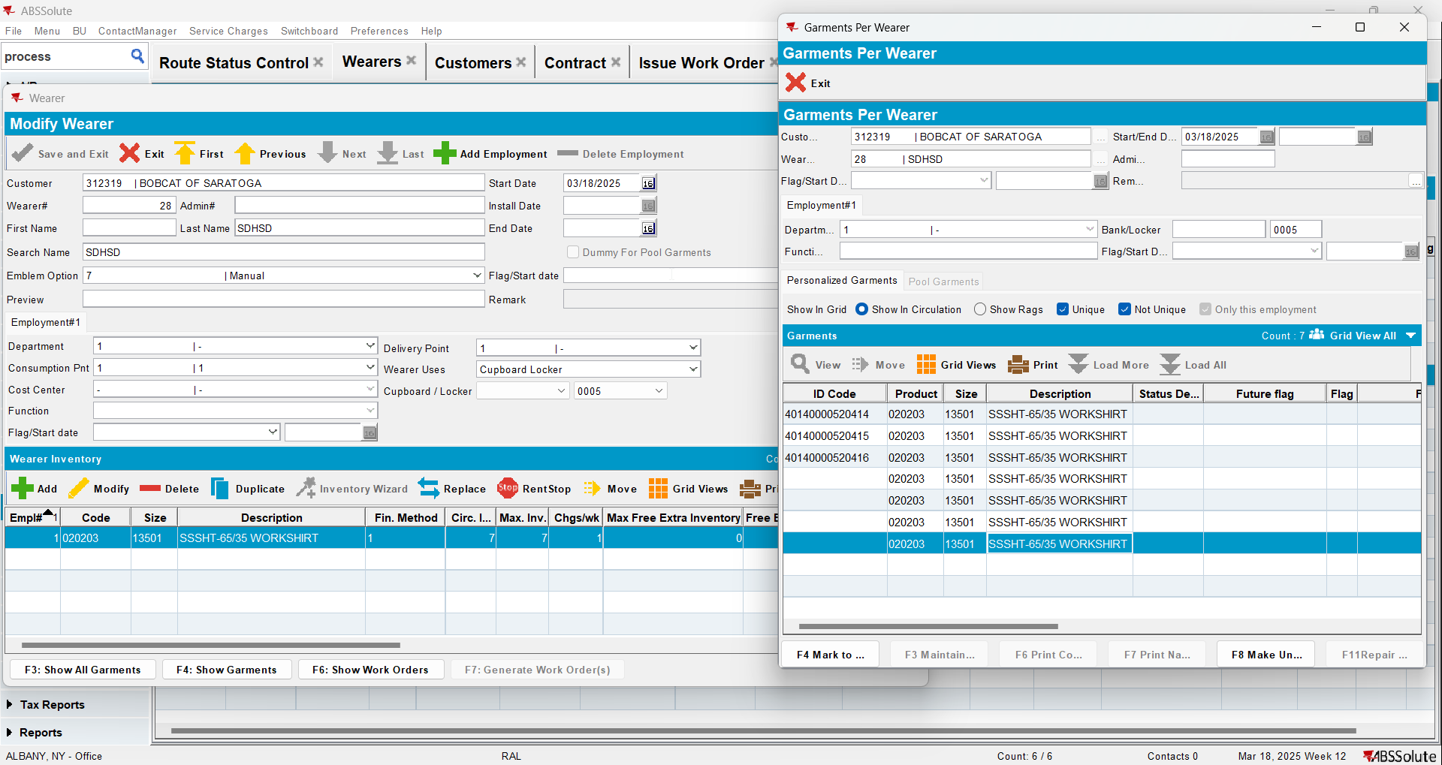
- Replace WI A changing just the size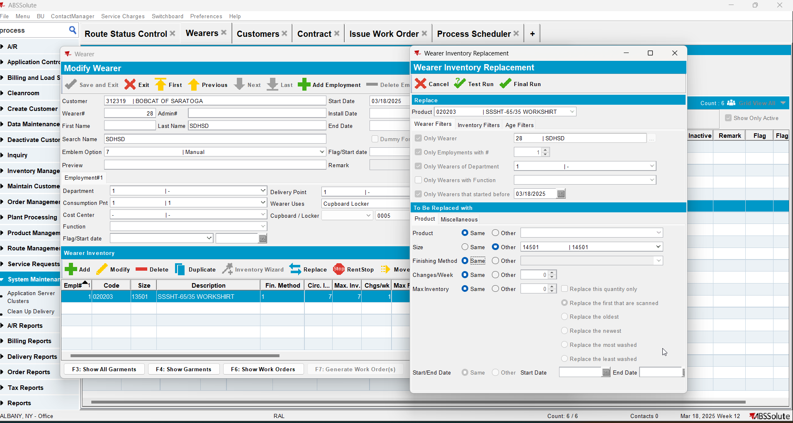
- Issue the WO and generate delivery notes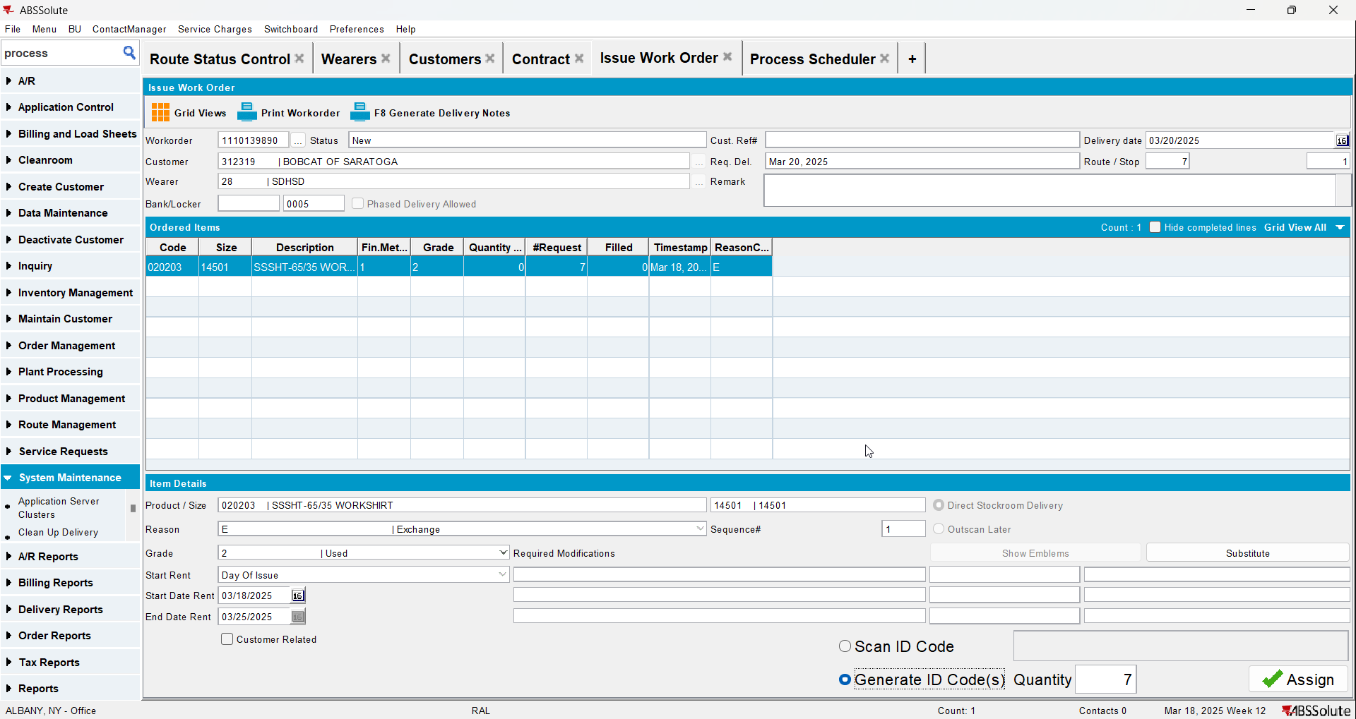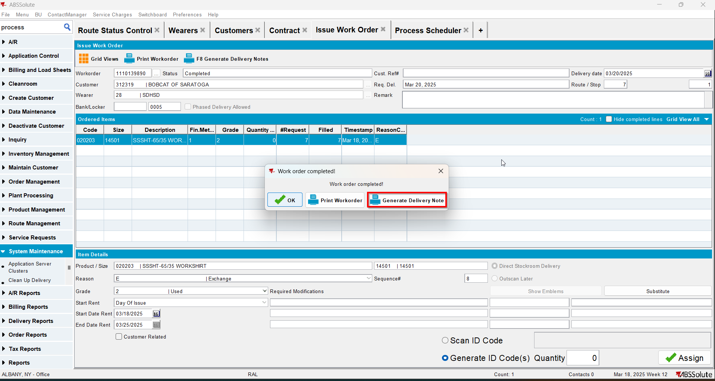
- Generate invoices and settle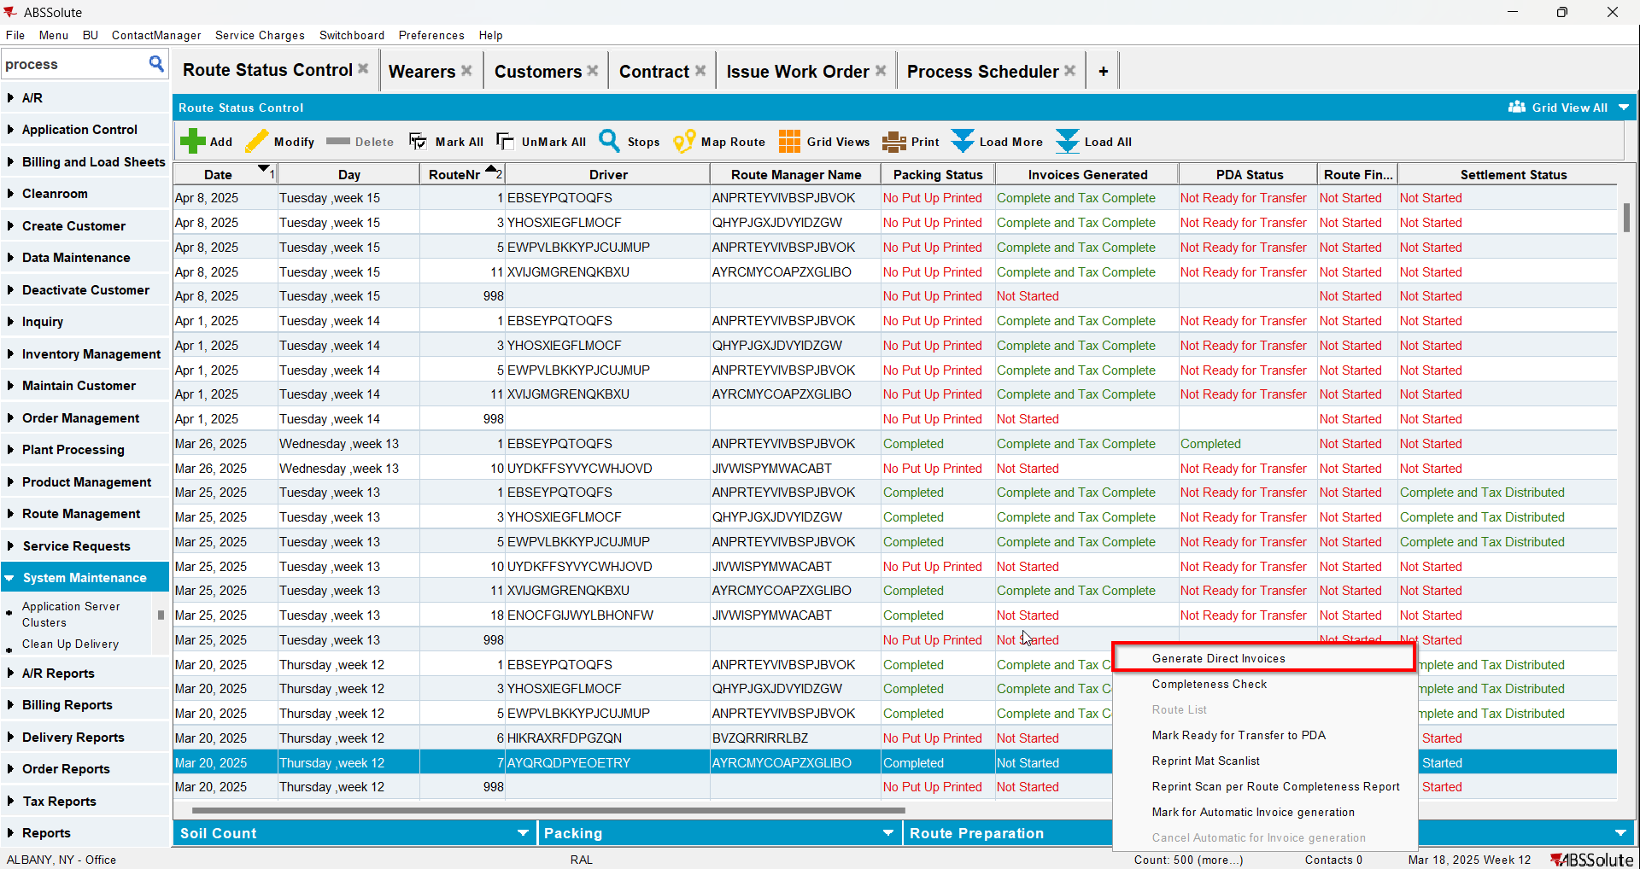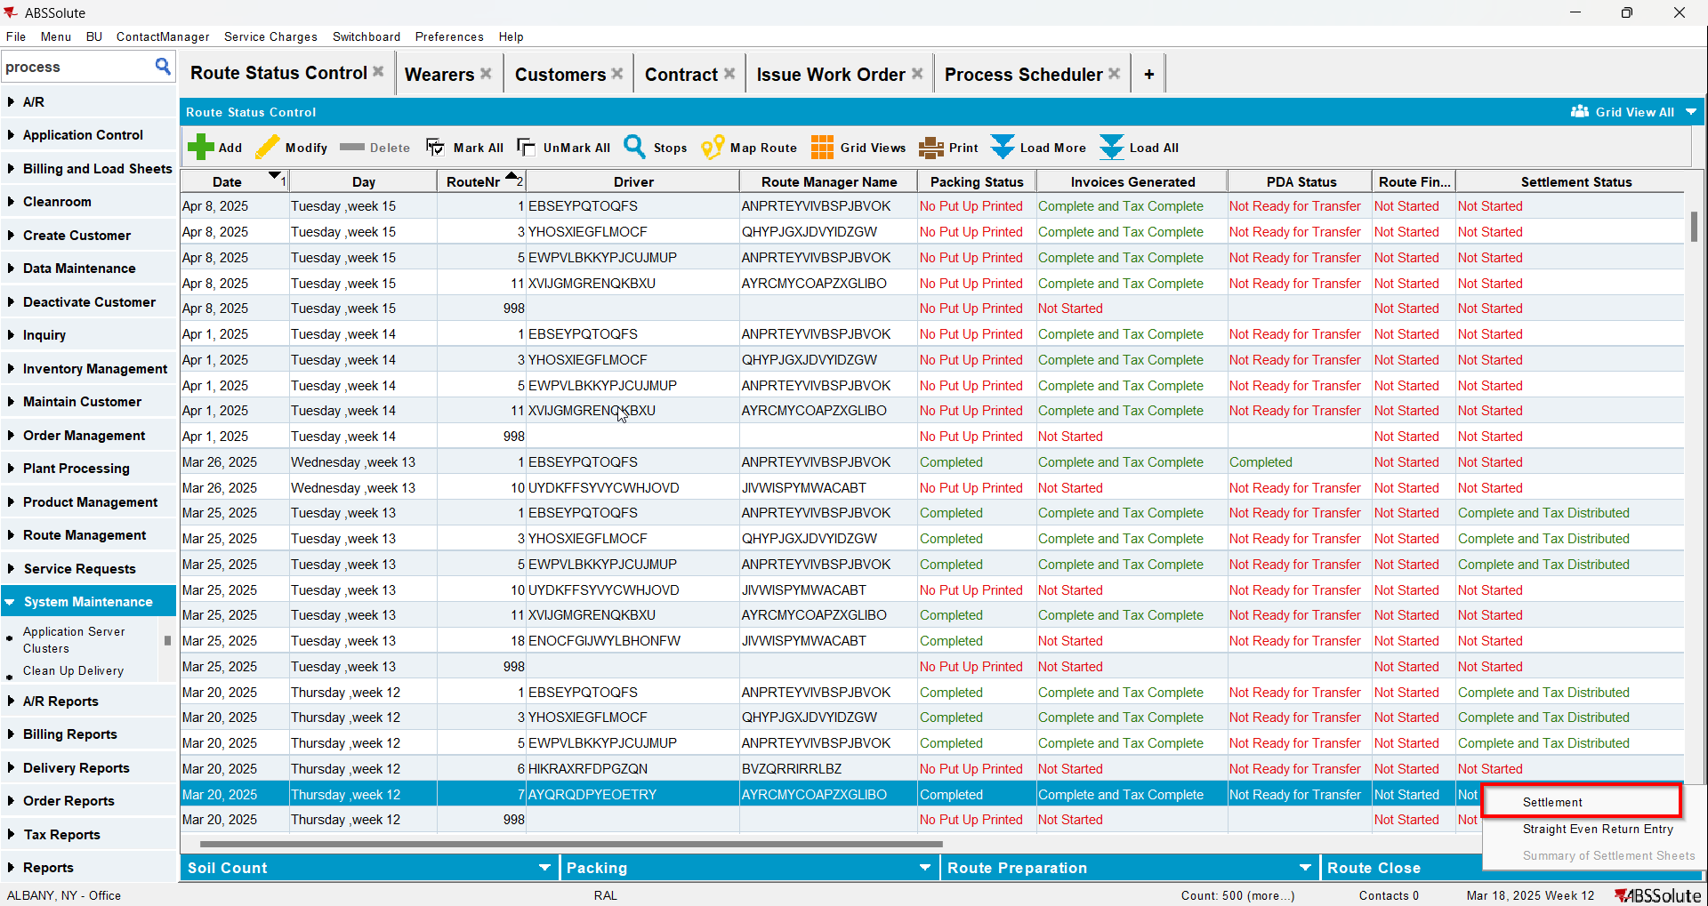
- Replace WI B back to its original size