ABSN-3989 Garment not billing rental charges
Environment | Prerequisites
Version:9.07.00  DBServerName=abs-SRV20.internal.abslbs.com  DBSID=CUST24  DBUser=UNFDEV  DBPassword=UNFDEV  Environment=Test | - Module:  - System setting

Contents
Test after fix 1
Test Case 1 – WI A full replacement by B & WI B full replacement by A, all unique items – Replacements done on Client – Tested OK 1
Test Case 2 – WI A full replacement by B & WI B full replacement by A, all non-unique items – Replacements done on Client – Tested OK 17
Test Case 3 – WI A full replacement by B & WI B full replacement by A, all mixed items – Replacements done on Client – Tested OK 32
Test Case 4 – WI A partial replacement by B & WI B full replacement by A, all unique items – Replacements done on Client – Tested OK 49
Test Case 5 – WI A full replacement by B & WI A is manually increased back to original MAX, all unique items – Replacements done on Client – Tested OK 56

Test after fix

Test Case 1 – WI A full replacement by B & WI B full replacement by A, all unique items – Replacements done on Client – Tested OK
Expected behavior: When generating the second replacement workorder we should change REPL_STILLTOBECHARGED to NULL.
Hash: 529d0c2
- Have SS CHARGEREPLACEDPRODUCT set on Y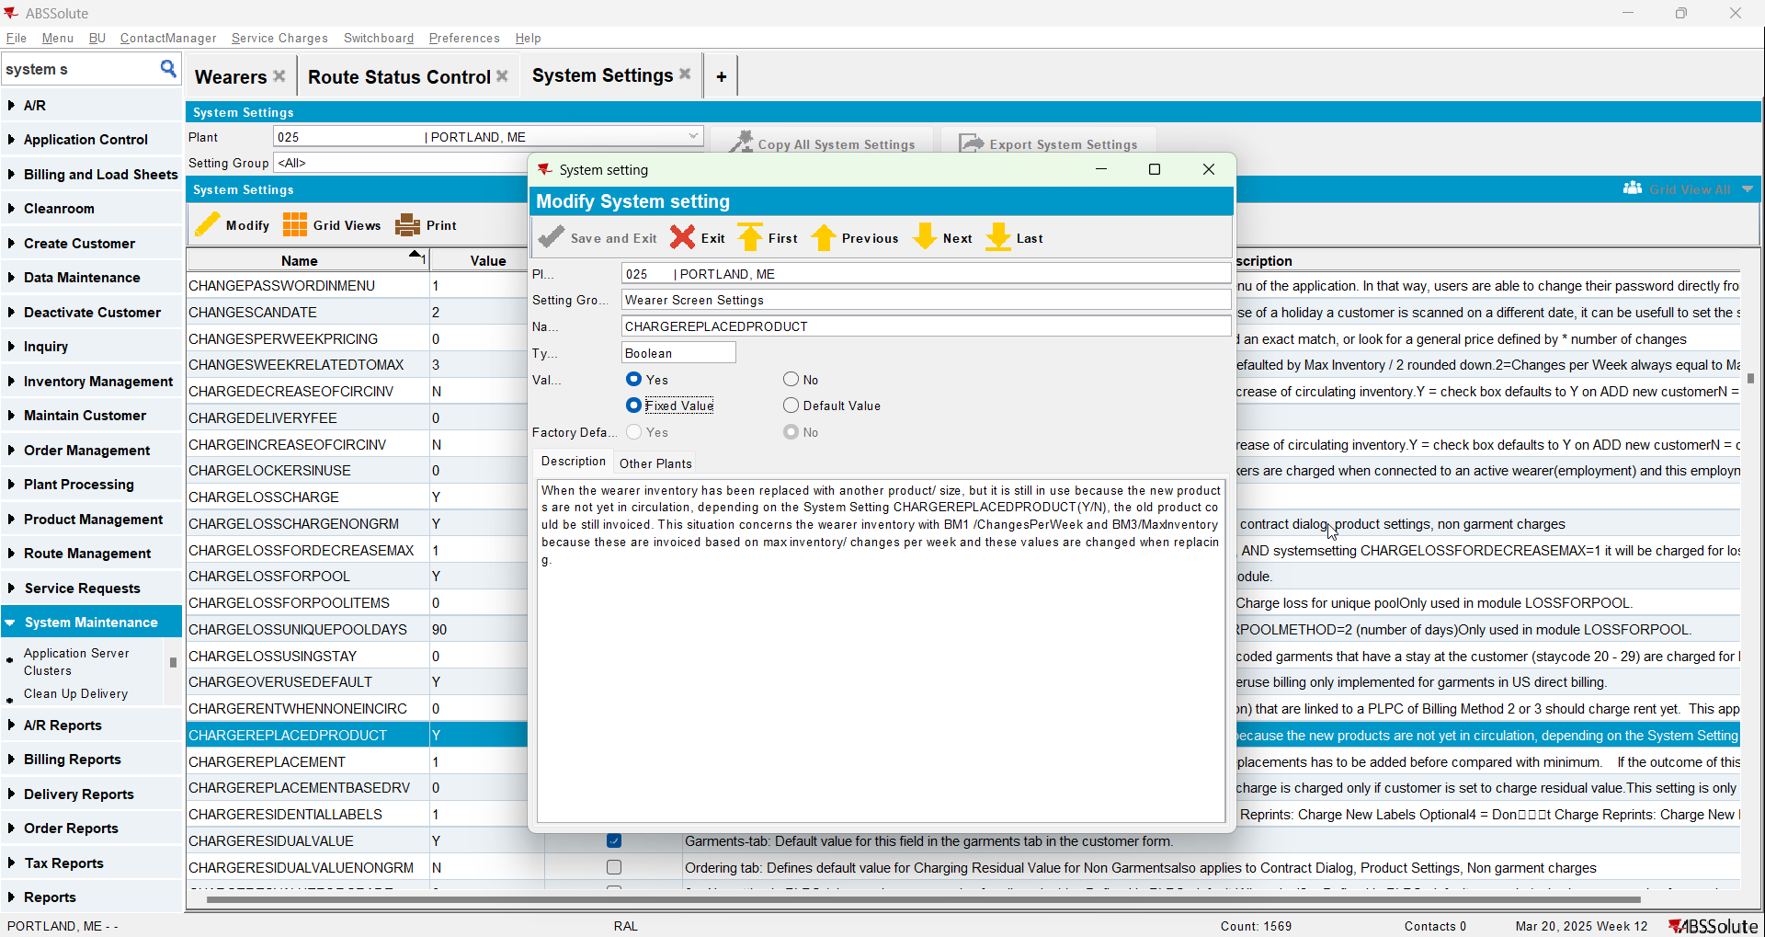
- Have a wearer inventory with unique items only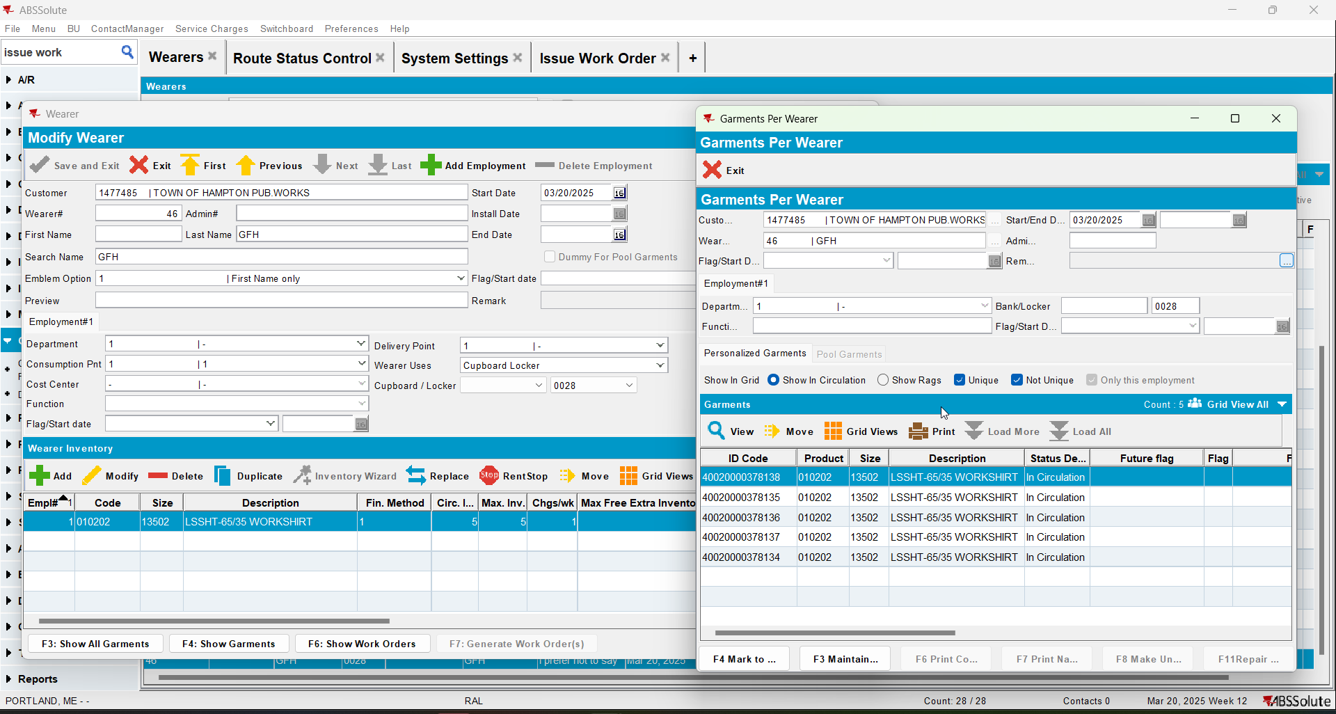
- Check the state of the product using the below sql
select w.wearernumber, p.code pdcode, SZ.code szcode, fm.code fmcode
, wi.wearerinventory_id, wi.circinventory circ
, wi.maxinventory maxi, wi.old_maxinventory oldmaxi
, wi.changesperweek chgwk, wi.old_changesperweek oldchg
, wi.losschargeinvoiceline_id, wi.repl_stilltobecharged, wi.dateinactive
from wearerinventory wi
join weareremployment we on we.weareremployment_id = wi.weareremployment_id
join wearer w on w.wearer_id = we.wearer_id
join customer c on c.customer_id = w.customer_id
join product p on p.product_id = wi.product_id
join sizedefinition sz on sz.sizedefinition_id = wi.sizedefinition_id
join finishingmethod fm on fm.finishingmethod_id = wi.finishingmethod_id
where c.customernumber =
and w.wearernumber =
and p.code = ''
order by p.code, wi.wearerinventory_id

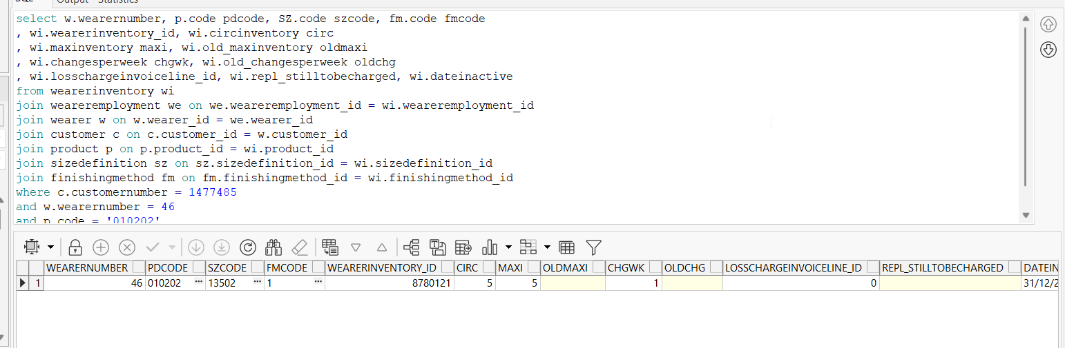
- Replace the wearer inventory changing only its size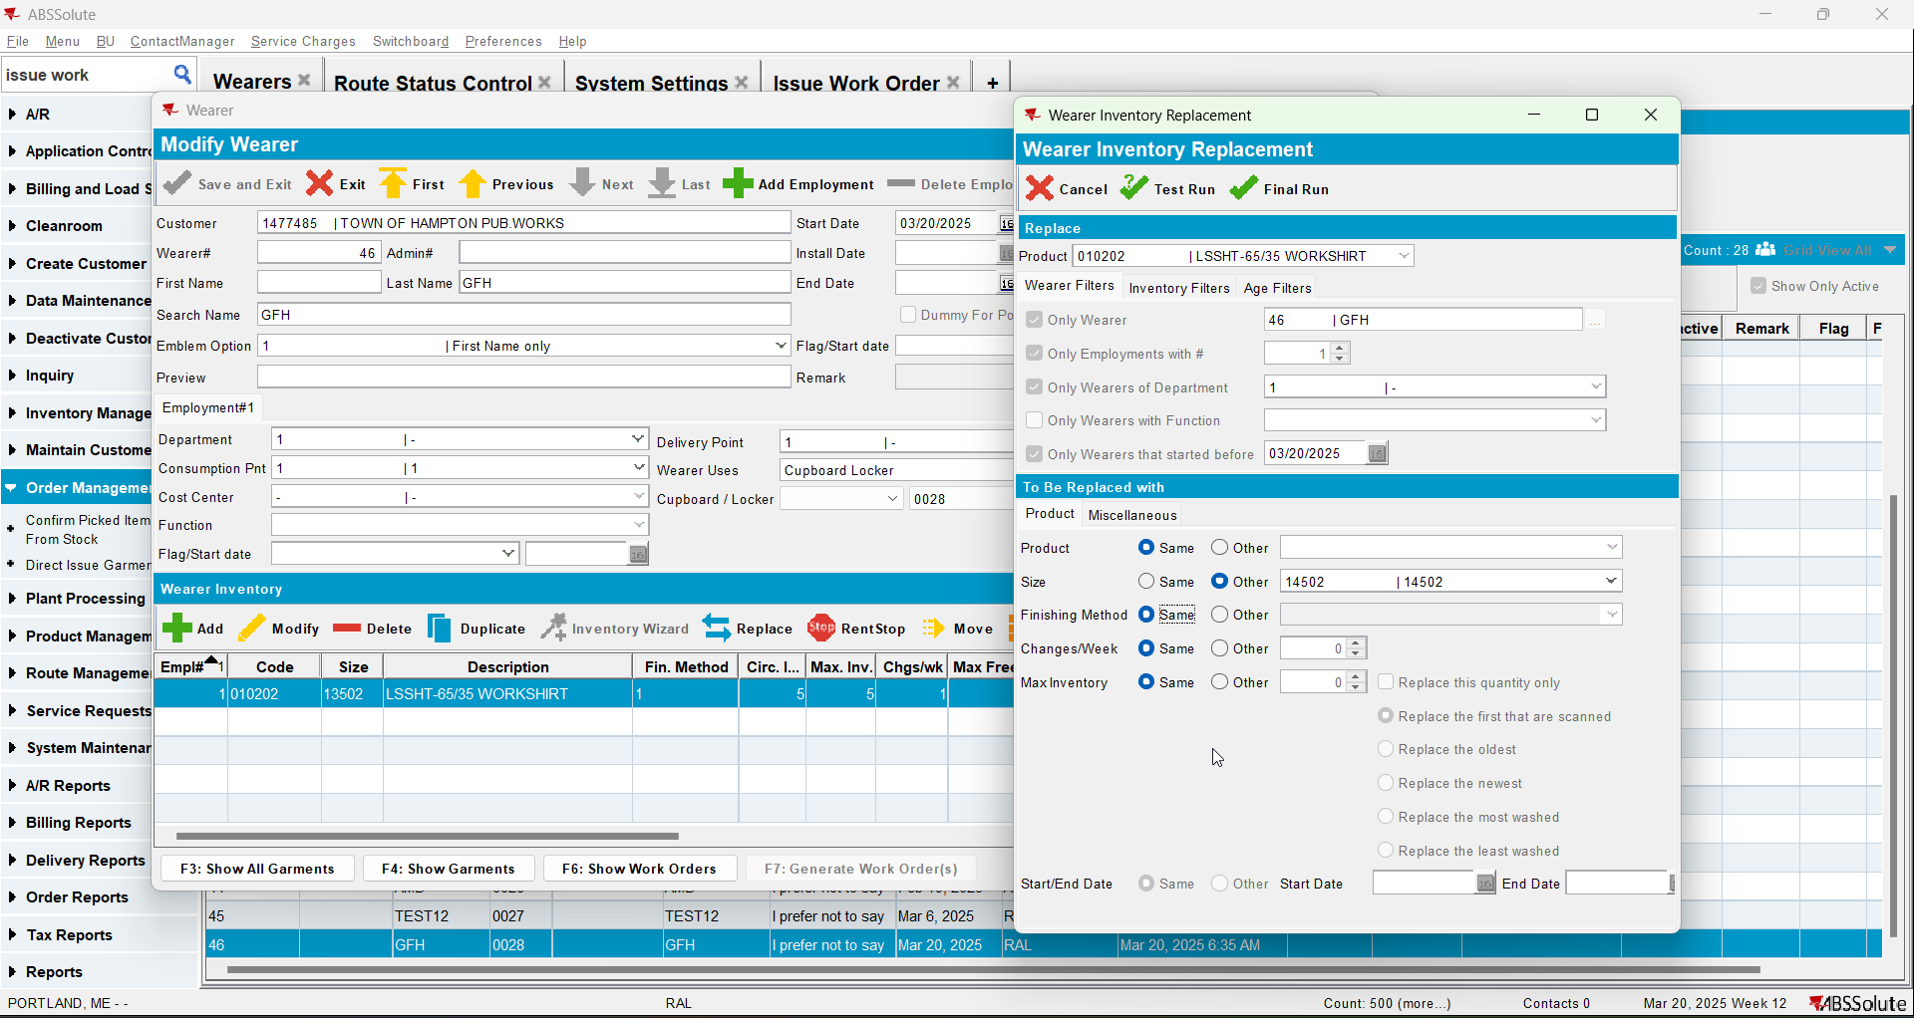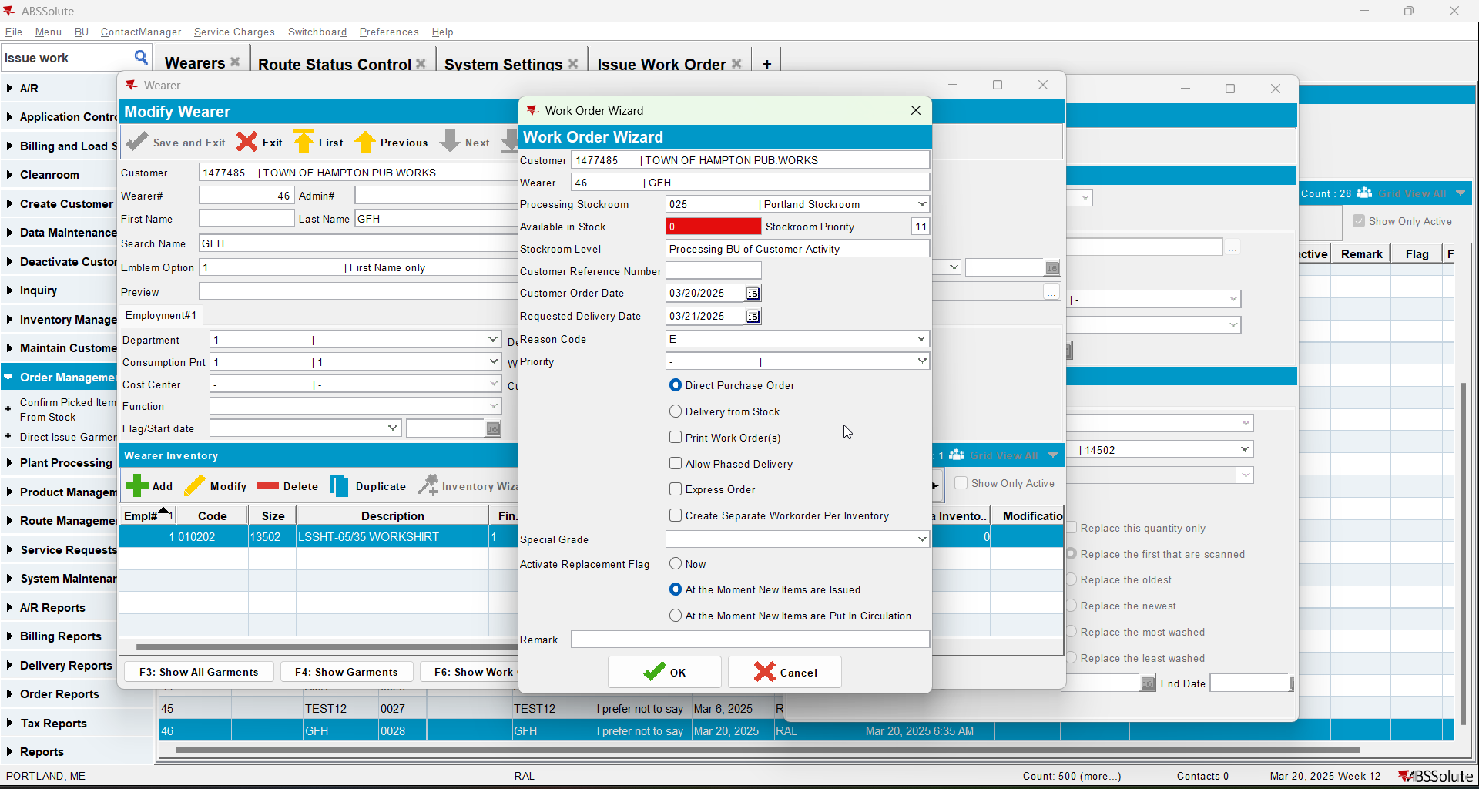
- Check the state of the product 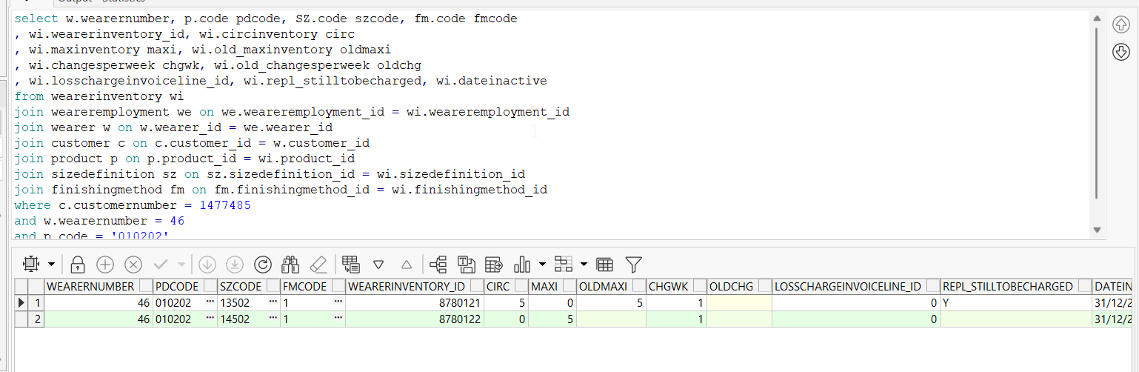
- Issue the items and generate delivery notes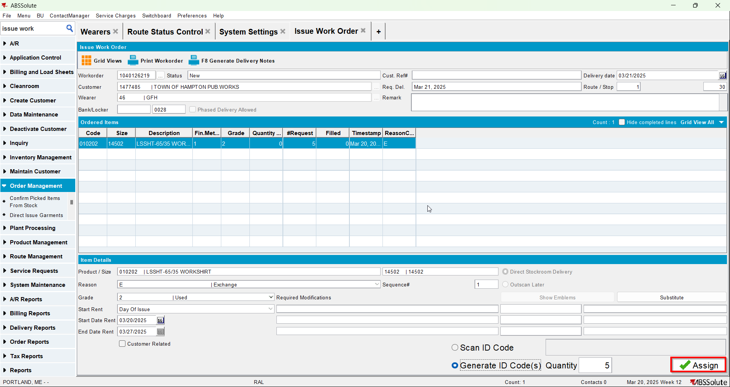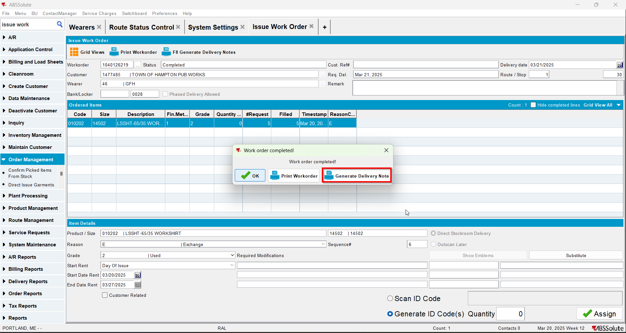
- Check the state of the product(REPL_STILLTOBECHARGED should be null for the second size and Y for the initial size)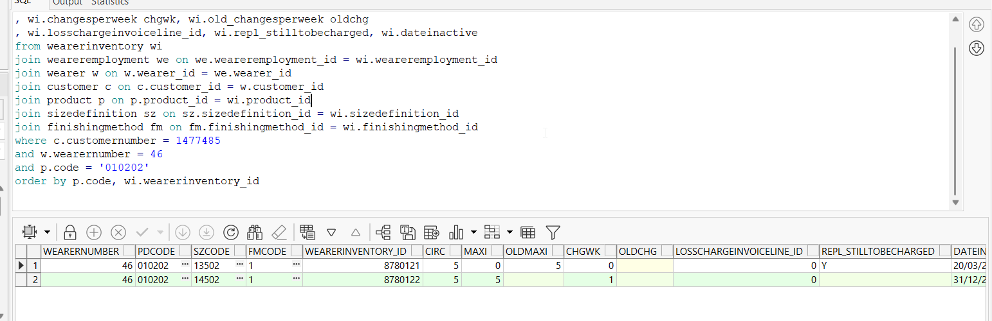
- Generate invoices and check the state of the product(REPL_STILLTOBECHARGED should be null for the second size and N for the initial size)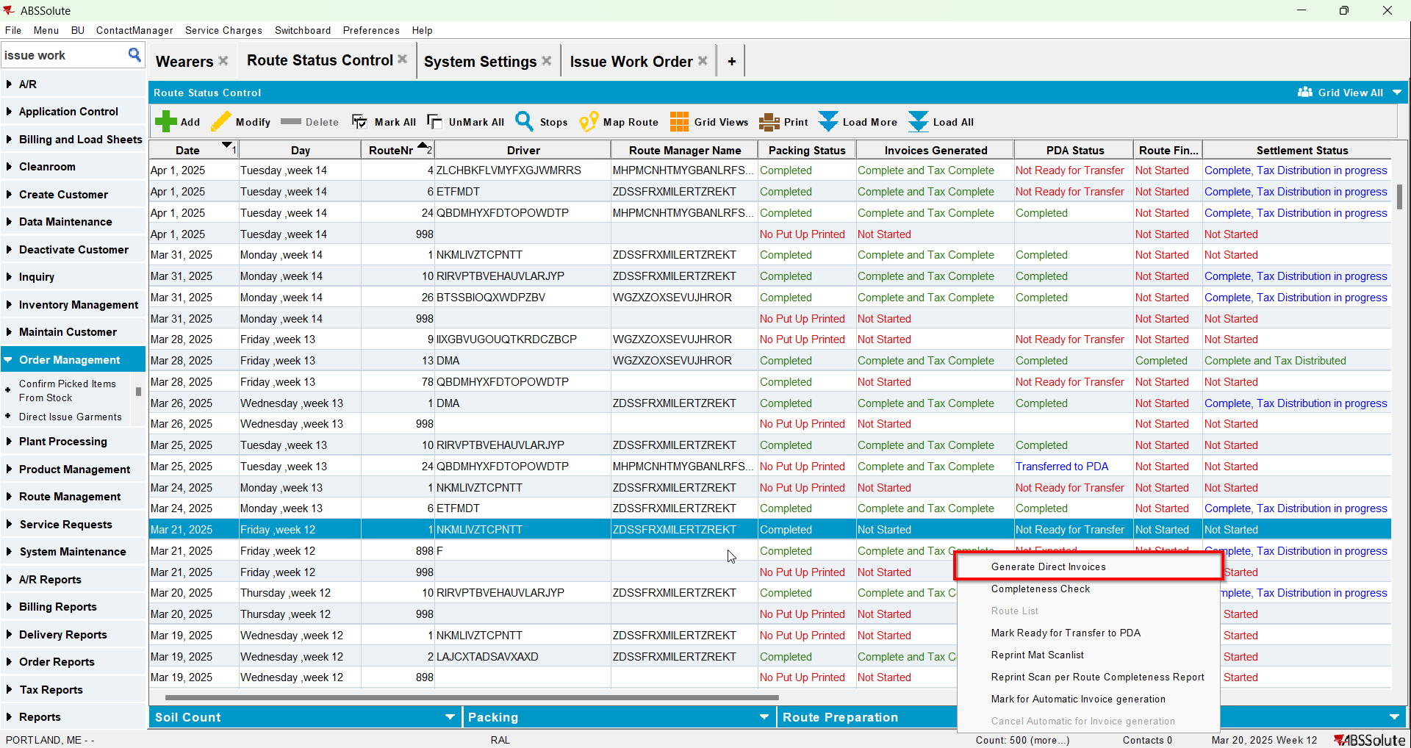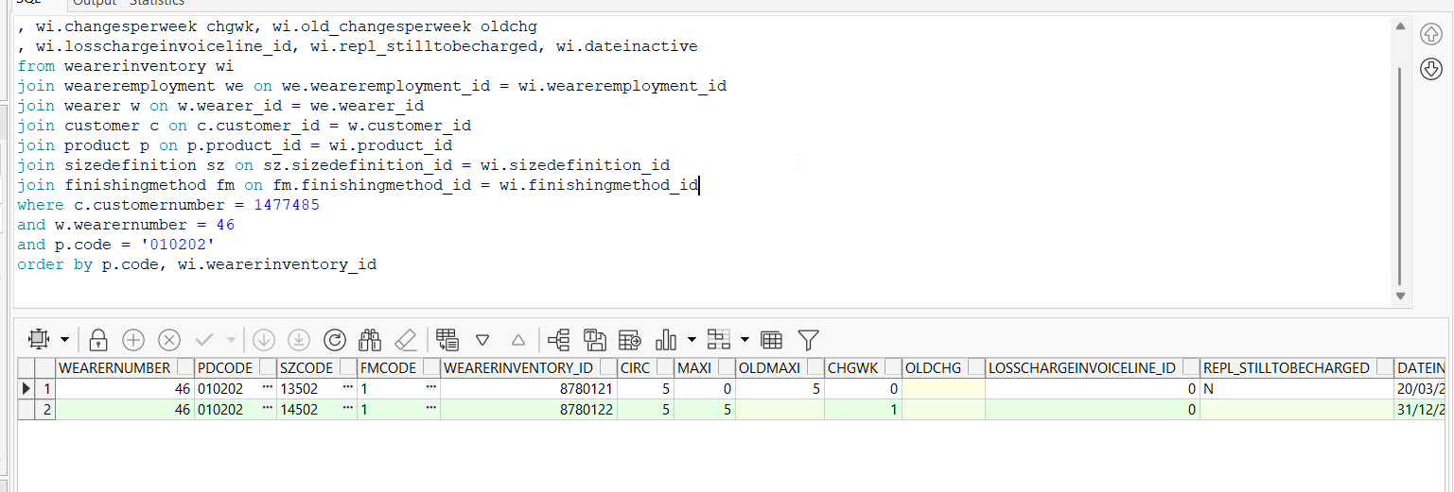
- Settle the route and check the state of the product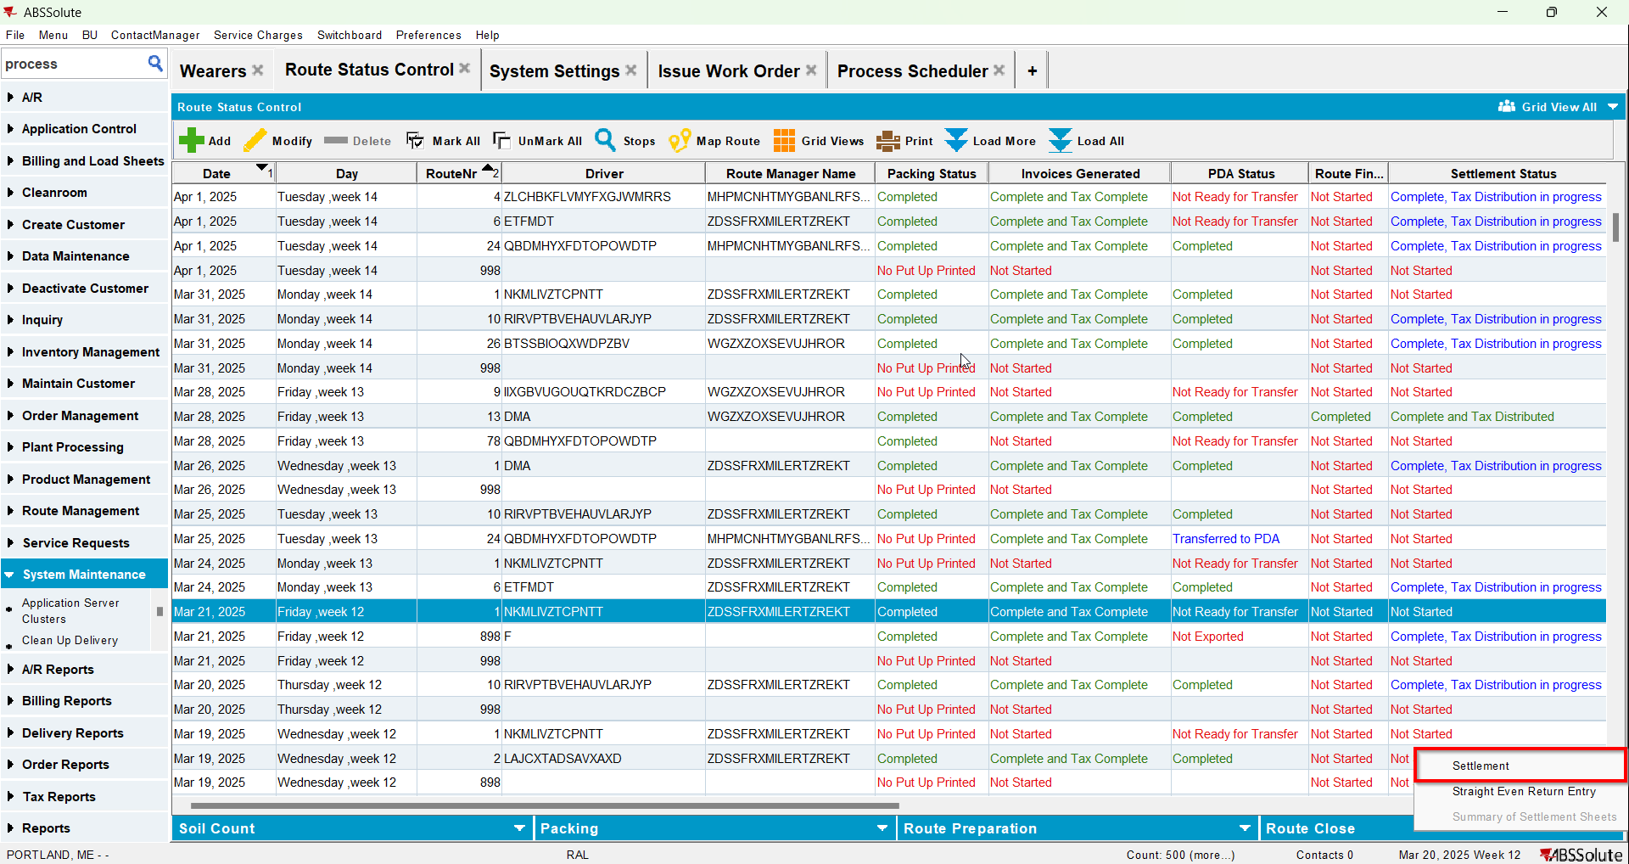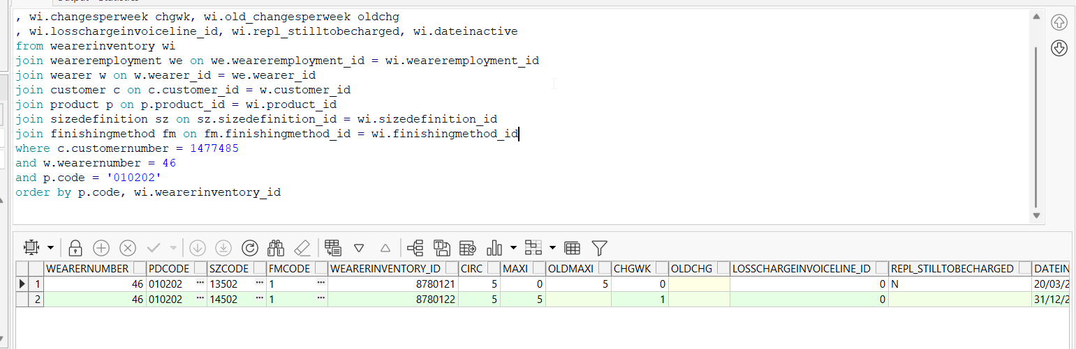
- Check the invoice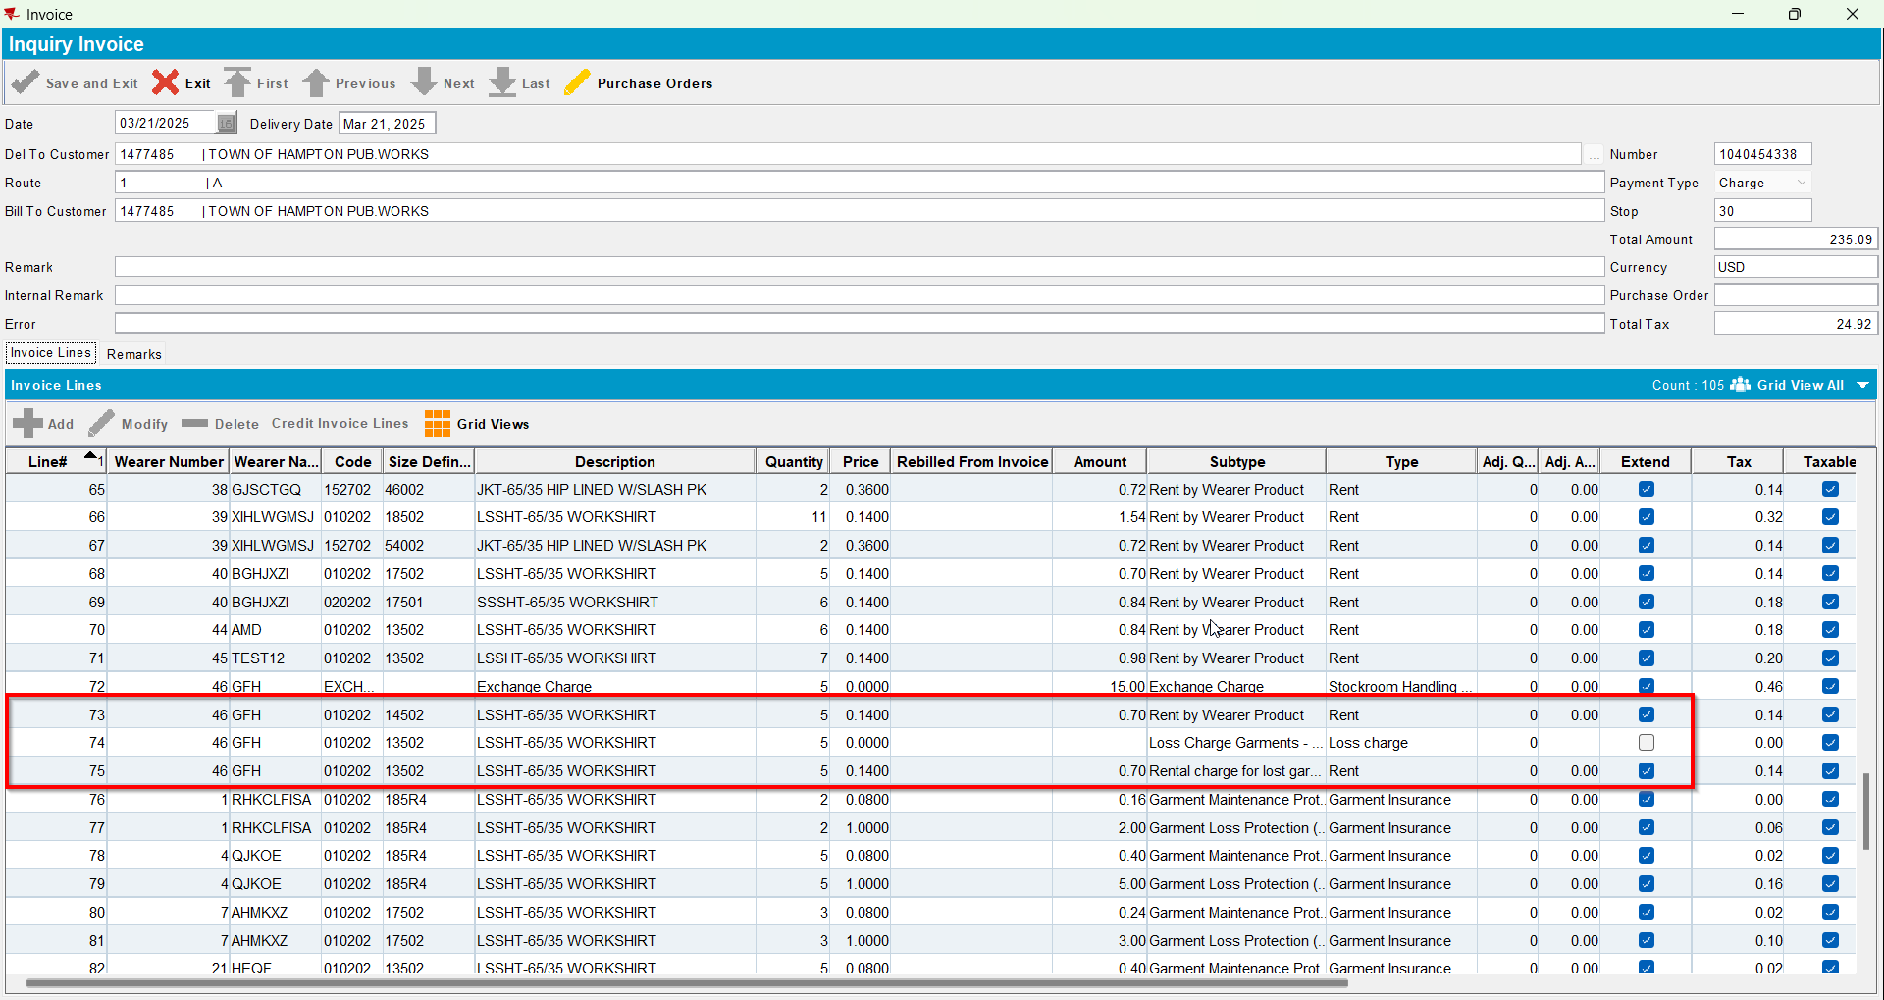
- Replace the new wearer inventory changing only its size back to its original size(REPL_STILLTOBECHARGED should be Y for the second size and Null for the initial size)
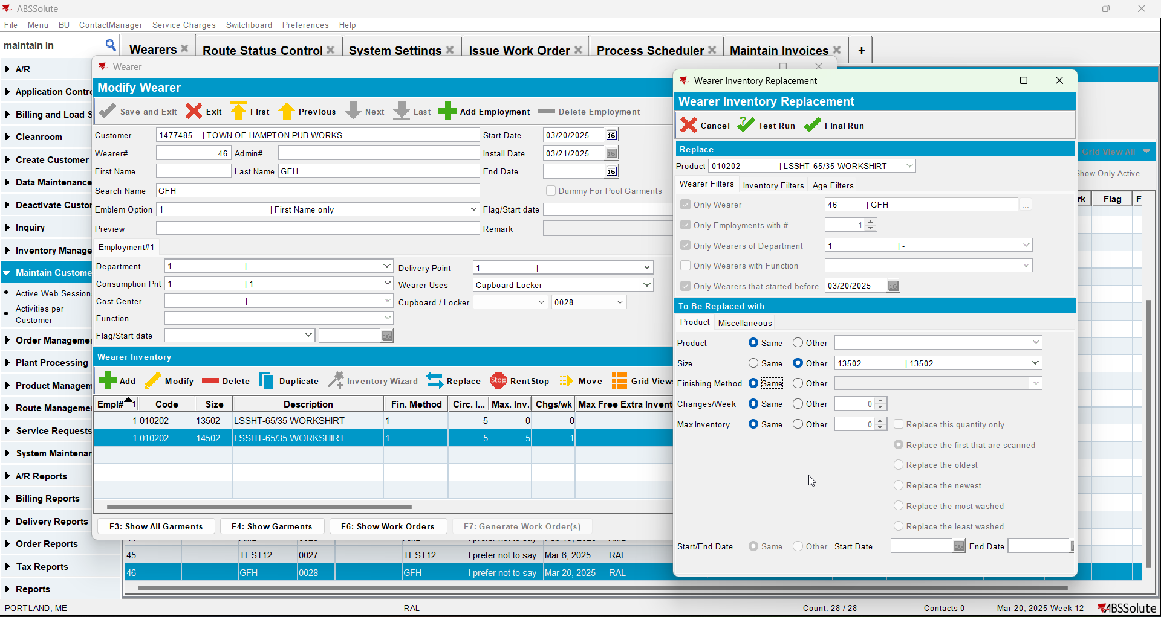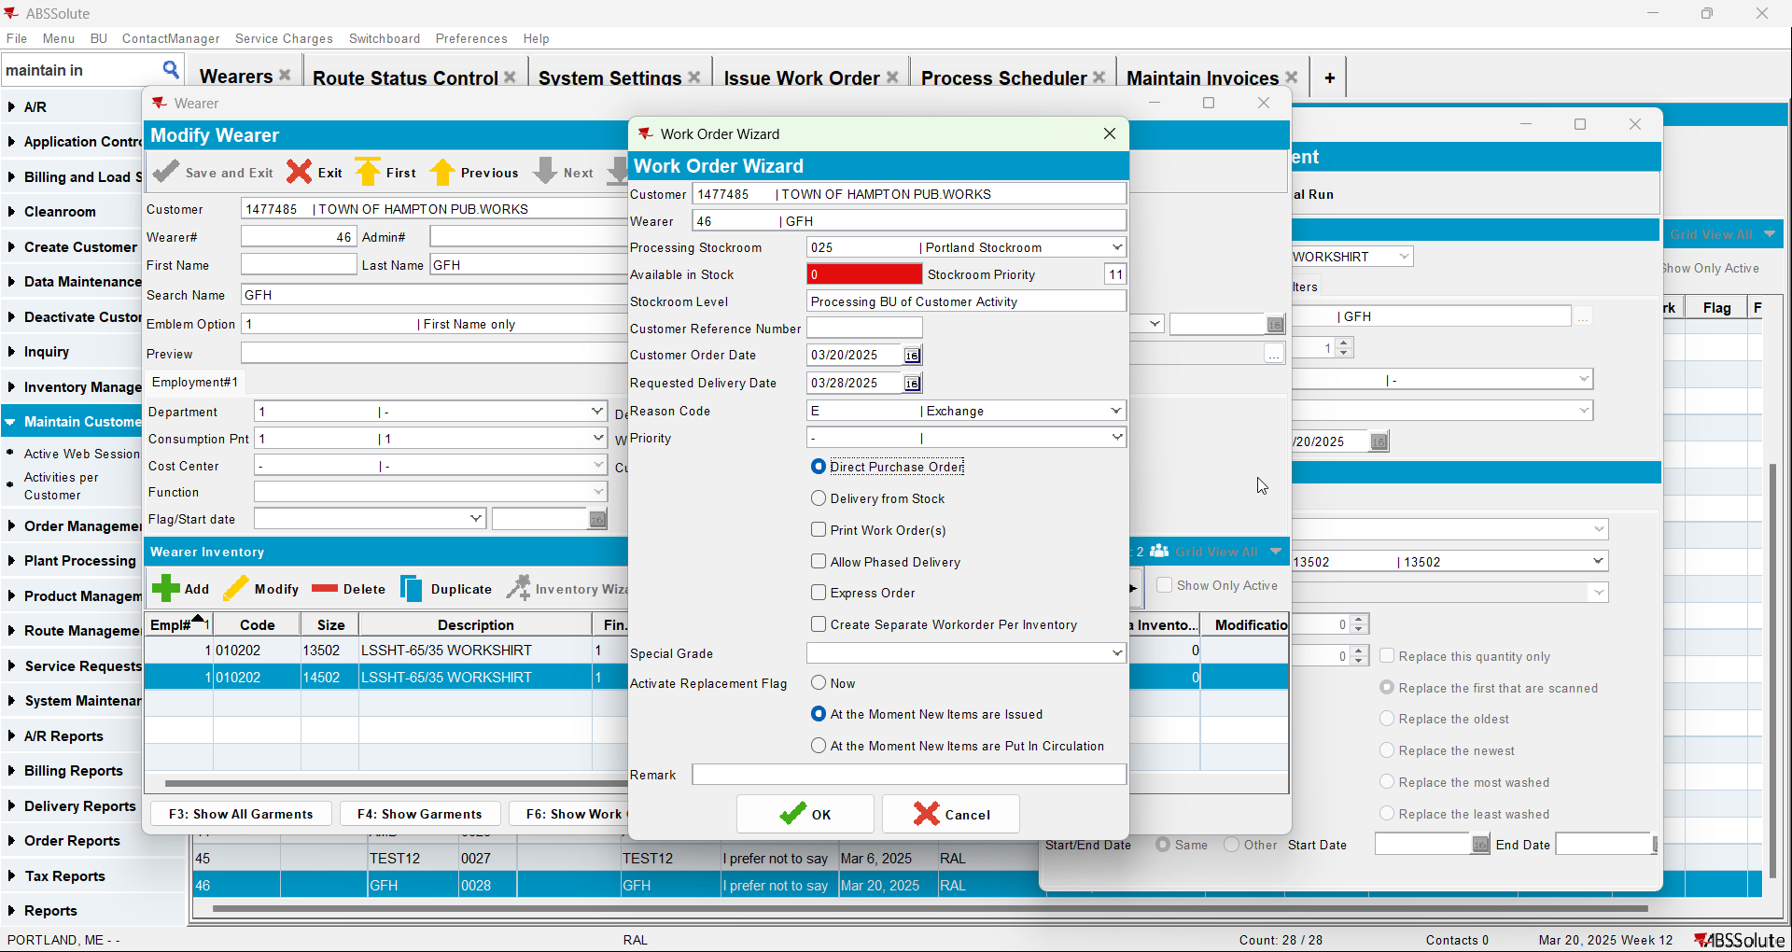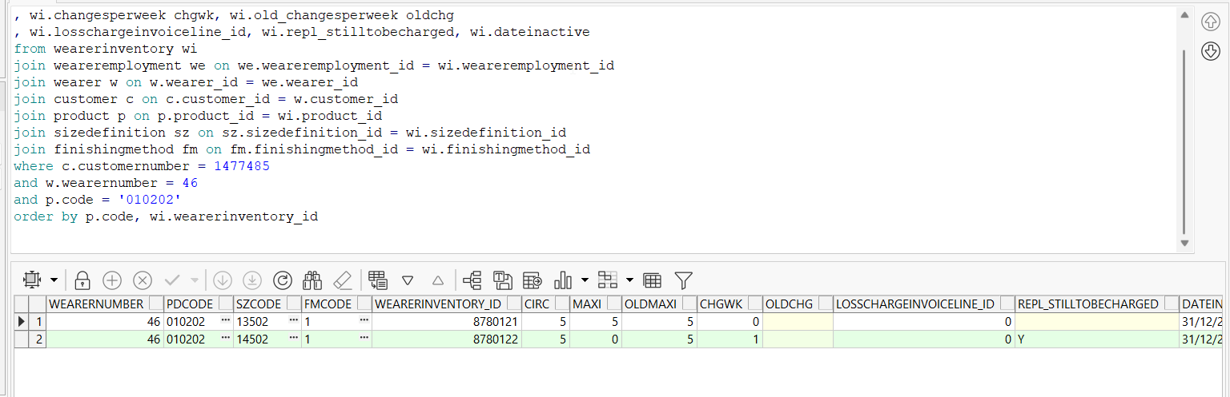
- Issue the items and generate delivery notes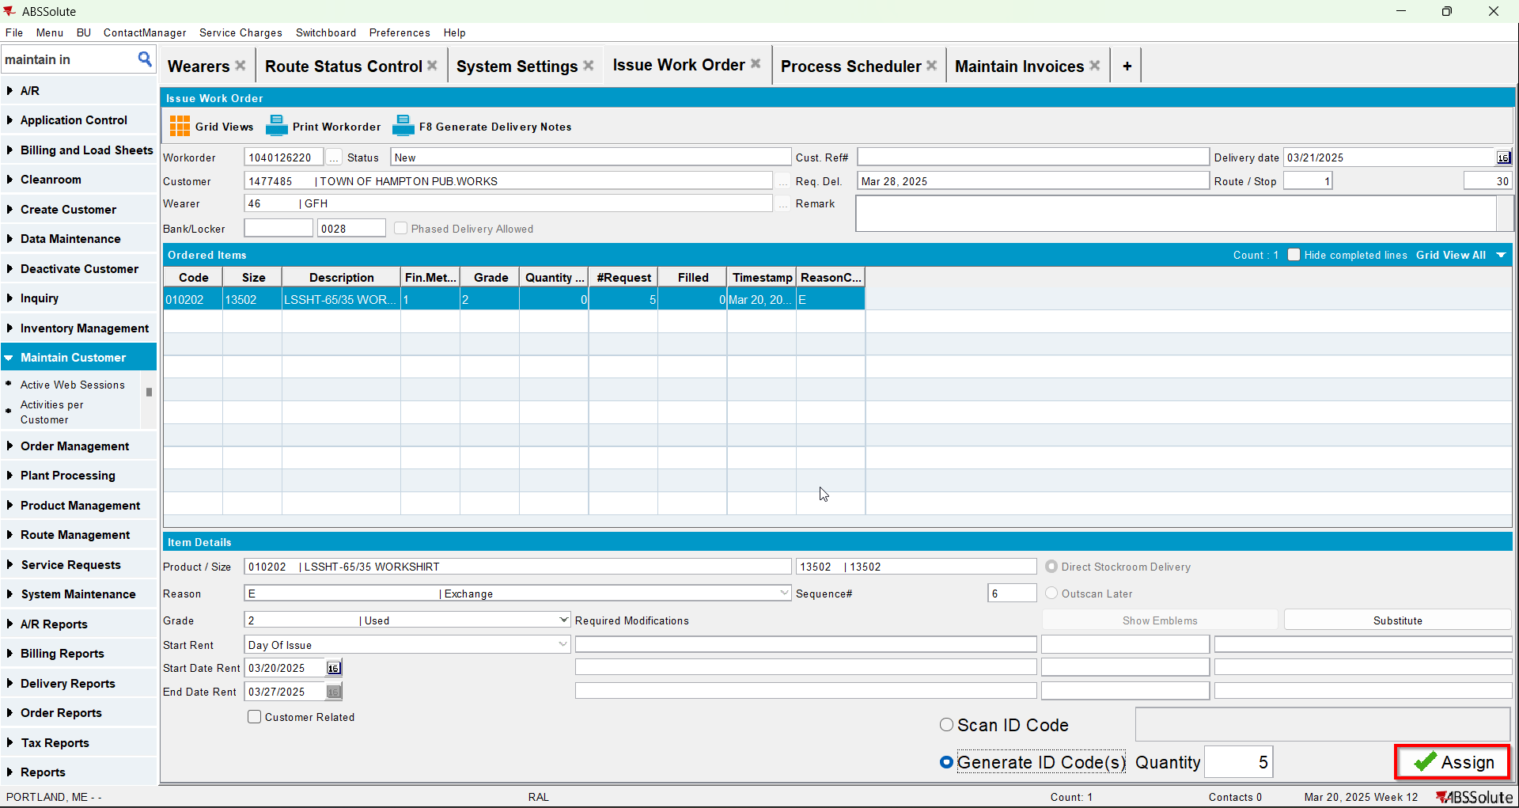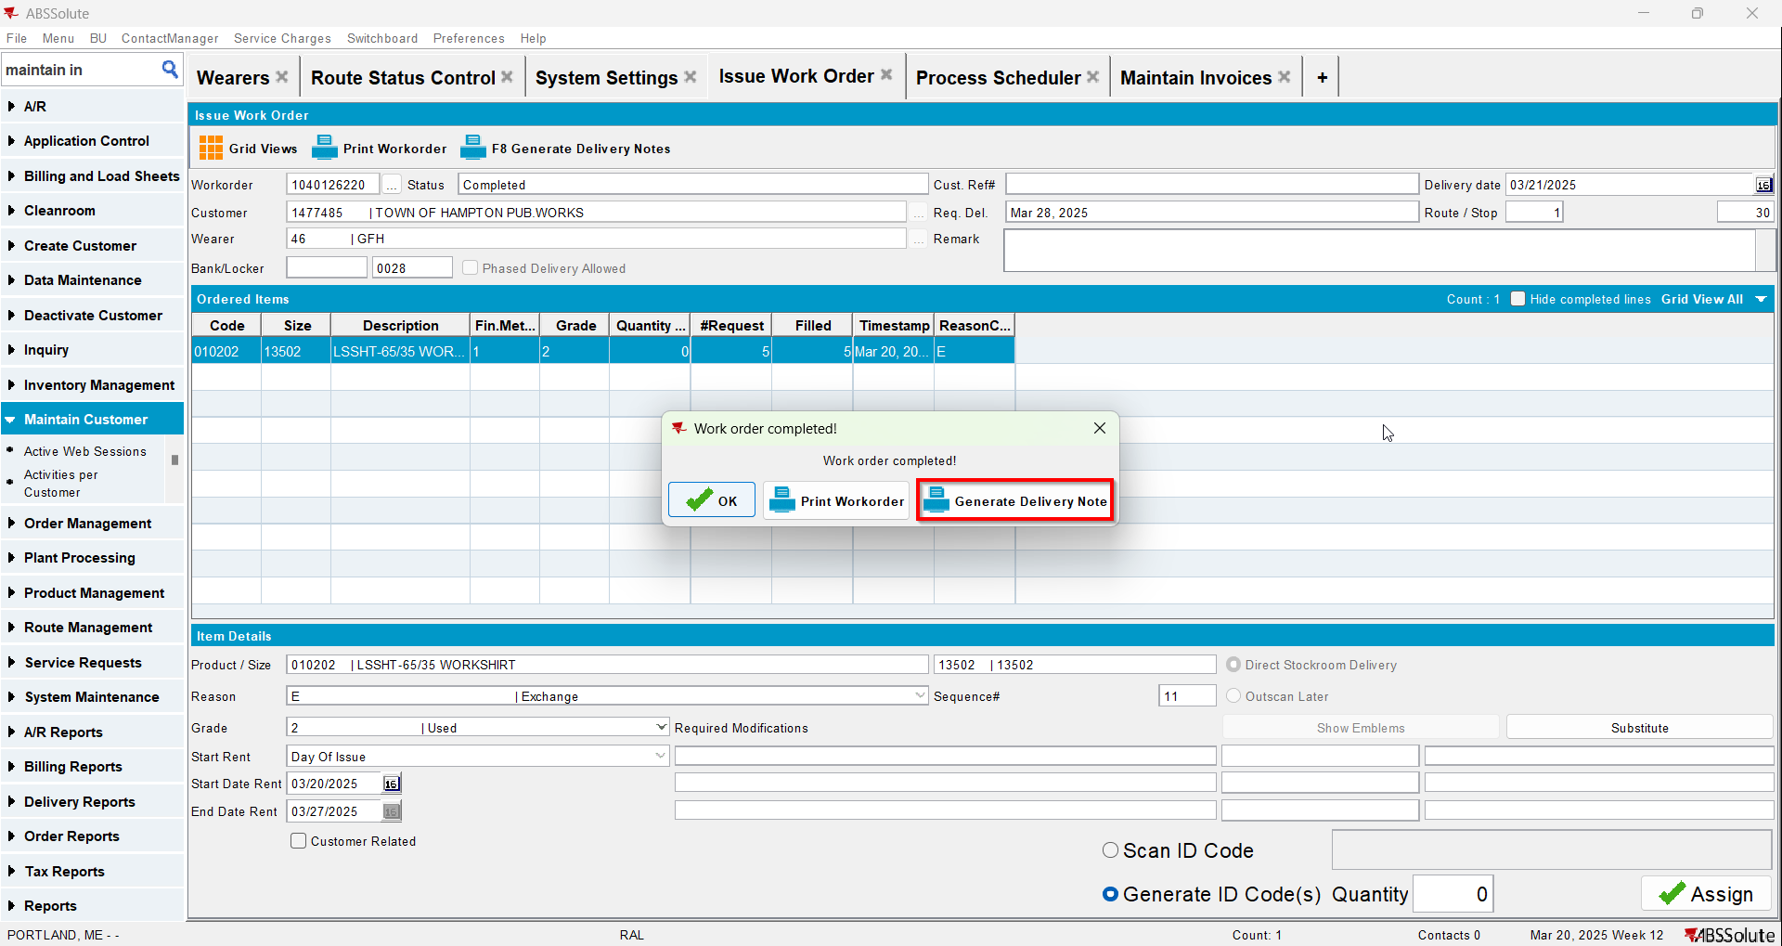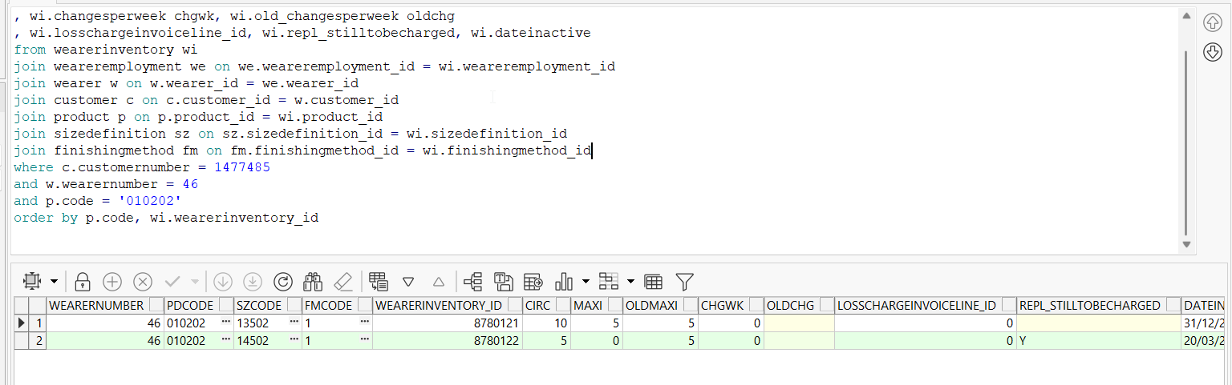
- Generate invoices for next route and check the state of the product(REPL_STILLTOBECHARGED should be N for the second size and Null for the initial size)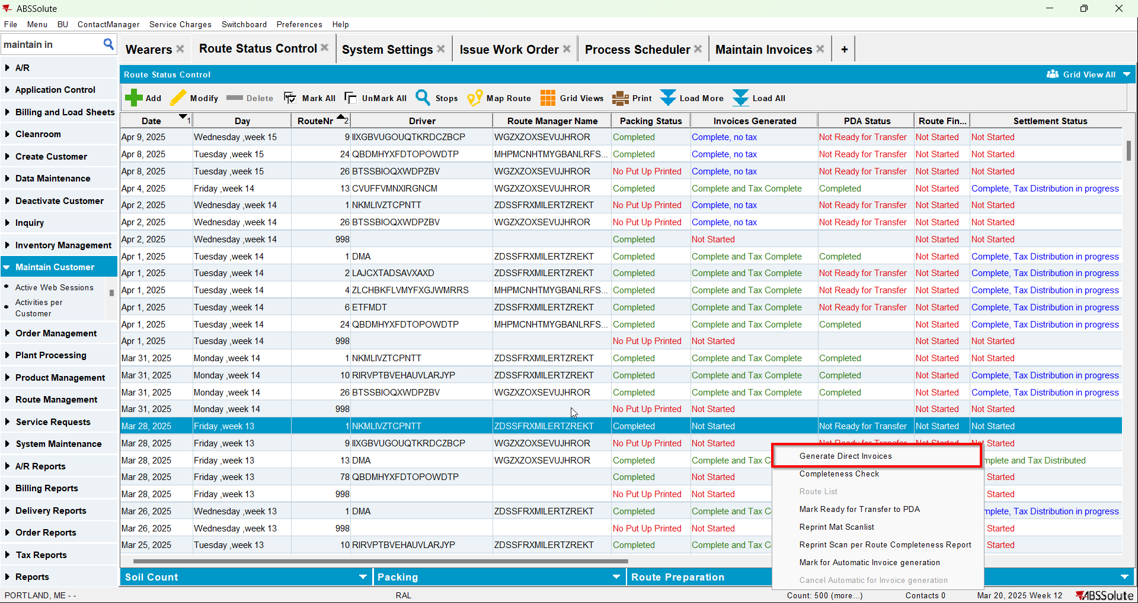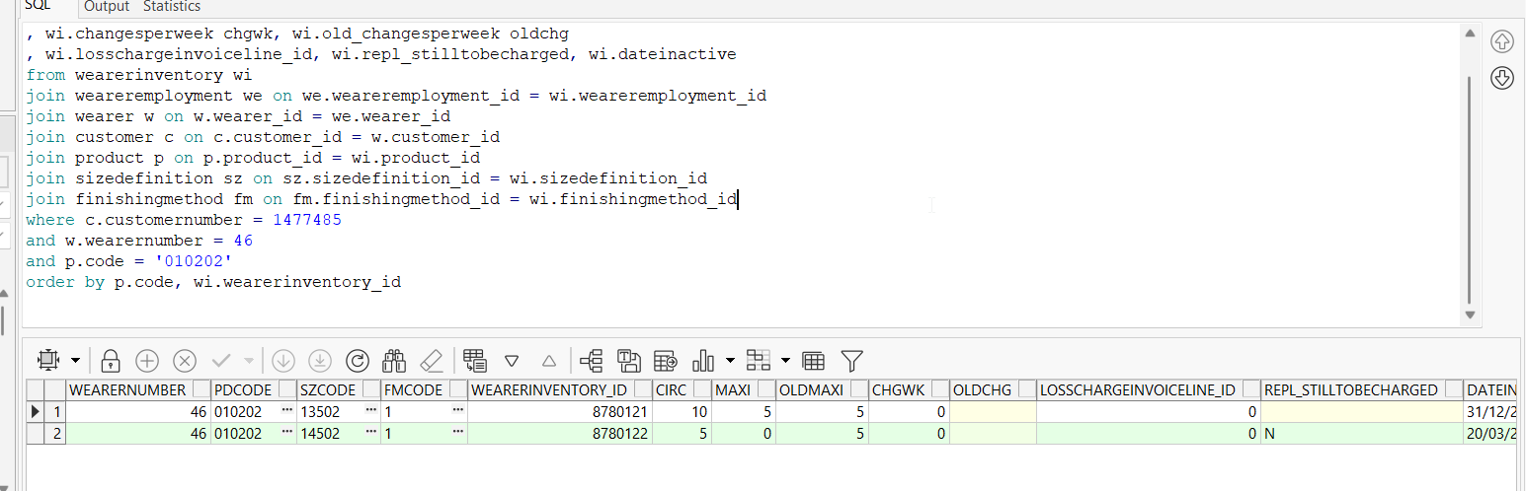
- Check the invoice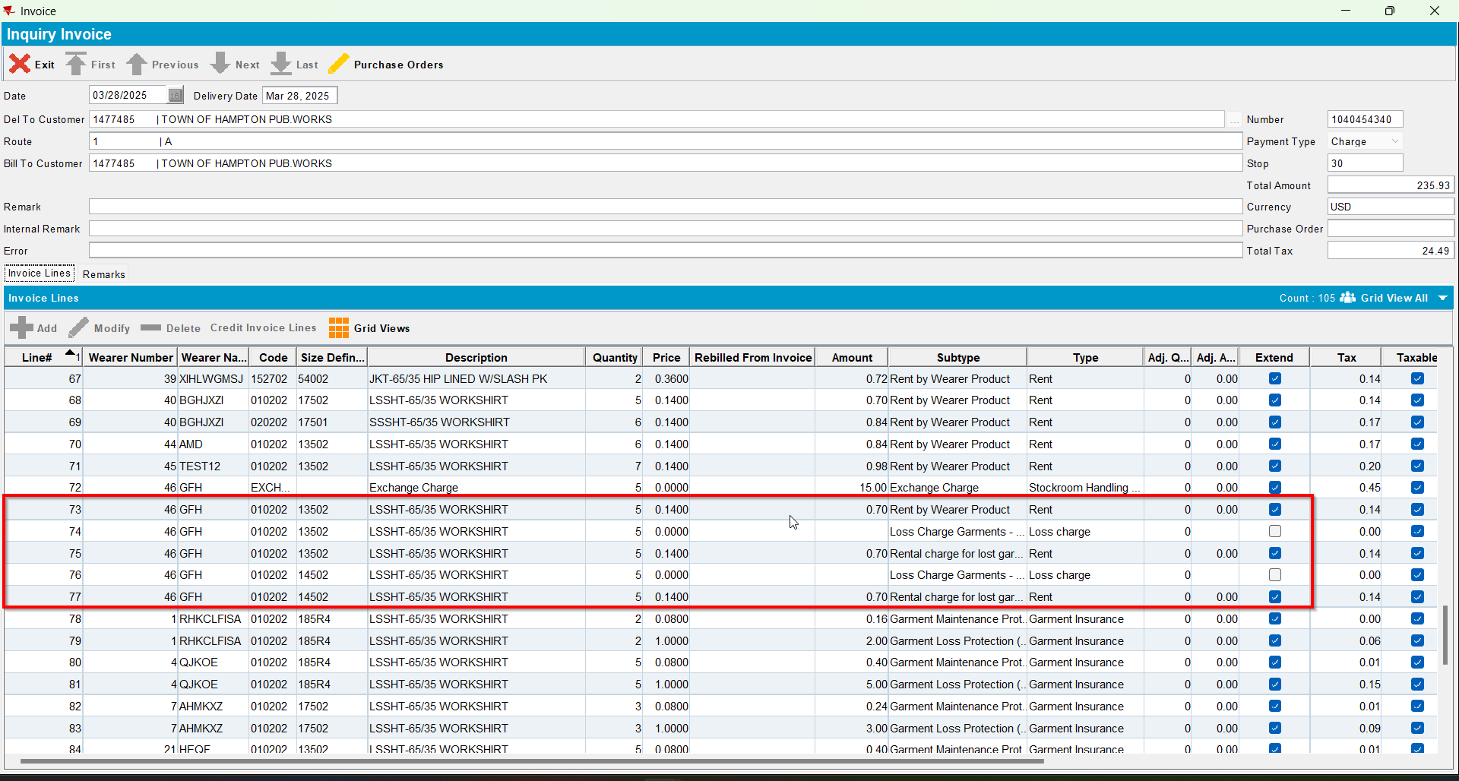
- Settle the route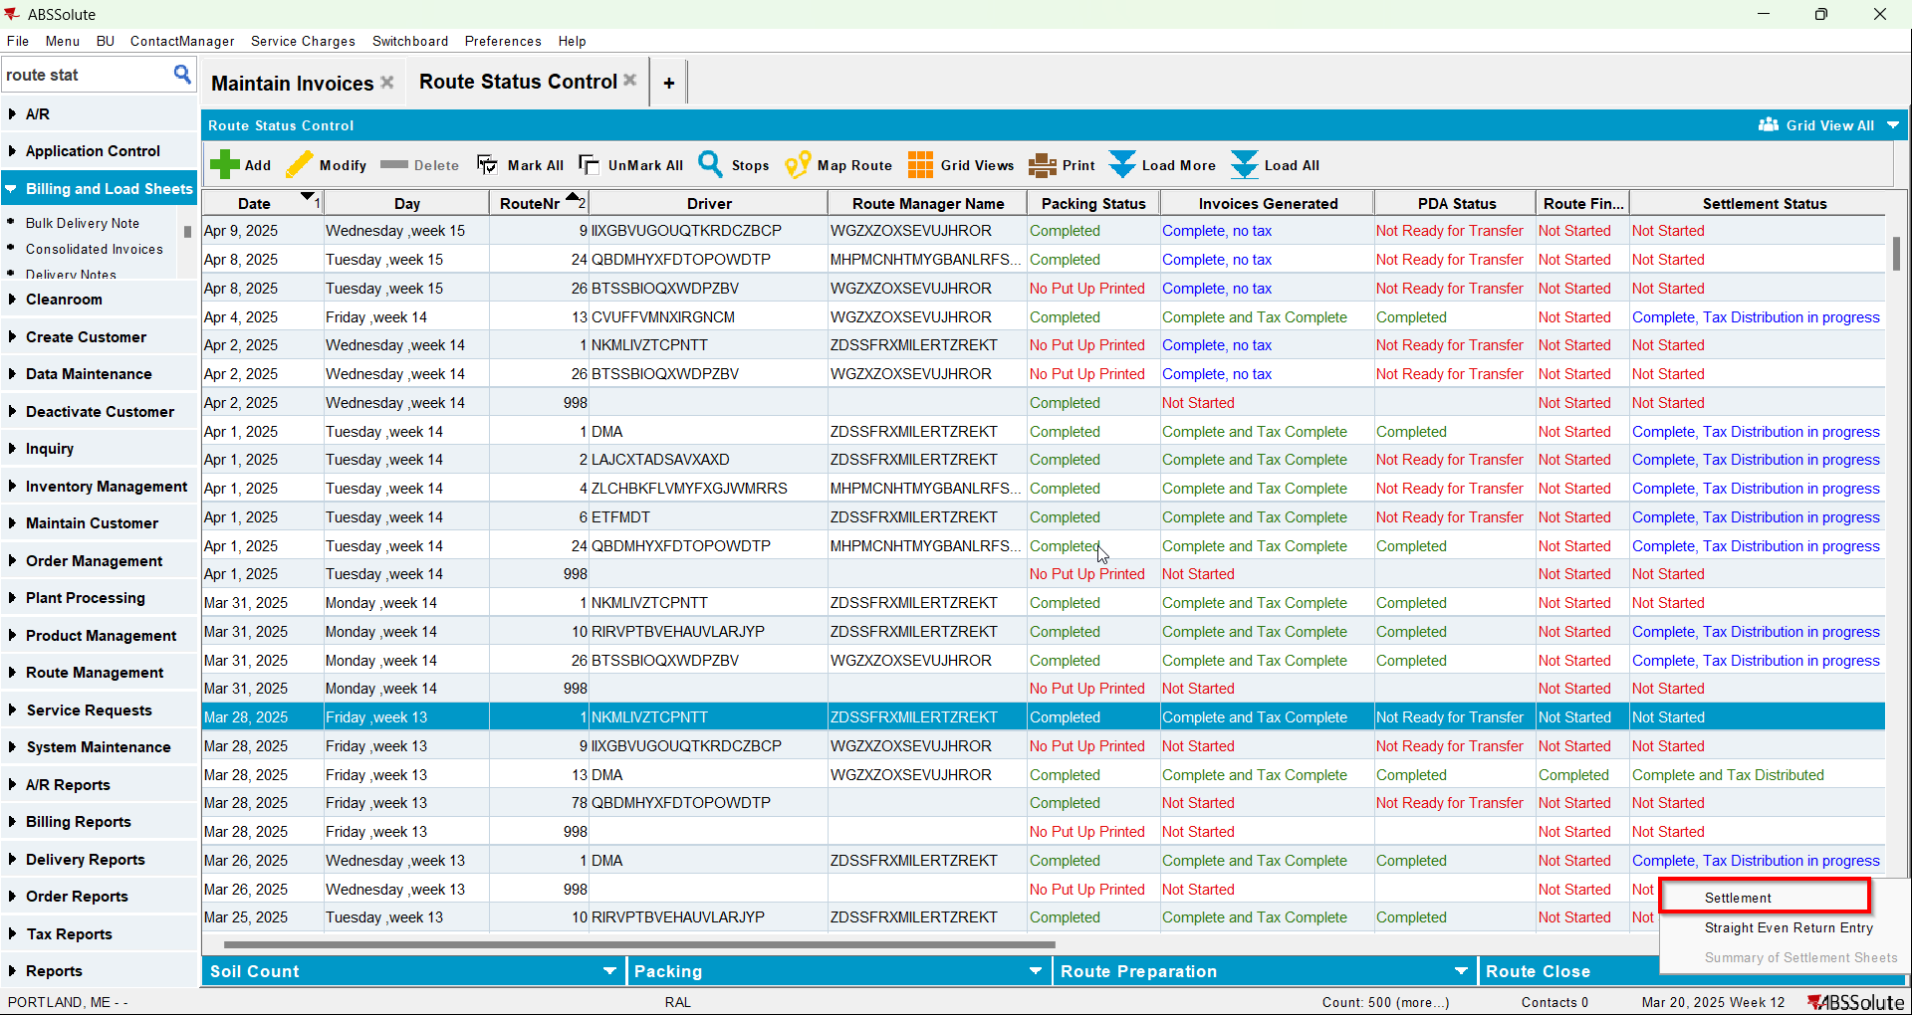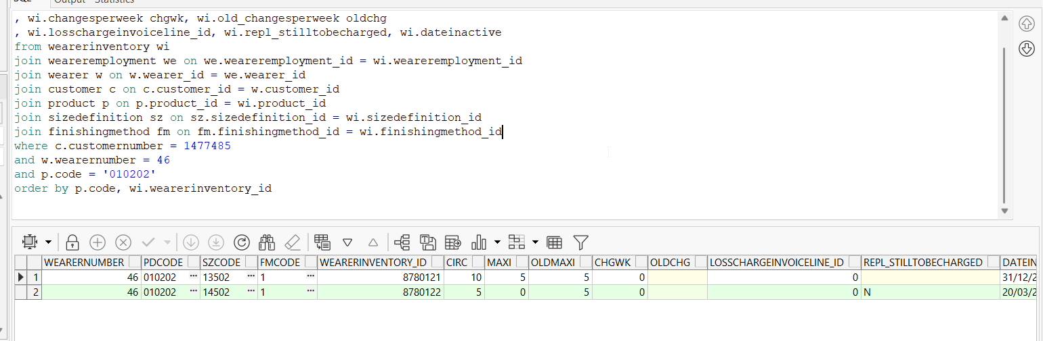
- Generate invoices for the next route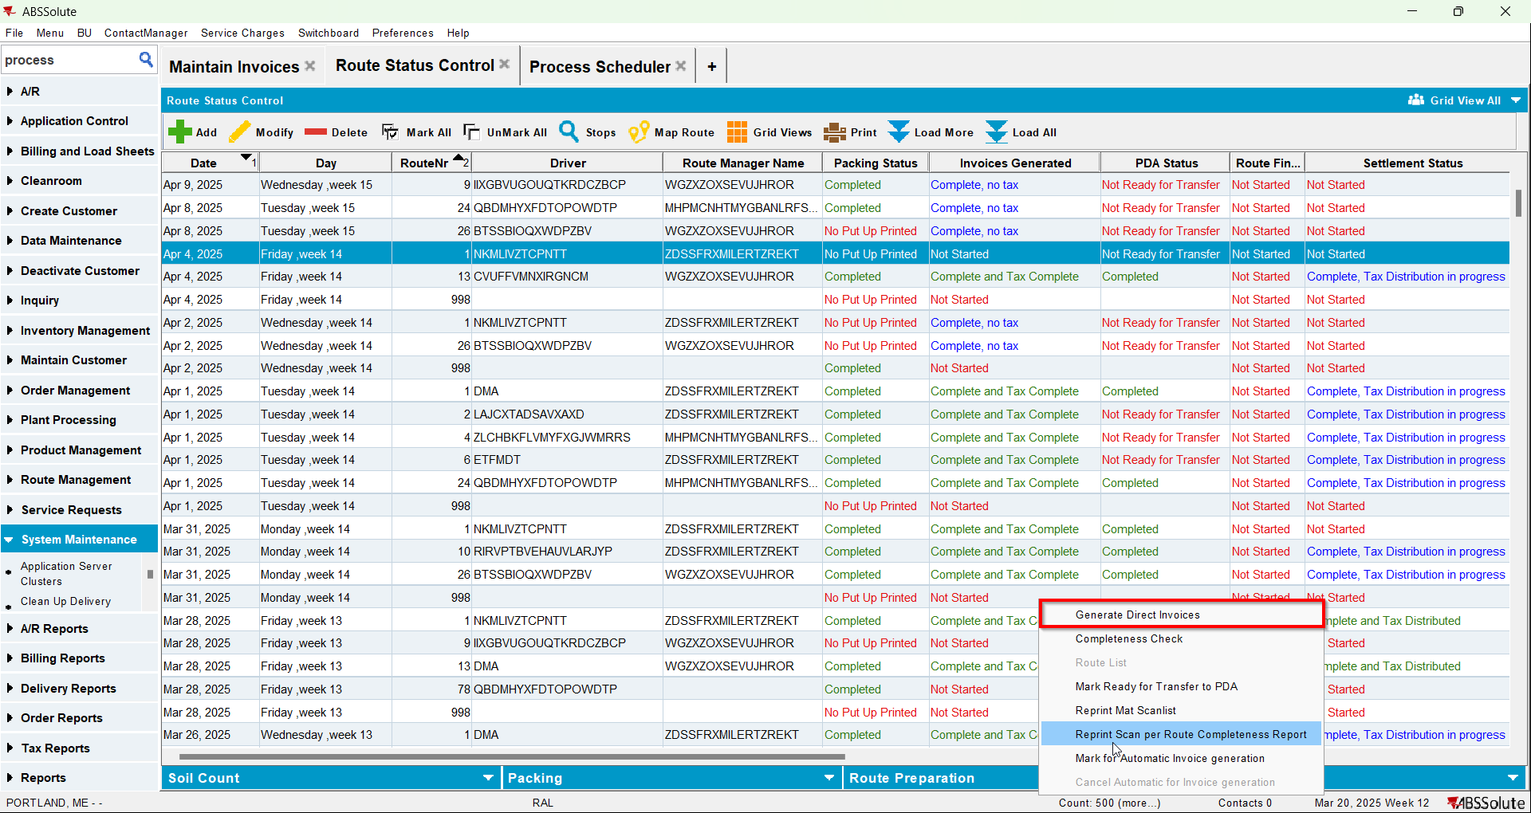
- Check the invoice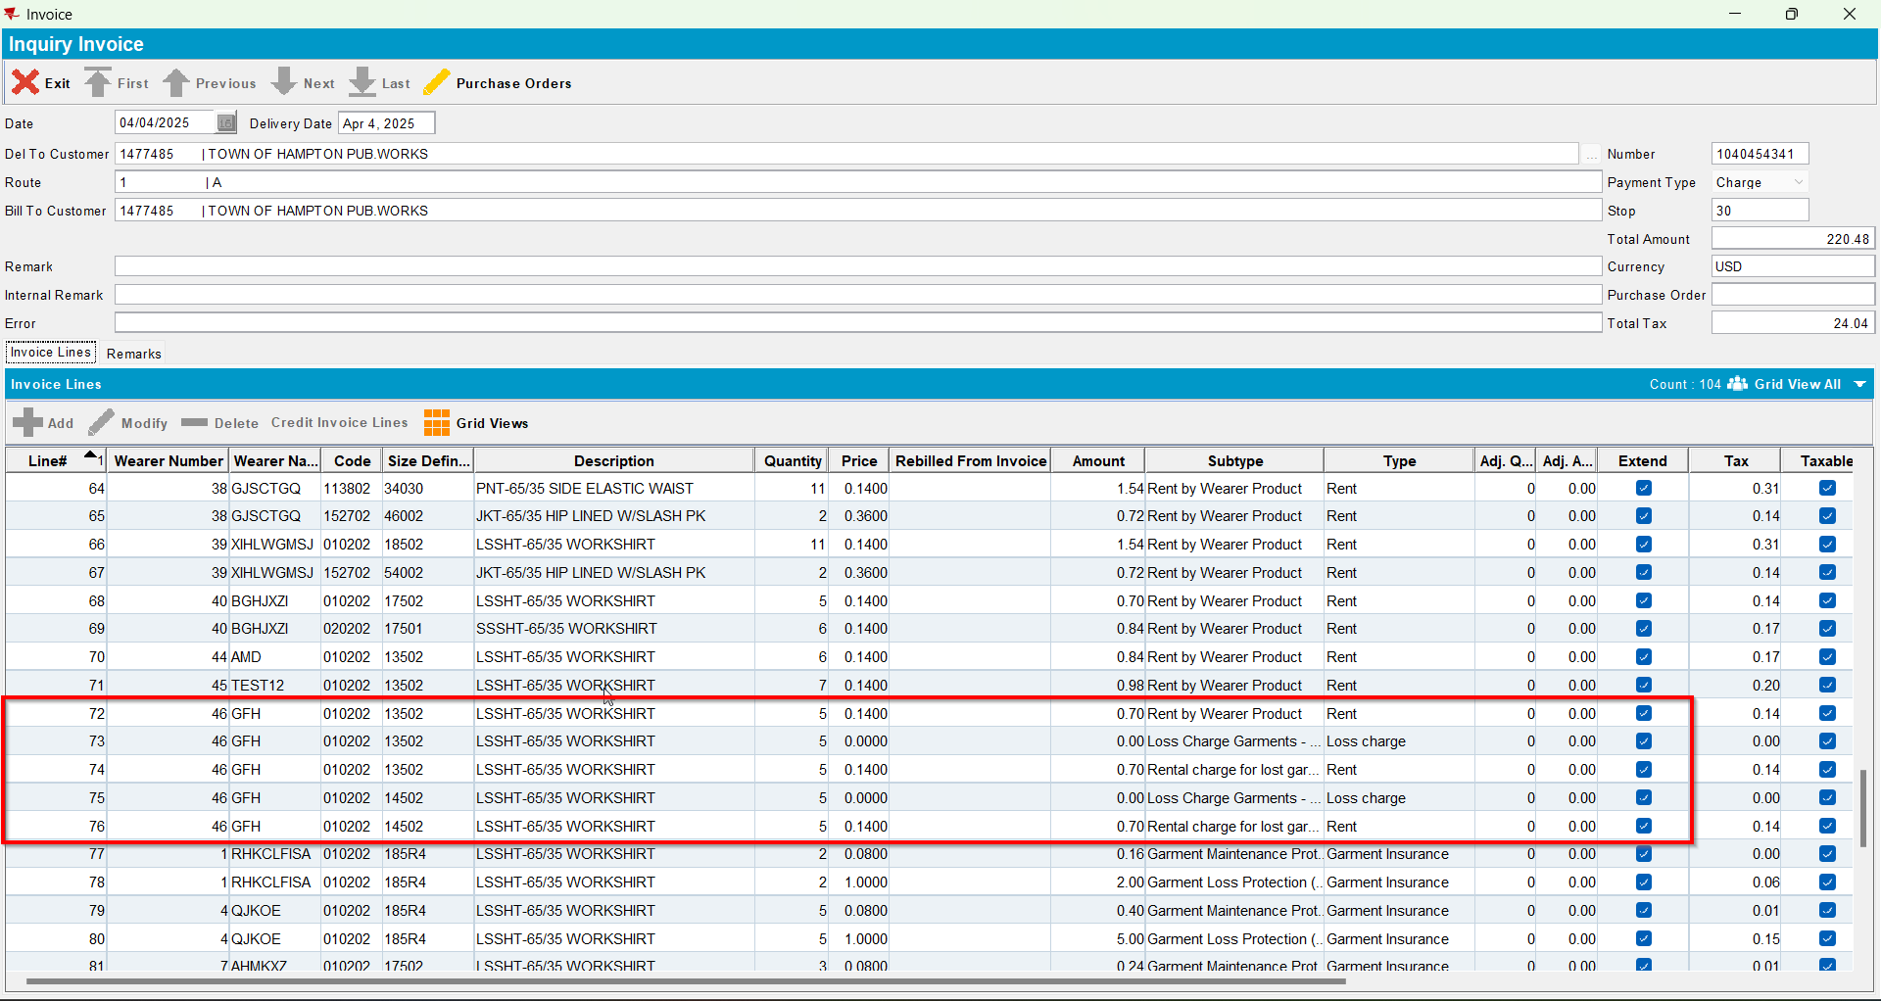
- Generate invoices for the next route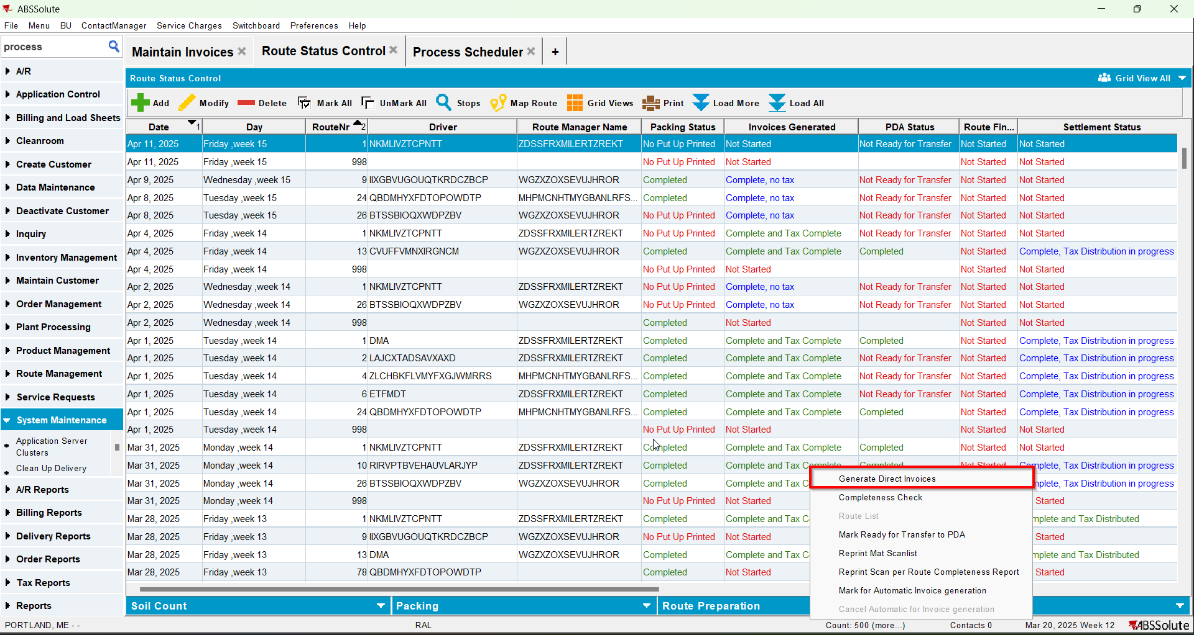
- Check the invoice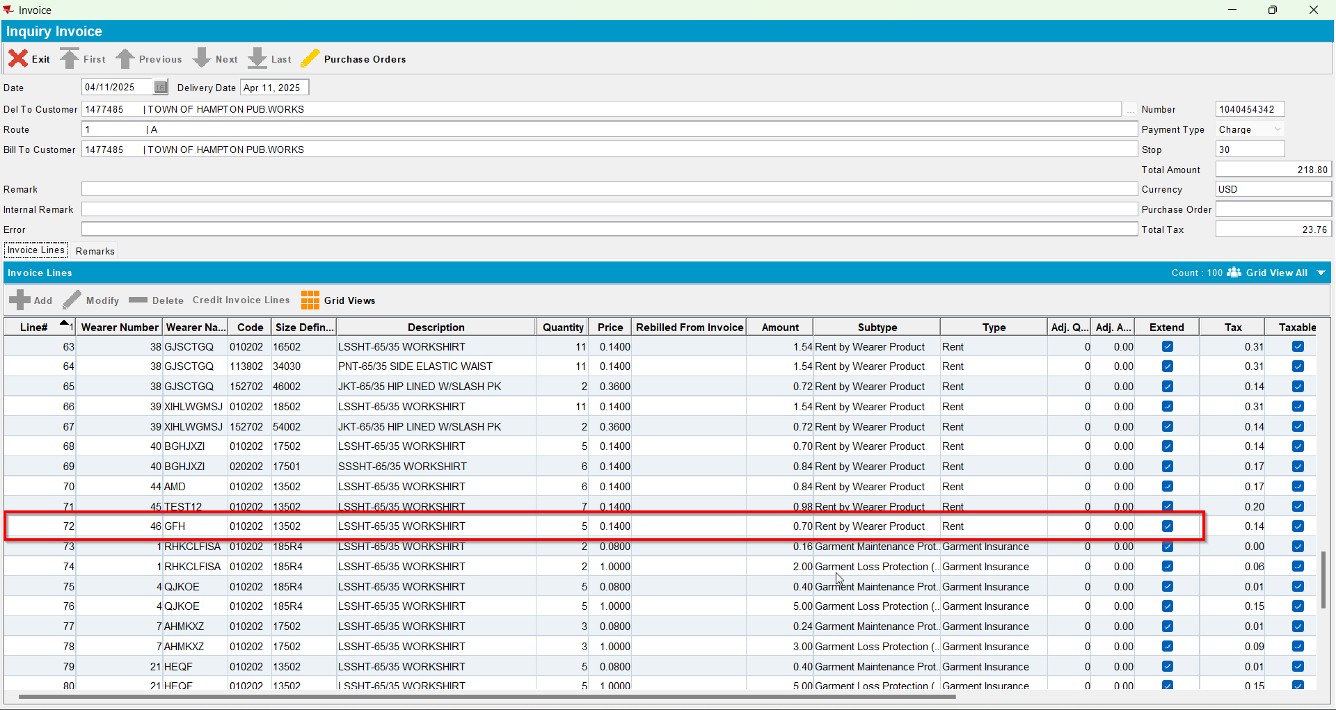

Test Case 2 – WI A full replacement by B & WI B full replacement by A, all non-unique items – Replacements done on Client – Tested OK
Expected behavior: When generating the second replacement workorder we should change REPL_STILLTOBECHARGED to NULL.
Hash: 529d0c2
- Have SS CHARGEREPLACEDPRODUCT set on Y
- Have a wearer inventory with non-unique items only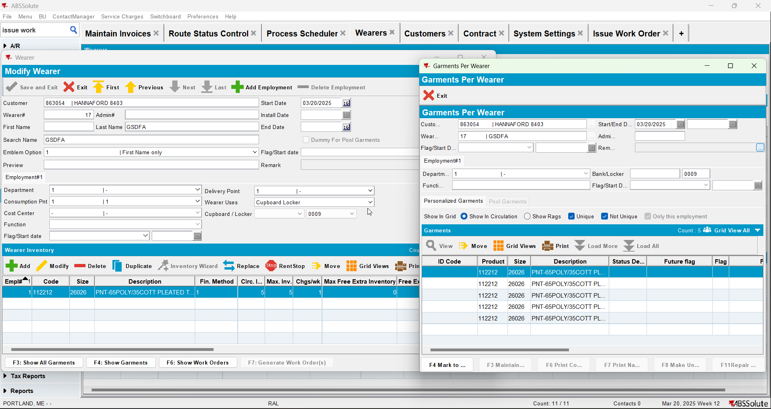
- Check the state of the product using the below sql
select w.wearernumber, p.code pdcode, SZ.code szcode, fm.code fmcode
, wi.wearerinventory_id, wi.circinventory circ
, wi.maxinventory maxi, wi.old_maxinventory oldmaxi
, wi.changesperweek chgwk, wi.old_changesperweek oldchg
, wi.losschargeinvoiceline_id, wi.repl_stilltobecharged, wi.dateinactive
from wearerinventory wi
join weareremployment we on we.weareremployment_id = wi.weareremployment_id
join wearer w on w.wearer_id = we.wearer_id
join customer c on c.customer_id = w.customer_id
join product p on p.product_id = wi.product_id
join sizedefinition sz on sz.sizedefinition_id = wi.sizedefinition_id
join finishingmethod fm on fm.finishingmethod_id = wi.finishingmethod_id
where c.customernumber =
and w.wearernumber =
and p.code = ''
order by p.code, wi.wearerinventory_id
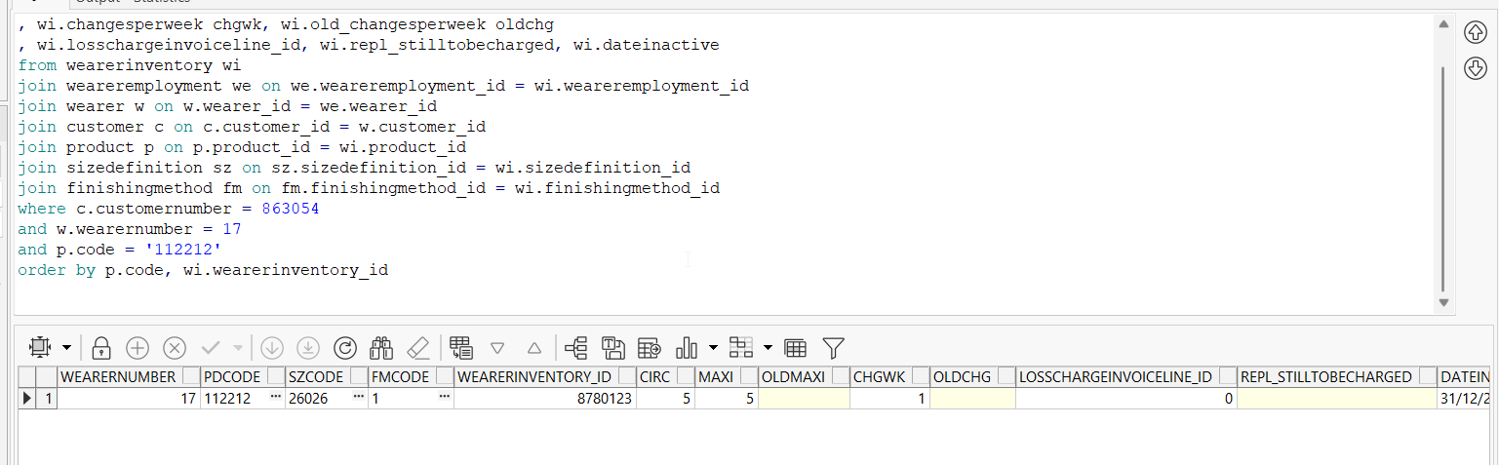

- Replace the wearer inventory changing only its size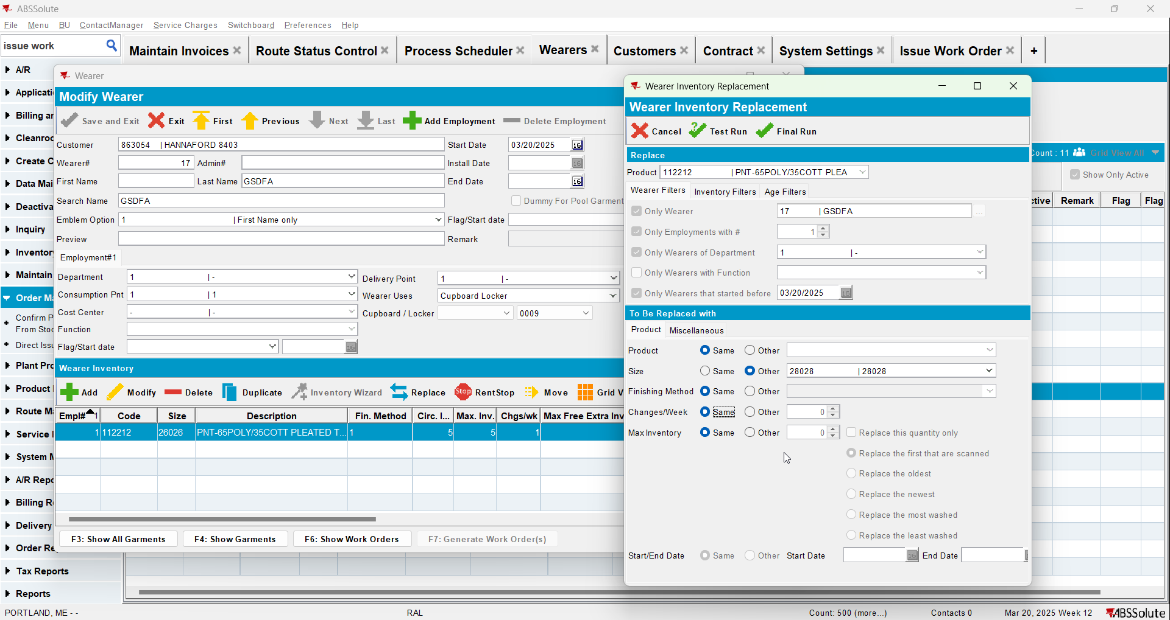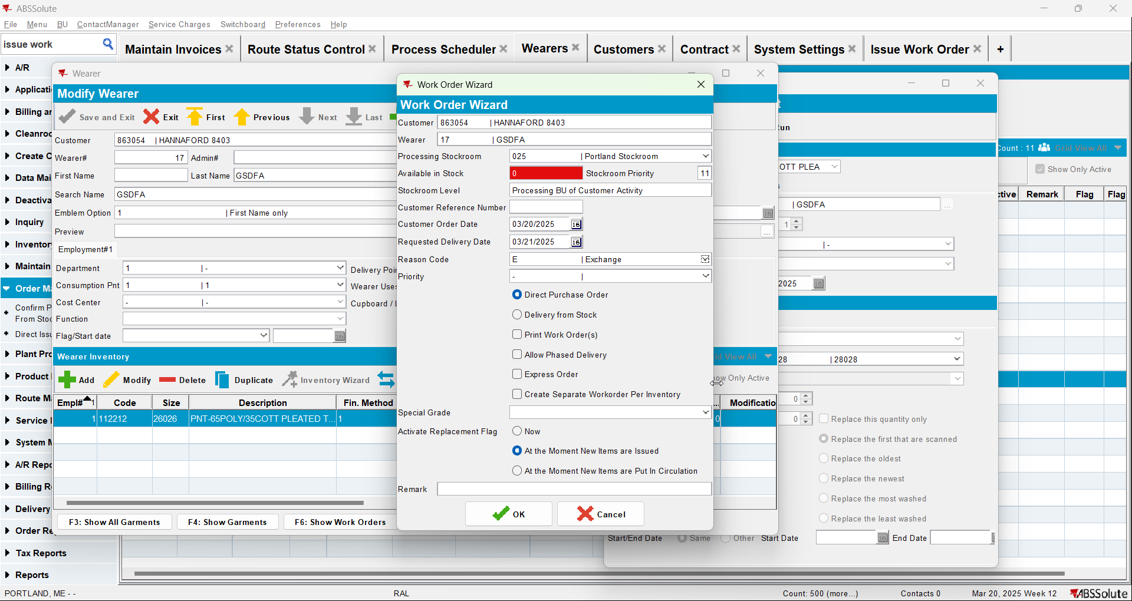
- Check the state of the product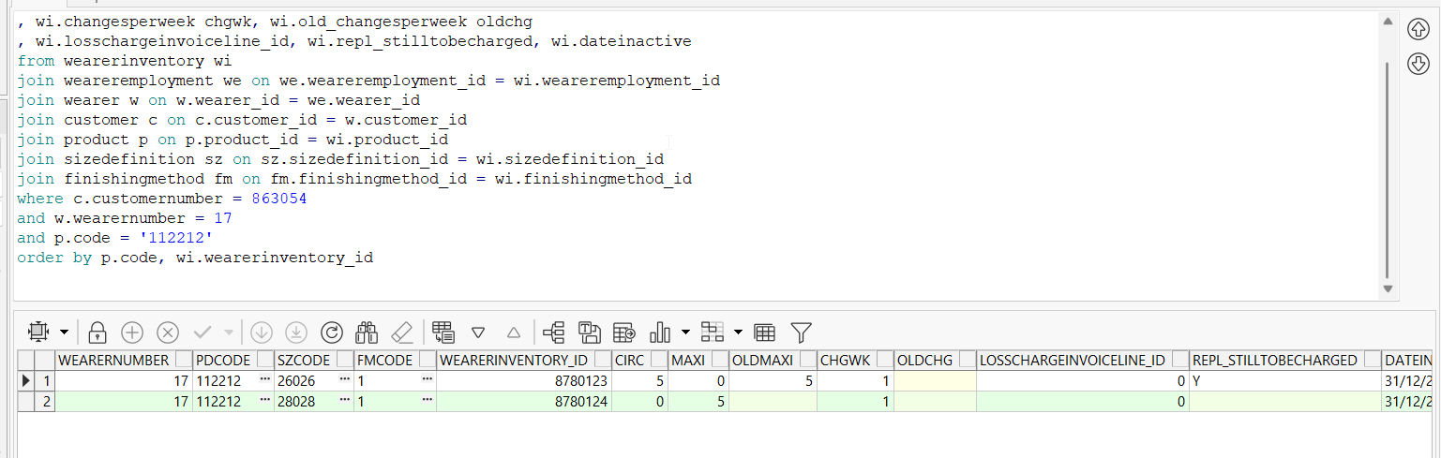
- Issue the items 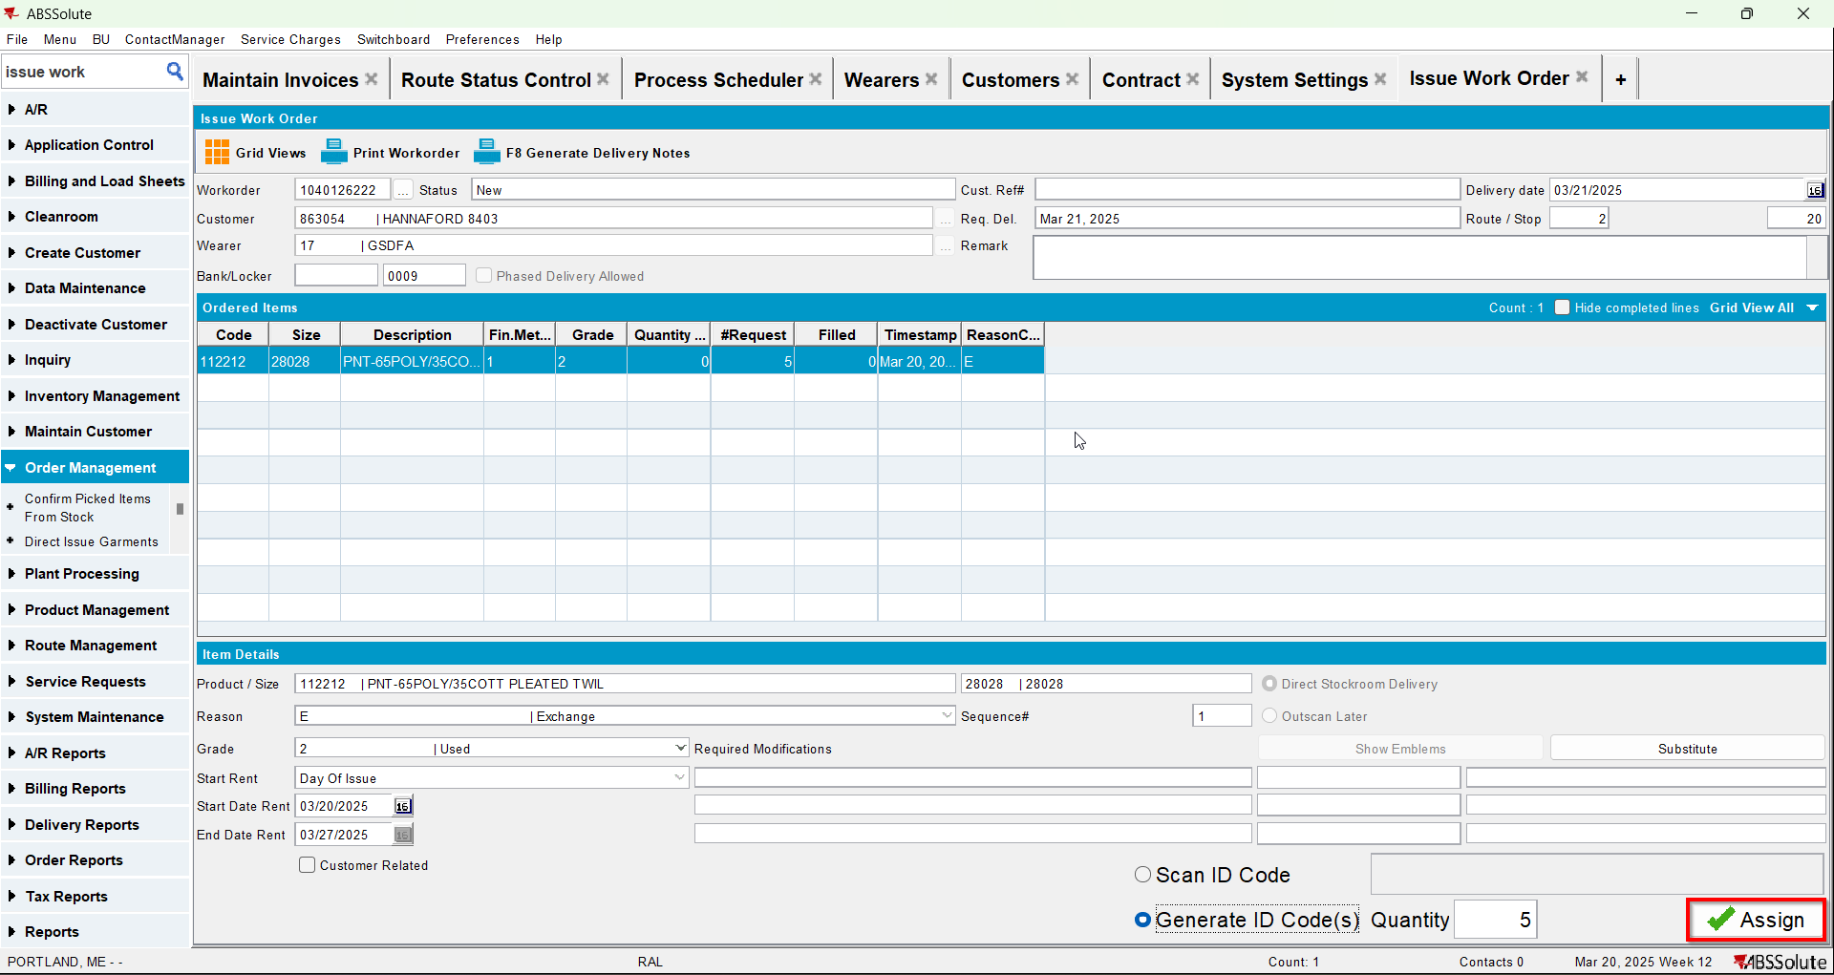
- Check the state of the product(REPL_STILLTOBECHARGED should be null for the second size and Y for the initial size)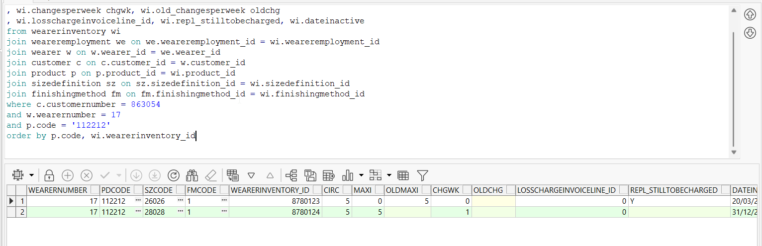
- Generate invoices and check the state of the product(REPL_STILLTOBECHARGED should be null for the second size and N for the initial size)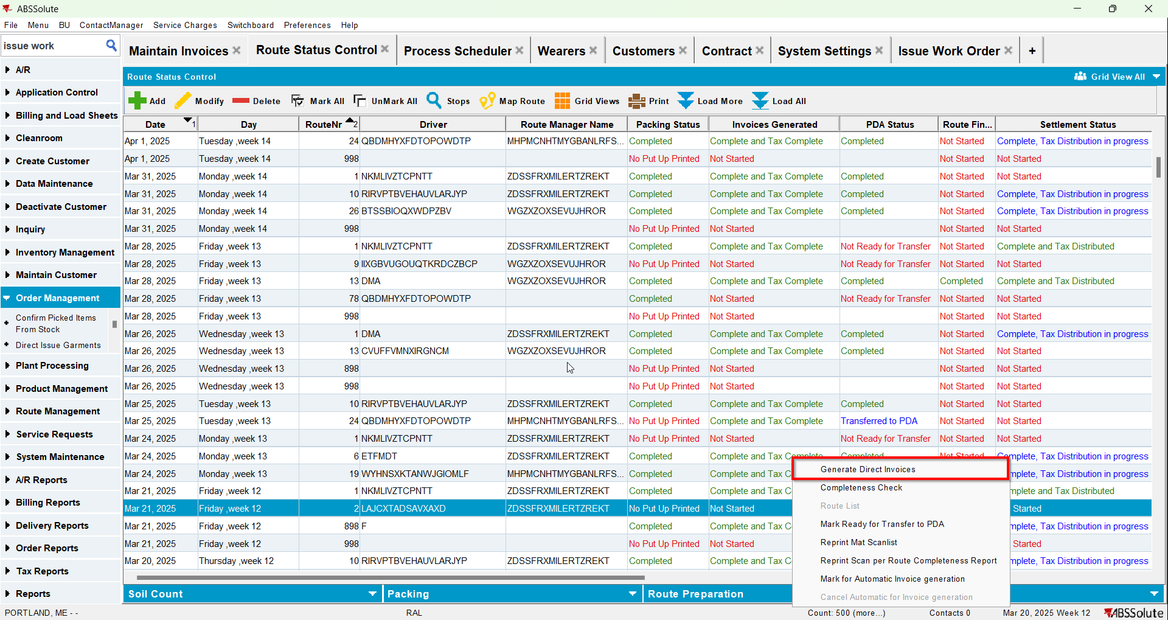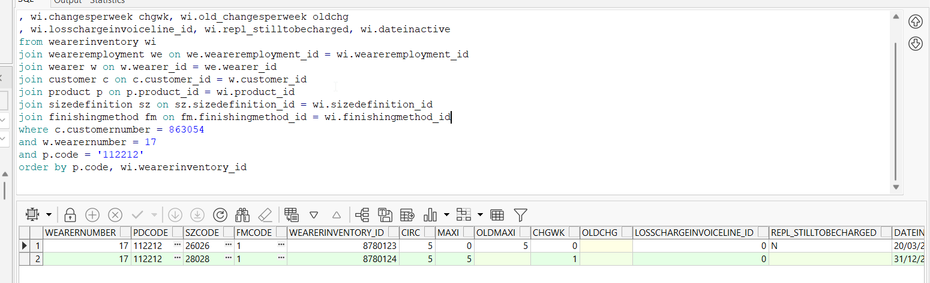
- Settle the route and check the state of the product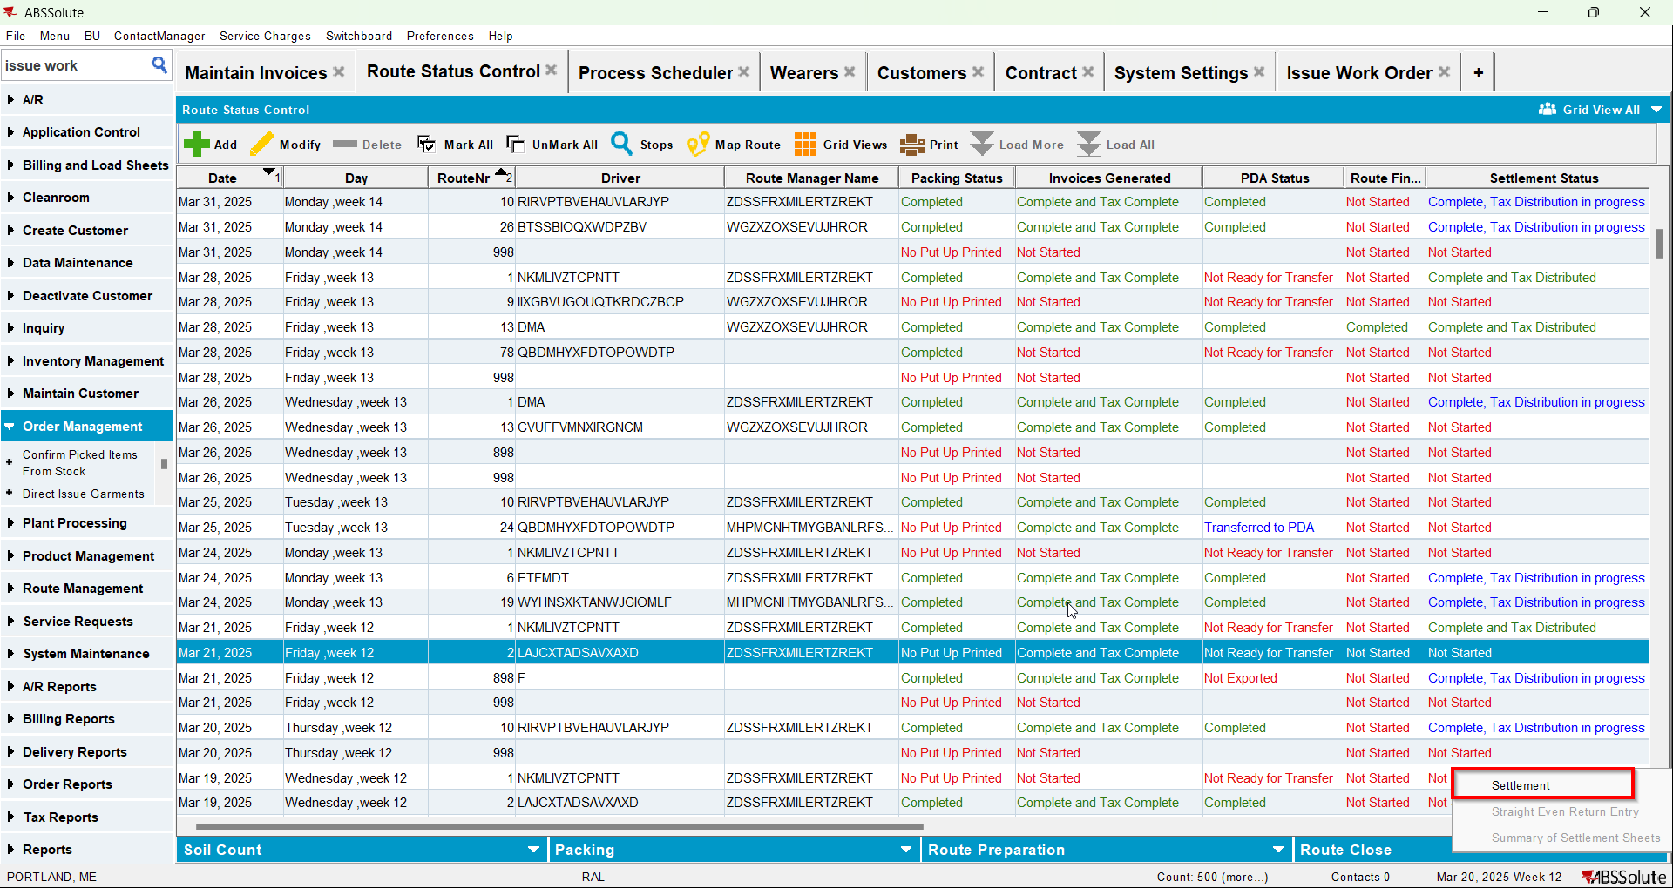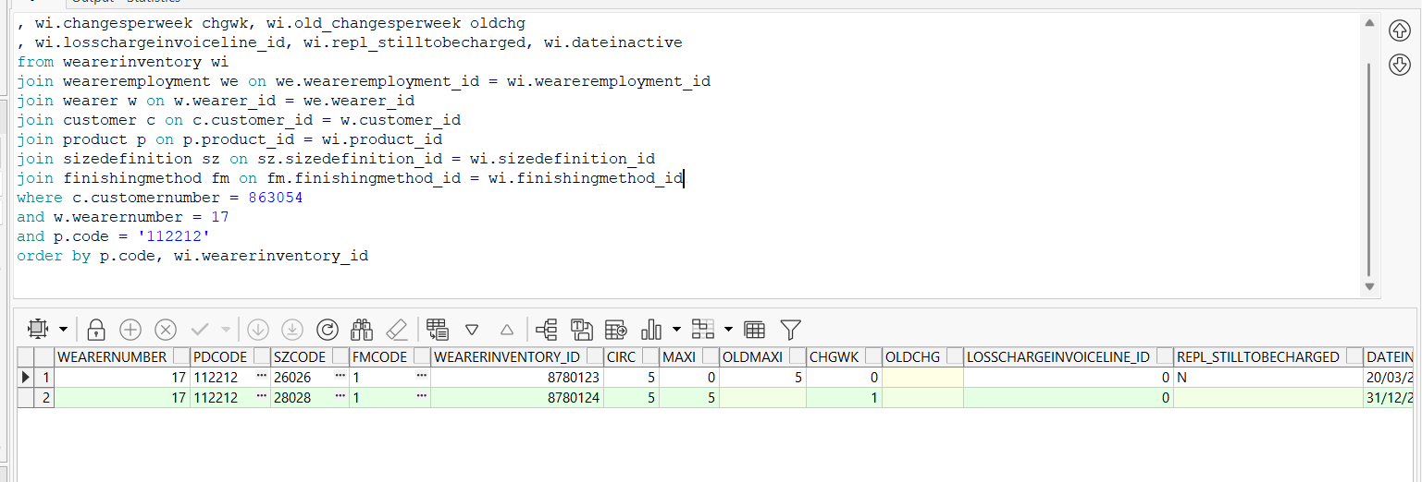
- Check the invoice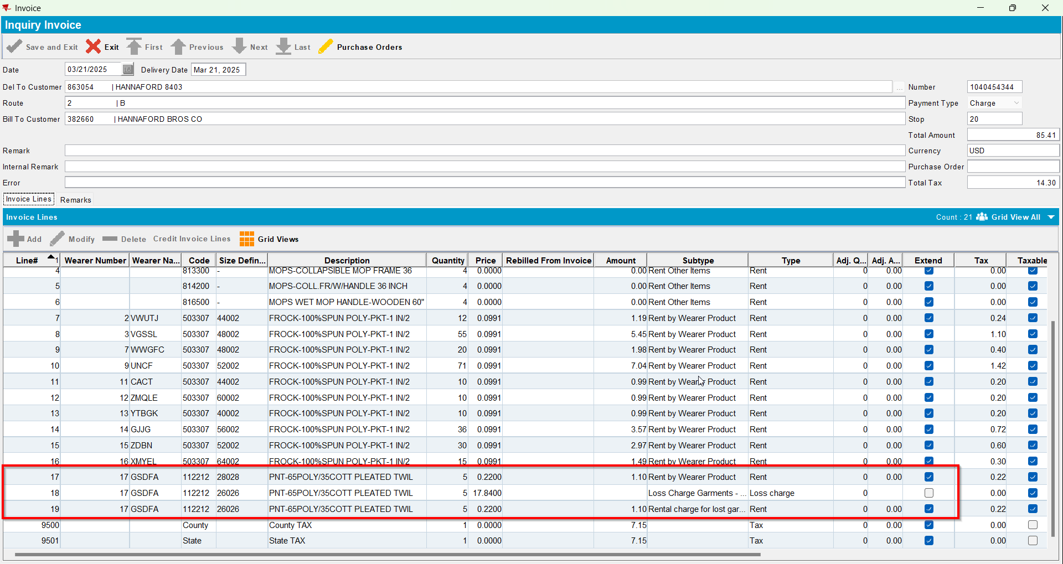
- Replace the new wearer inventory changing only its size back to its original size(REPL_STILLTOBECHARGED should be Y for the second size and Null for the initial size)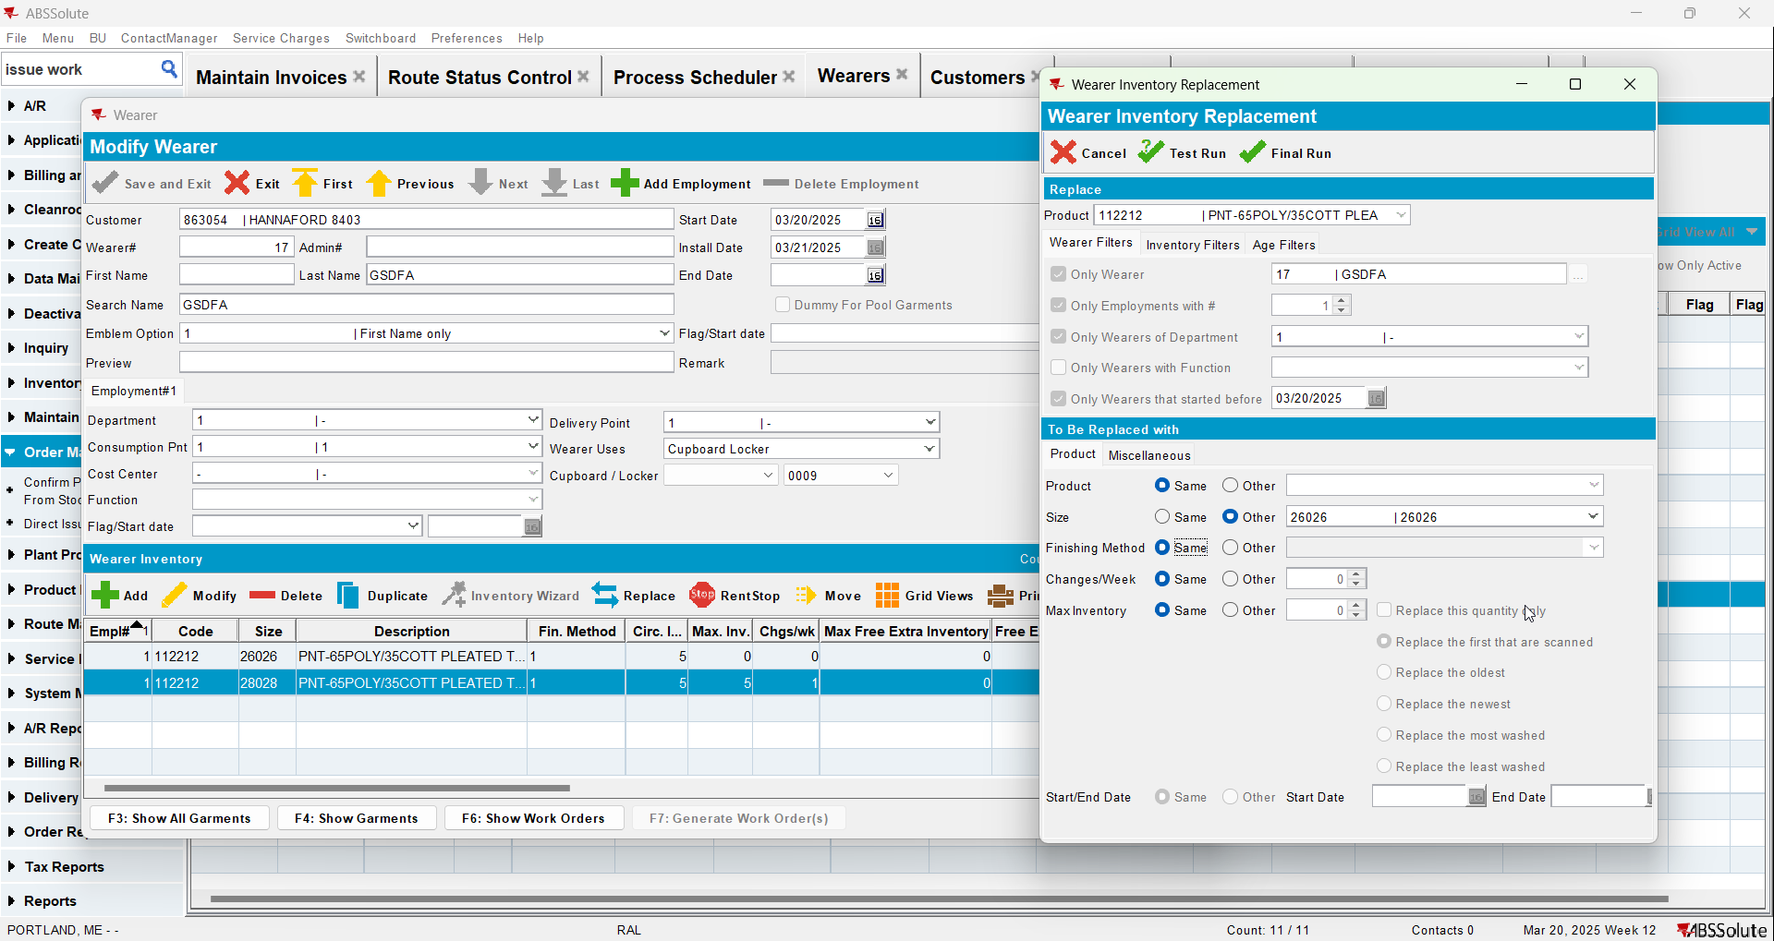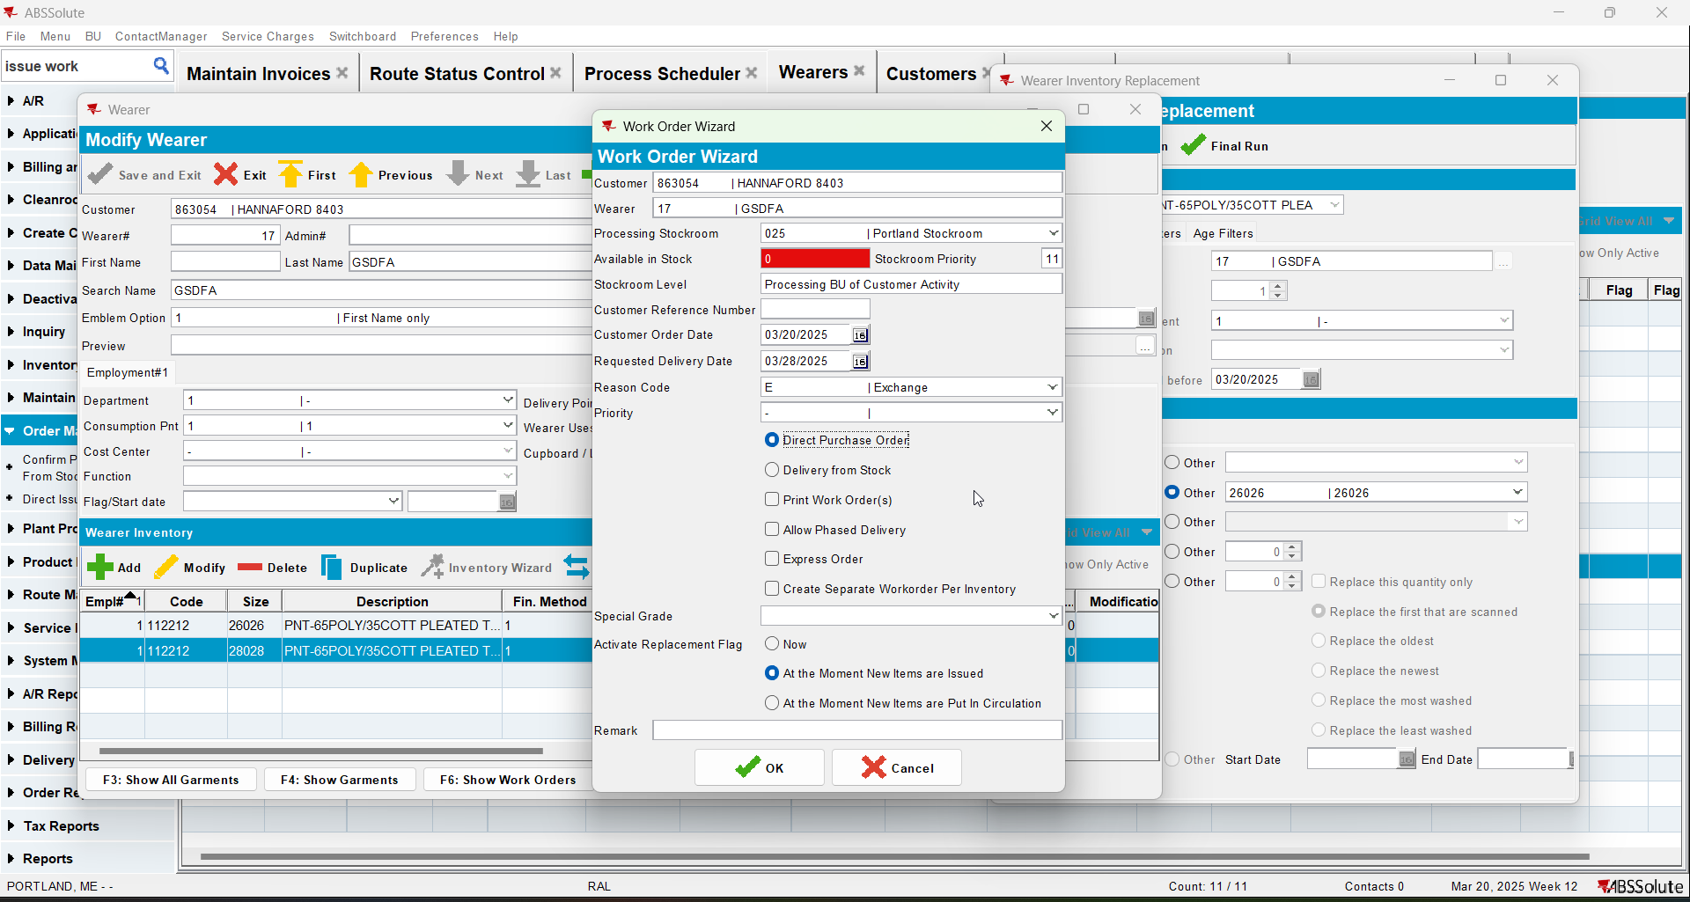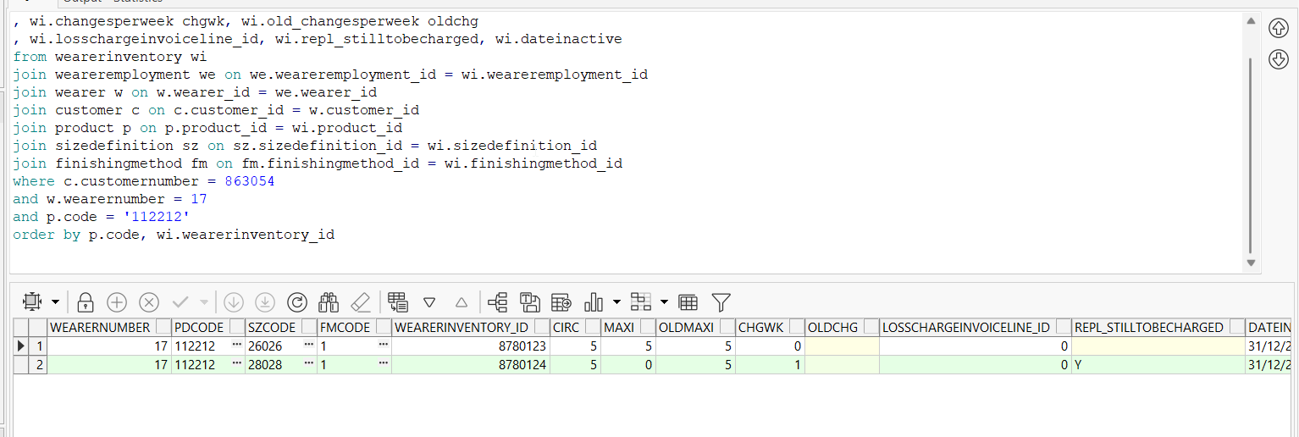
- Issue the items 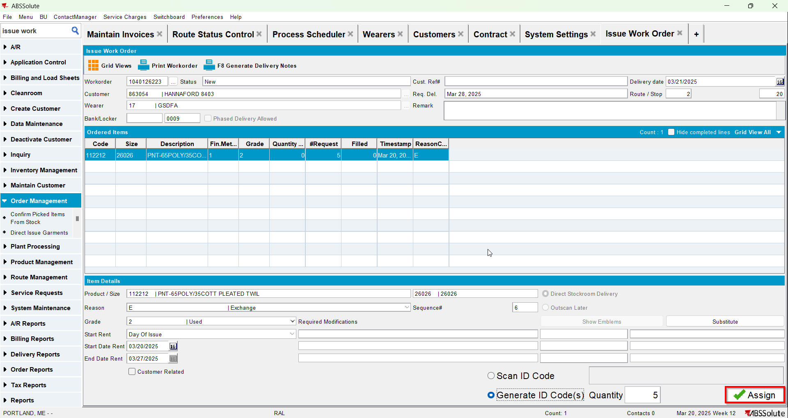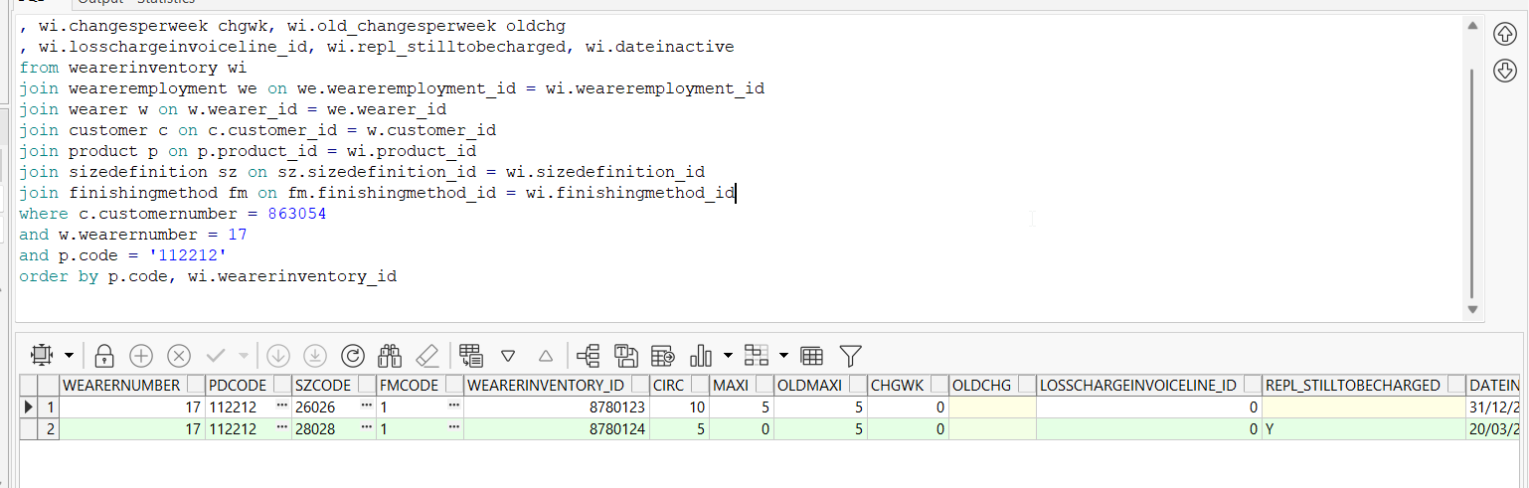
- Generate invoices for next route and check the state of the product(REPL_STILLTOBECHARGED should be N for the second size and Null for the initial size)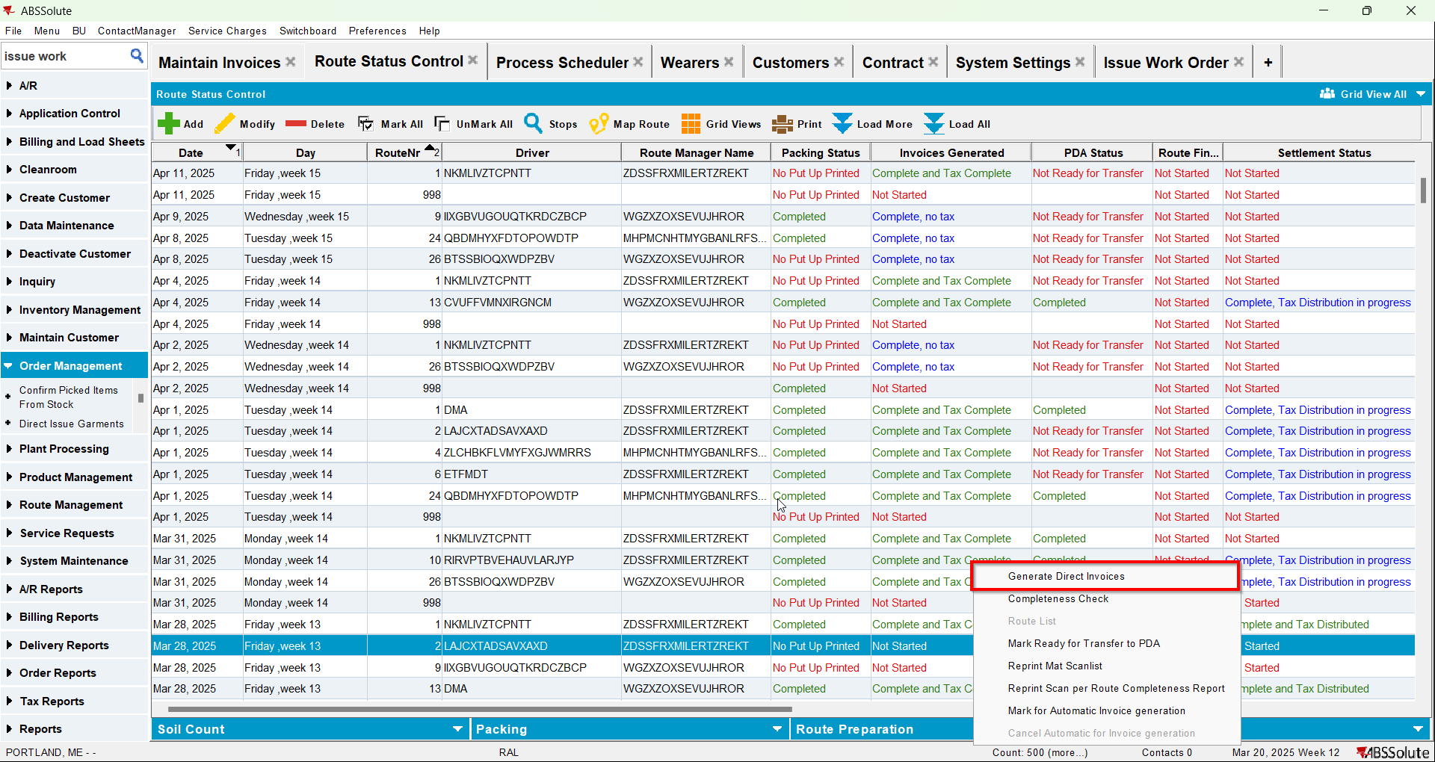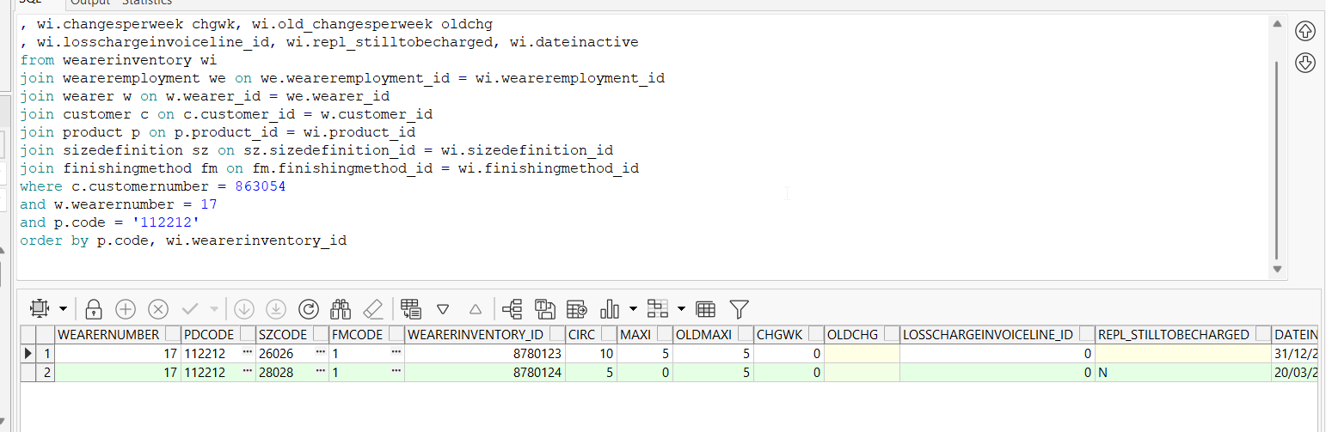
- Check the invoice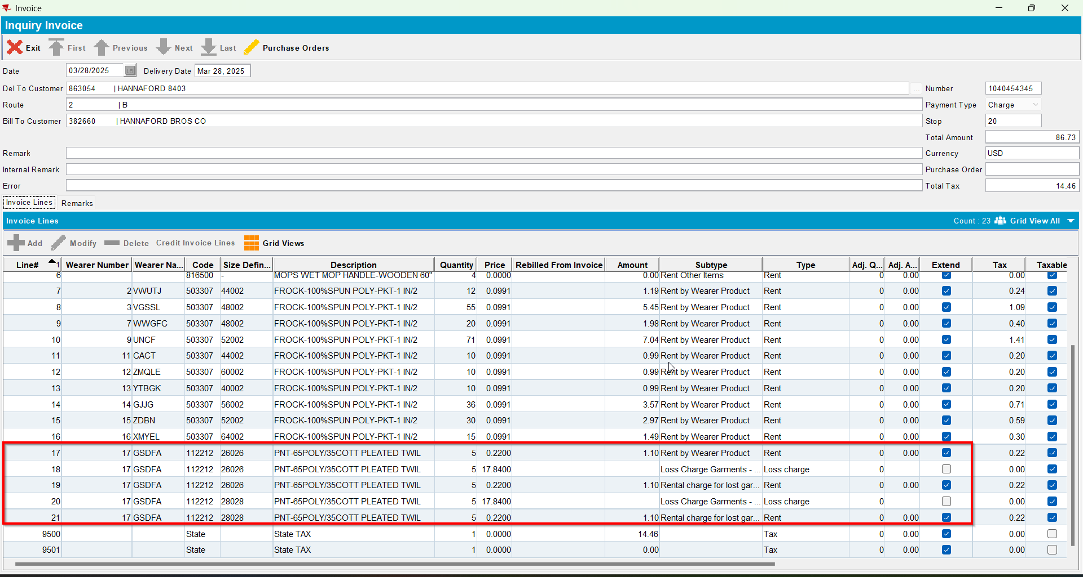
- Settle the route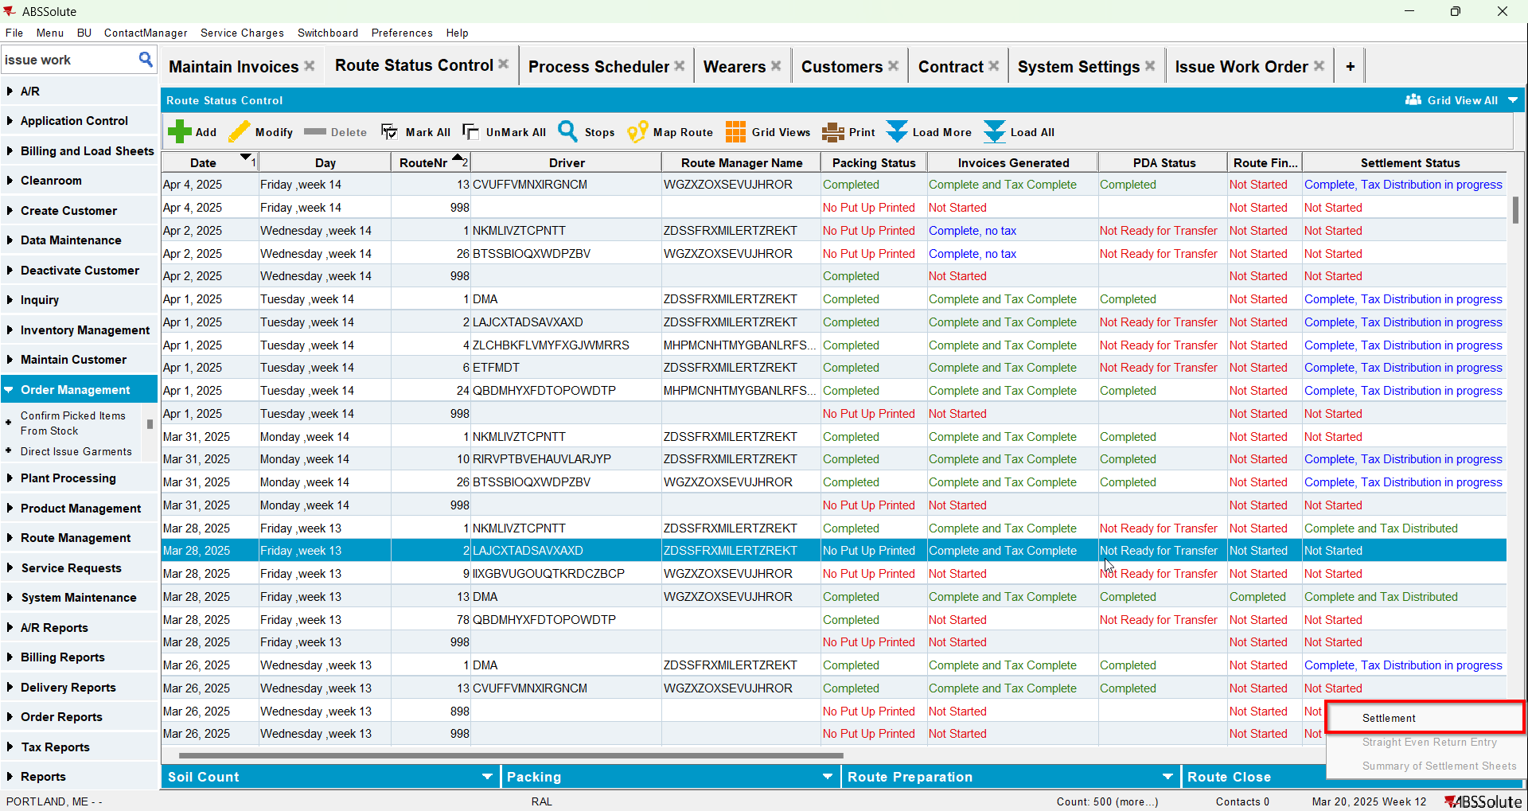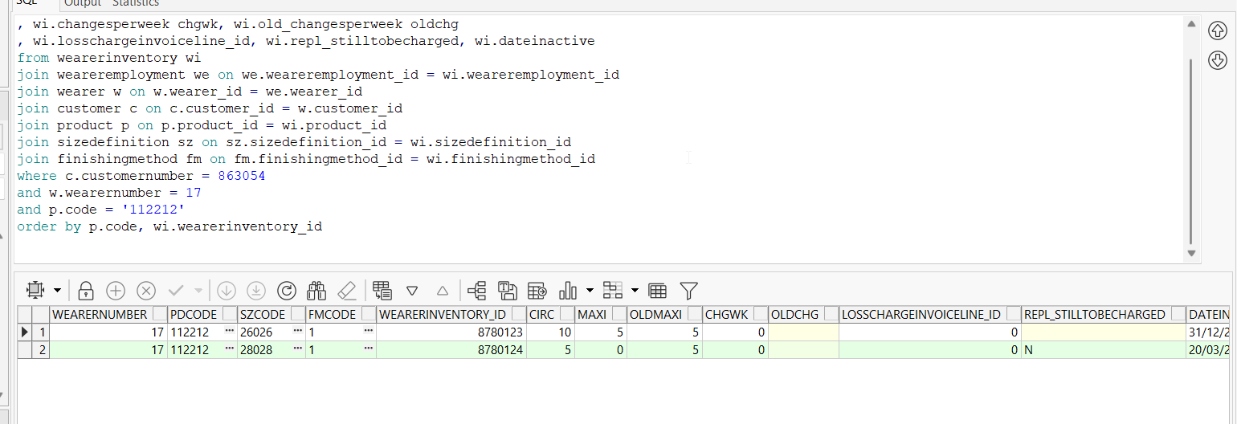
- Generate invoices for the next route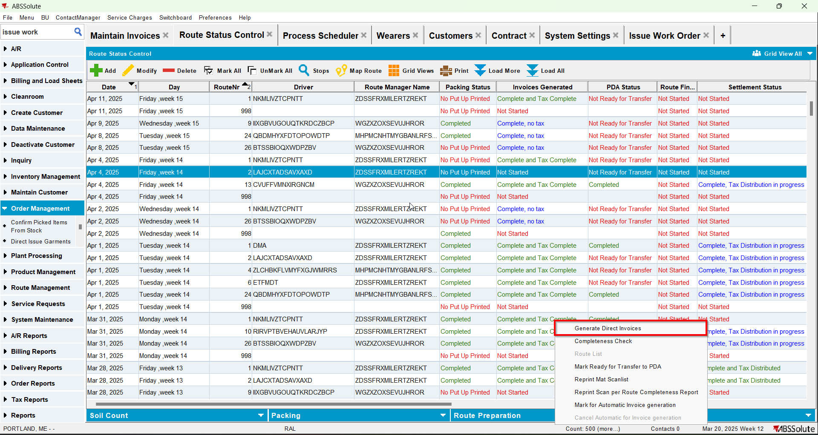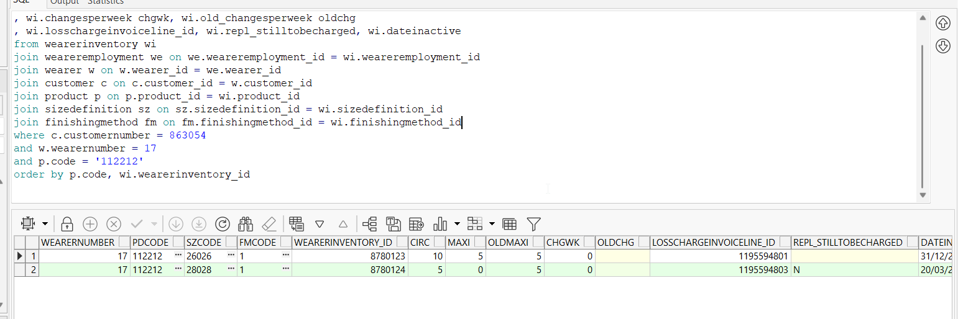
- Check the invoice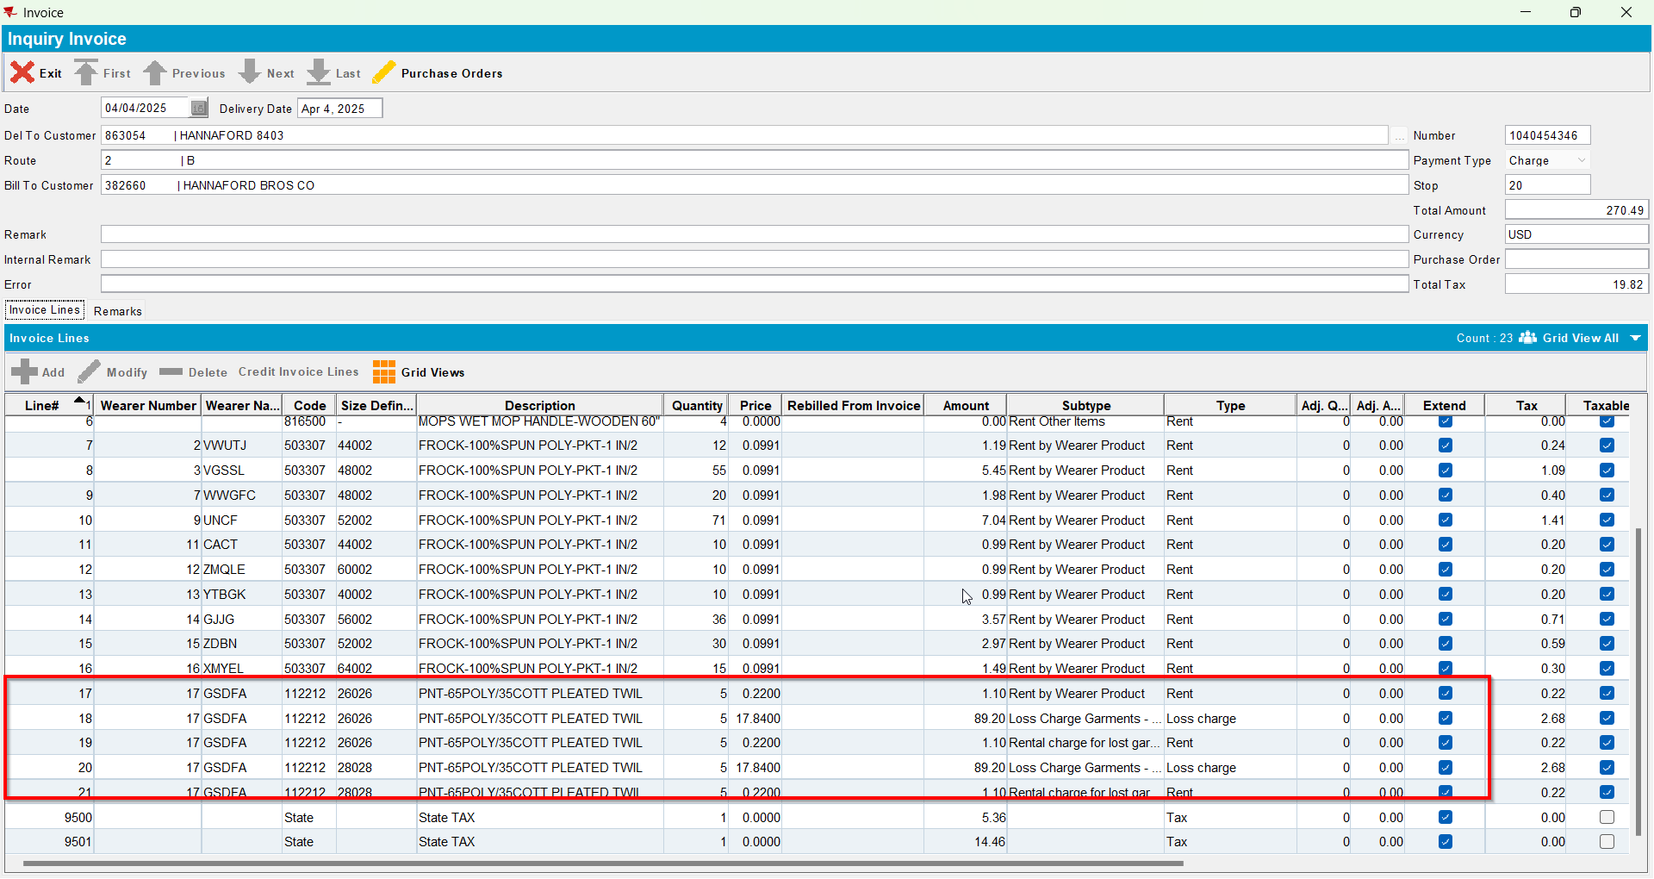
- Generate invoices for the next route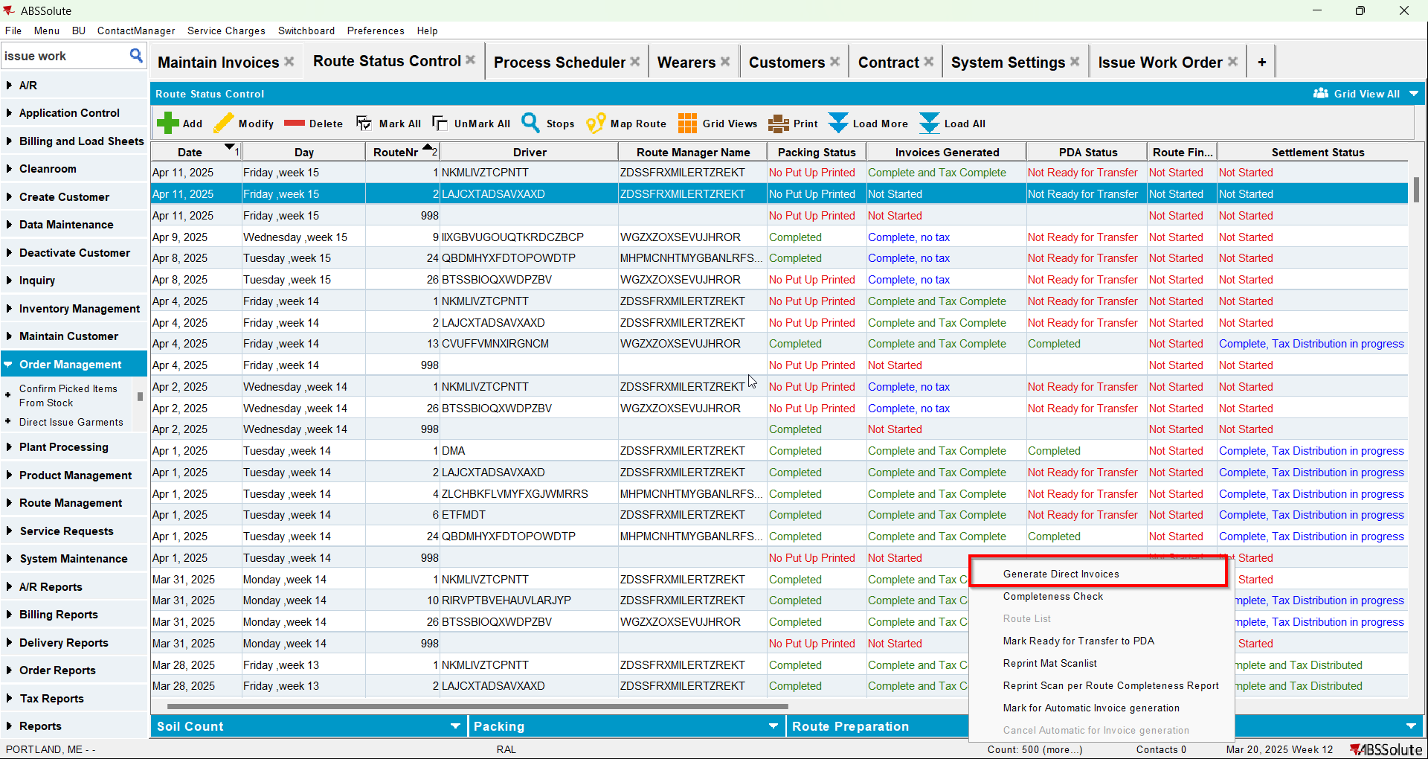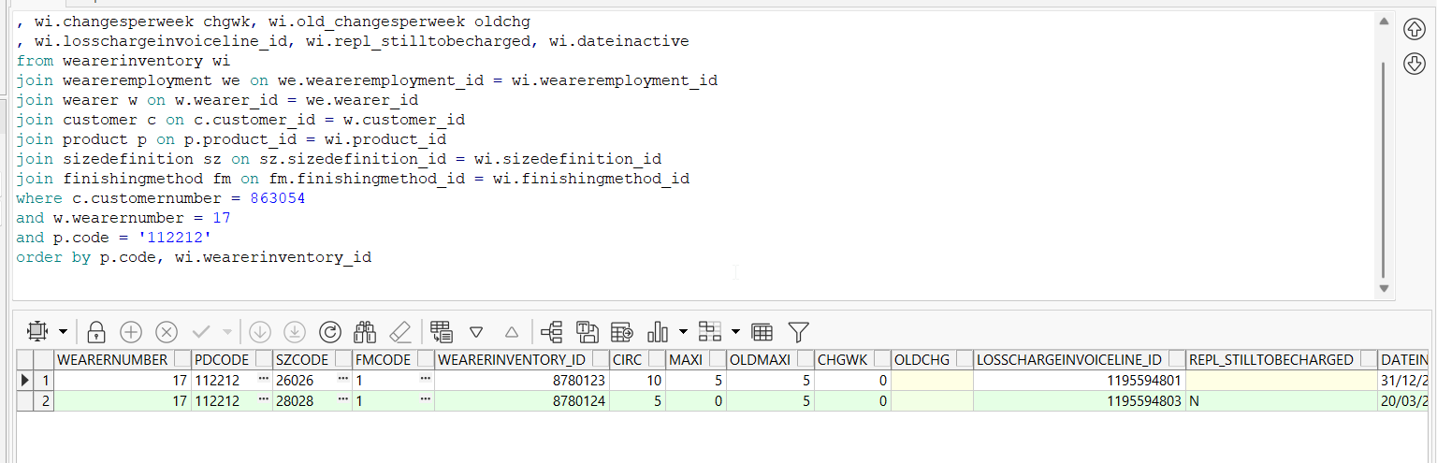
- Check the invoice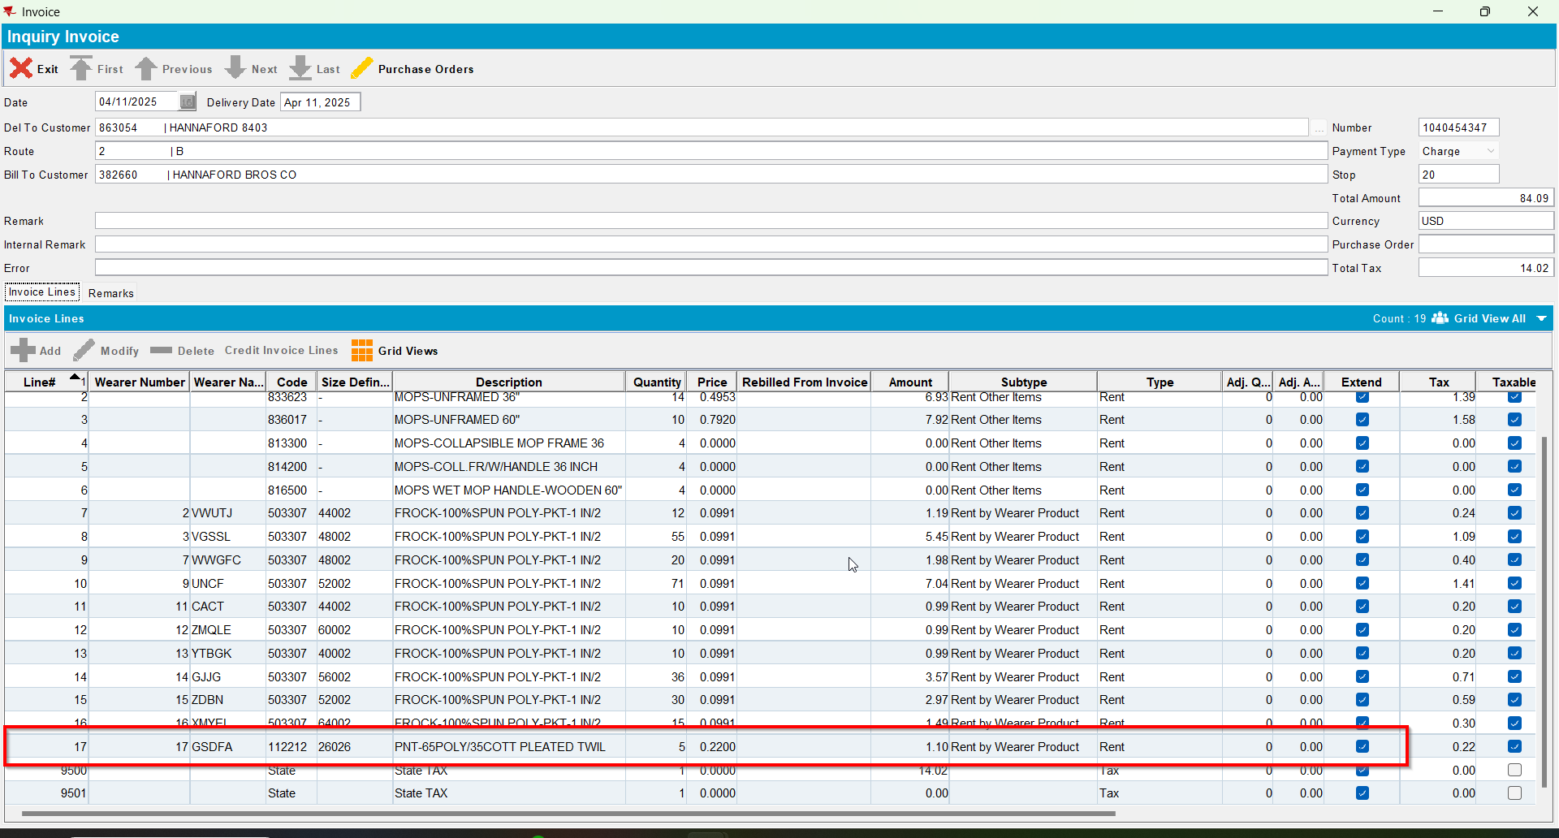

Test Case 3 – WI A full replacement by B & WI B full replacement by A, all mixed items – Replacements done on Client – Tested OK
Expected behavior: When generating the second replacement workorder we should change REPL_STILLTOBECHARGED to NULL.
Hash: 529d0c2
- Have SS CHARGEREPLACEDPRODUCT set on Y
- Have a wearer inventory with mixed items 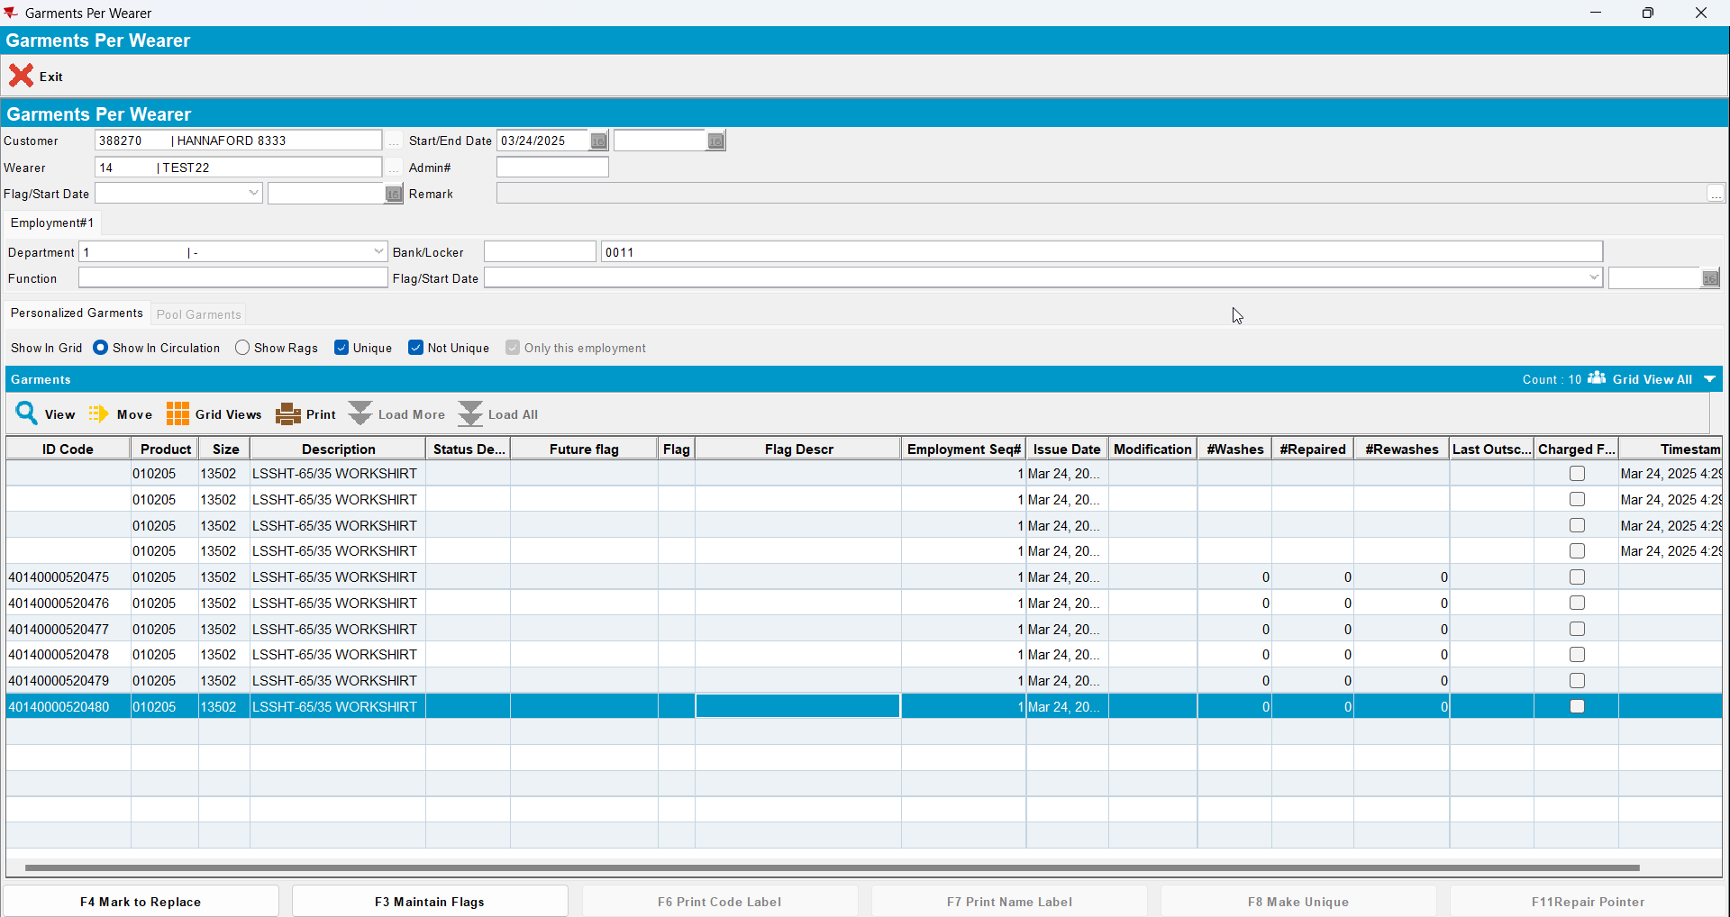
- Check the state of the product using the below sql
select w.wearernumber, p.code pdcode, SZ.code szcode, fm.code fmcode
, wi.wearerinventory_id, wi.circinventory circ
, wi.maxinventory maxi, wi.old_maxinventory oldmaxi
, wi.changesperweek chgwk, wi.old_changesperweek oldchg
, wi.losschargeinvoiceline_id, wi.repl_stilltobecharged, wi.dateinactive
from wearerinventory wi
join weareremployment we on we.weareremployment_id = wi.weareremployment_id
join wearer w on w.wearer_id = we.wearer_id
join customer c on c.customer_id = w.customer_id
join product p on p.product_id = wi.product_id
join sizedefinition sz on sz.sizedefinition_id = wi.sizedefinition_id
join finishingmethod fm on fm.finishingmethod_id = wi.finishingmethod_id
where c.customernumber =
and w.wearernumber =
and p.code = ''
order by p.code, wi.wearerinventory_id

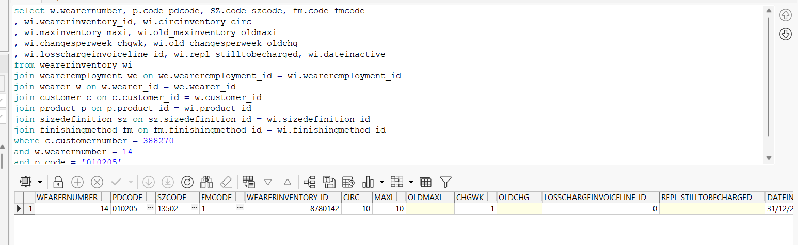
- Replace the wearer inventory changing only its size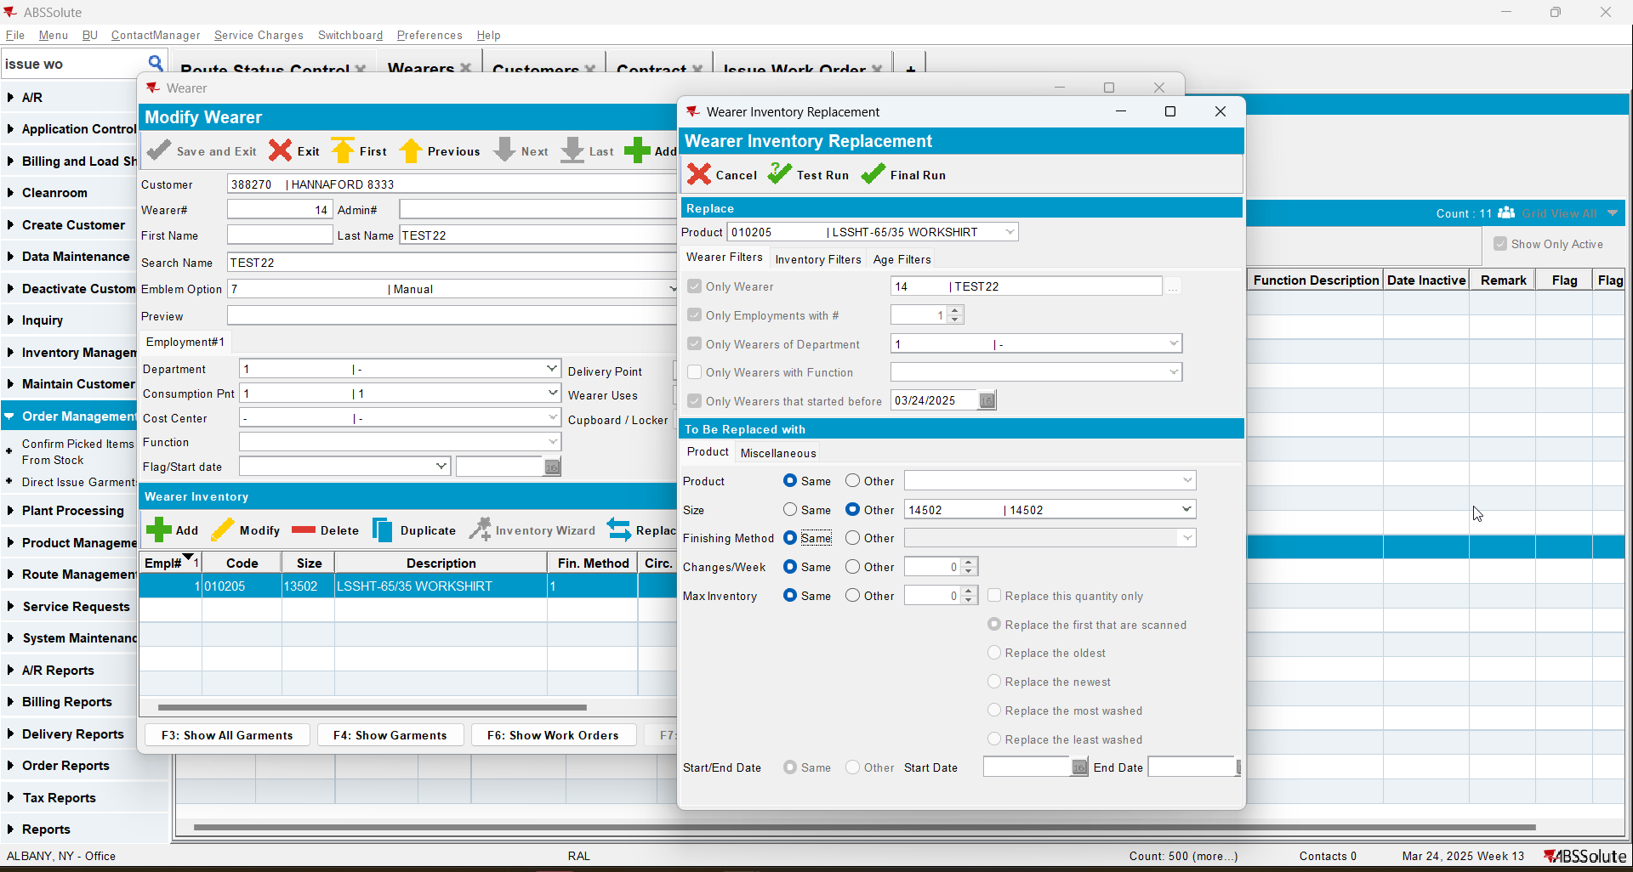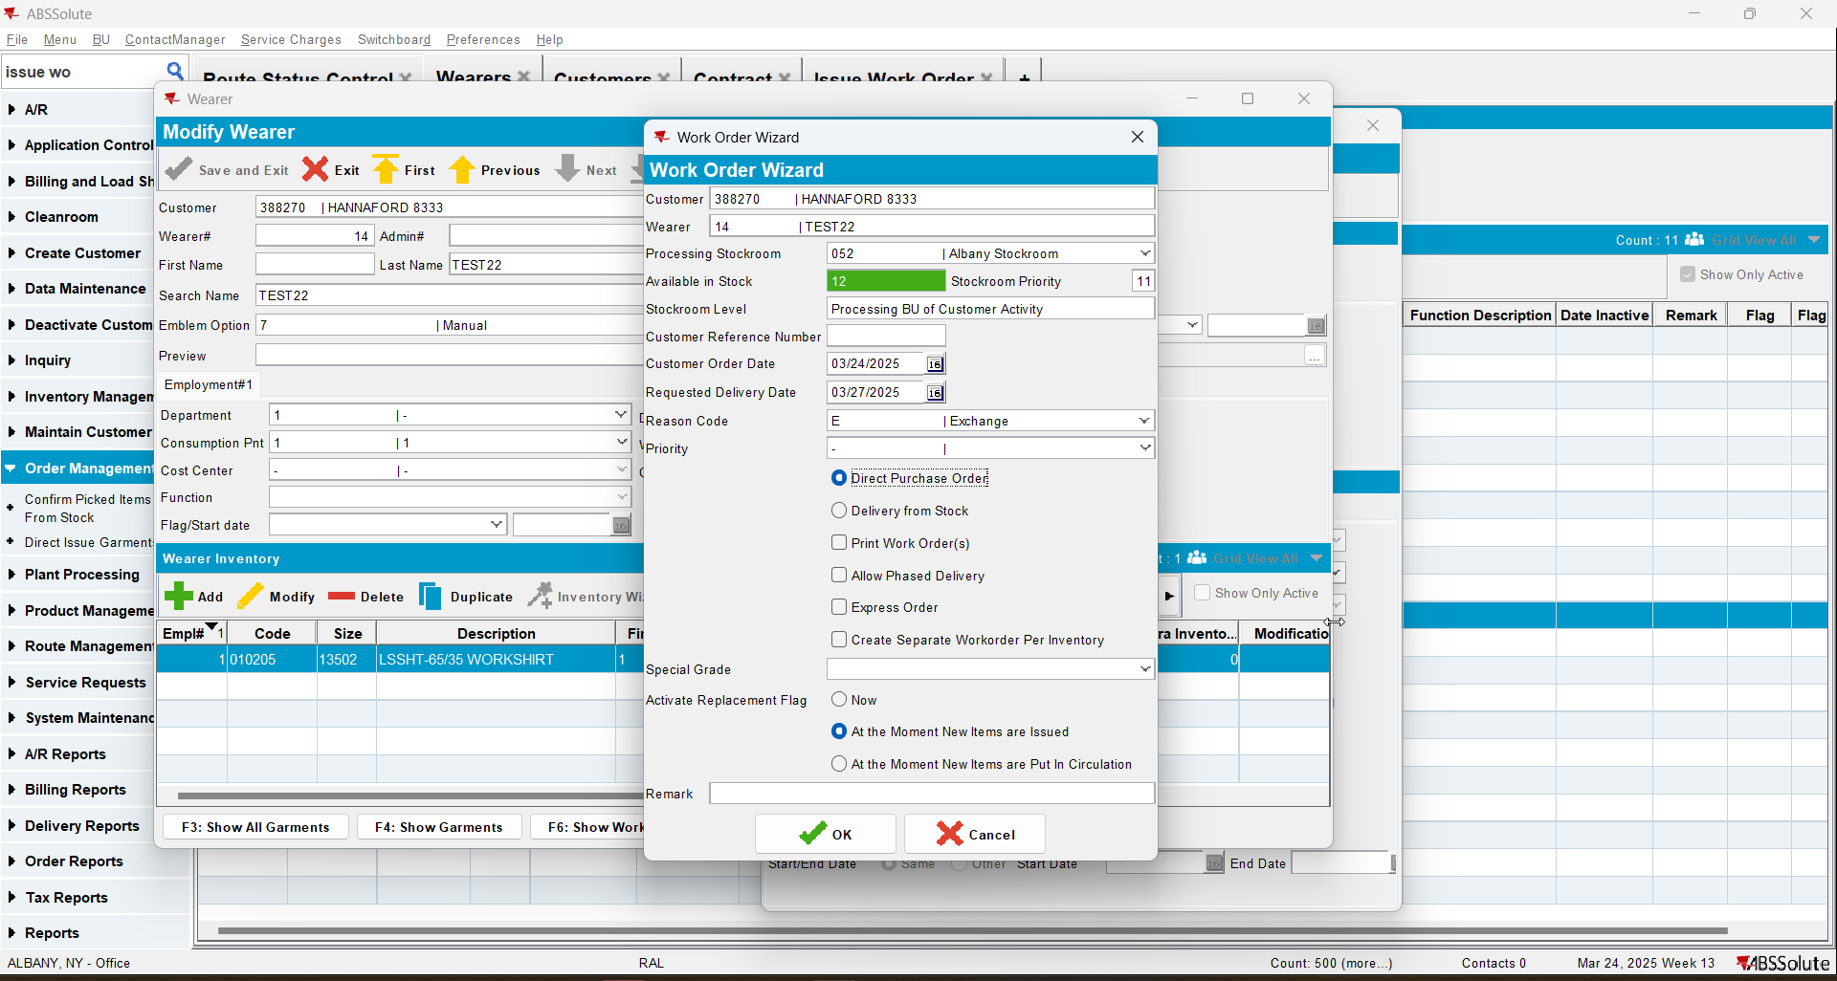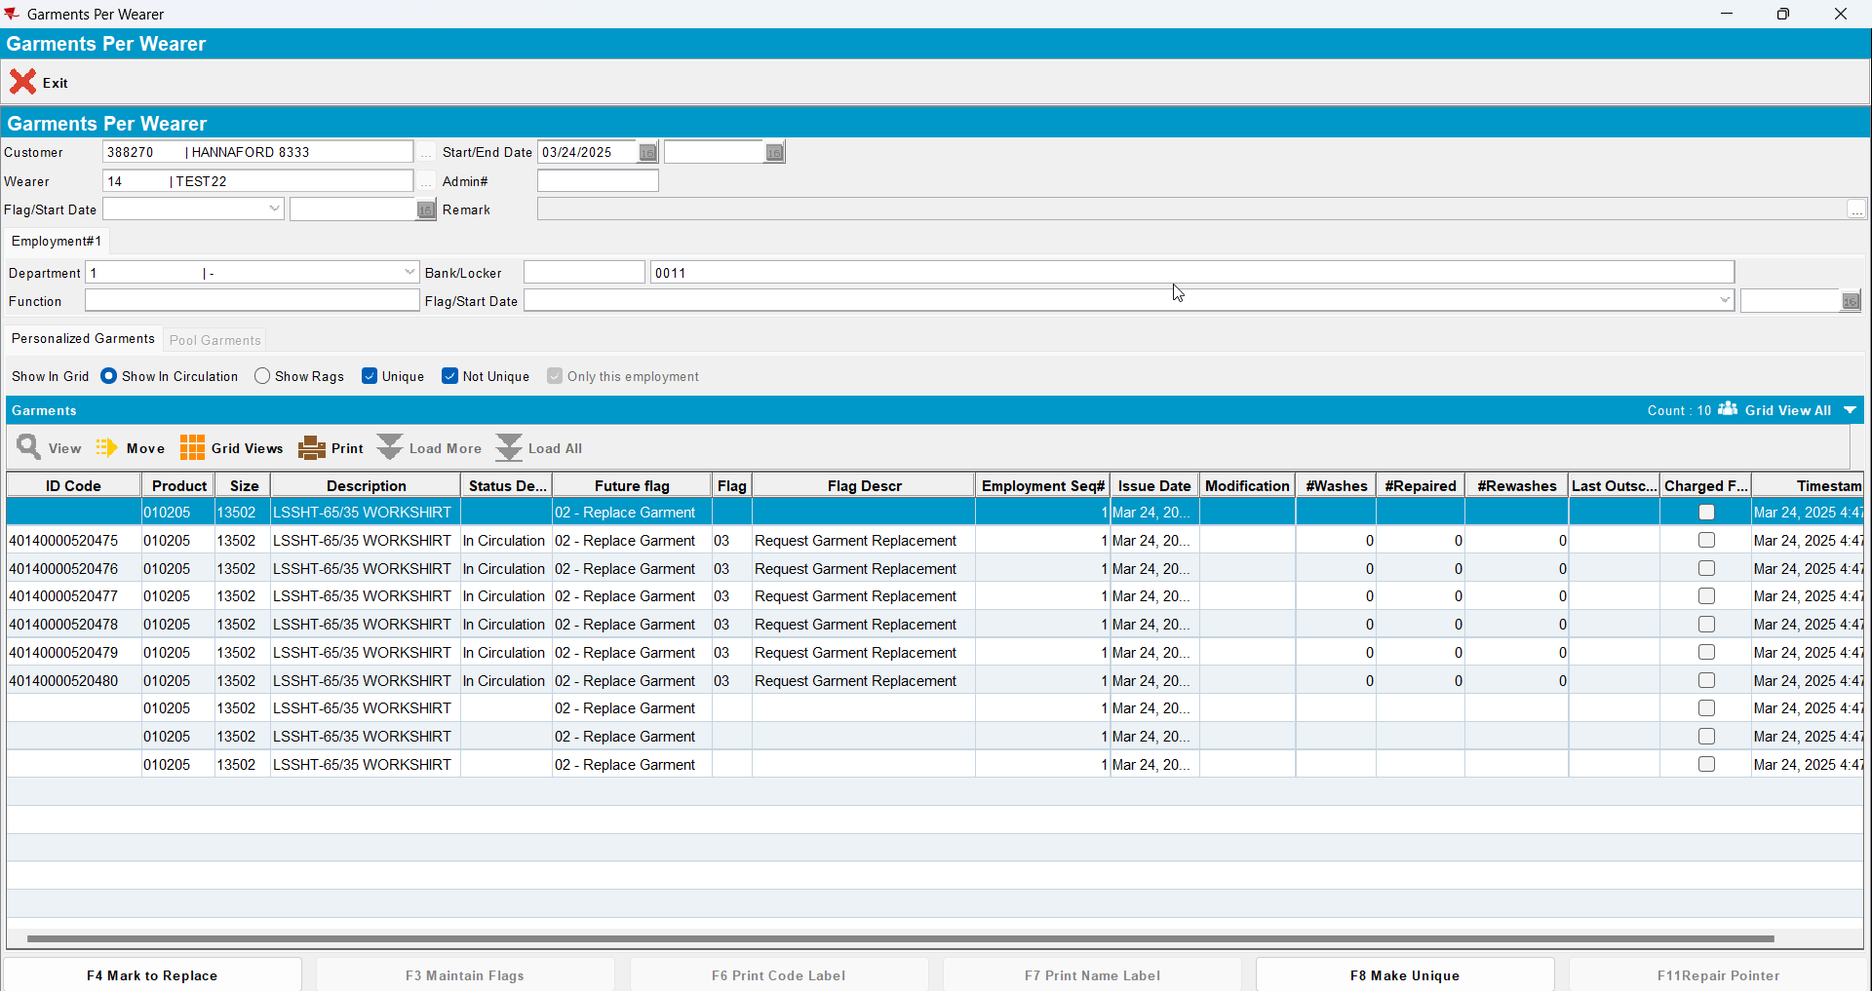
- Check the state of the product 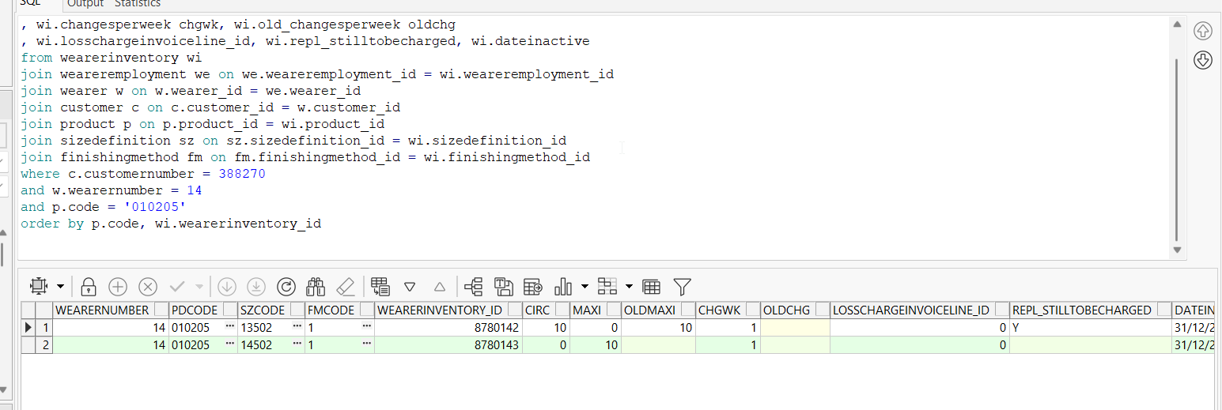
- Issue the items and generate delivery notes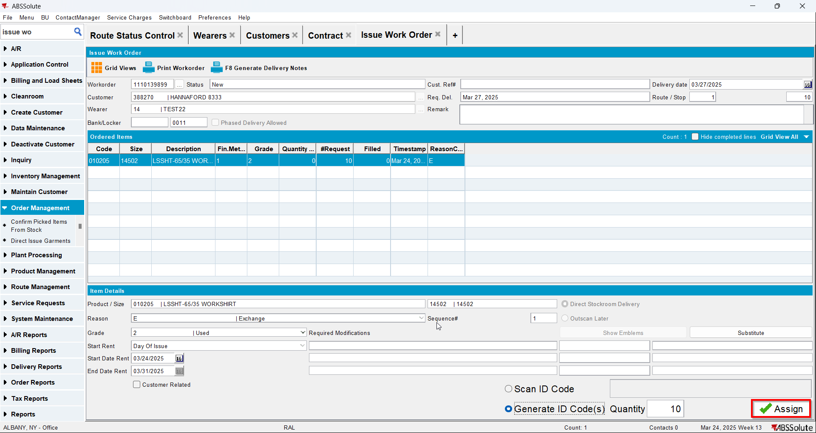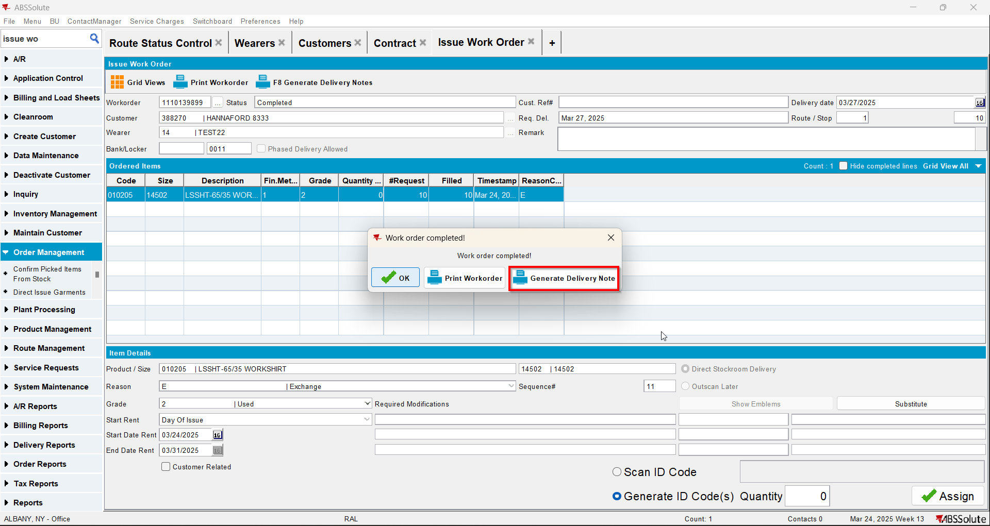
- Check the state of the product(REPL_STILLTOBECHARGED should be null for the second size and Y for the initial size)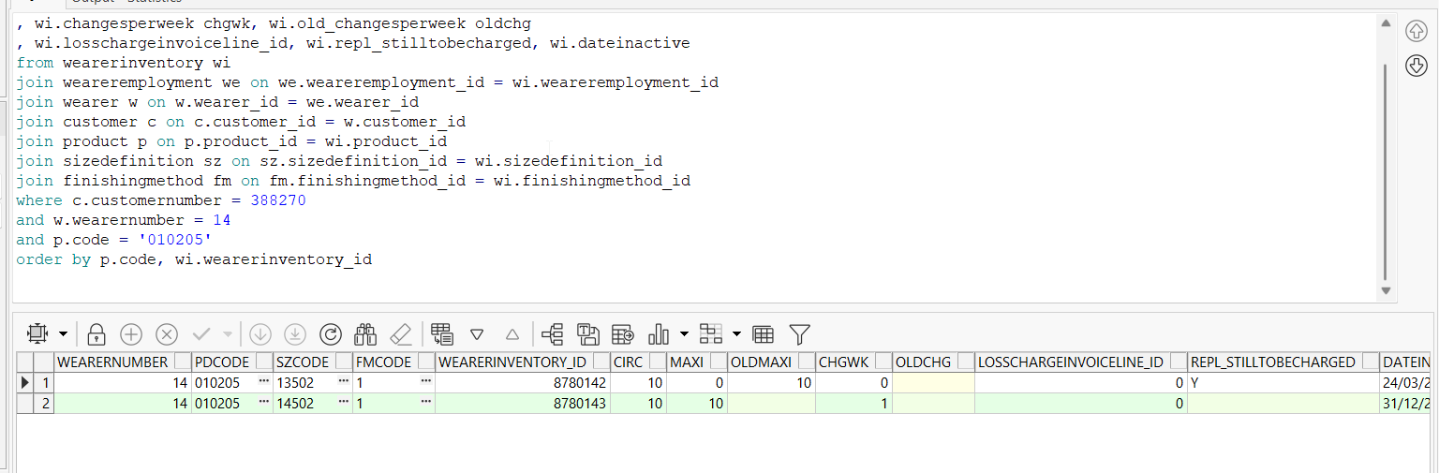
- Generate invoices and check the state of the product(REPL_STILLTOBECHARGED should be null for the second size and N for the initial size)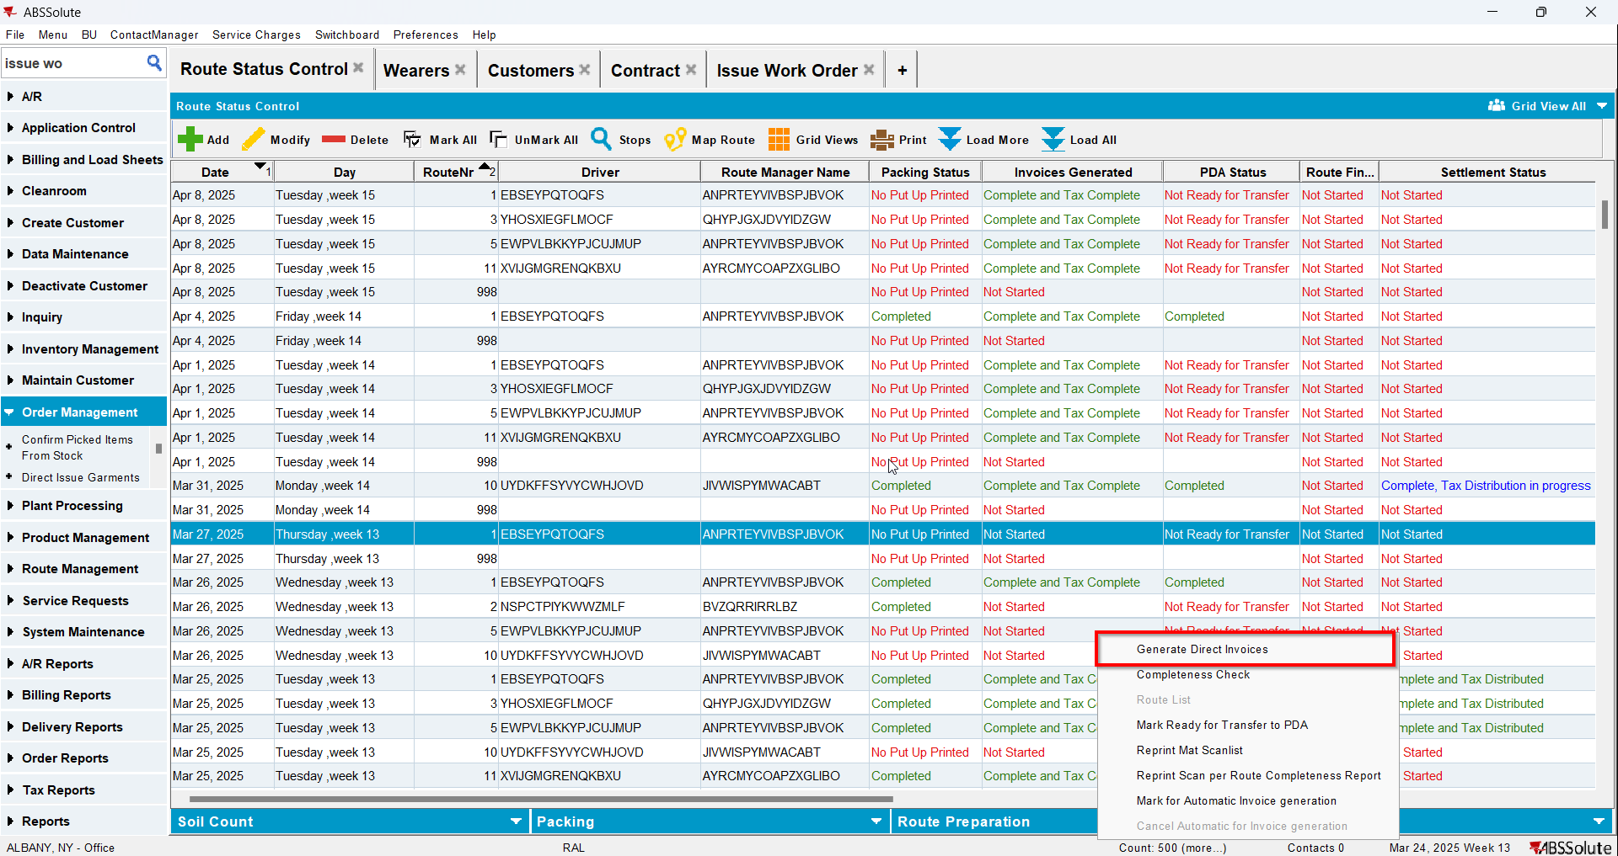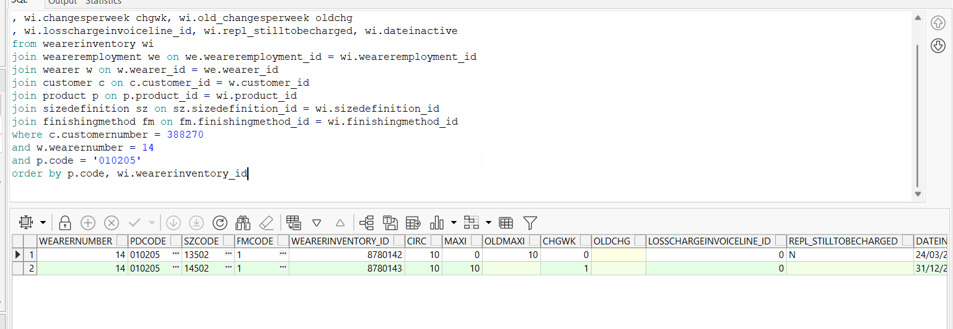
- Settle the route and check the state of the product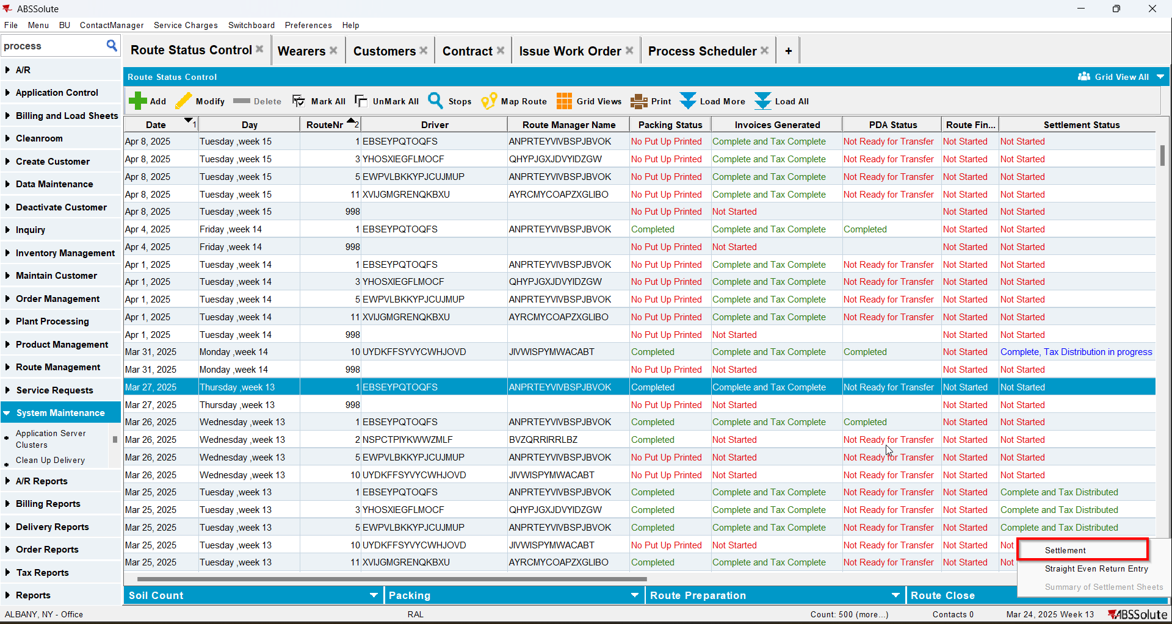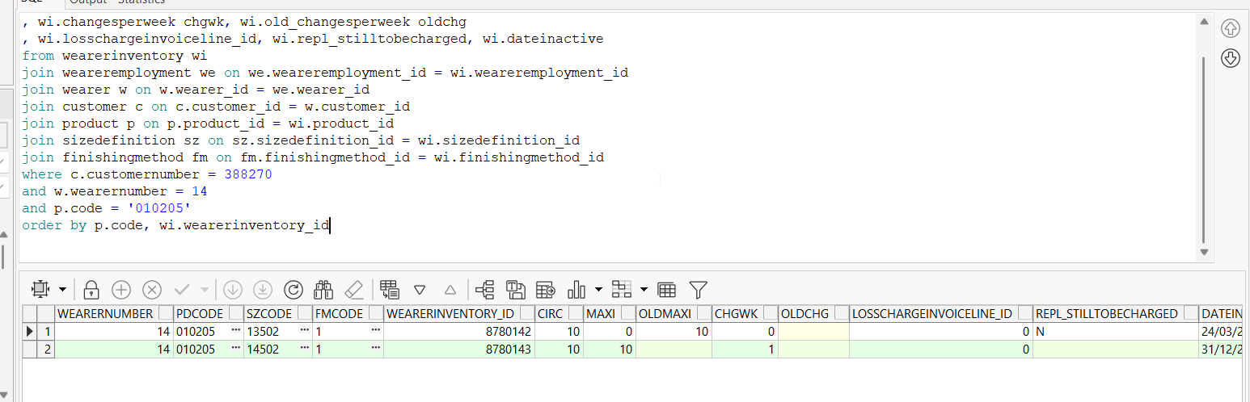
- Check the invoice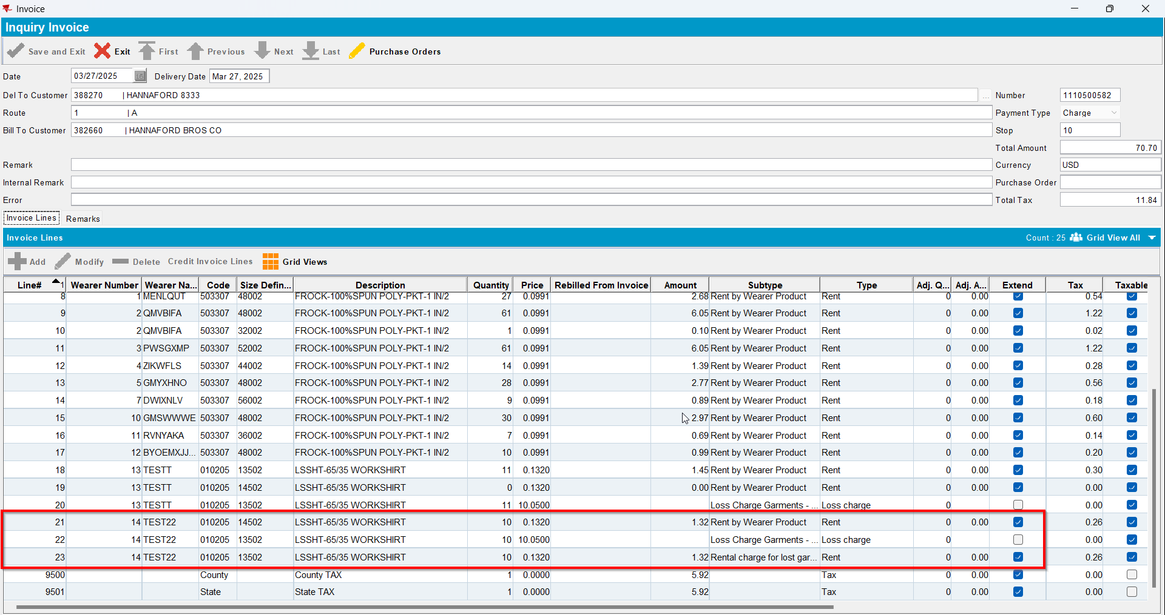
- Replace the new wearer inventory changing only its size back to its original size(REPL_STILLTOBECHARGED should be Y for the second size and Null for the initial size)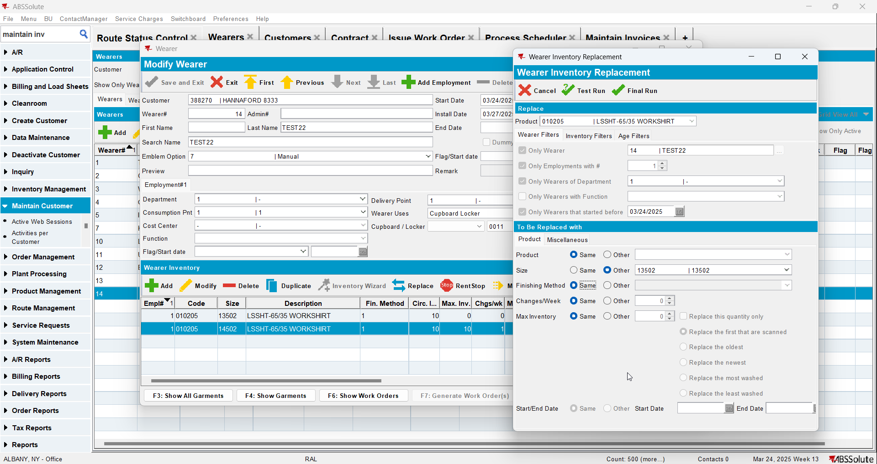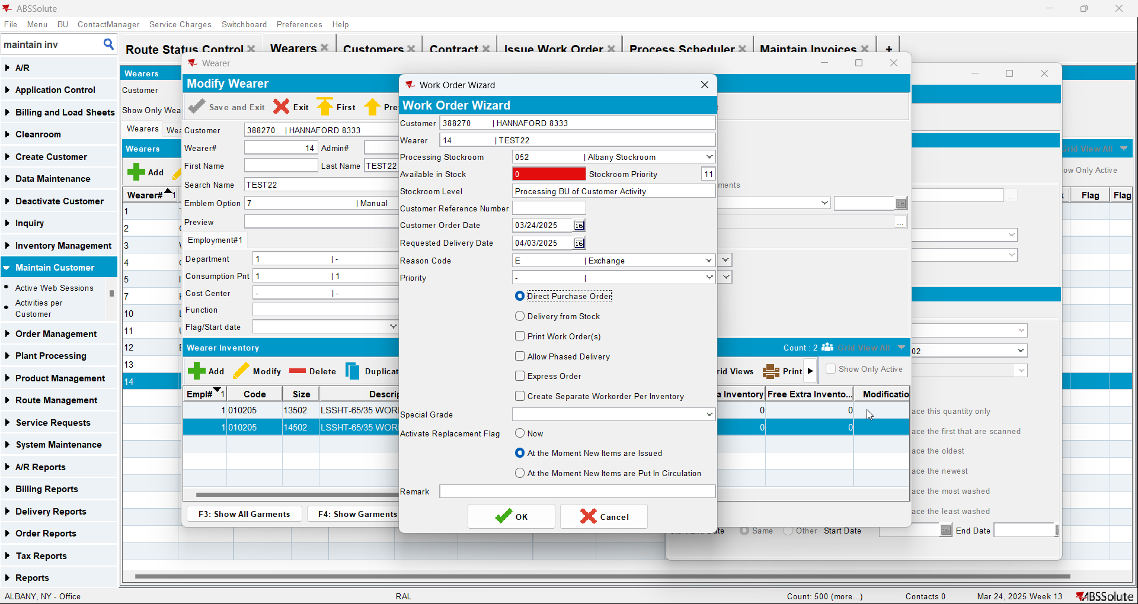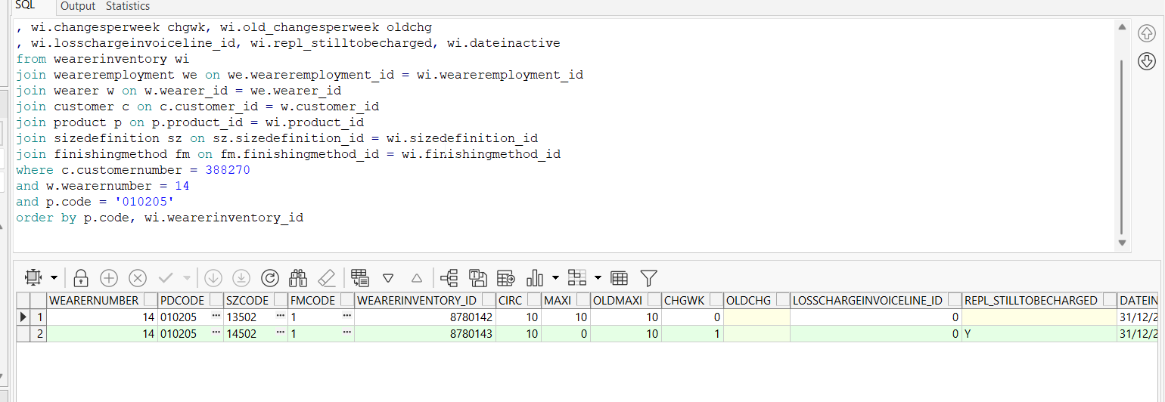
- Issue the items and generate delivery notes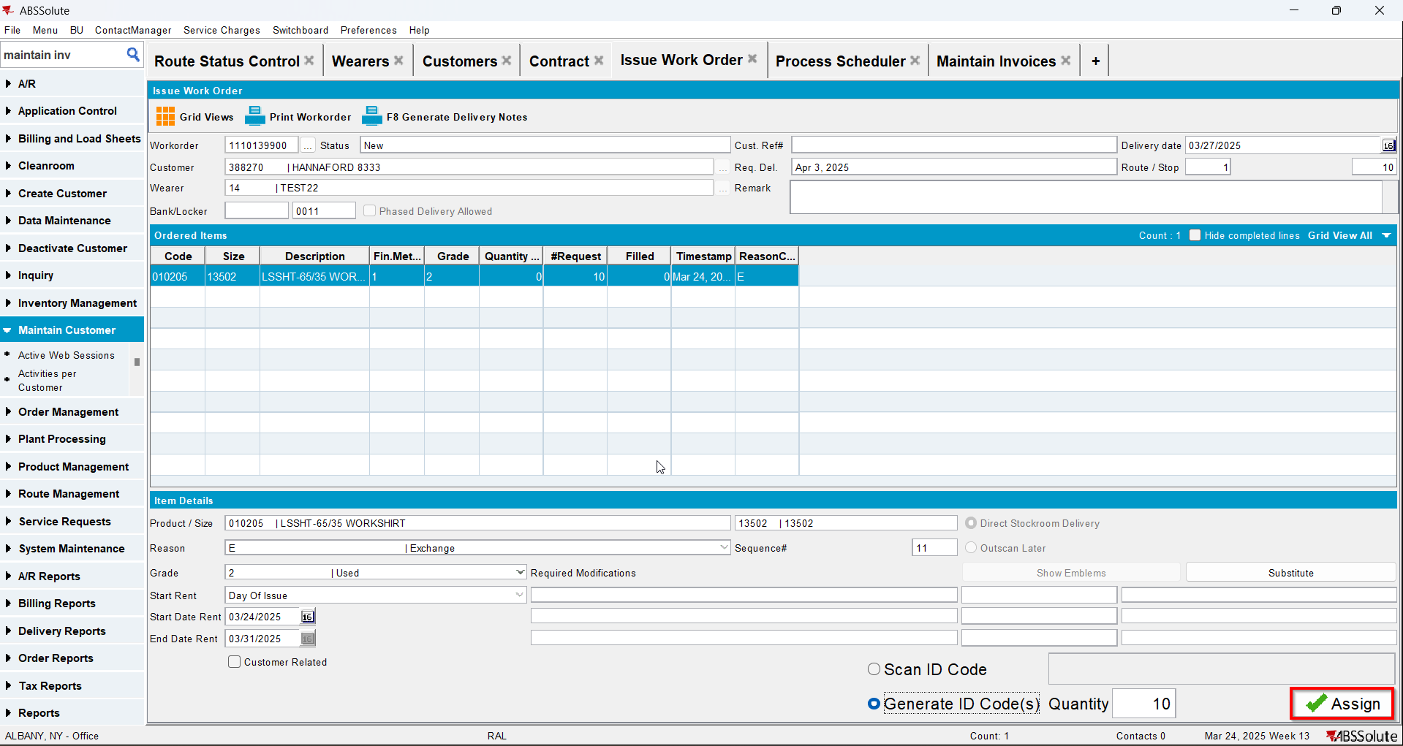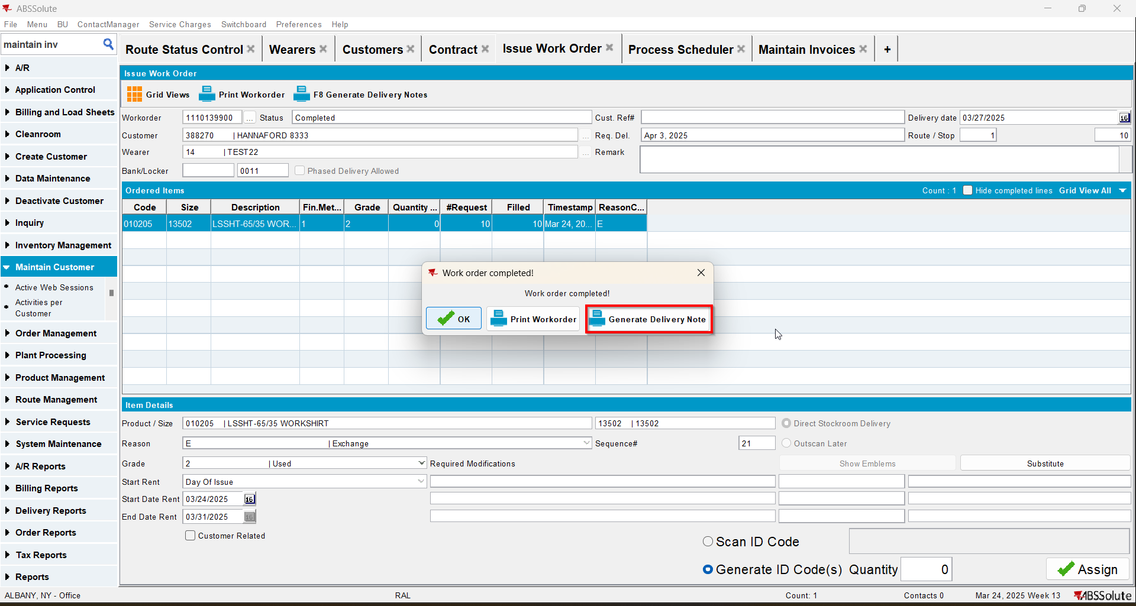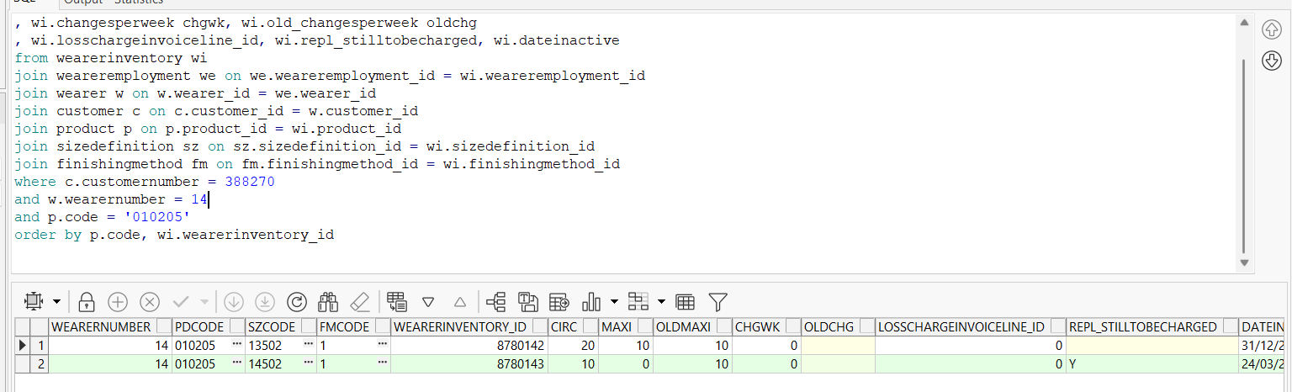
- Generate invoices for next route and check the state of the product(REPL_STILLTOBECHARGED should be N for the second size and Null for the initial size)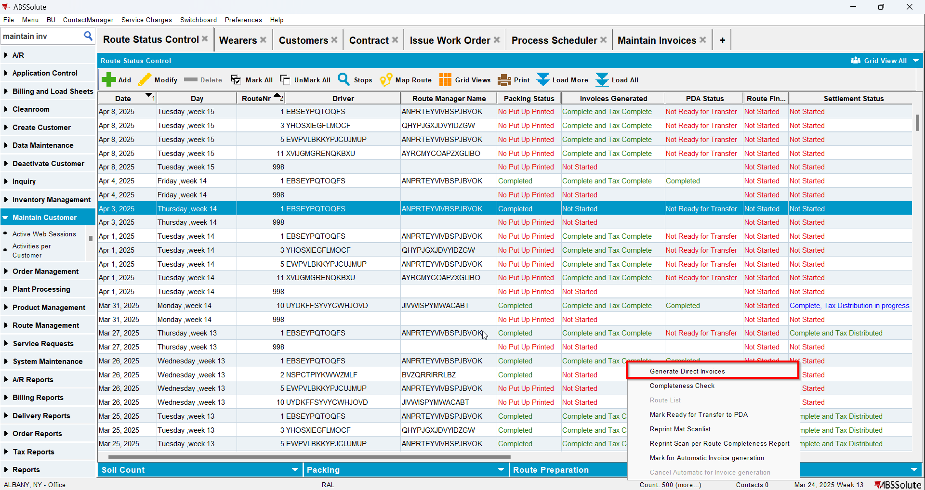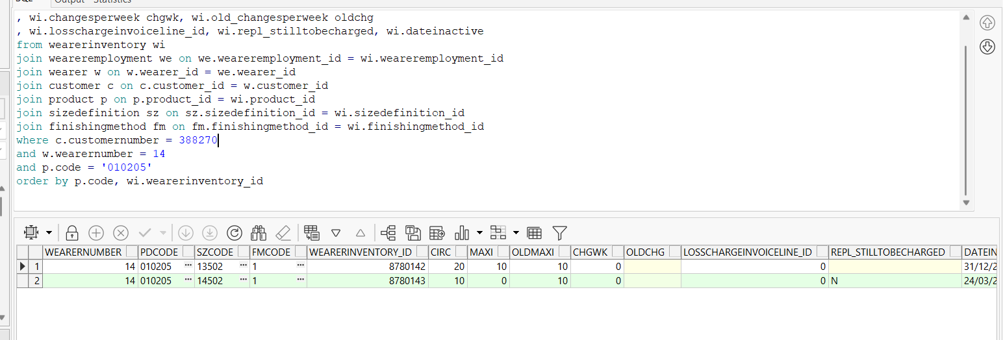
- Check the invoice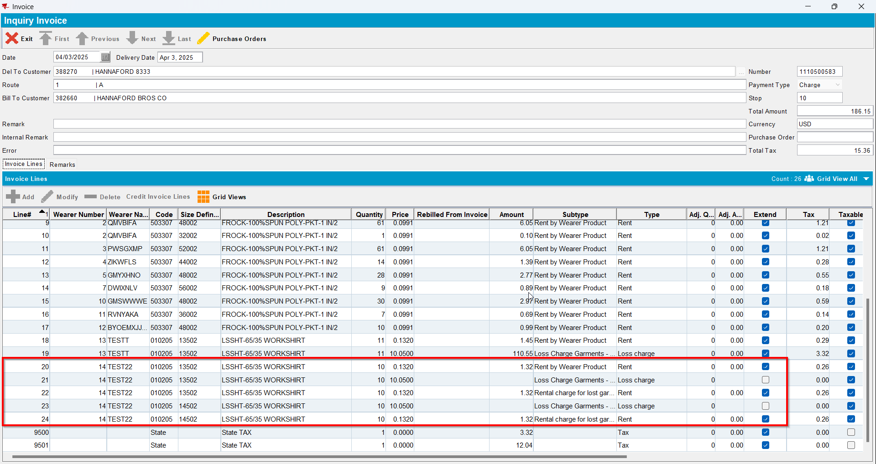
- Settle the route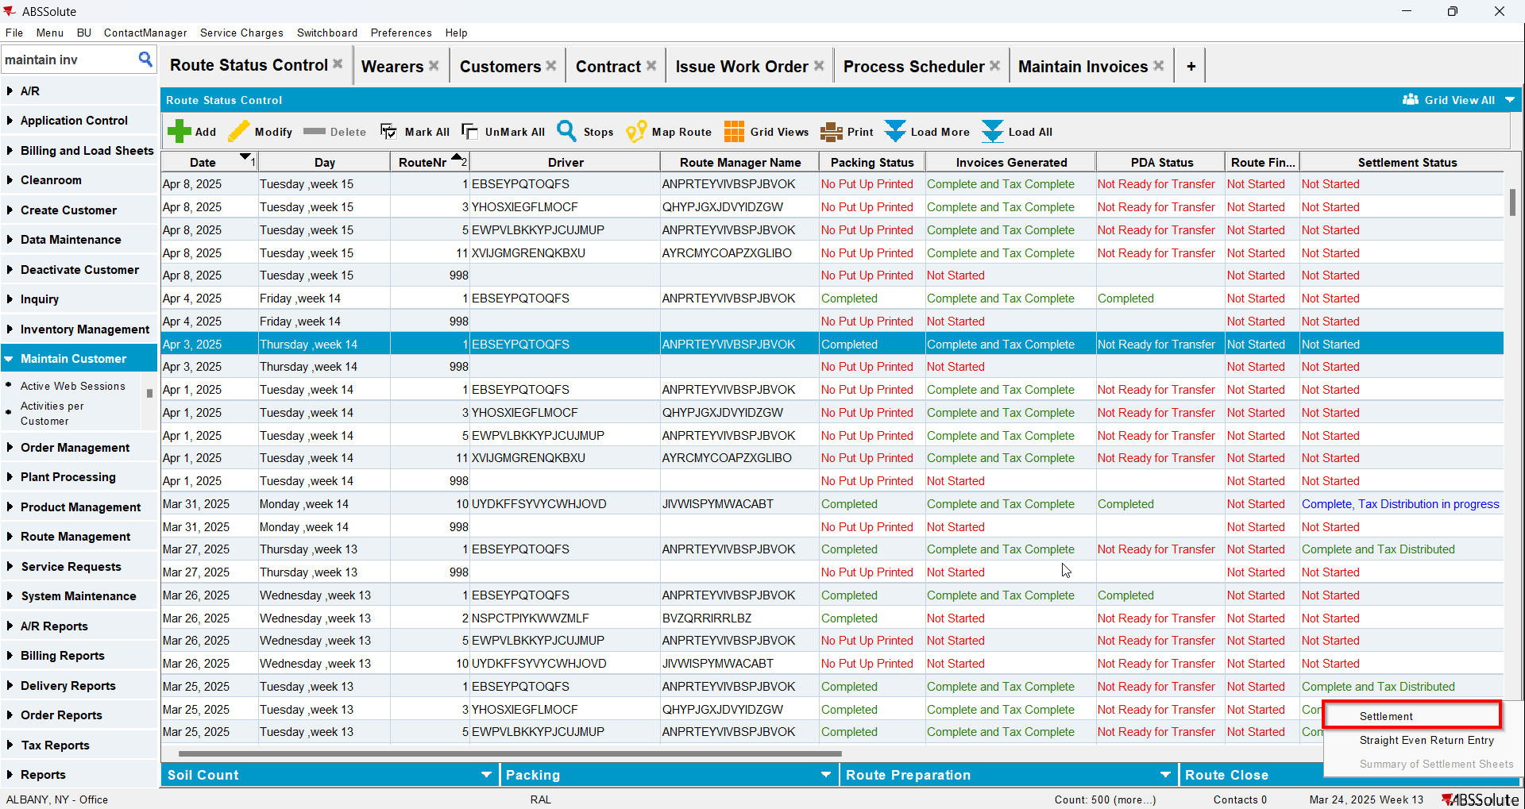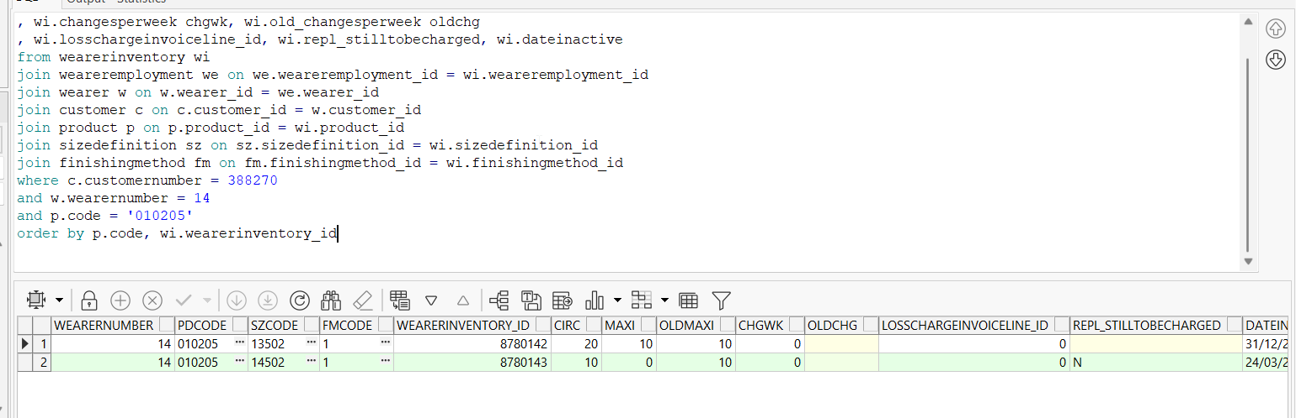
- Generate invoices for the next route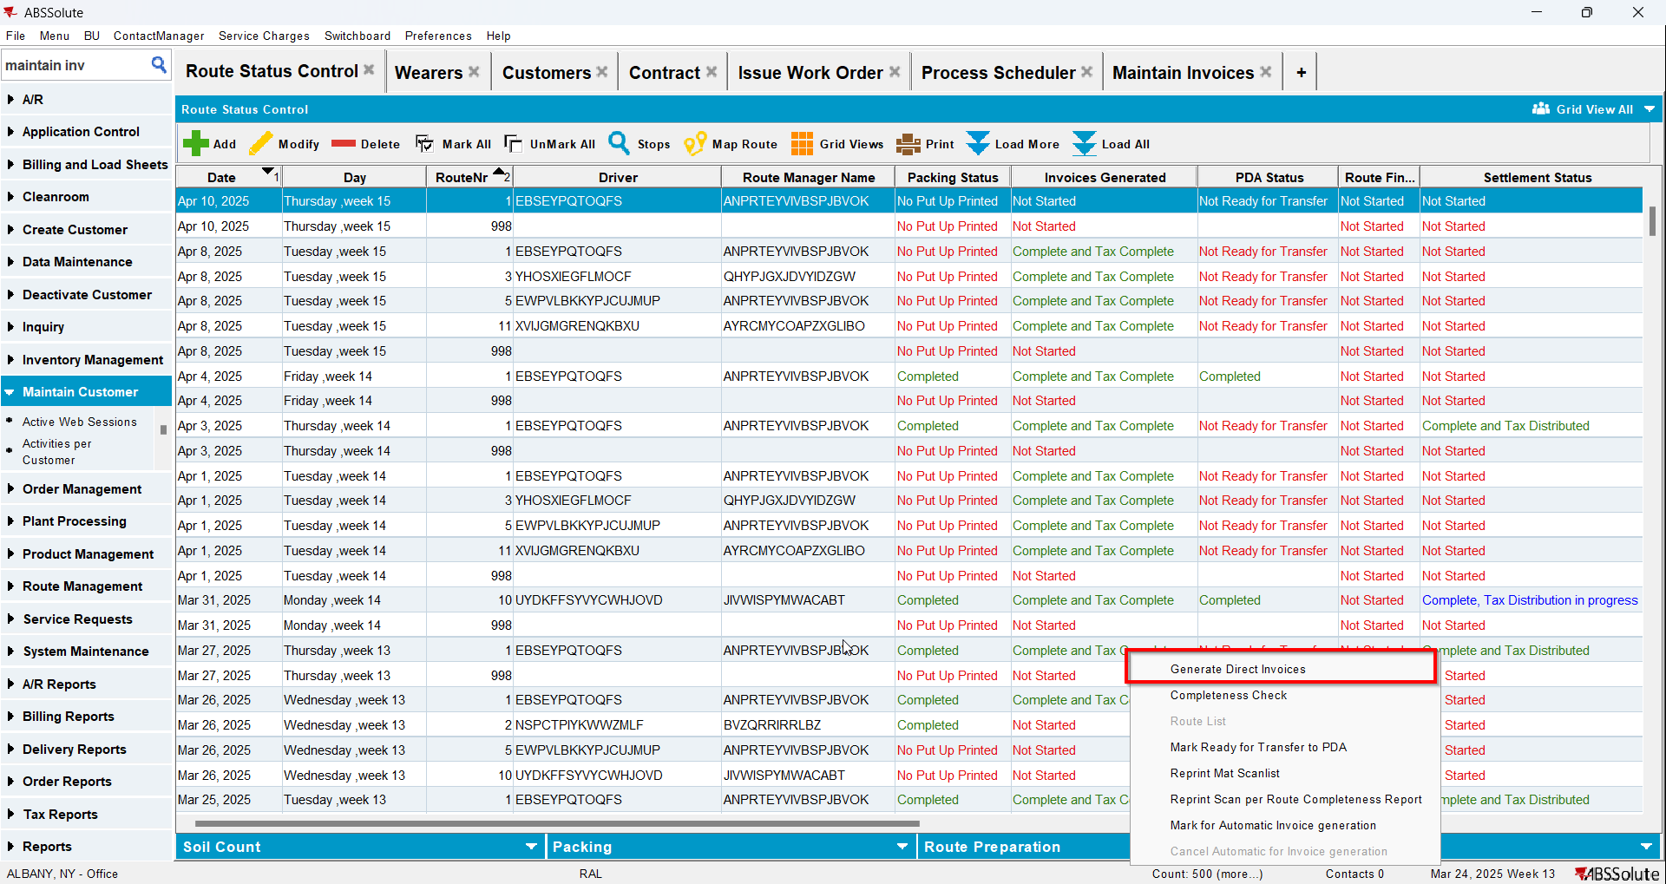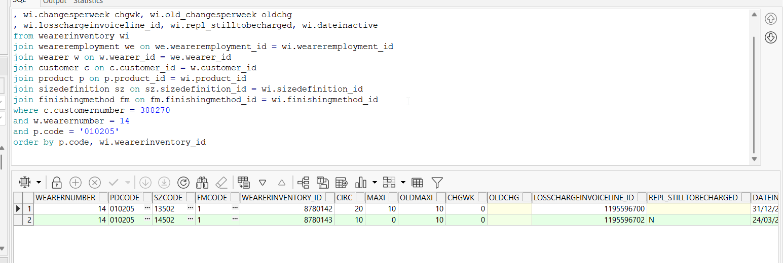
- Check the invoice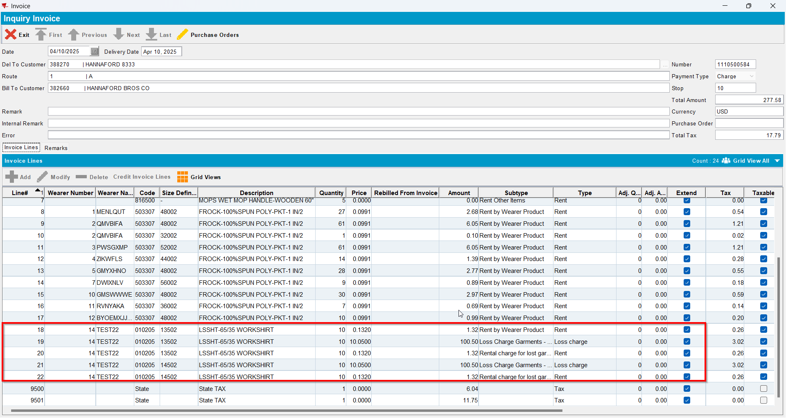
- Generate invoices for the next route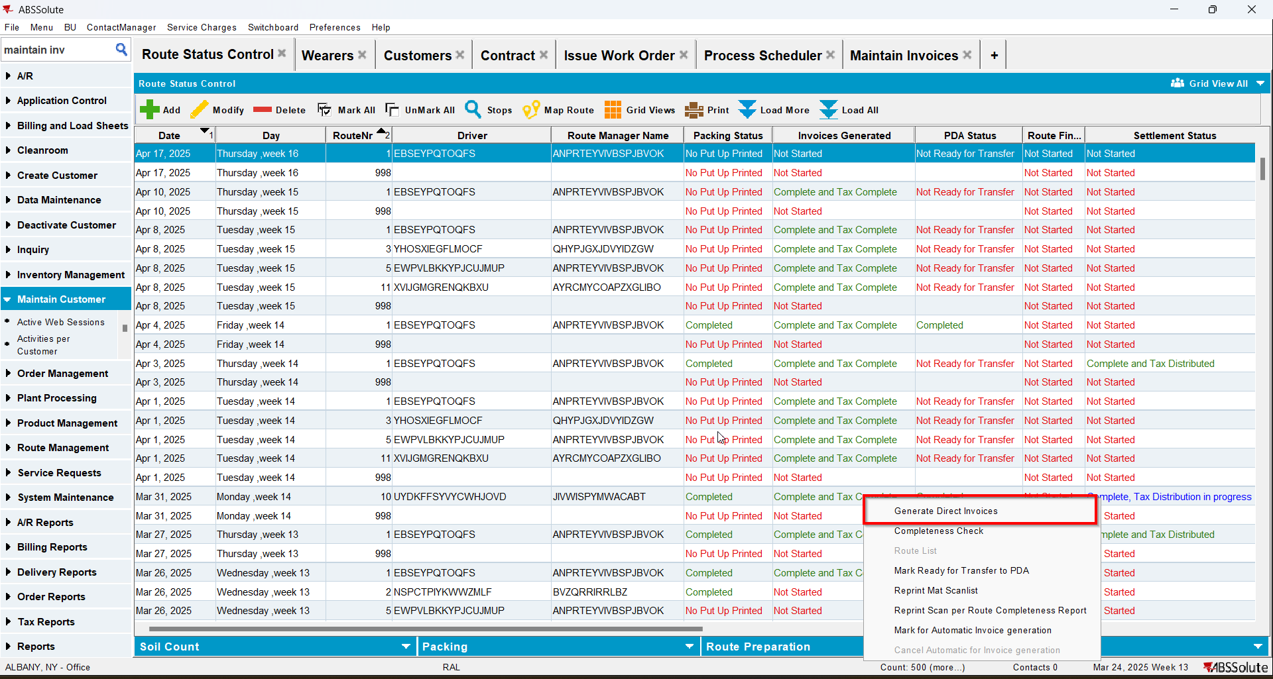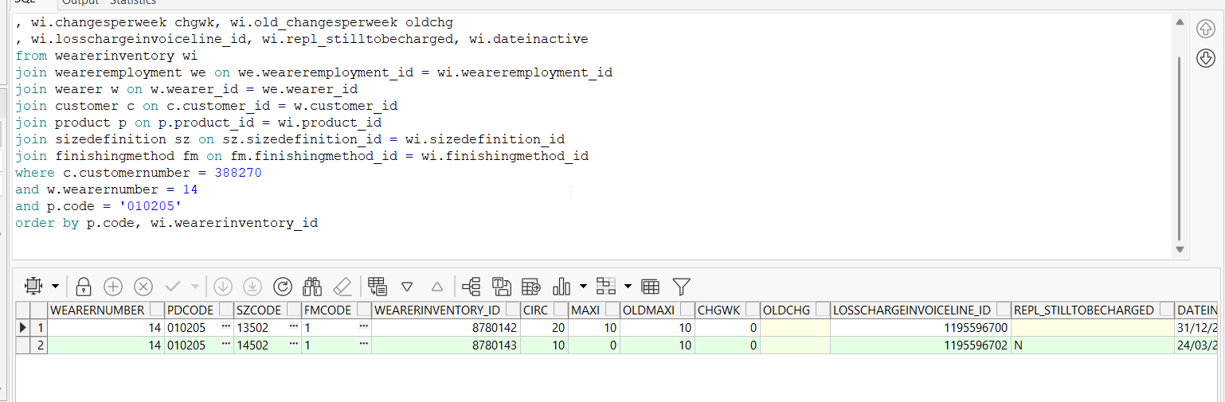
- Check the invoice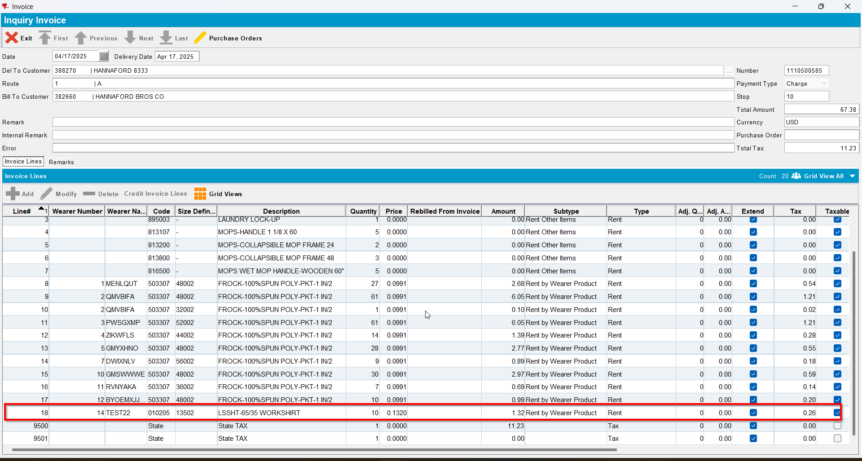

Test Case 4 – WI A partial replacement by B & WI B full replacement by A, all unique items – Replacements done on Client – Tested OK
Expected behavior: When doing the second replacement an error will appear
Hash: 529d0c2
- Have SS CHARGEREPLACEDPRODUCT set on Y
- Have a wearer inventory with unique items only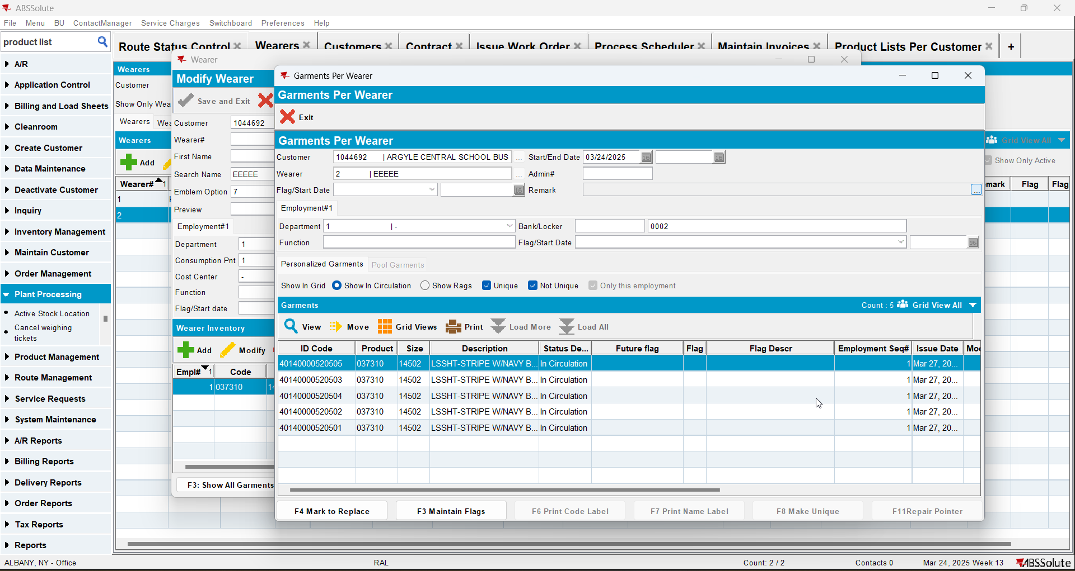
- Check the state of the product using the below sql
select w.wearernumber, p.code pdcode, SZ.code szcode, fm.code fmcode
, wi.wearerinventory_id, wi.circinventory circ
, wi.maxinventory maxi, wi.old_maxinventory oldmaxi
, wi.changesperweek chgwk, wi.old_changesperweek oldchg
, wi.losschargeinvoiceline_id, wi.repl_stilltobecharged, wi.dateinactive
from wearerinventory wi
join weareremployment we on we.weareremployment_id = wi.weareremployment_id
join wearer w on w.wearer_id = we.wearer_id
join customer c on c.customer_id = w.customer_id
join product p on p.product_id = wi.product_id
join sizedefinition sz on sz.sizedefinition_id = wi.sizedefinition_id
join finishingmethod fm on fm.finishingmethod_id = wi.finishingmethod_id
where c.customernumber =
and w.wearernumber =
and p.code = ''
order by p.code, wi.wearerinventory_id

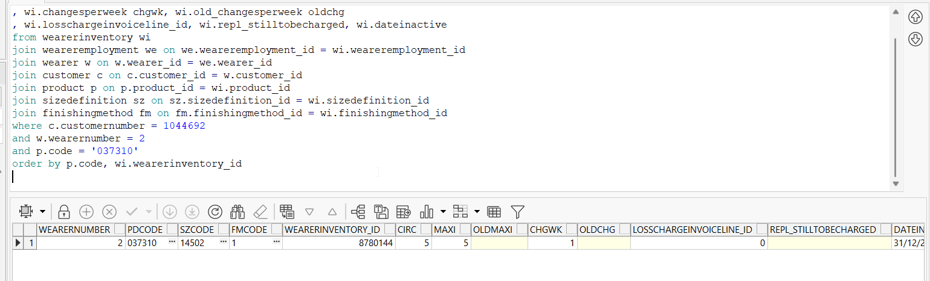
- Do a partial replacement on the wearer inventory changing only its size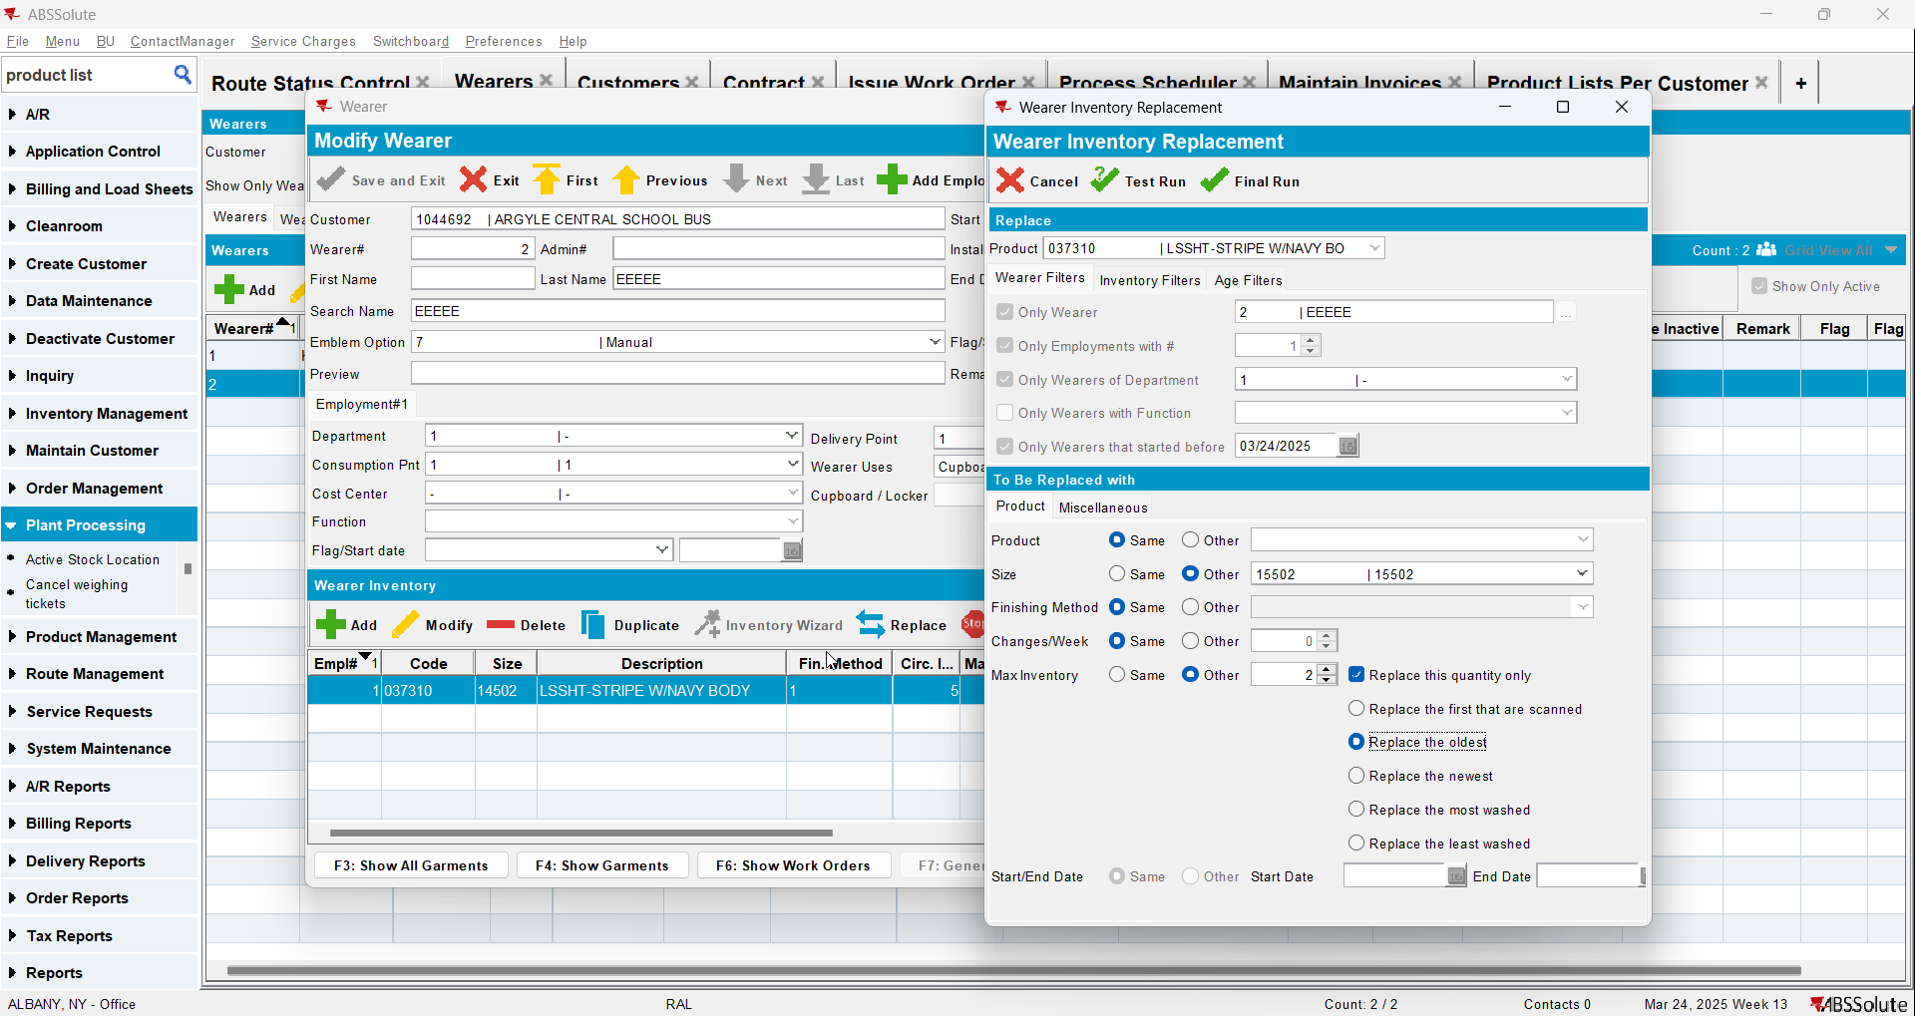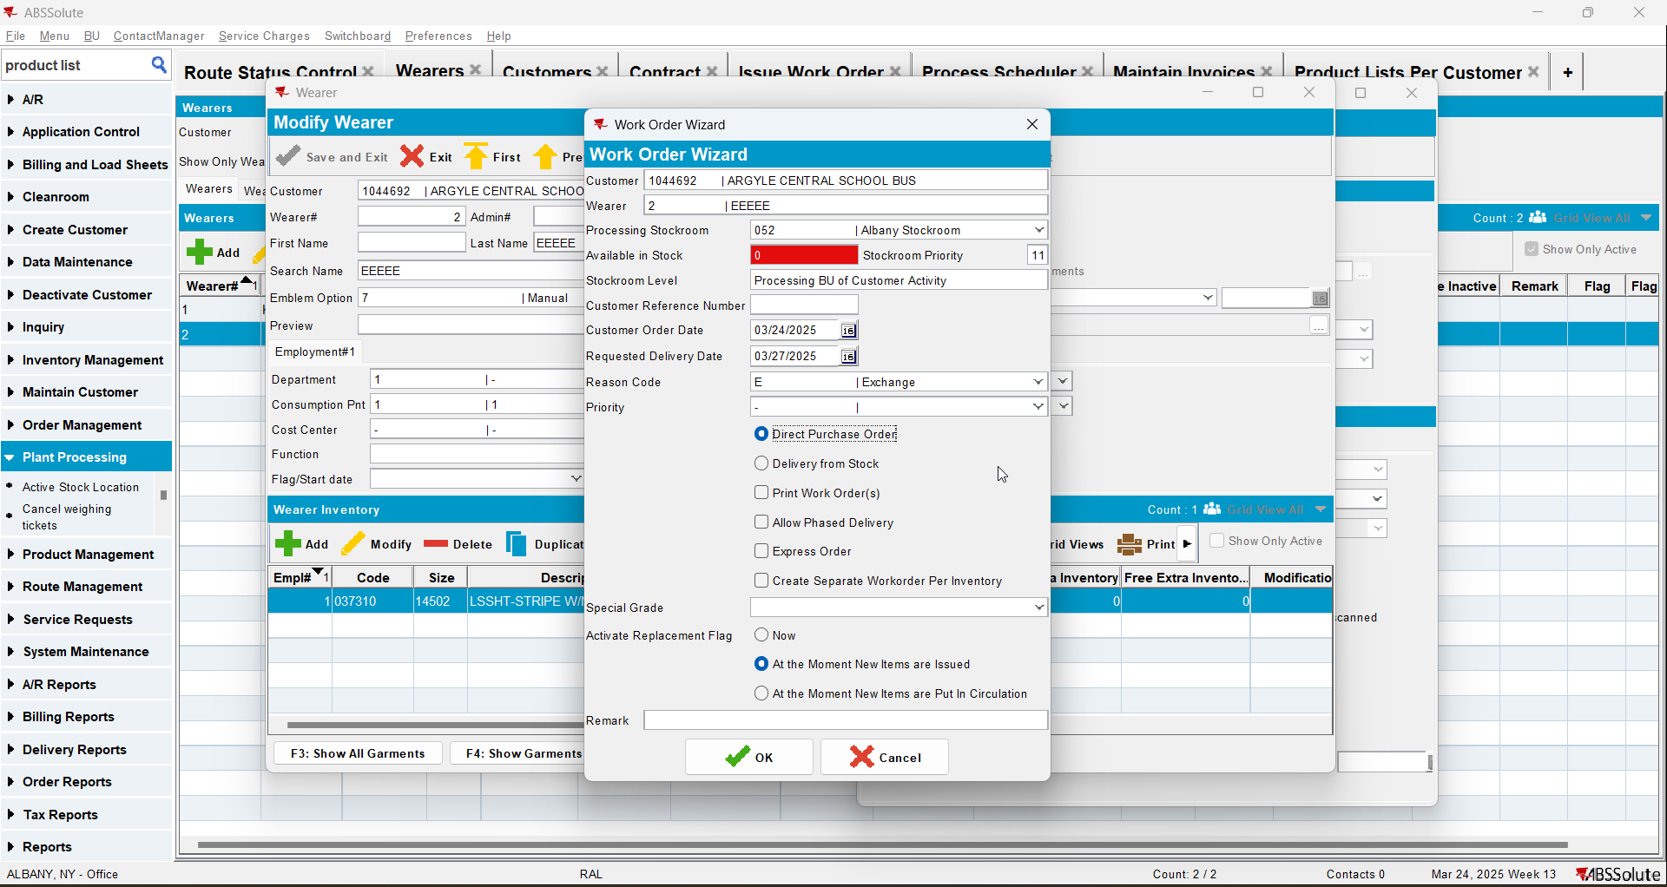
- Check the state of the product 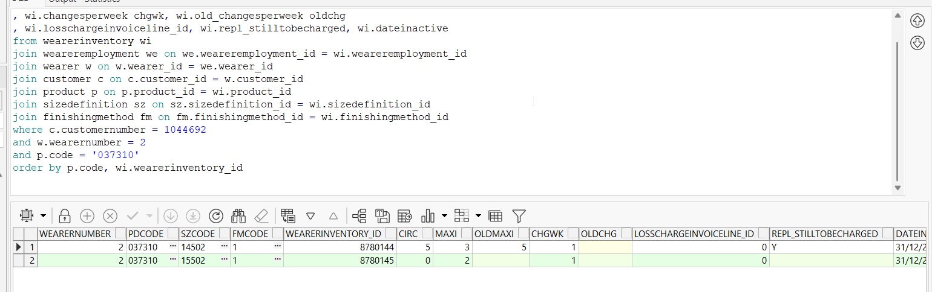
- Issue the items and generate delivery notes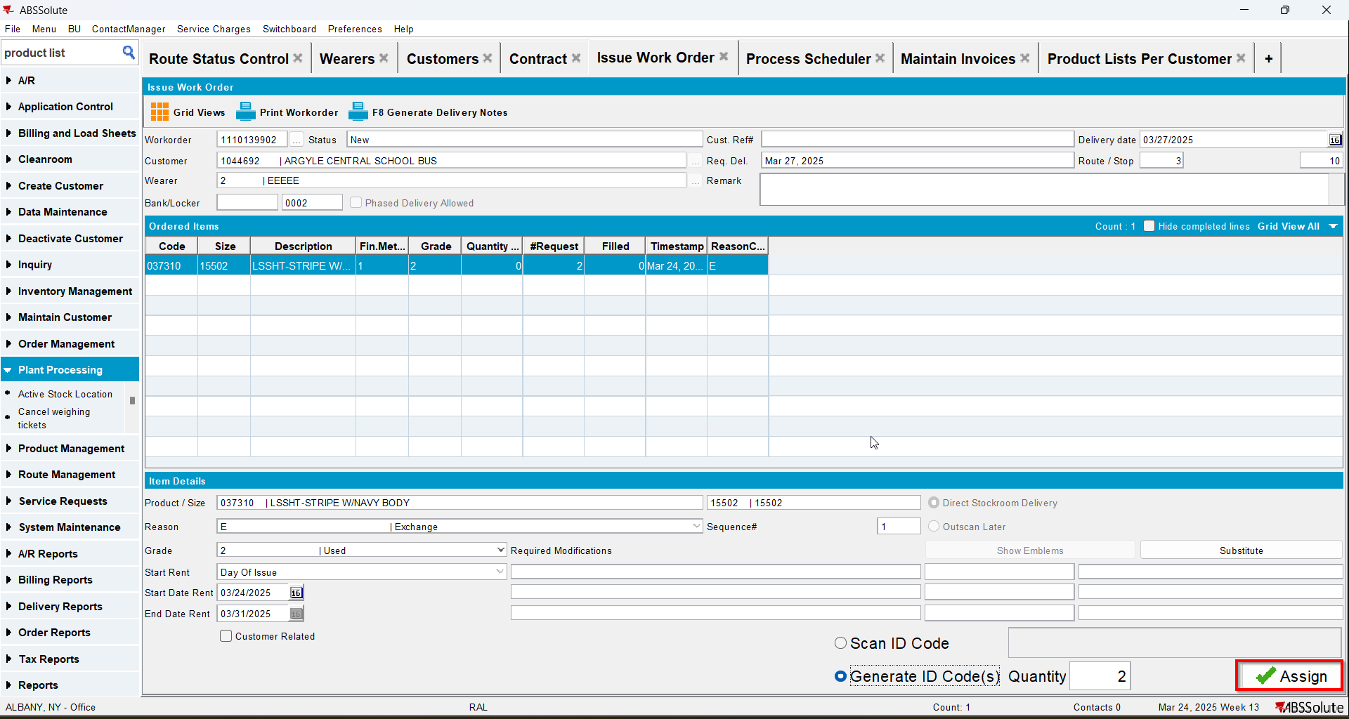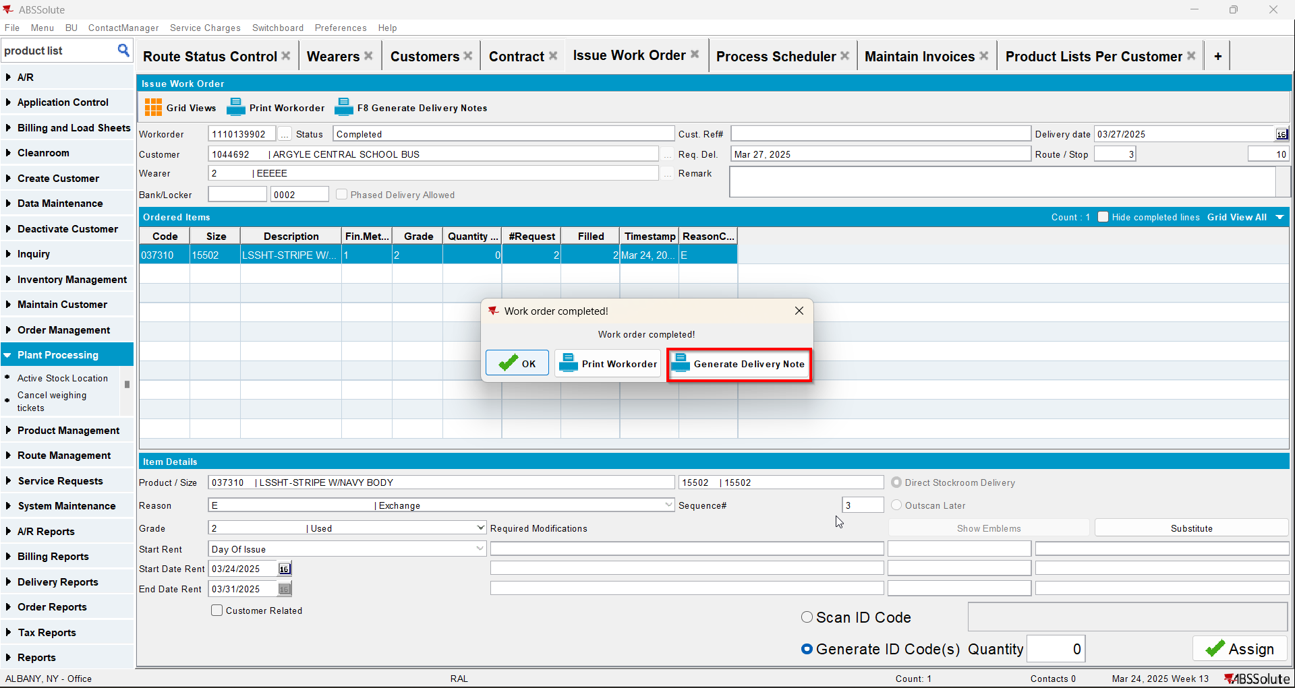
- Check the state of the product(REPL_STILLTOBECHARGED should be null for the second size and Y for the initial size)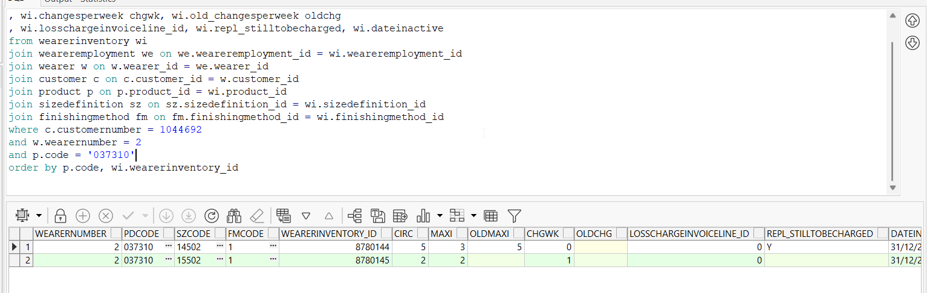
- Generate invoices and check the state of the product(REPL_STILLTOBECHARGED should be null for the second size and null for the initial size)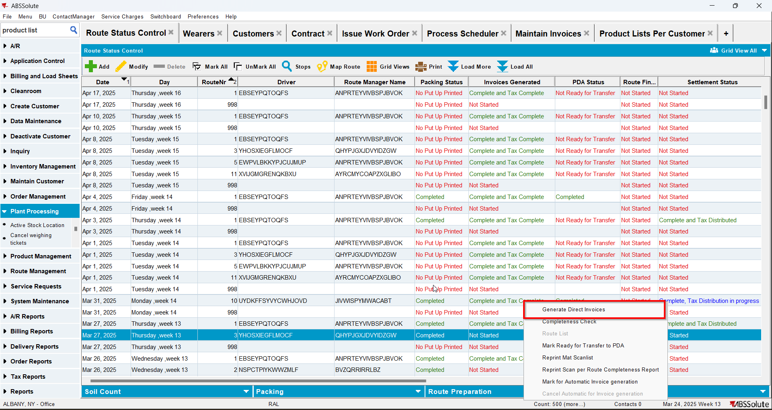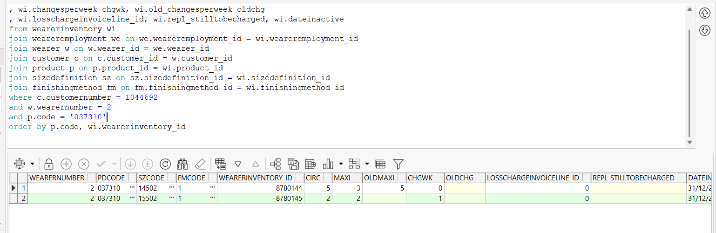
- Check the invoice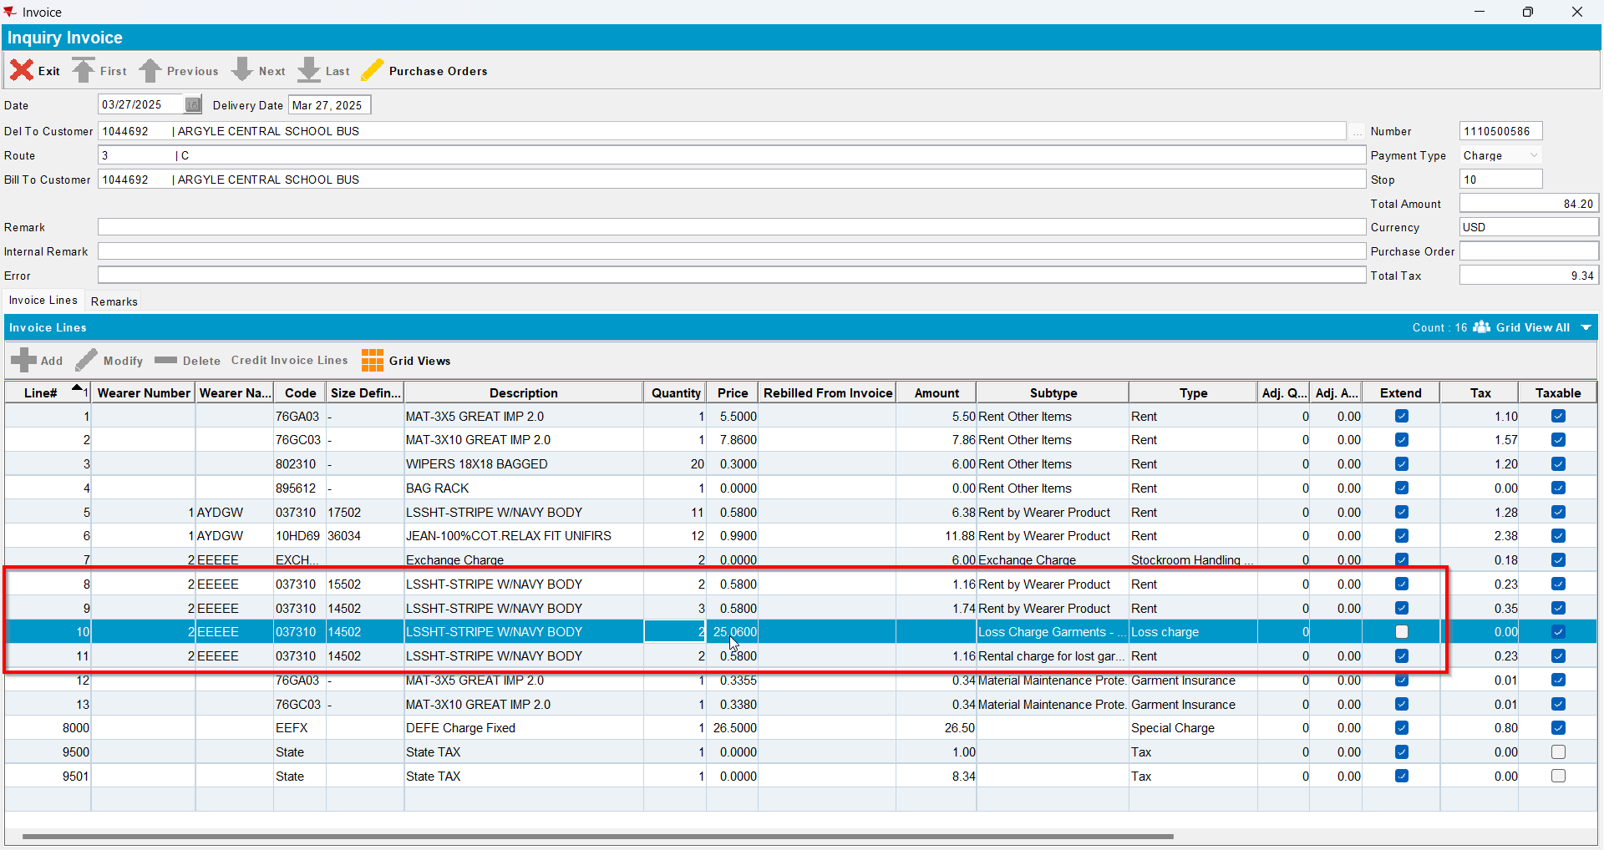
- Replace the new wearer inventory changing only its size back to its original size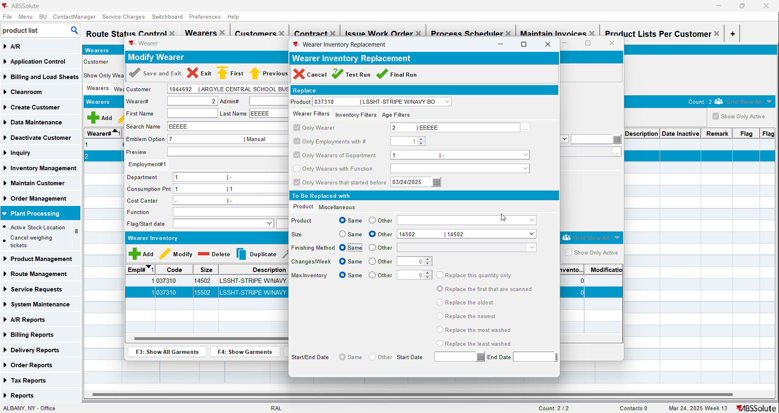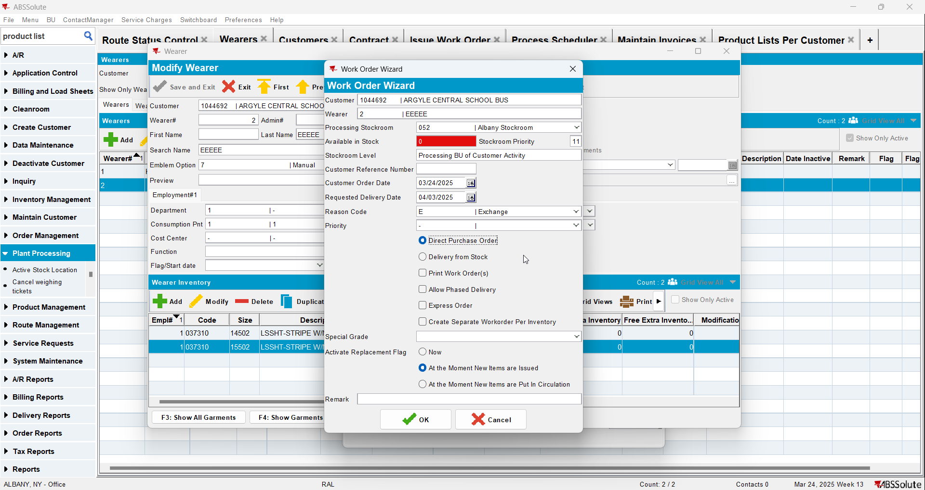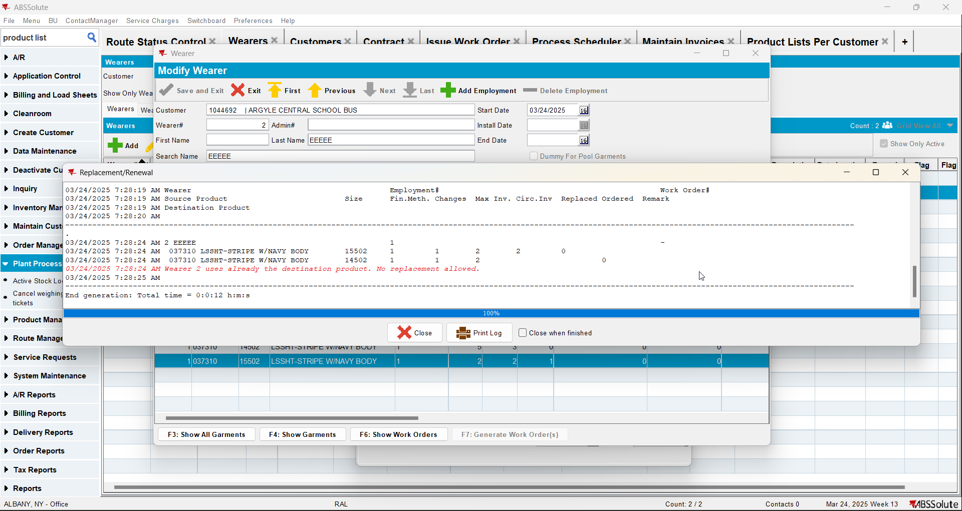

Test Case 5 – WI A full replacement by B & WI A is manually increased back to original MAX, all unique items – Replacements done on Client – Tested OK
Expected behavior: After increasing the inventory back to its original max the REPL_STILLTOBECHARGED should become null
Hash: 529d0c2
- Have SS CHARGEREPLACEDPRODUCT set on Y
- Have a wearer inventory with unique items only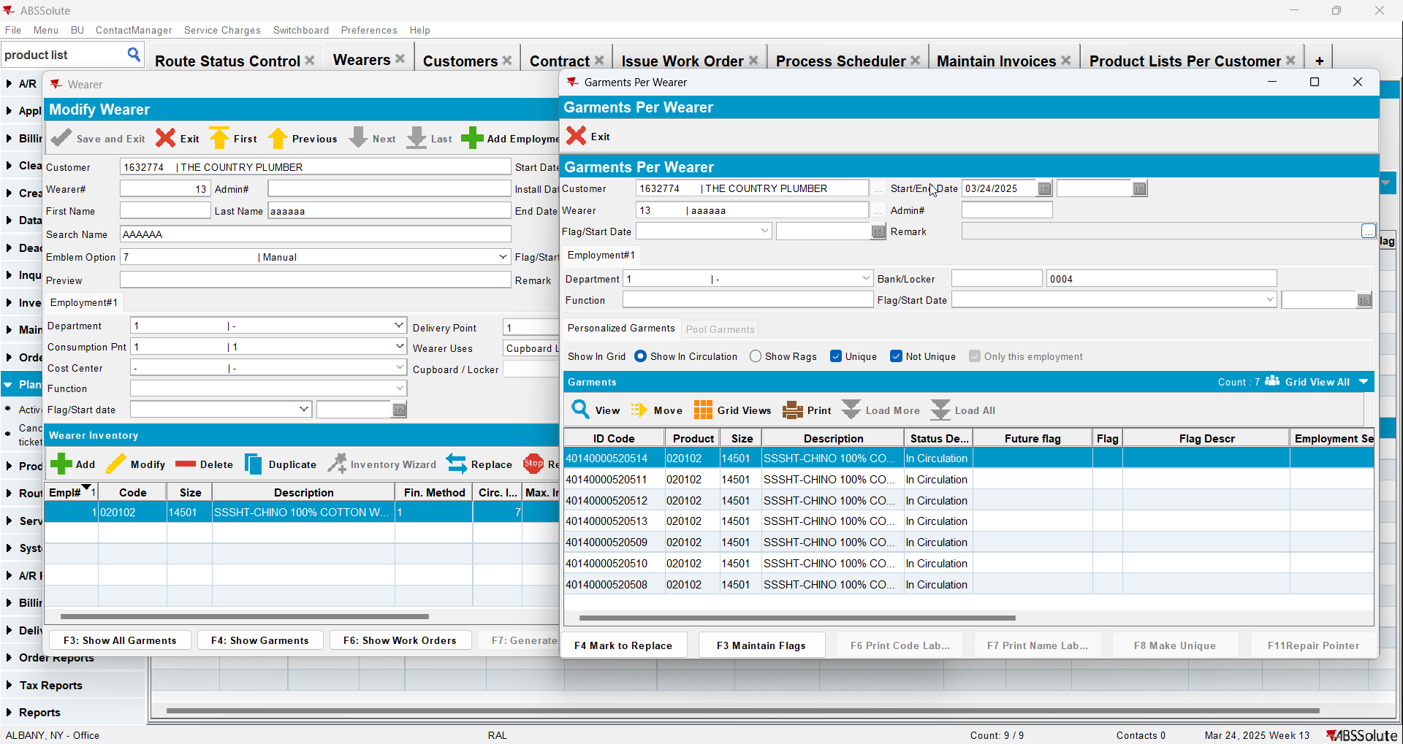
- Check the state of the product using the below sql
select w.wearernumber, p.code pdcode, SZ.code szcode, fm.code fmcode
, wi.wearerinventory_id, wi.circinventory circ
, wi.maxinventory maxi, wi.old_maxinventory oldmaxi
, wi.changesperweek chgwk, wi.old_changesperweek oldchg
, wi.losschargeinvoiceline_id, wi.repl_stilltobecharged, wi.dateinactive
from wearerinventory wi
join weareremployment we on we.weareremployment_id = wi.weareremployment_id
join wearer w on w.wearer_id = we.wearer_id
join customer c on c.customer_id = w.customer_id
join product p on p.product_id = wi.product_id
join sizedefinition sz on sz.sizedefinition_id = wi.sizedefinition_id
join finishingmethod fm on fm.finishingmethod_id = wi.finishingmethod_id
where c.customernumber =
and w.wearernumber =
and p.code = ''
order by p.code, wi.wearerinventory_id

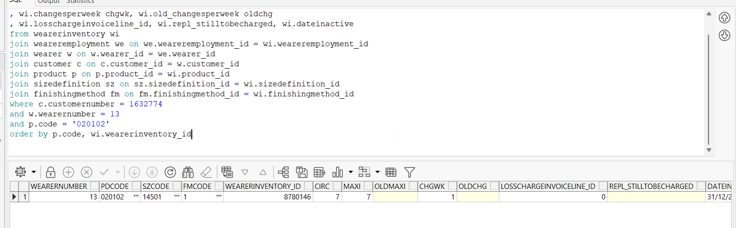
- Replace the wearer inventory changing only its size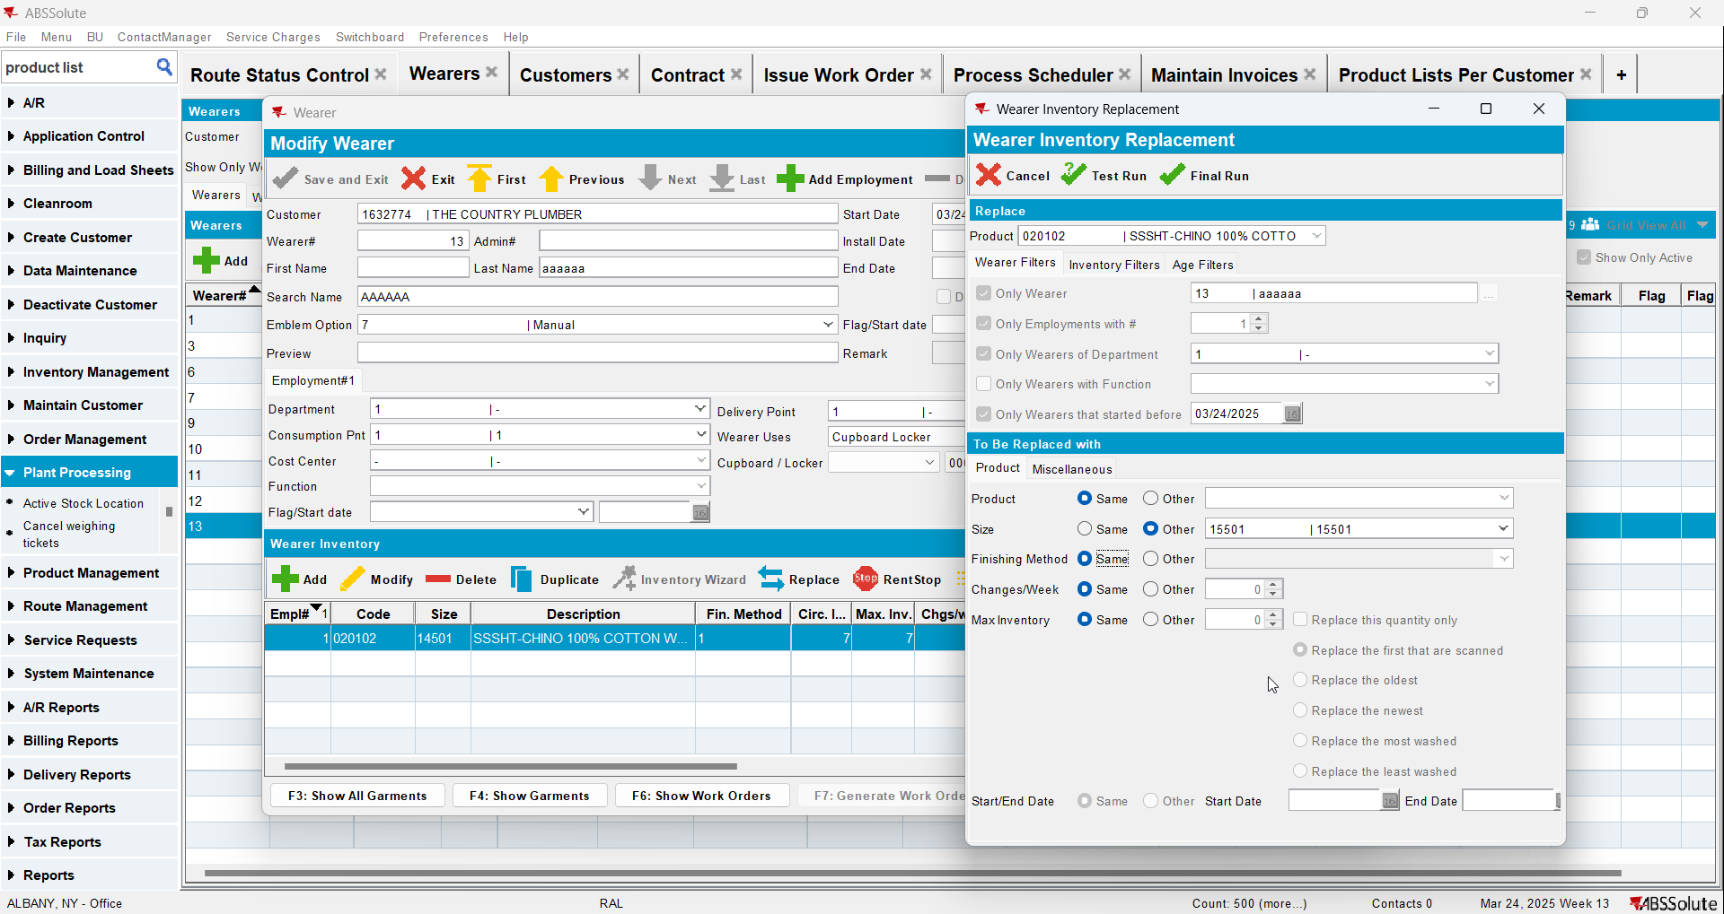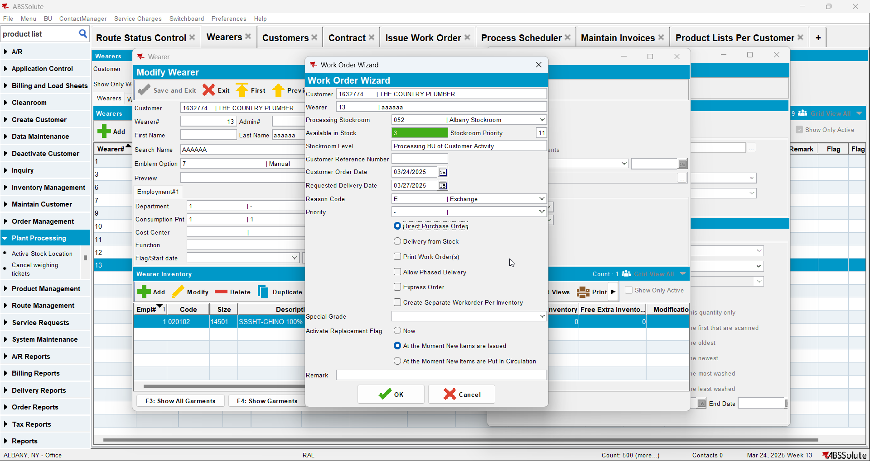
- Check the state of the product 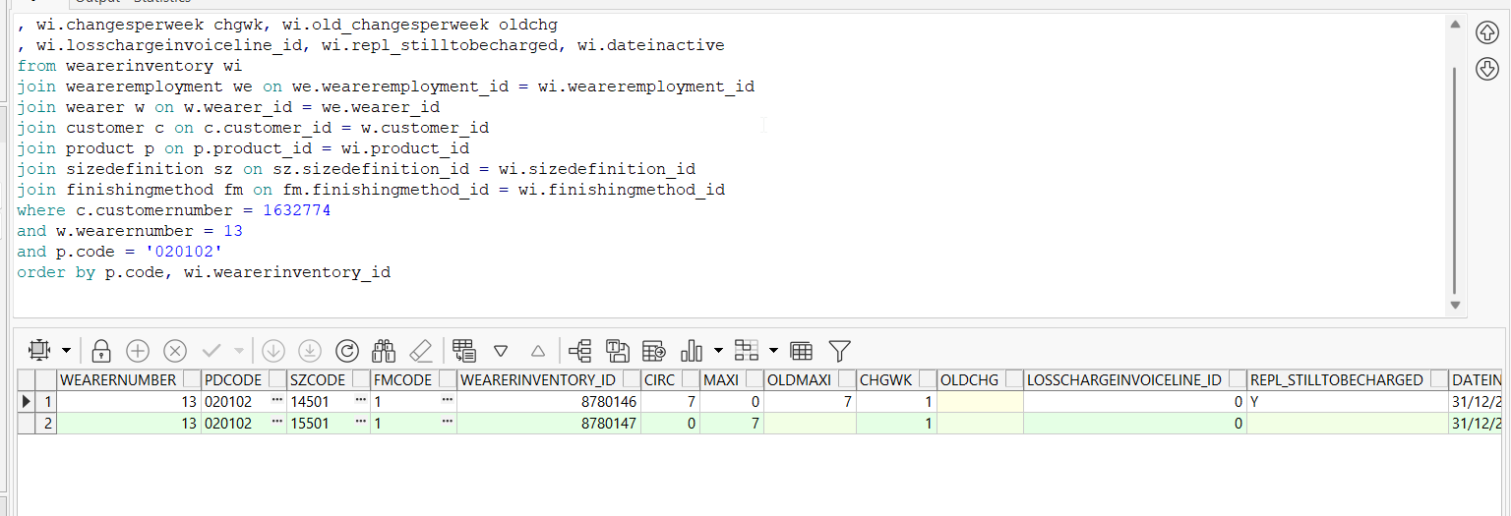
- Issue the items and generate delivery notes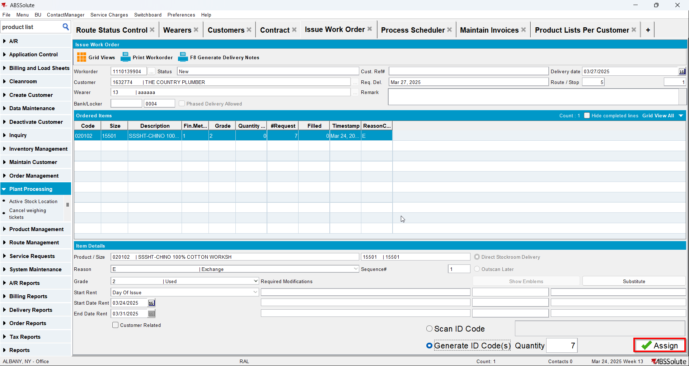
- Check the state of the product(REPL_STILLTOBECHARGED should be null for the second size and Y for the initial size)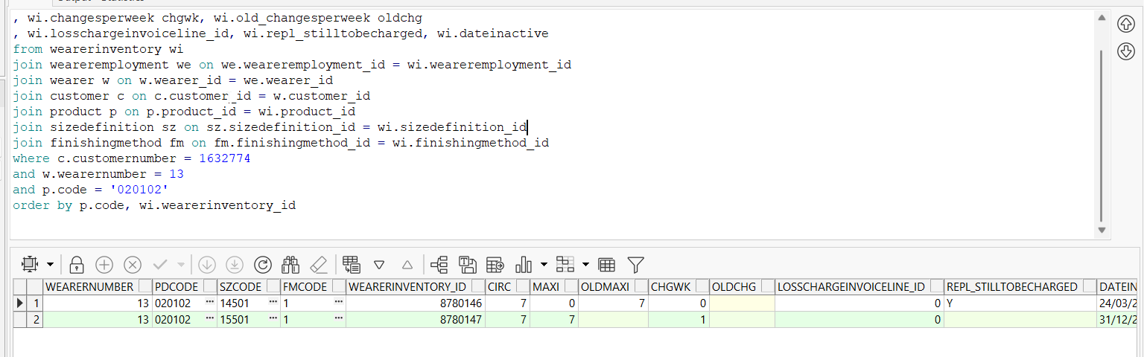
- Generate invoices and check the state of the product(REPL_STILLTOBECHARGED should be null for the second size and N for the initial size)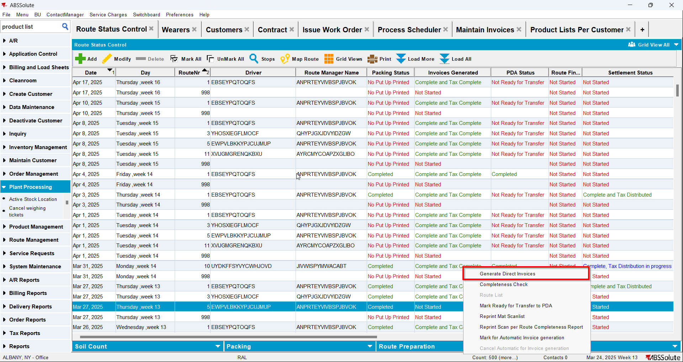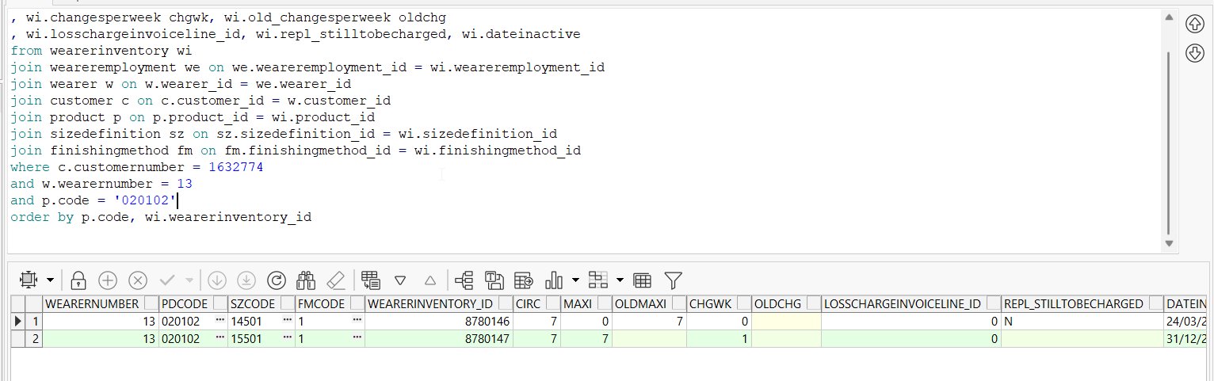
- Settle the route and check the state of the product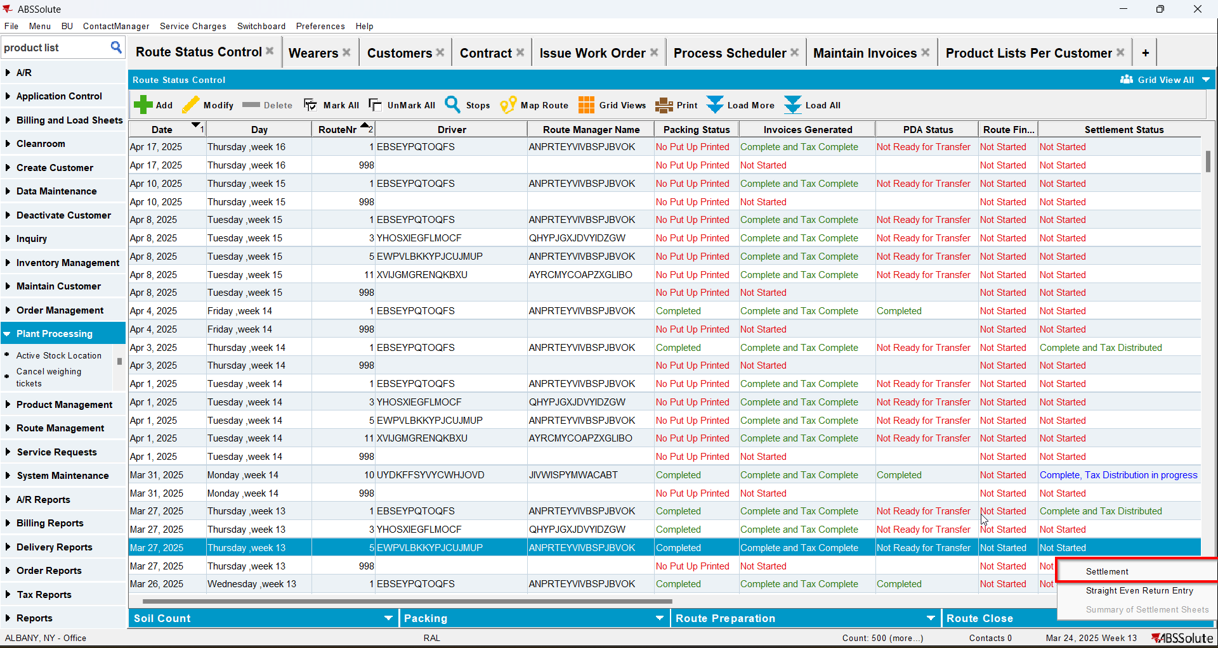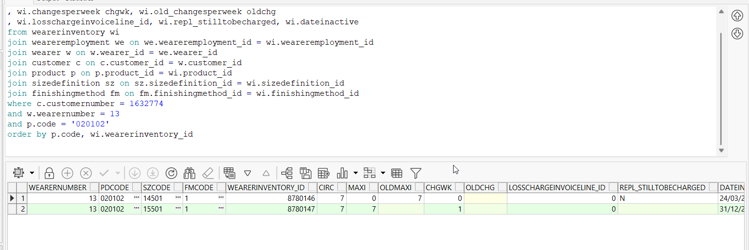
- Check the invoice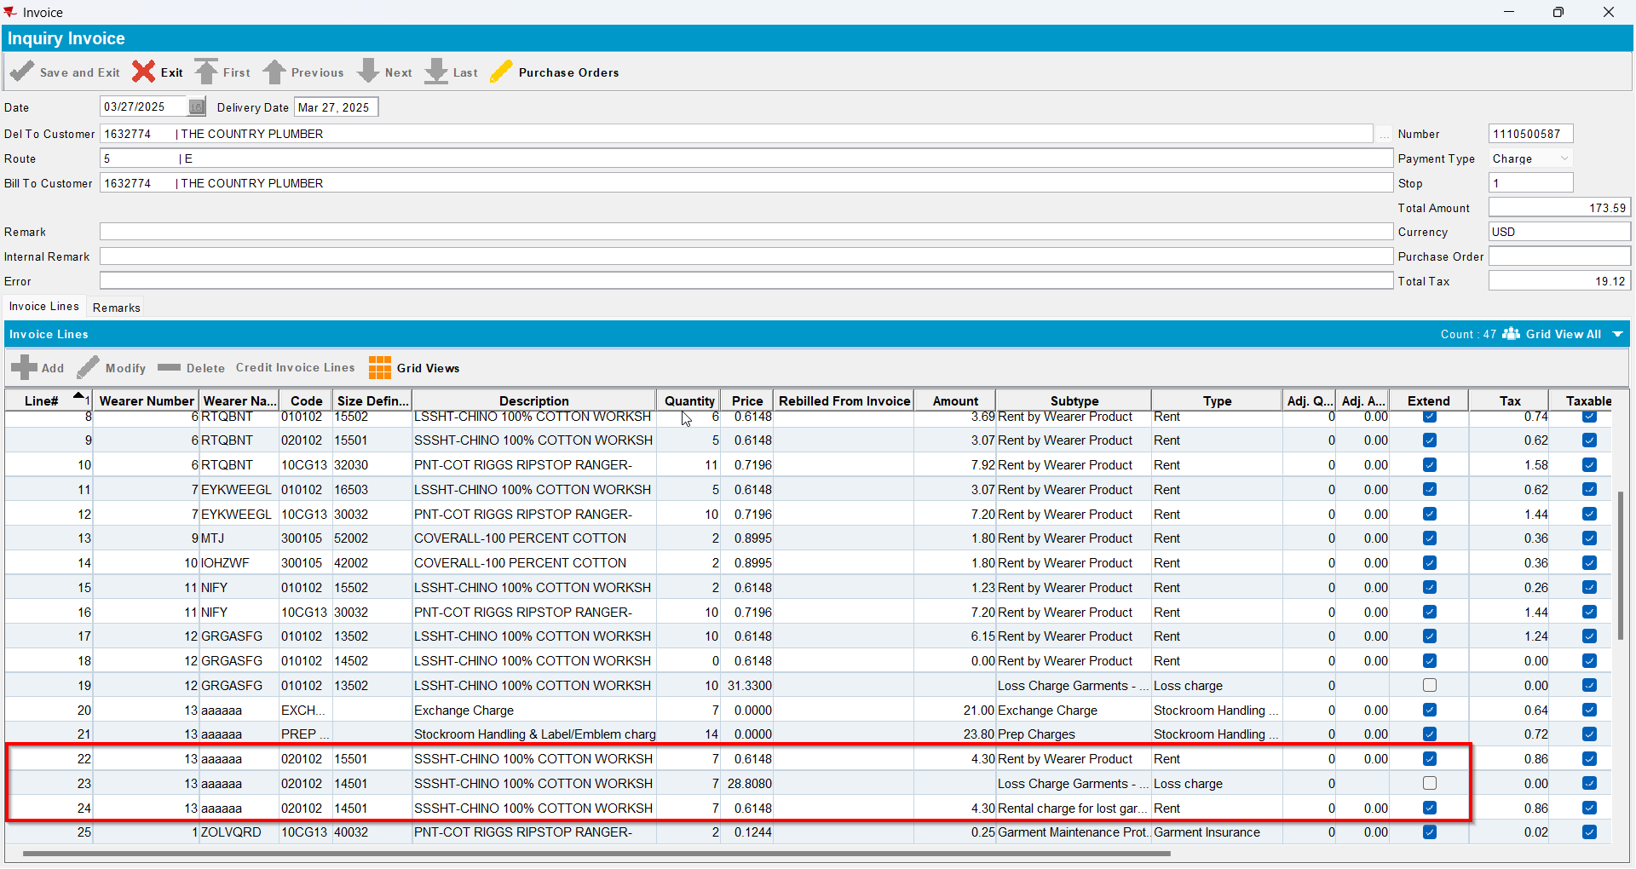
- Modify the original size increasing its max inventory back to its original value and deleting the end date(REPL_STILLTOBECHARGED should be null for the second size and Null for the initial size)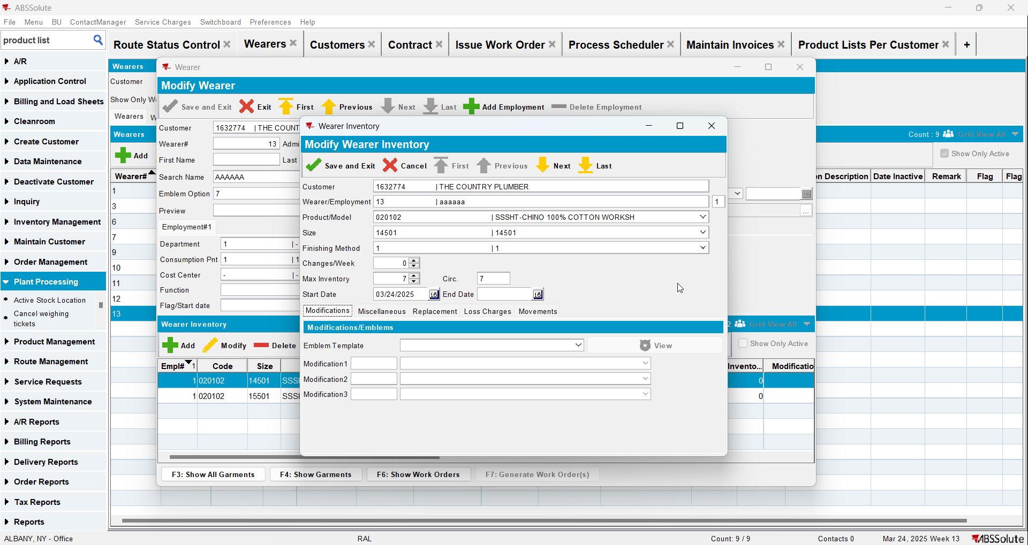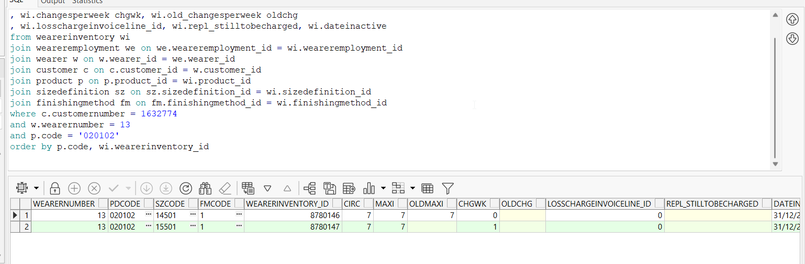
- Generate work order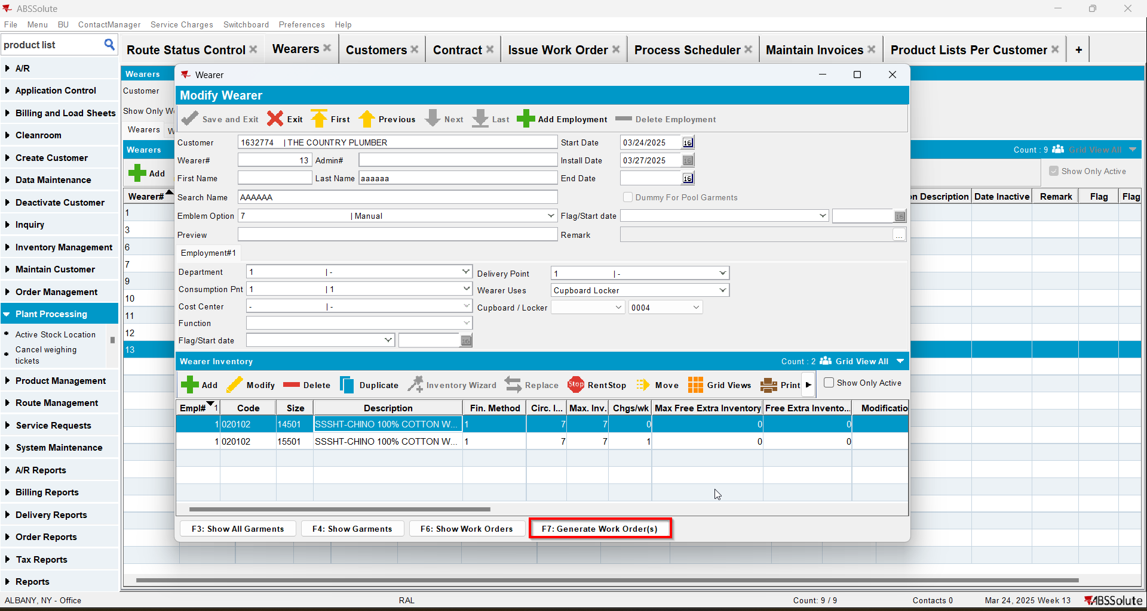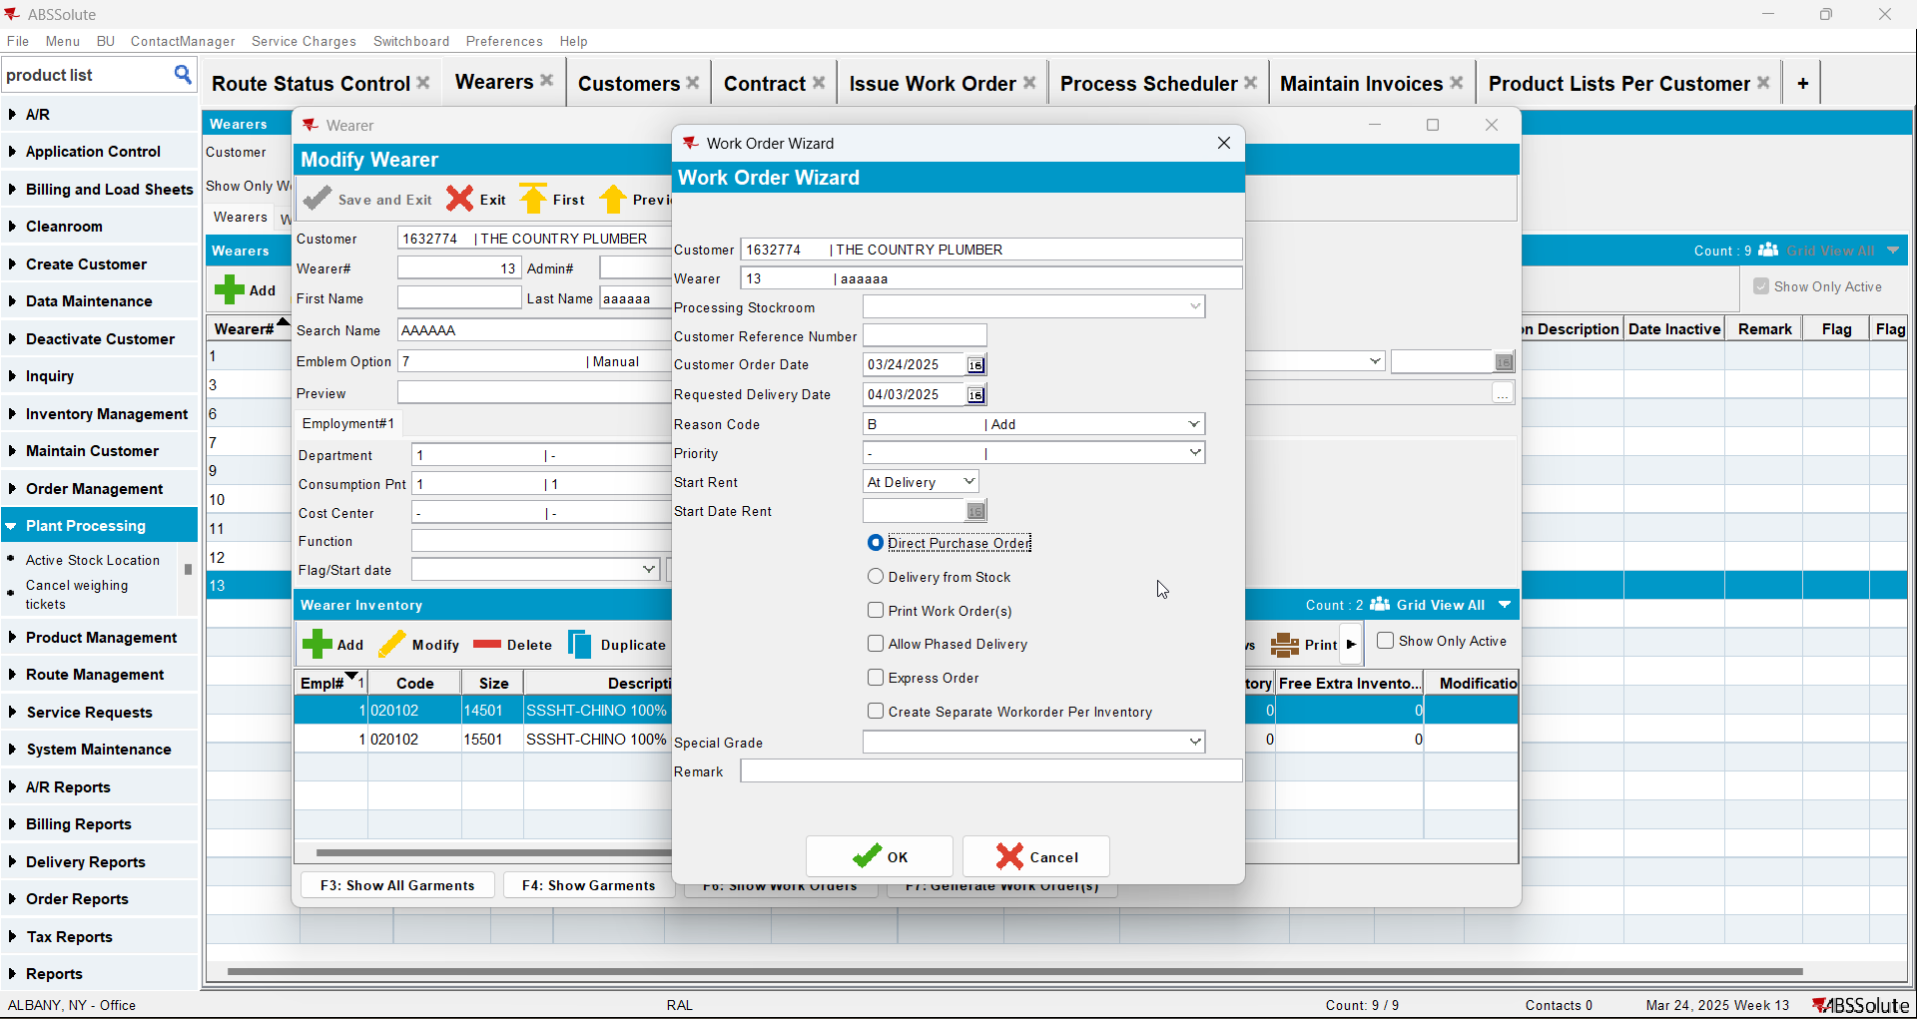
- Issue the items and generate delivery notes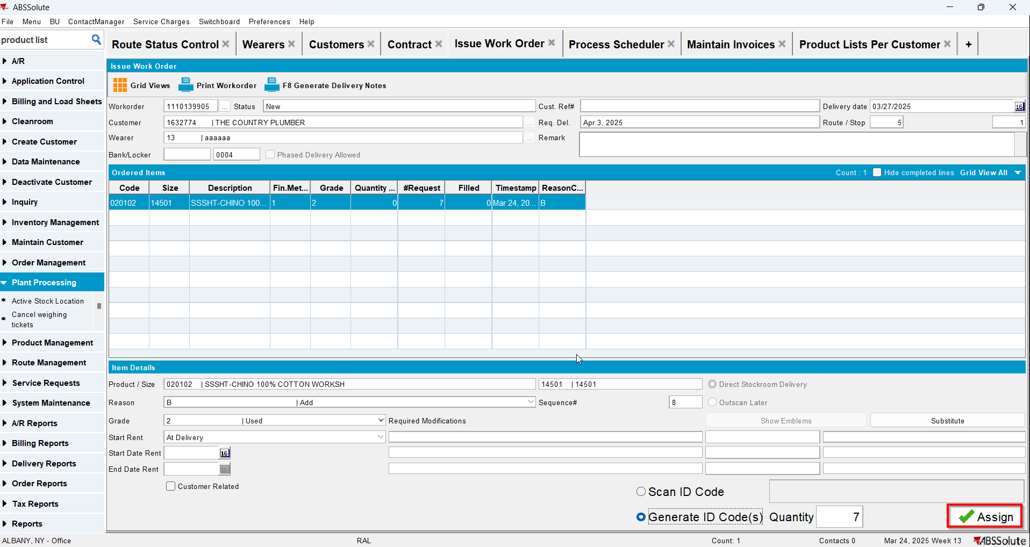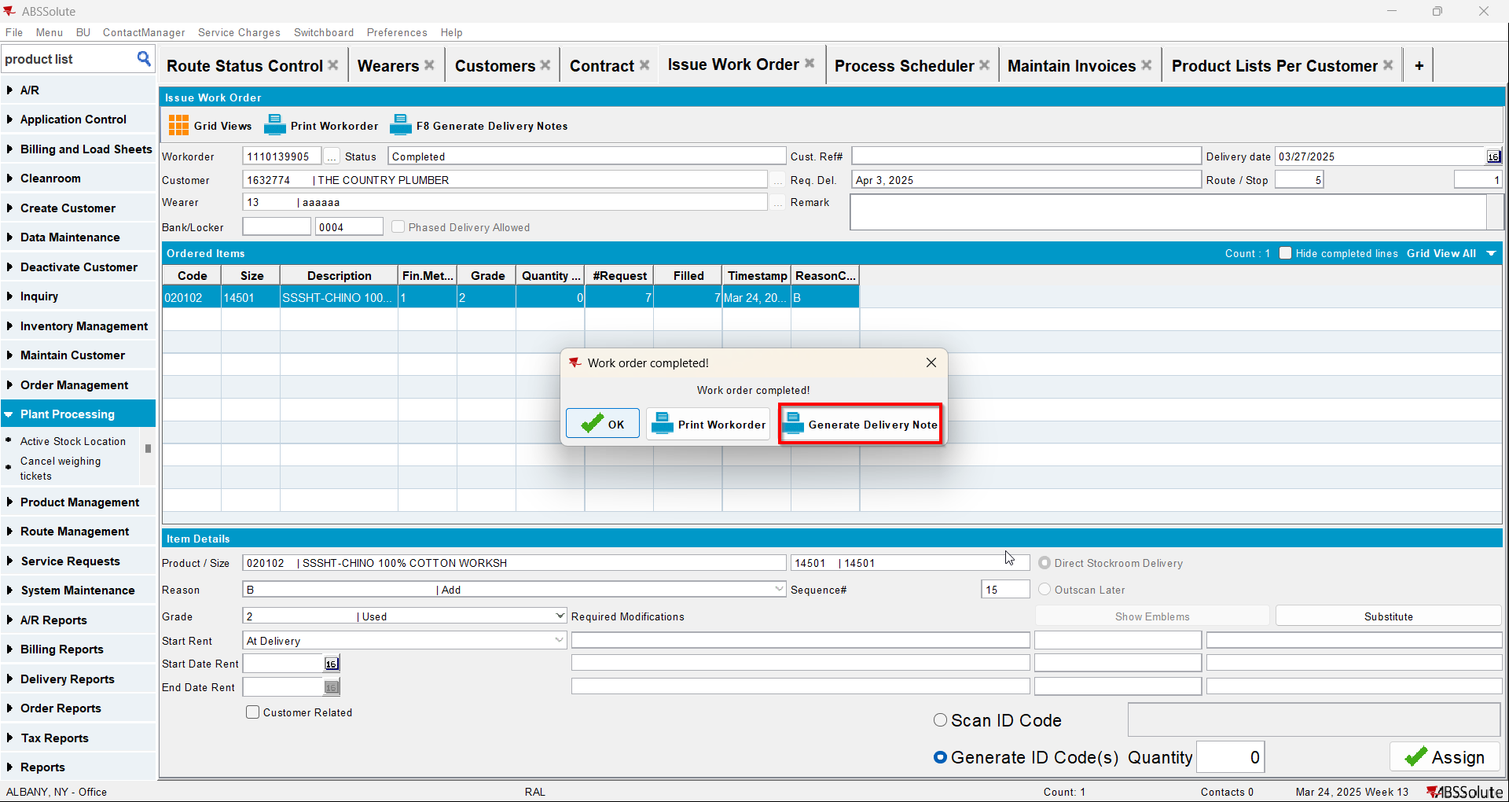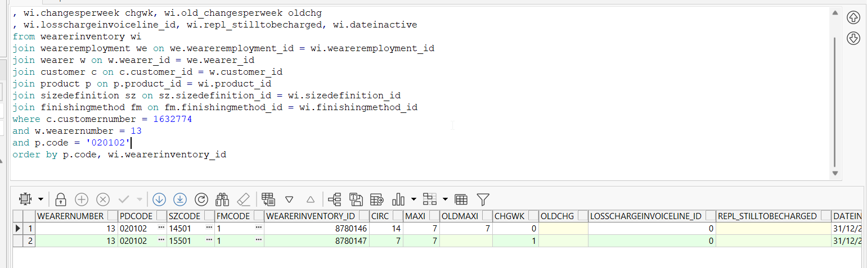
- Generate invoices for next route and check the state of the product(REPL_STILLTOBECHARGED should be null for the second size and Null for the initial size)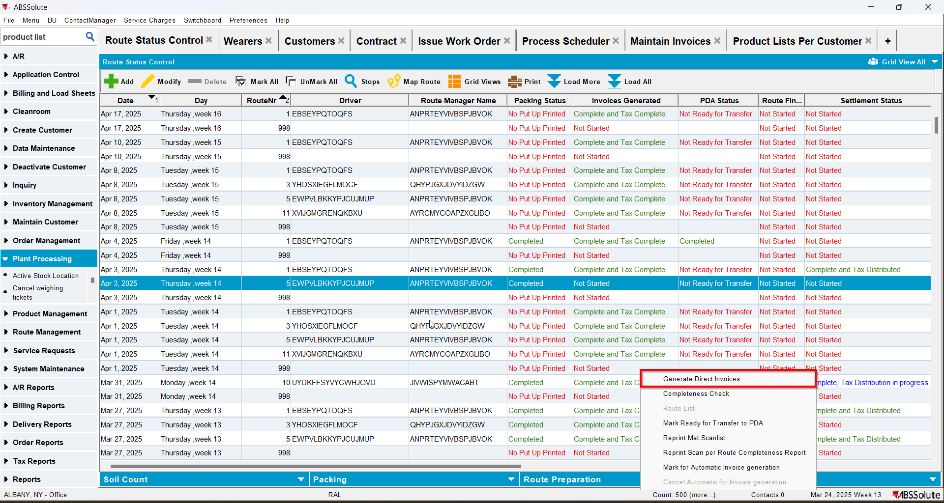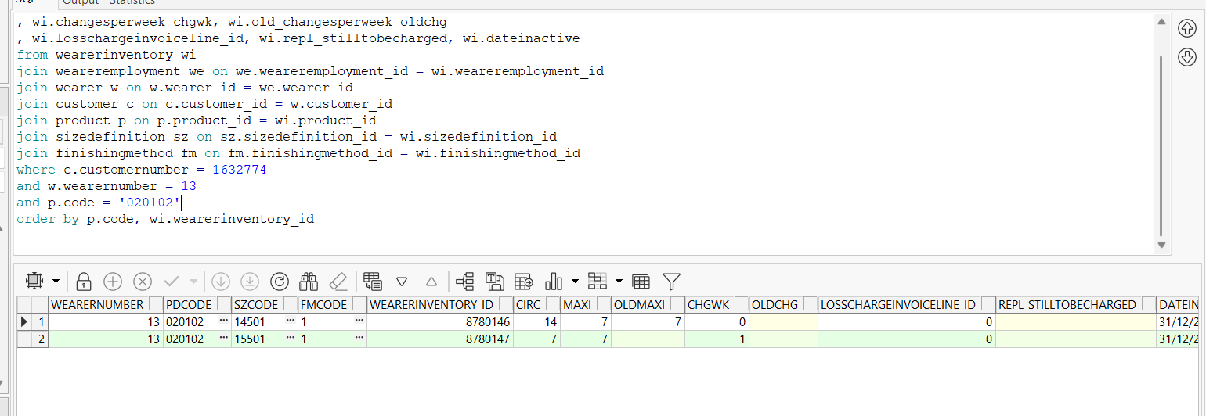
- Check the invoice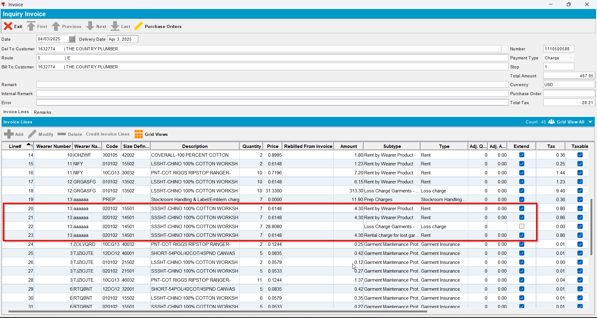
- Generate invoices for the next route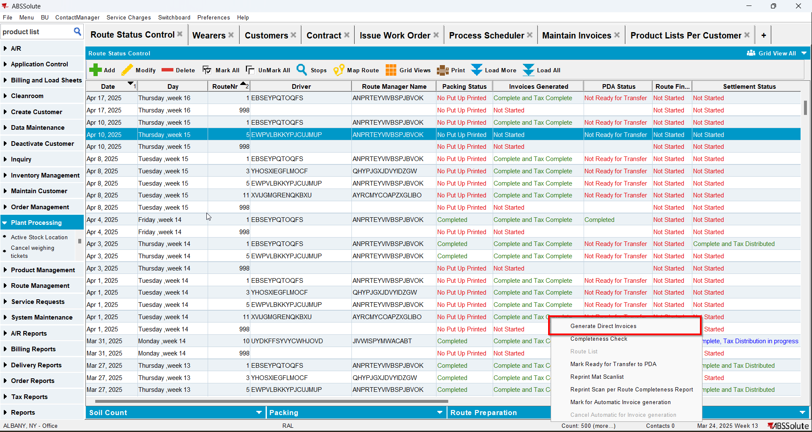
- Check the invoice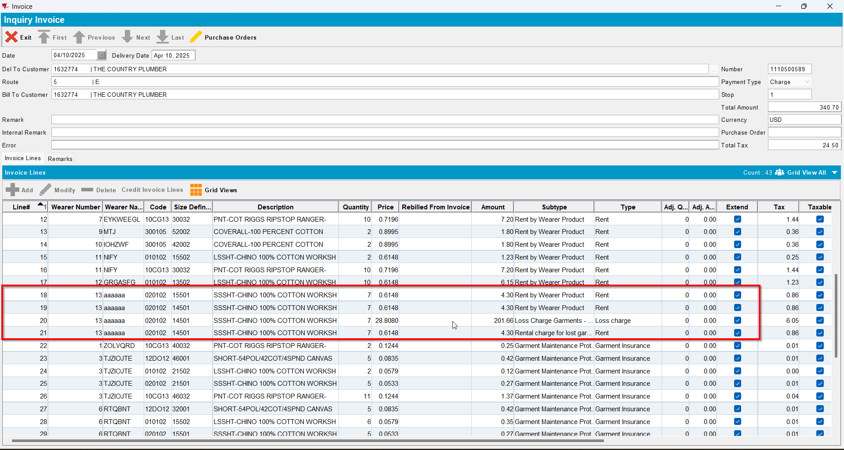
- Generate invoices for the next route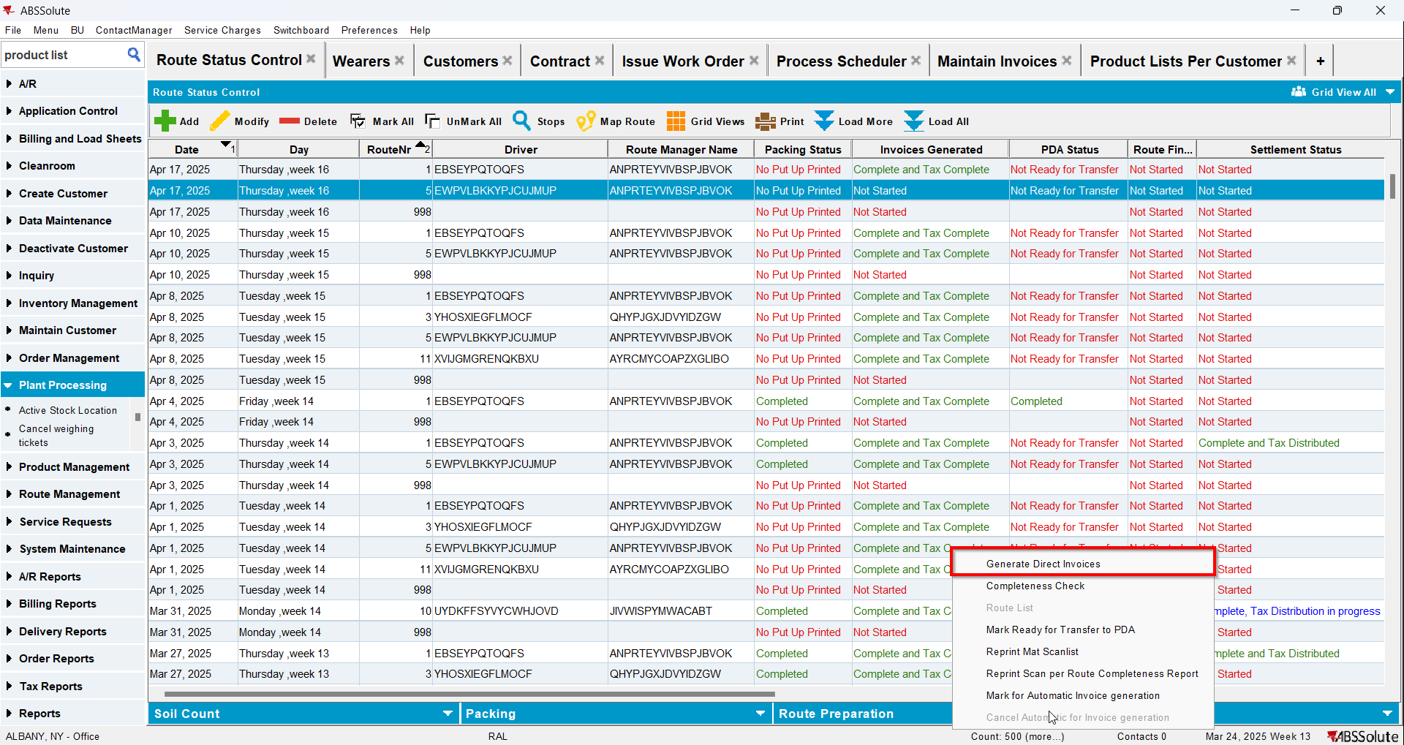
- Check the invoice