ABSN-3983 - Wearer DLG - Removing the DateInactive from a wearer inventory with a loss charge on an unsettled invoice removes the 04 flags
Environment | Prerequisites
Version: 9.07.00.UNF19  DBServerName= abs-srv20.internal.abslbs.com  DBSID=CUST24  DBUser=UNFDEV  DBPassword= UNFDEV  Environment=Test | - Module:  - System setting

Contents
Reproducing before fix 1
Steps to reproduce 1
Current Behavior 6
Retest after fix 7
Test Case 1 – RECHARGELOSSAFTERCREDIT = 1 remove Wearer.DateInactive for a wearer with 2 wearer inventories when the loss charge is present on an invoice with Extend = 'Y' 7
Test Case 2 – RECHARGELOSSAFTERCREDIT = 1 remove WearerInventory.DateInactive when the loss charge is present on an invoice with Extend = 'Y' 12
Test Case 3 – RECHARGELOSSAFTERCREDIT = 0 remove Wearer.DateInactive for a wearer with 2 wearer inventories when the loss charge is present on an invoice with Extend = 'Y' 17
Test Case 4 – RECHARGELOSSAFTERCREDIT = 0 remove WearerInventory.DateInactive when the loss charge is present on an invoice with Extend = 'Y' 23
Test Case 5 – RECHARGELOSSAFTERCREDIT = 2 remove Wearer.DateInactive for a wearer with 2 wearer inventories when the loss charge is present on an invoice with Extend = 'Y' 28
Test Case 6 – RECHARGELOSSAFTERCREDIT = 2 remove WearerInventory.DateInactive when the loss charge is present on an invoice with Extend = 'Y' 31

Reproducing before fix

Steps to reproduce
- Wearers DLG: Find an active wearer inventory 11 max/11 circ
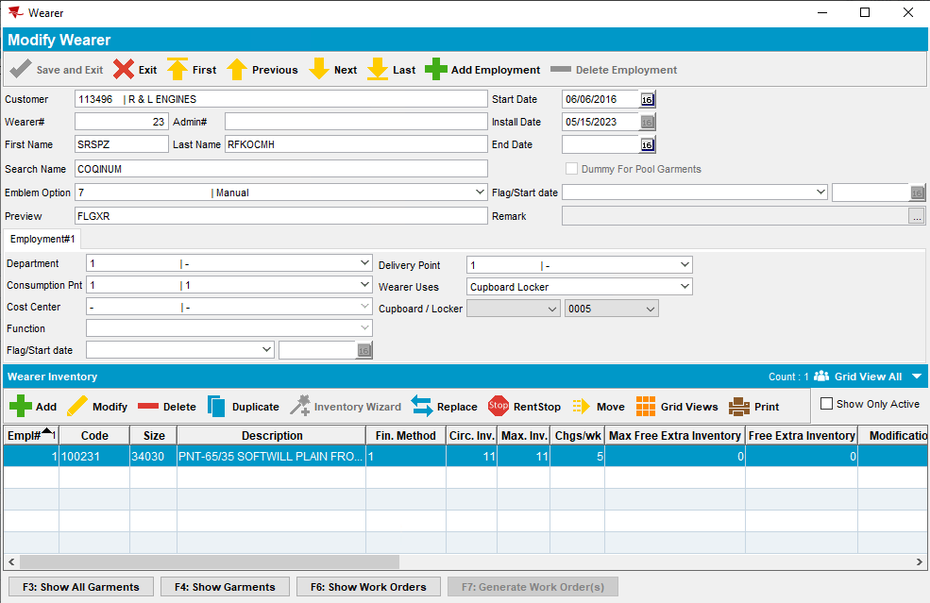
- Wearers DLG: Set the dateinactive for this WI as sysdate
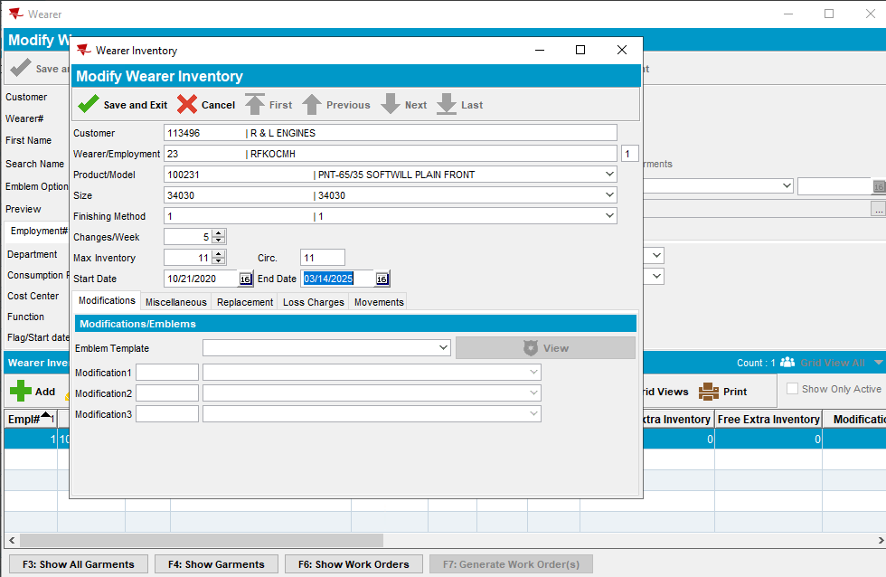
- Route Status Control DLG: Generate the invoice 3 weeks from sysdate so that the Loss charge will be Extend = 'Y'
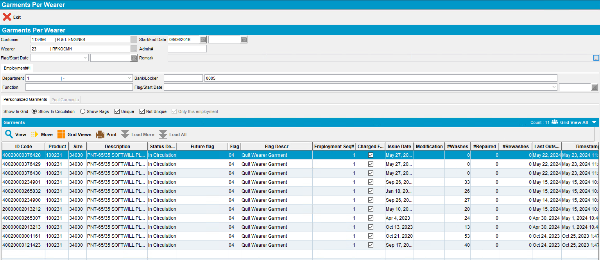
- Wearers DLG: Go back to the same wearer inventory and delete the DateInactive date
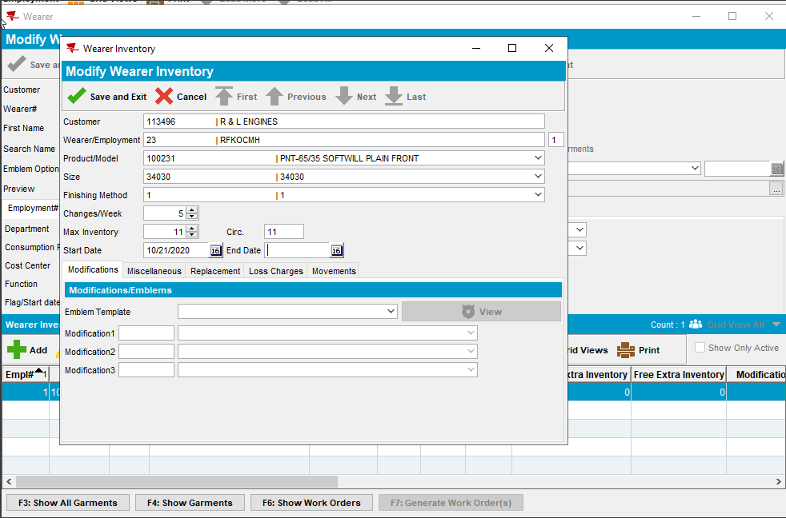
- Observe the garments per wearer
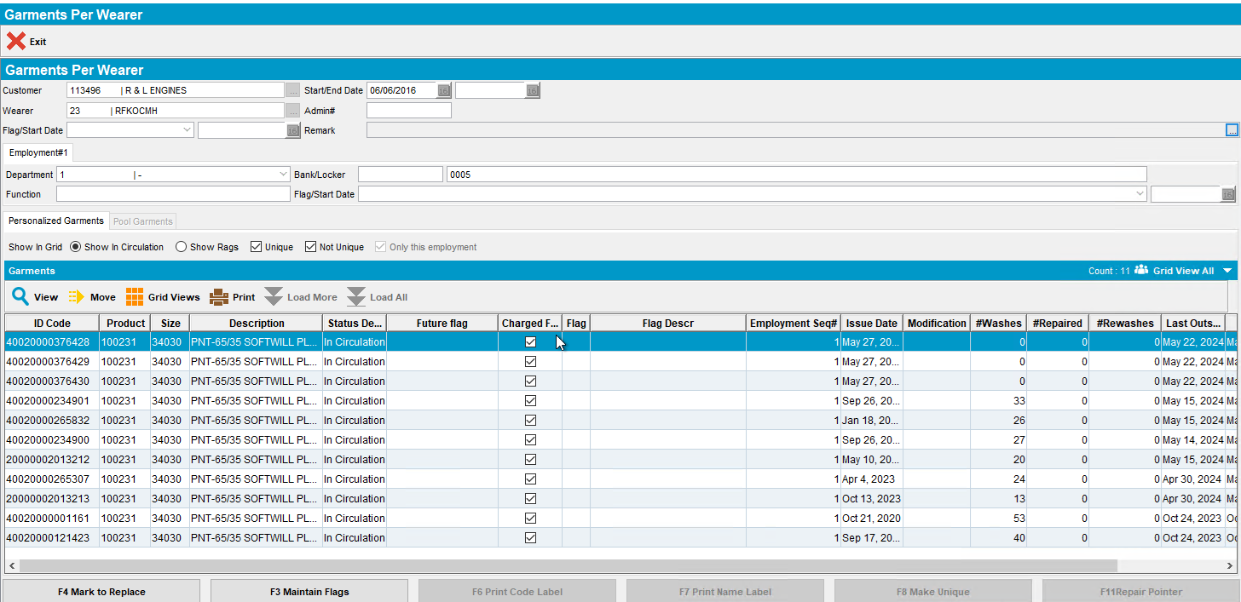
- Send the invoice to RA
- Do a full credit on the loss line on RA
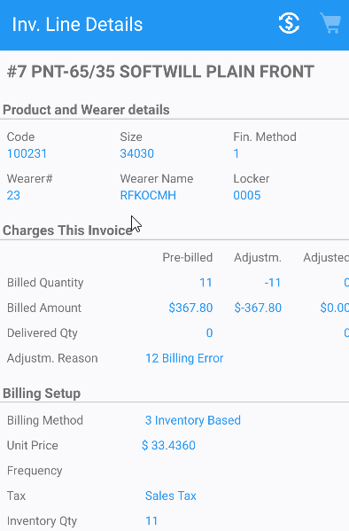
- WebX: Settle the route
- Wearers DLG: observe that the garments were ragged even though the quantity on the loss line was credited fully
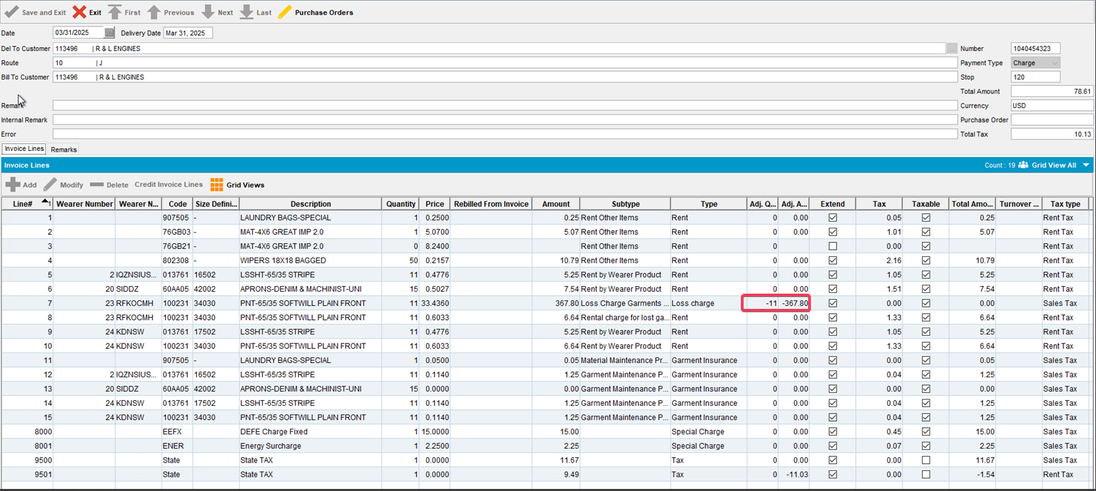
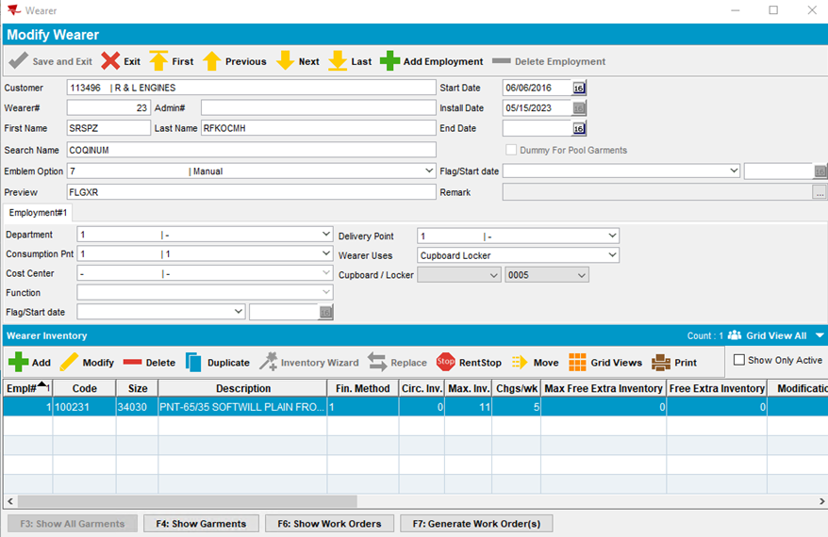

REPRODUCED OK.

Current Behavior
The garments per wearer are now still linked to the loss charge line and still have charged for loss = 'Y' but the 04 flags are gone. This leads to bad behavior down the line if the invoice line is credited we still rag the garments.

Retest after fix

Test Case 1 – RECHARGELOSSAFTERCREDIT = 1 remove Wearer.DateInactive for a wearer with 2 wearer inventories when the loss charge is present on an invoice with Extend = 'Y'
Hash: 268c8fa75cbf
Expected behavior: The user is blocked from removing the wearer.dateinactive while the invoice with the loss charge is unsettled, the user can remove the dateinactive after canceling the invoice with the loss charge
- System Settings: Set RECHARGELOSSAFTERCREDIT = 1
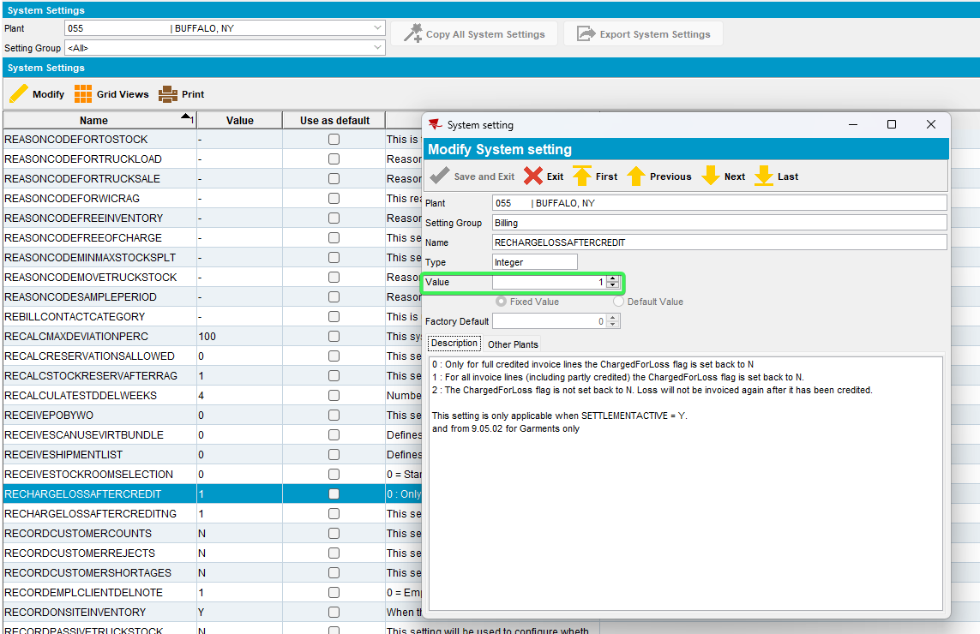
- Wearers DLG: Find an active wearer with wearer inventory
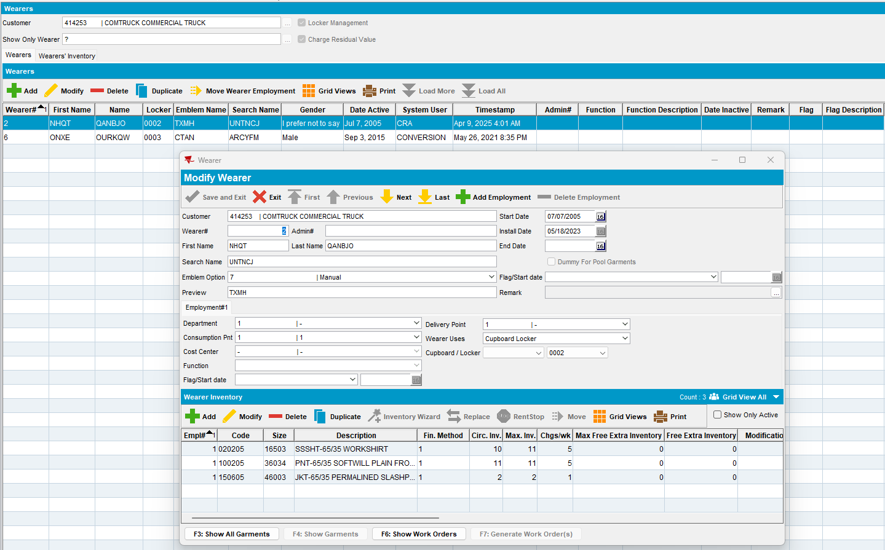
- Wearers DLG: Set the dateinactive for this Wearer as sysdate
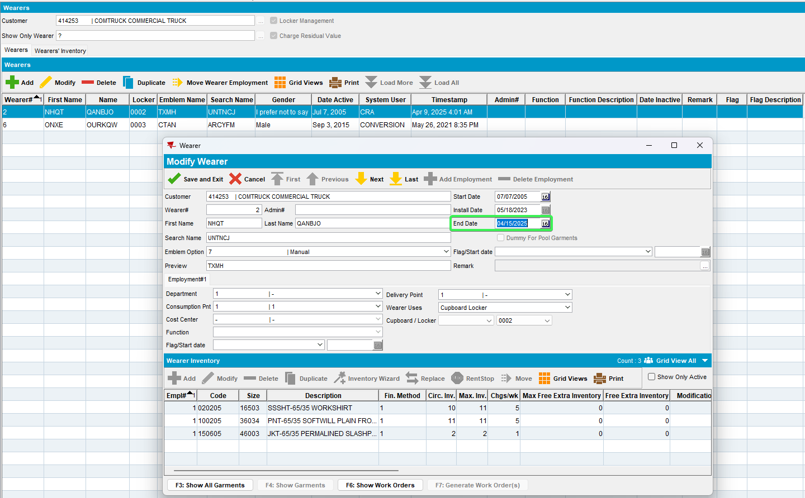
- Route Status Control DLG: Generate the invoice 3 weeks from sysdate so that the Loss charge will be Extend = 'Y'
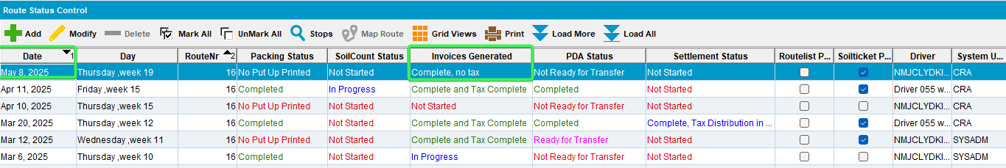
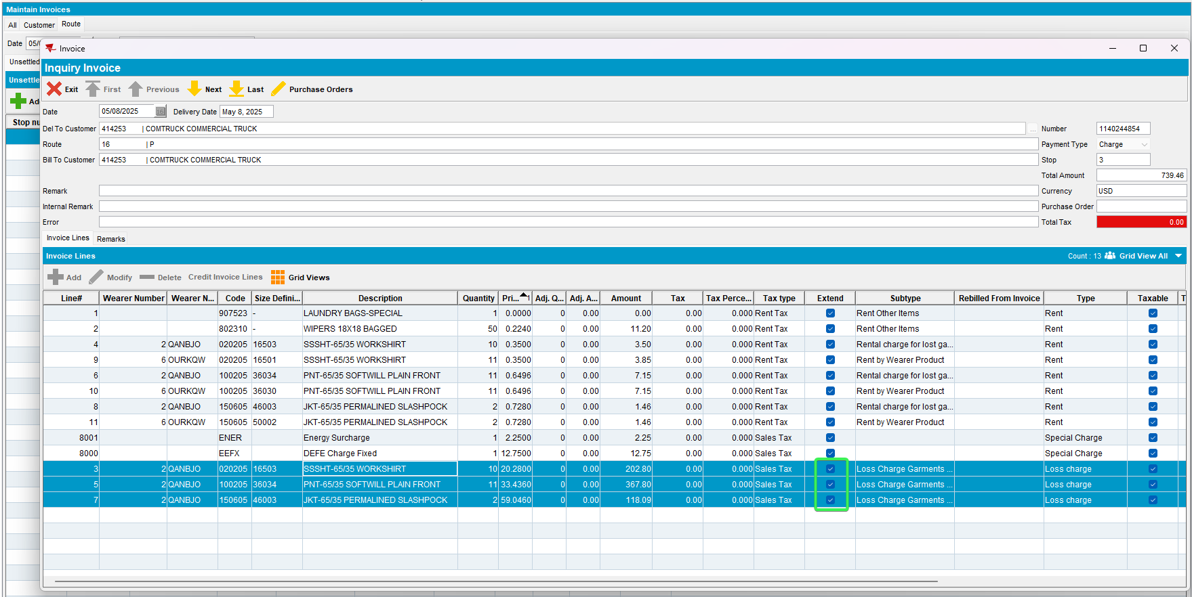
- Wearers DLG: Go back to the same wearer and delete the DateInactive date
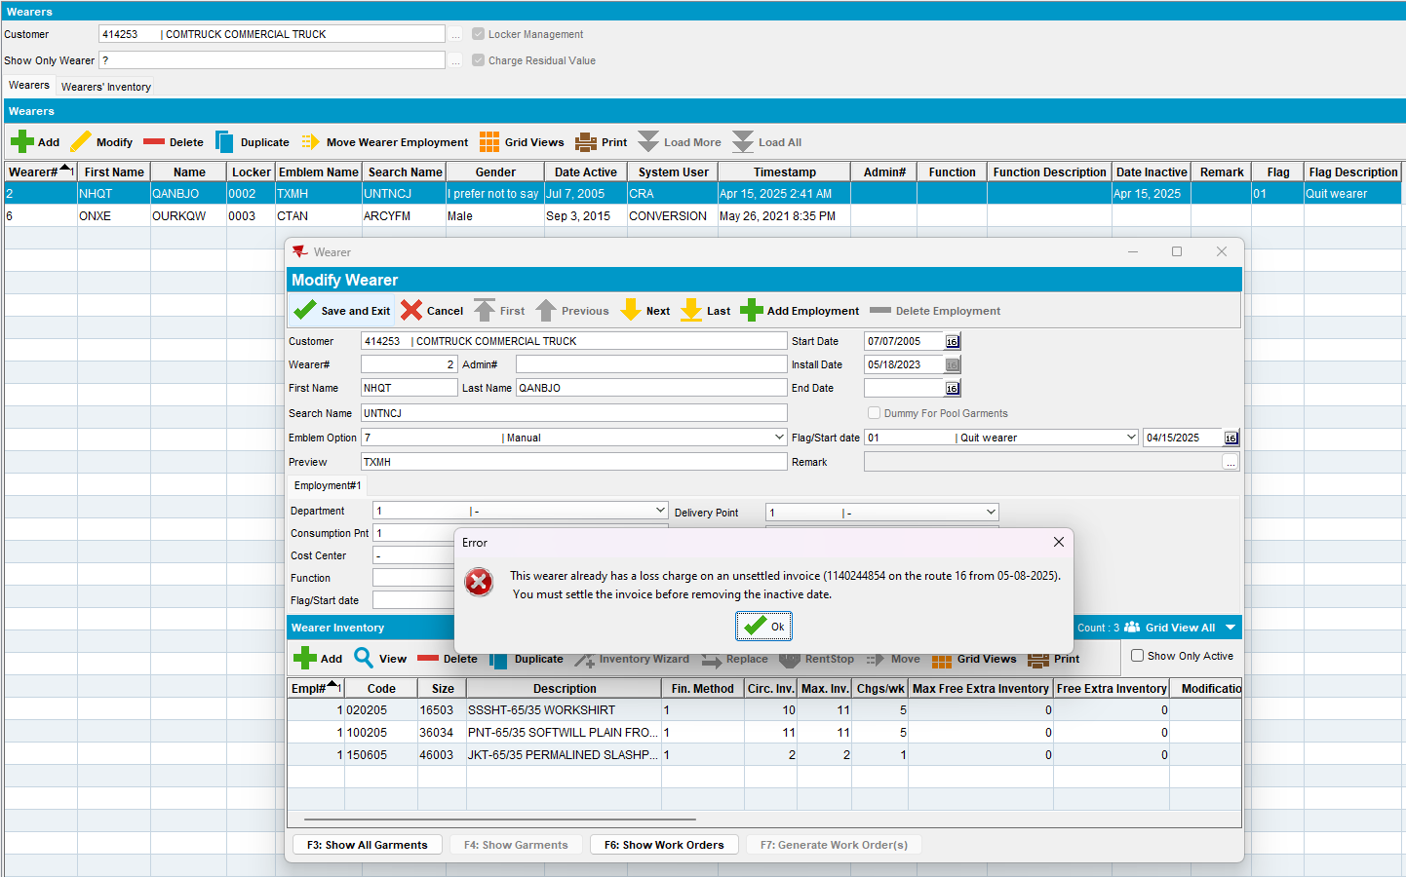
- Press Cancel and recheck the wearer date
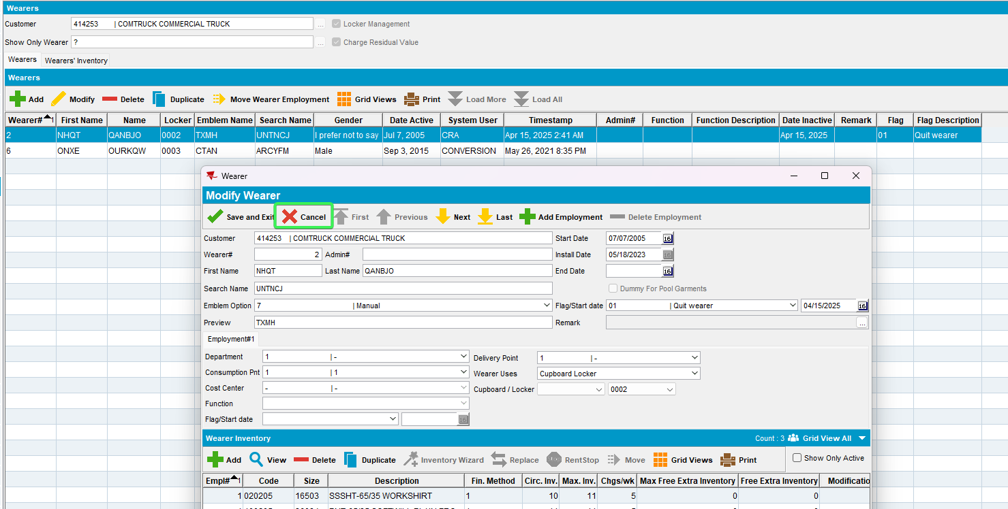
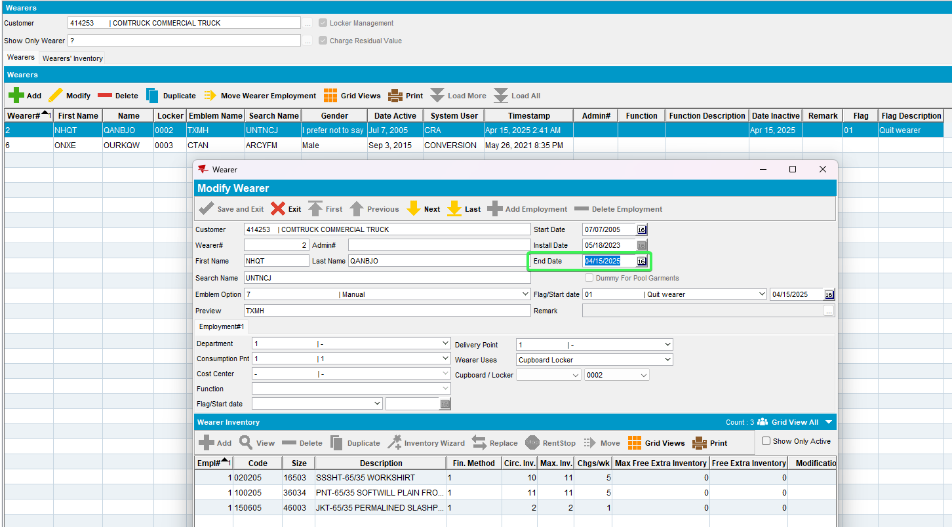
- Cancel the Generate invoice
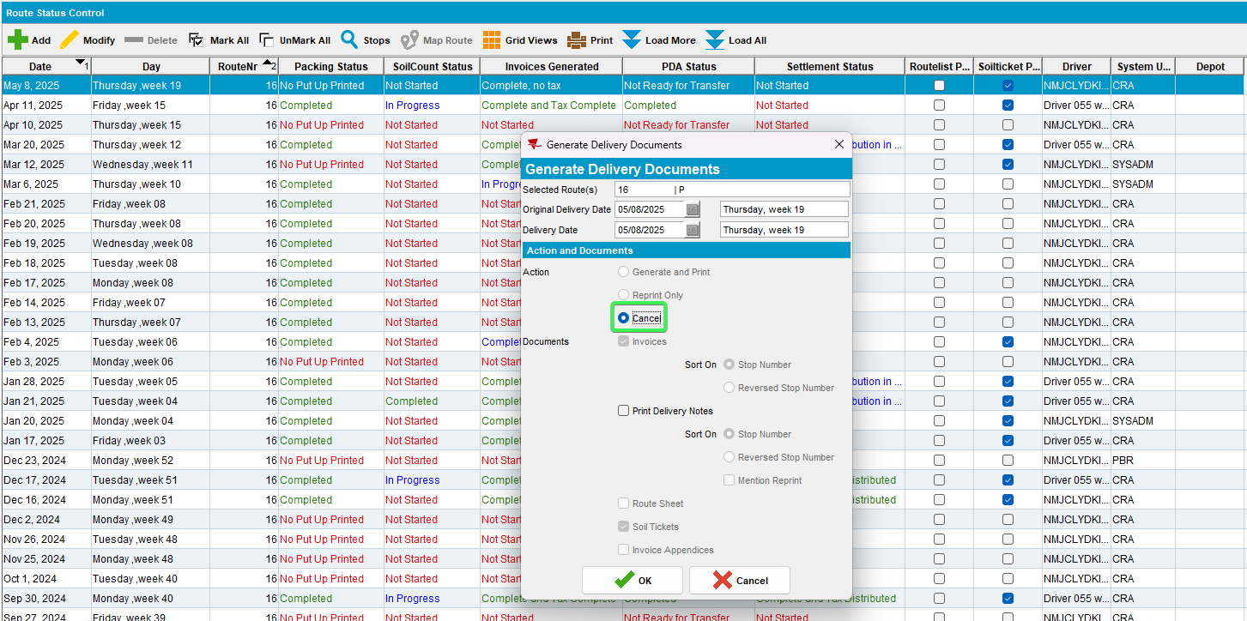
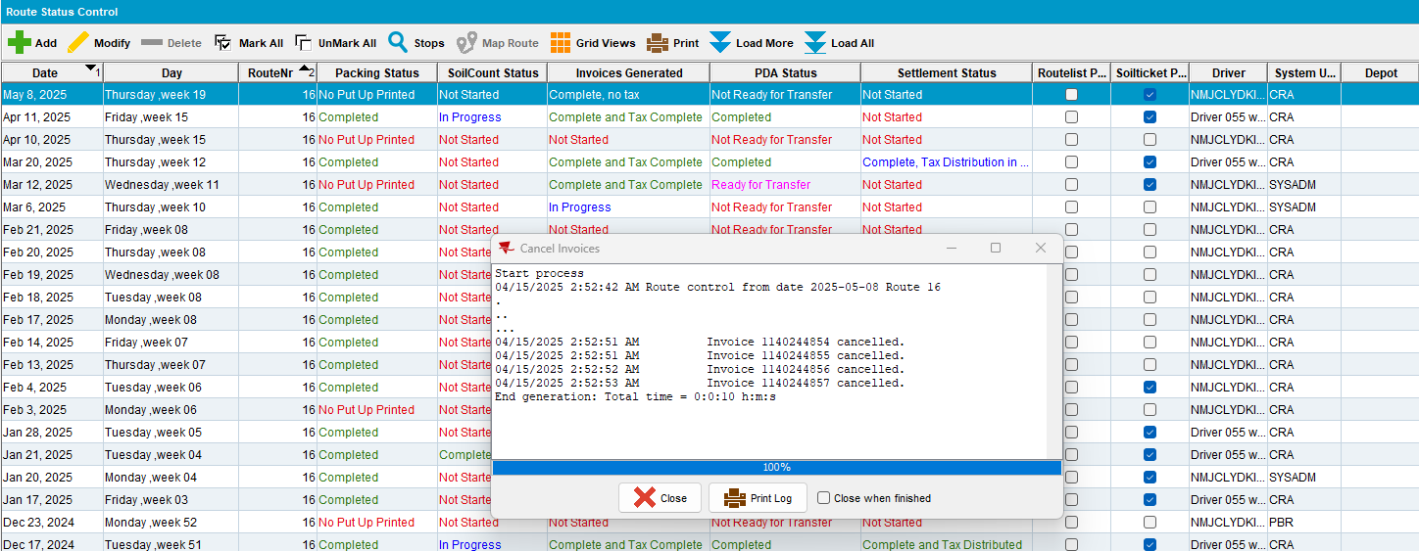
- Try removing the inactive date
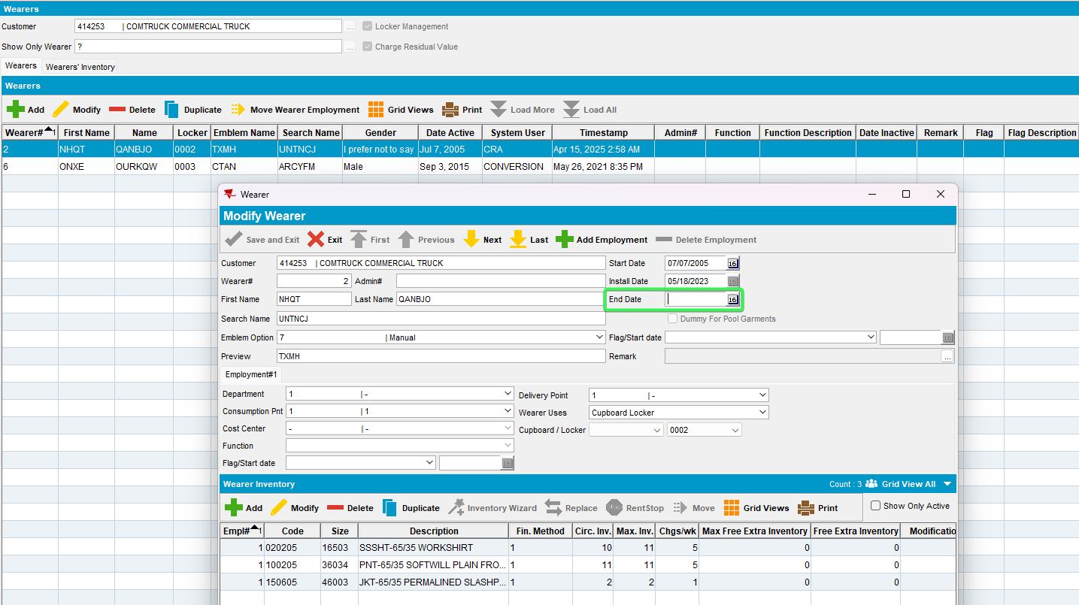
Tested OK

Test Case 2 – RECHARGELOSSAFTERCREDIT = 1 remove WearerInventory.DateInactive when the loss charge is present on an invoice with Extend = 'Y'
Hash: 268c8fa75cbf
Expected behavior: The user is blocked from removing the weareinventory.dateinactive while the invoice with the loss charge is unsettled, the user can remove the dateinactive after canceling the invoice with the loss charge
- System Settings: Set RECHARGELOSSAFTERCREDIT = 1
- Wearers DLG: Find an active wearer with wearer inventory
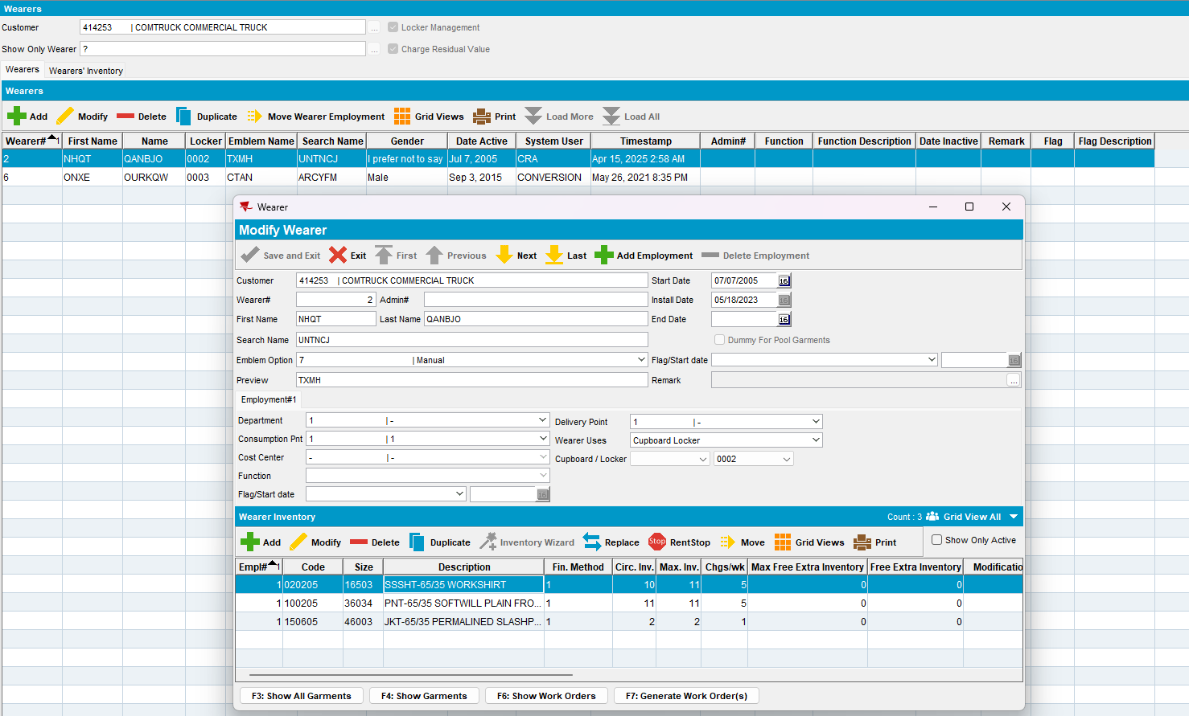
- Wearers DLG: Set the dateinactive for this WI as sysdate
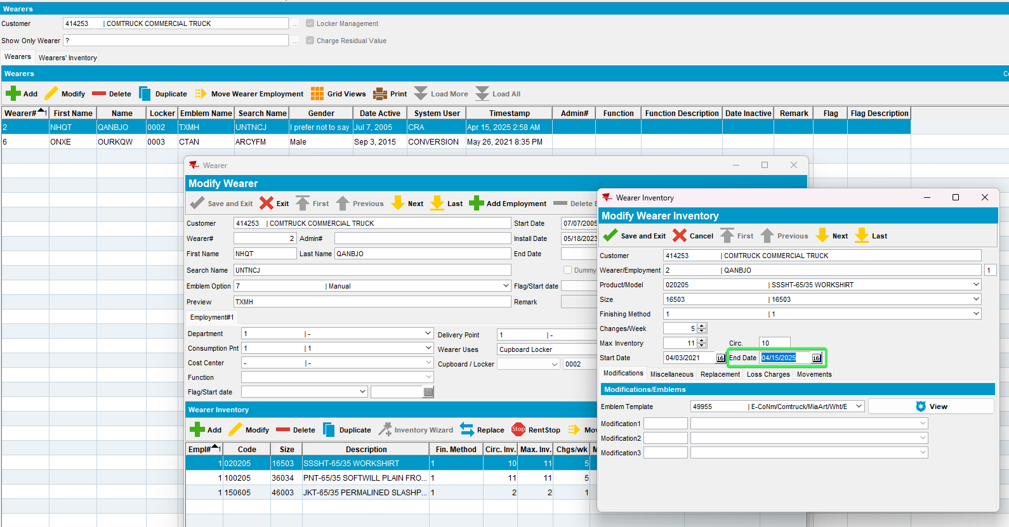

- Route Status Control DLG: Generate the invoice 3 weeks from sysdate so that the Loss charge will be Extend = 'Y'
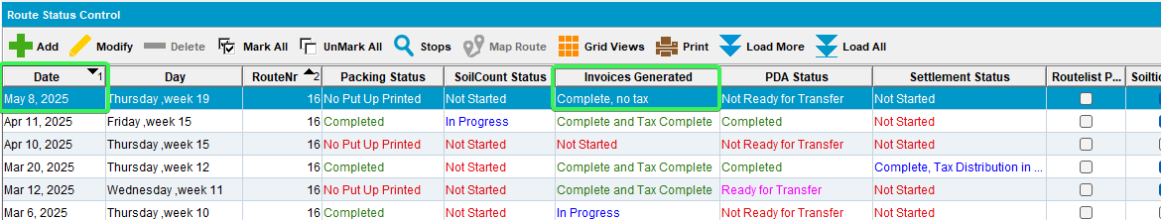
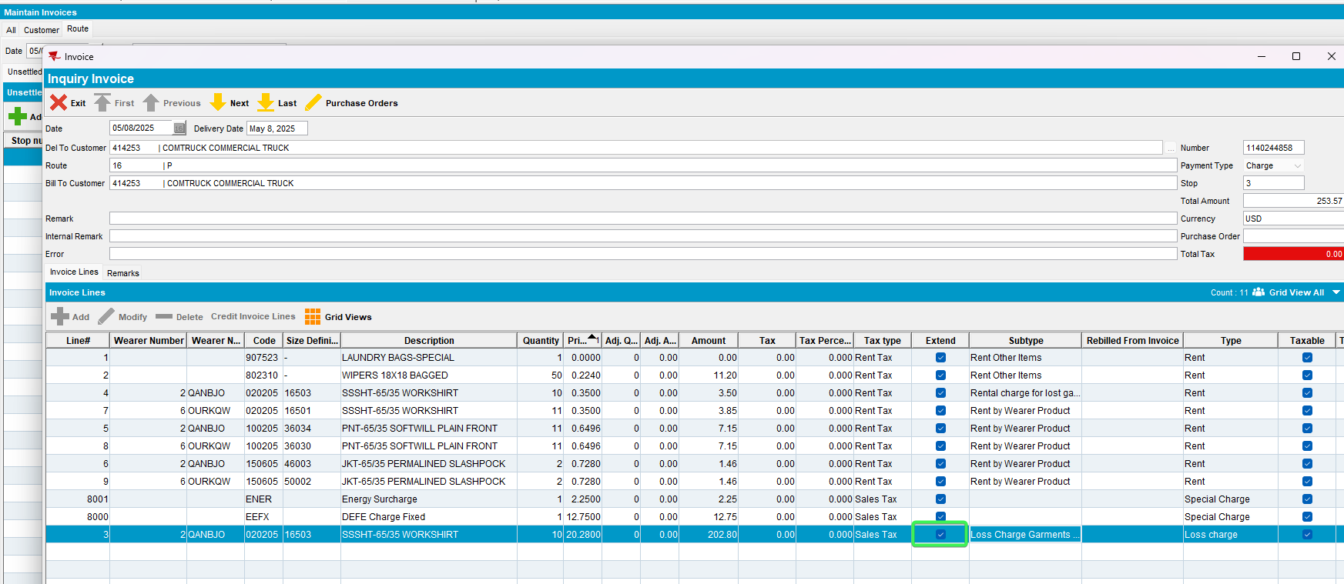
- Wearers DLG: Go back to the same WI and delete the DateInactive date
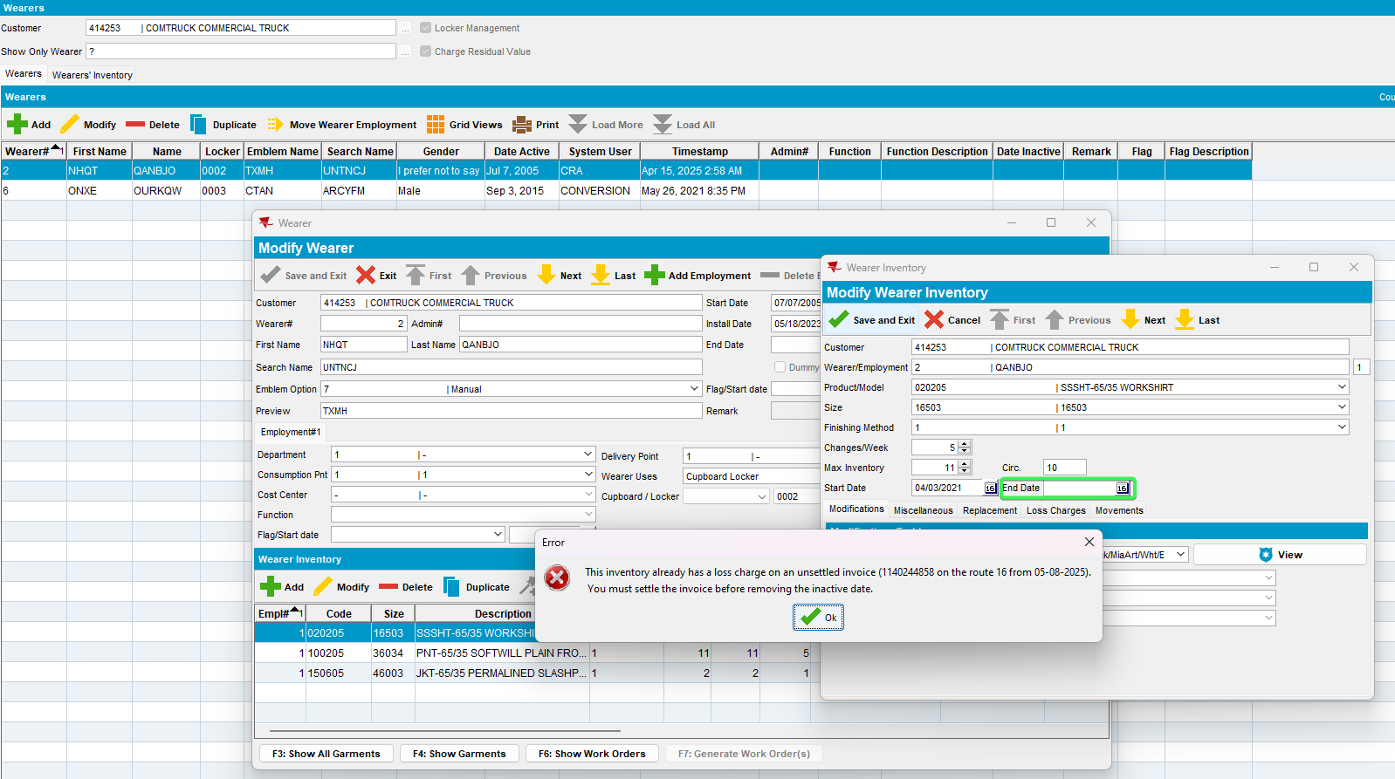
- Press Cancel and recheck the wearer date
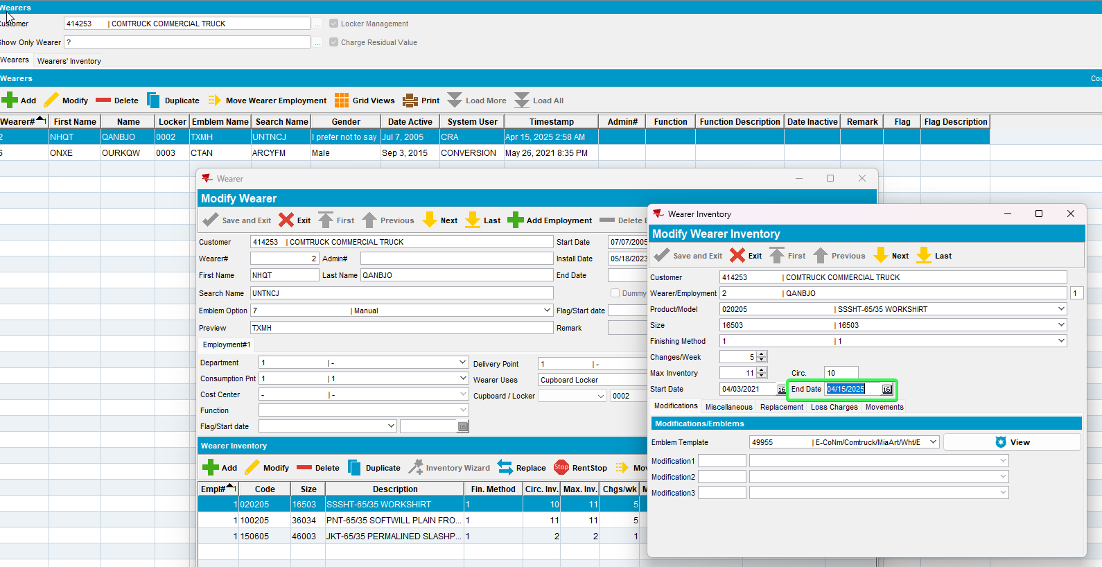
- Cancel the Generate invoice
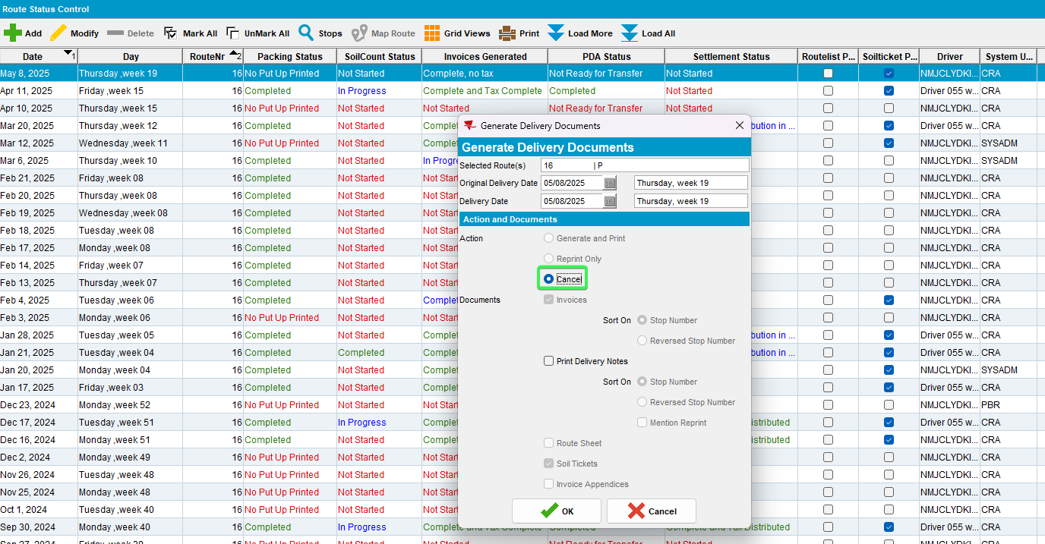
- Try removing the inactive date
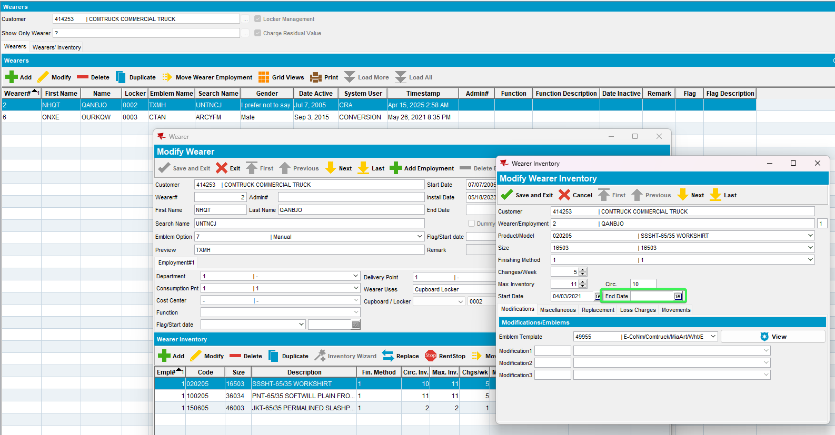
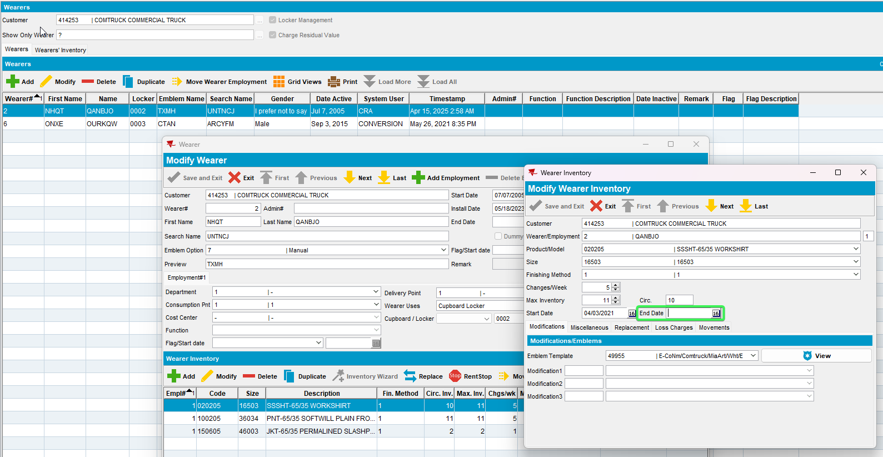
Tested OK

Test Case 3 – RECHARGELOSSAFTERCREDIT = 0 remove Wearer.DateInactive for a wearer with 2 wearer inventories when the loss charge is present on an invoice with Extend = 'Y'
Hash: 268c8fa75cbf
Expected behavior: The user is blocked from removing the wearer.dateinactive while the invoice with the loss charge is unsettled, the user can remove the dateinactive after canceling the invoice with the loss charge
- System Settings: Set RECHARGELOSSAFTERCREDIT = 0
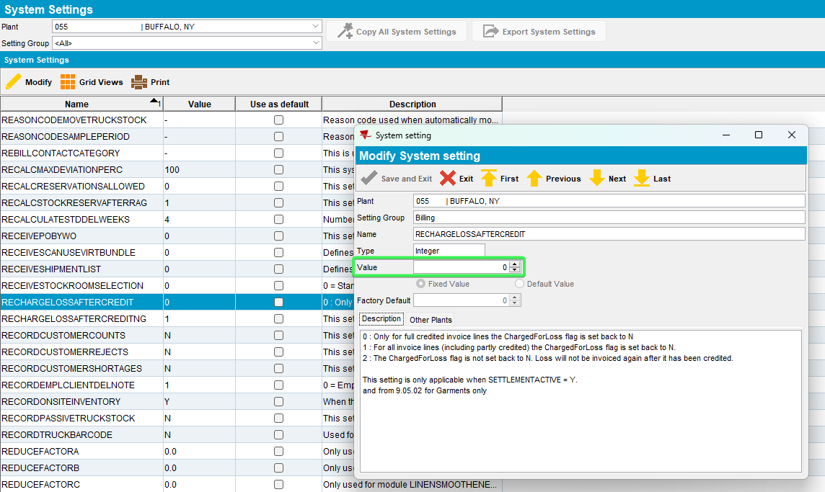
- Wearers DLG: Find an active wearer with wearer inventory
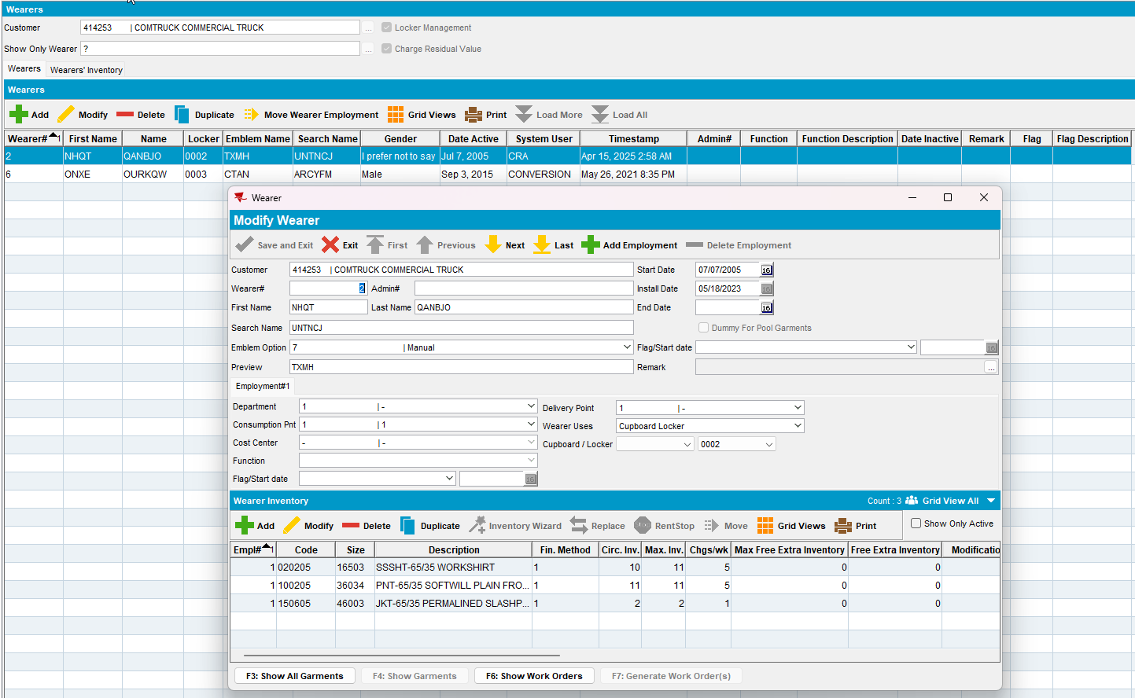
- Wearers DLG: Set the dateinactive for this Wearer as sysdate
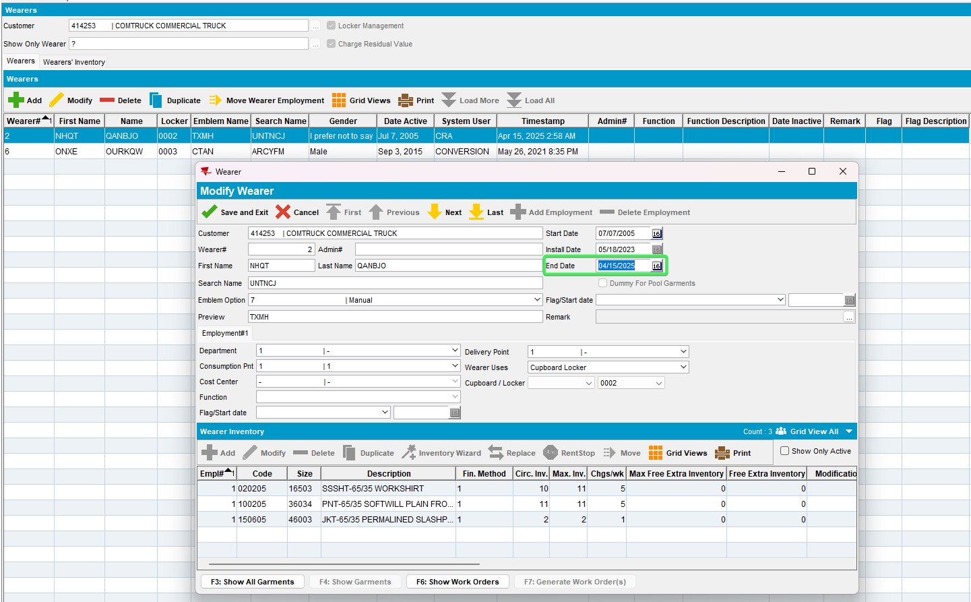
- Route Status Control DLG: Generate the invoice 3 weeks from sysdate so that the Loss charge will be Extend = 'Y'
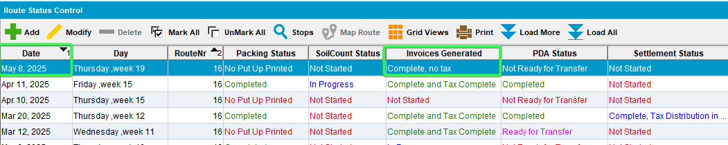
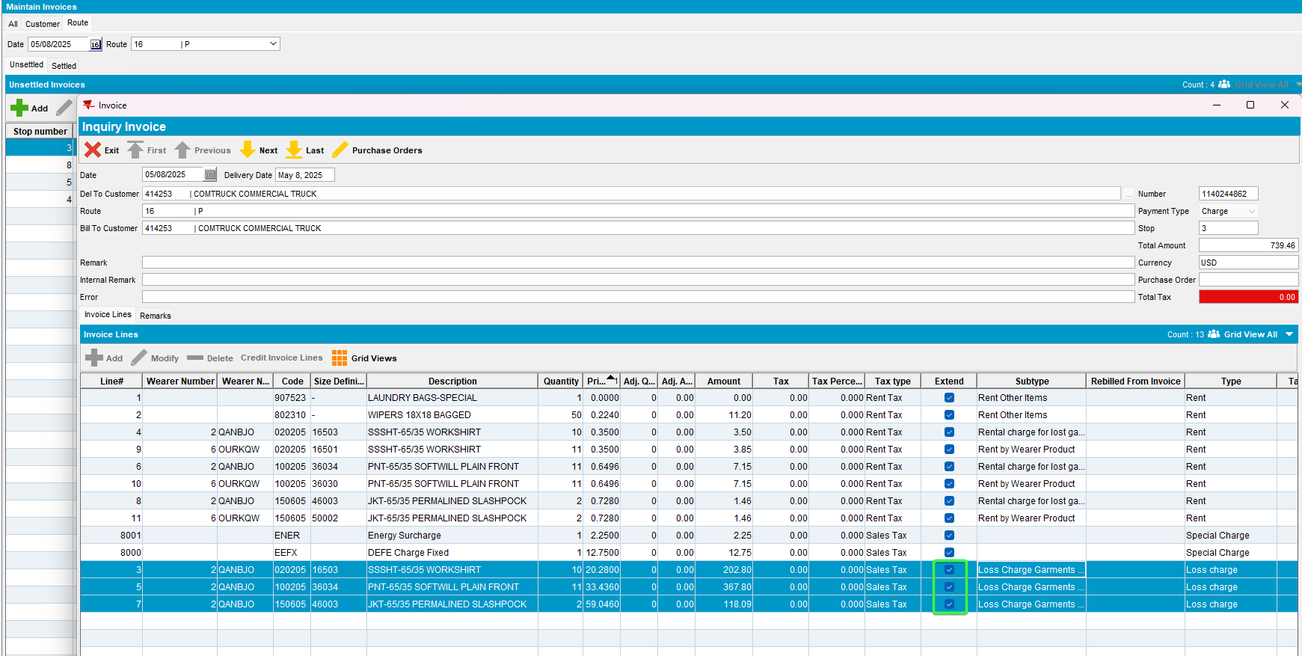
- Wearers DLG: Go back to the same wearer and delete the DateInactive date
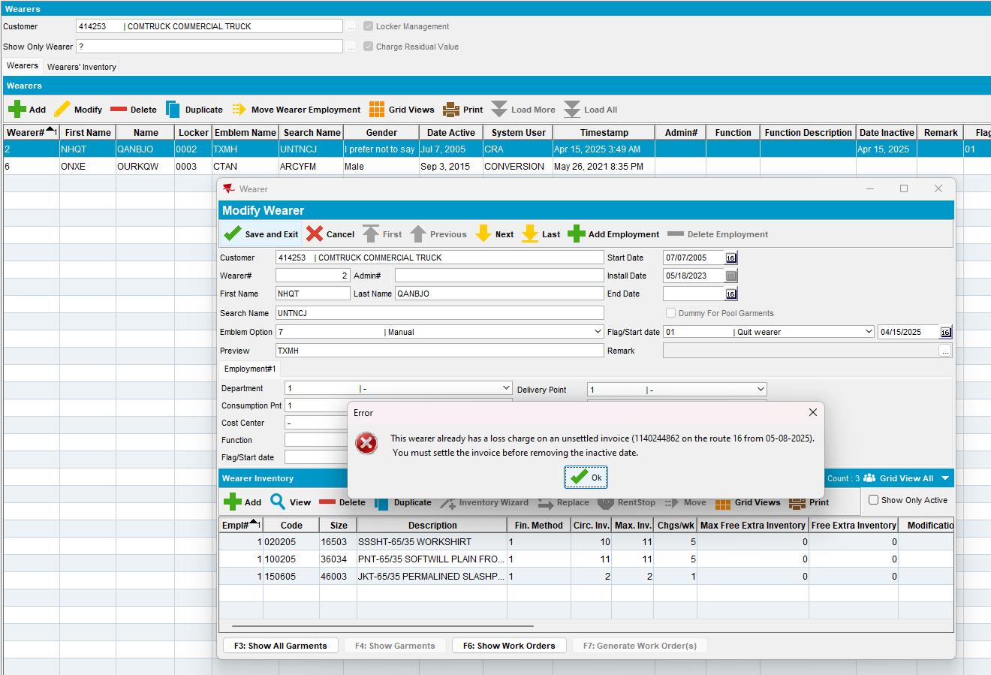
- Press Cancel and recheck the wearer date
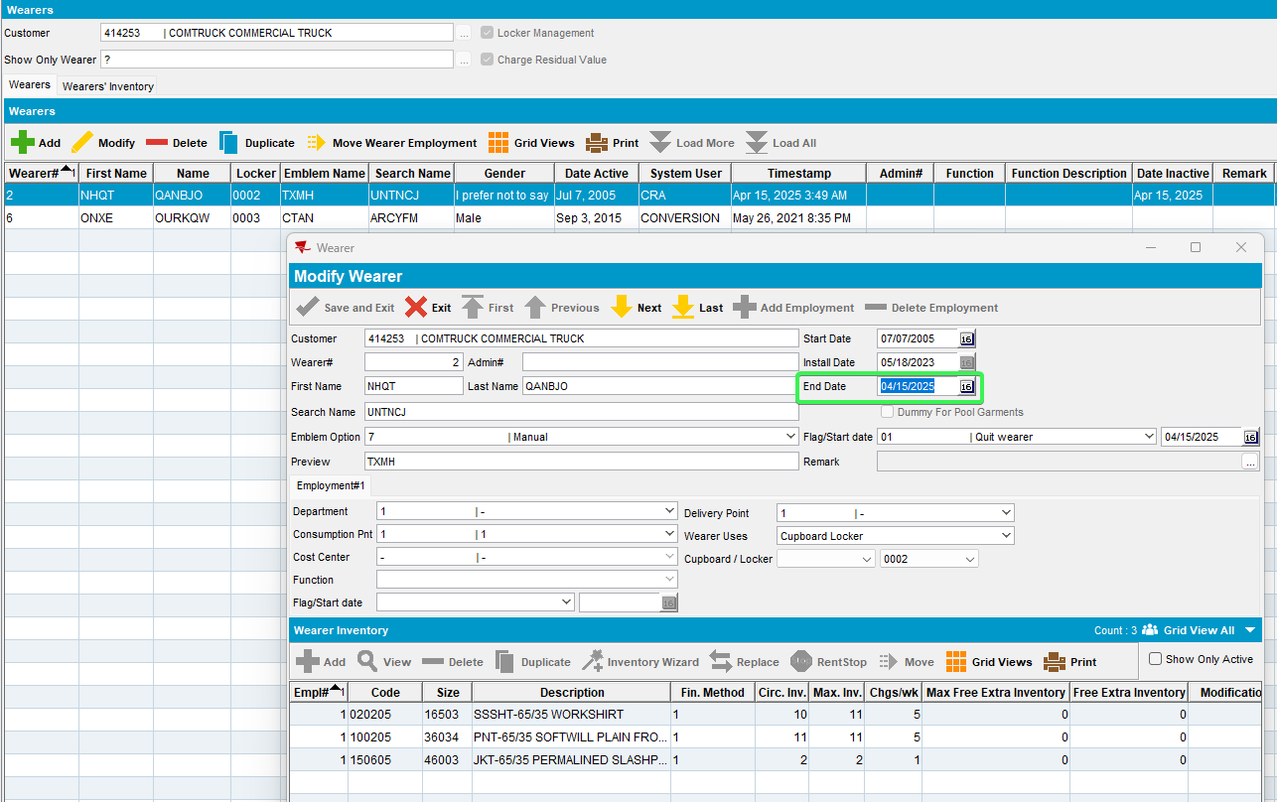

- Cancel the Generate invoice
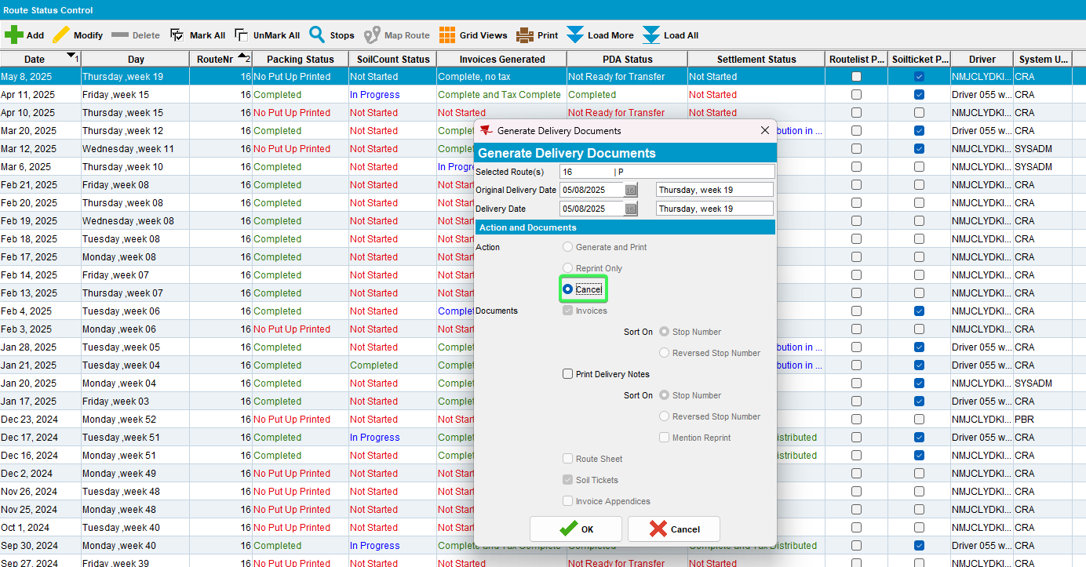
- Try removing the inactive date

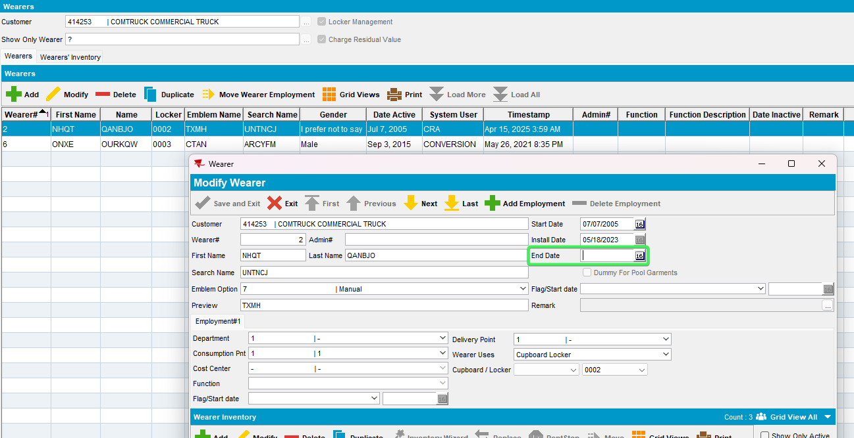
Tested OK

Test Case 4 – RECHARGELOSSAFTERCREDIT = 0 remove WearerInventory.DateInactive when the loss charge is present on an invoice with Extend = 'Y'
Hash: 268c8fa75cbf
Expected behavior: The user is blocked from removing the weareinventory.dateinactive while the invoice with the loss charge is unsettled, the user can remove the dateinactive after canceling the invoice with the loss charge
- System Settings: Set RECHARGELOSSAFTERCREDIT = 0
- Wearers DLG: Find an active wearer with wearer inventory
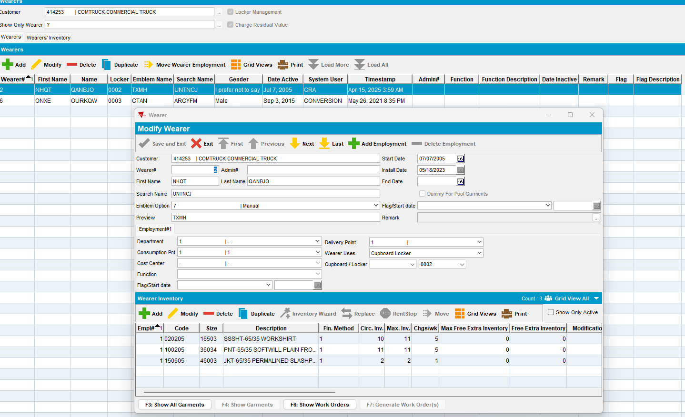
- Wearers DLG: Set the dateinactive for this WI as sysdate
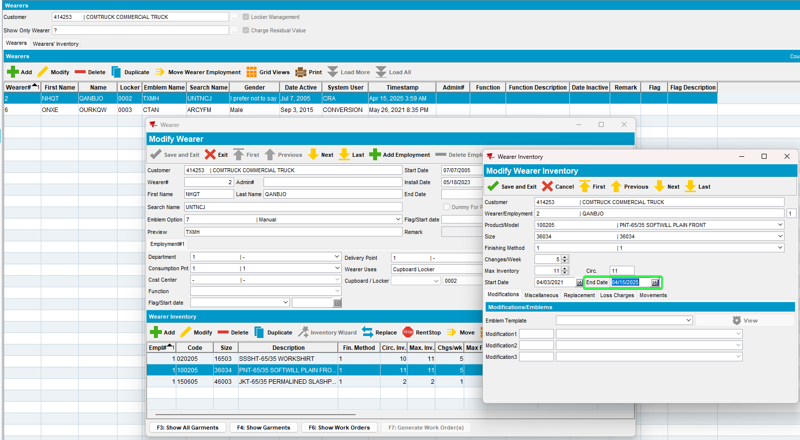
- Route Status Control DLG: Generate the invoice 3 weeks from sysdate so that the Loss charge will be Extend = 'Y'
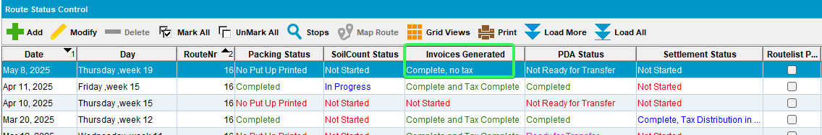
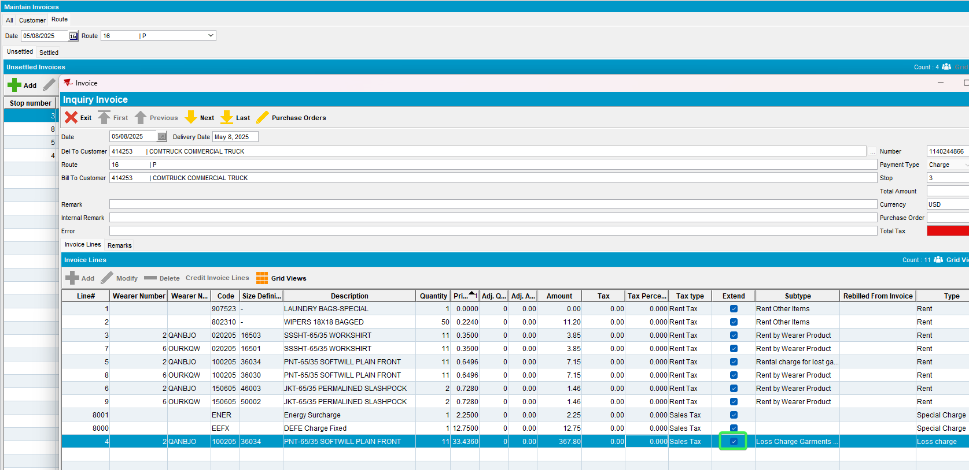
- Wearers DLG: Go back to the same WI and delete the DateInactive date
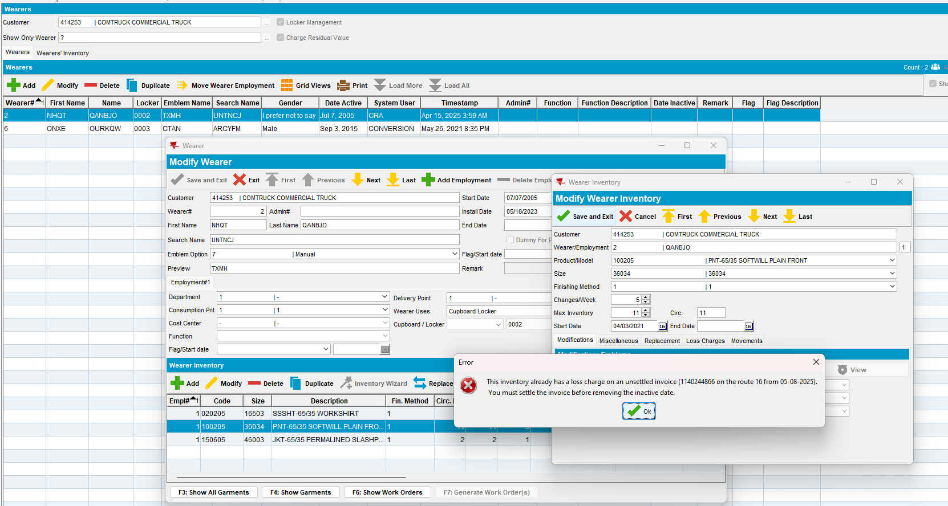
- Press Cancel and recheck the wearer date
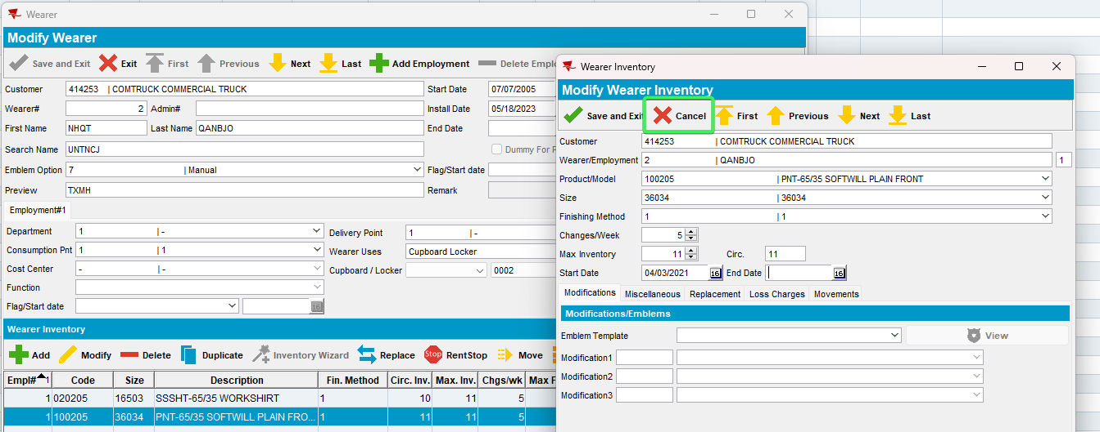
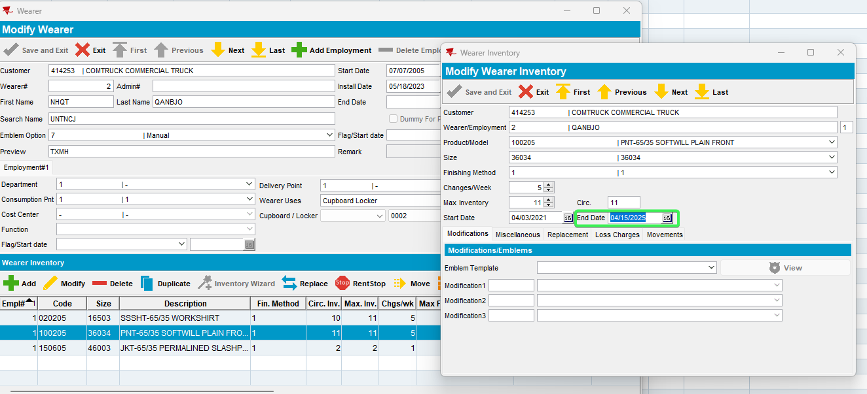
- Cancel the Generate invoice
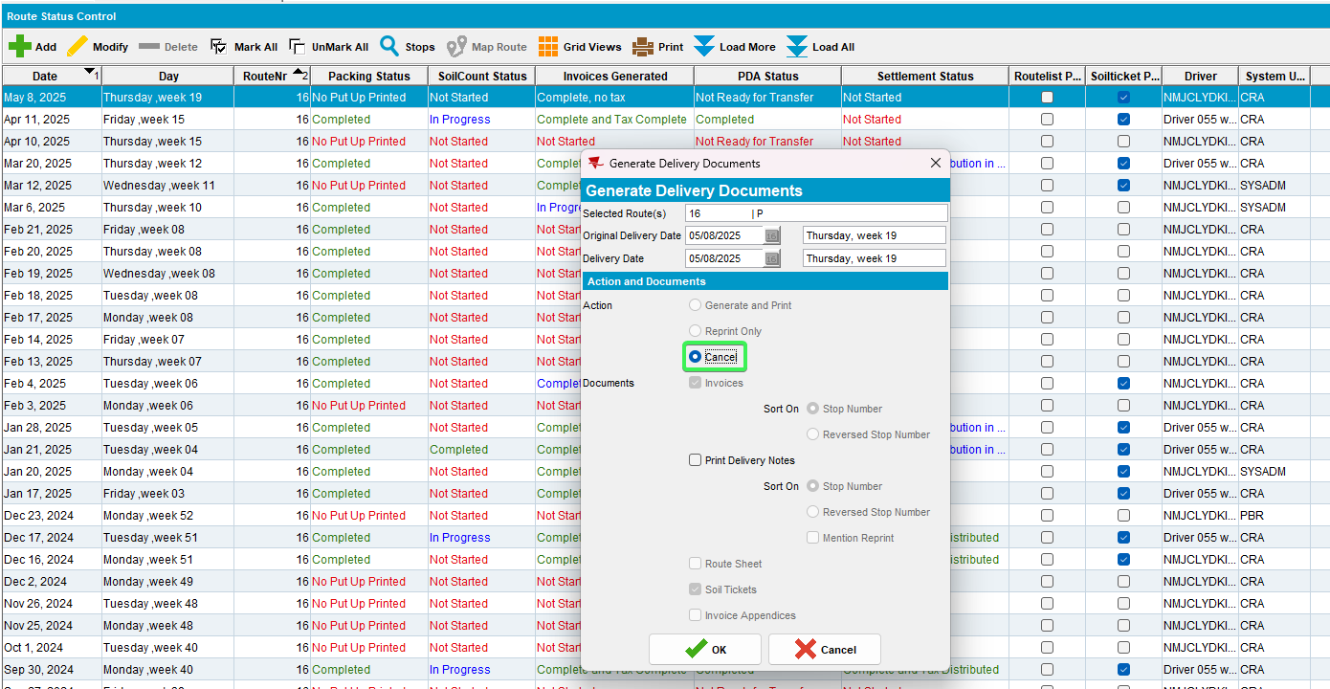
- Try removing the inactive date
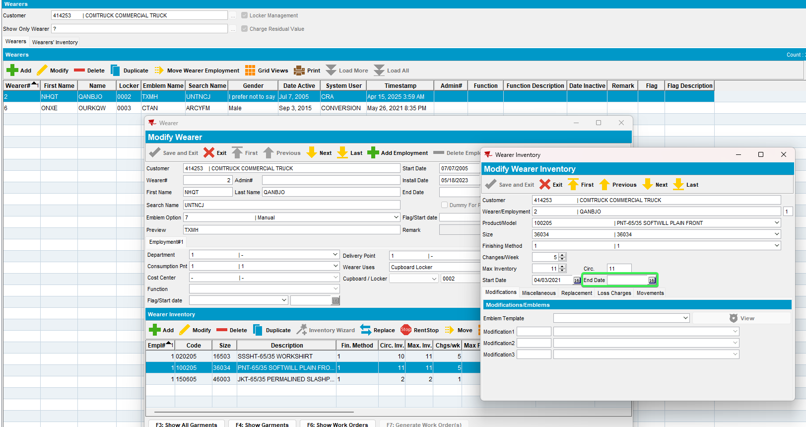

Tested OK

Test Case 5 – RECHARGELOSSAFTERCREDIT = 2 remove Wearer.DateInactive for a wearer with 2 wearer inventories when the loss charge is present on an invoice with Extend = 'Y'
Hash: 268c8fa75cbf
Expected behavior: The user is not blocked from removing the wearer.dateinactive while the invoice with the loss charge is unsettled
- System Settings: Set RECHARGELOSSAFTERCREDIT = 2
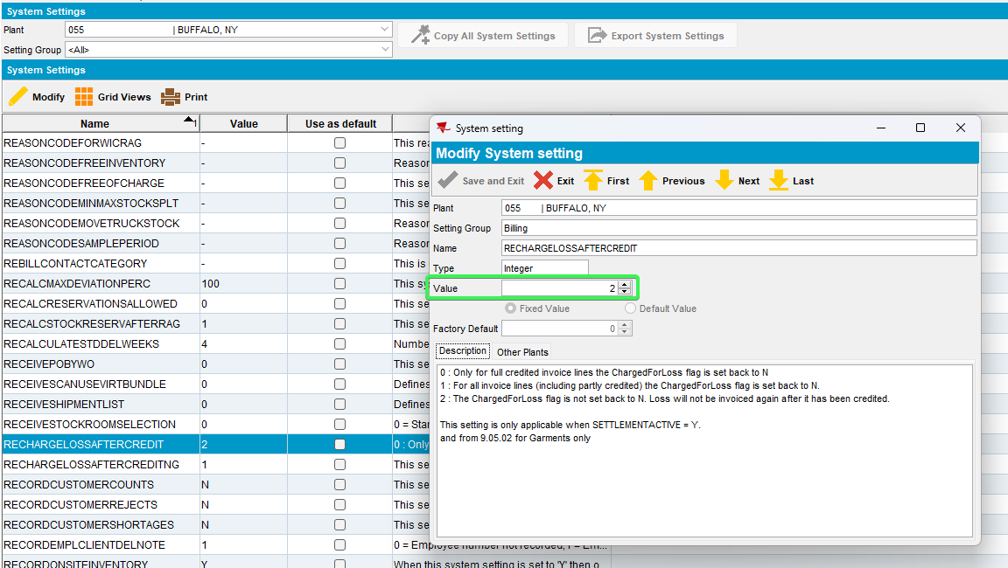
- Wearers DLG: Find an active wearer with wearer inventory
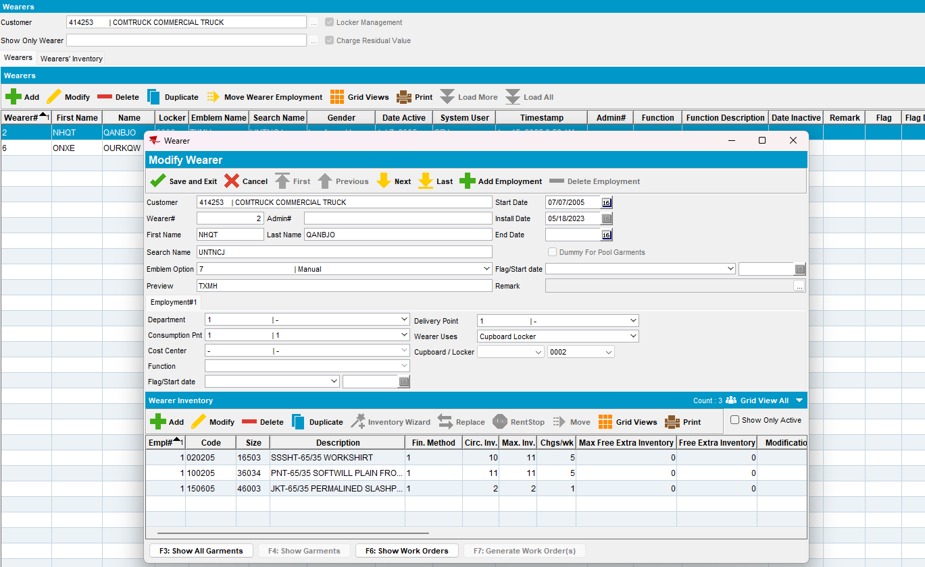
- Wearers DLG: Set the dateinactive for this Wearer as sysdate
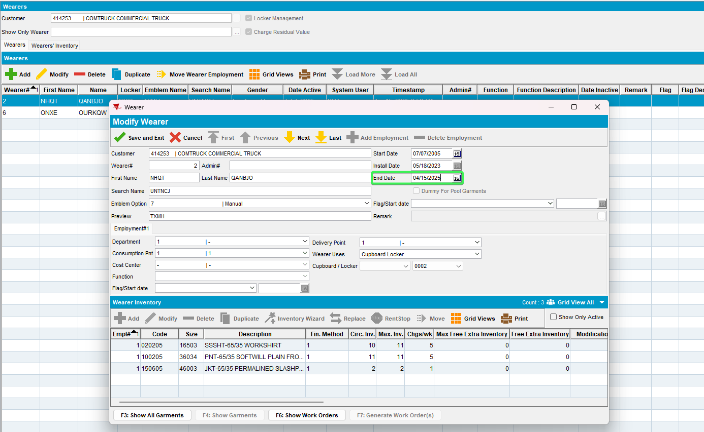
- Route Status Control DLG: Generate the invoice 3 weeks from sysdate so that the Loss charge will be Extend = 'Y'
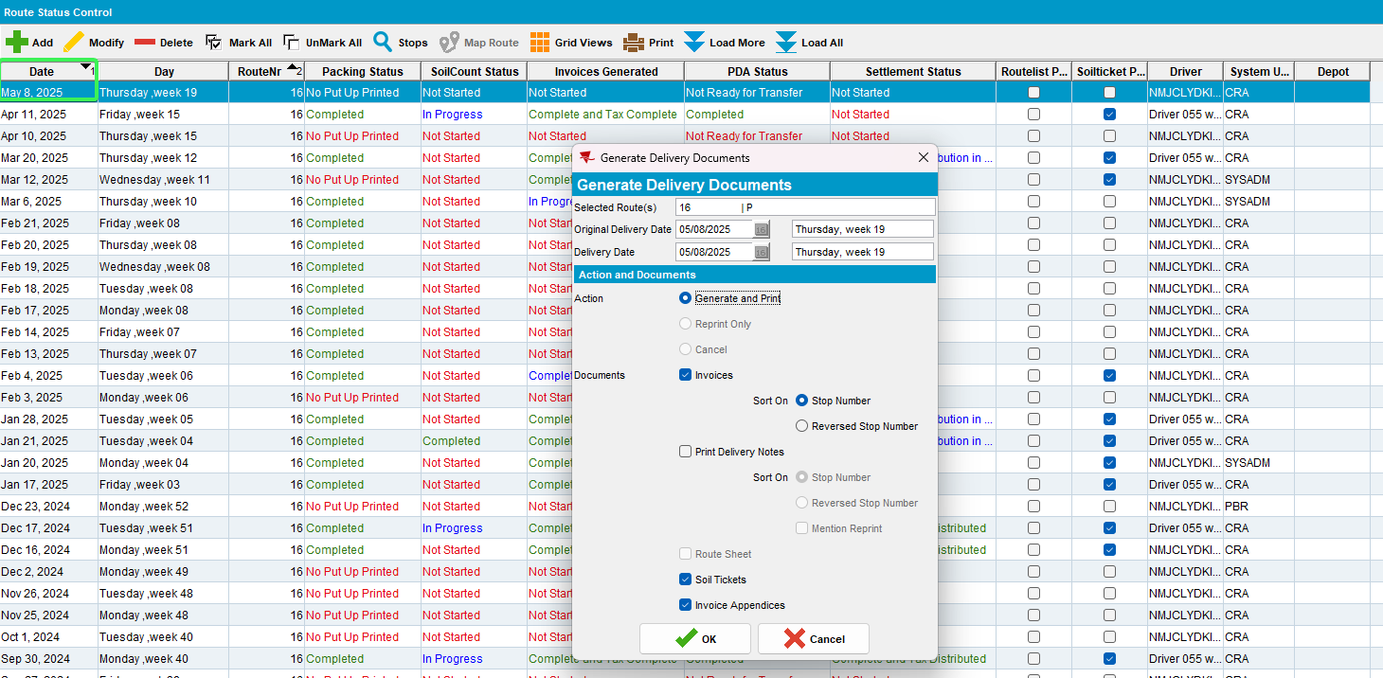
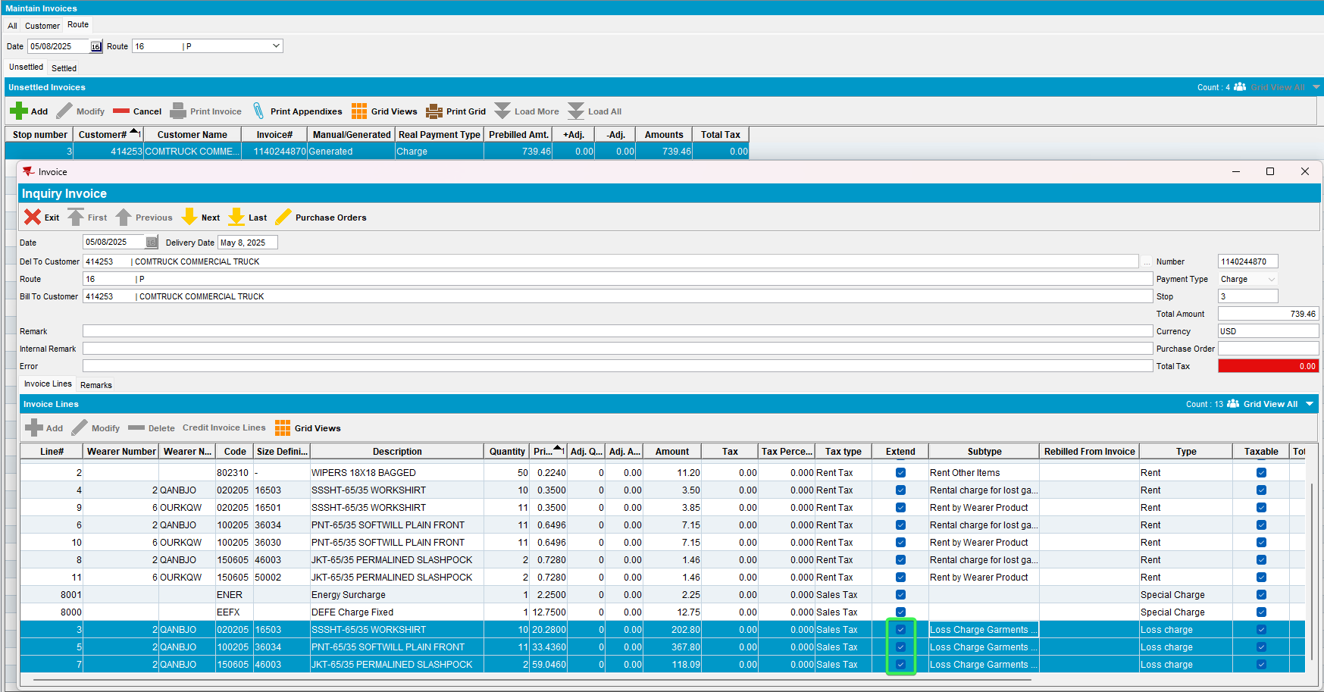
- Wearers DLG: Go back to the same wearer and delete the DateInactive date
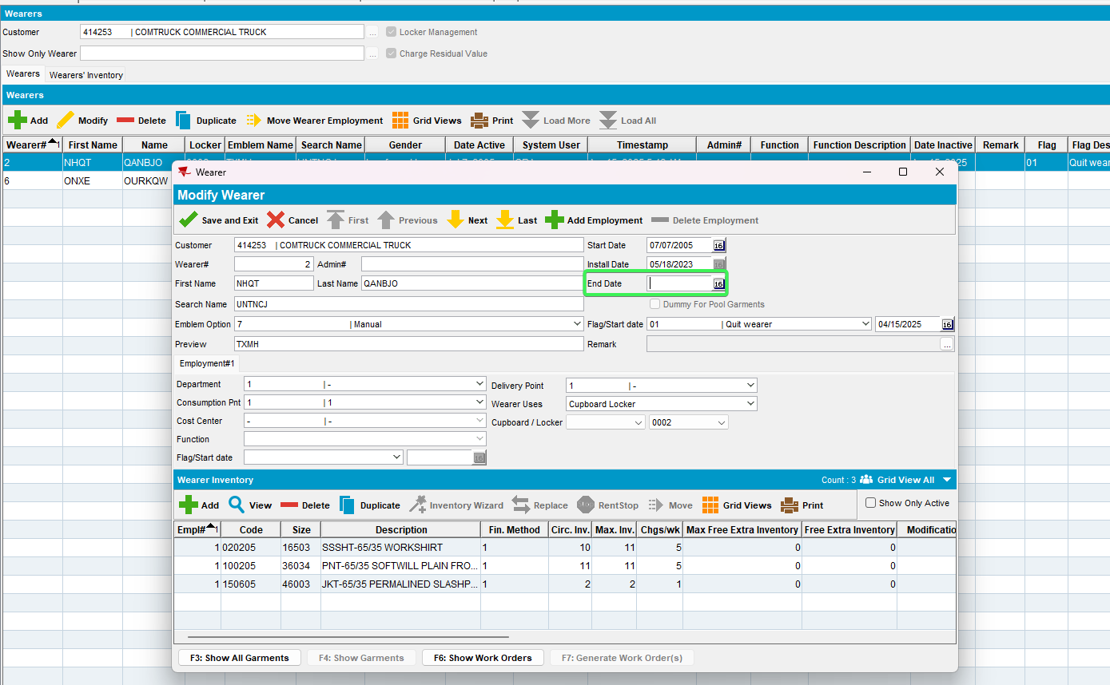
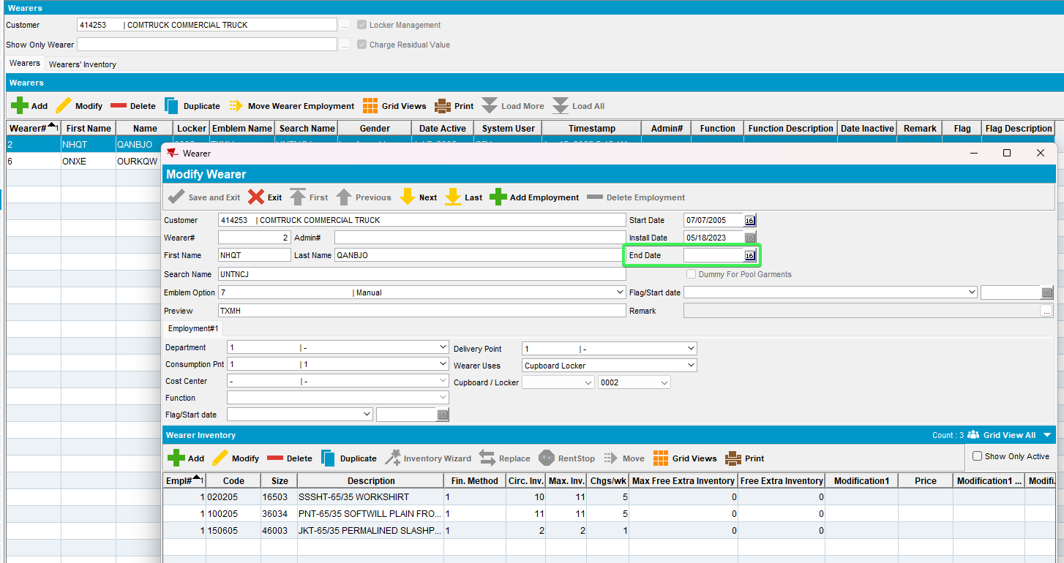
Tested OK

Test Case 6 – RECHARGELOSSAFTERCREDIT = 2 remove WearerInventory.DateInactive when the loss charge is present on an invoice with Extend = 'Y'
Hash: 268c8fa75cbf
Expected behavior: The user is not blocked from removing the weareinventory.dateinactive while the invoice with the loss charge is unsettled
- System Settings: Set RECHARGELOSSAFTERCREDIT = 2
- Wearers DLG: Find an active wearer with wearer inventory
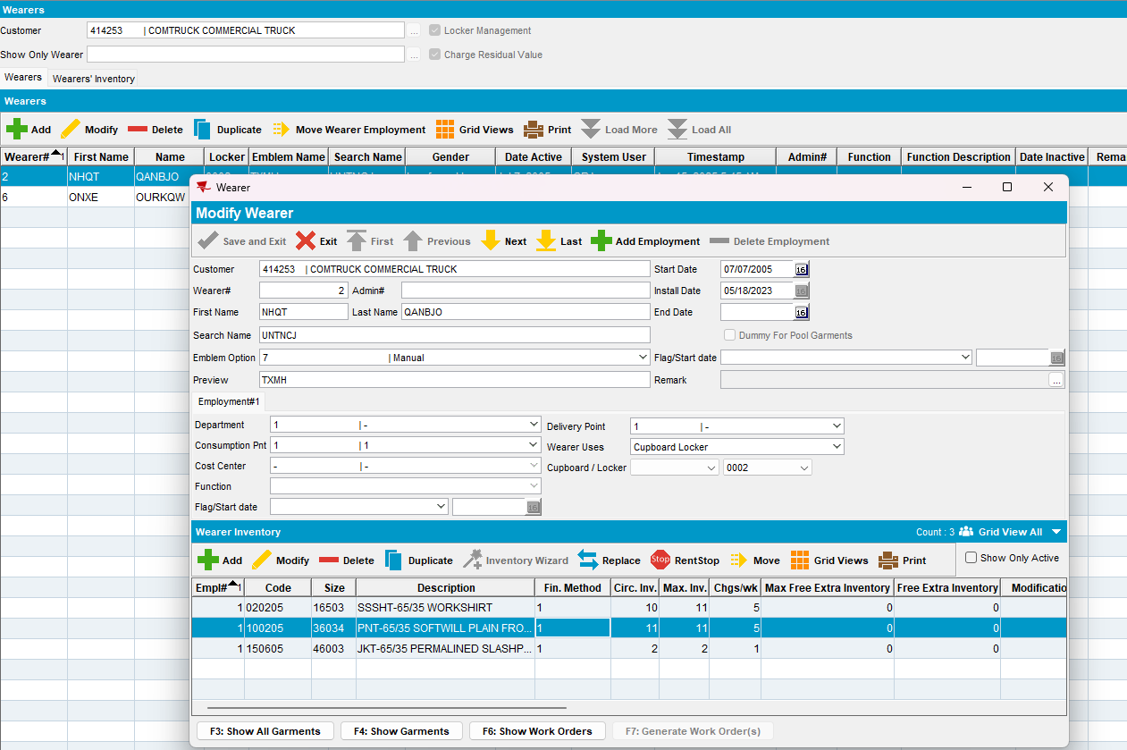
- Wearers DLG: Set the dateinactive for this WI as sysdate
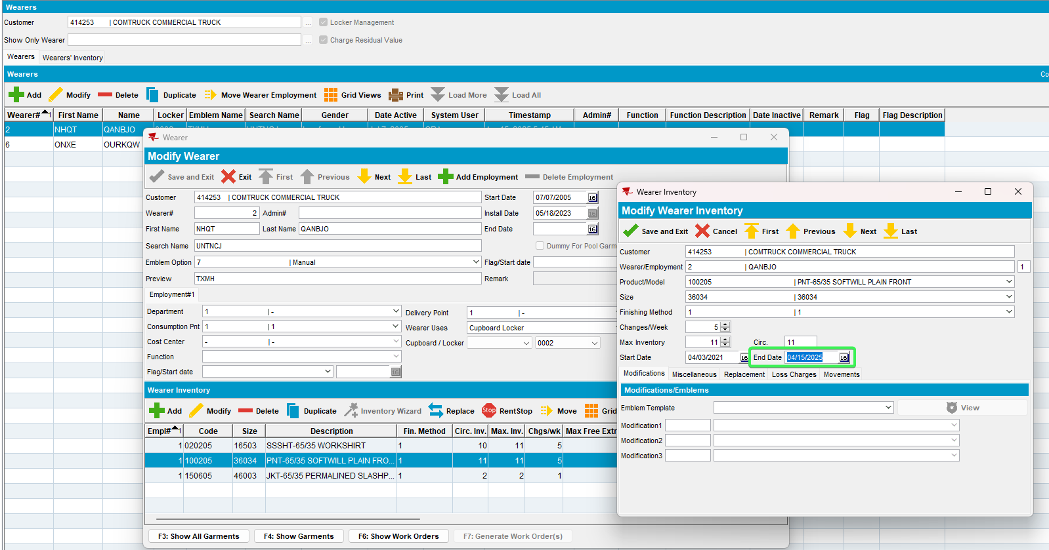
- Route Status Control DLG: Generate the invoice 3 weeks from sysdate so that the Loss charge will be Extend = 'Y'
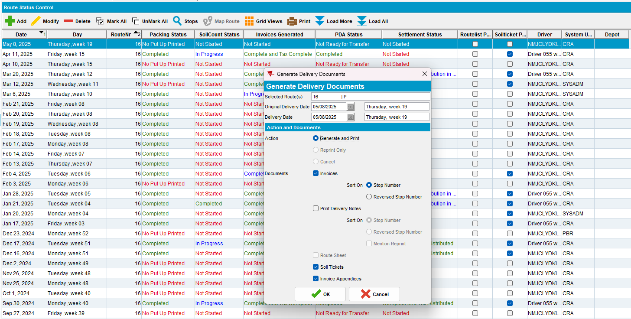
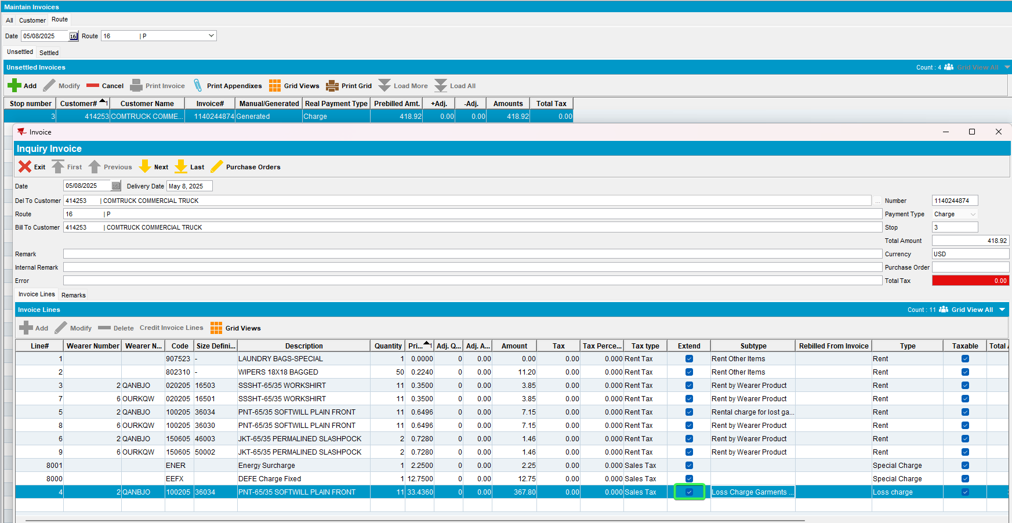
- Wearers DLG: Go back to the same WI and delete the DateInactive date
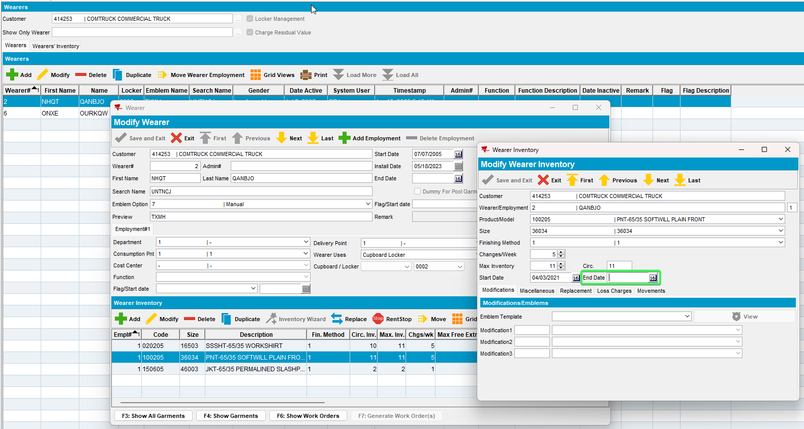
Tested OK

