ABSN-3765 Turnover group determination for Canada tax in Vertex tax distribution is setting the county level turnover group incorrectly
Environment | Prerequisites
Version:9.07.00.UNF19  DBServerName=abs-SRV20.internal.abslbs.com  DBSID=CUST24  DBUser=UNFDEV  DBPassword=UNFDEV  Environment=Test | - Module:  - System setting

Contents
Test after fix 1
Test Case 1 – Settle route for Canada – Tested OK 1

Test after fix

Test Case 1 – Settle route for Canada – Tested OK
Expected behavior: After settle the distribution tax line should be there on the invoice
Hash: e23520ca3fb6
- STATES DLG: Add the correct tax jurisdiction codes like so for CANADA
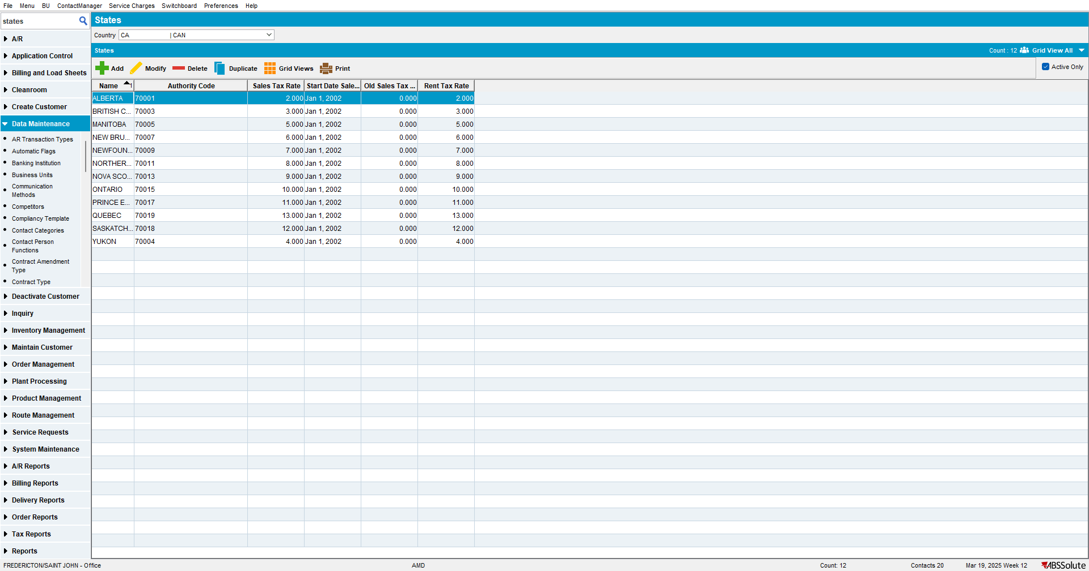

- STATES DLG: Under each state add a county named CANADA like so for each region:
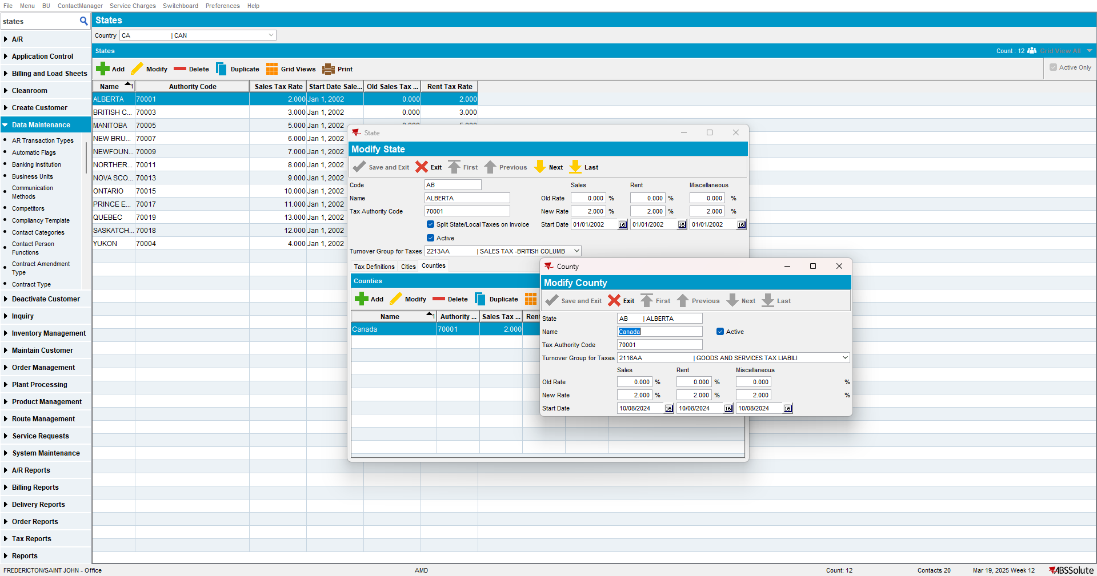
- Go to a BU like 710.
- CUSTOMERS DLG: Select one of the customers such as 9102363 and add a delivery point for it.
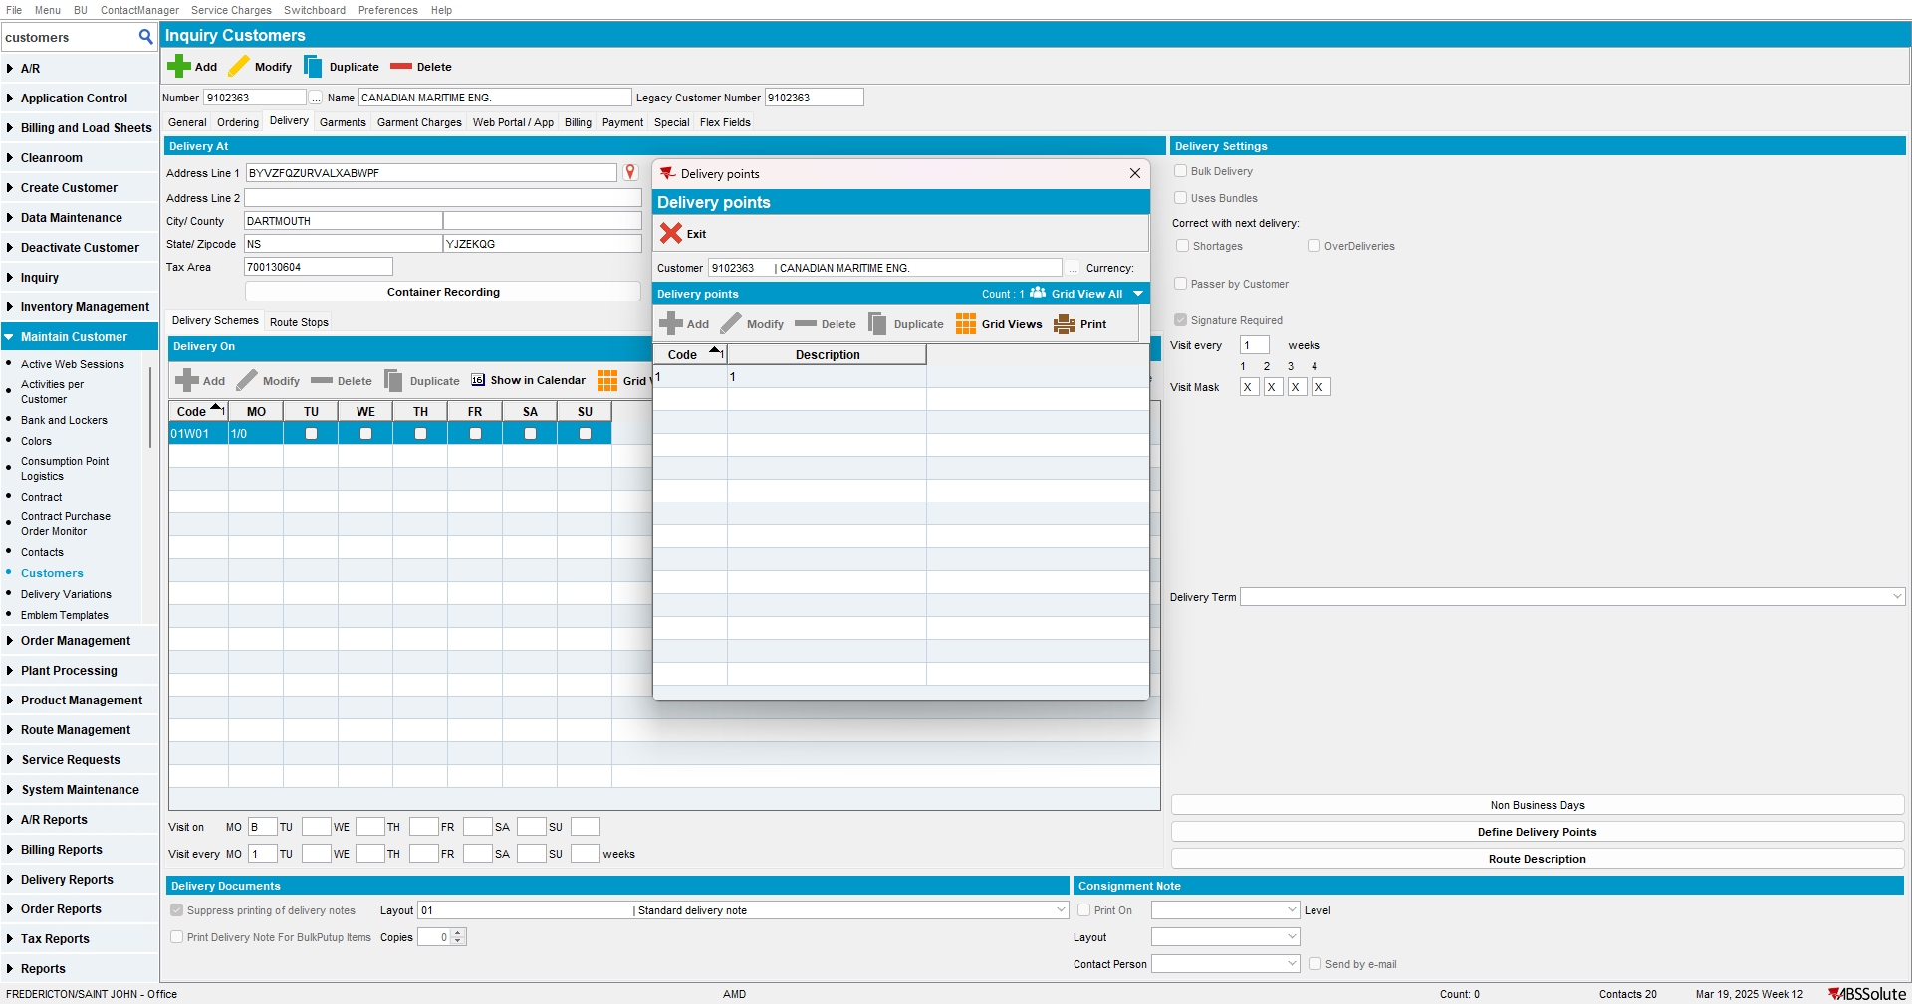

- DEPARTMENT DLG: Add a cost center and department for 9102363
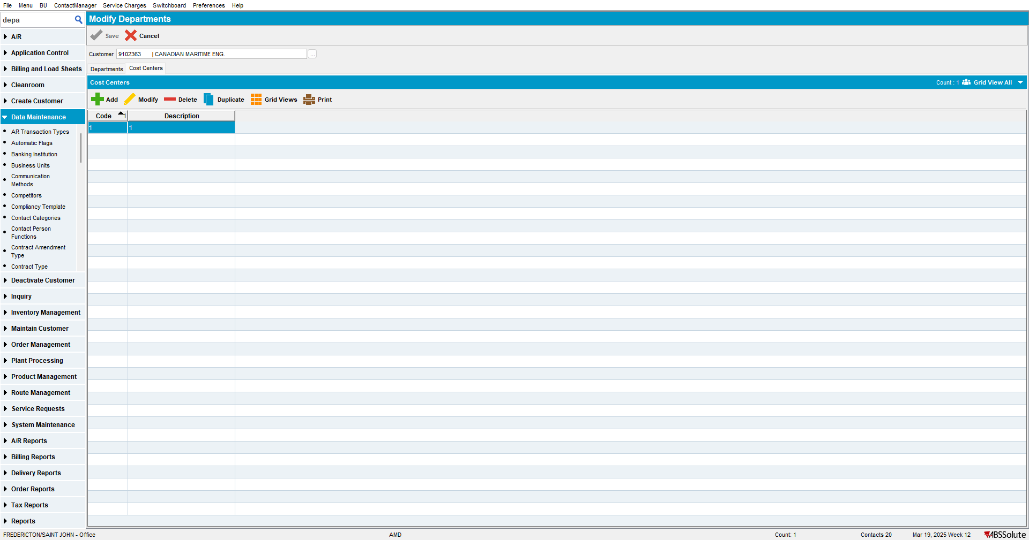
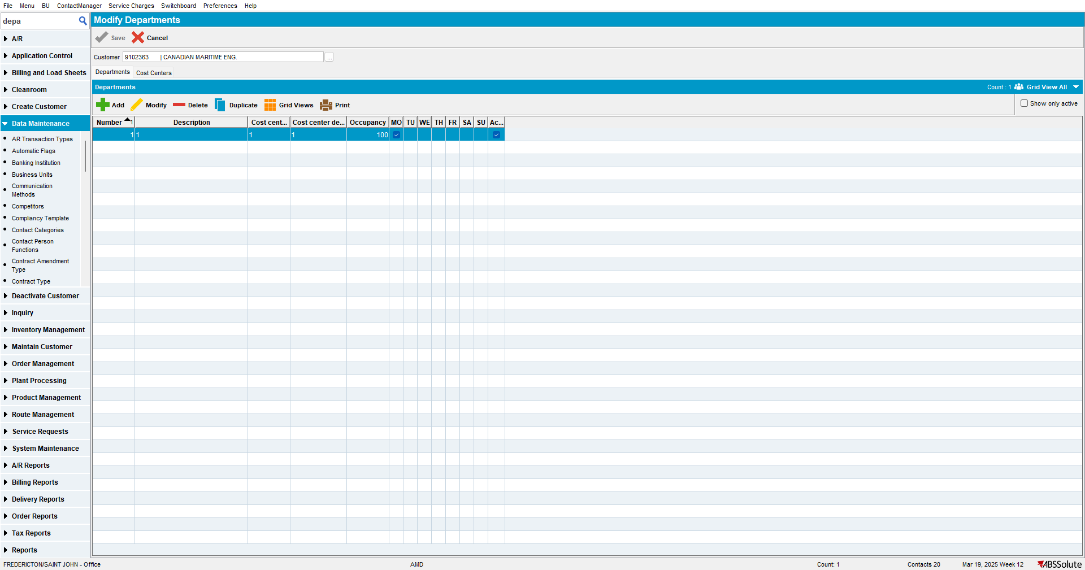

- Plants DLG: Add a district to Plant 027
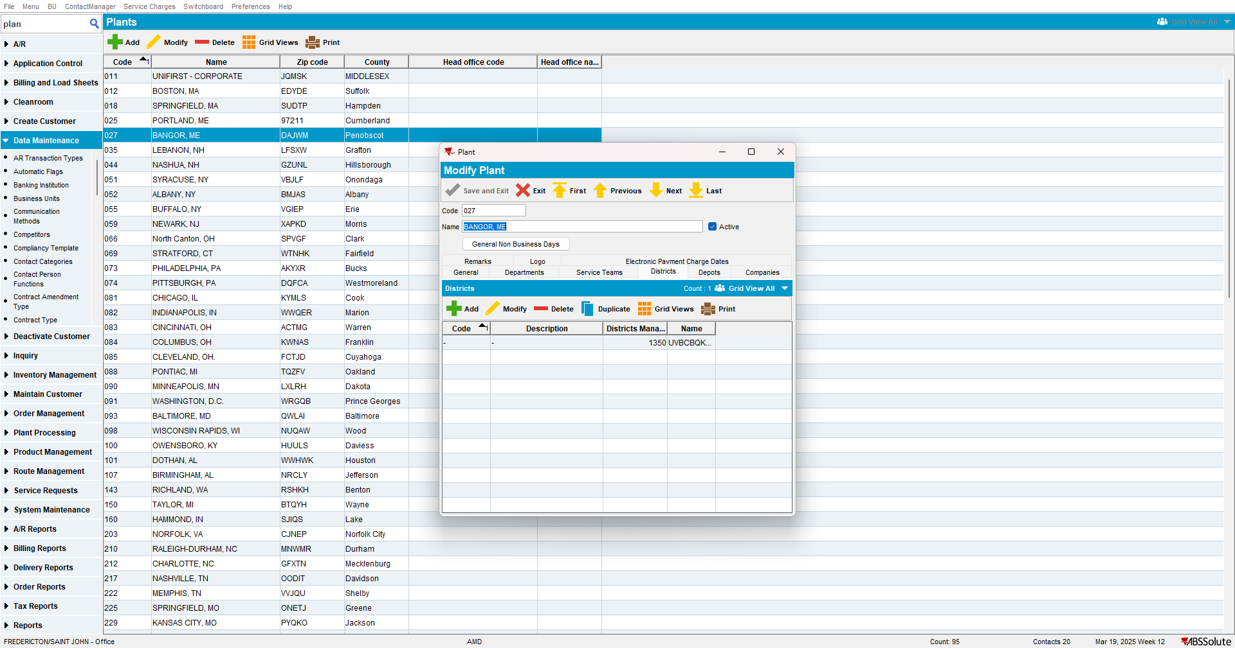

- Routes DLG: Add at least one route for one weekday
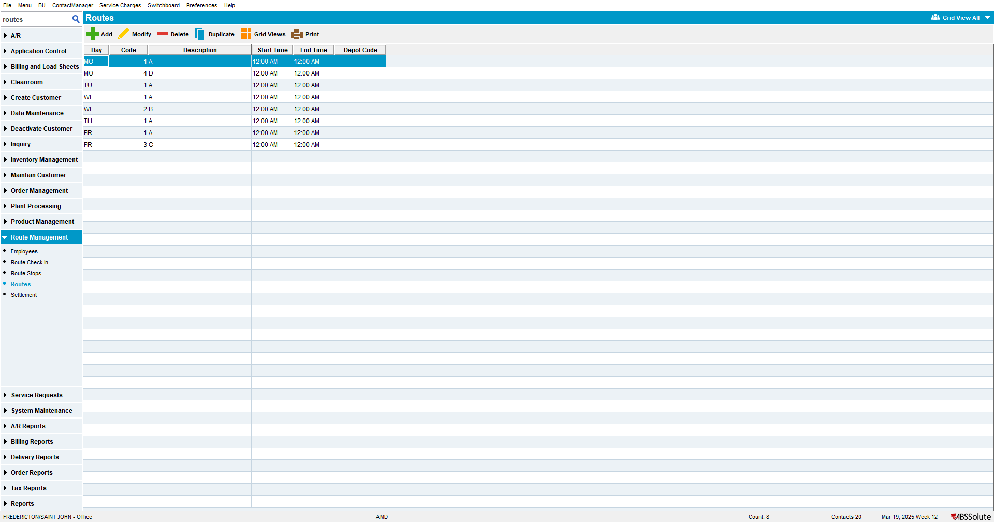

- Customers DLG: Add a route stop for customer 9102363
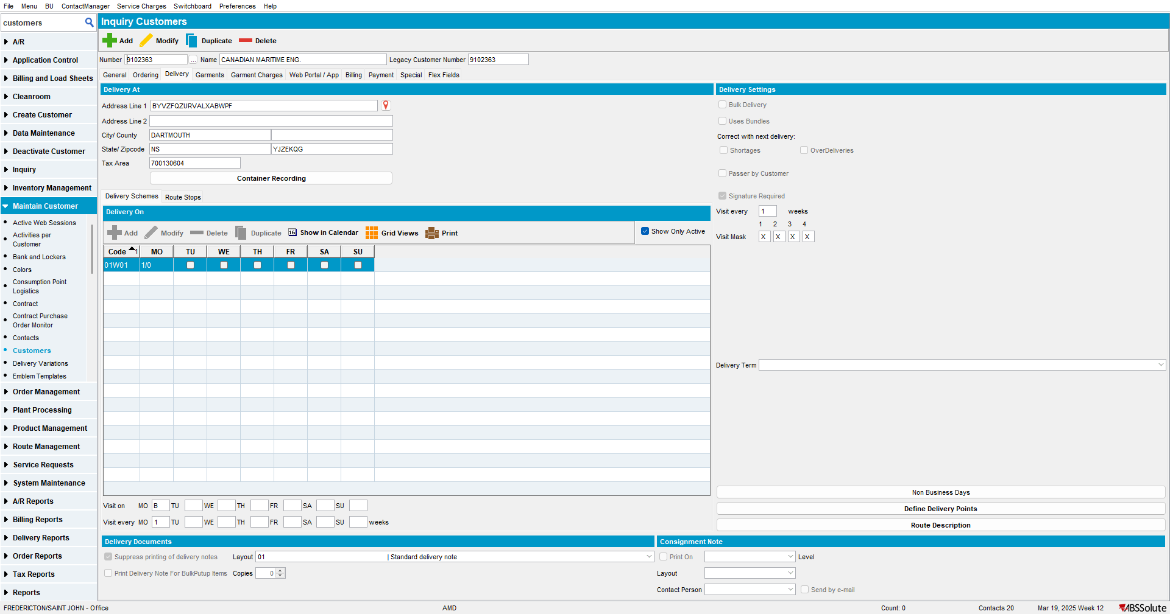

- Contract DLG: Add a new contract with Currency = CAD (start date needs to be yesterday) and with at least one released garment product on it
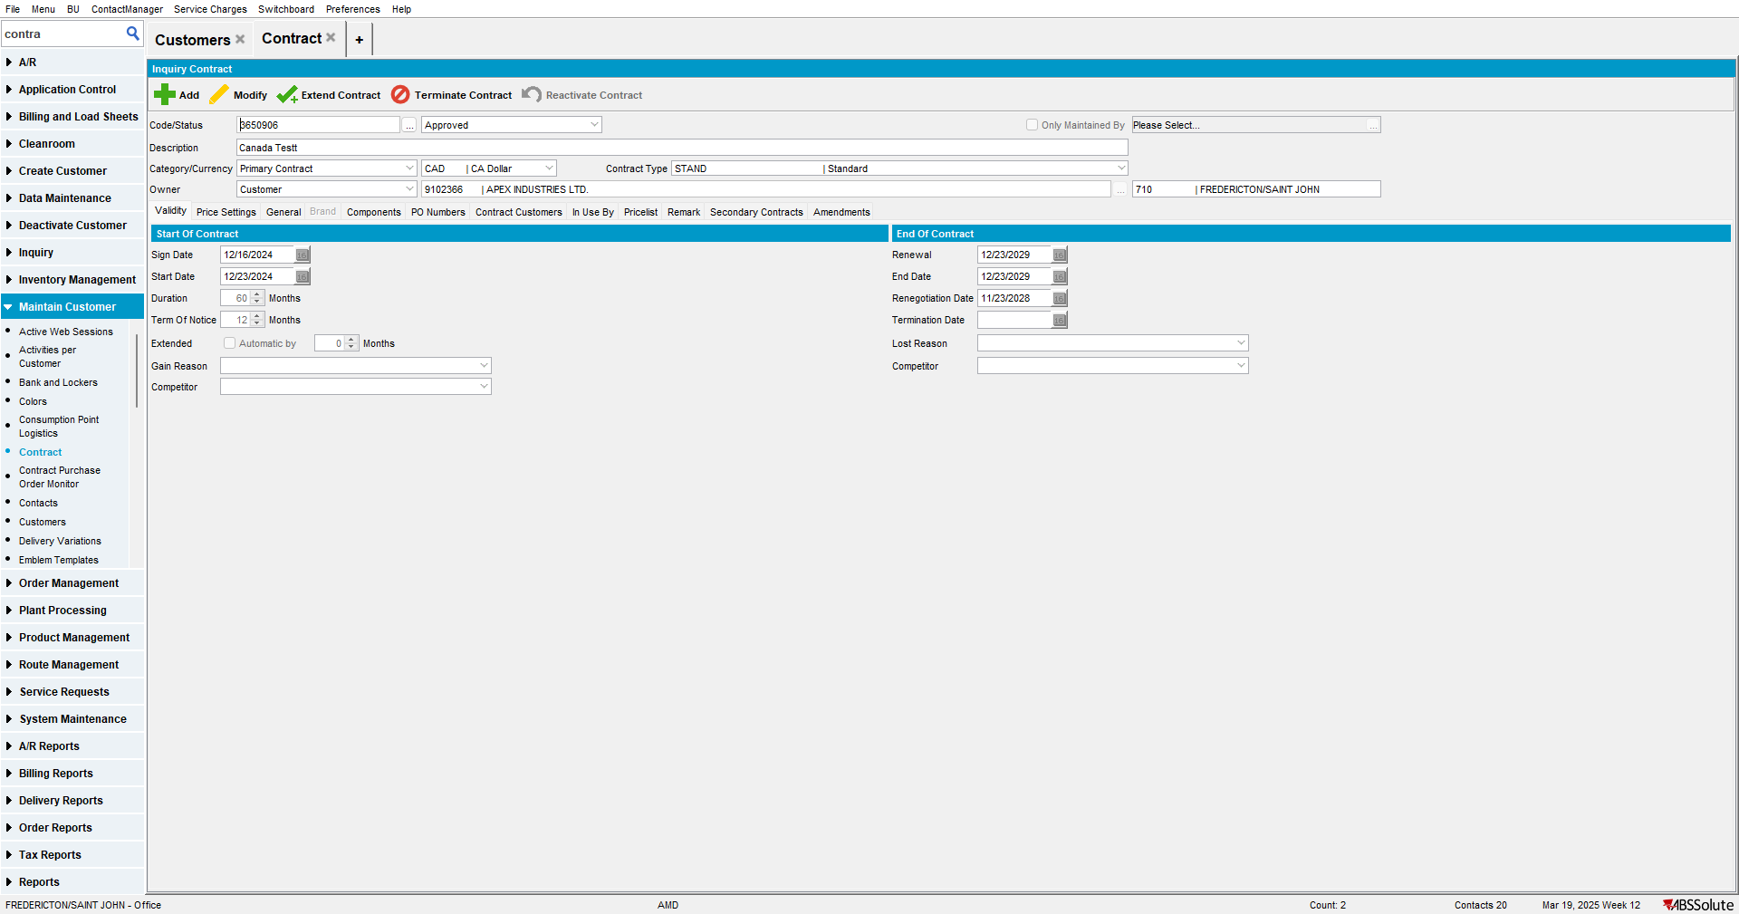

- Contract DLG: Add customer 9102363 to the contract (start date needs to be today or yesterday)
- Lockers DLG: Add lockers for 9102363
- Stockroom DLG: Add a stockroom for 710 by duplicating an existing stockroom.
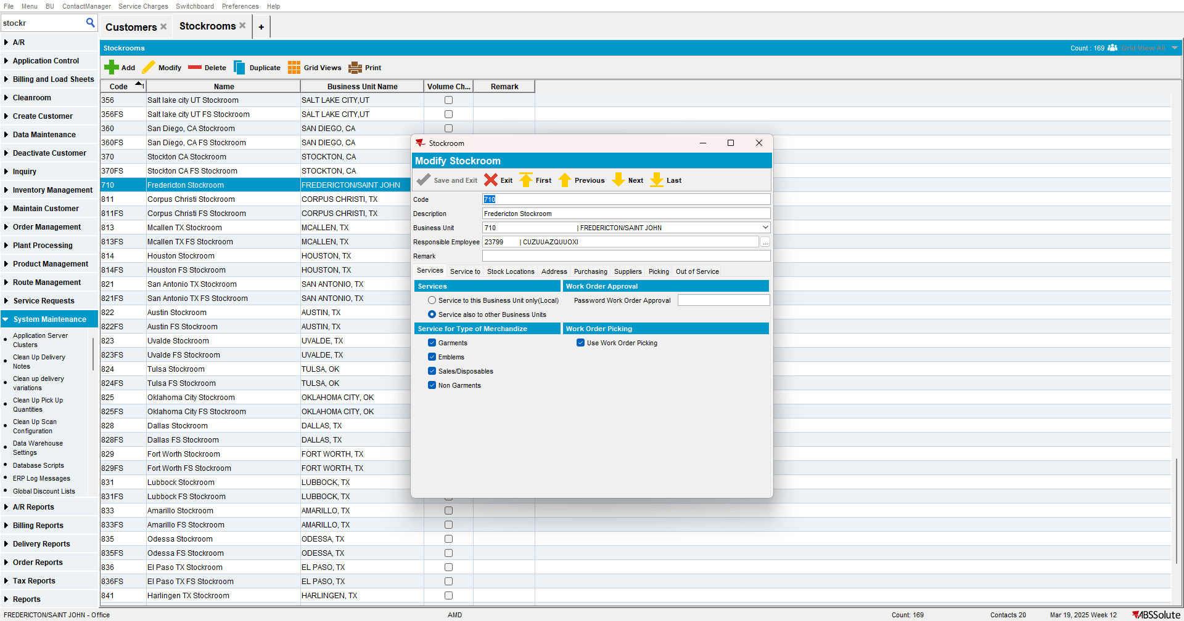

- Wearers DLG: Add at least one wearer with a wearer inventory and generate the WORKORDER with Start Rent = 'Day of issue'
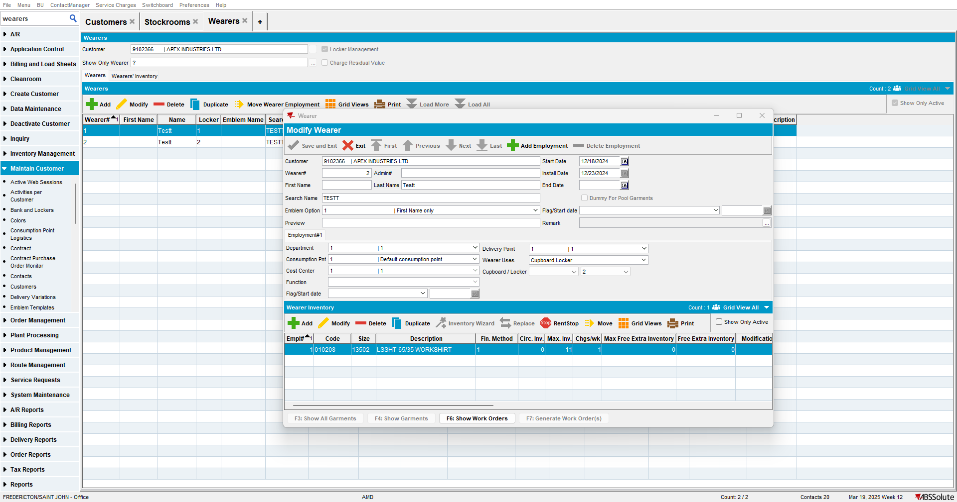

- ID Code Ranges DLG: Add a 14 digit range for Unique Items
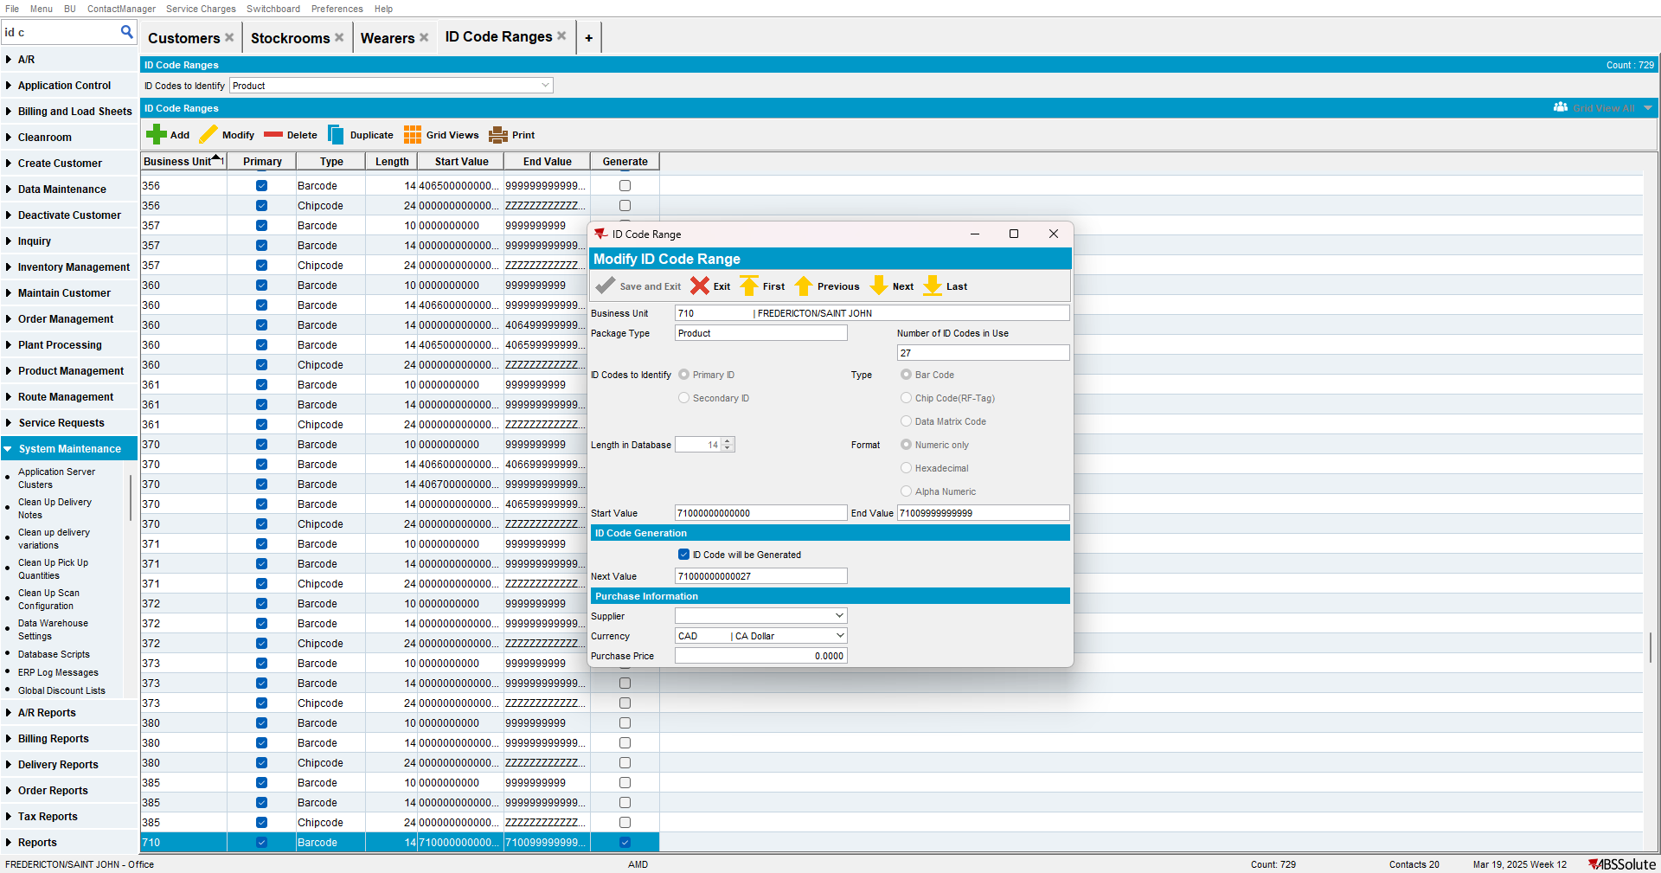

- Issue Work Order DLG: Issue all garments and generate items and then generate the Delivery Note
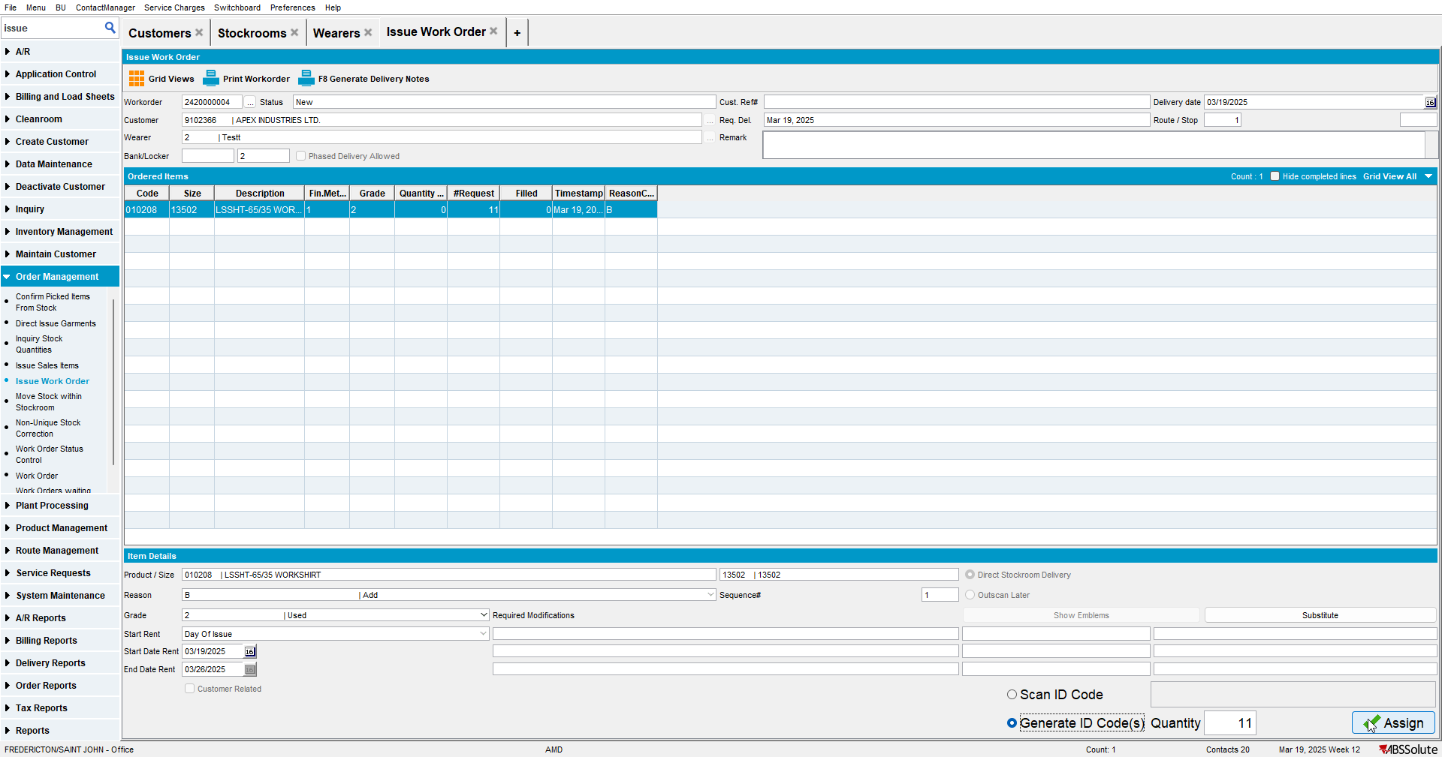

- Route Status Control DLG: Add the next route control for your customer if not added already
- Route Status Control DLG: Generate invoices for the route control
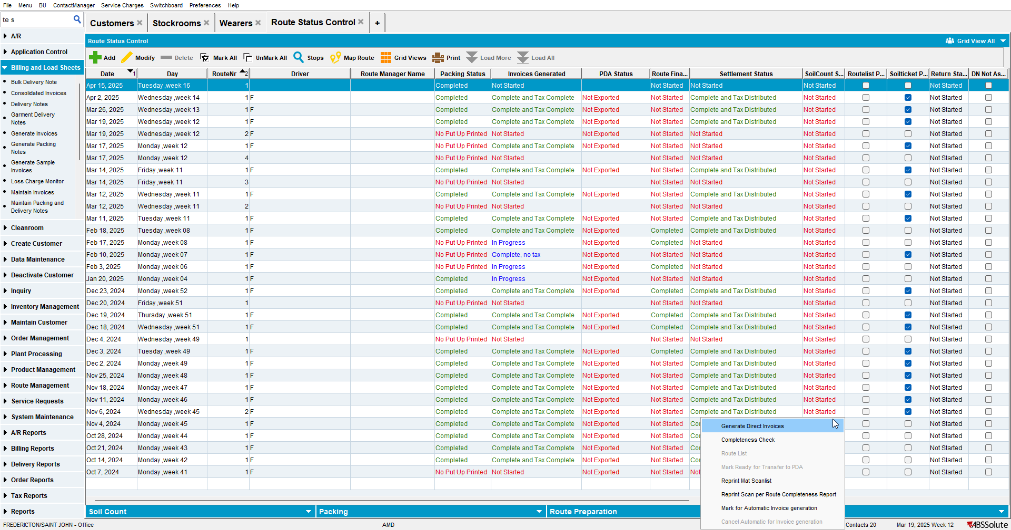
- Script the BCI for the quotation batch like so:
--PRE-BILLING

UPDATE VERTEXTRANSACTIONLOG VTL
SET VTL.EXPORTID = NULL,
VTL.STATUS = 2,
VTL.TAXAREAID = VTL.DESTINATIONTAXAREAID,
VTL.TOTALLINEITEMTAX = ROUND(((VTL.EXTENDEDPRICE * 0.07) / 2), 2) +
TRUNC(((VTL.EXTENDEDPRICE * 0.07) / 2), 2),
VTL.COMBINEDRATE = 0.08,
VTL.TOTALMAINDIVISIONTAX = ROUND(((VTL.EXTENDEDPRICE * 0.07) / 2), 2),
VTL.TOTALCOUNTRYTAX = TRUNC(((VTL.EXTENDEDPRICE * 0.07) / 2), 2)
WHERE VTL.BATCHID IN (2533998);

UPDATE VERTEXBATCHCONTROL VBC
SET VBC.BATCHSTATUS = 3
WHERE VBC.BATCHID IN (2533998);

- Run the process scheduler

- Maintain Invoices DLG: Find the invoice and verify that you have a COUNTY tax
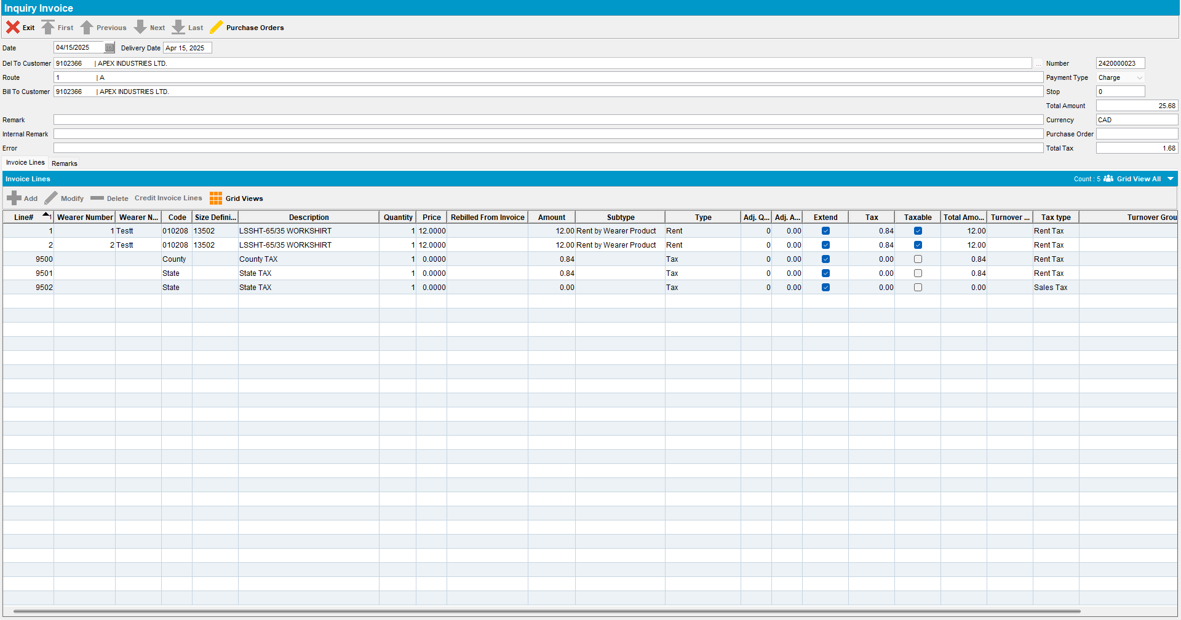

- Route Status Control DLG: Settle the route
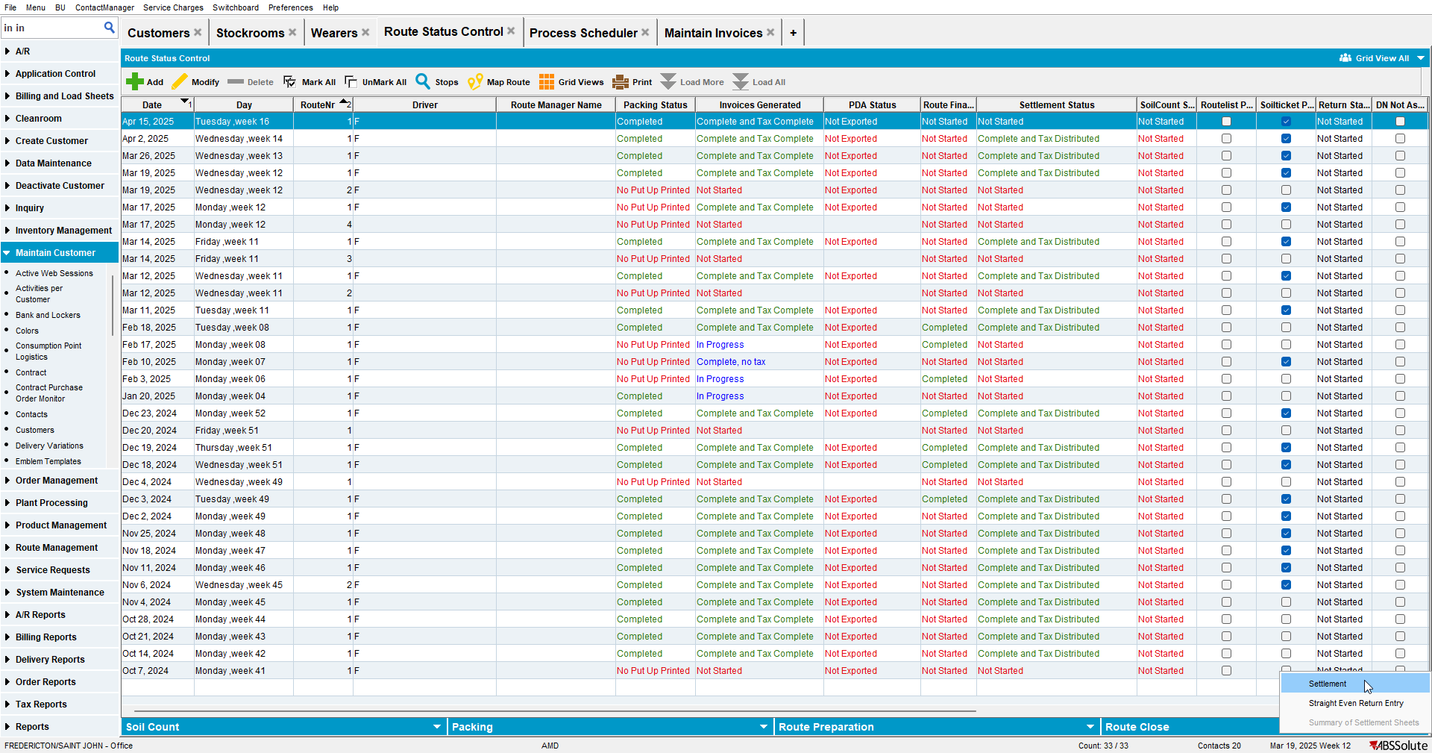

- Script the DISTRIBUTION batch like so:
--SETTLEMENT
UPDATE VERTEXTRANSACTIONLOG VTL
SET VTL.EXPORTID = NULL,
VTL.STATUS = 2,
VTL.TAXAREAID = VTL.DESTINATIONTAXAREAID,
VTL.TOTALLINEITEMTAX = ROUND(VTL.INPUTTOTALTAX, 2),
VTL.COMBINEDRATE = 0.08,
VTL.TOTALMAINDIVISIONTAX = ROUND(((VTL.EXTENDEDPRICE * 0.07) / 2), 2),
VTL.TOTALCOUNTRYTAX = TRUNC(((VTL.EXTENDEDPRICE * 0.07) / 2), 2)
WHERE VTL.BATCHID IN (2533999);

UPDATE VERTEXBATCHCONTROL VBC
SET VBC.BATCHSTATUS = 3
WHERE VBC.BATCHID IN (2533999);
- Run the Vertex Process Scheduler again
- Maintain Invoices DLG: Open the same invoice
