ABSN-3643 [QF][EU_TradeUnderuse] Cannot select a route/stop when adding a delivery scheme

Environment | Prerequisites
Version:9.07.00  DBServerName=abs-SRV20.internal.abslbs.com  DBSID=CUST24  DBUser=UNFDEV  DBPassword=UNFDEV  Environment=Test | - Module:  - System setting

Contents
Test after fix 1
Test Case 1 – Add new route to a new added customer – Tested OK 1
Test Case 2 – Add new route to a new duplicated customer – Tested OK 3

Test after fix

Test Case 1 – Add new route to a new added customer – Tested OK
Expected behavior: The route is added
Hash: 40b4468
- Create a new route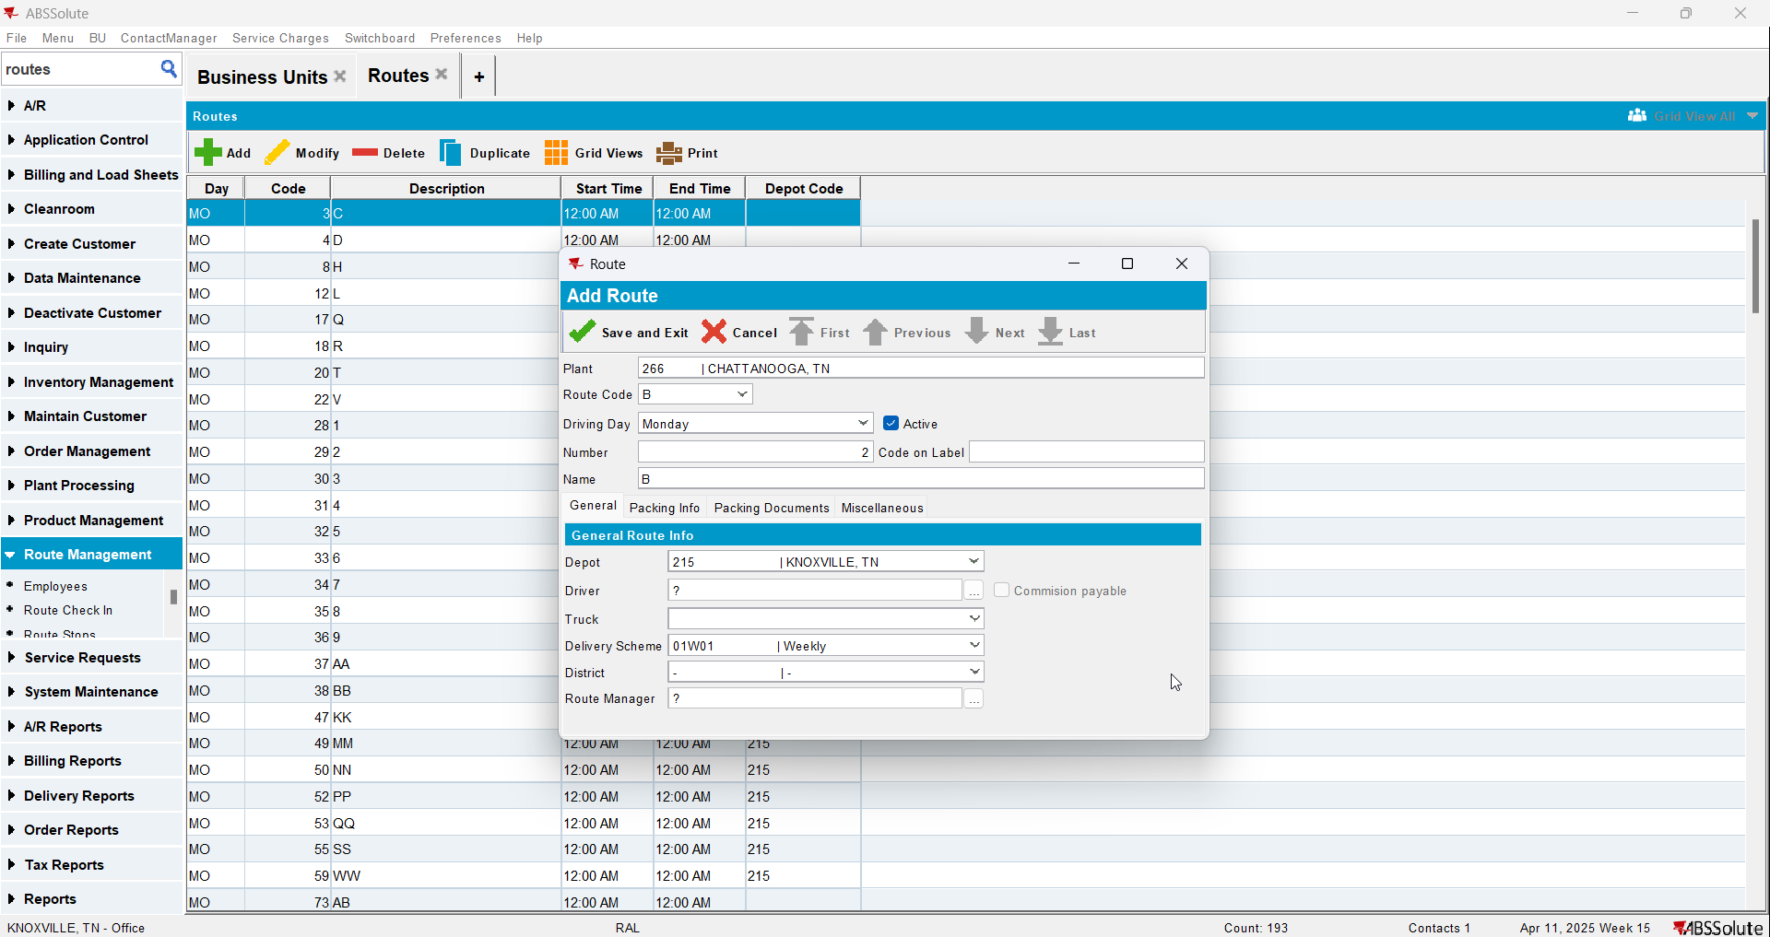
- Add a new customer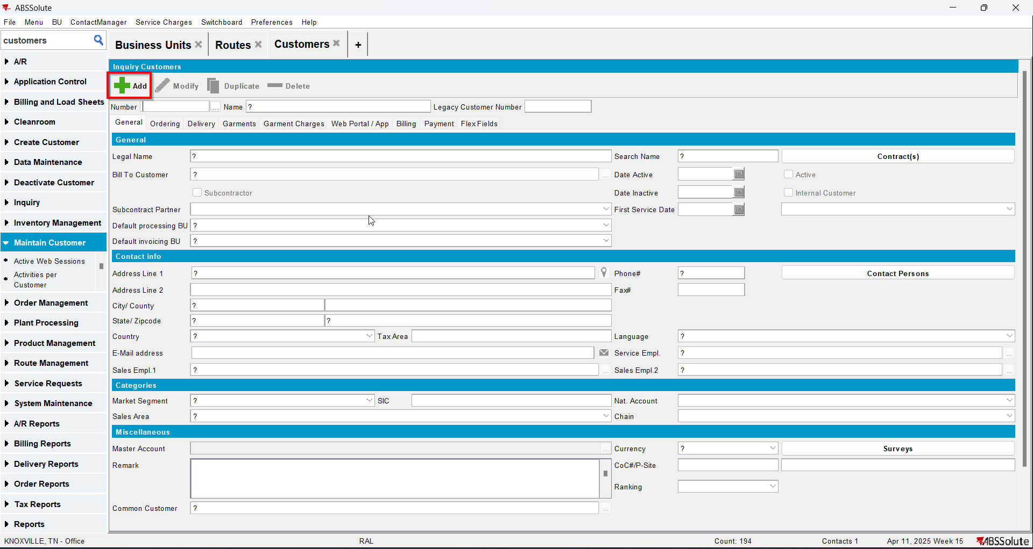
- Add a delivery point for it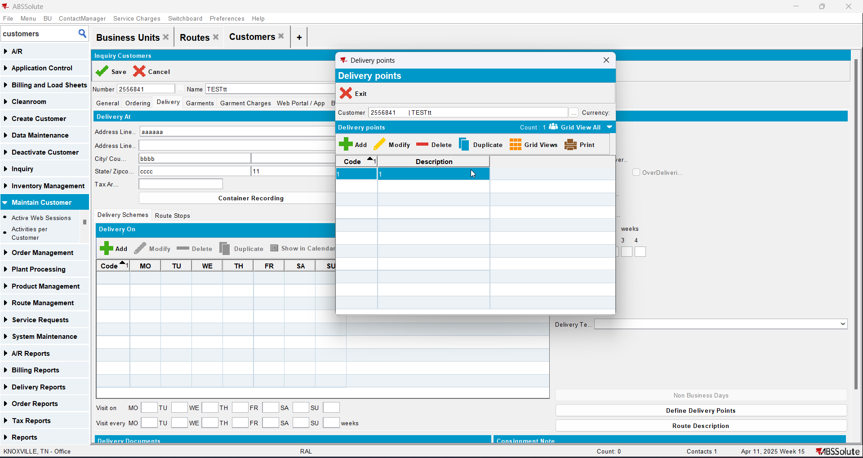
- Add the new route to the customer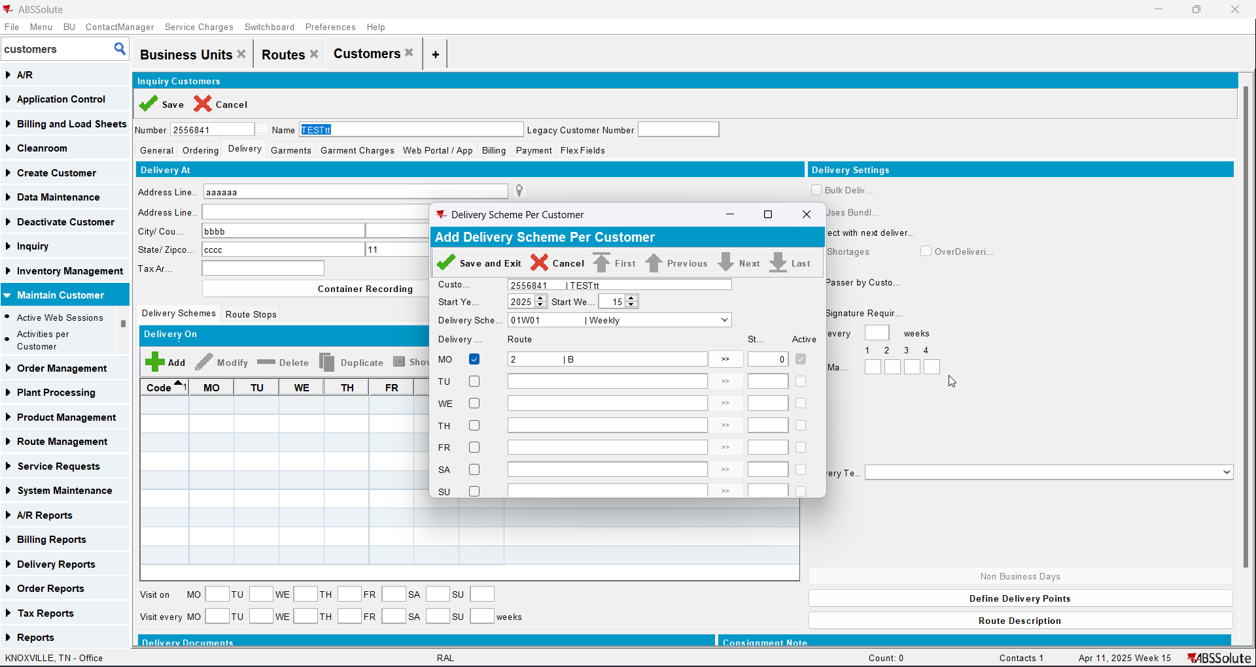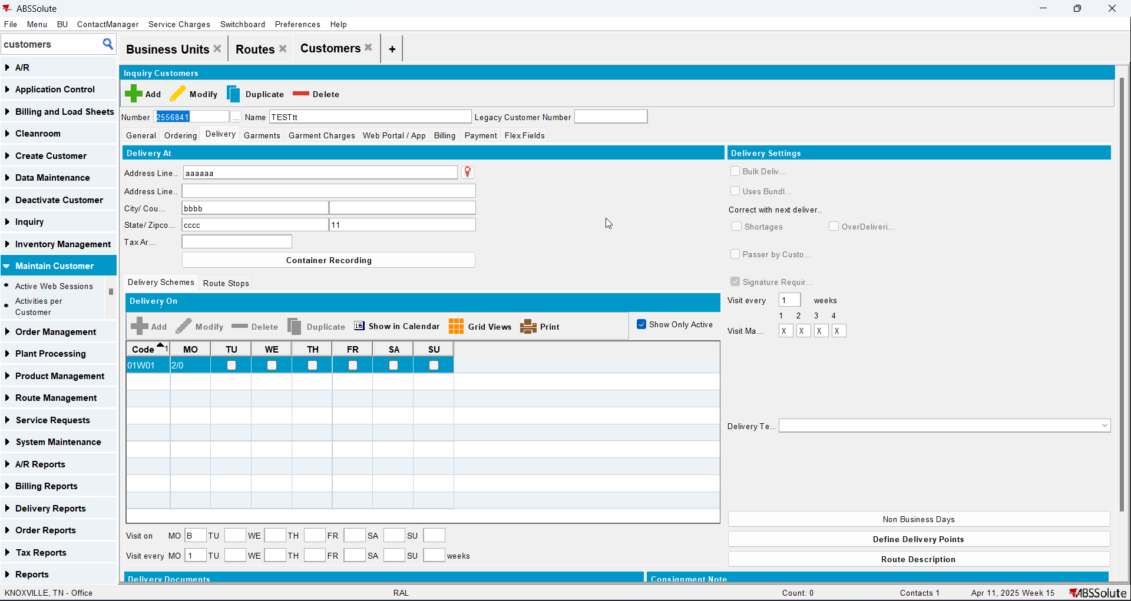

Test Case 2 – Add new route to a new duplicated customer – Tested OK
Expected behavior: The route is added
Hash: 40b4468
- Create a new route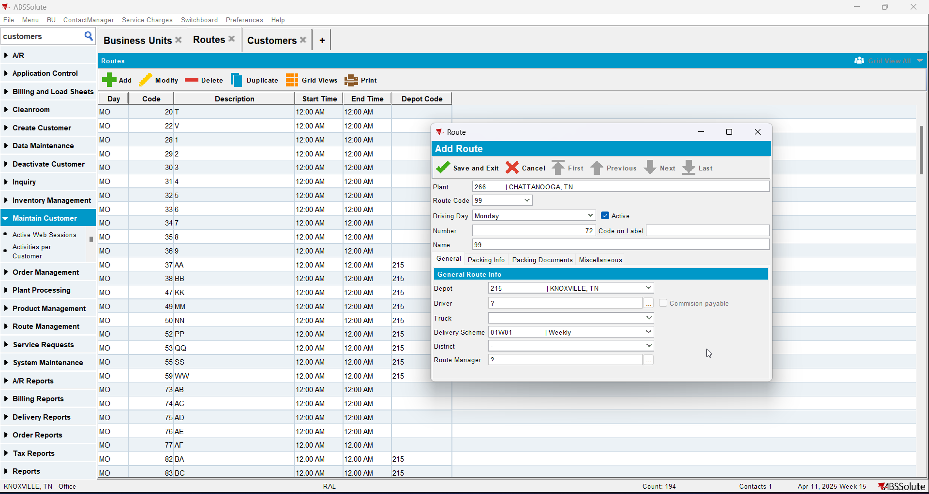
- Duplicate a customer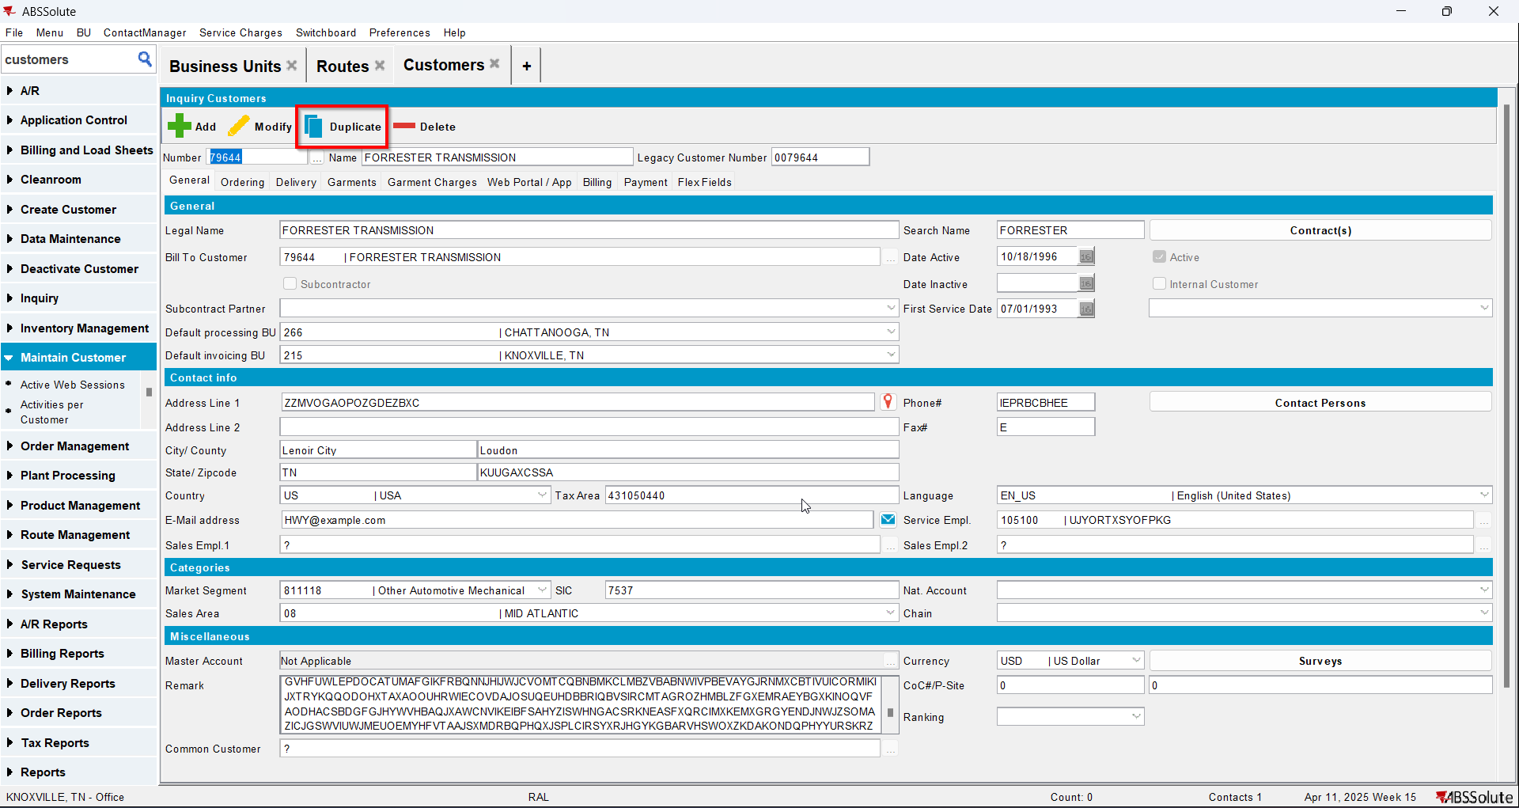
- Add a delivery point for it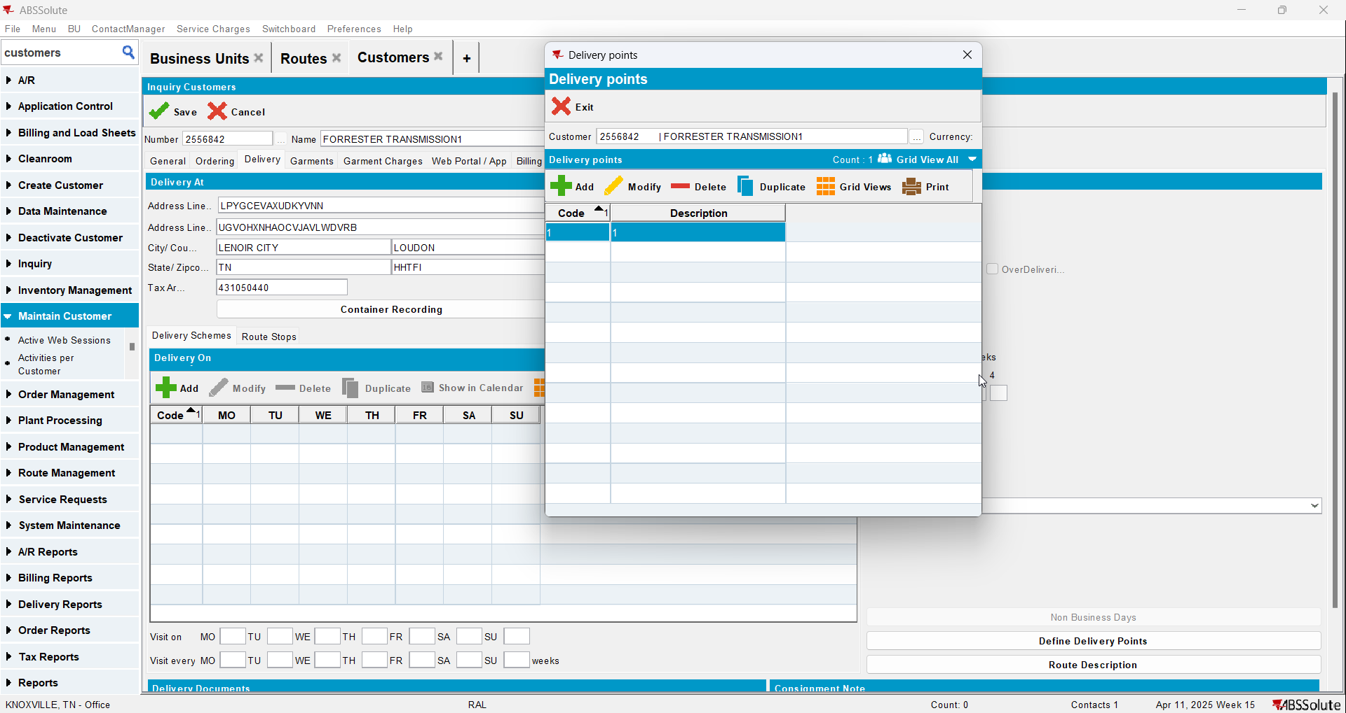
- Add the new route to the customer