ABSN-3636 - Invoice Generation - java.lang.NullPointerException: Cannot invoke "absgroup.bl.garment.WearerEmployment.getID()"
Environment | Prerequisites
Version: 9.07.00.UNF19  DBServerName= abs-srv20.internal.abslbs.com  DBSID=CUST24  DBUser=UNFDEV  DBPassword= UNFDEV  Environment=Test | - Module:  - System setting

Contents
Reproducing before fix 1
Steps to reproduce 1
Current Behavior 2
Expected behavior 3
Retest after fix 3
Test Case 1 – Check that the error is not prompted when adding a delivery variation 3
Test Case 2 – Check if non garment prep charges still apply 5

Reproducing before fix

Steps to reproduce
- BU: 335
- Add a new route for route 1, Friday and leave only customer 869153 with an active stop
- Add a new delivery variation for this stop for product 76GA03 for a quantity of 5
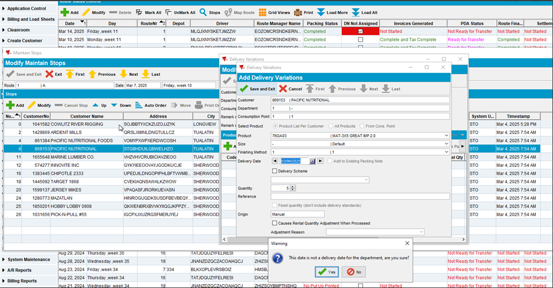
- Generate packing notes for this delivery variation for the same delivery date as your driving date
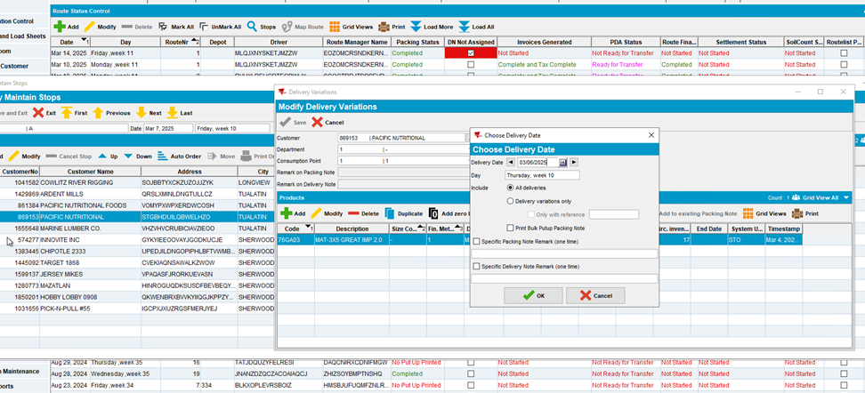
- Generate invoices for your route
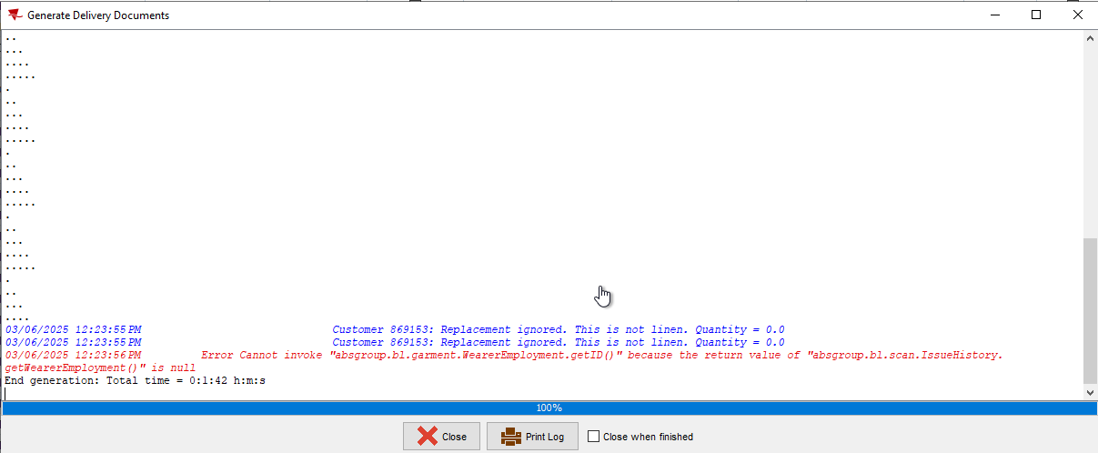

REPRODUCED OK.

Current Behavior
We receive the following error:
025-03-06 11:45:44.247 *----> ABSSolute exception occurred <----*
When: Thu Mar 06 11:45:44 EST 2025
User: system
Error message: Generate Invoices
An unexpected exception occurred.
Additional error message: Cannot invoke "absgroup.bl.garment.WearerEmployment.getID()" because the return value of "absgroup.bl.scan.IssueHistory.getWearerEmployment()" is null
Stack trace: java.lang.NullPointerException: Cannot invoke "absgroup.bl.garment.WearerEmployment.getID()" because the return value of "absgroup.bl.scan.IssueHistory.getWearerEmployment()" is null

Expected behavior
.

Retest after fix

Test Case 1 – Check that the error is not prompted when adding a delivery variation
Hash: c620897273ab
- BU: 335
- Add a new route for route 1, Friday and leave only customer 869153 with an active stop
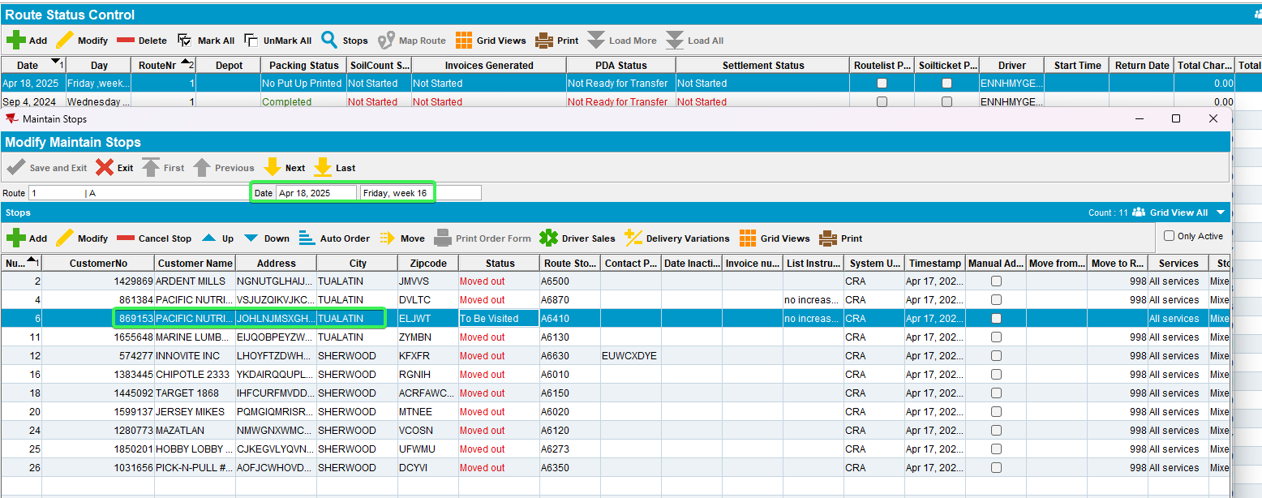
- Add a new delivery variation for this stop for product 76GA03 for a quantity of 5
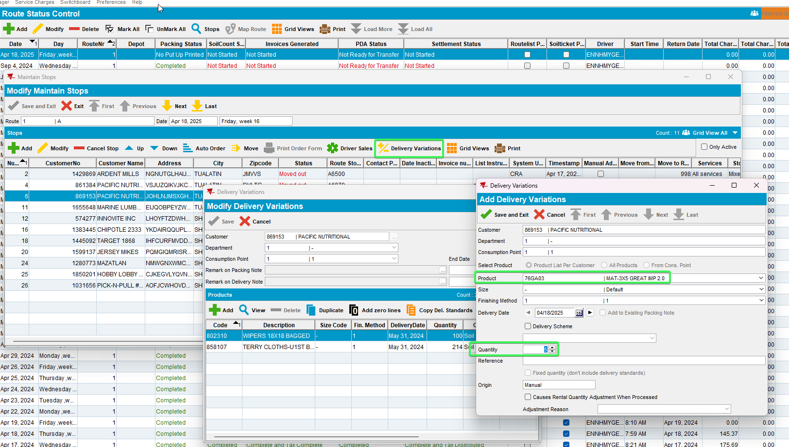
- Generate packing notes for this delivery variation for the same delivery date as your driving date
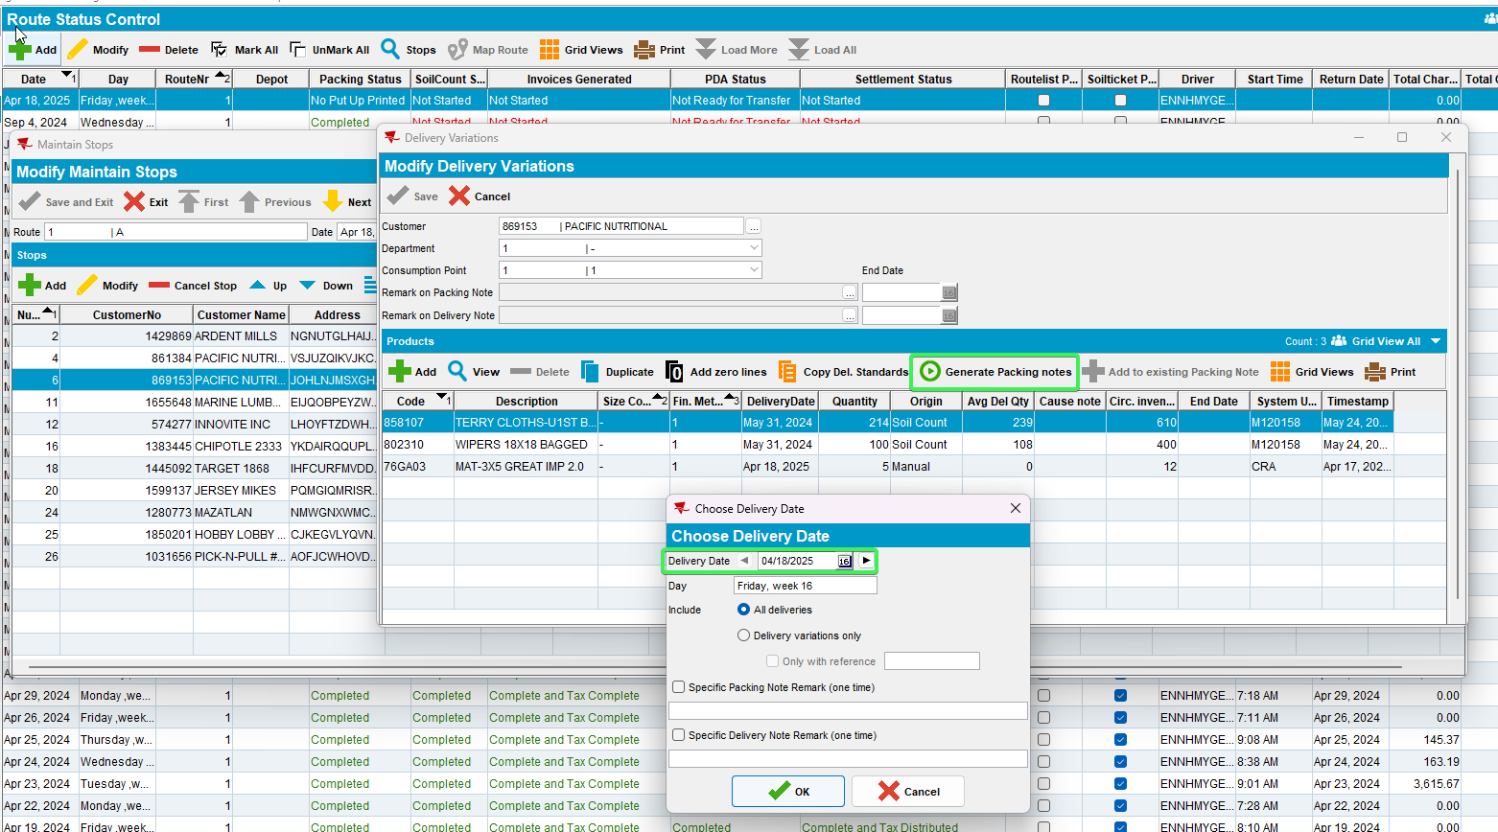
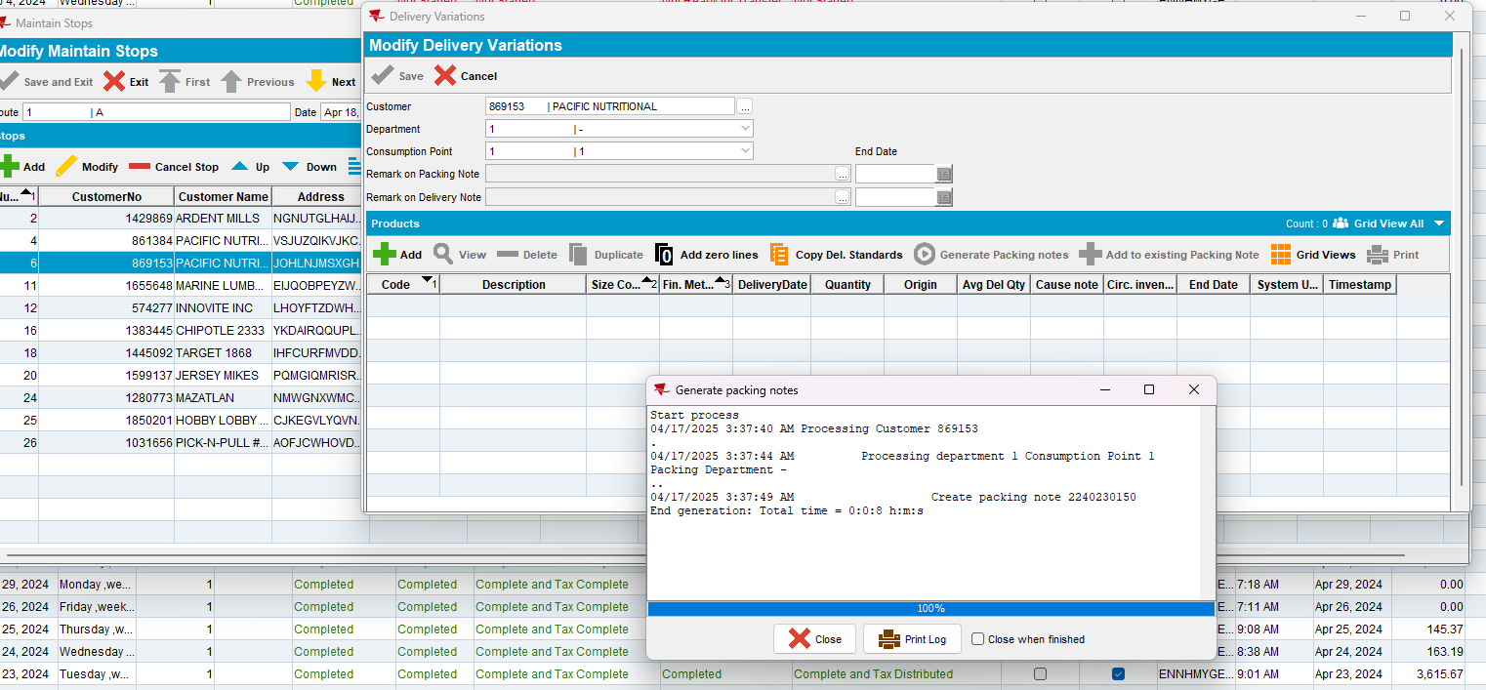
- Generate invoices for your route
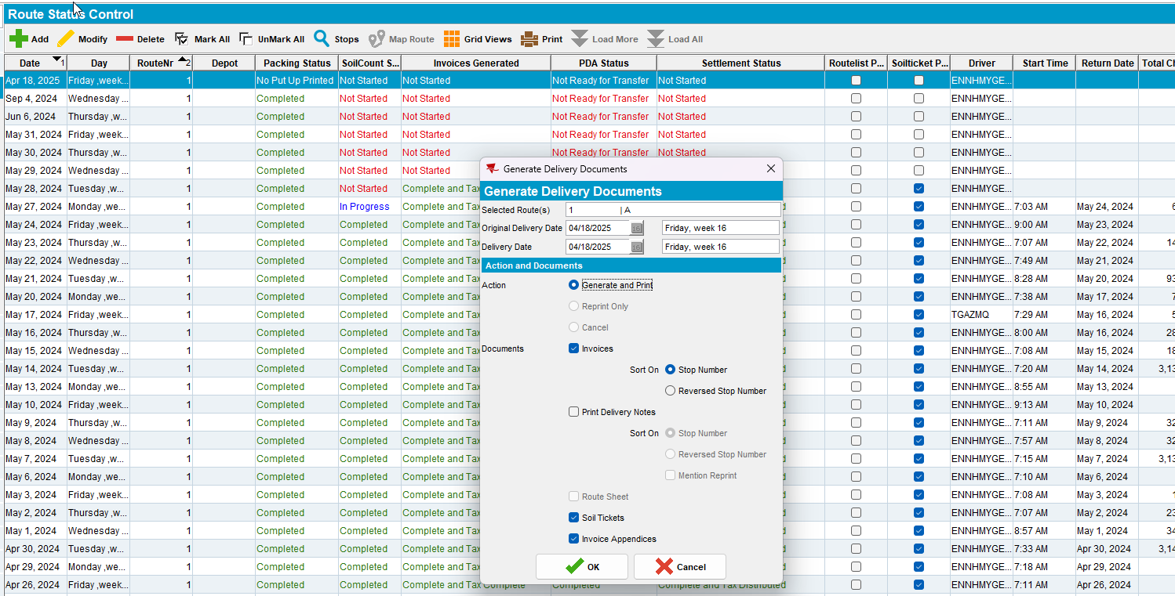
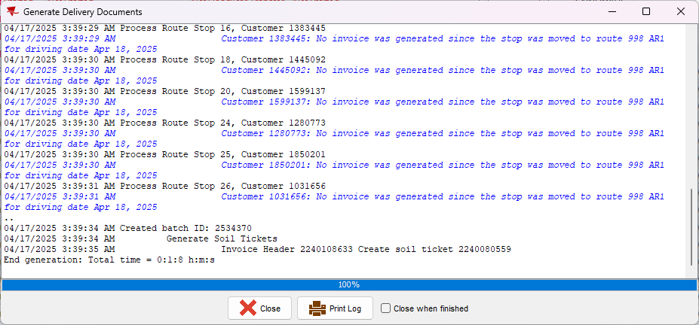
Tested OK

Test Case 2 – Check if non garment prep charges still apply
Hash: c620897273ab
Expected Behavior: There should be a line for Stockroom Handling charges after invoicing
- Product list per customer DLG: Have a customer (28102) with active unique mats (UL0744)
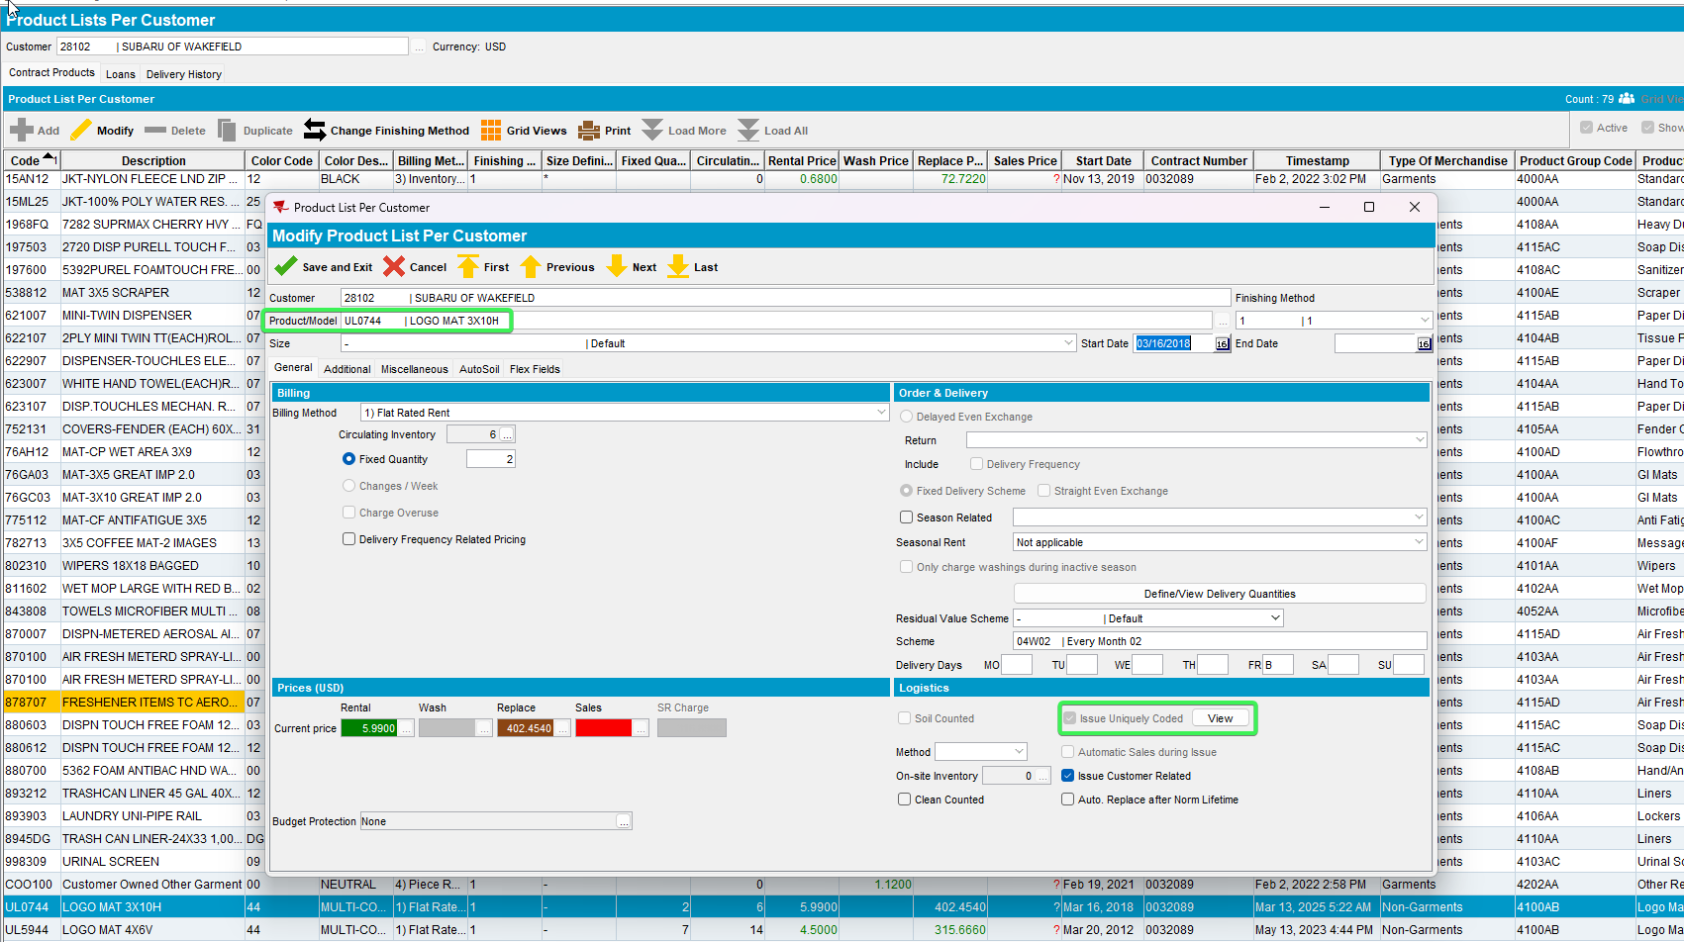
- Reason Codes DLG: Pick a reason code which has charges prep / makeup costs
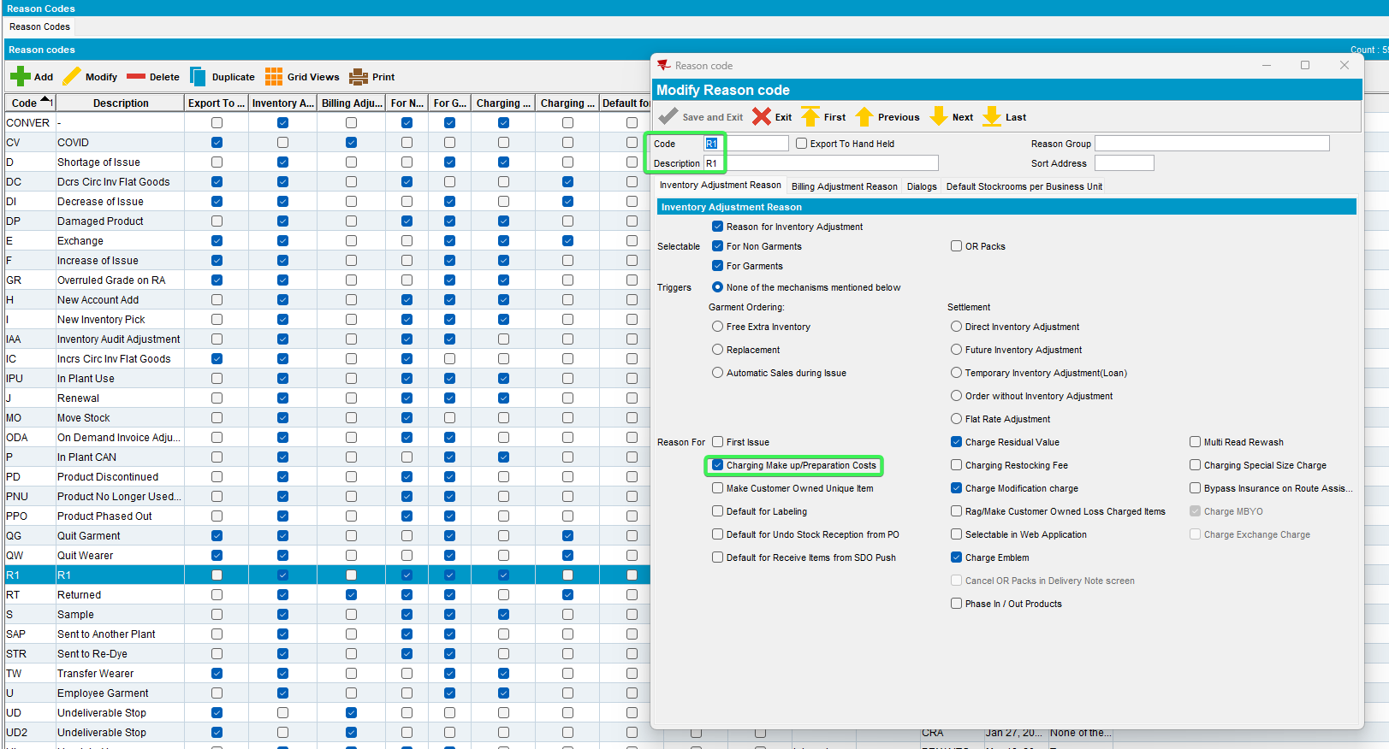
- Go to Customers Contract (0032089) and press modify
- Components > Product settings: Make sure General Prep Charge is checked and has a price
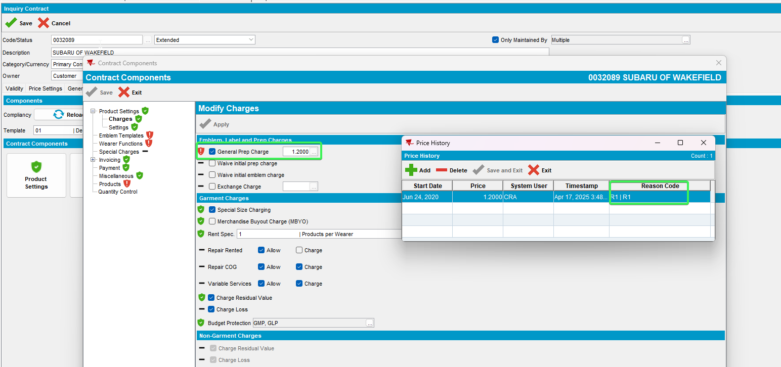
- Update Compliancy to your customer as well
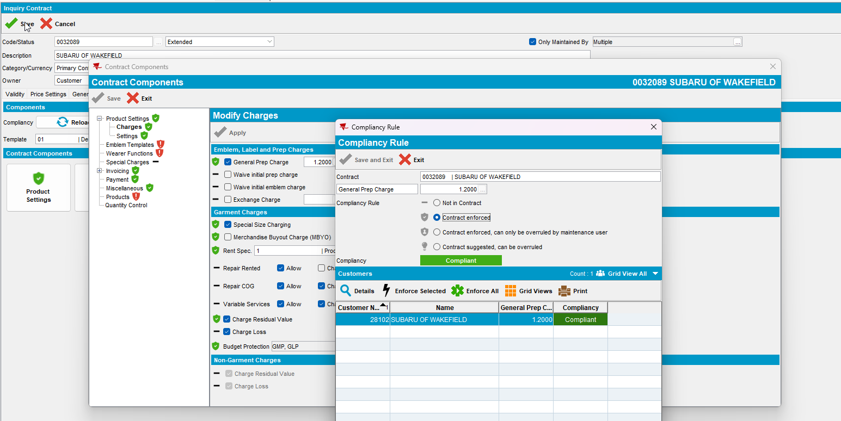
- Work Order Status Control: Pool tab > Add new WO for customer related pool
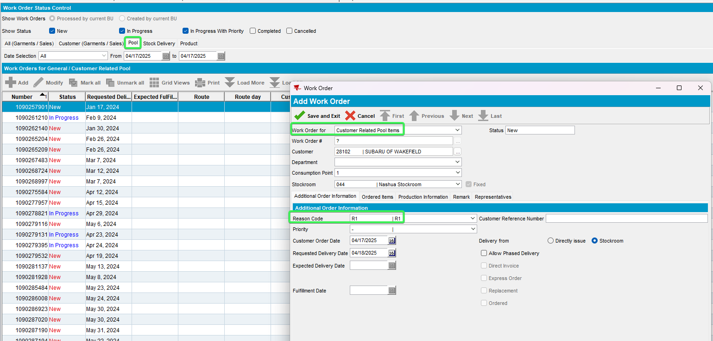
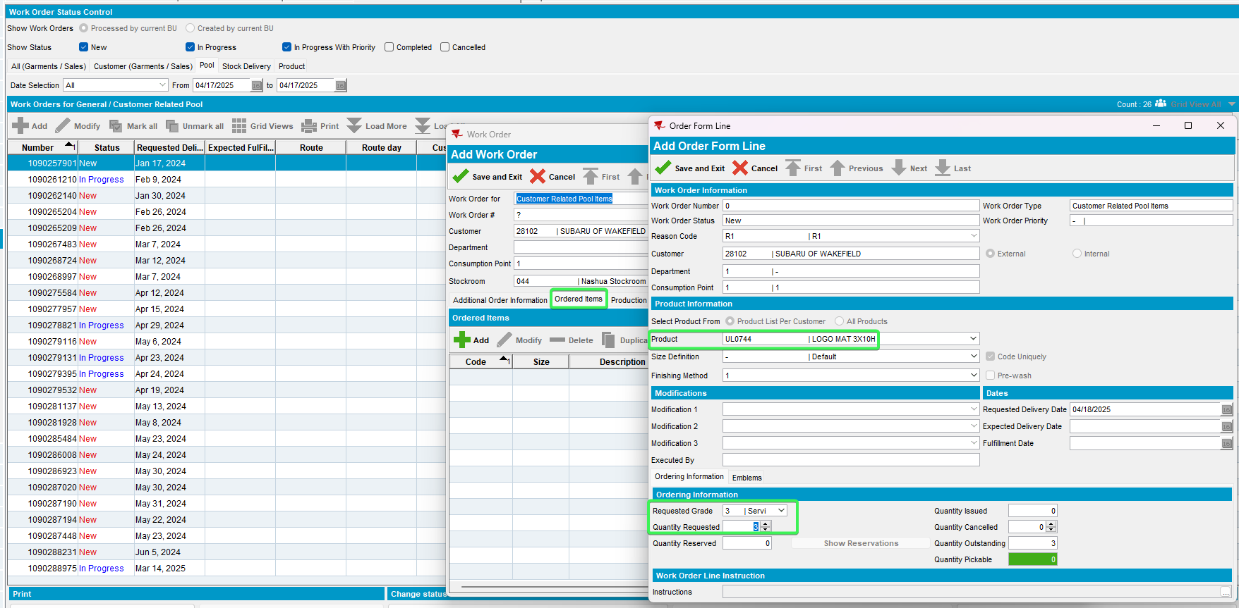
- Press Issue > Issue the work order with some chip codes (you can see the existing codes in use from the PLPC view unique items button, copy one of these and change the numbers a little)
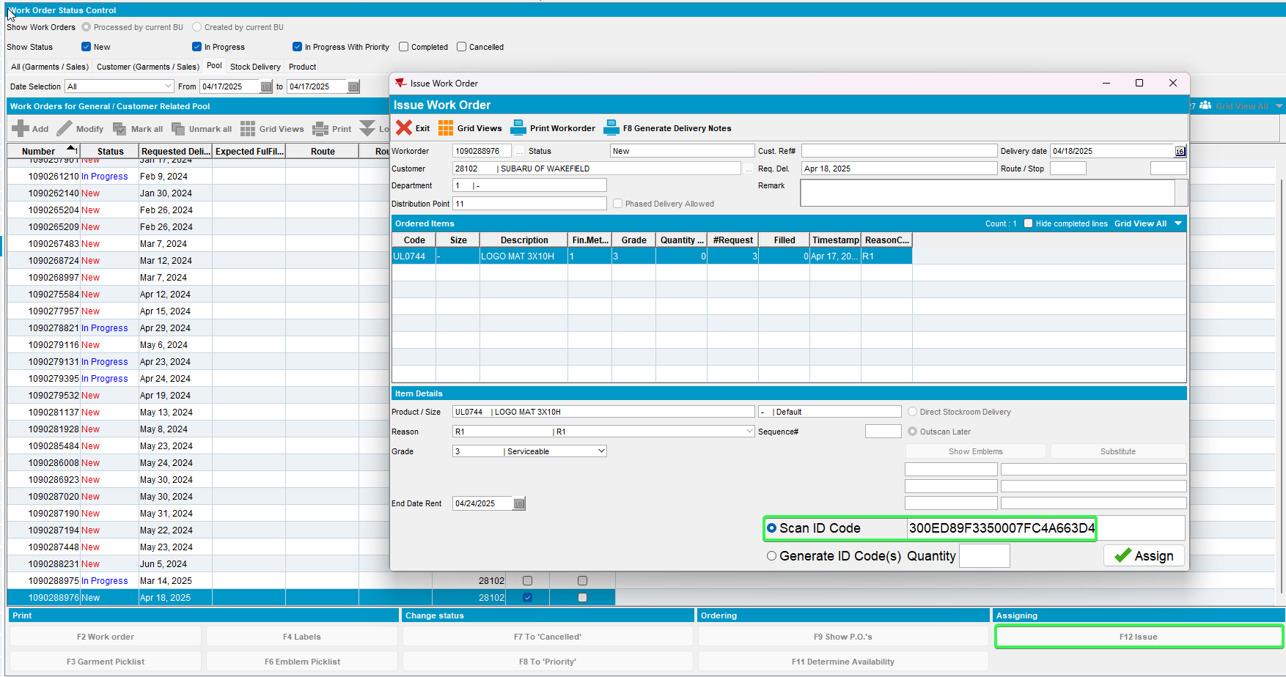
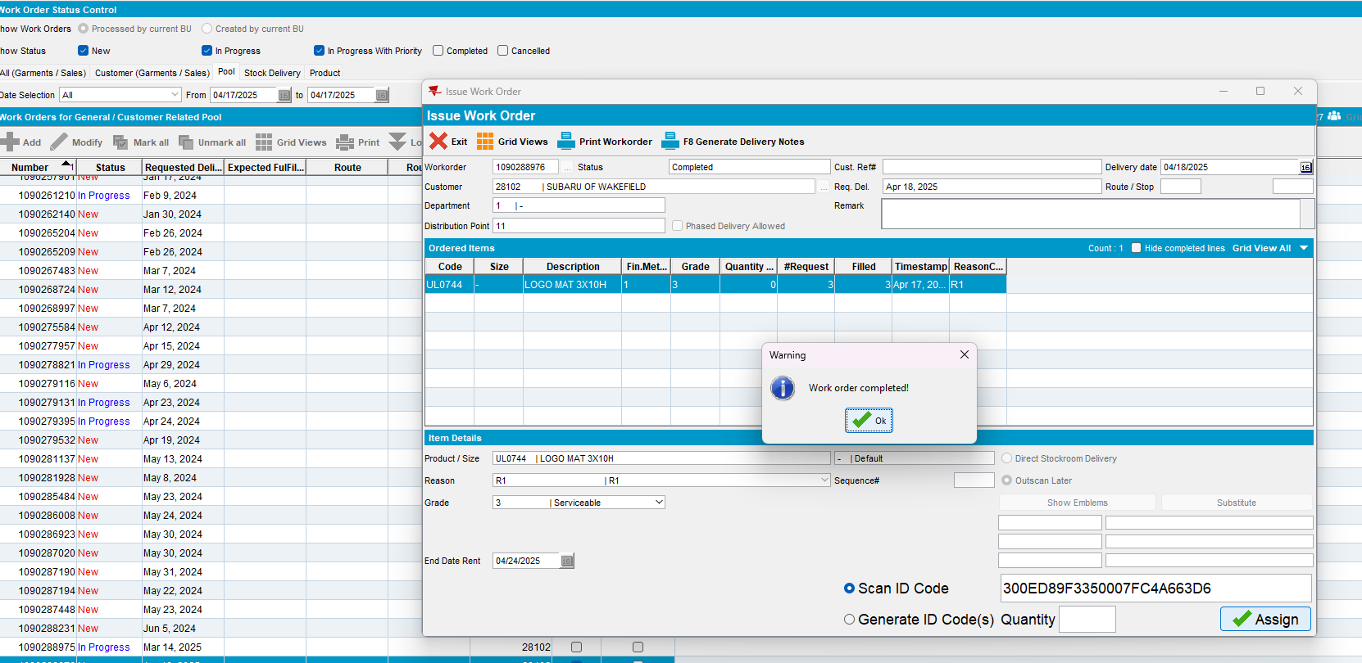
- Maintain Garment Charges: You then see the lines in maintain garment charges, prep charges tab
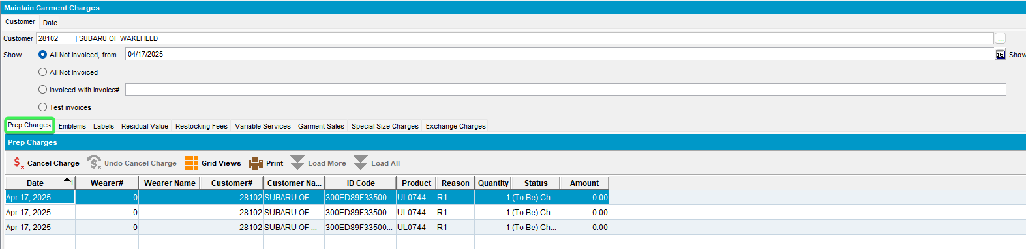
- Generate invoices for the route the customer is on
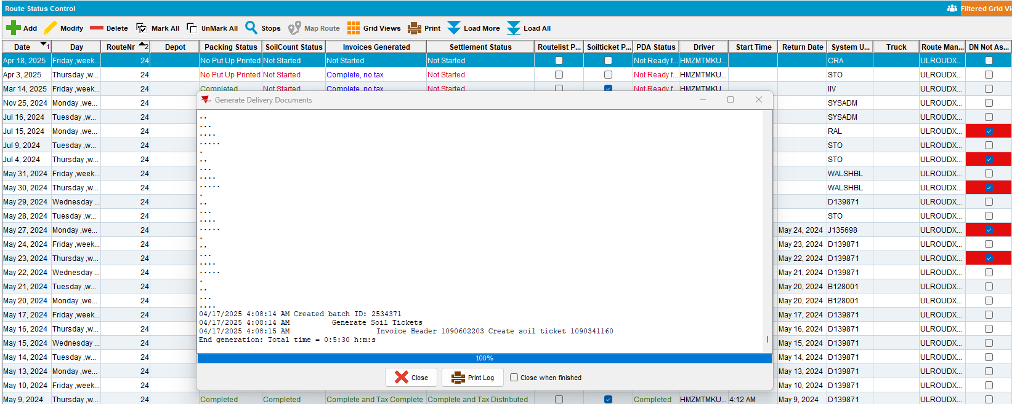
- Maintain Invoices: There should be a line for Stockroom Handling charges
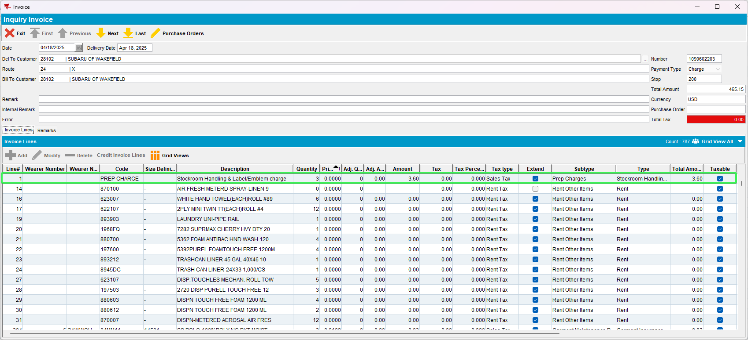
Tested OK

