ABSN-3486 [QF][UNFGarment] - Circulating inventory is not decrease to zero, after a decrease and full replace of a wearer inventory
Environment | Prerequisites
Version: 9.07.00.UNF19  DBServerName=abs-SRV20.internal.abslbs.com  DBSID=CUST24  DBUser=UNFDEV  DBPassword=UNFDEV  Environment=Test | - Module:  - System setting

Contents
Test after fix 1
Test Case 1 – Non unique garments only 1
Test Case 2 – Unique garments only 5
Test Case 3 – Mixed garments 9

Test after fix

Test Case 1 – Non unique garments only
Expected behavior: The circulating inventory should have decreased to zero for wearer inventory A.
Hash: 529d0c2c4922
- Wearers dlg: Have a wearer with wearer inventory A with 11 garments (non-unique). Make a decrease of inventory of 2 garments to 9.
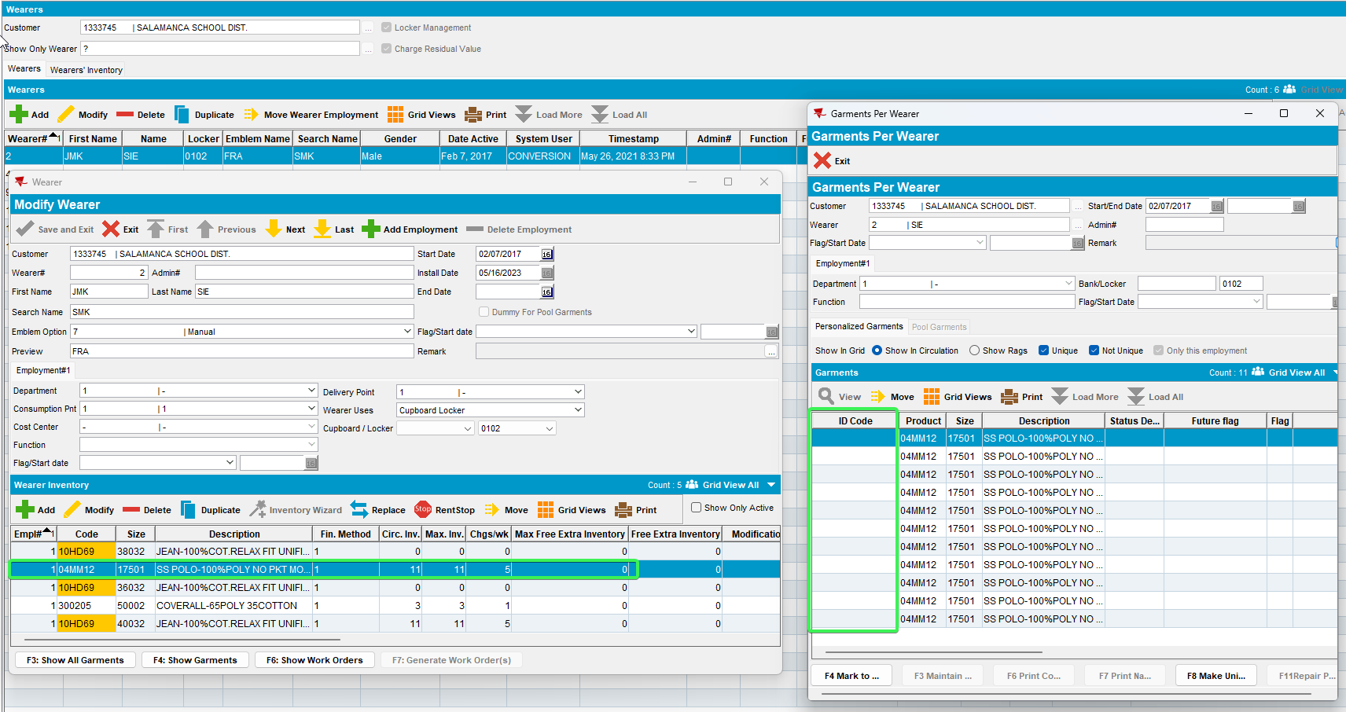
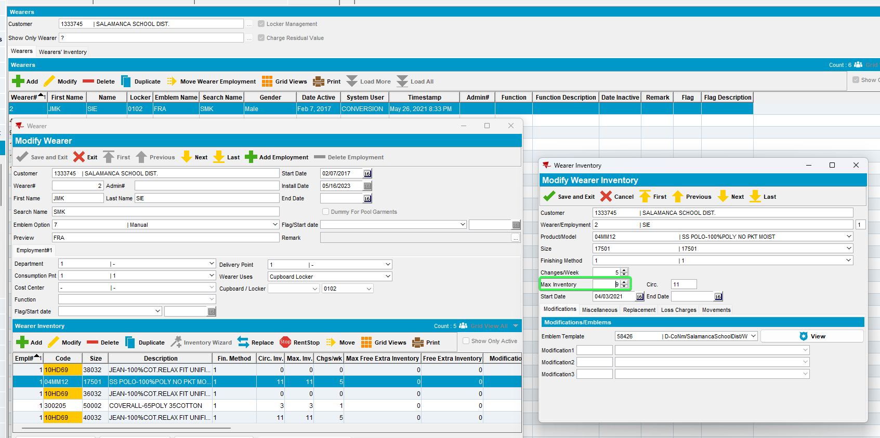
- Wearers dlg: Make a full replacement of wearer inventory A with another garment (wi B / unique garment). Issue the new garments.
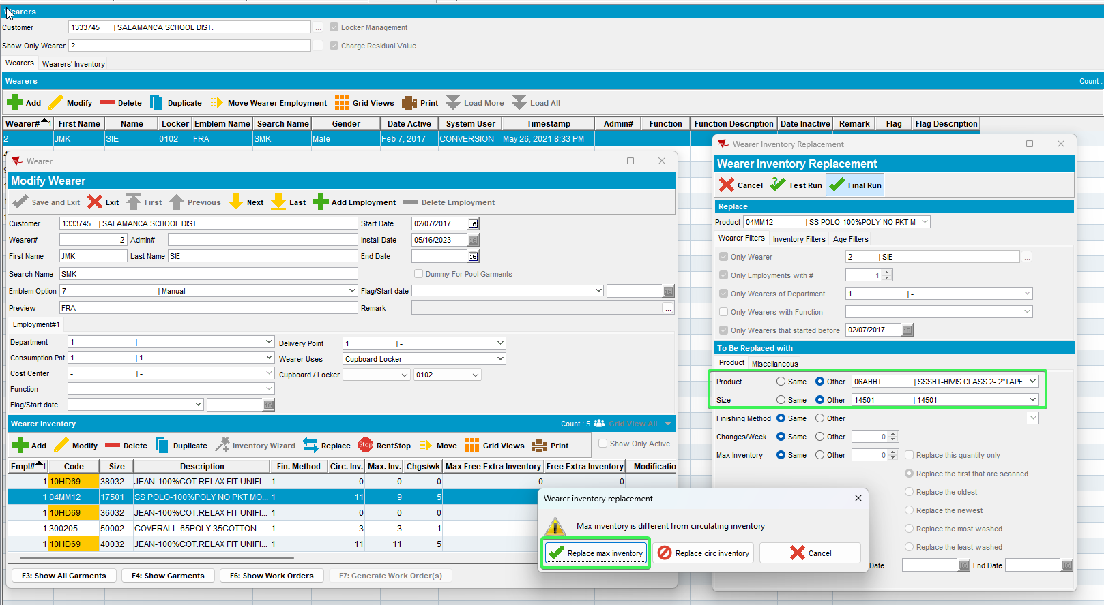
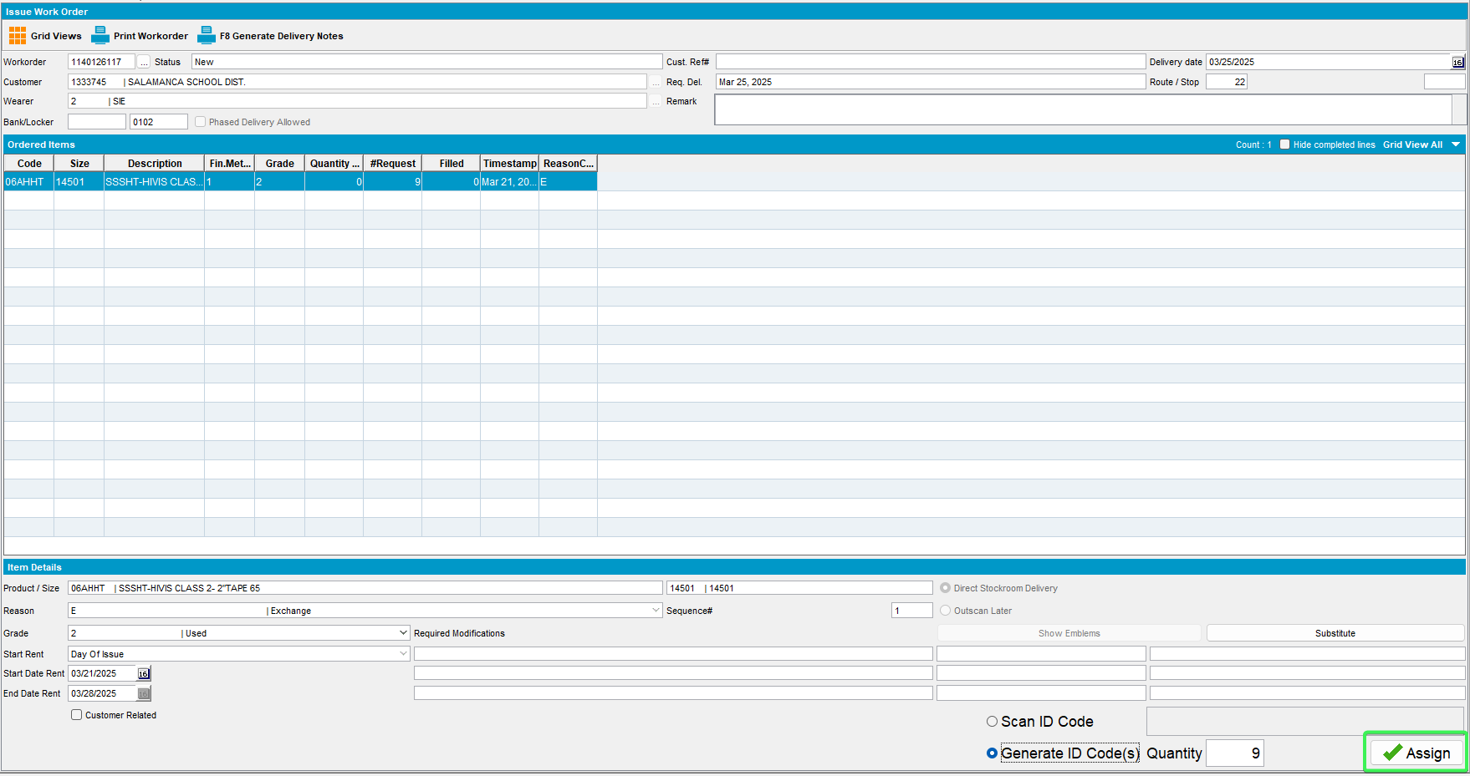
- RSC: Make a route 2weeks+ in the future. Generate invoices and settle the route.
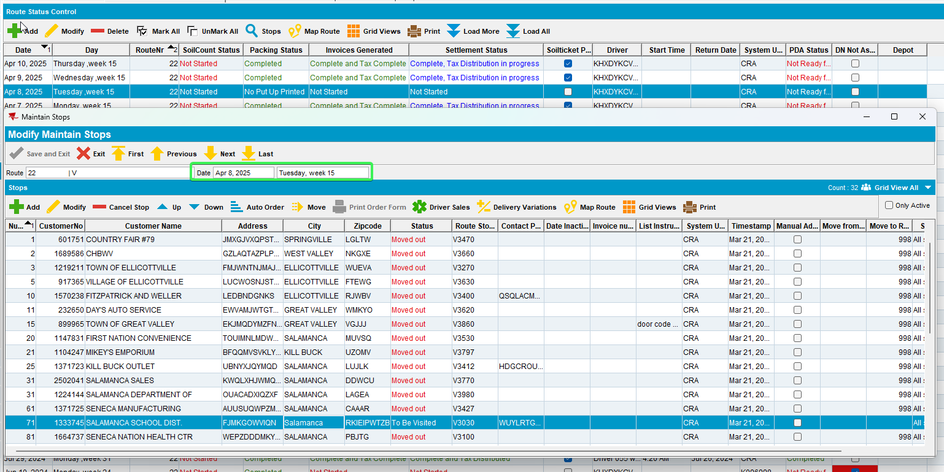
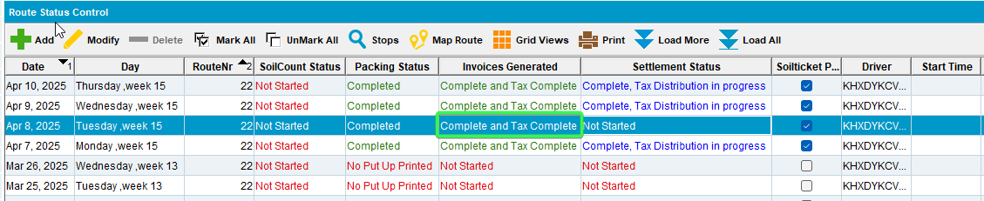
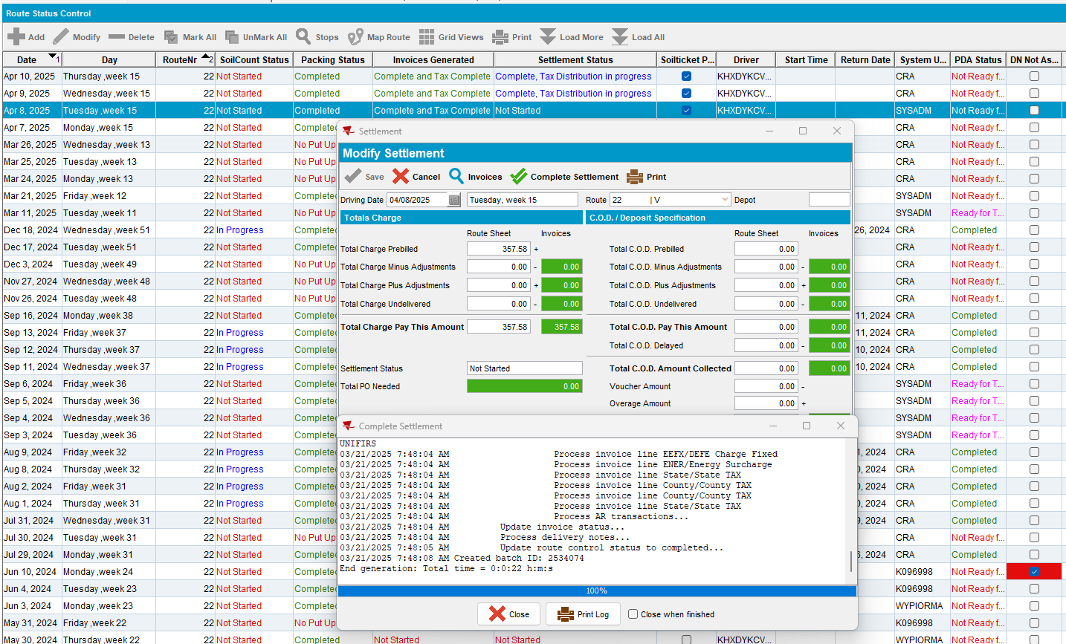
- Wearers dlg: Recheck the circulating inventory of wearer inventory A.
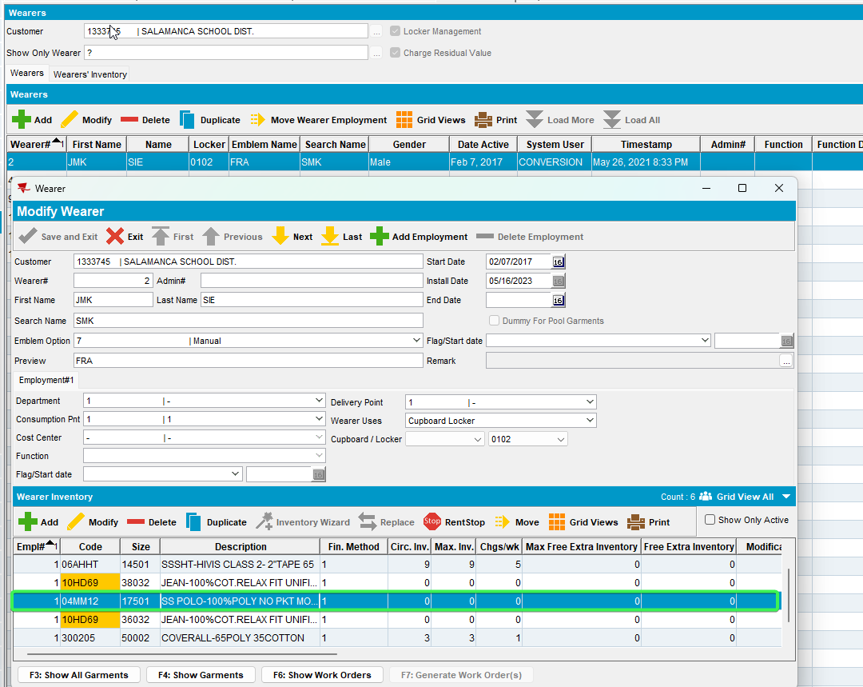
Tested OK

Test Case 2 – Unique garments only
Expected behavior: The circulating inventory should have decreased to zero for wearer inventory A
Hash: 529d0c2c4922
- Wearers dlg: Have a wearer with wearer inventory A with 11 garments (unique). Make a decrease of inventory of 2 garments to 9.
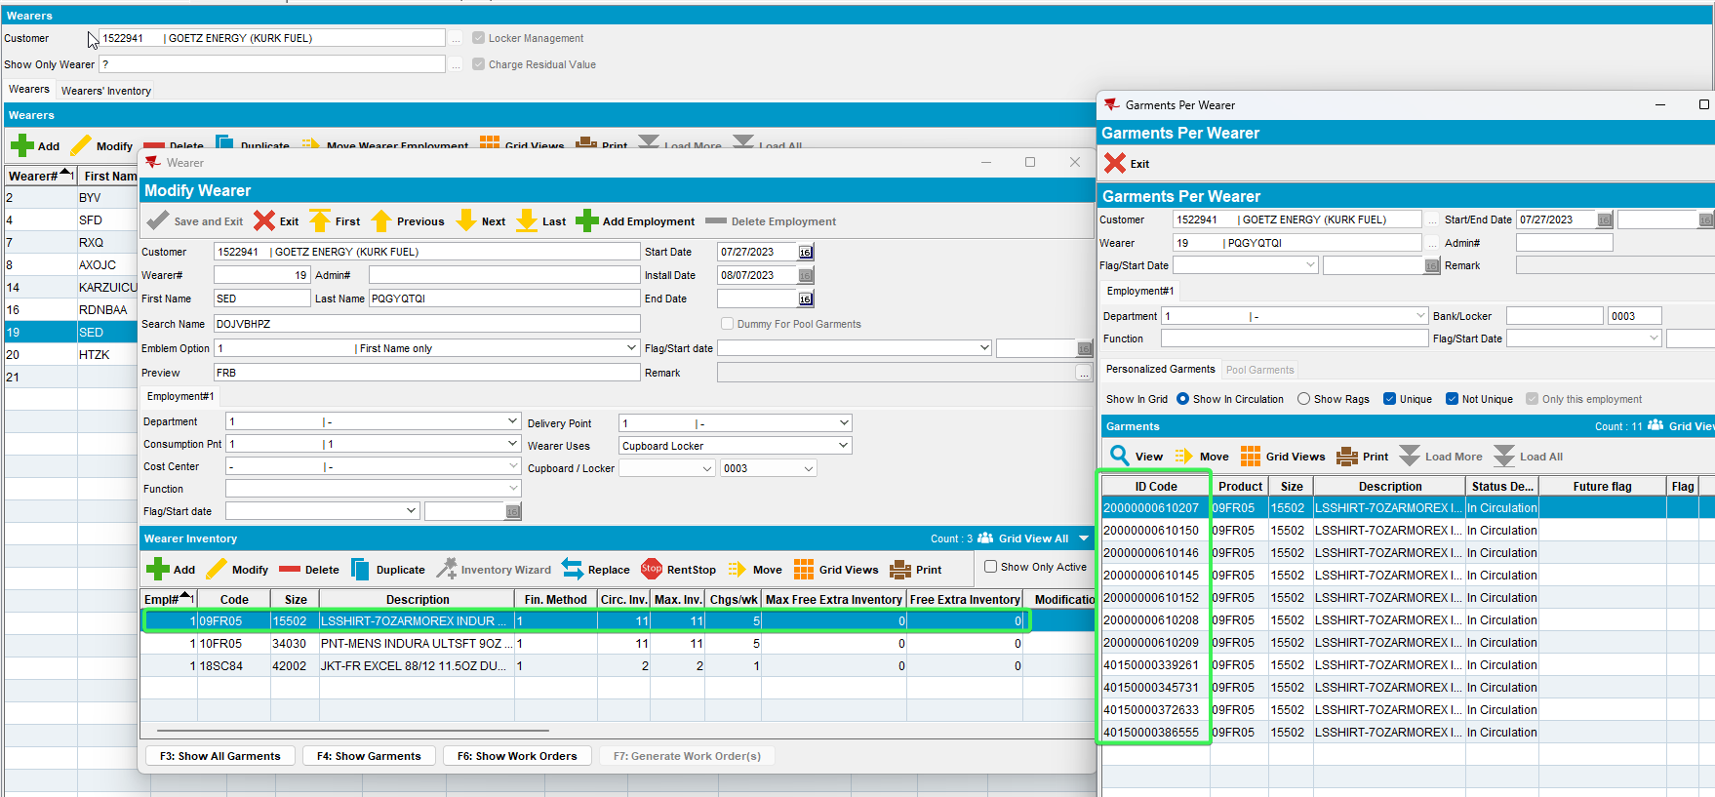
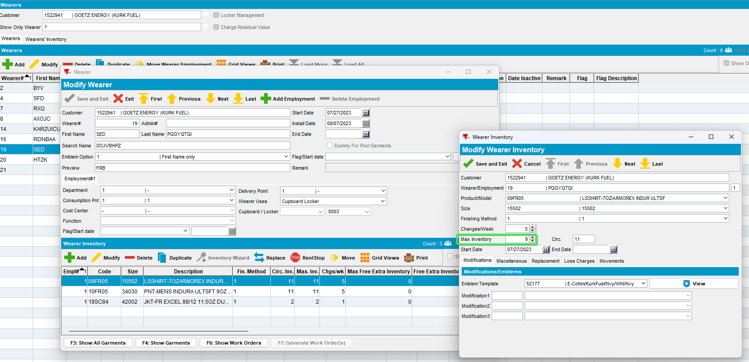
- Wearers dlg: Make a full replacement of wearer inventory A with another garment (wi B / unique garment). Issue the new garments.
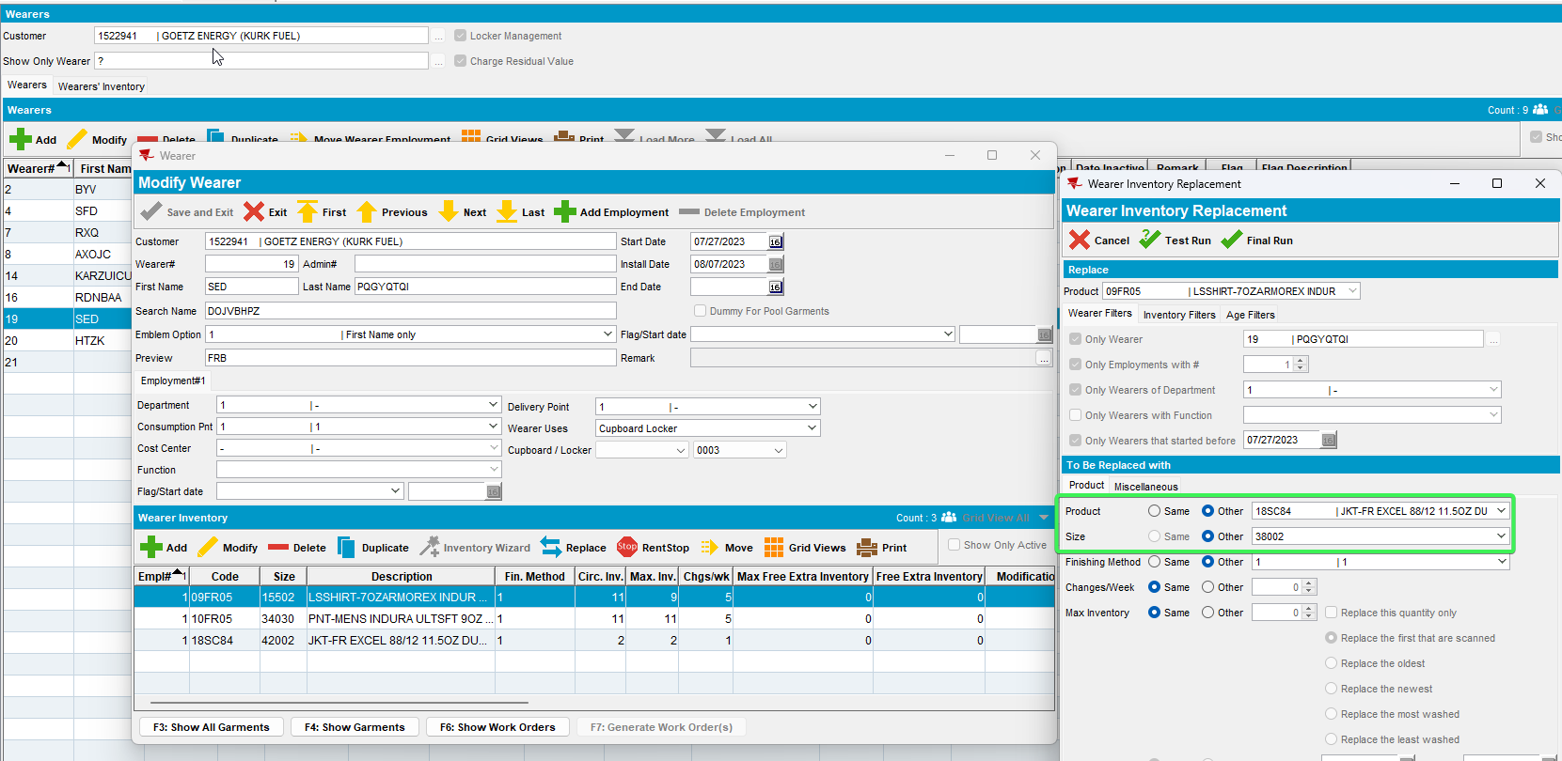
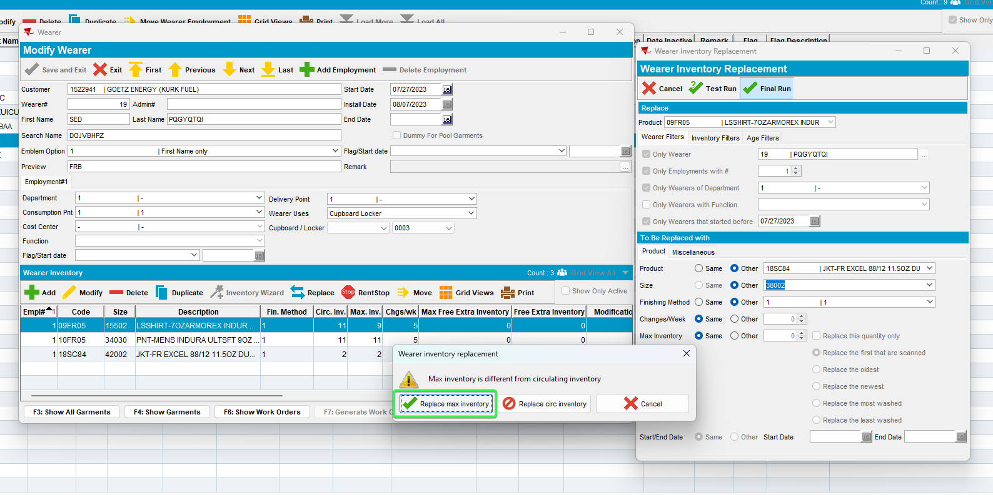
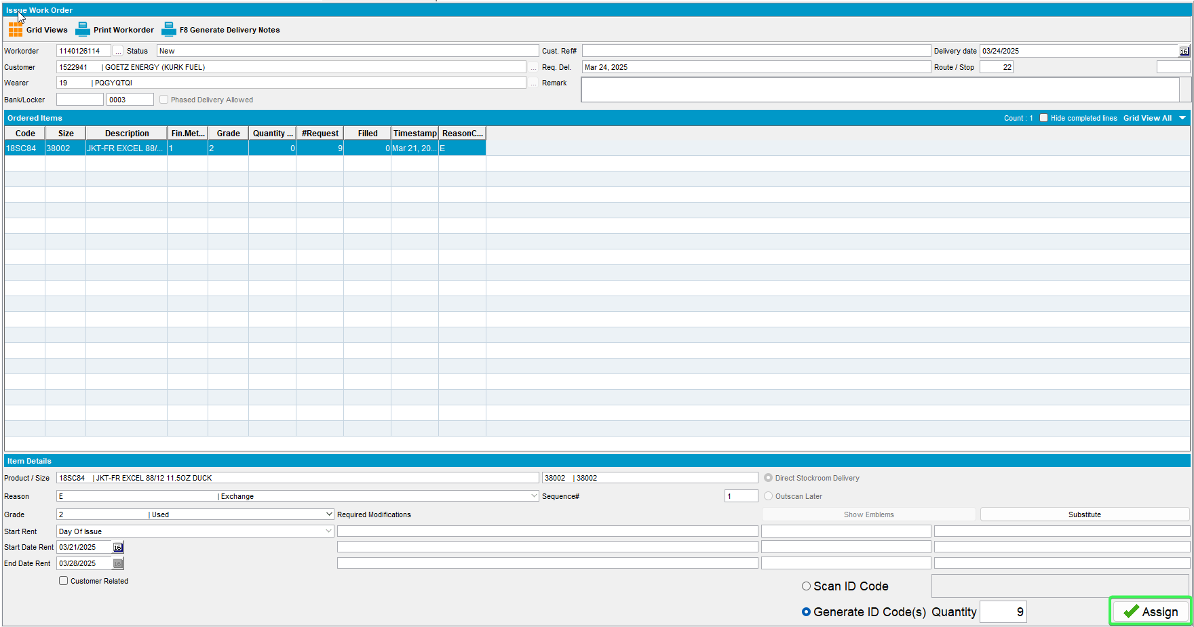

- RSC: Make a route 2weeks+ in the future. Generate invoices and settle the route.
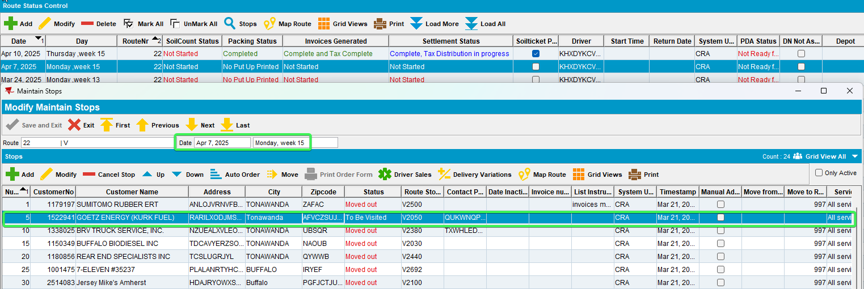
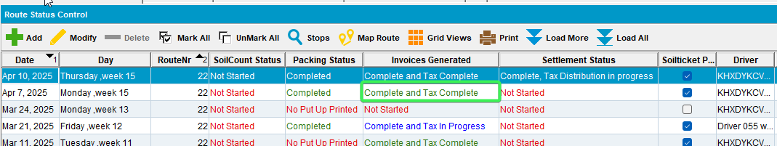
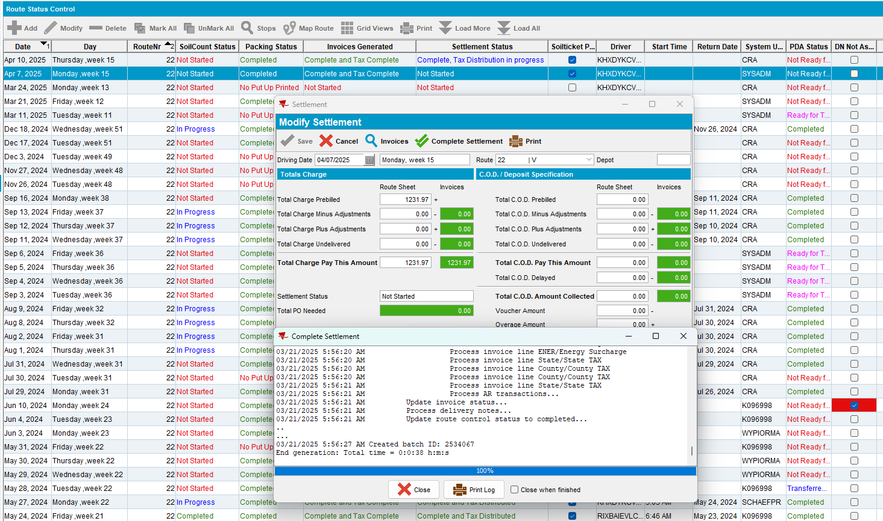
- Wearers dlg: Recheck the circulating inventory of wearer inventory A.
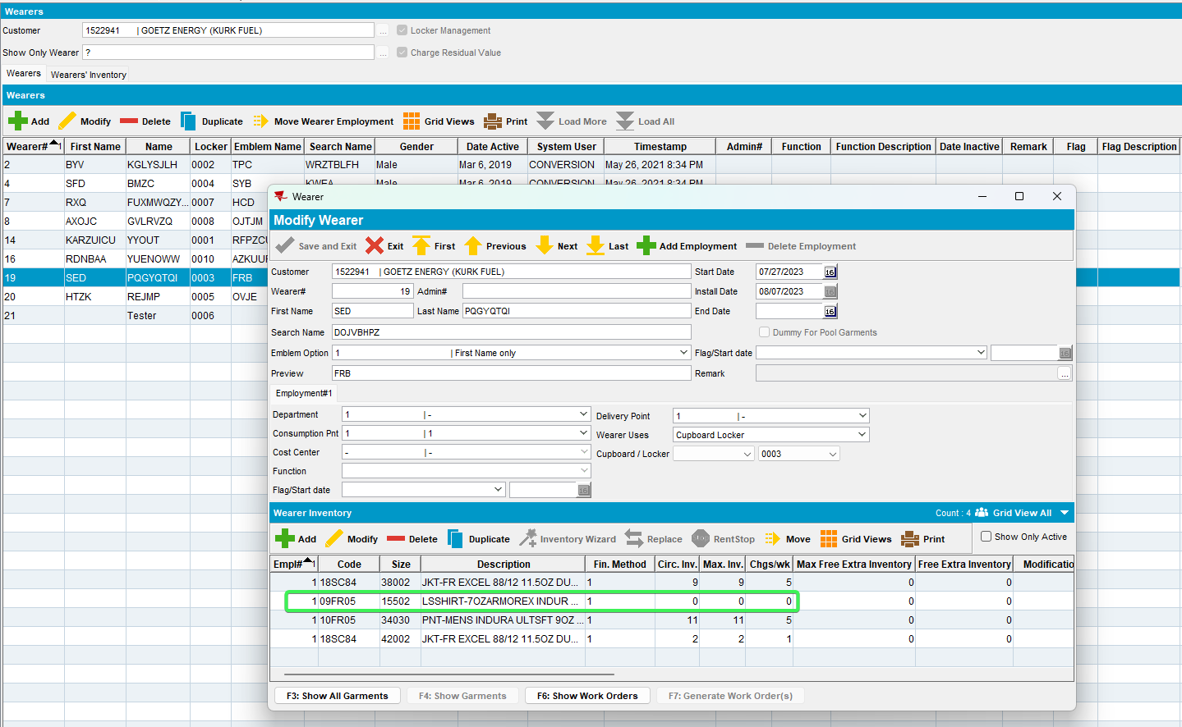
Tested OK

Test Case 3 – Mixed garments
Expected behavior: The circulating inventory should have decreased to zero for wearer inventory A
Hash: 529d0c2c4922
- Wearers dlg: Have a wearer with wearer inventory A with 11 garments (1 non-unique and 10 unique). Make a decrease of inventory of 2 garments to 9.
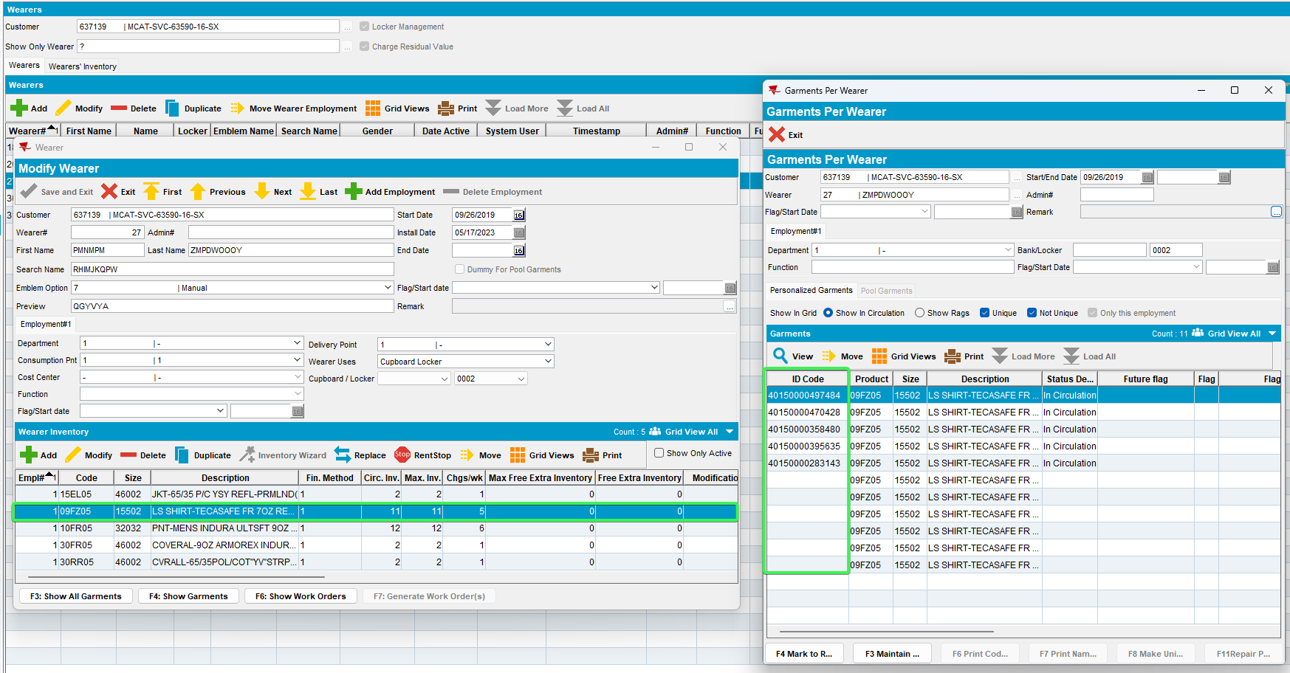
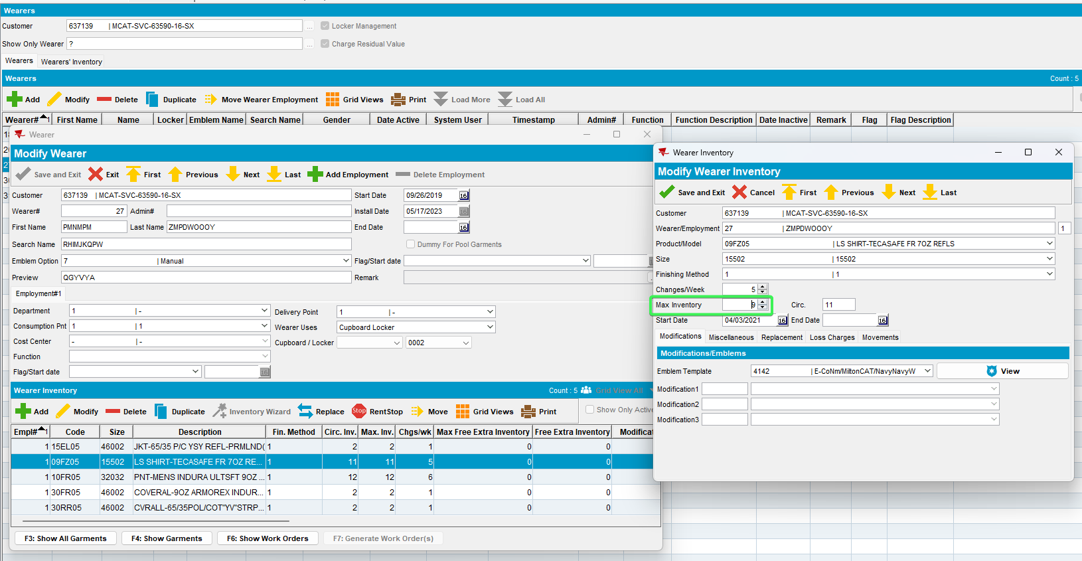
- Wearers dlg: Make a full replacement of wearer inventory A with another garment (wi B / unique garment). Issue the new garments.

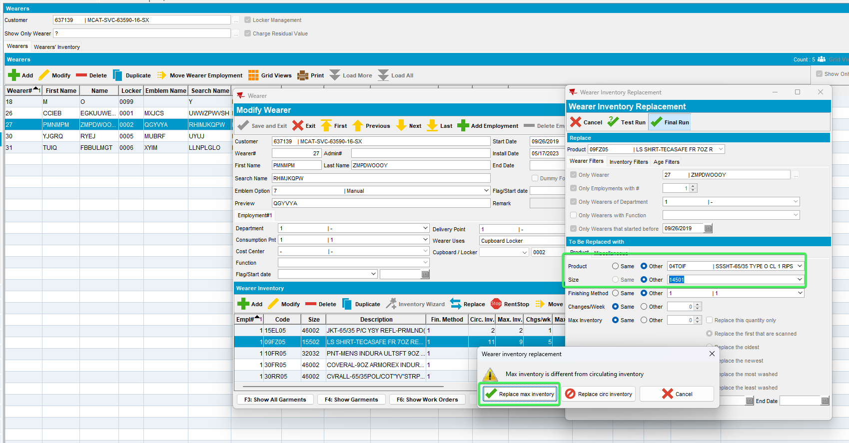
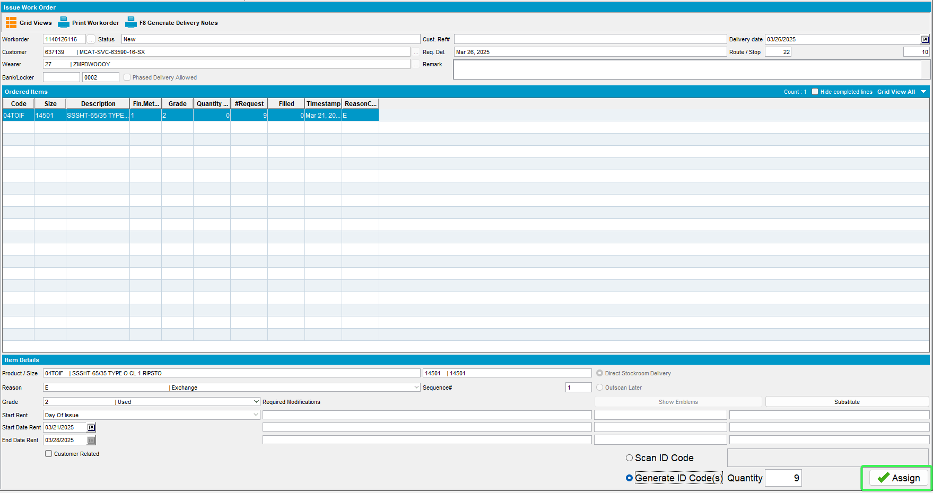
- RSC: Make a route 2weeks+ in the future. Generate invoices and settle the route.
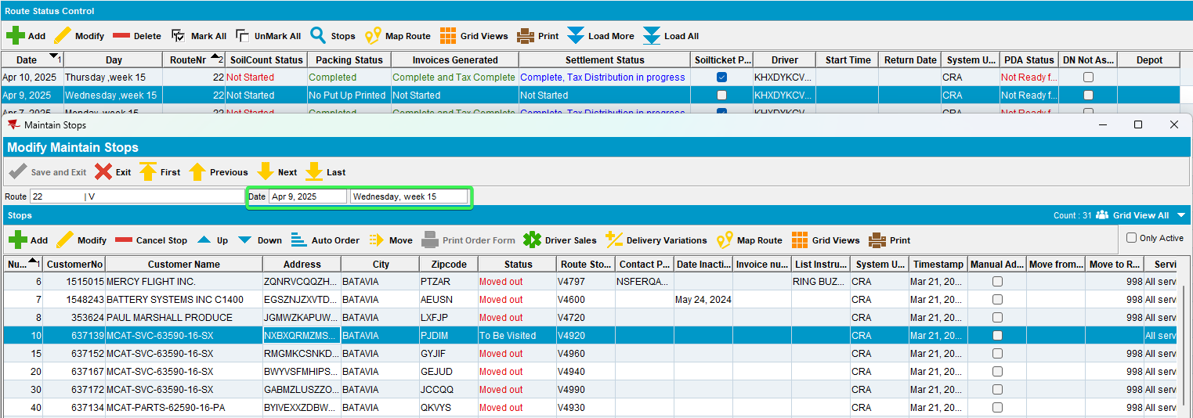
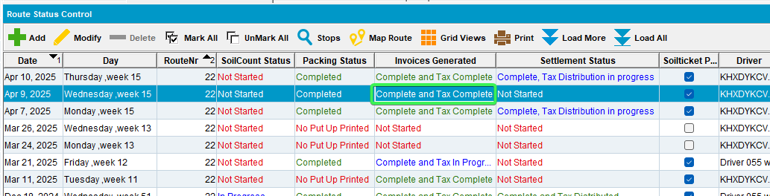
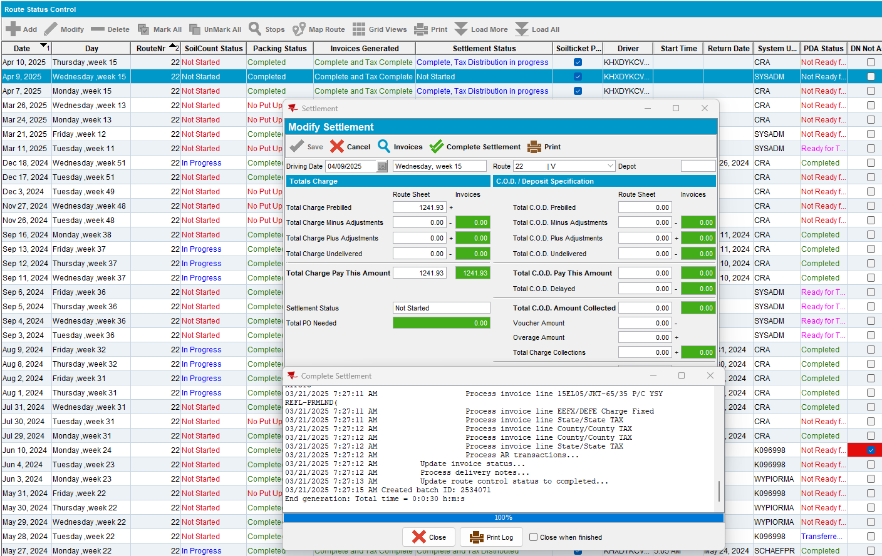
- Wearers dlg: Recheck the circulating inventory of wearer inventory A.
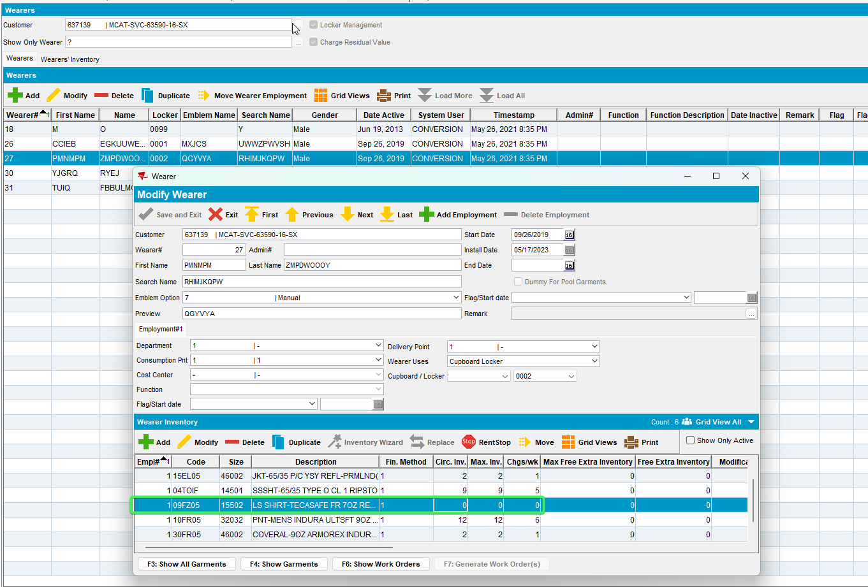
Tested OK

