ABSN-3336 Printing invoices when using Route Finalization
Environment | Prerequisites
Version: 9.07.00.UNF17  DBServerName= abs-srv20.internal.abslbs.com  DBSID=CUST24  DBUser=UNFDEV  DBPassword=UNFDEV  Environment=Production | - Module:  - System setting

Contents
Test after fix 1
Test #1 – RSC - Reprint the invoices for a route with Finalization Status !=2 1
Test #2 – Maintain Invoices - Print an invoice for a route with Finalization Status !=2 2

Test after fix
Hash: efdd1bf7567

Test #1 – RSC - Reprint the invoices for a route with Finalization Status !=2

- RSC dlg: Find a route with generated invoices and Route Finalization Status is not Completed
- RSC dlg: Reprint the invoices for that route
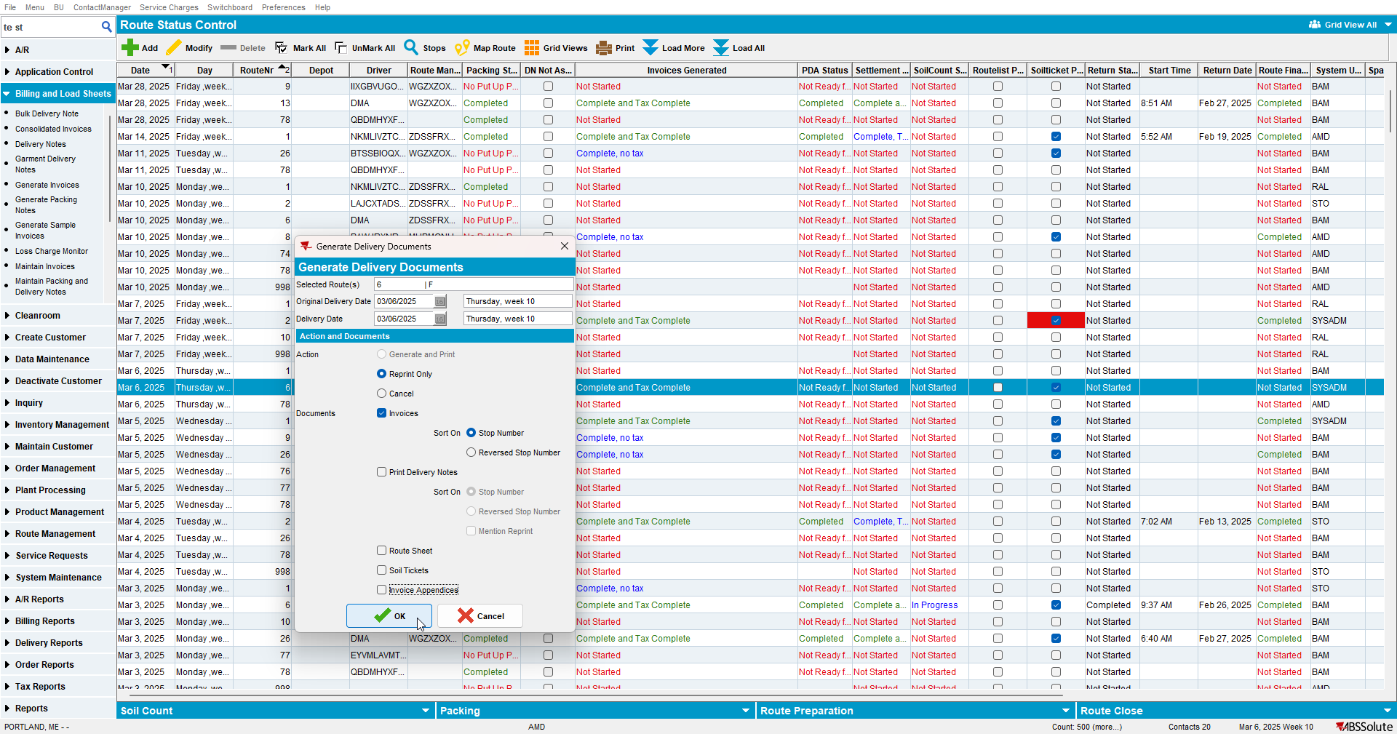
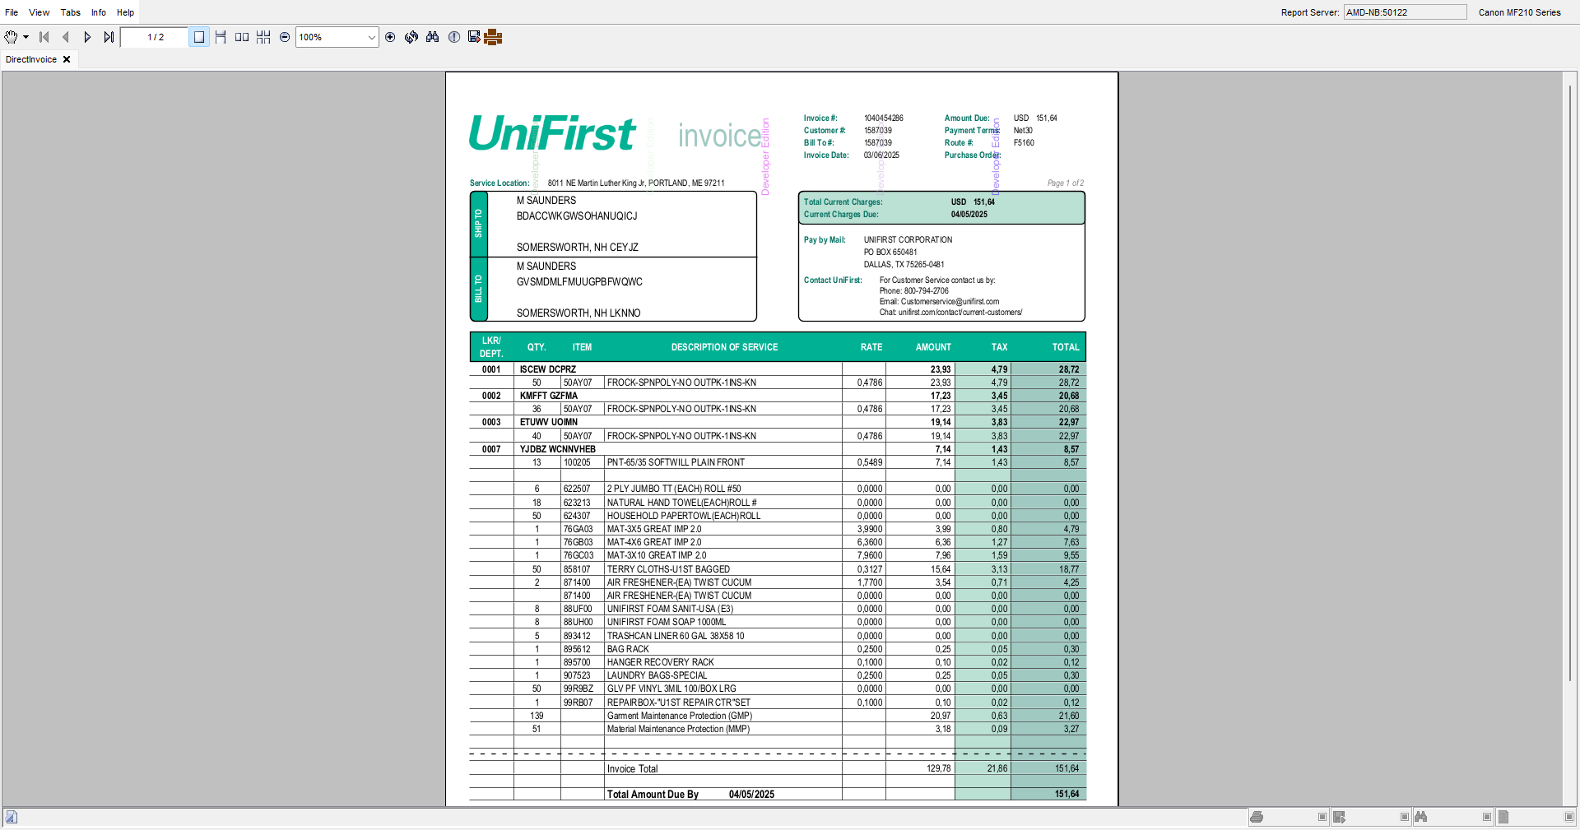
Expected behavior: No error occurs and the invoices are printed.
Actual behavior: No error occurs and the invoices are printed.

Test #2 – Maintain Invoices - Print an invoice for a route with Finalization Status !=2

- Maintain Invoices dlg: Select a route with Route Finalization Status is not Completed
- Maintain Invoices dlg: Print an invoice for that route
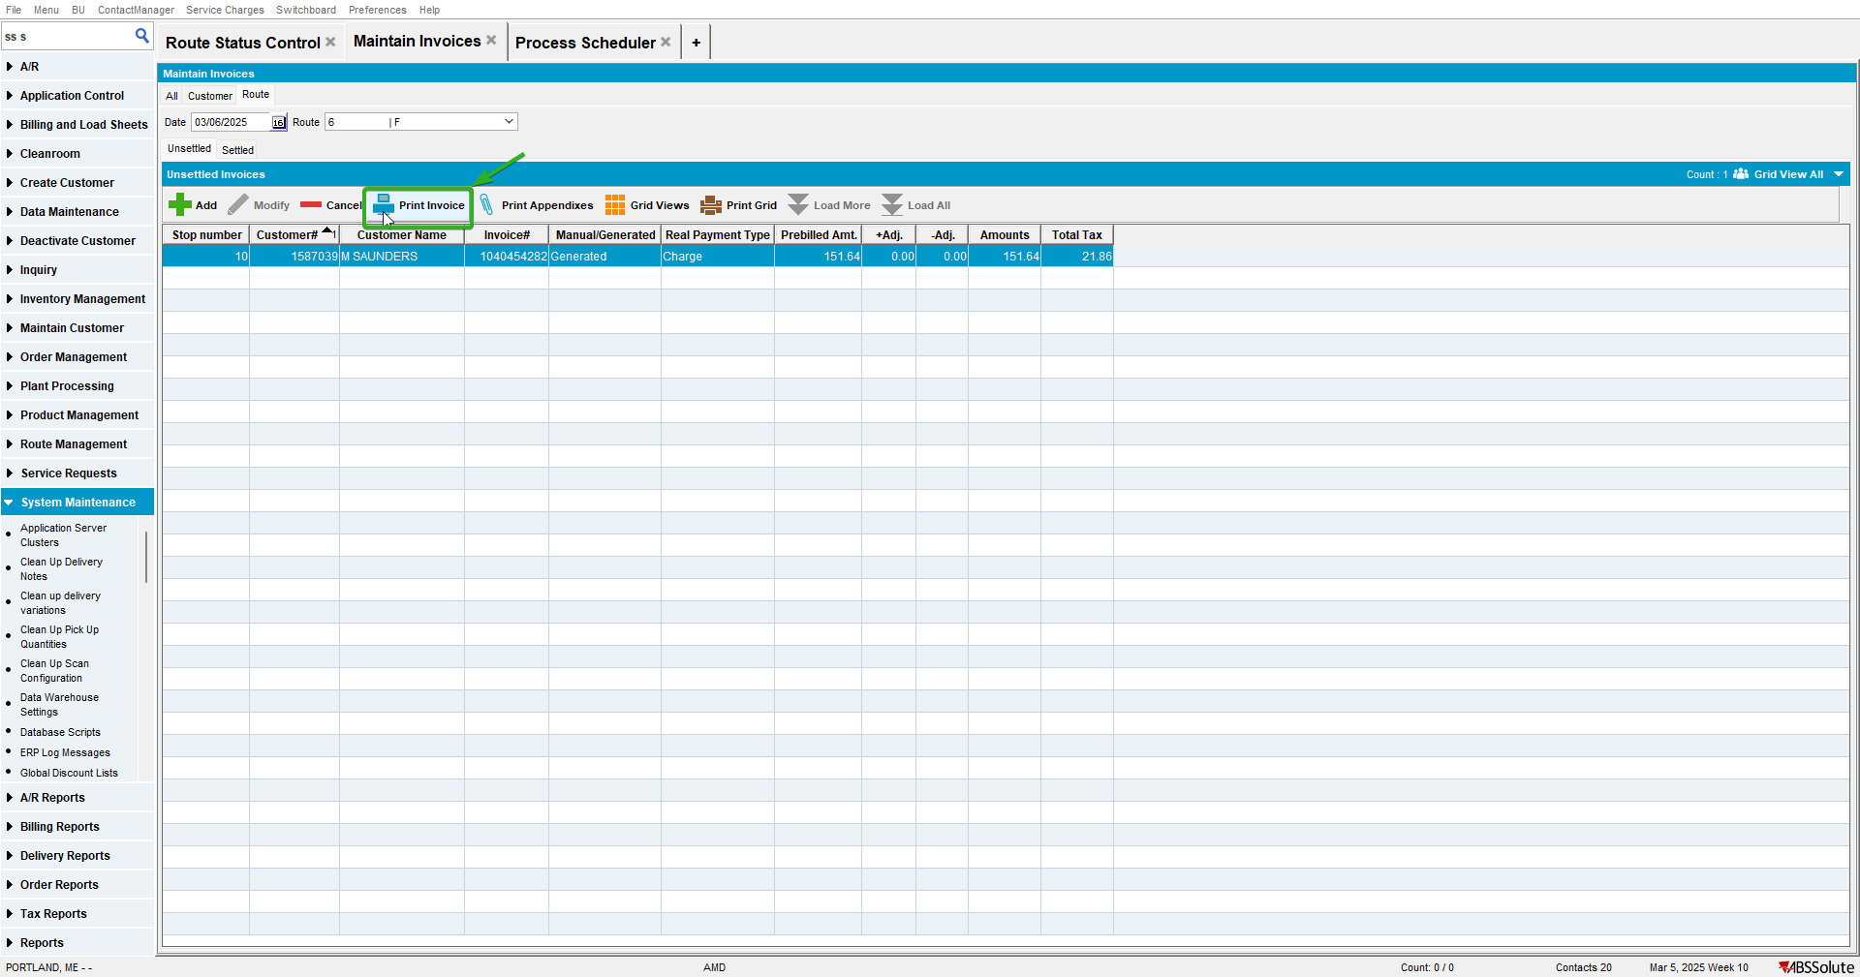
Expected behavior: No error occurs and the invoice is printed.
Actual behavior: No error occurs and the invoice is printed.
TESTED OK.

