ABSN-3327 - Block specific actions when finalization is in progress
Environment | Prerequisites
Version: 9.07.00.UNF17.p03 hash: 080a54ad0126  DBServerName= abs-srv20.internal.abslbs.com  DBSID=CUST24  DBUser=UNFDEV  DBPassword= UNFDEV  Environment=Test | - Module:  - System setting

Contents
Testing 2
Data preparation 2
Maintain Invoices DLG 6
Cancel Invoices 6
Test Case 1 - Maintain Invoices DLG> Route Tab – cancel one invoice on a route with Route Finalization Status in Progress 6
Test Case 2 - Maintain Invoices DLG> Route Tab – cancel two invoices on a route with Route Finalization Status in Progress 6
Test Case 3 - Maintain Invoices DLG> All Tab > Unsettled subtab – select two or more invoices where only one belongs to a route with Route Finalization Status in Progress 7
Assign to Route 8
Test 1 – Maintain Invoices DLG > All Tab > Unsettled subtab – Select one “Generated Invoices” radio button & Assigned to Route Status Control – “Yes” Radio buttons – Select one Invoice that is at this moment on a route that has Route Finalization status In Progress and try to assign it to a new route with no invoices on it 8
Test 2 – Maintain Invoices DLG > All Tab > Unsettled subtab – Select one “Generated Invoices” radio button & Assigned to Route Status Control – “Yes” Radio buttons – Select two OR more Invoices that are at this moment on a route that has Route Finalization status In Progress and try to assign it to a new route with no invoices on it 9
Test 3 – Maintain Invoices DLG > All Tab > Unsettled subtab – Select one “Generated Invoices” radio button & Assigned to Route Status Control – “Yes” Radio buttons –Select an invoice that does NOT belong to a route that has Finalization Status in progress, click on assign to route and verify that routes with the Finalization Status = 2 or 1 DO NOT appear in the list (use same select from the how to, step 5, to update the status) 10
Test 4 – Maintain Invoices DLG > All Tab > Unsettled subtab – Select “Generated Invoices” radio button & Assigned to Route Status Control – “Yes” Radio buttons – Select one Invoice that is NOT on a route that has Route Finalization status In Progress and try to assign it to a route which has Route Finalization status In Progress, if module UNFCUSTOM is in the license, PocketPCStatus = 0 (not exported) 11
Route Status Control DLG 13
Packing sub menu 13
Test 1 – Route Status Control DLG > Packing > ViewPacking and Delivery Notes – select a route control with Route Finalization Status in Progress and click on Assign Not Linked button 13
Test 2 - Route Status Control DLG > Packing > ViewPacking and Delivery Notes – select a route control with Route Finalization Status > 0 and verify if the Assign Not Linked button is enabled 15
Generate Del. Docs 15
Test 1 – Route Status Control DLG > Route Preparation > Generate Del. Docs – Canceling invoices when selecting a route control where invoices are generated and the Route Finalization Status is In Progress 15
Test 2 – Route Status Control DLG > Route Preparation > Generate Del. Docs – Canceling invoices when selecting 3 route controls where invoices are generated and the Route Finalization Status is In Progress on ONLY one of them 17
Maintain Packing and Delivery Notes DLG 18
Test 1 – Maintain Packing and Delivery Notes DLG > All tab – From the top panel select a Route and a delivery date and a route number that has Finalization Status In Progress and click on Assign Not Linked button 18
Test 2 - Maintain Packing and Delivery Notes DLG > All tab – From the top panel select a Route and a delivery date and a route number that has Finalization Status > 0 and verify if the Assign Not Linked button is enabled 20

Testing

Data preparation
Steps:
- Run generate packing notes and generate invoices for a route
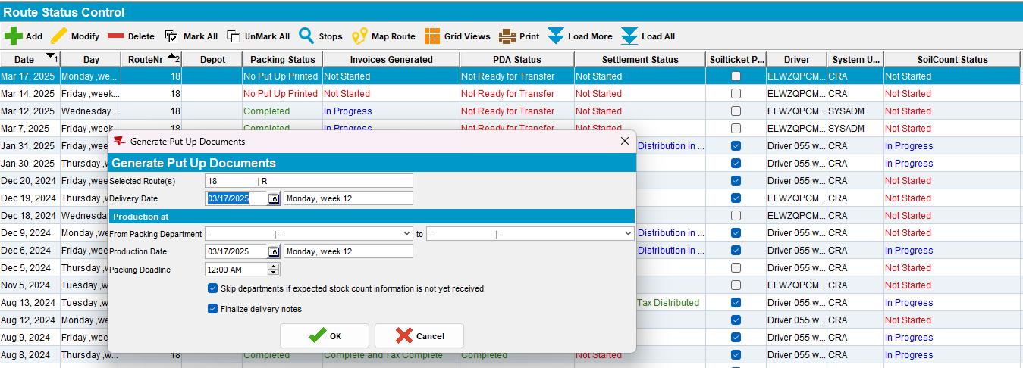
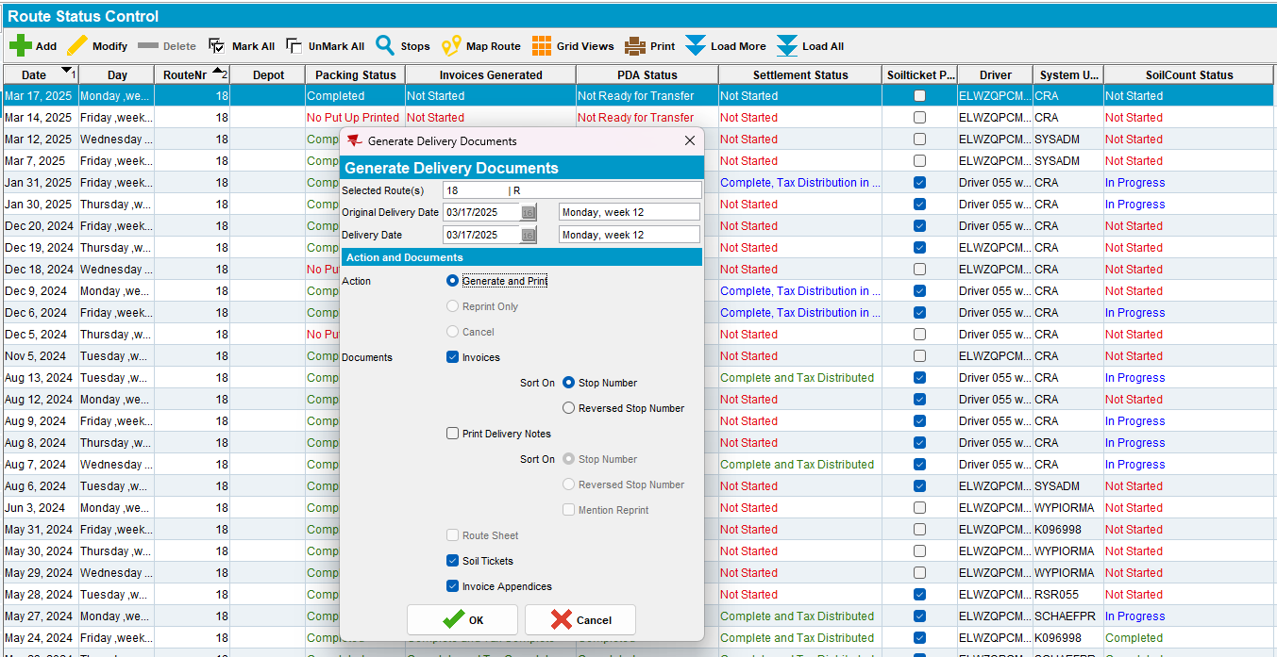
- Run the BCI taxes script and the process scheduler for Vertex tax import
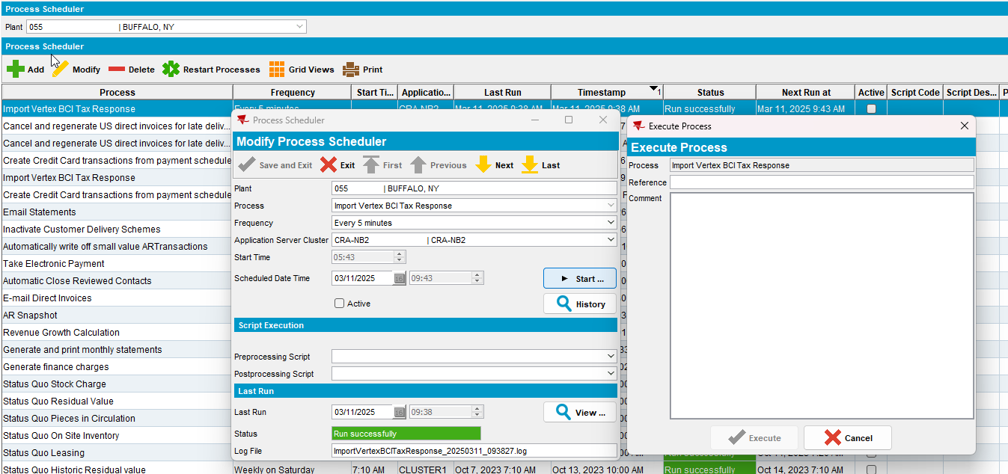
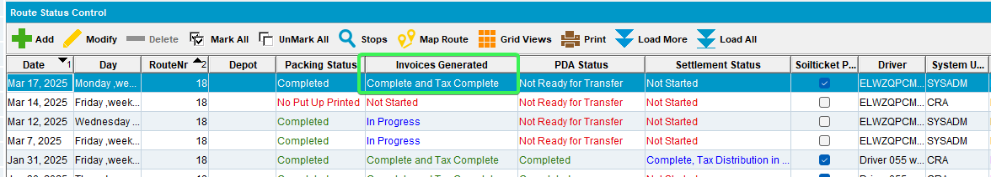
- Run the “Cancel and regenerate US direct invoices for late delivery notes”
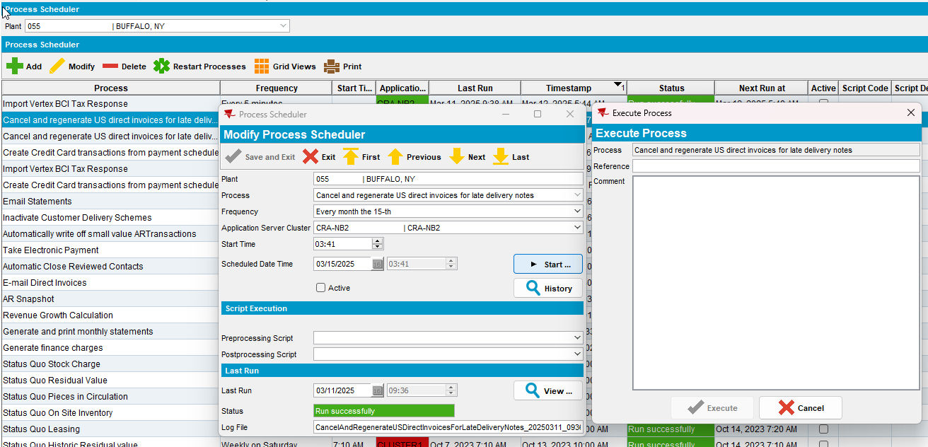
- At this point the FinalizationStatus is 2 (completed)
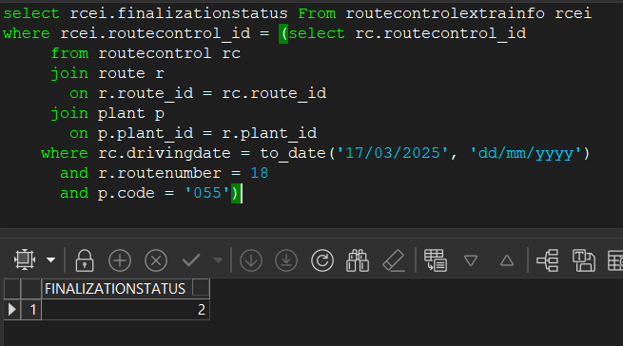
- Use the following update to change the FinalizationStatus from 2 to 0
select rcei.finalizationstatus From routecontrolextrainfo rcei
where rcei.routecontrol_id = (select rc.routecontrol_id
from routecontrol rc
join route r
on r.route_id = rc.route_id
join plant p
on p.plant_id = r.plant_id
where rc.drivingdate = to_date('17/03/2025', 'dd/mm/yyyy')
and r.routenumber = 18
and p.code = '055') for update;
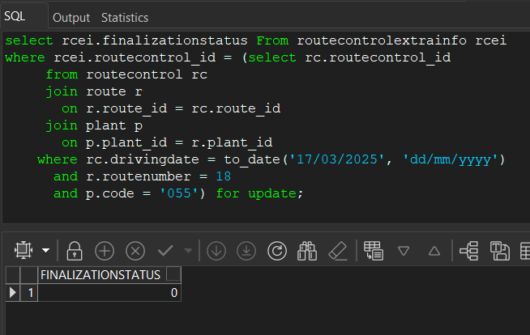
- Use the following update to delete the endfinalizationtimestamp from the first row.
select rcf.* From routecontrolfinalization rcf
where rcf.routecontrol_id = (select rc.routecontrol_id
from routecontrol rc
join route r
on r.route_id = rc.route_id
join plant p
on p.plant_id = r.plant_id
where rc.drivingdate = to_date('17/03/2025', 'dd/mm/yyyy')
and r.routenumber = 18
and p.code = '055')
order by rcf.startfinalizationtimestamp desc
for update;
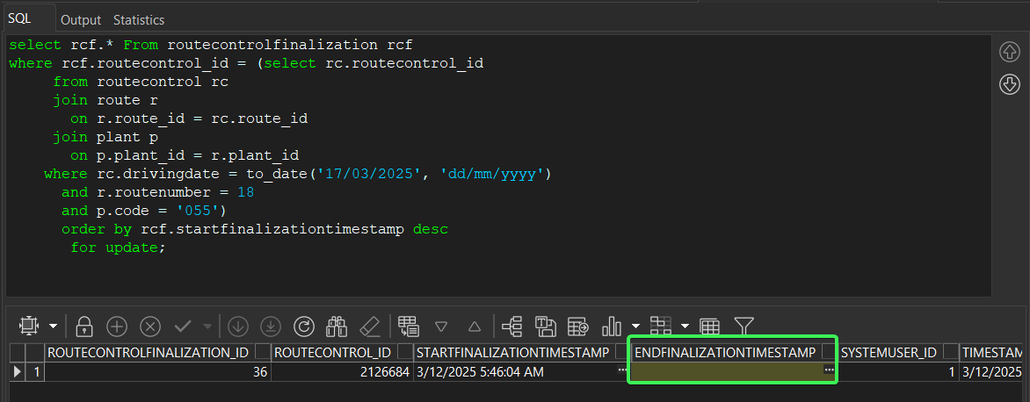

Maintain Invoices DLG

Cancel Invoices

Test Case 1 - Maintain Invoices DLG> Route Tab – cancel one invoice on a route with Route Finalization Status in Progress
Expected Behavior:
Show a message to the user “Route Finalization is in progress so invoices cannot be cancelled. This was started <current server timestamp minus RCF. StartFinalizationTimestamp in minutes> minutes ago, please try later” OK and do not continue.
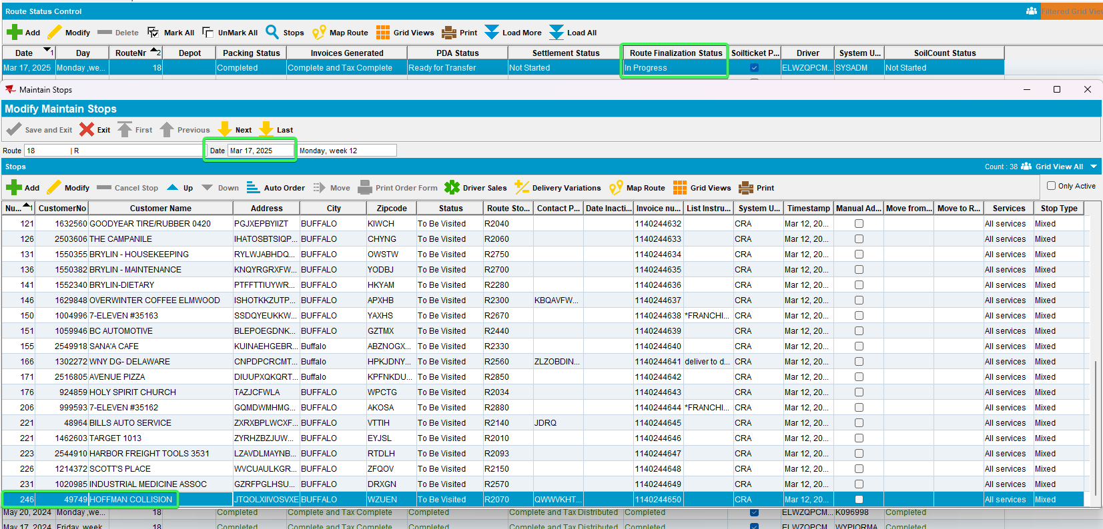
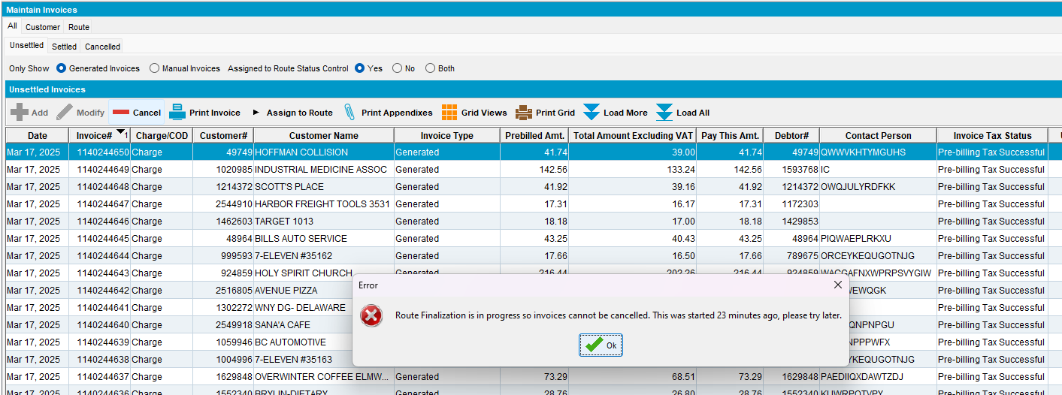
Tested OK

Test Case 2 - Maintain Invoices DLG> Route Tab – cancel two invoices on a route with Route Finalization Status in Progress
Expected Behavior:
Show a message to the user “Route Finalization is in progress so invoices cannot be cancelled. This was started <current server timestamp minus RCF. StartFinalizationTimestamp in minutes> minutes ago, please try later” OK and do not continue.
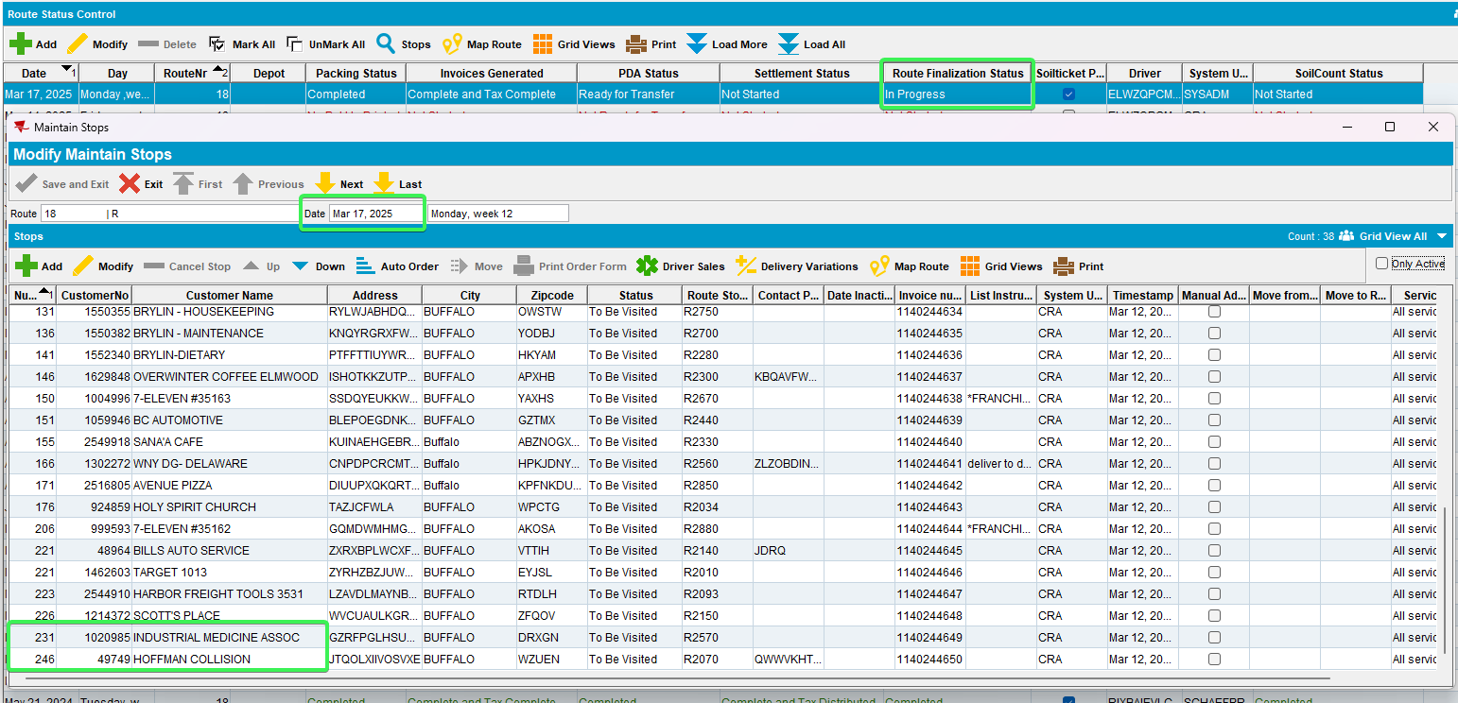
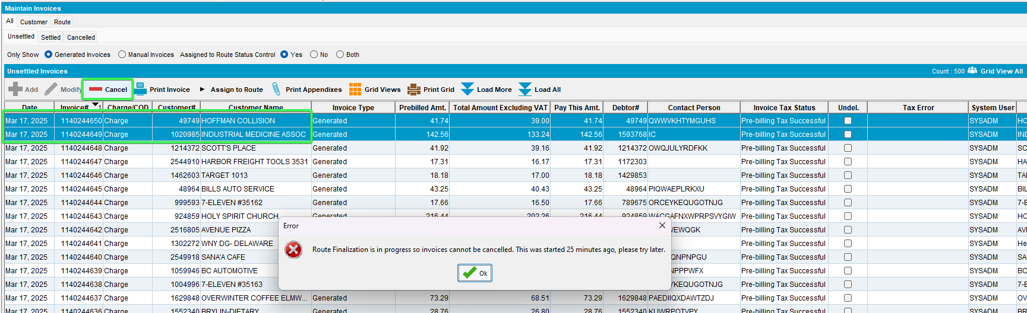
Tested OK

Test Case 3 - Maintain Invoices DLG> All Tab > Unsettled subtab – select two or more invoices where only one belongs to a route with Route Finalization Status in Progress
Expected Behavior:
If multiple invoices are selected to cancel from different route control and at least one of the route controls fails the check above, then show a message (we don’t have a log on the screen here) saying “One of more of the routes controls of these invoices has route finalization in progress so invoices cannot be cancelled, please try later”
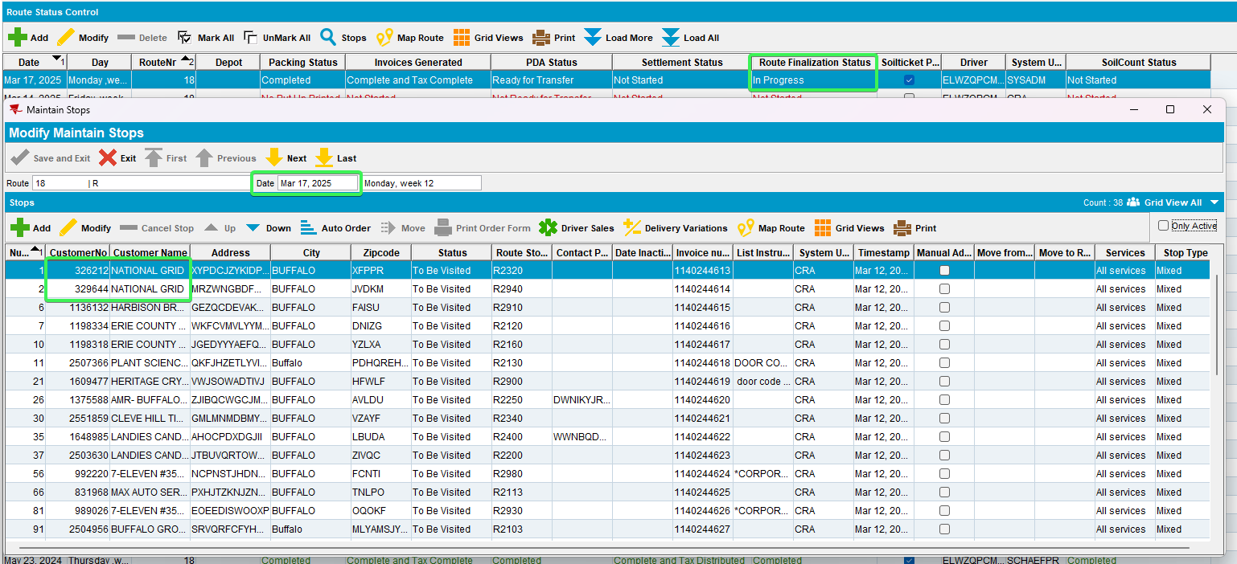
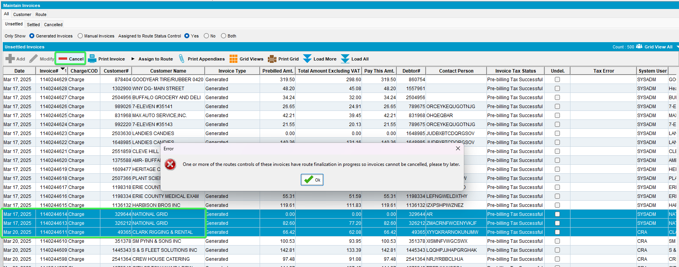
Tested OK

Assign to Route

Test 1 – Maintain Invoices DLG > All Tab > Unsettled subtab – Select one “Generated Invoices” radio button & Assigned to Route Status Control – “Yes” Radio buttons – Select one Invoice that is at this moment on a route that has Route Finalization status In Progress and try to assign it to a new route with no invoices on it
Expected Behavior:
Show a message to the user “Route Finalization is in progress so an invoice cannot be assigned to this route. This was started <current server timestamp minus RCF. StartFinalizationTimestamp in minutes> minutes ago, please try later” OK and do not continue.
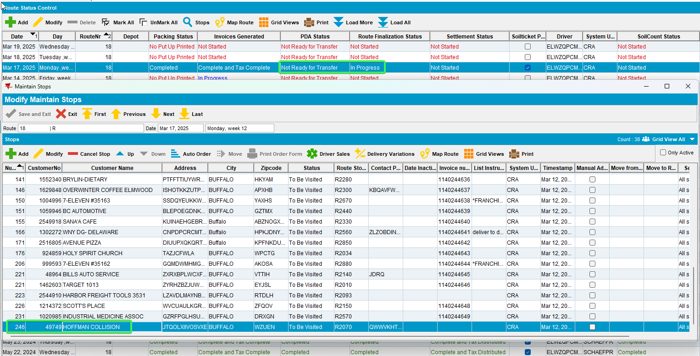
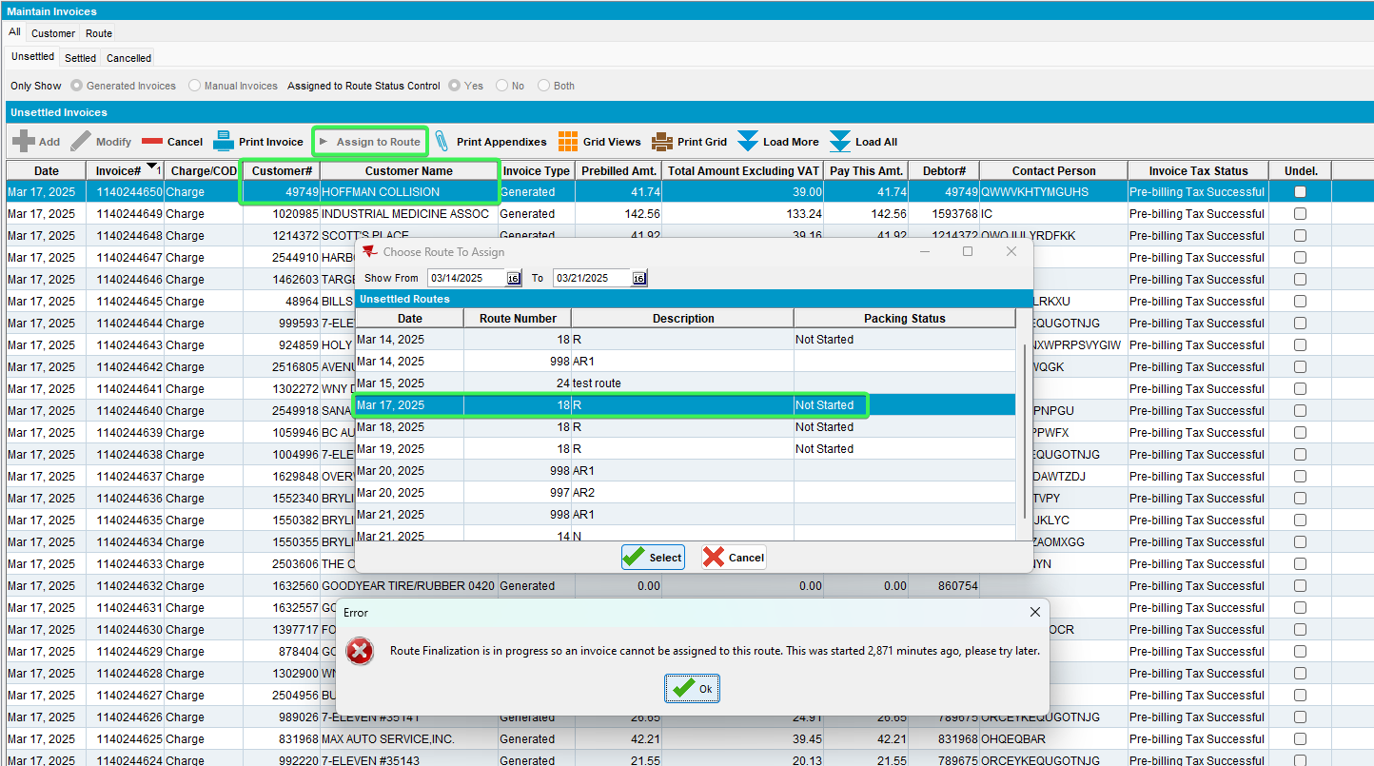
Tested OK

Test 2 – Maintain Invoices DLG > All Tab > Unsettled subtab – Select one “Generated Invoices” radio button & Assigned to Route Status Control – “Yes” Radio buttons – Select two OR more Invoices that are at this moment on a route that has Route Finalization status In Progress and try to assign it to a new route with no invoices on it
Expected Behavior:
Show a message to the user “Route Finalization is in progress so an invoice cannot be assigned to this route. This was started <current server timestamp minus RCF. StartFinalizationTimestamp in minutes> minutes ago, please try later” OK and do not continue.
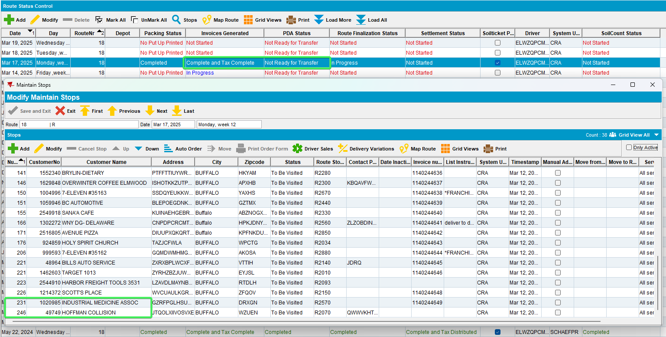
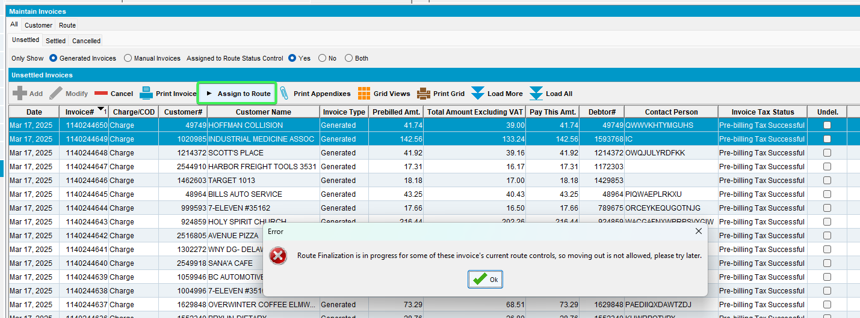
Tested OK

Test 3 – Maintain Invoices DLG > All Tab > Unsettled subtab – Select one “Generated Invoices” radio button & Assigned to Route Status Control – “Yes” Radio buttons –Select an invoice that does NOT belong to a route that has Finalization Status in progress, click on assign to route and verify that routes with the Finalization Status = 2 or 1 DO NOT appear in the list (use same select from the how to, step 5, to update the status)
Expected Behavior:
If the route is finalized (RC. FinalizationStatus > 0) then do not include this route in the selection list
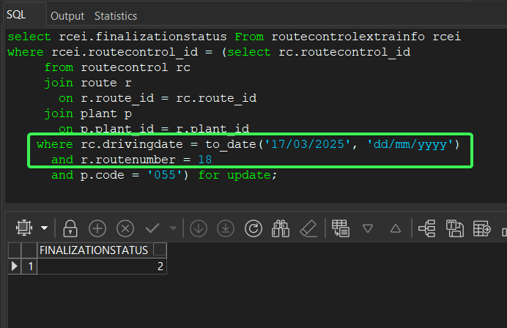
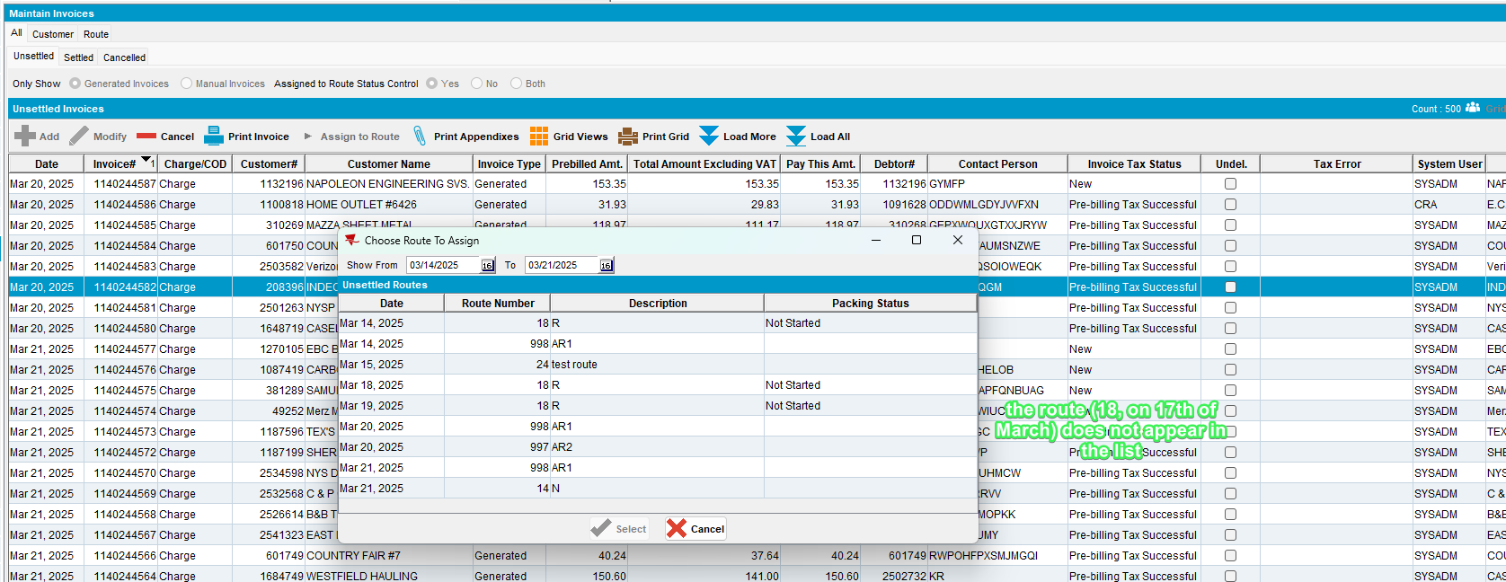
Tested OK

Test 4 – Maintain Invoices DLG > All Tab > Unsettled subtab – Select “Generated Invoices” radio button & Assigned to Route Status Control – “Yes” Radio buttons – Select one Invoice that is NOT on a route that has Route Finalization status In Progress and try to assign it to a route which has Route Finalization status In Progress, if module UNFCUSTOM is in the license, PocketPCStatus = 0 (not exported)
Expected Behavior:
Show a message to the user “Route Finalization is in progress so an invoice cannot be assigned to this route. This was started <current server timestamp minus RCF. StartFinalizationTimestamp in minutes> minutes ago, please try later” OK and do not continue.
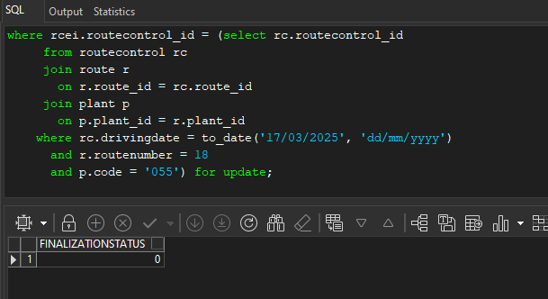
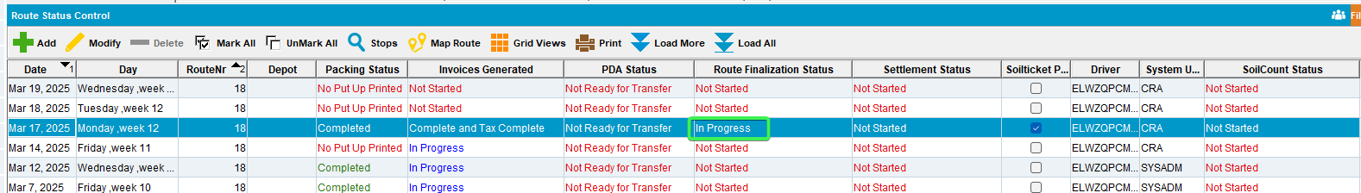
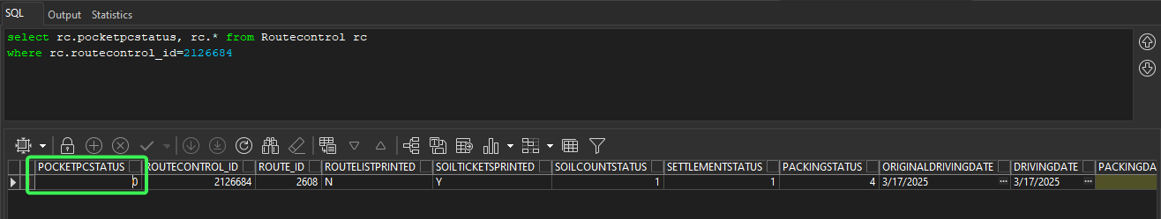
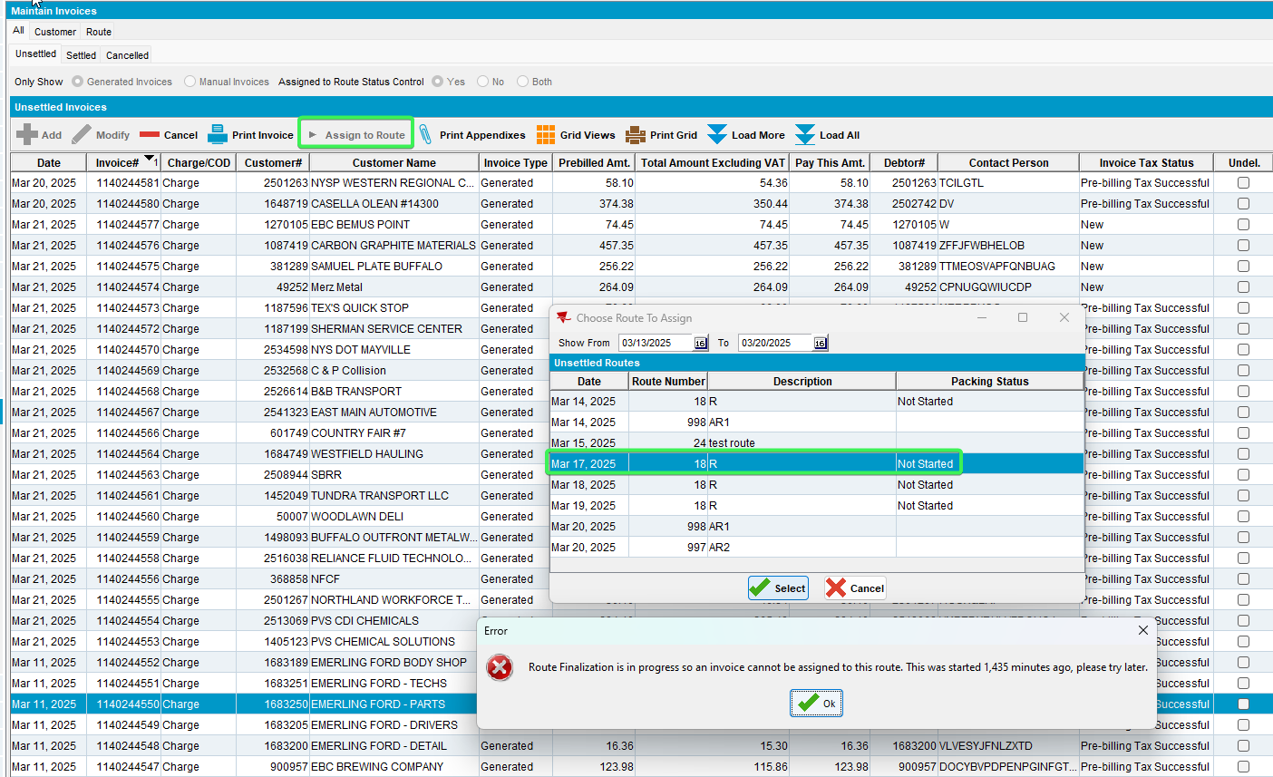
Tested OK

Route Status Control DLG

Packing sub menu

Test 1 – Route Status Control DLG > Packing > ViewPacking and Delivery Notes – select a route control with Route Finalization Status in Progress and click on Assign Not Linked button
Expected behavior:
The assign not linked pop-up does not open instead show a message to the user “Route Finalization is in progress so packing notes cannot be assigned to this route. This was started <current server timestamp minus RCF. StartFinalizationTimestamp in minutes> minutes ago, please try later” OK and do not continue.

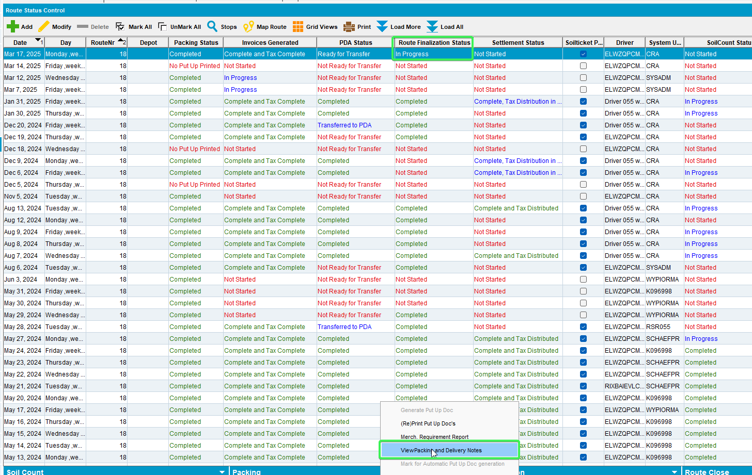
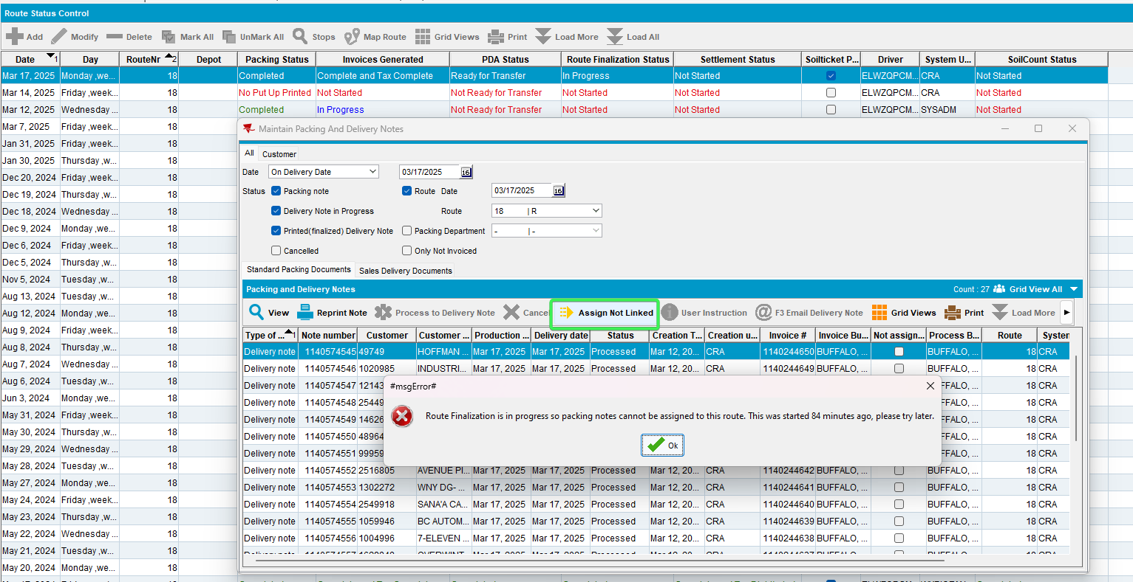
Tested OK

Test 2 - Route Status Control DLG > Packing > ViewPacking and Delivery Notes – select a route control with Route Finalization Status > 0 and verify if the Assign Not Linked button is enabled
Note: use same select from the how to, step 5, to update the status to 1 or 2 if needed
Expected behavior:
Assign not linked button is disabled if the route is finalized (so RC. FinalizationStatus > 0)
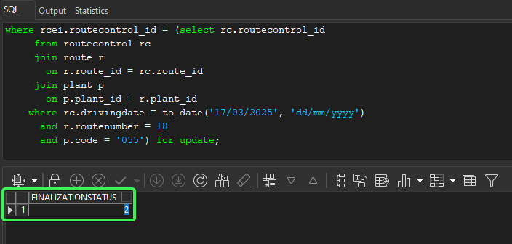
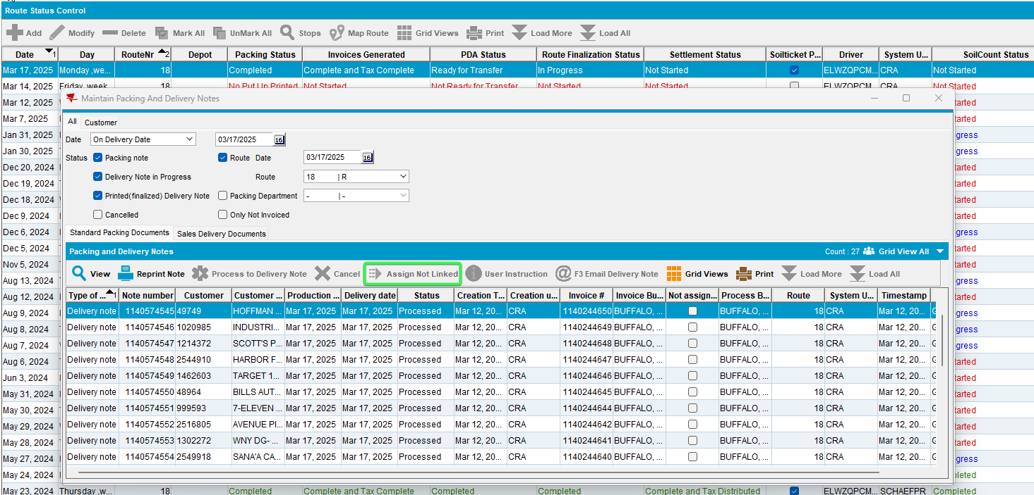
Tested OK

Generate Del. Docs

Test 1 – Route Status Control DLG > Route Preparation > Generate Del. Docs – Canceling invoices when selecting a route control where invoices are generated and the Route Finalization Status is In Progress
Expected behavior:
When the “OK” button is pressed show a message to the user “Route Finalization is in progress so invoices cannot be cancelled. This was started <current server timestamp minus RCF. StartFinalizationTimestamp in minutes> minutes ago, please try later”
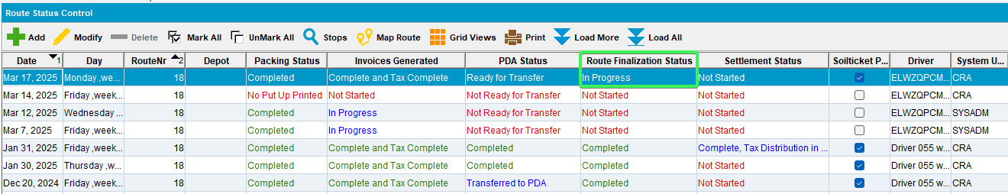
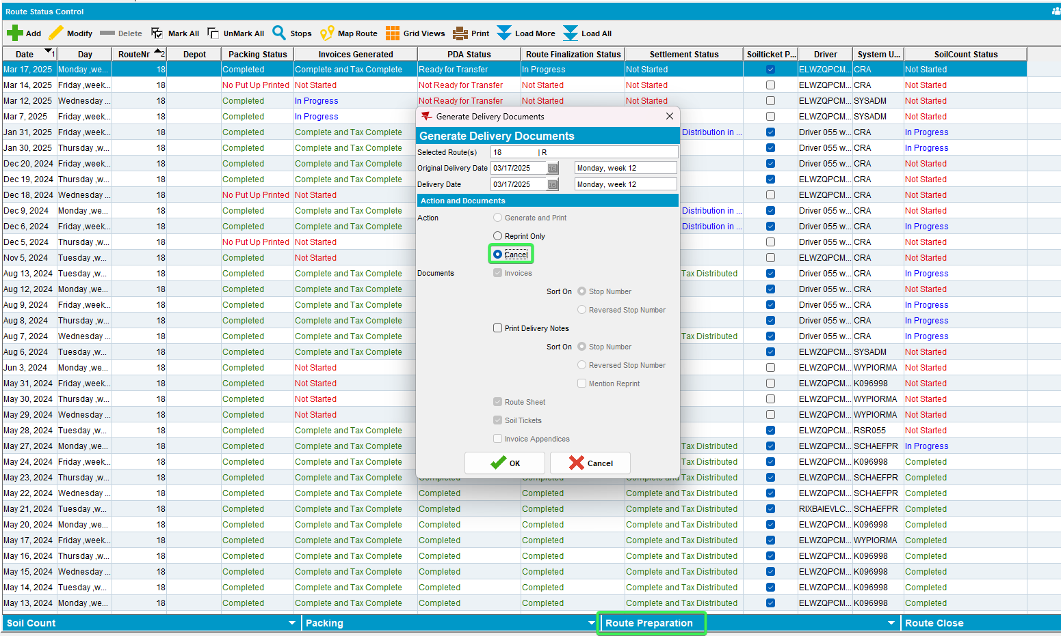
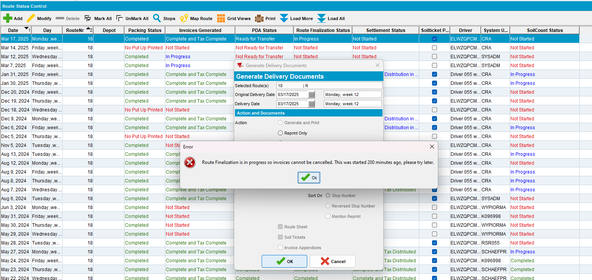

Test 2 – Route Status Control DLG > Route Preparation > Generate Del. Docs – Canceling invoices when selecting 3 route controls where invoices are generated and the Route Finalization Status is In Progress on ONLY one of them
Expected behavior:
The invoices are cancelled for the 2 routes where Route Finalization Status is NOT In Progress but NOT cancelled for the route where Route Finalization Status is In Progress (a message should be logged in the cancel invoices log)
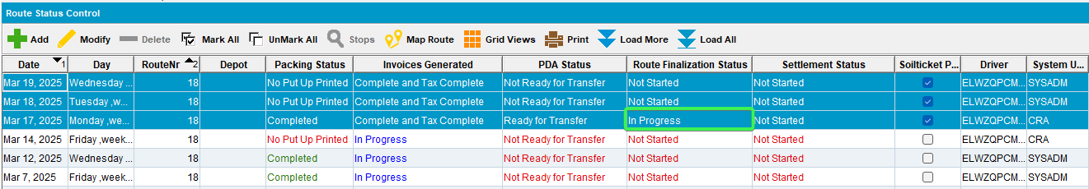
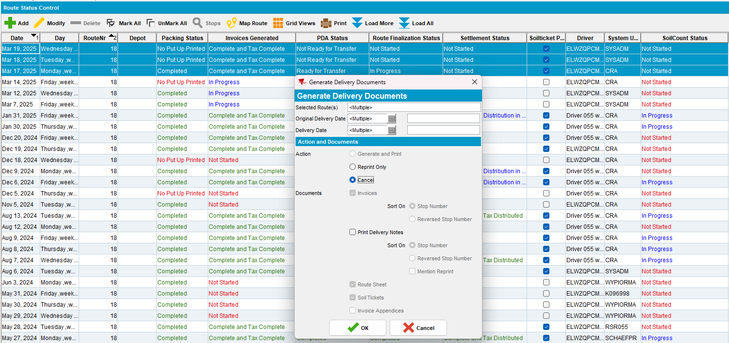
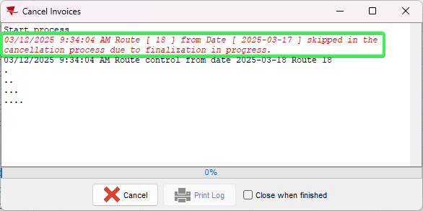
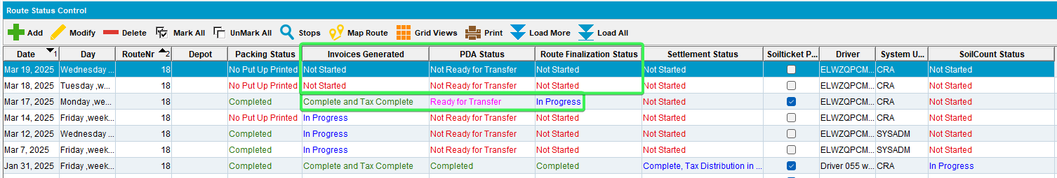
Tested OK

Maintain Packing and Delivery Notes DLG

Test 1 – Maintain Packing and Delivery Notes DLG > All tab – From the top panel select a Route and a delivery date and a route number that has Finalization Status In Progress and click on Assign Not Linked button
Expected behavior:
The assign not linked pop-up does not open instead show a message to the user “Route Finalization is in progress so packing notes cannot be assigned to this route. This was started <current server timestamp minus RCF. StartFinalizationTimestamp in minutes> minutes ago, please try later” OK and do not continue.
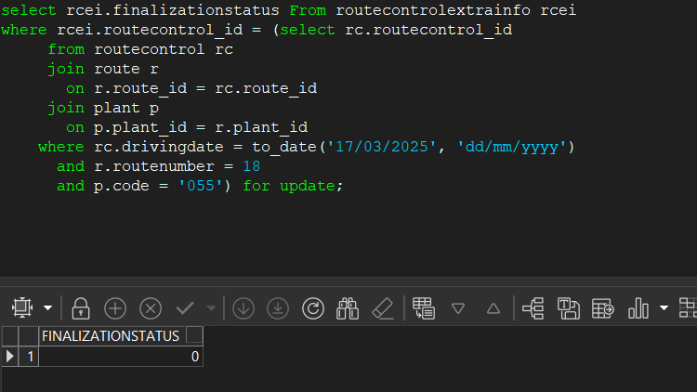 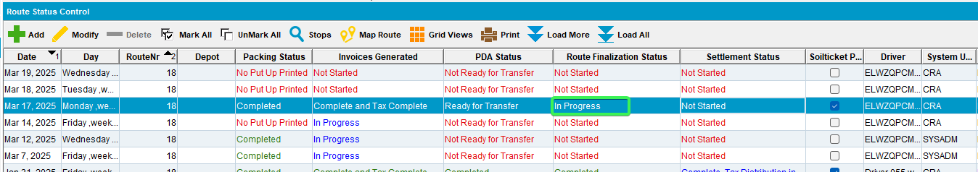 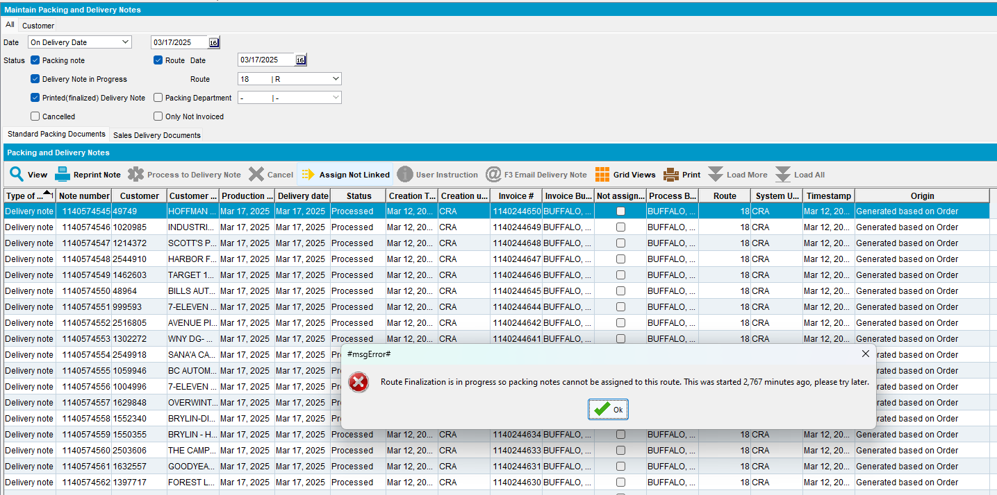Tested OK

Test 2 - Maintain Packing and Delivery Notes DLG > All tab – From the top panel select a Route and a delivery date and a route number that has Finalization Status > 0 and verify if the Assign Not Linked button is enabled
Note: use same select from the how to, step 5, to update the status to 1 or 2 if needed
Expected behavior:
Assign not linked button is disabled if the route is finalized (so RC. FinalizationStatus > 0)
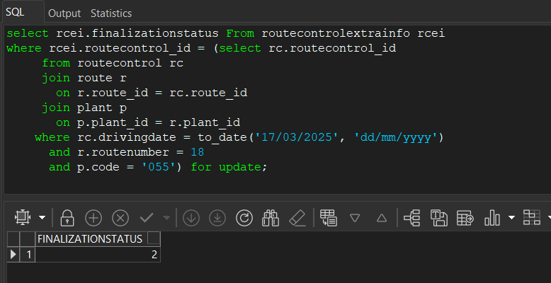
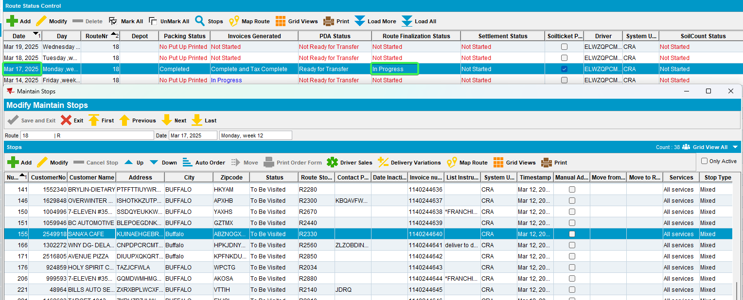
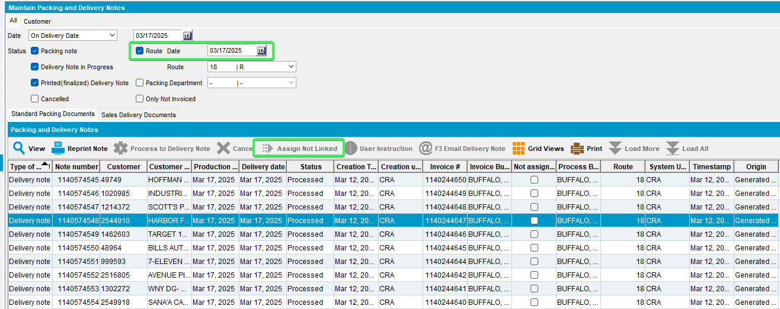
Tested OK

