ABSN-3291 Extend status web service with info on finalization
Environment | Prerequisites
Version:9.07.00  DBServerName=abs-SRV20.internal.abslbs.com  DBSID=CUST24  DBUser=UNFDEV  DBPassword=UNFDEV  Environment=Test | - Module:  - System setting

Contents
Test after fix 1
Test Case 1 – RCEI.FinalizationStatus=0 and No RouteControlFinalization record – Tested OK 1
Test Case 2 – RCEI.FinalizationStatus=1 and No RouteControlFinalization record – Tested OK 3
Test Case 3 – RCEI.FinalizationStatus=2 and No RouteControlFinalization record – Tested OK 5
Test Case 4 – RCEI.FinalizationStatus=0 and RCF.StartTimestamp NOT NULL RCF.EndFinalizationTimestamp NOT NULL– Tested OK 8
Test Case 5 – RCEI.FinalizationStatus=1 and RCF.StartTimestamp NOT NULL RCF.EndFinalizationTimestamp NOT NULL– Tested OK 10
Test Case 6 – RCEI.FinalizationStatus=2 and RCF.StartTimestamp NOT NULL RCF.EndFinalizationTimestamp NOT NULL– Tested OK 12
Test Case 7 – RCEI.FinalizationStatus=0 and RCF.StartTimestamp NOT NULL RCF.EndFinalizationTimestamp IS NULL– Tested OK 14
Test Case 8 – RCEI.FinalizationStatus=1 and RCF.StartTimestamp NOT NULL RCF.EndFinalizationTimestamp IS NULL– Tested OK 16
Test Case 9 – RCEI.FinalizationStatus=2 and RCF.StartTimestamp NOT NULL RCF.EndFinalizationTimestamp IS NULL– Tested OK 19

Test after fix

Test Case 1 – RCEI.FinalizationStatus=0 and No RouteControlFinalization record – Tested OK
Expected behavior: Status=0 on Postman and ‘Not Started’ on Route Finalization Status column from RSC
Hash: 40b4468
- Have a route with generated PN and generated invoices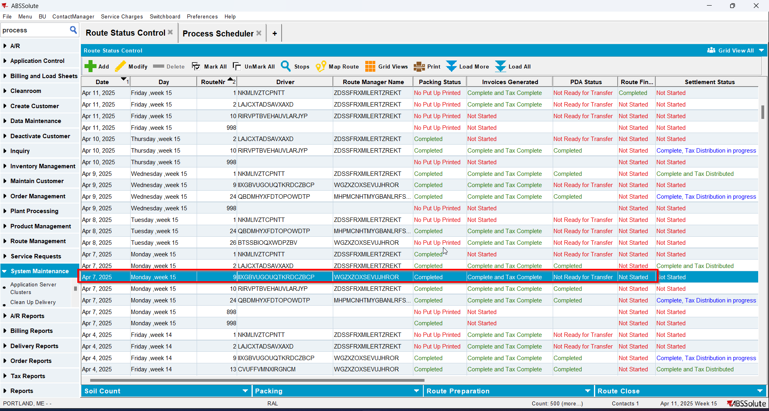
- Check that the RCEI.FinalizationStatus=0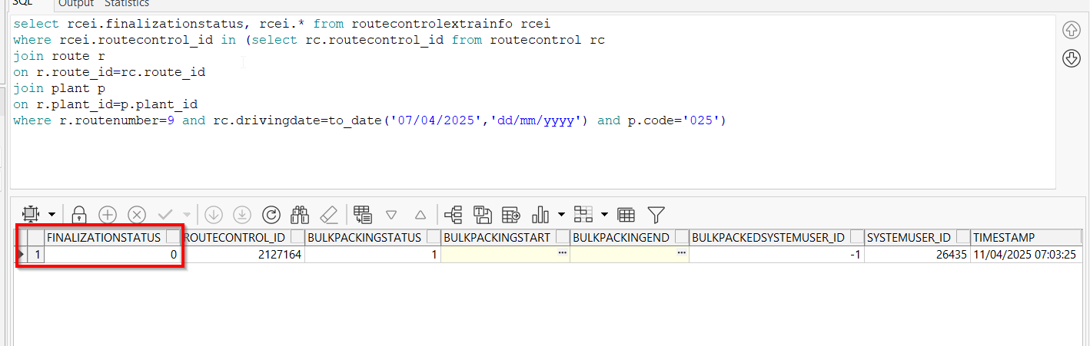
- Check there are no records for that routecontrol_id in RouteControlFinalization table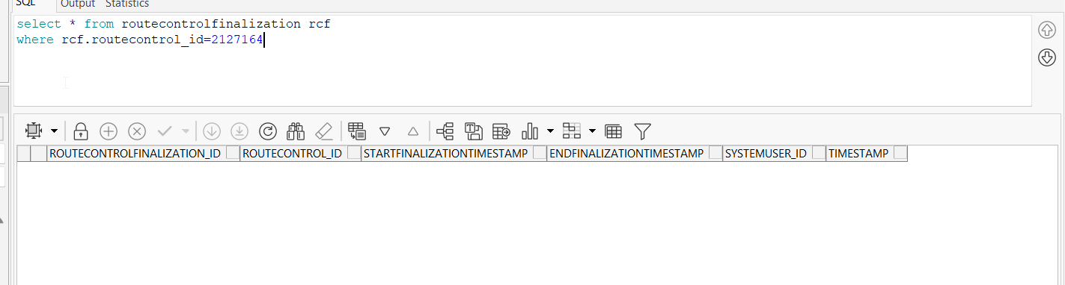
- Check the status of the route on Postman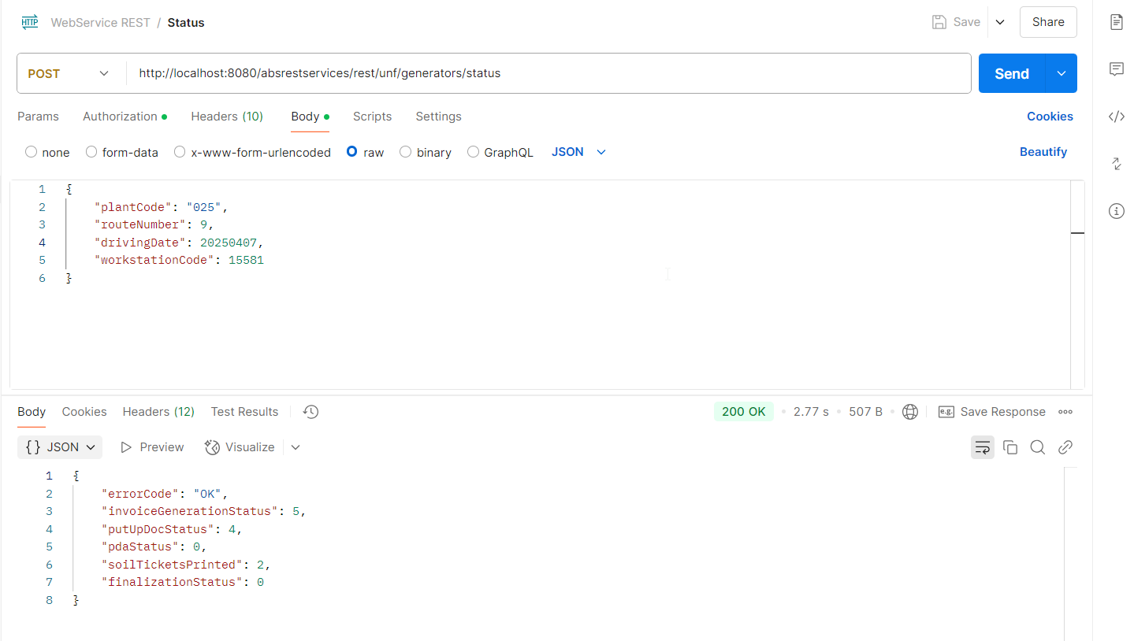
- Go to RSC dlg and check that your route has the same status for column Route Finalization Status as the one in Postman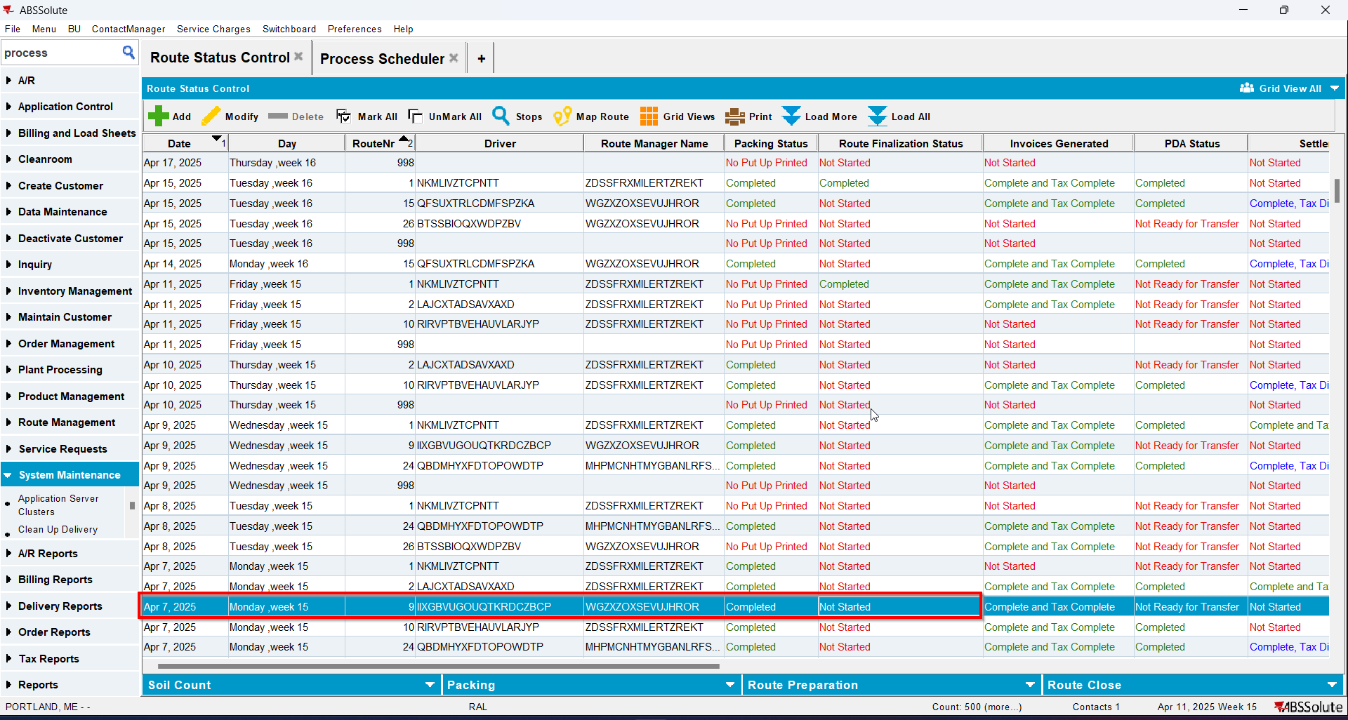

Test Case 2 – RCEI.FinalizationStatus=1 and No RouteControlFinalization record – Tested OK
Expected behavior: Status=1 and ‘Pending Taxation’ on Route Finalization Status column from RSC

Hash: 40b4468
- Have the route from Test 1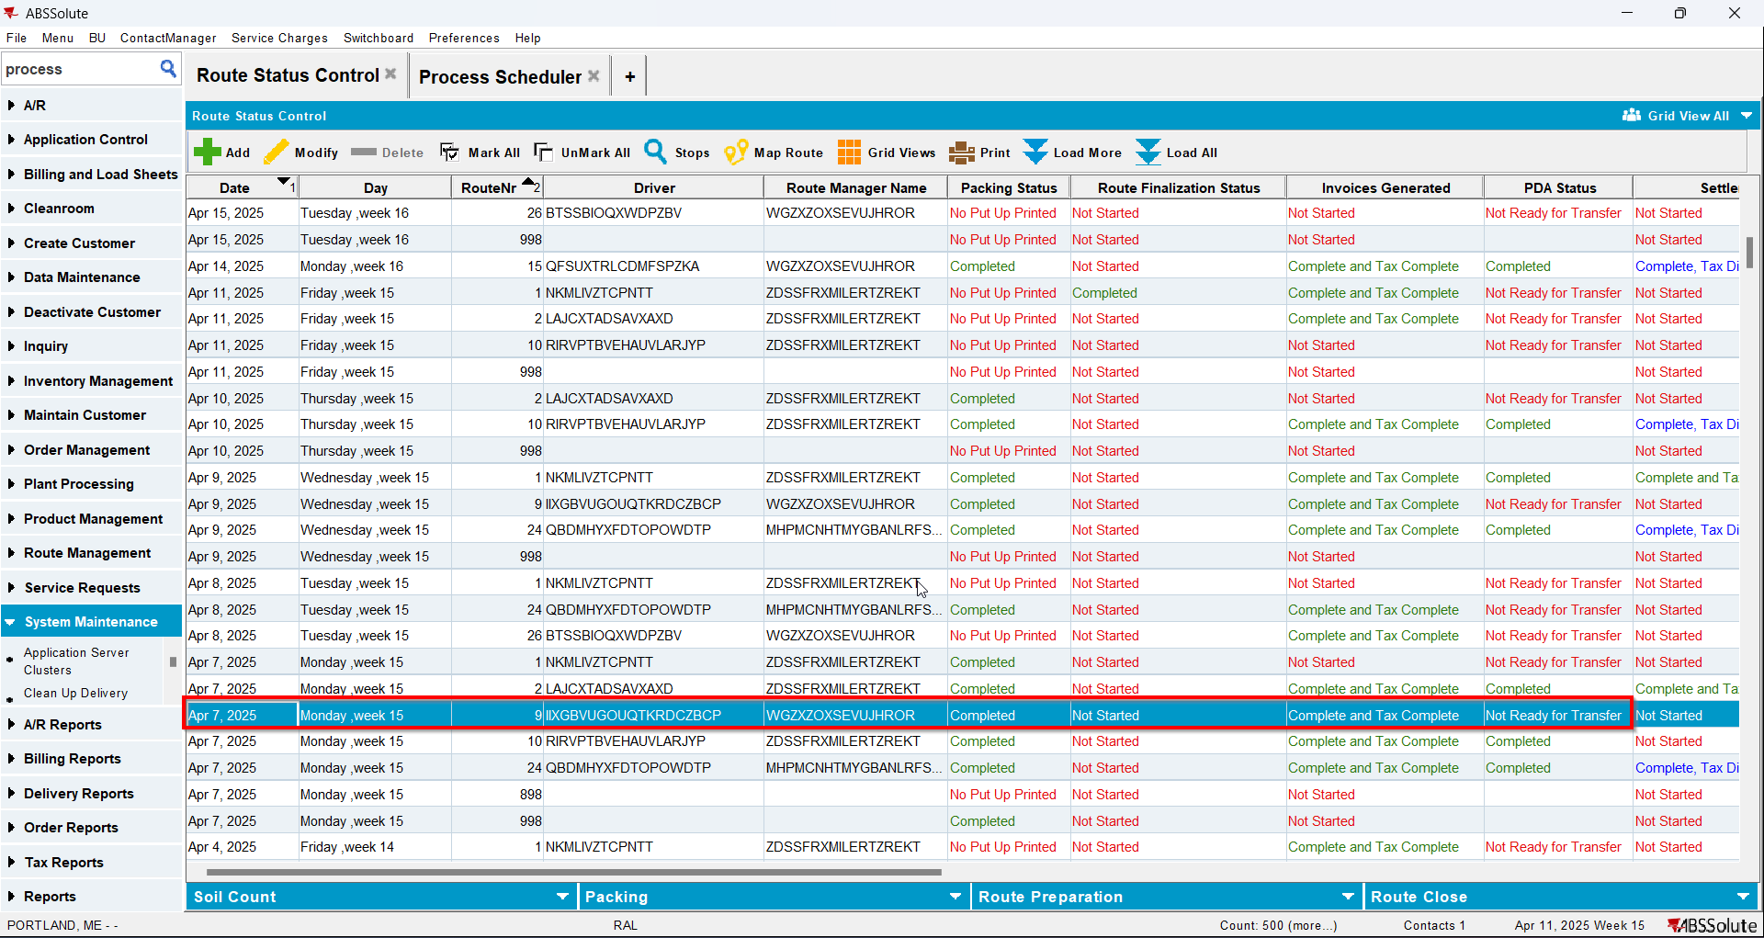
- Update RCEI.FinalizationStatus=1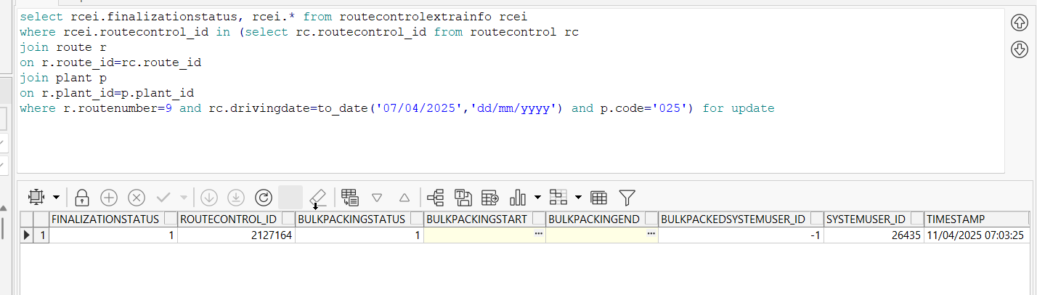
- Check there are no records for that routecontrol_id in RouteControlFinalization table 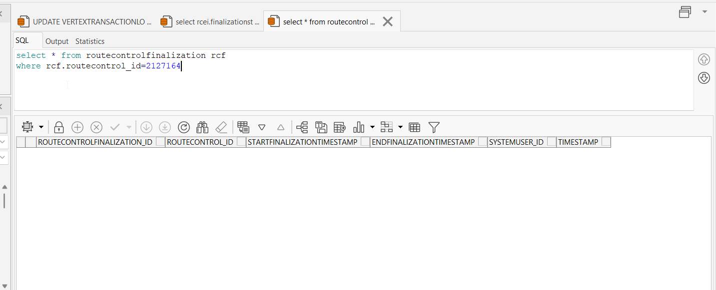
- Check the status of the route on Postman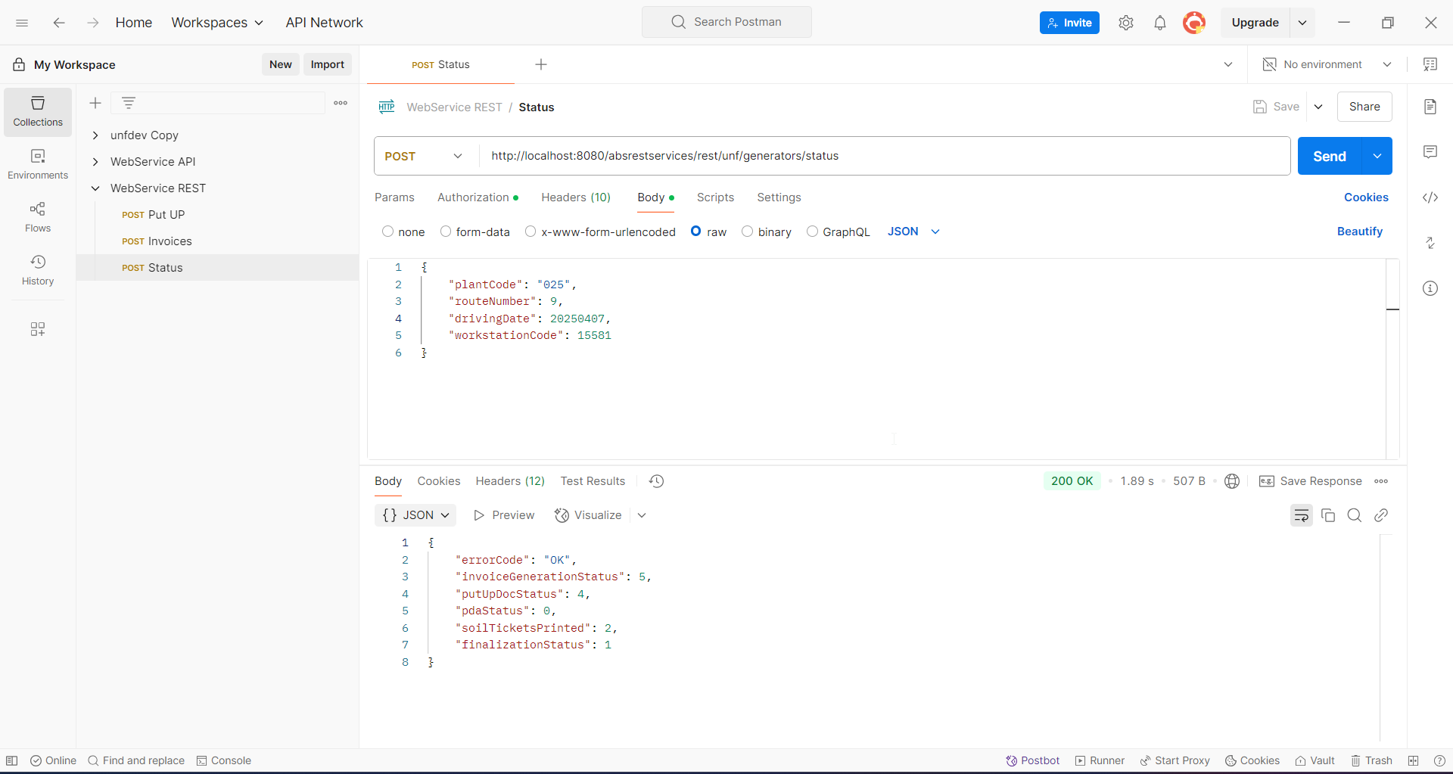
- Go to RSC dlg and check that your route has the same status for column Route Finalization Status as the one in Postman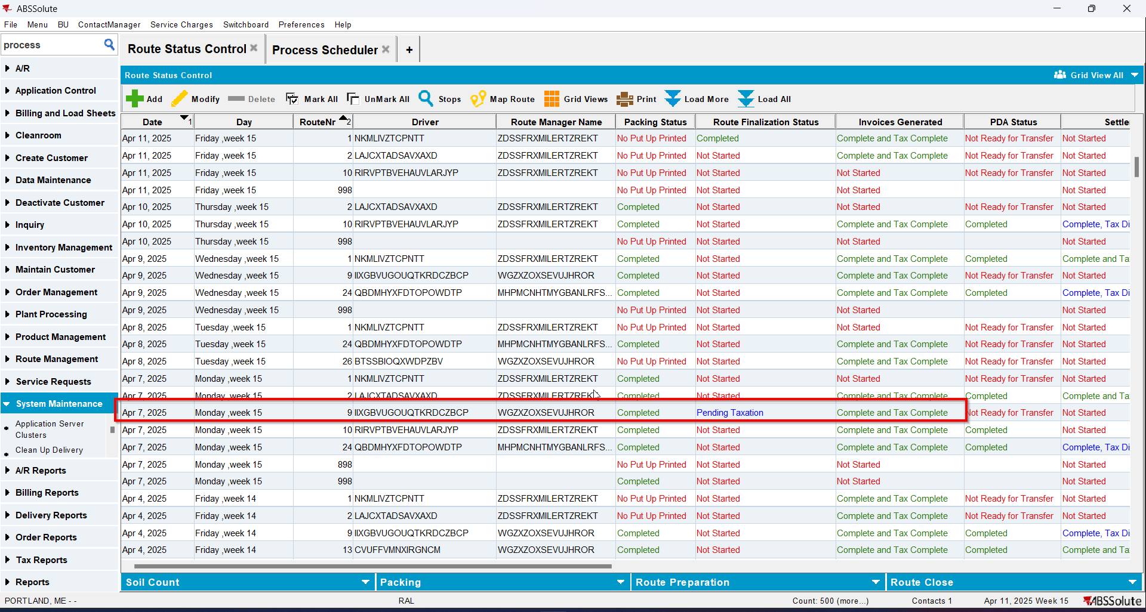

Test Case 3 – RCEI.FinalizationStatus=2 and No RouteControlFinalization record – Tested OK
Expected behavior: Status=2 and ‘Completed’ on Route Finalization Status column from RSC
Hash: 40b4468
- Have the route from Test 2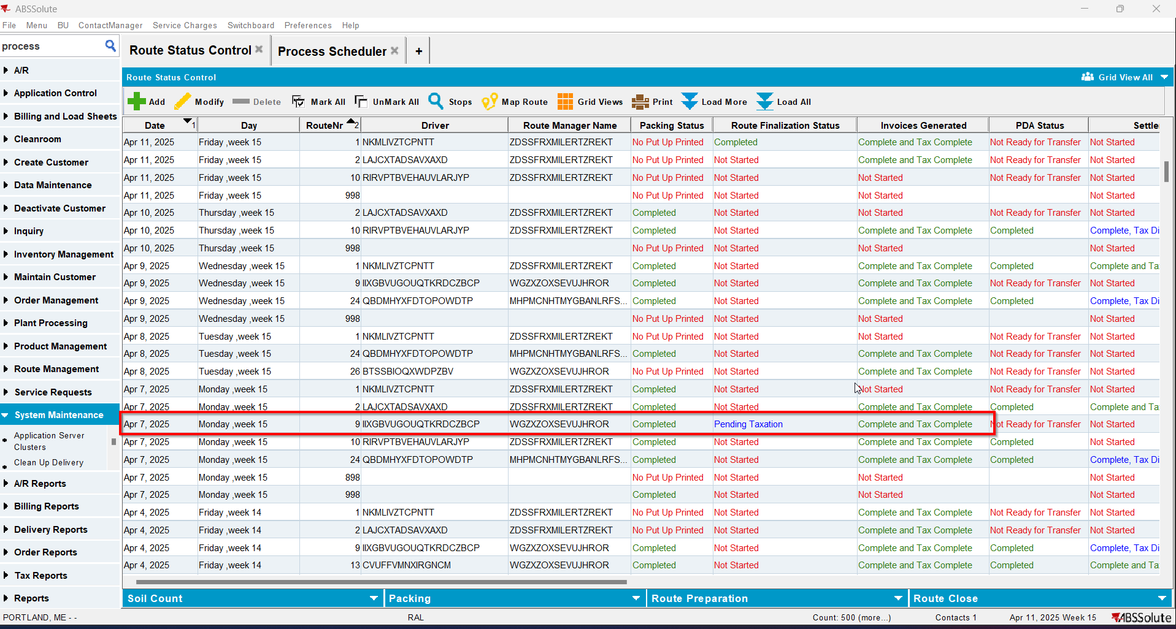
- Update RCEI.FinalizationStatus=2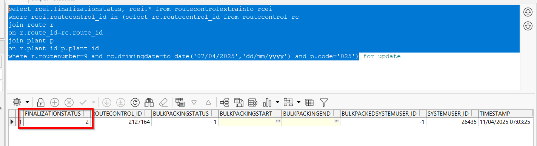
- Check there are no records for that routecontrol_id in RouteControlFinalization table 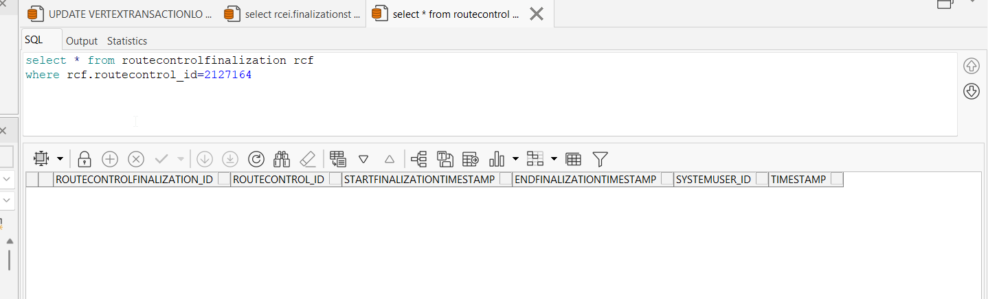
- Check the status of the route on Postman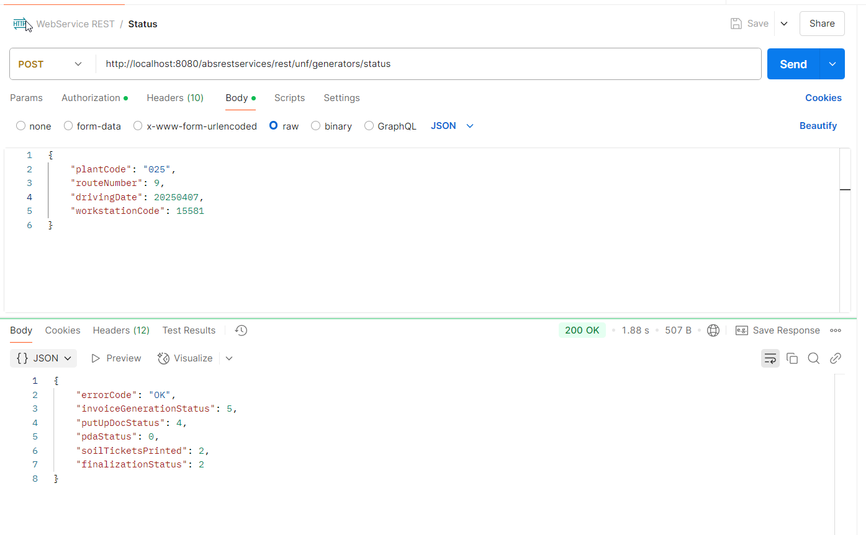
- Go to RSC dlg and check that your route has the same status for column Route Finalization Status as the one in Postman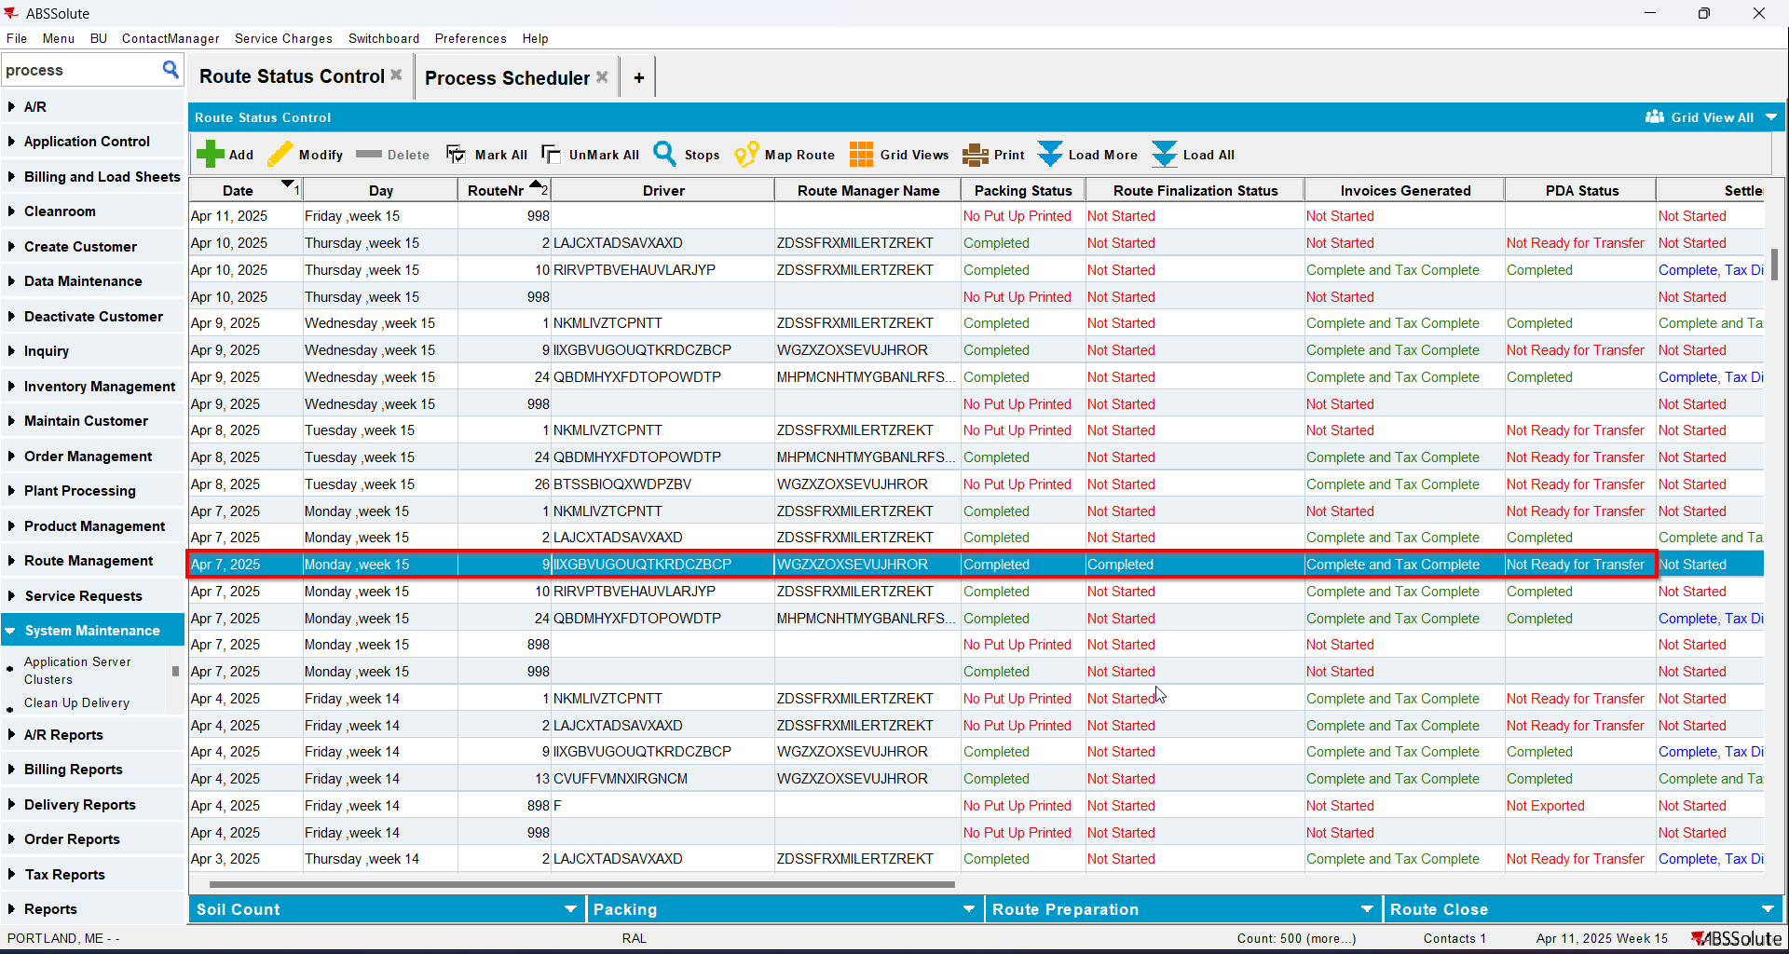

Test Case 4 – RCEI.FinalizationStatus=0 and RCF.StartTimestamp NOT NULL RCF.EndFinalizationTimestamp NOT NULL– Tested OK
Expected behavior: Status=0 and ‘Not Started’ on Route Finalization Status column from RSC
Hash: 40b4468
- Have a route with generated PN and generated invoices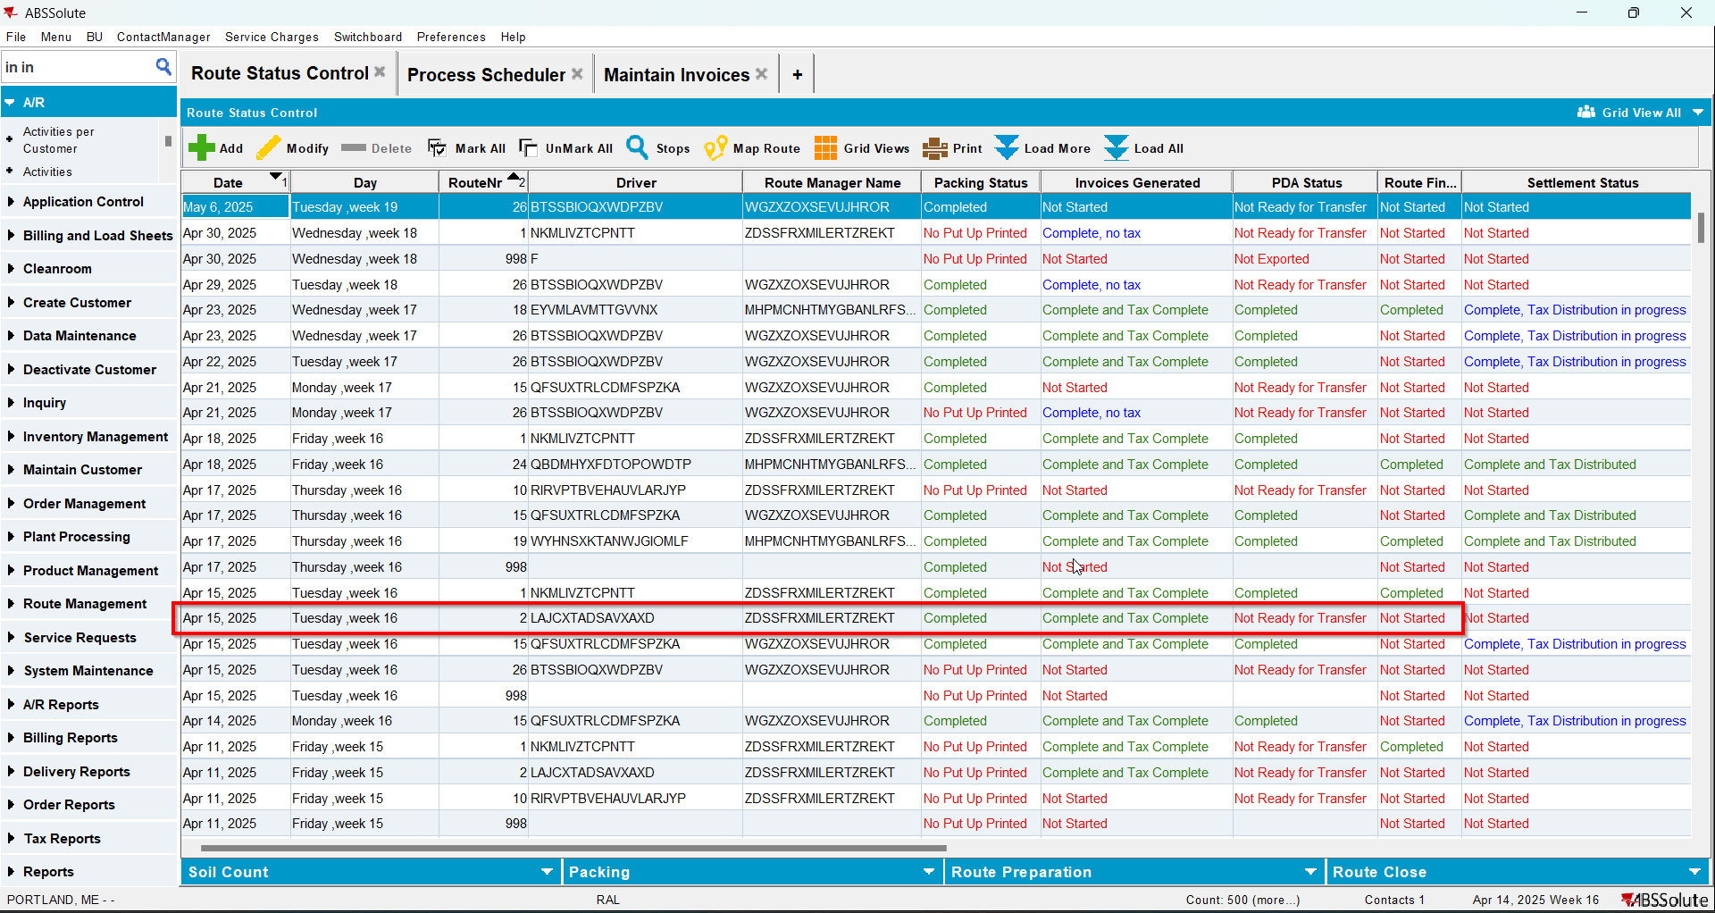
- Check that the RCEI.FinalizationStatus=0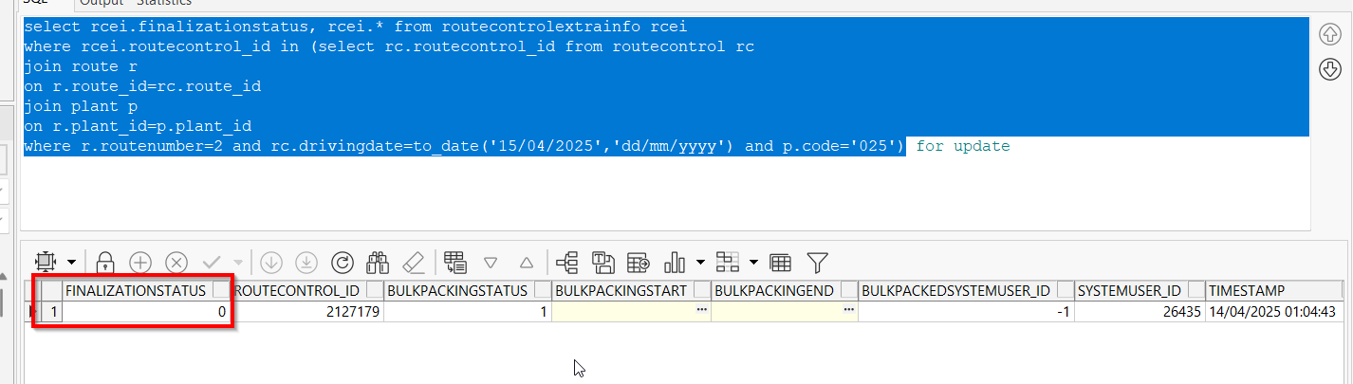
- Insert 2 records in RouteControlFinalization table
insert into routecontrolfinalization(routecontrolfinalization_id, routecontrol_id, startfinalizationtimestamp, endfinalizationtimestamp,
systemuser_id, timestamp)
values(SEQ_RouteControlFinalization.nextval, 2127179, to_date('14/04/2025 08:00:00', 'dd/mm/yyyy hh24:mi:ss'),
to_date('14/04/2025 08:01:00', 'dd/mm/yyyy hh24:mi:ss'), 26435, sysdate)

insert into routecontrolfinalization(routecontrolfinalization_id, routecontrol_id, startfinalizationtimestamp, endfinalizationtimestamp,
systemuser_id, timestamp)
values(SEQ_RouteControlFinalization.nextval, 2127179, to_date('14/04/2025 08:02:00', 'dd/mm/yyyy hh24:mi:ss'),
to_date('14/04/2025 08:03:00', 'dd/mm/yyyy hh24:mi:ss'), 26435, sysdate)

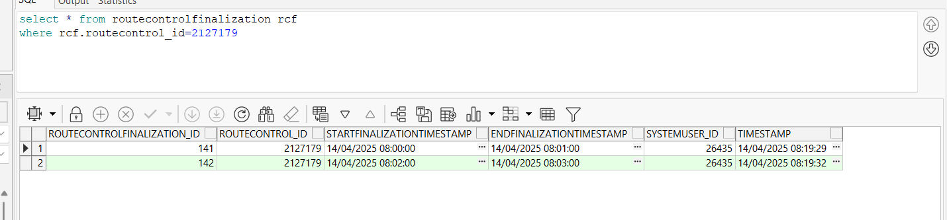

- Check the status of the route on Postman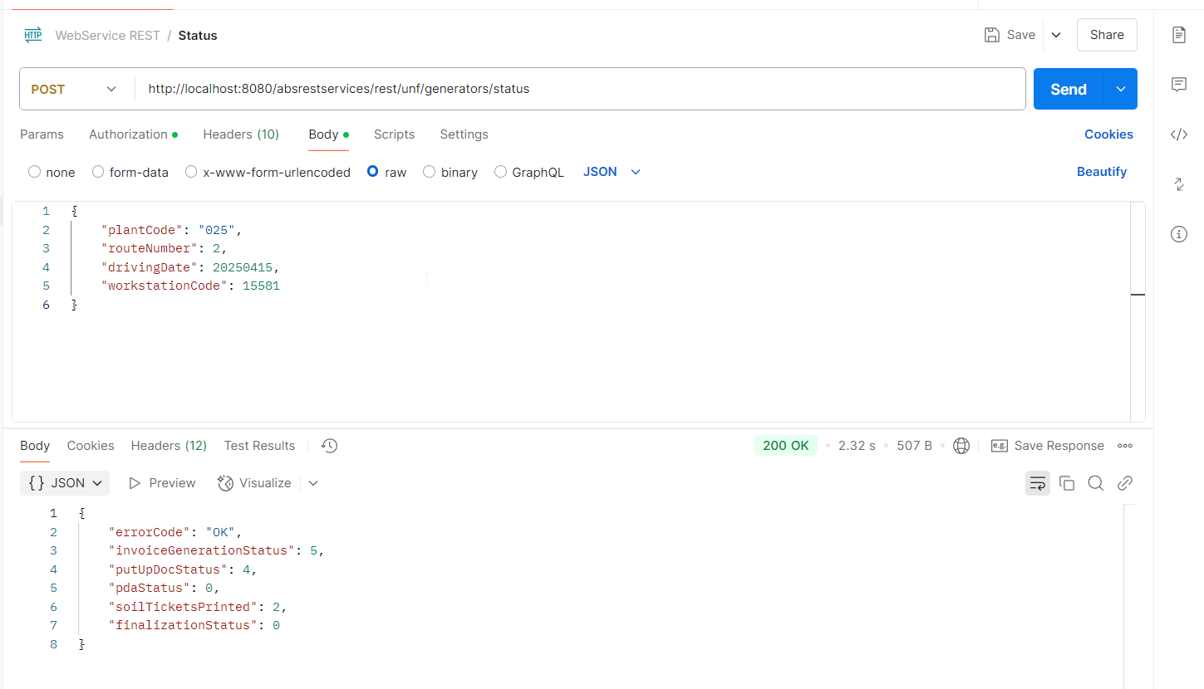
- Go to RSC dlg and check that your route has the same status for column Route Finalization Status as the one in Postman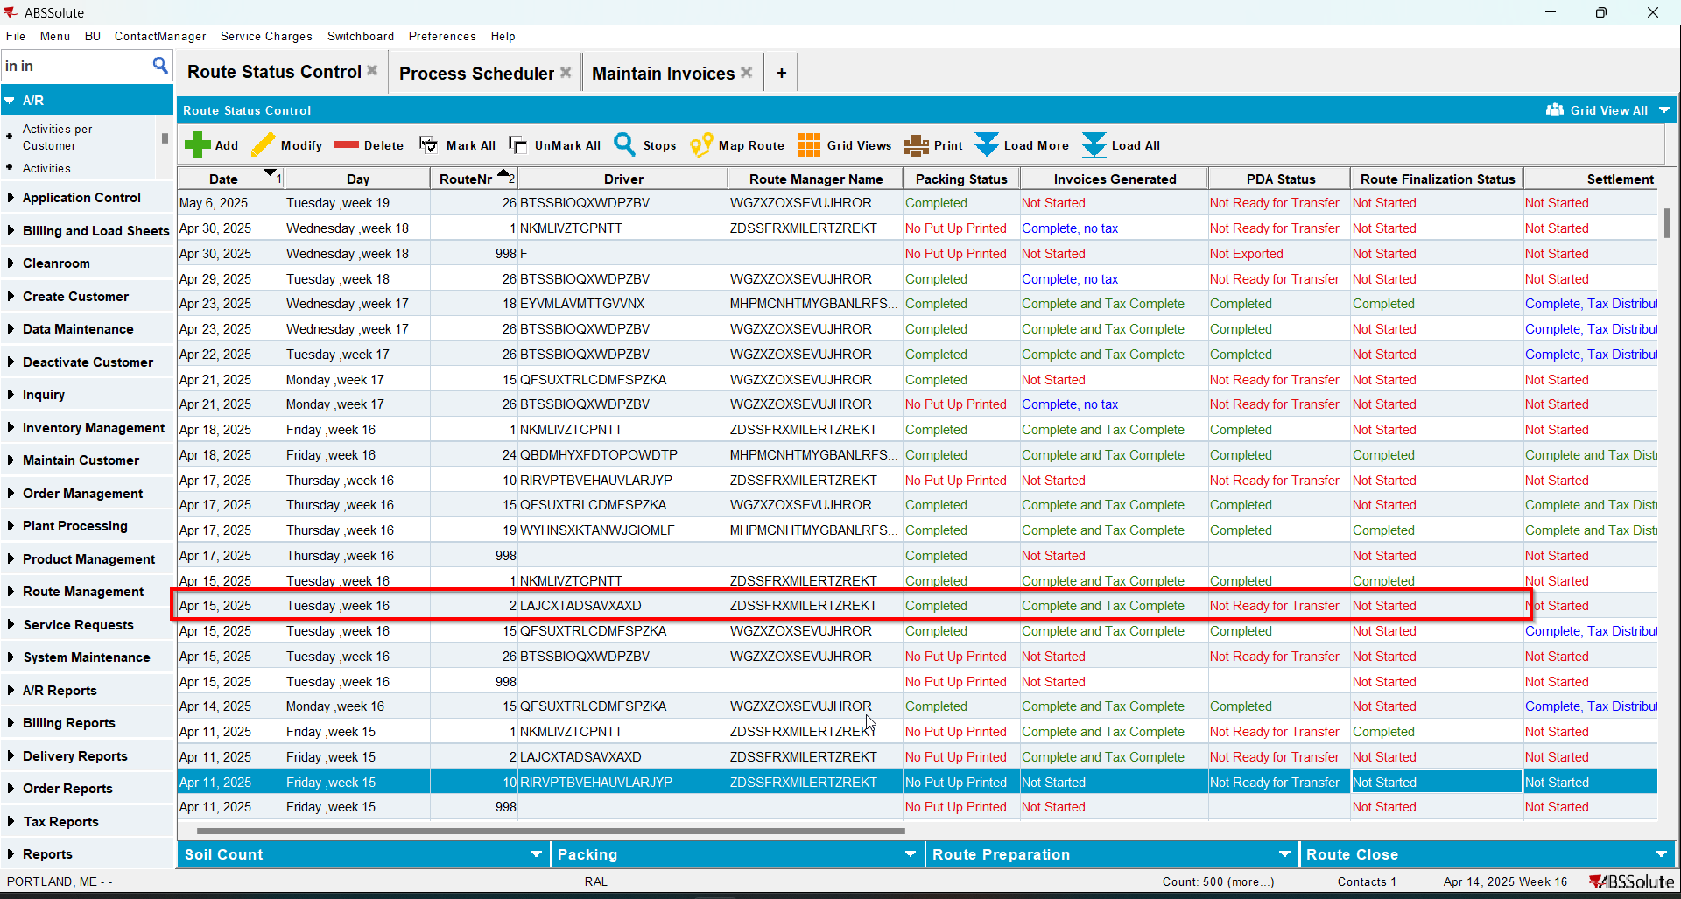

Test Case 5 – RCEI.FinalizationStatus=1 and RCF.StartTimestamp NOT NULL RCF.EndFinalizationTimestamp NOT NULL– Tested OK
Expected behavior: Status=1 and ‘Pending Taxation’ on Route Finalization Status column from RSC
Hash: 40b4468
- Have the route from Test 4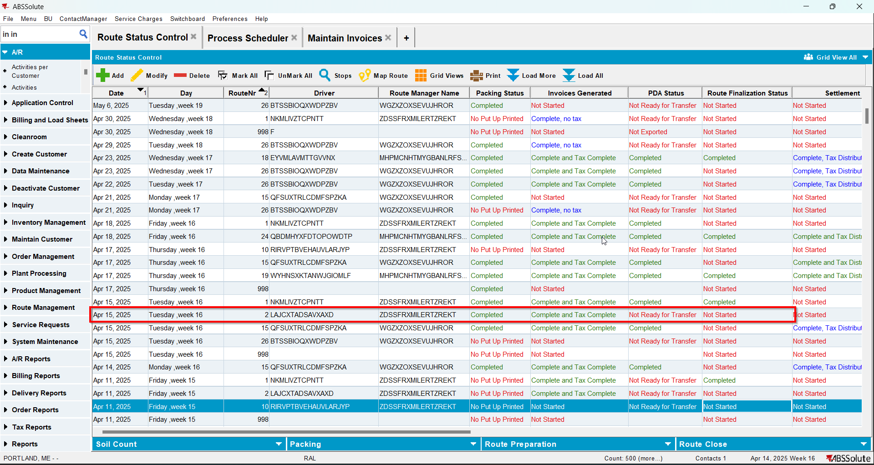
- Update RCEI.FinalizationStatus=1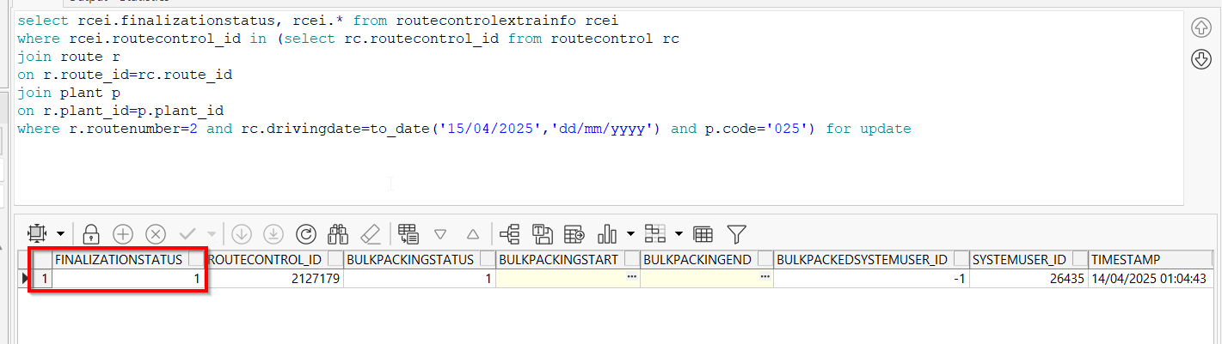
- Check there are records for that routecontrol_id in RouteControlFinalization table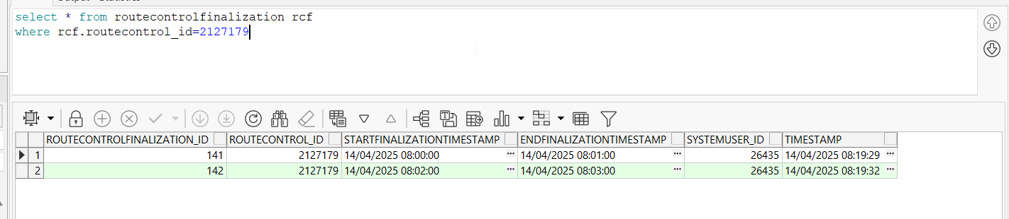
- Check the status of the route on Postman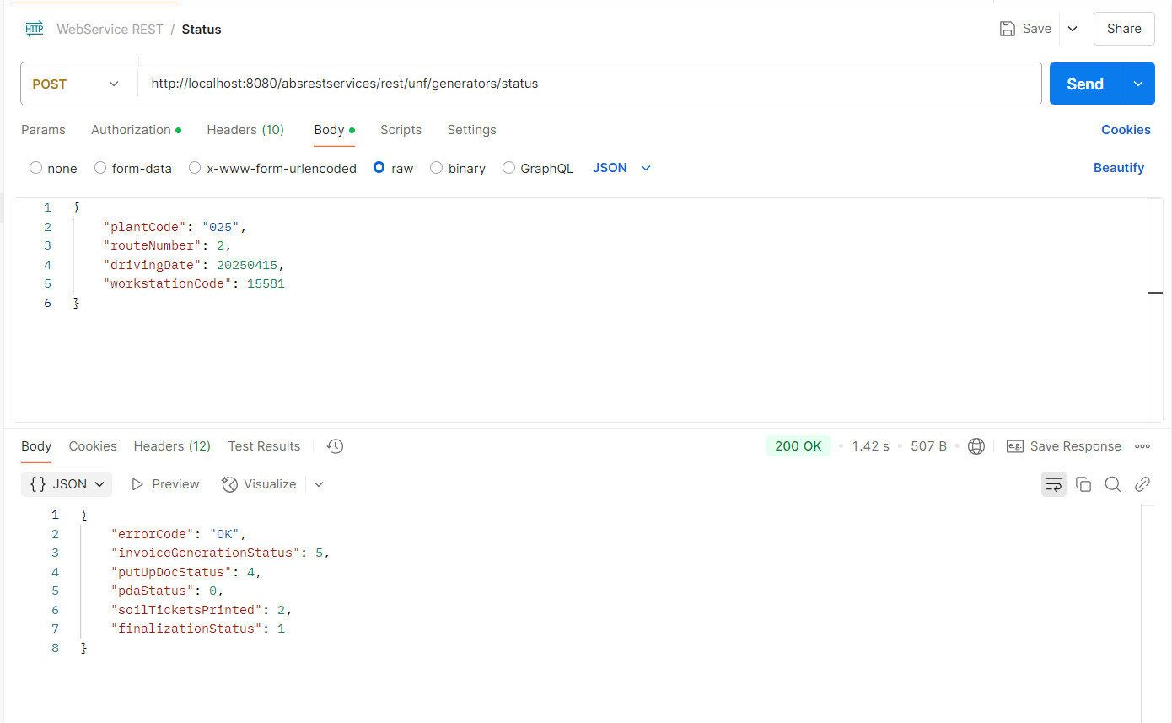
- Go to RSC dlg and check that your route has the same status for column Route Finalization Status as the one in Postman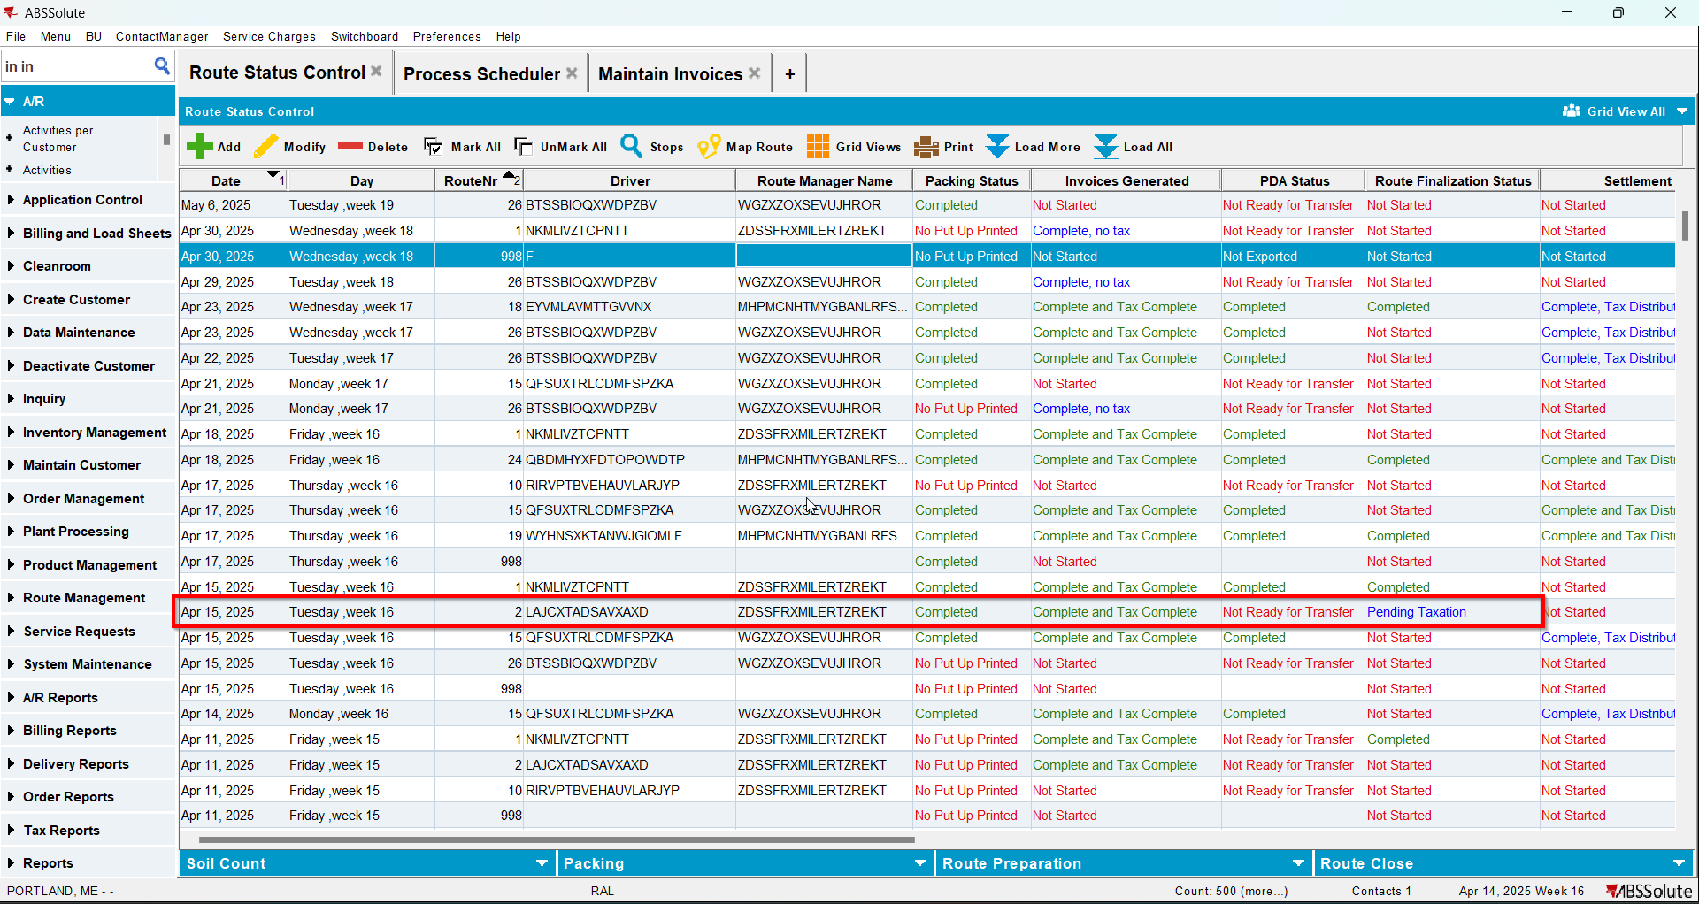

Test Case 6 – RCEI.FinalizationStatus=2 and RCF.StartTimestamp NOT NULL RCF.EndFinalizationTimestamp NOT NULL– Tested OK
Expected behavior: Status=2 and ‘Completed’ on Route Finalization Status column from RSC
Hash: 40b4468
- Have the route from Test 5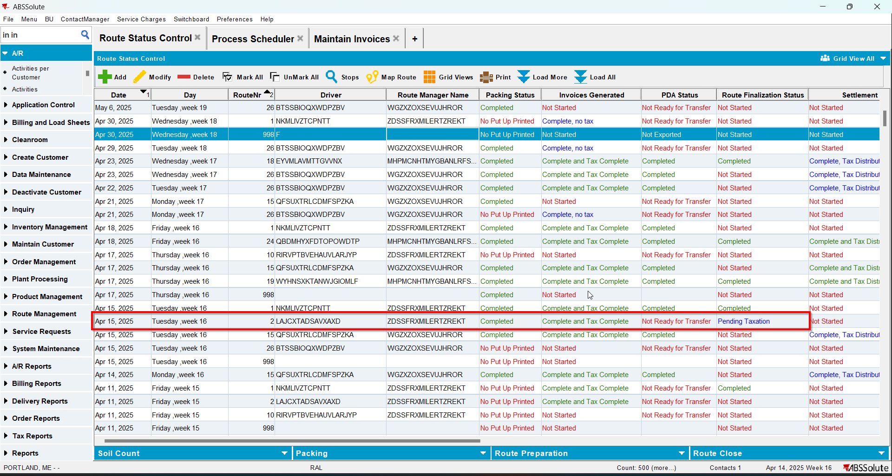
- Update RCEI.FinalizationStatus=2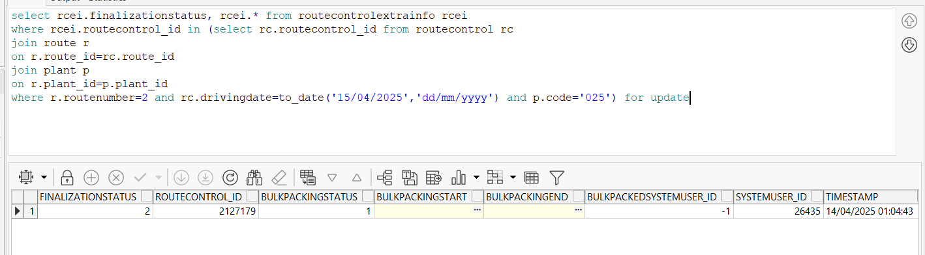
- Check there are records for that routecontrol_id in RouteControlFinalization table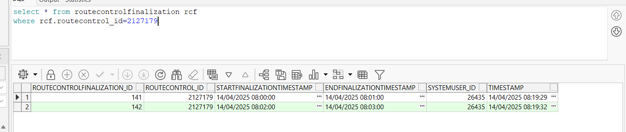
- Check the status of the route on Postman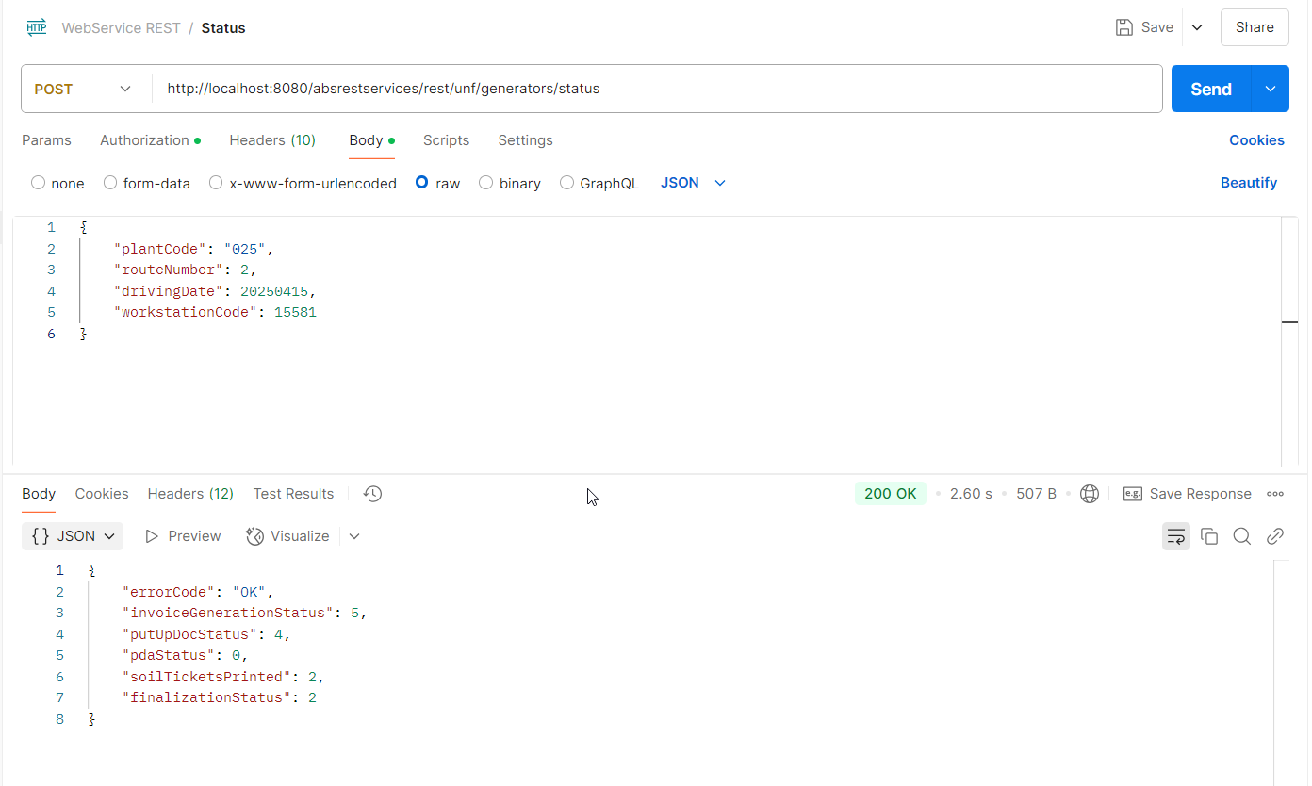
- Go to RSC dlg and check that your route has the same status for column Route Finalization Status as the one in Postman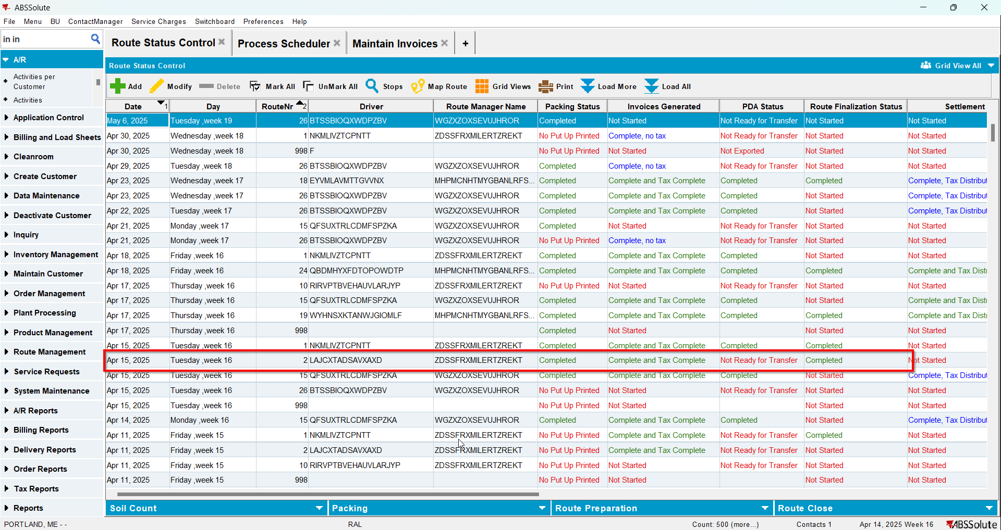

Test Case 7 – RCEI.FinalizationStatus=0 and RCF.StartTimestamp NOT NULL RCF.EndFinalizationTimestamp IS NULL– Tested OK
Expected behavior: Status=3 and ‘In Progress’ on Route Finalization Status column from RSC
Hash: 40b4468
- Have a route with generated PN and generated invoices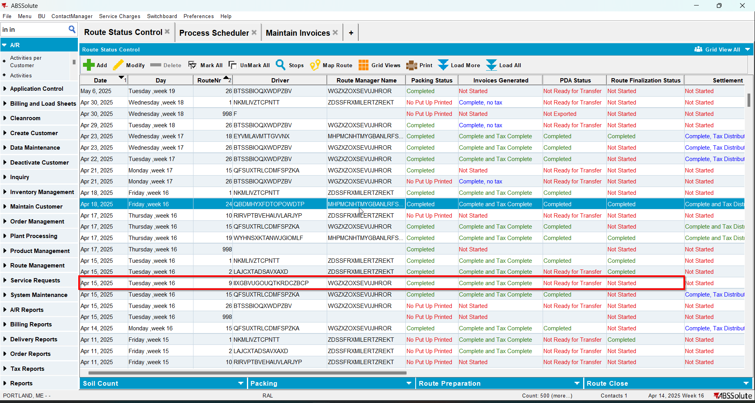
- Check that the RCEI.FinalizationStatus=0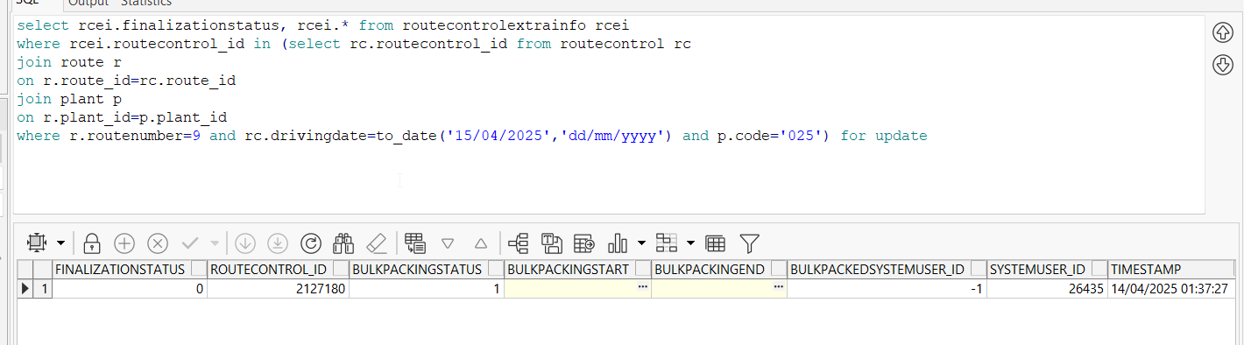
- Insert 2 records in RouteControlFinalization table. The first one should have EndFinalizationTimestamp and the second one should not have EndFinalizationTimestamp
insert into routecontrolfinalization(routecontrolfinalization_id, routecontrol_id, startfinalizationtimestamp, endfinalizationtimestamp,
systemuser_id, timestamp)
values(SEQ_RouteControlFinalization.nextval, 2127180, to_date('14/04/2025 08:04:00', 'dd/mm/yyyy hh24:mi:ss'),
to_date('14/04/2025 08:05:00', 'dd/mm/yyyy hh24:mi:ss'), 26435, sysdate)

insert into routecontrolfinalization(routecontrolfinalization_id, routecontrol_id, startfinalizationtimestamp, endfinalizationtimestamp,
systemuser_id, timestamp)
values(SEQ_RouteControlFinalization.nextval, 2127180, to_date('14/04/2025 08:06:00', 'dd/mm/yyyy hh24:mi:ss'),
null, 26435, sysdate)
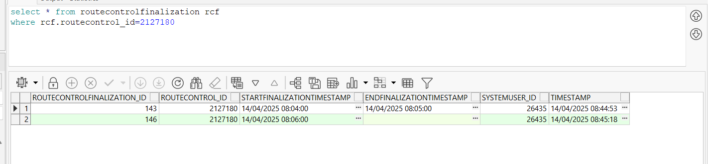

- Check the status of the route on Postman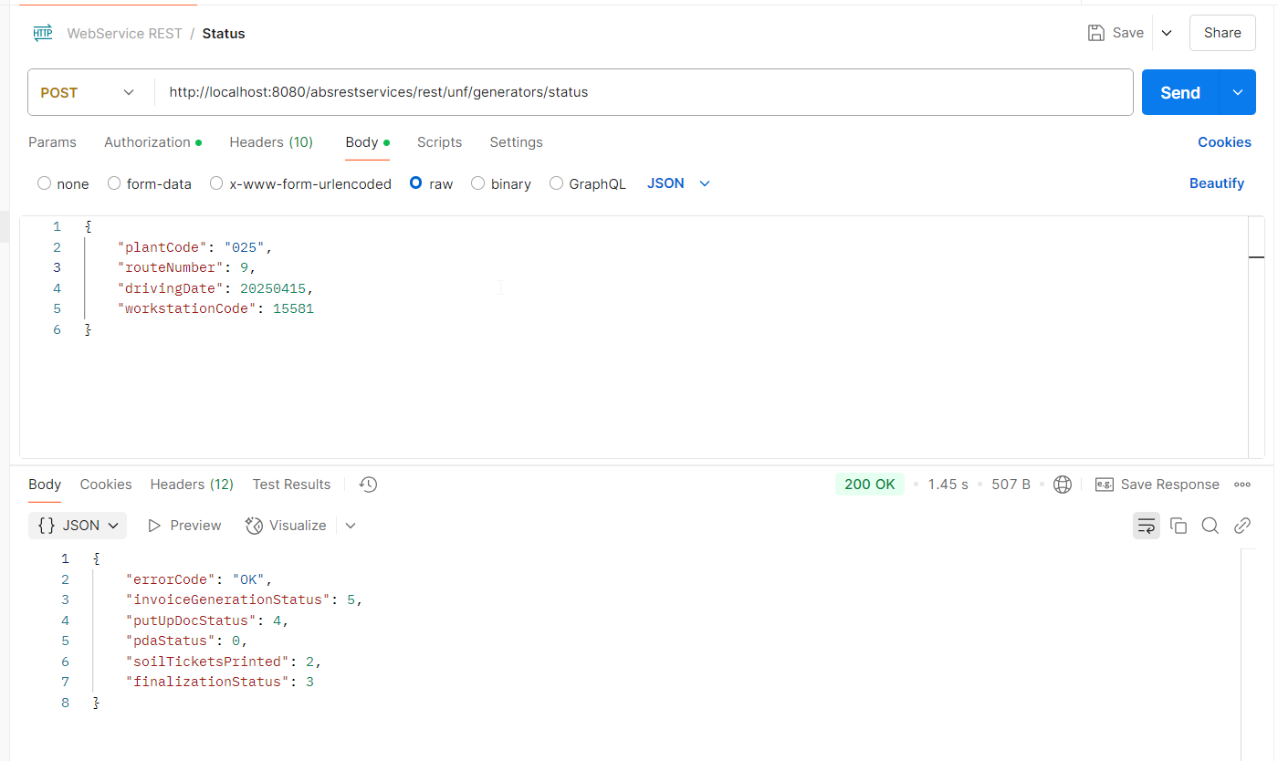
- Go to RSC dlg and check that your route has the same status for column Route Finalization Status as the one in Postman
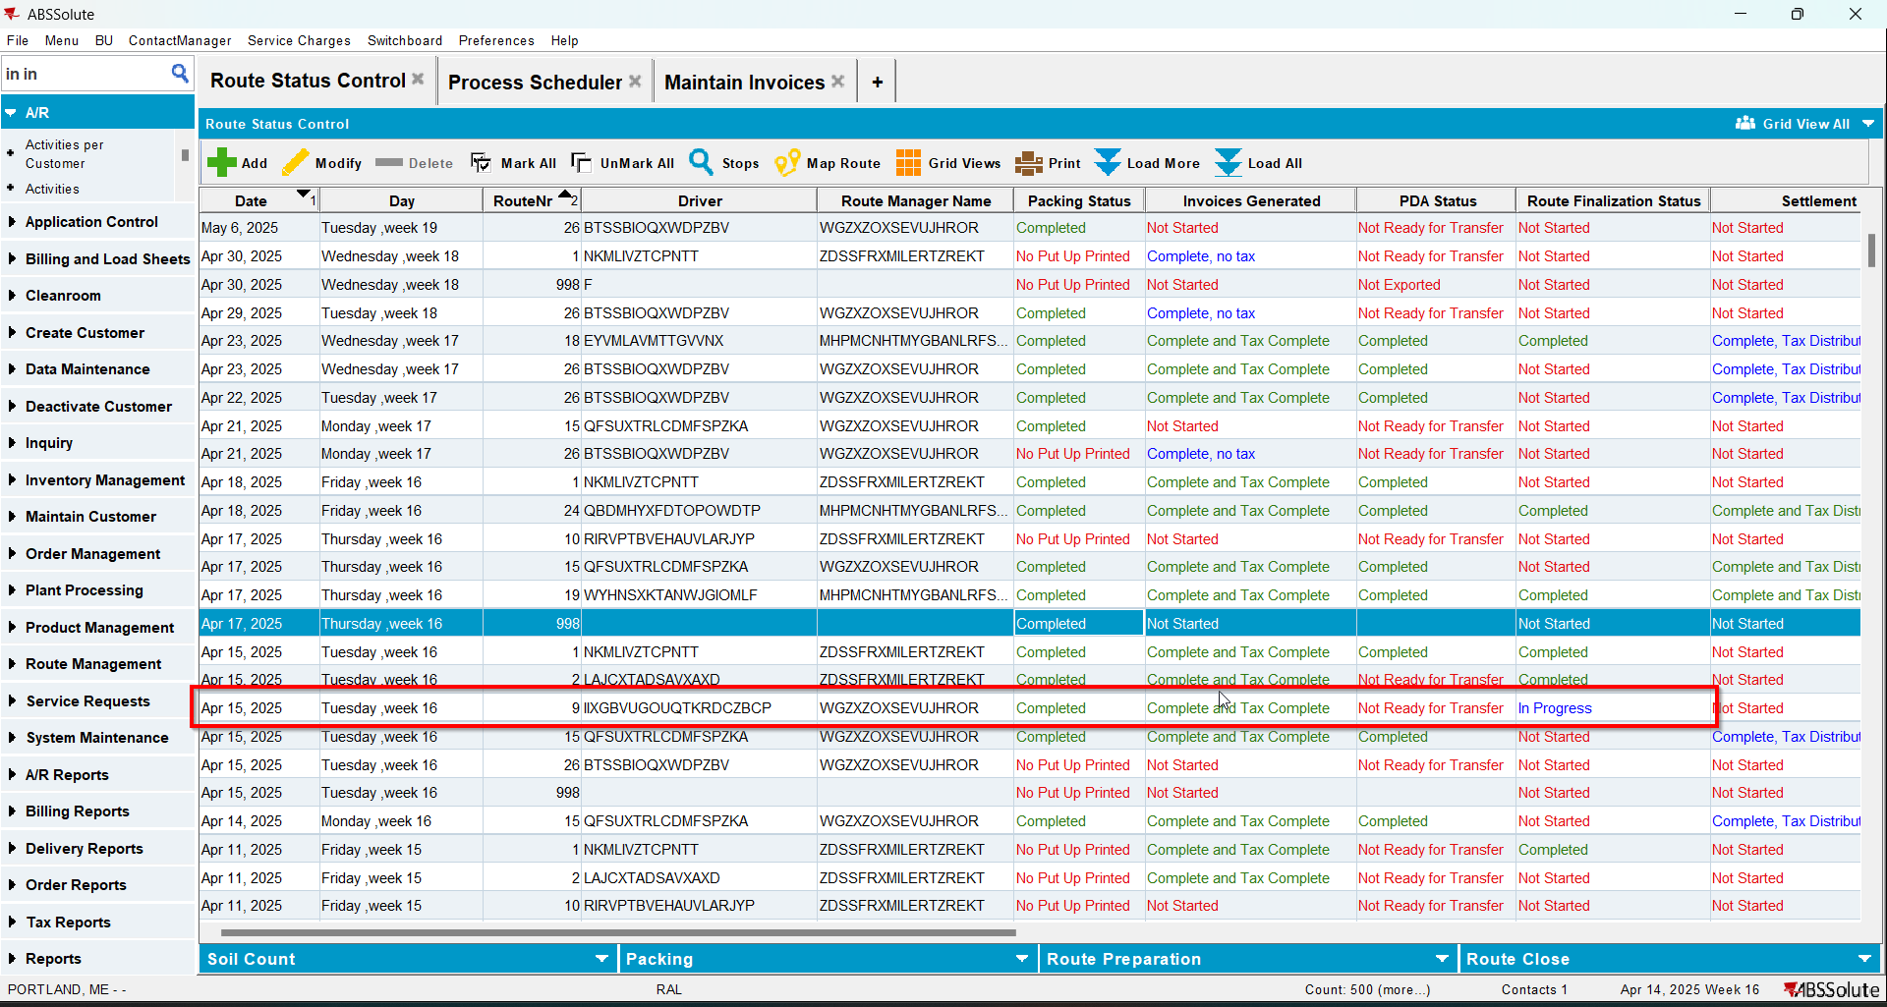

Test Case 8 – RCEI.FinalizationStatus=1 and RCF.StartTimestamp NOT NULL RCF.EndFinalizationTimestamp IS NULL– Tested OK
Expected behavior: Status=3 and ‘In Progress’ on Route Finalization Status column from RSC
Hash: 40b4468
- Have a route with generated PN and generated invoices 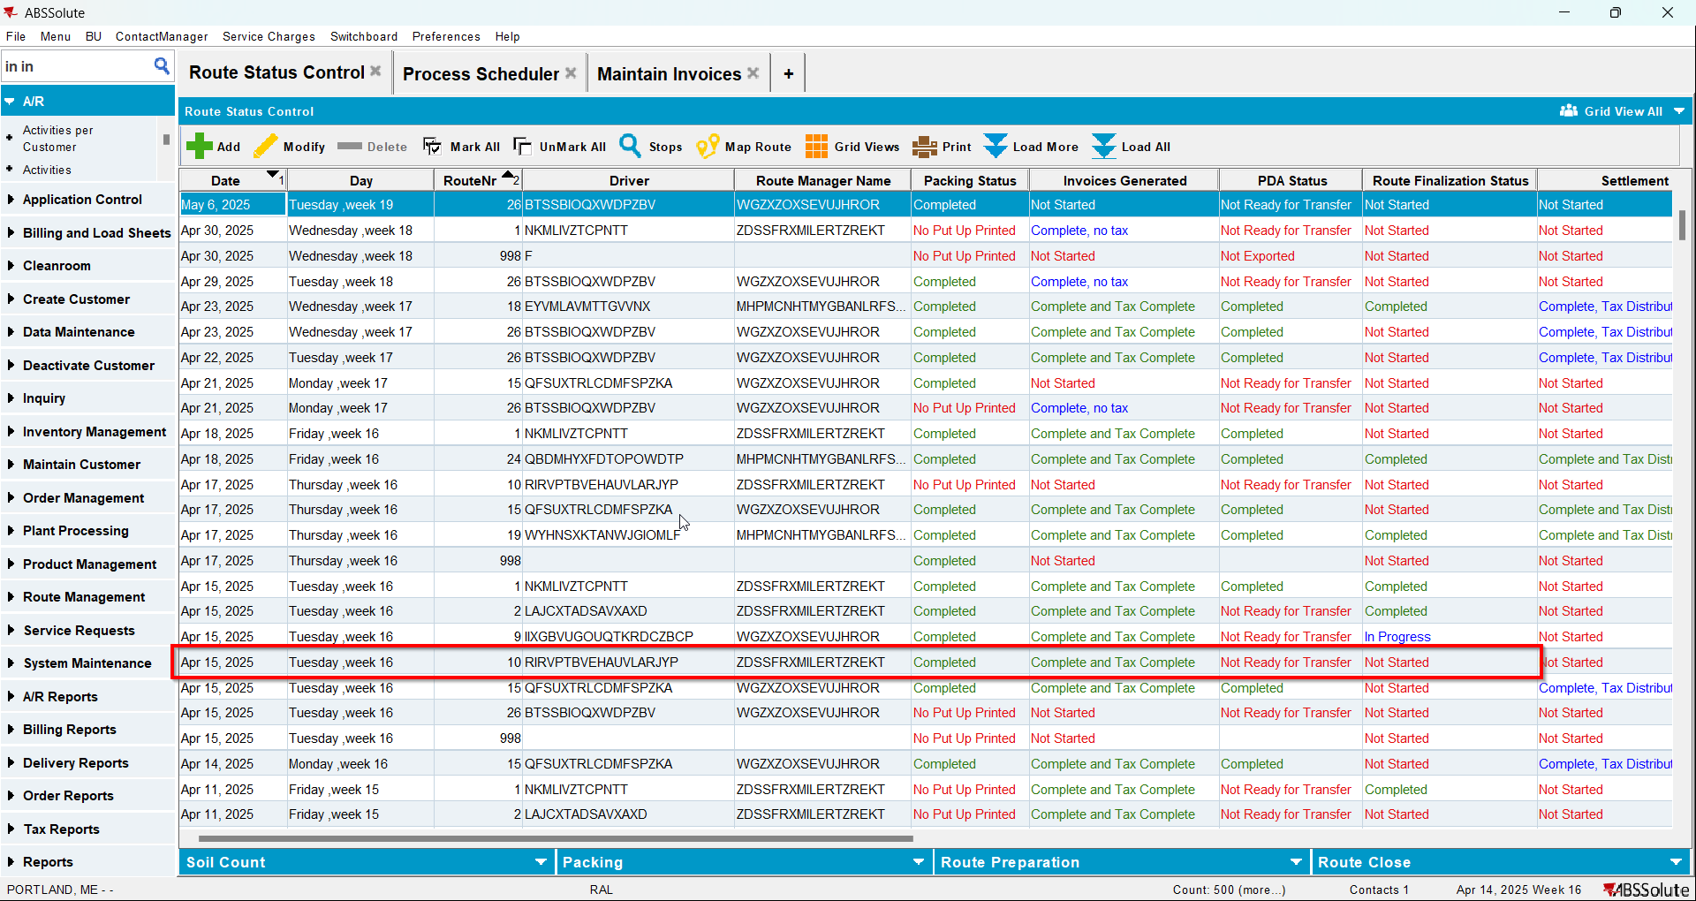
- Update RCEI.FinalizationStatus=1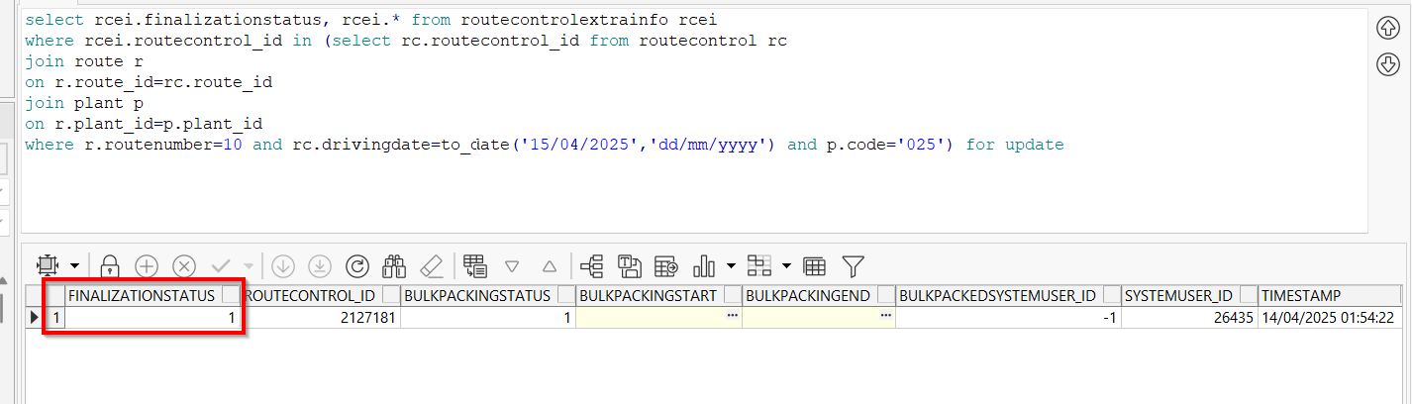
- Insert 2 records in RouteControlFinalization table. The first one should have EndFinalizationTimestamp and the second one should not have EndFinalizationTimestamp
insert into routecontrolfinalization(routecontrolfinalization_id, routecontrol_id, startfinalizationtimestamp, endfinalizationtimestamp,
systemuser_id, timestamp)
values(SEQ_RouteControlFinalization.nextval, 2127181, to_date('14/04/2025 08:07:00', 'dd/mm/yyyy hh24:mi:ss'),
to_date('14/04/2025 08:08:00', 'dd/mm/yyyy hh24:mi:ss'), 26435, sysdate)

insert into routecontrolfinalization(routecontrolfinalization_id, routecontrol_id, startfinalizationtimestamp, endfinalizationtimestamp,
systemuser_id, timestamp)
values(SEQ_RouteControlFinalization.nextval, 2127181, to_date('14/04/2025 08:09:00', 'dd/mm/yyyy hh24:mi:ss'),
null, 26435, sysdate)
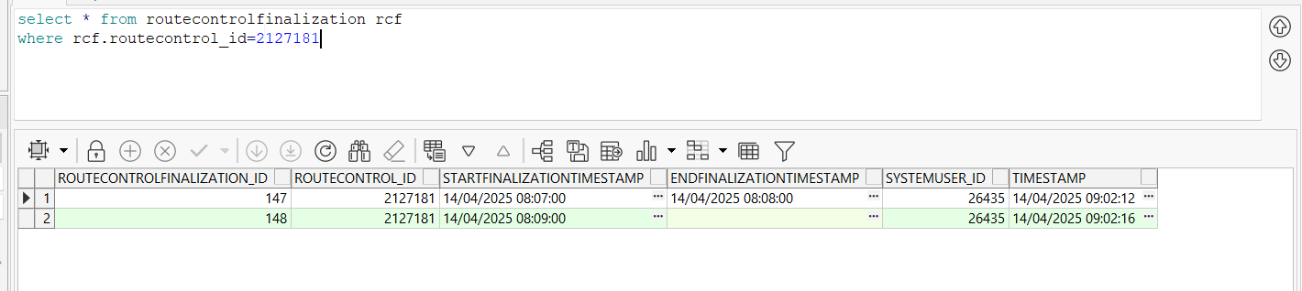
- Check the status of the route on Postman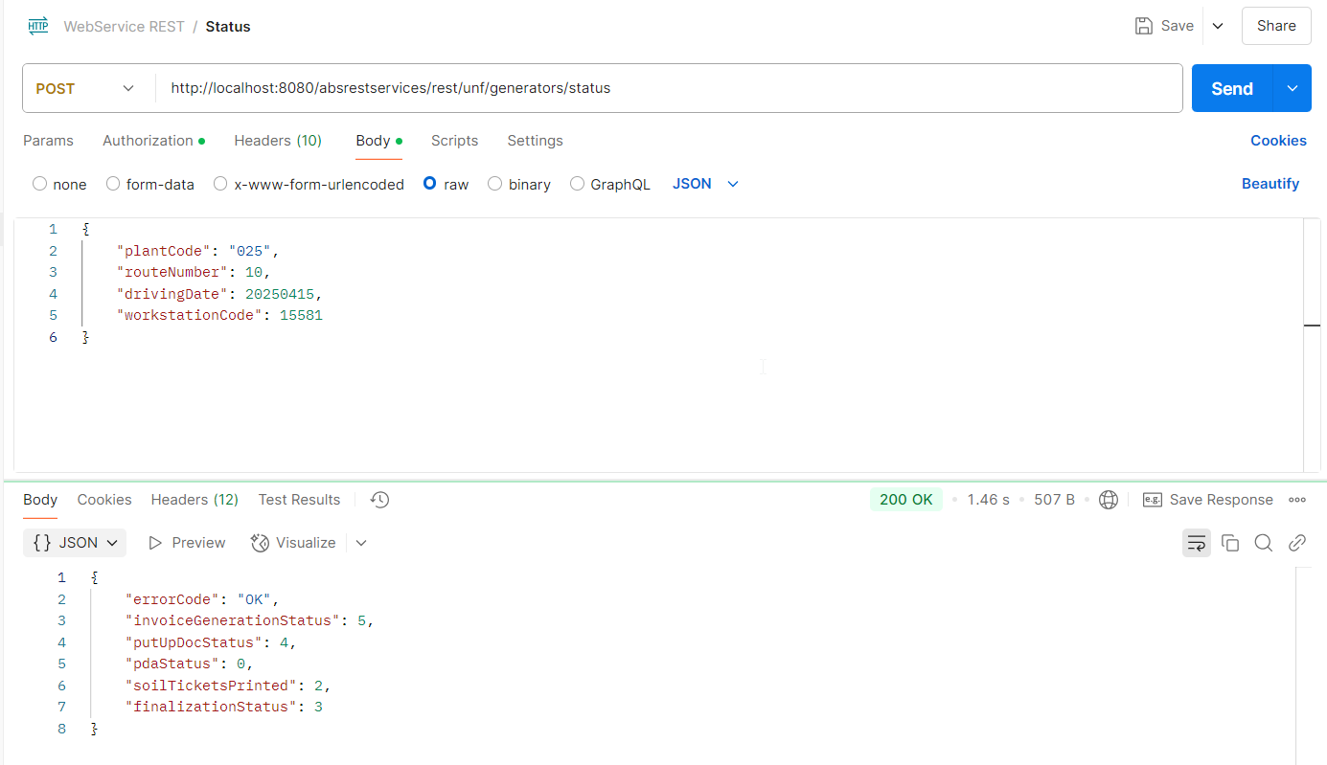
- Go to RSC dlg and check that your route has the same status for column Route Finalization Status as the one in Postman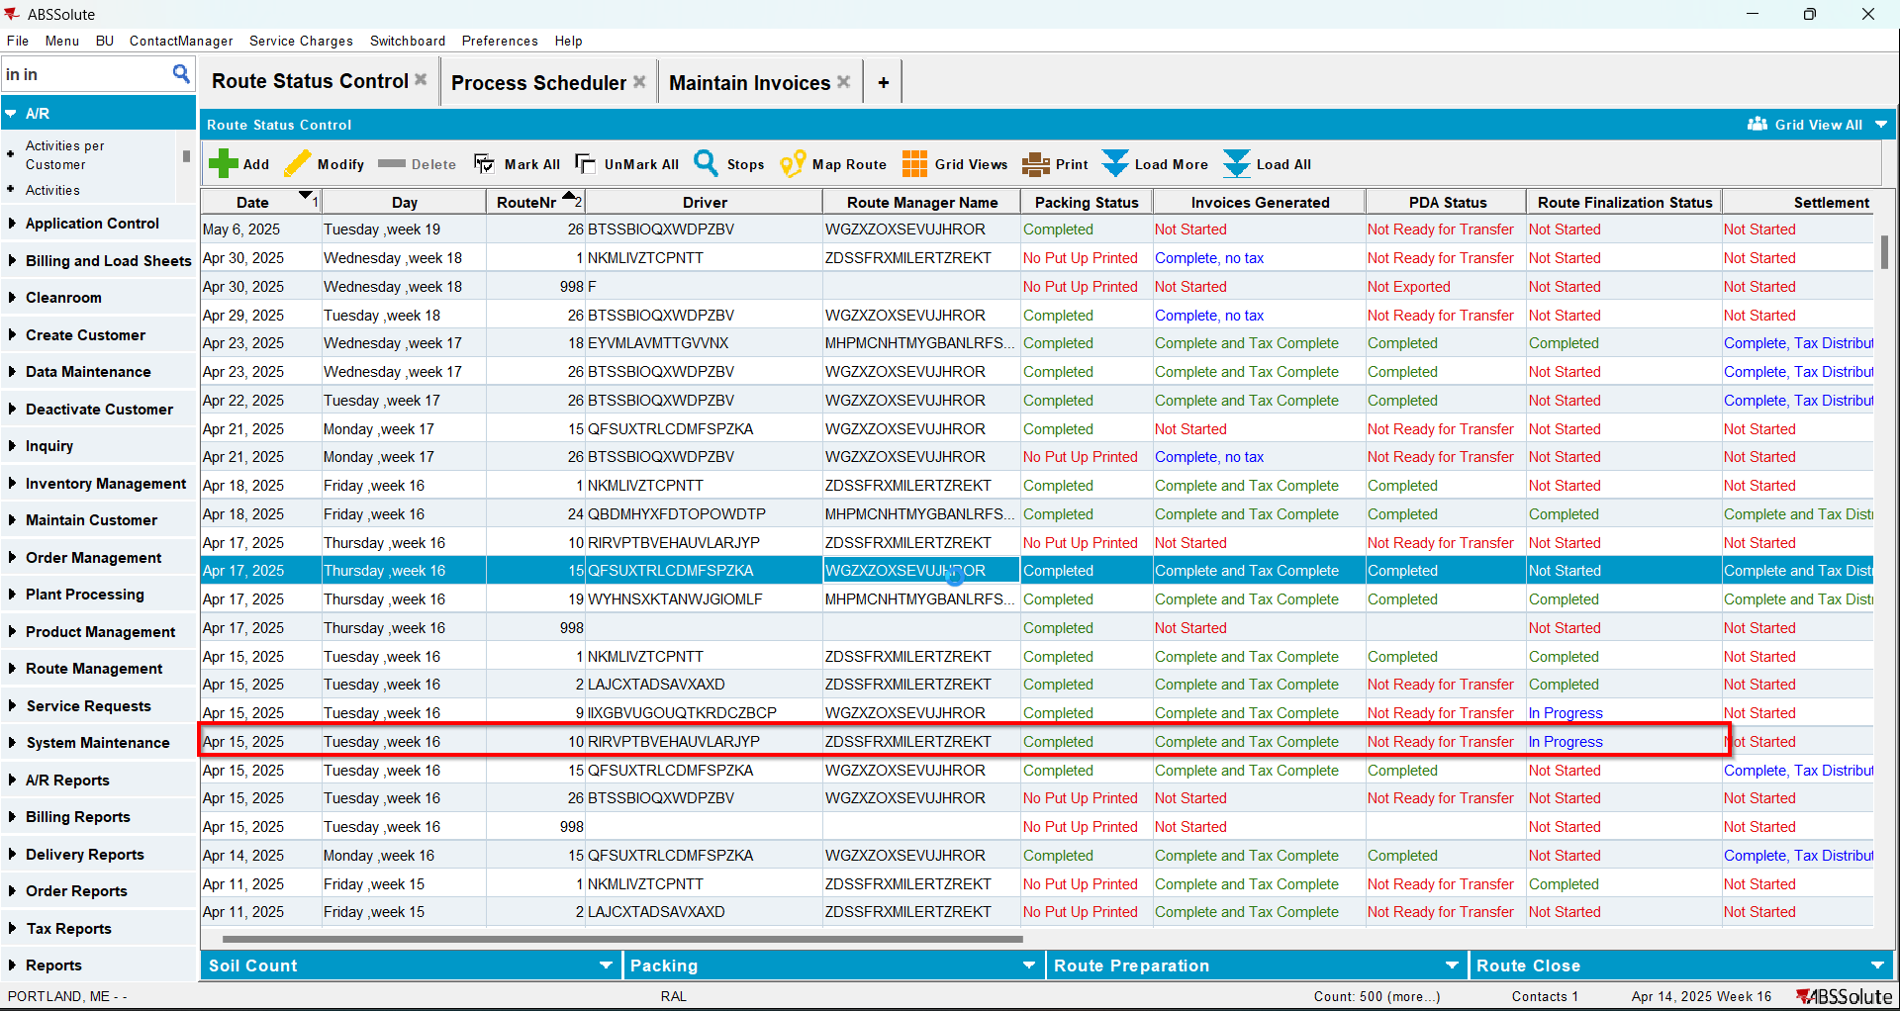

Test Case 9 – RCEI.FinalizationStatus=2 and RCF.StartTimestamp NOT NULL RCF.EndFinalizationTimestamp IS NULL– Tested OK
Expected behavior: Status=3 and ‘In Progress’ on Route Finalization Status column from RSC
Hash: 40b4468
- Have a route with generated PN and generated invoices 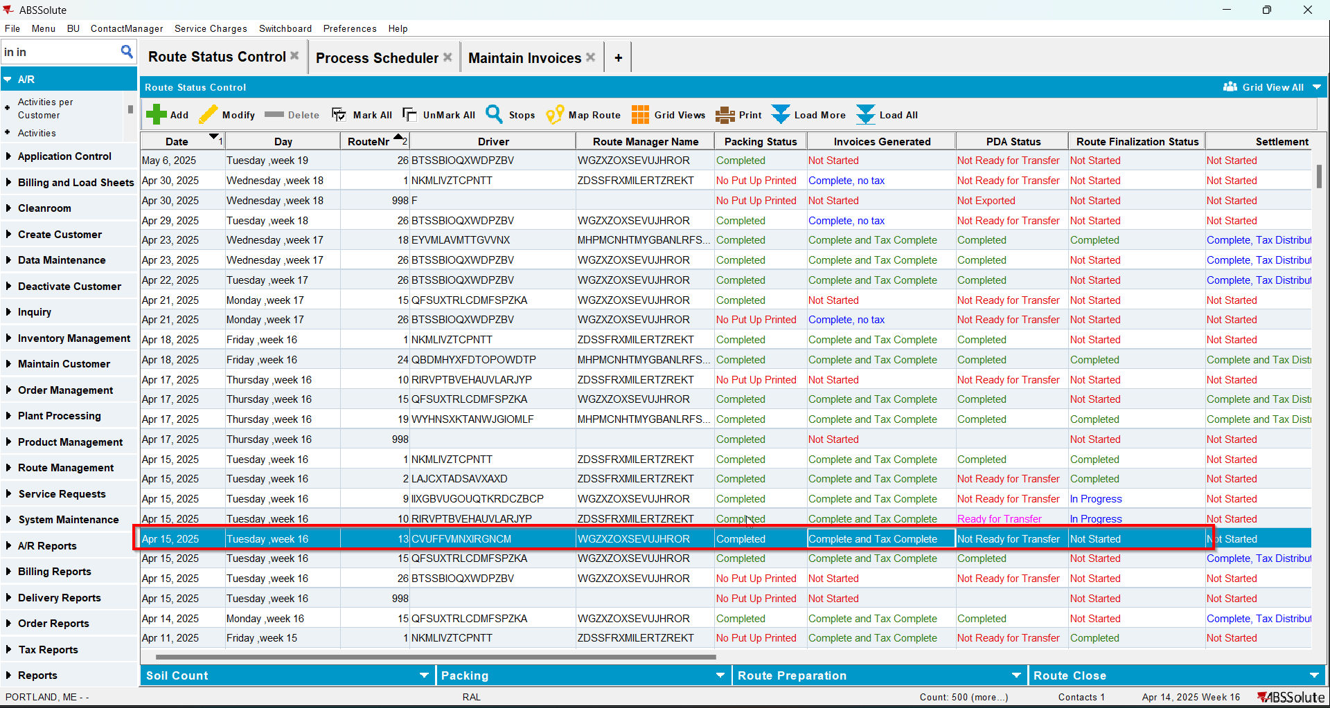
- Update RCEI.FinalizationStatus=2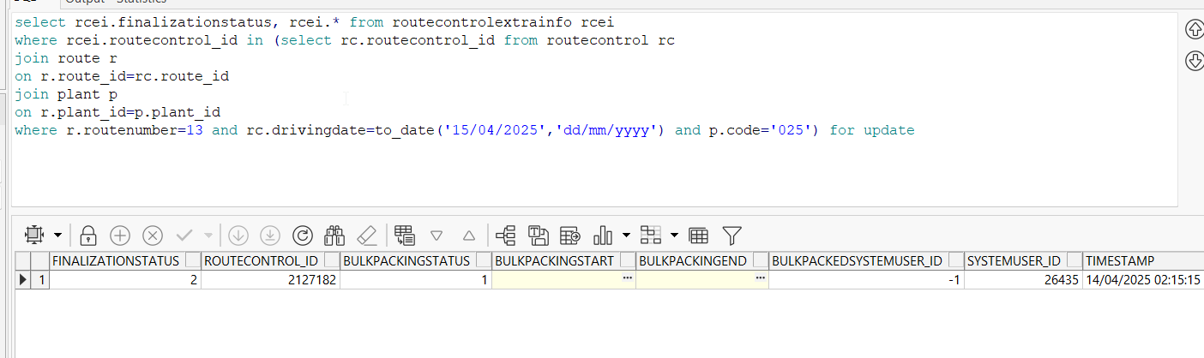
- Insert 2 records in RouteControlFinalization table. The first one should have EndFinalizationTimestamp and the second one should not have EndFinalizationTimestamp
insert into routecontrolfinalization(routecontrolfinalization_id, routecontrol_id, startfinalizationtimestamp, endfinalizationtimestamp,
systemuser_id, timestamp)
values(SEQ_RouteControlFinalization.nextval, 2127182, to_date('14/04/2025 08:10:00', 'dd/mm/yyyy hh24:mi:ss'),
to_date('14/04/2025 08:11:00', 'dd/mm/yyyy hh24:mi:ss'), 26435, sysdate)

insert into routecontrolfinalization(routecontrolfinalization_id, routecontrol_id, startfinalizationtimestamp, endfinalizationtimestamp,
systemuser_id, timestamp)
values(SEQ_RouteControlFinalization.nextval, 2127182, to_date('14/04/2025 08:12:00', 'dd/mm/yyyy hh24:mi:ss'),
null, 26435, sysdate)
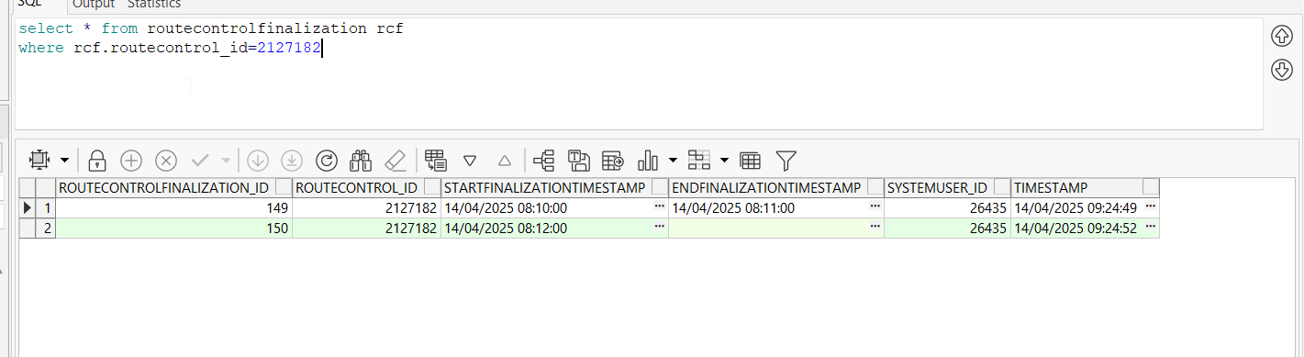
- Check the status of the route on Postman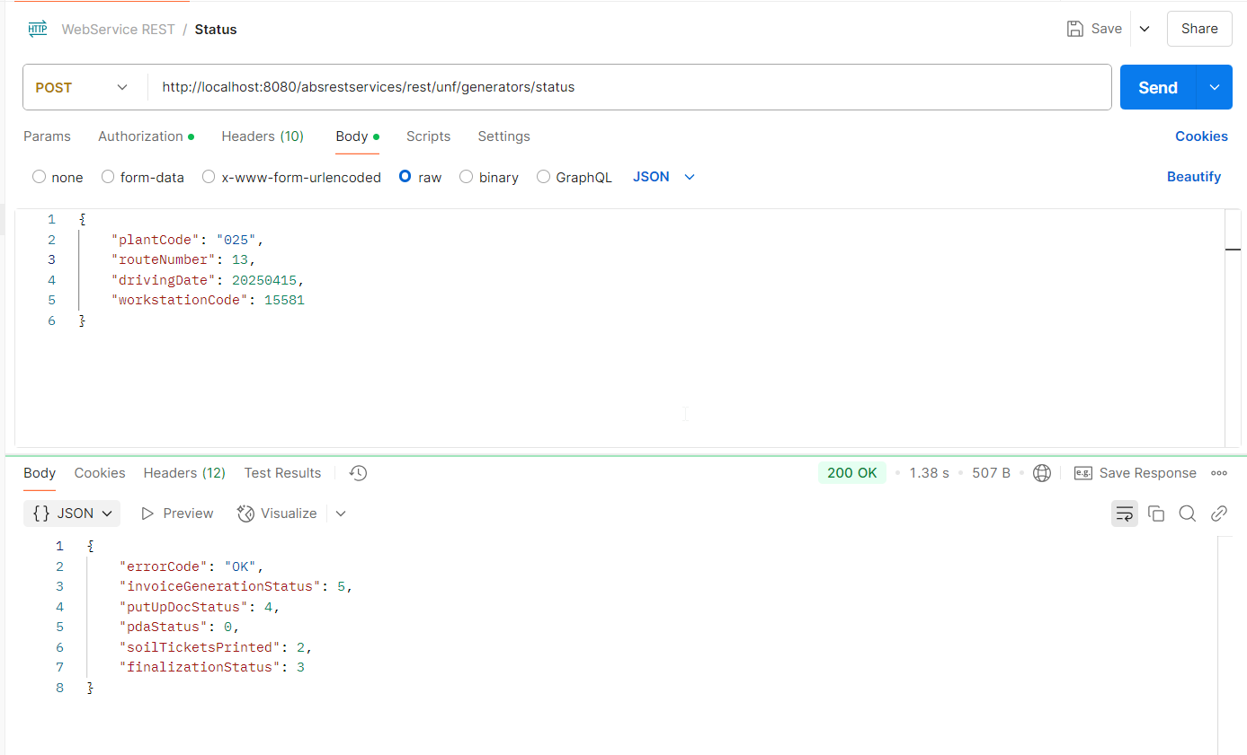
- Go to RSC dlg and check that your route has the same status for column Route Finalization Status as the one in Postman

