ABSN-3261 - WebX - On several tabs with tables empty cells have no id elements
Environment | Prerequisites
Version: 9.07.00.UNF19  DBServerName= abs-srv20.internal.abslbs.com  DBSID=CUST24  DBUser=UNFDEV  DBPassword= UNFDEV  Environment=Test | - Module:  - System setting

Contents
Retest after fix 1
Test Case 1 – Check the Overview tab in WebX for empty cells which don’t have id elements 1
Test Case 2 – Check the Invoice details tab in WebX for empty cells which don’t have id elements 5
Test Case 3 – Check the Invoice adjustments tab - adjusted amount cell for id elements 9
Test Case 4 – Check the wearer maintenance tab - quantity column, chg cells for id elements 10

Retest after fix

Test Case 1 – Check the Overview tab in WebX for empty cells which don’t have id elements
Hash: 14fd539ff715
Expected Behavior: Inspected cell should have an existing ID
- WebX: Find a route with data that was uploaded from RA
- Complete Start My day
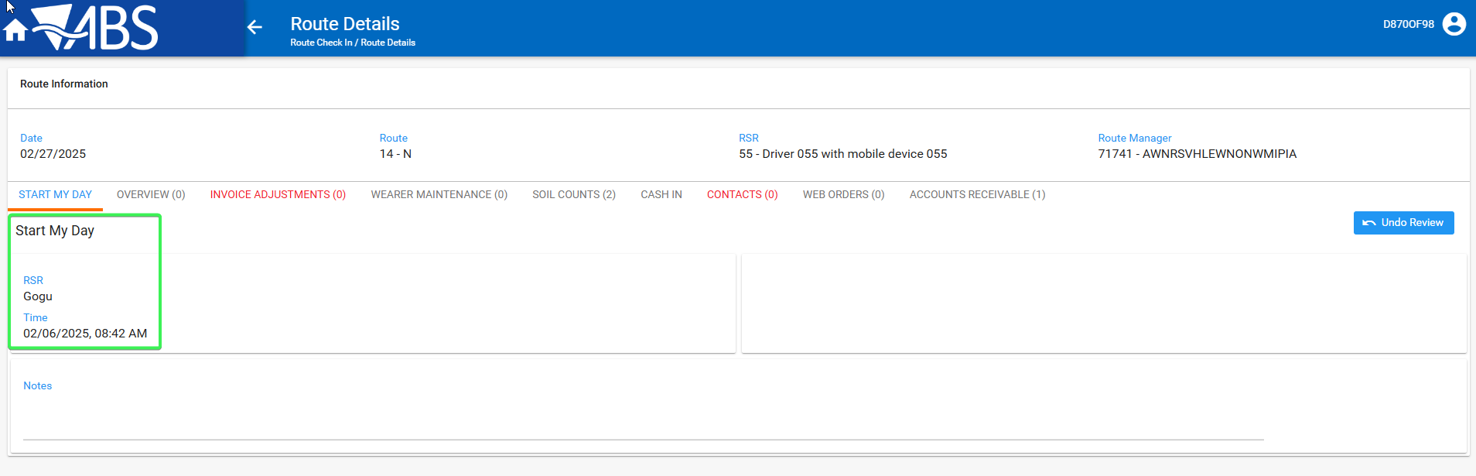
- Go to Overview tab and press Ctrl + Shift + C for the console to appear
- Inspect the empty cells of the following columns: Check that they have an id.
New Route
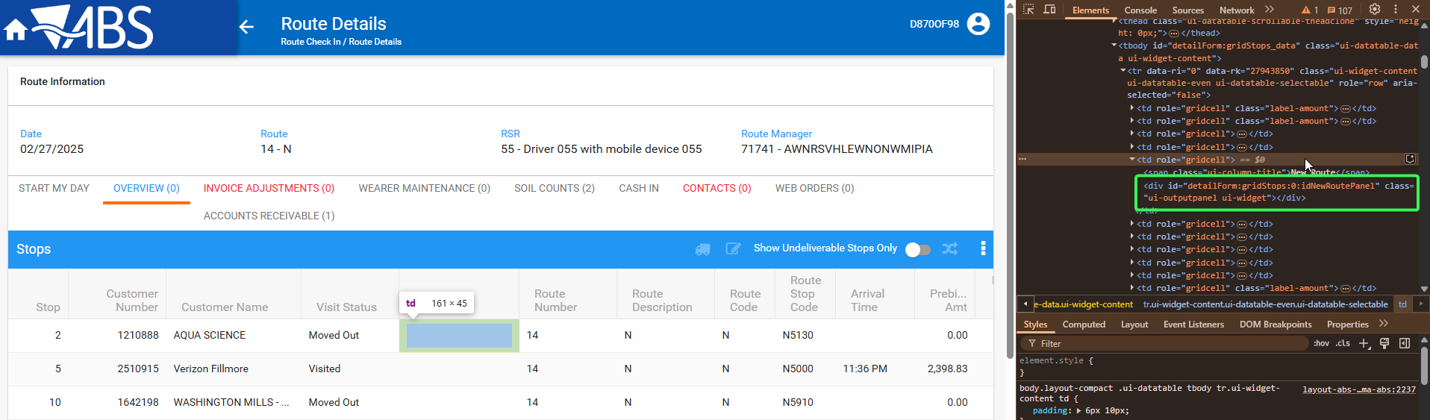
Prebill amount
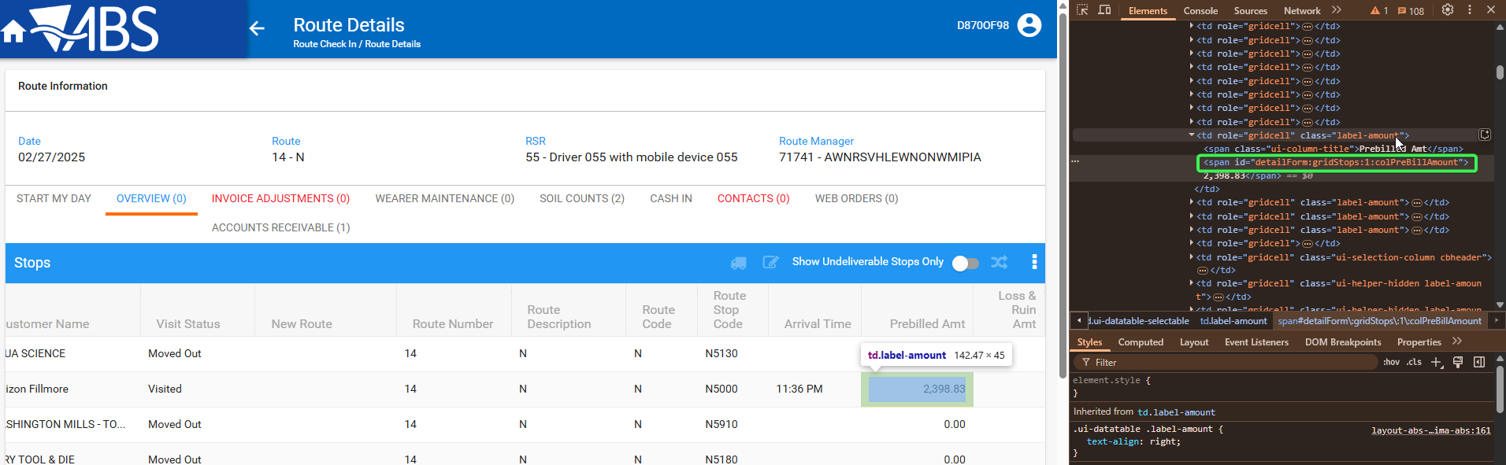
Loss and ruin amt
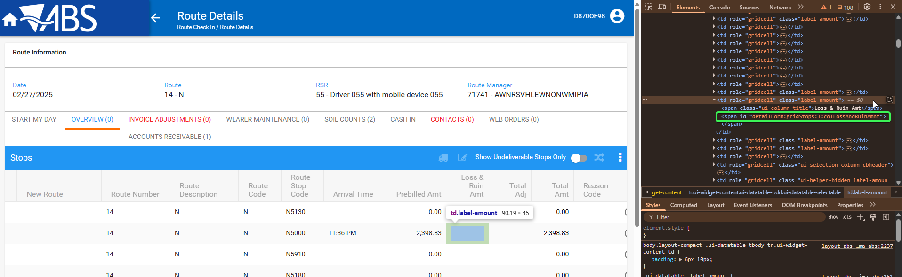
total adj
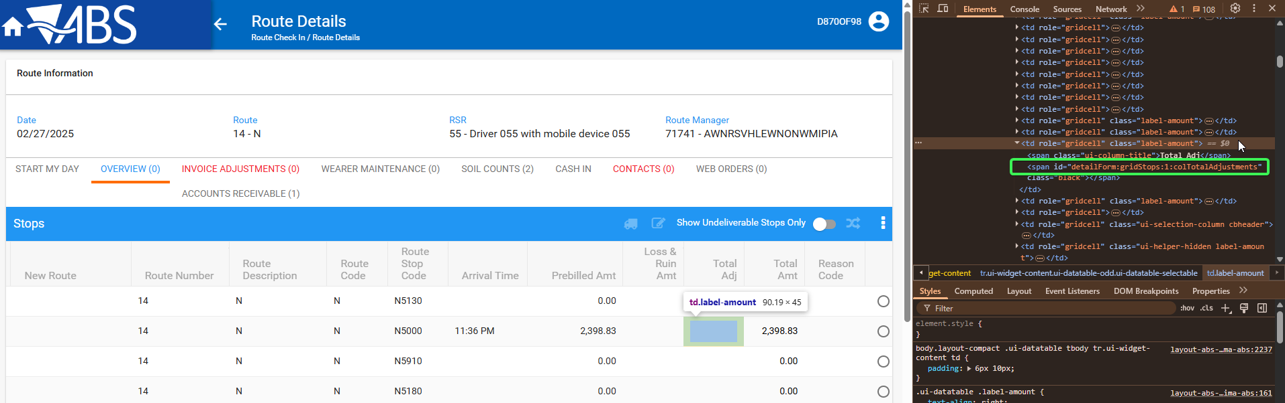
total amt
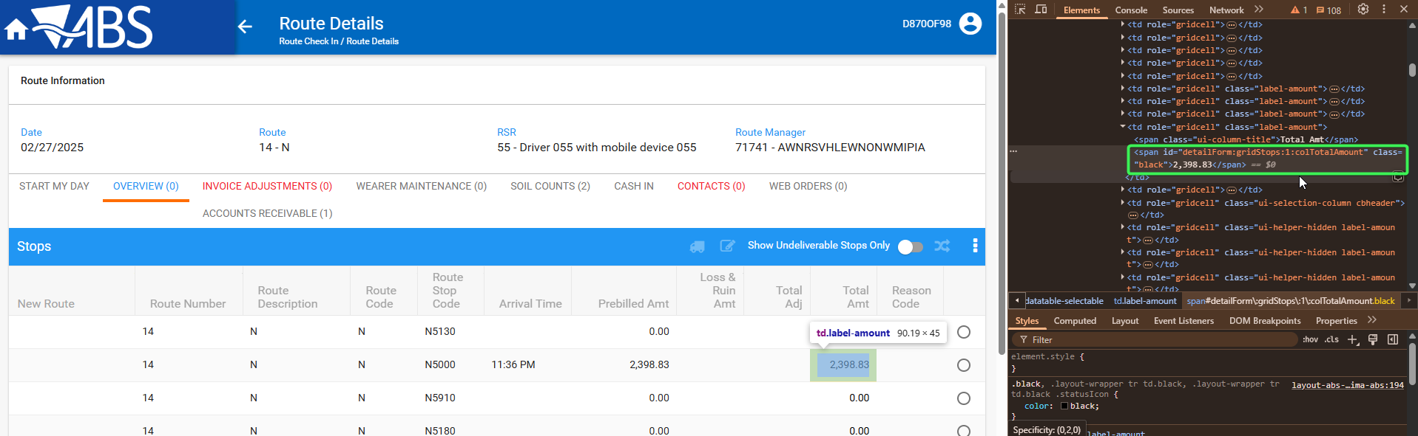
cash collected
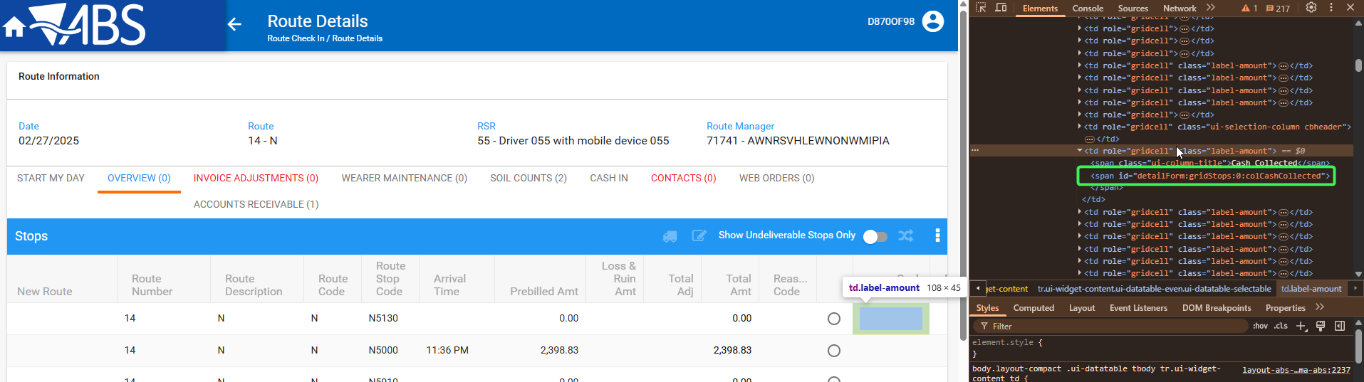
prebilled amt cod
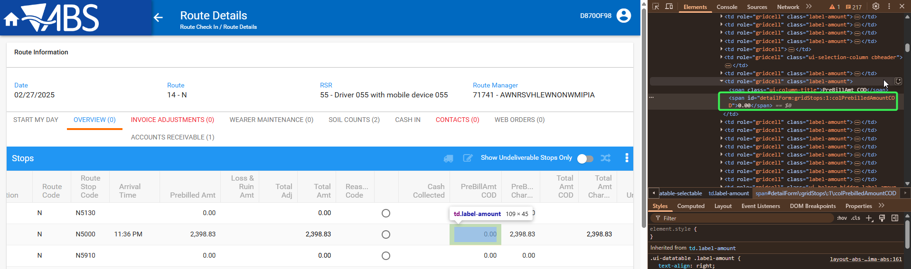
prebillied amt charge
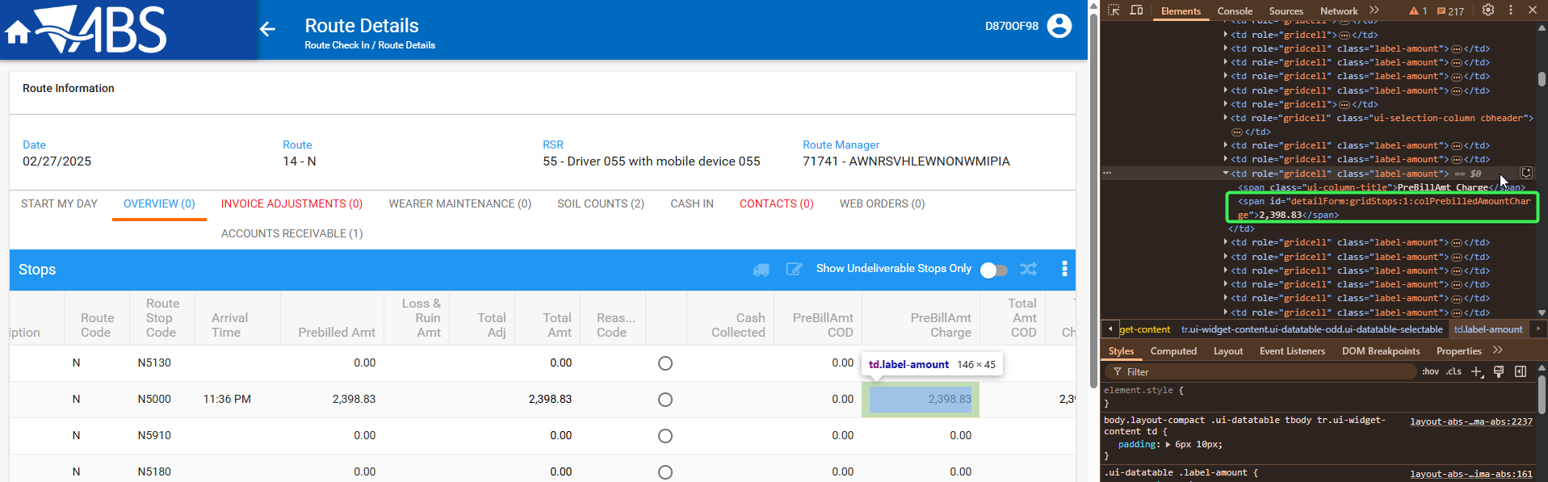
total plus adj
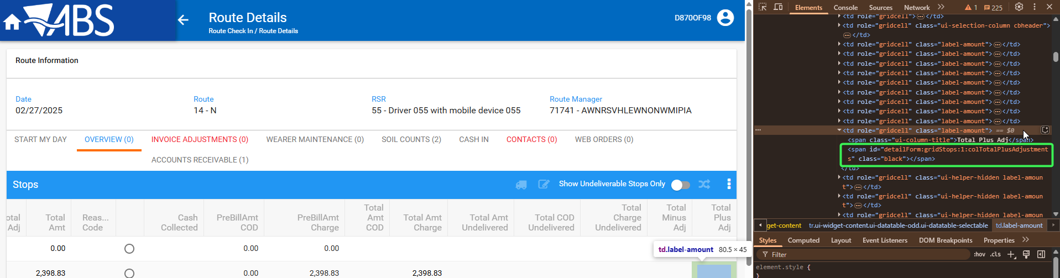
total minus adj
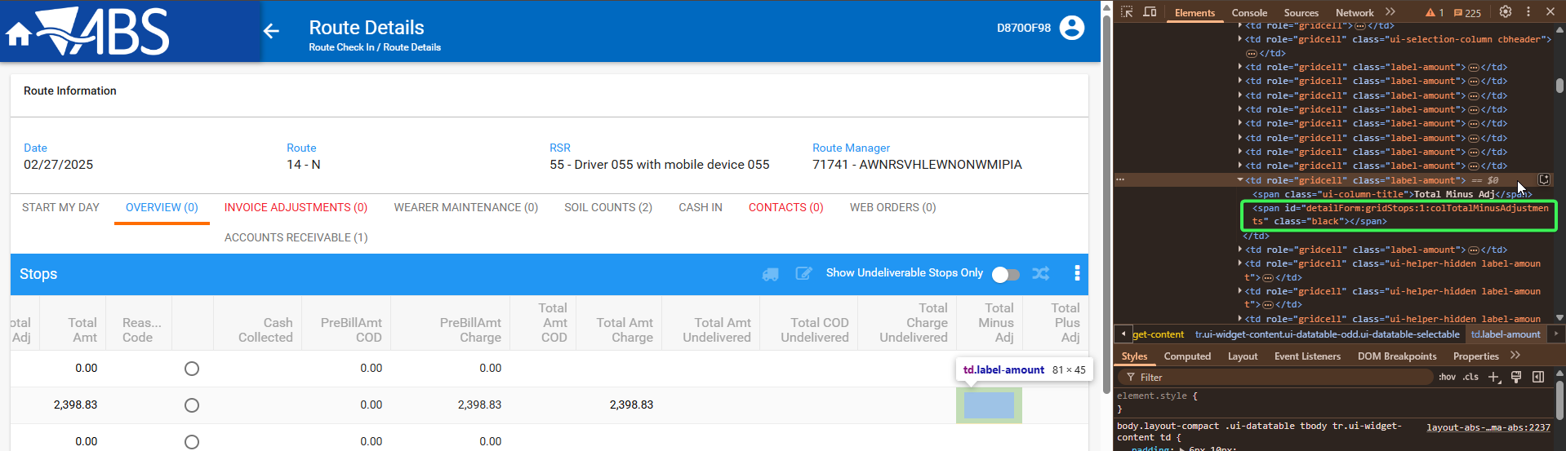
total amt COD
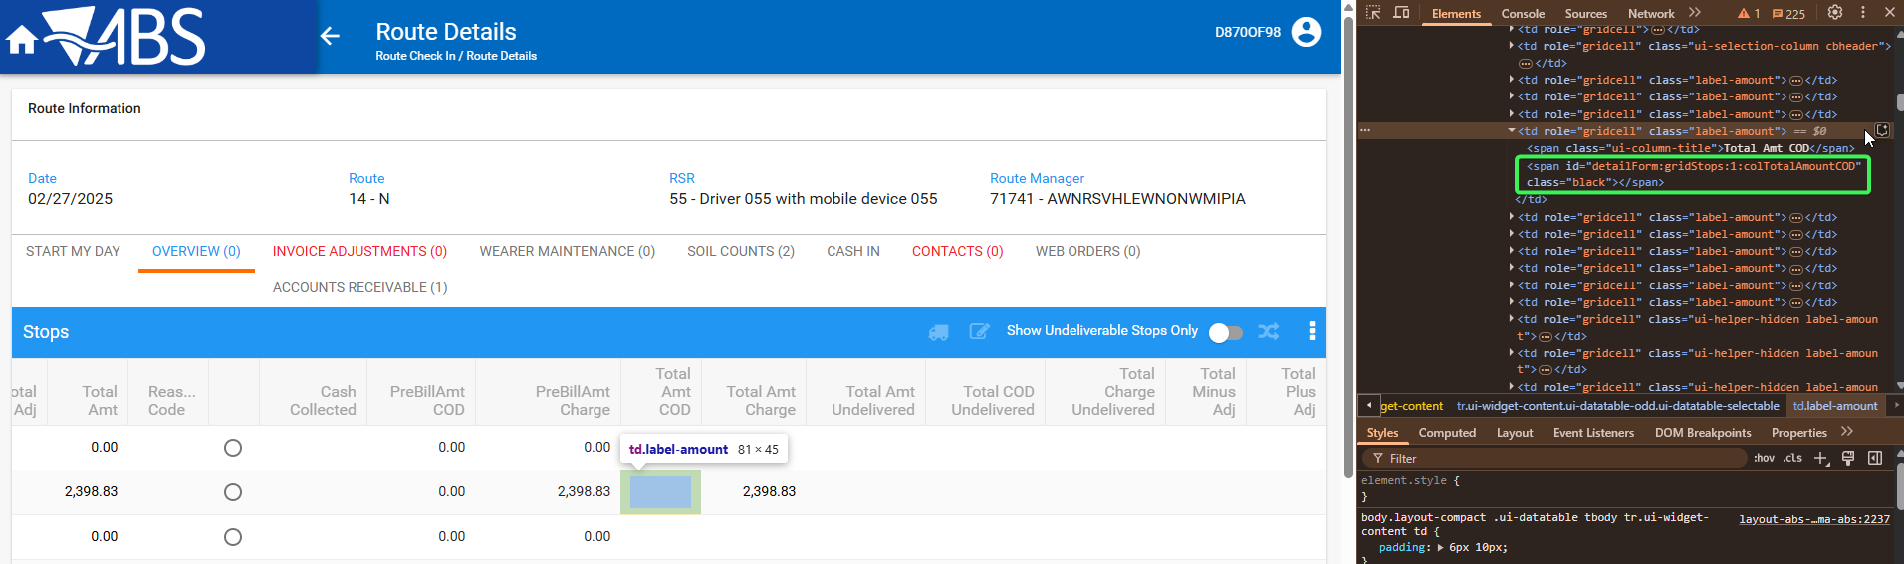
total amt charge
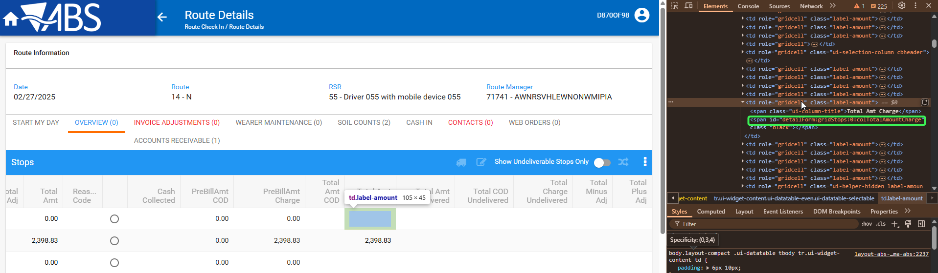
total amt undelivered
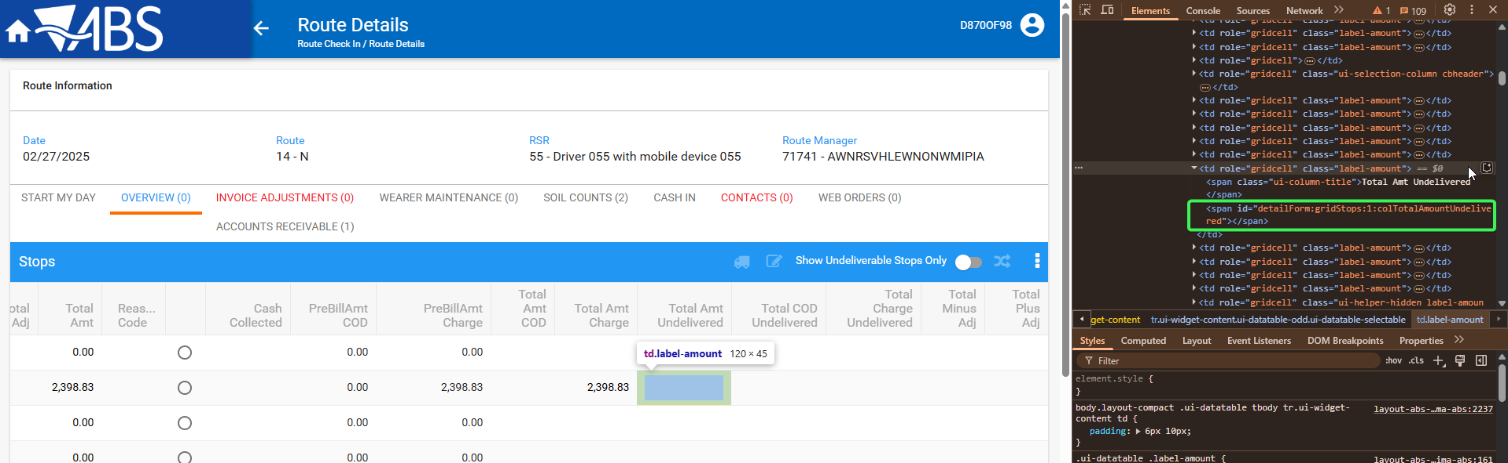
total undelivered COD
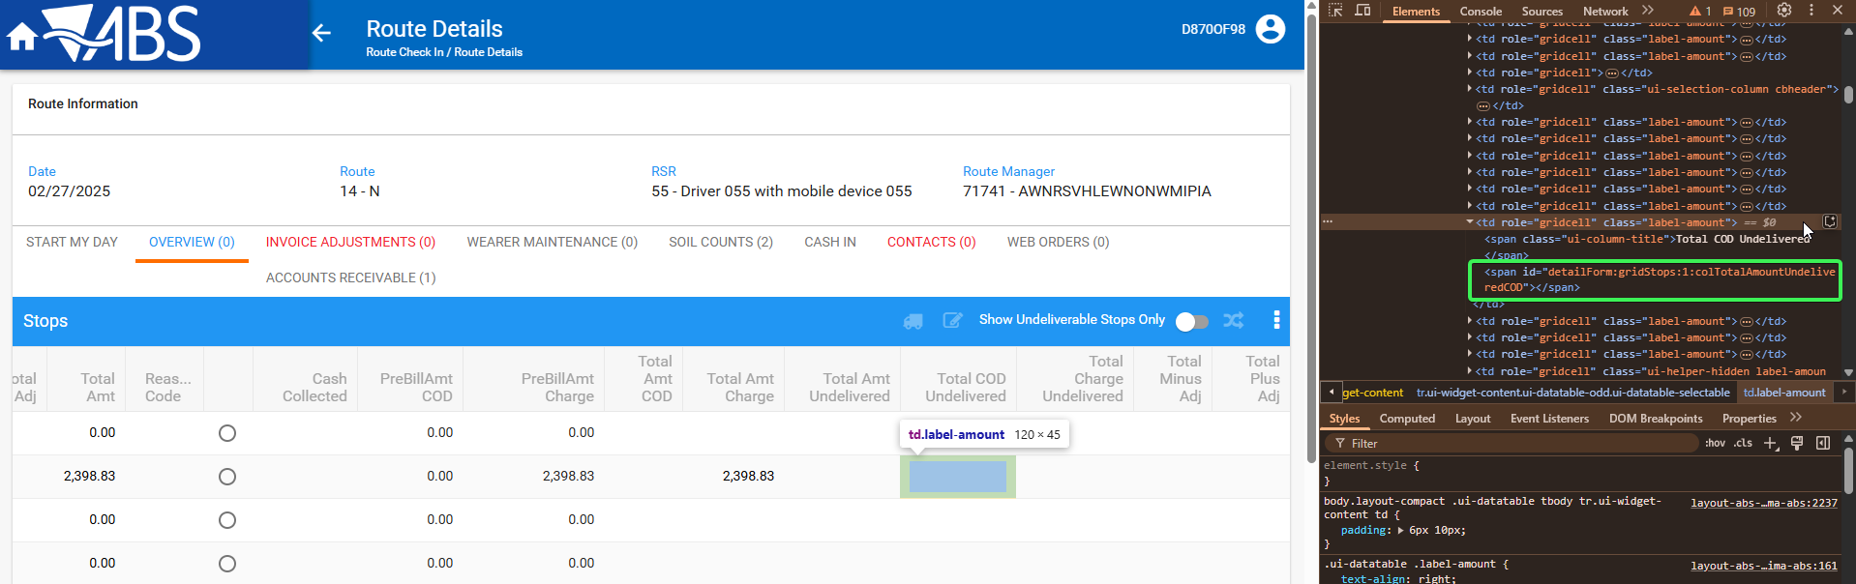
total undelivered charge
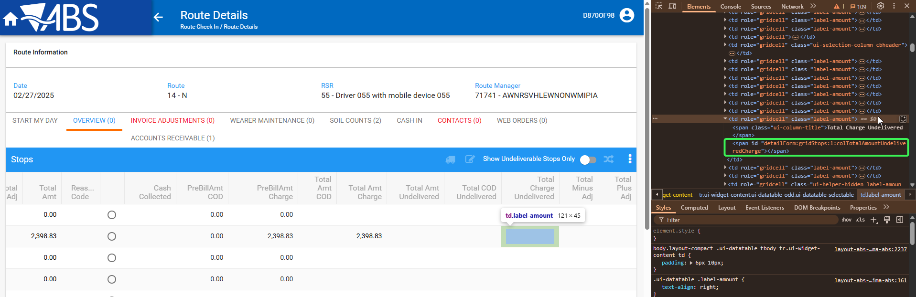

Test Case 2 – Check the Invoice details tab in WebX for empty cells which don’t have id elements
Hash: 14fd539ff715
Expected Behavior: Inspected cell should have an existing ID
- WebX: Find a route with data that was uploaded from RA
- Complete Start My day
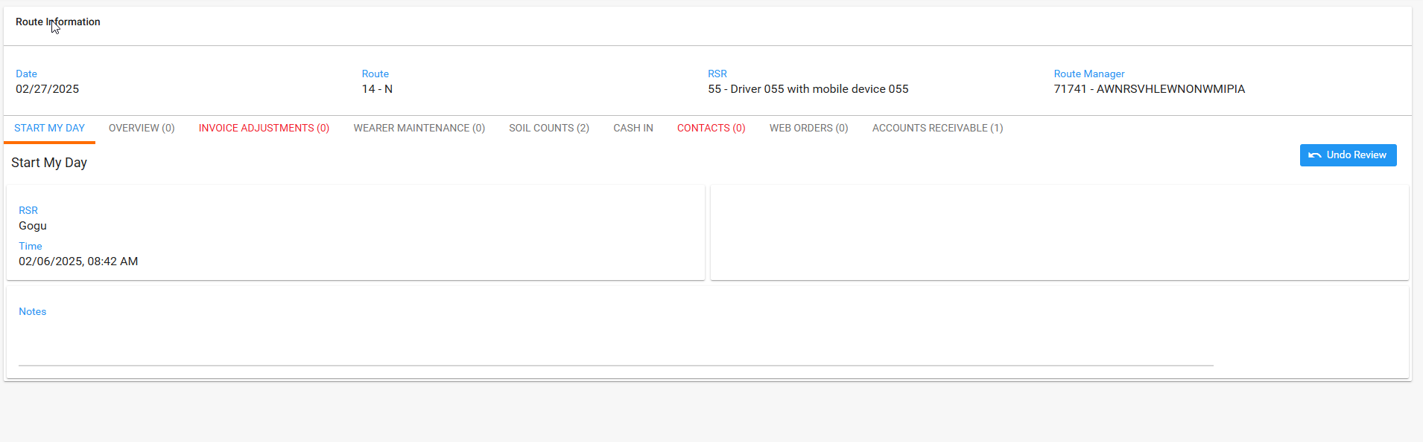
- Go to Invoice adjustments tab press Add button and pic an invoice
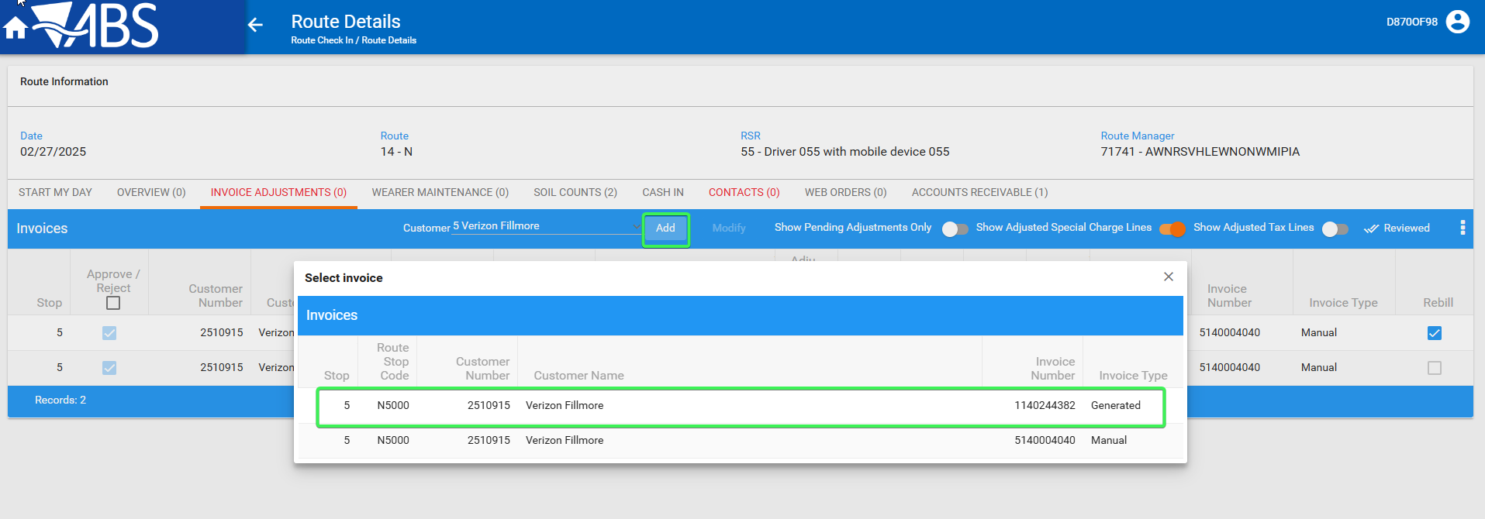
- Press Ctrl + Shift + C for the console to appear
- Inspect the empty cells present in the grid and see that they have an ID element
Wearer No
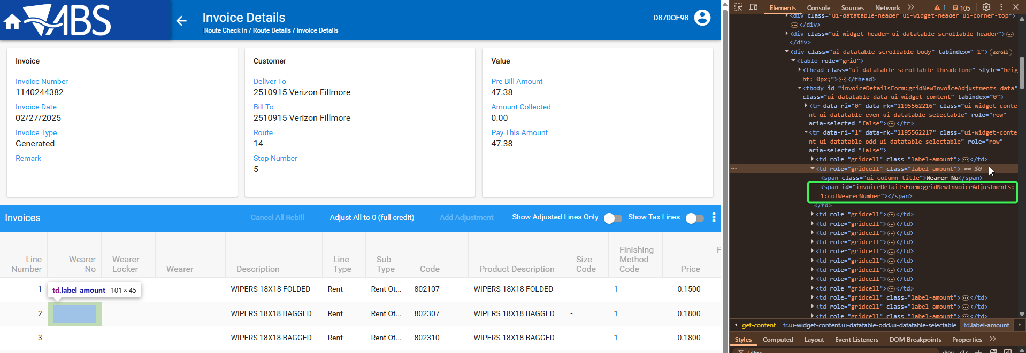
Warer Locker
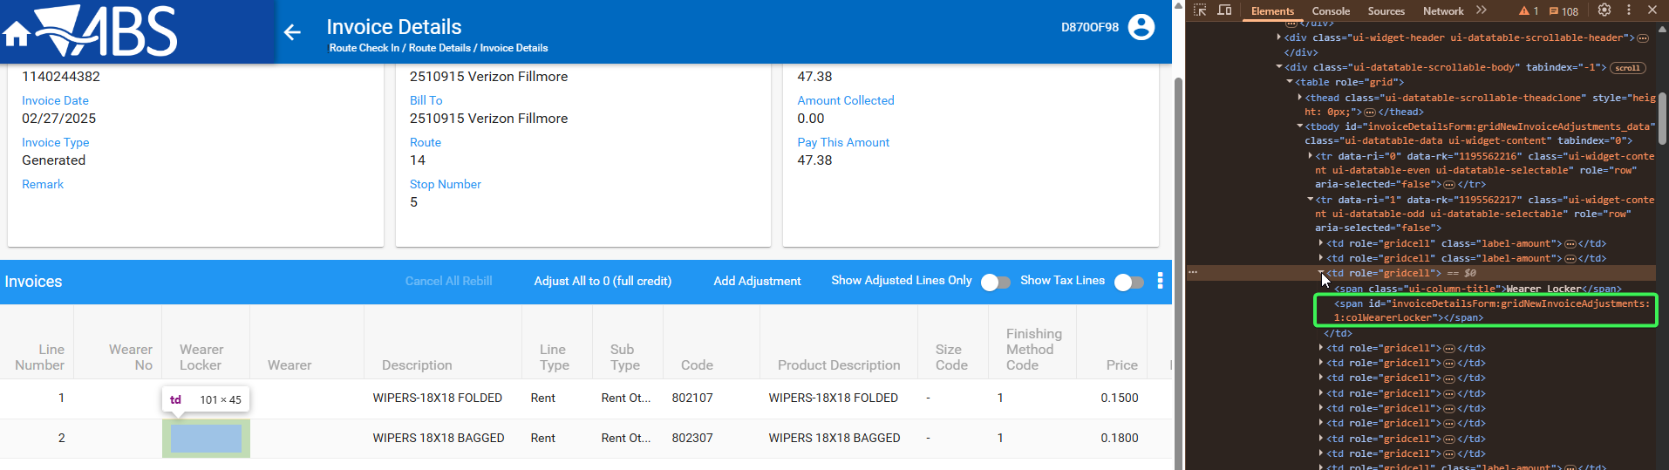
Wearer
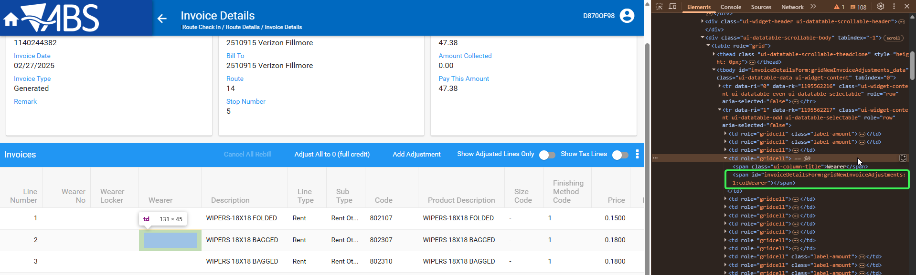
Prebilled Qty
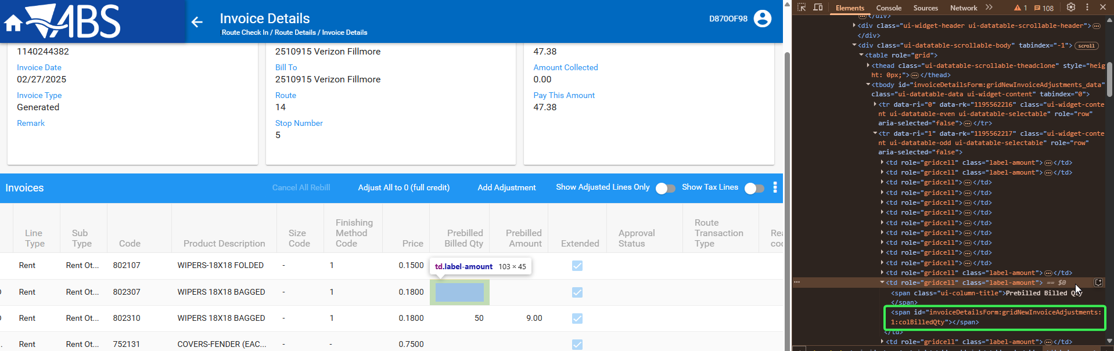
Prebilled Amount
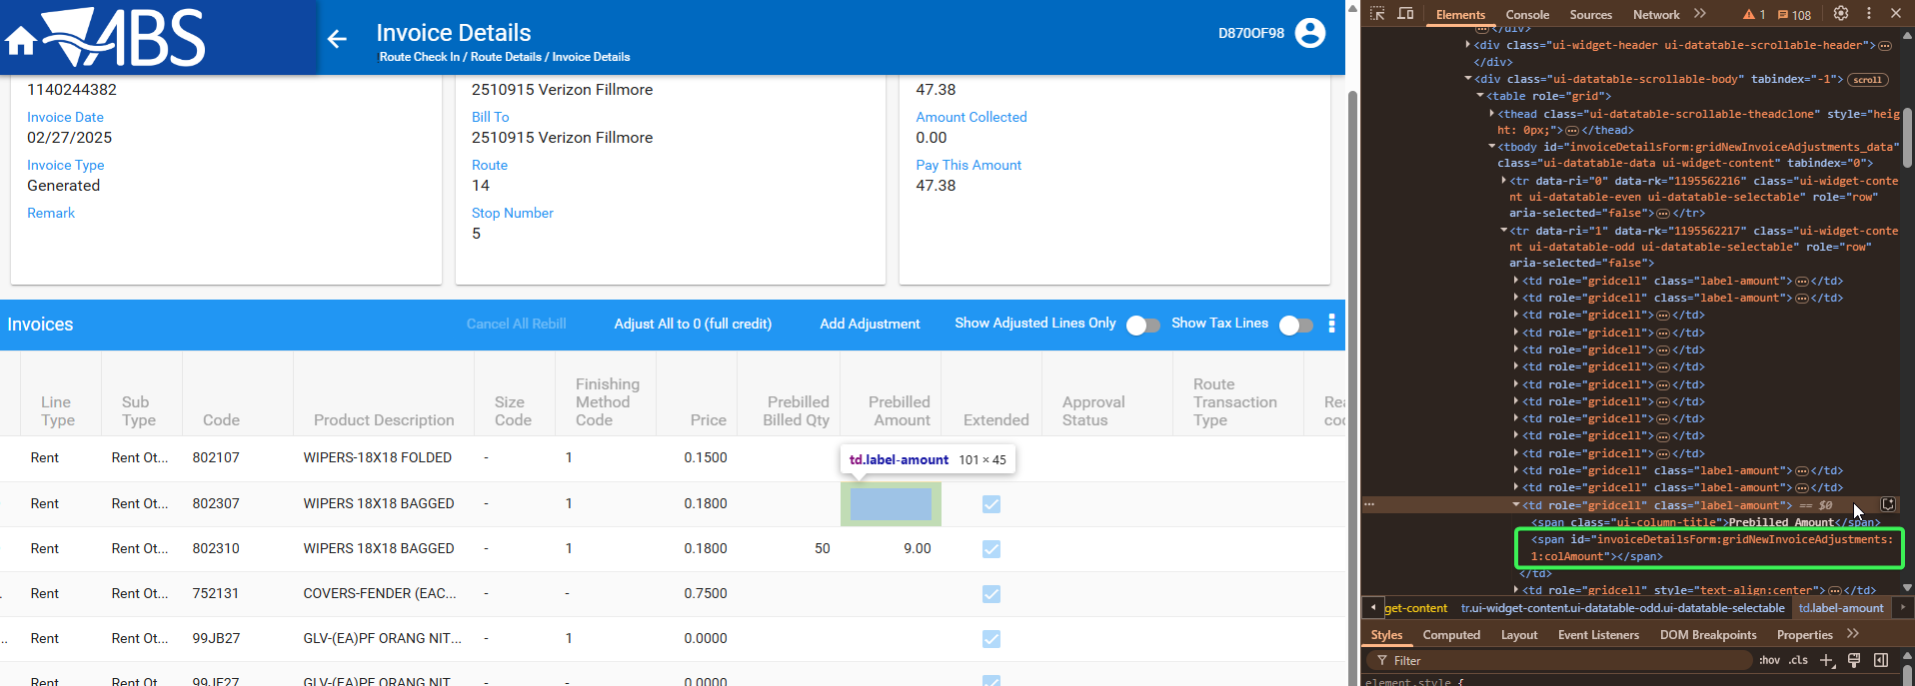
Approval Status
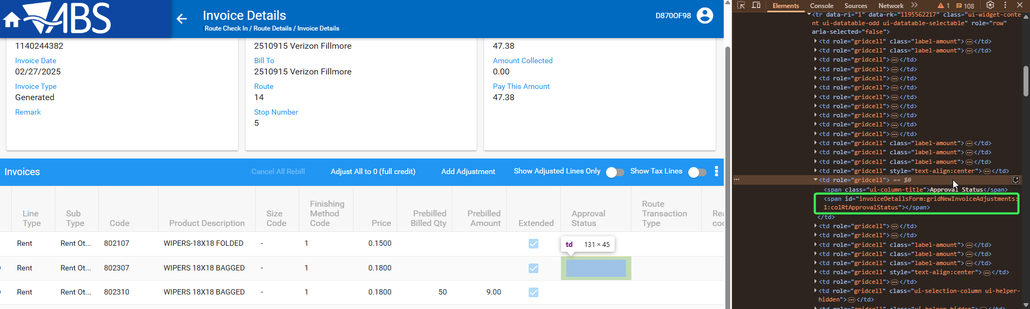
Route Transaction Type
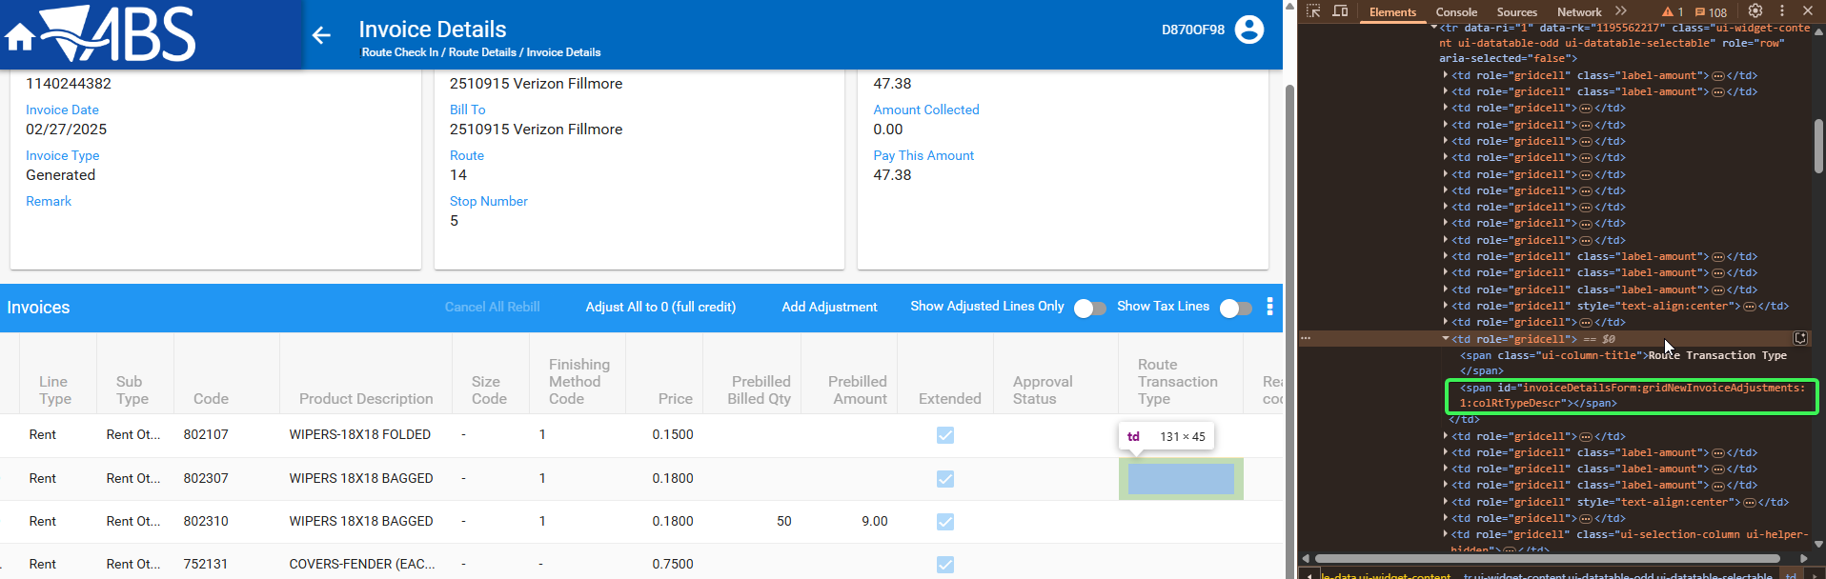
Reason Code
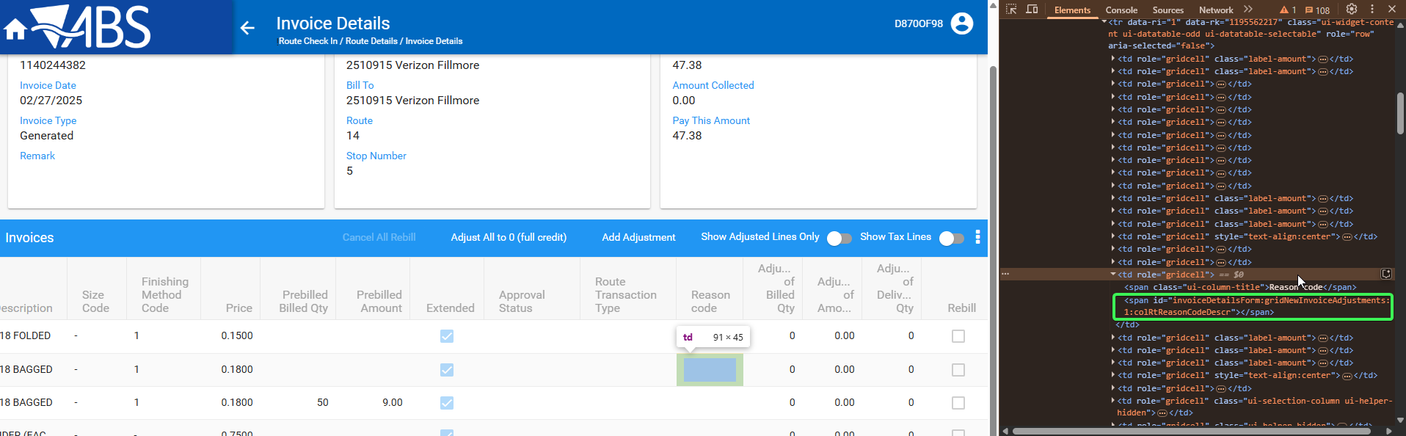
Adjustment Source
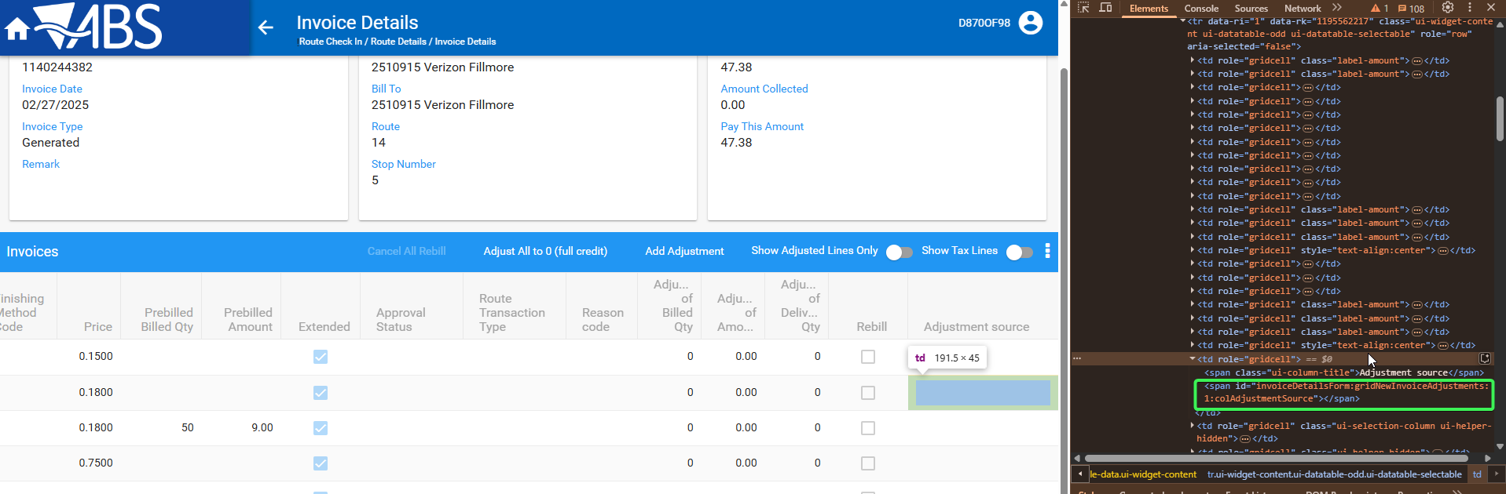

Test Case 3 – Check the Invoice adjustments tab - adjusted amount cell for id elements
Hash: 14fd539ff715
Expected Behavior: Inspected cell should have an existing ID
- WebX: Find a route with data that was uploaded from RA
- Complete Start My day
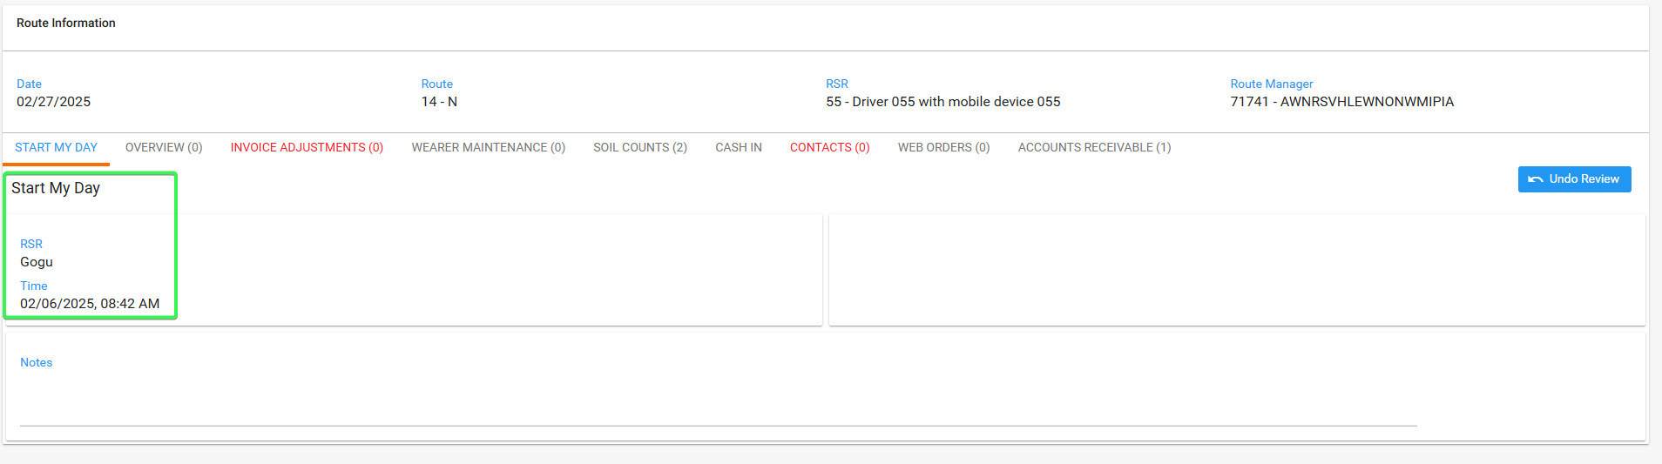
- Go to Invoice adjustments tab
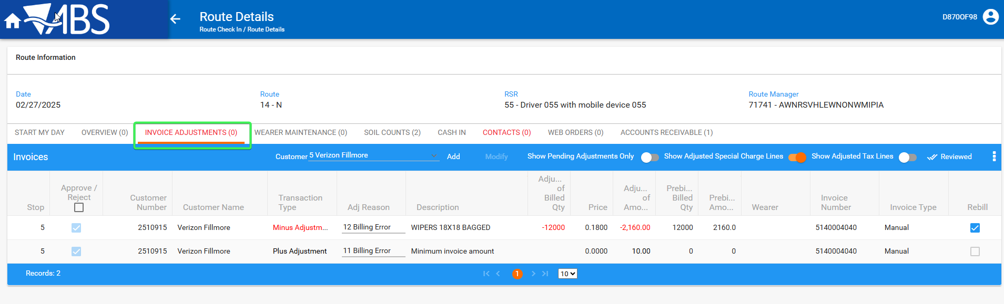
- Check that Adjusted amount cell has an existing ID
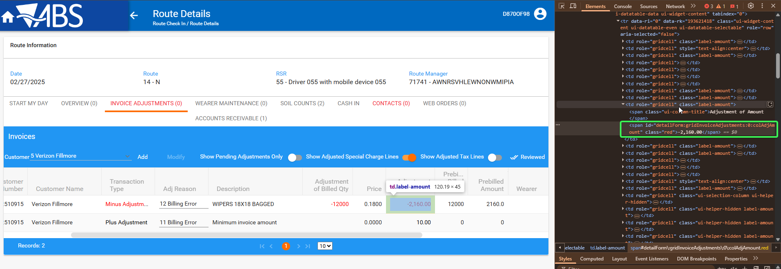
Tested OK

Test Case 4 – Check the wearer maintenance tab - quantity column, chg cells for id elements
Hash: 14fd539ff715
Expected Behavior: Inspected cell should have an existing ID
- WebX: Find a route with data that was uploaded from RA
- Complete Start My day
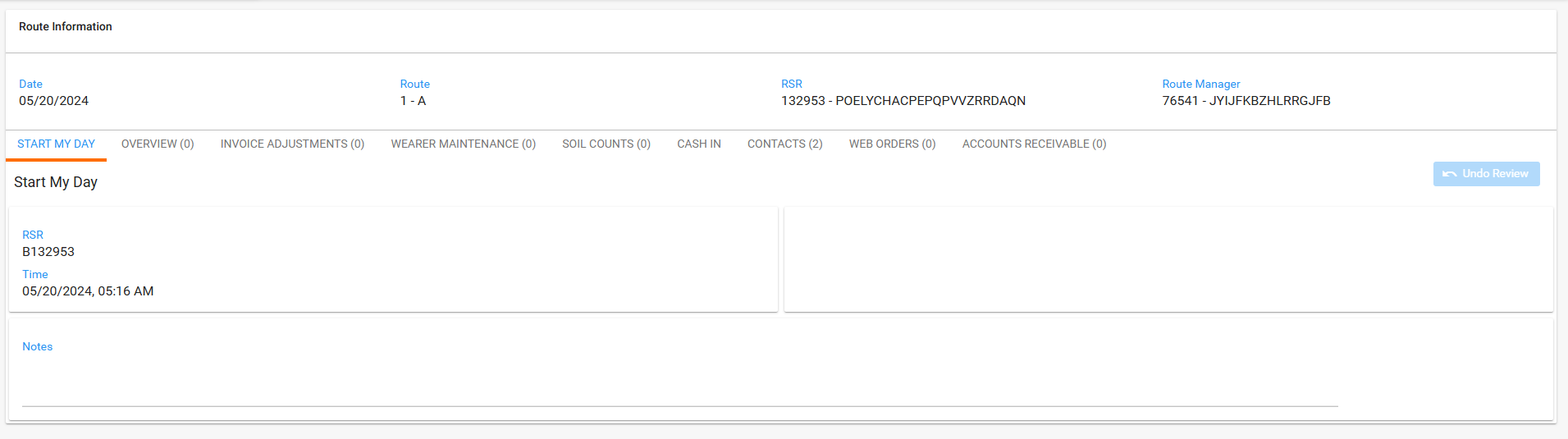
- Go to Wearer Maintenance tab
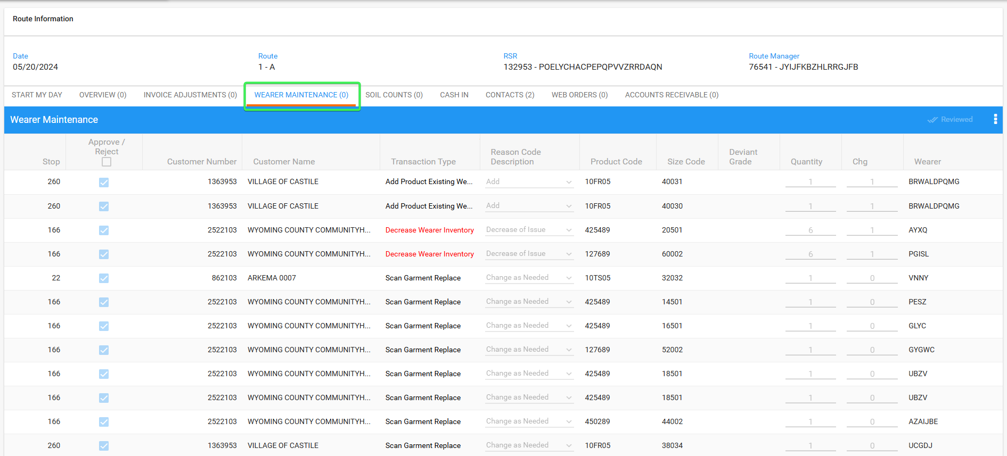
- Inspect Quantity and Changes (Chg) columns and see that they have element IDs
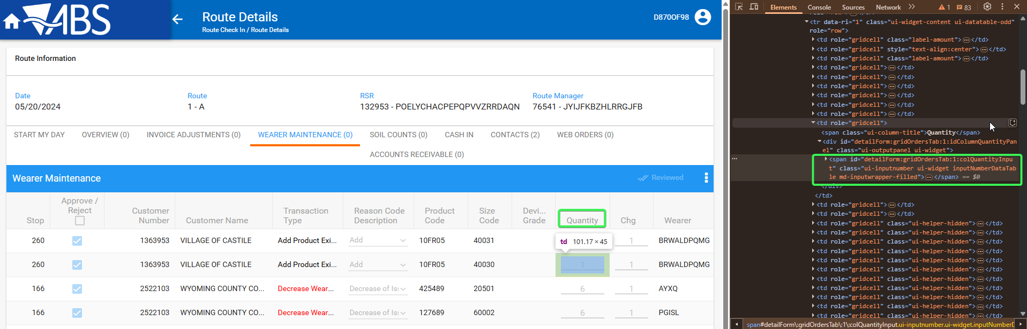
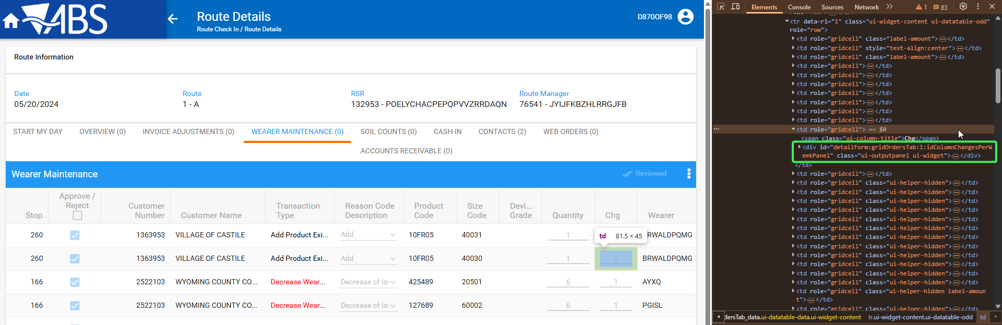
Tested OK

