ABSN-3257 Customer screen - validations bypassed
Environment | Prerequisites
Version:9.07.00  DBServerName=abs-SRV20.internal.abslbs.com  DBSID=CUST24  DBUser=UNFDEV  DBPassword=UNFDEV  Environment=Test | - Module:  - System setting

Contents
ABSN-3257 Customer screen - validations bypassed 1
Test after fix 1
Test Case 1 – Change Bill-to when DEBTORCHANGEWITHOPENAR =1 and Stock count/Ordering via Web Portal or Order by Date Web Portal are checked– Tested OK 1
Test Case 2 – Change Bill-to when DEBTORCHANGEWITHOPENAR =0– Tested OK 6
Test Case 3 – Change Bill-to when DEBTORCHANGEWITHOPENAR =2– Tested OK 9
Test Case 4 – Change Bill-to when DEBTORCHANGEWITHOPENAR =1– Tested OK 13
Test Case 5 – Change Bill-to with a customer that has a different country_id than the del to customer– Tested OK 19

Test after fix

Test Case 1 – Change Bill-to when DEBTORCHANGEWITHOPENAR =1 and Stock count/Ordering via Web Portal or Order by Date Web Portal are checked– Tested OK
Expected behavior: An error message saying “Please allow at least one product type” should appear and the AR transactions will not be moved and the bill to customer will change back
Hash: 466f852
- Set SS DEBTORCHANGEWITHOPENAR to 1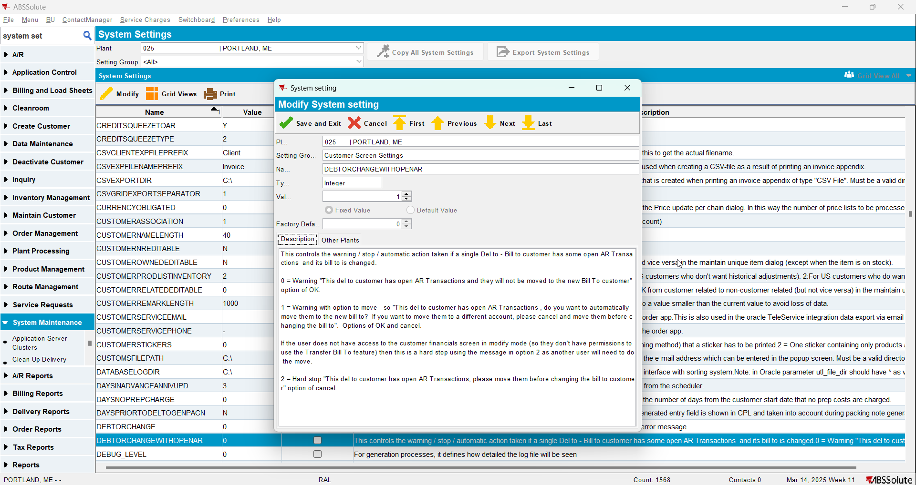
- Have a customer that is its own bill to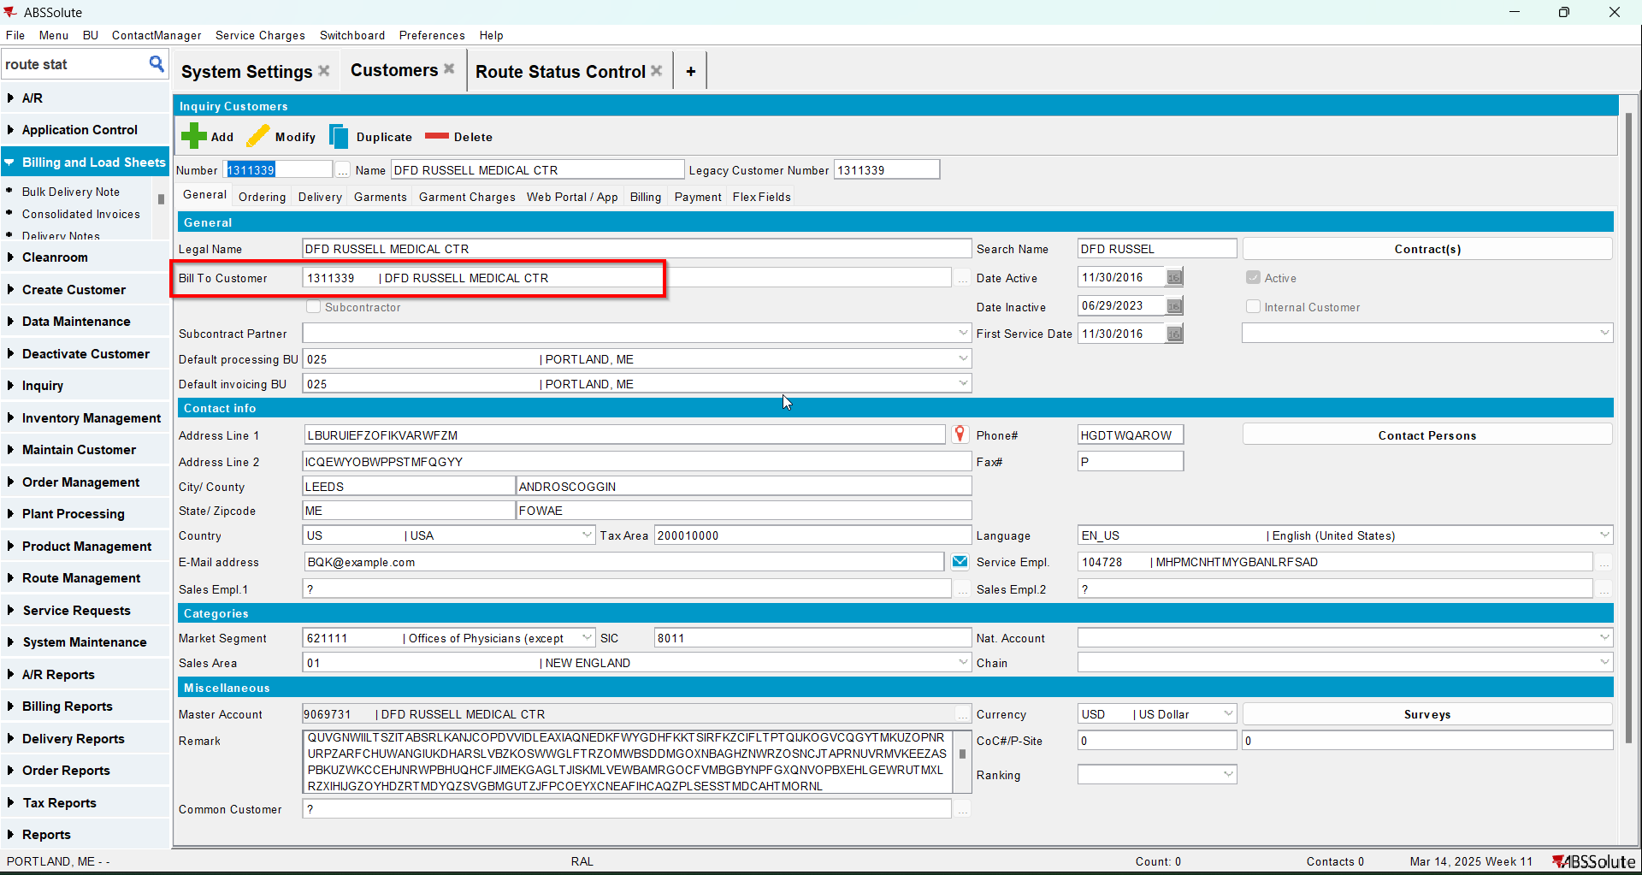
- Have another customer that is its own bill to and has open AR transactions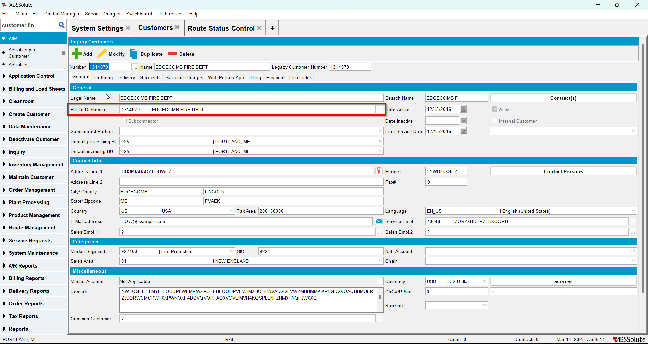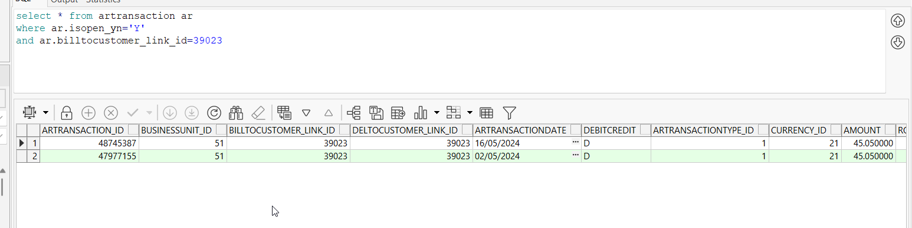
- For the customer at Step 3 change its bill to with the customer from Step 2 and go to Web Portal/App tab and check the Stock count and Order by Date checkboxes. Make sure that the checkboxes for Product Filter are unchecked.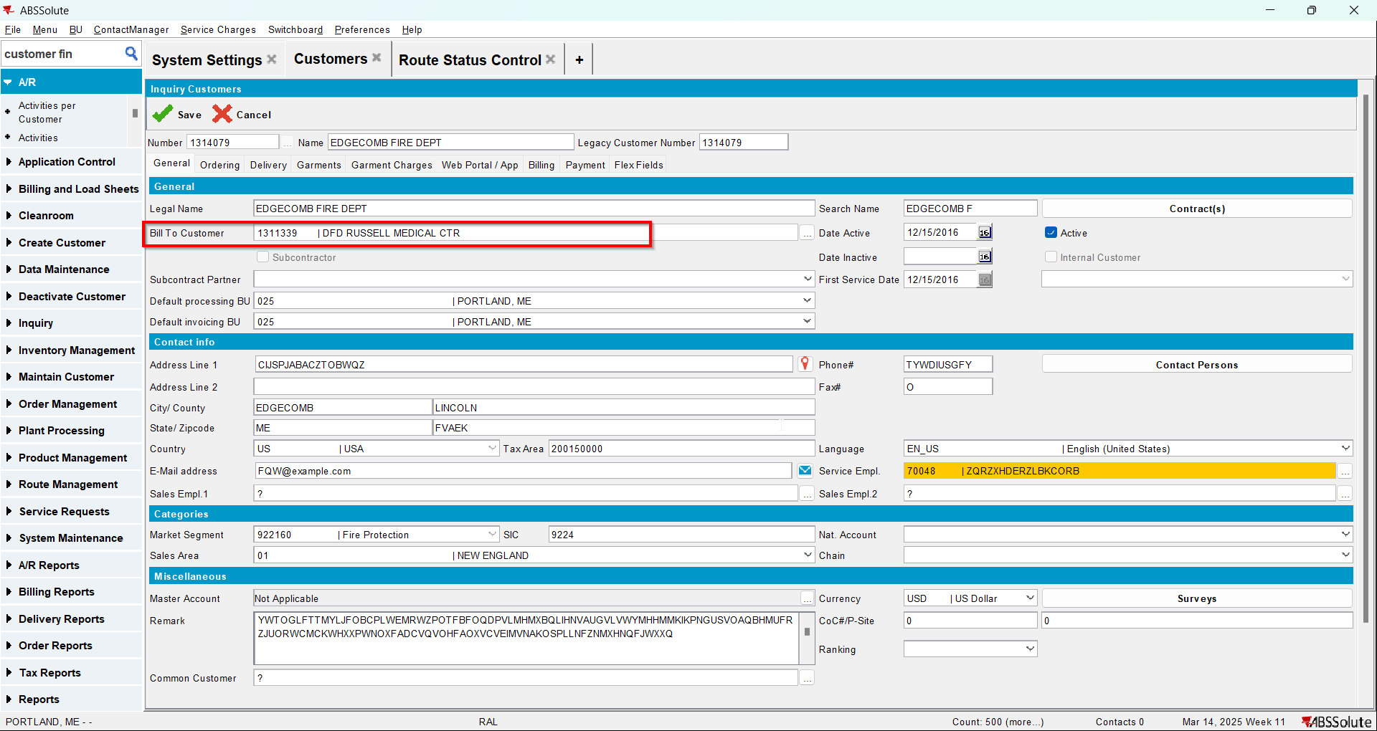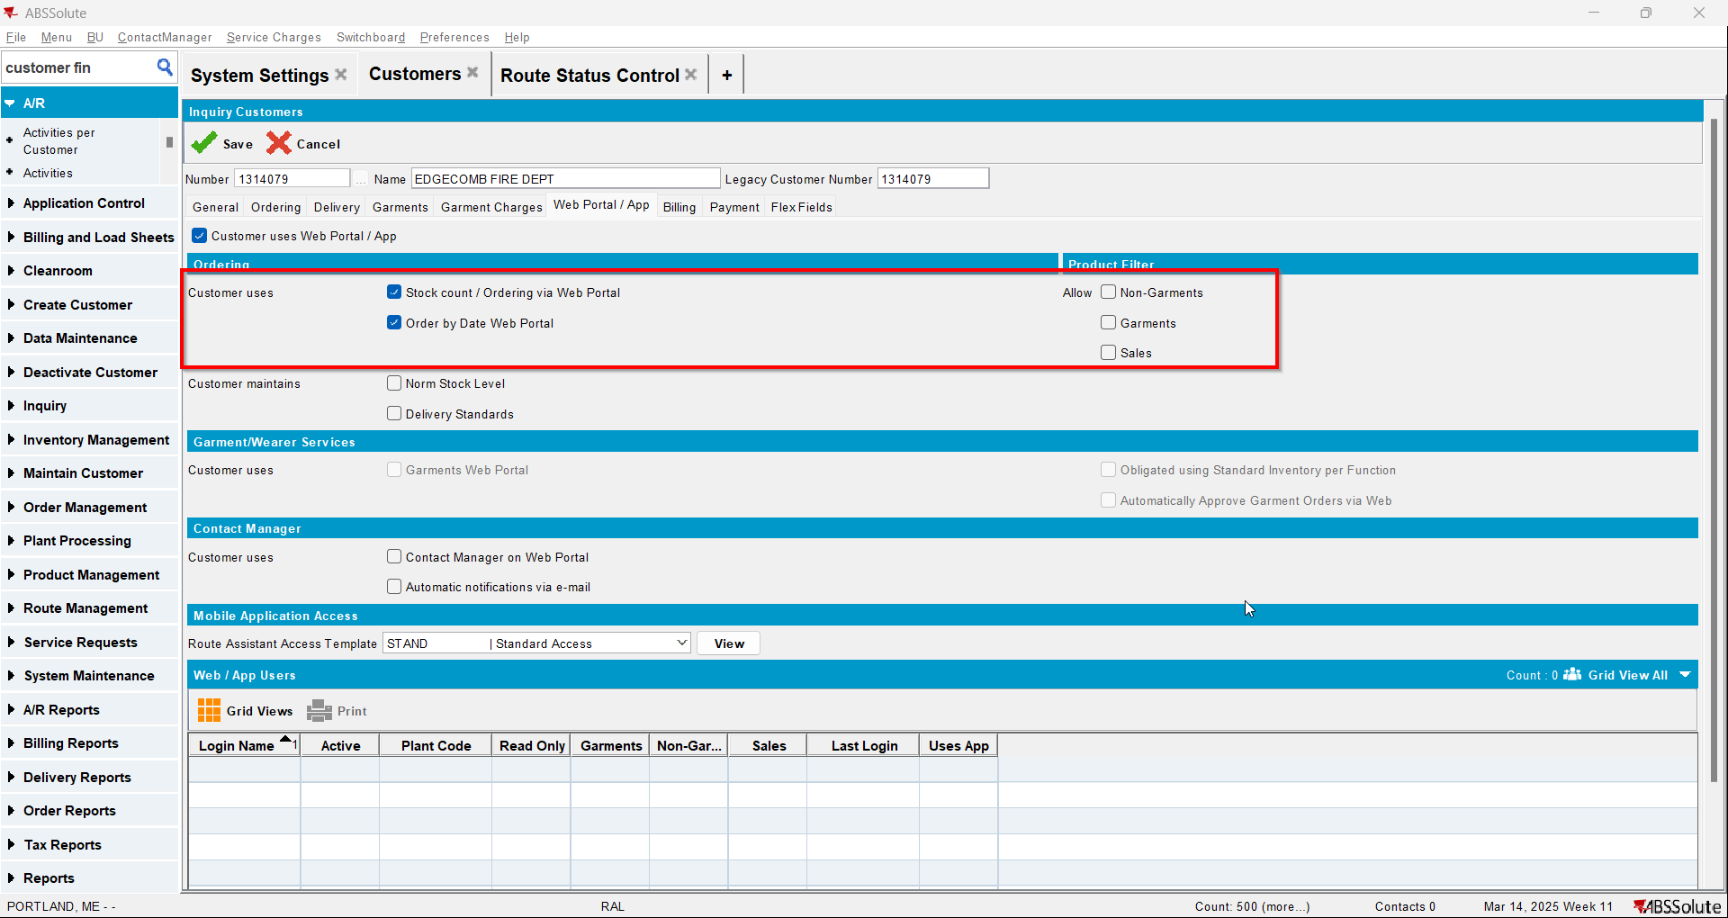
- When the message appears press Yes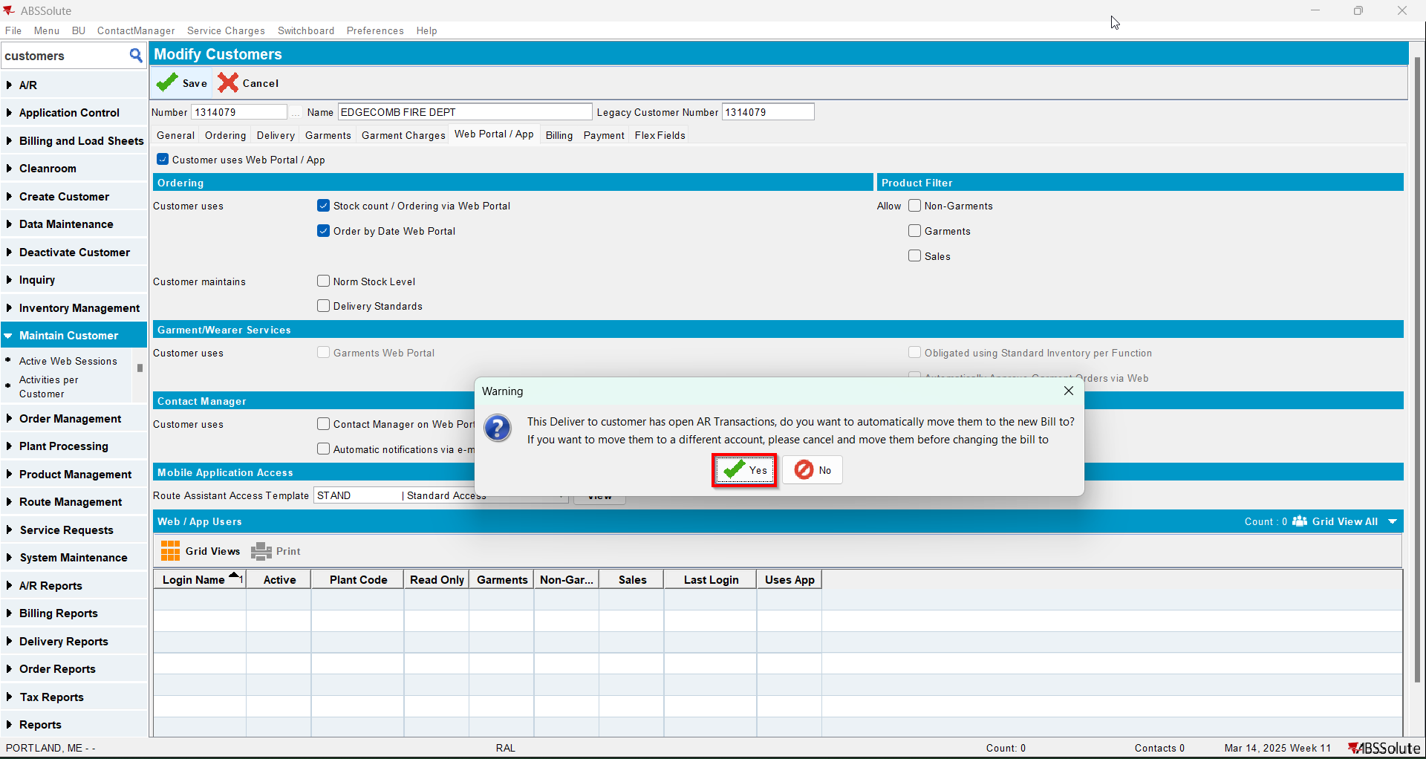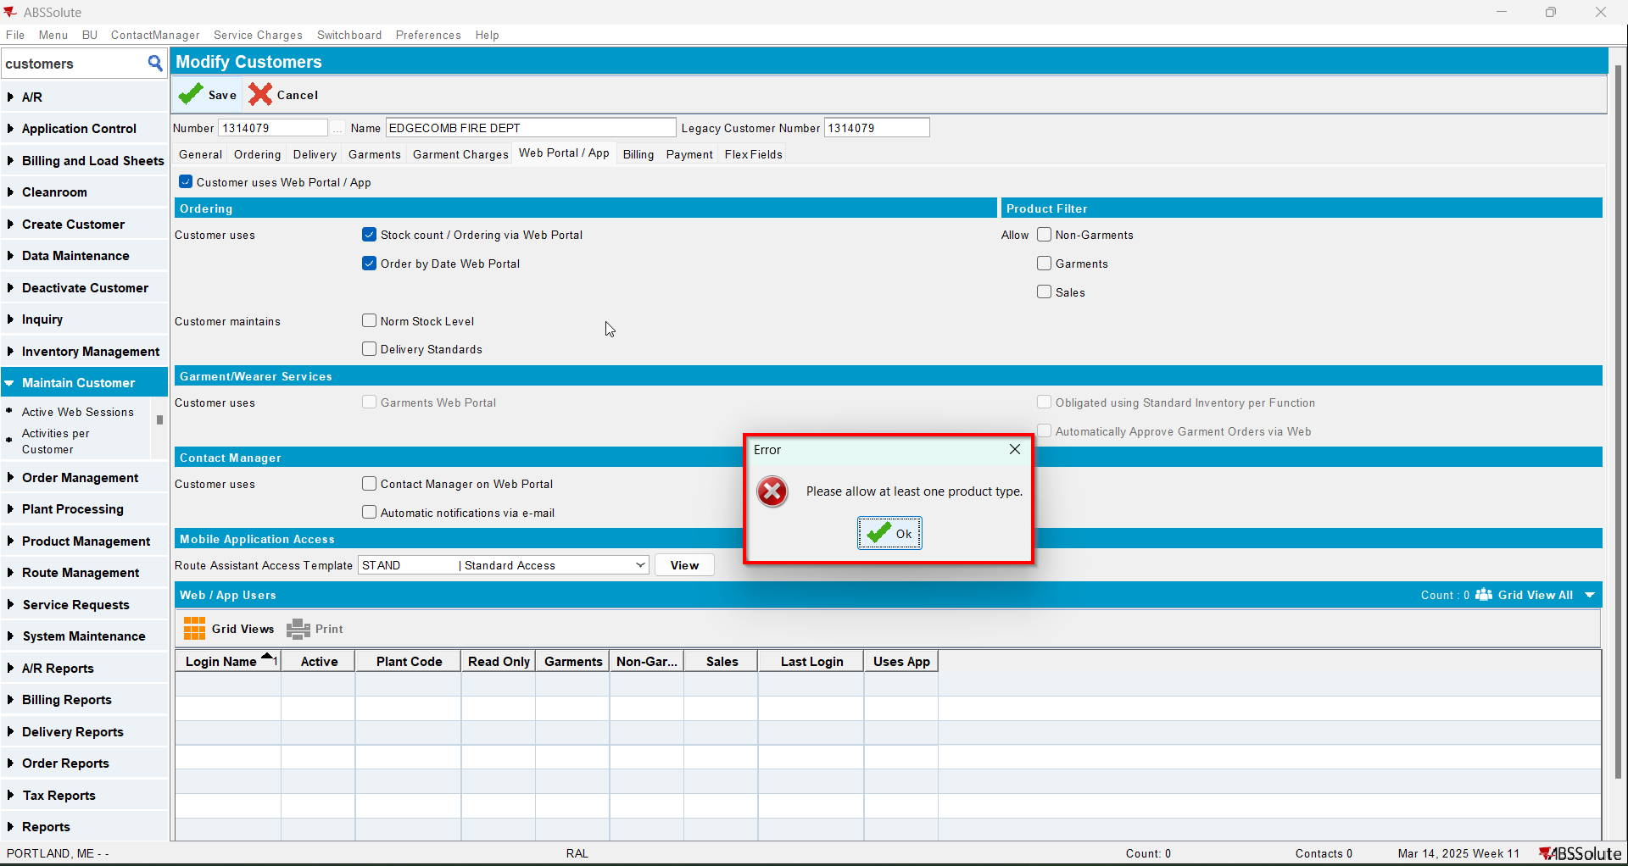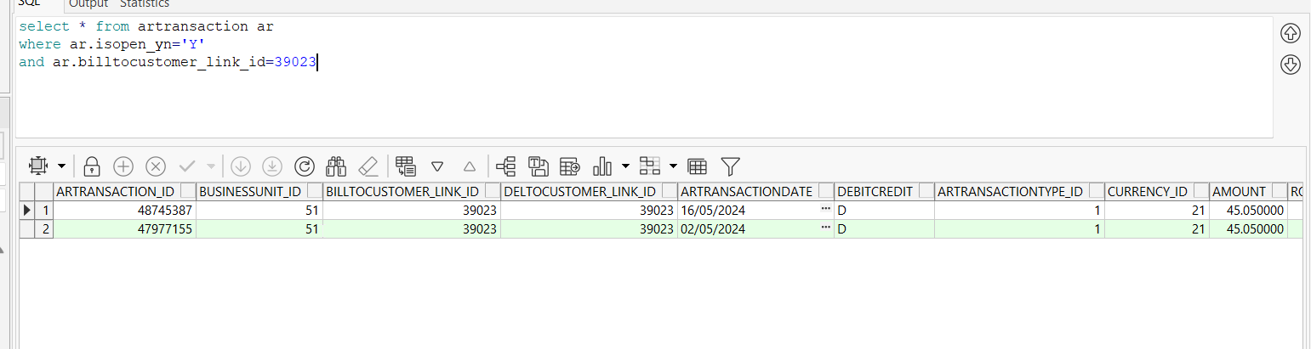

Test Case 2 – Change Bill-to when DEBTORCHANGEWITHOPENAR =0– Tested OK
Expected behavior: Show a warning “This Deliver to customer has open AR Transactions and they will not be moved to the new Bill To customer” option of OK.
Hash: 466f852
- Set SS DEBTORCHANGEWITHOPENAR to 0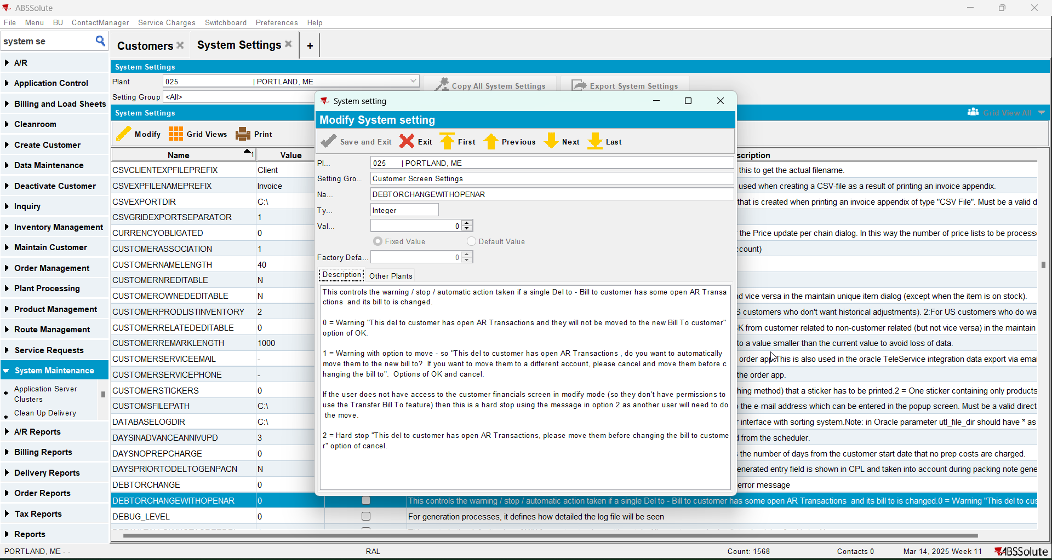
- Have a customer that is its own bill to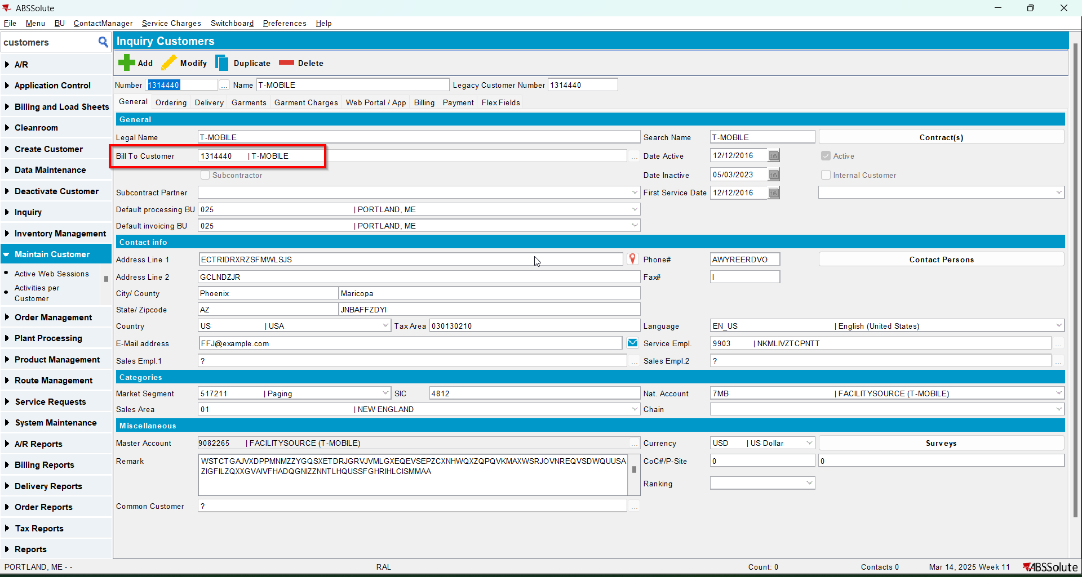
- Have another customer that is its own bill to and has open AR transactions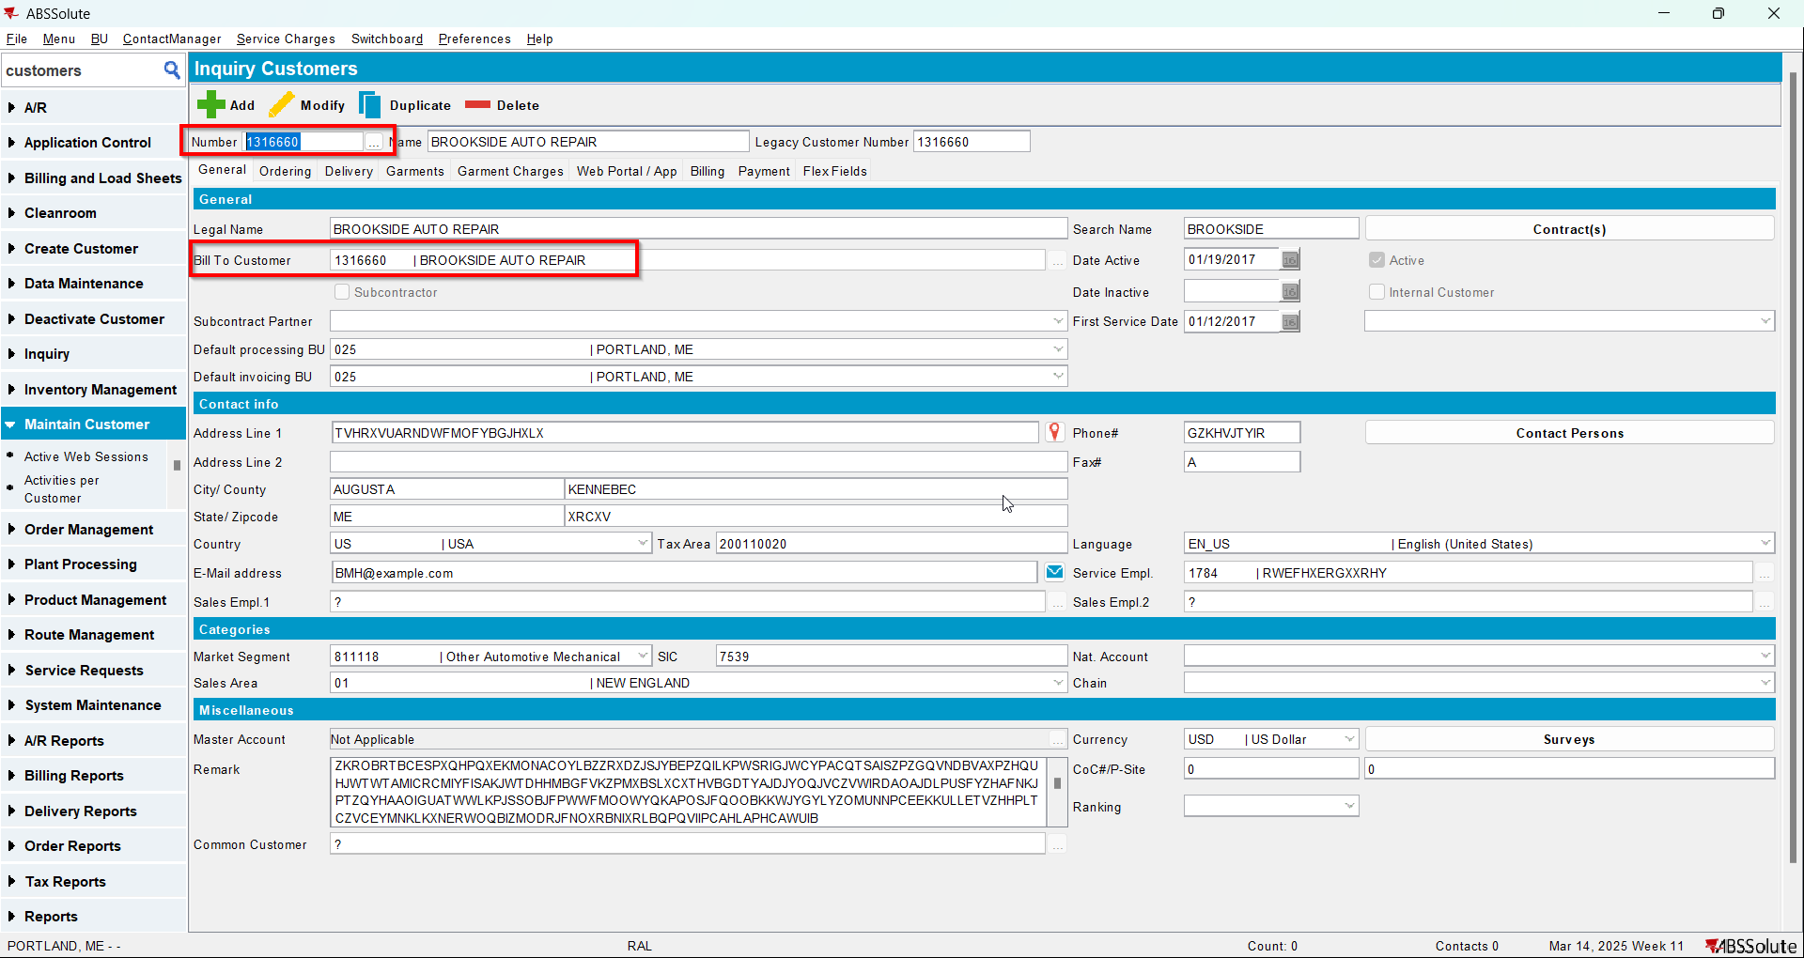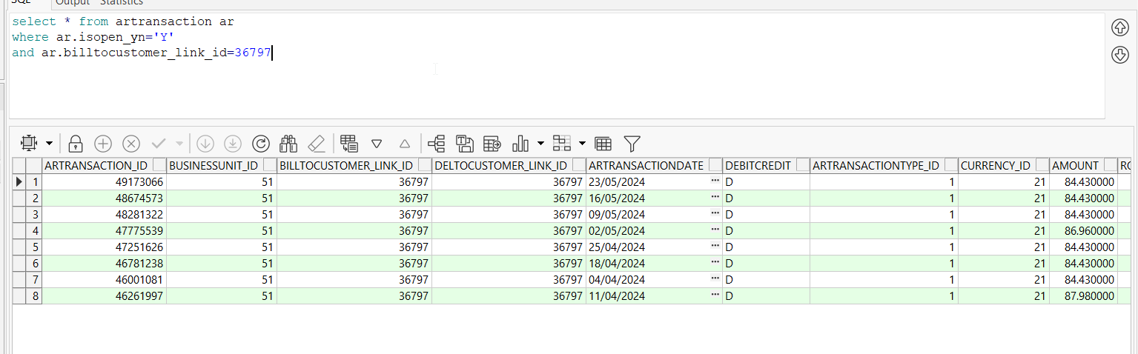
- For the customer at Step 3 change its bill to with the customer from Step 2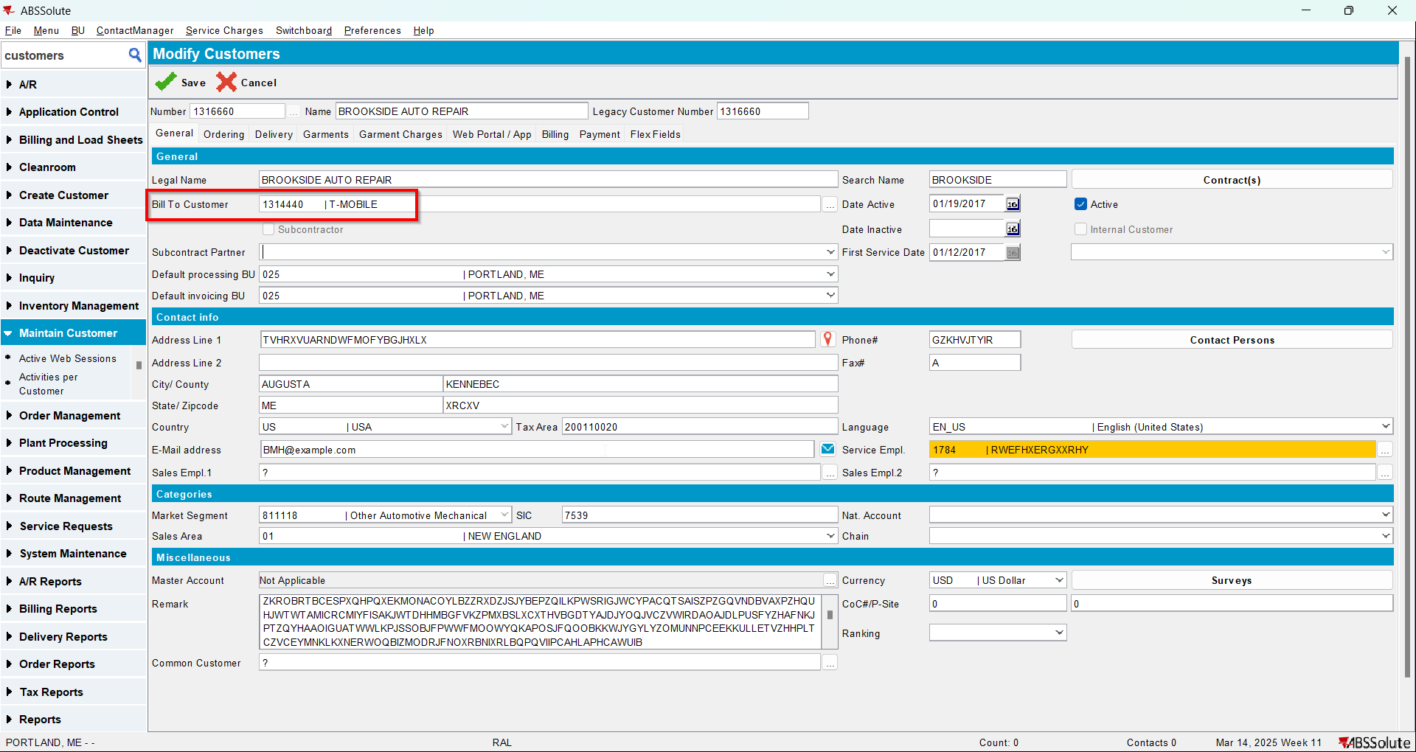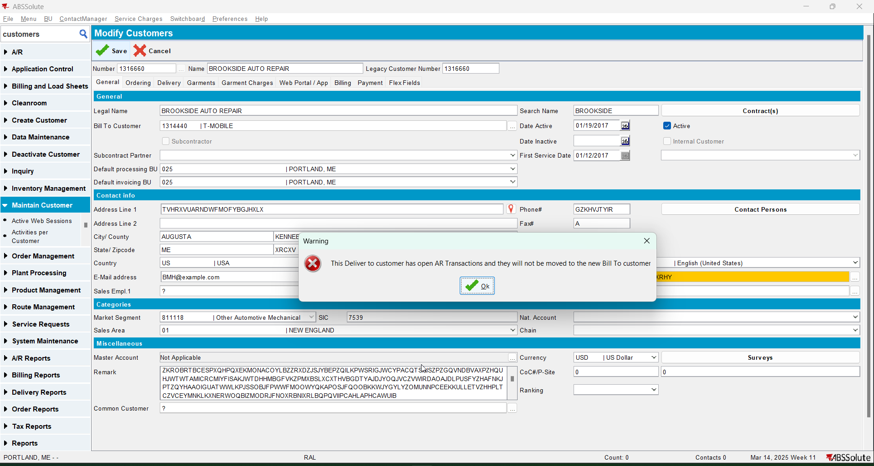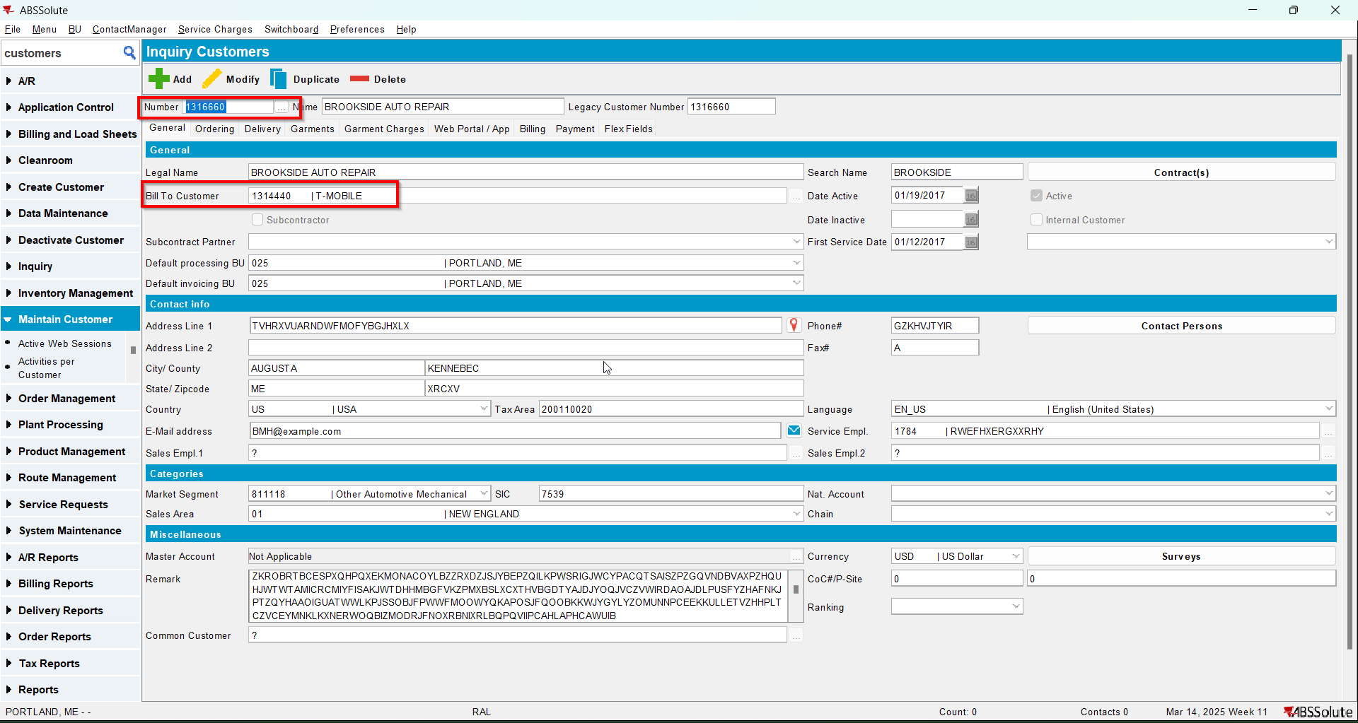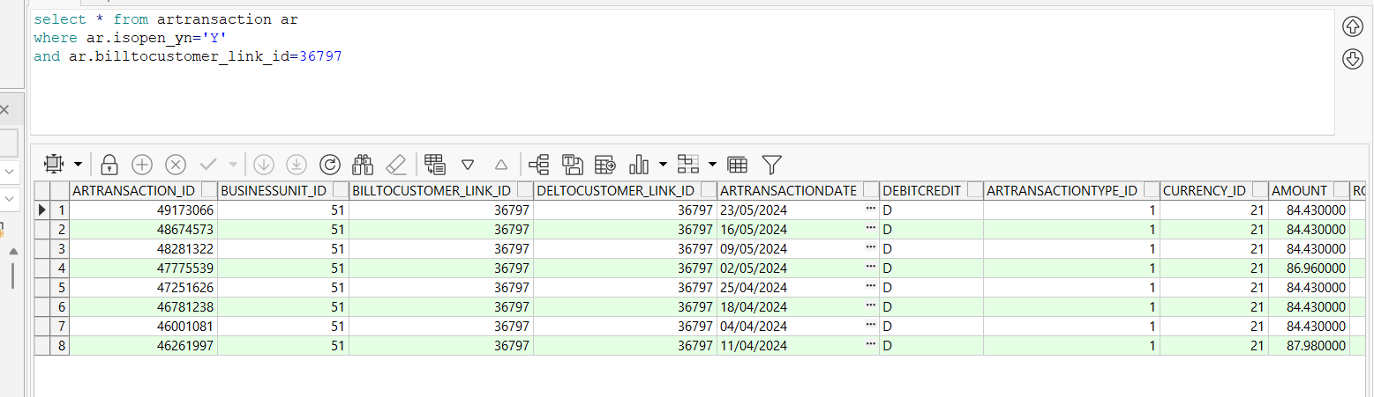

Test Case 3 – Change Bill-to when DEBTORCHANGEWITHOPENAR =2– Tested OK
Expected behavior: Show an error “This Deliver to customer has open AR Transactions, please move them before changing the Bill to customer” option of OK and revert the change of the Bill to customer field.
Hash: 466f852
- Set SS DEBTORCHANGEWITHOPENAR to 2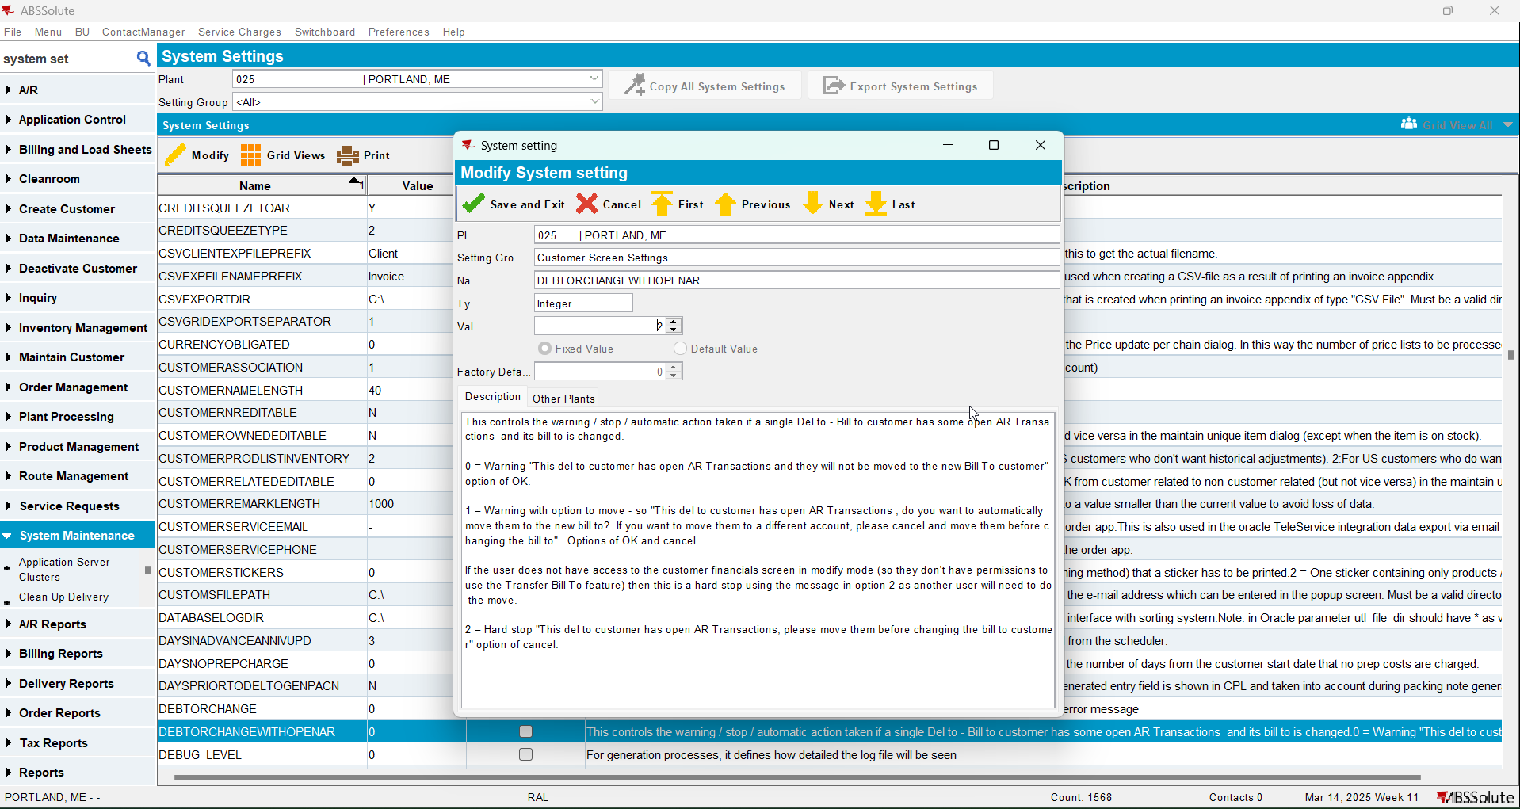
- Have a customer that is its own bill to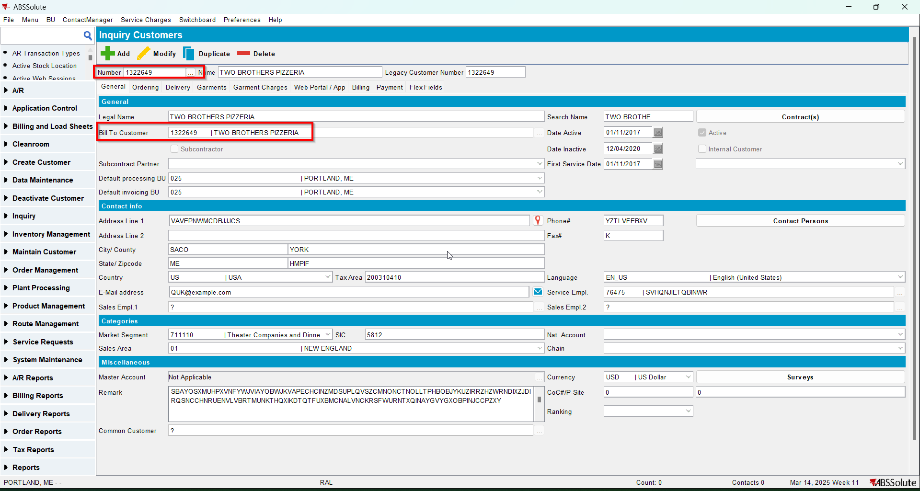
- Have another customer that is its own bill to and has open AR transactions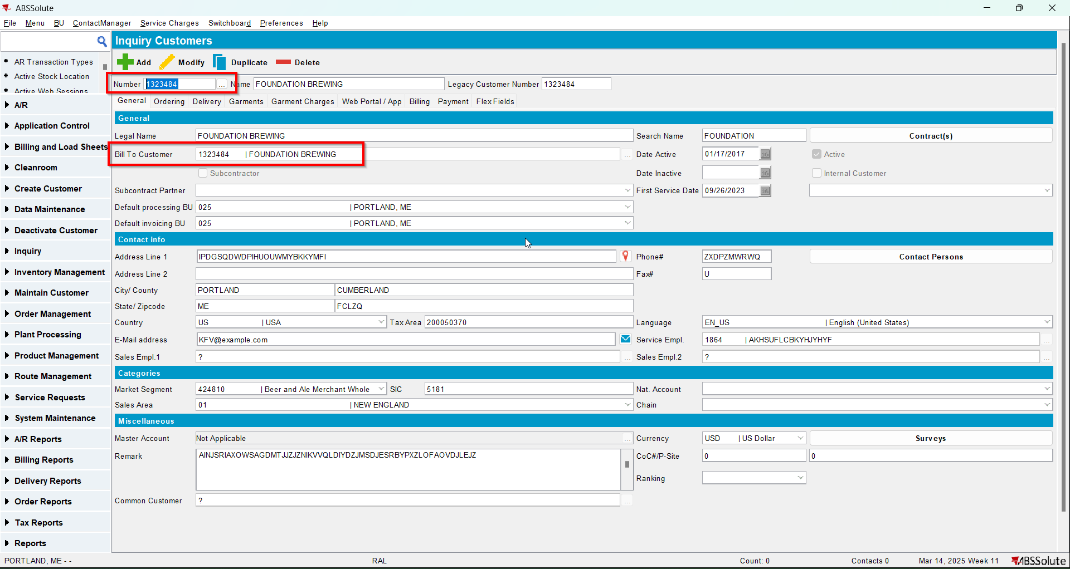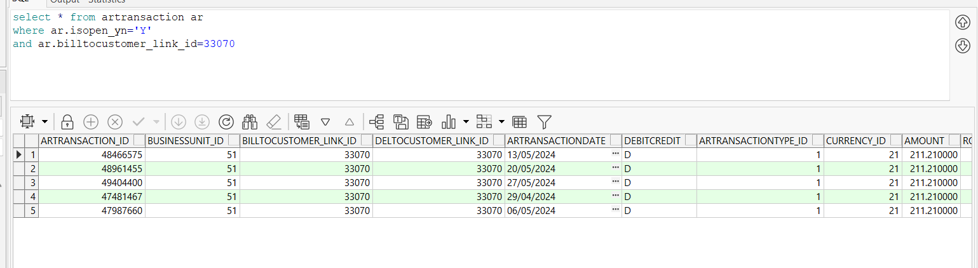
- For the customer at Step 3 change its bill to with the customer from Step 2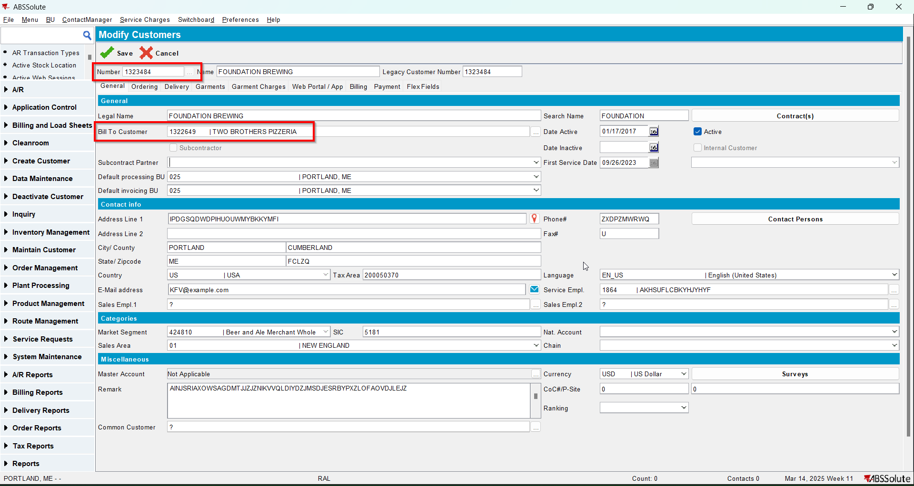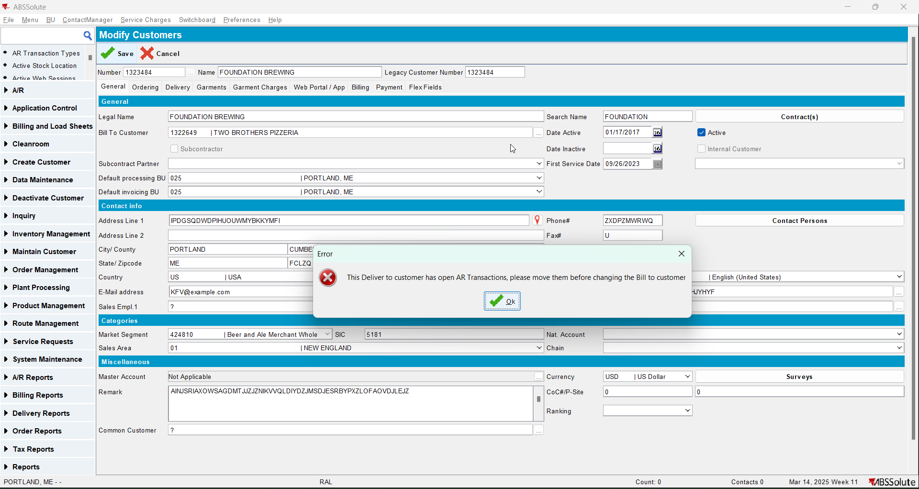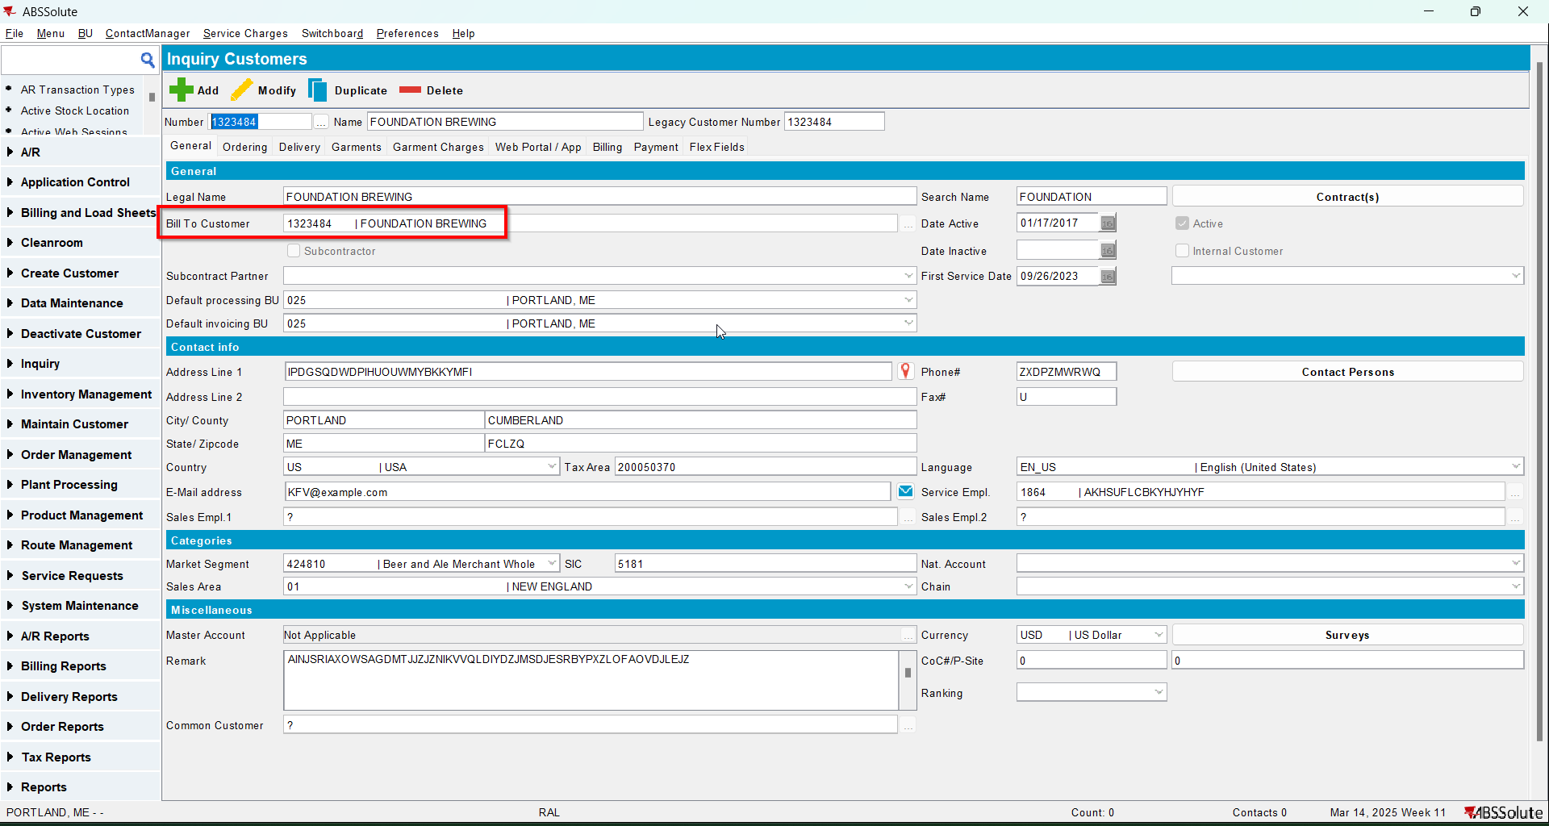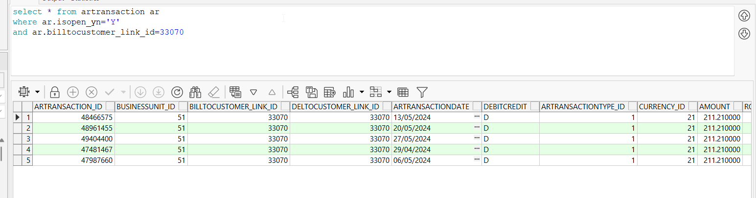

Test Case 4 – Change Bill-to when DEBTORCHANGEWITHOPENAR =1– Tested OK
Expected behavior:
1. Show a message “This Deliver to customer has open AR Transactions, do you want to automatically move them to the new Bill to? If you want to move them to a different account, please cancel and move them before changing the bill to” with Yest and No.
2. “No” reverts the change of the Bill to customer field.
3. “Yes” will move the debt to the new bill to using the same process as Customer Financials.Transfer Bill To feature
Hash: 466f852
- Set SS DEBTORCHANGEWITHOPENAR to 1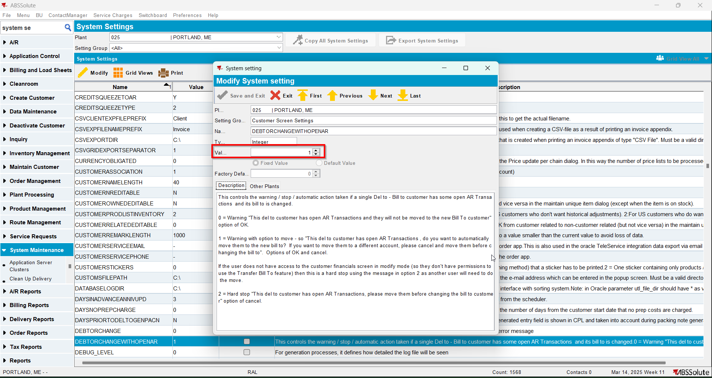
- Have a customer that is its own bill to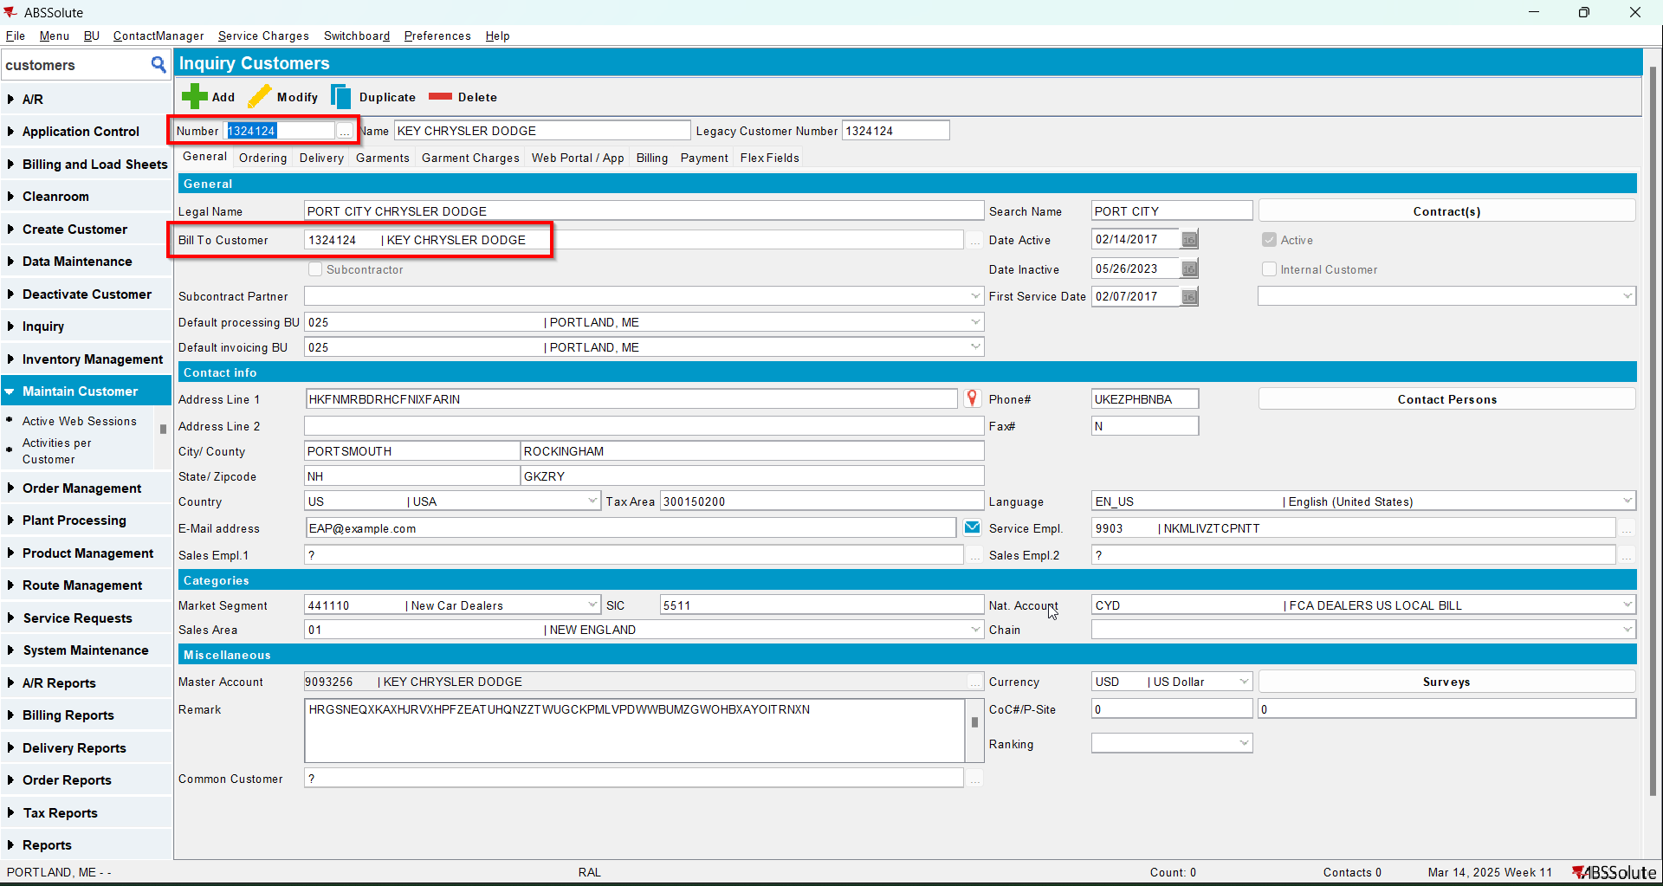
- Have another customer that is its own bill to and has open AR transactions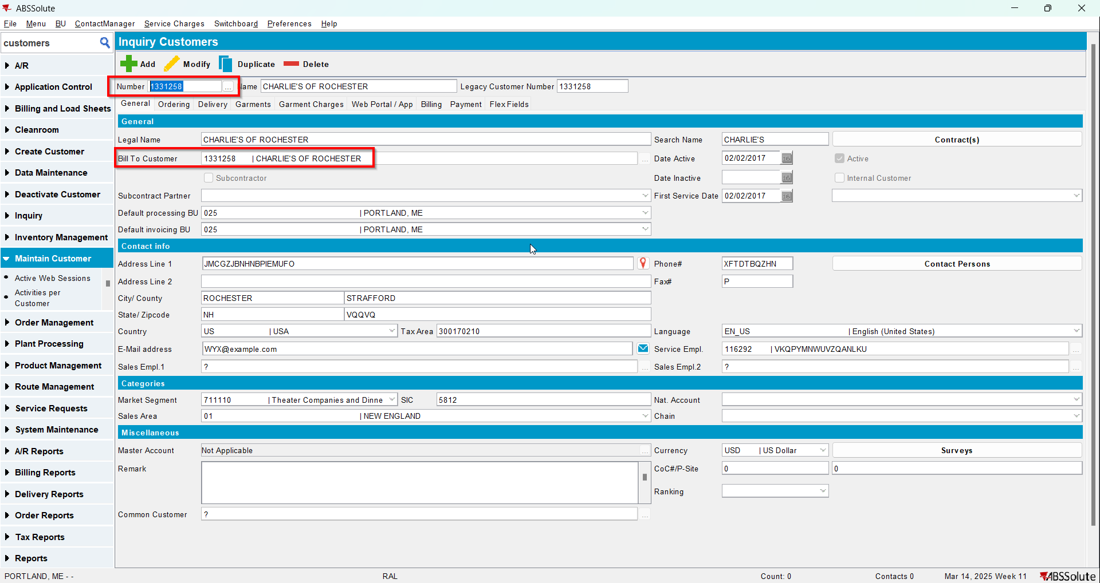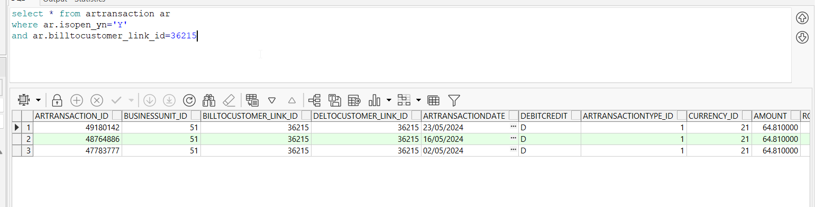
- For the customer at Step 3 change its bill to with the customer from Step 2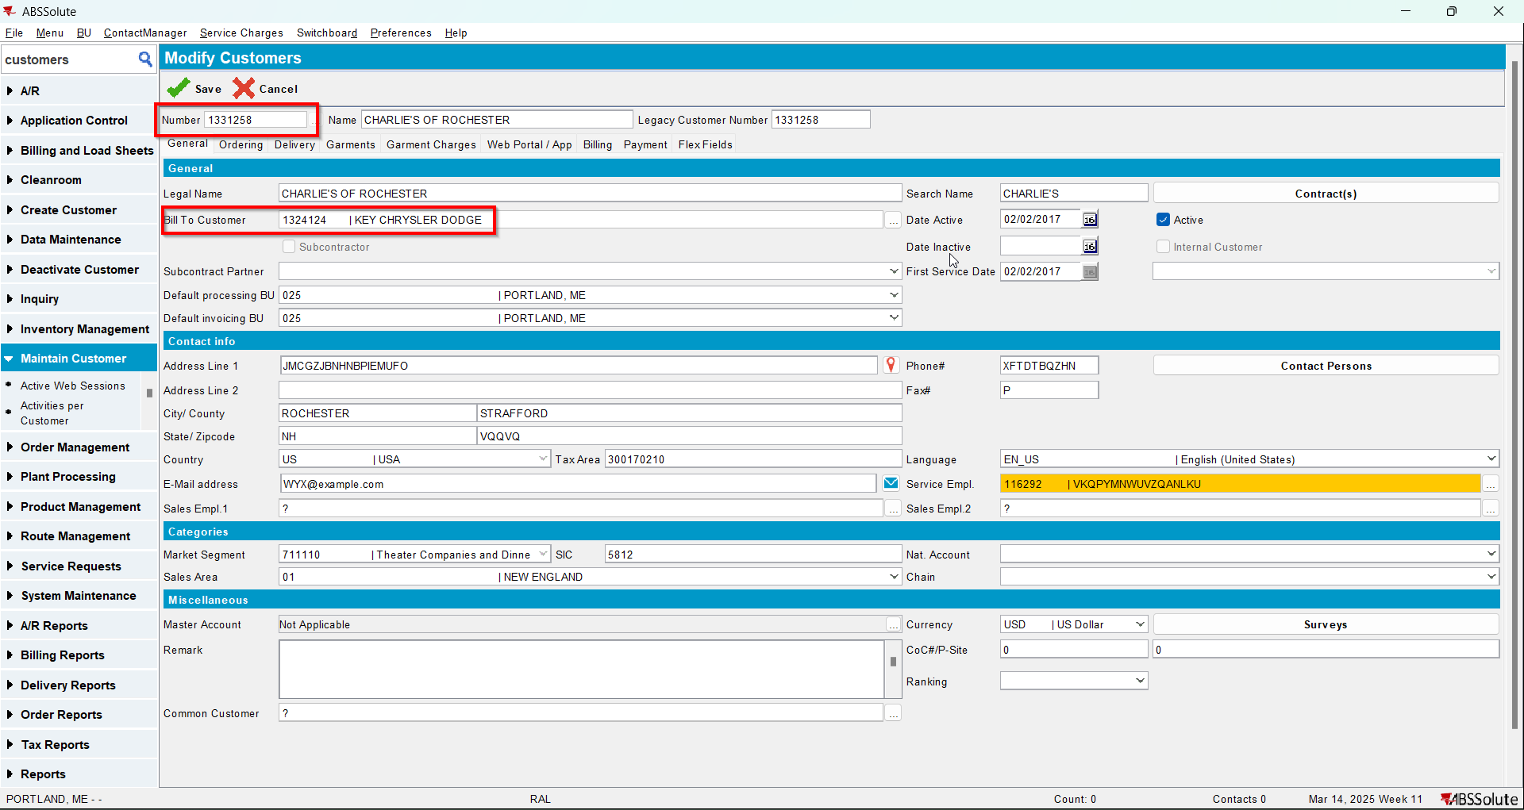
- When the message appears press No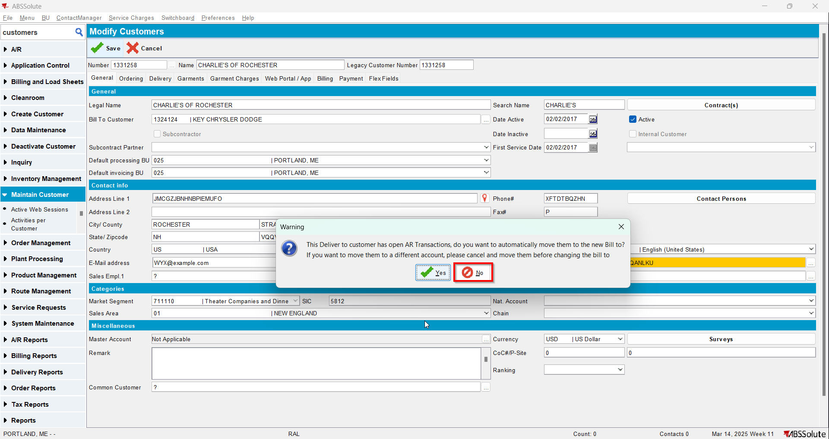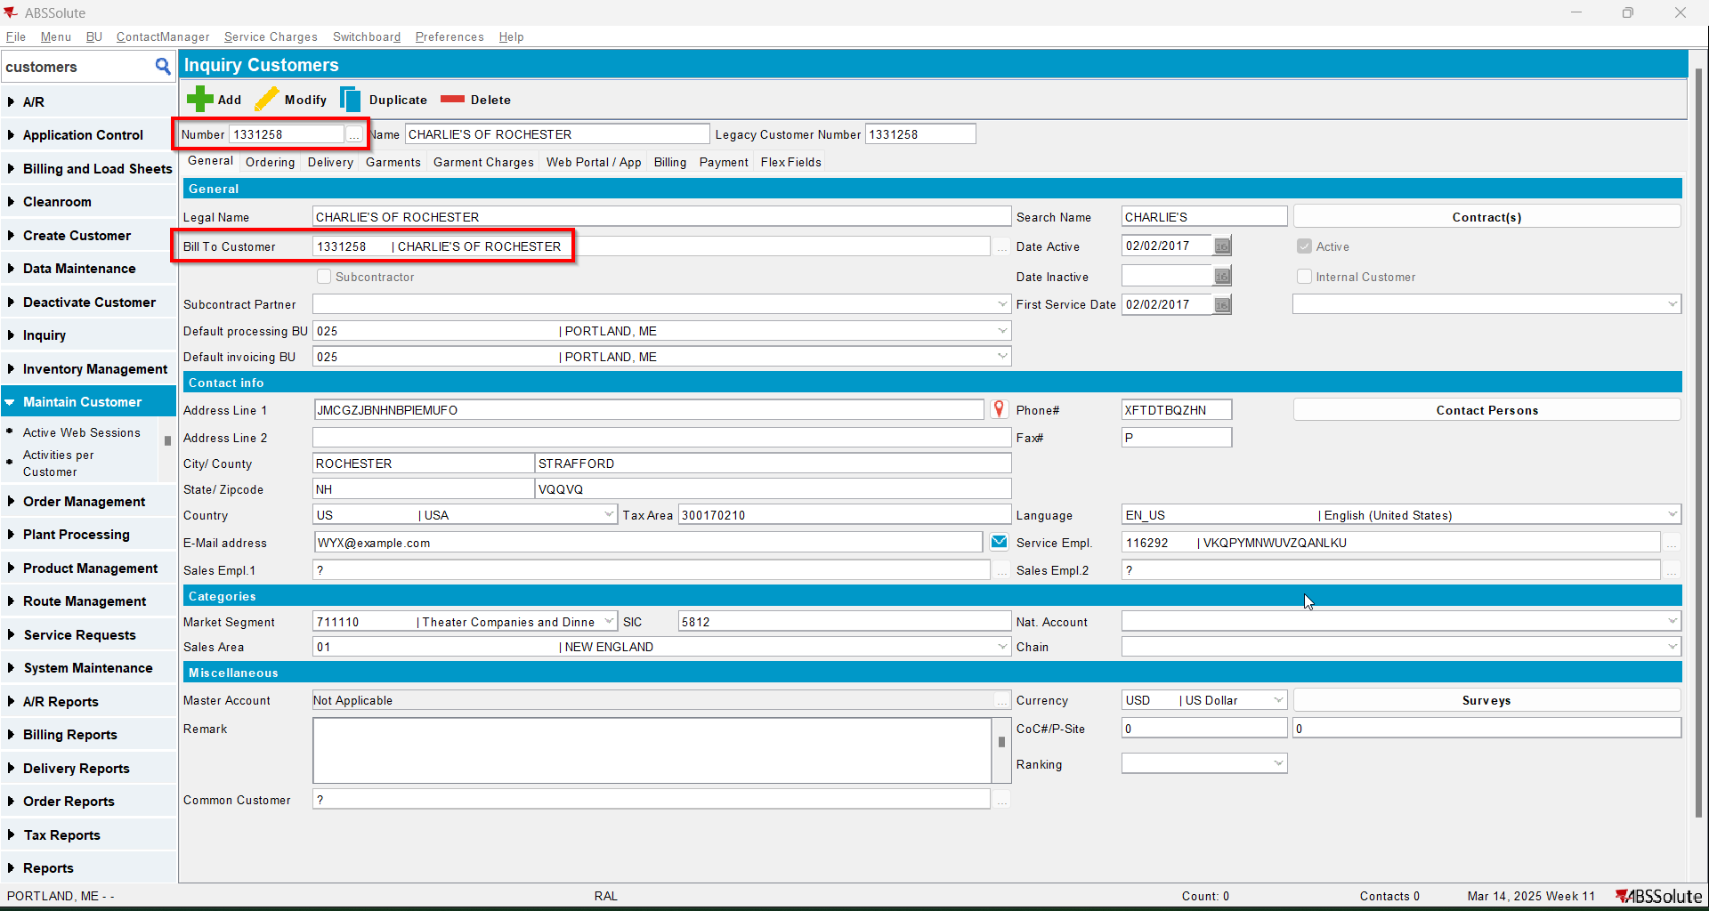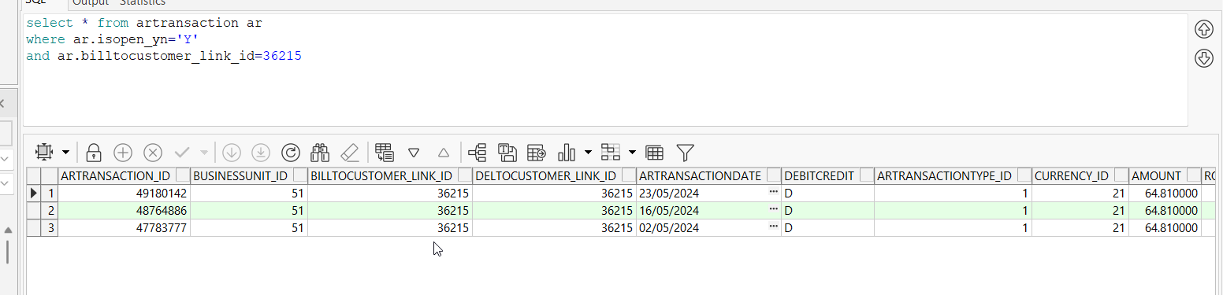
- For the customer at Step 3 change its bill to with the customer from Step 2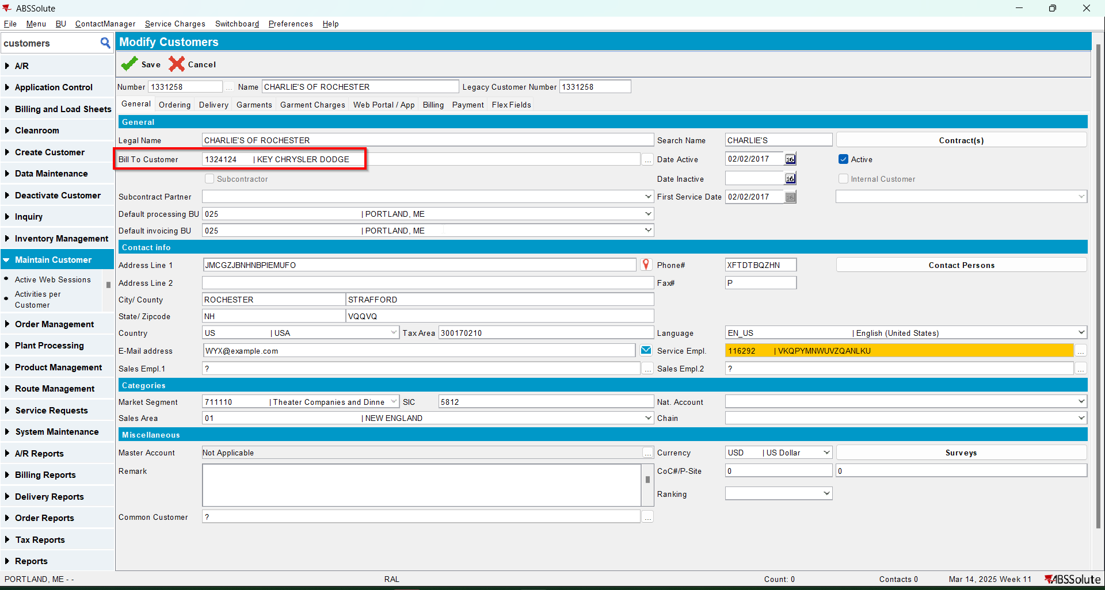
- When the message appears press Yes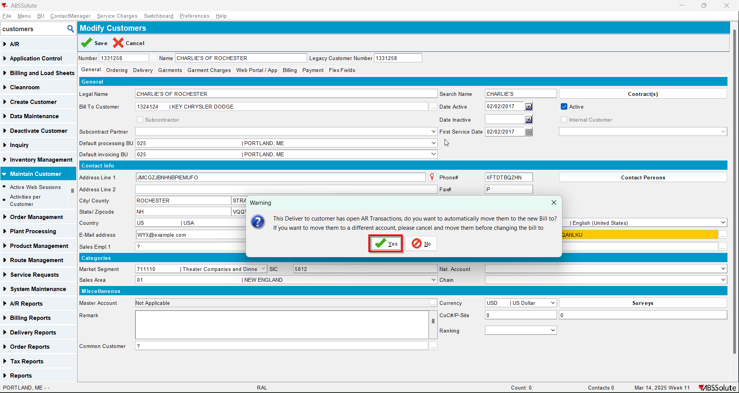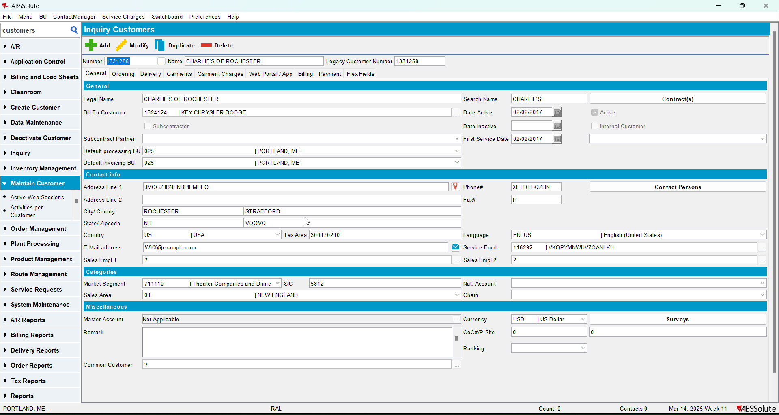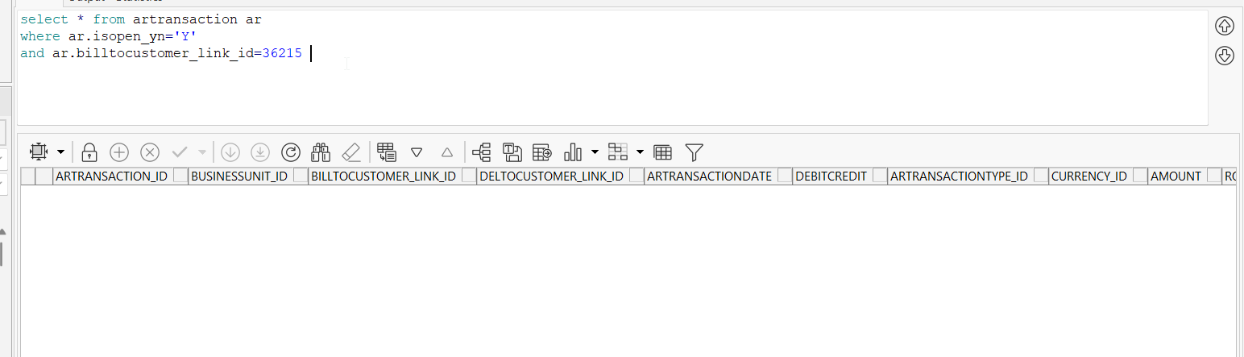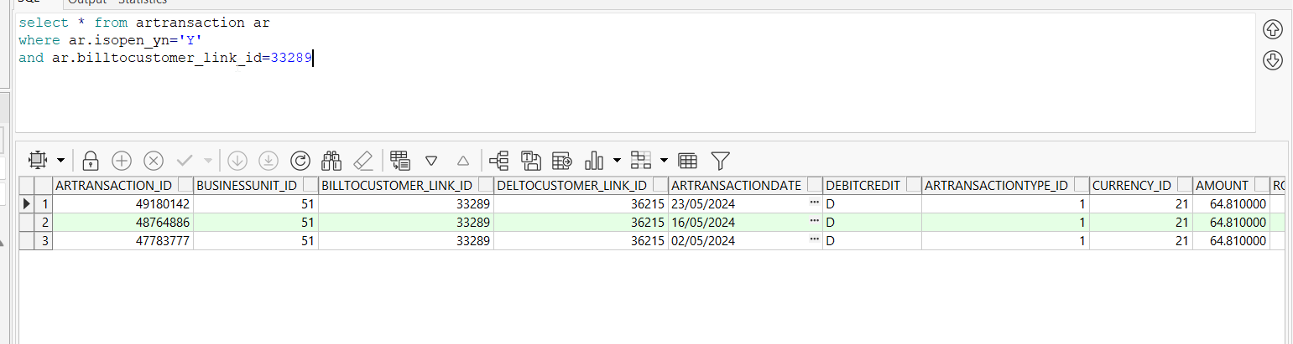

Test Case 5 – Change Bill-to with a customer that has a different country_id than the del to customer– Tested OK
Expected behavior: There should be an error message and a hard stop since the country_id of the new debtor is different than the country_id of the del-to-customer
Hash: 466f852
- Customers DLG: Select any customer from BU 325 that is an US customer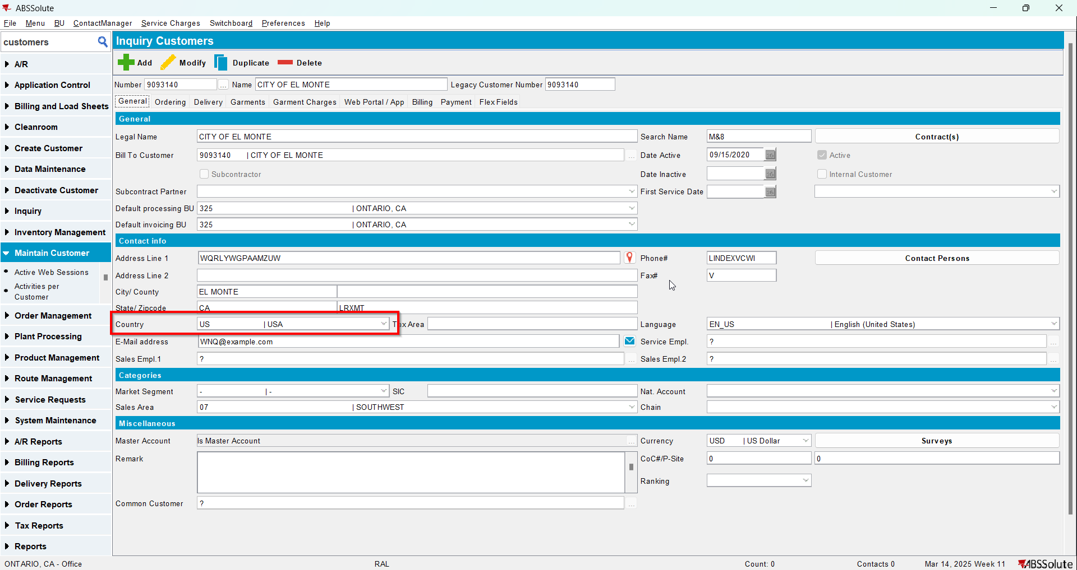
- Customers DLG: Modify the customer
- Customers DLG: Set the bill-to customer as 1284993 that is a CANADA customer