ABSN-3189 WebX route check in, overview tab, Total Adj colum showing wrong data
Environment | Prerequisites
Version: 9.09.01  DBServerName= abs-srv20.internal.abslbs.com  DBSID=CUST24  DBUser=UNFA  DBPassword=UNFA  Environment=Production | - Module:  - System setting

Contents
Reproduction before fix 1
Retest after fix 6

Reproduction before fix
Hash: 87b22c5a6973

- Web X: Do some negative adjustments on an invoice.
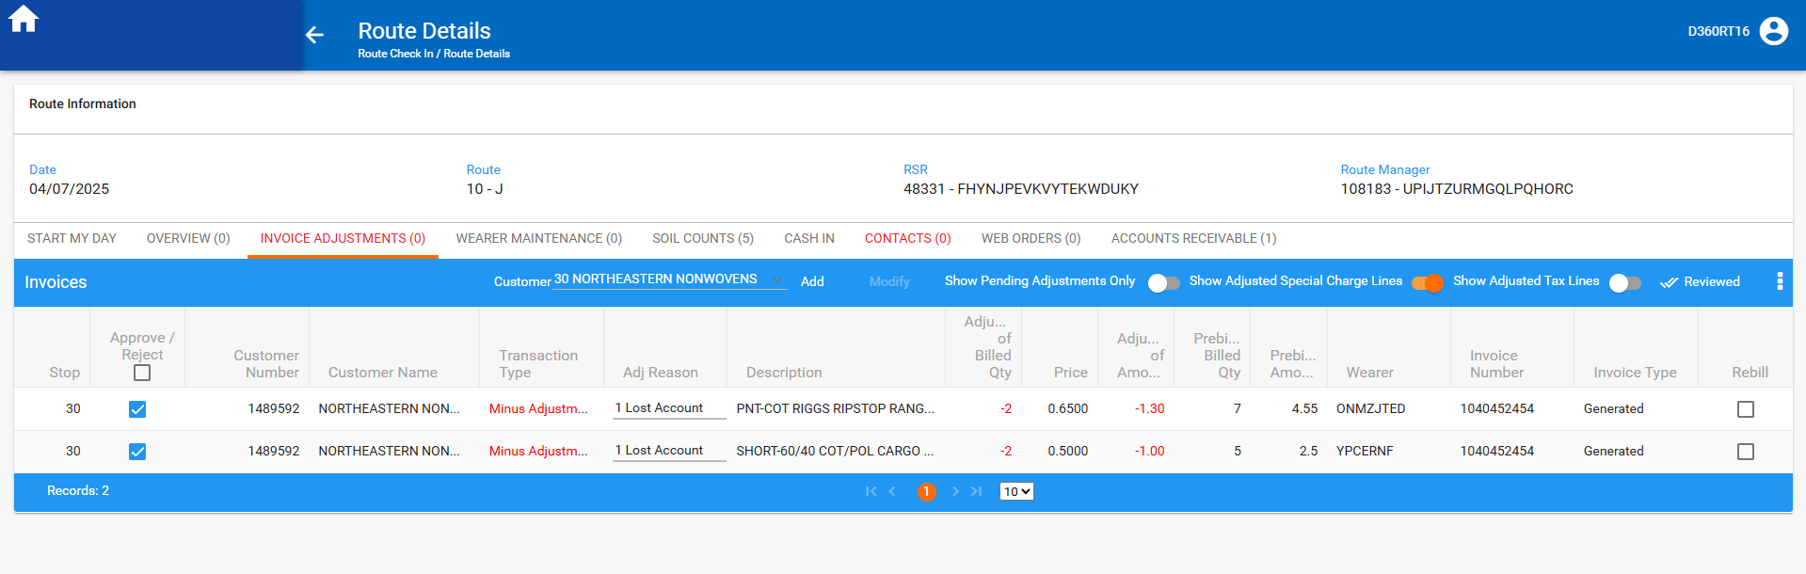

- Go to overview tab and check the value.
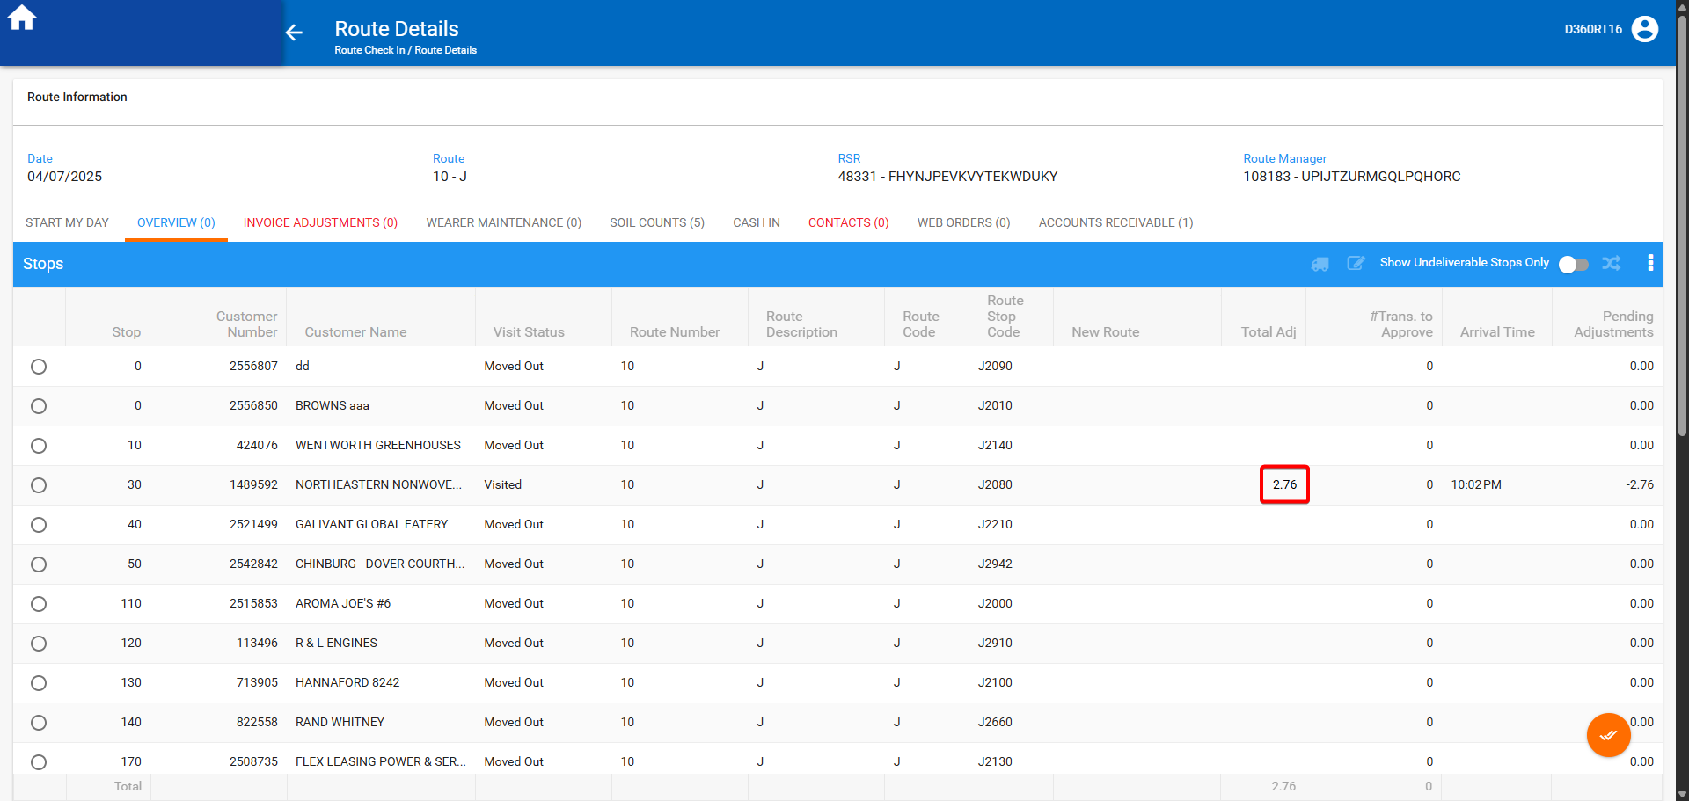

Total adj has a positive value instead of a negative one.

Retest after fix
Hash: 09447926df9a

- Web X: Do some negative adjustments on an invoice.
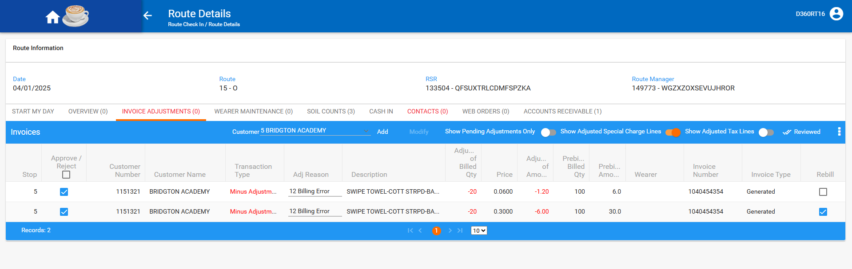

- Go to overview tab and check the value.
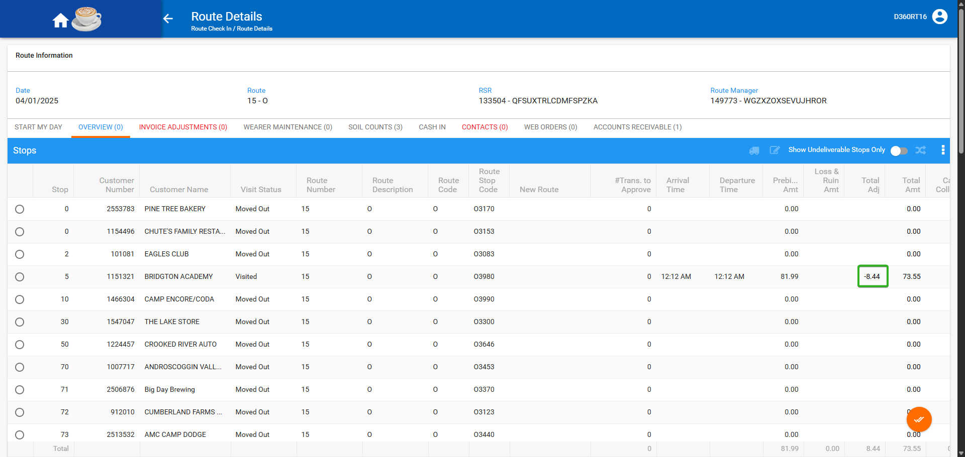

Total adj has a negative value.

