ABSN-3138 Customer Financial Details the Transfer Bill-to button allows the user to update the Debit ARTransactions of a bill-to-customer from customer A to customer B.
Environment | Prerequisites
Version:9.07.00.UNF19  DBServerName=abs-SRV20.internal.abslbs.com  DBSID=CUST24  DBUser=UNFDEV  DBPassword=UNFDEV  Environment=Test | - Module:  - System setting

Contents
Test after fix 1
Test Case 1 – Select multiple lines and move to bill-to from US to CA– Tested OK 1
Test Case 2 – Select multiple lines and move to bill-to from CA to US– Tested OK 4
Test Case 3 – Select multiple lines and move to bill-to from US to US– Tested OK 7

Test after fix

Test Case 1 – Select multiple lines and move to bill-to from US to CA– Tested OK
Expected behavior: Should get error message and hard stop
Hash: 0909430198fd
- Have a customer with USD currency
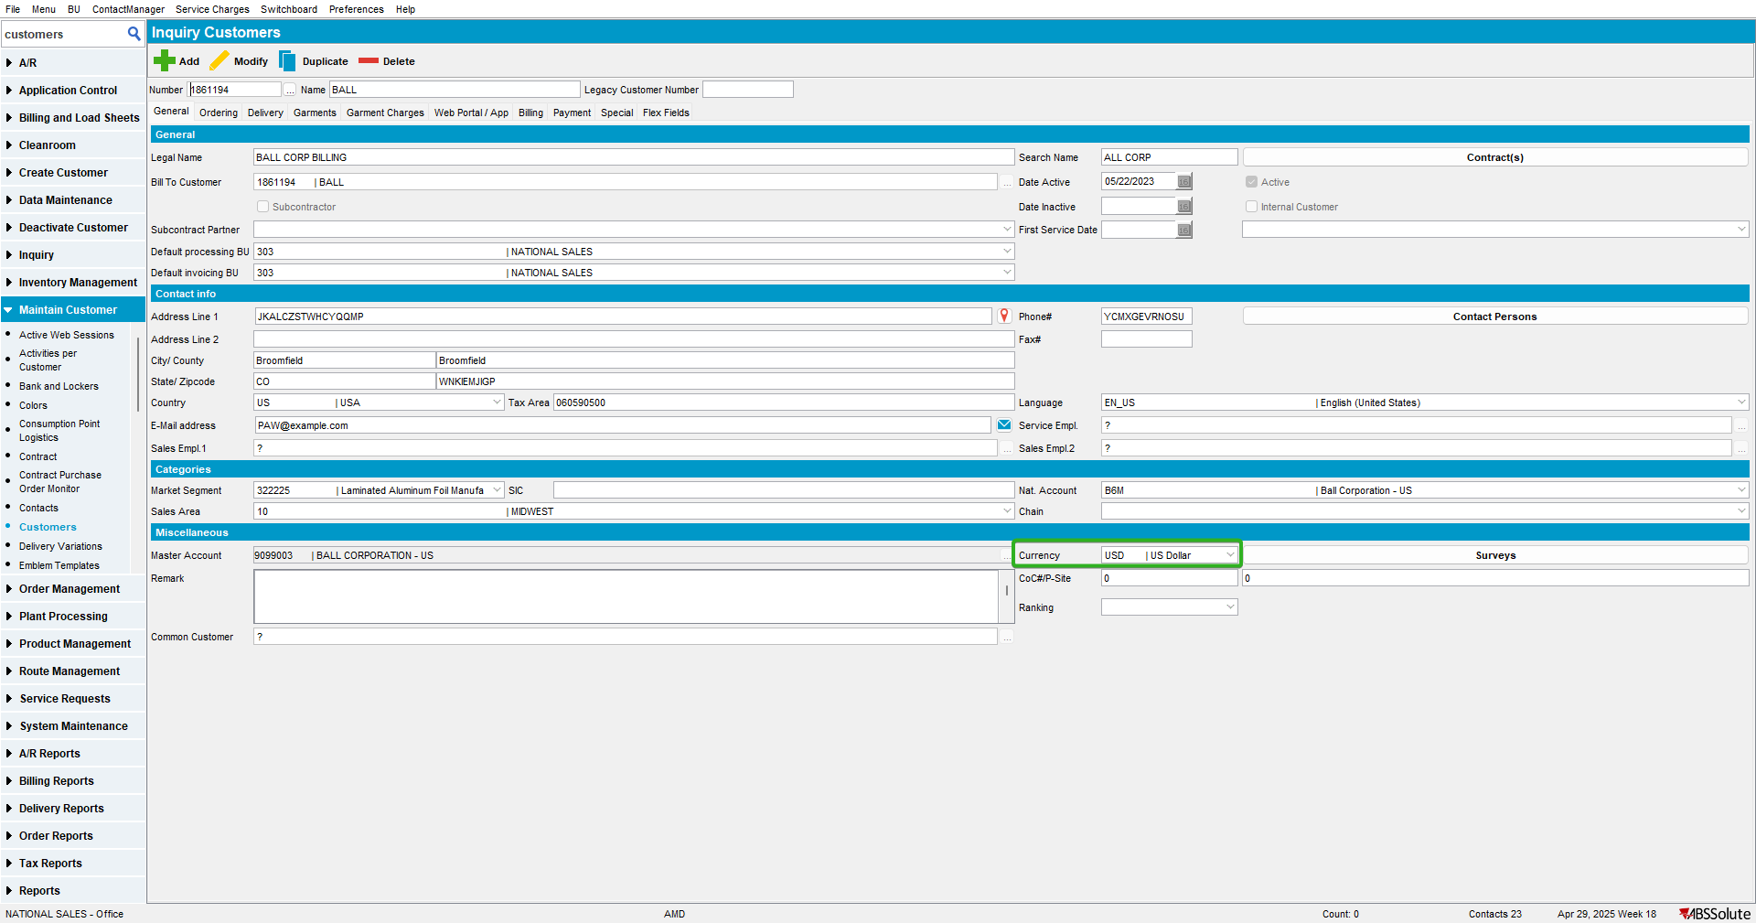

- Go to Customer Financial Details to Invoices/Charges Tab and check that there are records
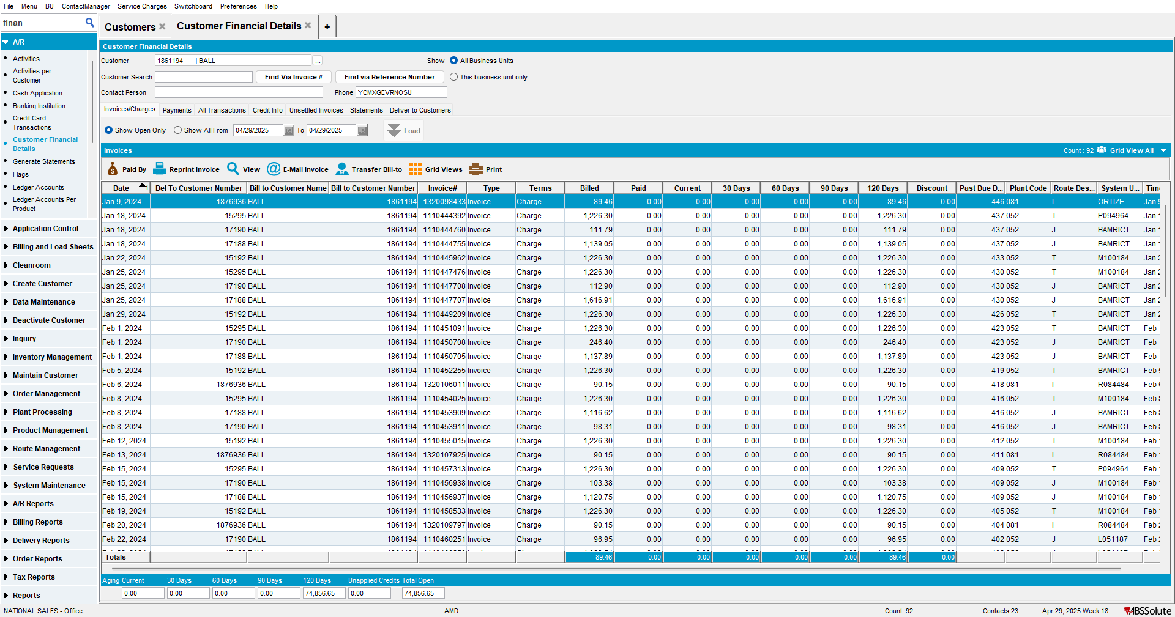

- Have a customer with CAD currency
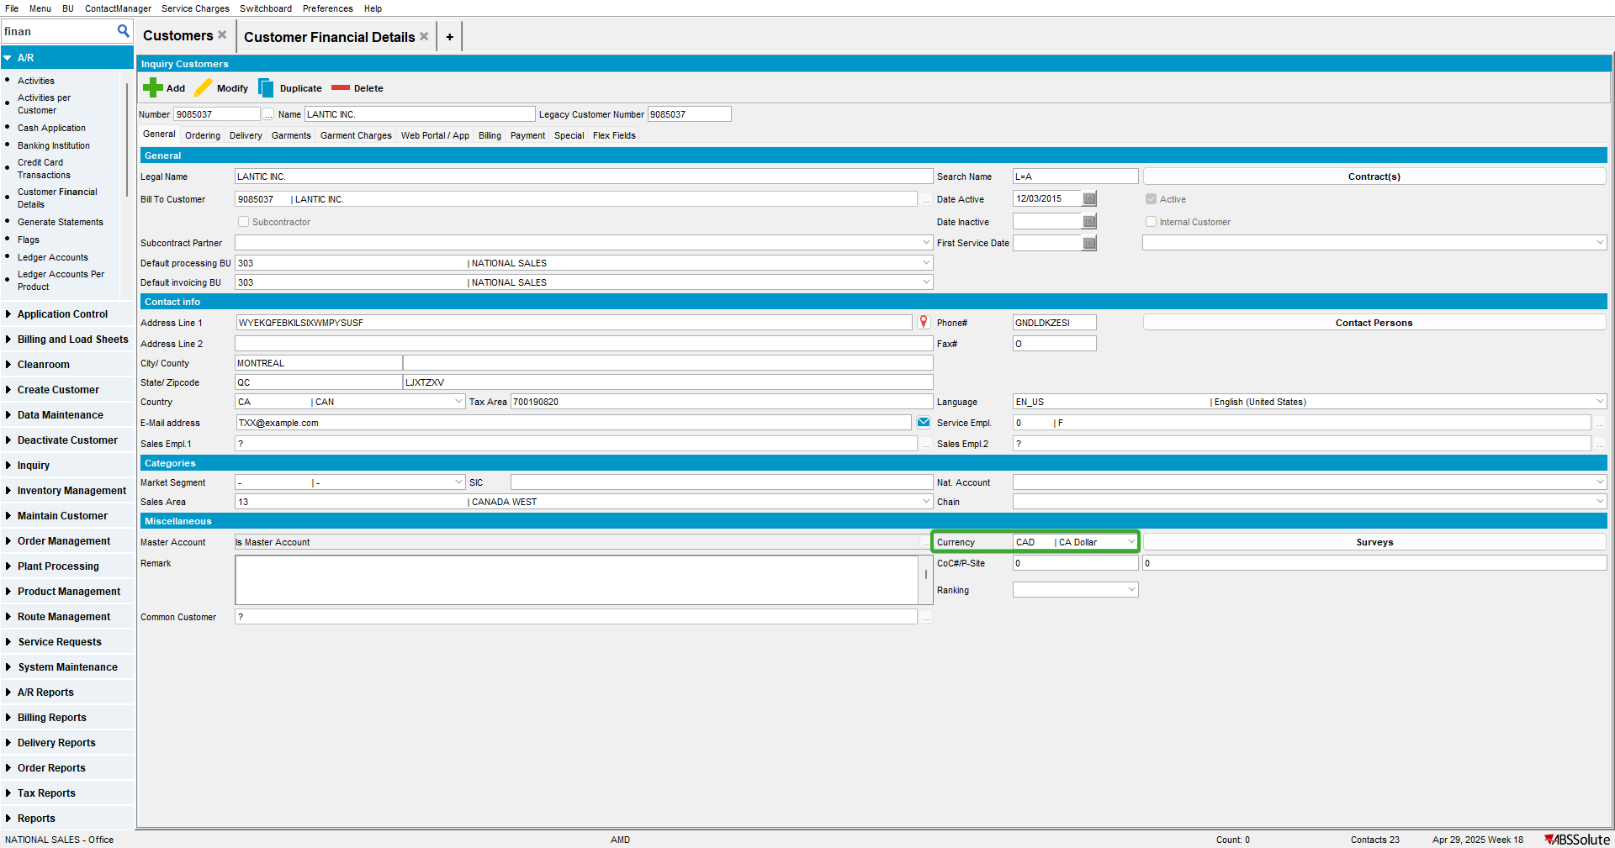

- Go to Customer Financial Details to Invoices/Charges tab, select the customer with US currency
- Select some invoices and press on Transfer Bill-to
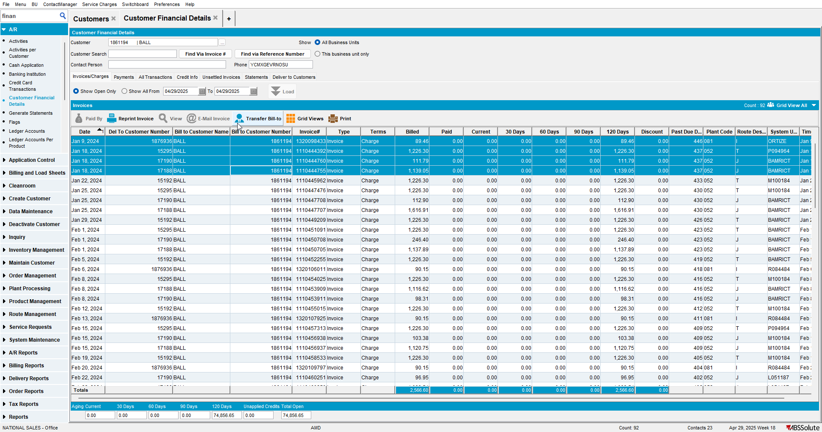

- For Bill to Customer use the customer with CA currency
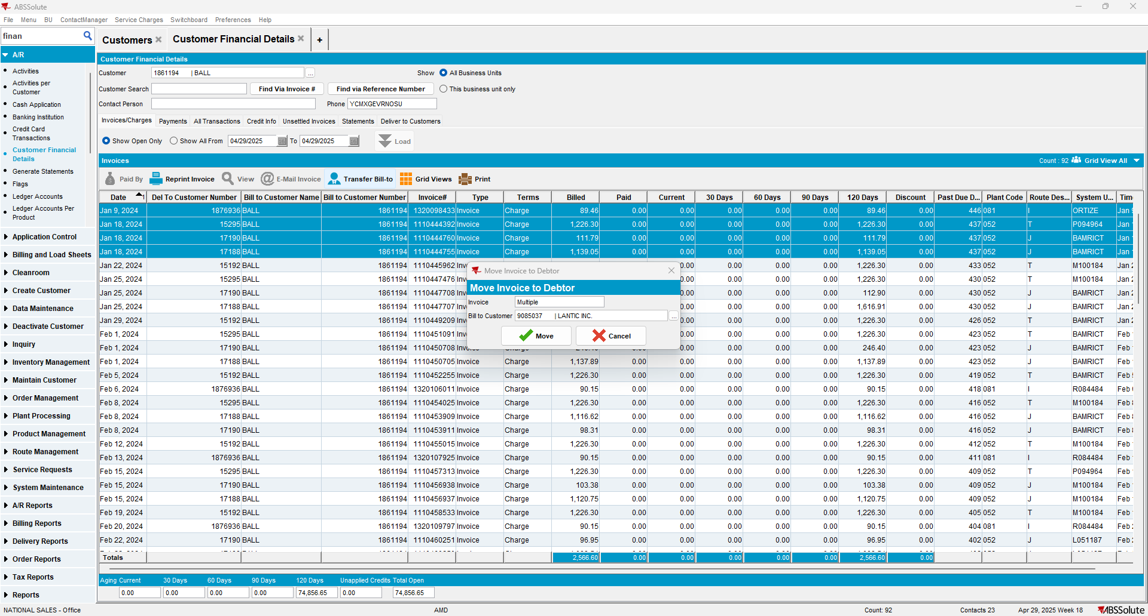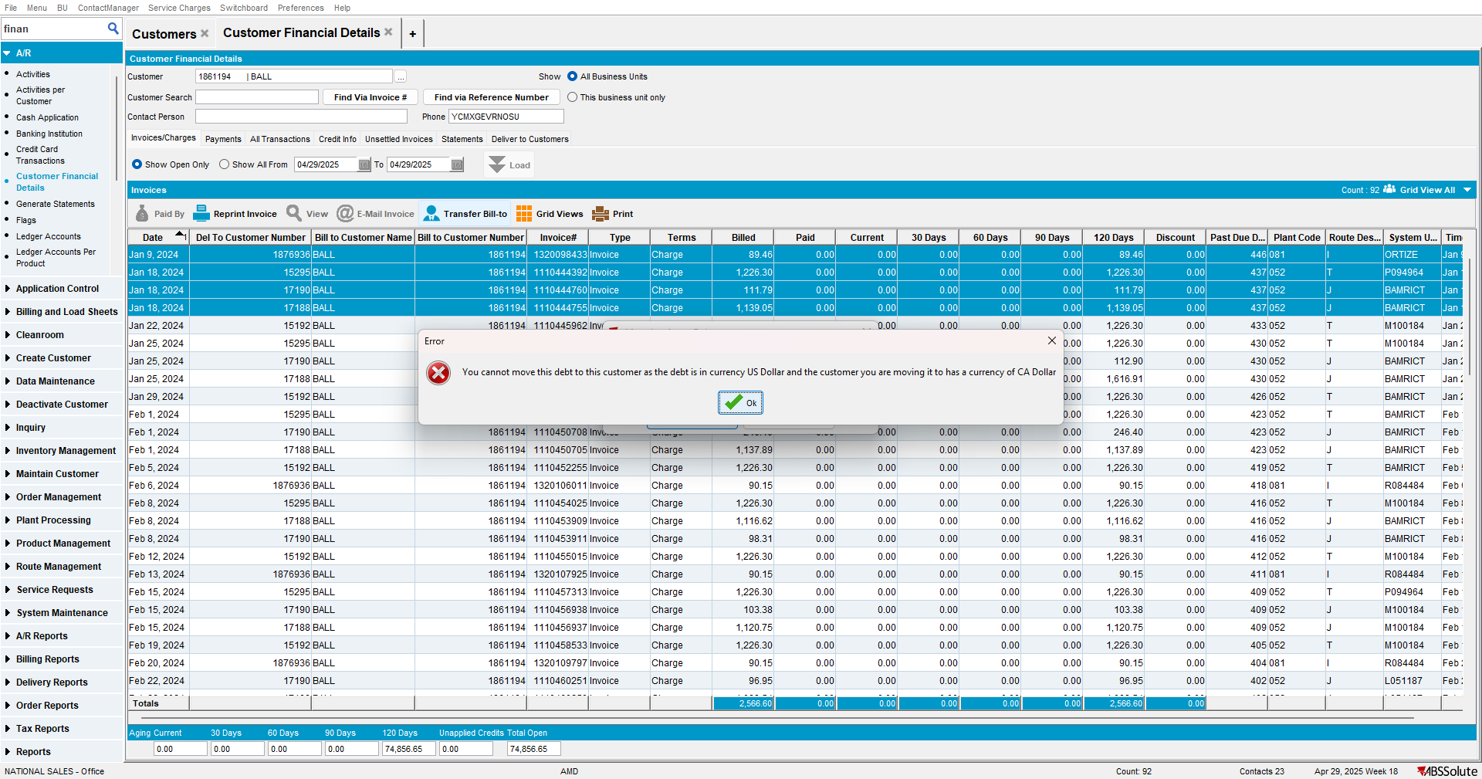

Test Case 2 – Select multiple lines and move to bill-to from CA to US– Tested OK
Expected behavior: Should get error message and hard stop
Hash: 0909430198fd
- Have a customer with CAD currency
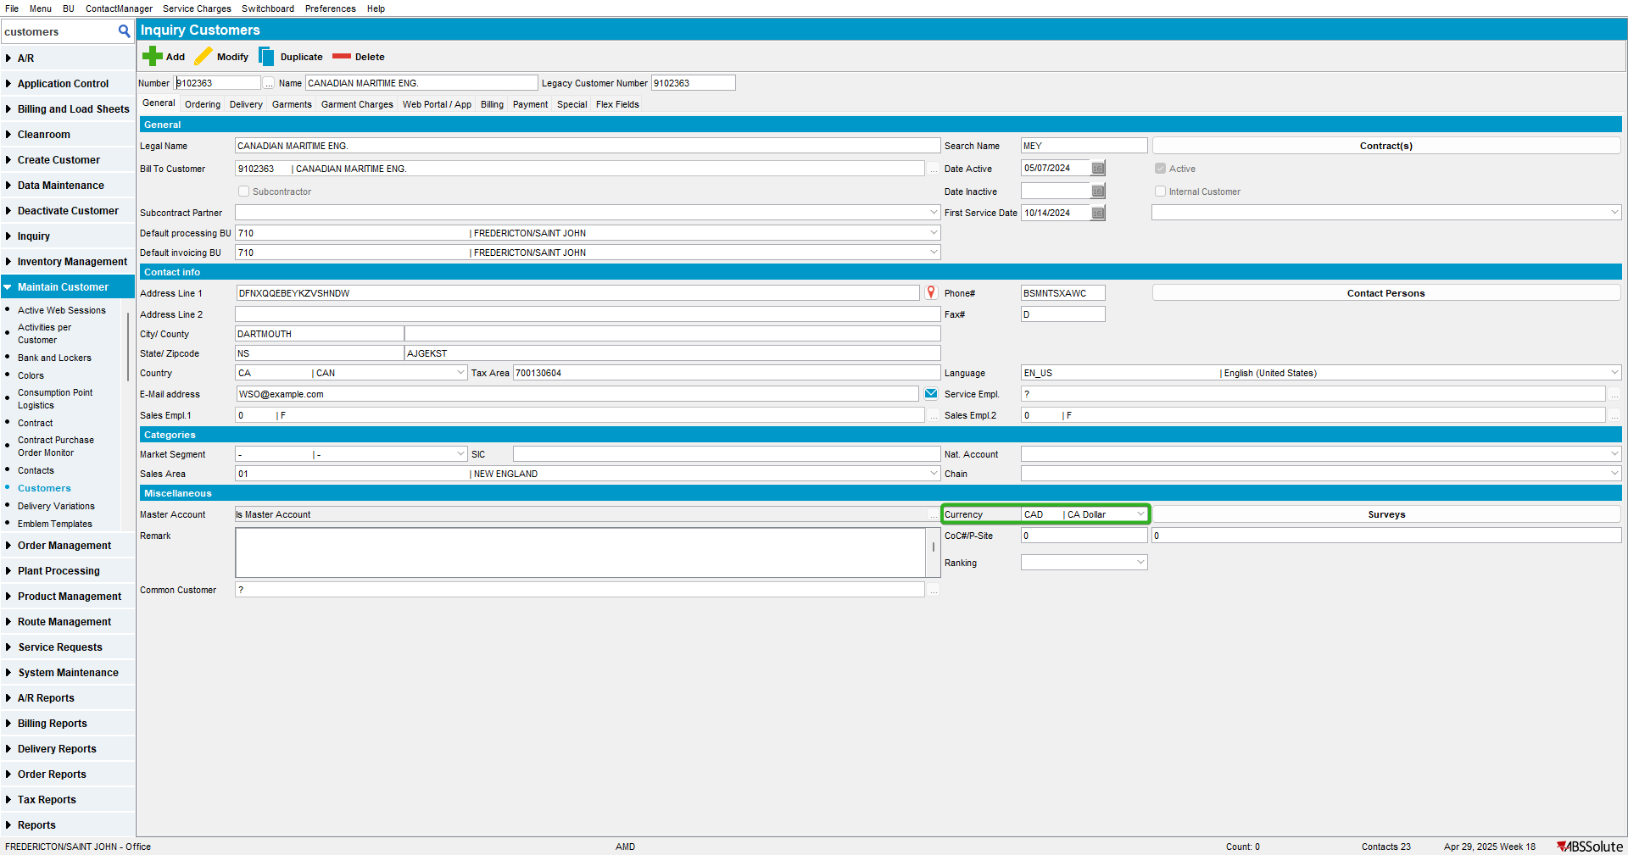

- Go to Customer Financial Details to Invoices/Charges Tab and check that there are records
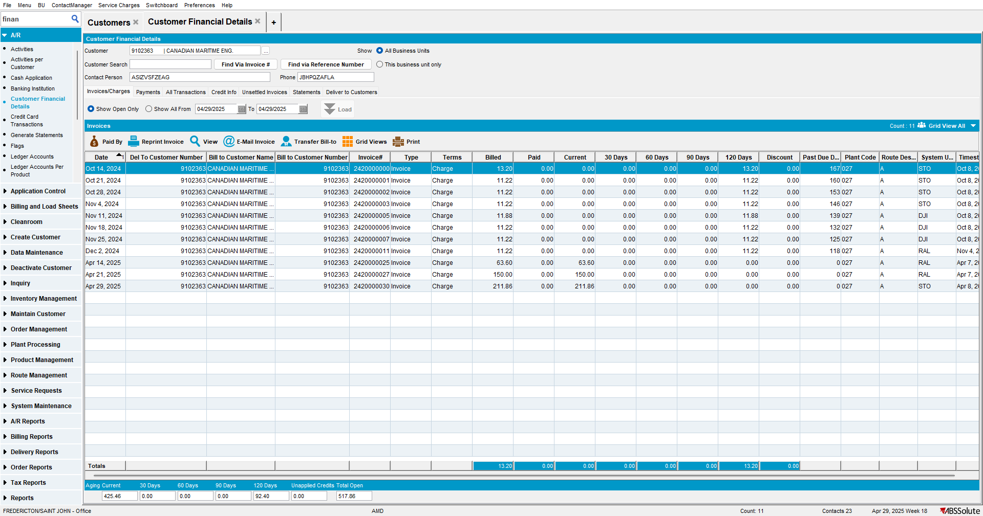
- Have a customer with USD currency
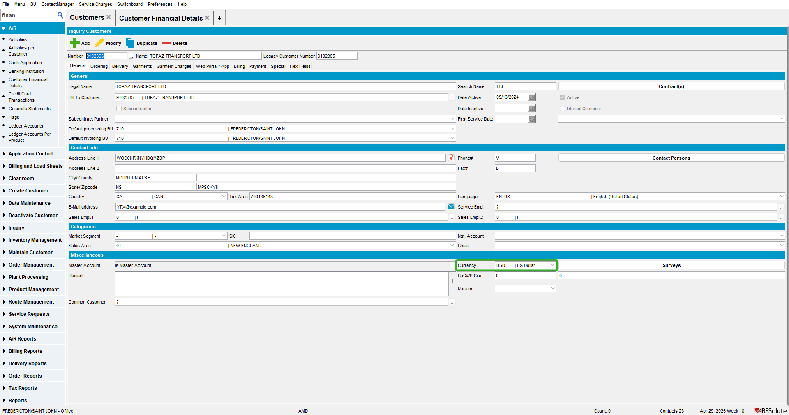

- Go to Customer Financial Details to Invoices/Charges tab, select the customer with CAD currency
- Select some invoices and press on Transfer Bill-to
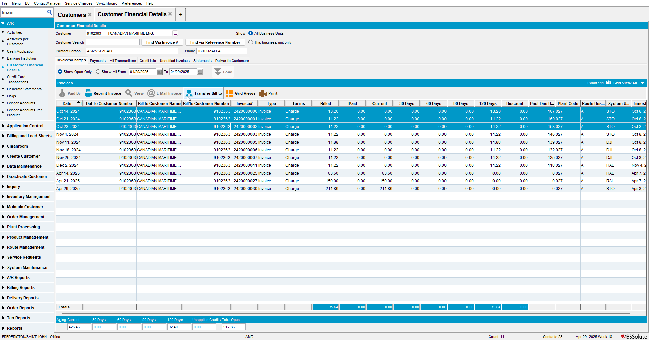

- For Bill to Customer use the customer with USD currency
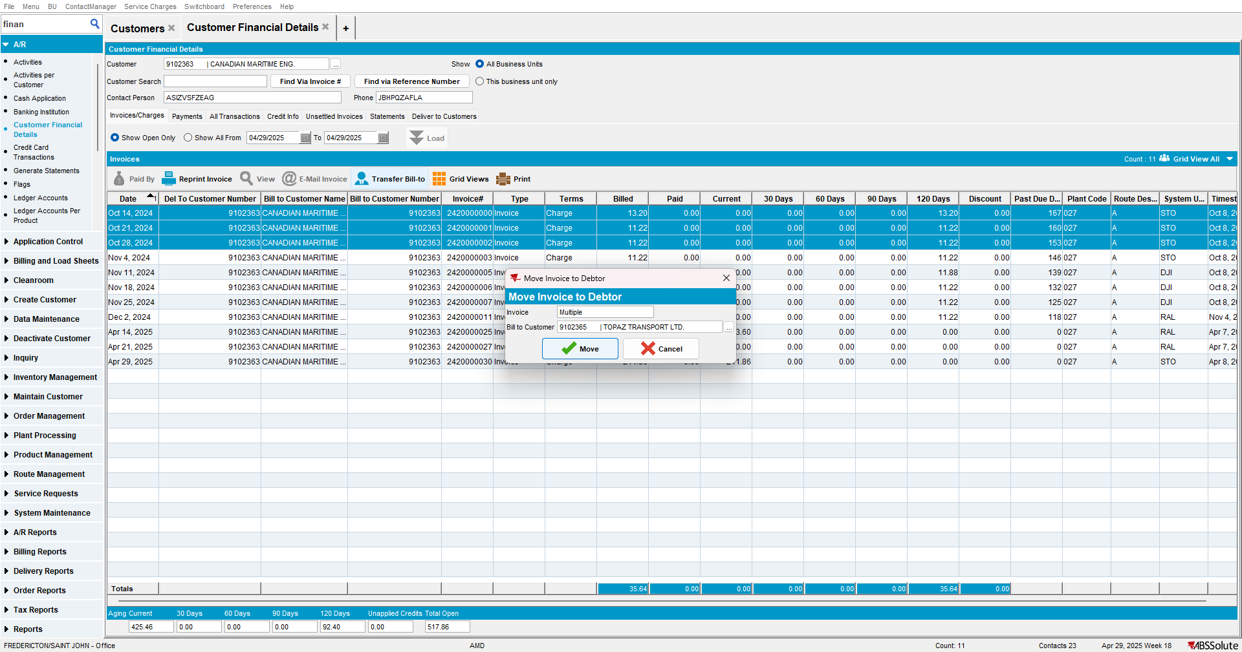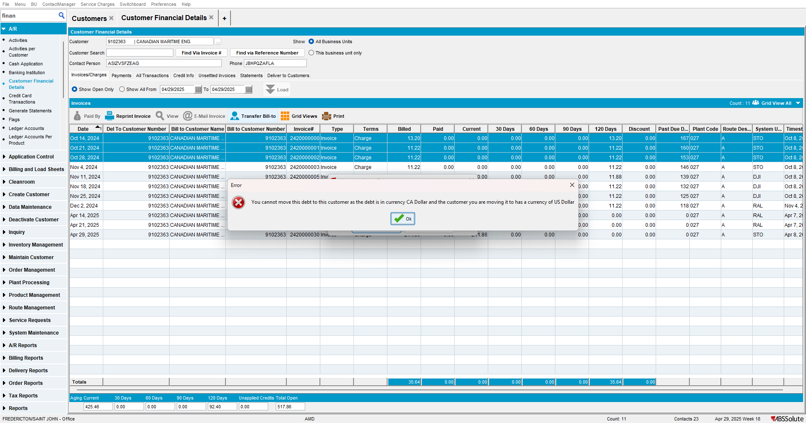

Test Case 3 – Select multiple lines and move to bill-to from US to US– Tested OK
Expected behavior: Should be allowed to move the ARTransaction successfully
Hash: 0909430198fd
- Have a customer with USD currency
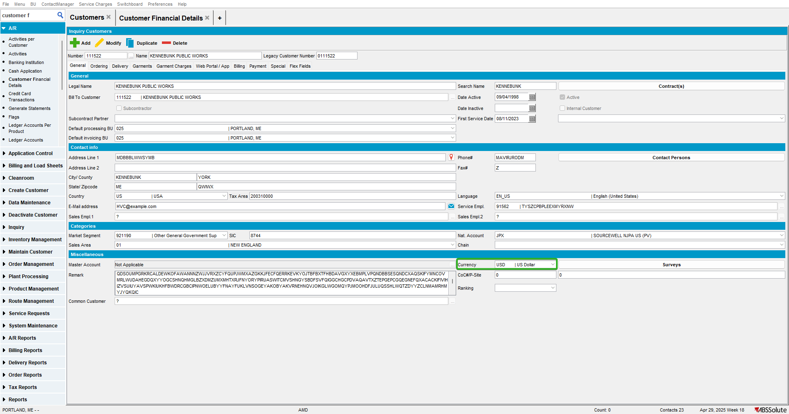

- Go to Customer Financial Details to Invoices/Charges Tab and check that there are records
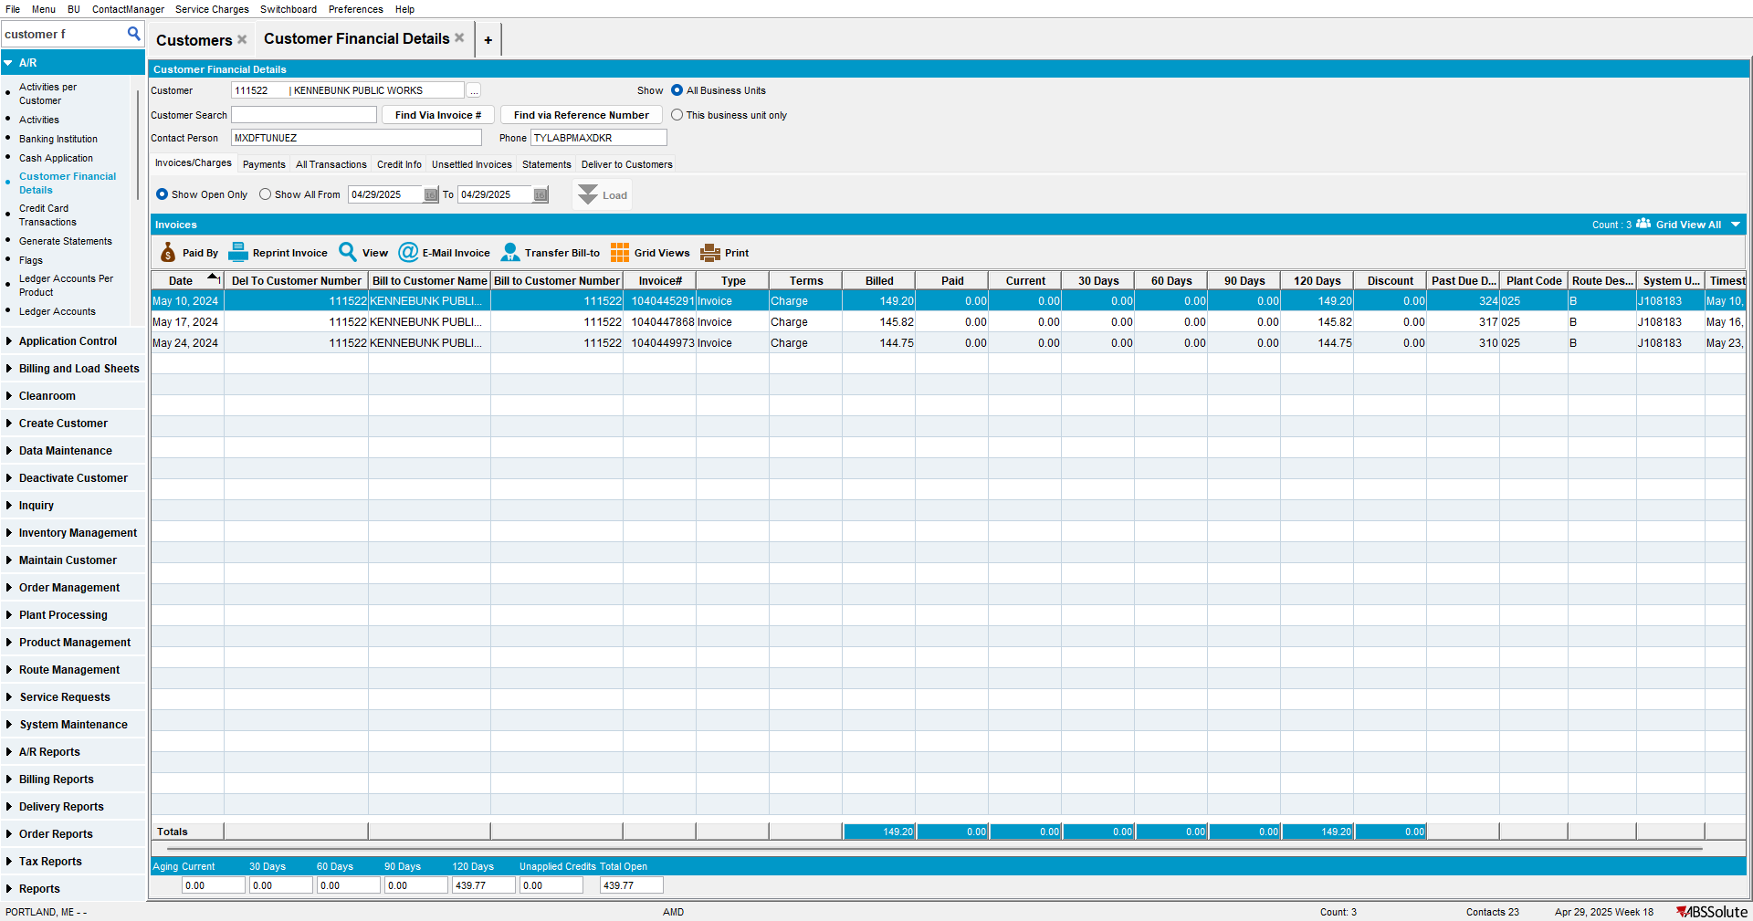
- Have another customer with USD currency
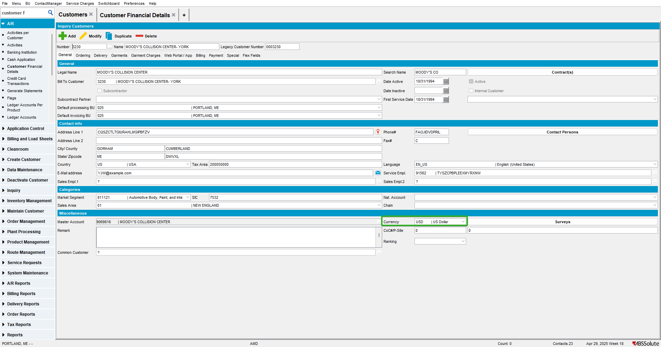

- Go to Customer Financial Details to Invoices/Charges tab, select the first customer with USD currency
- Select some invoices and press on Transfer Bill-to
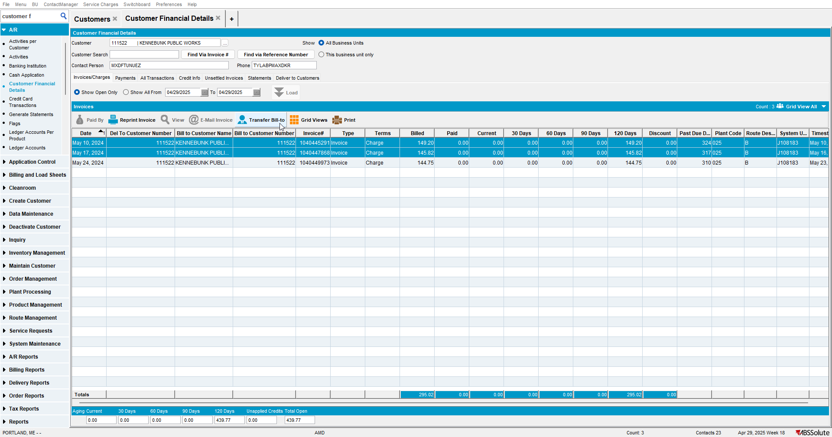

- For Bill to Customer use the second customer with USD currency
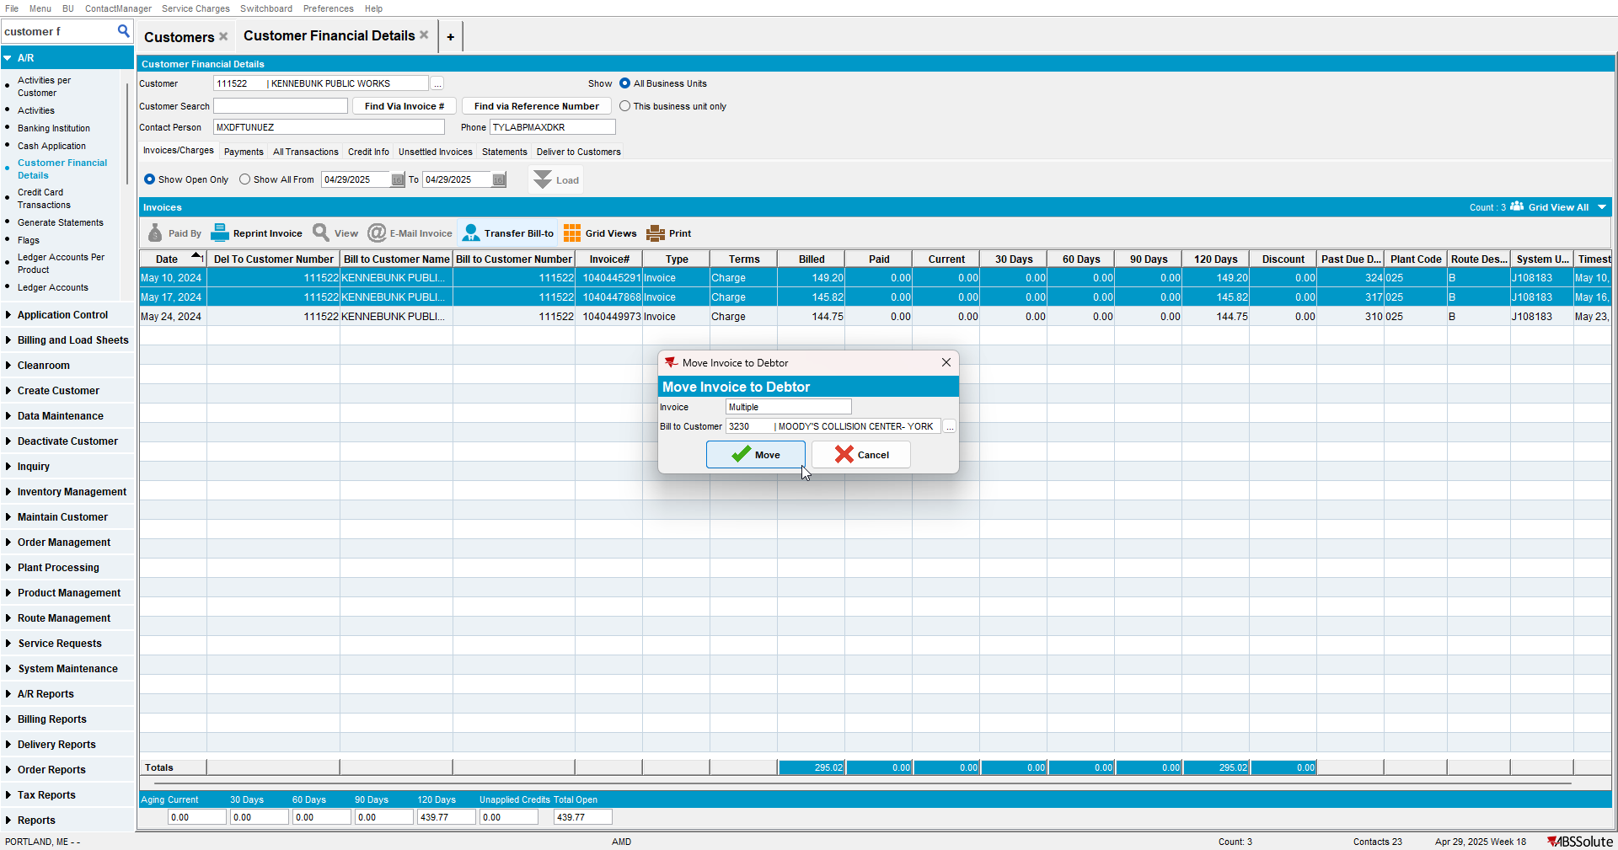

- Check that the records were moved
