ABSN-3165 D_UBS_2624 User receives the error “Putup docs were not generated because last weeks route was not settled” when attempting to generate the Put Up Docs
Environment | Prerequisites
Version: 9.07.00.UNF19  DBServerName= abs-srv20.internal.abslbs.com  DBSID=CUST24  DBUser=UNFDEV  DBPassword=UNFDEV  Environment=Production | - Module:

Contents
Retest after fix 1
Test case #1 - All stops from the previous week are moved 1
Test case #2 - A stop is not moved from the previous week 3
Test case #3 - A stop is moved but has an invoice attached 6

Retest after fix

Test case #1 - All stops from the previous week are moved
Hash: e23520ca3fb6
- RSC dlg: Add two routes with a one-week gap between them
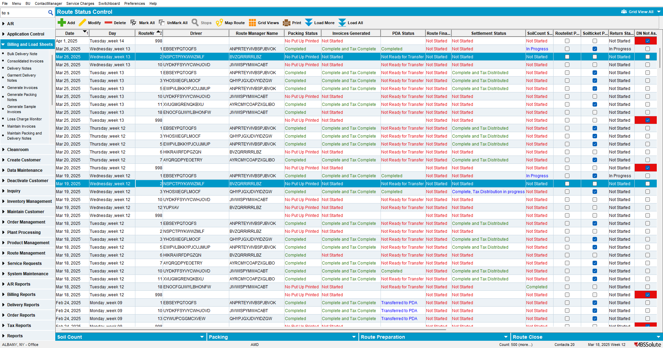

- RSC dlg: For the first route, move all the stops
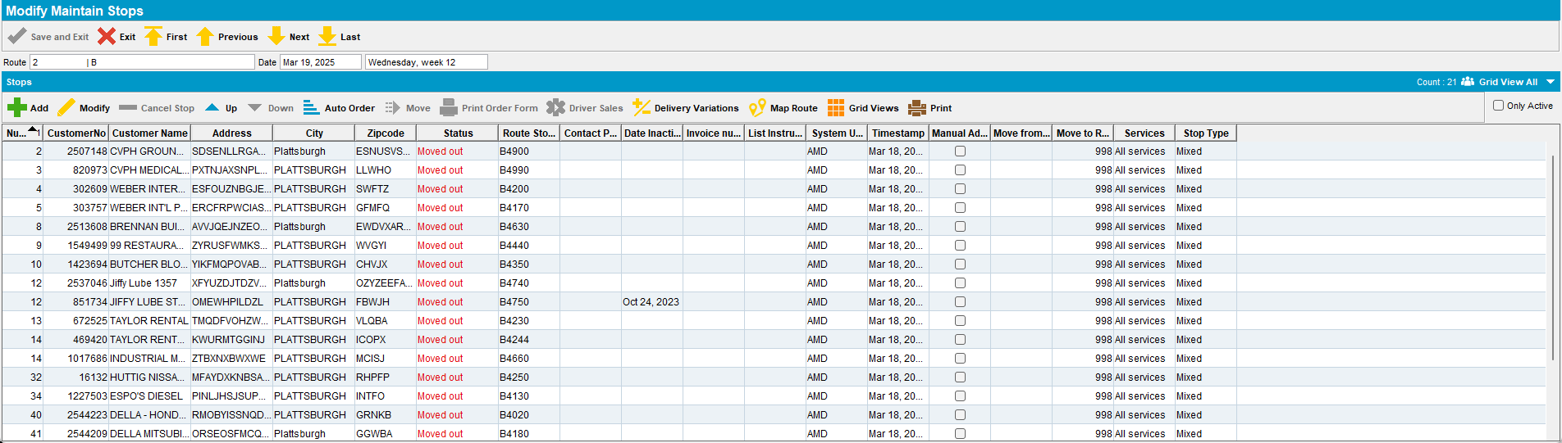

- RSC dlg: Generate Put Up Doc for the second route
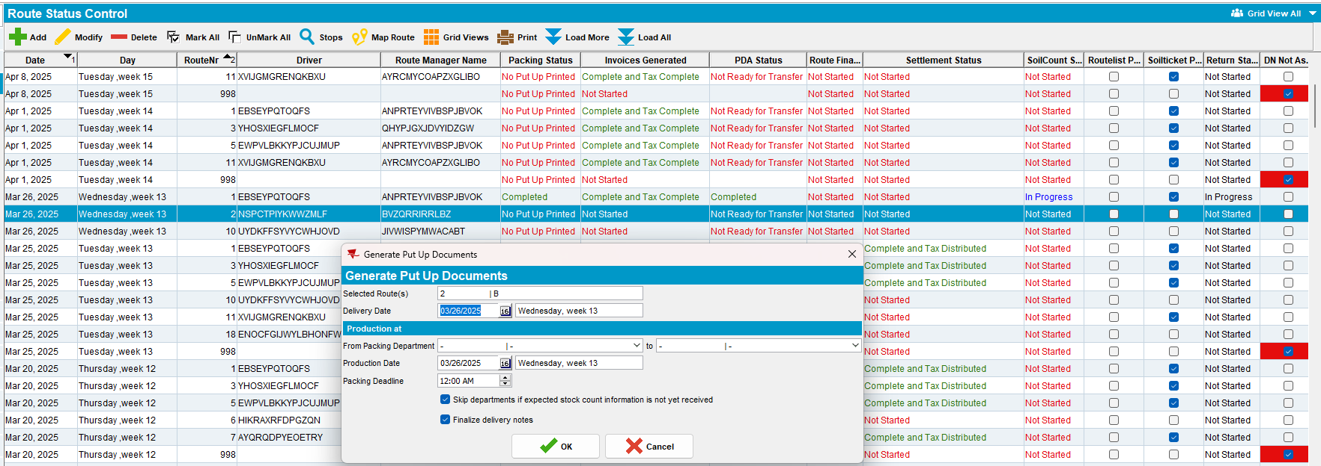
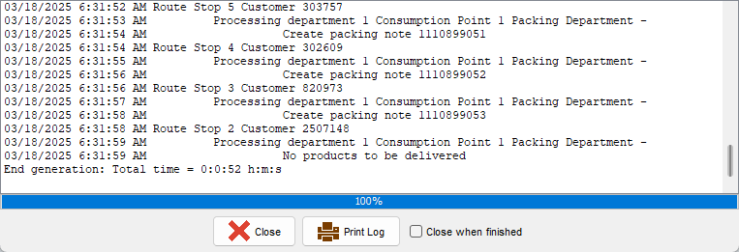

Expected Behavior: When all the stops from the previous week are moved, we should be able to generate put up docs.
Actual Behavior: When all the stops from the previous week are moved, we can generate put up docs.
TESTED OK.

Test case #2 - A stop is not moved from the previous week

- RSC dlg: Add two routes with a one-week gap between them
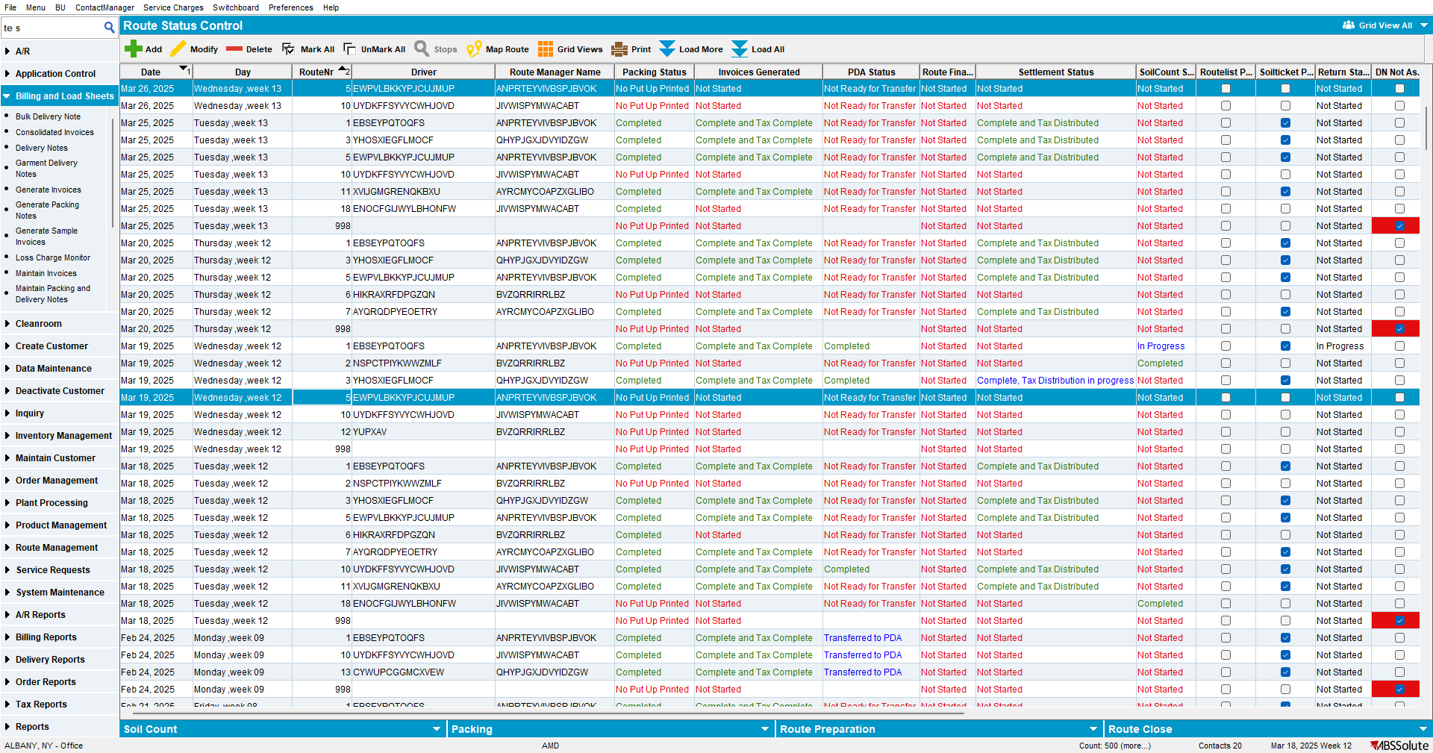

- RSC dlg: For the first route, move all the stops but one
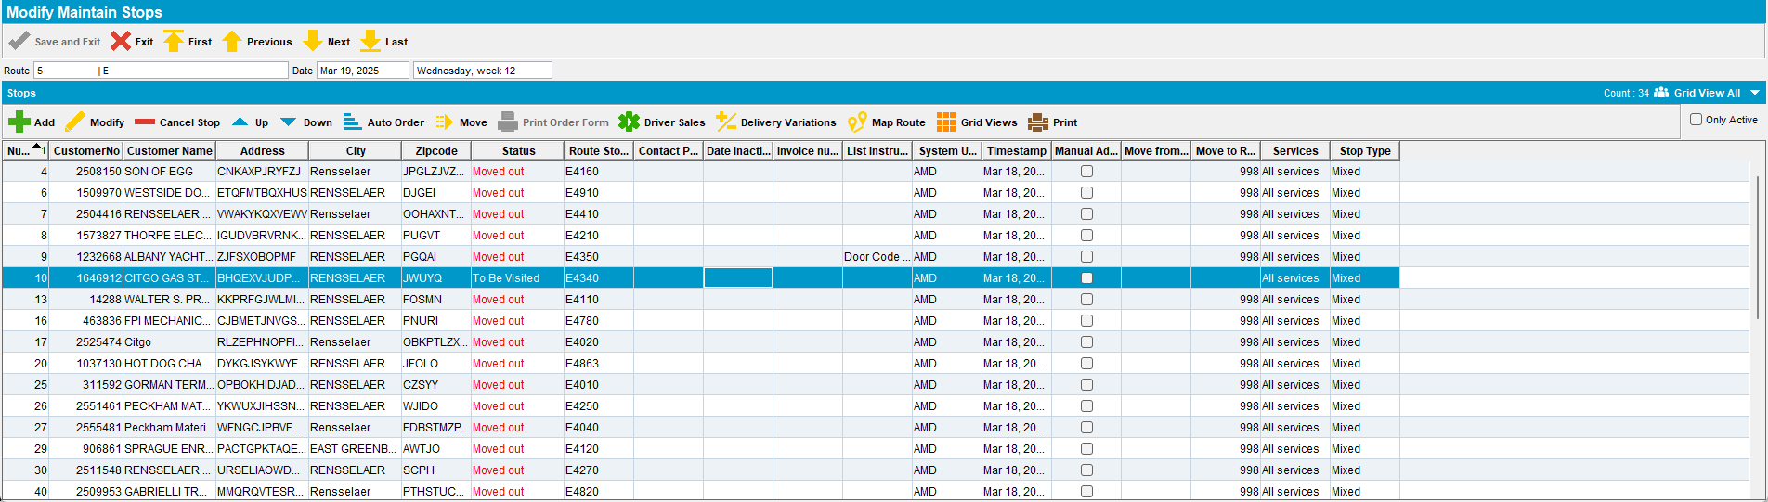

- Generate the invoices for the first route

- RSC dlg: Generate Put Up Doc for the second route
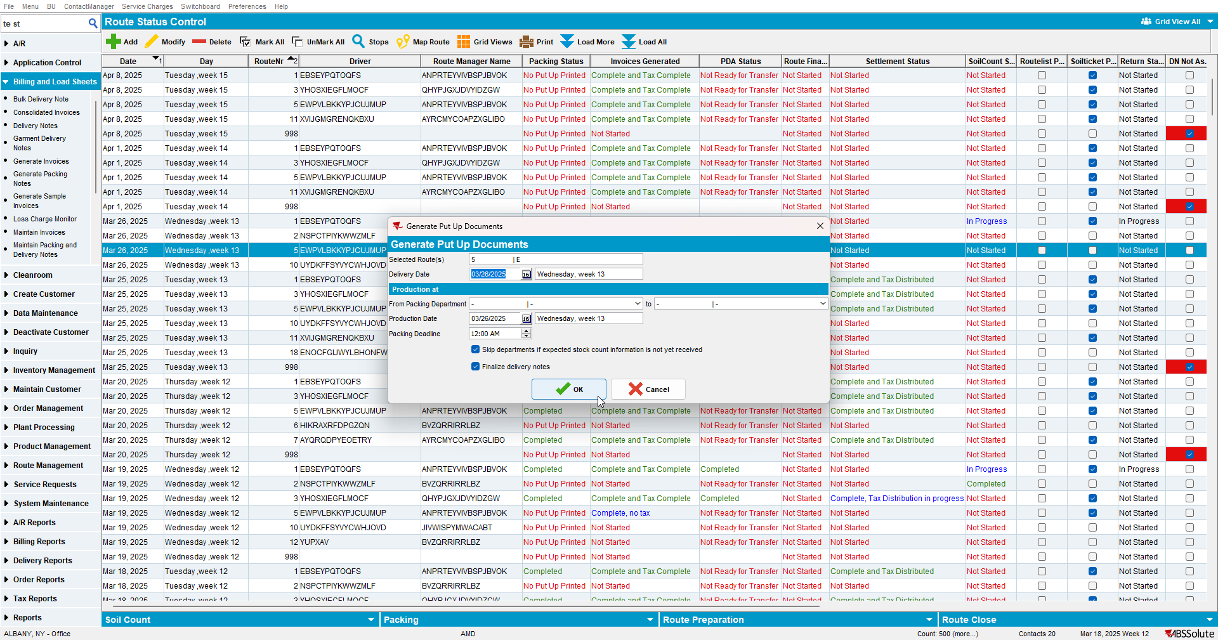
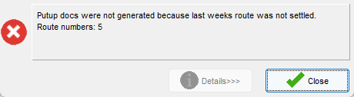

Expected Behavior: When a stop from the previous week is not moved, we shouldn’t be able to generate put up doc.
Actual Behavior: When a stop from the previous week is not moved, we aren’t able to generate put up doc.
TESTED OK.

Test case #3 - A stop is moved but has an invoice attached

- RSC dlg: Add two routes with a one-week gap between them
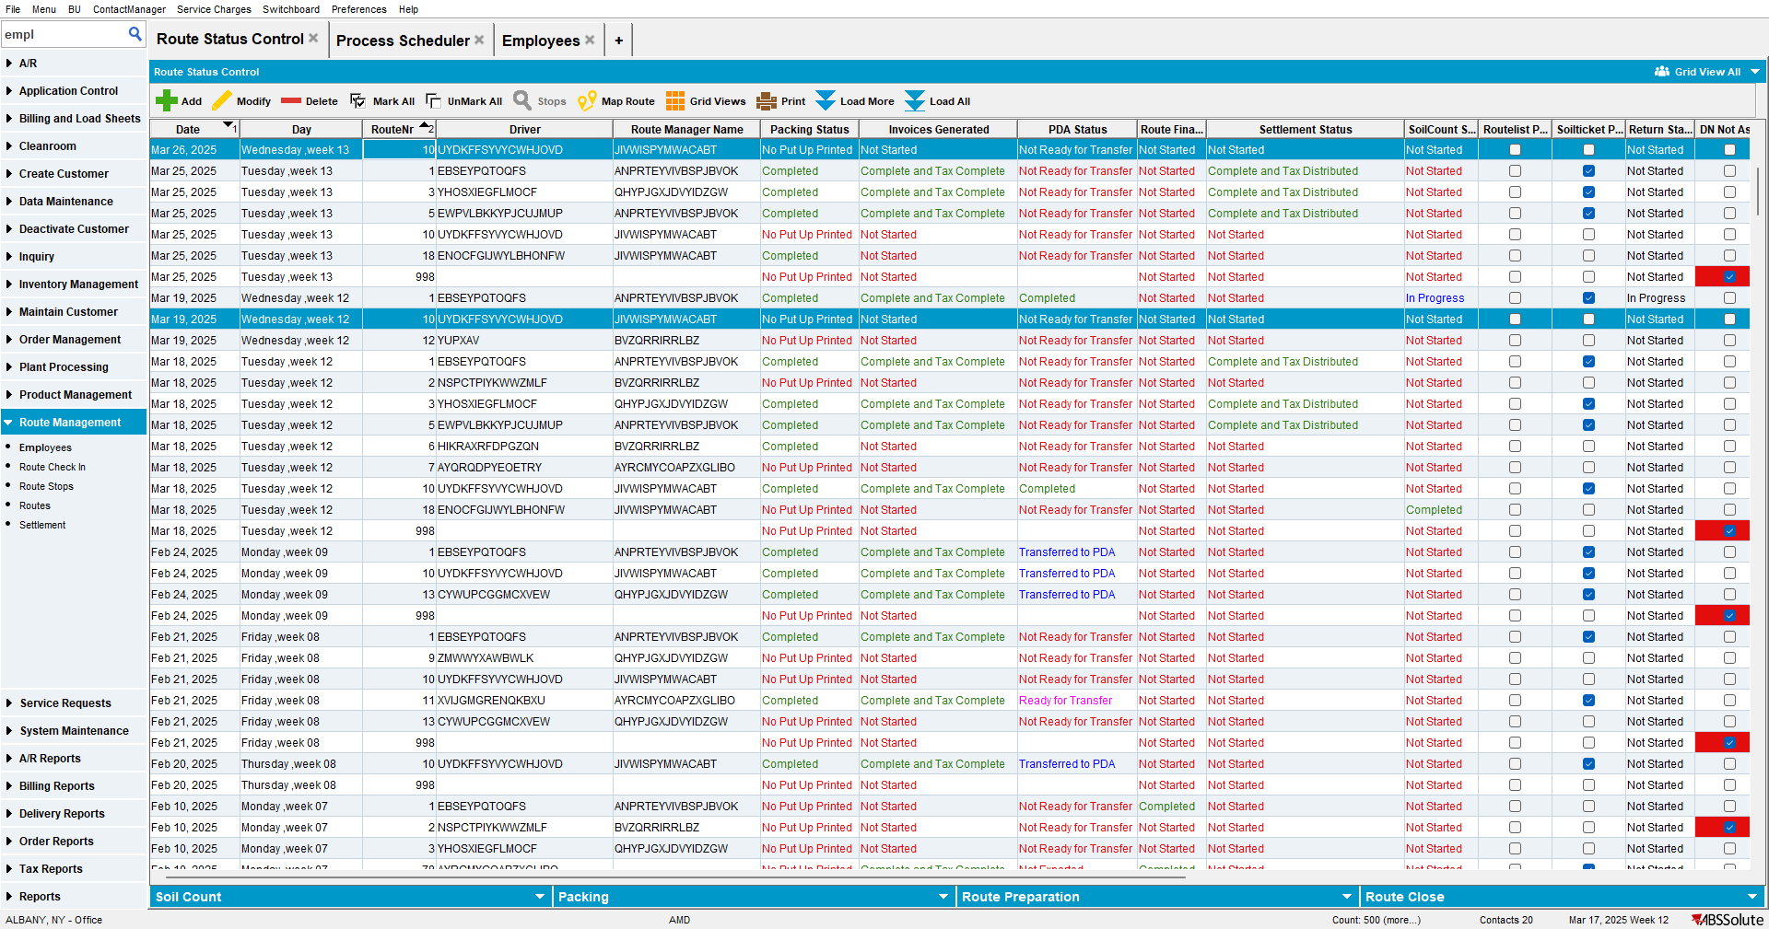

- RSC dlg: For the first route, move all the stops.
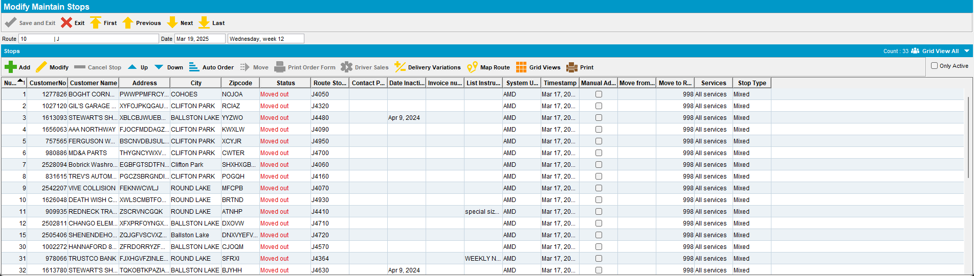

- Move a stop that has an invoice attached to the route where you just moved all the stops
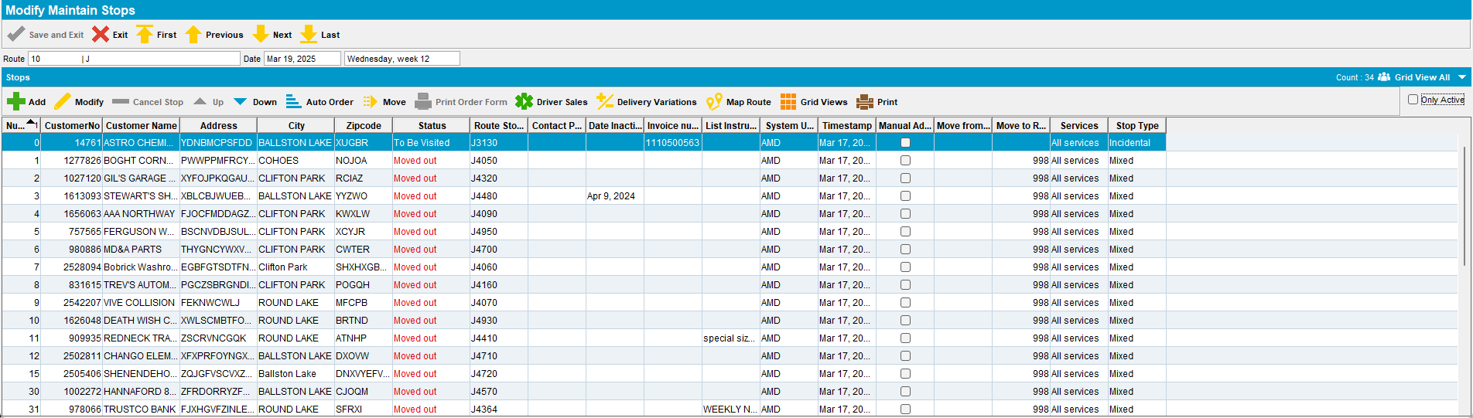

- RSC dlg: Generate Put Up Doc for the second route
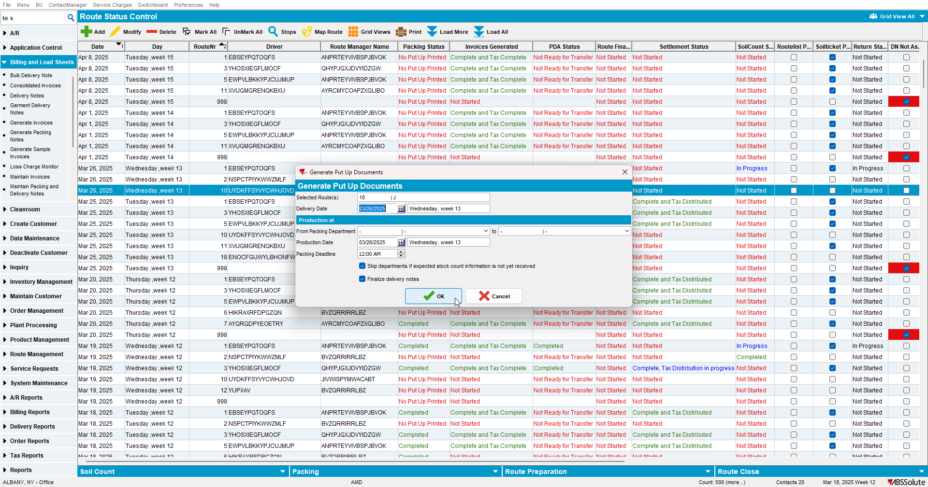
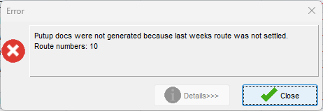

Expected Behavior: When a stop from the previous week is not moved, we shouldn’t be able to generate put up doc.
Actual Behavior: When a stop from the previous week is not moved, we aren’t able to generate put up doc.
TESTED OK.

