ABSN-3163 Manual Invoice fails to Rebill
Environment | Prerequisites
Version: 9.07.00.UNF19  DBServerName=abs-SRV20.internal.abslbs.com  DBSID=CUST24  DBUser=UNFDEV  DBPassword=UNFDEV  Environment=Test | - Module:  - System setting

Contents
Reproducing before fix 1
Steps to reproduce 1
Current behavior 5
Expected behavior 5
Retest after fix 5
Test Case 1 – Manual invoice lines are rebilled on a route where the customer has no routestop 5
Test Case 2 – Generated invoice lines are rebilled on a “B” day and then invoices are generated on a “D” day and a different “B” day 9
Test Case 3 – Generated additional invoice lines are rebilled on a route that is not a “B” day and then invoice are generated on the next “B” day 13

Reproducing before fix

Steps to reproduce
1. Find a customer that has one billing day, for example customer 907870 has one billing day on Monday route 1 on BU 025
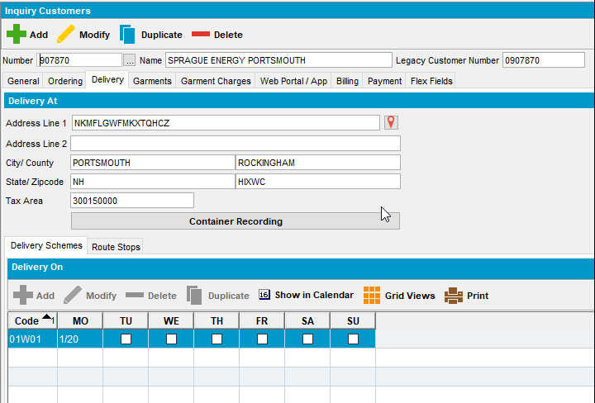
2. Create a route control for a different route on a different day for example i used route one on Friday 14-02-2025
3. Maintain Invoices DLG>Route Tab: Add a manual invoice for the Friday route on 14-02-2025
4. RSC DLG: Generate invoices for the Friday route
5. Send the route to RA
6. RA: adjust down at least one invoice lines from the manual invoice for customer 907870
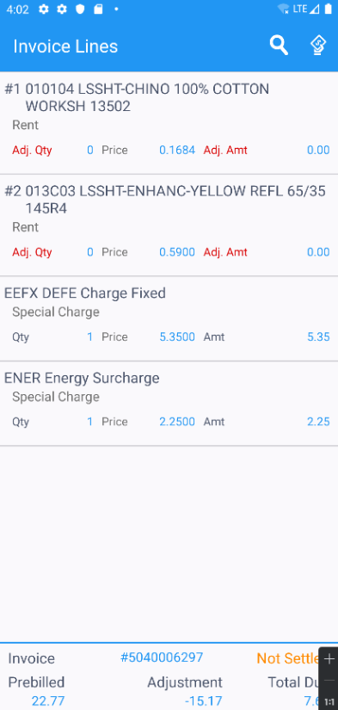
7. RA: Finish and upload the route
8. WebX: Check that your adjustments are marked down as "Rebill"
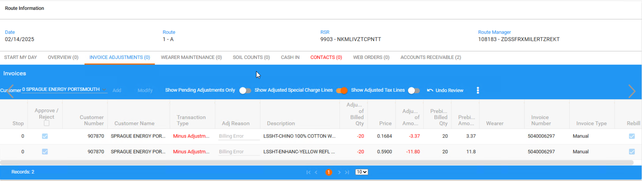
9. WebX: Settle the route
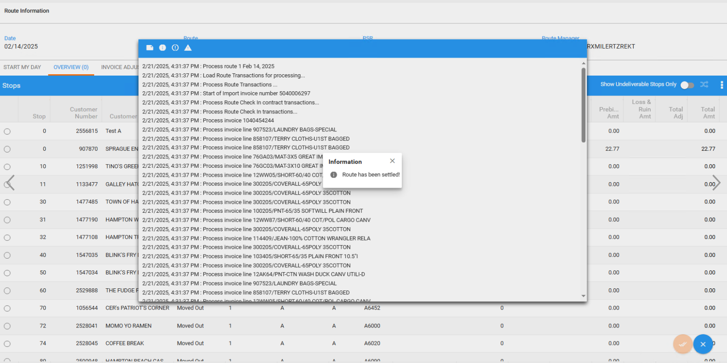
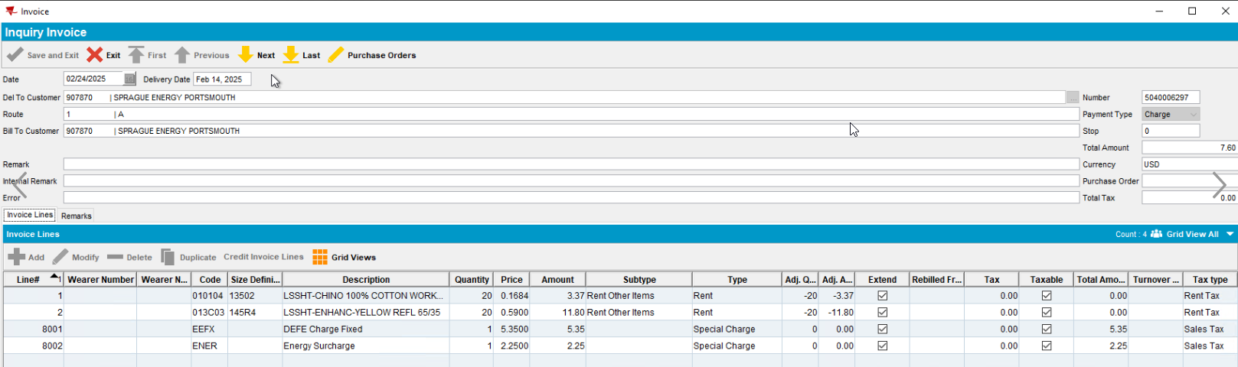
10. PLSQL/SQL Developer: Use the following select to check that the adjusted lines for the manual invoice
select ilr.*, ih.route_id from invoicelinerebill ilr
join invoiceline il on il.invoiceline_id = ilr.adjustedinvoiceline_id
join invoiceheader ih on ih.invoiceheader_id = il.invoiceheader_id
where ih.invoicenumber = 5040006297;
11. RSC DLG: Add the next Monday's route for route 1 (the billing day for customer 907870 )
12. RSC DLG: Generate invoices for the Monday's route
13. Maintain Invoices DLG: Check if the rebill lines were generated on the generated invoice
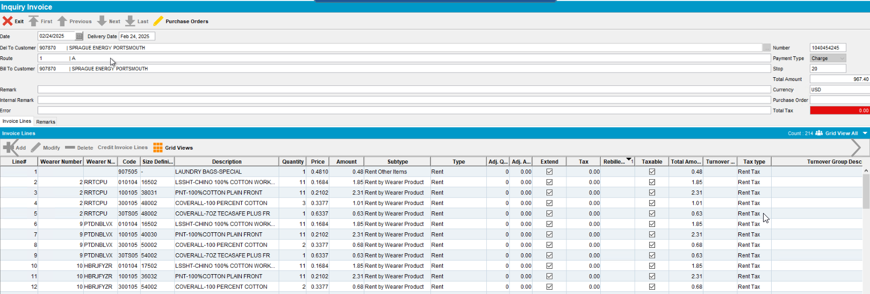

Current behavior
Currently because the original invoiceheader on which the rebills were created has a different route_id than the route control on which you are trying to generate invoices with the rebill lines

Expected behavior
Route_ID of the invoiceheader where the rebills were created should not matter when trying to determine if we should generate rebill lines.
REPRODUCED OK.

Retest after fix

Test Case 1 – Manual invoice lines are rebilled on a route where the customer has no routestop
Expected behavior: On the next “B” day for that customer we should get the rebill lines re-generated
Hash: 9.07.00.UNF19 hash: 549daf544512
- Generate a Manual Invoice for a customer with a single “B” day
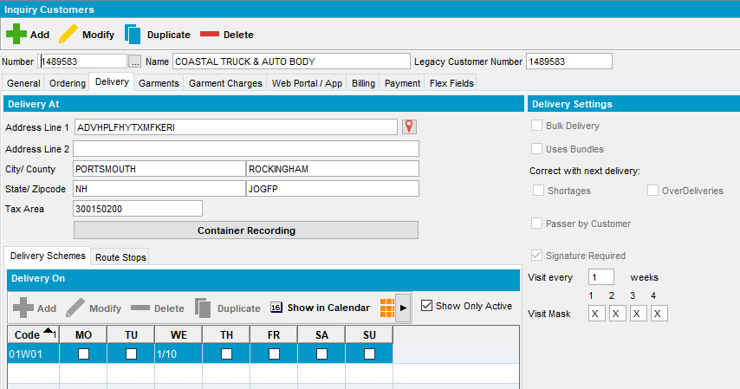
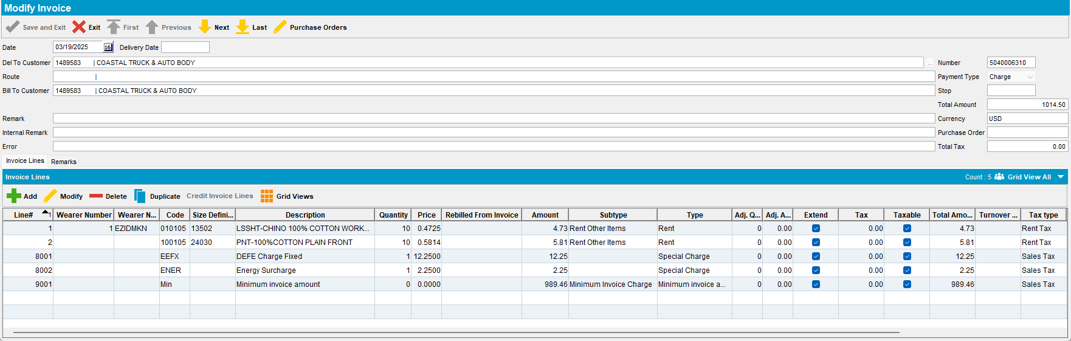
- Route Status Control DLG: Add a route where the customer has no billing day, in this case Monday 24th of March, route 6
- Maintain Invoices DLG>All: Assign the manual invoice to the route from the previous step
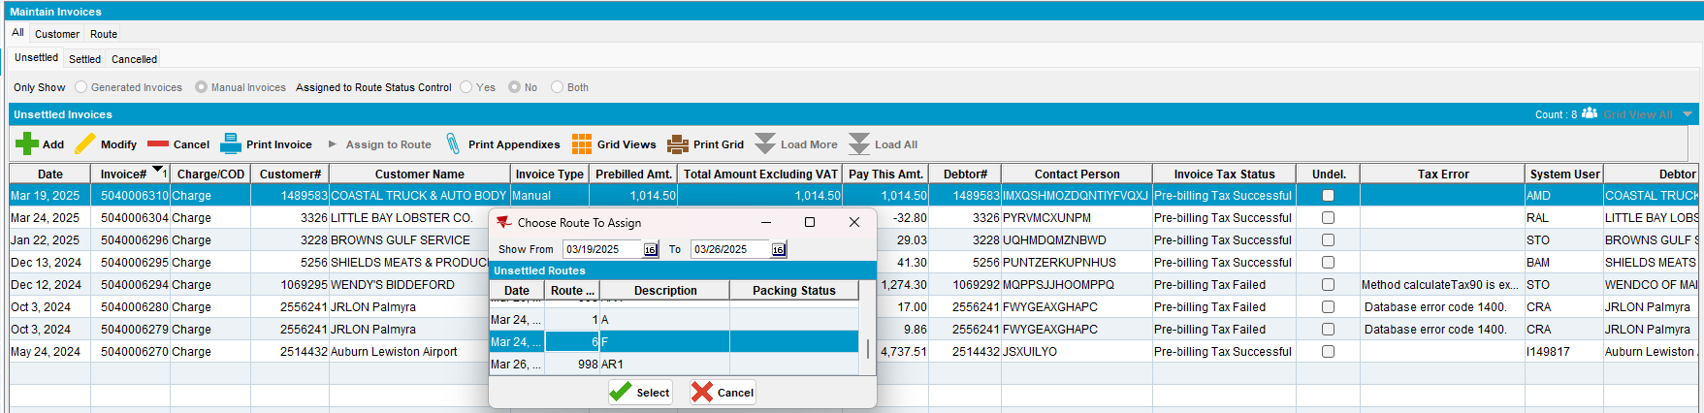
- Route Status Control DLG: Generate Packing notes and then invoices for route 6 on 24th of March
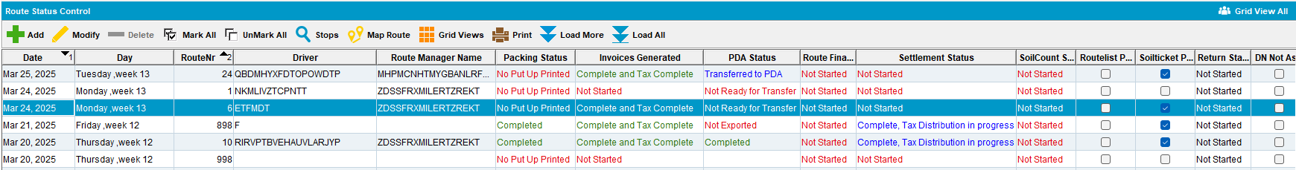
- RA: download the route
- RA: arrive at the customer with the manual invoice and credit both invoice lines one partially and one fully
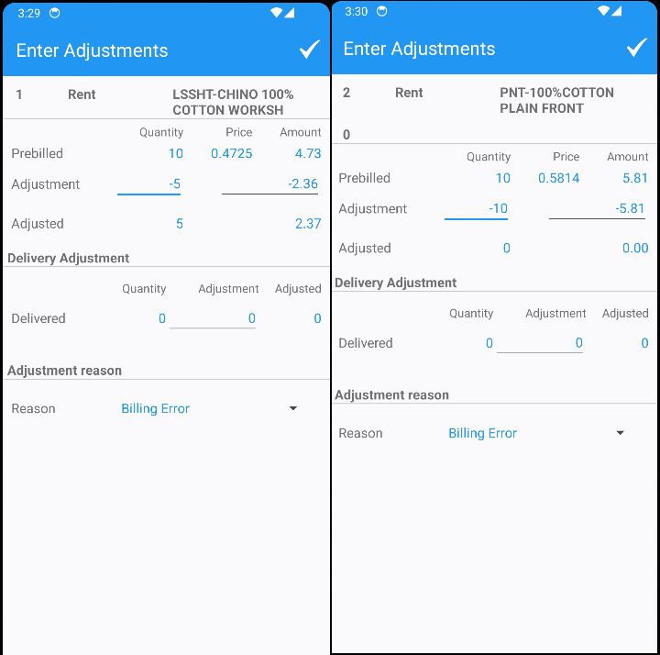
- RA: Settle and upload the route back to the server
- WebX: check that the 2 adjustments on the manual invoice have the Rebill checkbox checked
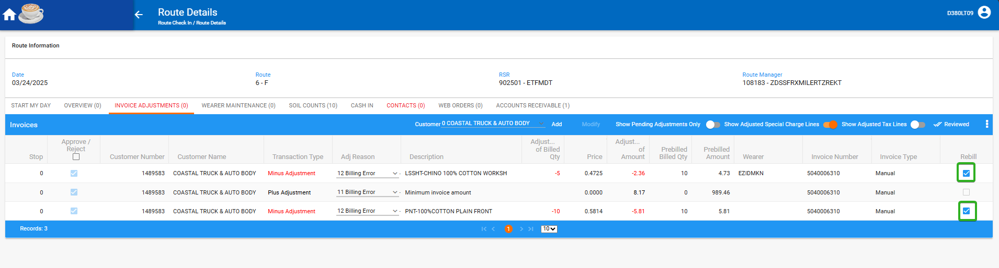
- WebX: Settle the route
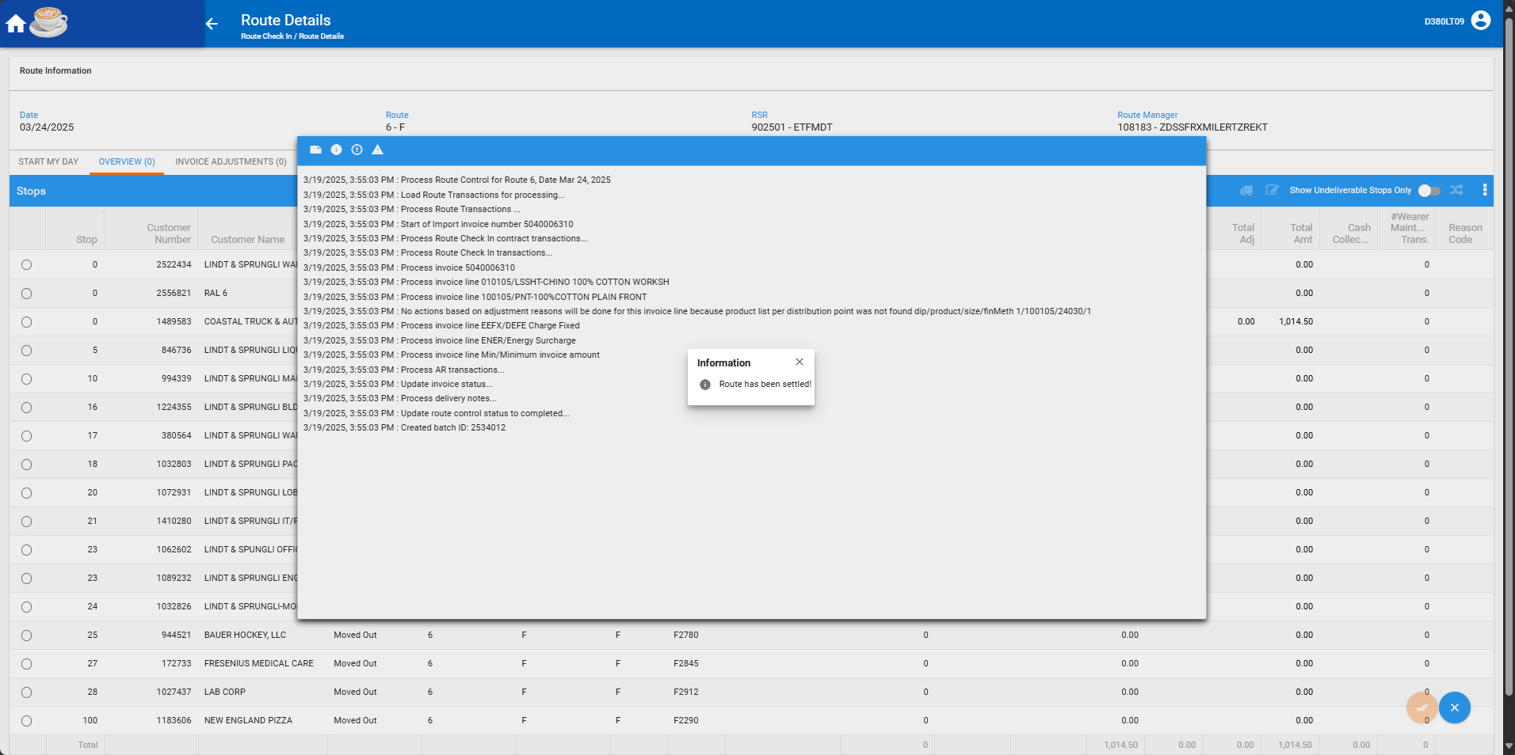
- Check that the invoicelinerebill table has the two entries related to the rebill lines
select ilr.*, ih.route_id from invoicelinerebill ilr
join invoiceline il on il.invoiceline_id = ilr.adjustedinvoiceline_id
join invoiceheader ih on ih.invoiceheader_id = il.invoiceheader_id
where ih.invoicenumber = 5040006310;
- Route Status Control DLG: Generate invoices for the March 2nd route 1 which is a “B” day for our customer
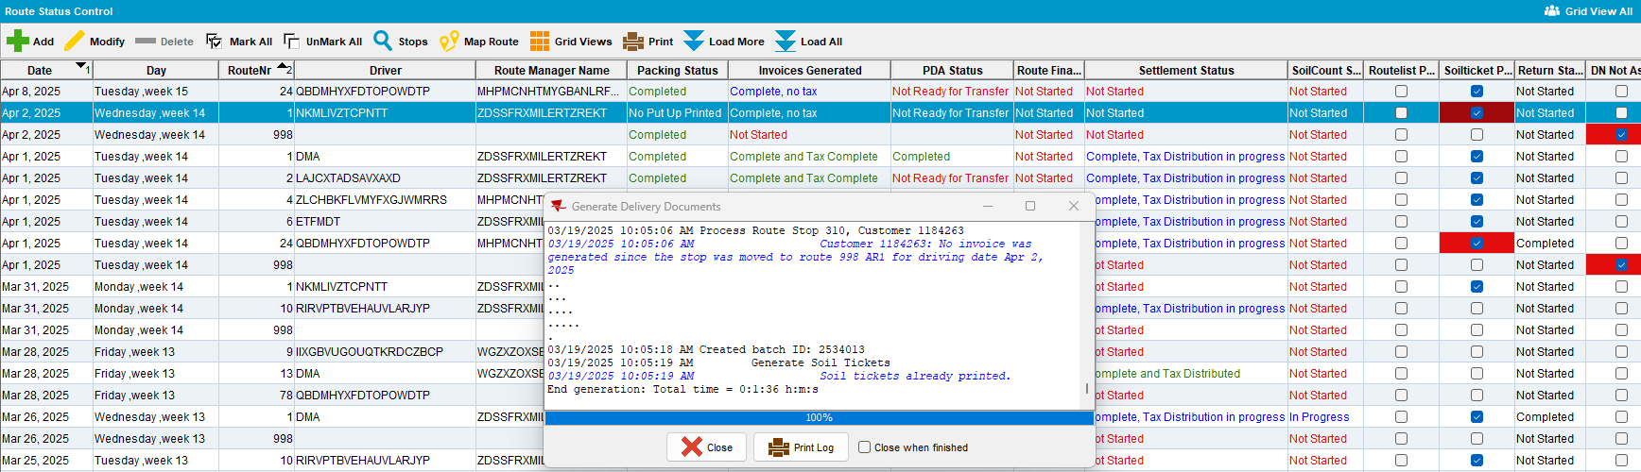
- Maintain Invoices DLG: Verify that the two invoice lines that were adjusted from the manual invoice have been rebilled
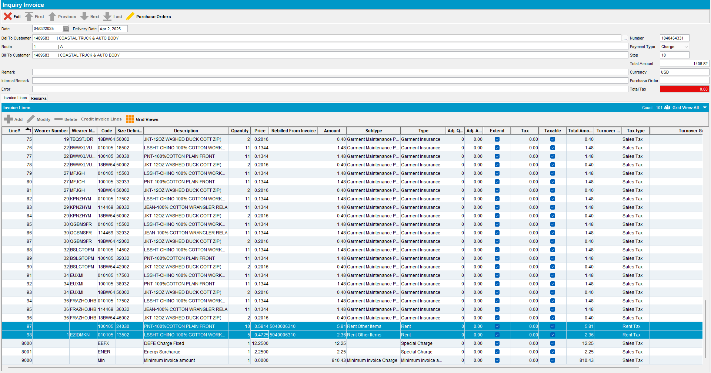
Tested OK

Test Case 2 – Generated invoice lines are rebilled on a “B” day and then invoices are generated on a “D” day and a different “B” day
Expected behavior: On the second “B” day the rebilled invoice lines are re-generated but not on a “D” day
Hash: 9.07.00.UNF19 hash: 549daf544512
- Customer DLG: Find a customer and make sure it has 2 “B” days and one “D” day
SELECT DISTINCT c.customer_id, cd.*, c.*
FROM customer c
JOIN customerdeliveryday cd ON cd.customer_id = c.customer_id
WHERE c.customer_id IN (
SELECT customer_id
FROM customerdeliveryday
WHERE deliverytype IN ('B', 'D')
GROUP BY customer_id
HAVING
SUM(CASE WHEN deliverytype = 'B' THEN 1 ELSE 0 END) >= 2
AND SUM(CASE WHEN deliverytype = 'D' THEN 1 ELSE 0 END) >= 1)
AND C.DEFAULTBUSINESSUNIT_ID = (SELECT BU.BUSINESSUNIT_ID FROM BUSINESSUNIT BU WHERE BU.CODE = '025');
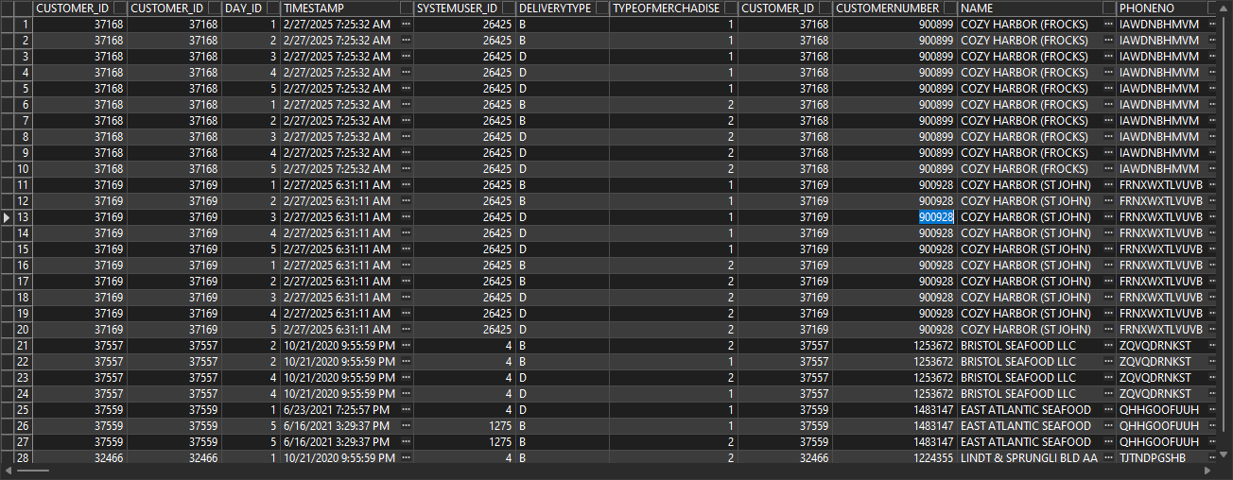
Modify the delivery scheme to have 2 billing days
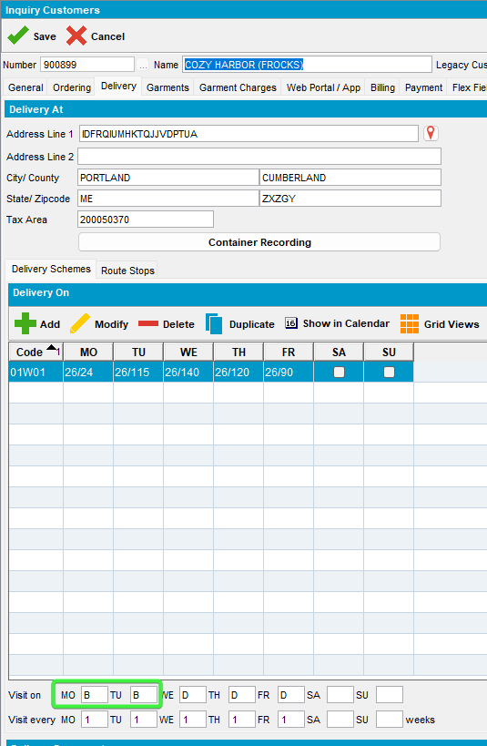
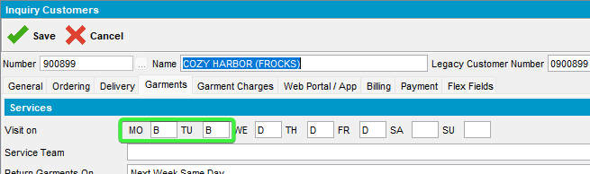
- Route Status Control DLG: Generate invoices for this customer on the first available Monday on Route 26
- RA: Download the route and arrive at the customer. Make some adjustments on 2 rent lines, one full credit the other one partial credit.
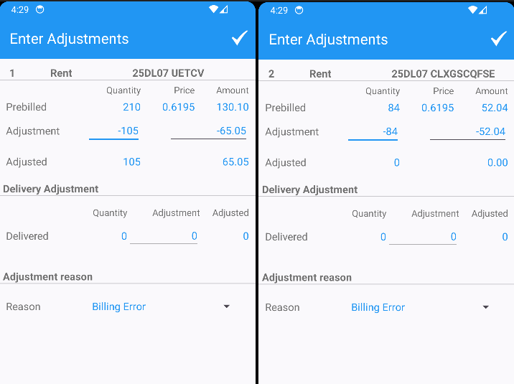
- RA: Settle, finish and upload the route back to the server
- WebX: Verify that the invoice adjustments created on RA have been marked for rebill
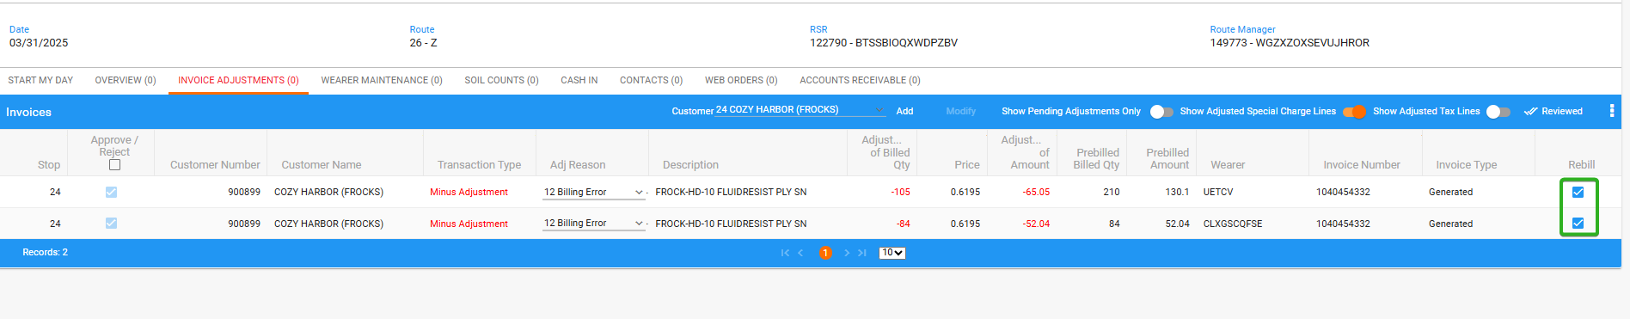
- WebX: Settle the route
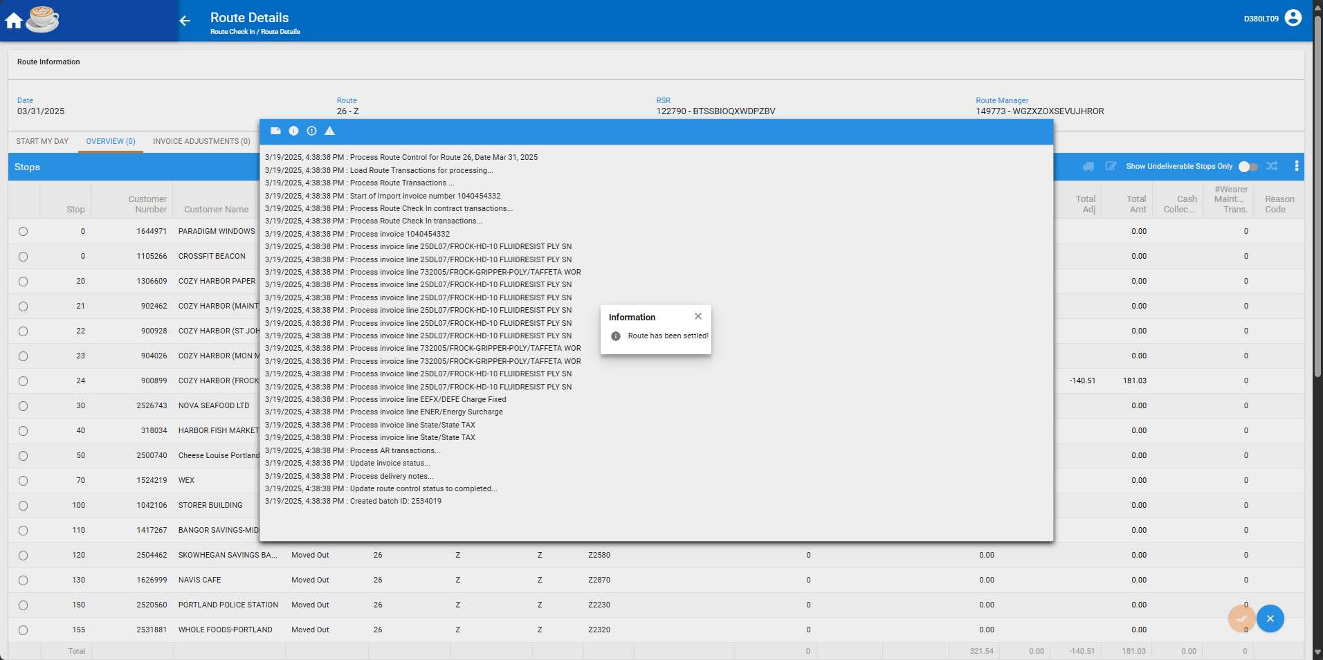

- Check that the invoicelinerebill table has the two entries related to the rebill lines
select ilr.*, ih.route_id from invoicelinerebill ilr
join invoiceline il on il.invoiceline_id = ilr.adjustedinvoiceline_id
join invoiceheader ih on ih.invoiceheader_id = il.invoiceheader_id
where ih.invoicenumber = 1040454332;
- Route Status Control DLG: Add the next D delivery route 26 for Wednesday, 2nd of April 2025
- Route Status Control DLG: Generate invoices for this route
- Maintain Invoices DLG: Check that the Rebill lines are not there
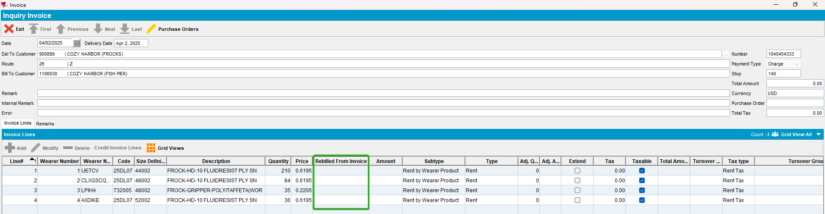
- Route Status Control DLG: Add the next route 26 for the next week’s Tuesday (8th of April, the other “B” day for this customer)
- Route Status Control DLG: Generate invoices for this route
- Maintain Invoices DLG: Check that the invoice generated for the other “B” day (the 8th of April) has the rebill lines on it
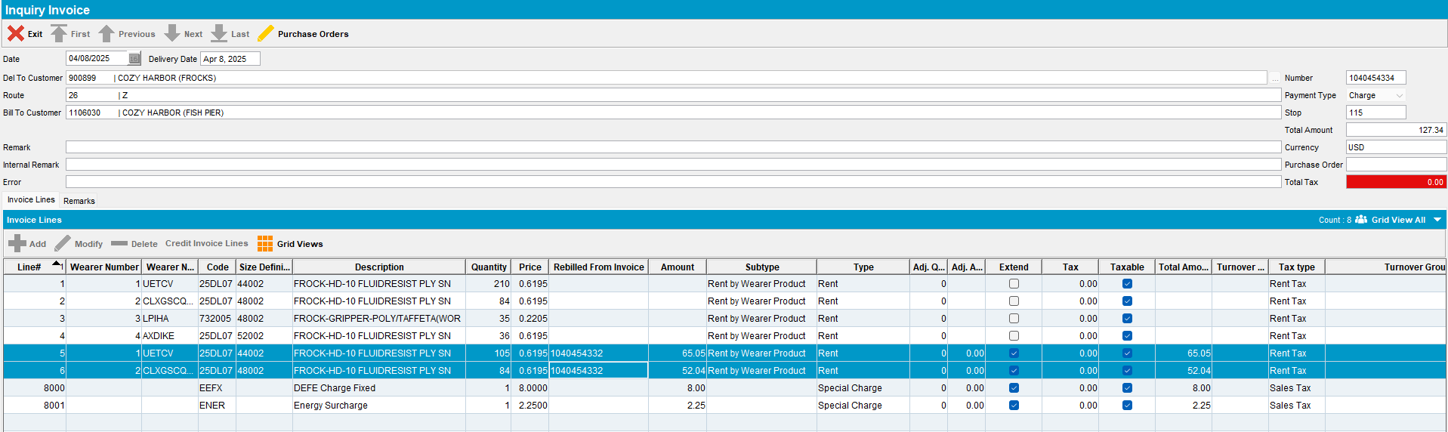
Tested OK

Test Case 3 – Generated additional invoice lines are rebilled on a route that is not a “B” day and then invoice are generated on the next “B” day
Expected behavior: On the “B” day the delivery note is attached and a new generated additional invoice is generated with the rebill invoicelines
Hash: 9.07.00.UNF19 hash: 549daf544512
- Customers DLG: Find a new customer with one “B” day
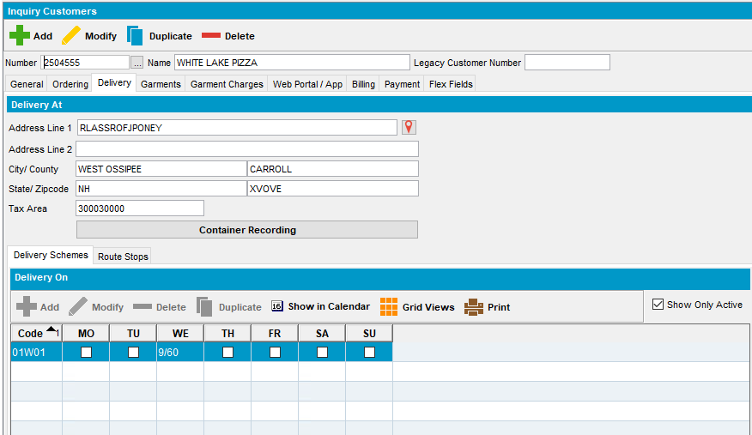
- Maintain Sales Notes DLG: Add a sales order for this customer
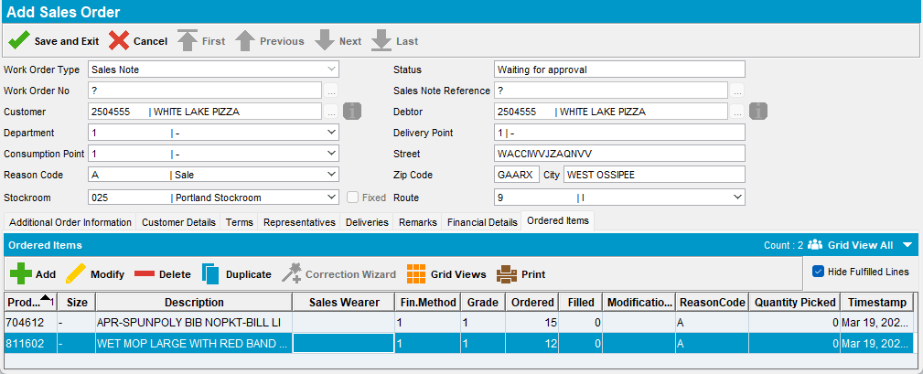
- Work Orders Waiting for Approval DLG: Approve the order
- Maintain Sales Notes DLG: Issue all items and generate delivery note for a different day than one of the customer’s “B” days
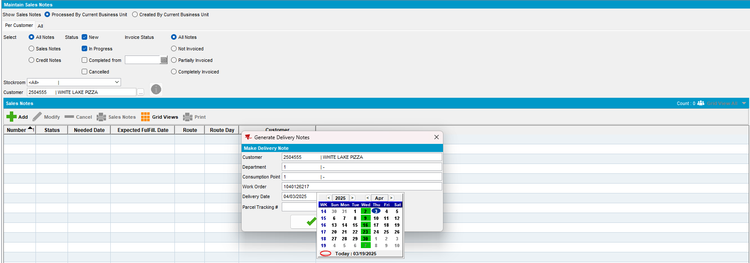
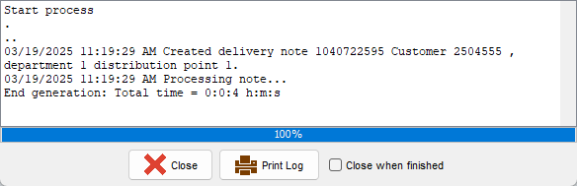
- Route Status Control DLG: Add a route on a non-billing day for your customer like 4th of April, Friday route number 13
- Route Status Control DLG: Add an incidental stop for the Friday route for your customer
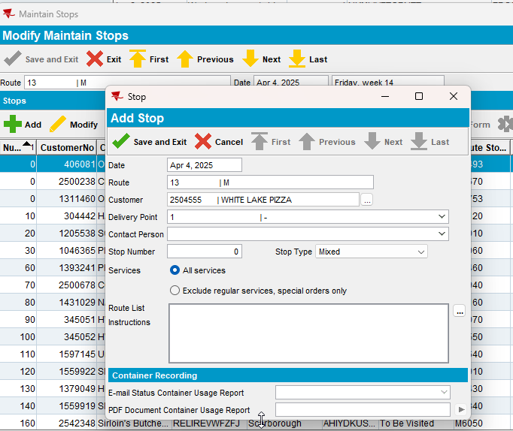
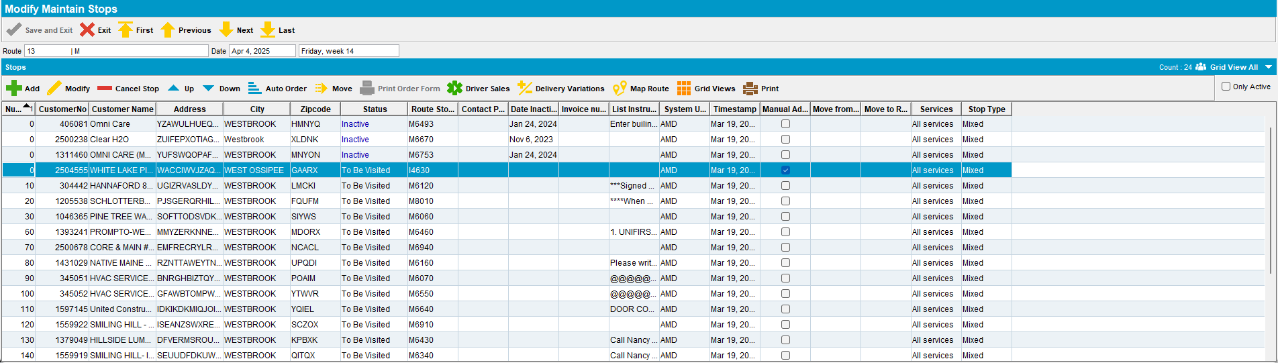
- Route Status Control DLG: Packing> View Packing and Delivery notes: Assign not linked sales note to this route
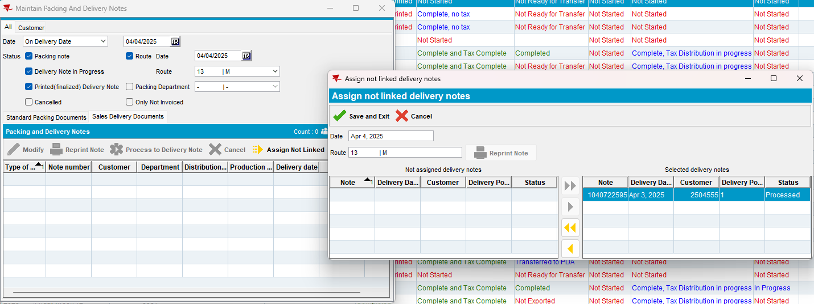
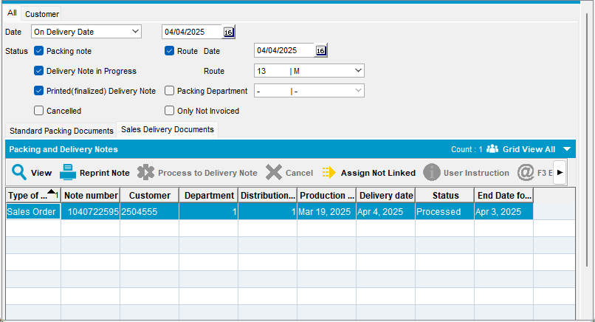
- Route Status Control DLG: Generate packing notes and invoices for this route
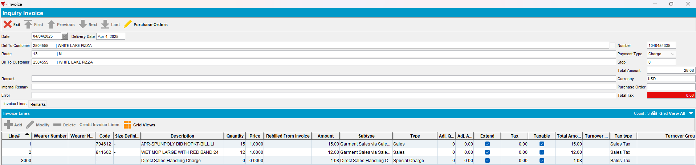
- Route Status Control DLG: Send route to RA
- RA: Full credit the generated additional invoice
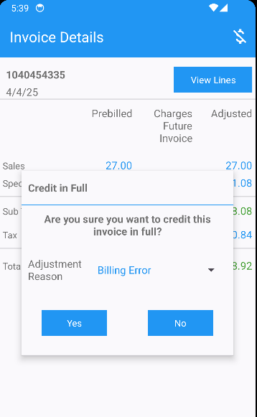
- RA: Finish the route and upload the data back to the server
- WebX: Complete the Start my Day.
- WebX: Verify that the invoice line adjustments for the Generated Additional invoice are present. Mark for rebill 2 of the lines.
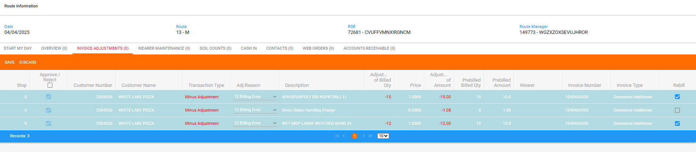
- WebX: Settle the route
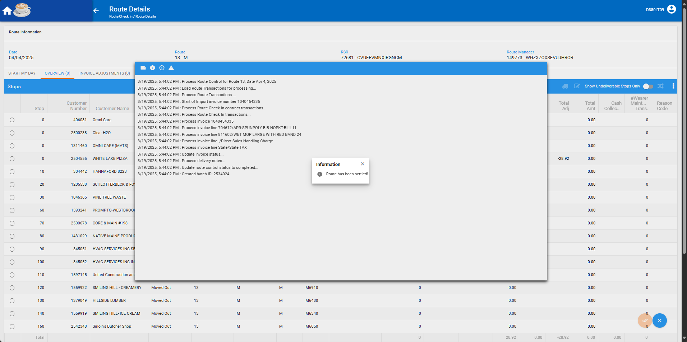
- Maintain Sales Notes DLG: Find the Sales Order and verify that there’s a new delivery note generated
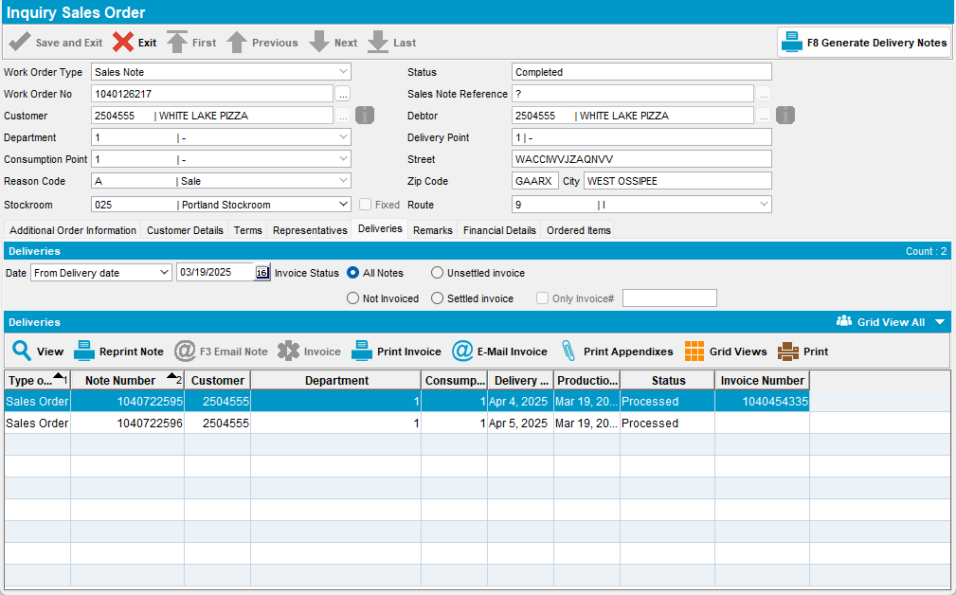
- Route Status Control DLG: Add the next “B” day route for this customer, 9th of March, route number 9
- Route Status Control DLG: Assign the not linked delivery sales note that was just generated for rebill
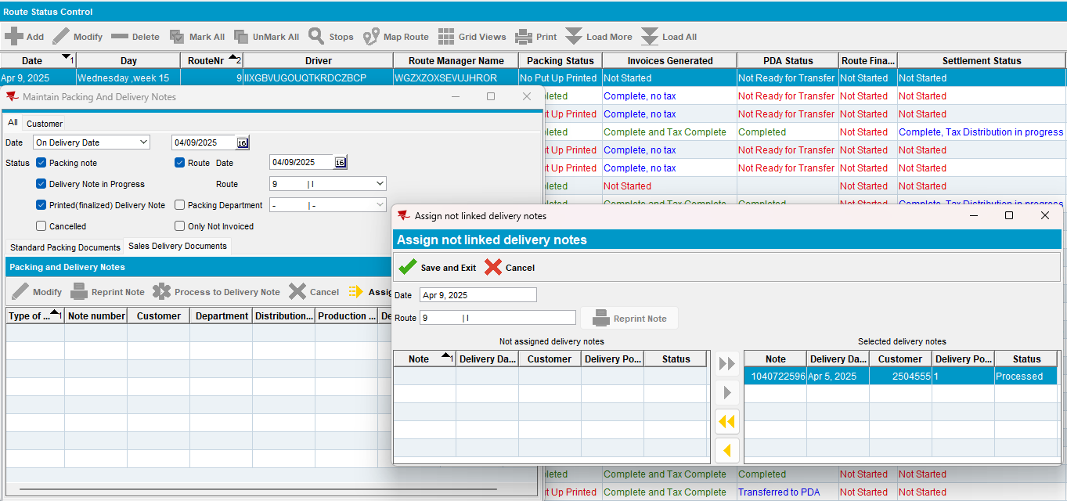
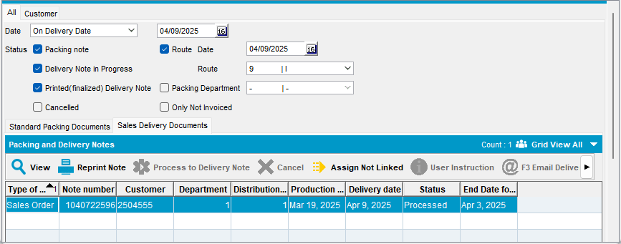
- Route Status Control DLG: Generate invoices for this route
- Maintain Invoices DLG: Verify that the Generated Additionally invoice with the rebill lines was generated
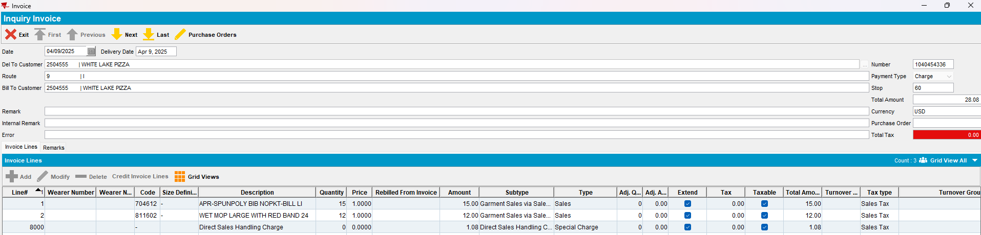
Tested OK

