ABSN-3065 WebX - Web Orders tab counter not working showing zero
Environment | Prerequisites
Version:9.09.01  DBServerName= abs-srv16.internal.abslbs.com  DBSID=CUST24  DBUser=UNFA  DBPassword=UNFA  Environment=PRODUCTION | - Module:  - System setting:

Reproduction before fix
9.07.00.UNF17.p01 hash: 68e5465326a2
BU: 288 RICHMOND, VA
UNFDEV@CUST24
Customer: 1493302
Route: 10 / Date: 20 February 2025

Steps to reproduce:
- Wearers dlg: Make some replacements on some wearers with "woDeliverFrom": 4, using the below command.
{
"businessUnitCode": "288",
"customerNumber": 1493302,
"emblemTemplateCode": "109973",
"newFinishingMethodCode": "1",
"newProductCode": "100205",
"newSizeCode": "34028",
"productCode": "100205",
"sizeCode": "34028",
"webServiceLogID": 12,
"sequenceNumber": 1,
"wearerNumber": 2,
"woCustomerOwned": false,
"woDeliverFrom": 4,
"woReasonCode": "E",
"woReferenceNumber": "RestWebApiRefference",
"woRemark": "TESTwEB",
"workstationCode": "15603"
}

- Wearers dlg: Check the wo status.
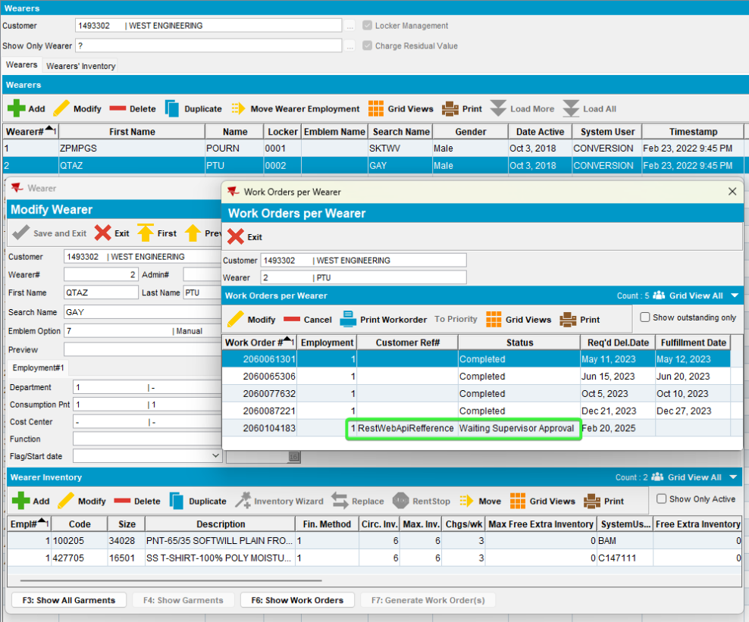
- Check the wo statuses
select wo.deliverfrom, sd.description, wo.reasoncode_id, rc.code, rc.internetselectable, s.code, wo.* from workorder wo
join status_desc sd on sd.status_id = wo.status_id
join reasoncode rc on rc.reasoncode_id = wo.reasoncode_id
join status s on s.status_id = wo.status_id
where wo.workordernumber in (2060104183, 2060104184);

- RSC dlg: Add the route visiting the customer, generate invoices and send it to RA.
- RA: Settle the route and upload it.
- WebX: Check the WebOrders for the replacements.
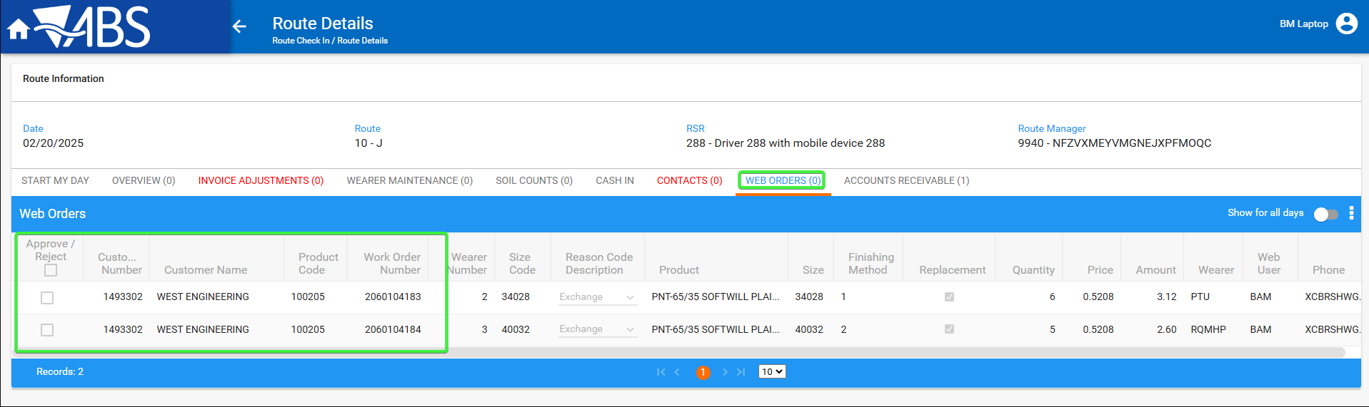

Current behavior:
Web Orders tab counter not working showing zero

Expected Behavior:
Web Orders tab counter should show the number of web orders lines.
REPRODUCED OK

Retest after fix
Bu: 025 PORTLAND, ME
9.07.00.UNF19 hash: e4ea4aab85bb

Test steps:
- Wearers dlg: Make a replacement on wearer inventory.
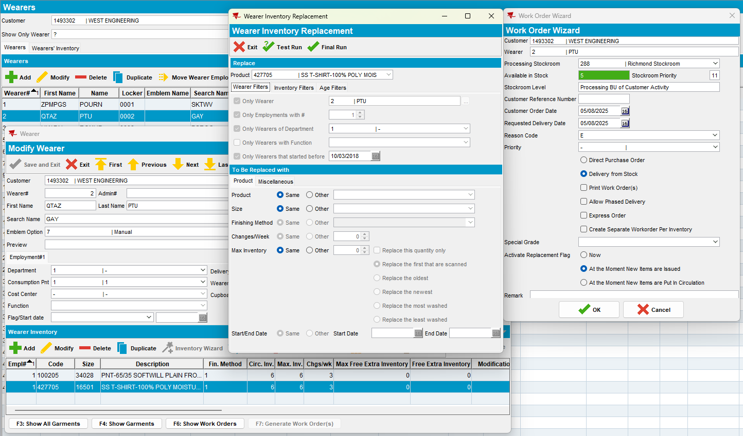
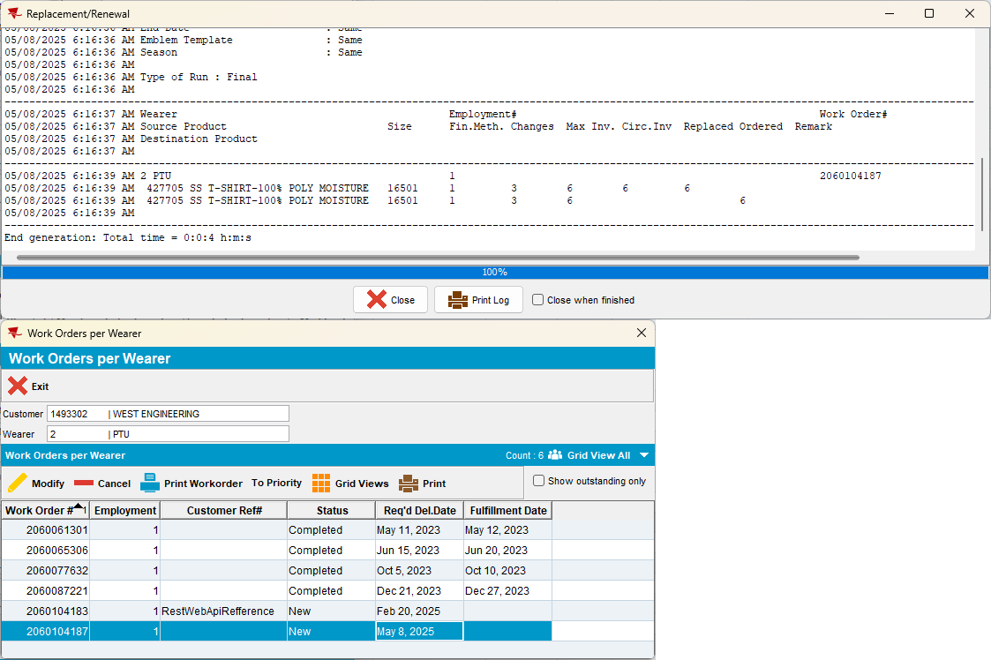
- Wearers dlg: Add a new wearer inventory on a new wearer.
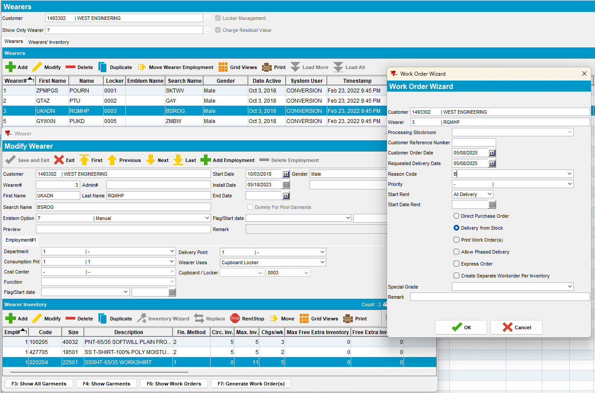
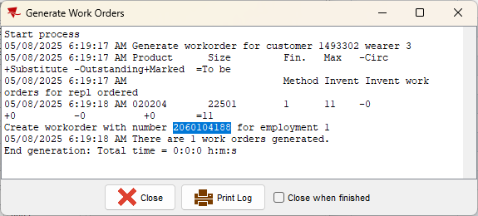

- PLSQL: check the wo.origin
select wo.status_id, wo.origin, wo.deliverfrom, sd.description, wo.reasoncode_id, rc.code, rc.internetselectable, s.code, wo.* from workorder wo
join status_desc sd on sd.status_id = wo.status_id
join reasoncode rc on rc.reasoncode_id = wo.reasoncode_id
join status s on s.status_id = wo.status_id
where wo.workordernumber in (2060104187, 2060104188);

- Change the status_id to 18
update workorder wo set wo.status_id = 18
where wo.workordernumber in (2060104187, 2060104188);

- Change one of the wo origin to 3 = Created by web module.
update workorder wo set wo.origin =3
where wo.workordernumber = 2060104187;

- Re-check the wo
- RSC dlg: Add a new route where our customer is visited and generate packing notes.
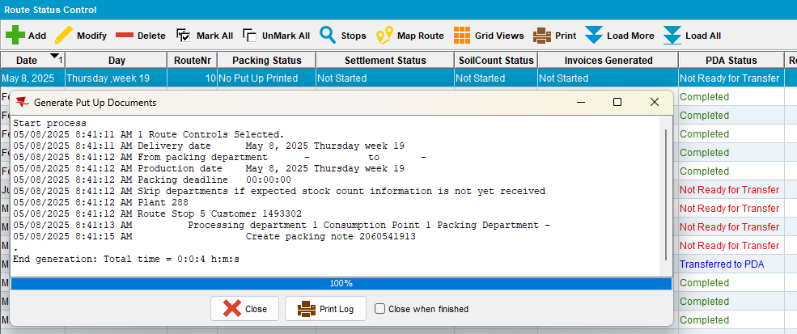
- WebX: Load that route and check the Web Orders tab
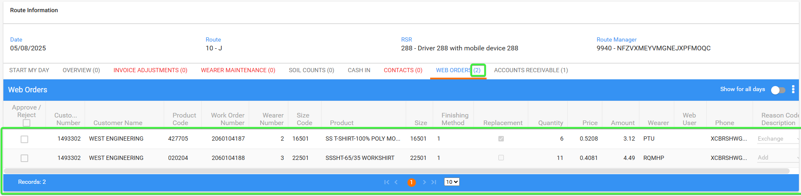
Accounts receivable
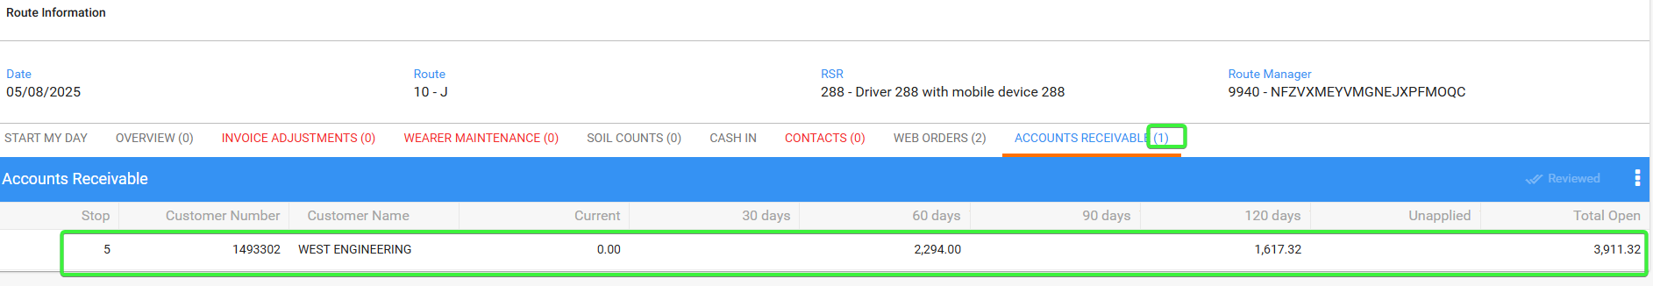
Contacts
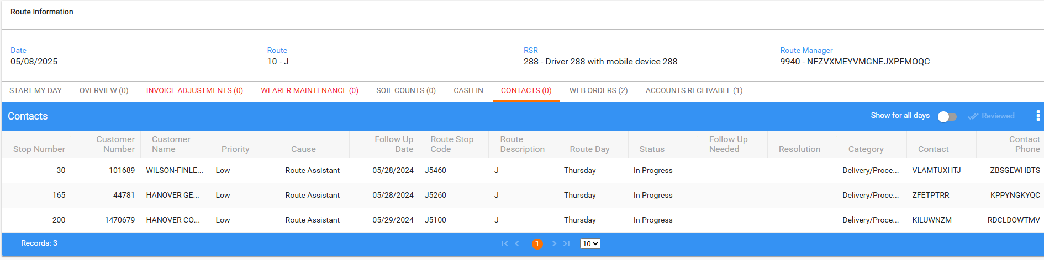
Soil Counts
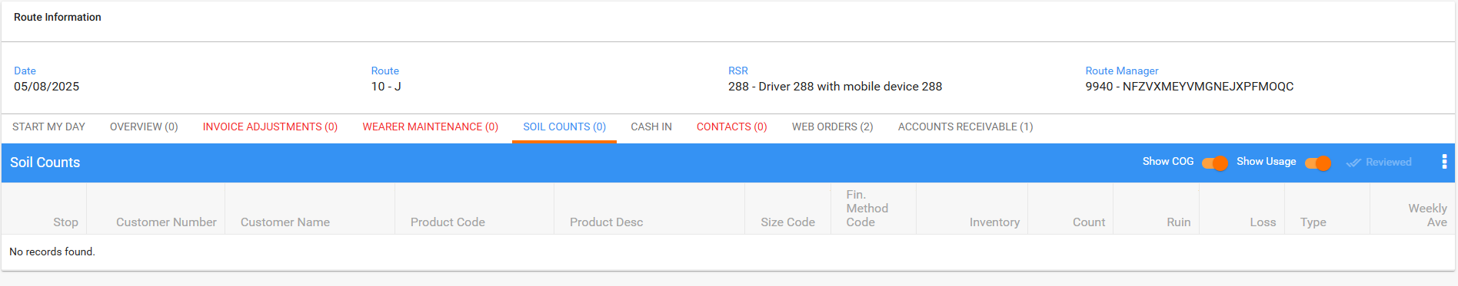
Wearer maintenance
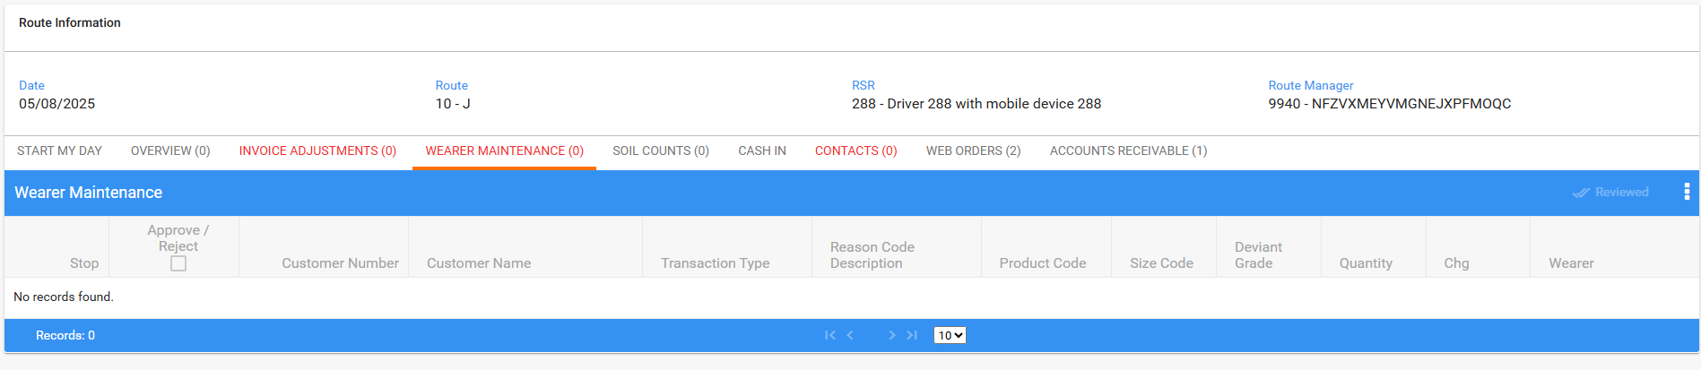
Invoice adjustments
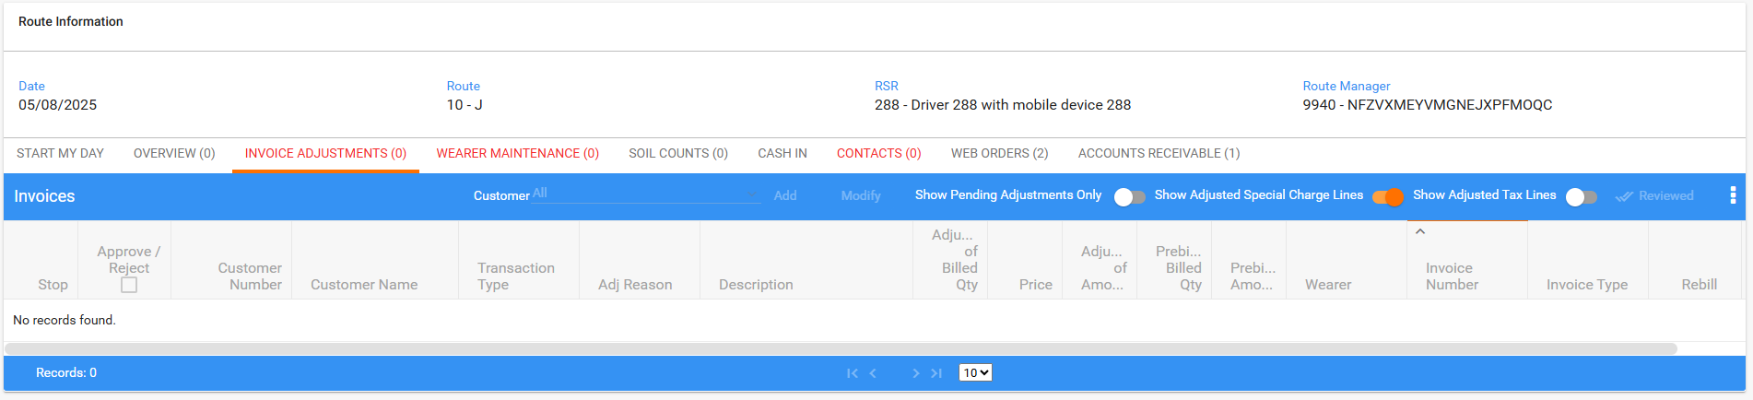
- RSC dlg: Generate invoices and send the route through the RA.
- RA: Download the route and arrive at the customer.
- Add a new message
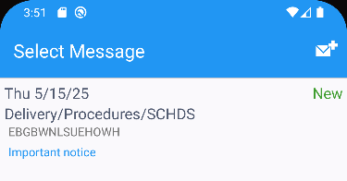
- Add a new contact person
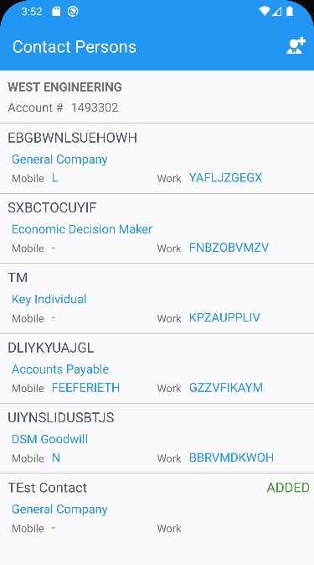
- Make a minus adjustment
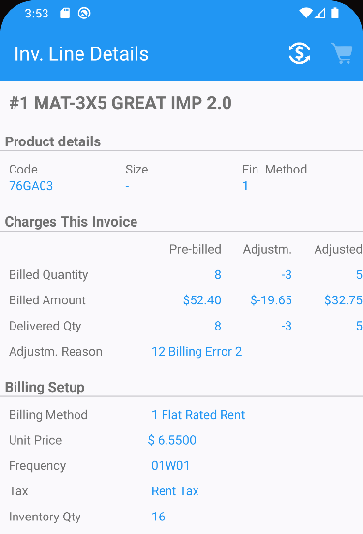
- Make a plus adjustment
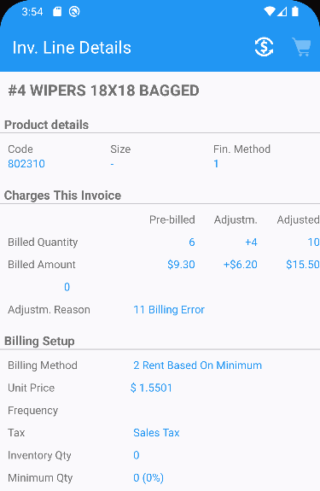
- Increase a wearer inventory
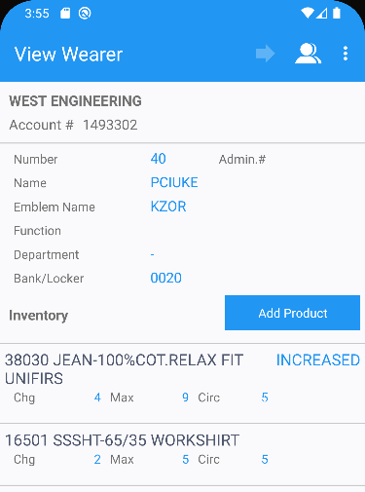
- Decrease another wearer inventory
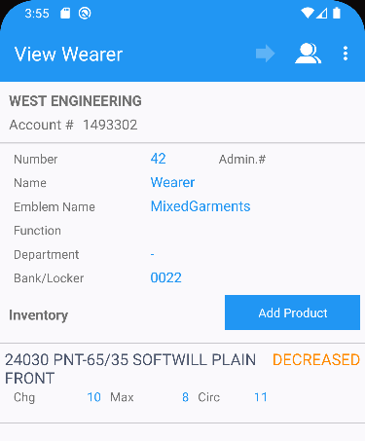
- Style exchange
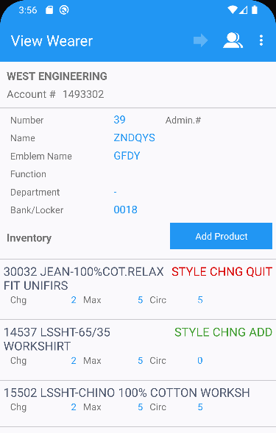
- Quit wearer inventory
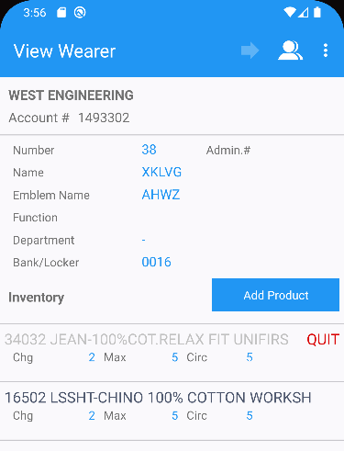
- Quit a wearer
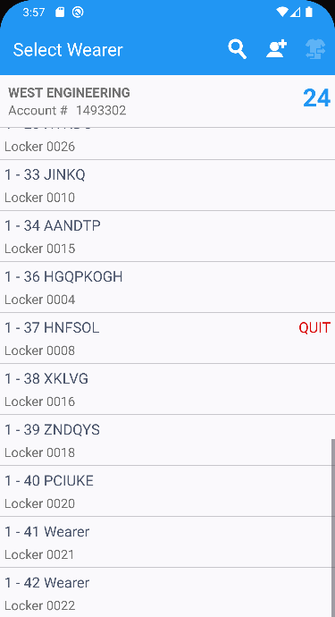
- Add soil count
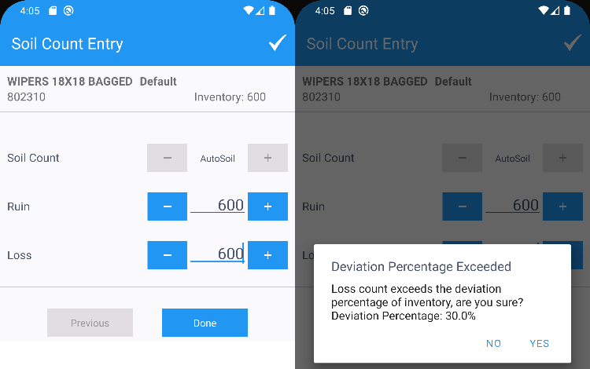
- Scan return a garment
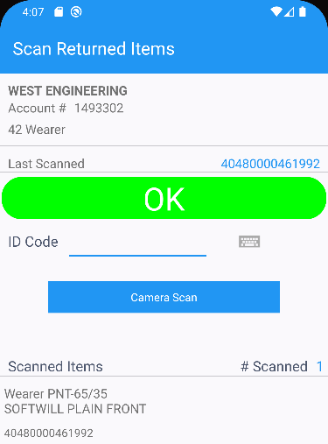
- Bill for loss now for another entry
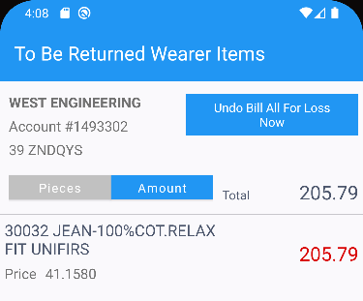
- RA: Settle the invoice, depart and upload the route.
- WebX: How the weborder counter looks.
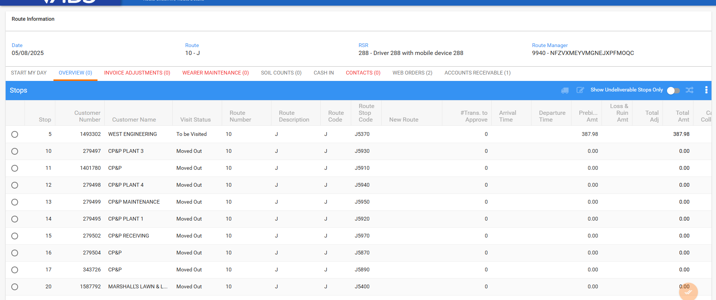
Re-enter the route.
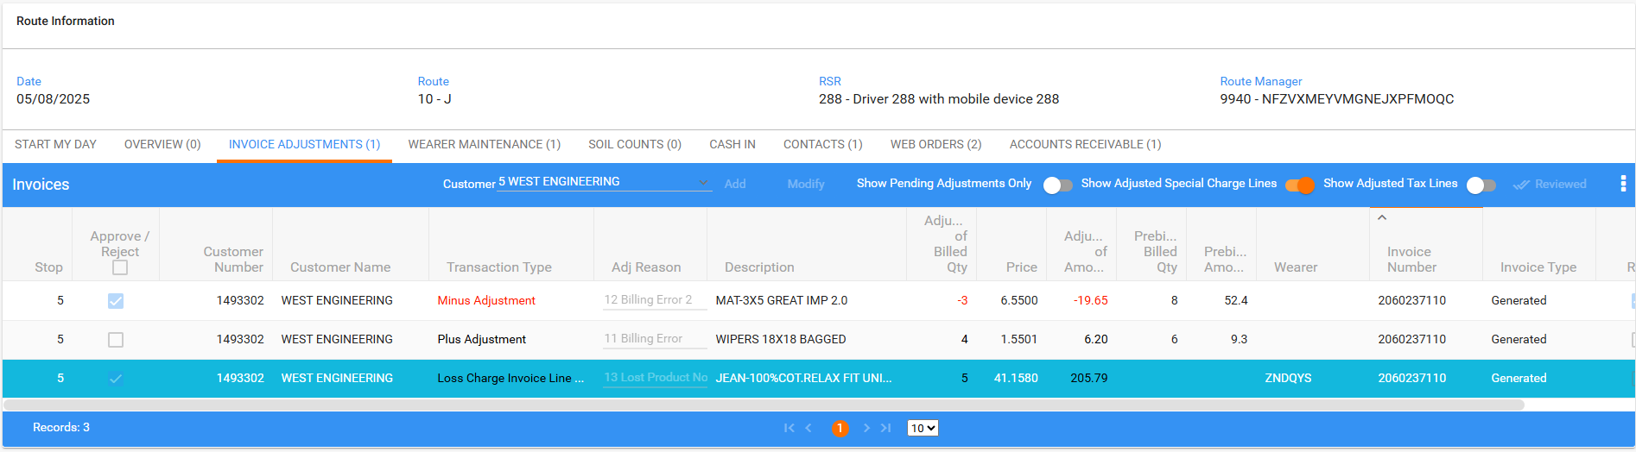
- WebX: Complete the start my day.
- WebX: Recheck the counters and the tabs.
Invoice adjustments
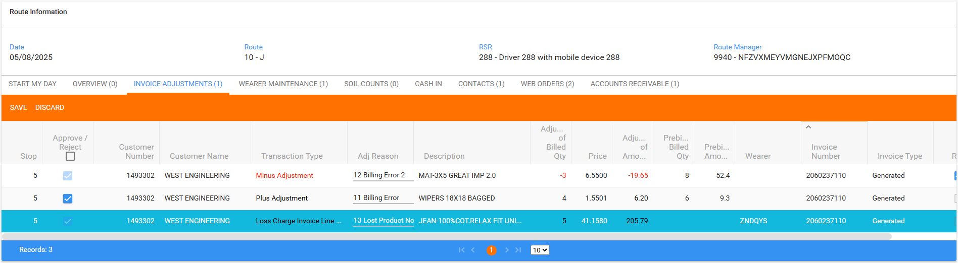
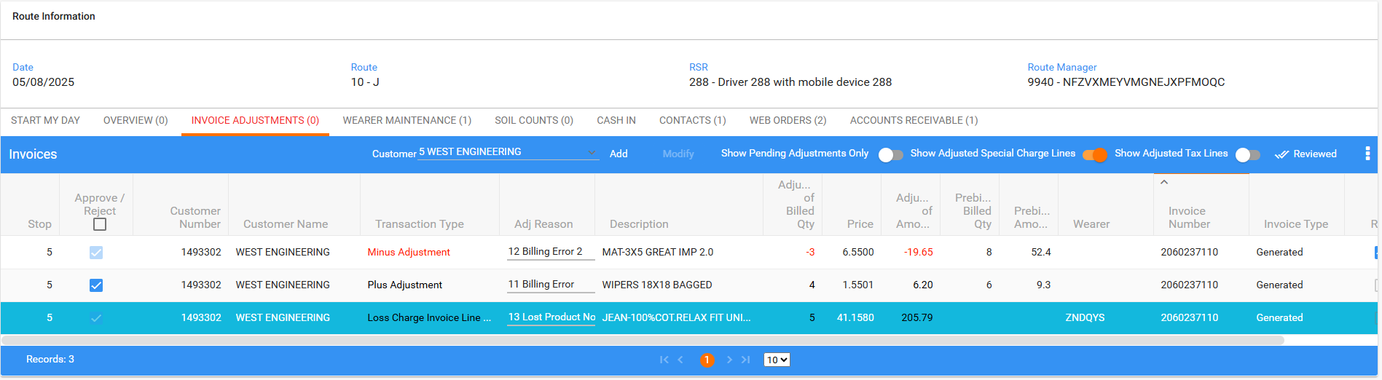
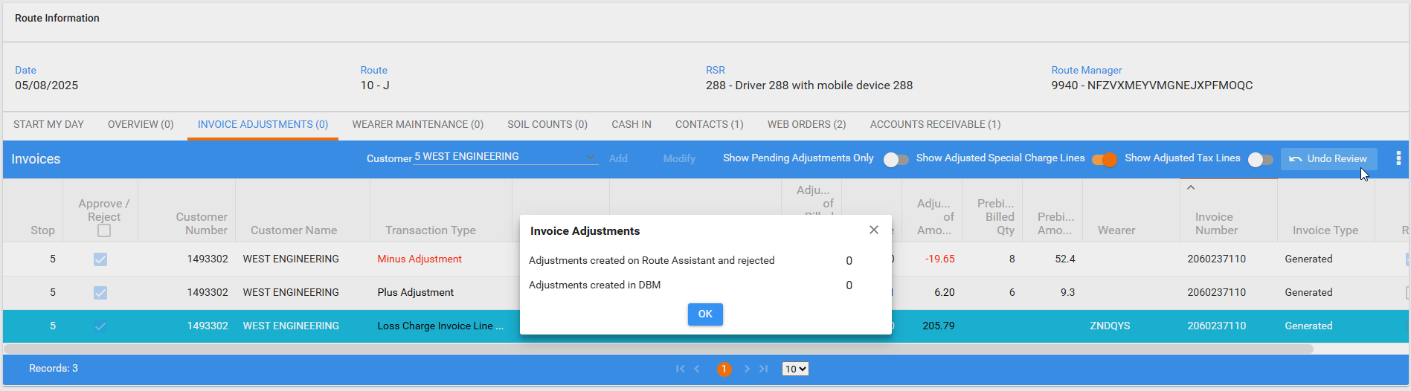
Wearer maintenance
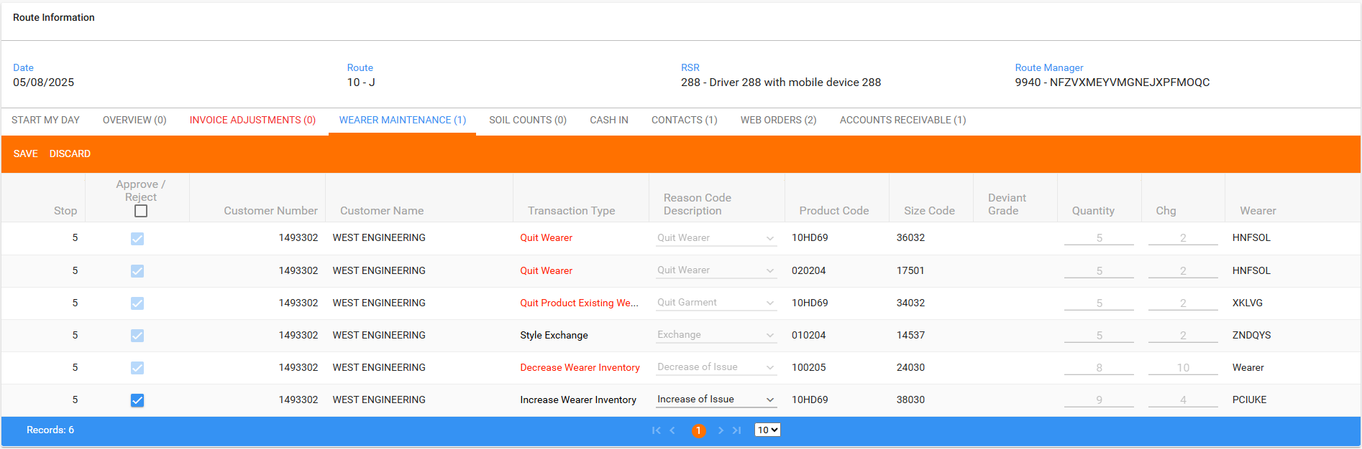
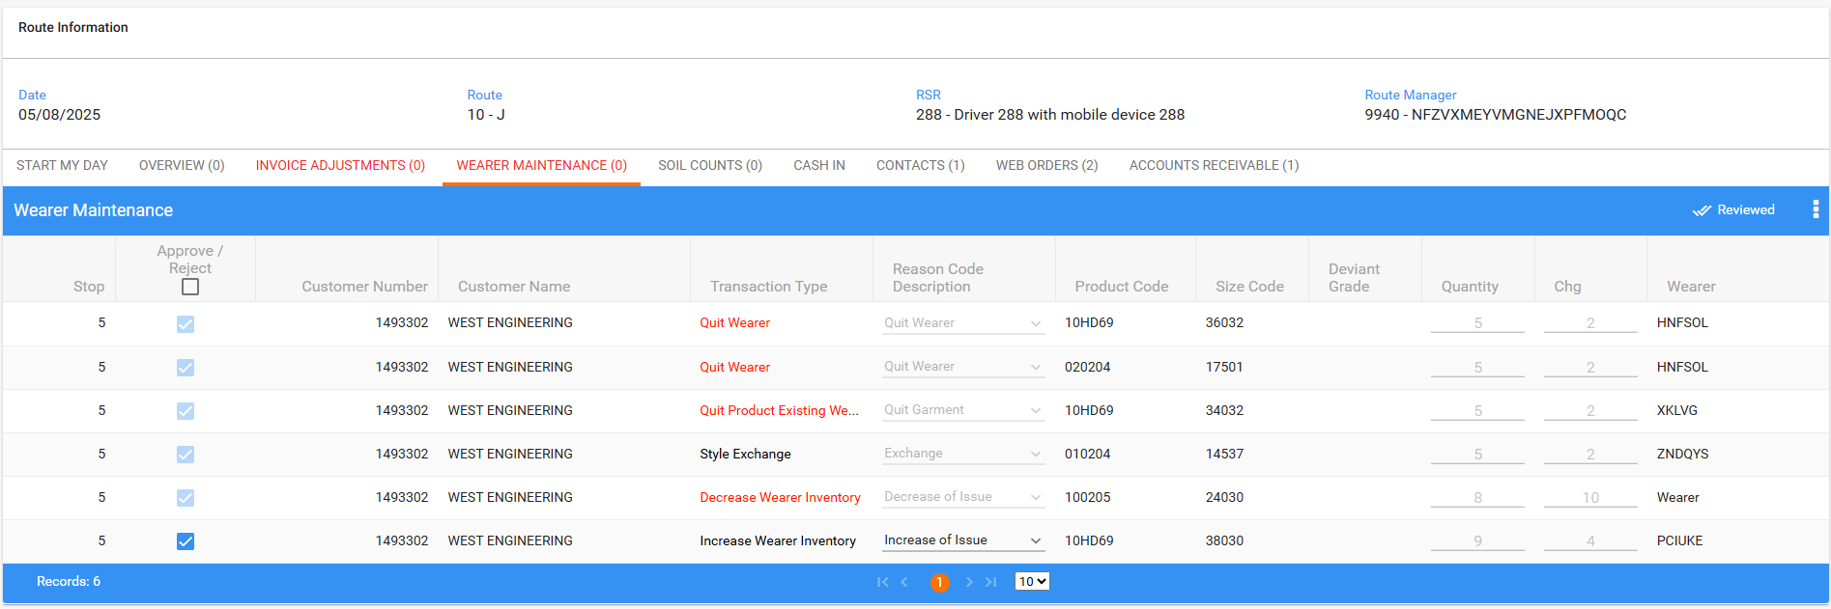
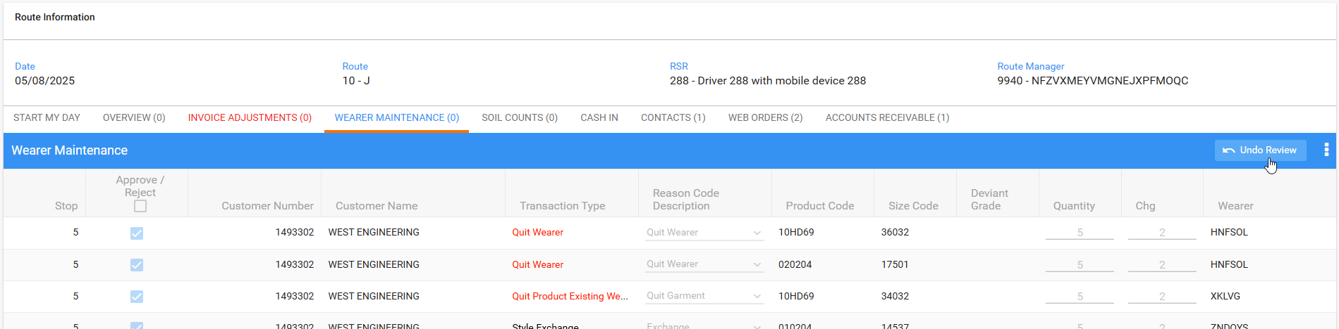
Soil counts
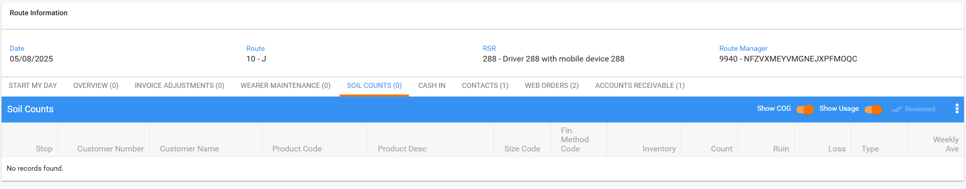
Contacts
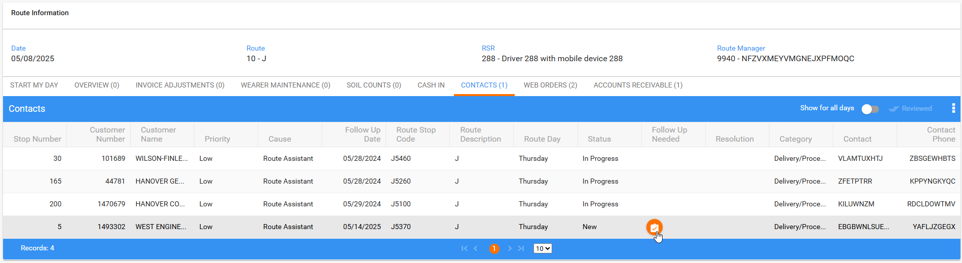
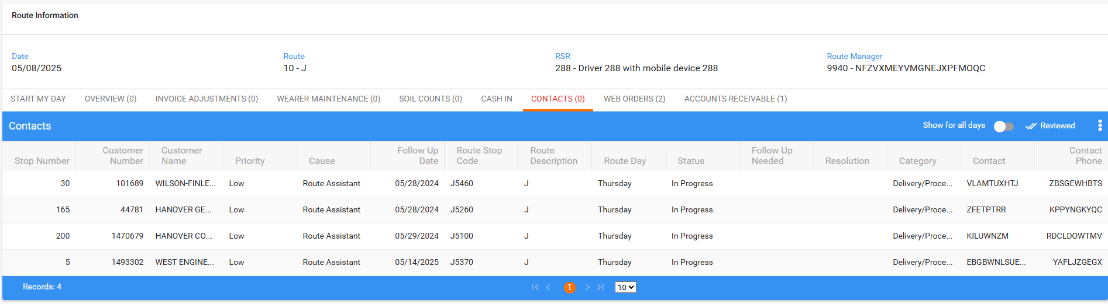
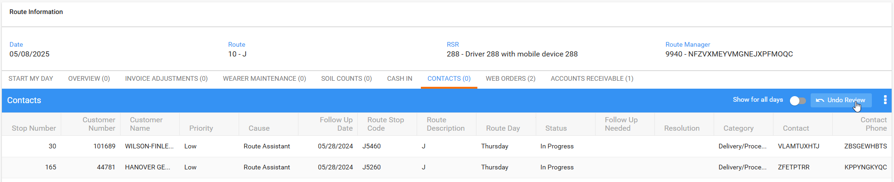
Web Orders
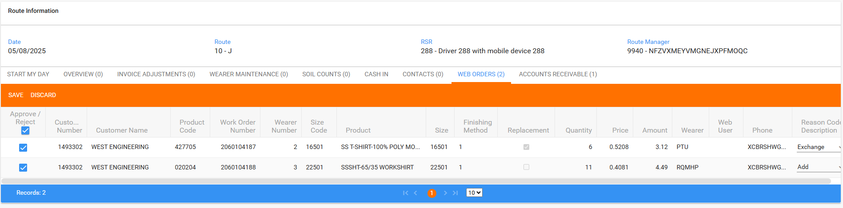
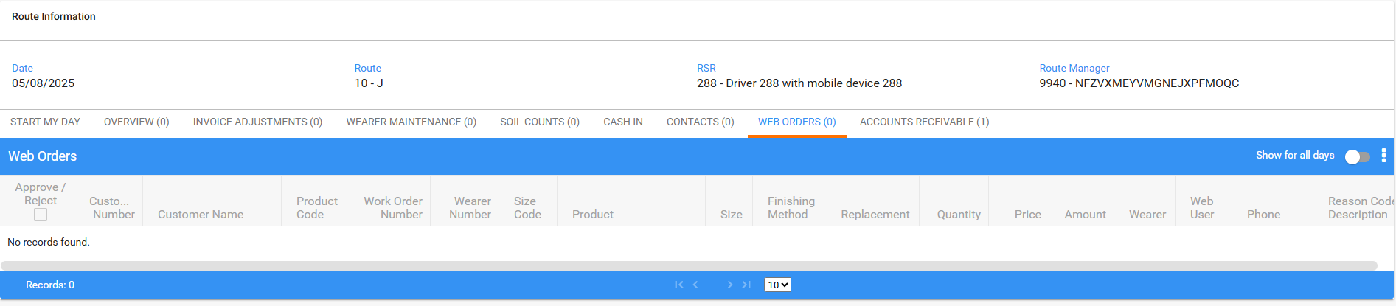
Accounts receivable
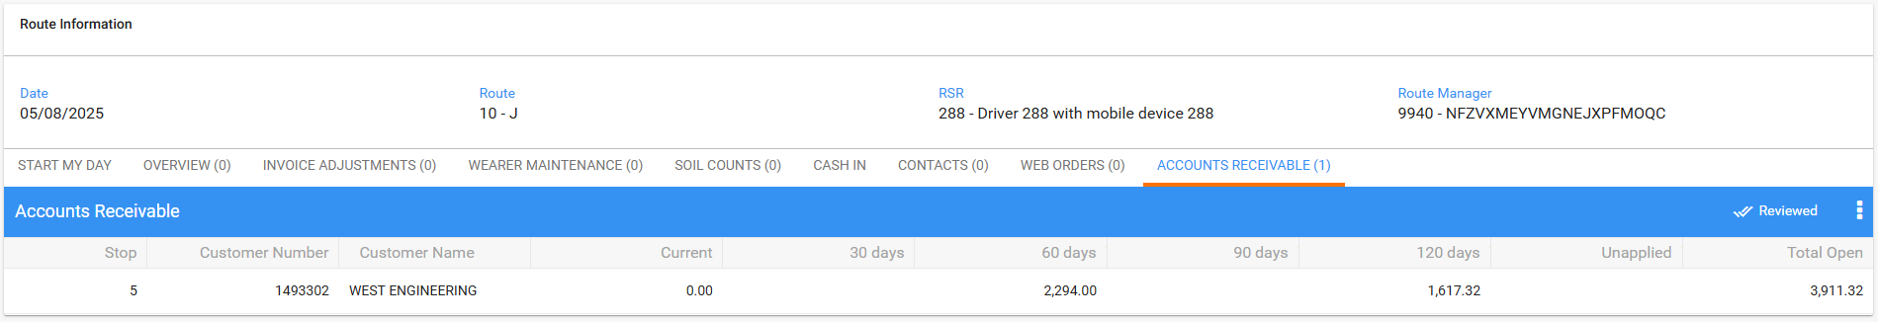
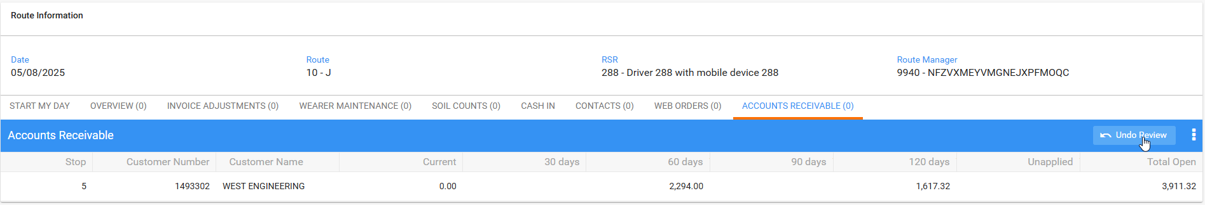
- WebX: Settle the route.
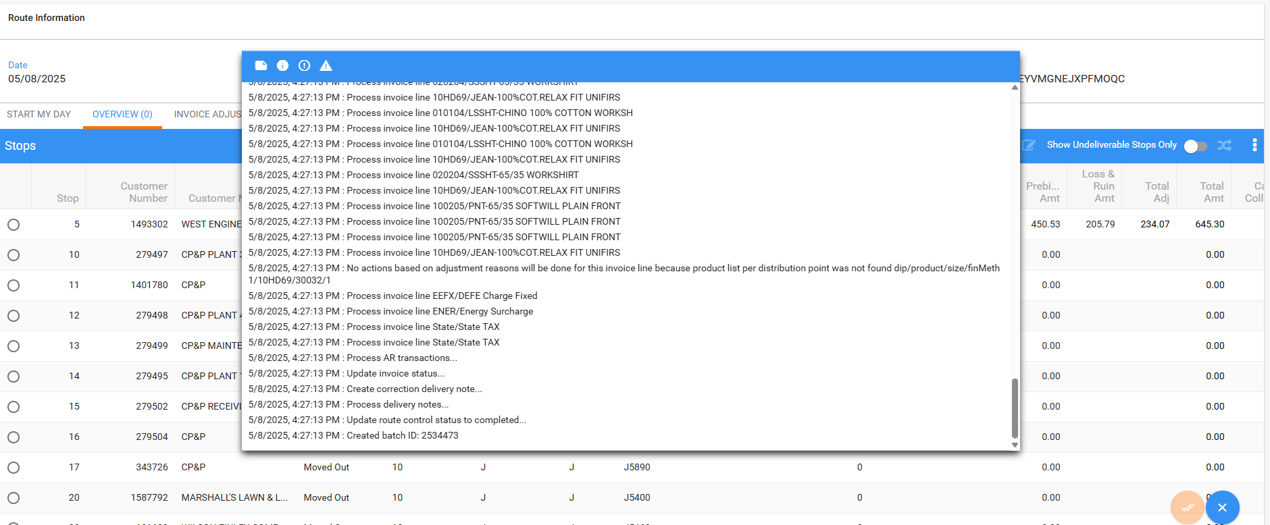
- WebX logs don’t contain errors.
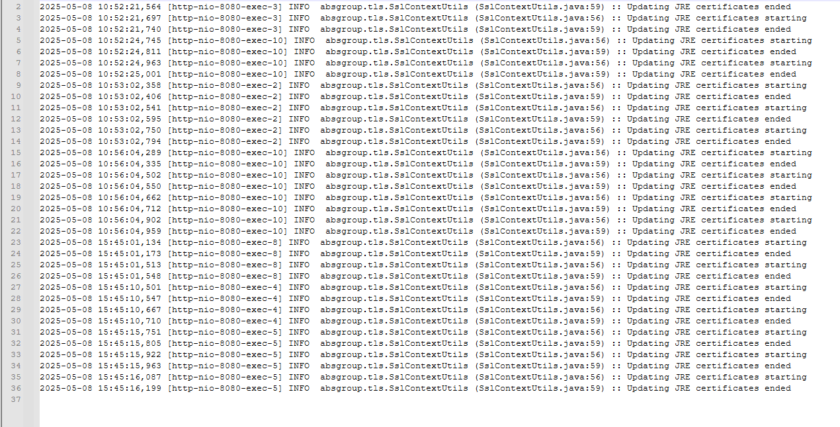
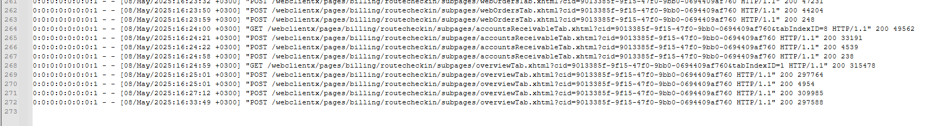
Tested OK

