ABSN-2980 - Moving a RouteStop creates routes with mixed stops
Environment | Prerequisites
Version: 9.07.00.UNF19  DBServerName= abs-srv20.internal.abslbs.com  DBSID=CUST24  DBUser=UNFDEV  DBPassword= UNFDEV  Environment=Test | - Module:  - System setting

Contents
Retest after fix 1
Test Case 1 – With UNFCUSTOM try to move a stop from customer with Invoicing BU A to a route with customers with Invoicing BU B 1
Test Case 2 – With NO UNFCUSTOM try to move a stop from customer with Invoicing BU A to a route with customers with Invoicing BU B 5
Test Case 3 – With UNFCUSTOM try to move a stop from customer with Invoicing BU A to a new route with no existing route controls 9
Test Case 4 - With UNFCUSTOM try to move a stop from customer with Invoicing BU A to a new route with one existing route controls 12

Retest after fix

Test Case 1 – With UNFCUSTOM try to move a stop from customer with Invoicing BU A to a route with customers with Invoicing BU B
Hash: 567b4f91ccf0
Expected behavior: Routes with customers that have invoicing BU B are not in the drop-down list.
- Have UNFCUSTOM module present in the license
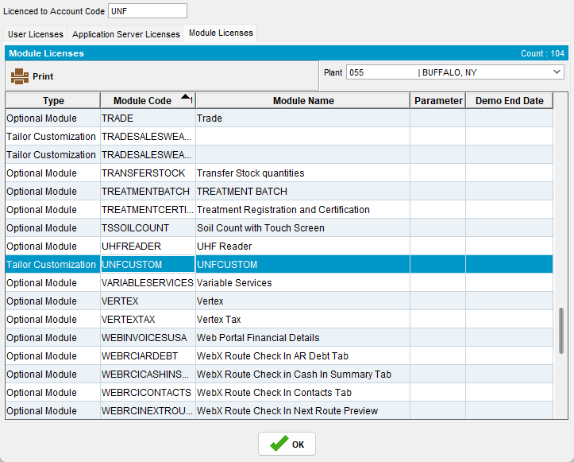
- Add a route in Route Status Control
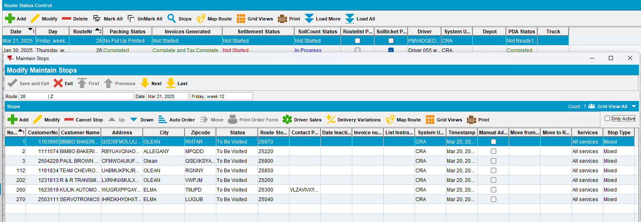
- Generate invoices
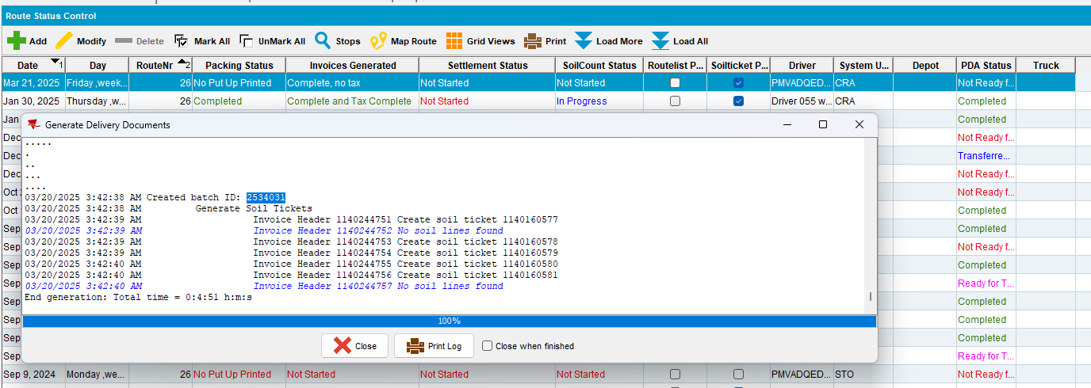
- Tax invoices - run BCI scheduled process
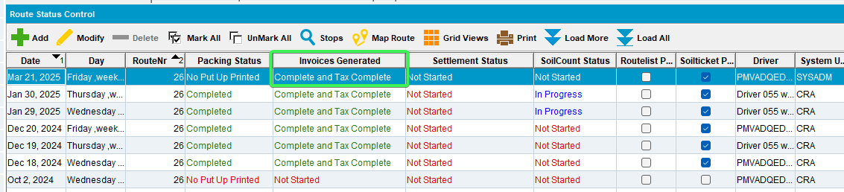
- Pick a customer having a different invoicing BU than the customers from the route
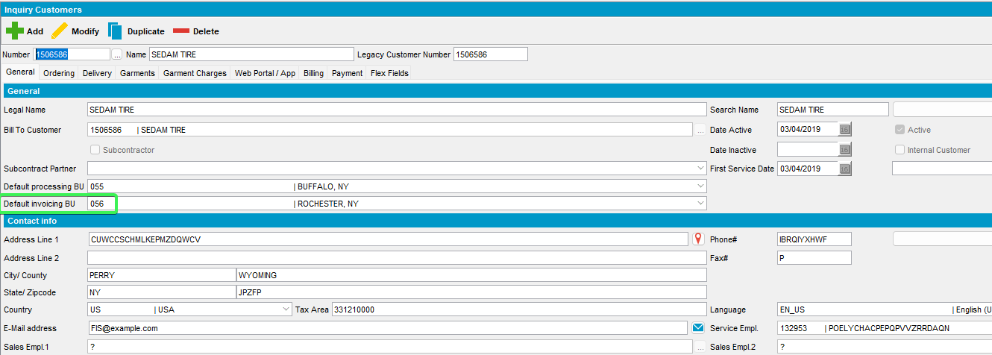
- Customer DLG: Delivery tab > Route stops > Press Move button and select the date on which the route created on step 1 is running
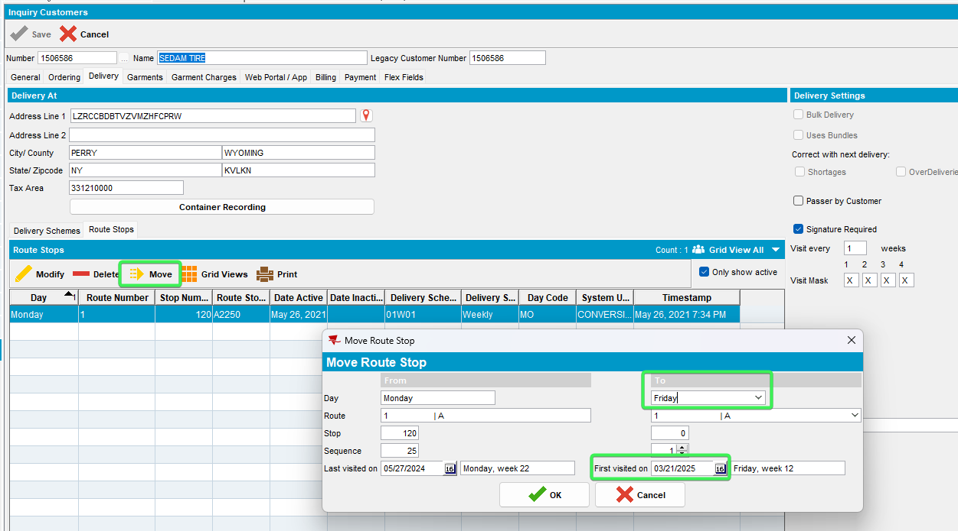
- Try finding your route number in the Drop-down list (Route 26 in this case)
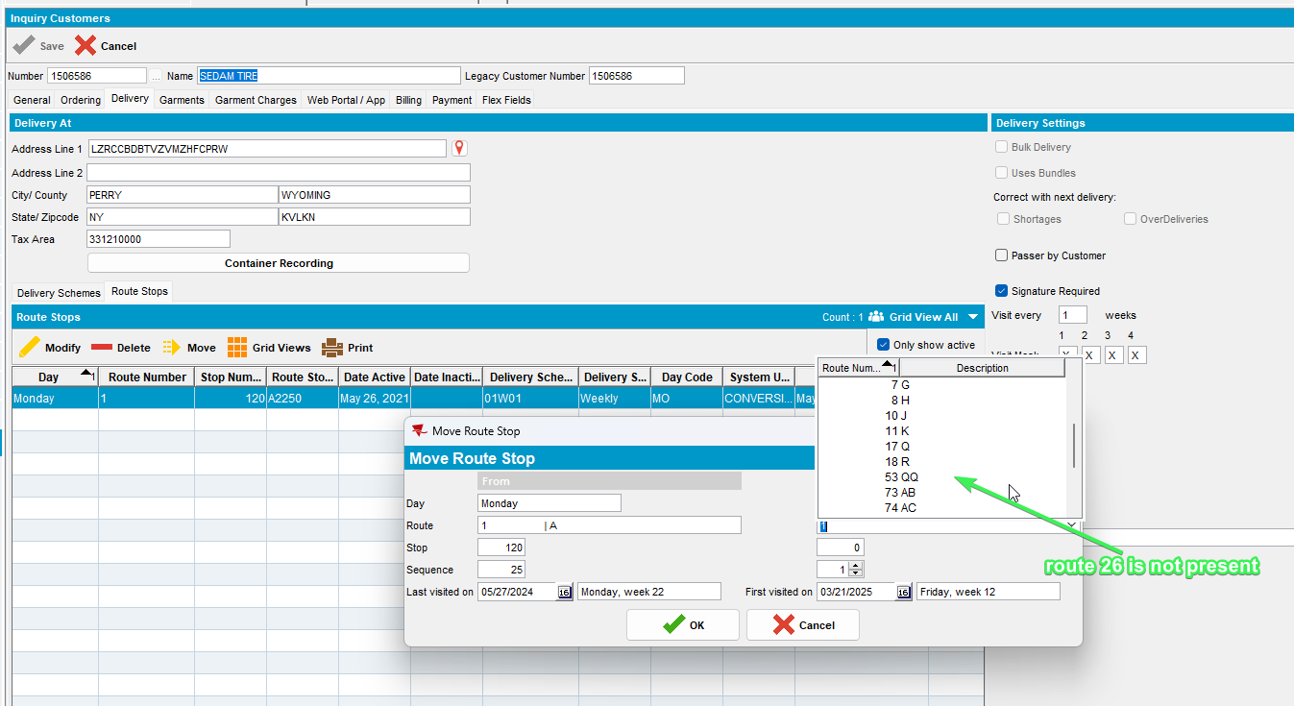
Tested OK

Test Case 2 – With NO UNFCUSTOM try to move a stop from customer with Invoicing BU A to a route with customers with Invoicing BU B
Hash: 567b4f91ccf0
Expected behavior: Routes with customers that have invoicing BU B are in the drop-down list.
- Make sure UNFCUSTOM module is not present in the license for your BU
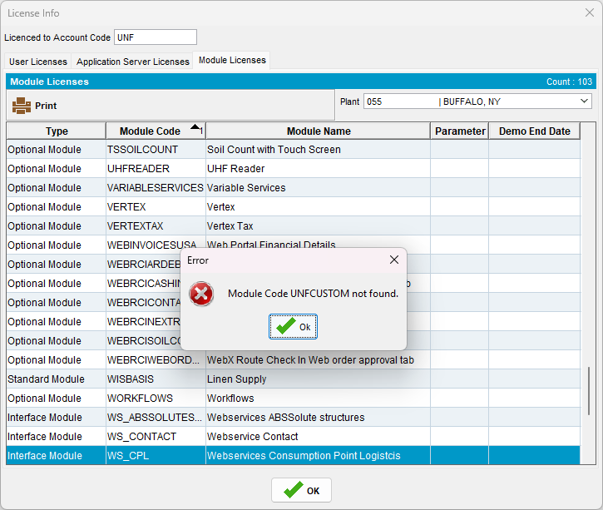
- Add a route in Route Status Control
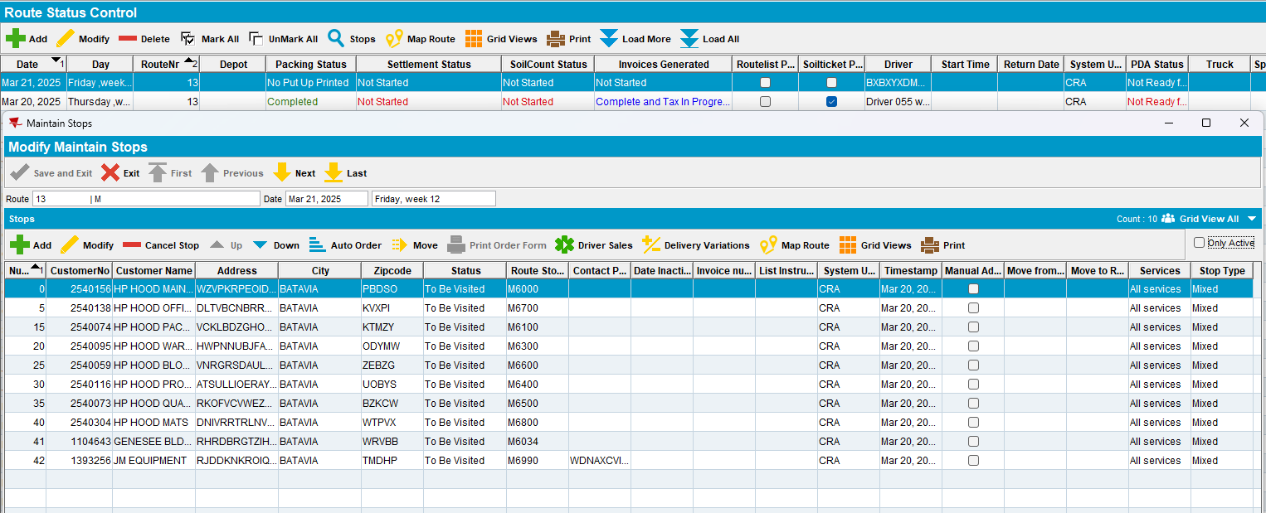
- Generate invoices
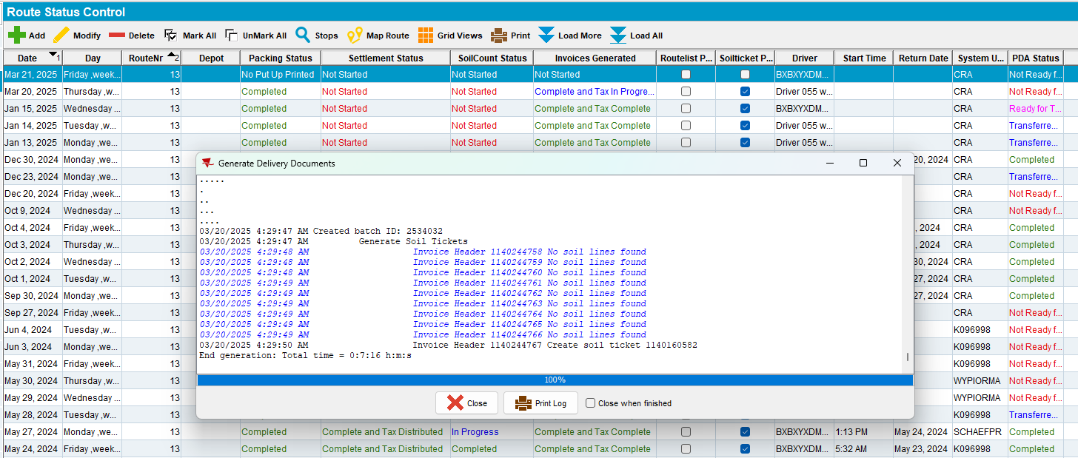
- Tax invoices - run BCI scheduled process
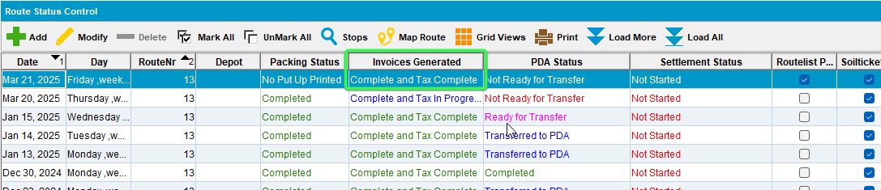
- Pick a customer having a different invoicing BU than the customers from the route
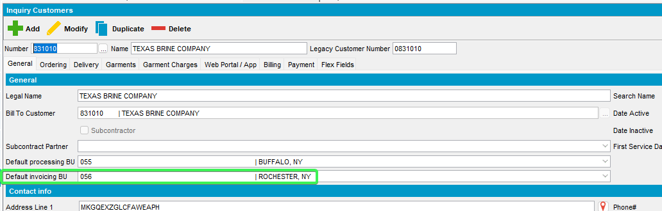
- Customer DLG: Delivery tab > Route stops > Press Move button and select the date on which the route created on step 1 is running
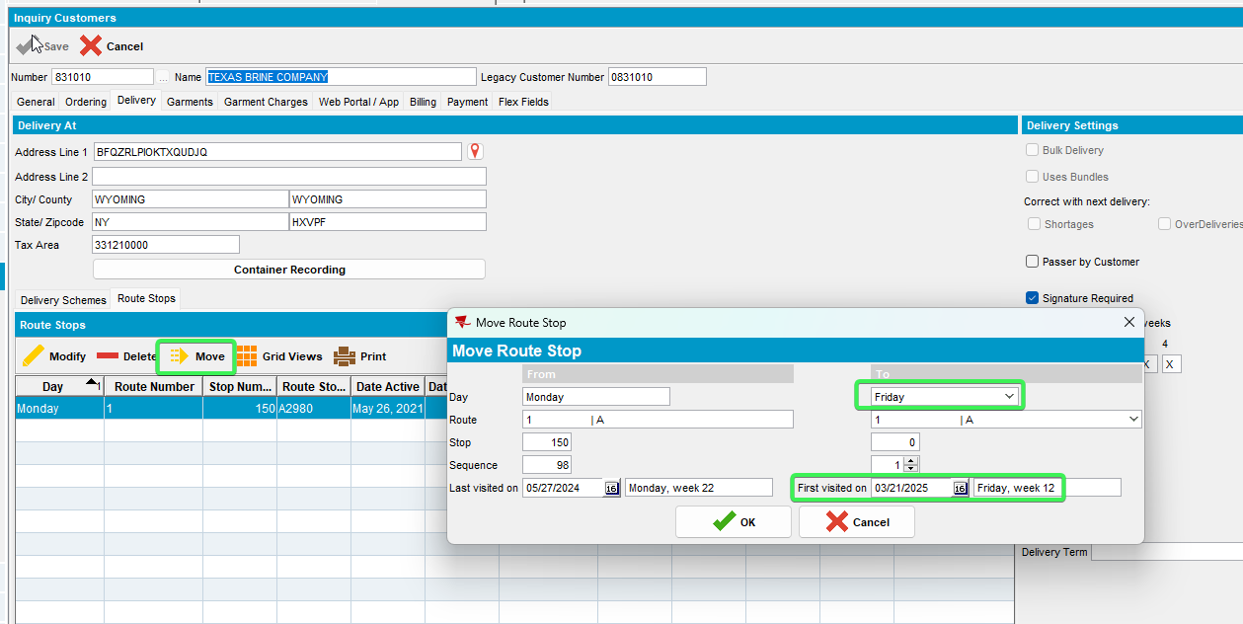
- See that the route is present in the dop-down
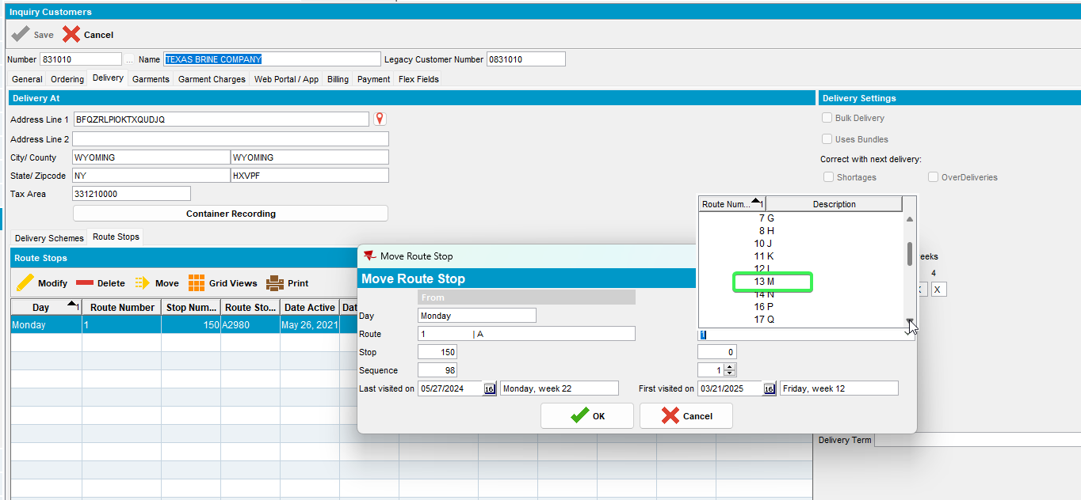
Tested OK

Test Case 3 – With UNFCUSTOM try to move a stop from customer with Invoicing BU A to a new route with no existing route controls
Hash: 567b4f91ccf0
Expected behavior: The new route is available in the dropdown list.
- Have UNFCUSTOM module present in the license
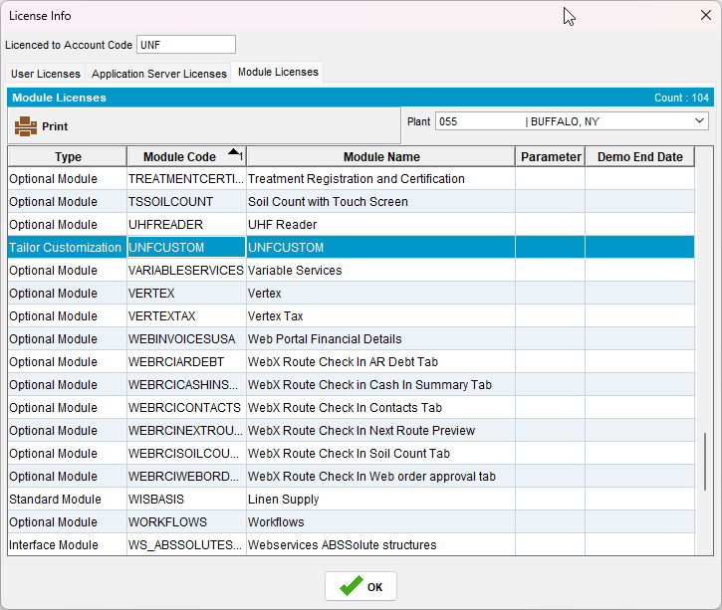
- Routes DLG: Create a new Route
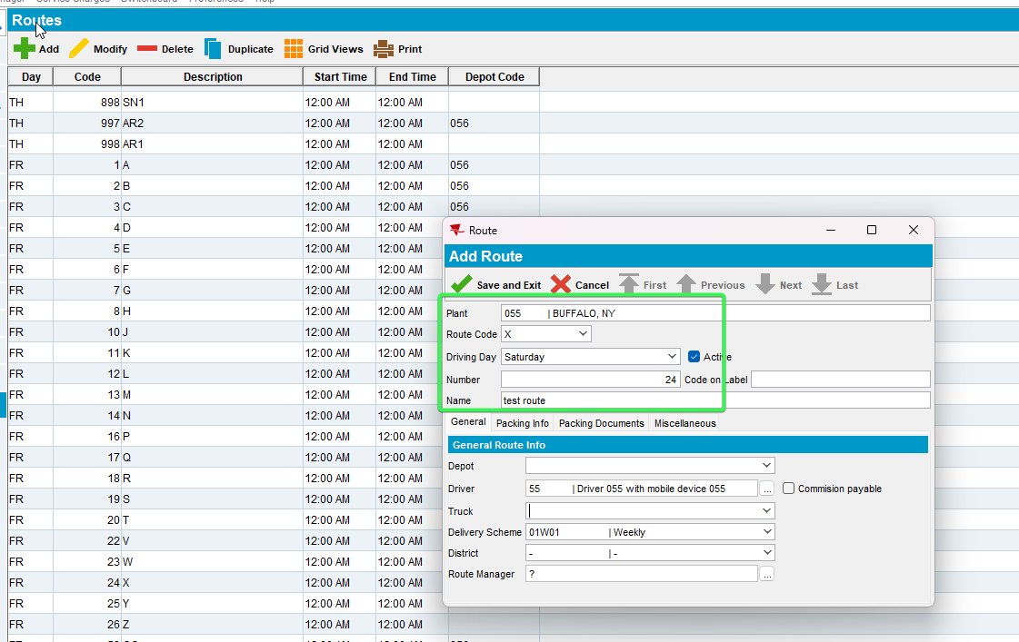
- Pick a customer having a different invoicing BU
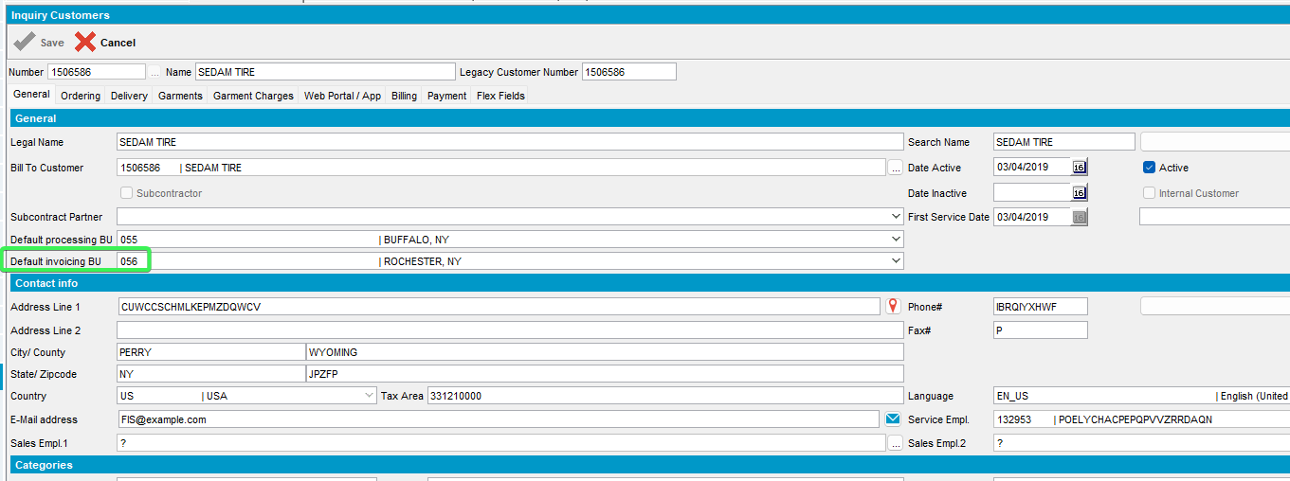
- Customer DLG: Delivery tab > Route stops > Press Move button and select the weekday you created the route on, see that your route is present in the drop-down
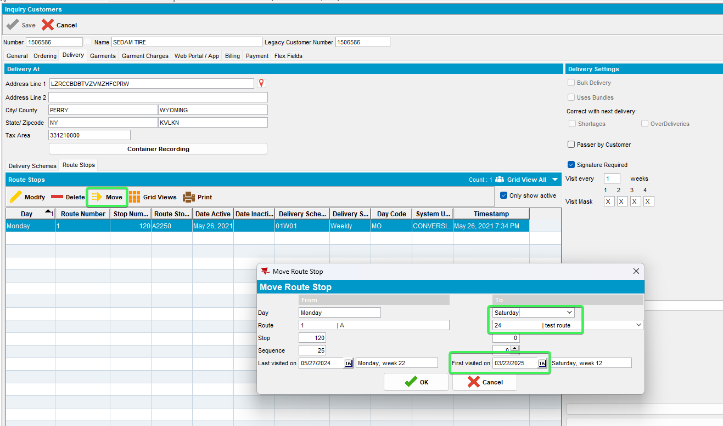
Tested OK

Test Case 4 - With UNFCUSTOM try to move a stop from customer with Invoicing BU A to a new route with one existing route controls
Hash: 567b4f91ccf0
Expected behavior: The new route is available in the dropdown list.
- Have UNFCUSTOM module present in the license
- Routes DLG: Create a new Route
- Route Status Control: Create a new RC for that route
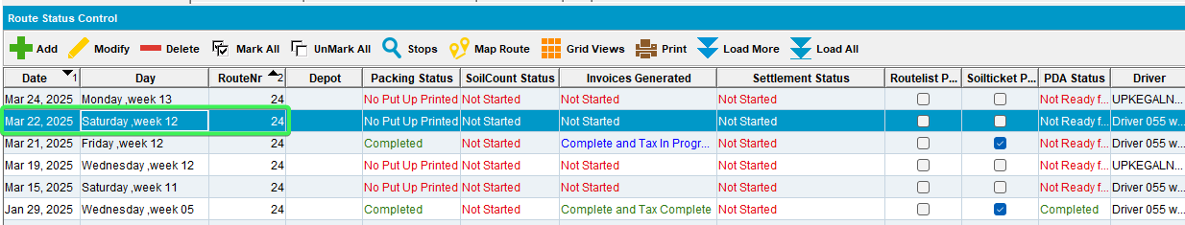

- Pick a customer having a different invoicing BU
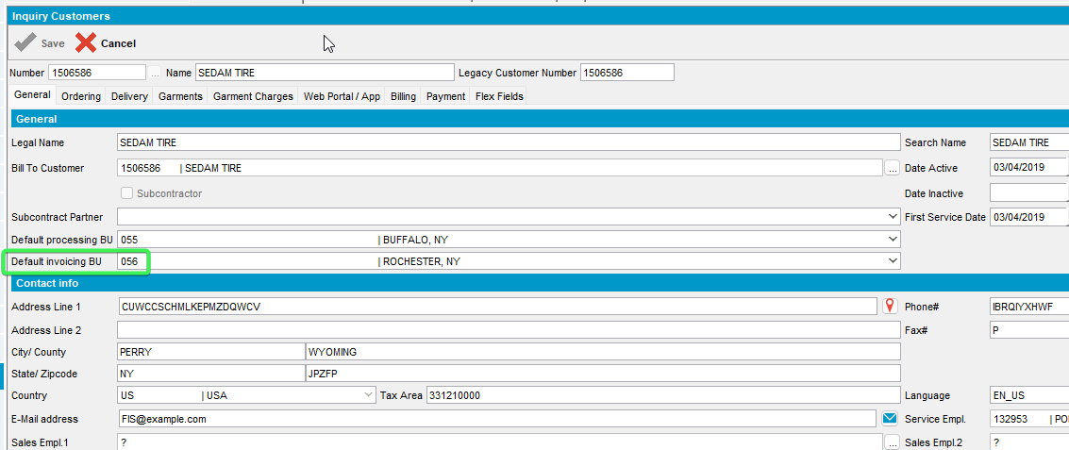
- Customer DLG: Delivery tab > Route stops > Press Move button and select the weekday you created the route on, see that your route is present in the drop-down
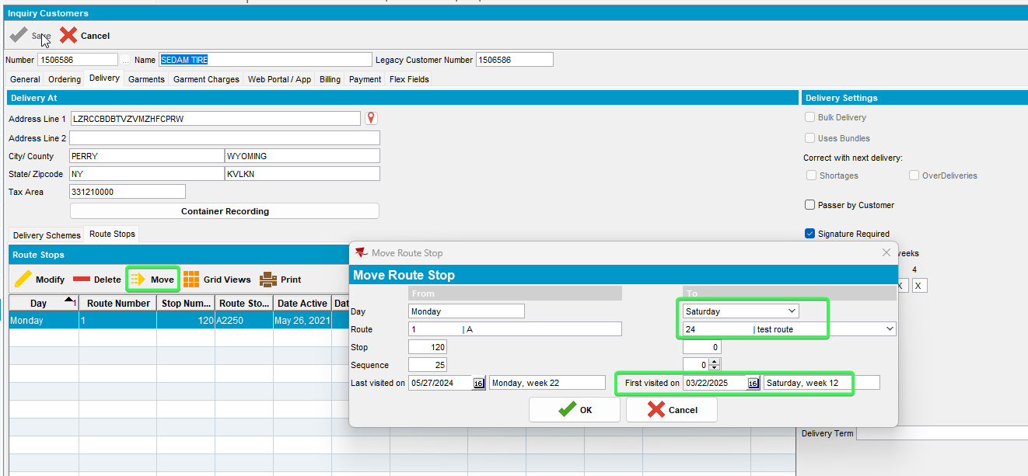
Tested OK

