ABSN-2959 D_UBS_2613 Route Finalization to complete automatically for specific routes
Environment | Prerequisites
Version: 9.07.00.UNF17  DBServerName= abs-srv20.internal.abslbs.com  DBSID=CUST24  DBUser=UNFDEV  DBPassword=UNFDEV  Environment=Production | - Module:  - System setting

Contents
Test after fix 1
Test #1 – Check if the Automatic Finalization checkbox is visible with UNFCUSTOM 1
Test #2 – Check if the Automatic Finalization checkbox is visible without UNFCUSTOM 3
Test #3 – Check if Automatic Finalization checkbox value is N when adding a new route 4
Test #4 – Check if Route Finalization Status is marked as completed after invoice generation 5

Test after fix
Hash: bf4a2c710bc

Test #1 – Check if the Automatic Finalization checkbox is visible with UNFCUSTOM

- Routes dlg: Select a route and press Modify
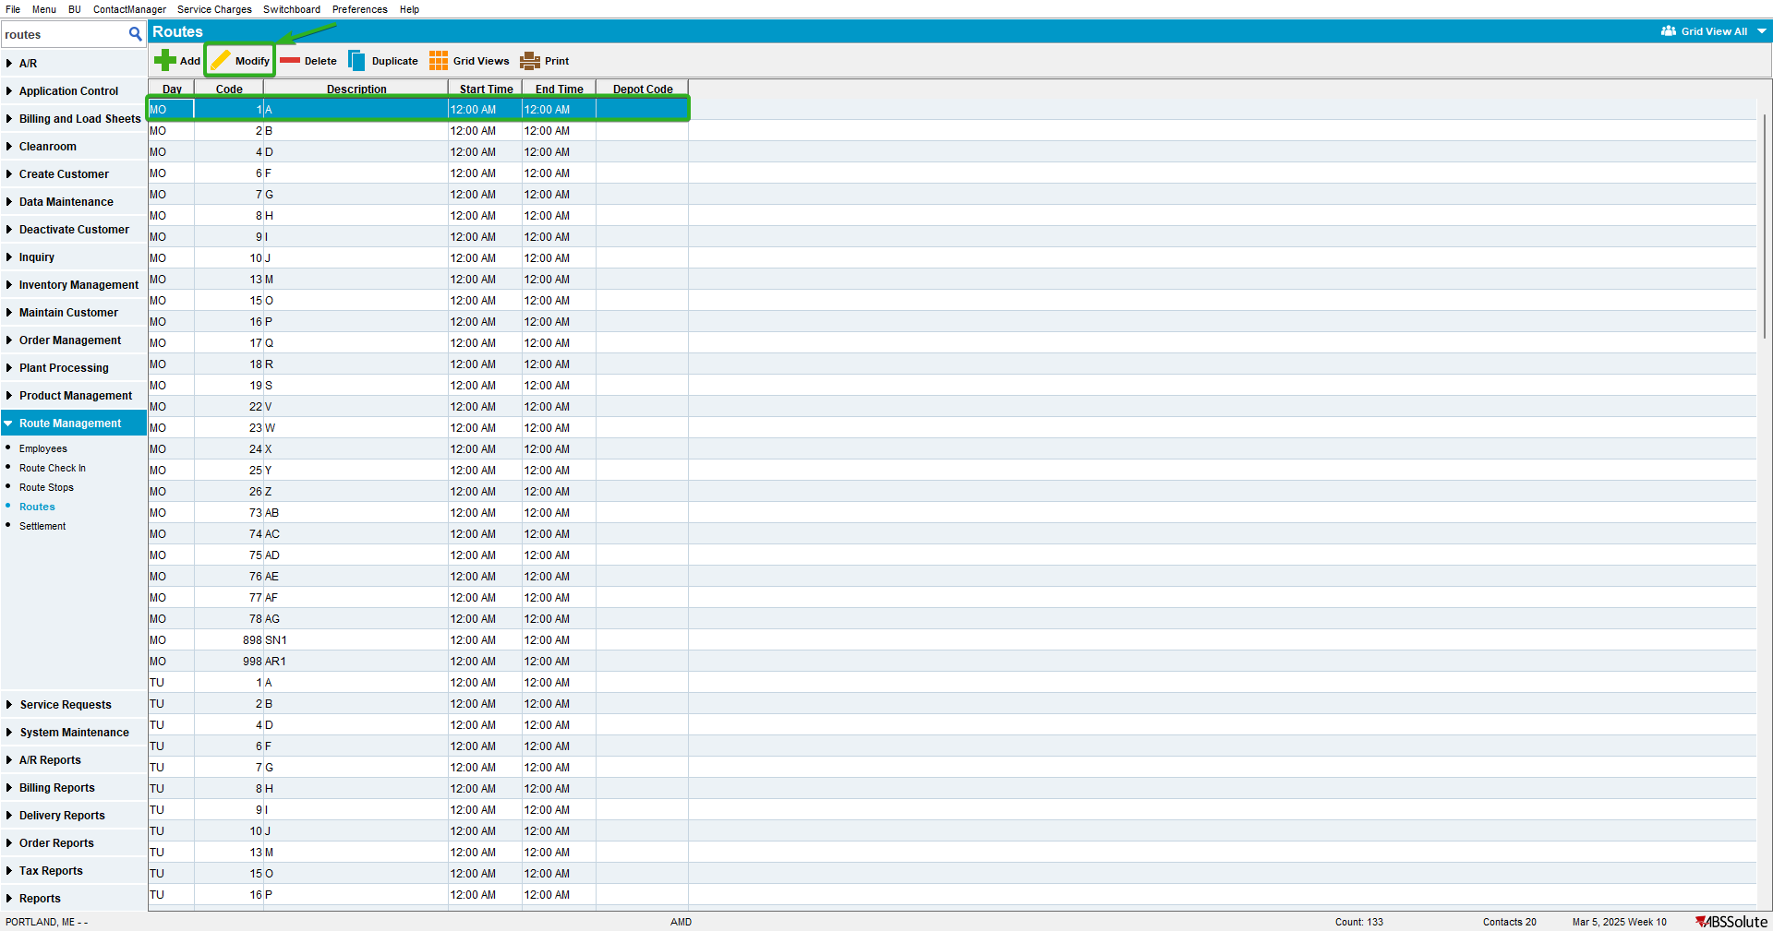

- Routes dlg: Go to miscellaneous tab
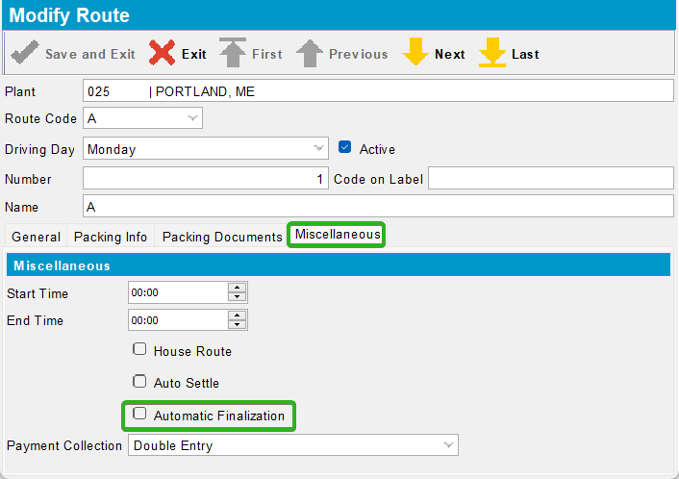
Expected behavior: Automatic Finalization checkbox is visible.
Actual behavior: Automatic Finalization checkbox is visible.

Test #2 – Check if the Automatic Finalization checkbox is visible without UNFCUSTOM

- Routes dlg: Select a route and press Modify

- Routes dlg: Go to miscellaneous tab
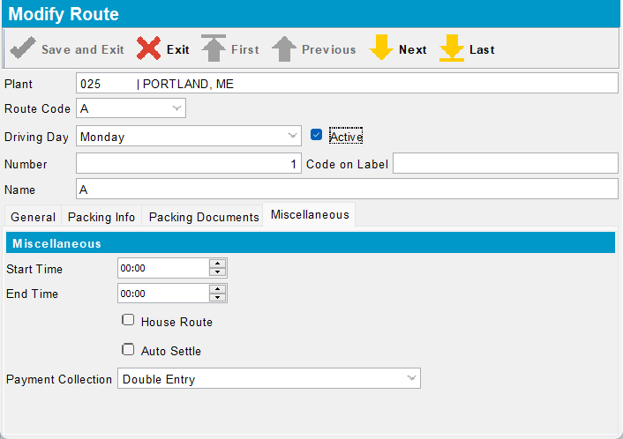
Expected behavior: Automatic Finalization checkbox is not visible.
Actual behavior: Automatic Finalization checkbox is not visible.

Test #3 – Check if Automatic Finalization checkbox value is N when adding a new route

- Routes dlg: Select a route and press Add
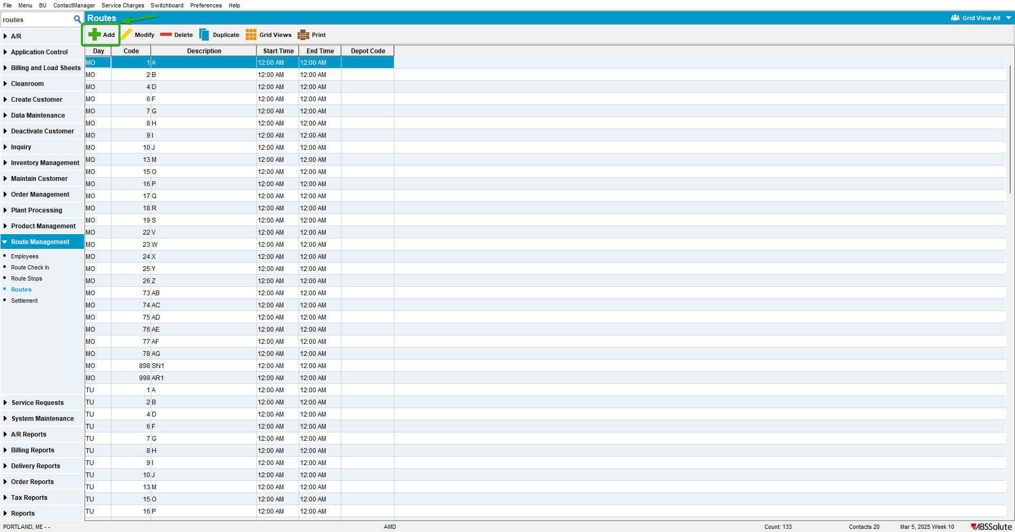

- Routes dlg: Go to miscellaneous tab
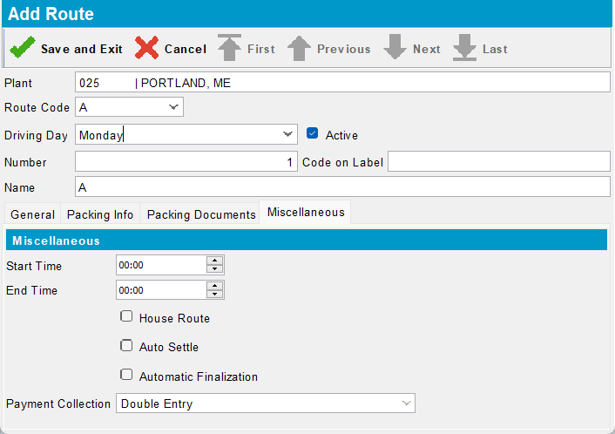
Expected behavior: Automatic Finalization checkbox value is N.
Actual behavior: Automatic Finalization checkbox value is N.

Test #4 – Check if Route Finalization Status is marked as completed after invoice generation

- Routes dlg: Select a route and check the Automatic Finalization checkbox
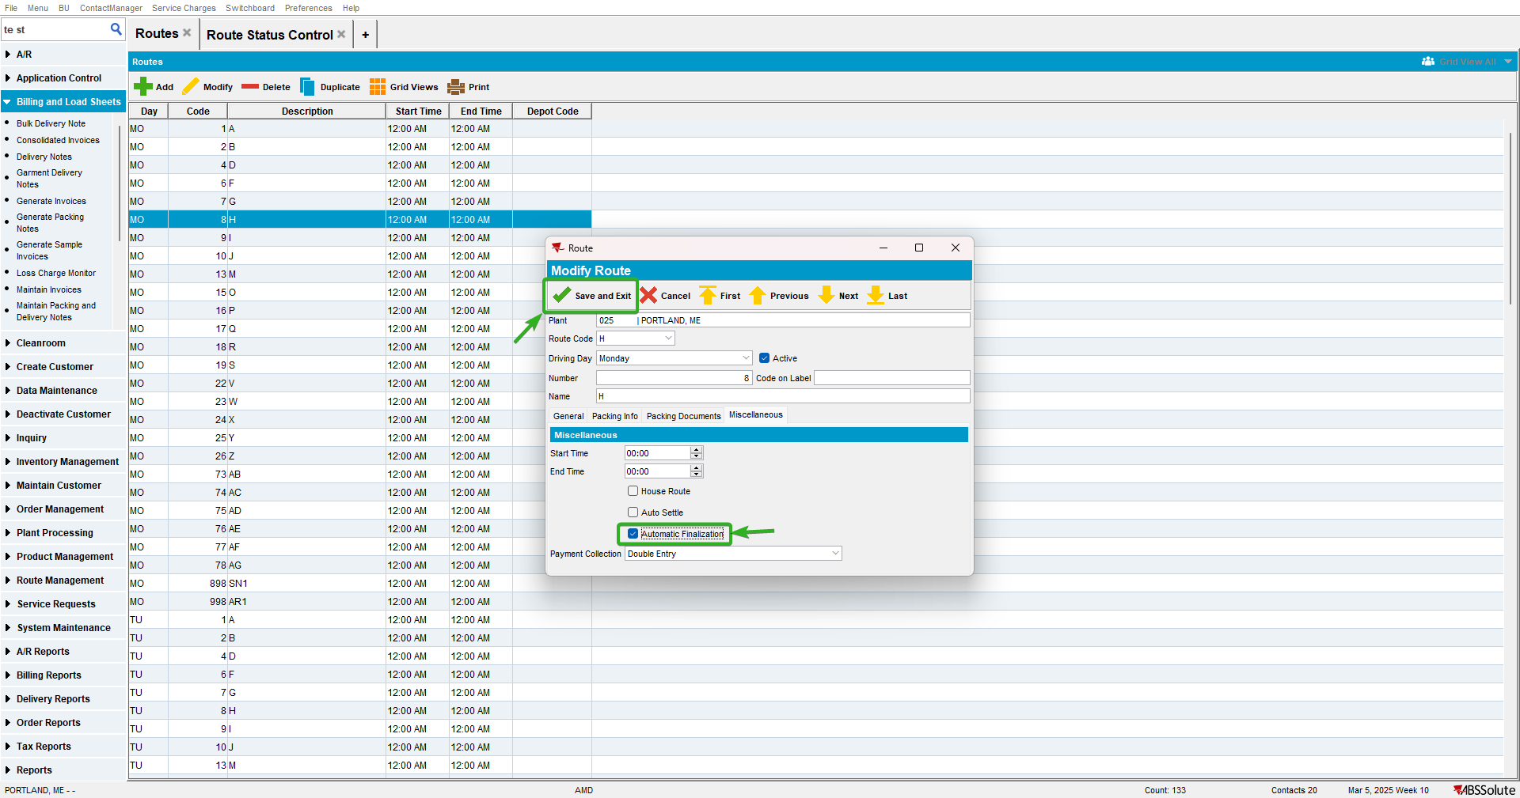

- RSC dlg: Add the previous route and generate the invoices
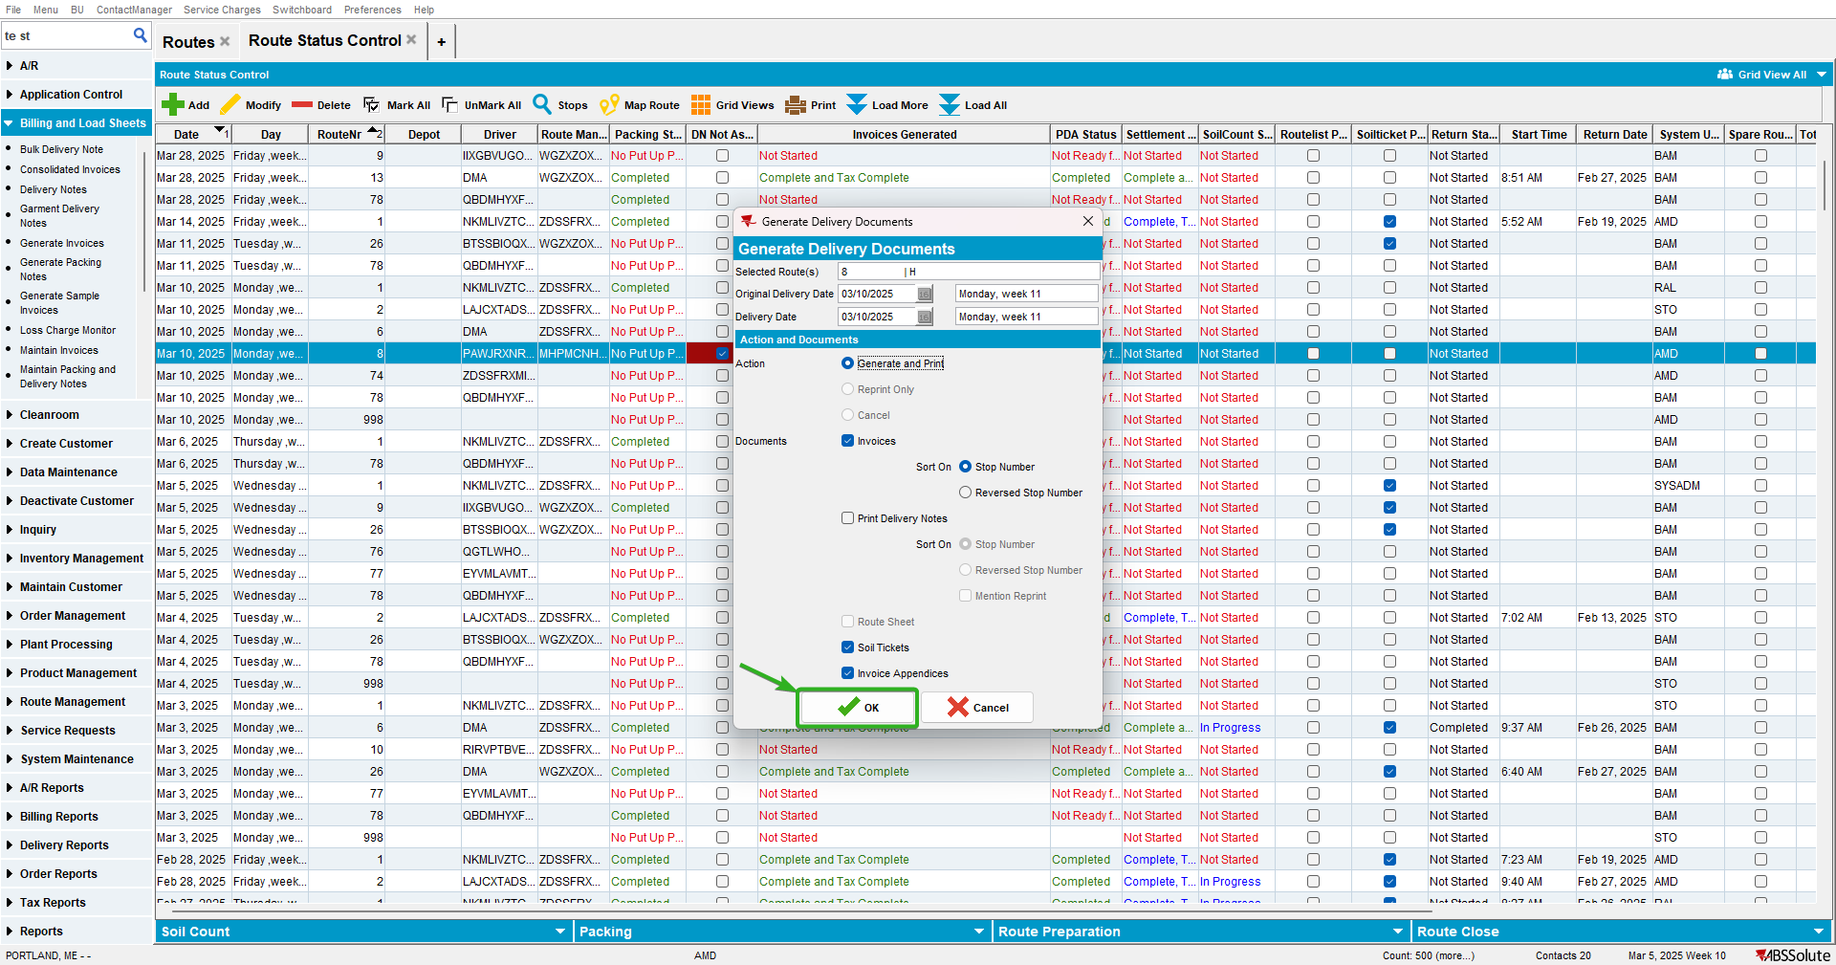

- RSC dlg: Check Route Finalization Status
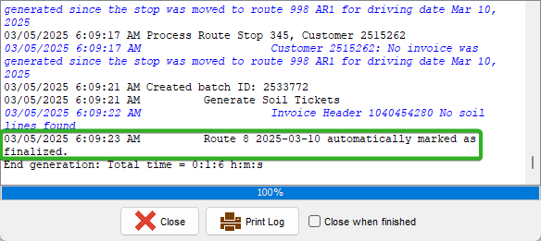
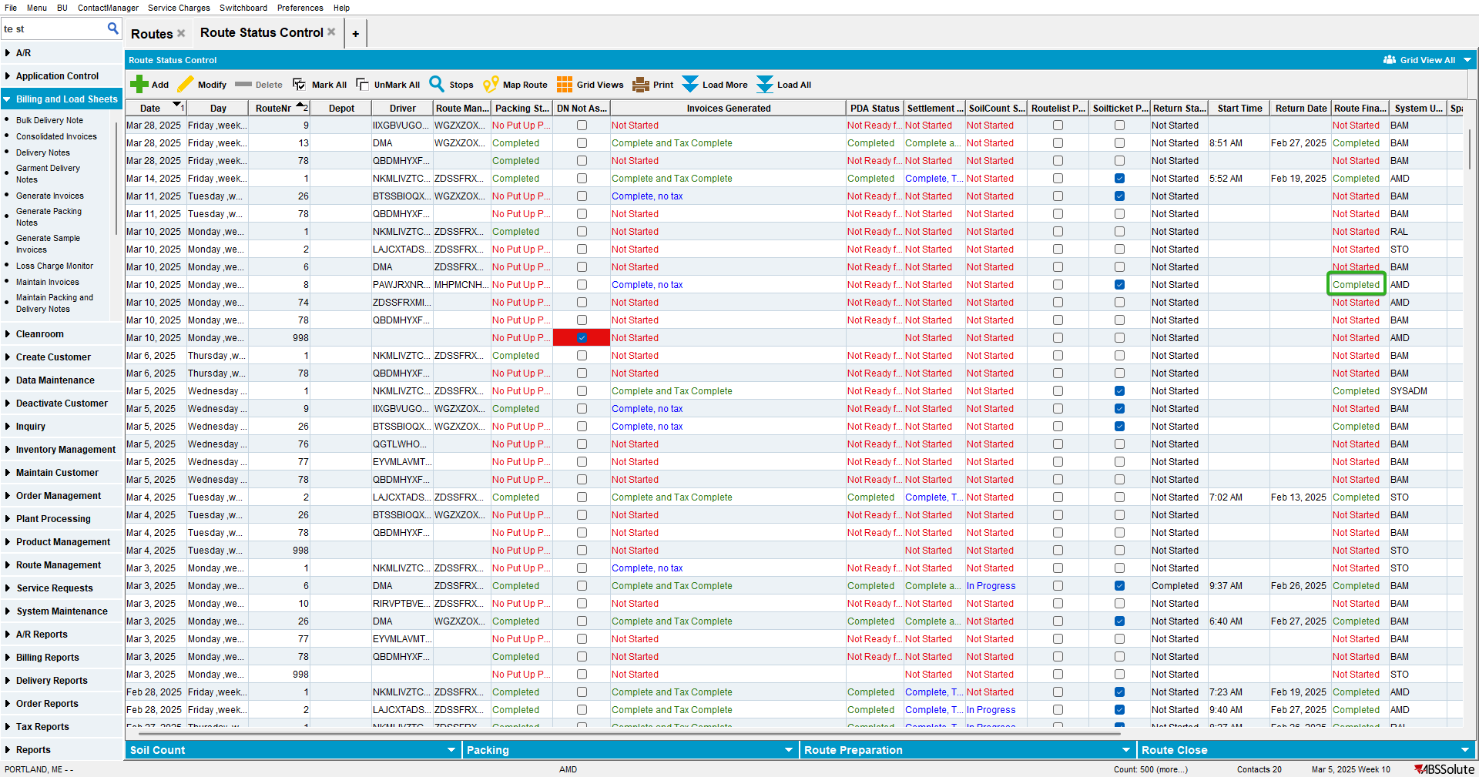
Expected behavior: Route Finalization Status should be marked as completed.
Actual behavior: Route Finalization Status should be marked as completed.

TESTED OK.

