ABSN-2942 - D_UBS_2625 Moving an Undeliverable stop two days from the original route date is causing the soil counts from the undeliverable stop to miss the next week’s route and be delivered the following week
Environment | Prerequisites
Version: 9.07.00.UNF19  DBServerName= abs-srv20.internal.abslbs.com  DBSID=CUST24  DBUser=UNFDEV  DBPassword= UNFDEV  Environment=Test | - Module:  - System setting

Contents
Reproducing before fix 1
Steps to reproduce 1
Current Behavior 5
Expected behavior 6
Retest after fix 6
Test Case 1 – Check that Soil tickets are also processed for undeliverable invoices with a customer that is invoiced every 2 weeks 6
Test Case 2 – Check that Soil tickets are also processed for undeliverable invoices with a customer that is invoiced every week 11
Test Case 3 – Check that Soil tickets are also processed for undeliverable invoices with a customer that has multiple delivery days and 1 billing day and Packing notes and invoices are generated before uploading data from RA 15
Test Case 4 – Check that Soil tickets are also processed for undeliverable invoices with a customer that has multiple delivery days, and 1 billing day and Packing notes and invoices are generated after uploading data from RA 22

Reproducing before fix

Steps to reproduce
- Generate invoices with soiltickets and send to RA for route A
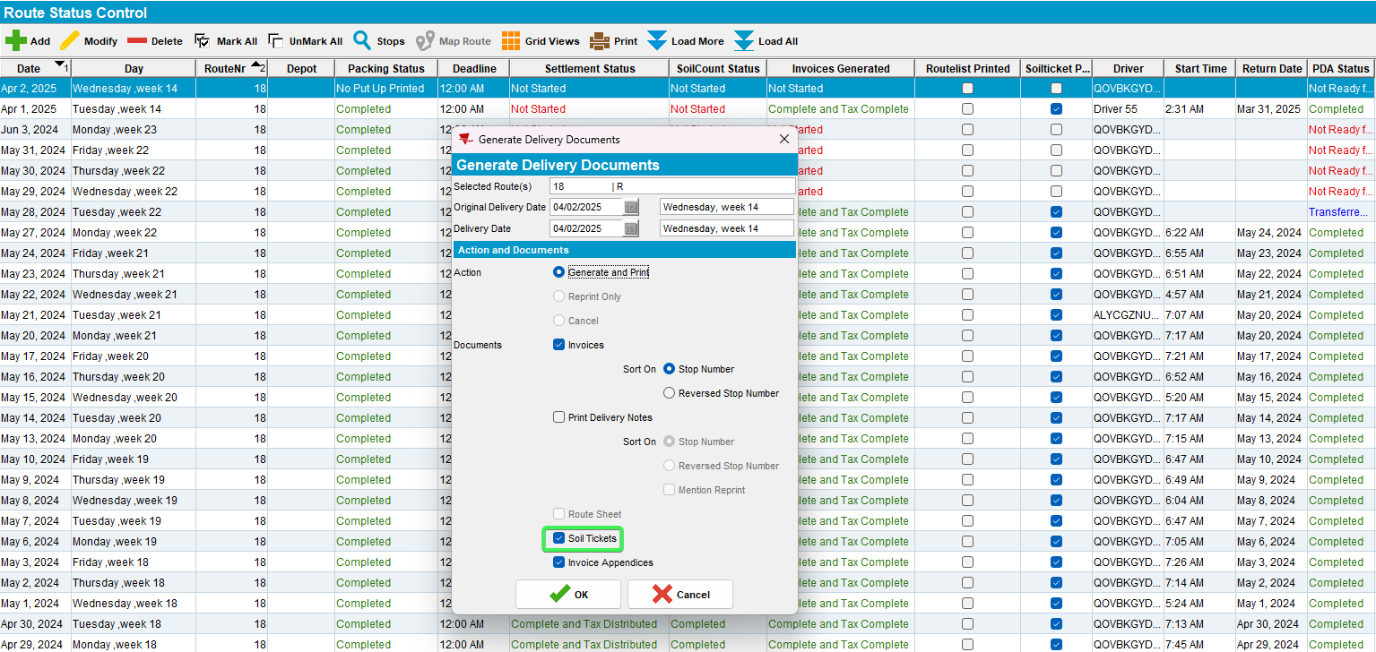
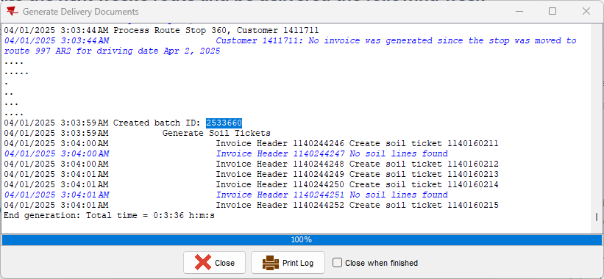

- Soil count entry: select route A and make a note of the soilticket number belonging to the customer you intend to set as undeliverable
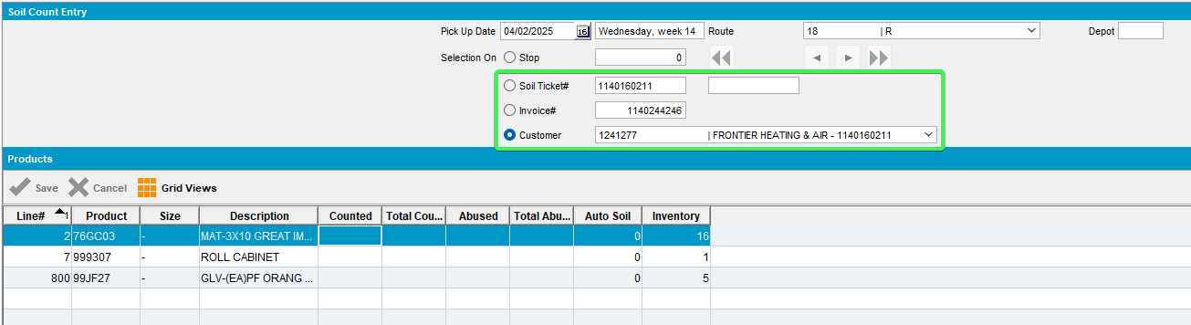
- RA: Set customer from step 2 with a soil ticket to undeliverable
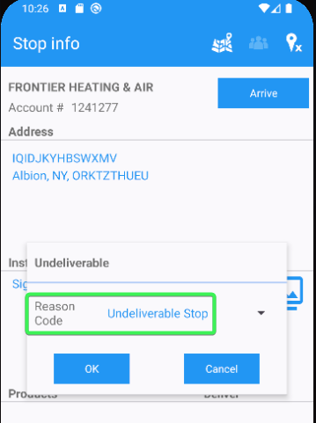
- WebX: move the undeliverable stop to tomorrow's date on route B
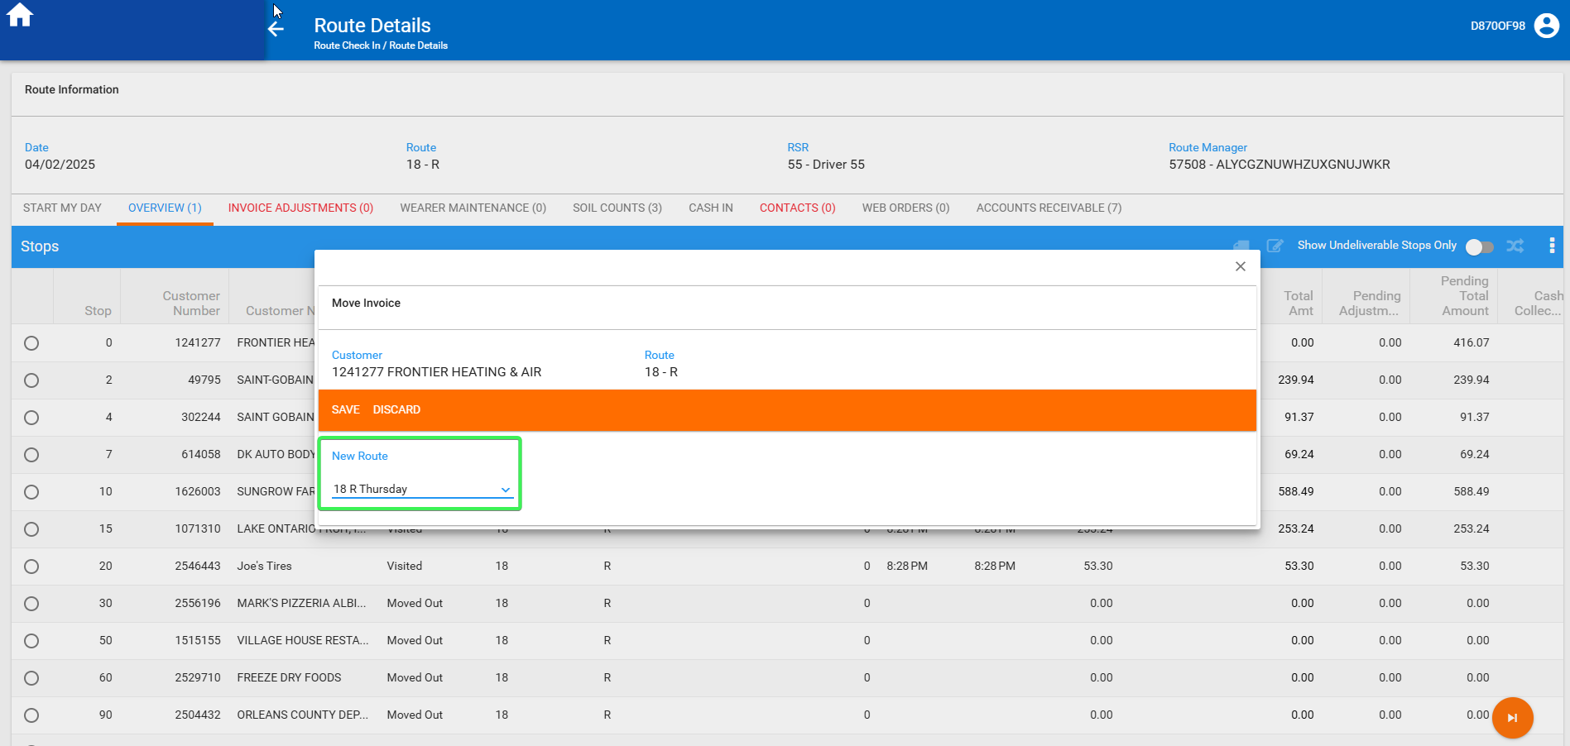
- WebX: settle the route
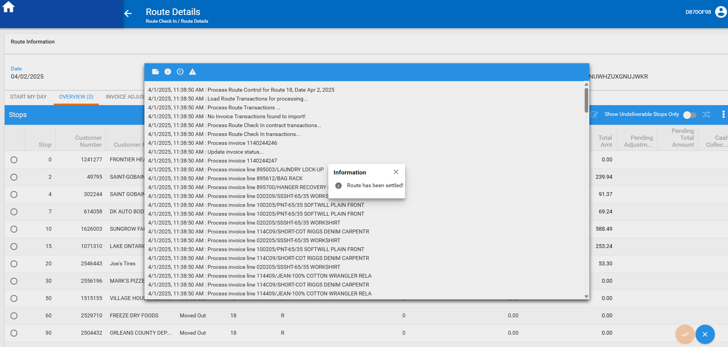
- On route B generate invoices and send it to RA
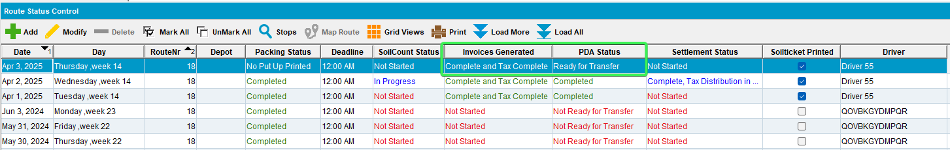
- RA: complete route
- WebX: settle the route
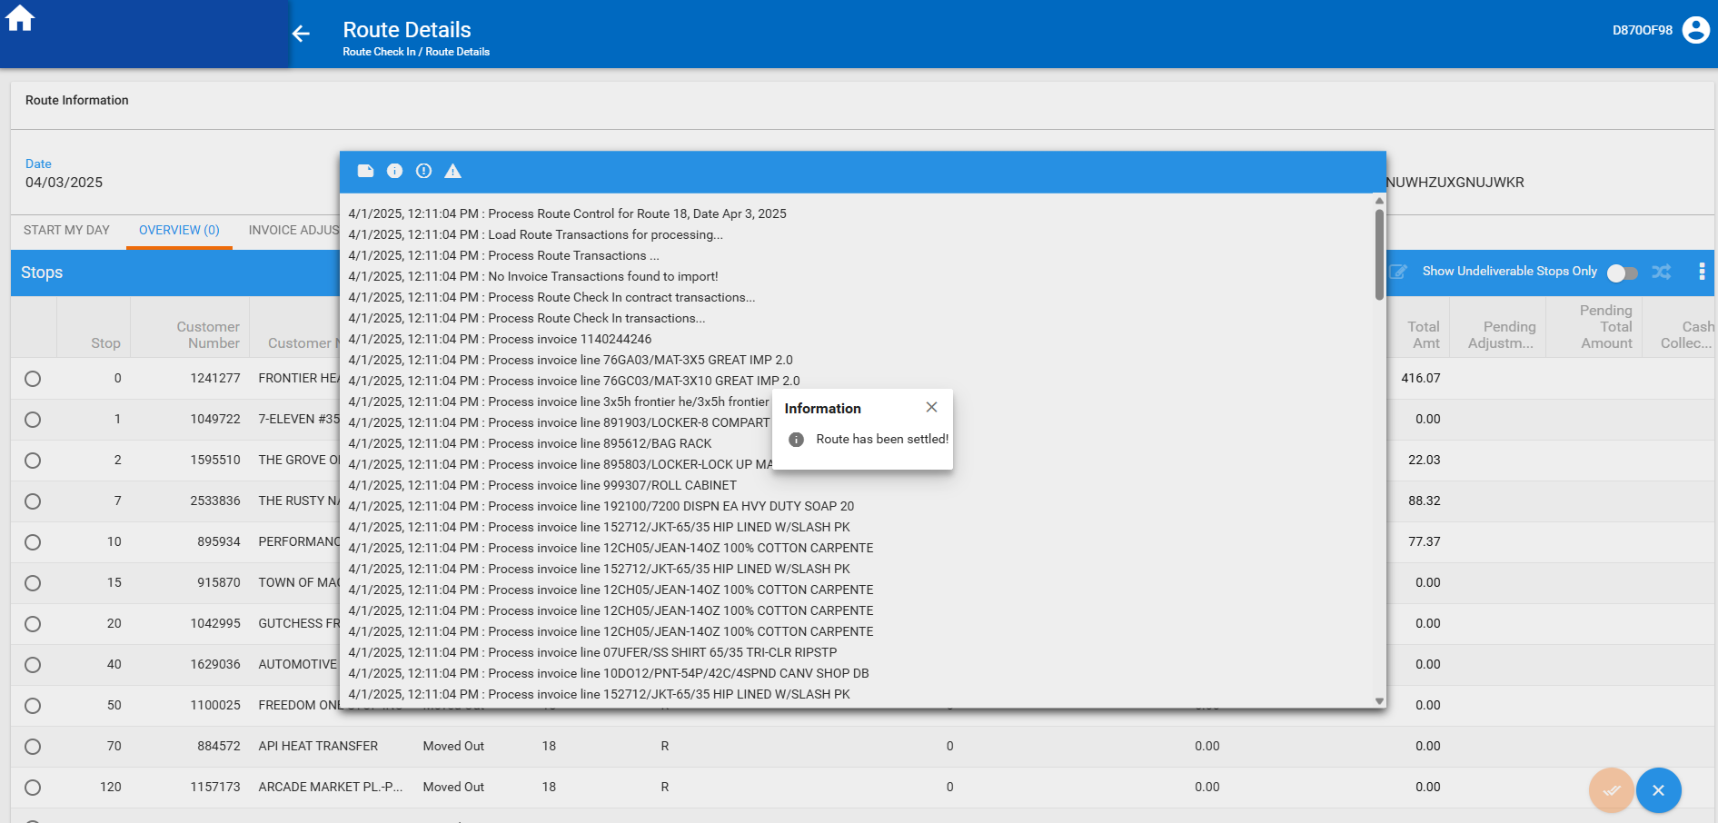
- Add route A +7 days (next week's route)
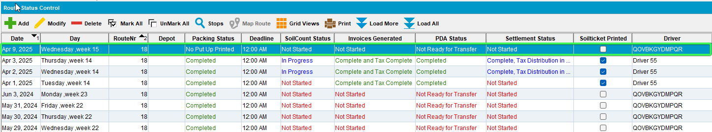
- Generate packing notes for route A +7
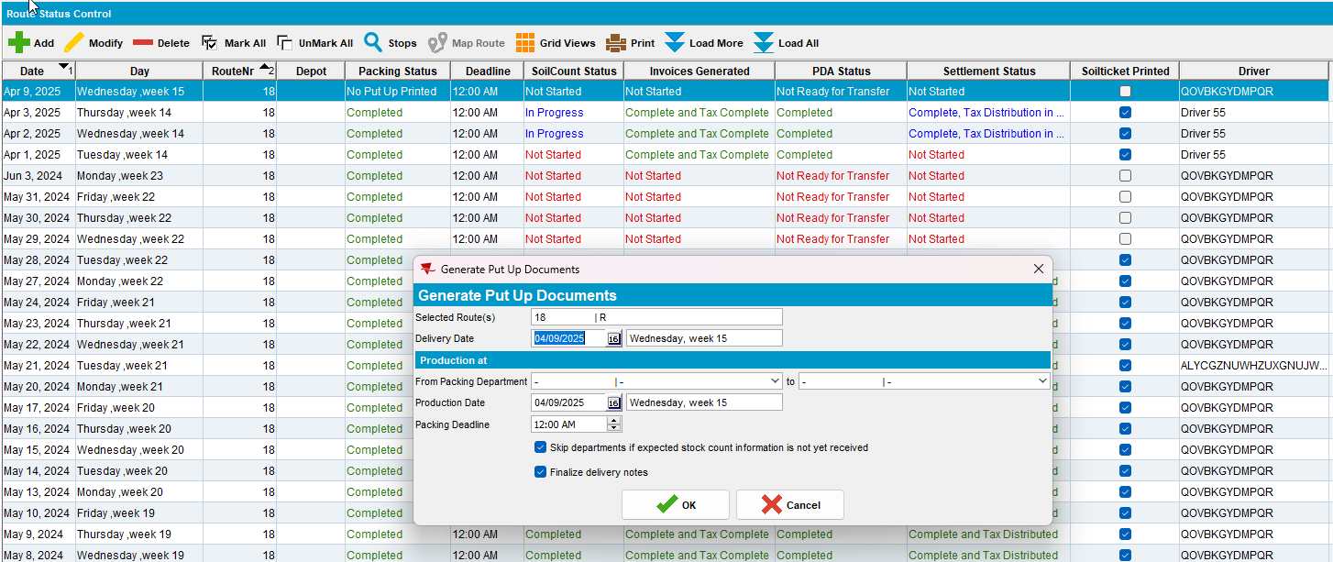
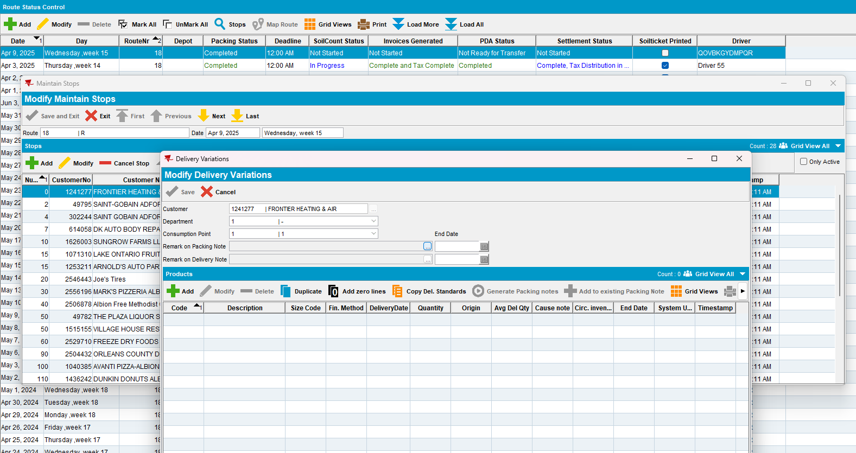
REPRODUCED OK.

Current Behavior
There is no delivery variation for the customer that was set as undeliverable on route A when checking on route A for next week

Expected behavior
When soil tickets are automatically processed before next week's packing notes are generated, we also process soil tickets attached to undeliverable invoices that were moved to different routes.

Retest after fix

Test Case 1 – Check that Soil tickets are also processed for undeliverable invoices with a customer that is invoiced every 2 weeks
Hash: 6dce86a4bdea
- Generate invoices with soil tickets and send to RA for route A
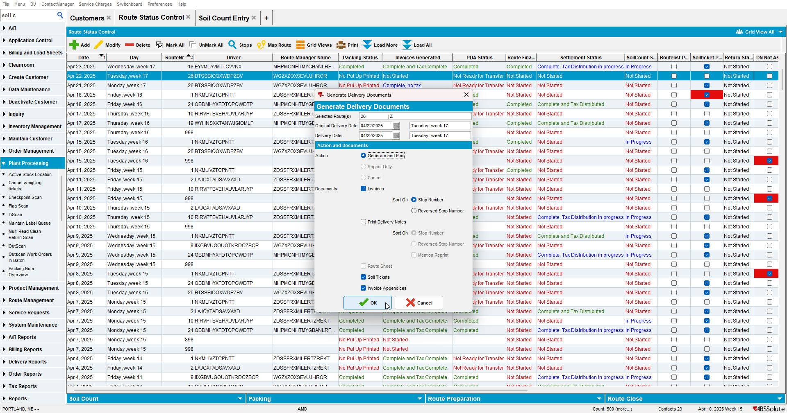

- Soil count entry: select route A and make a note of the soil ticket number belonging to the customer you intend to set as undeliverable this customer is invoiced every 2 weeks
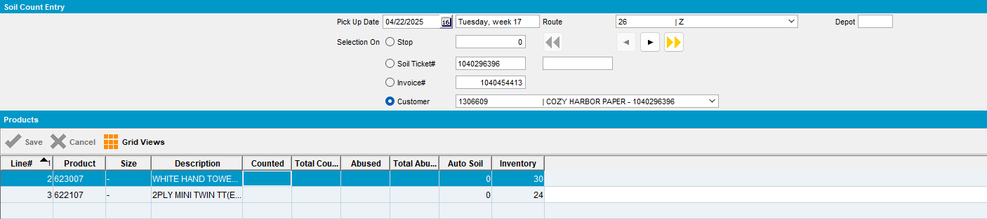

- RA: Set one customer with a soil ticket to undeliverable
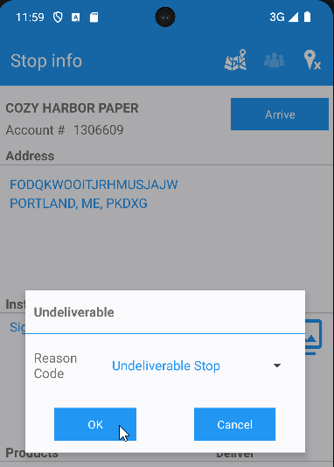

- WebX: move the undeliverable stop to tomorrow's date on route B
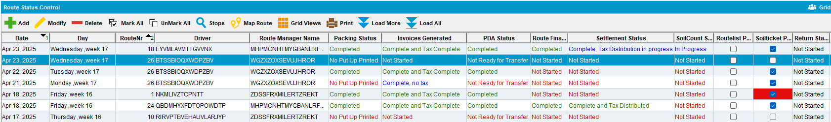
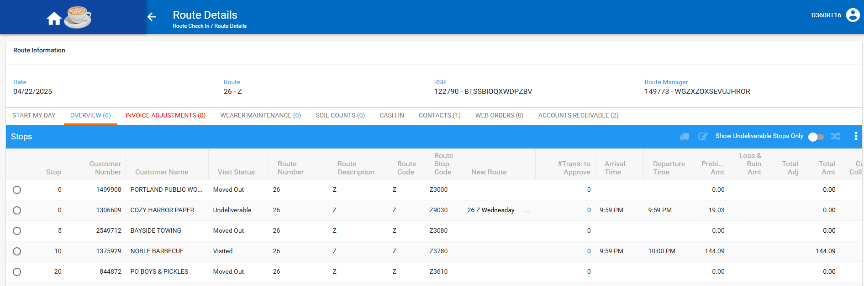

- WebX: settle the route
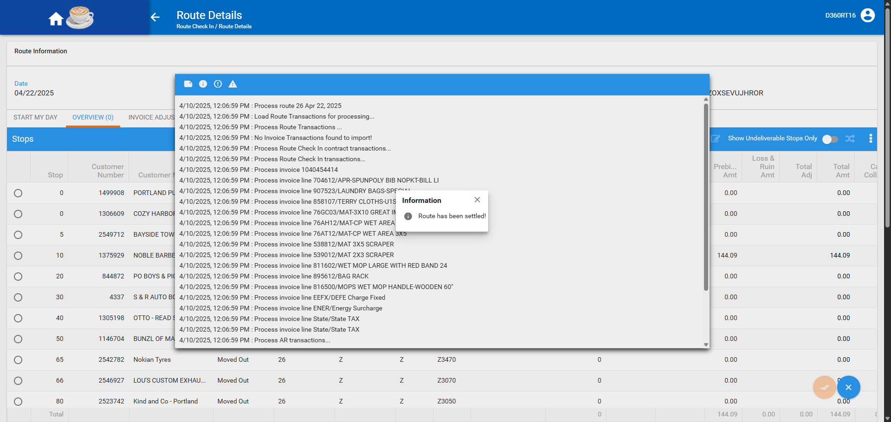

- On route B generate invoices and send it to RA
- RA: complete route
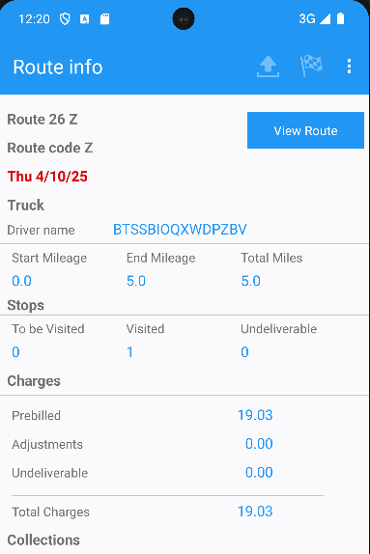

- WebX: settle the route
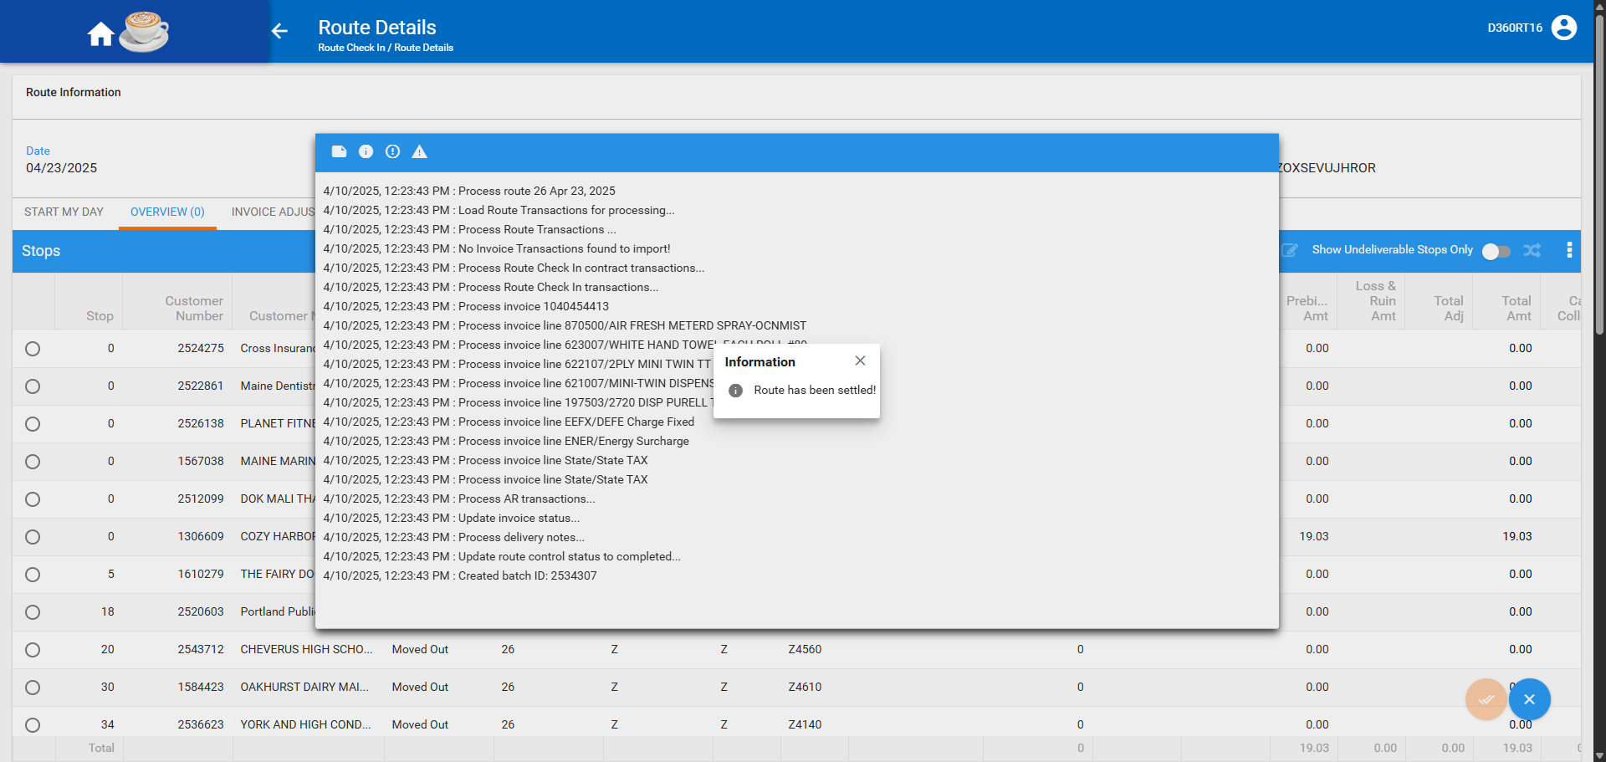

- Add route A +7 days (next week's route)
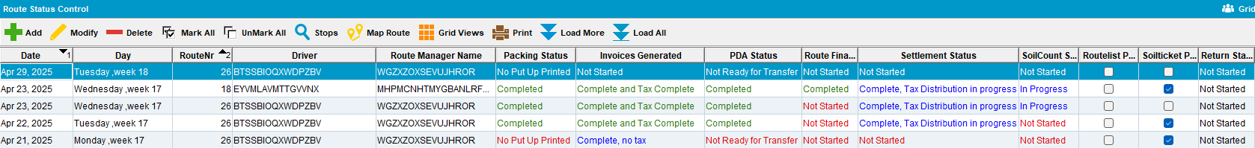

- Generate packing notes for route A +7
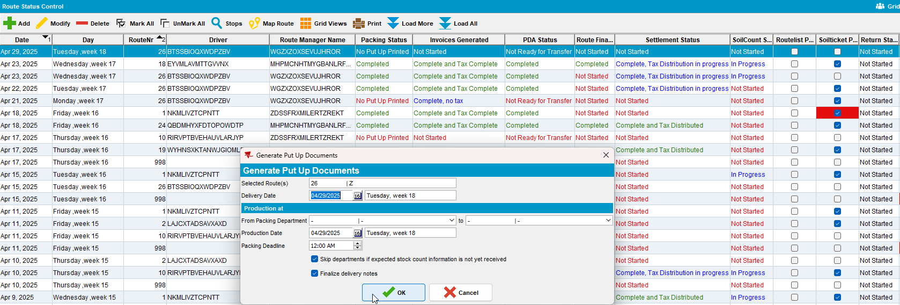

- Add route A +14 days
- Generate packing notes for route A +14 where the customer Is present
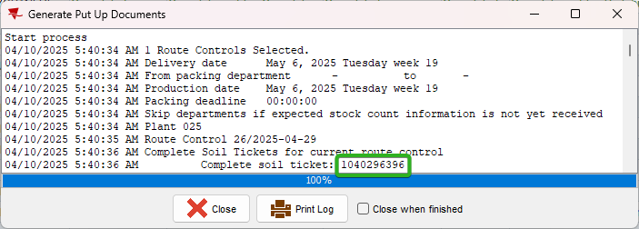

Test Case 2 – Check that Soil tickets are also processed for undeliverable invoices with a customer that is invoiced every week
Hash: 6dce86a4bdea
Expected Behavior: When soil tickets are automatically processed before next week's packing notes are generated, we also process soil tickets attached to undeliverable invoices that were moved to different routes.
- Generate invoices with soil tickets and send to RA for route A
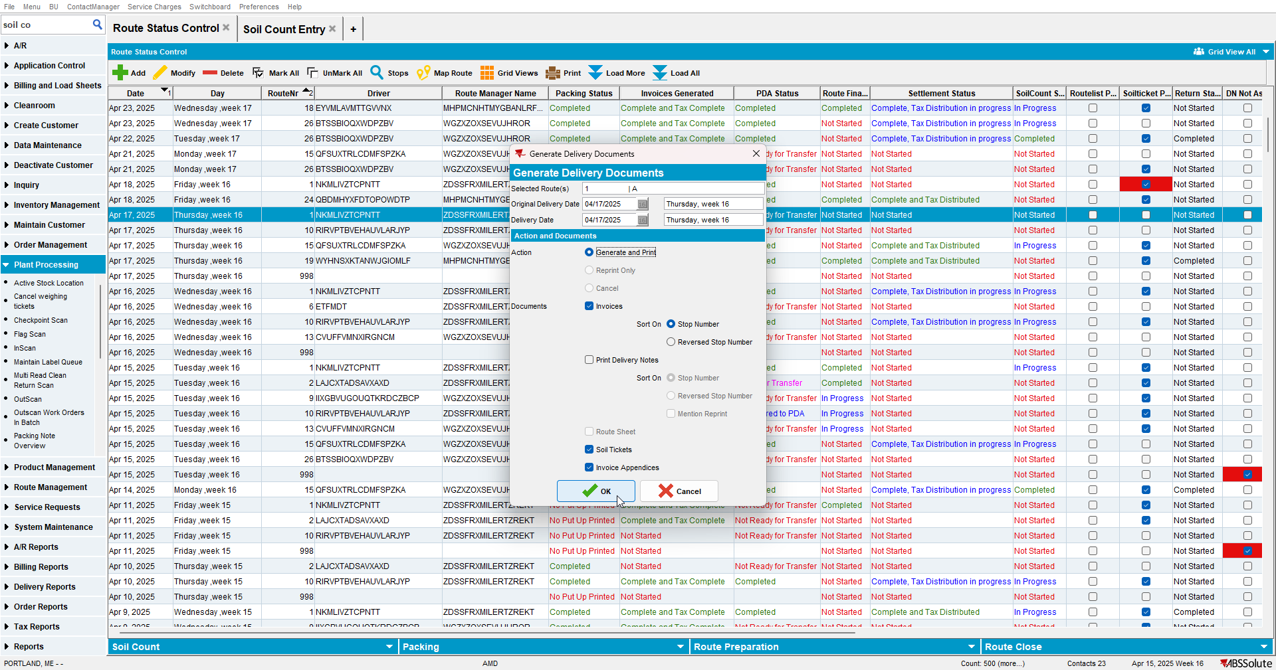

- Soil count entry: select route A and make a note of the soil ticket number belonging to the customer you intend to set as undeliverable this customer is invoiced every week
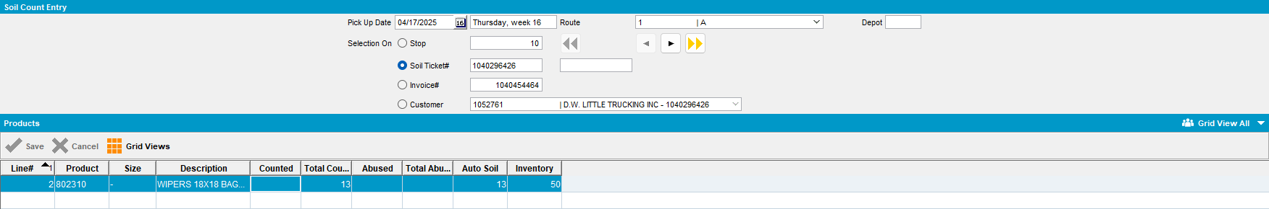
- RA: Set one customer with a soil ticket to undeliverable
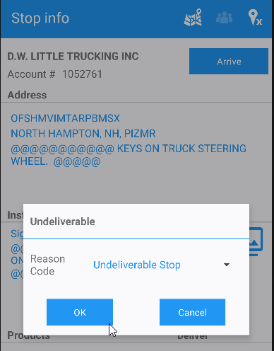

- WebX: move the undeliverable stop to another date on route B
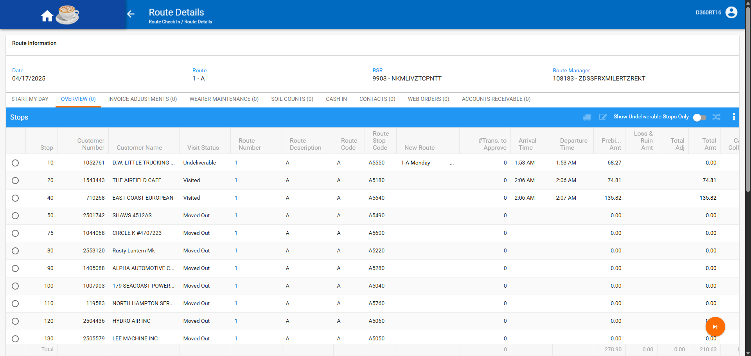

- WebX: settle the route
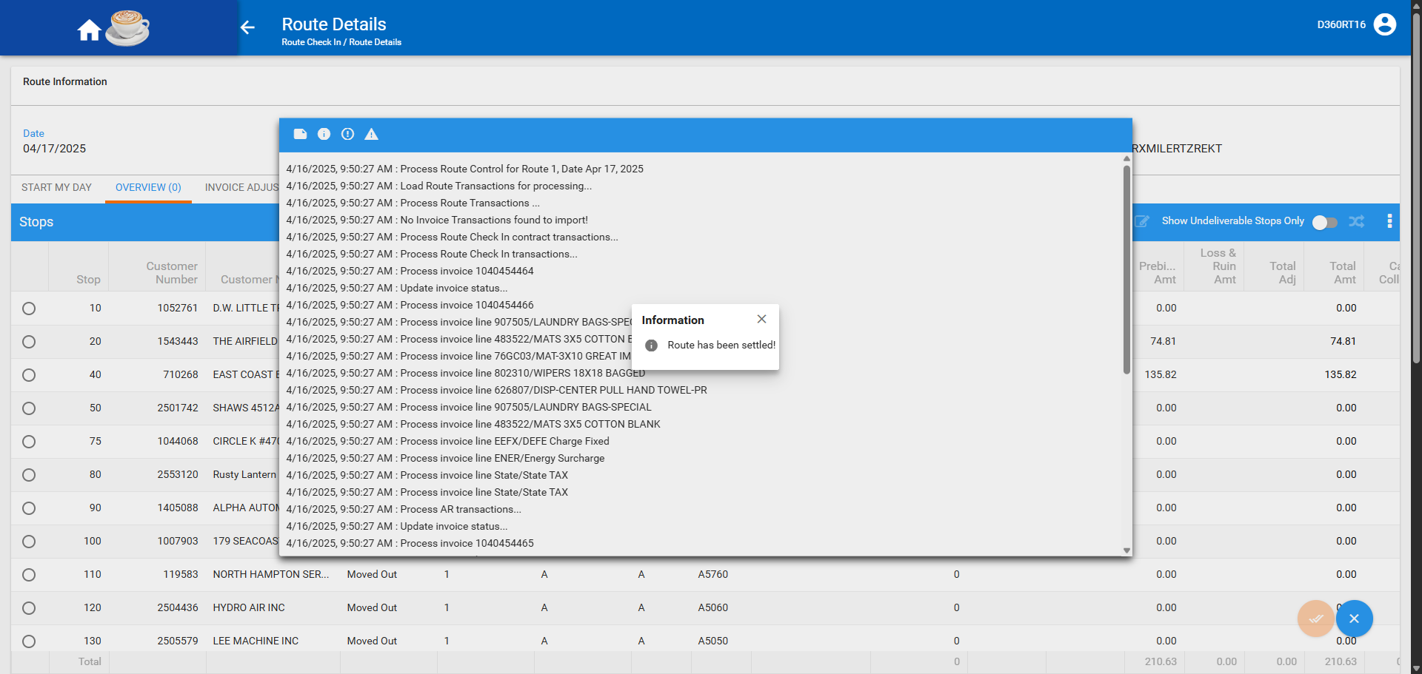

- On route B generate invoices and send it to RA
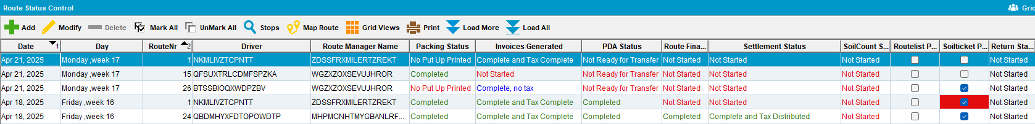

- RA: complete route
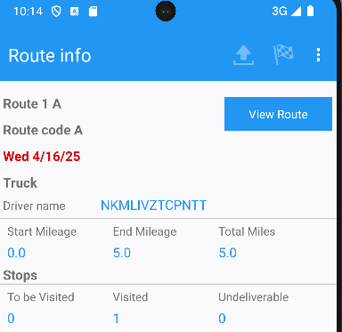

- WebX: settle the route
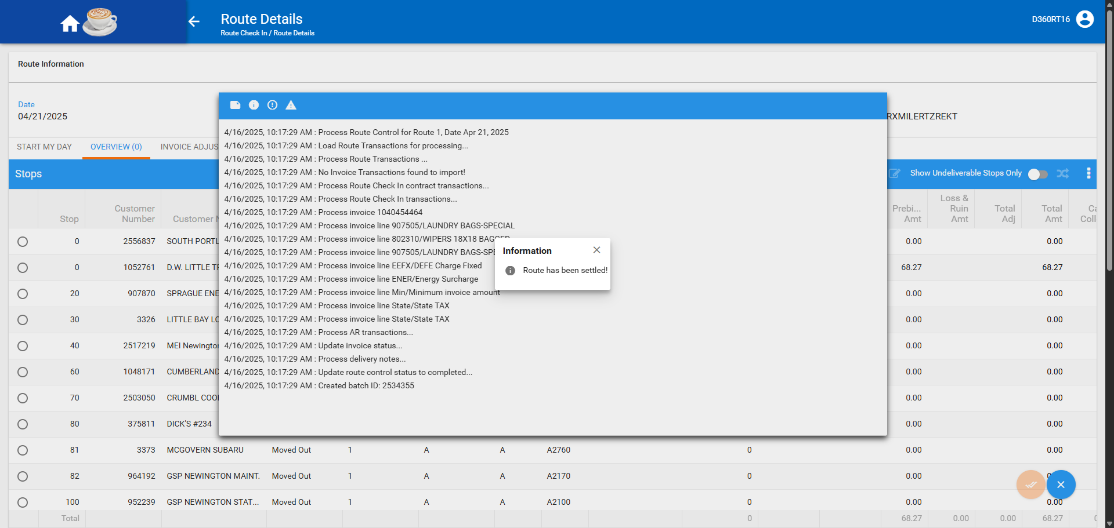

- Add route A +7 days (next week's route)
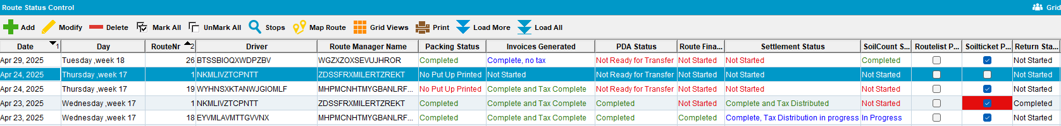

- Generate packing notes for route A +7
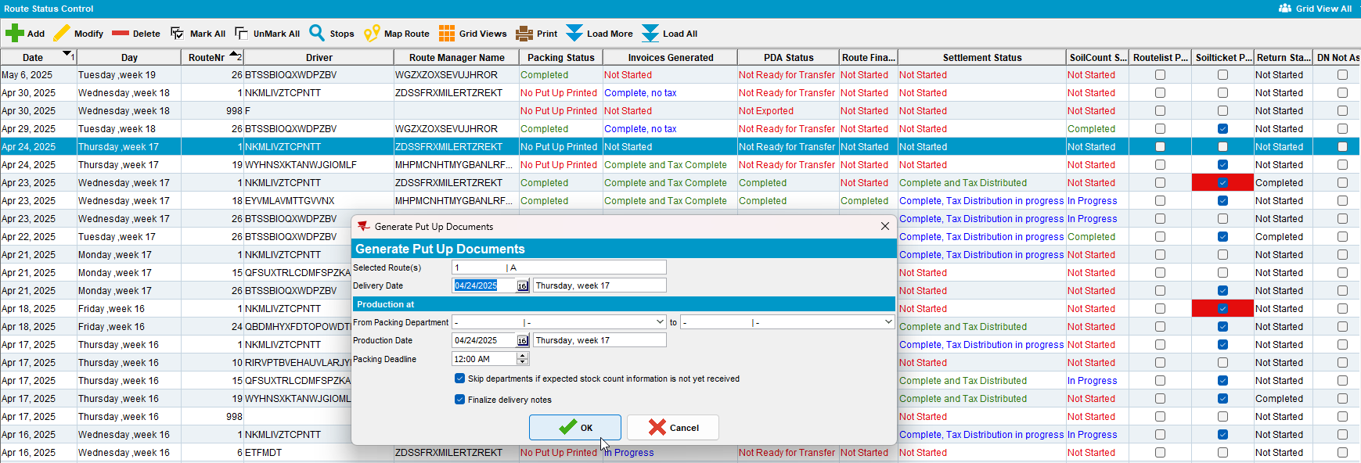
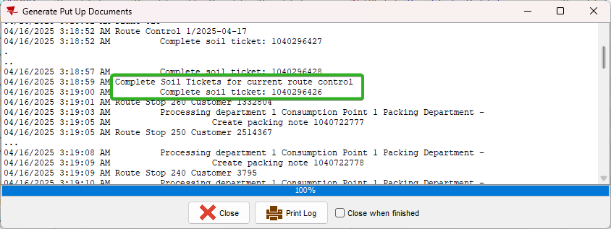
Tested OK

Test Case 3 – Check that Soil tickets are also processed for undeliverable invoices with a customer that has multiple delivery days and 1 billing day and Packing notes and invoices are generated before uploading data from RA
Hash: 6dce86a4bdea
Expected behavior: When generating packing notes for route A+7 the soil ticket from the original Monday's route A should be marked as complete.
- Have a customer with B day on Monday (route A) and D day on Thursday (route C)
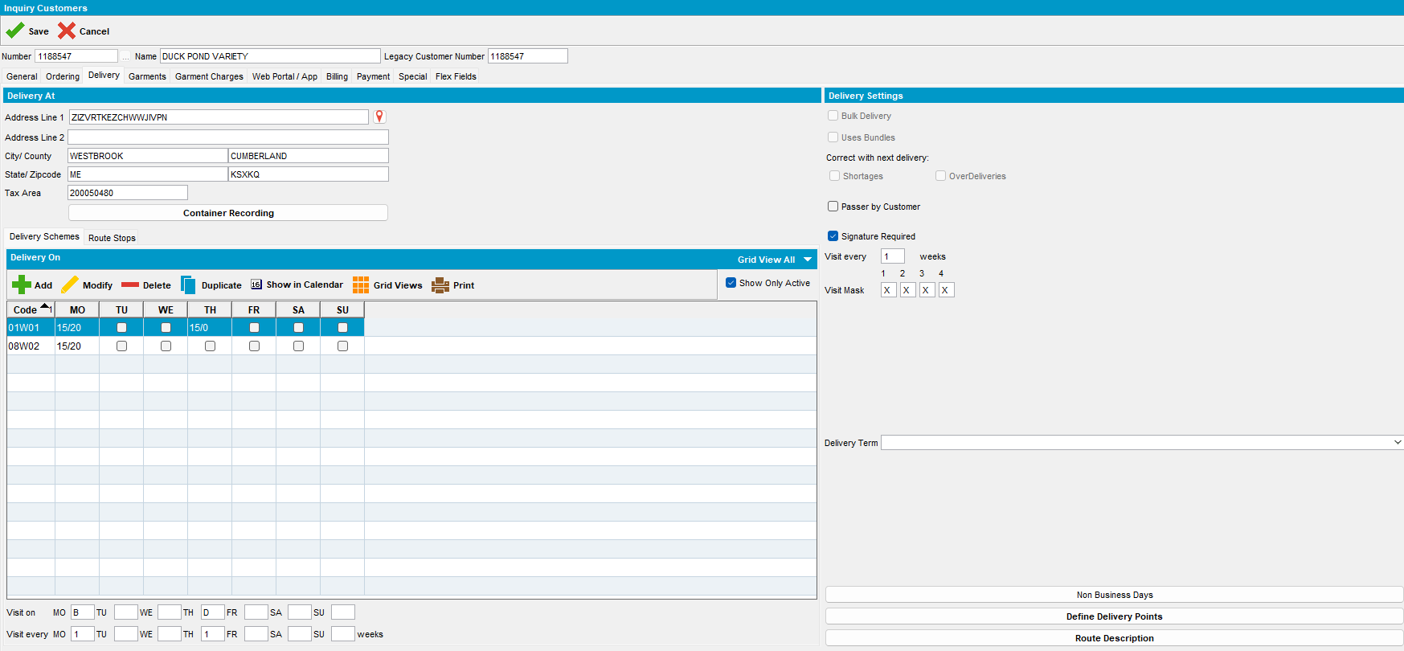

- Generate invoices with soiltickets and send to RA for route A
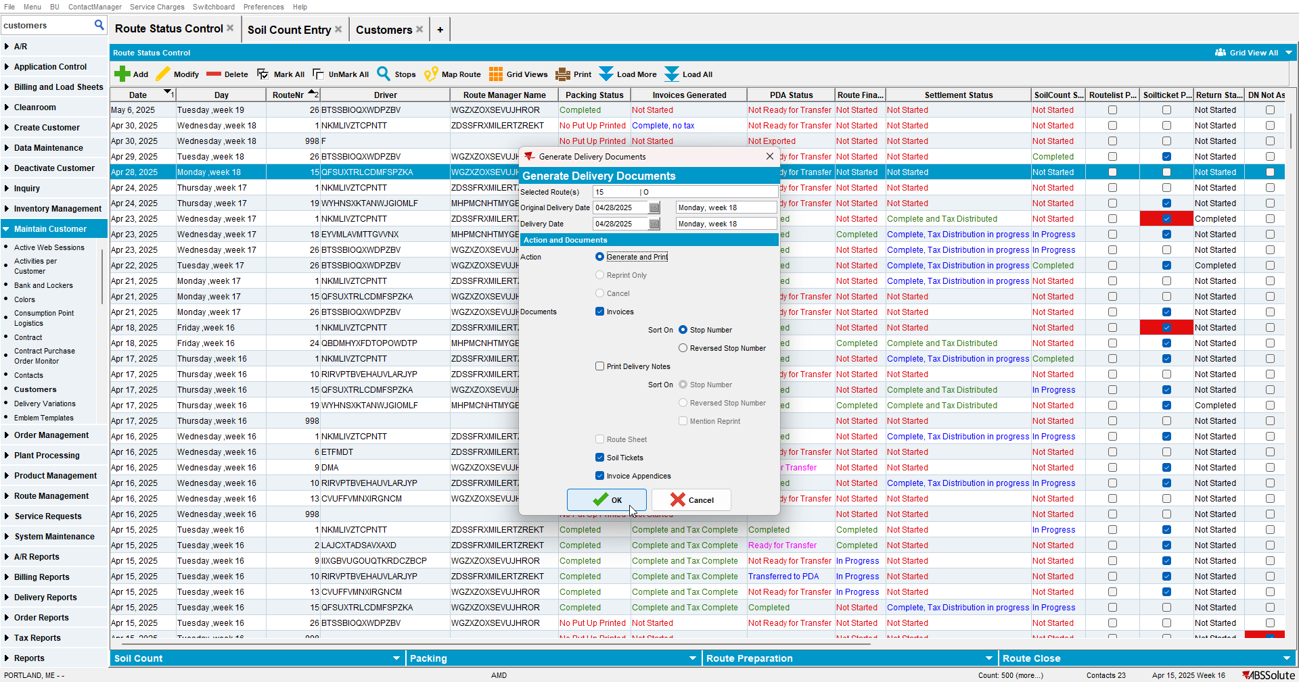

- Soil count entry: select route A and make a note of the soilticket number belonging to the customer you intend to set as undeliverable
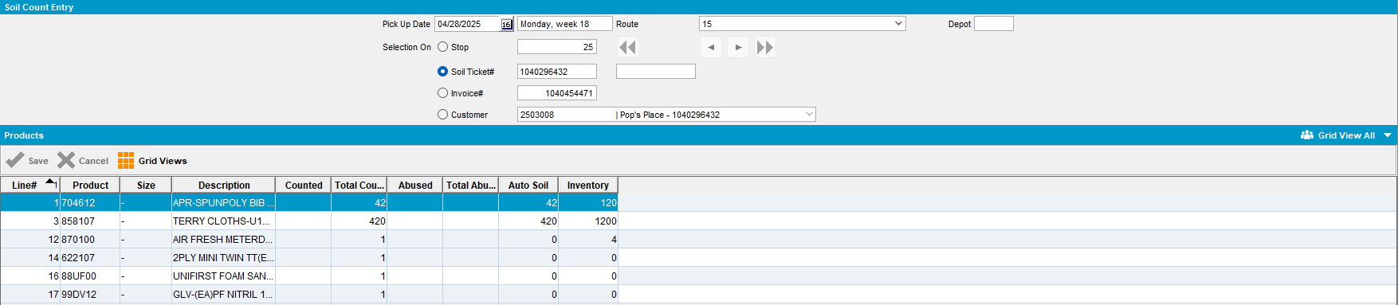

- RA: Set one customer with a soilticket to undeliverable
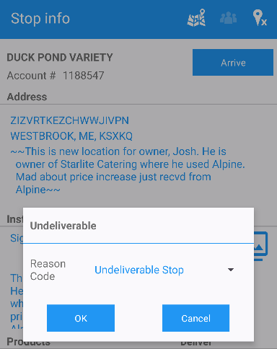

- WebX: move the undeliverable stop to tomorrow's date on route B
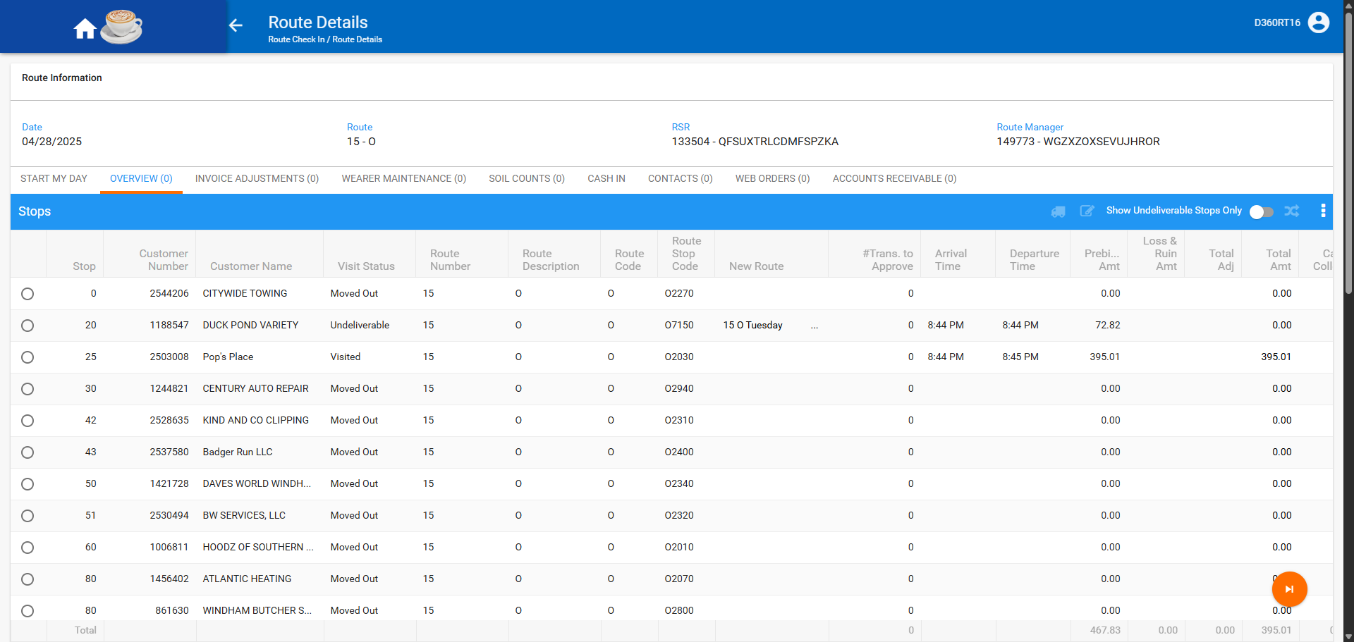

- WebX: settle the route
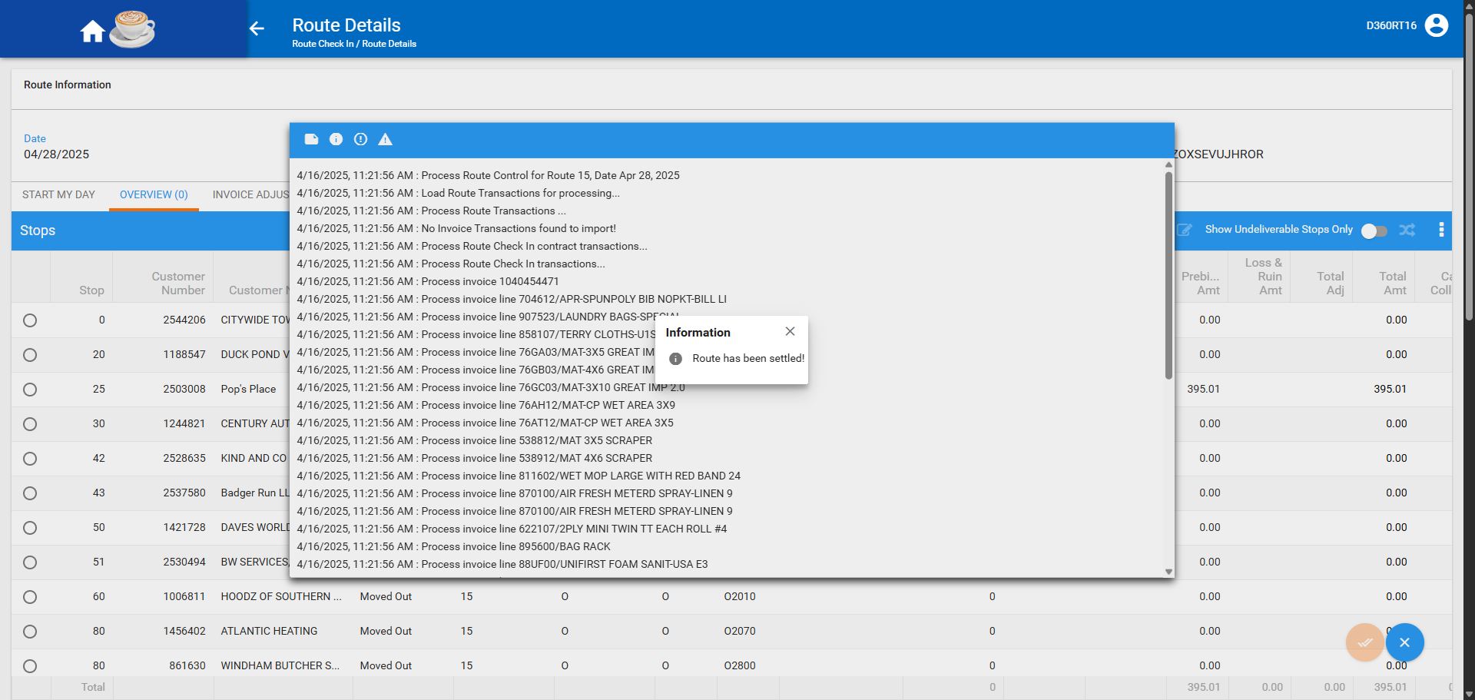

- RSC DLG: On route B generate invoices and send to RA
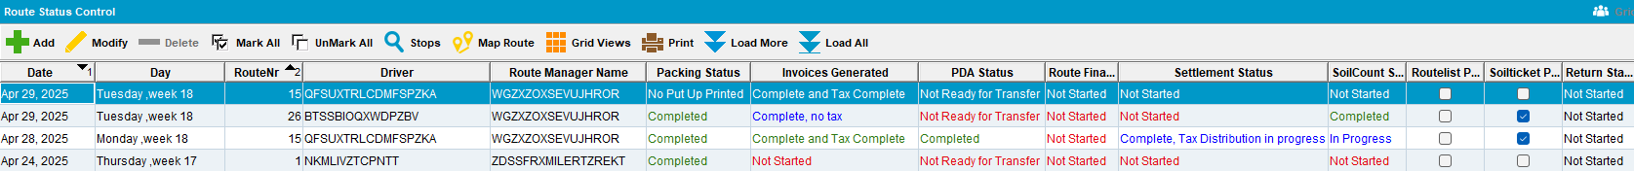

- RSC DLG: Add Thursday route for route C
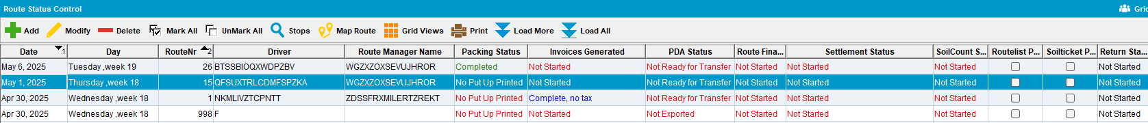

- RSC DLG: Generate packing notes for route C (Soil ticket should not be completed)
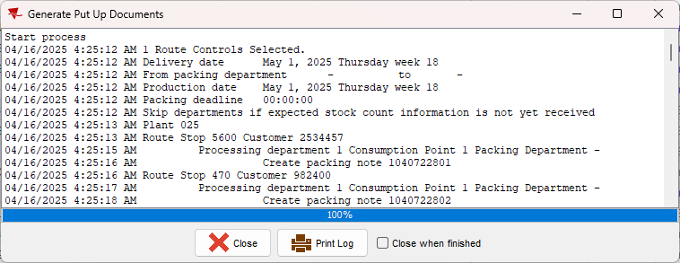

- RSC DLG: Generate invoices for route C
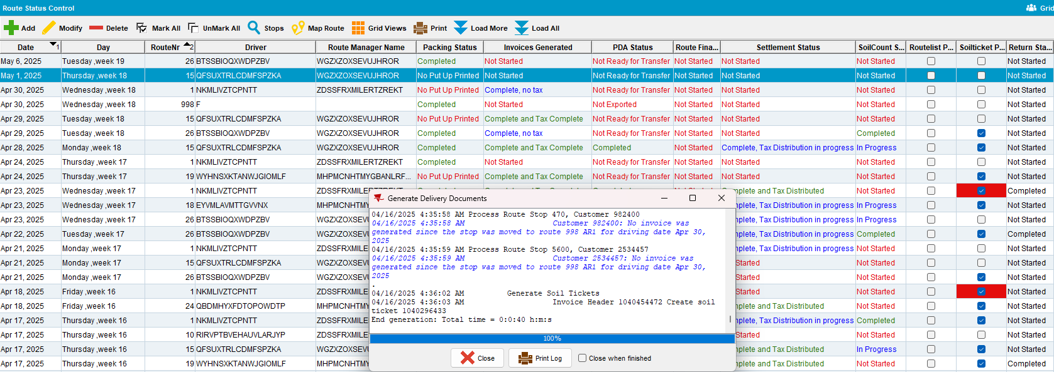

- RA: complete route B and upload
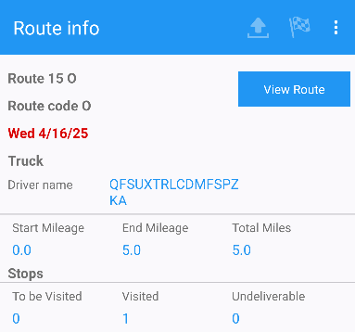

- WebX: settle route B
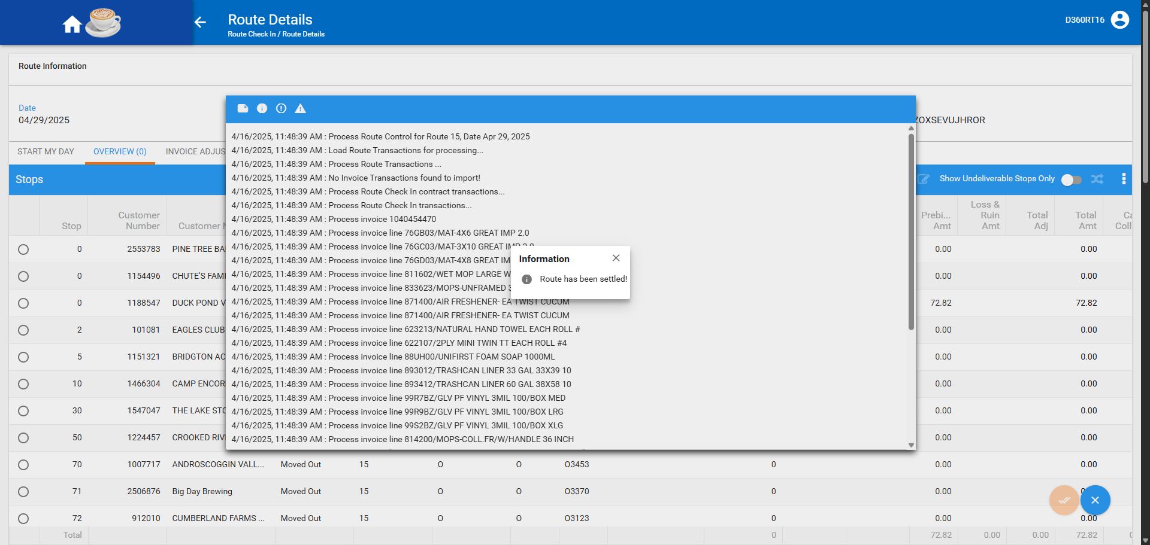

- RA: complete route C and upload
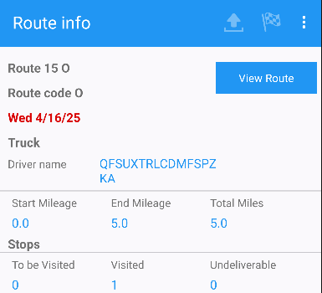

- WebX: settle route C
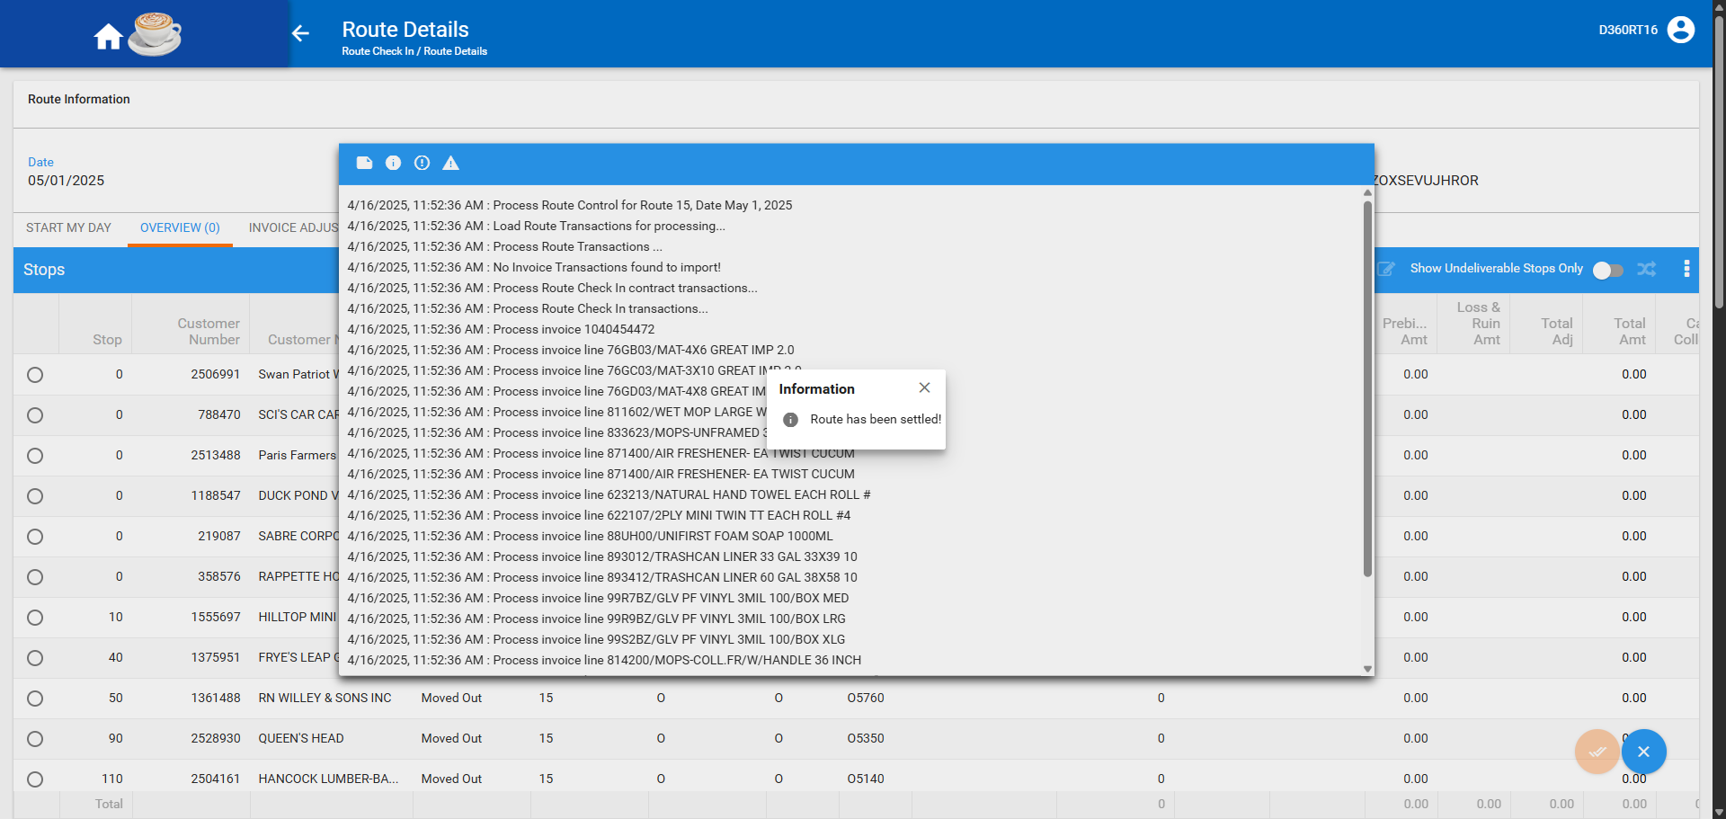
- Add route A +7 days (next week's route)
- Generate packing notes for route A +7
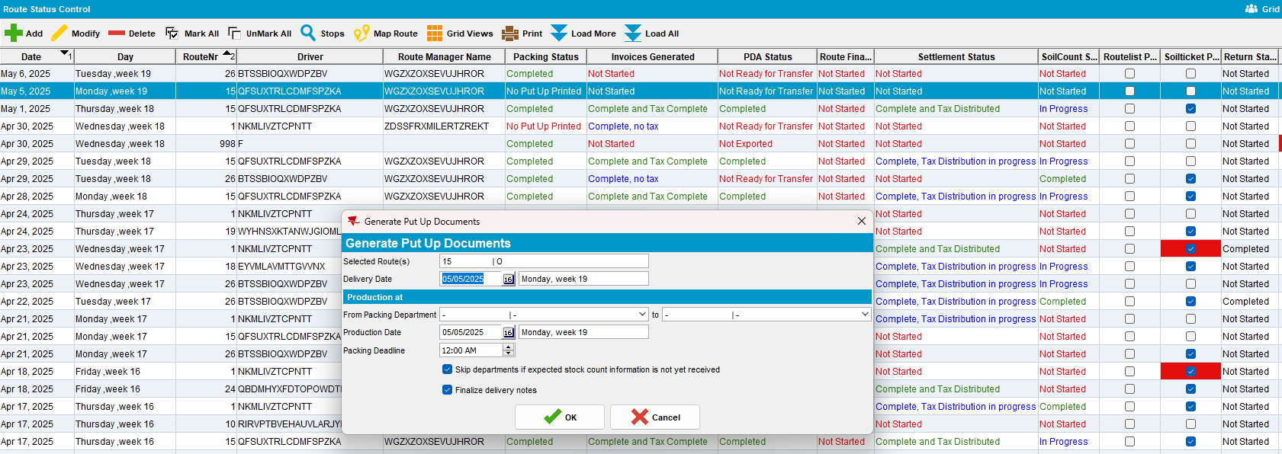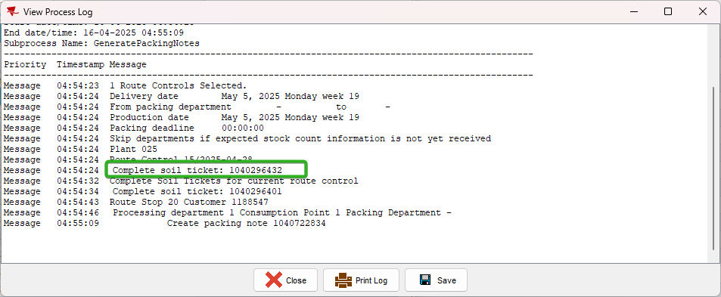

Tested OK

Test Case 4 – Check that Soil tickets are also processed for undeliverable invoices with a customer that has multiple delivery days, and 1 billing day and Packing notes and invoices are generated after uploading data from RA
Hash: 6dce86a4bdea
Expected behavior: When generating packing notes for route C the soil ticket from the original Monday's route A should NOT be marked as complete. It should be marked as complete when generating packing notes for route A + 7 days.
- Have a customer with B day on Monday (route A) and D day on Friday (route C)
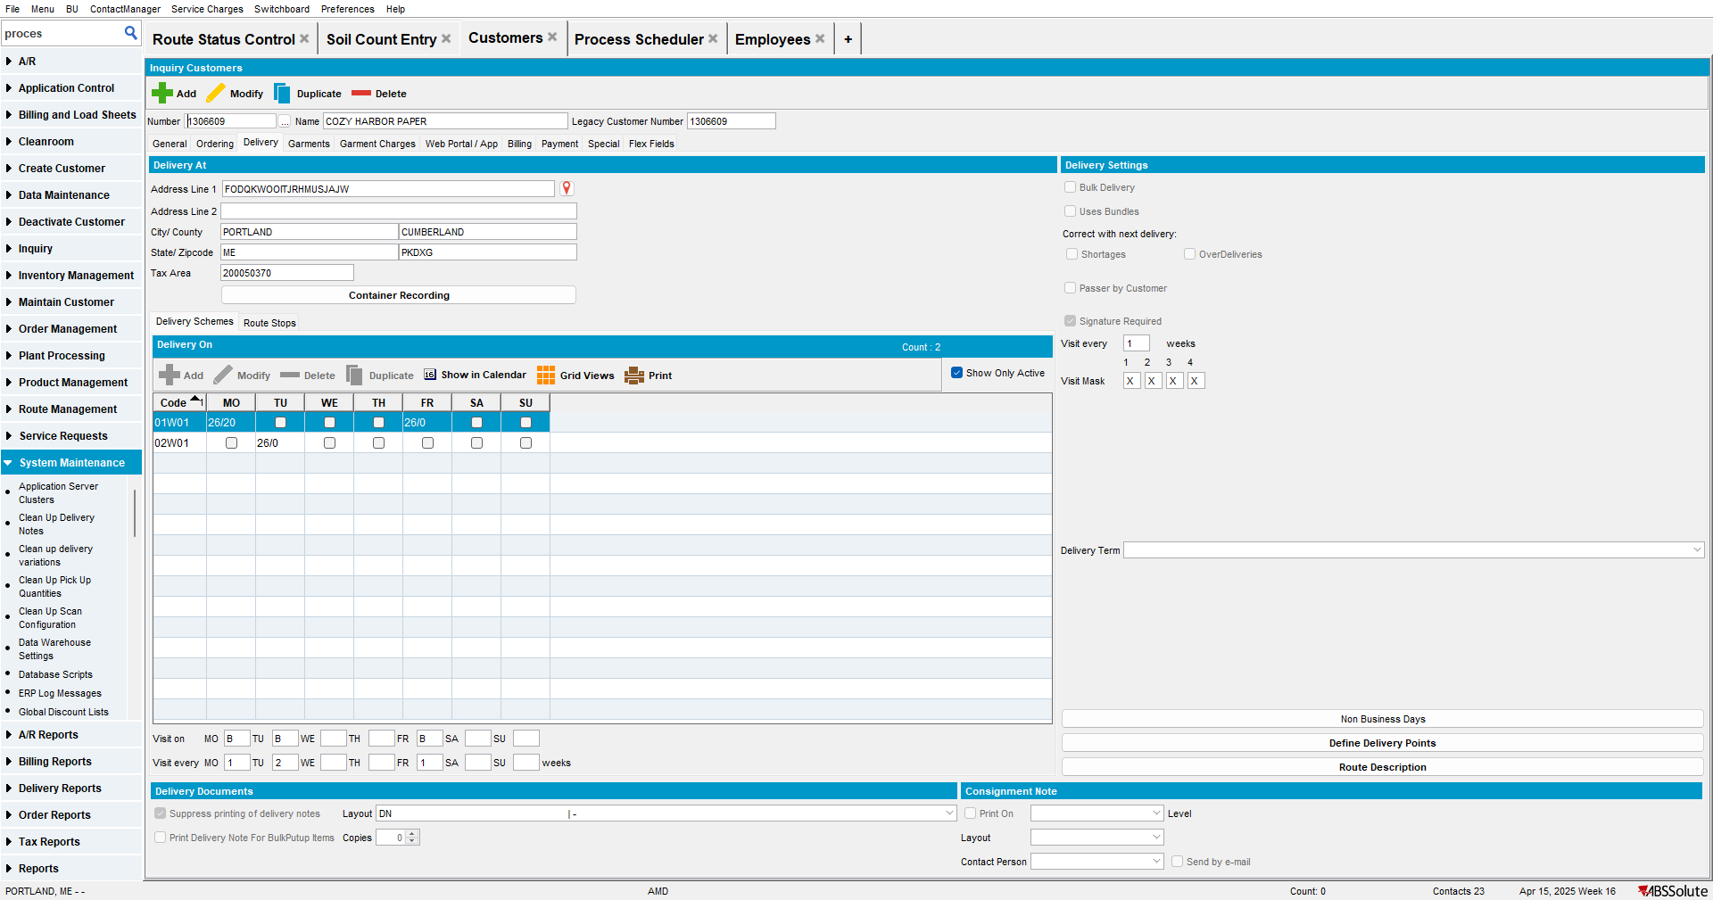

- Generate invoices with soiltickets and send to RA for route A
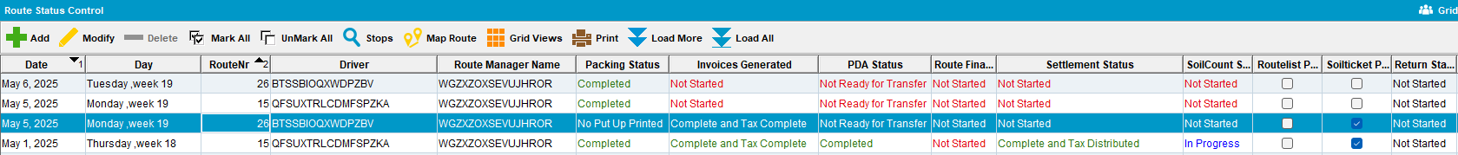

- Soil count entry: select route A and make a note of the soilticket number belonging to the customer you intend to set as undeliverable
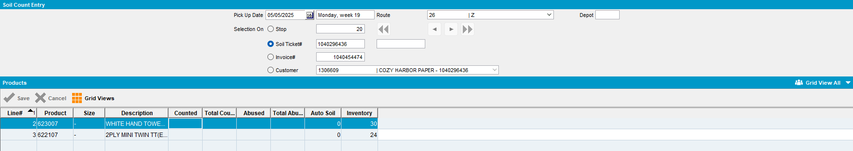

- RA: Set one customer with a soilticket to undeliverable
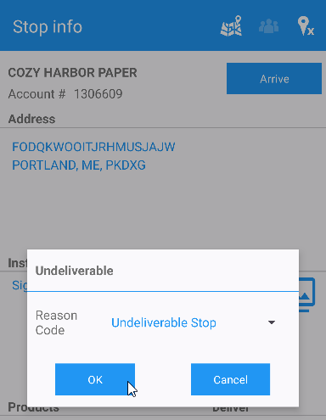

- WebX: move the undeliverable stop to another date on route B
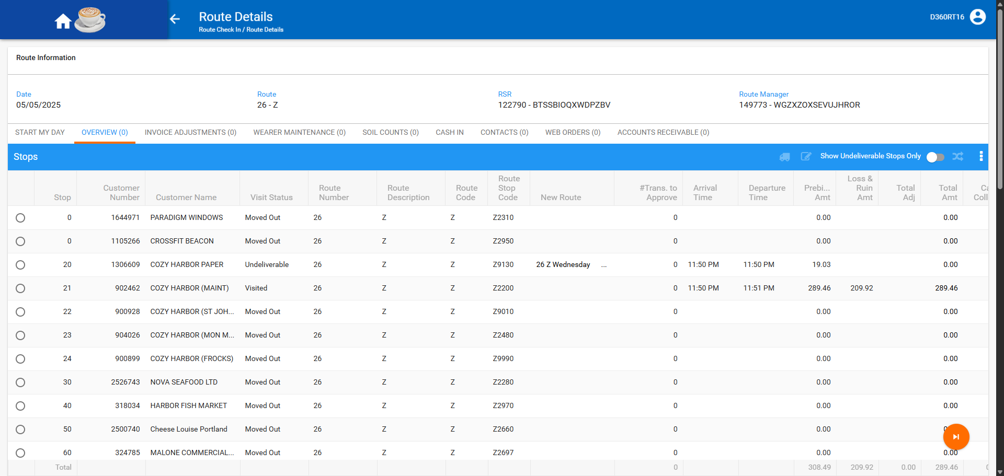

- WebX: settle the route
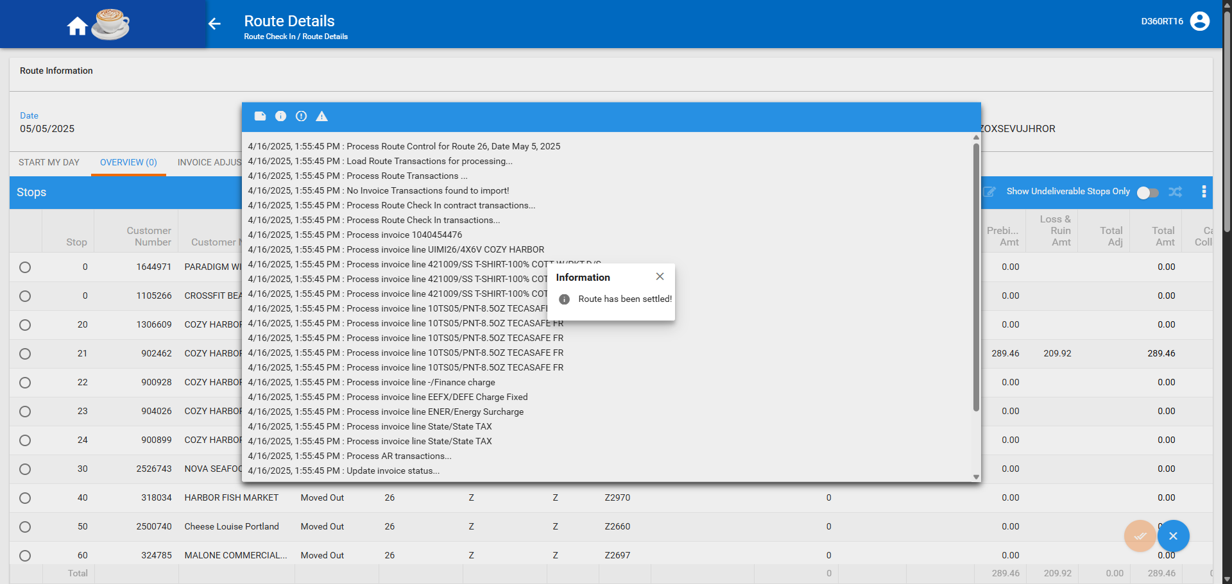

- RSC DLG: On route B generate invoices and send to RA

- RA: complete route B and upload
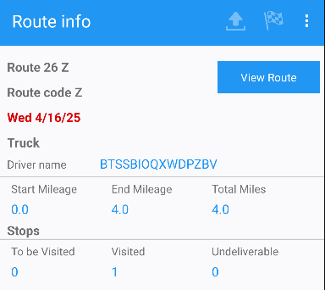

- WebX: settle route B
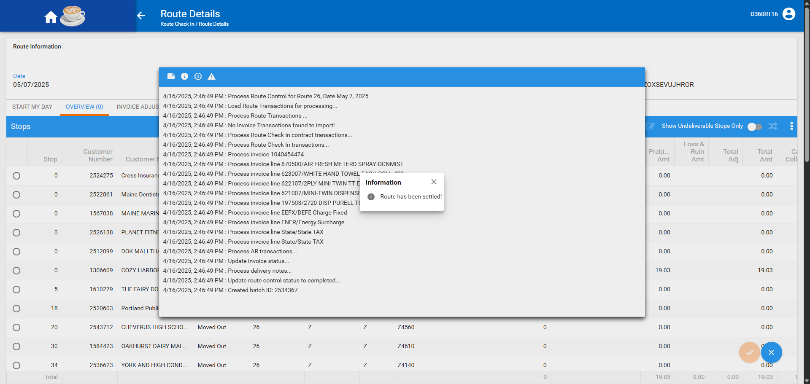

- RSC DLG: Add route C
- RSC DLG: Generate packing notes for route C
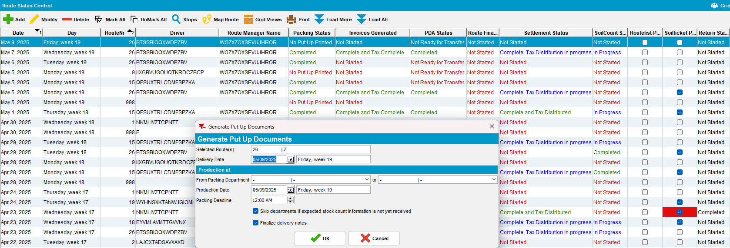

- RSC DLG: Generate invoices for route C
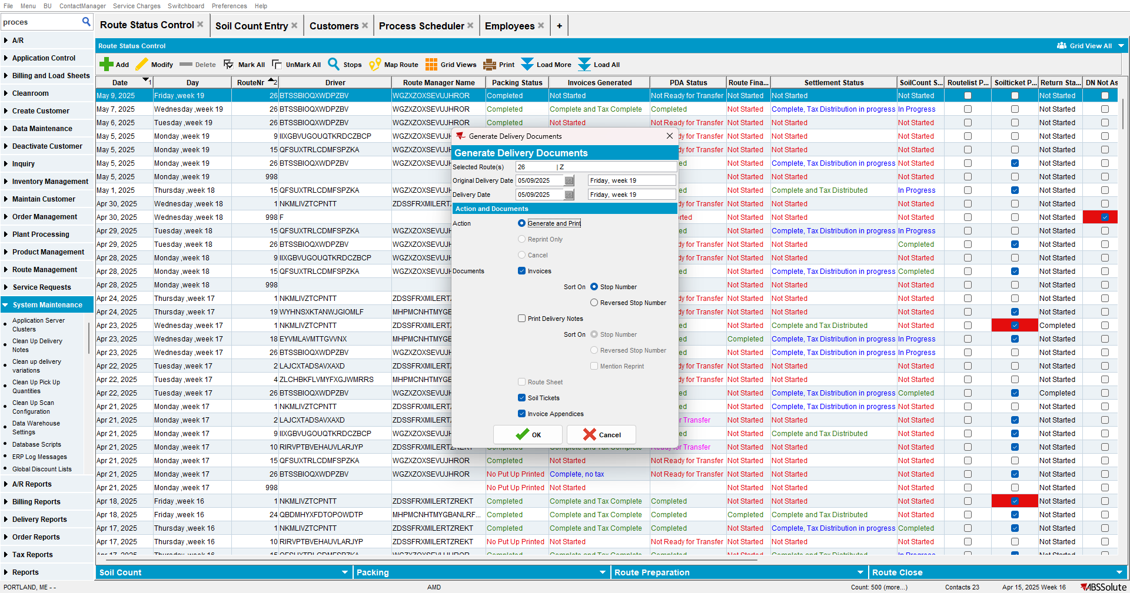

- RSC DLG: Settle route C
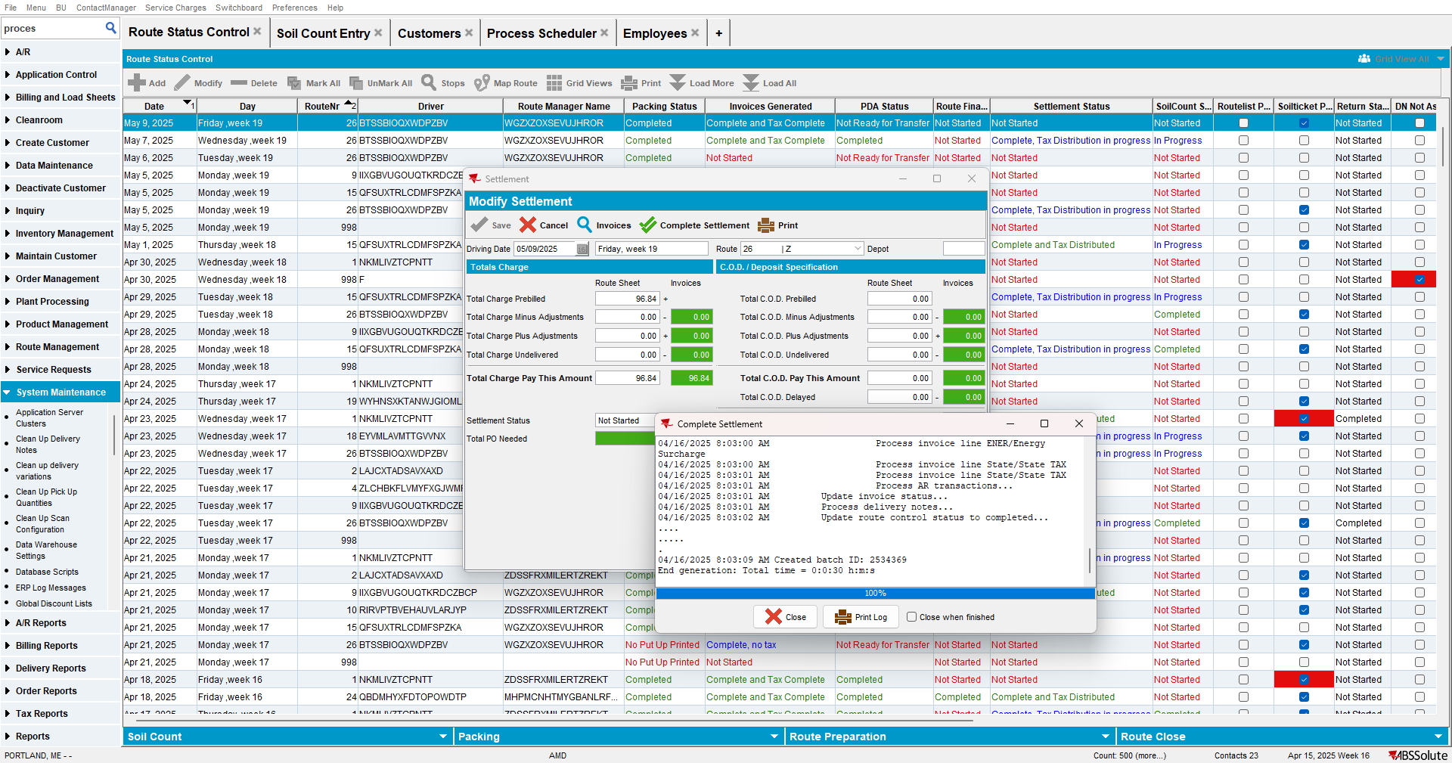

- Add A new route for route A + 7 days
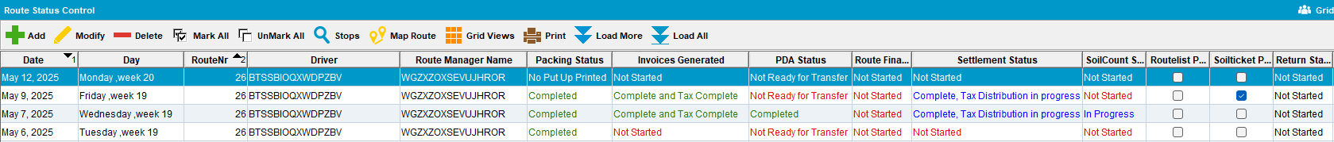

- Generate packing notes for this route and check the soil ticket is marked as compete
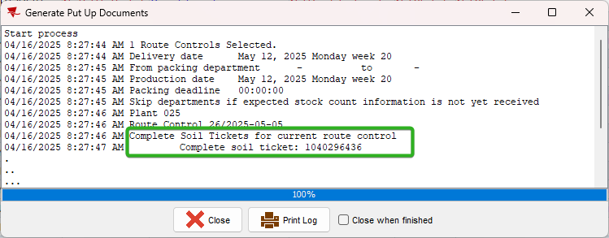
Tested OK

