ABSN-294 D_UBS_2584 Location when key direct sales with discount more than 100 Percent which causes direct sales invoice to credit invoice
Environment | Prerequisites
Version: 9.07.00.UNF19 hash: d6dd0810319  DBServerName= abs-srv20.internal.abslbs.com  DBSID=CUST24  DBUser=UNFA  DBPassword= UNFA  Environment=Test | - Module:  - System setting

Contents
Retest after fix 1

Retest after fix
Hash: 9.07.00.UNF19 hash: d6dd0810319
- Go to Maintain Sales Notes dlg and select a customer
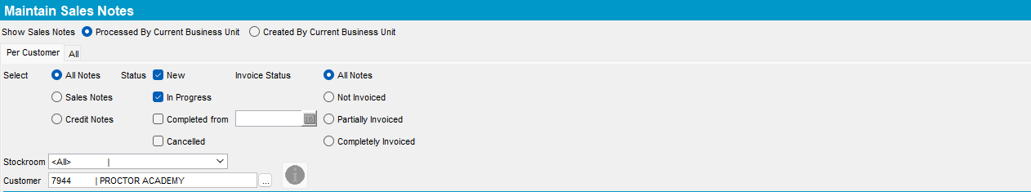

- Add a sales note for that customer. On the Ordered Items tab add an item. Select an item, for requested add a sales price and for Discount field put a value bigger than 100.
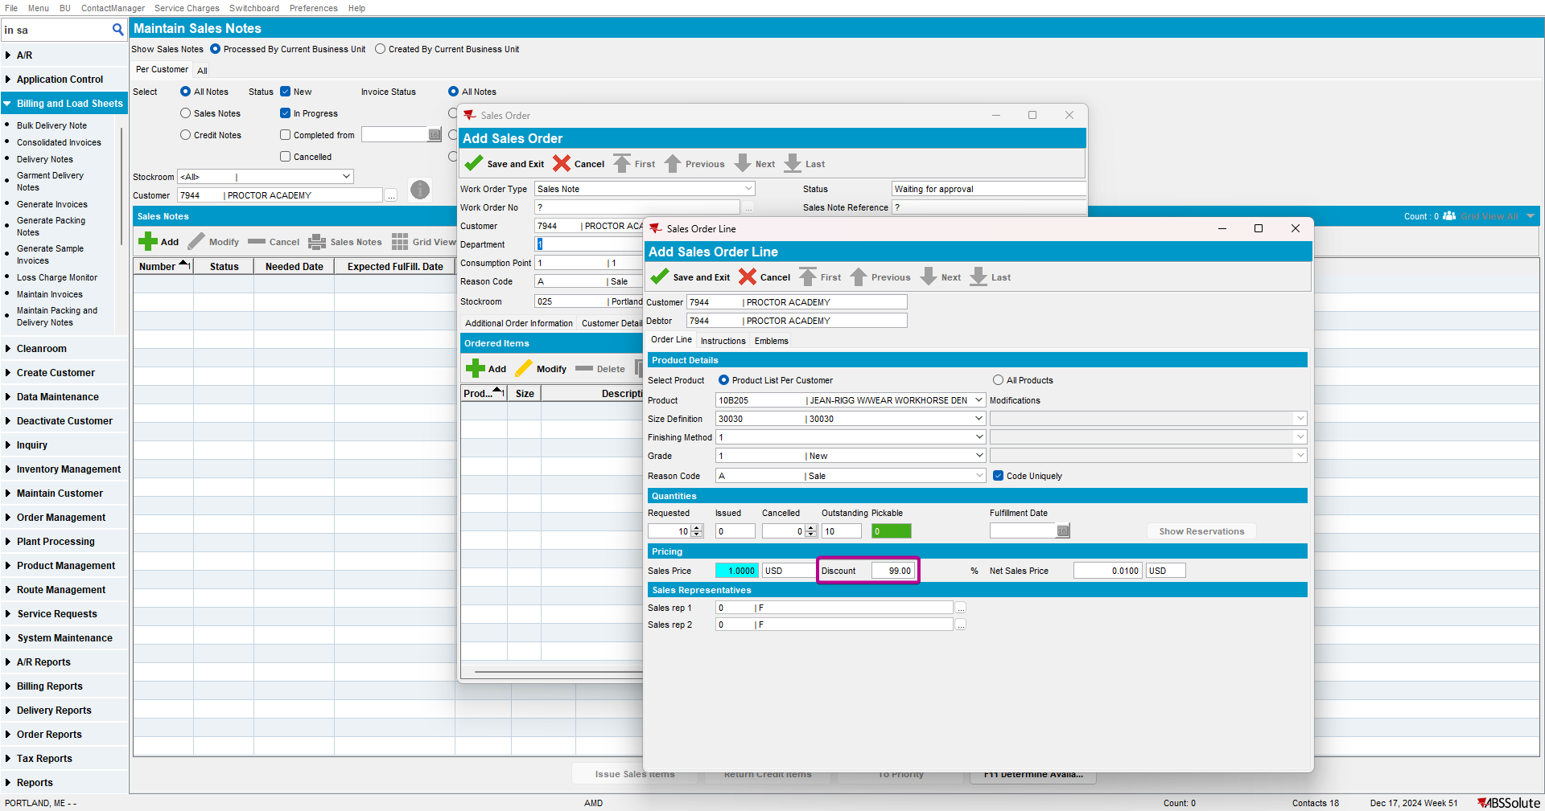
You cannot input a value greater than 100
- Go to Work Orders waiting for Approval dlg and approve your added sales note
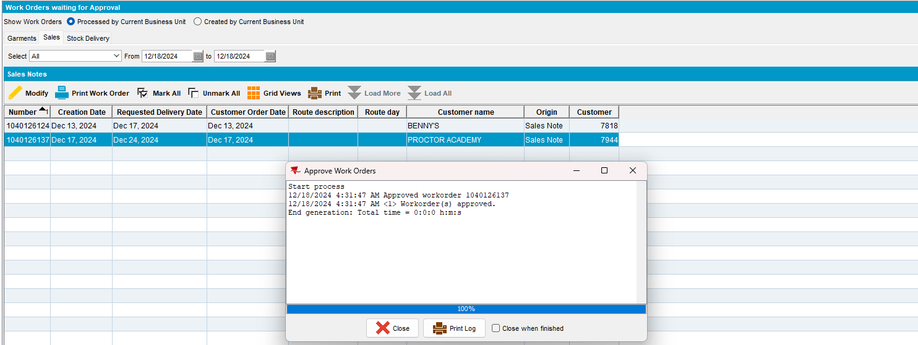

- Go back to Maintain Sales Notes dlg, issue your sales note and generate delivery notes
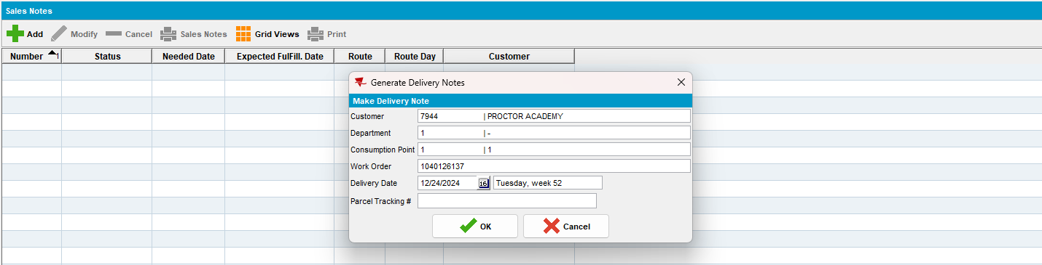

- In RSC dlg add the route for your customer and generate invoices
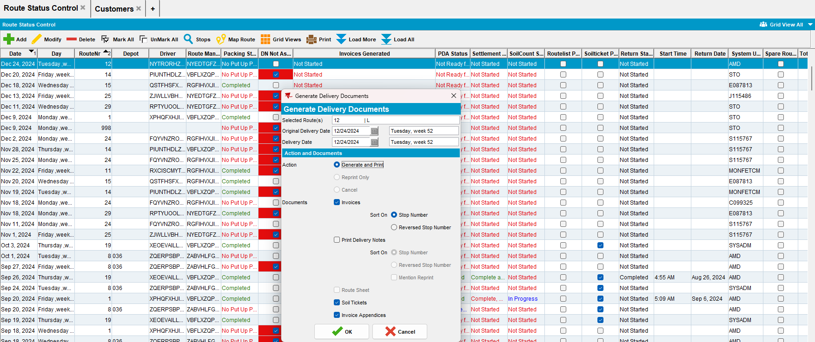

- Go to Maintain Invoices dlg to Route tab and select your route. Check to see that you have a Generated invoice and a Generated Additional for your customer
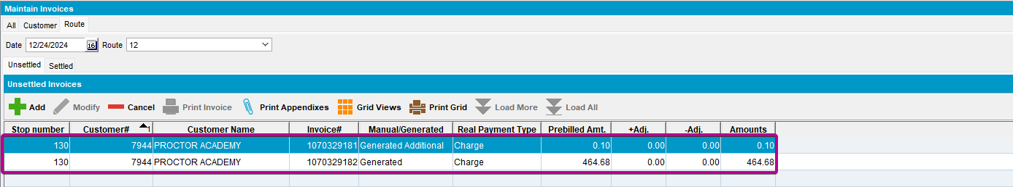
Tested OK

