ABSN-2937 - Route finalized although invoice generation failed due to mixed BUs
Environment | Prerequisites
Version: 9.07.00.UNF19  DBServerName= abs-srv20.internal.abslbs.com  DBSID=CUST24  DBUser=UNFDEV  DBPassword= UNFDEV  Environment=Test | - Module:  - System setting

Contents
Reproducing before fix 1
Steps to reproduce 1
Current Behavior 6
Expected behavior 6
Retest after fix 6
Test Case 1 – Route finalized although invoice generation failed due to mixed BUs 6

Reproducing before fix

Steps to reproduce
- Add a route in Route Status Control
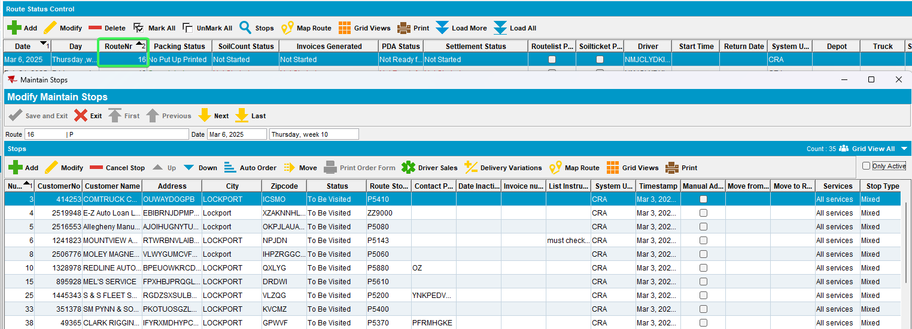
- Generate invoices
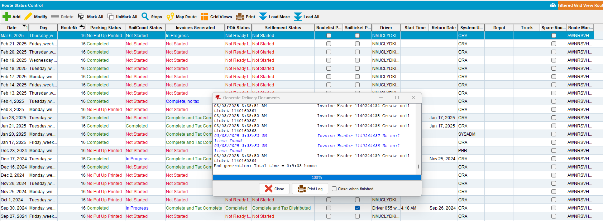
- Tax invoices - run BCI scheduled process
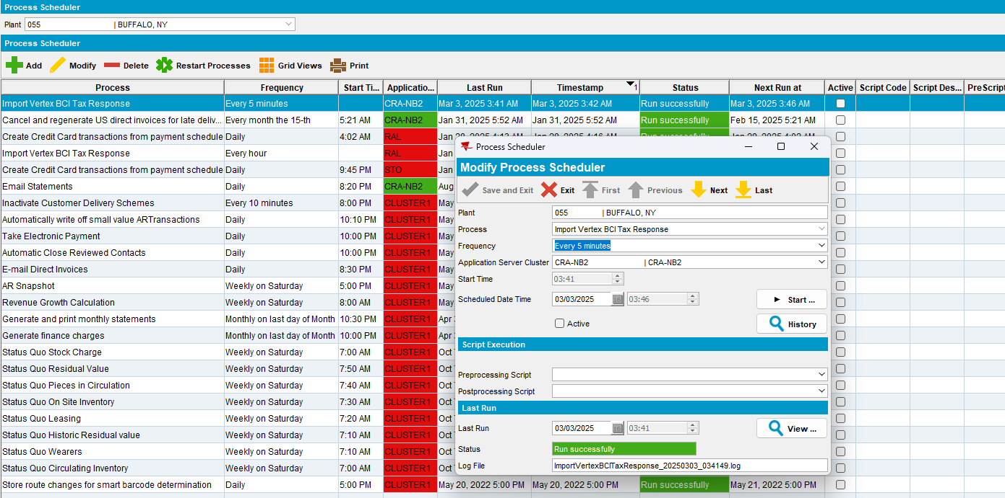
- Pick a customer having a different invoicing BU than the customers from the route
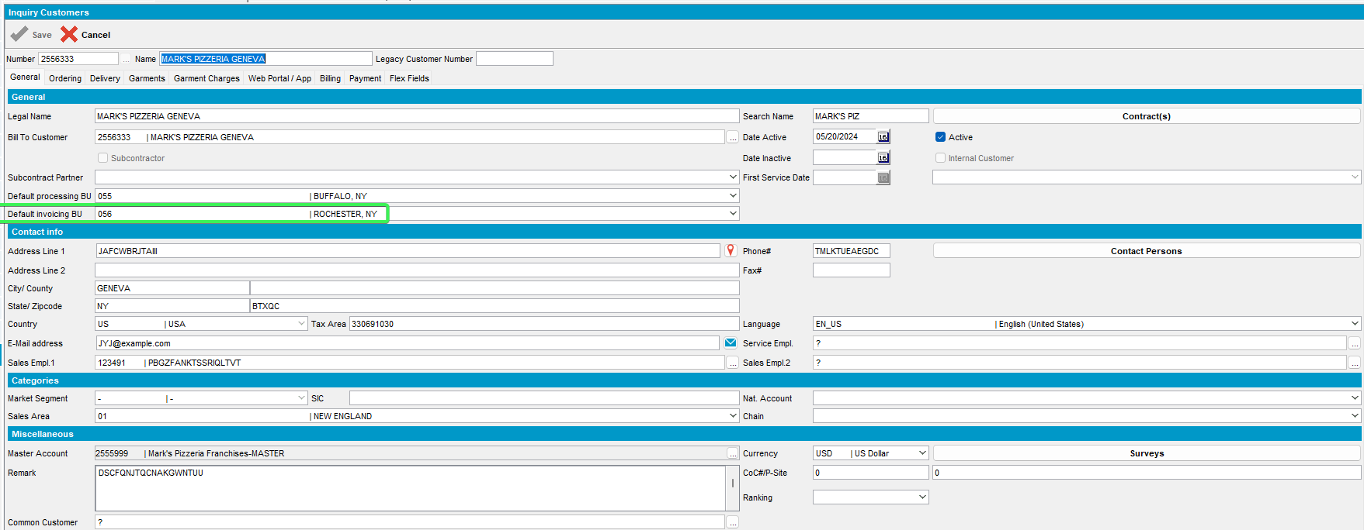
- Move and existing route stop on the route from step 1
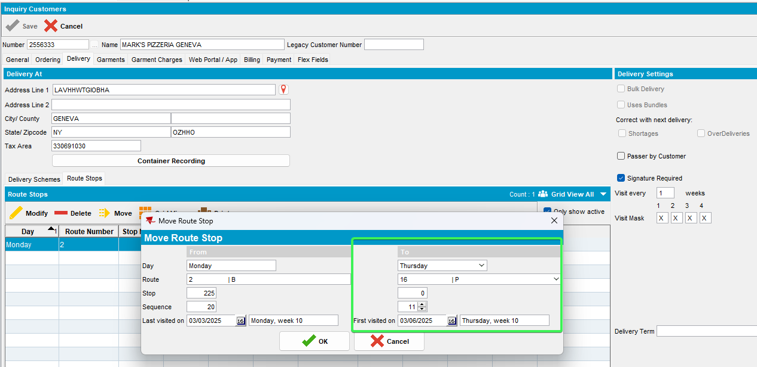
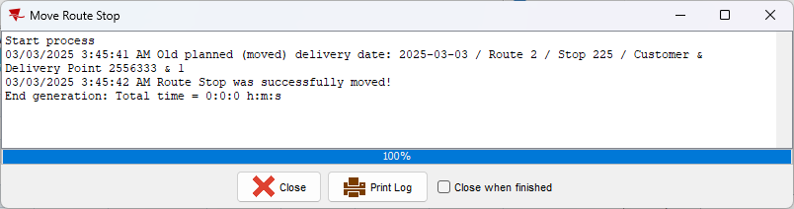
- Currently this route has mixed BUs - one customer on one invoicing BU and all the other customers on a different BU
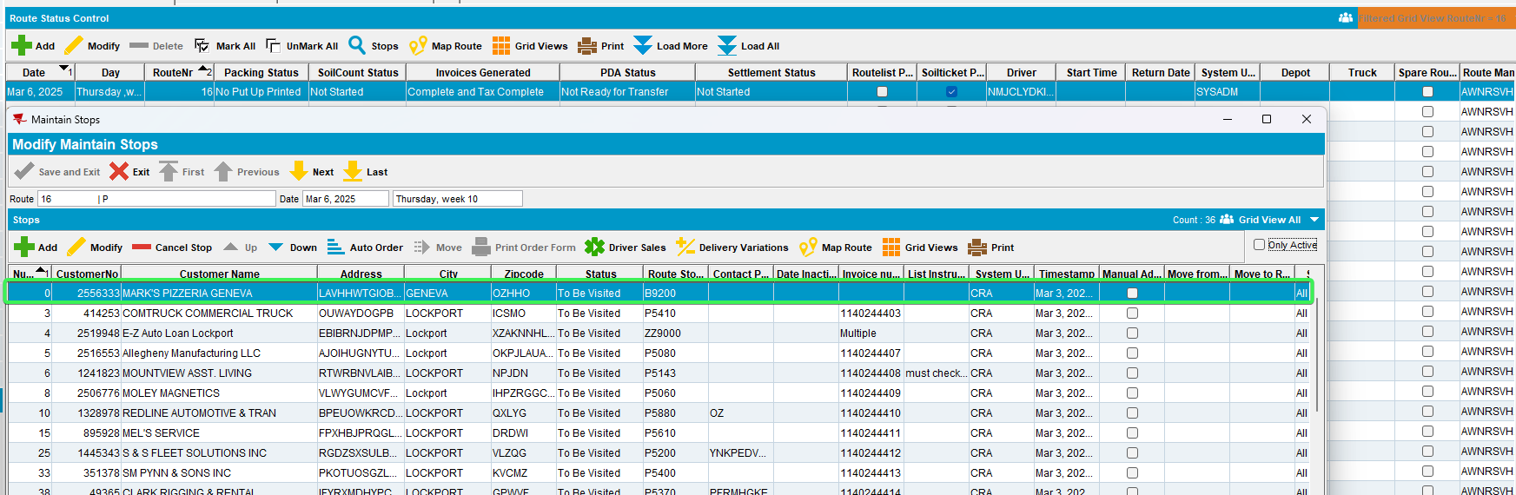
- Pick a customer which is invoiced on the current BU (from first route) and create a sales note for it.
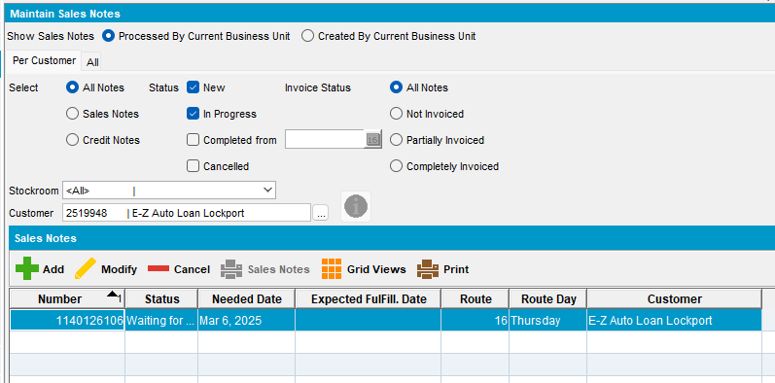
- Approve the sales note
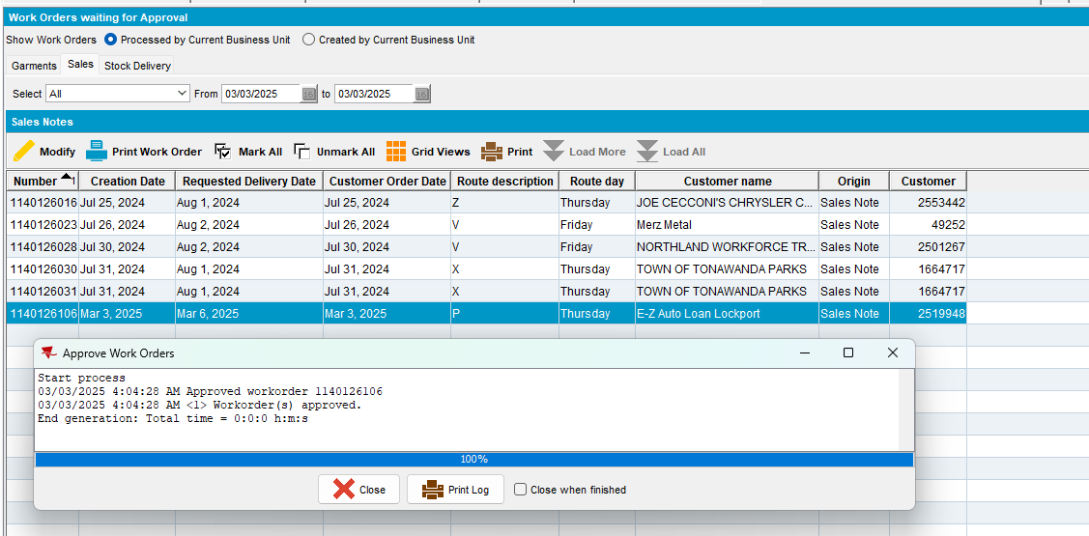
- Issue the sales items > Generate the delivery note but a day earlier than the date the route is running on
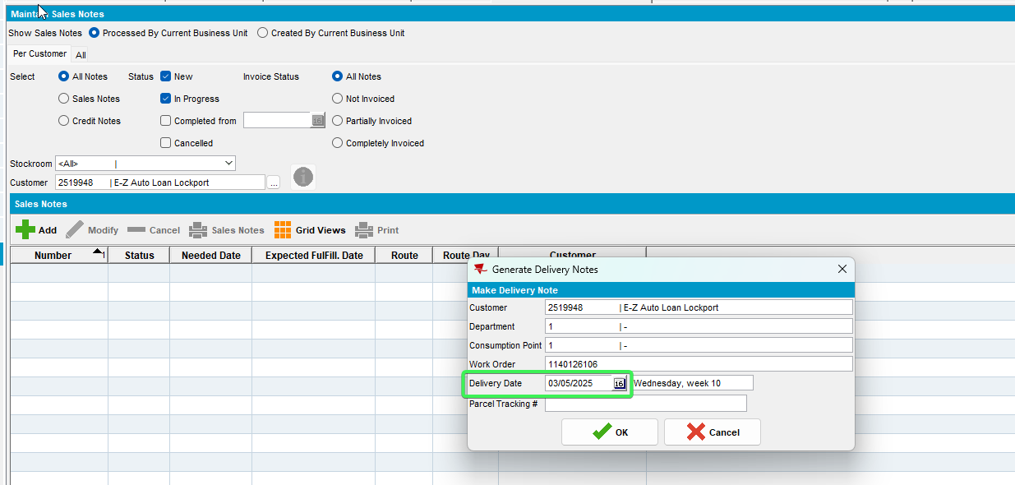
- Run Cancel and Regenerate Direct US Invoices scheduled process
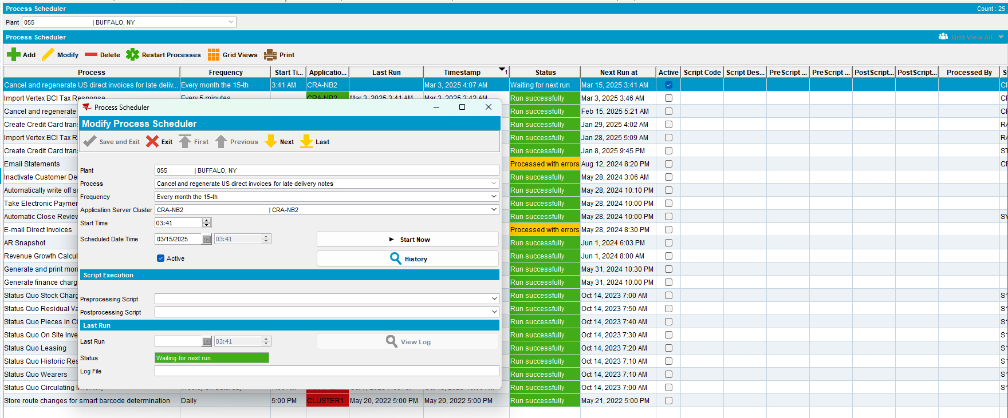
- RSC: Check the “Route Finalization Status” column
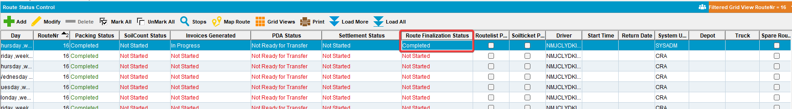
- View Process Log: Check the GenerateInvoicesFromFinaliseRoutesProcess log from Others category
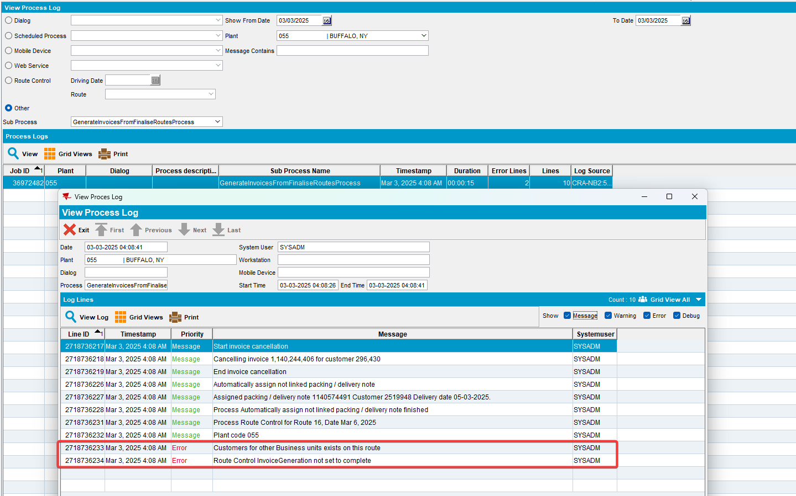
REPRODUCED OK.

Current Behavior
Route marked as finalized
Although the invoice generation log showed an error due to mixed BUs (log is under Others in View Process Log)

Expected behavior
Error message to be shown in scheduled process log when invoicing failed - RouteControl.InvoiceGeneration <> 3 Completed
Route finalization status not changed - remains 0 Not Started.

Retest after fix

Test Case 1 – Route finalized although invoice generation failed due to mixed BUs
Hash: 28e146cccee0
- Add a route in Route Status Control
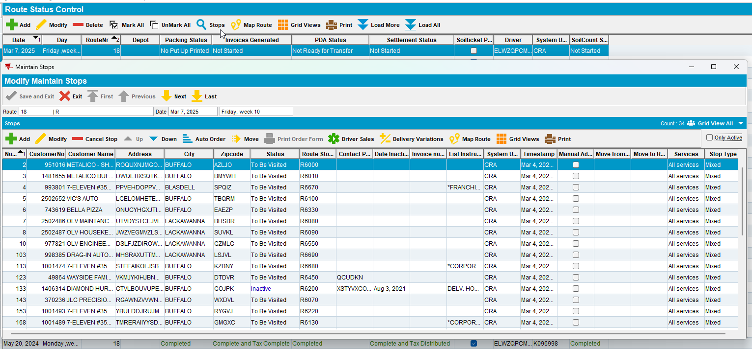
- Generate invoices
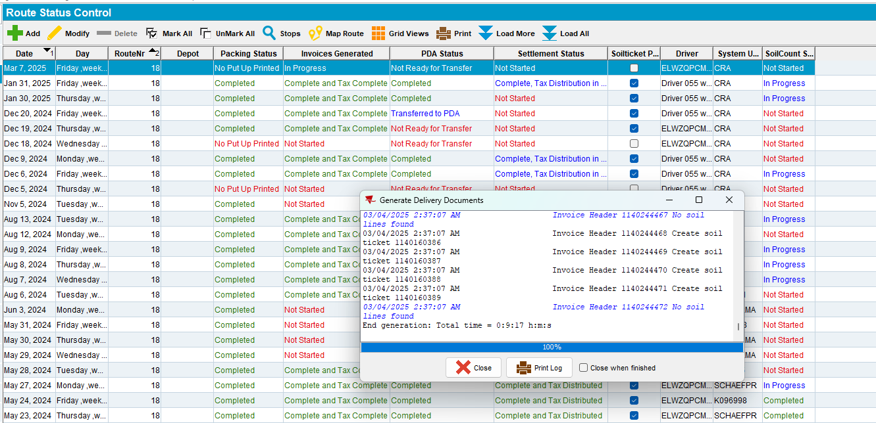
- Tax invoices - run BCI scheduled process
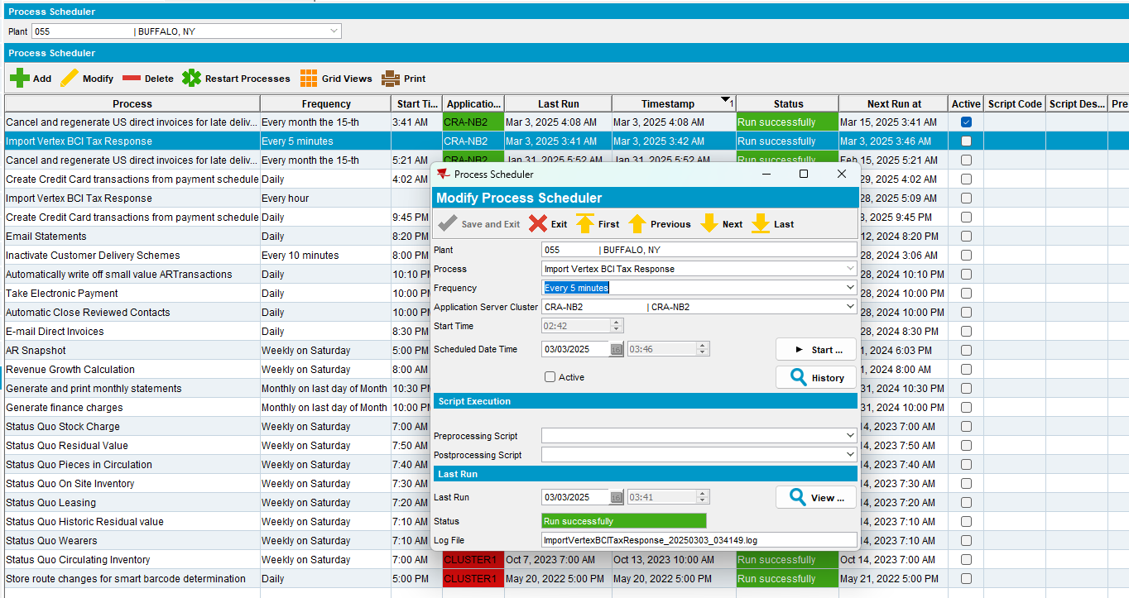
- Pick a customer having a different invoicing BU than the customers from the route
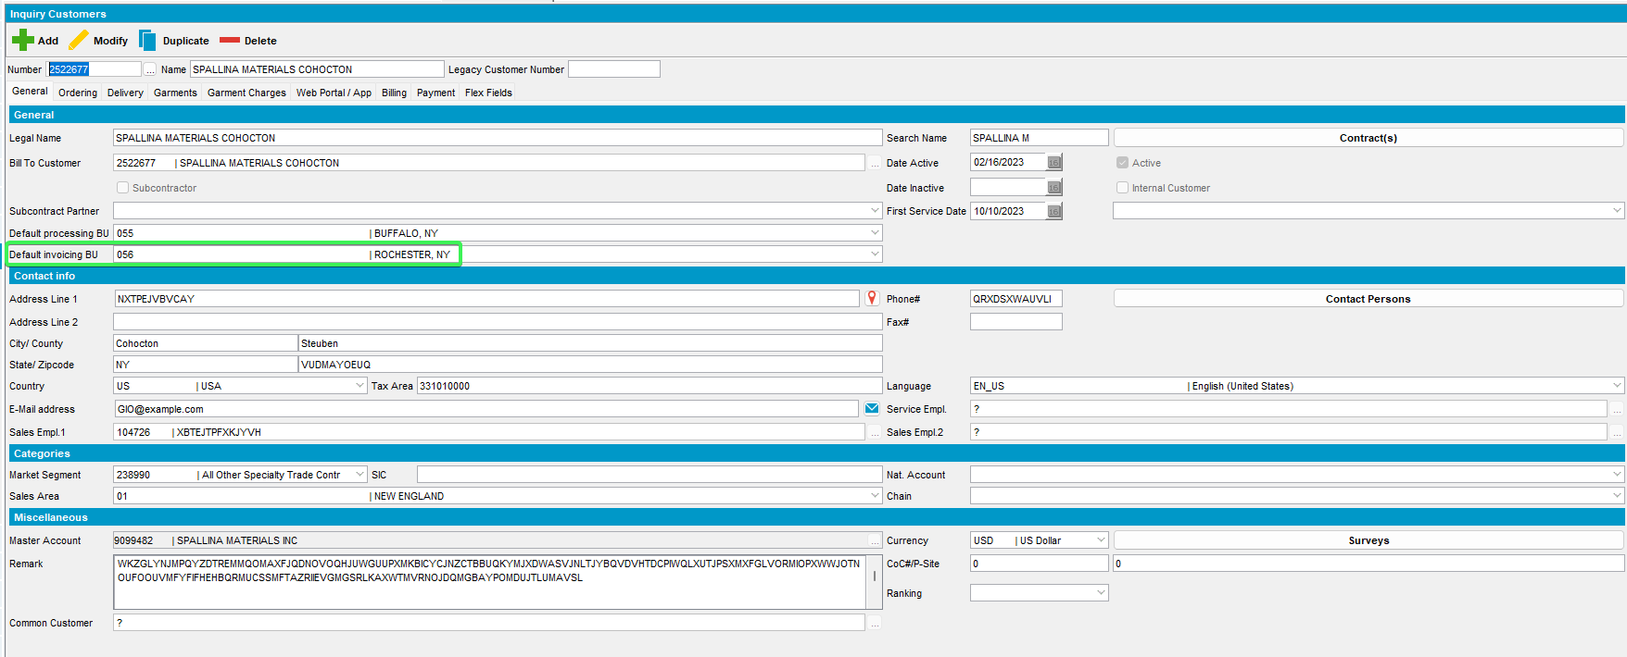
- Move an existing route stop on the route from step 1
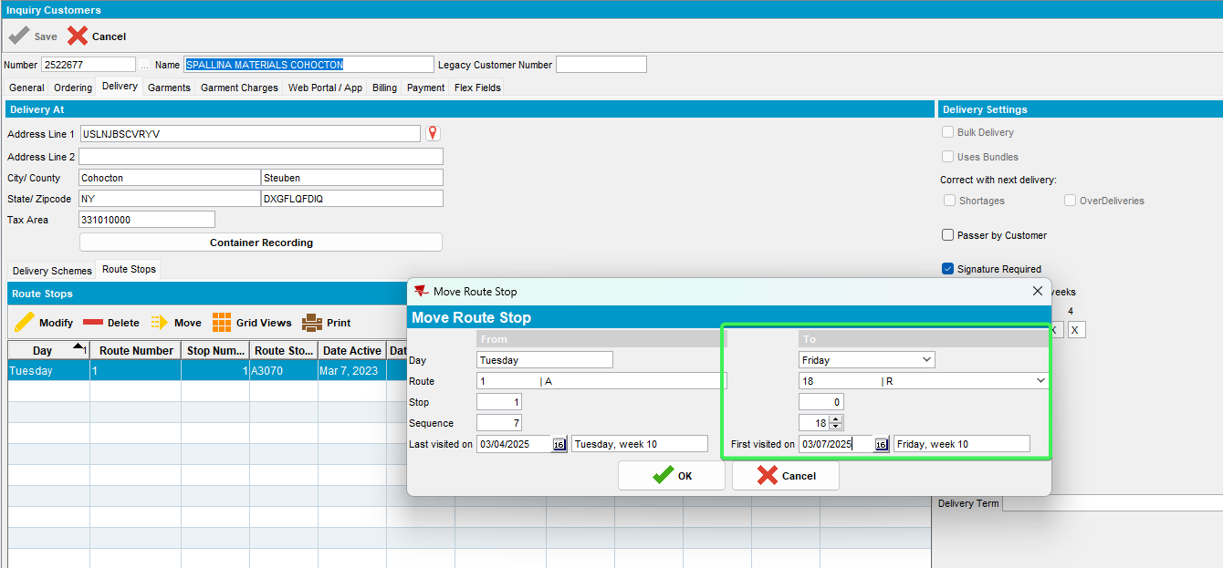
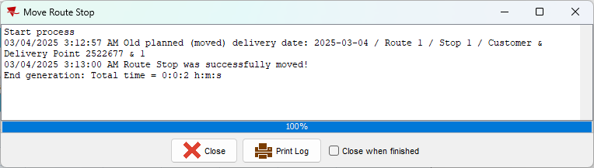
- Currently this route has mixed BUs - one customer on one invoicing BU and all the other customers on a different BU
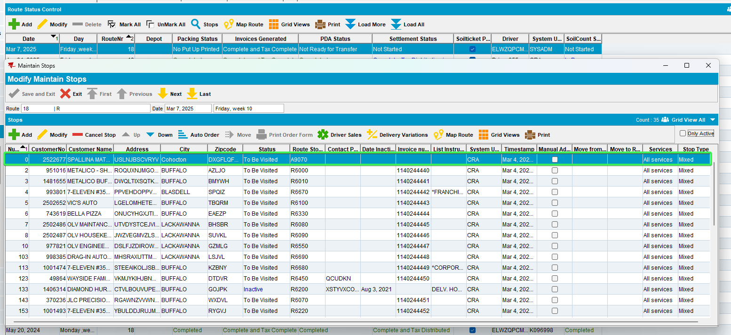
- Pick a customer which is invoiced on the current BU (from first route) and create a sales note for it.
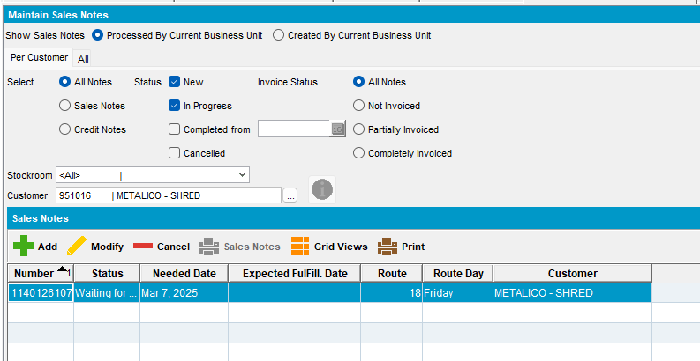
- Approve the sales note
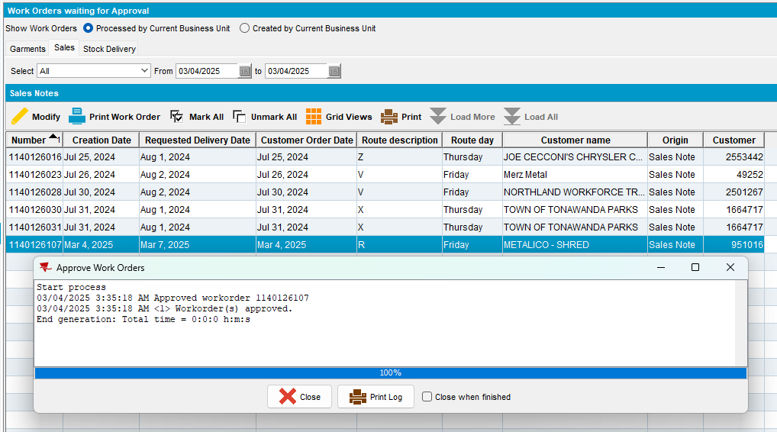
- Issue the sales items > Generate the delivery note but a day earlier than the date the route is running on
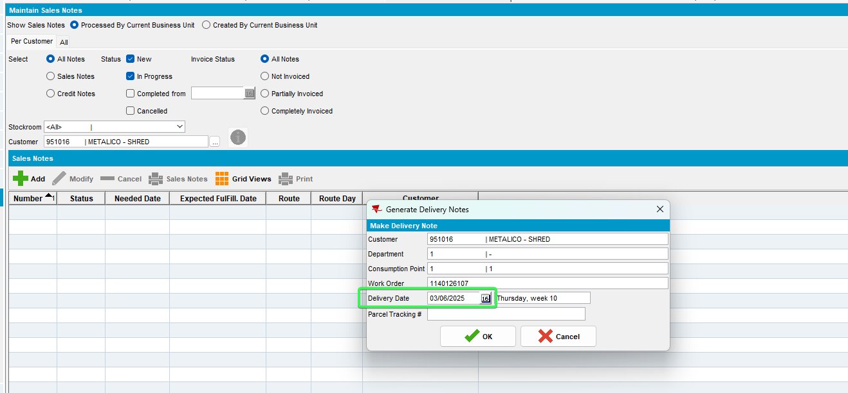
- Run Cancel and Regenerate Direct US Invoices scheduled process
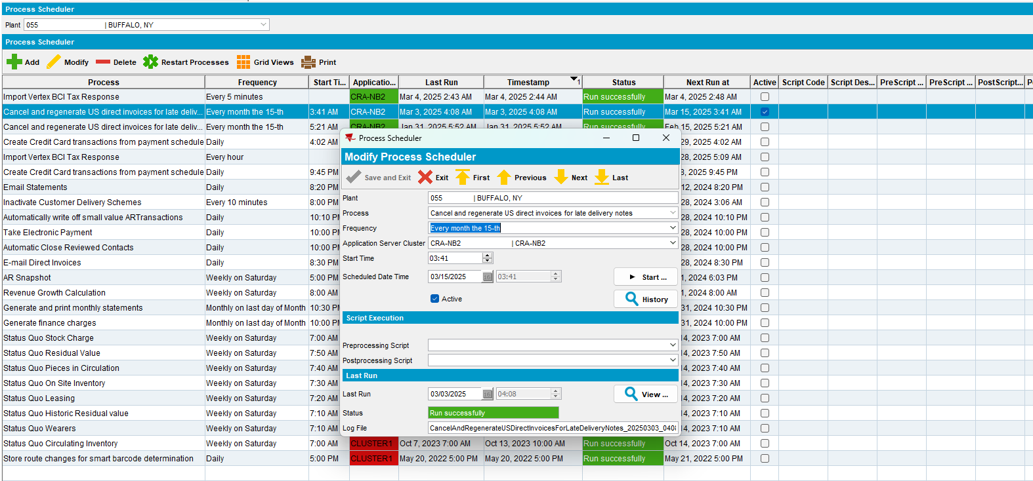
- RSC: Check the “Route Finalization Status” column
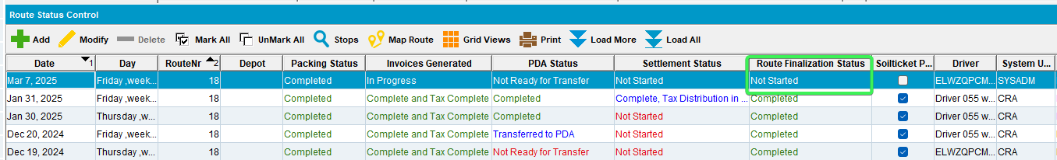
- View Process log from Process Scheduler DLG “Cancel and Regenerate Direct US Invoices”, see that the error is shown in the log
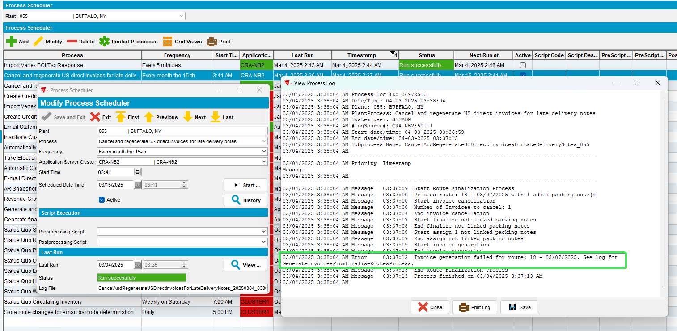
- View Process Log: Check the GenerateInvoicesFromFinaliseRoutesProcess log from Others category
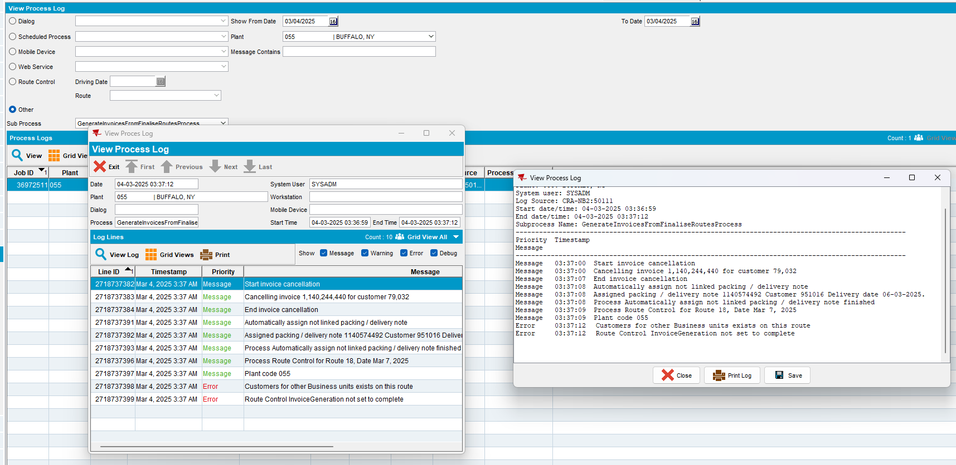
Tested OK

