ABSN-2894 - ASD-64977 UNF: D_UBS_2561 11 “Charged for loss” flags remain on serialized garment after being returned to stock and issued with a new work order
Environment | Prerequisites
Version: 9.07.00  DBServerName=abs-SRV20.internal.abslbs.com  DBSID=CUST24  DBUser=UNFDEV  DBPassword=UNFDEV  Environment=Test | - Module:  - System setting

Contents
Reproducing before fix 2
Steps to reproduce 2
Current Behavior 7
Expected behavior 7
Retest after fix 7
Test Case 1 – DOI mixed inventory Bill Loss now on existing loss charge (mark all non-uniques and a few uniques as DOI) 7
Test Steps 7
Test Case 2 – DOI mixed inventory Bill Loss now on existing loss charge (mark some non-uniques as DOI and no uniques) 15
Test Steps 16
Test Case 3 – DOI mixed inventory Bill Loss now on existing loss charge (mark all non-uniques and some uniques) return some non-uniques as Smartbarcodes and some uniques 23
Test Steps 23
Test Case 4 – DOI mixed inventory Bill Loss now on existing loss charge (mark all non-uniqies and some uniques) return all non-uniques as Smartbarcodes and some uniques 35
Test Steps 36
Test Case 5 – DOI mixed inventory Bill Loss now on existing loss charge (mark all non-uniques and a few uniques as DOI) and change Flag Start date for some non unique 48
Test Steps 48

Reproducing before fix

Steps to reproduce
- Have a mixed WI 11 circ/11 max with 4 non unique and 7 unique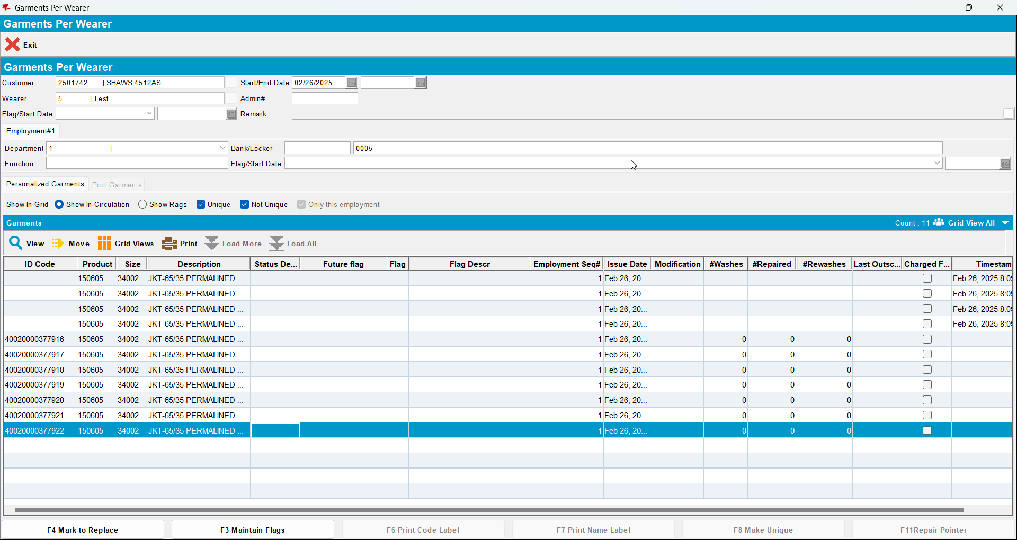
- Decrease max by 7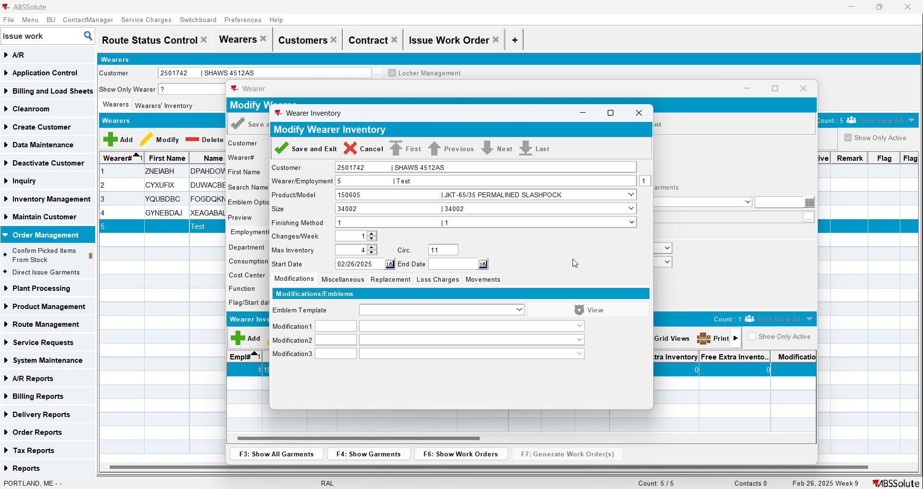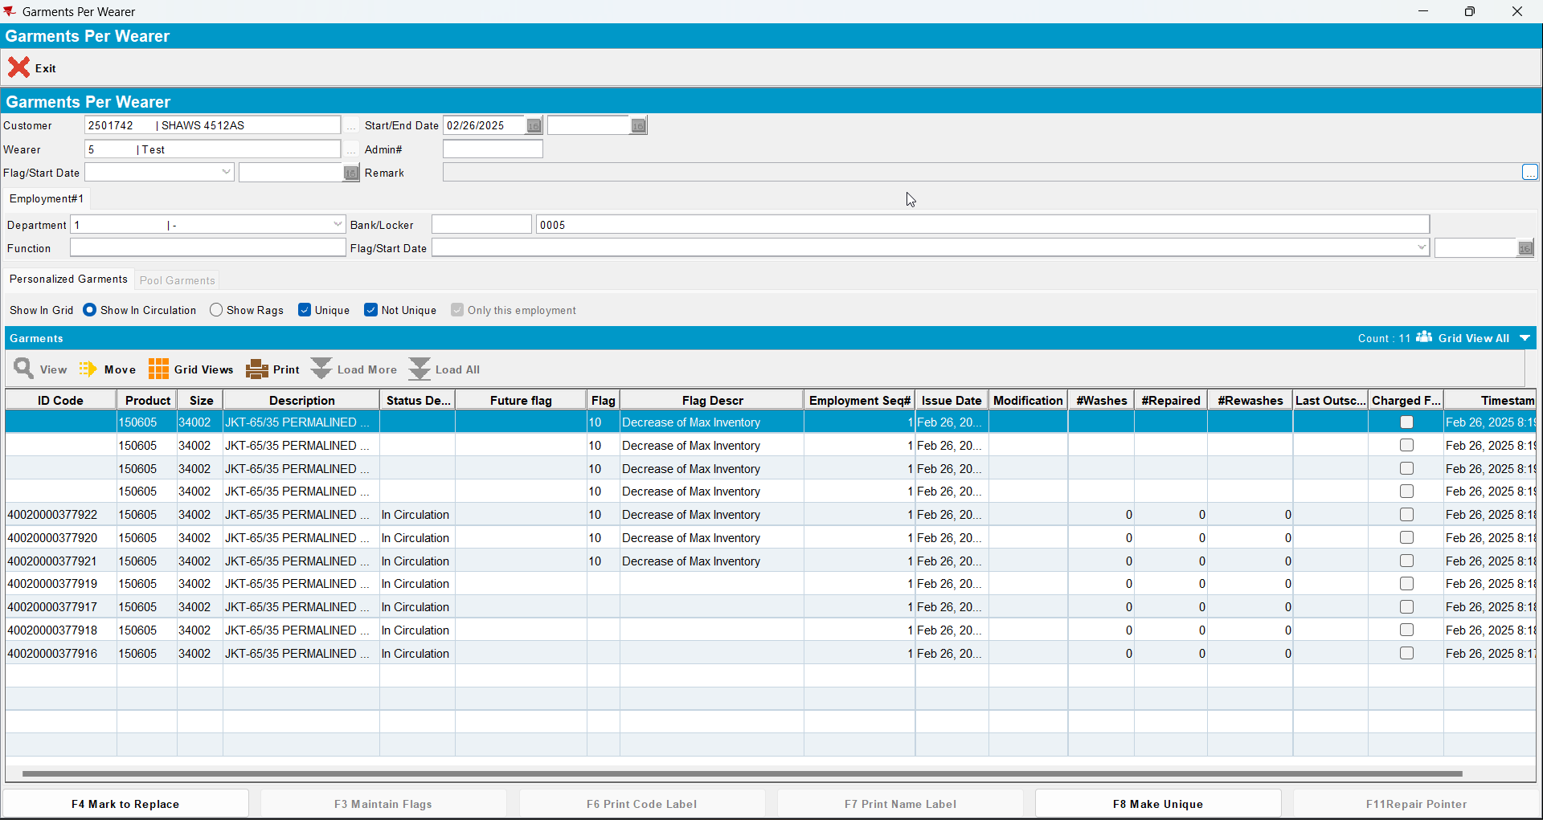
- Generate invoices and mark the route ready for transfer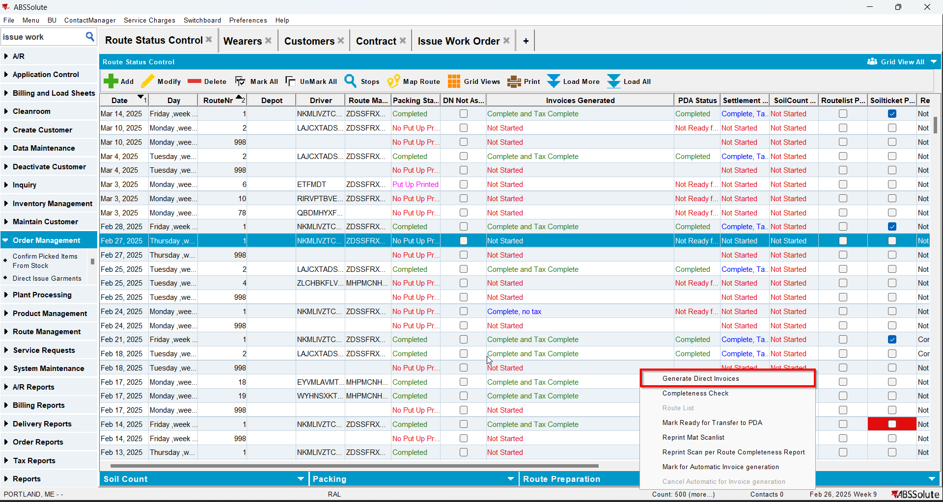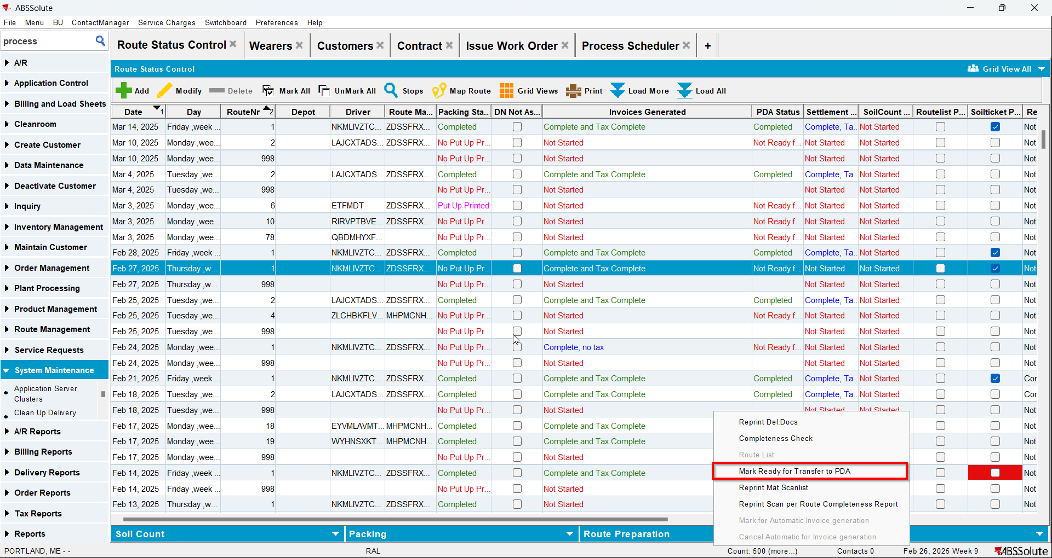
- On RA Bill All For Loss Now
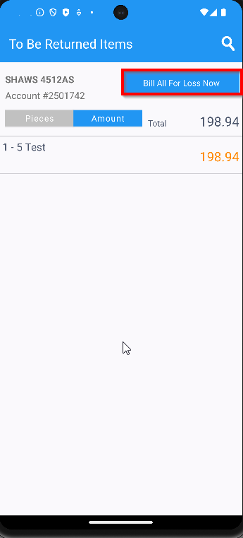
- Finish the route and upload it
- On WebX settle the route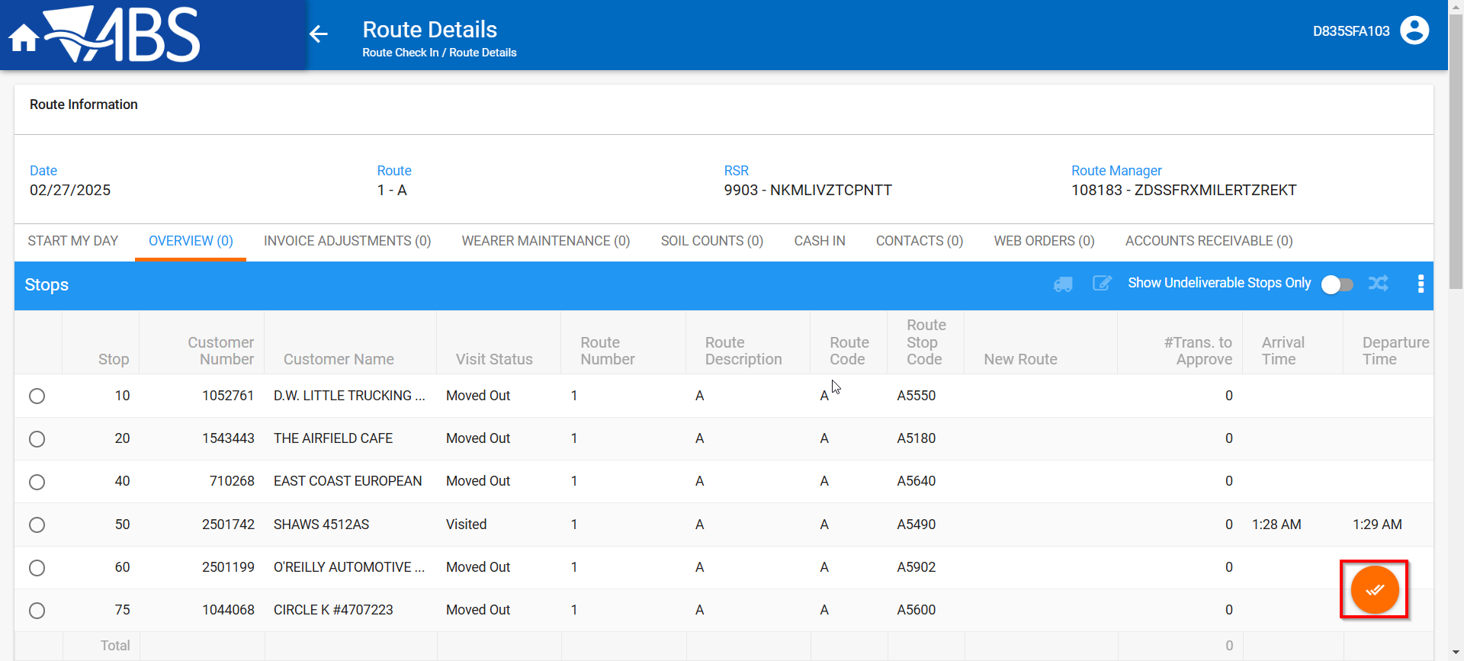
- Maintain Invoices DLG: Verify that the loss charge is now Extend = ‘Y’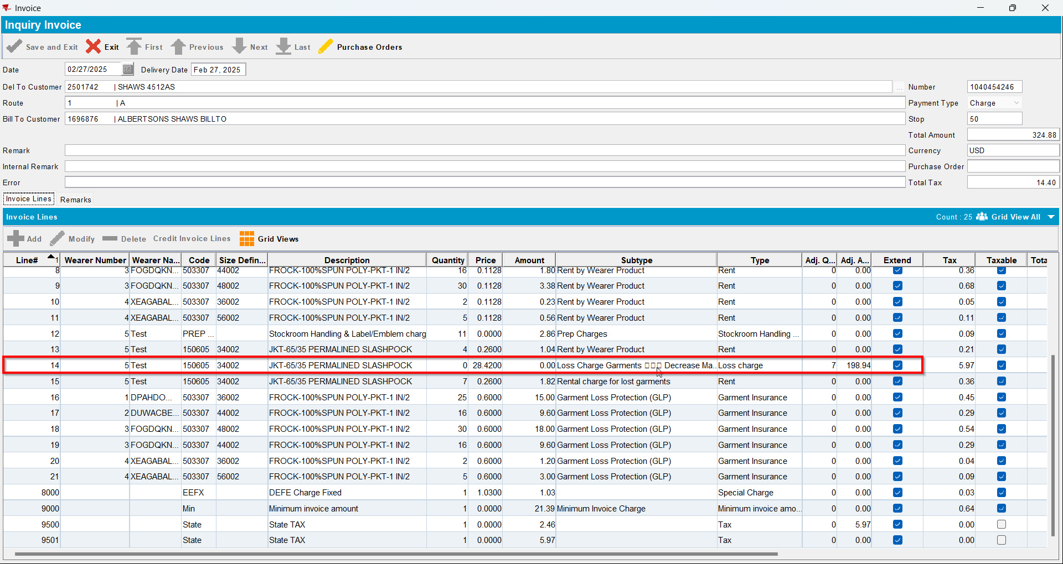
- Check the WI and the garments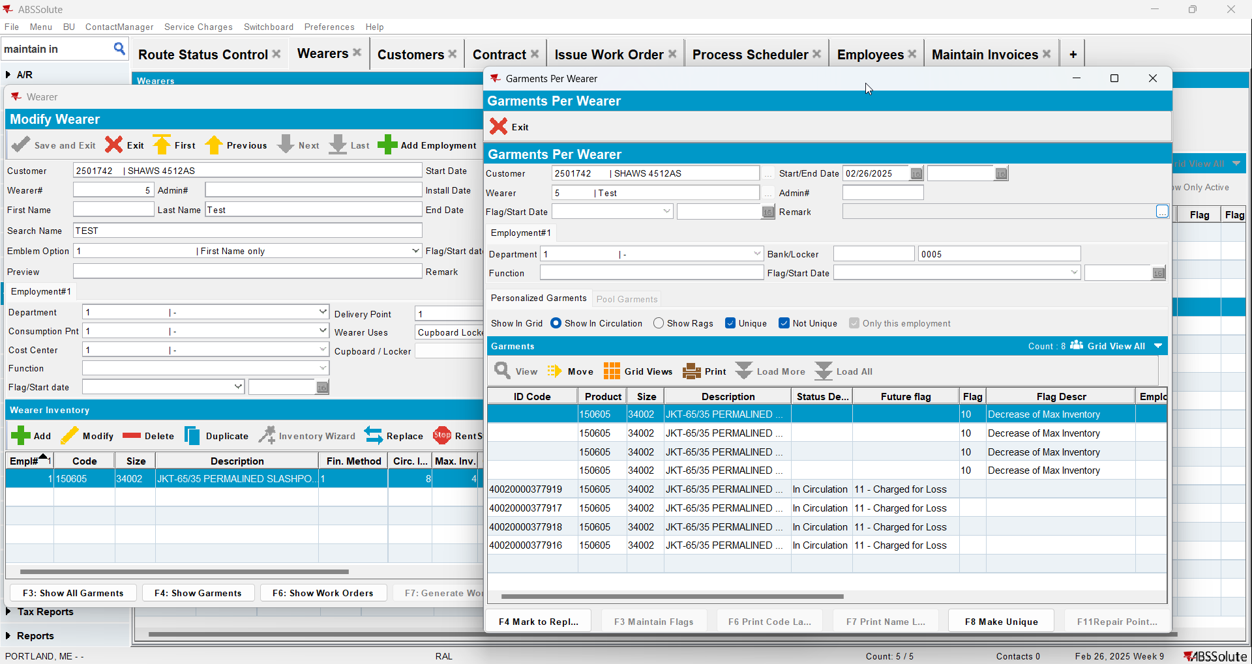

REPRODUCED OK.

Current Behavior
Non unique items are not ragged.

Expected behavior
All garments flagged for DOI are ragged, uniques and non-uniques.

Retest after fix

Test Case 1 – DOI mixed inventory Bill Loss now on existing loss charge (mark all non-uniques and a few uniques as DOI)
Expected behavior: All garments flagged for DOI are ragged, uniques and non-uniques. The remaining garments are not flagged in any way.
Hash: 549daf5

Test Steps
- Find a wearer inventory with a mixed inventory of uniques and non-uniques
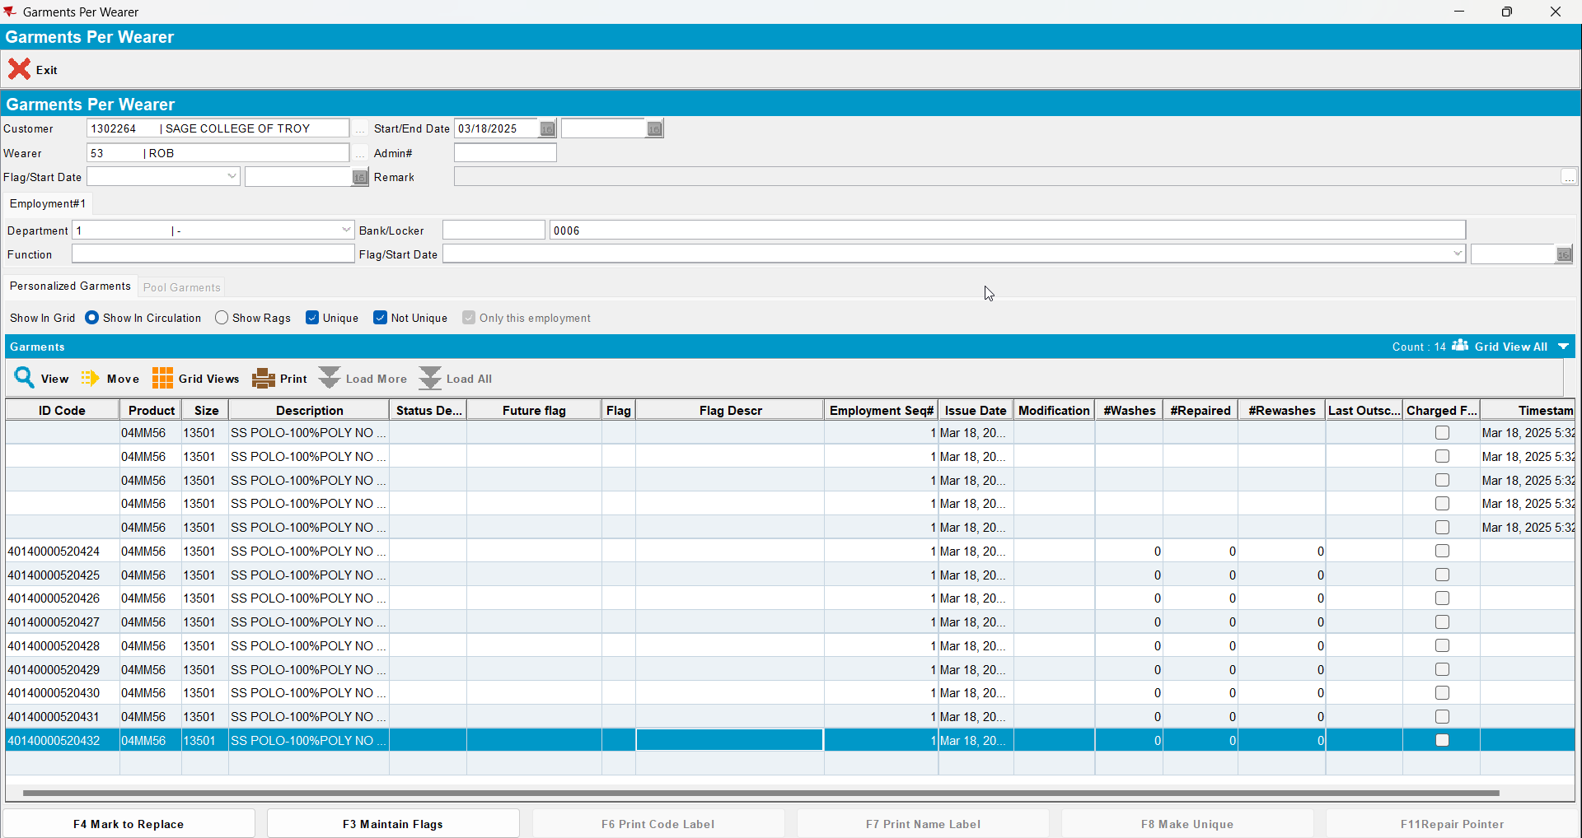
- Decrease inventory from 14 to 7 (so 7 garments in total will be flagged as DOI)
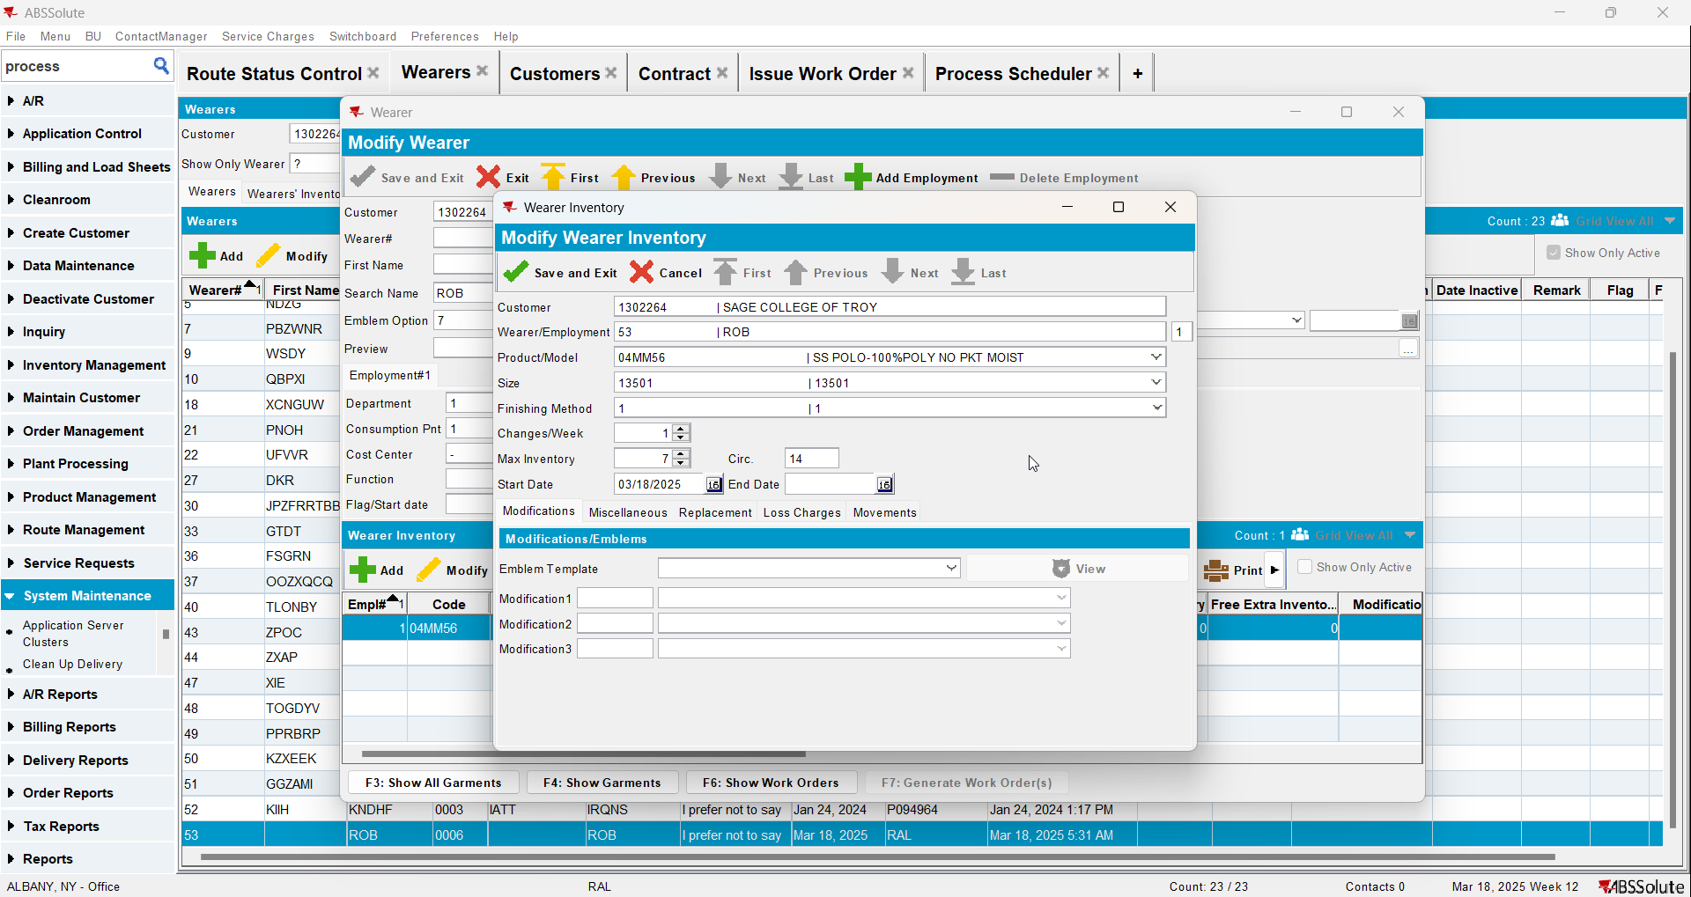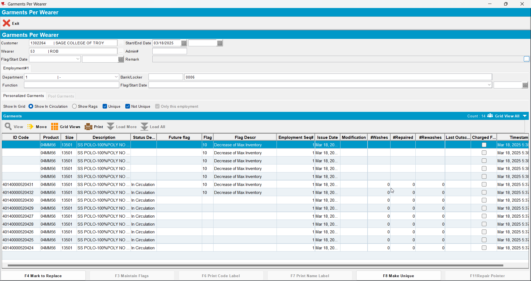

- Generate invoices on the current week’s route, there should be a loss charge of subtype DOI with Extend = ‘N’
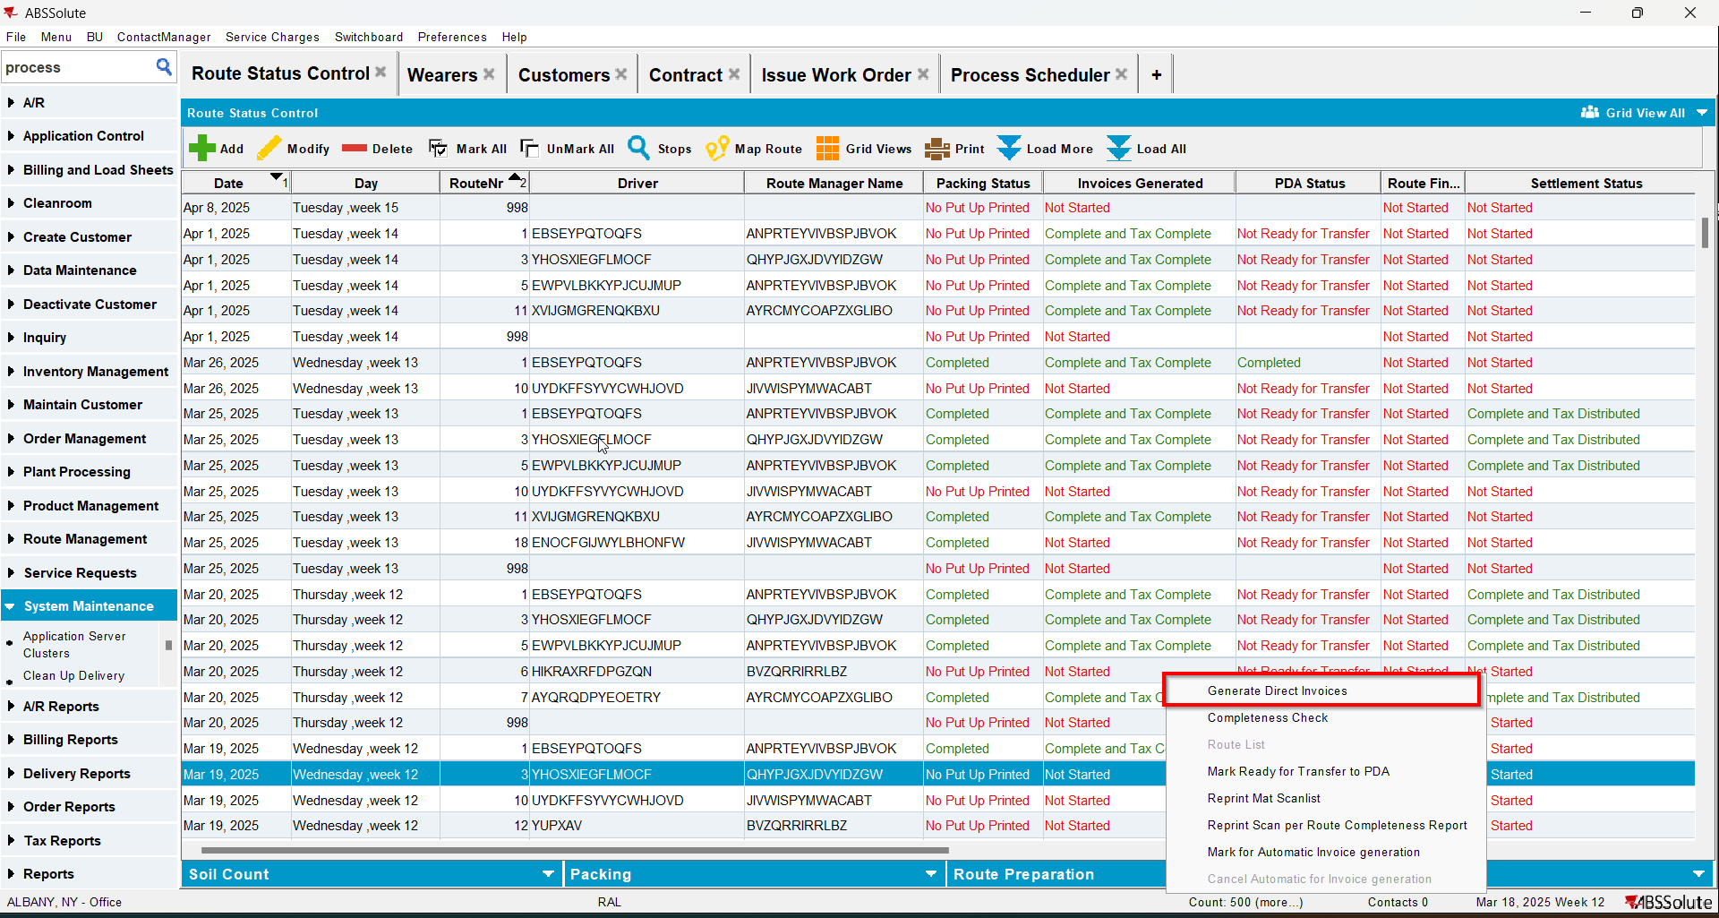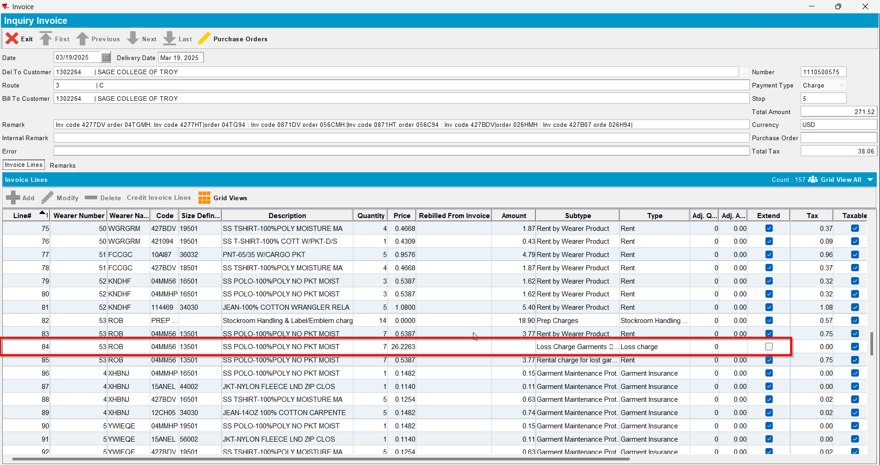
- Send the route to RA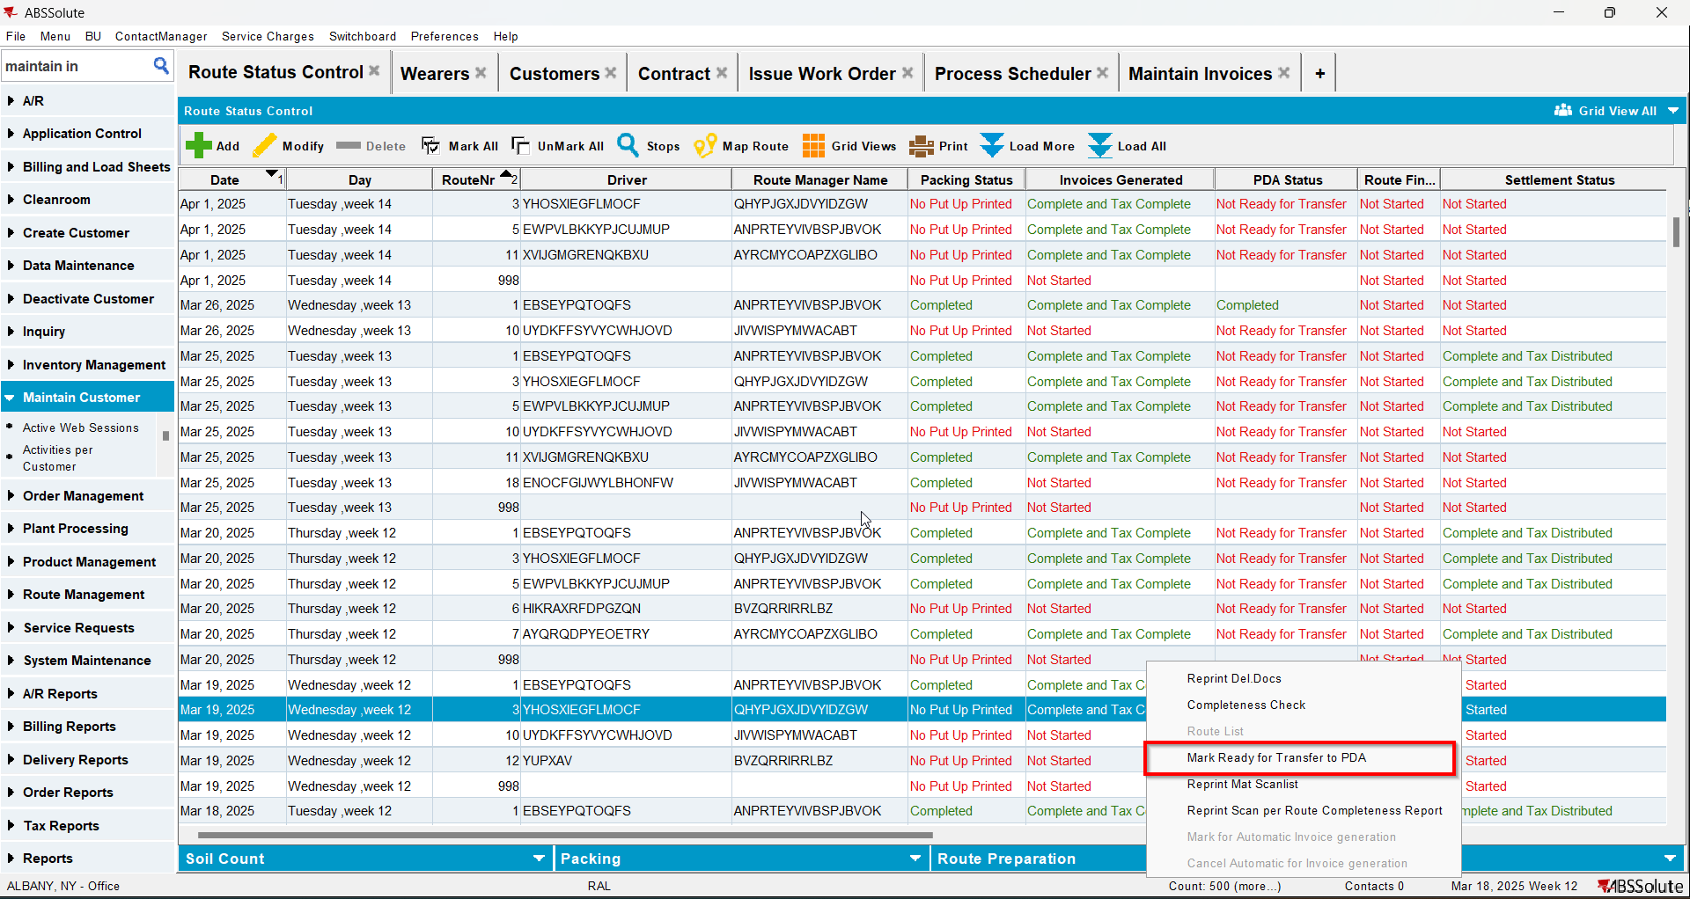
- RA: Do a bill loss now for the loss line
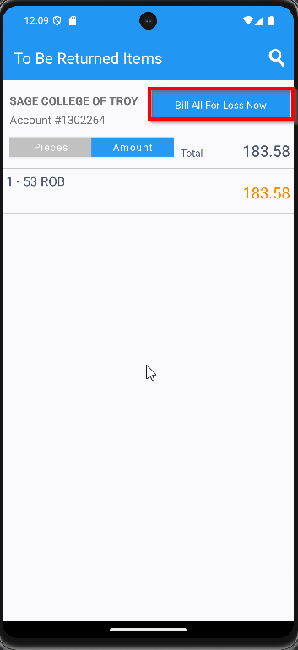
- Settle and upload the route back to the server
- WebX: Settle the route
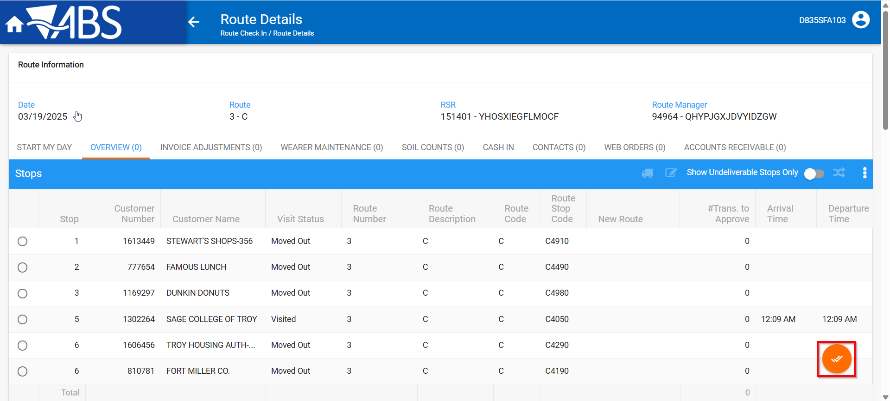

- Maintain Invoices DLG: Verify that the loss charge is now Extend = ‘Y’
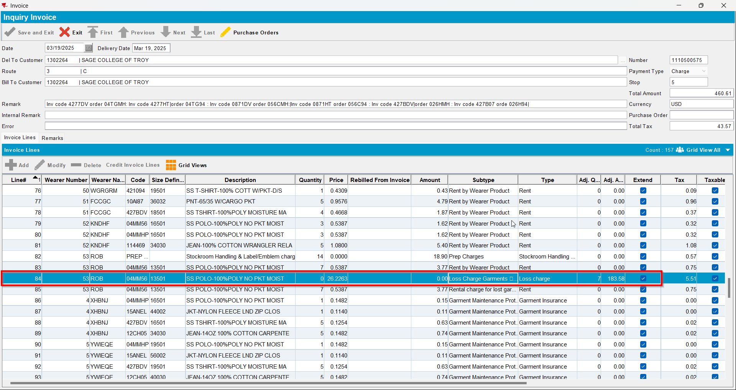
- Wearers DLG: Check that the wearer inventory associated with the loss charge has had the circ inventory has gone down and that the unique and non-unique garments were ragged
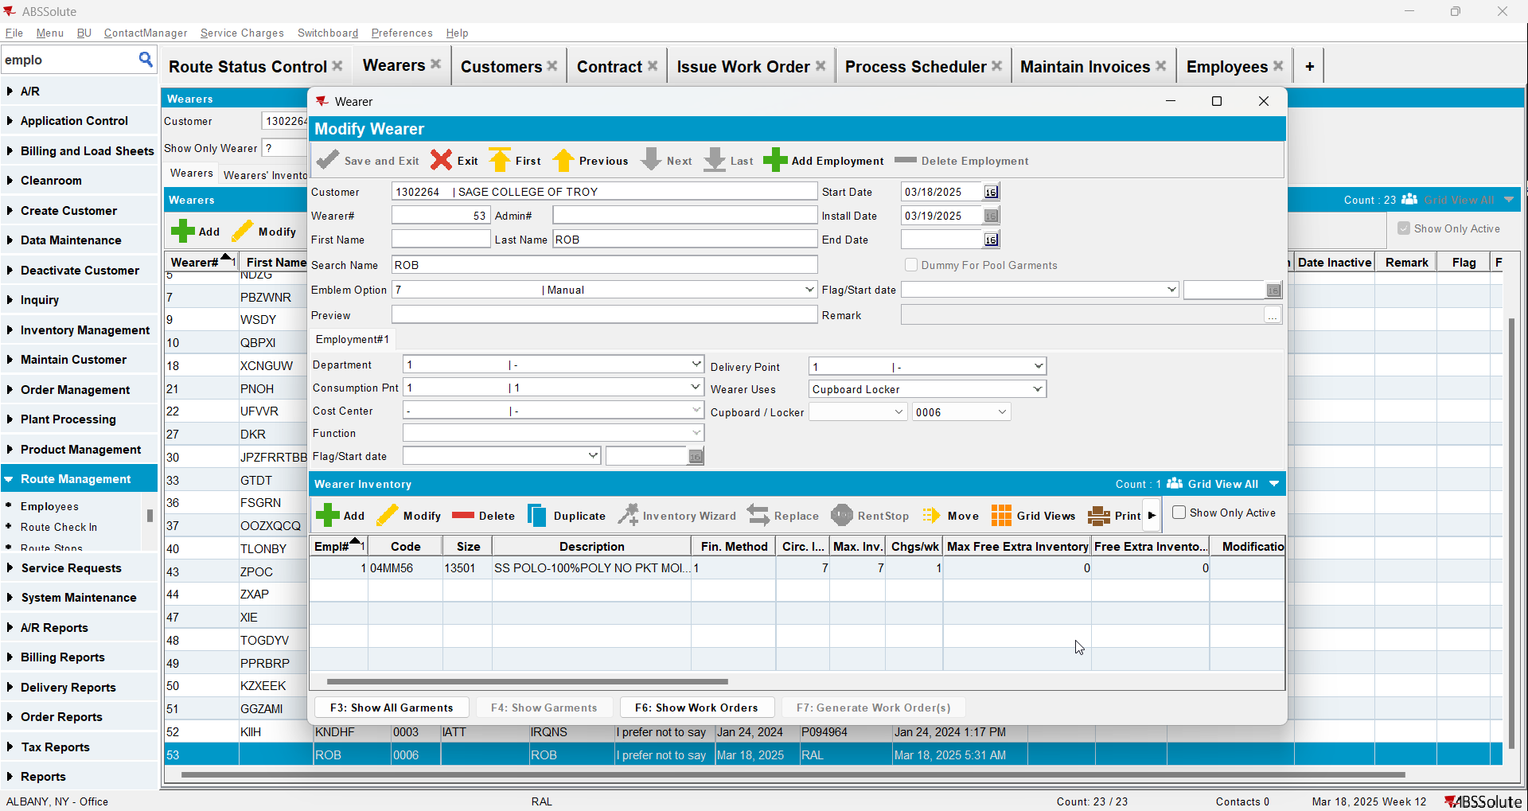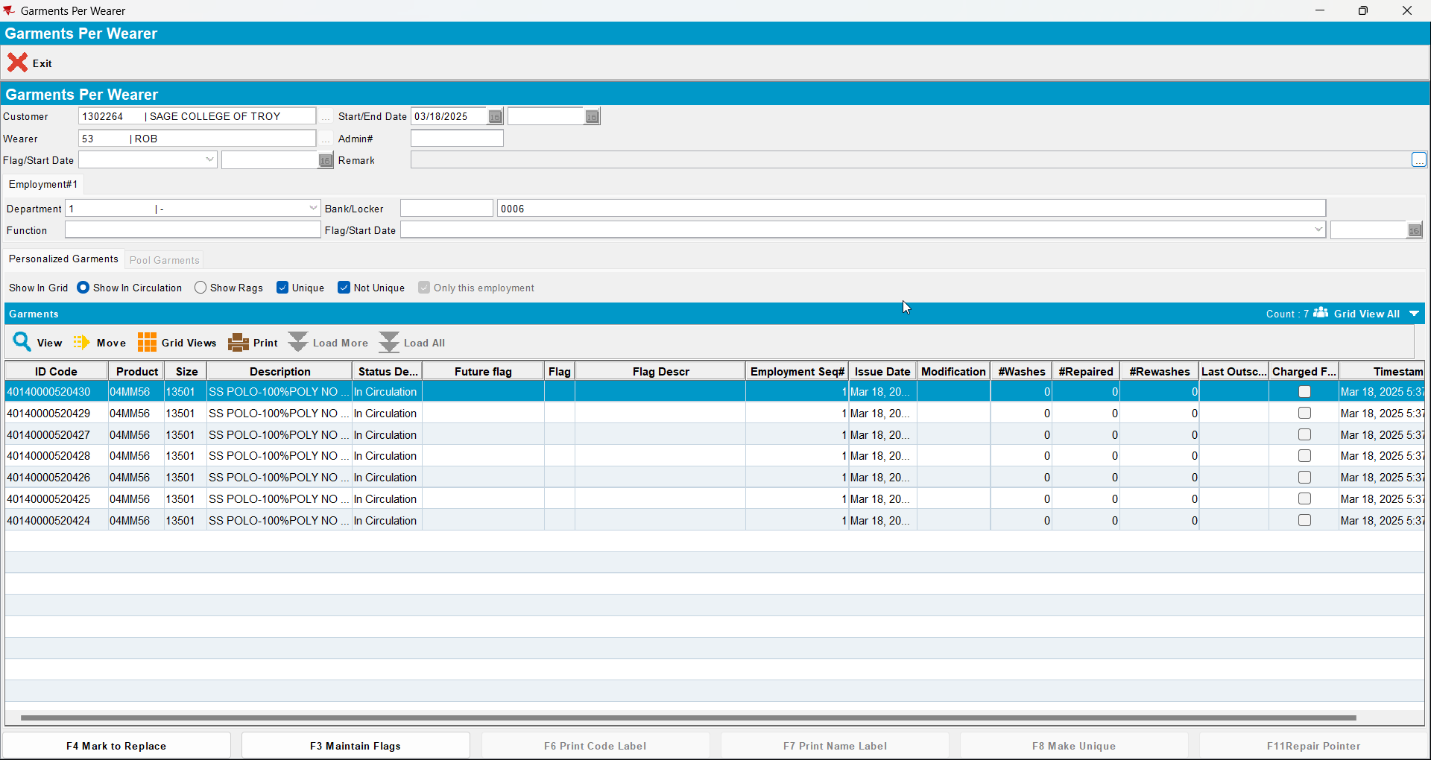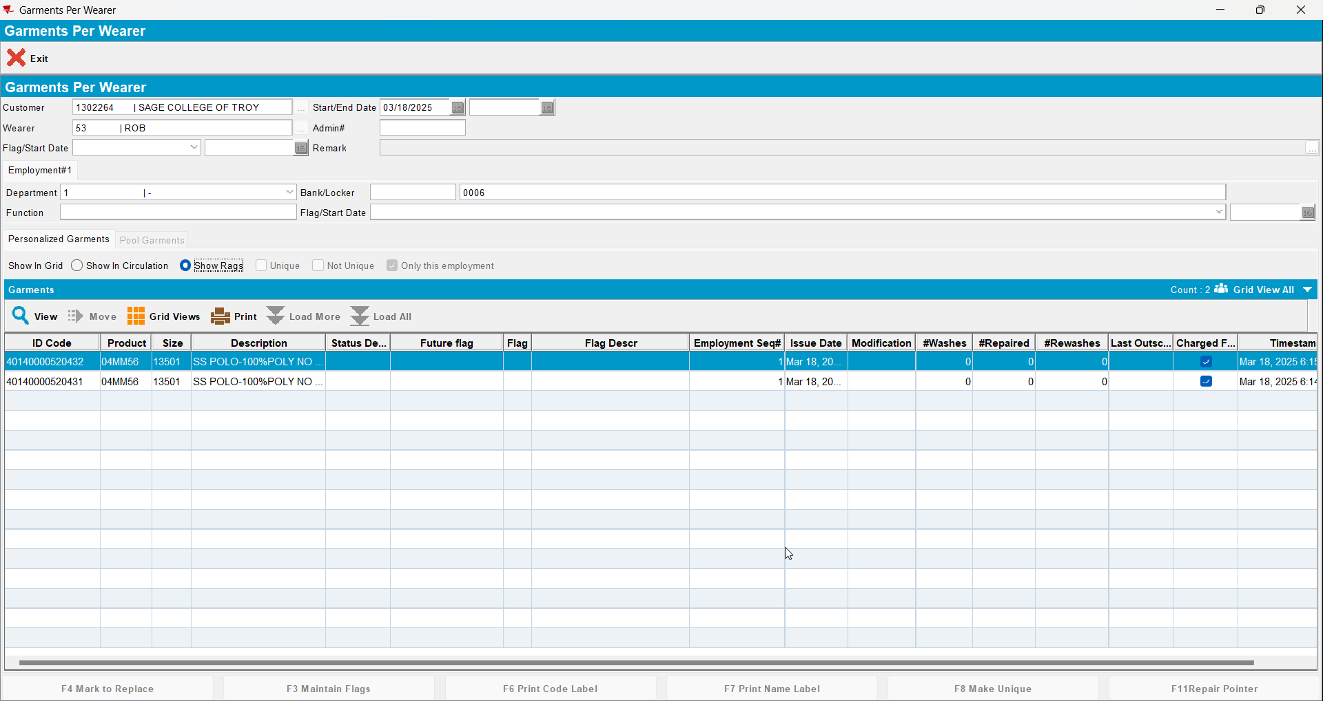

Tested OK

Test Case 2 – DOI mixed inventory Bill Loss now on existing loss charge (mark some non-uniques as DOI and no uniques)
Expected behavior: All garments flagged for DOI are ragged. The remaining garments are not flagged in any way.
Hash: 549daf5

Test Steps
- Find a wearer inventory with a mixed inventory of uniques and non-uniques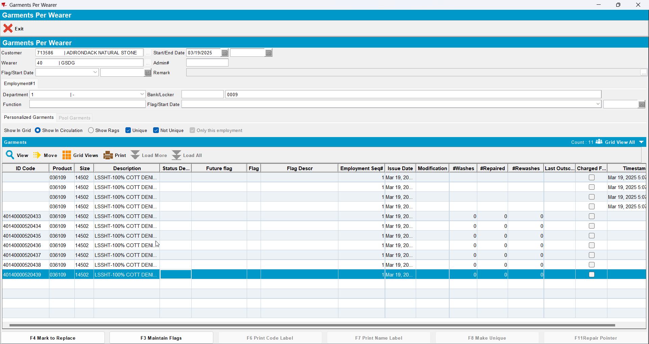
- Decrease inventory from 11 to 8 (so 3 non-unique garments in total will be flagged as DOI)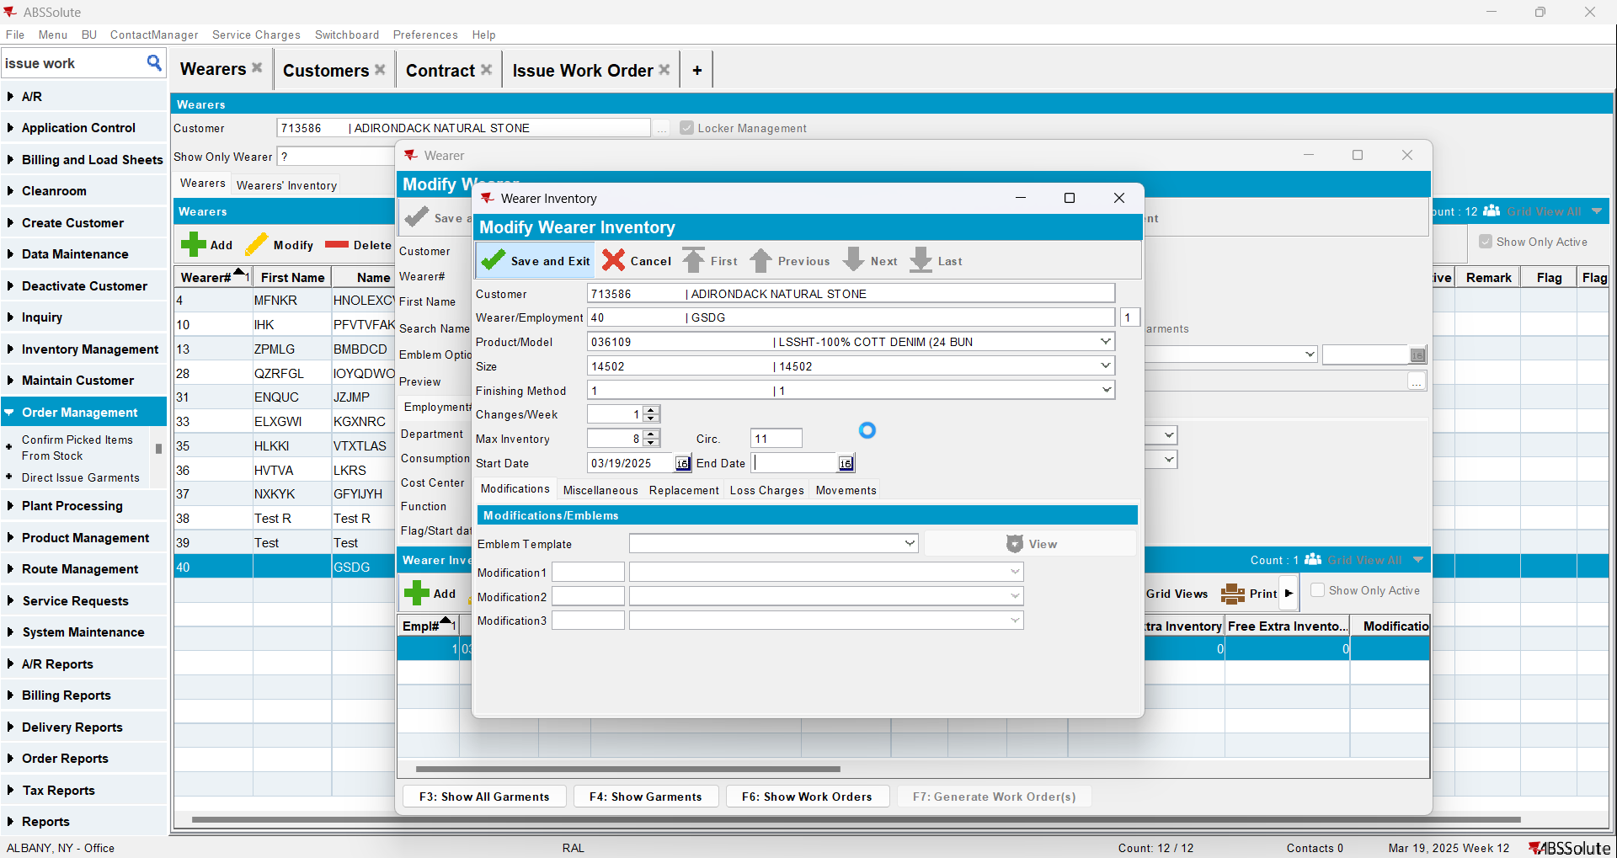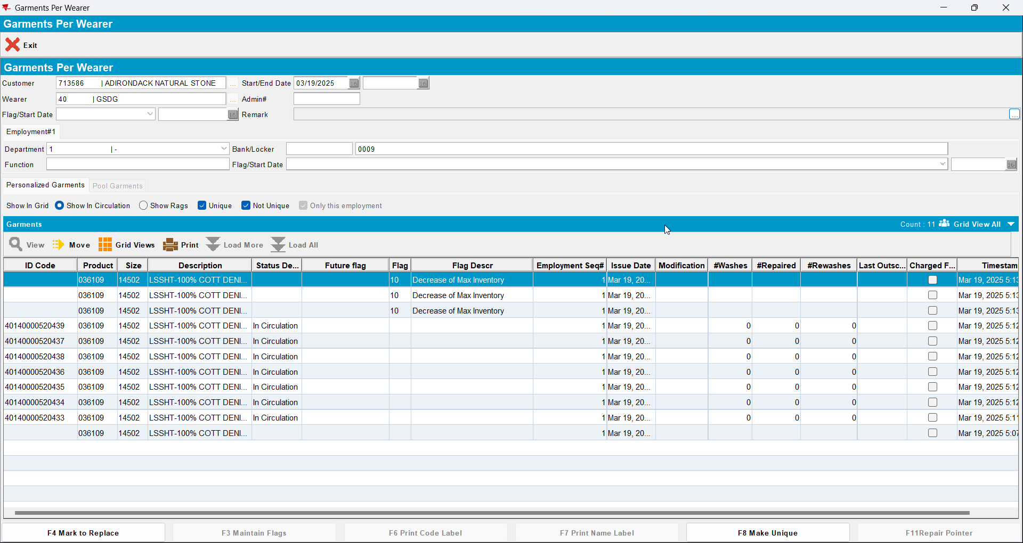
- Generate invoices on the current week’s route, there should be a loss charge of subtype DOI with Extend = ‘N’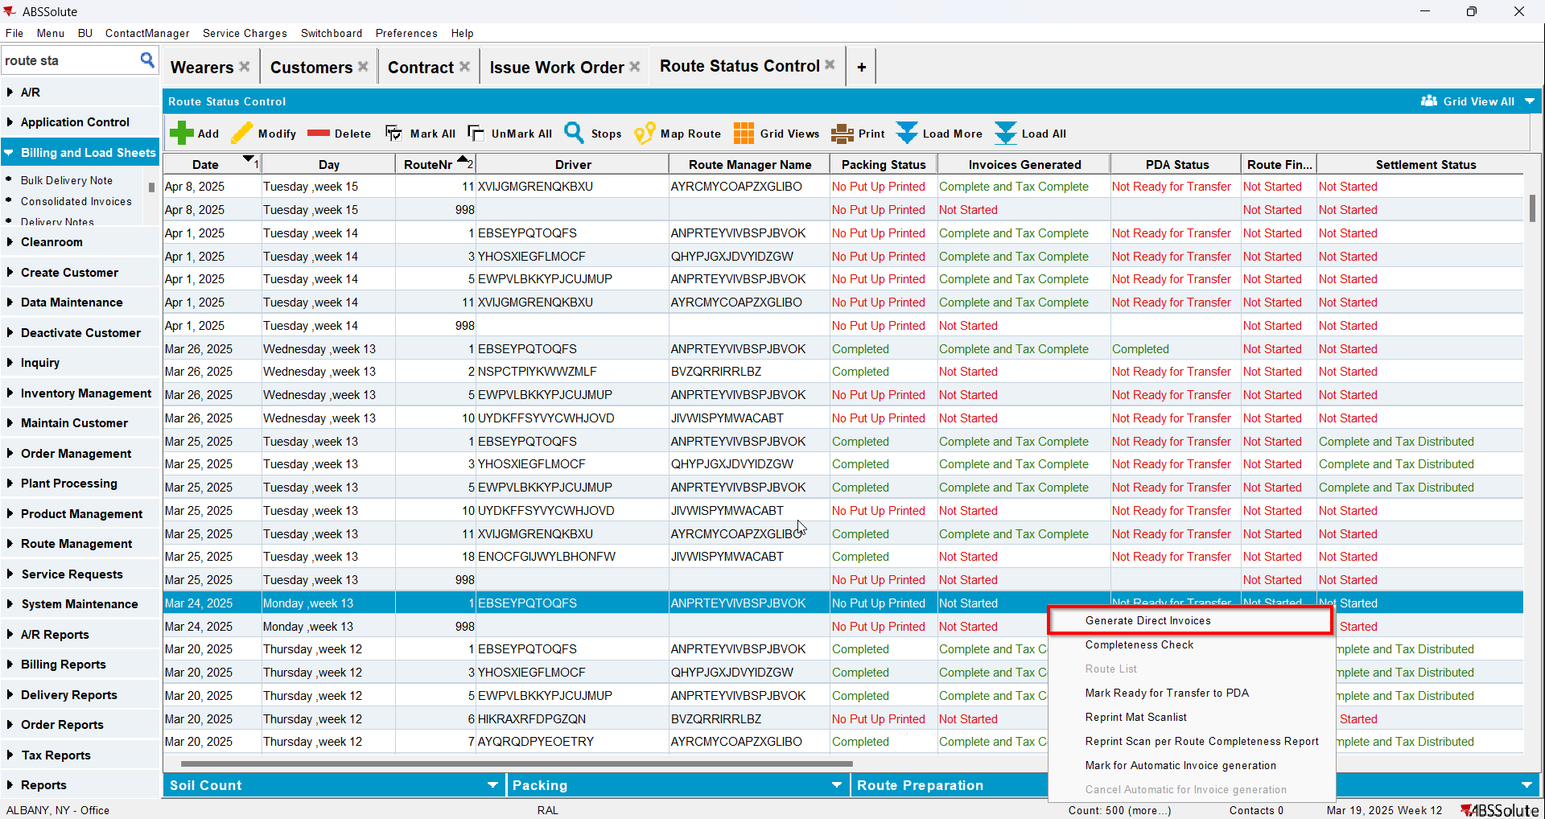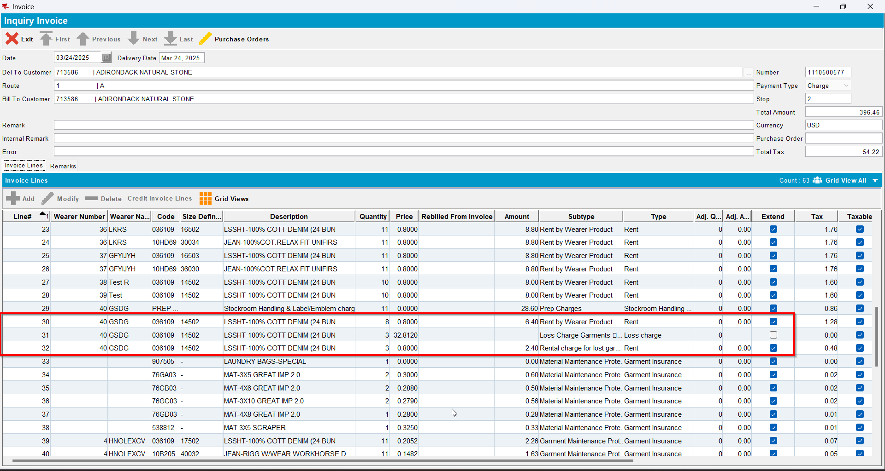
- Send the route to RA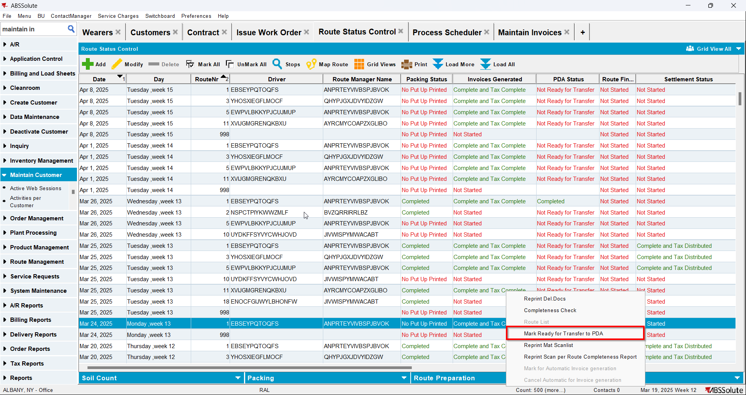
- RA: Do a bill loss now for the loss line
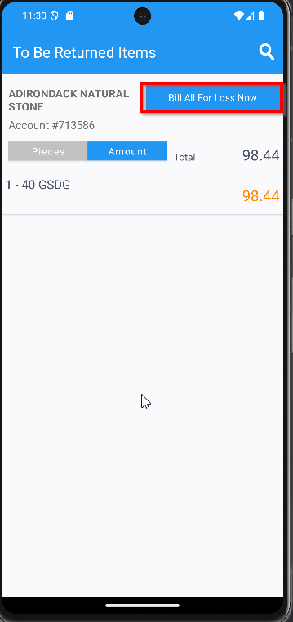
- Settle and upload the route back to the server
- WebX: Settle the route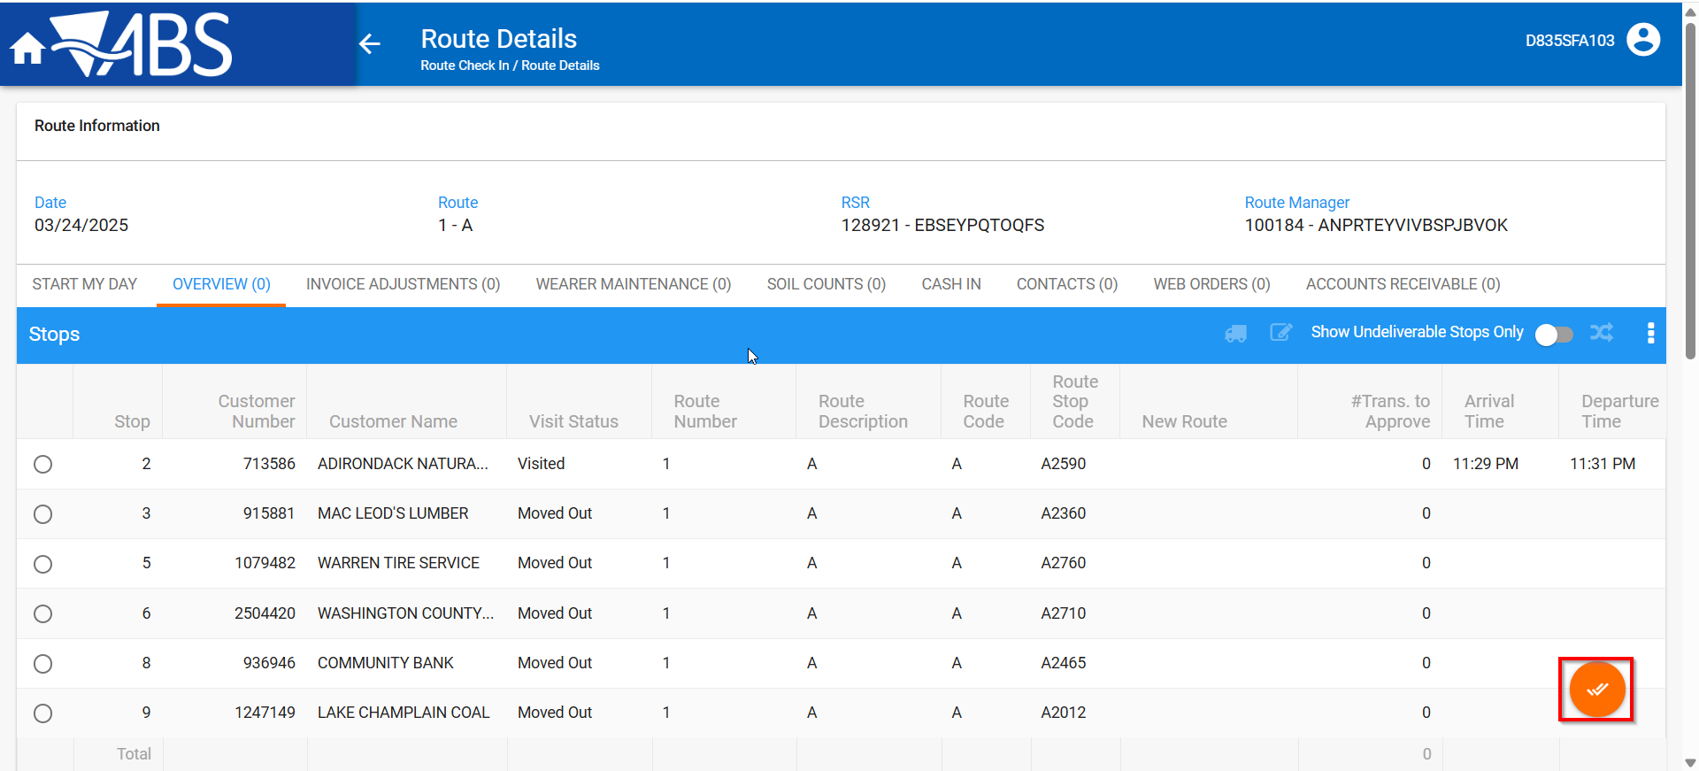
- Maintain Invoices DLG: Verify that the loss charge is now Extend = ‘Y’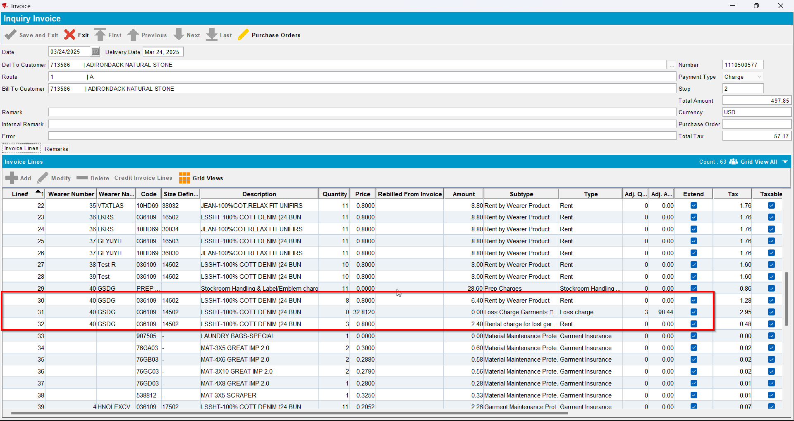
- Wearers DLG: Check that the wearer inventory associated with the loss charge has had the circ inventory has gone down and that the non-unique garments were ragged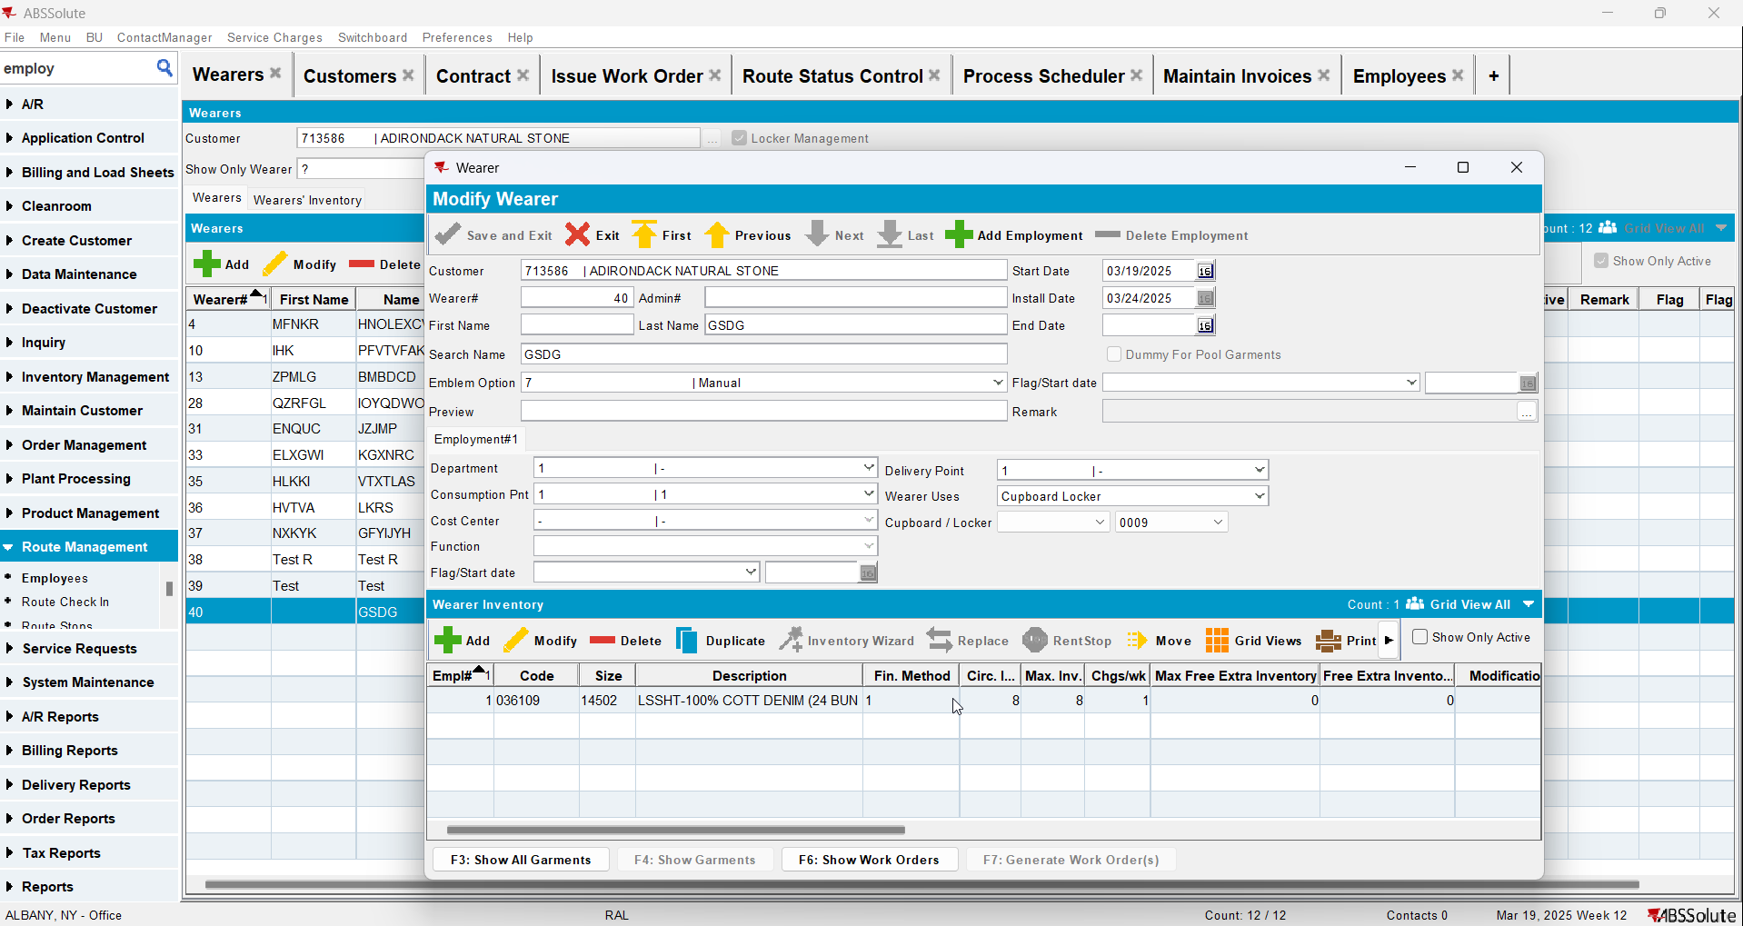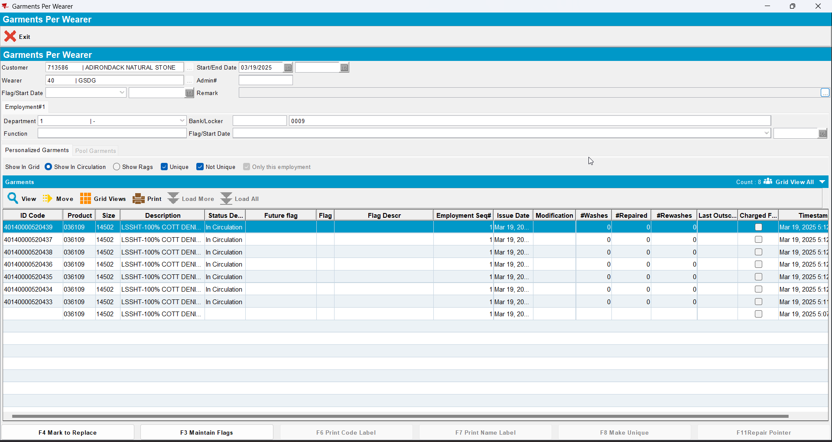

Tested OK

Test Case 3 – DOI mixed inventory Bill Loss now on existing loss charge (mark all non-uniques and some uniques) return some non-uniques as Smartbarcodes and some uniques
Expected behavior: All returned garments are returned to stock when scanned in Route Returns (check in maintain unique garments). The non-uniques and uniques that are not returned are ragged. At the end circ should be equal to max and only uniques that are not flagged remain in show garments.
Hash: 549daf5

Test Steps
- Find a wearer inventory with a mixed inventory of uniques and non-uniques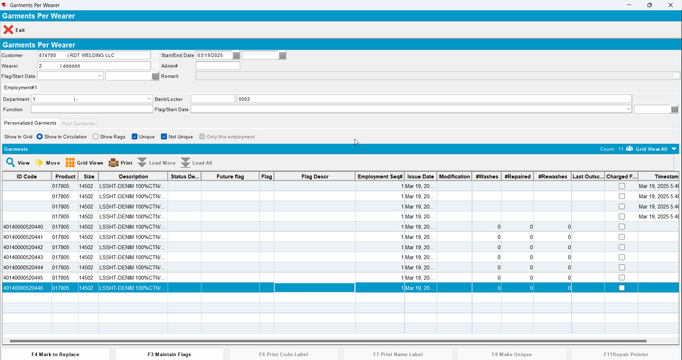
- Decrease inventory from 11 to 4 (so 4 non-unique garments in total will be flagged as DOI and 3 unique)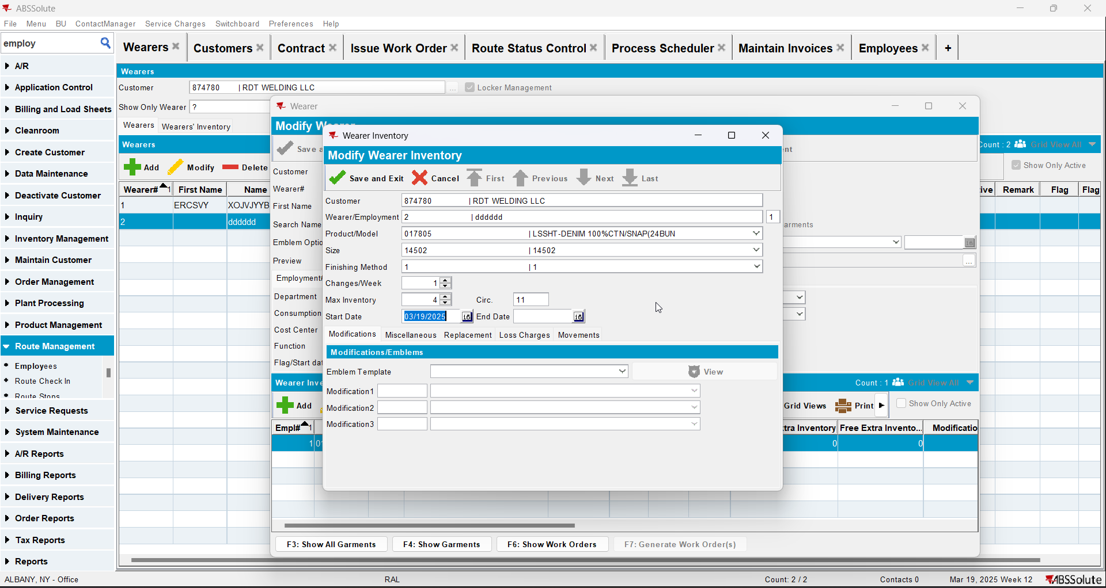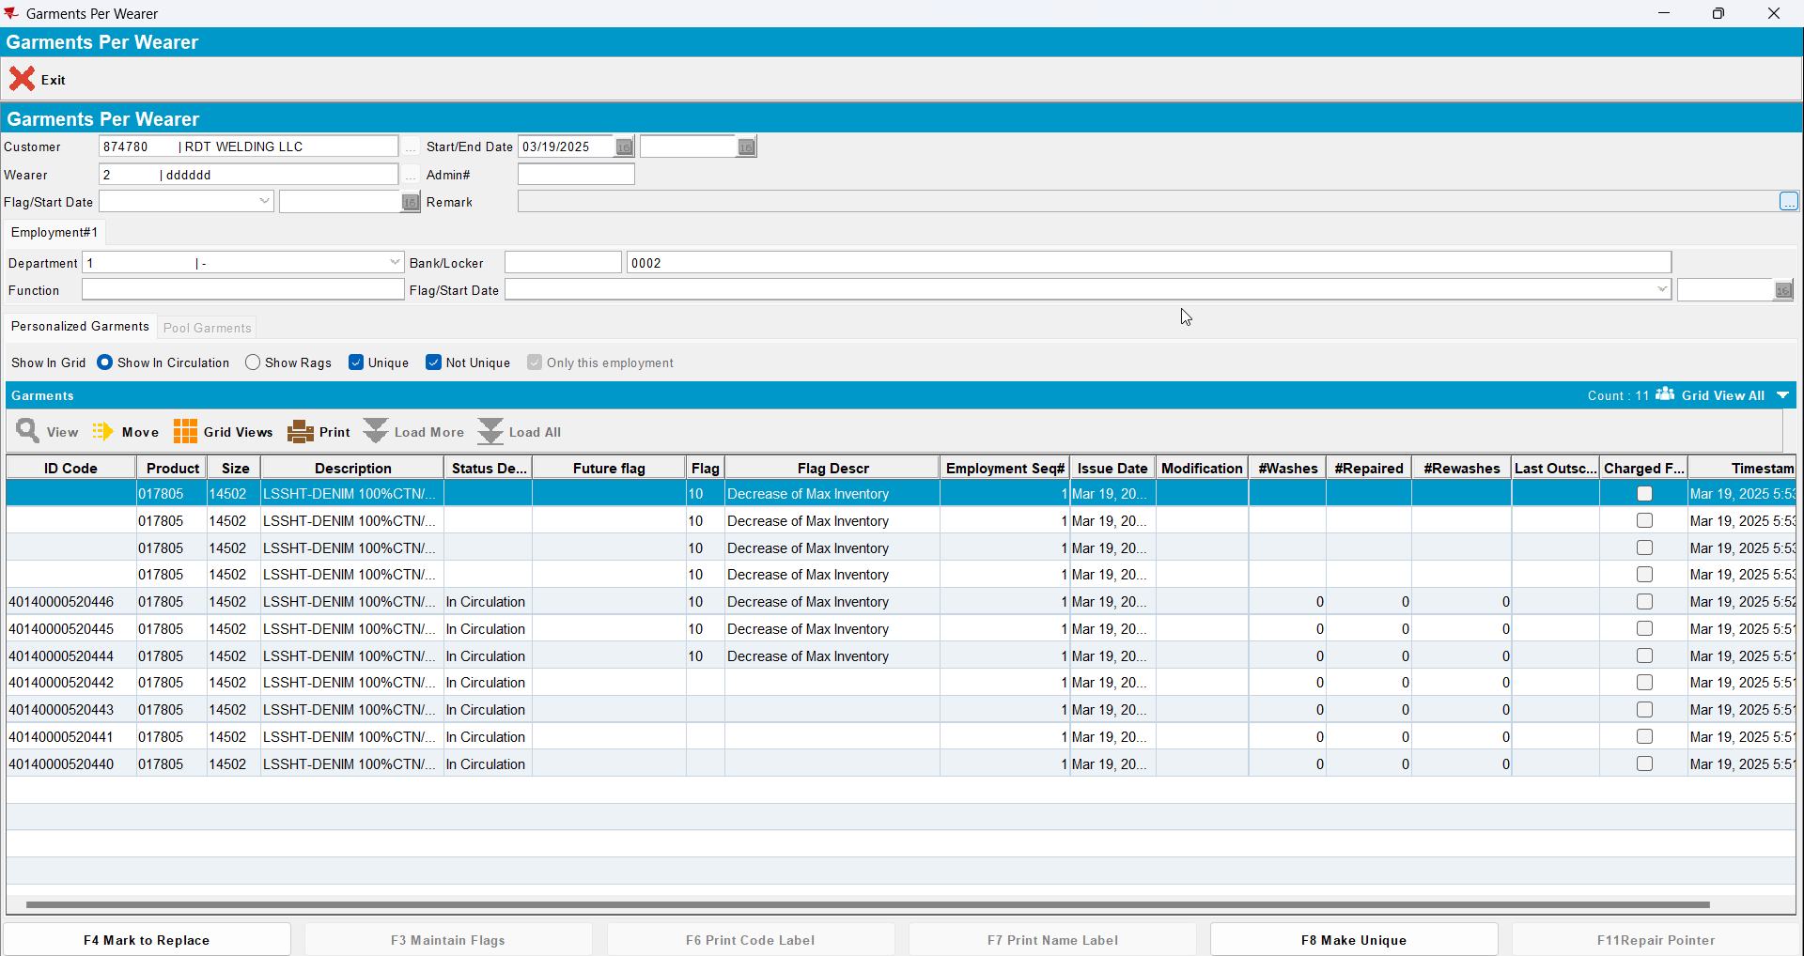
- Generate invoices on the current week’s route, there should be a loss charge of subtype DOI with Extend = ‘N’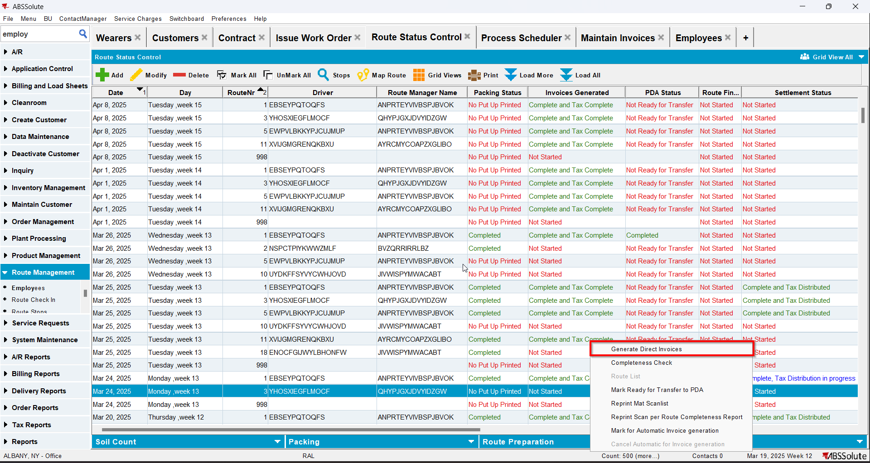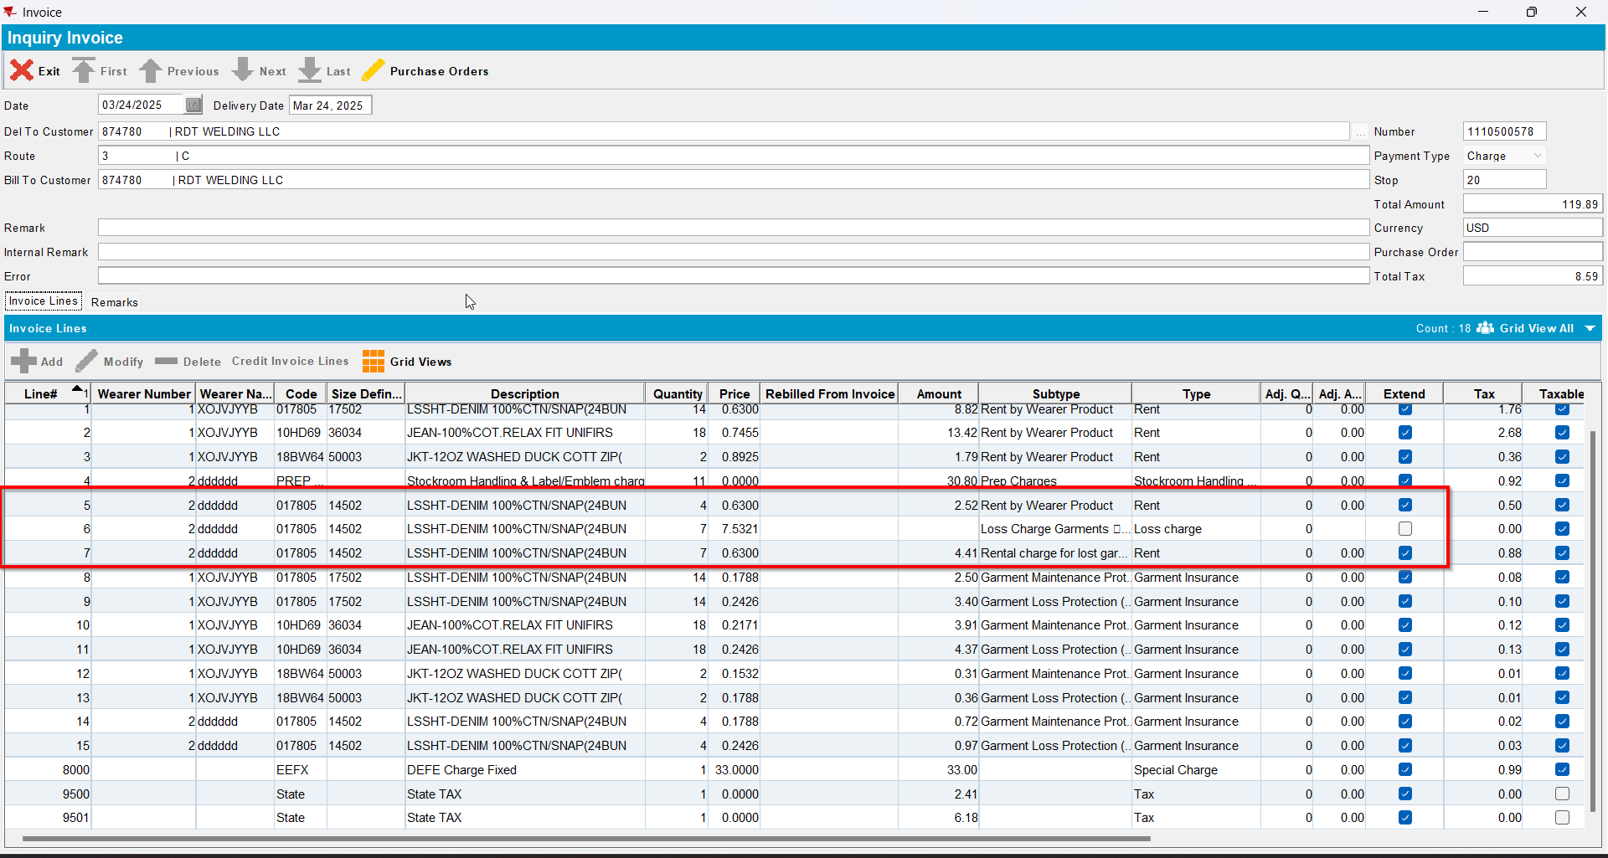
- Send the route to RA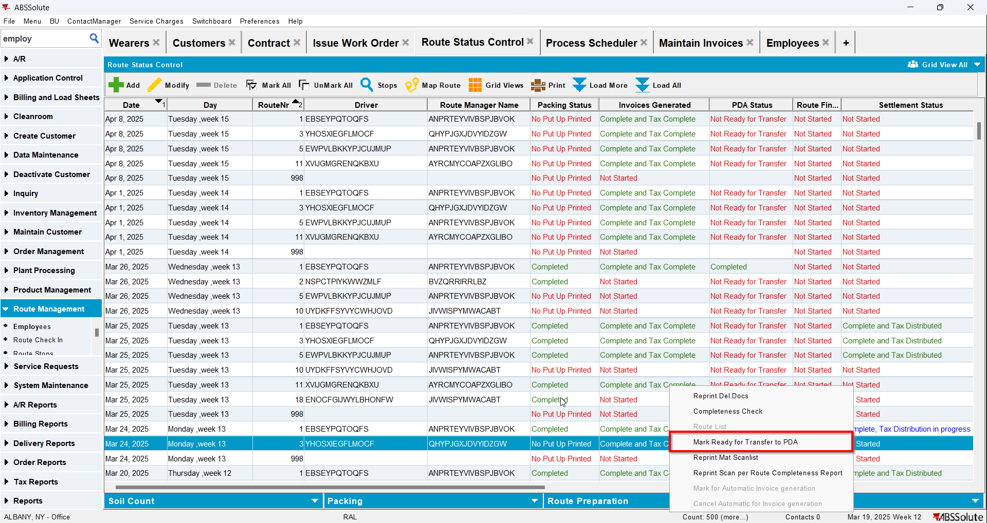
- Scan for return 2 non uniques and 1 unique
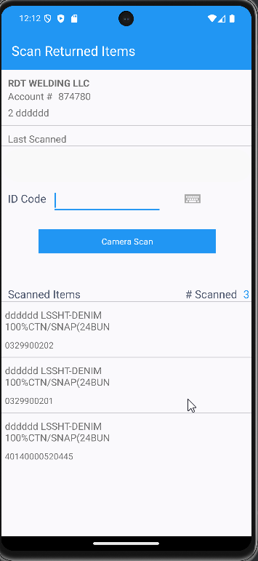
- RA: Do a bill loss now for the loss line
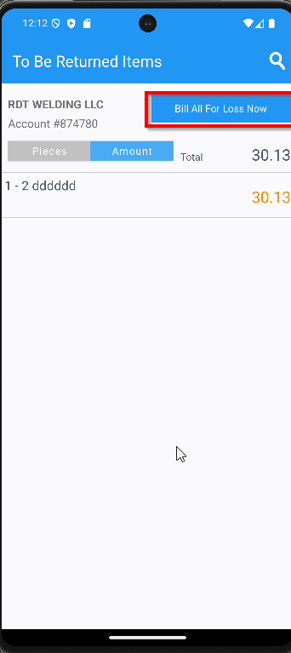
- Settle and upload the route back to the server
- On Route Returns send to stock the garments scanned for returned on RA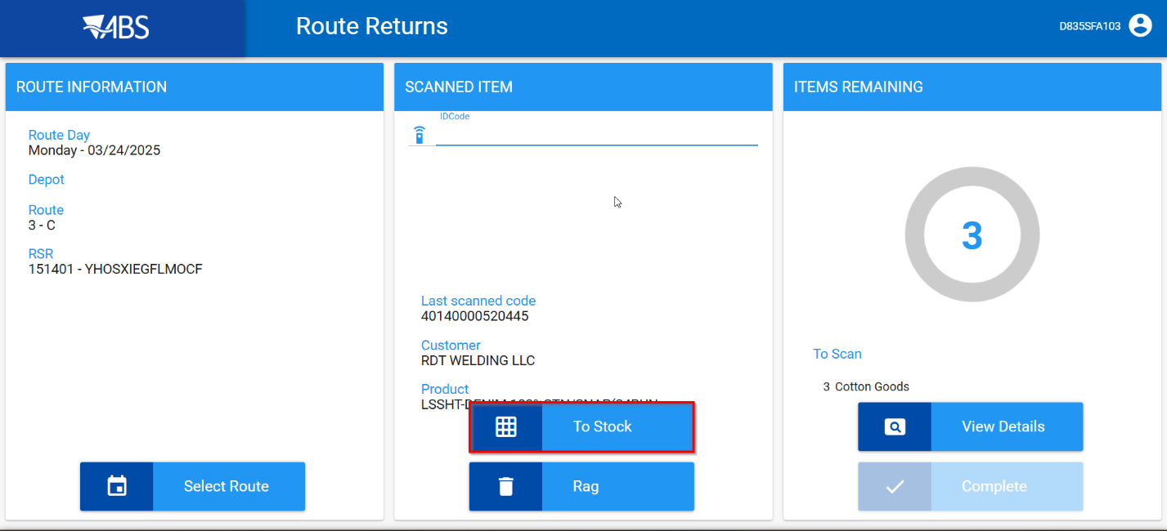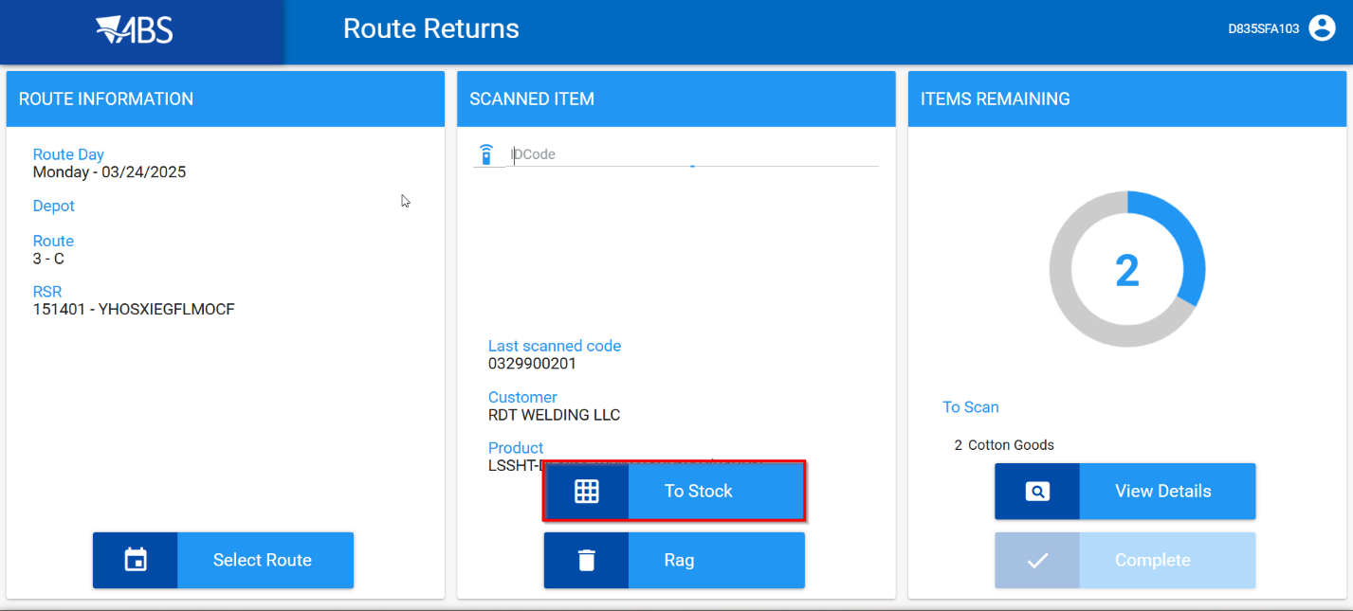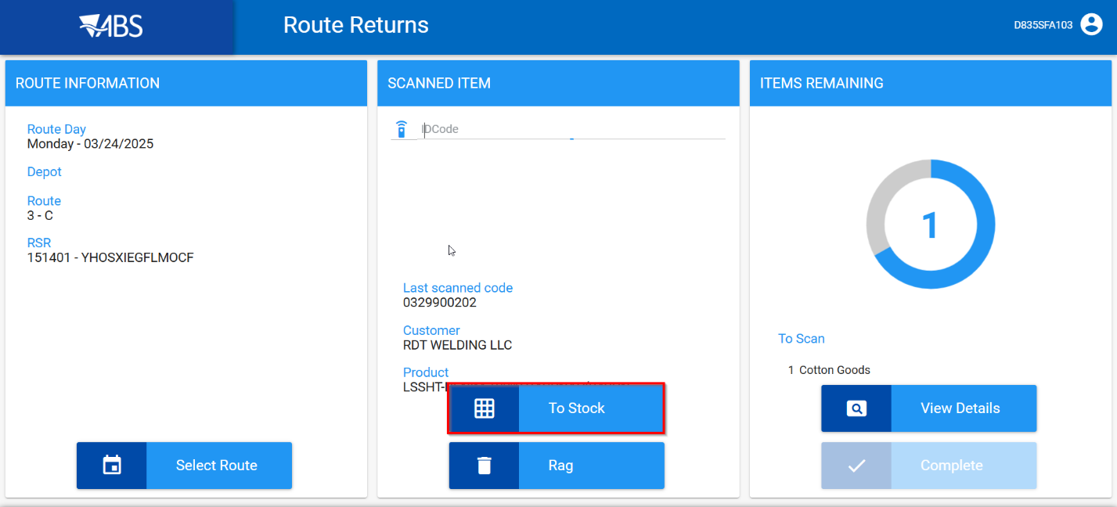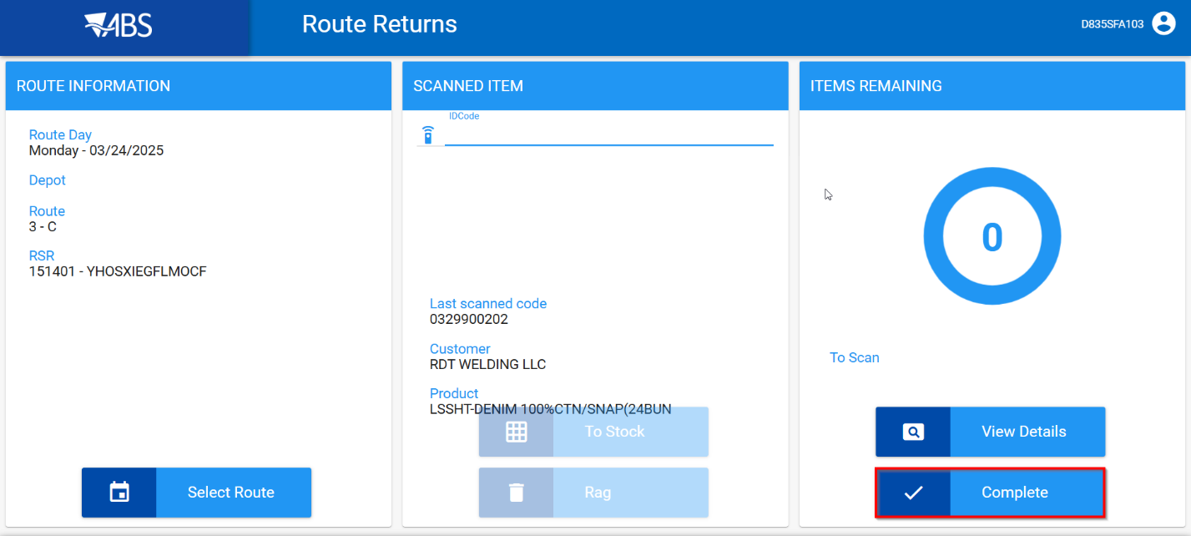
- WebX: Settle the route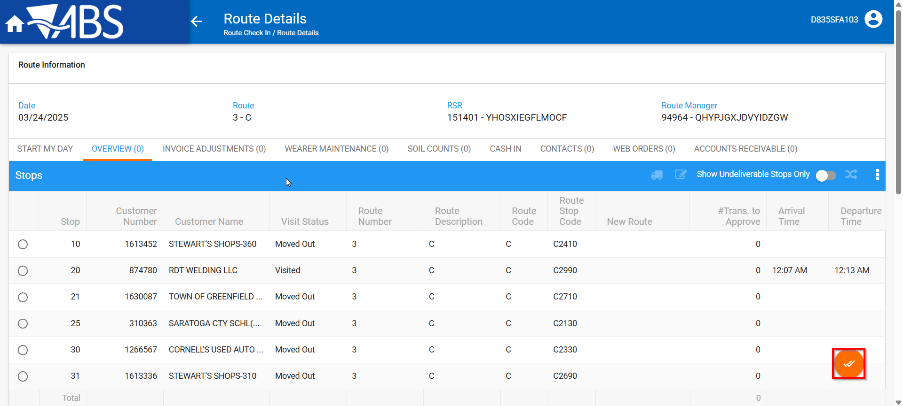
- Maintain Invoices DLG: Verify that the loss charge is now Extend = ‘Y’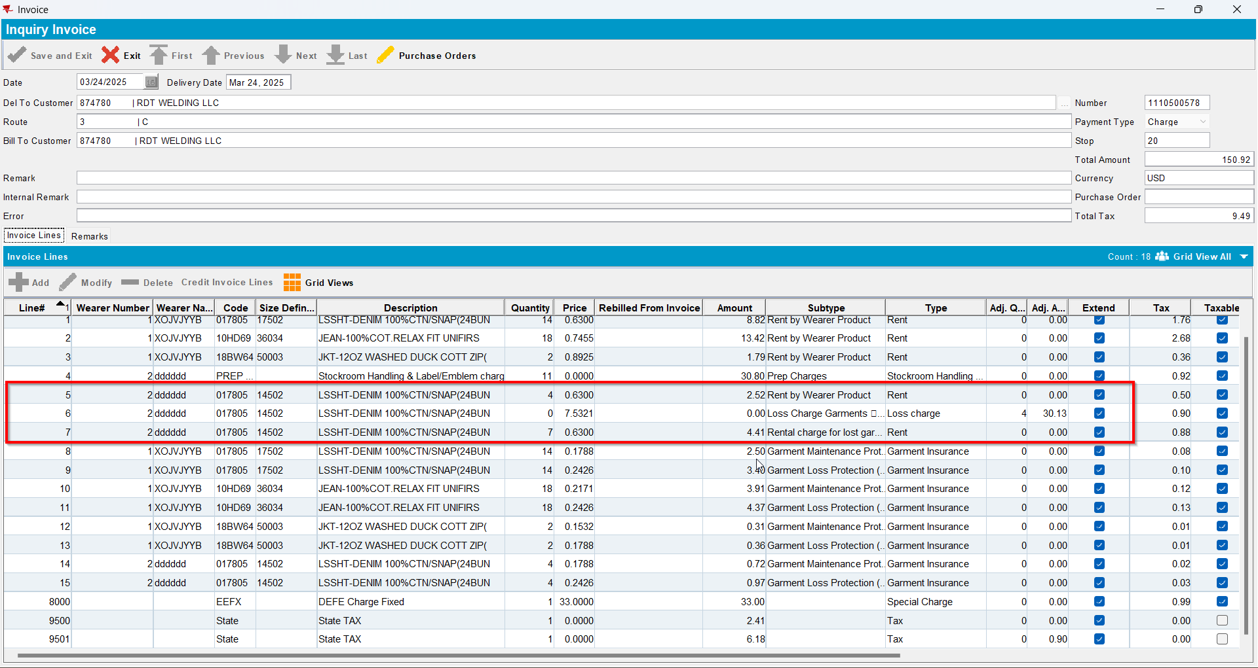
- Maintain Unique Items dlg. Check that the items were returned to stock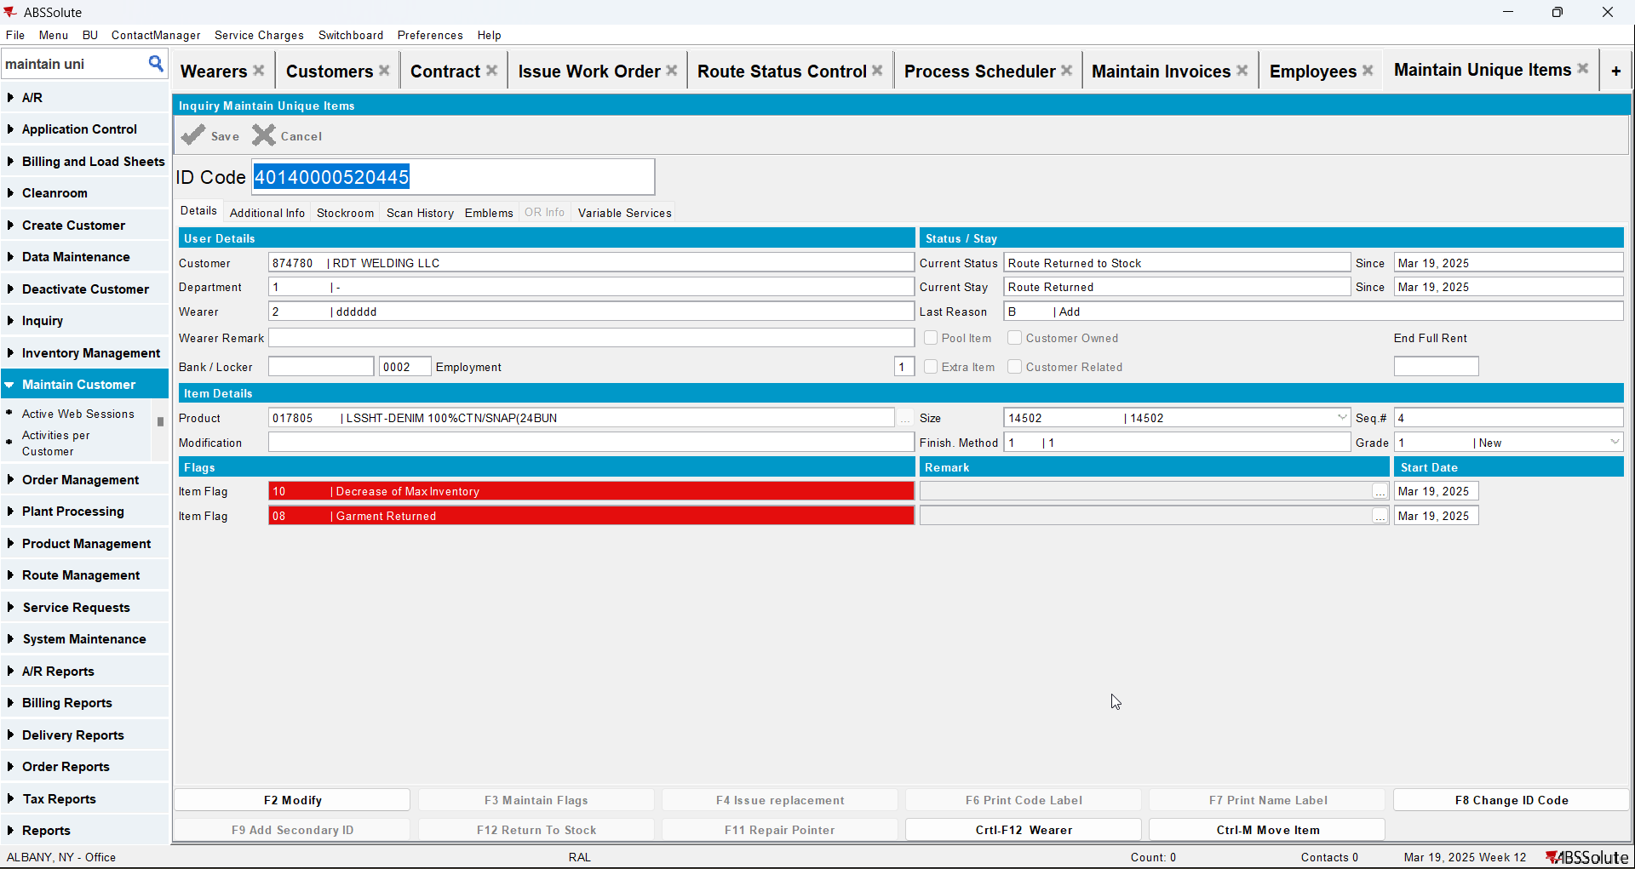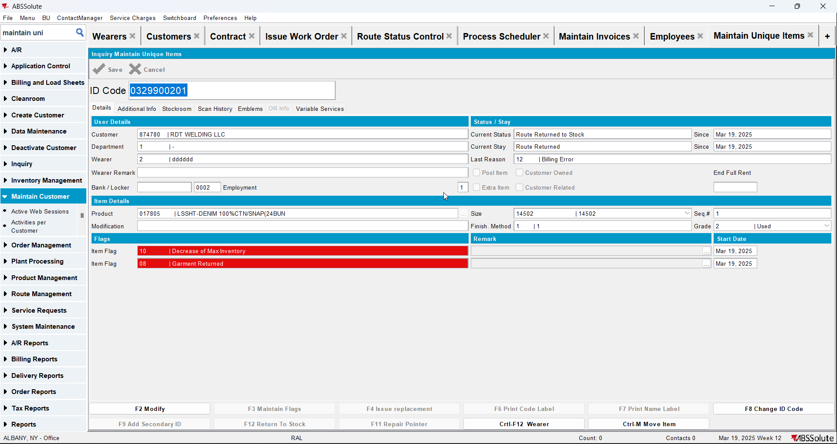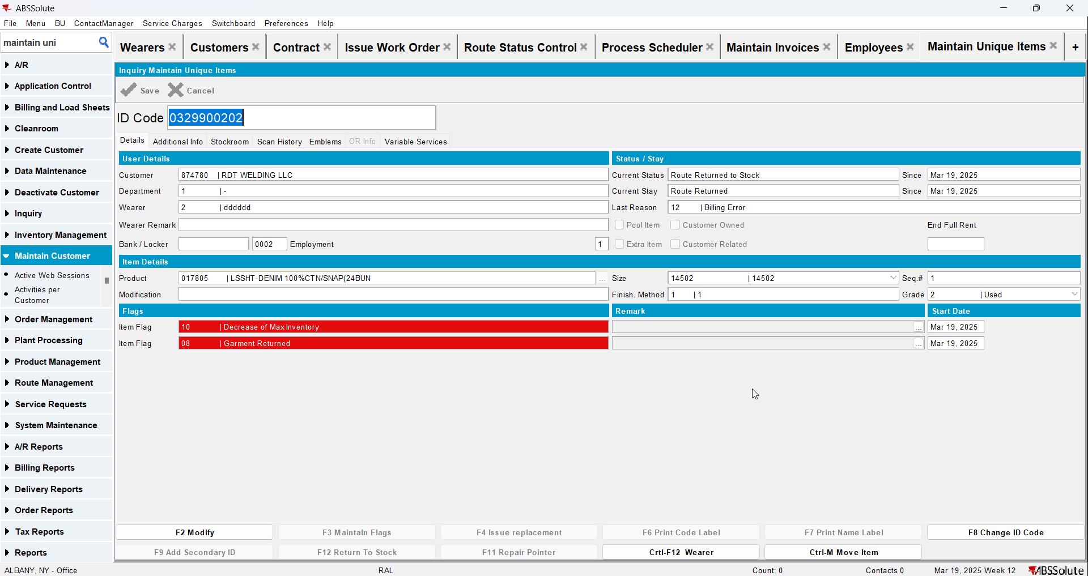
- Wearers DLG: Check that the wearer inventory associated with the loss charge has had the circ inventory has gone down and that the unique and non-unique garments were ragged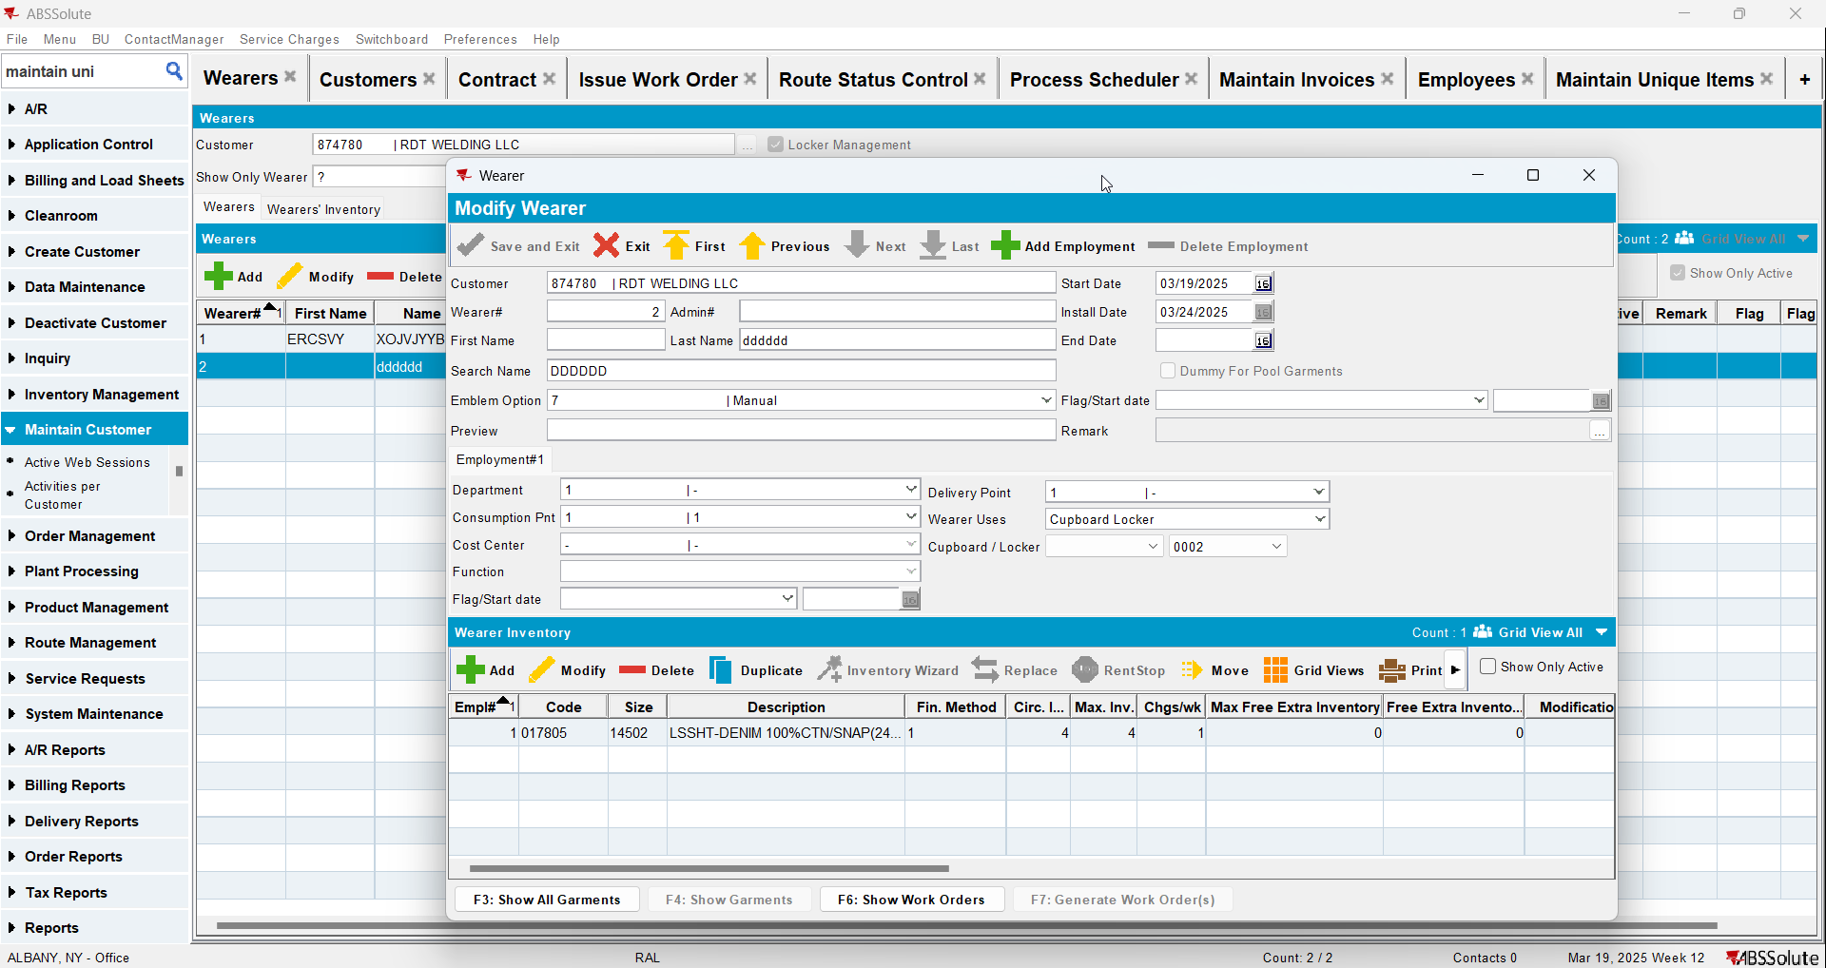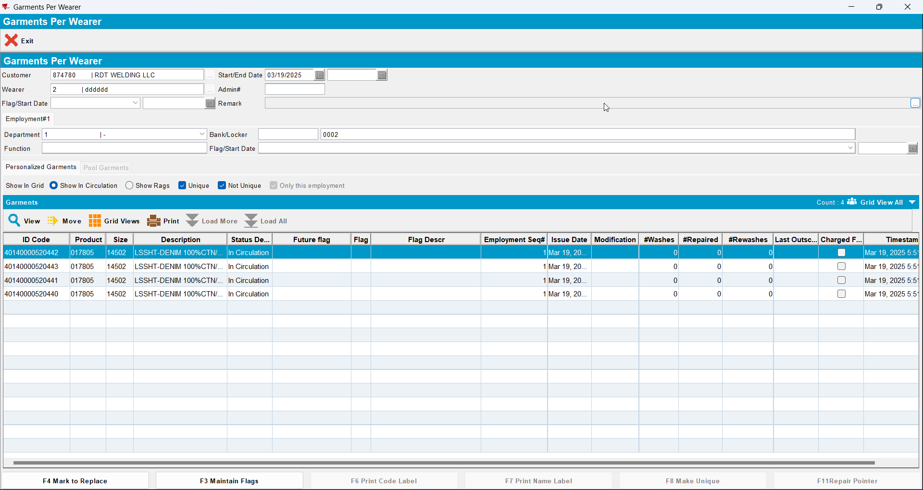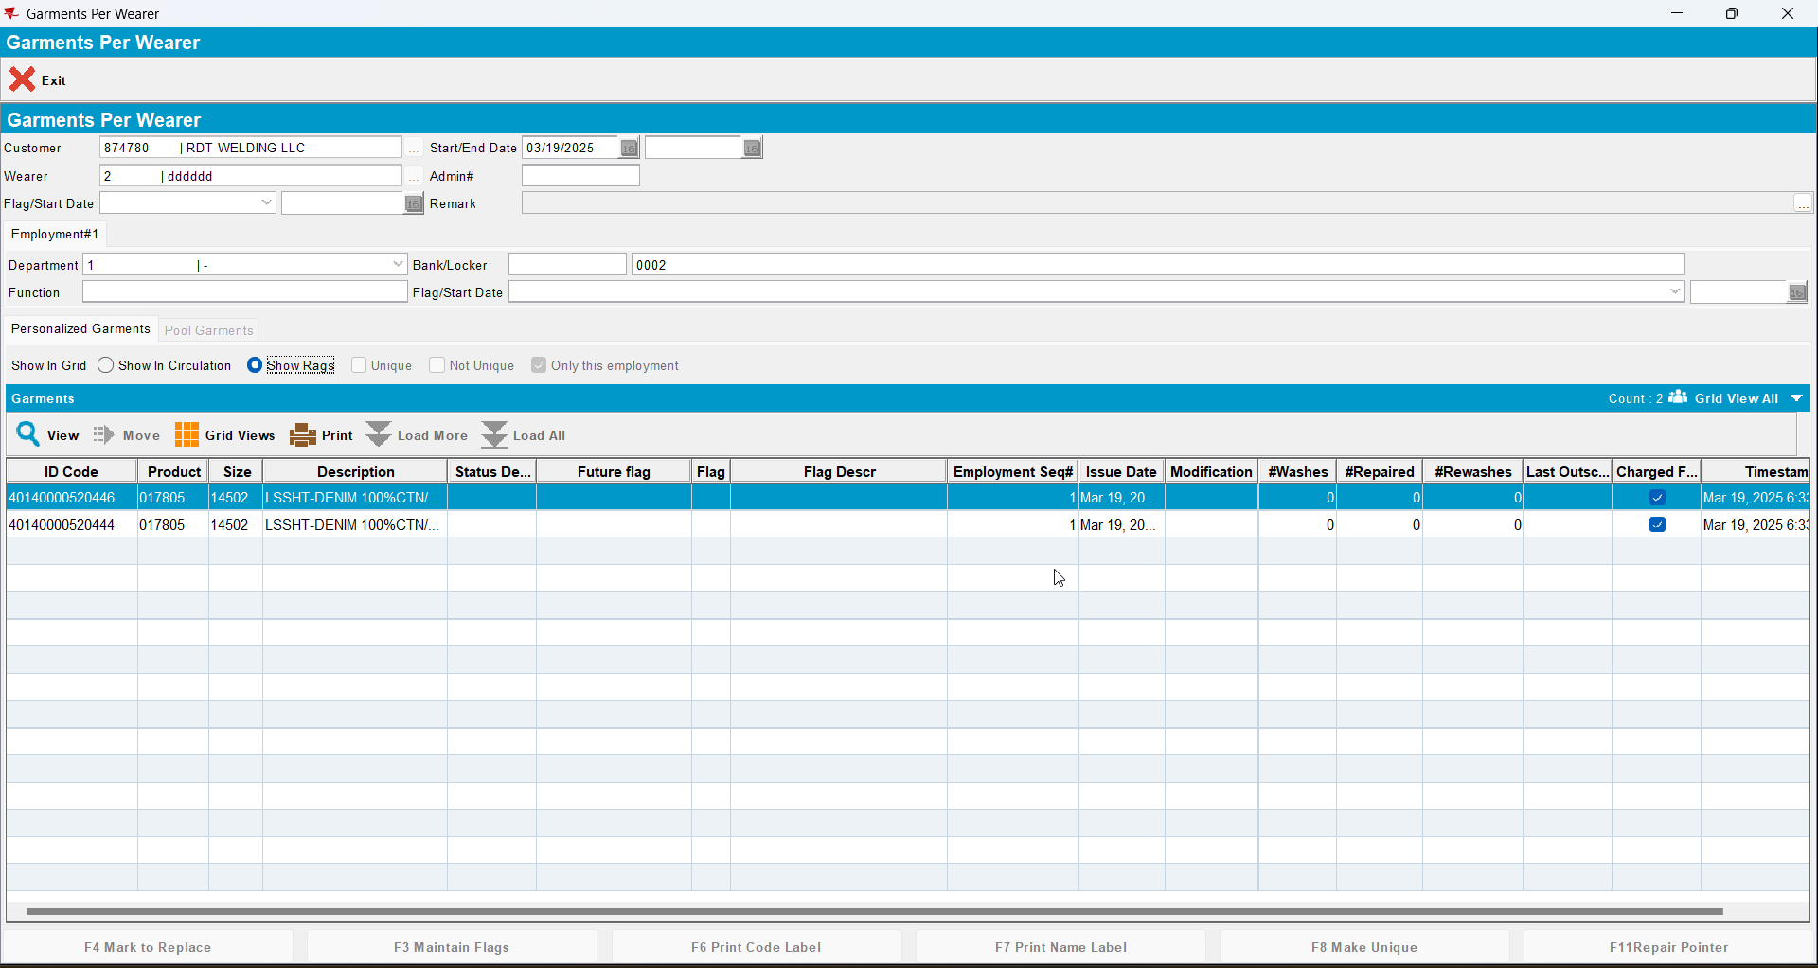

Test Case 4 – DOI mixed inventory Bill Loss now on existing loss charge (mark all non-uniqies and some uniques) return all non-uniques as Smartbarcodes and some uniques
Expected behavior: All returned garments are returned to stock when scanned in Route Returns (check in maintain unique garments). At the end circ should be equal to max and only uniques that are not flagged remain in show garments.
Hash: 549daf5

Test Steps
- Find a wearer inventory with a mixed inventory of uniques and non-uniques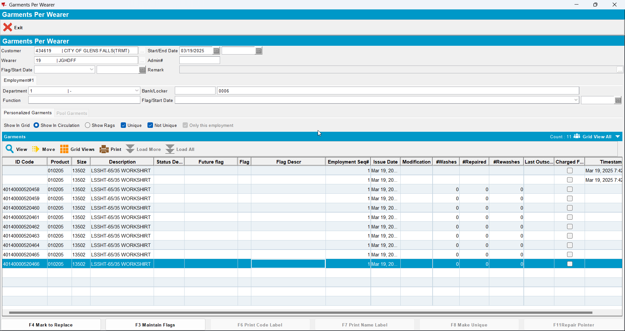
- Decrease inventory from 11 to 5 (so 2 non-unique garments in total will be flagged as DOI and 4 uniques)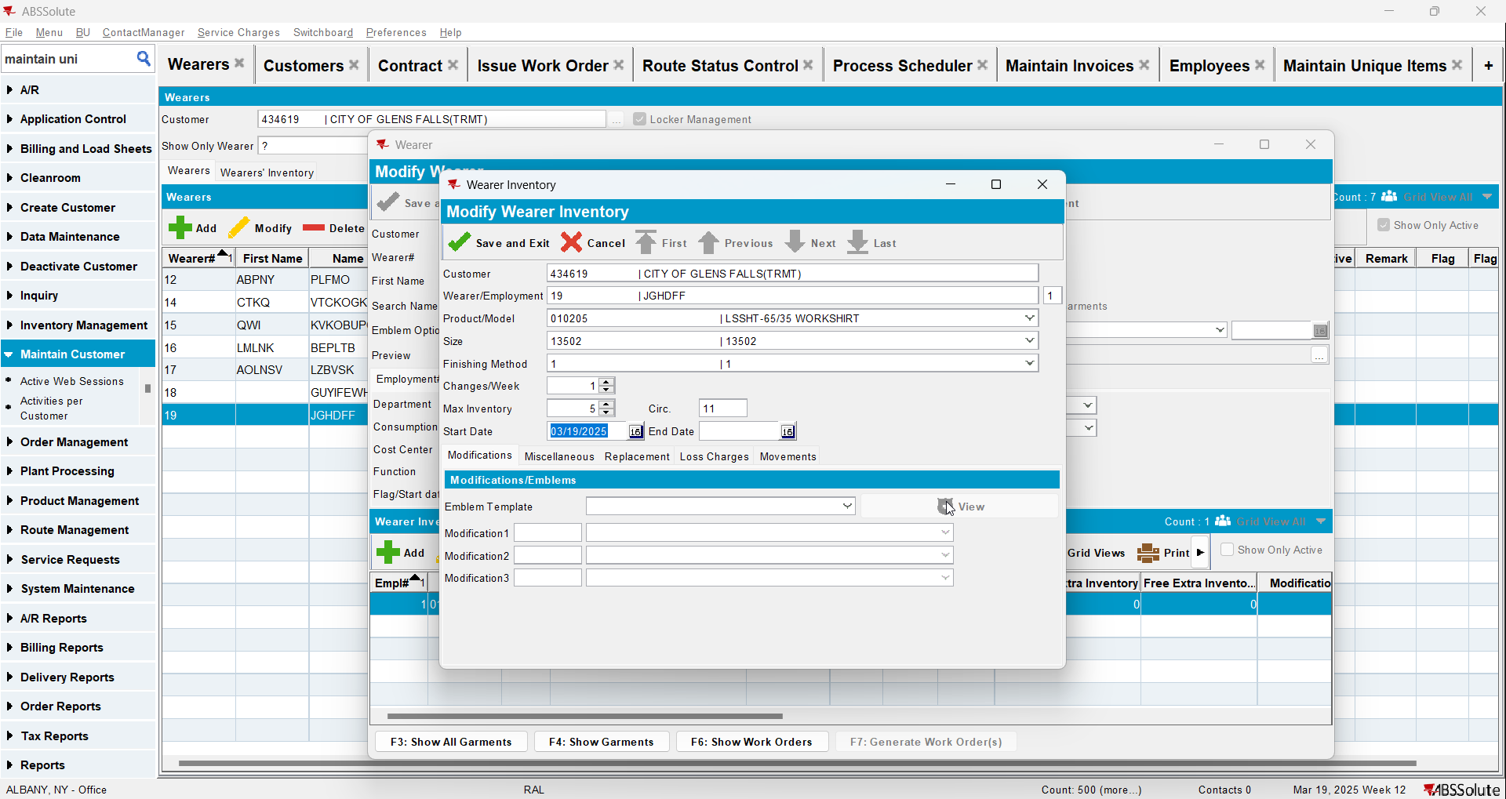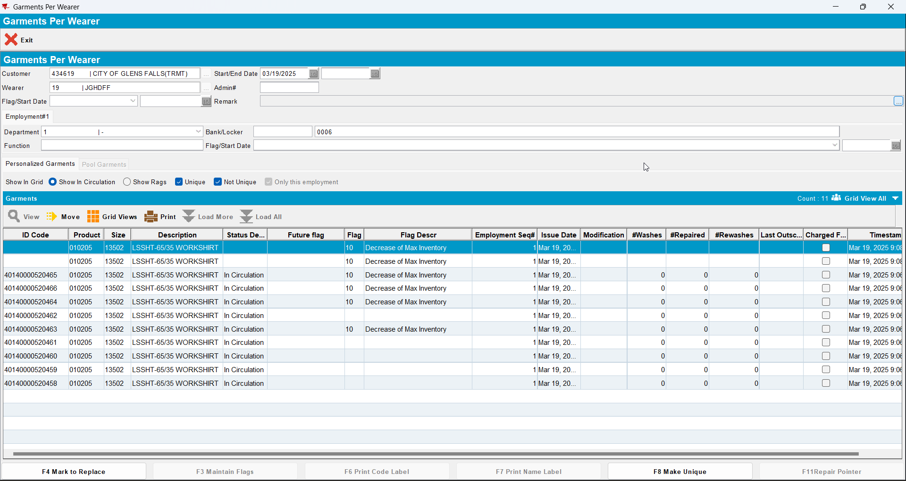
- Generate invoices on the current week’s route, there should be a loss charge of subtype DOI with Extend = ‘N’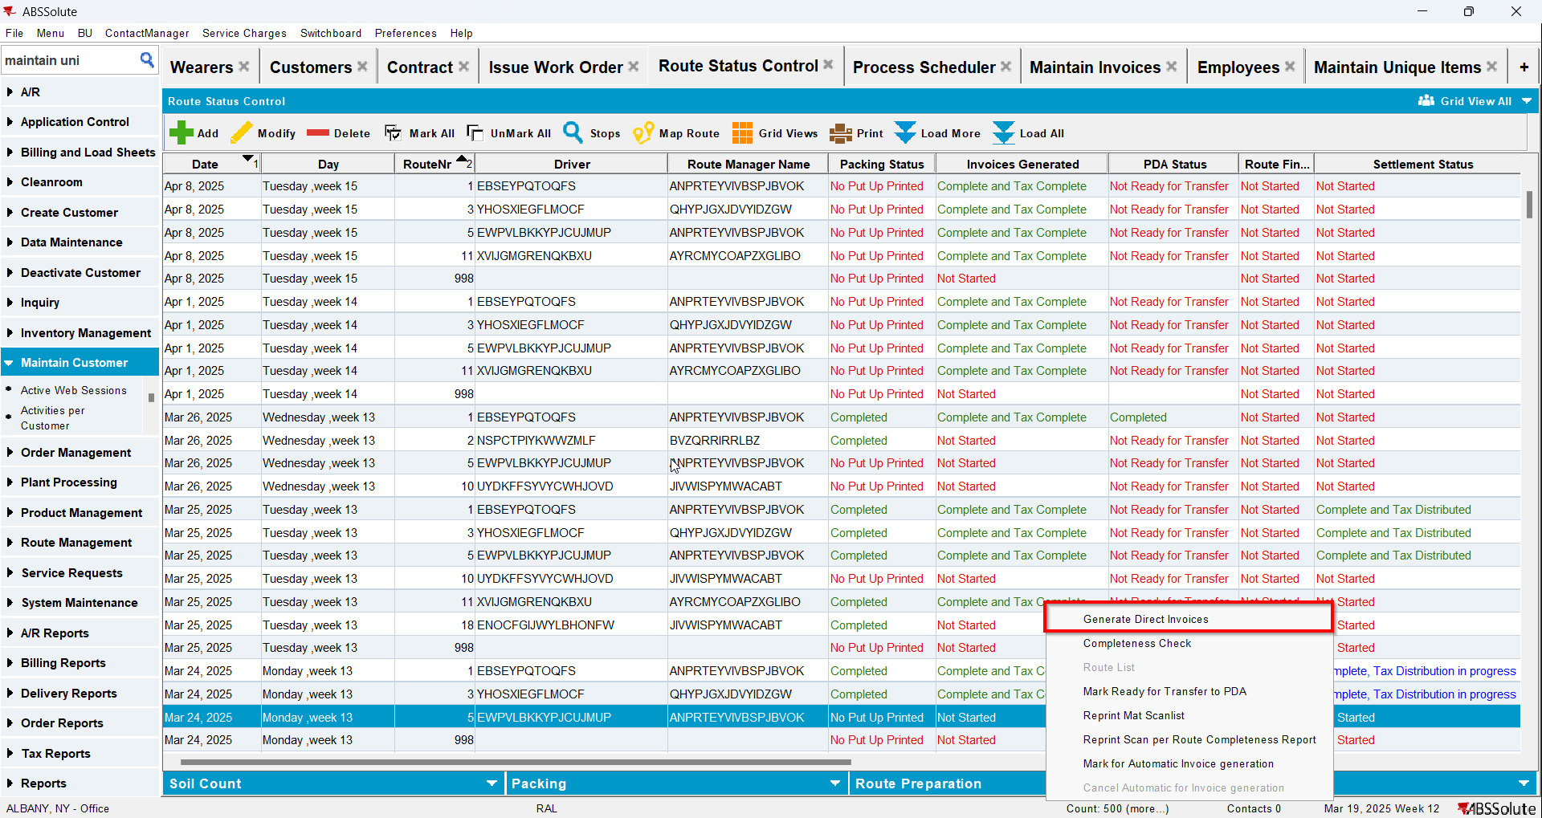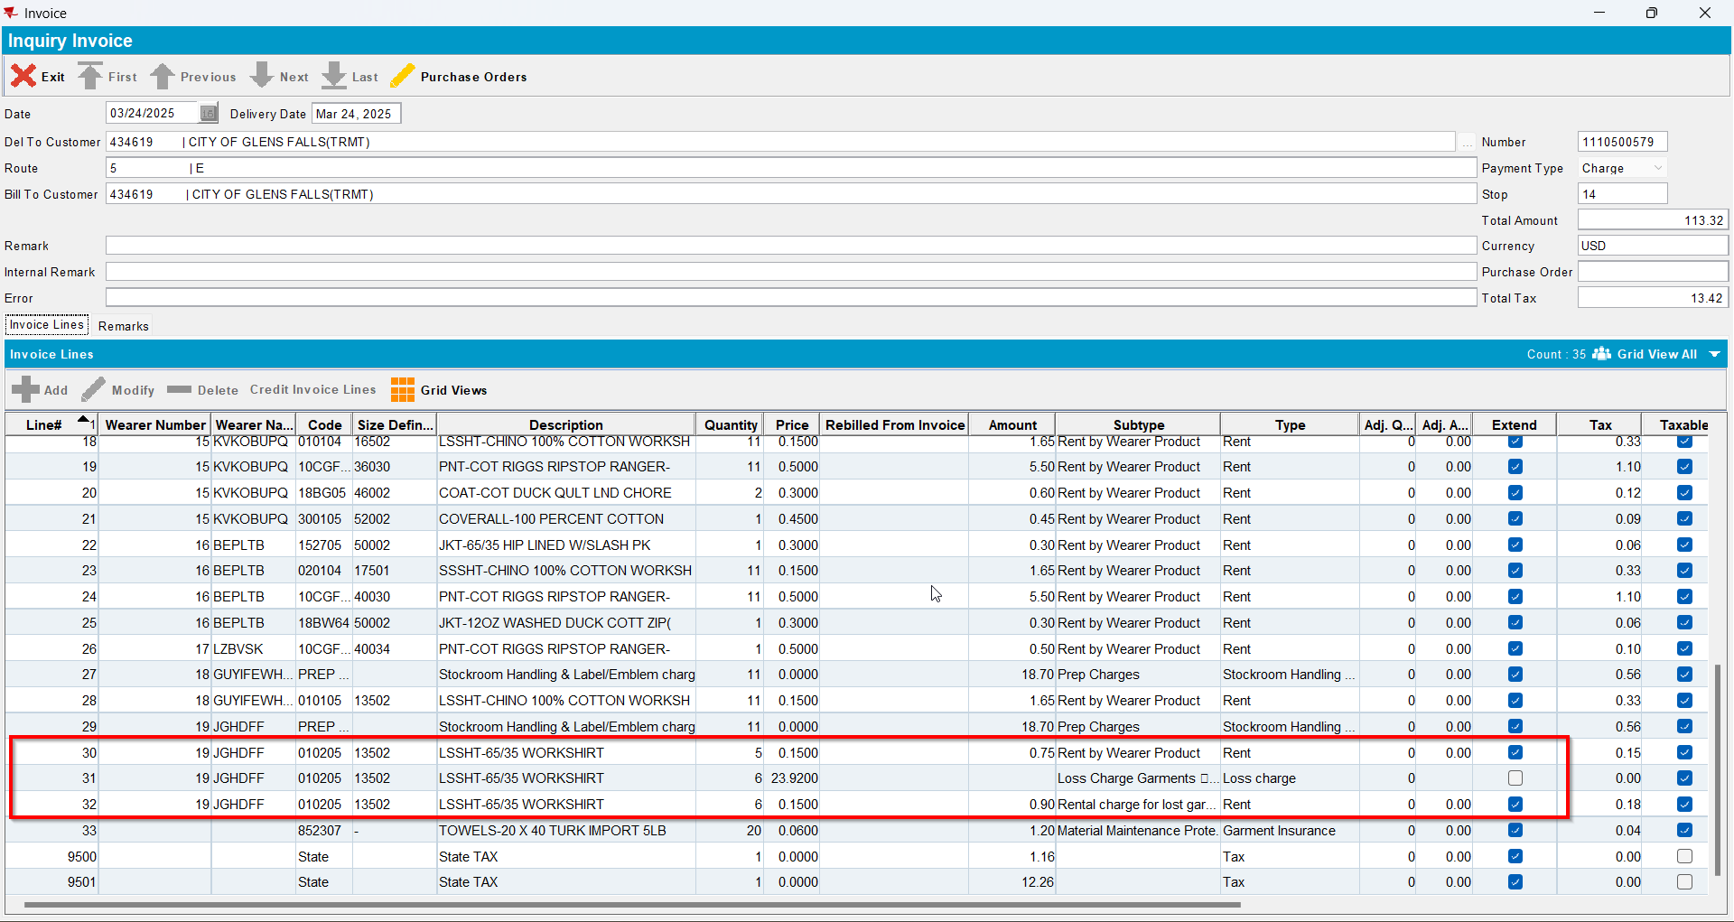
- Send the route to RA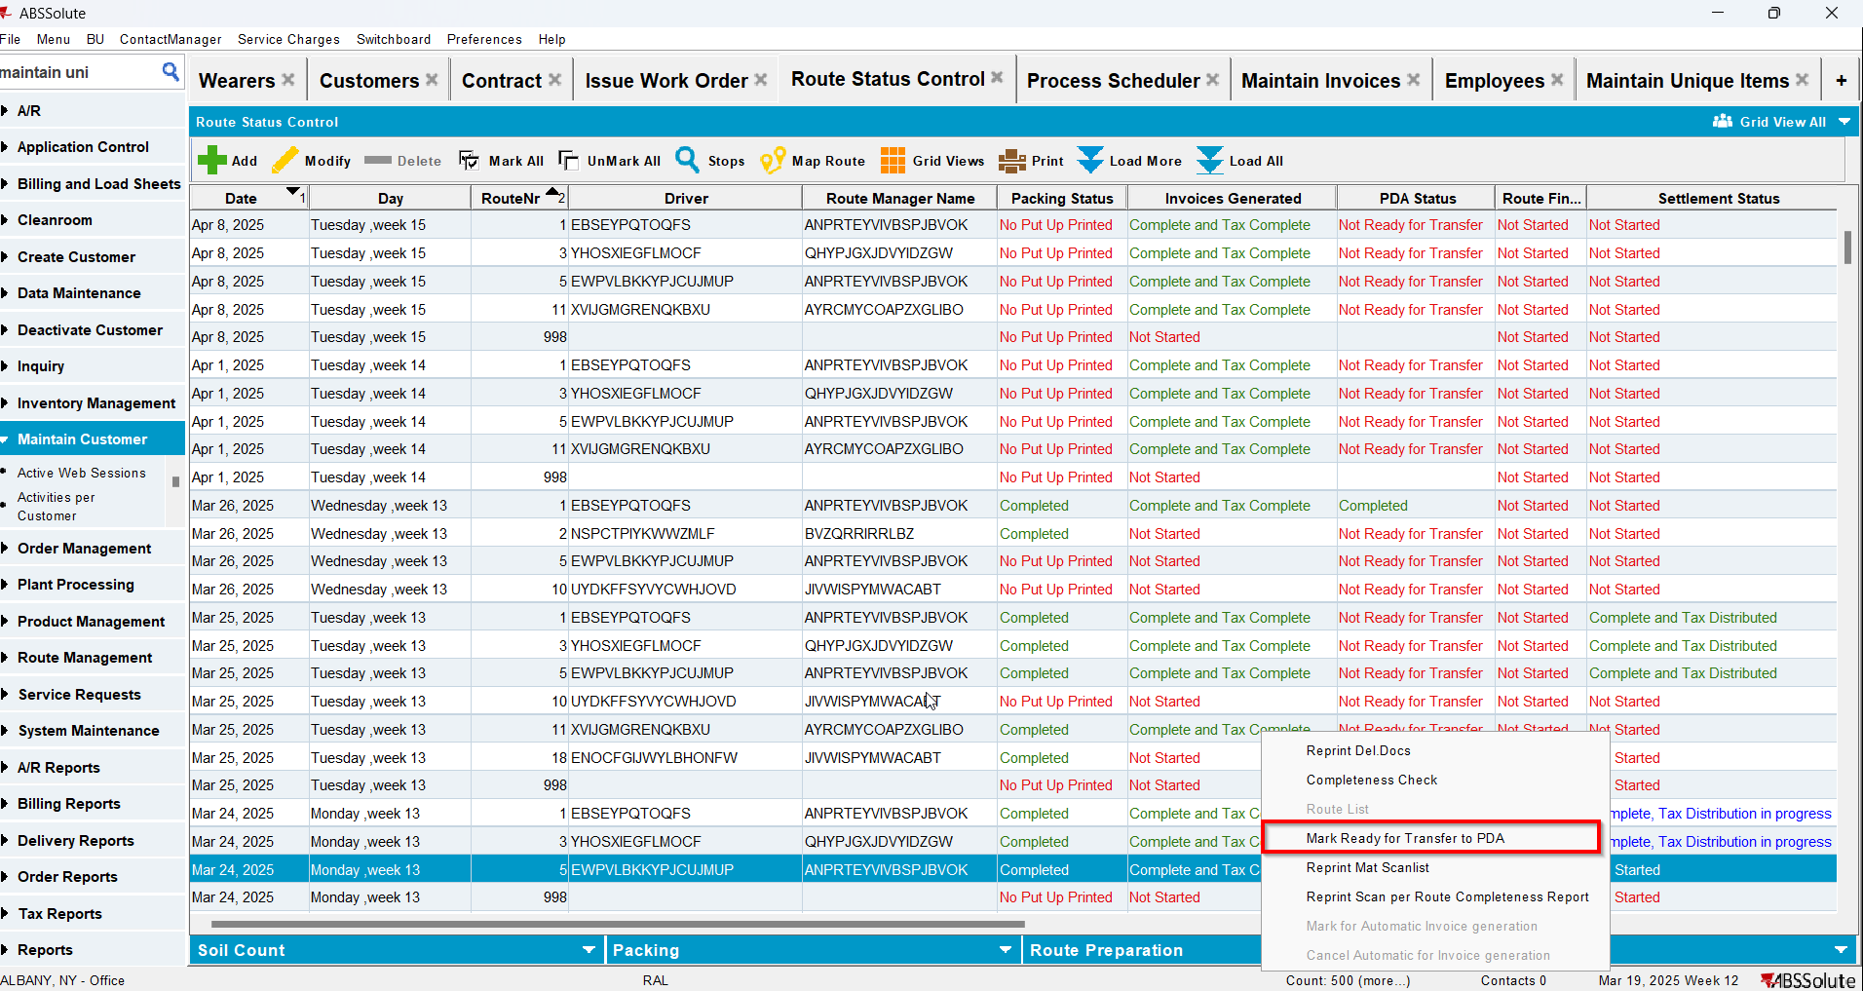
- Scan for return 2 non uniques and 1 unique
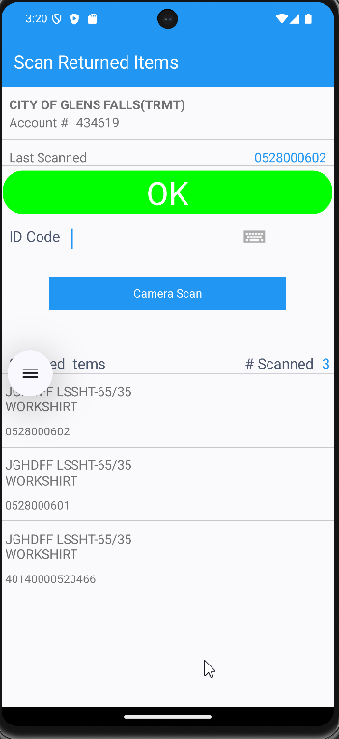
- RA: Do a bill loss now for the loss line
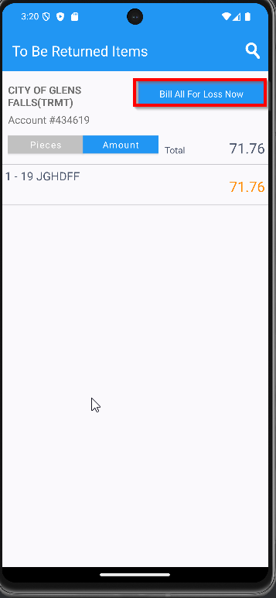
- Settle and upload the route back to the server
- On Route Returns send to stock the garments scanned for returned on RA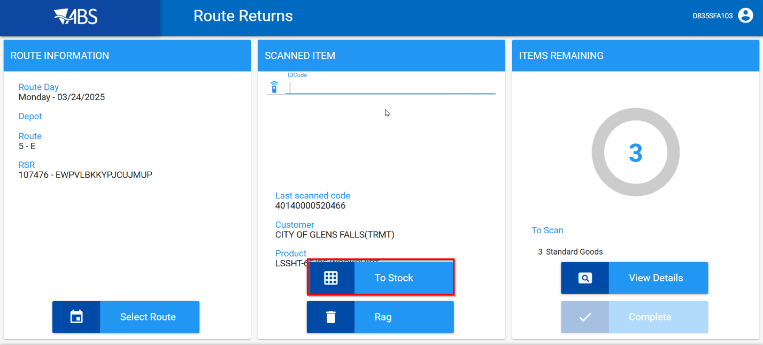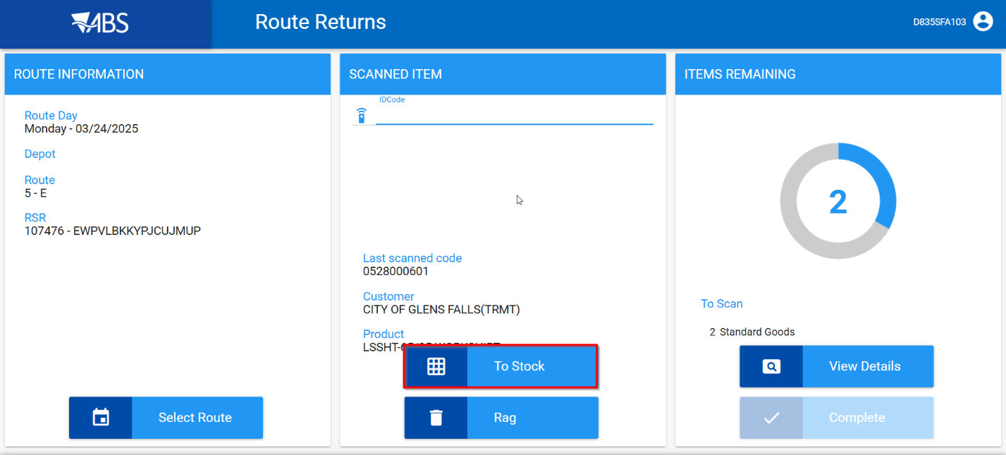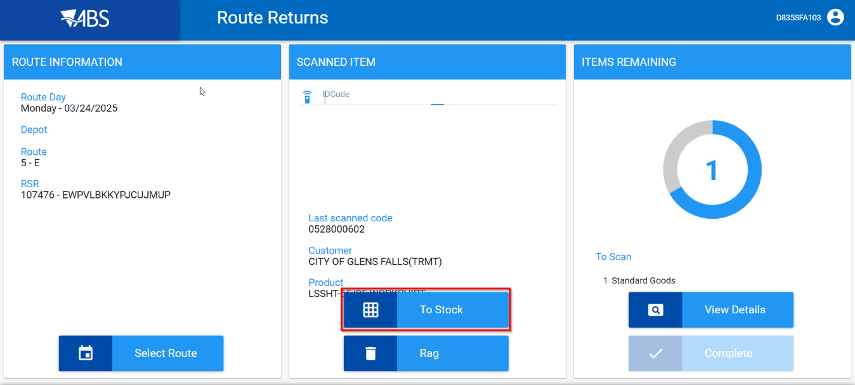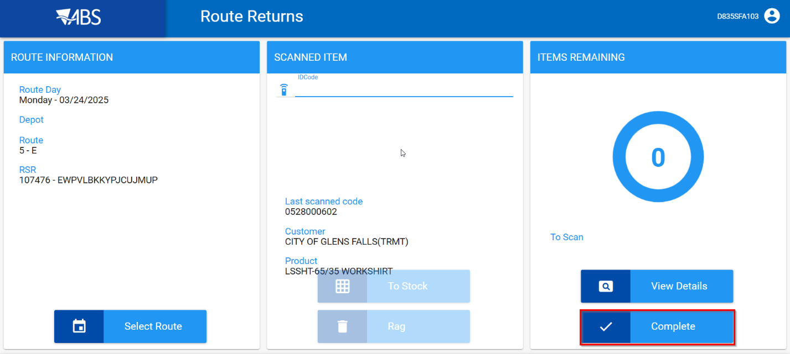
- WebX: Settle the route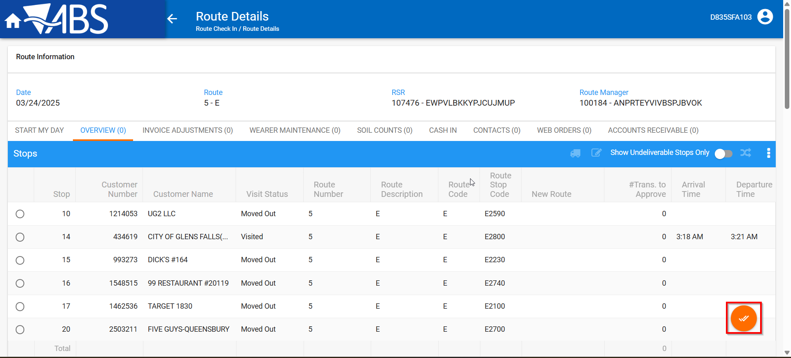
- Maintain Invoices DLG: Verify that the loss charge is now Extend = ‘Y’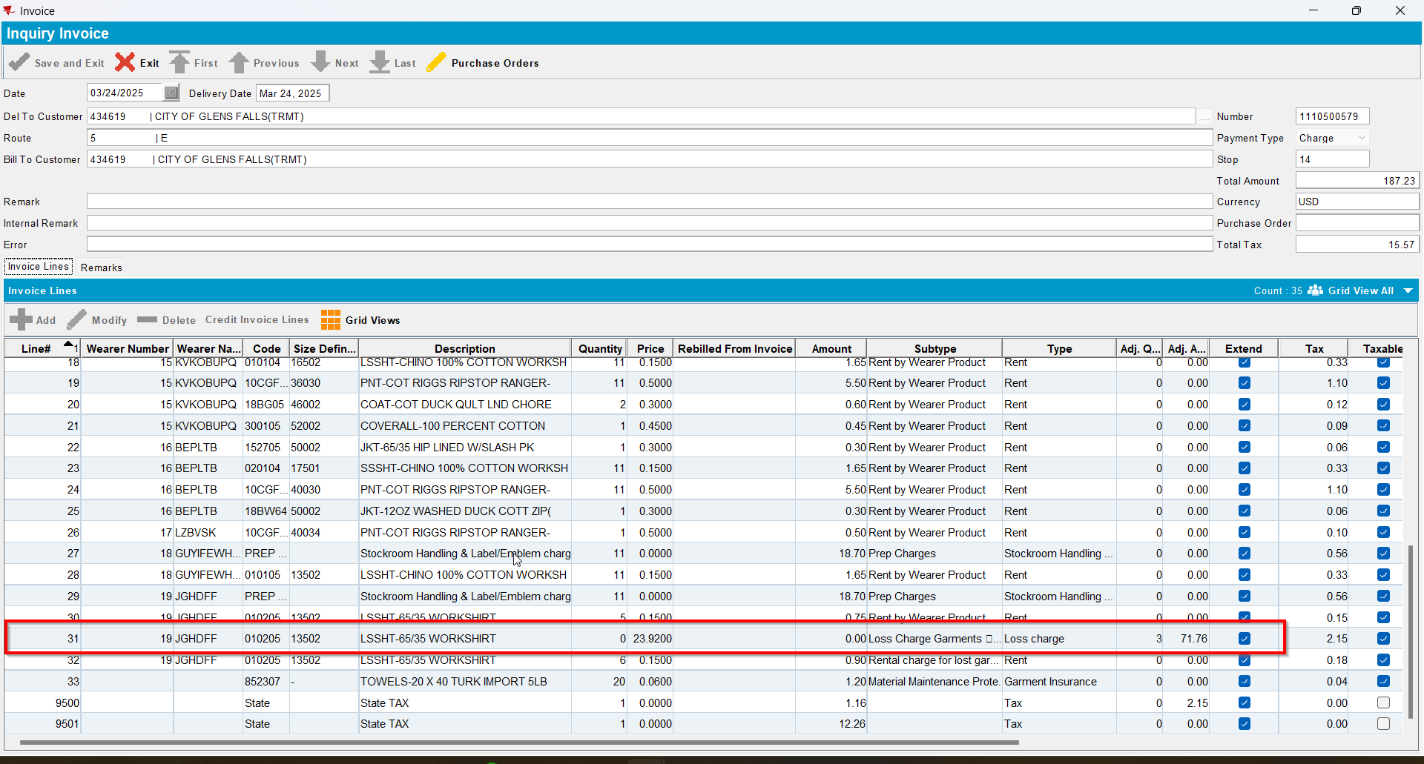
- Maintain Unique Items dlg. Check that the items were returned to stock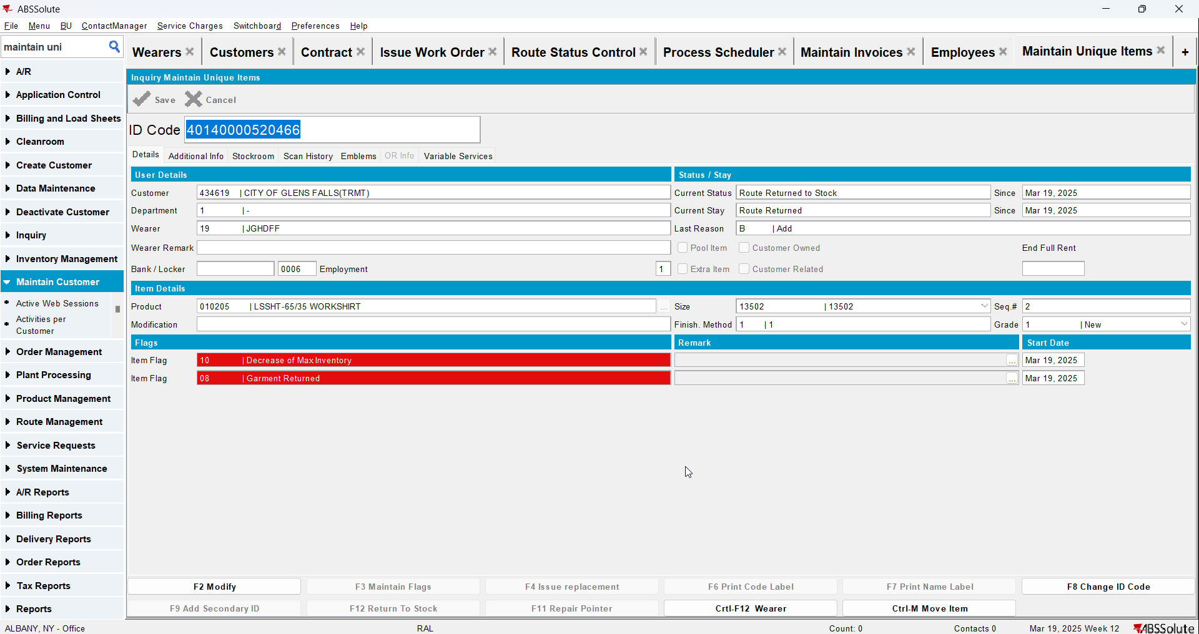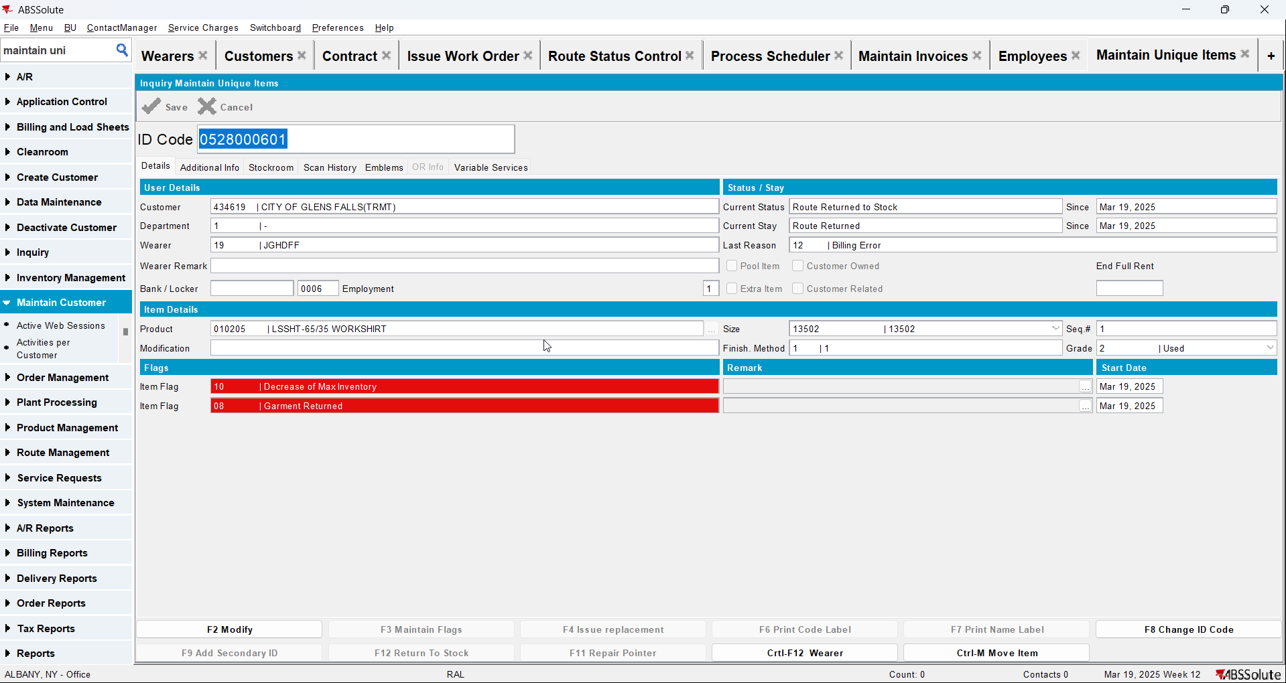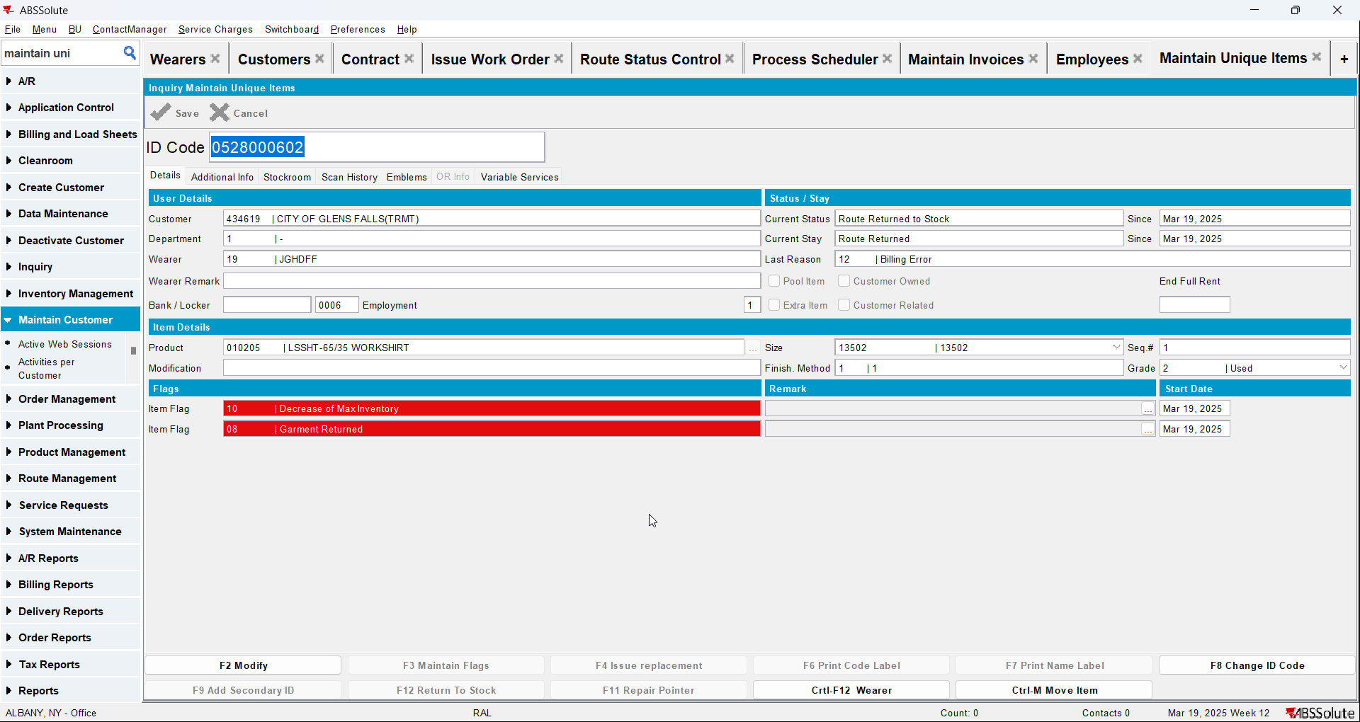
- Wearers DLG: Check that the wearer inventory associated with the loss charge has had the circ inventory has gone down and that the unique and non-unique garments were ragged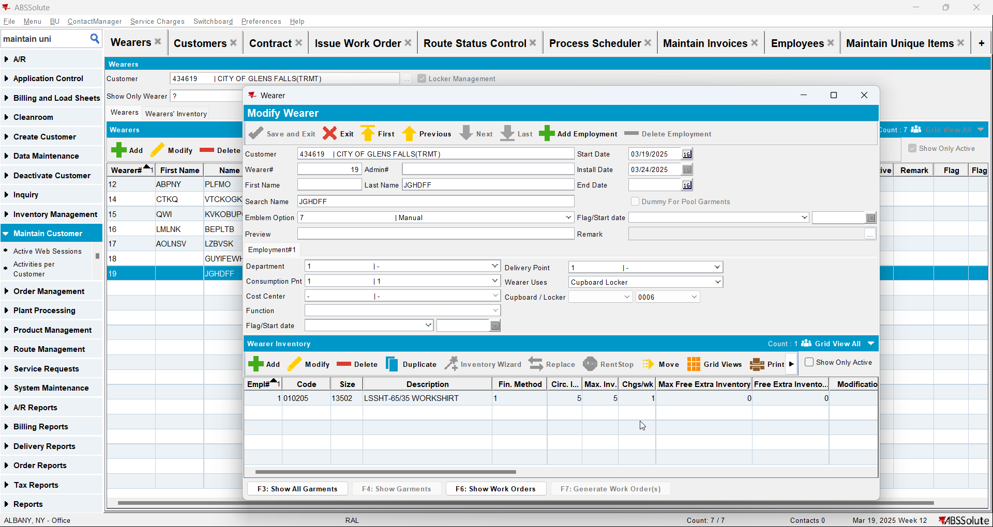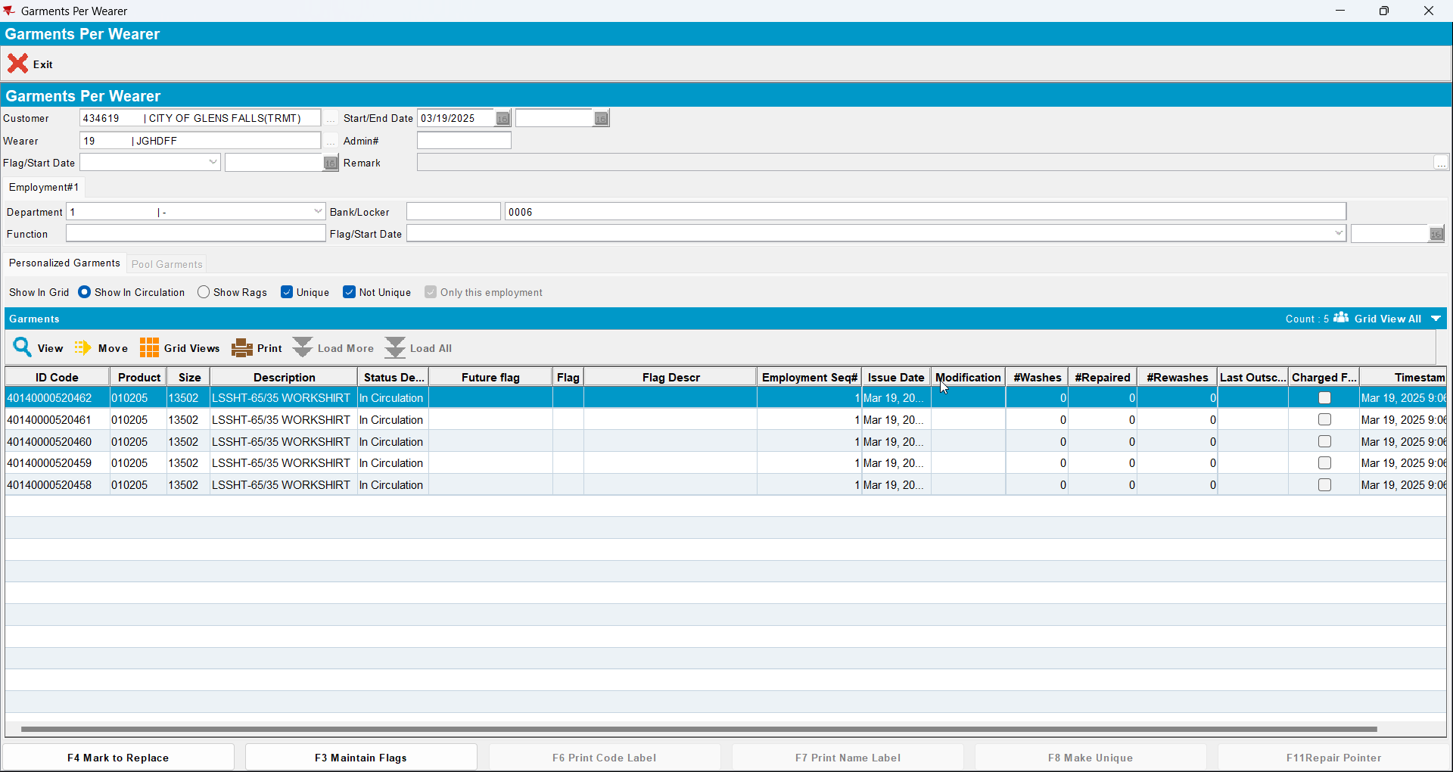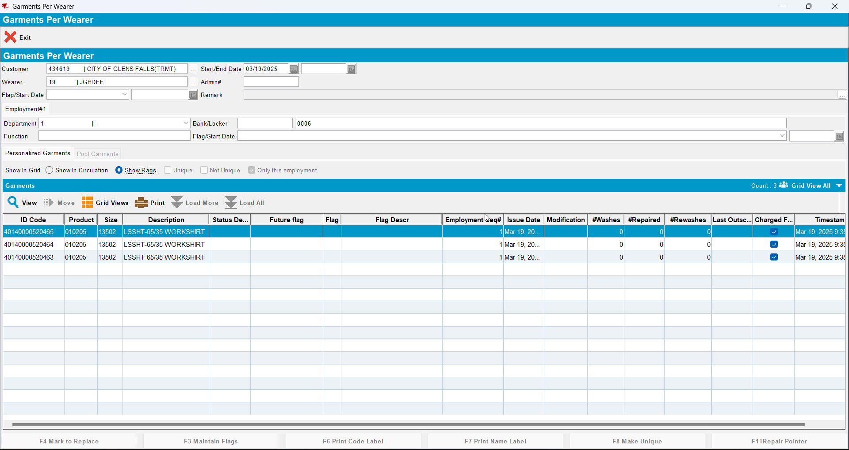

Test Case 5 – DOI mixed inventory Bill Loss now on existing loss charge (mark all non-uniques and a few uniques as DOI) and change Flag Start date for some non unique
Expected behavior: : All garments flagged for DOI are ragged
Hash: 549daf5

Test Steps
- Find a wearer inventory with a mixed inventory of uniques and non-uniques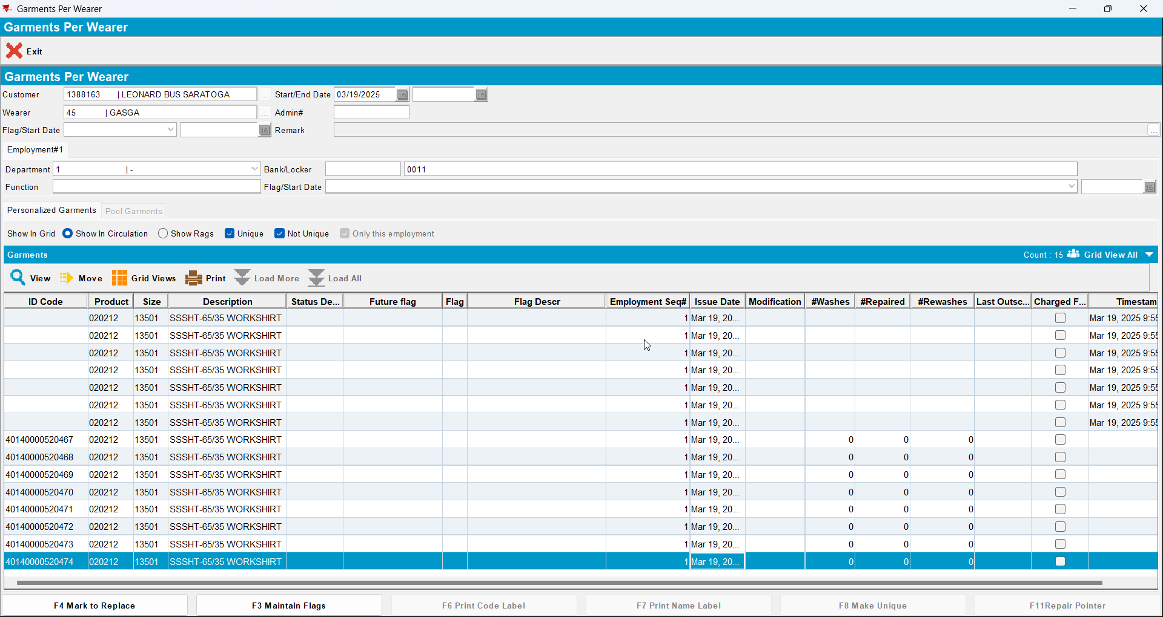
- Decrease inventory from 15 to 5 (so 7 non-unique garments in total will be flagged as DOI and 3 uniques)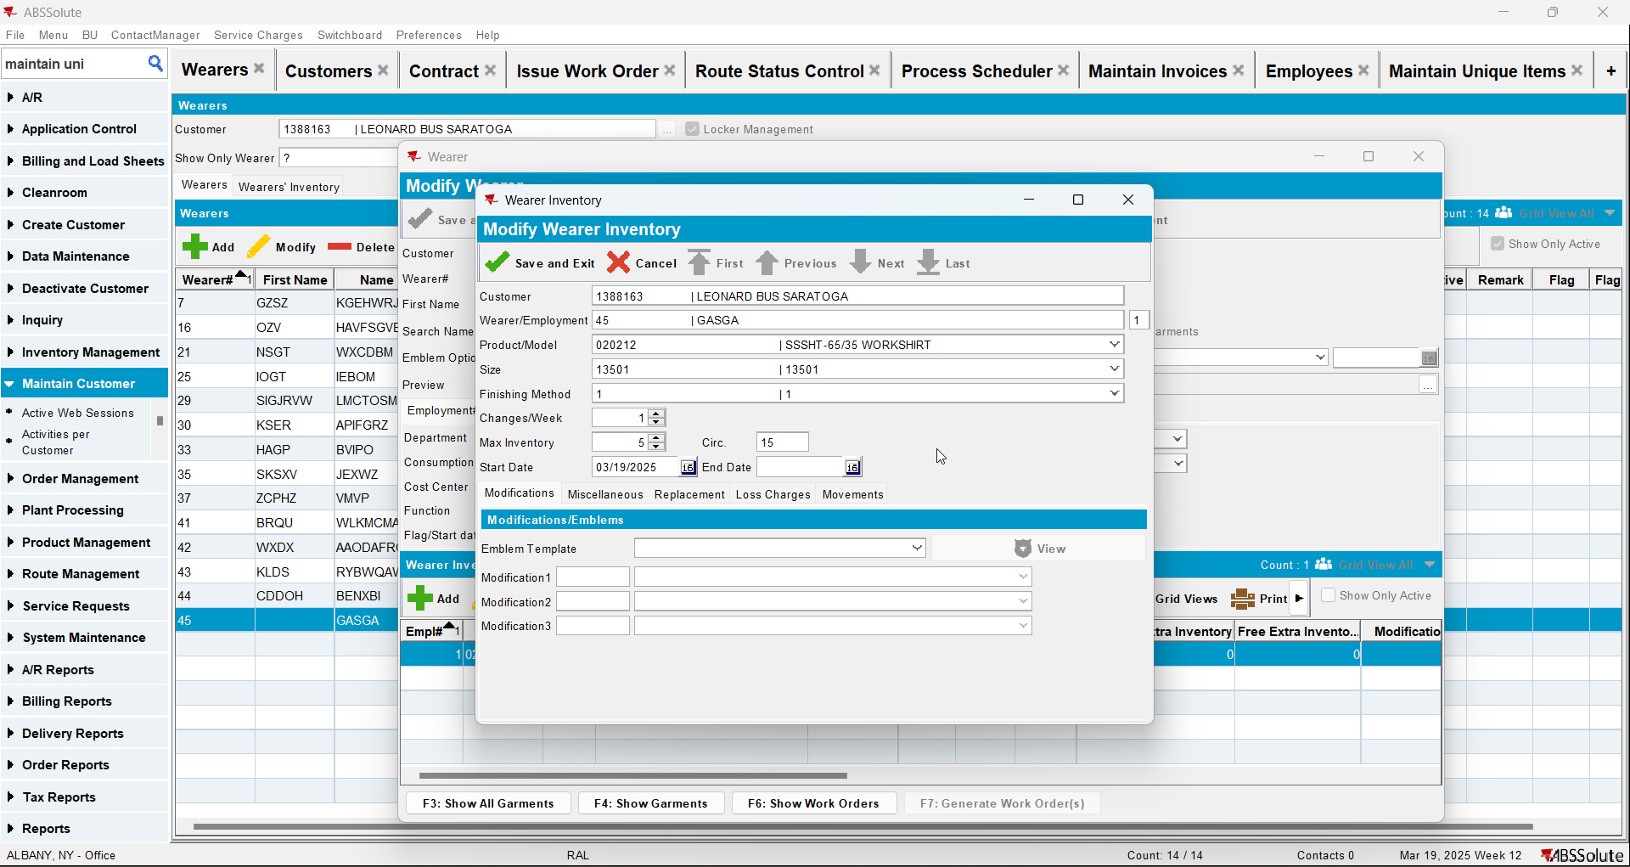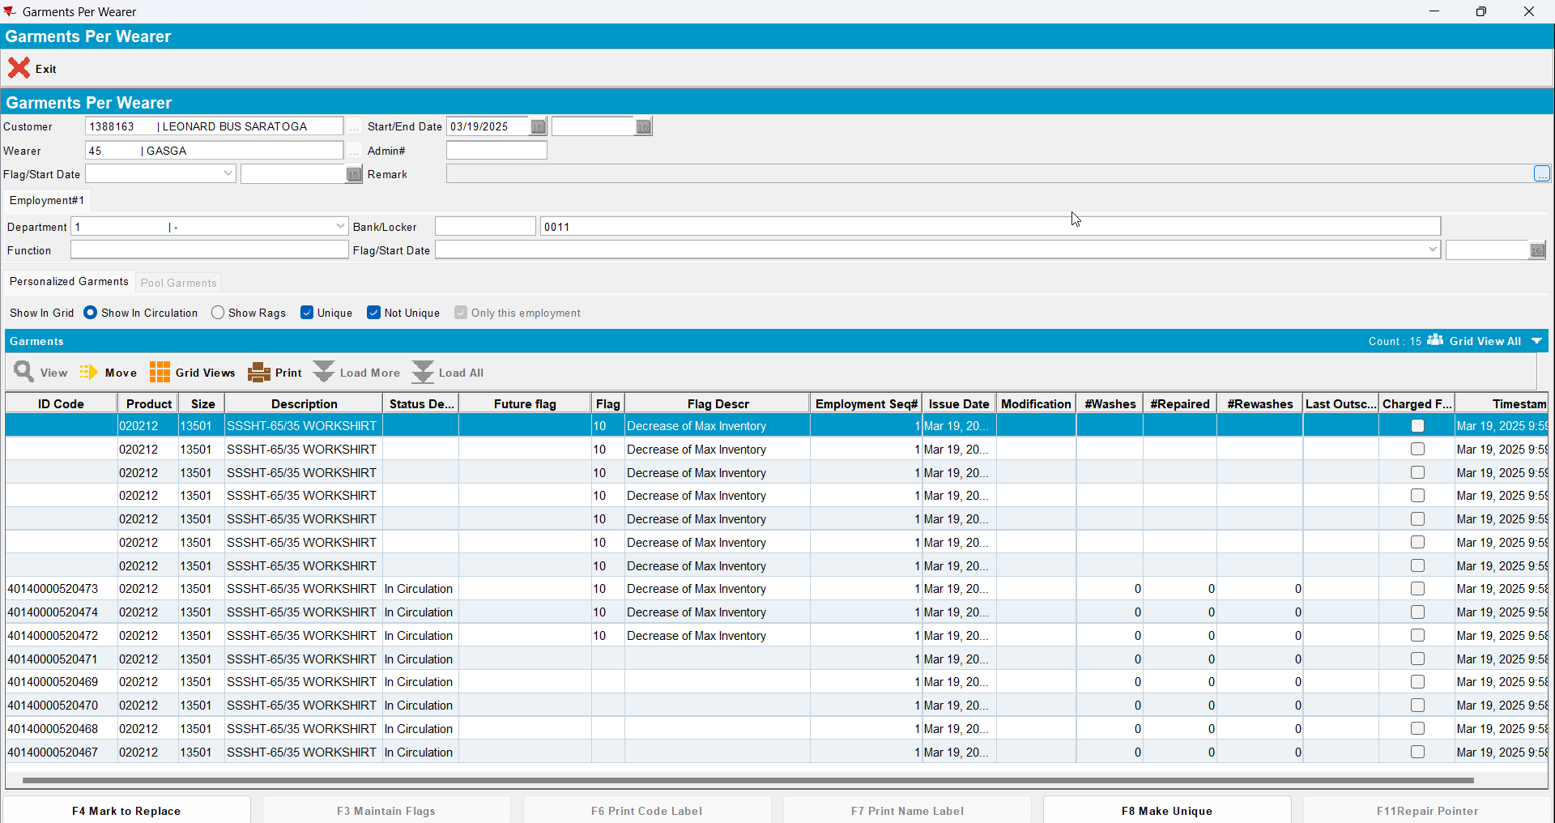
- Change flag start date for some non unique garments(sysdate+1 week)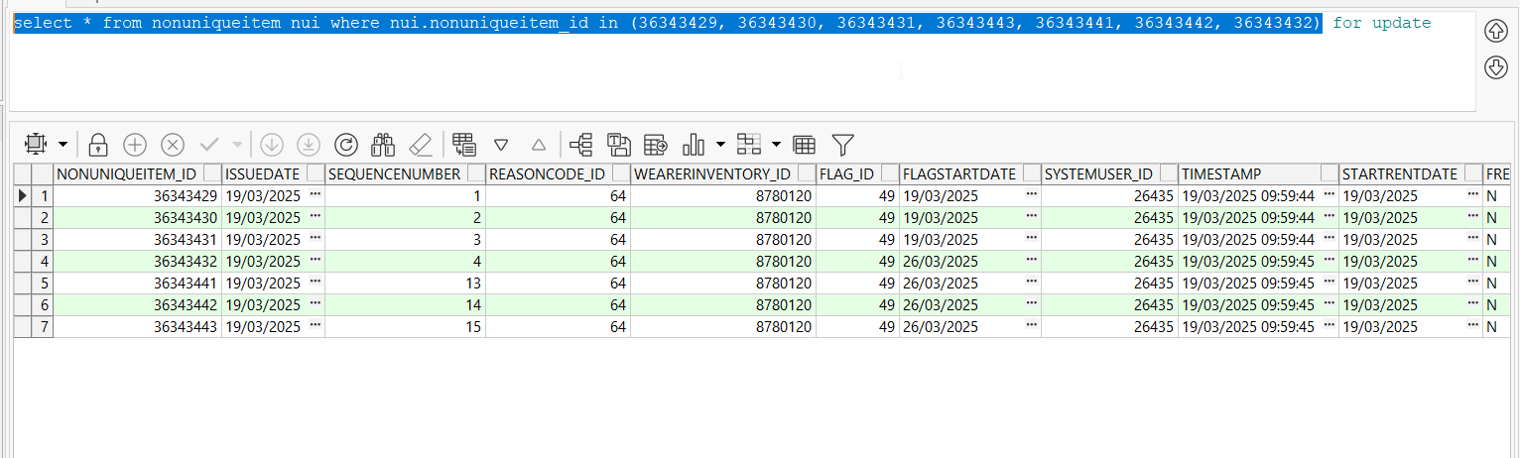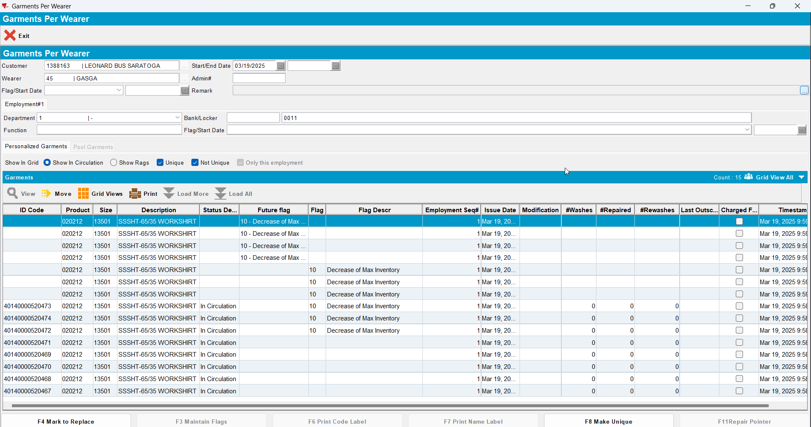
- Generate invoices for the route that’s after 26/03/2025, there should be a loss charge of subtype DOI with Extend = ‘N’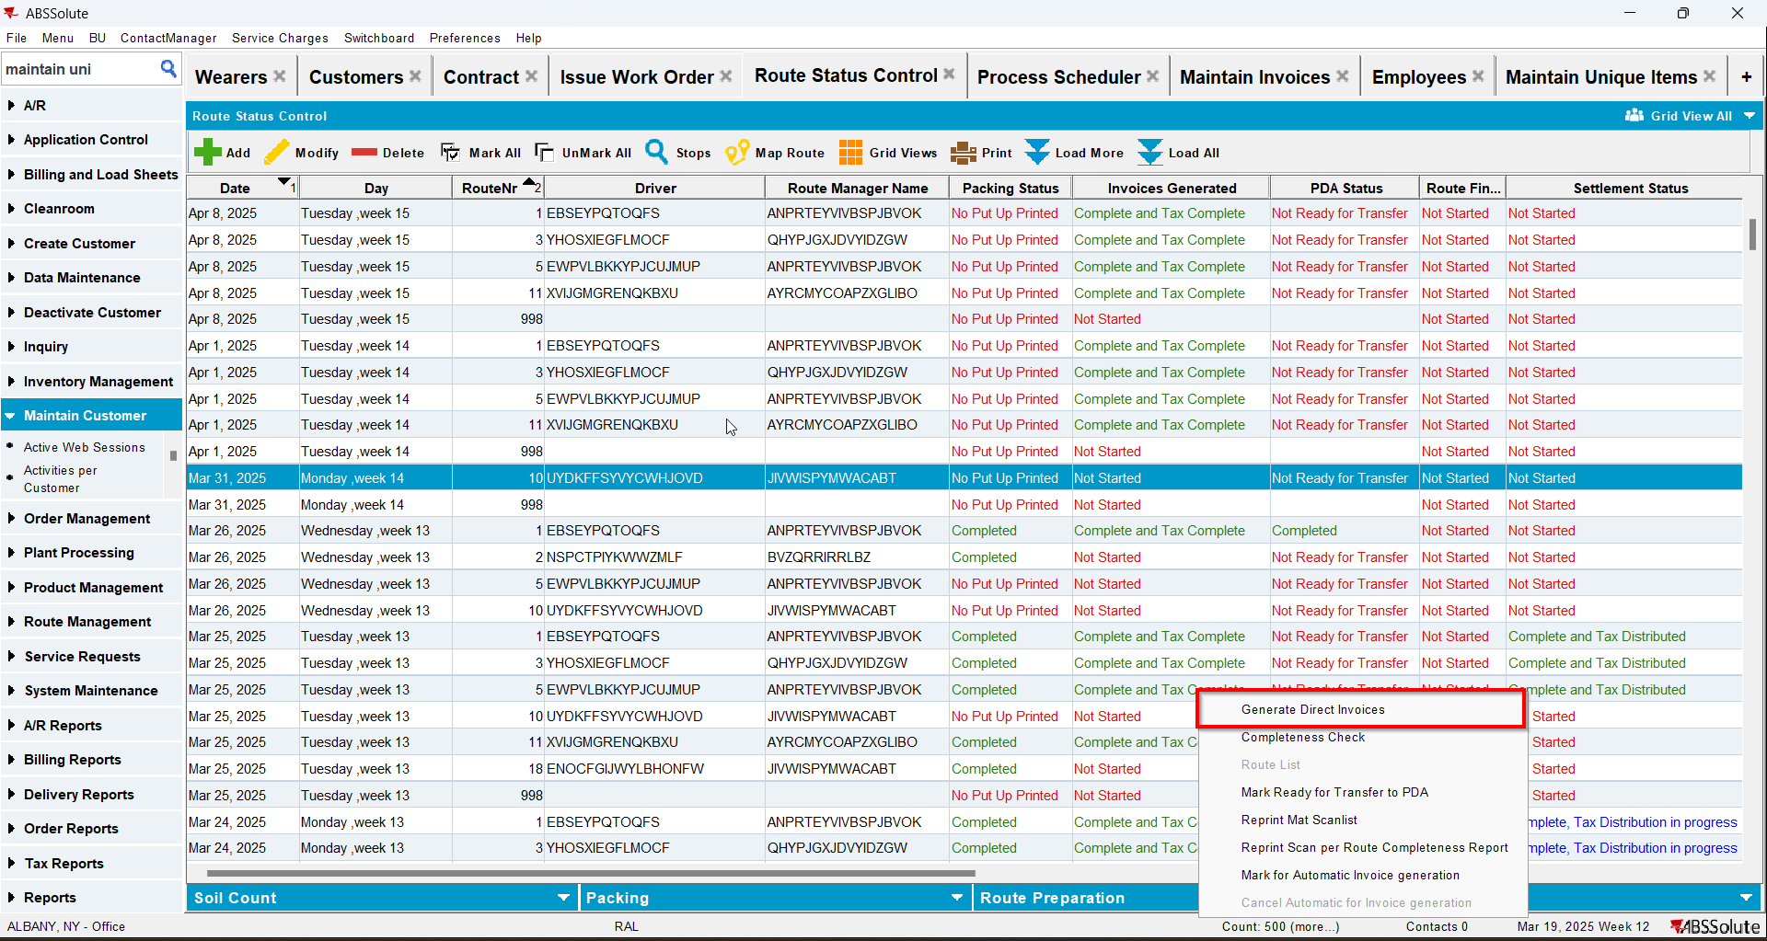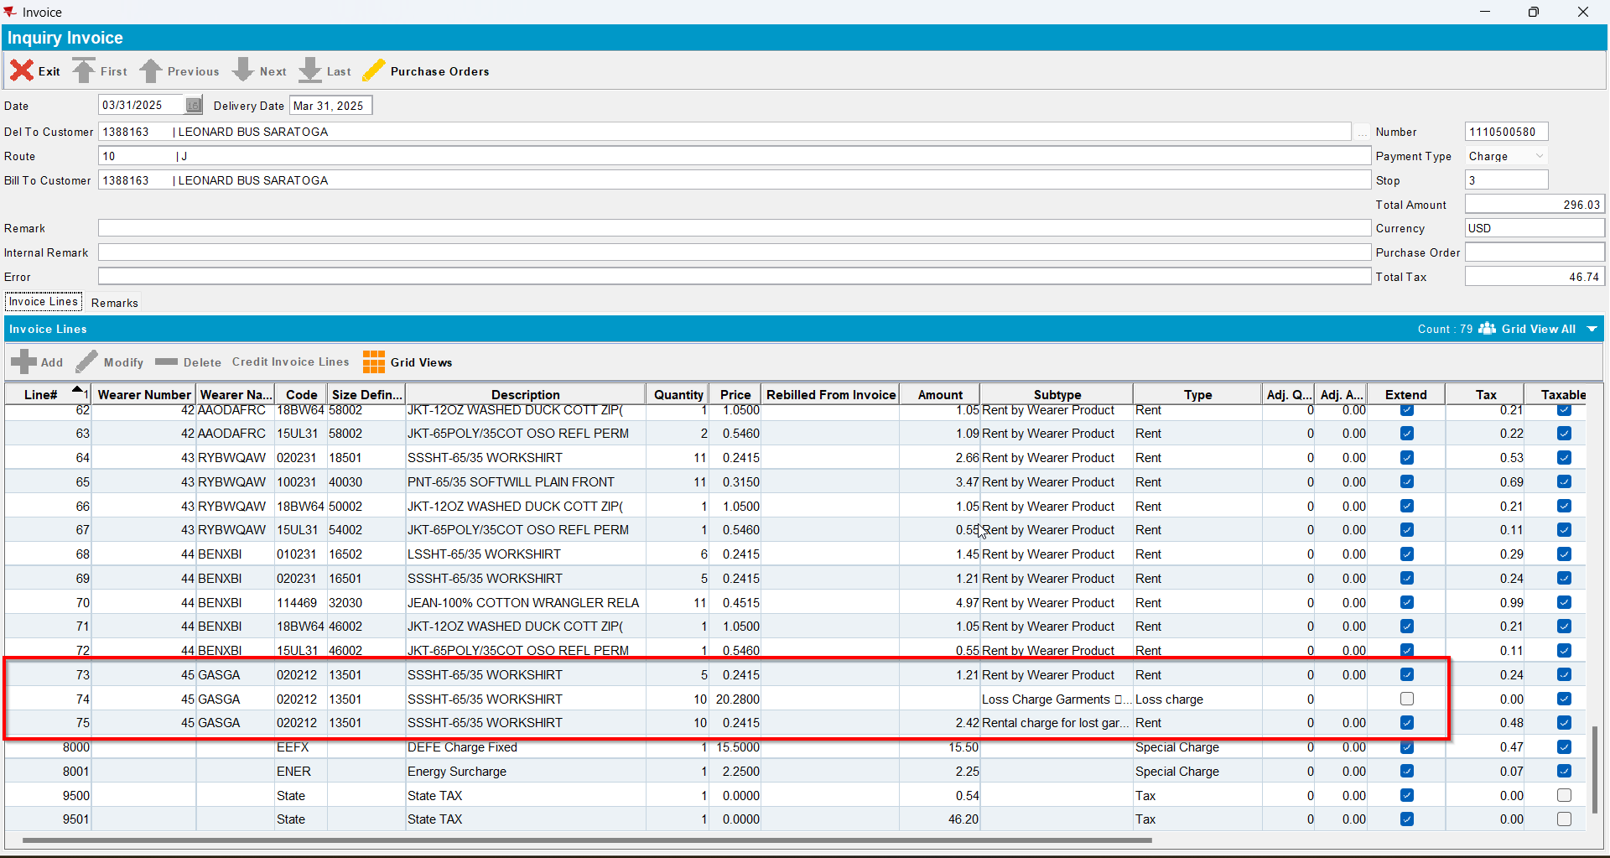
- Send the route to RA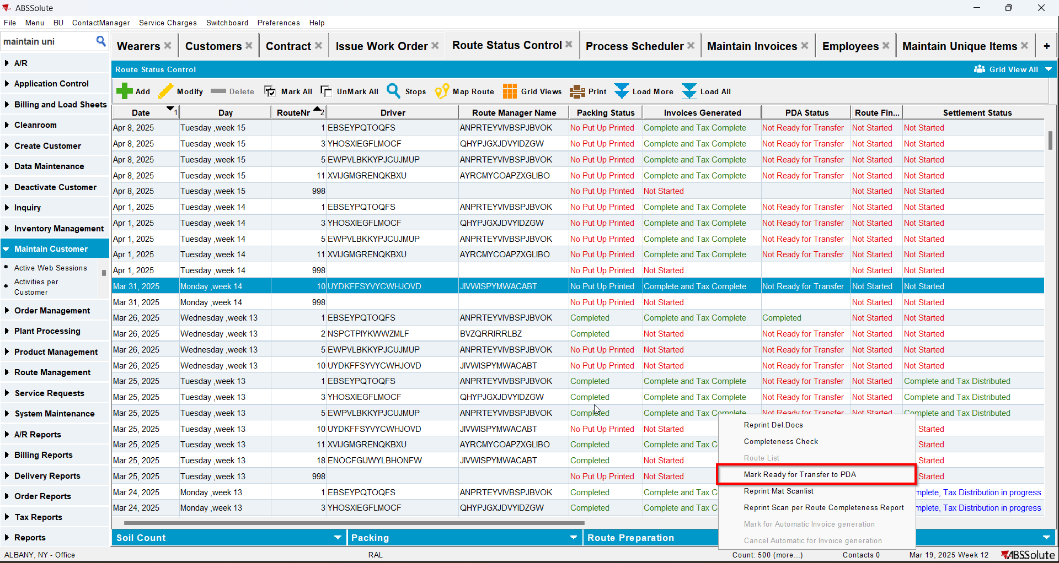
- RA: Do a bill loss now for the loss line
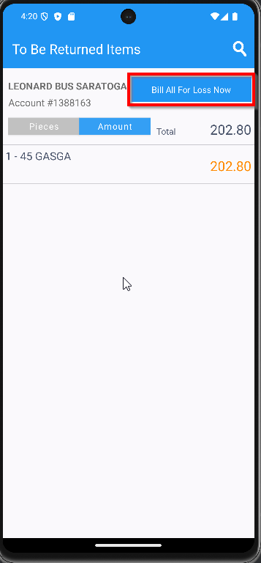
- Settle and upload the route back to the server
- WebX: Settle the route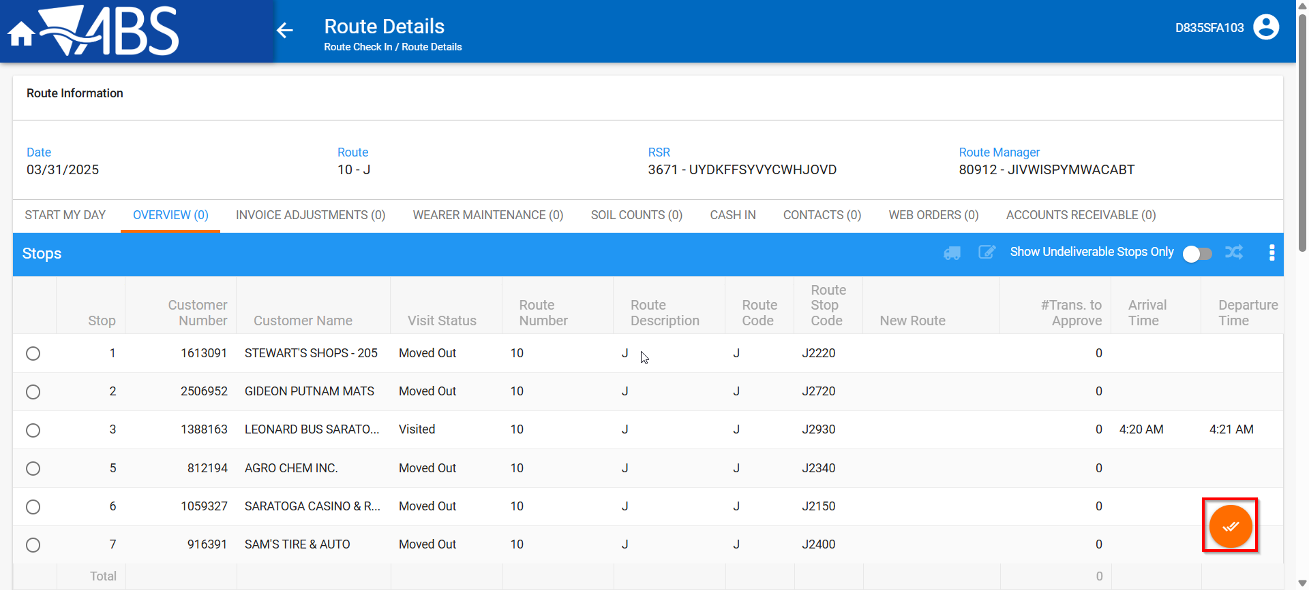
- Maintain Invoices DLG: Verify that the loss charge is now Extend = ‘Y’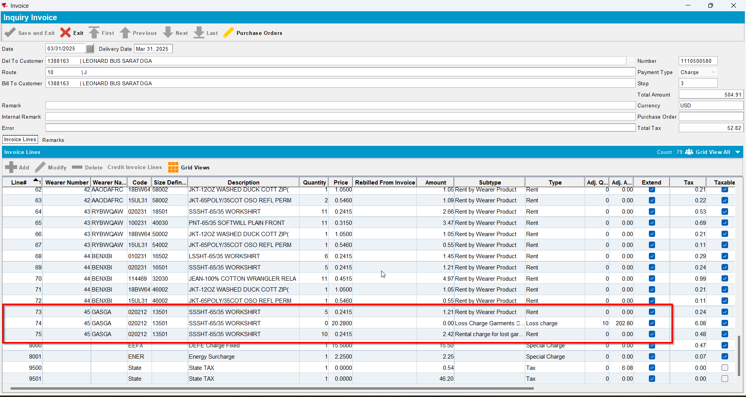
- Wearers DLG: Check that the wearer inventory associated with the loss charge has had the circ inventory has gone down and that the non-unique and unique garments were ragged