ABSN-2846 D_UBS_2619 fter adding “External Web Portal Access” to My Views in Modify Grid Views in the Contact Person dialog, the column does not appear in the grid when reopening the dialog
Environment | Prerequisites
Version:9.07.00  DBServerName=abs-SRV20.internal.abslbs.com  DBSID=CUST24  DBUser=UNFDEV  DBPassword=UNFDEV  Environment=Test | - Module:  - System setting

Contents
Test after fix 1
Test Case 1 – In Grid Views check Web User and External Web Portal Access and save – Tested OK 1

Test after fix

Test Case 1 – In Grid Views check Web User and External Web Portal Access and save – Tested OK
Expected behavior: Web User and External Web Portal Access are displayed
Hash: a6826de
- Go to Customers dlg and load a customer
- Go to Contact Persons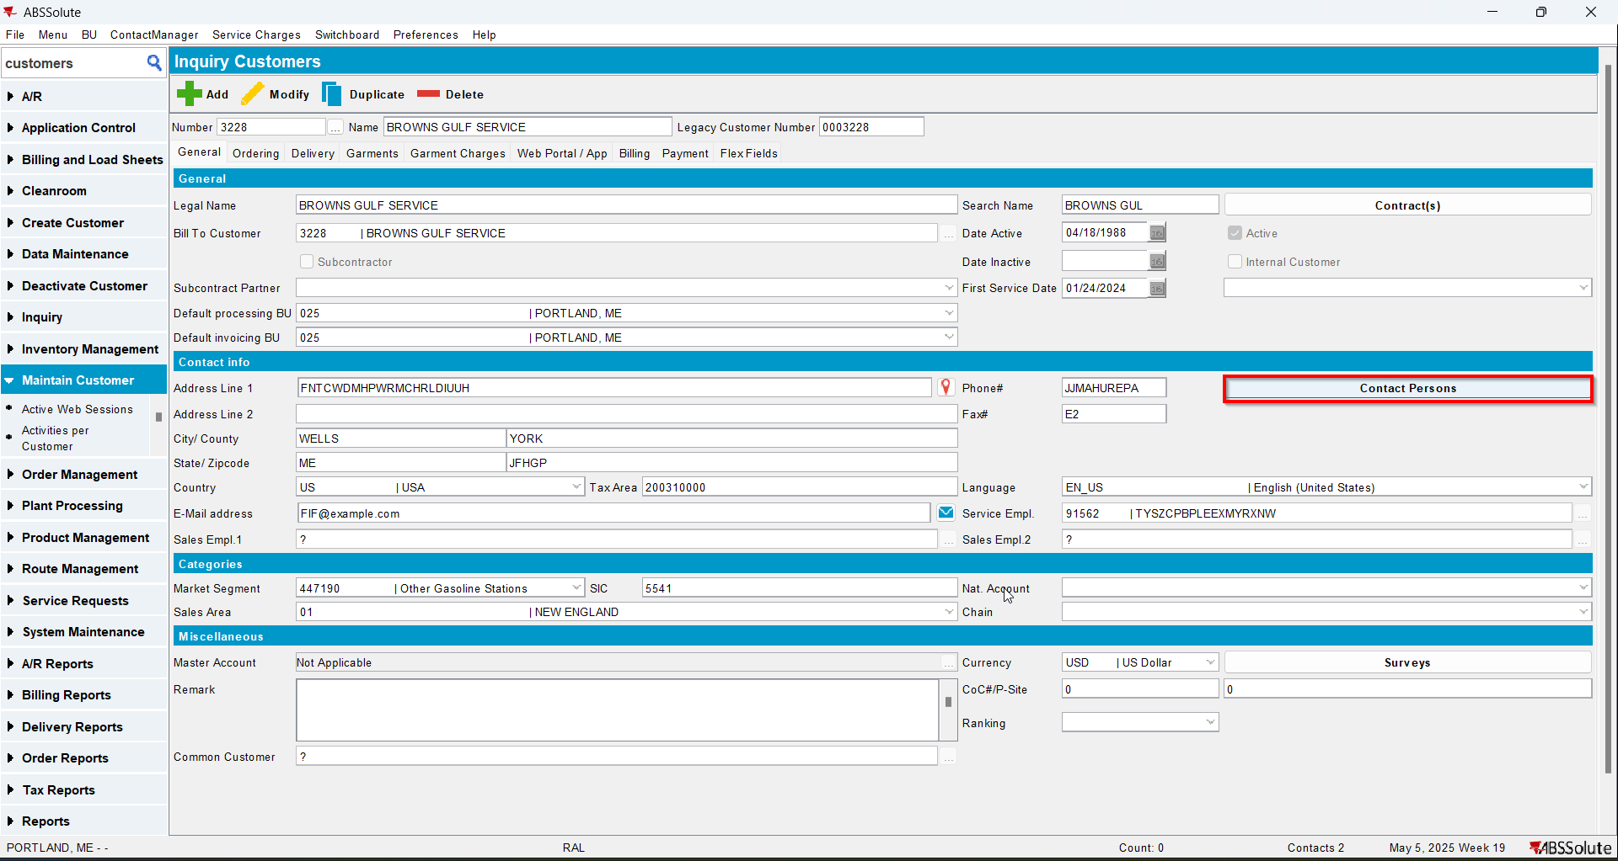
- In Grid Views check Web User and External Web Portal Access and save them 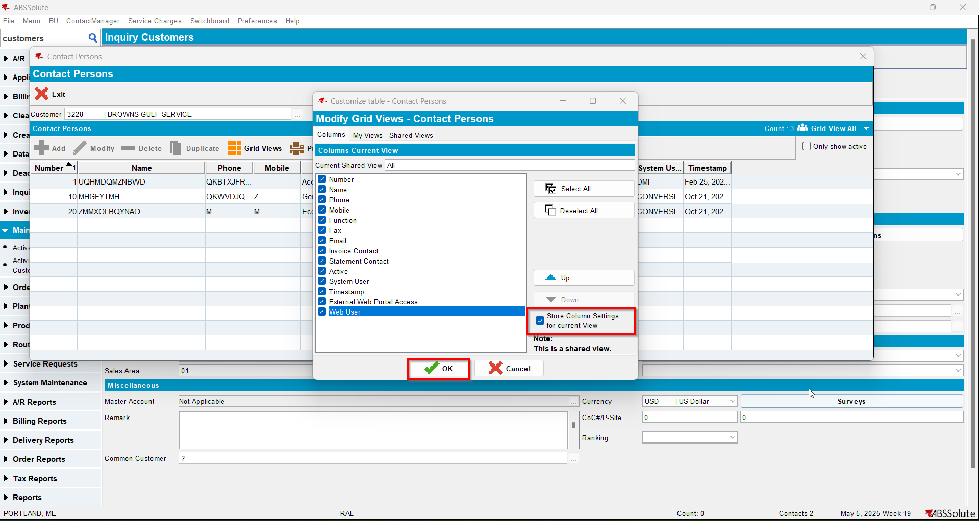
- Reload the customer and check that Web User and External Web Portal Access are displayed