ABSN-2806 D_UBS_2128 BPA, if a hive mat is shorted, then clear the active stock location in ABSSolute
Environment | Prerequisites
Version:9.07.00.UNF19  DBServerName= abs-srv16.internal.abslbs.com  DBSID=CUST24  DBUser=UNFDEV  DBPassword=UNFDEV  Environment=PRODUCTION | - Module:  - System setting

Contents
Reproduction before fix 1
Steps to reproduce 1
Retest after fix 4
Steps to reproduce 4

Reproduction before fix
Bu: 025 PORTLAND, ME
9.07.03.RC1 hash: 1dd1d9ab817e

Steps to reproduce
- Route Status Control dlg: Create a new route 1 on current sysdate and leave all the customers. Generate put up documents.
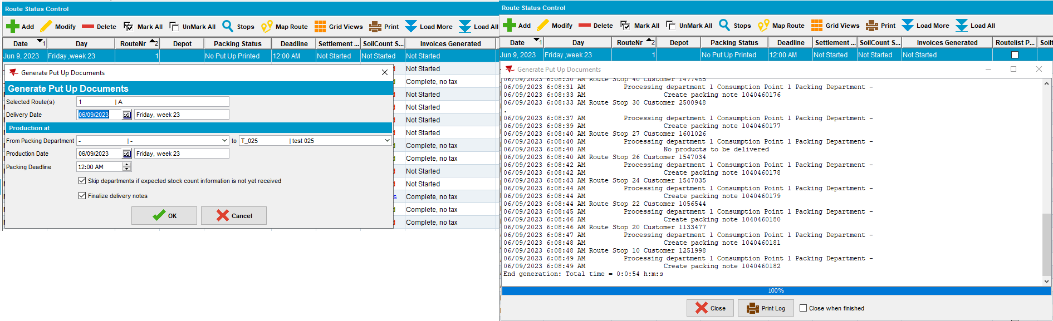
- BPA: Go to Pack, select the day and route from previous step. Look through the mats and choose a customer
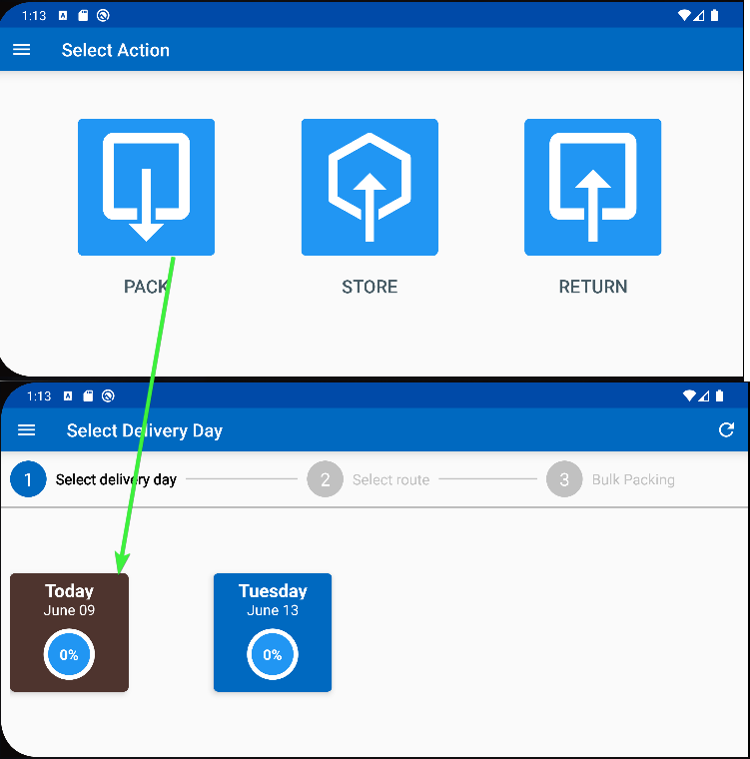 -> 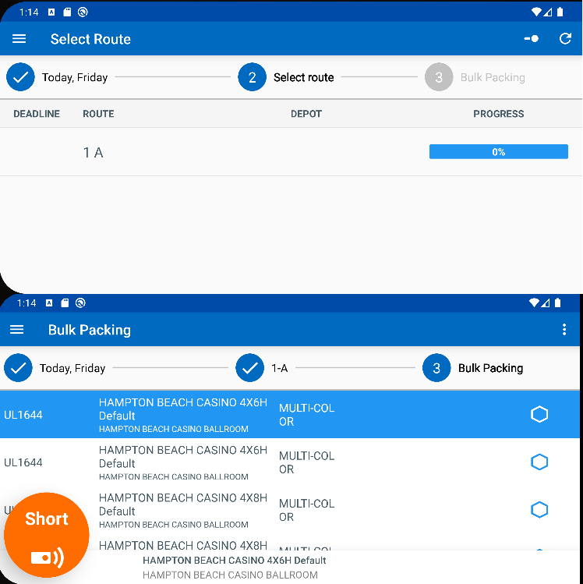
- Product Lists Per Customer dlg: Check the mat discovered at previous step that it has Issue Uniquely Coded option.
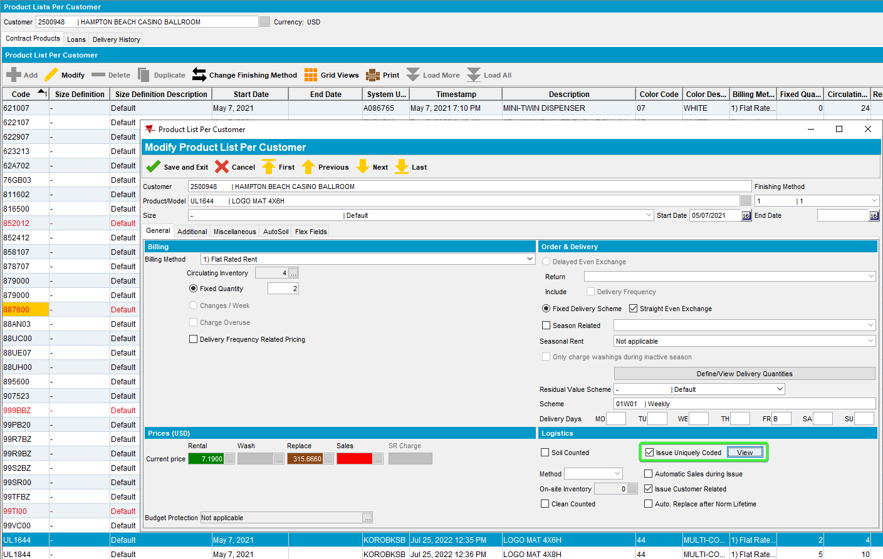
- Work Order Status Control dlg: Create a work order containing the mat from previous step.
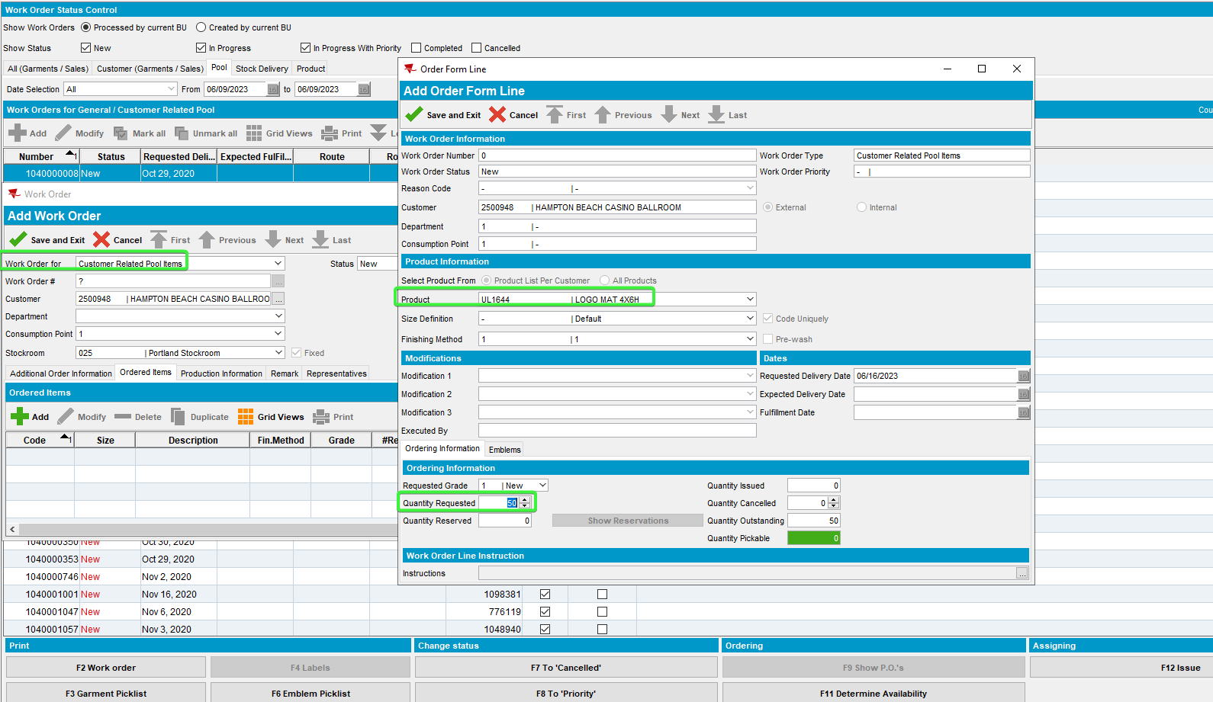
- Work Order Status Control dlg: Issue the work order.
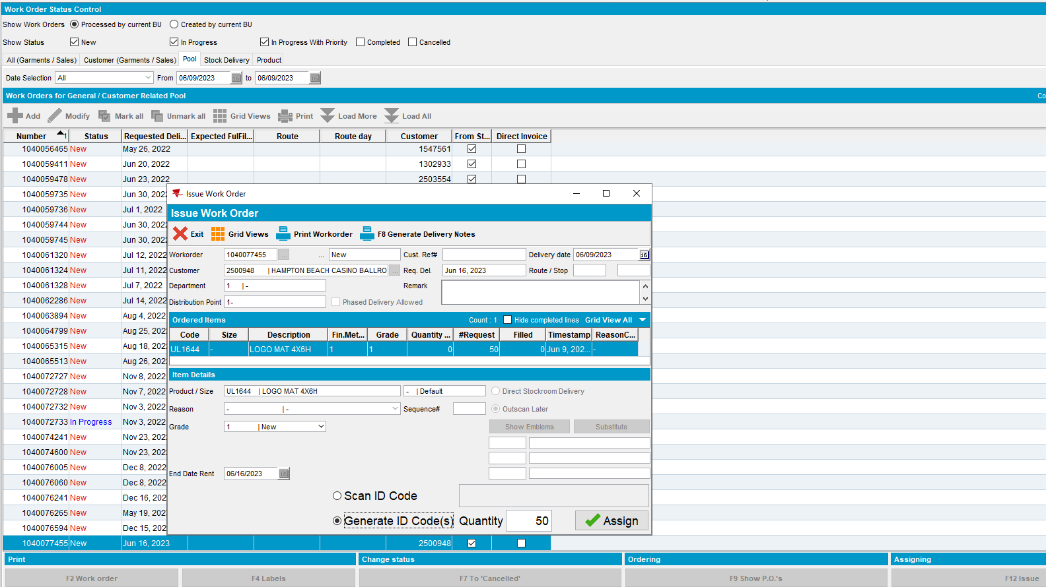
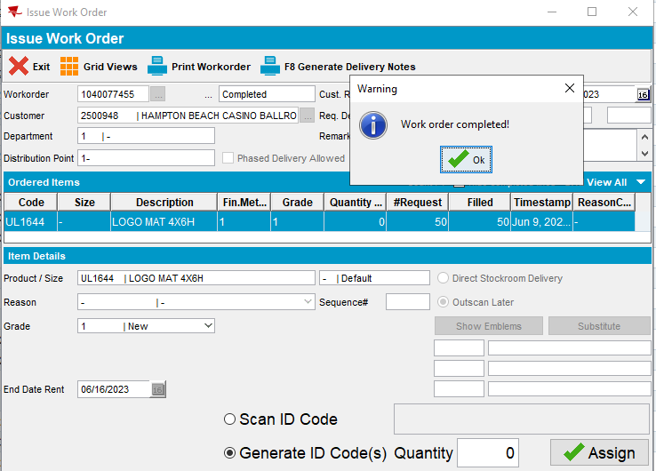
- Products List per Customers dlg: Take one unique code to scan it on BPA.
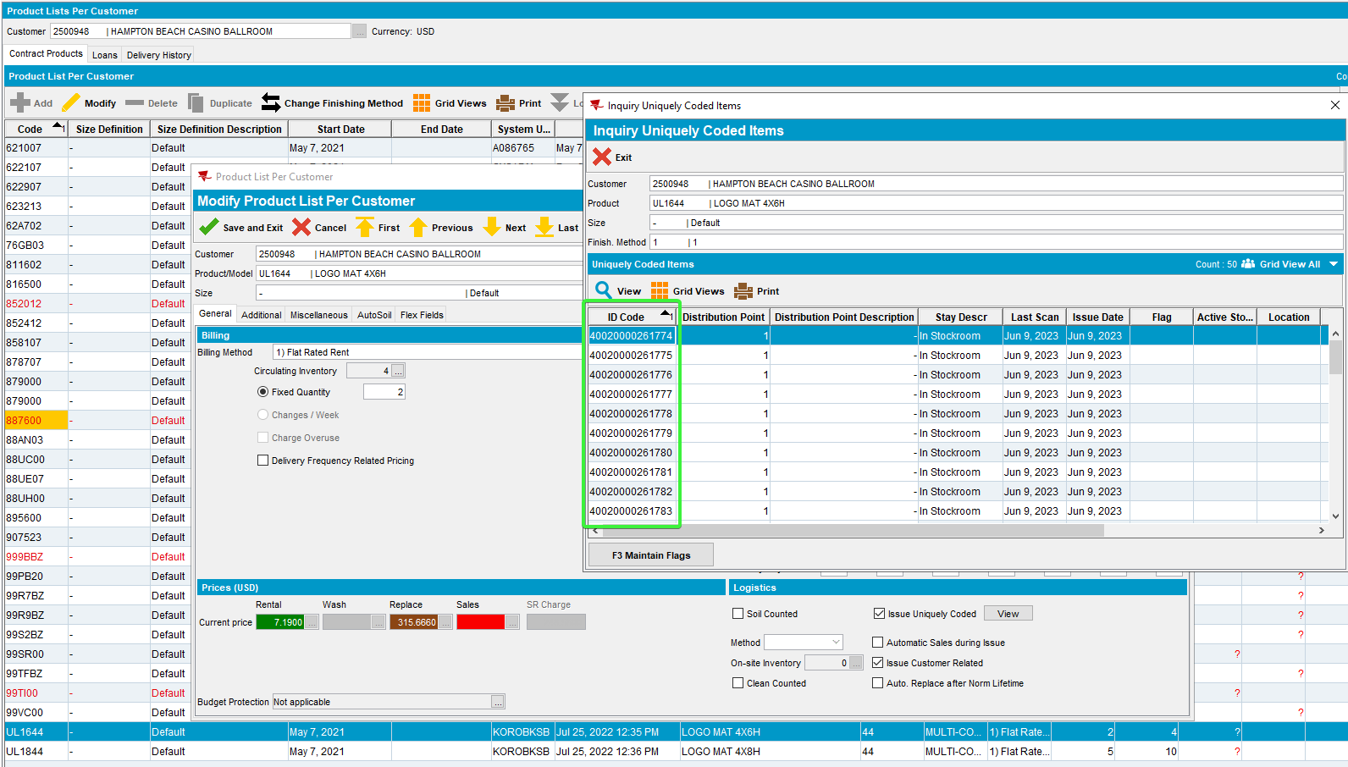
- BPA: Scan to store the code.
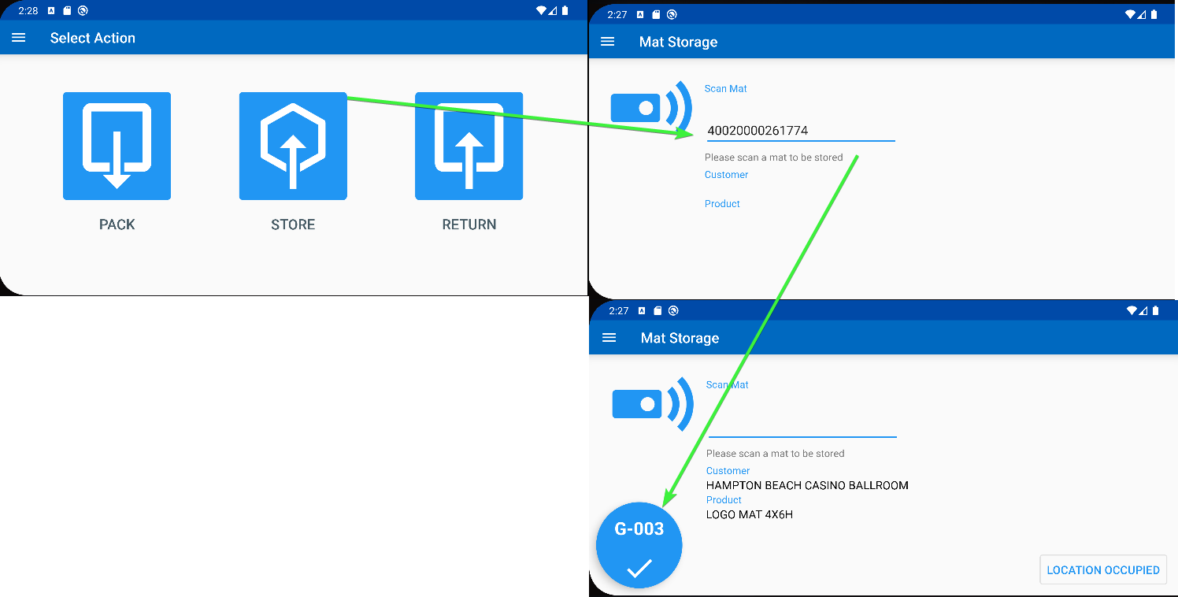 -> 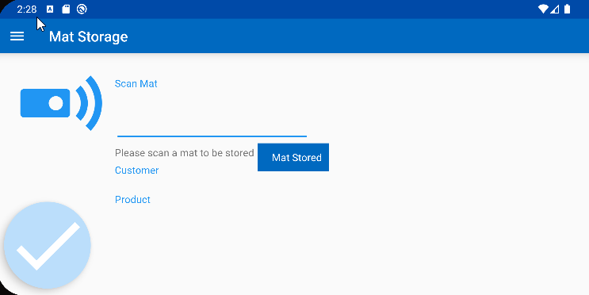

- Product Lists Per Customers dlg: Check that the location for the product was updated.
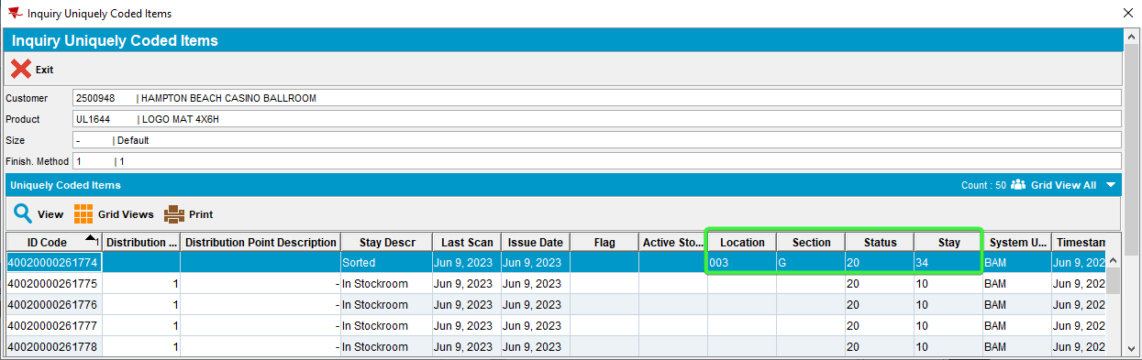
- BPA: Enter Pack, select the day for which we’ve made put up documents
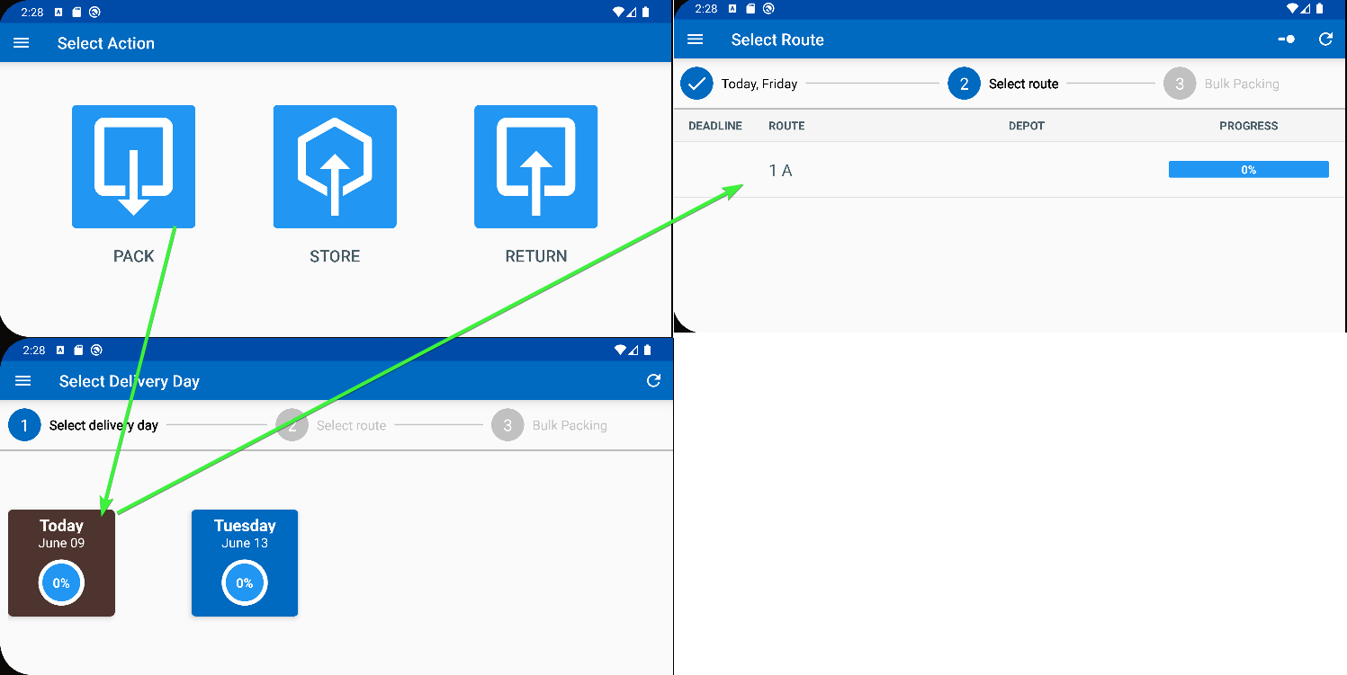
- BPA: Swipe left on a product to short the item.
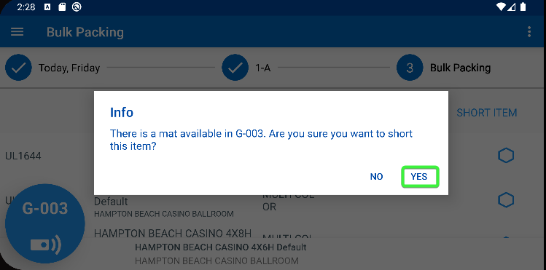
- Product List for Customers dlg: Go back to the uniquely coded items and check that the active stock location was deleted, is blank.
The location was not reverted back to blank
REPRODUCED OK

Retest after fix
Bu: 025 PORTLAND, ME
9.07.00.UNF19 hash: 40366e9201ac

Steps to reproduce
- Configure the absmobilerestservices.war and deploy it using tomcat.
- Configure the latest version of BPA.
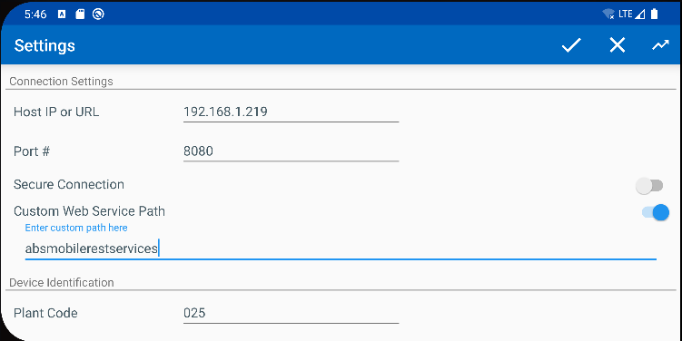
- Find a customer with logo mats, eg: 2514367. Check the unique codes
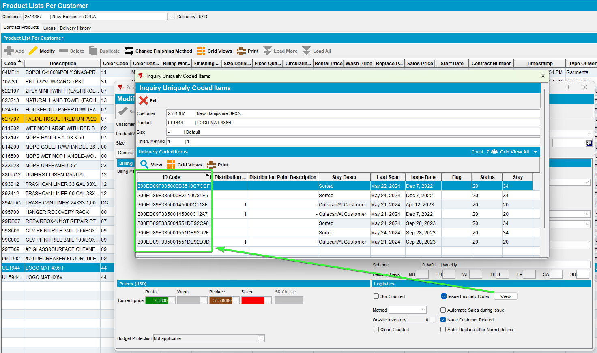
- BPA: Go to Store and scan a code
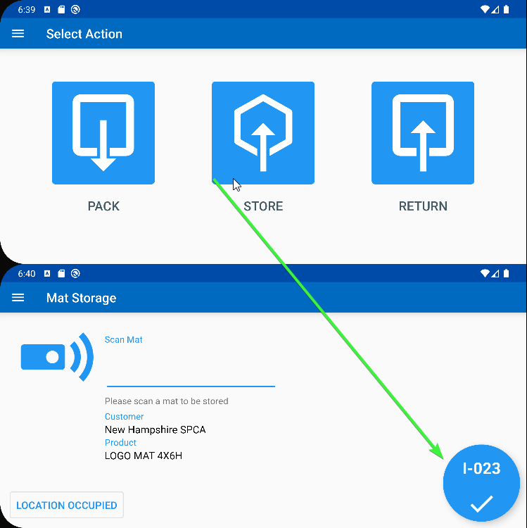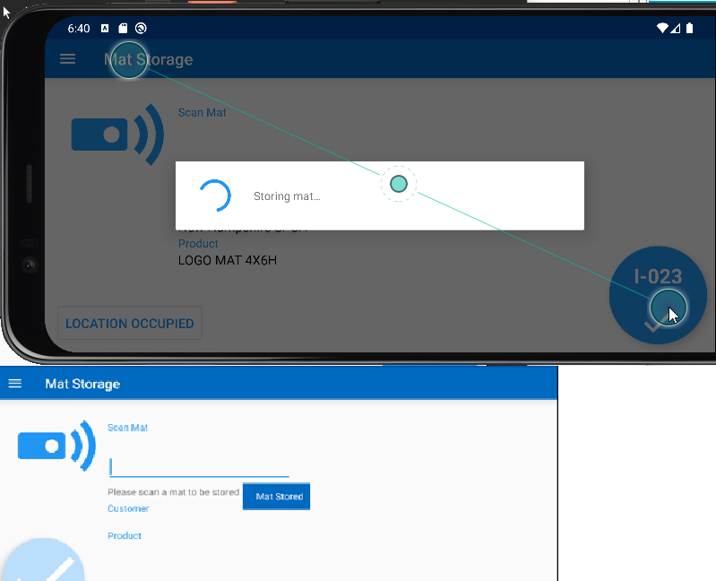
- Product Lists Per Customers dlg: Check that the location for the product was updated.
Before
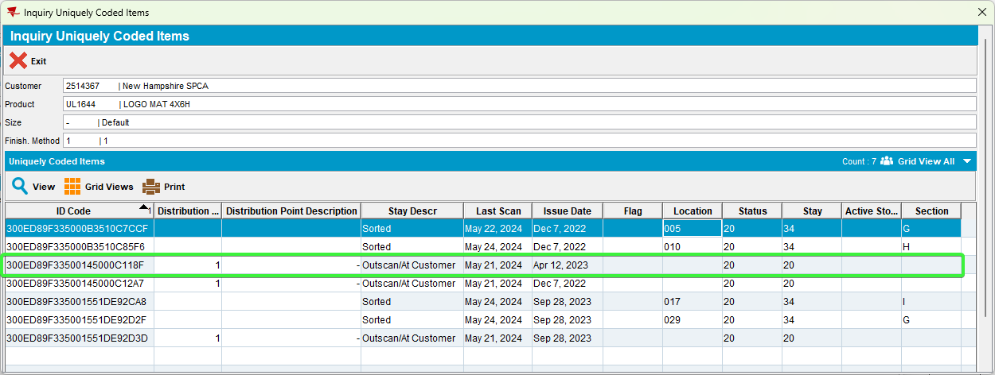

After
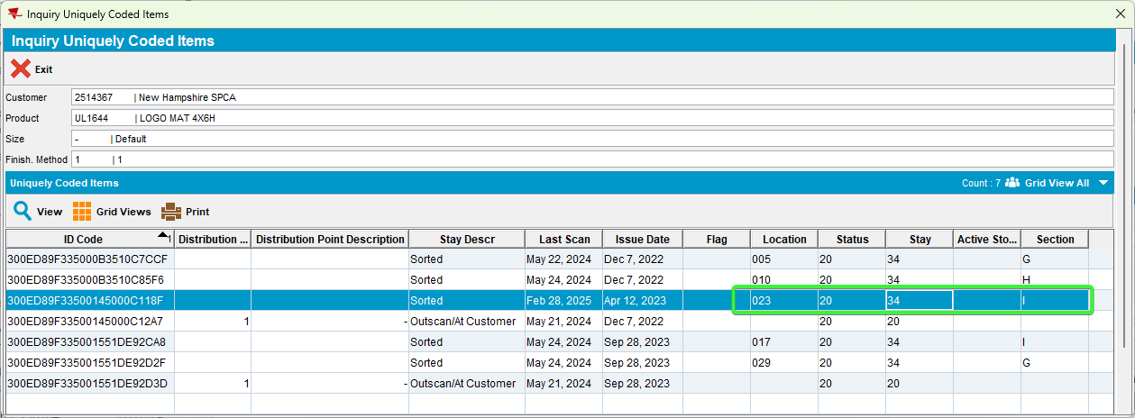
- Route Status Control dlg: Create a new route containing the customer 2514367 . Move out all the other customers.
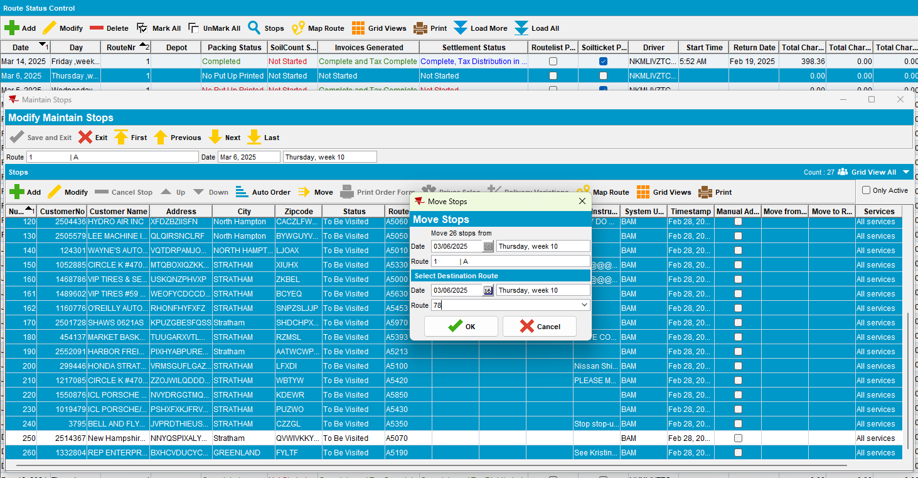
- Route Status control dlg: Generate put up docs.
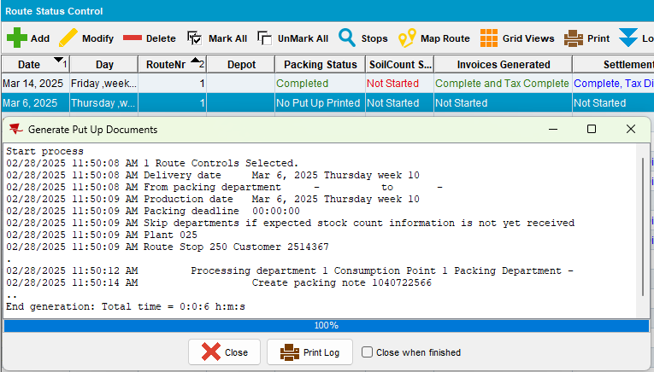
- BPA: Enter Pack, select the day for which we’ve made put up documents
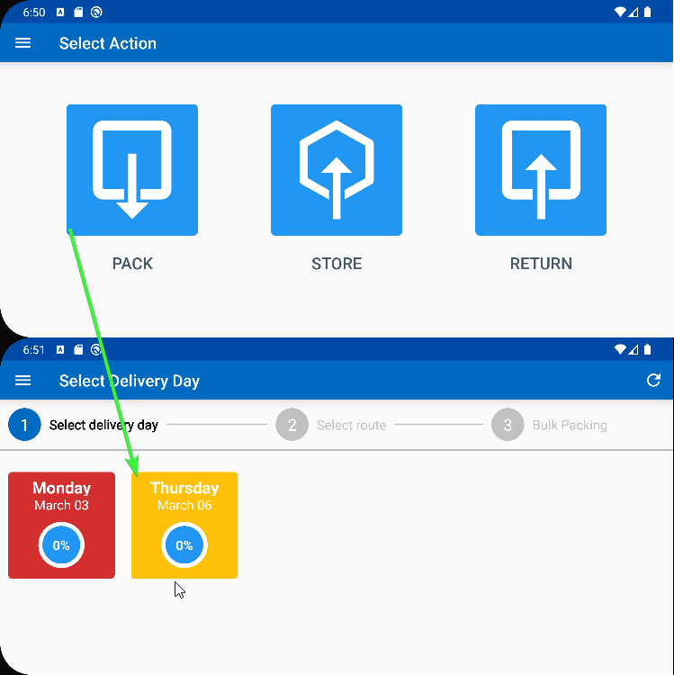 -> 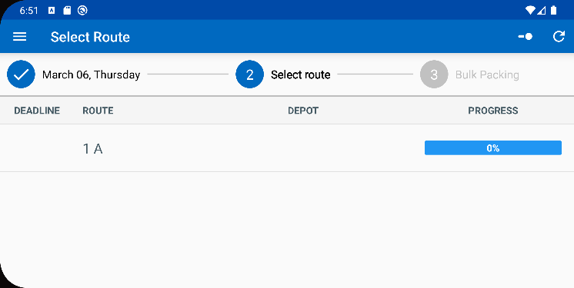
- BPA: Swipe left on a product to short the item.
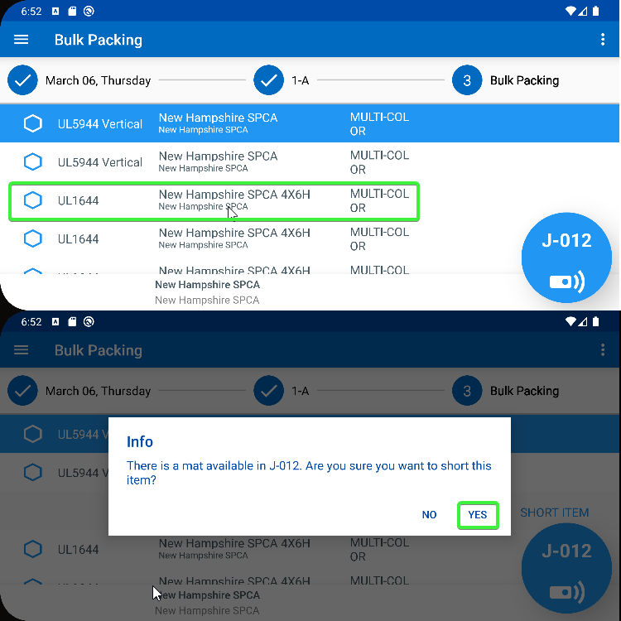 -> 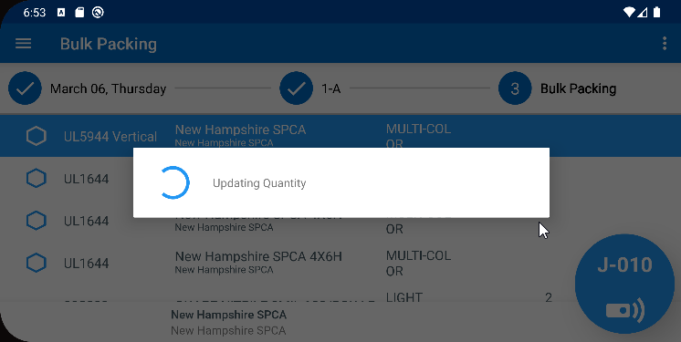
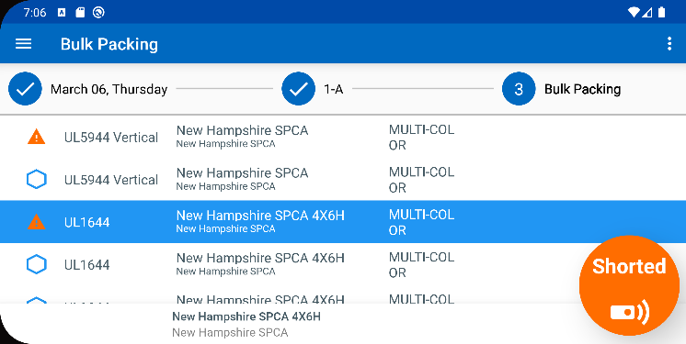
- Product List for Customers dlg: Go back to the uniquely coded items and check that the active stock location was deleted, is blank.
Before
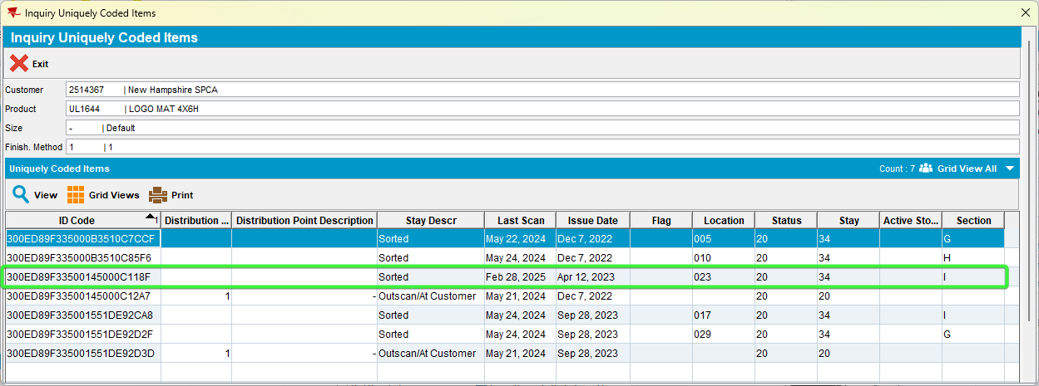
After
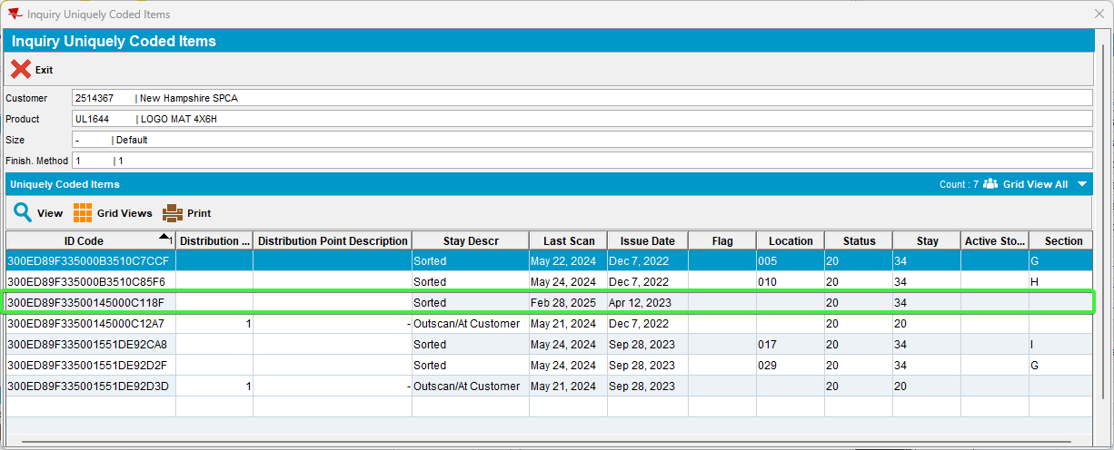
The location field was updated and reverted back to blank as the mats was stored.
TESTED OK

