ABSN-278 ASD-65902 UNF: D_UBS_2590 Global exchange didn’t move the SRC percentage price
Environment | Prerequisites
Version: 9.07.00.UNF19  DBServerName= abs-srv20.internal.abslbs.com  DBSID=CUST24  DBUser=UNFDEV  DBPassword=UNFDEV  Environment=Production | - Module:  - System setting

Contents
Reproduction before fix 1
Retest after fix 6

Reproduction before fix
Hash: c57a2e44dc5

- Have a customer C1 with a non-garment product in the contract and PLPC, say product P1.
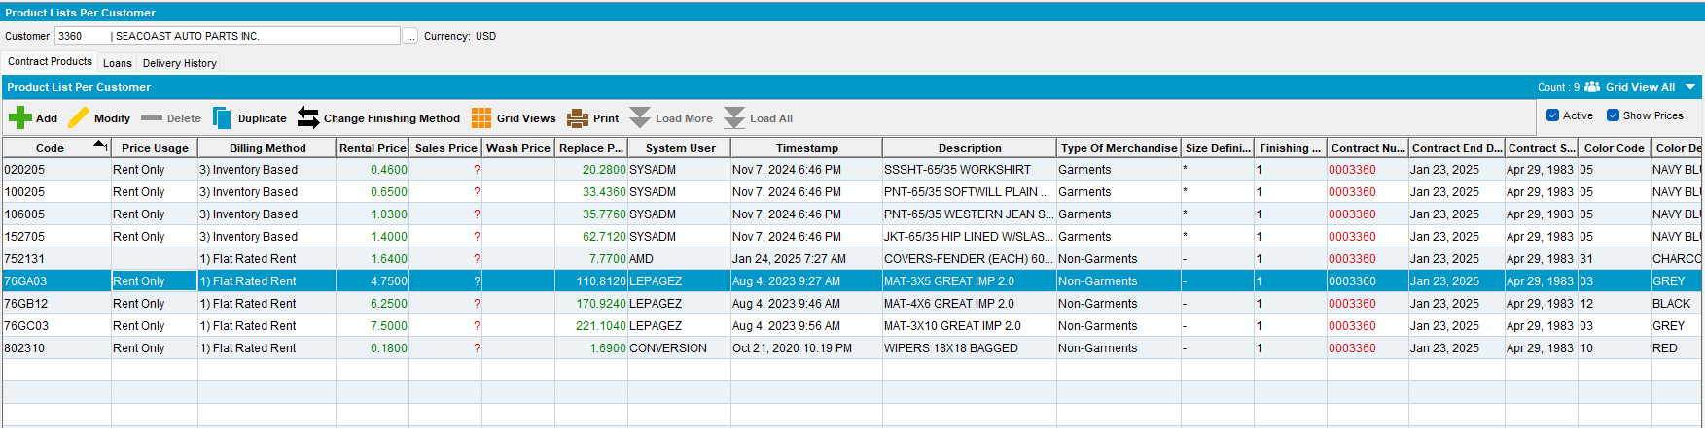

- In the PLPC screen, “Additional” tab, make sure to have “Systematic Replacement” checked.
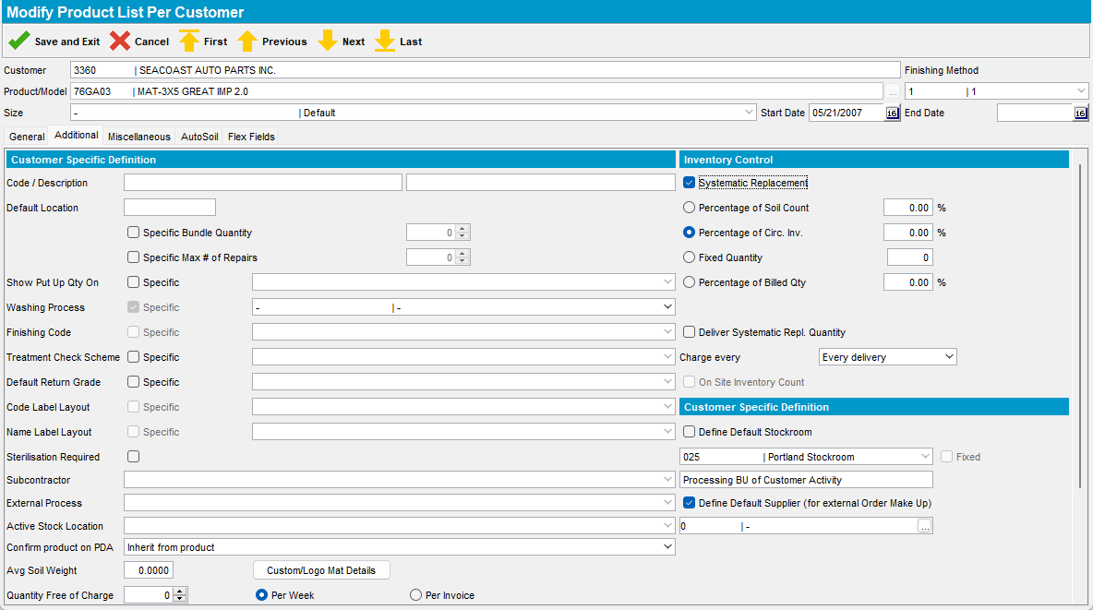
- In the PLPC screen, “General” tab, change the “SR Charge” price to a value different from the default.
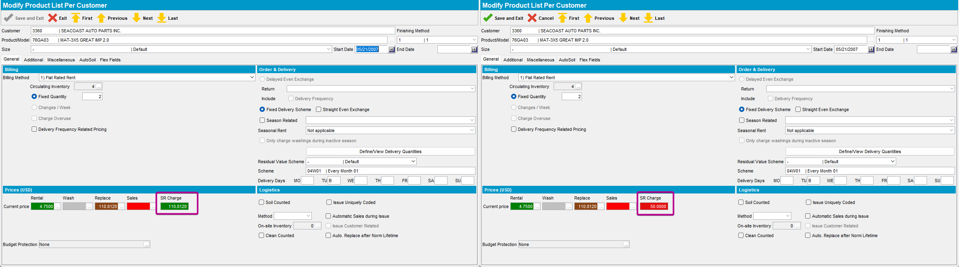

- Create a new product P2 with characteristics like P1 (for example, by duplicating it)
- Run the Product Conversion Wizard, replacing product P1 with product P2, choose the selection criteria so to include the customer C1.
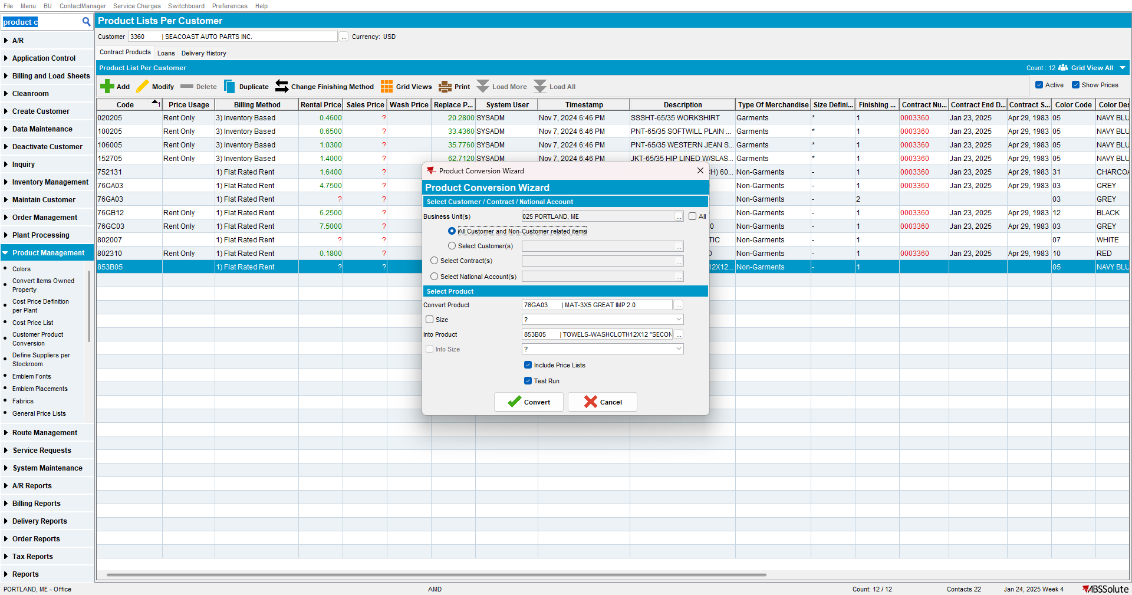
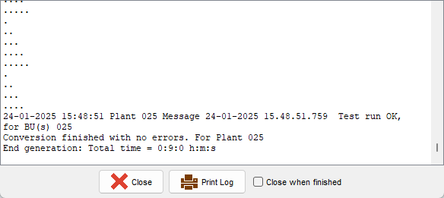

- Check the PLPC for customer C1, product P2.
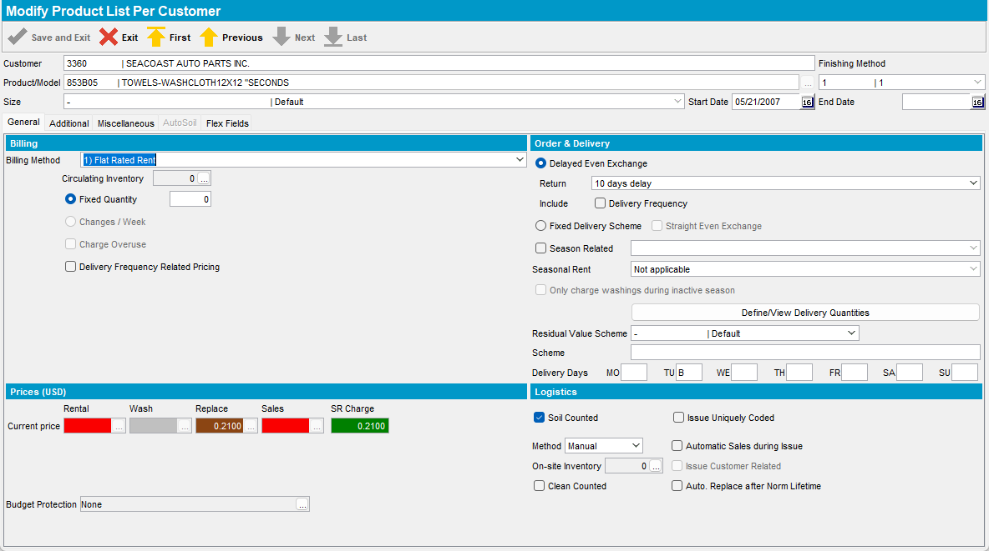

Expected behavior: the SR Charge is the same as for product P1 (the value changed in step 3)
Actual behavior: the SR Charge for product P2 has the default value, without the modification done in step 3

Retest after fix
Hash: b6cdb19546f

- Have a customer C1 with a non-garment product in the contract and PLPC, say product P1.
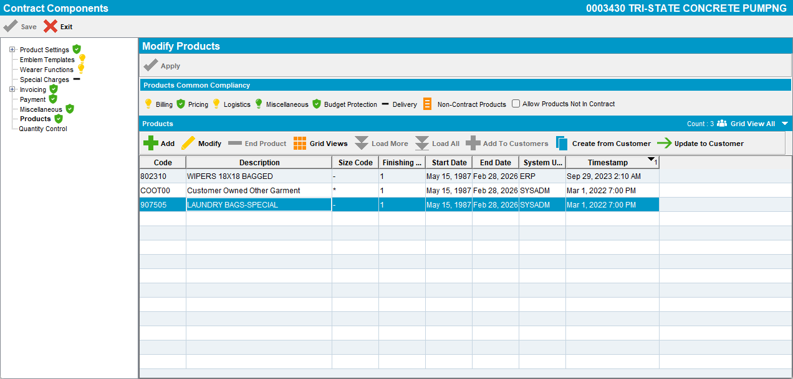

- In the Modify Contract Product screen, “Additional” tab, make sure to have “Systematic Replacement” checked.
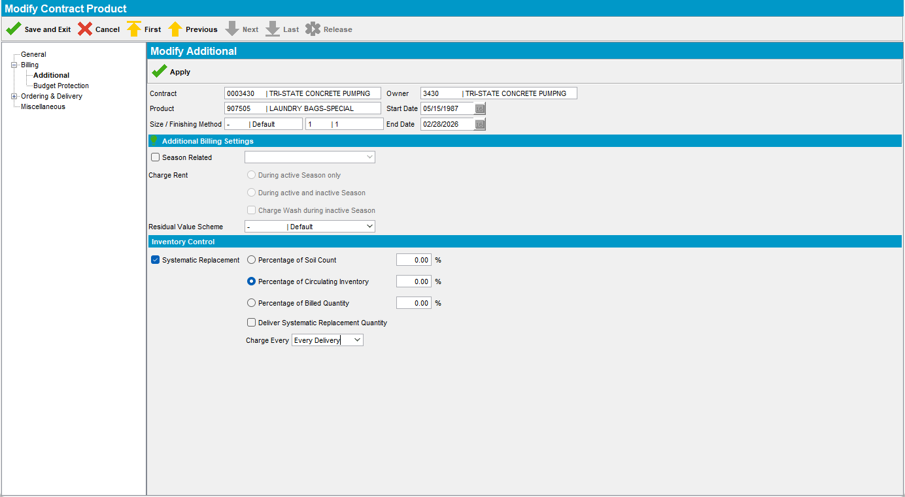
- In the PLPC screen, “General” tab, change the “SR Charge” price to a value different from the default.
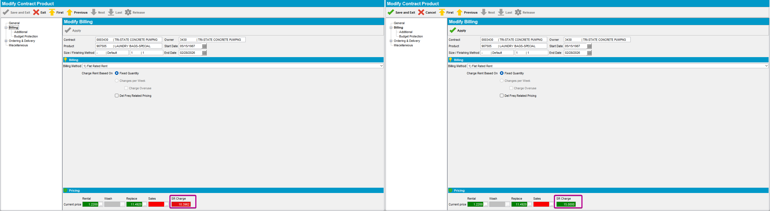

- Create a new product P2 with characteristics like P1 (for example, by duplicating it)
- Run the Product Conversion Wizard, replacing product P1 with product P2, choose the selection criteria so to include the customer C1.
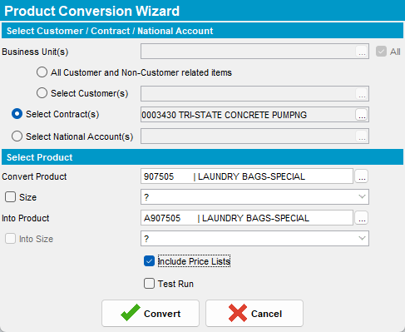
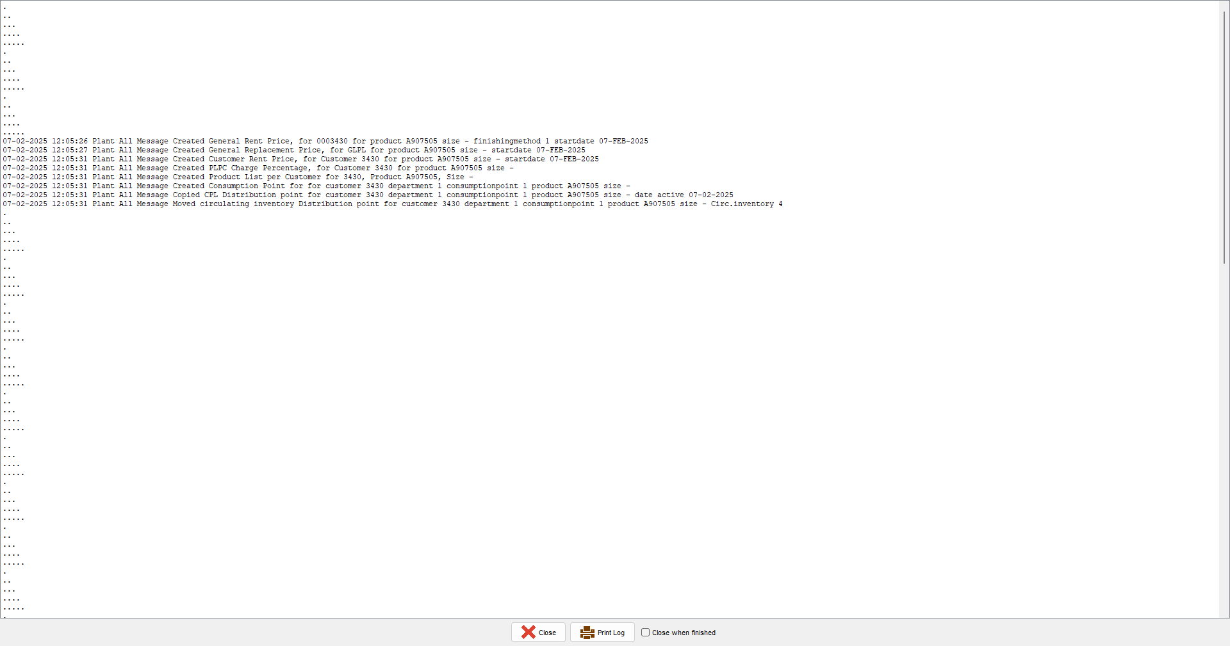

- Check the PLPC for customer C1, product P2.
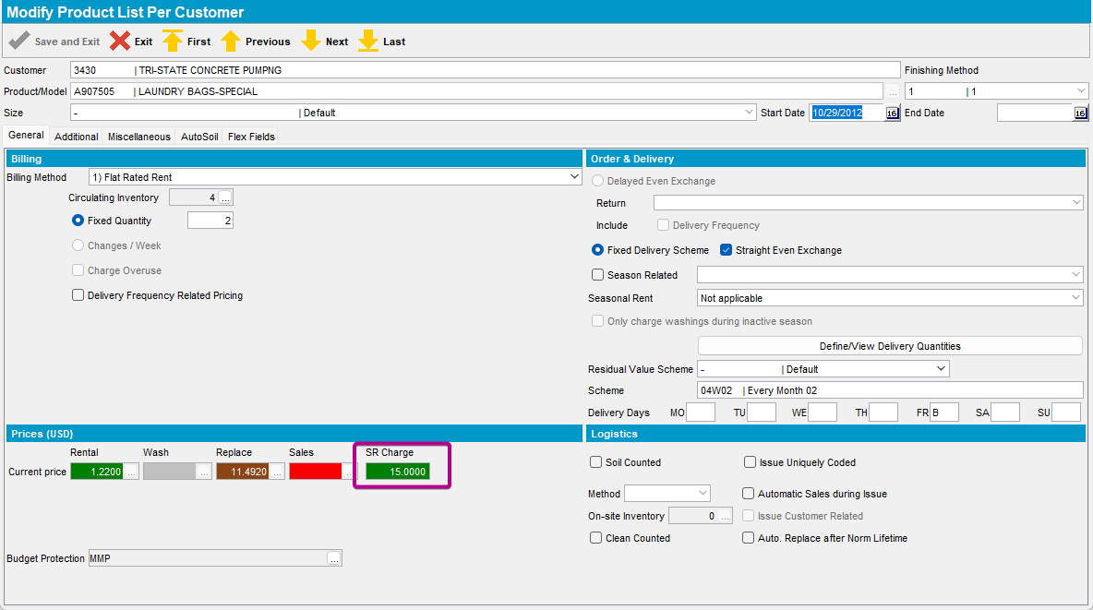

Expected behavior: the SR Charge is the same as for product P1 (the value changed in step 3)
Actual behavior: the SR Charge is the same as for product P1 (the value changed in step 3)

