ABSN-2674 Loss charges billing twice
Environment | Prerequisites
Version: 9.07.00.UNF19  DBServerName= abs-srv20.internal.abslbs.com  DBSID=CUST24  DBUser=UNFDEV  DBPassword=UNFDEV  Environment=Production | - Module:

Contents
Reproducing before fix 1
Retest after fix 3

Reproducing before fix
Hash: cd485b743c8
- Have a wearer with a wearer inventory circ=max (5/5)
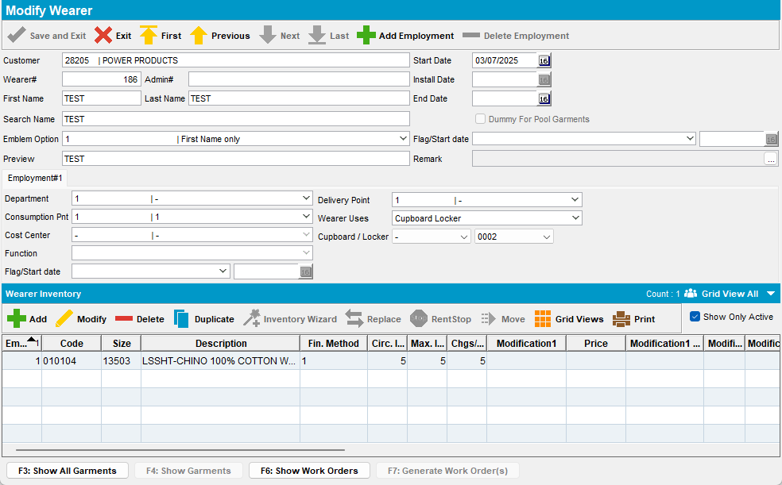

- Generate invoices and send route to RA
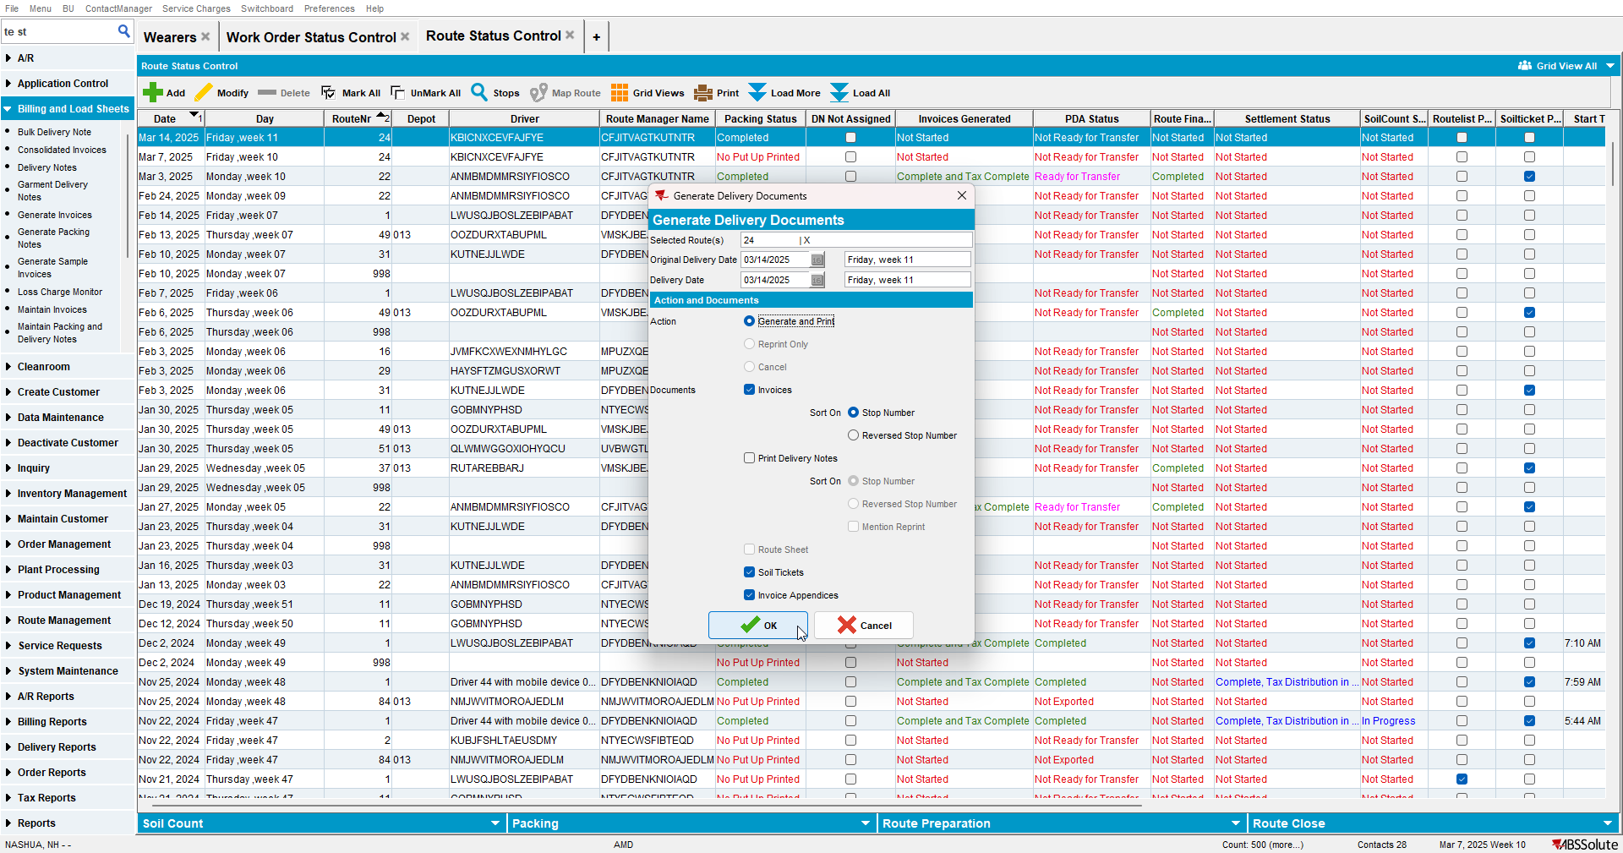

- Do a size exchange for your product
- Do a bill loss now
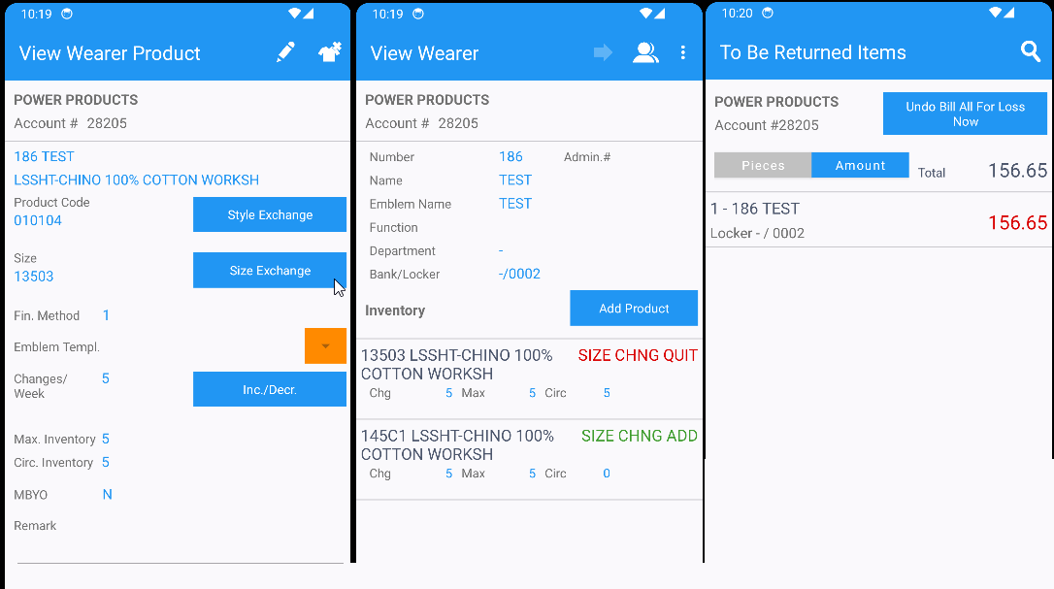

- Settle the route, finish and upload it
- On Webx settle the route
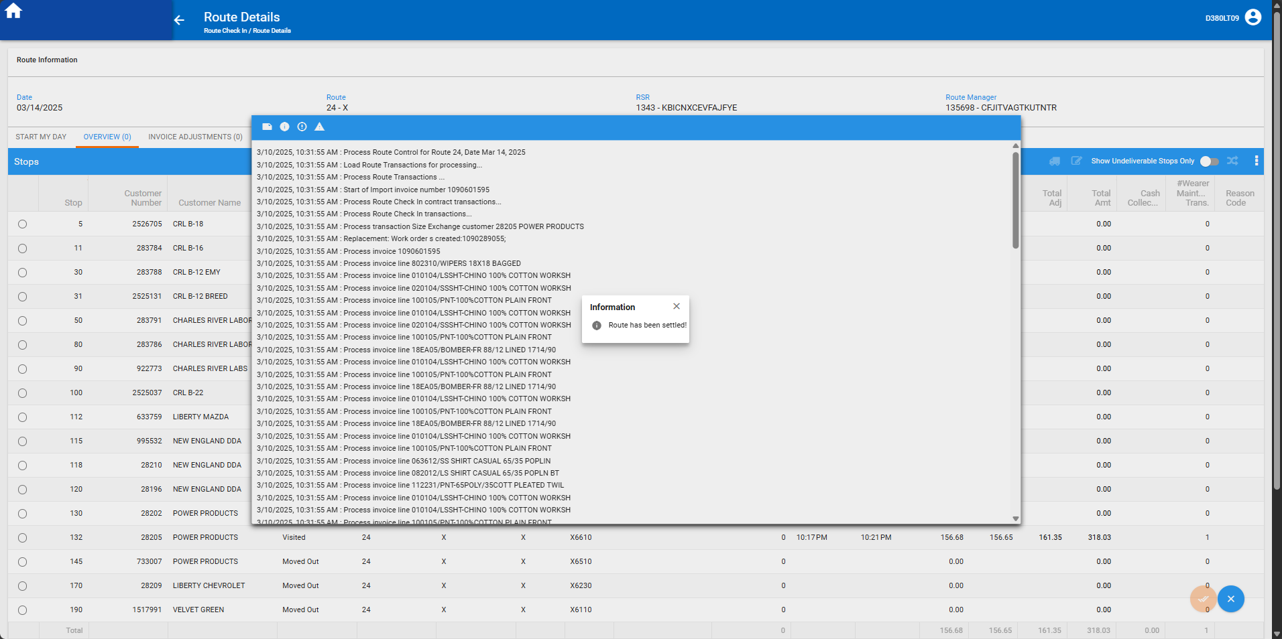

- Check the invoice and there will be a loss charge
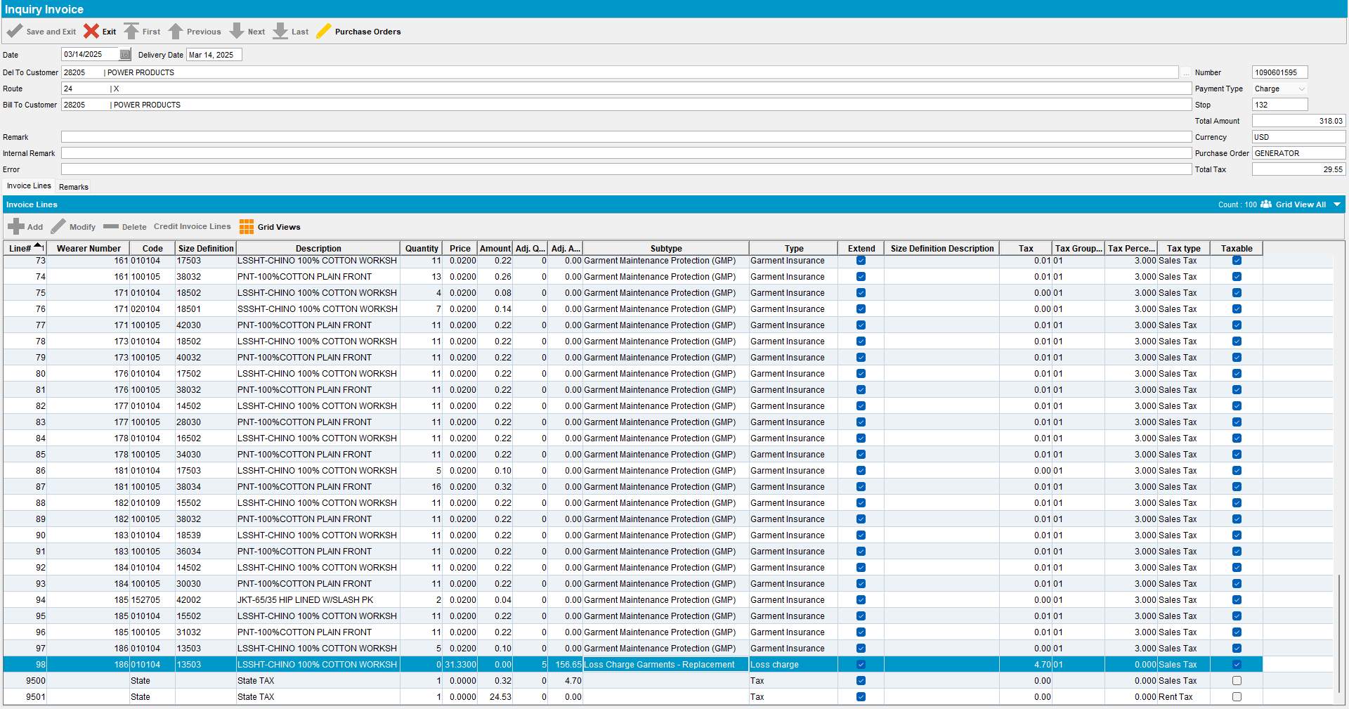

- Issue the WO created by the size exchange
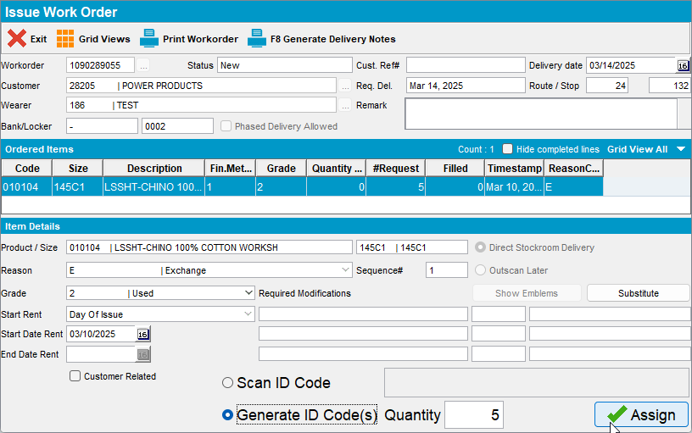

- Generate invoices for the next route
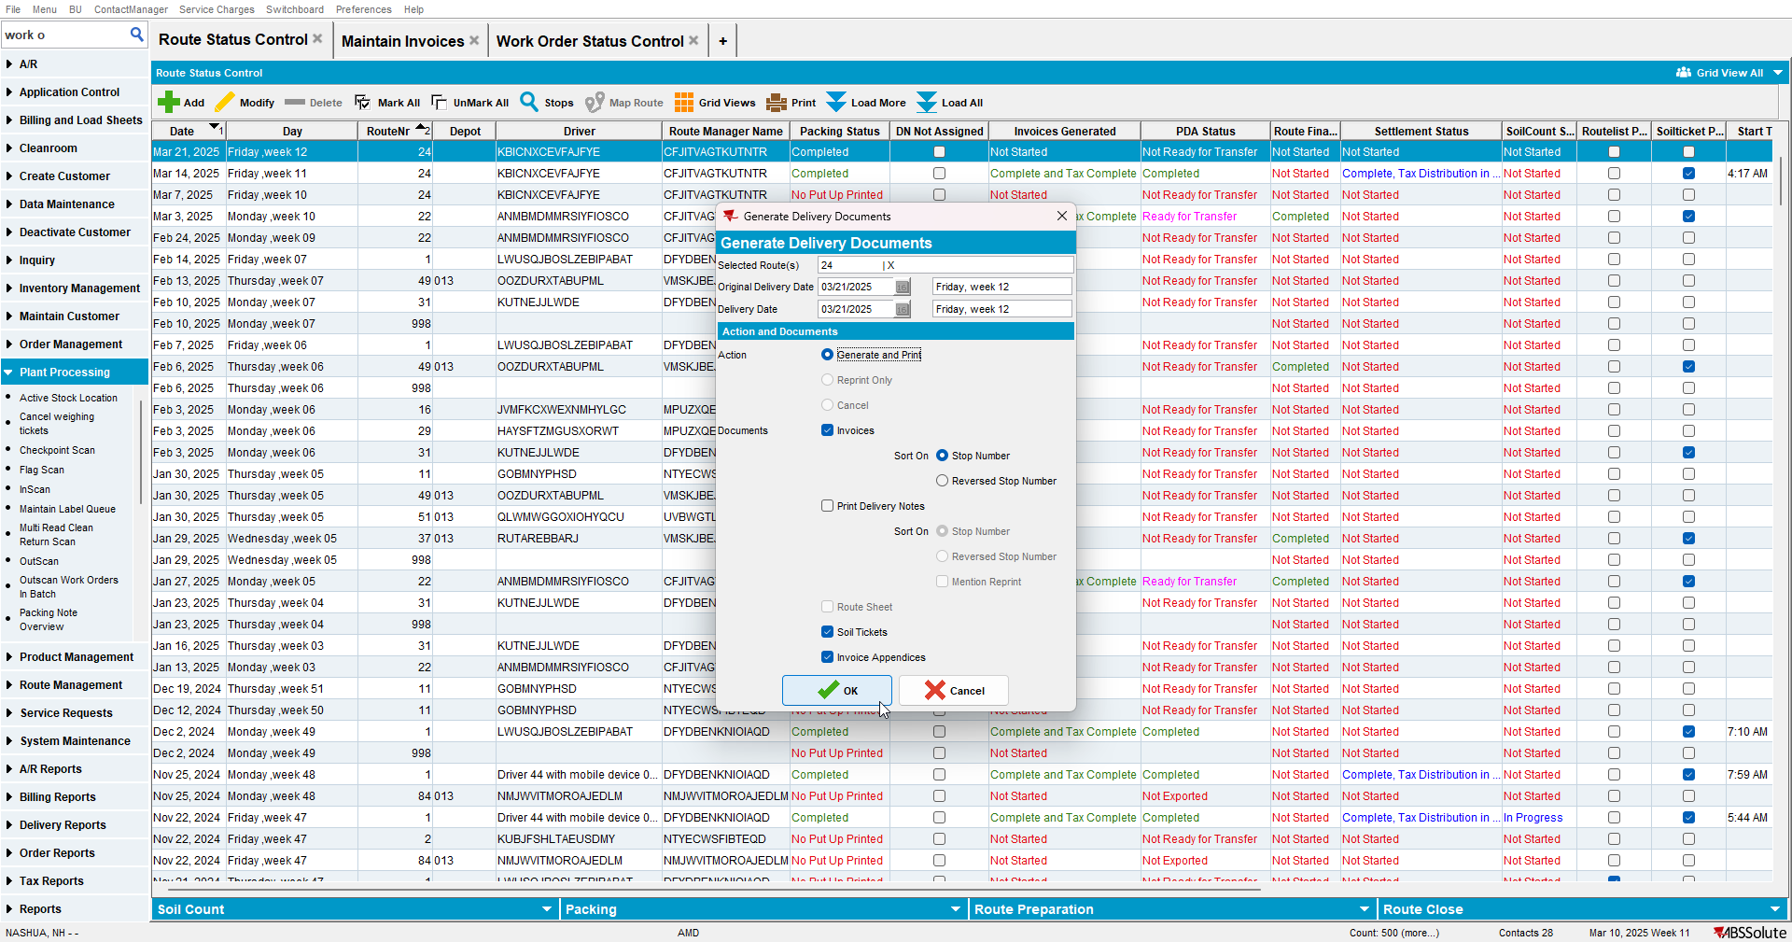

- Check the invoice and there will be again a loss charge
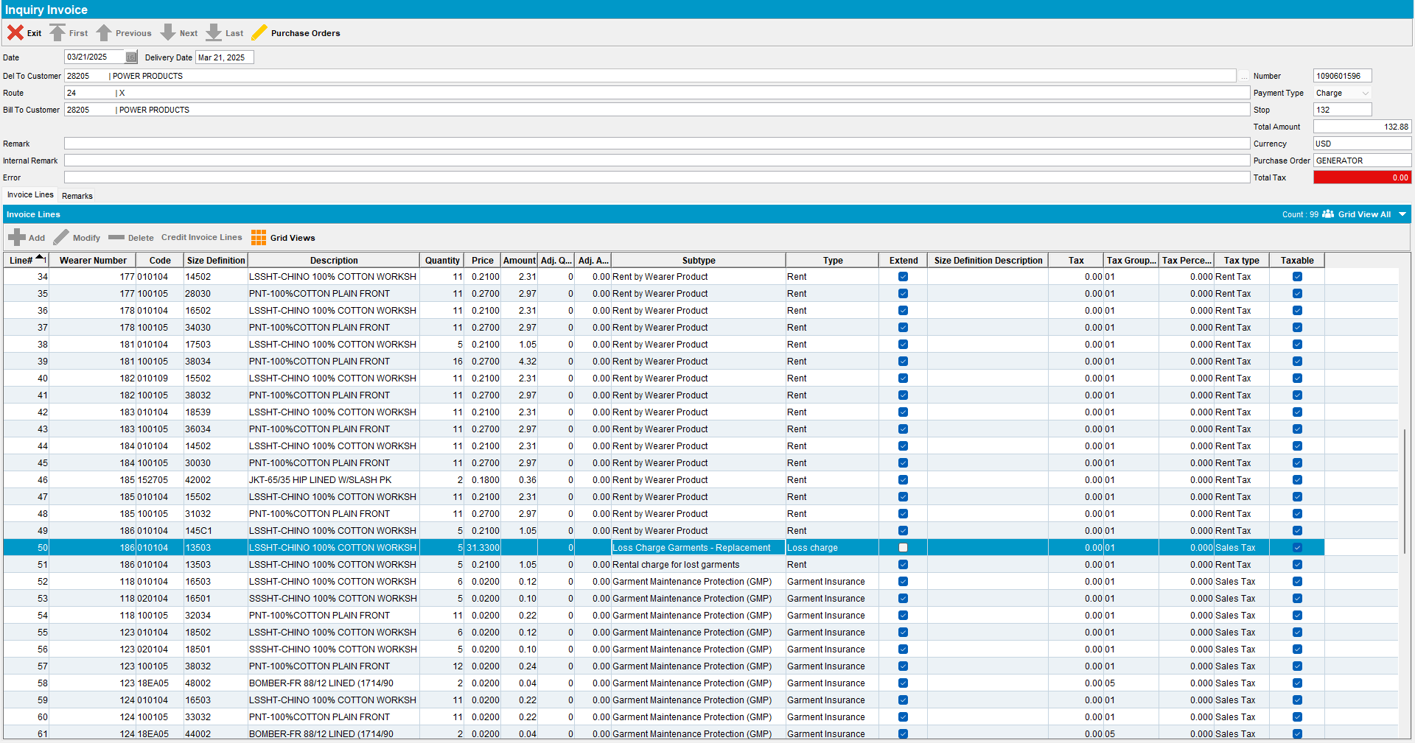

Retest after fix
Hash: e96edc19e0a
- Have a wearer with a wearer inventory circ=max (11/11)
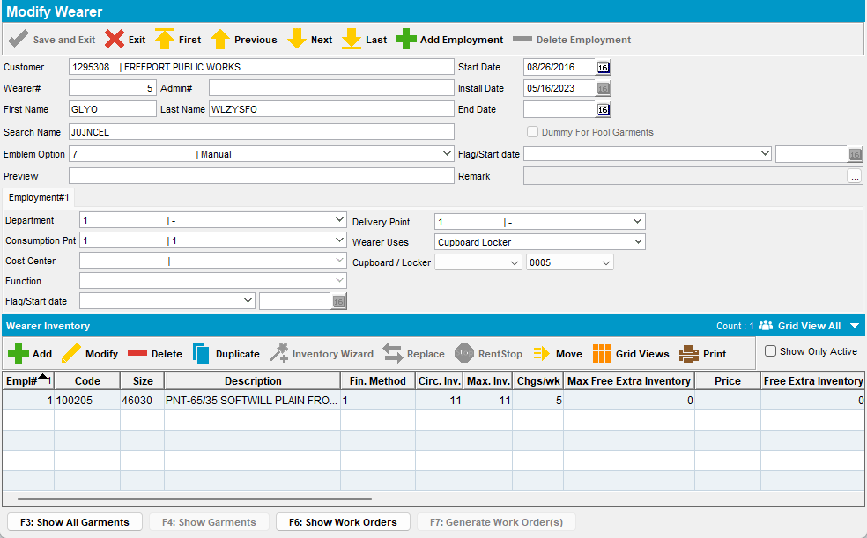

- Generate invoices and send route to RA
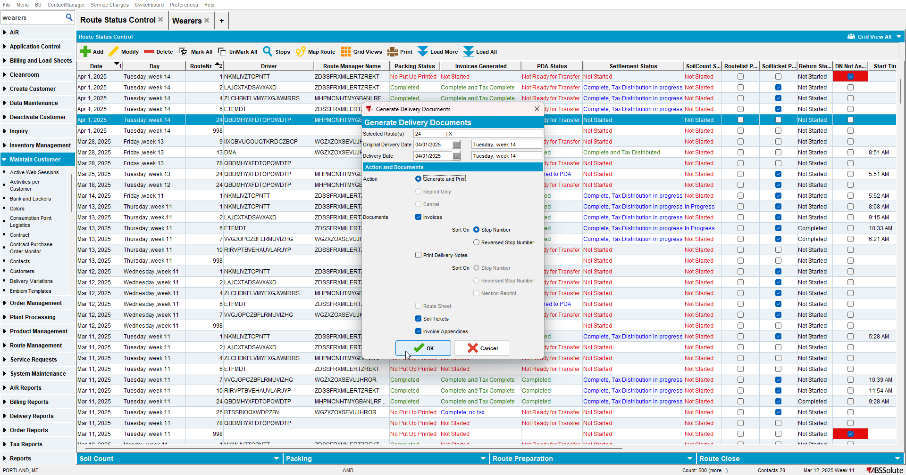
- Do a size exchange for your product
- Do a bill loss now
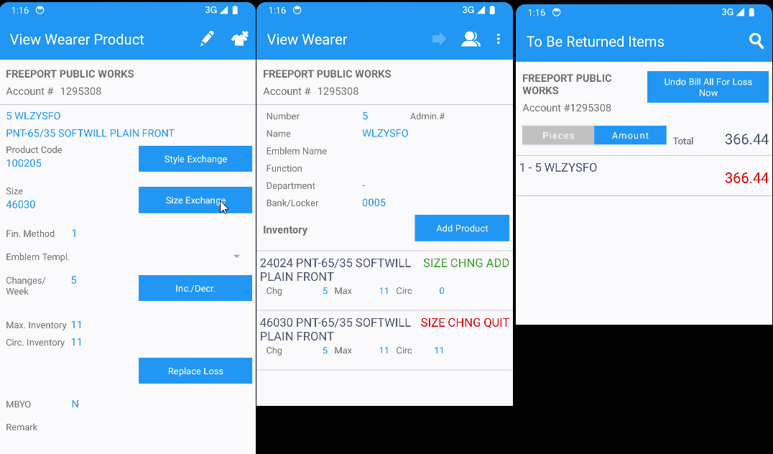

- Settle the route, finish and upload it
- On Webx settle the route
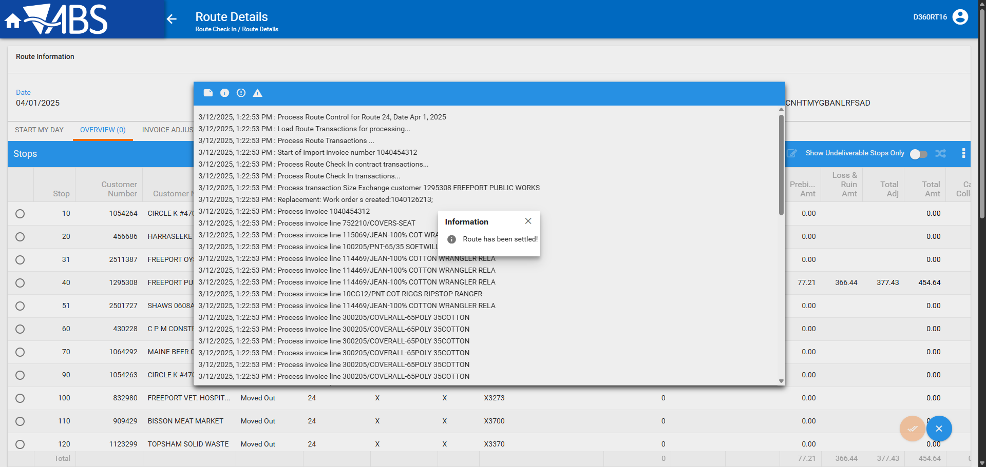

- Check the invoice and there will be a loss charge
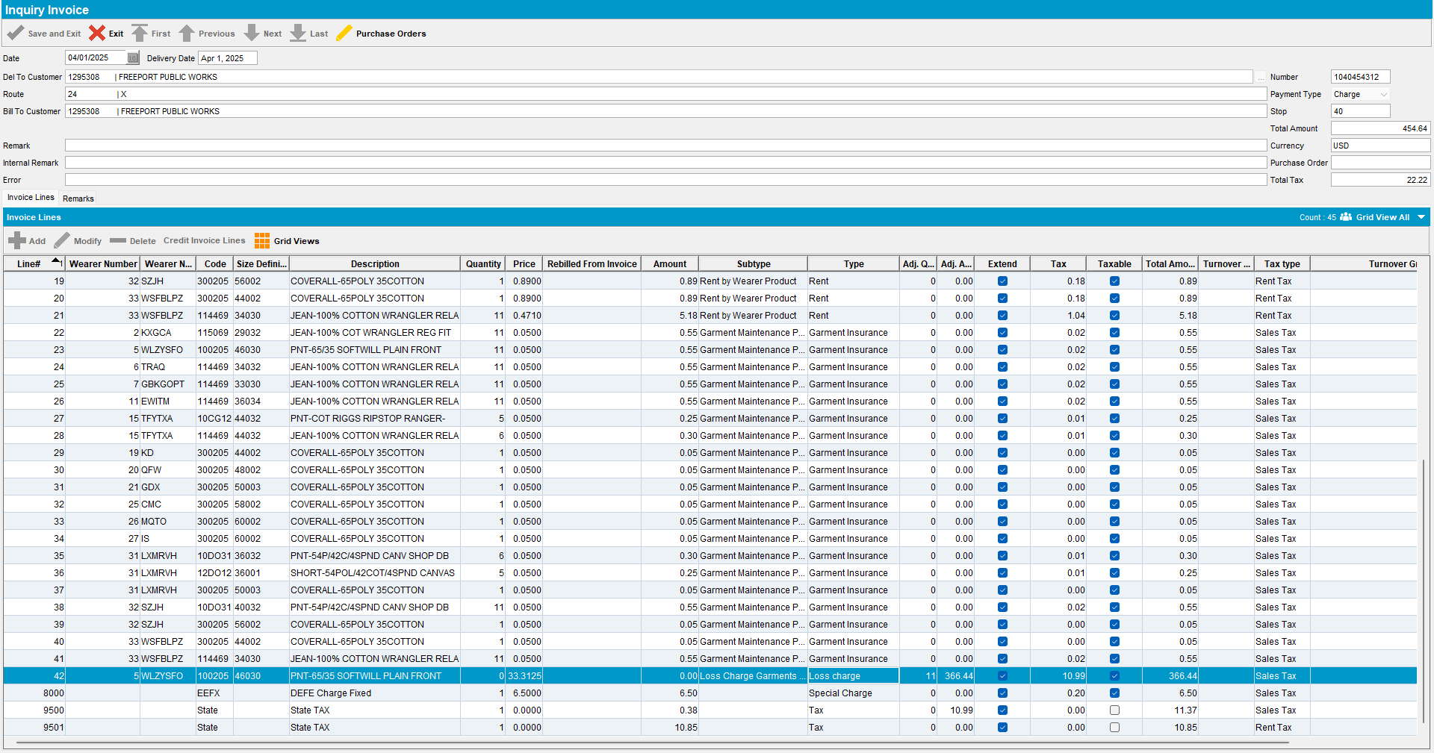

- Issue the WO created by the size exchange
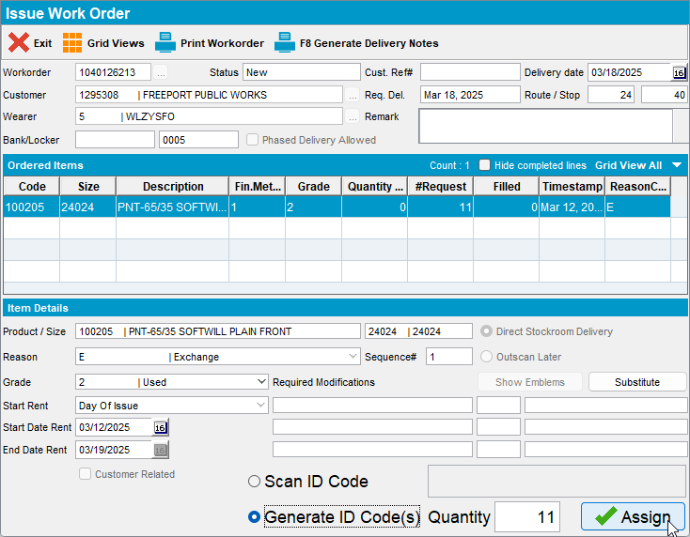

- Generate invoices for the next route
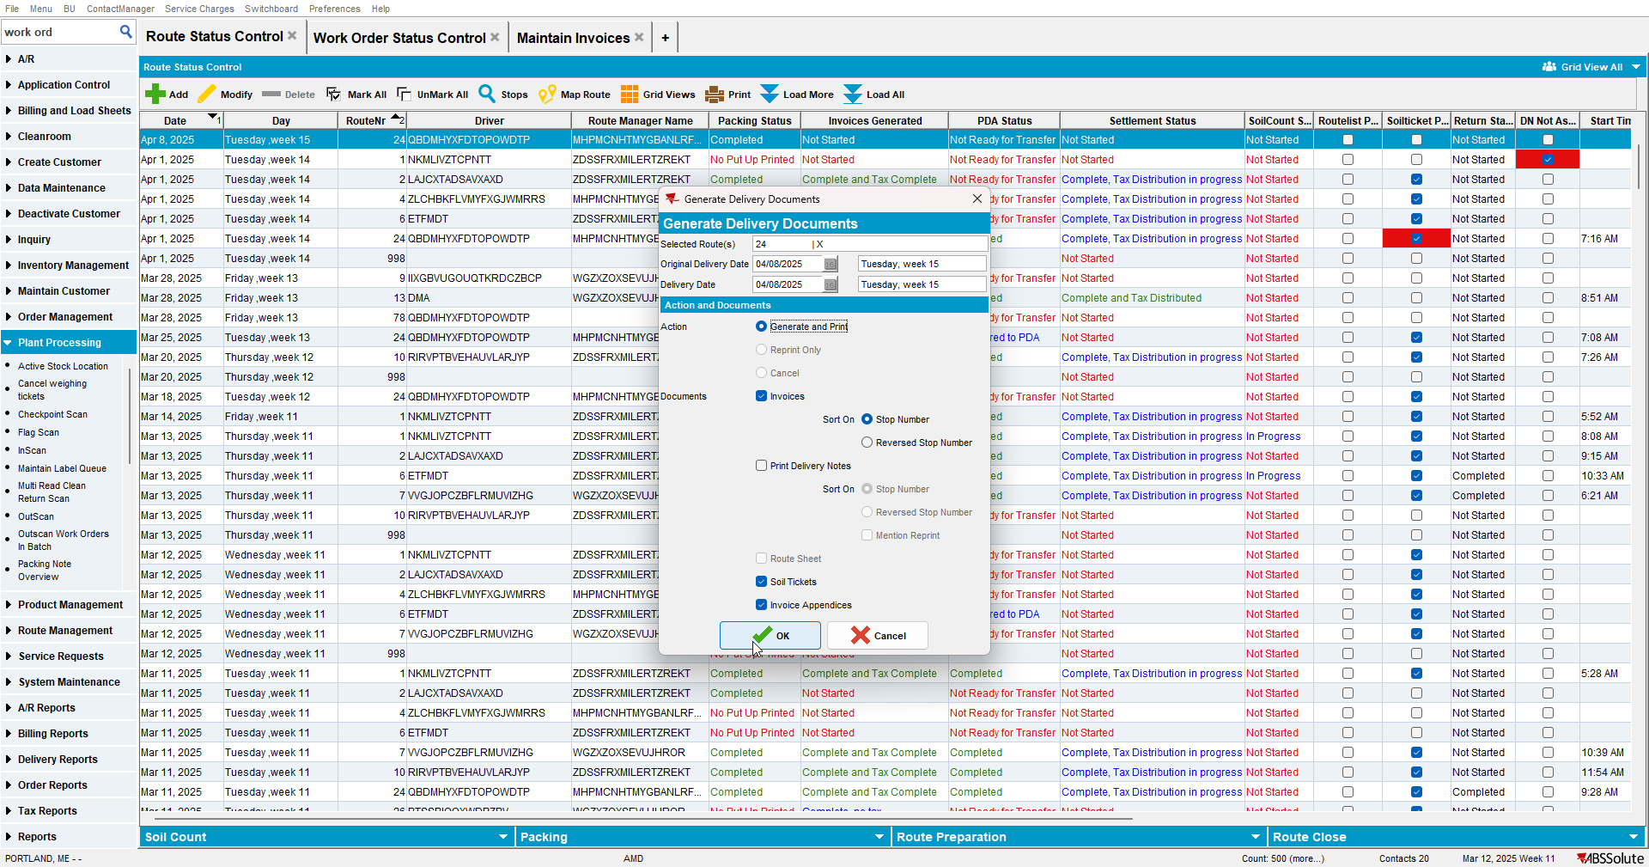

- Check the invoice
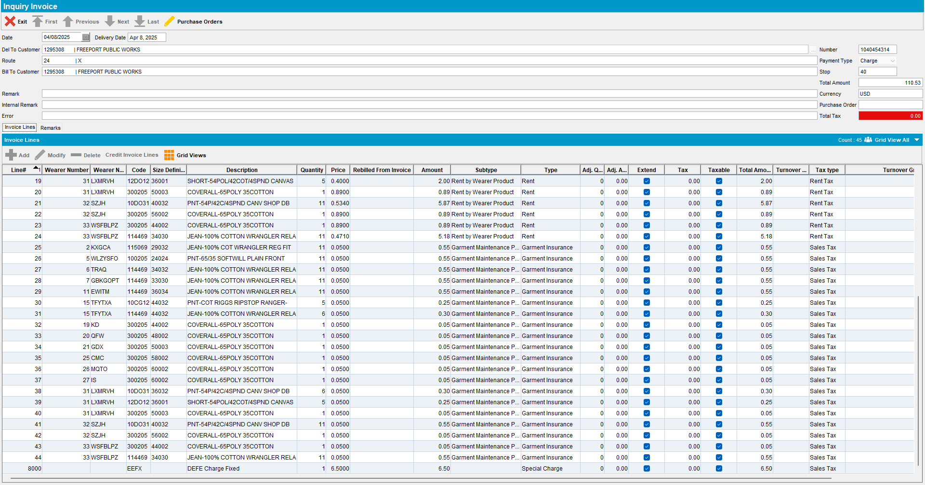
Expected behavior: Loss charge should not be billed again.
Actual behavior: Loss charge was not billed again.

TESTED OK.

