ABSN-2635 Loss Charges - With GPL set to 100% and PROCESSLOSSINSETTLEMENT = 1 we do not rag garments linked to loss charges that are settled
Environment | Prerequisites
Version: 9.07.00.UNF17  DBServerName=abs-SRV20.internal.abslbs.com  DBSID=CUST24  DBUser=UNFDEV  DBPassword=UNFDEV  Environment=Test | - Module:  - System setting

Contents
Retest after fix 1
Test Case 1 – Full credit invoice with GLP 100% and no GPL 1
Test Case 2 – DOI, Replacement from client – Tested OK 10
Test Case 3 – DOI, Quit wearer inventory from RA– Tested OK 19

Retest after fix

Test Case 1 – Full credit invoice with GLP 100% and no GPL
Hash: 9.07.00.UNF19 hash: a5f03ad12c1
- Make sure one of your PLPC’s has GPL with 100%
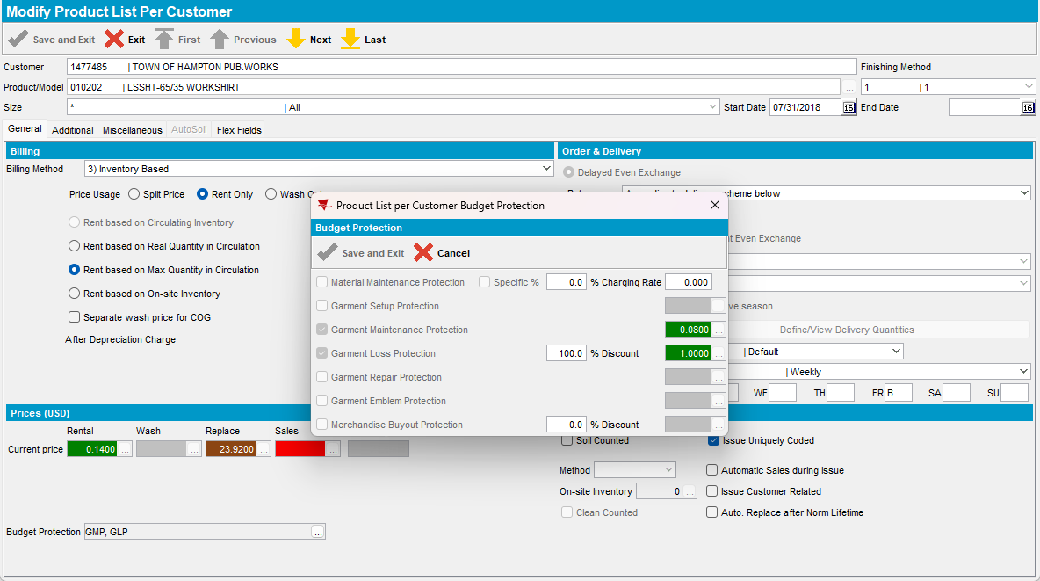
- Find at least two wearers with garments for that PLPC
- View the garments attached to this Wearer Inventory
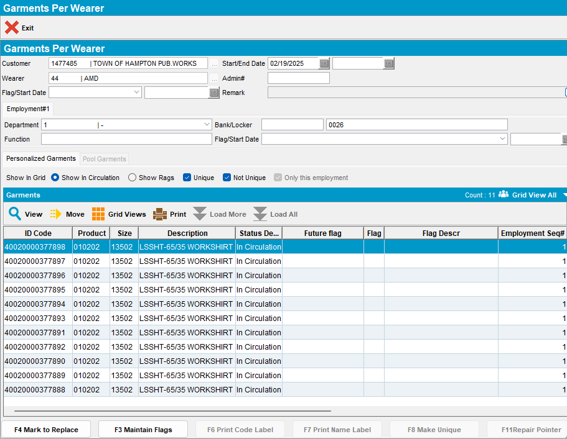
- Quit the first wearer inventory
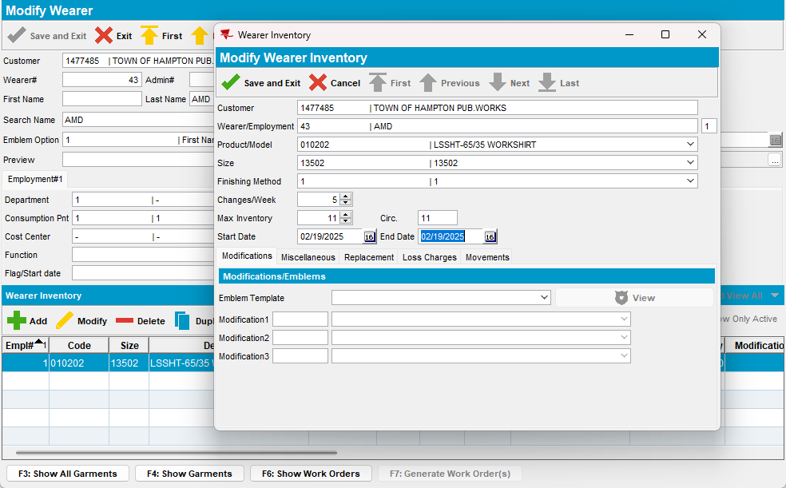
- DOI on the other Wearer inventory
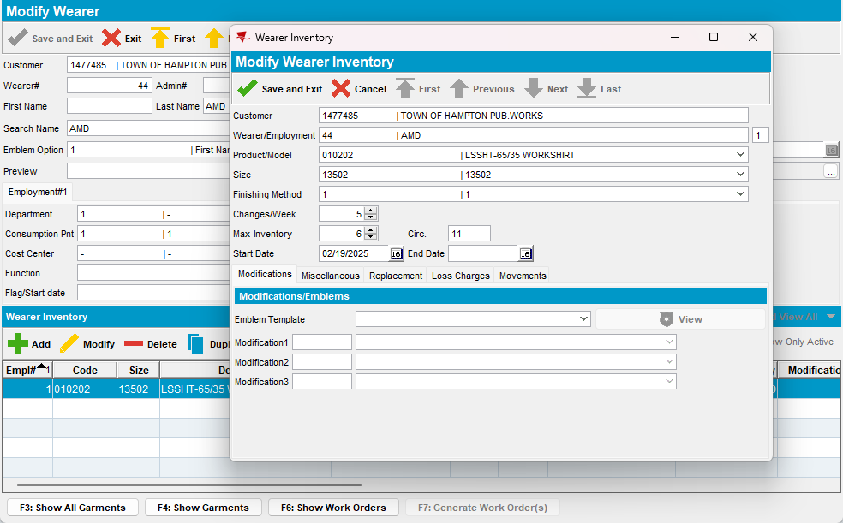
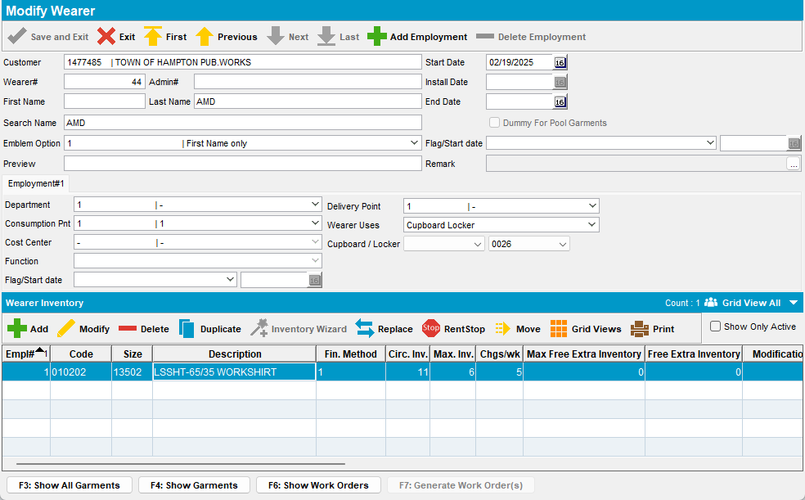
- Generate invoices for the 3 weeks from now route – check that you have 2 loss charges with extended = ‘Y’
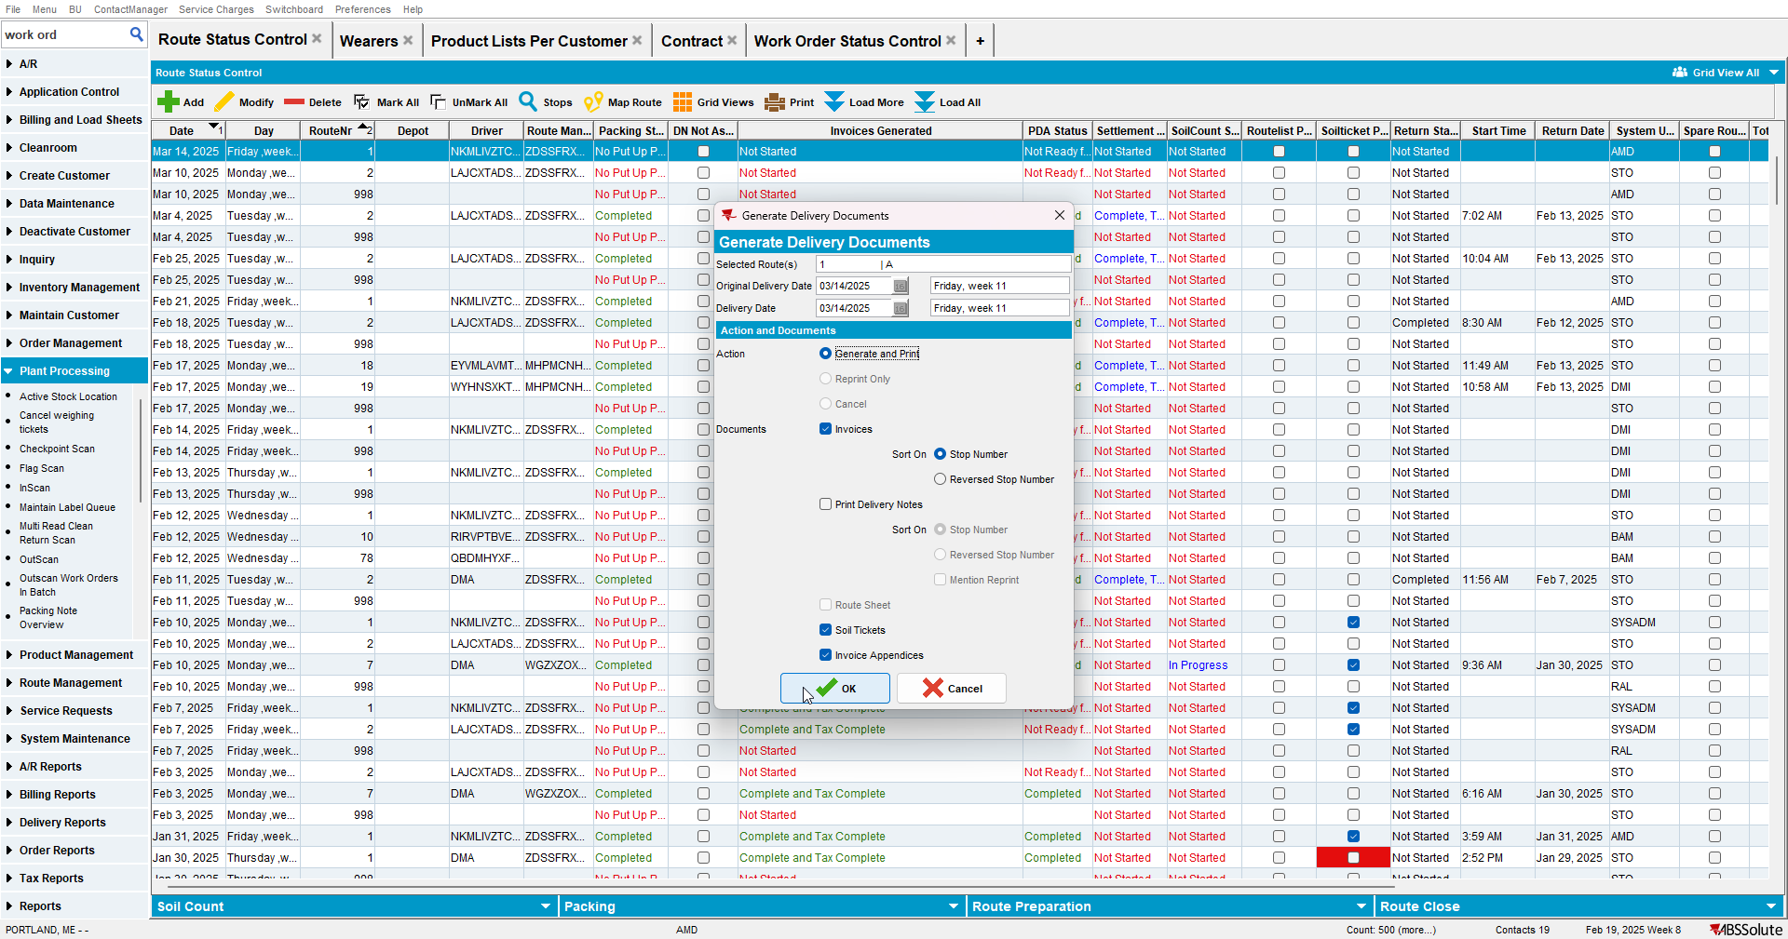
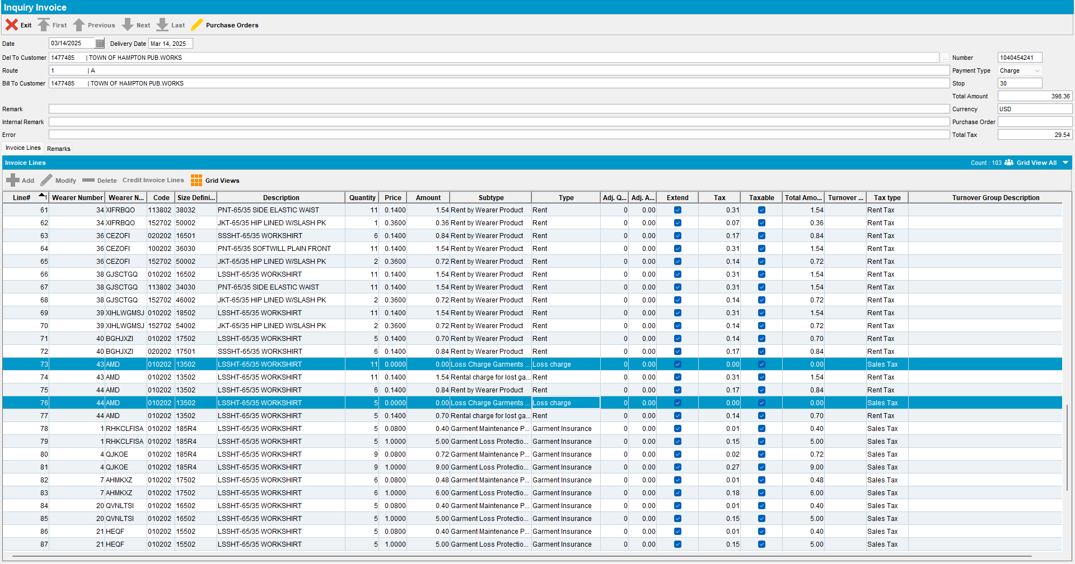
- Send the route to RA
- Full credit the invoice
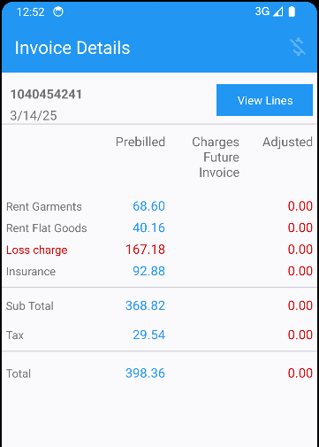
- Settle and upload the route
- WebX: Settle the route
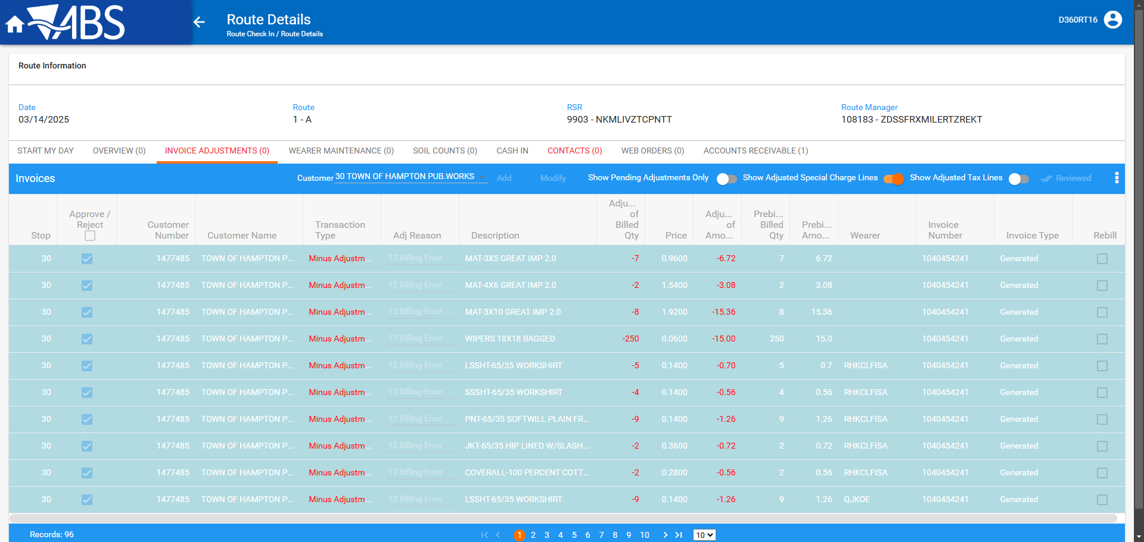
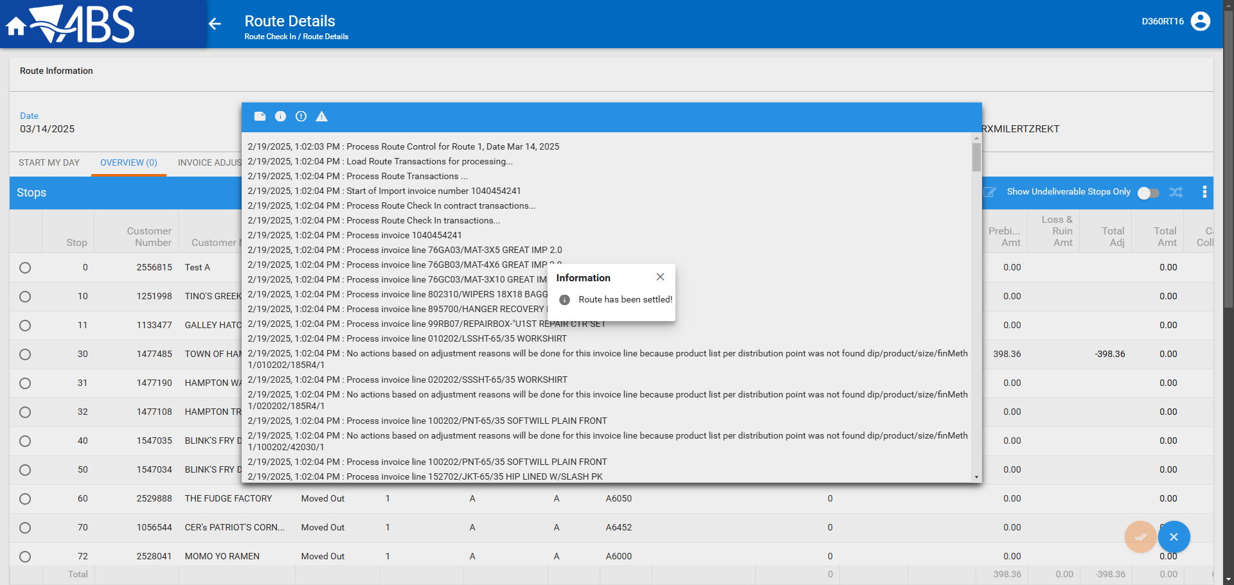

- Check the invoice and verify that the loss charges are now extend = ‘Y’
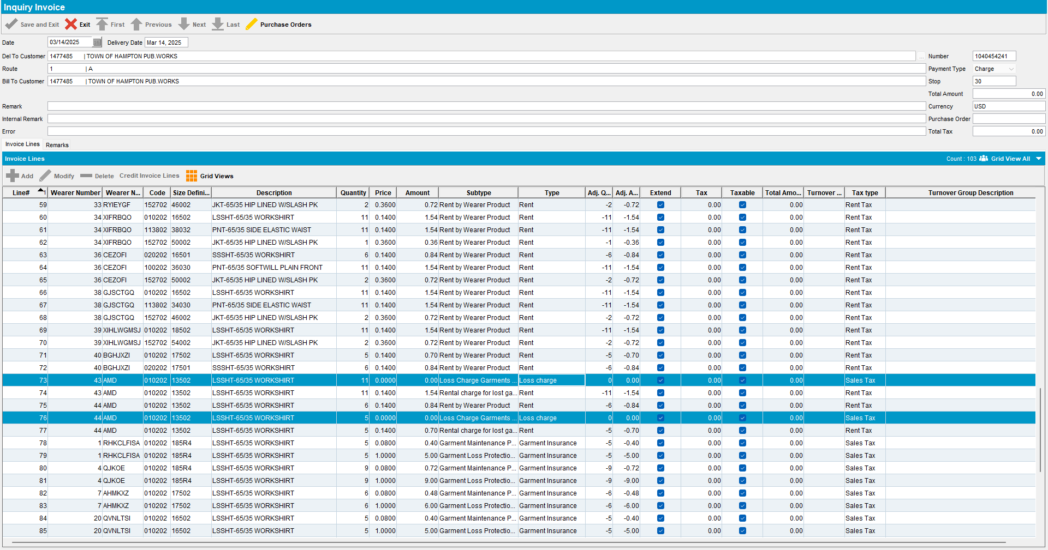

- Check the garments on the two wearer inventories that had loss charges
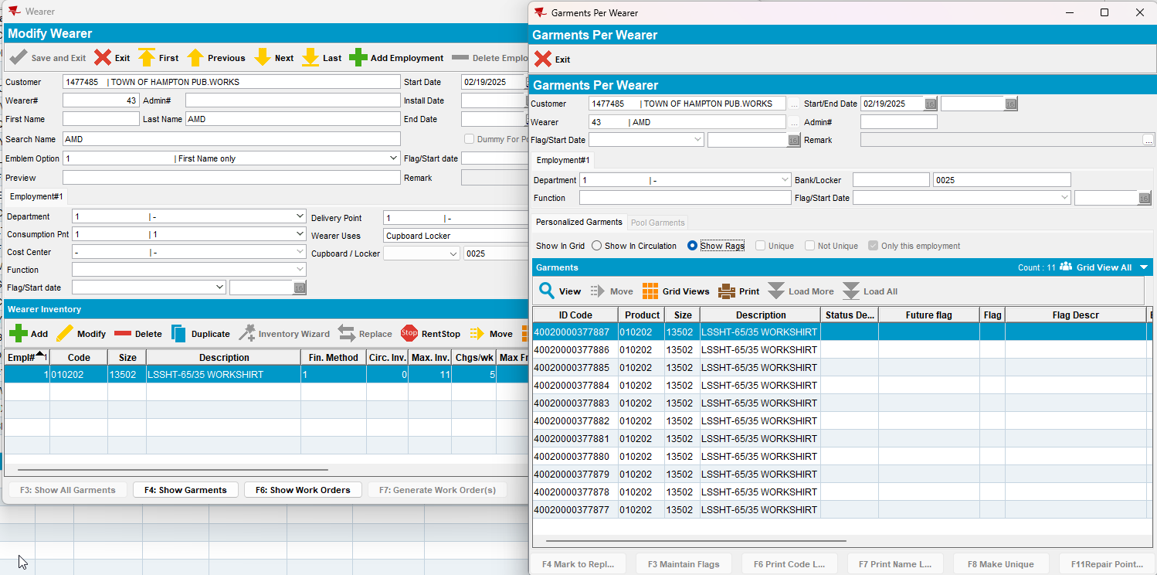
Quit WI has 0 Circ / 11 max – 11 ragged
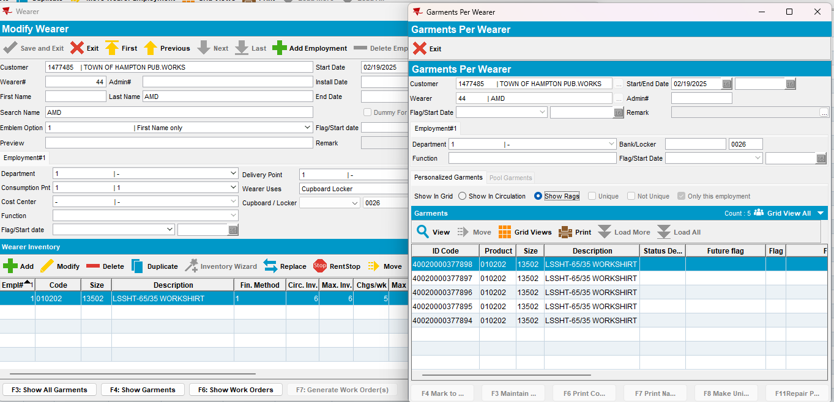
DOI WI has 6 circ / 6 max from 11 max – 5 ragged
TESTED OK

Test Case 2 – DOI, Replacement from client – Tested OK
Expected behavior: The garments on the loss charges with a price of 0$ should be ragged even though PROCESSLOSSINSETTLEMENT = 1.
Hash: 9.07.00.UNF19 hash: a5f03ad12c1
- Have SS PROCESSLOSSINSETTLEMENT = 1
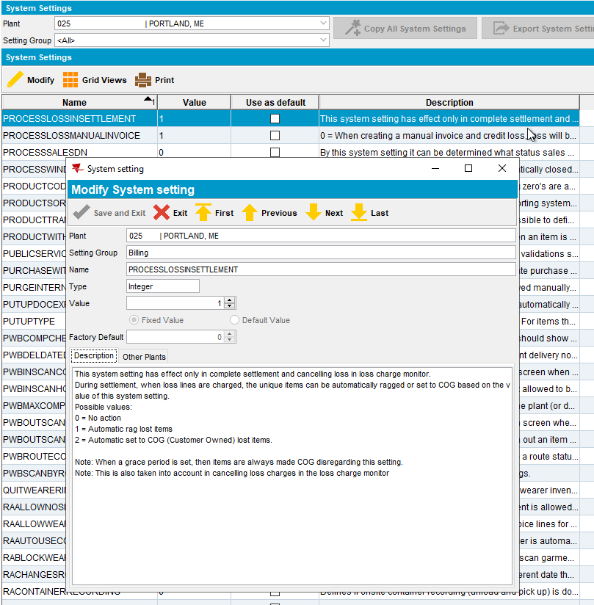

- Use customer 1477485 and product 010202
- Make sure product has GLP 100%
- Have a wearer with wearer inventory 5 circ/5 max with the product 010202 non unique and uniques
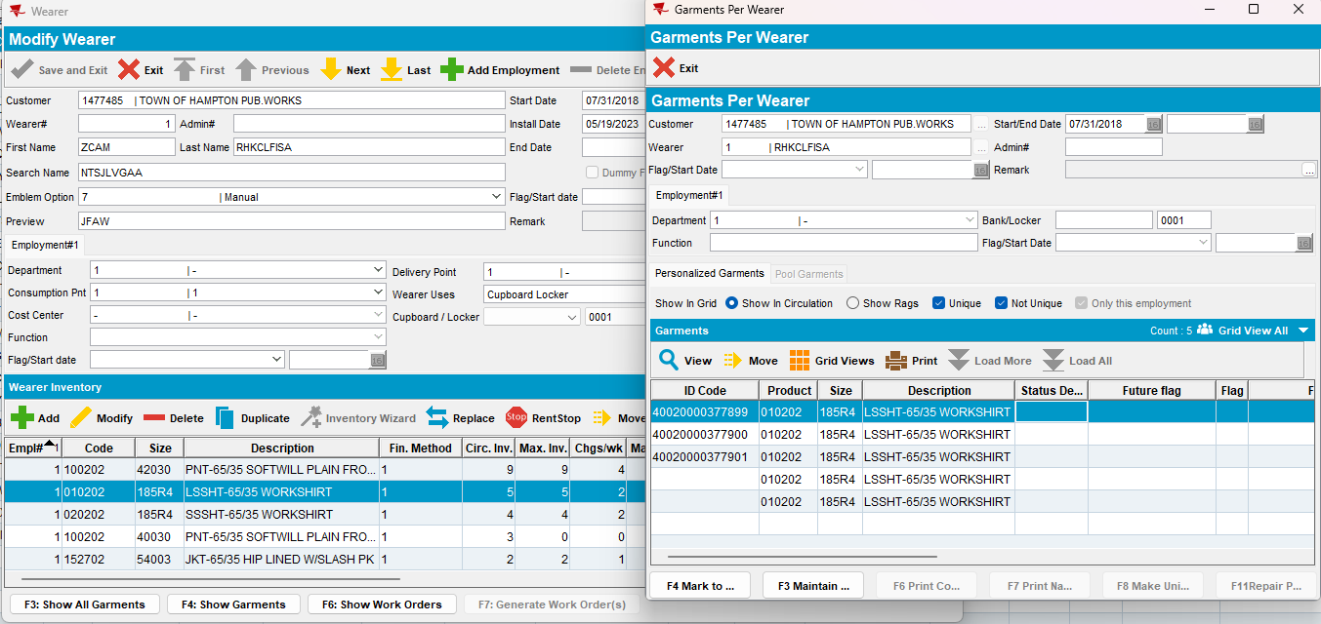

- Decrease inventory
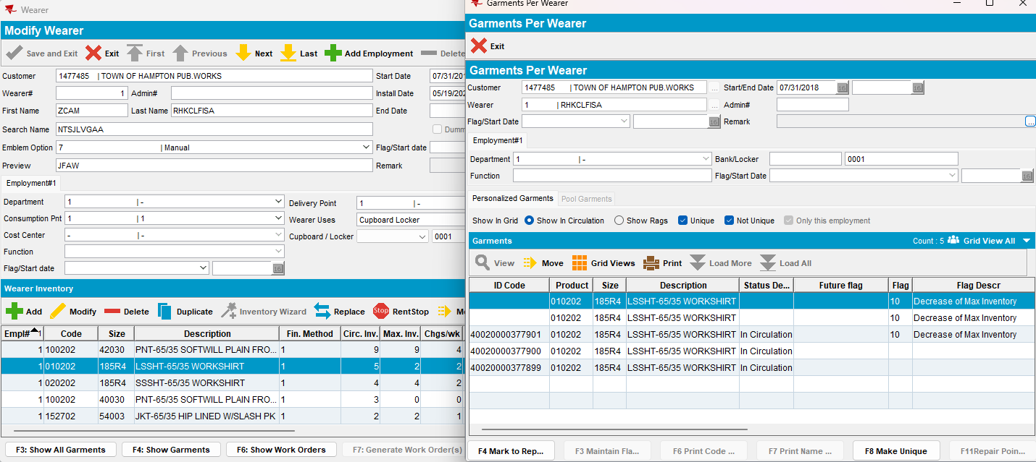

- Have a wearer with wearer inventory 9 circ/9 max with the product 010202 unique
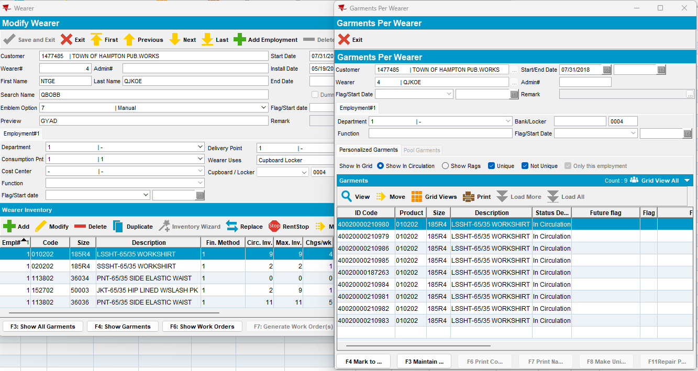

- Decrease inventory
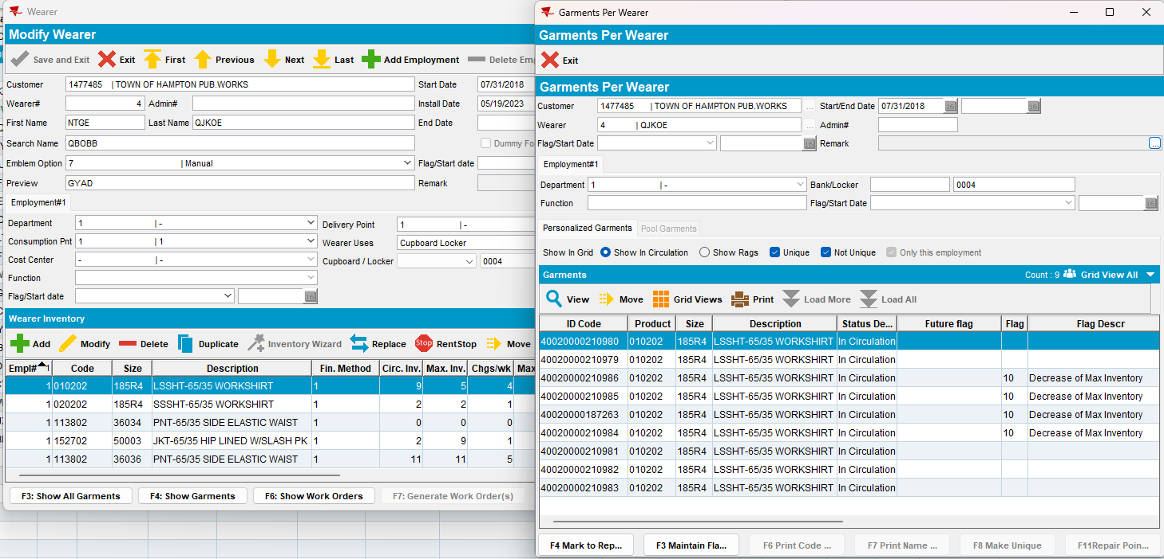

- Have a wearer with wearer inventory 5 circ/5 max with the product 010202 unique
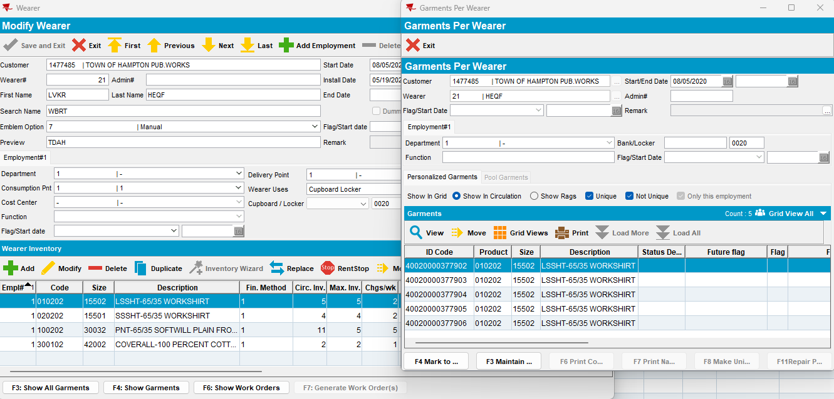

- Do a full replacement and issue the replacement WO
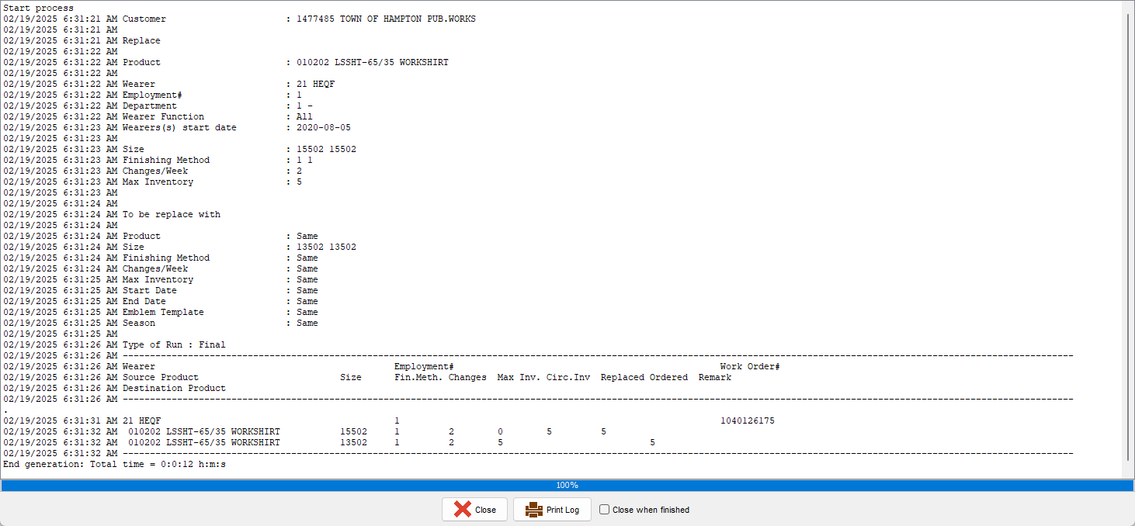
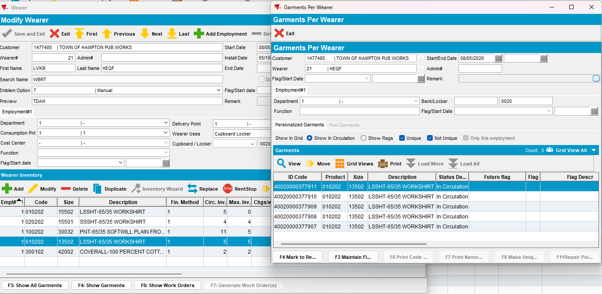

- Generate invoices
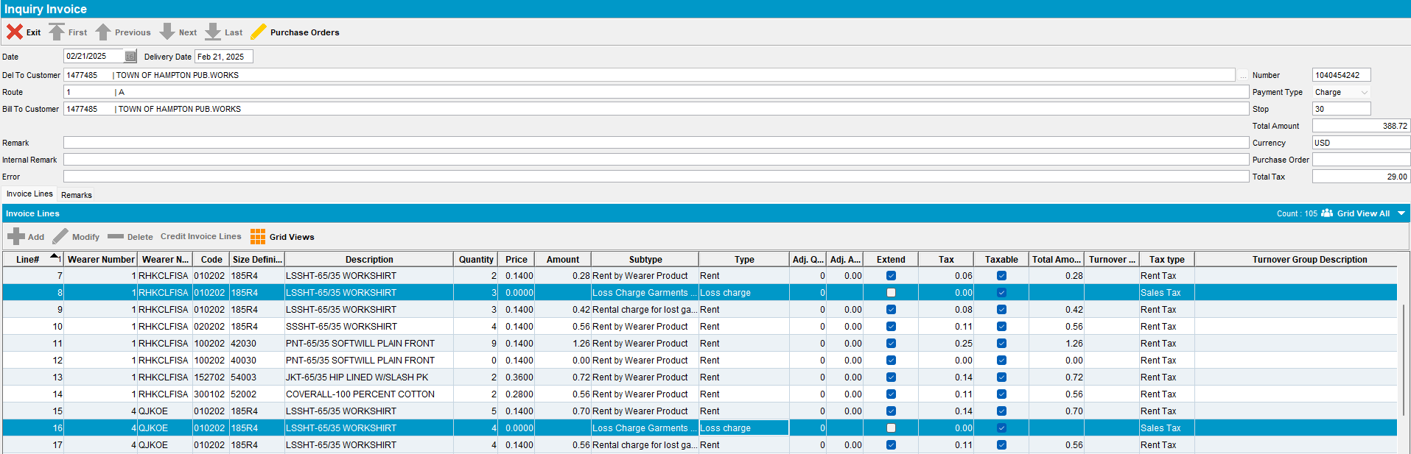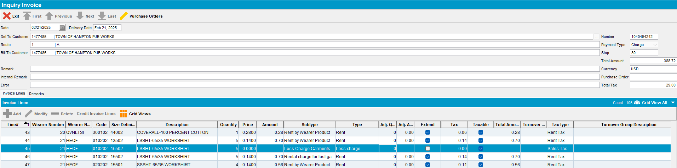
- Mark the route ready for transfer
- On RA Bill All for Loss Now
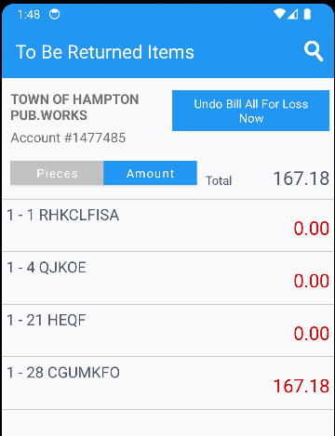
- Settle the route, finish and upload it
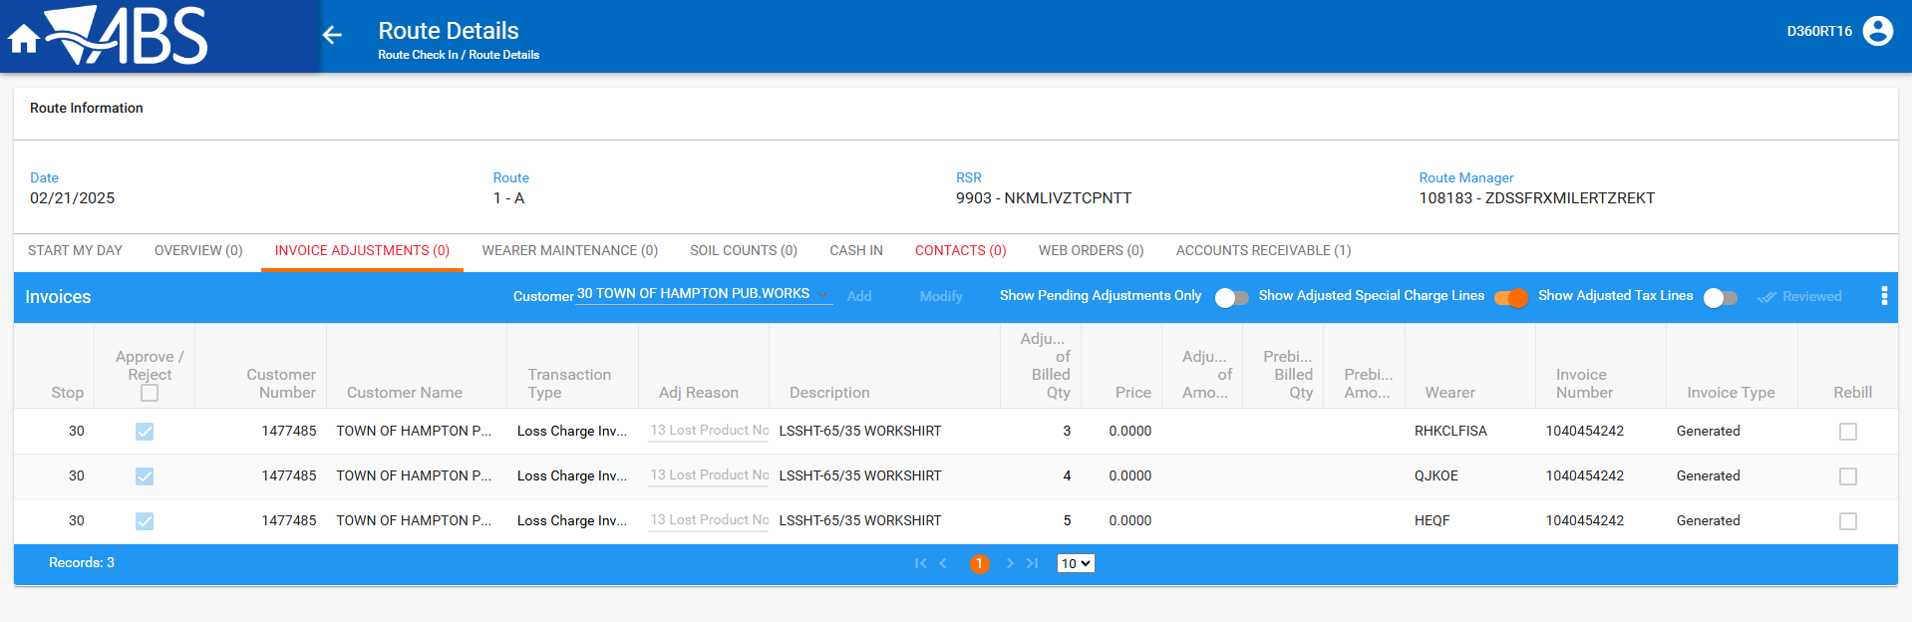
- On WebX settle the route
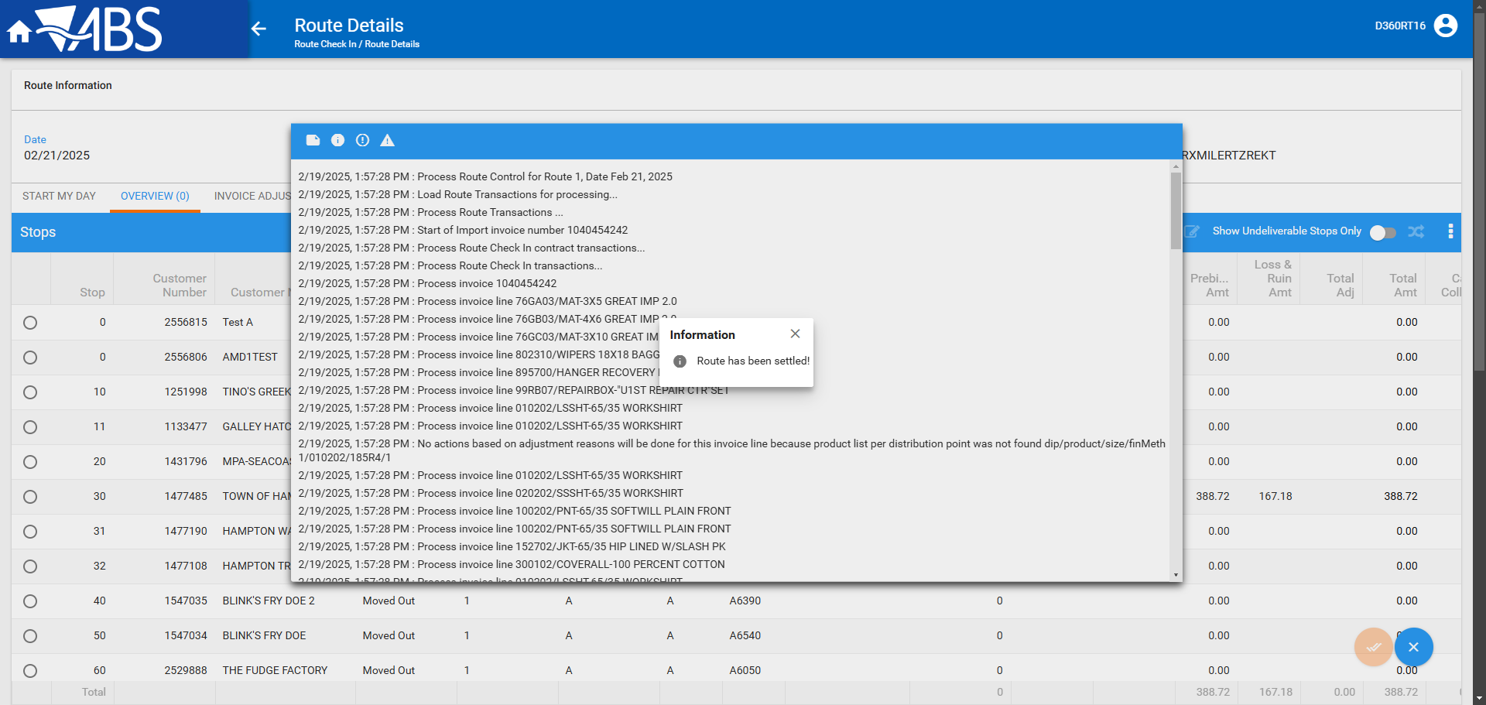
- Check that the invoice has all 3 loss lines Extend = ‘Y’
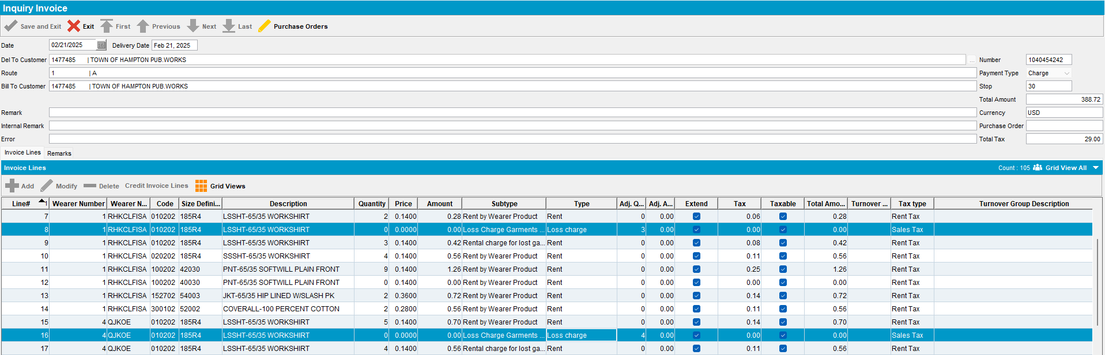
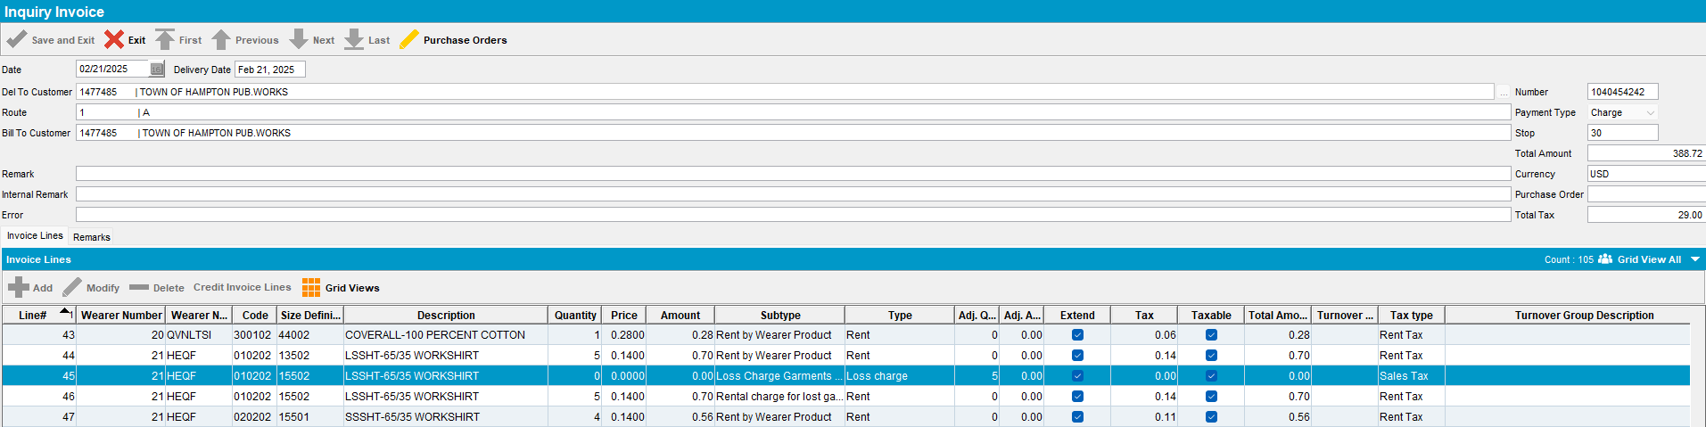
- Check that the garments were ragged
Wearer 1 – DOI From 5 to 2 Both unique and non-unique item was ragged– OK
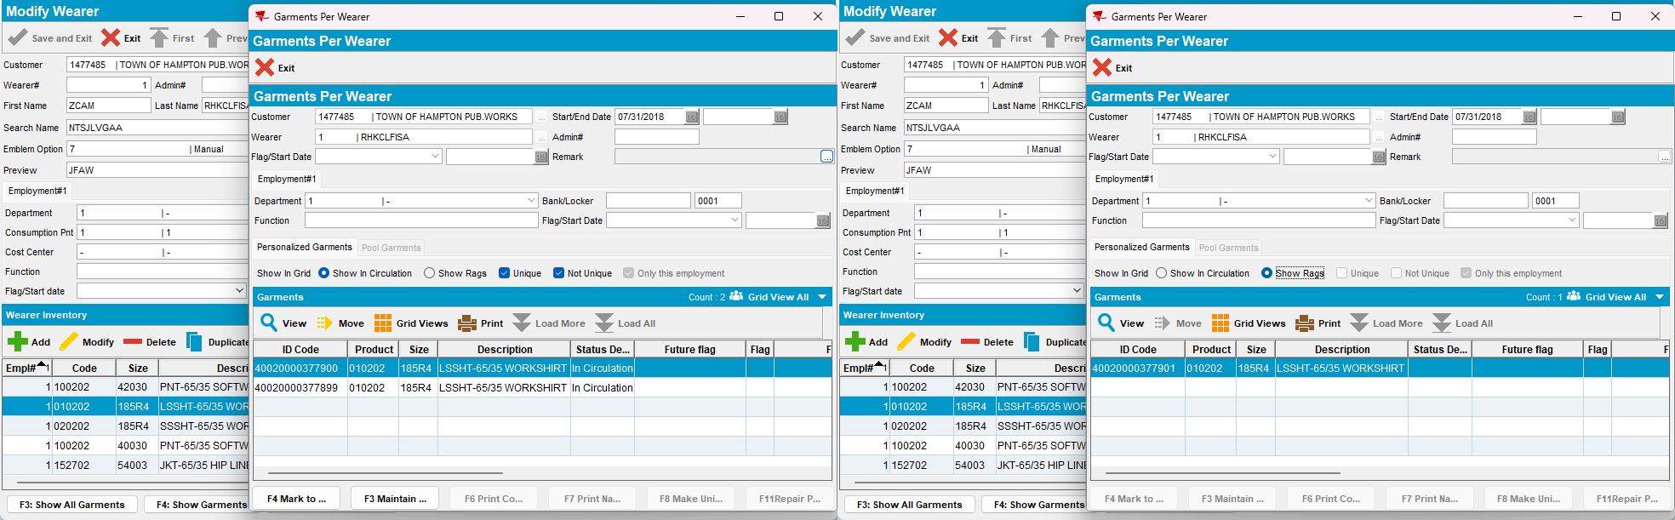
Wearer 4 – DOI From 9 to 5 All unique items were ragged - OK
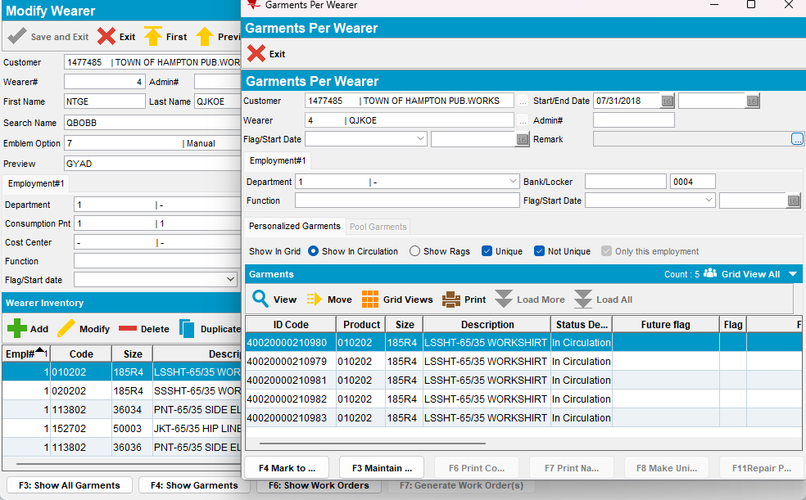

Wearer 21 – Full Replacement All unique items were ragged - OK
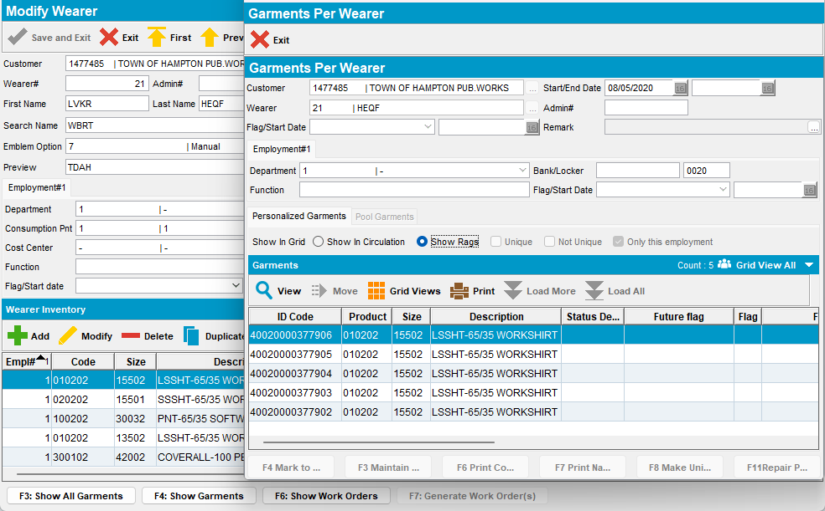

Test Case 3 – DOI, Quit wearer inventory from RA– Tested OK
Expected behavior: The garments on the loss charges with a price of 0$ should be ragged even though PROCESSLOSSINSETTLEMENT = 1
Hash: 9.07.00.UNF19 hash: a5f03ad12c1
- Have SS PROCESSLOSSINSETTLEMENT = 1
- Use customer 1477485 and product 010202
- Make sure product has GLP 100%
- Have a wearer with wearer inventory 6 circ/6 max with the product 010202 uniques and non-uniques
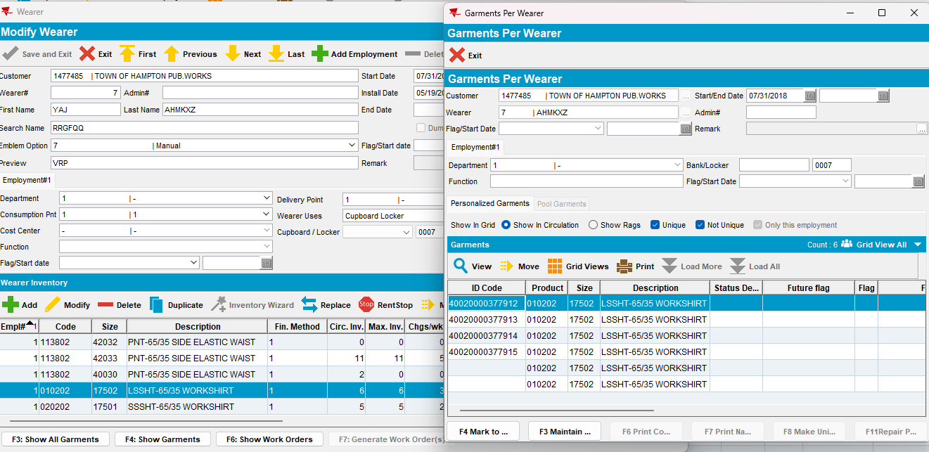
- Have a wearer with wearer inventory 11 circ/11 max with the product 100212 non-uniques
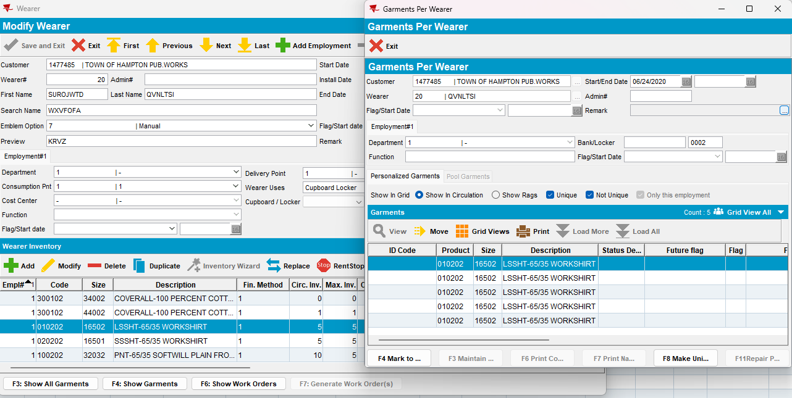

- Generate invoices
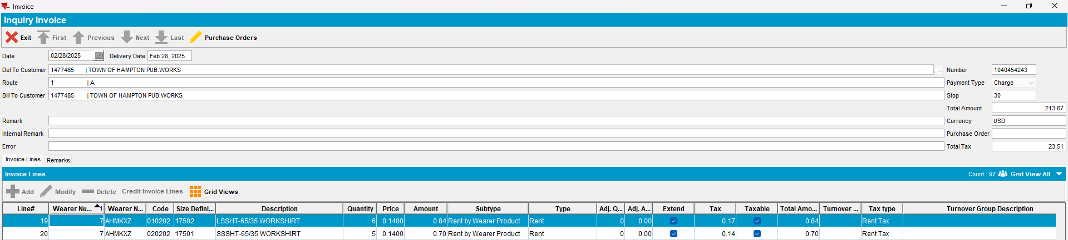
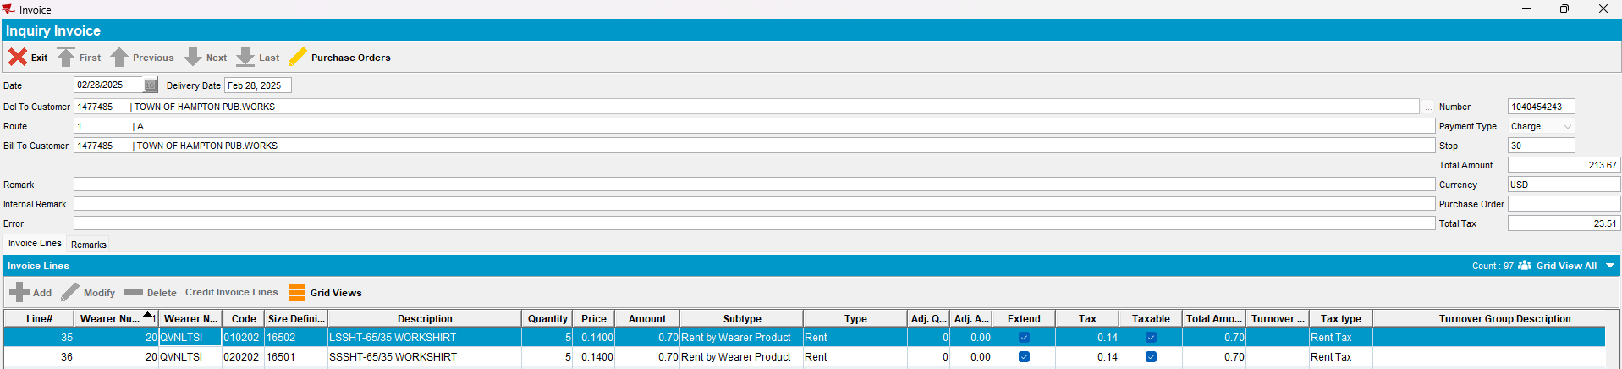
- Mark the route ready for transfer
- Do a decrease of max on the first wearer
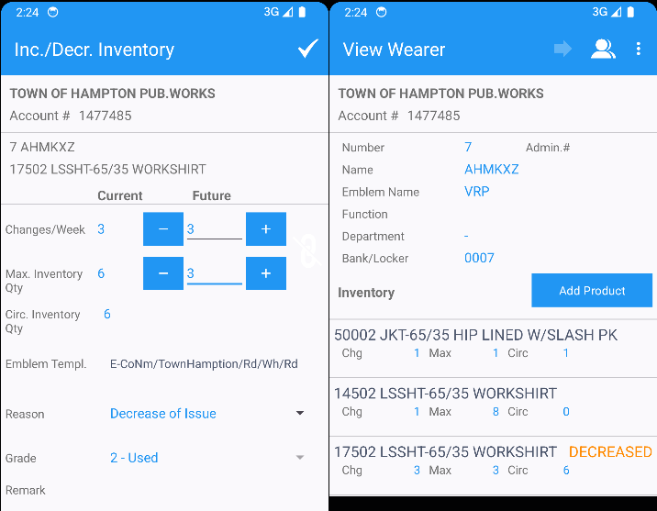

- Do a quit WI on the second wearer
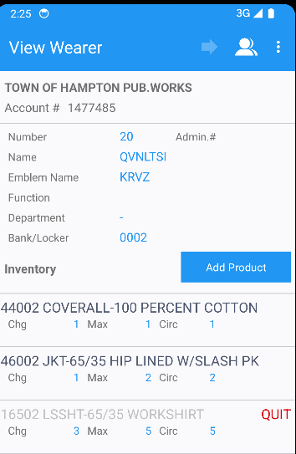

- On RA Bill All for Loss Now
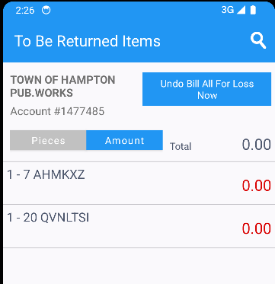
- Settle the route, finish and upload it
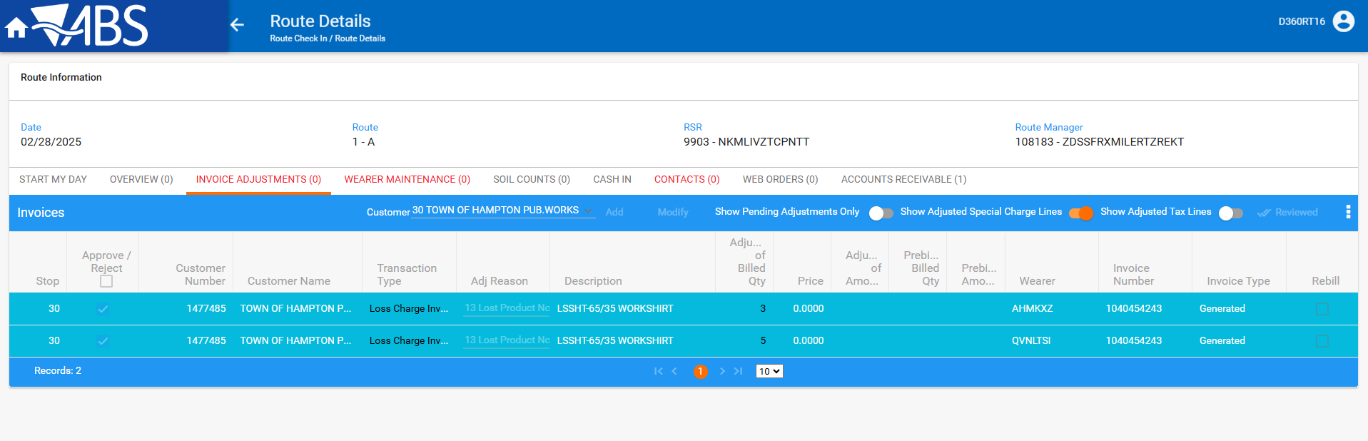

- On WebX settle the route
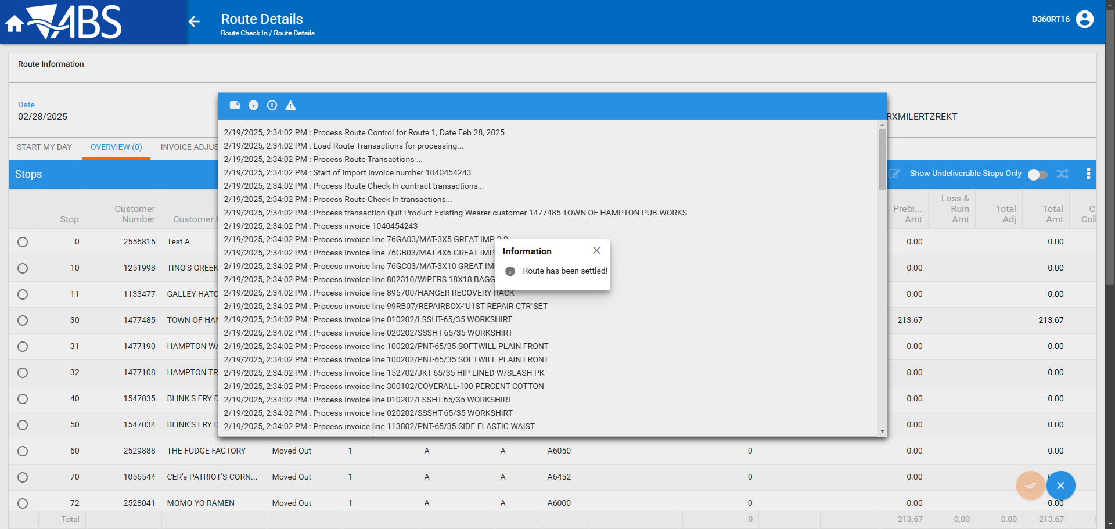

- Check the invoice, it should have 2 new loss charges for a total amount 0
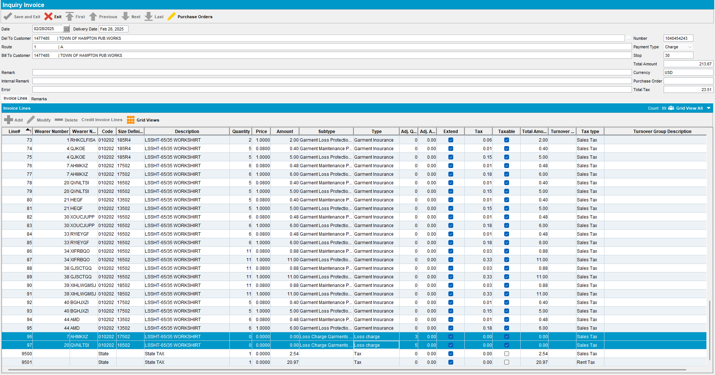

- Check that the garments that were marked for loss were ragged
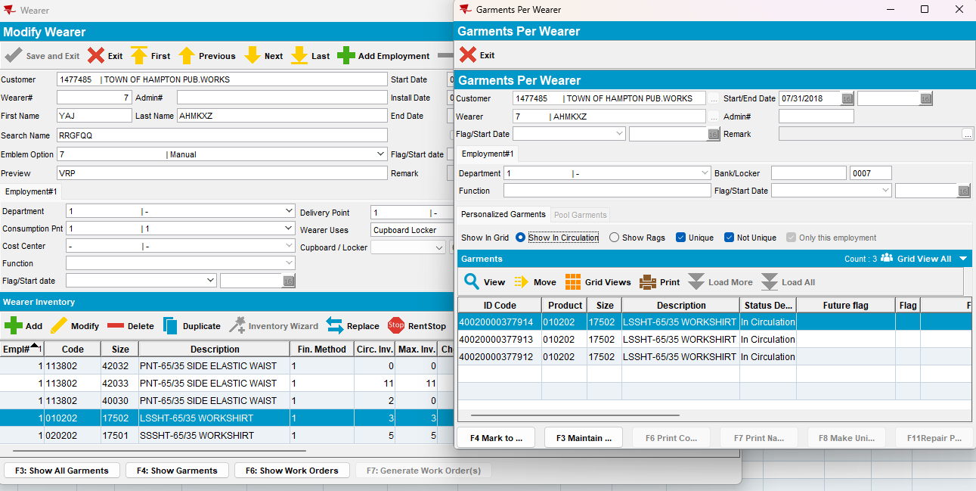
Wearer 7 – DOI from 7 to 3 2 non-uniques and 1 unique were ragged – OK

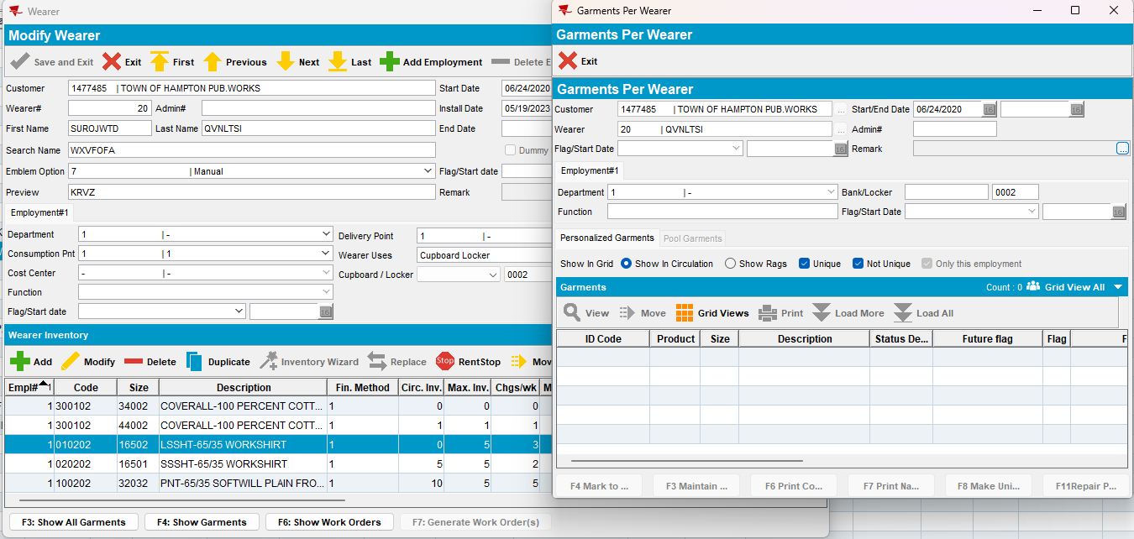
Wearer 22 – Quit WI all 5 non-uniques were ragged –OK

