ABSN-2296 D_UBS_2339 User receiving No wearer inventories found for wearer 1 employment 1 when attempting to process renewal in Replacement Renewal dialog
Environment | Prerequisites
Version: 9.0.00.UNF19  DBServerName= abs-srv20.internal.abslbs.com  DBSID=CUST24  DBUser=UNFDEV  DBPassword=UNFDEV  Environment=Production | - Module:

Contents
Reproducing before fix 1
Retest after fix 3

Reproducing before fix
Hash: e1ba2b5577f

Steps to reproduce:

- Create a replacement from the menu
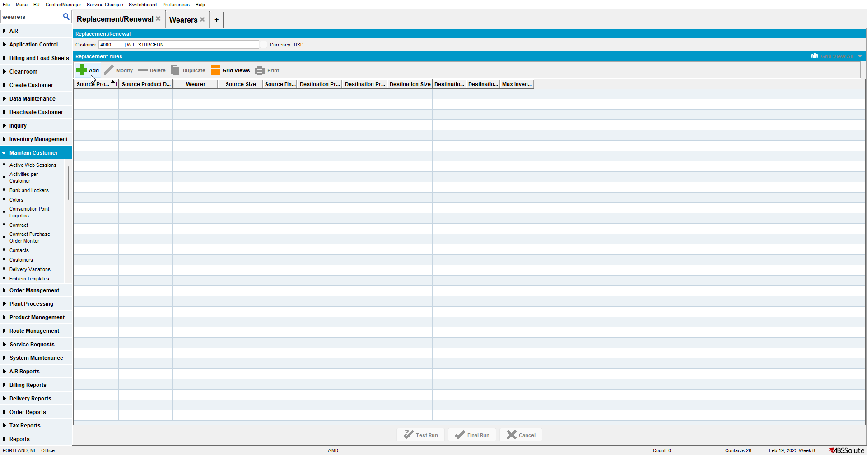

- Select a product
- Check Only Wearer and select a wearer that has a wearer inventory with the previous product
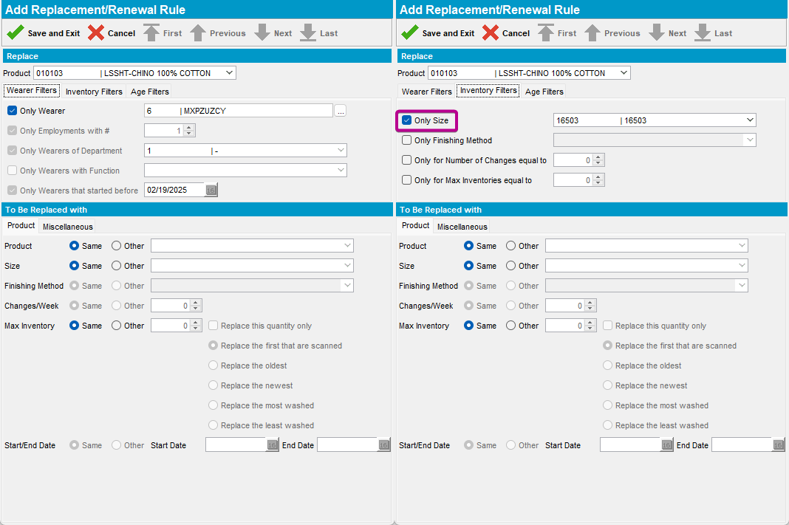

Current behavior: the "Only size" is selected automatically if the field is empty
Expected behavior: the "Only size" must not be selected automatically. When the replacement is created from the Wearers dialog is the only case when it should be selected automatically.

Retest after fix
Hash: 732e018d5ae
- Create a replacement from the menu
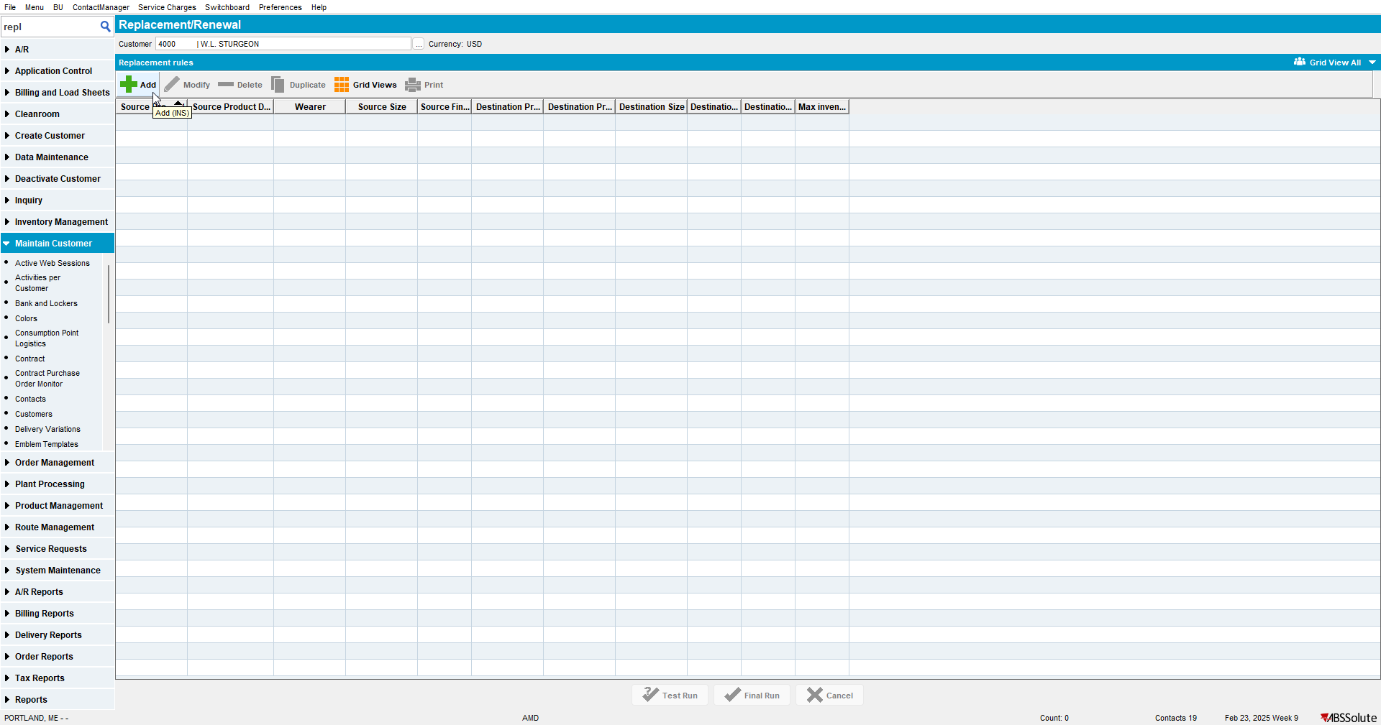

- Select a product
- Check Only Wearer and select a wearer that has a wearer inventory with the previous product
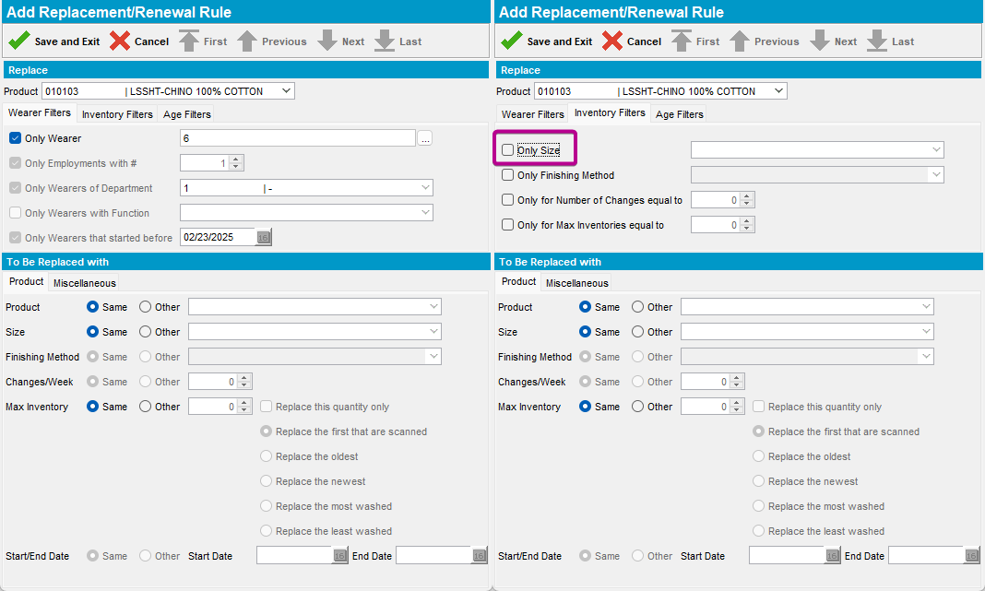

Current behavior: the "Only size" must not be selected automatically.
Expected behavior: the "Only size" must not be selected automatically. When the replacement is created from the Wearers dialog is the only case when it should be selected automatically.

TESTED OK. 💚

