ABSN-2269 [QF][EU_Garment] 'Wrong value class: 2 for column ISSUESTATUS' exception is thrown once pressing Cancel Charge button
Environment | Prerequisites
Version:9.07.00  DBServerName=abs-SRV20.internal.abslbs.com  DBSID=CUST24  DBUser=UNFDEV  DBPassword=UNFDEV  Environment=Test | - Module:  - System setting

Contents
Retest after fix 1
Test Case 1 – Prep Charges – Tested OK 1
Test Case 2 – Special Size Charge – Tested OK 4
Test Case 3 – Exchange Charge – Tested OK 6

Retest after fix

Test Case 1 – Prep Charges – Tested OK
Expected behavior: Cancel Charge or Undo Cancel Charge should update only Status, System User and Timestamp.
Hash: bff01e8
- Do a Cancel Charge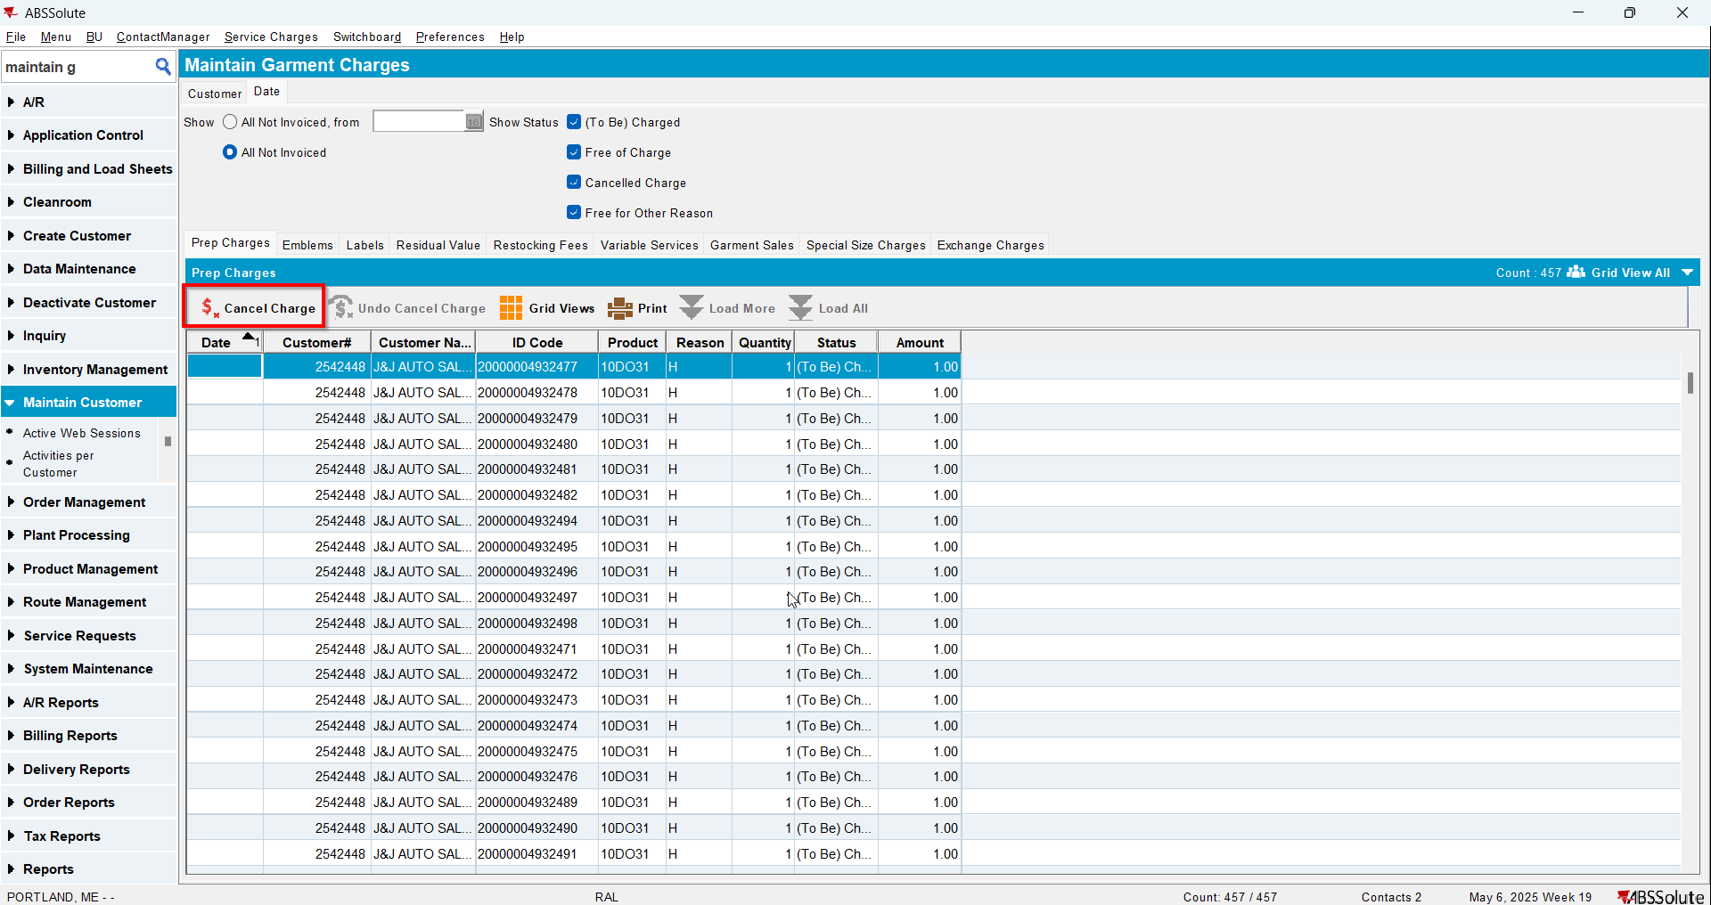
- Check the Executed Transactions for the update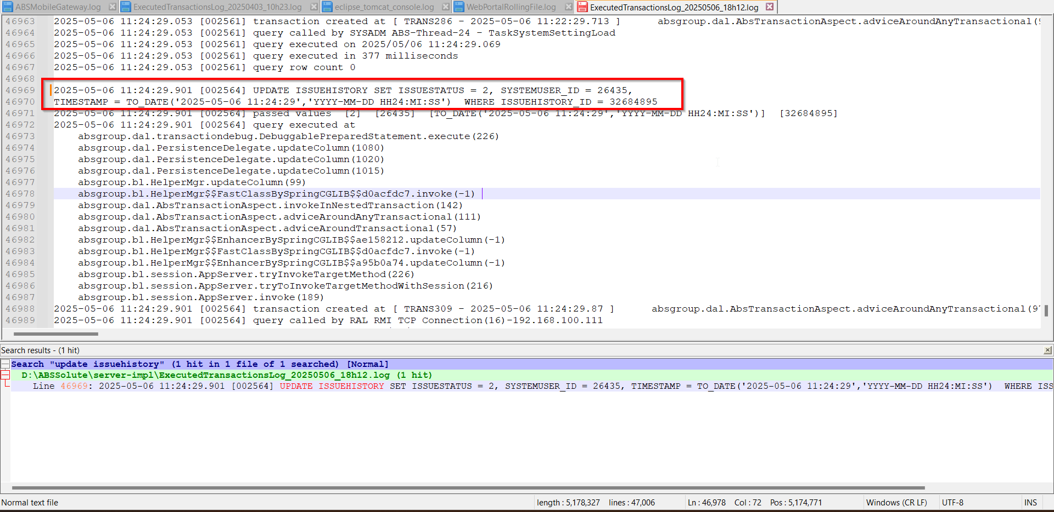
- Do an Undo Cancel Charge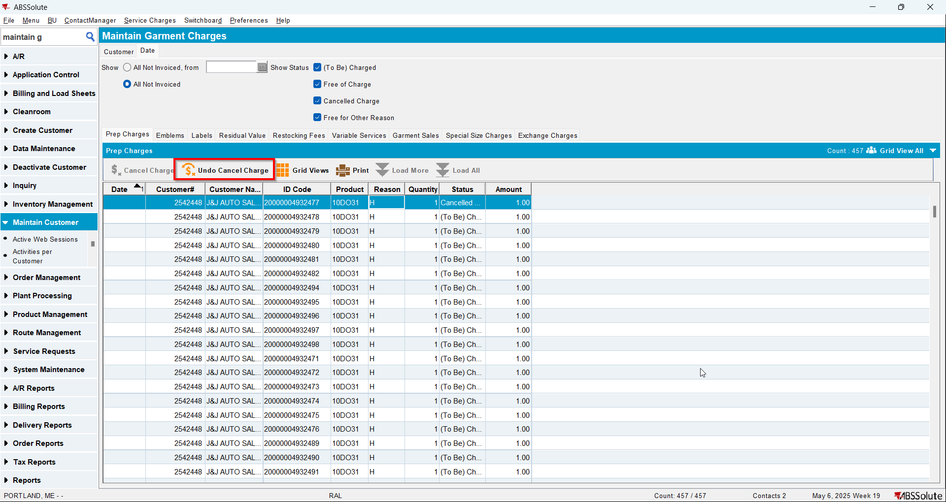
- Check the Executed Transactions for the update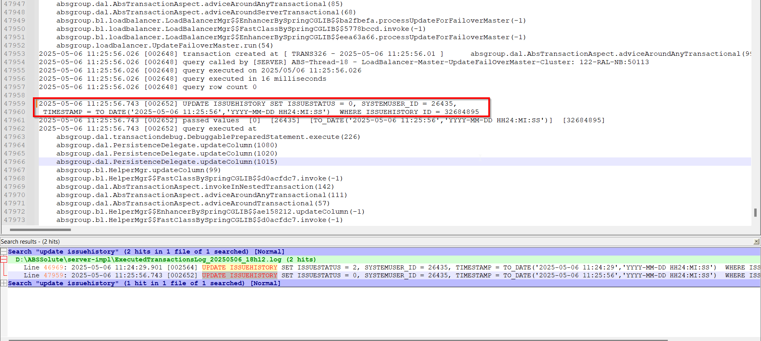
- Check there are no errors in Server Error Log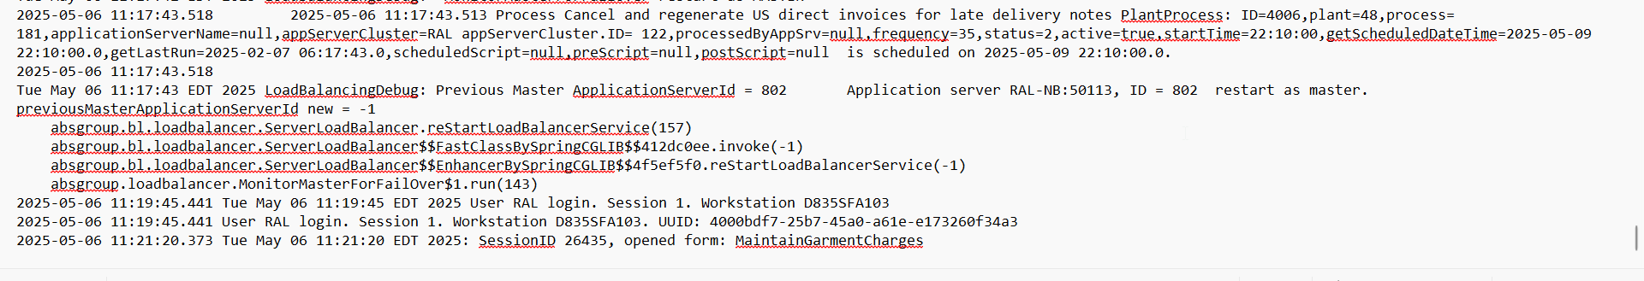
- Check there are no errors in Client Error Log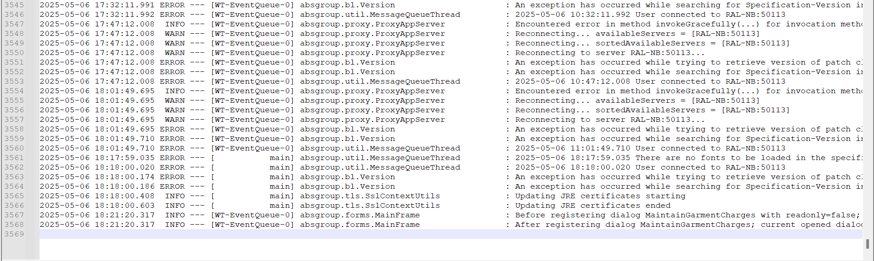

Test Case 2 – Special Size Charge – Tested OK
Expected behavior: Cancel Charge or Undo Cancel Charge should update only Status, System User and Timestamp.
Hash: bff01e8
- Do a Cancel Charge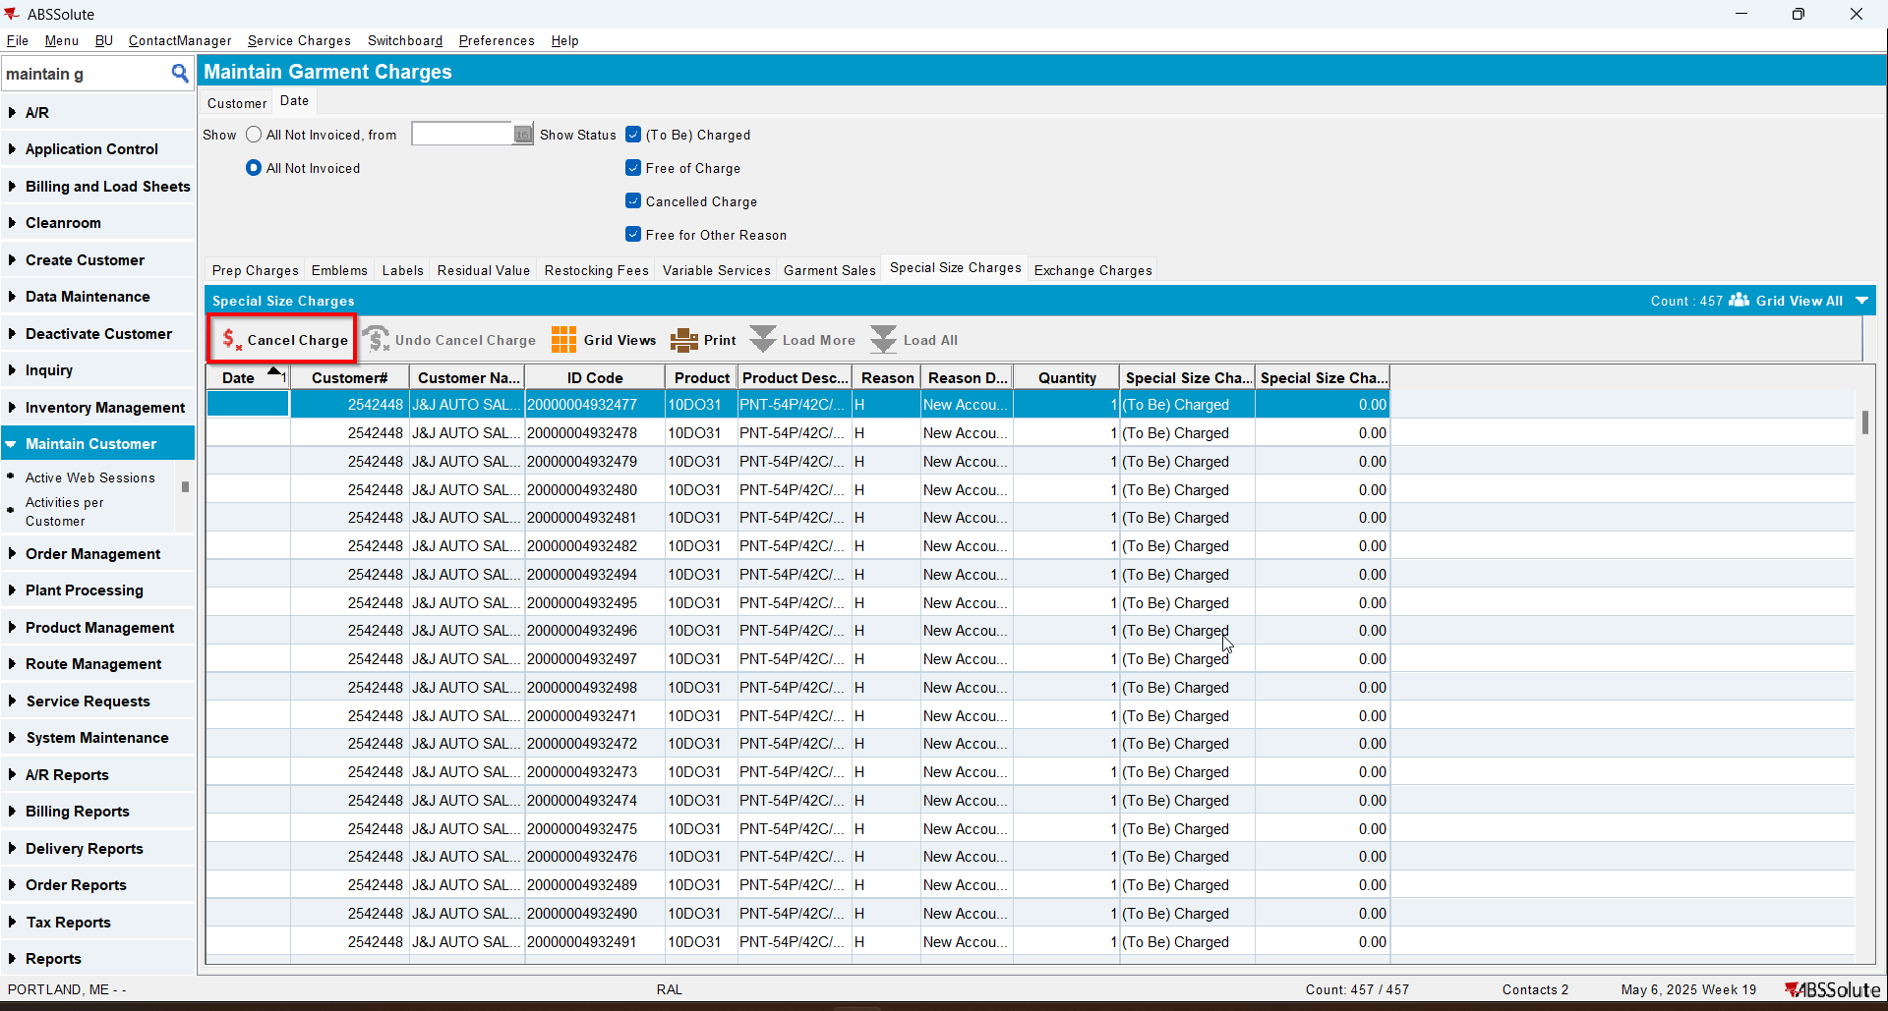
- Check the Executed Transactions for the update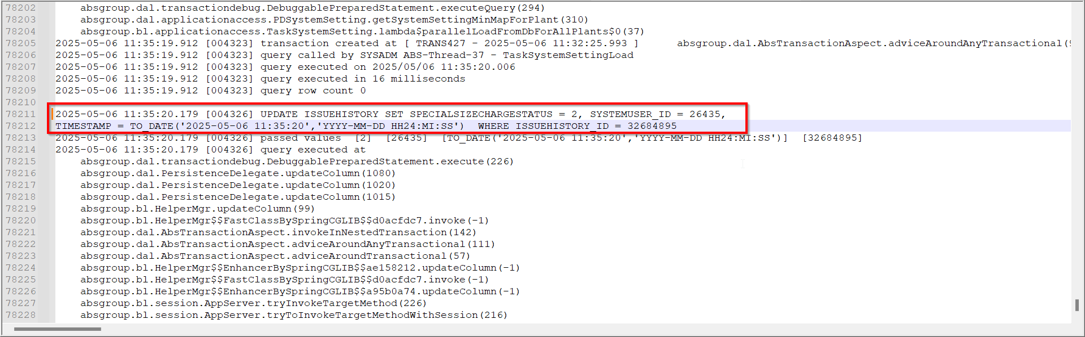
- Do an Undo Cancel Charge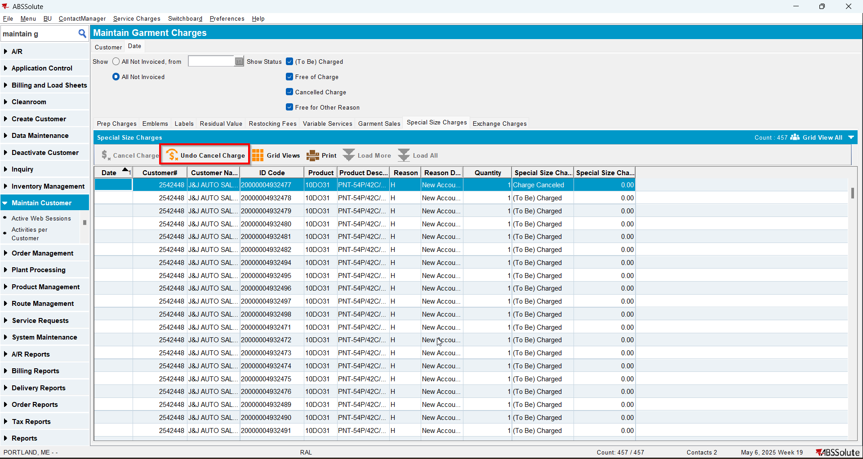
- Check the Executed Transactions for the update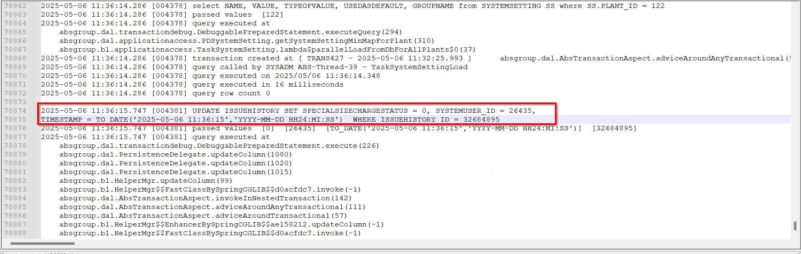
- Check there are no errors in Server Error Log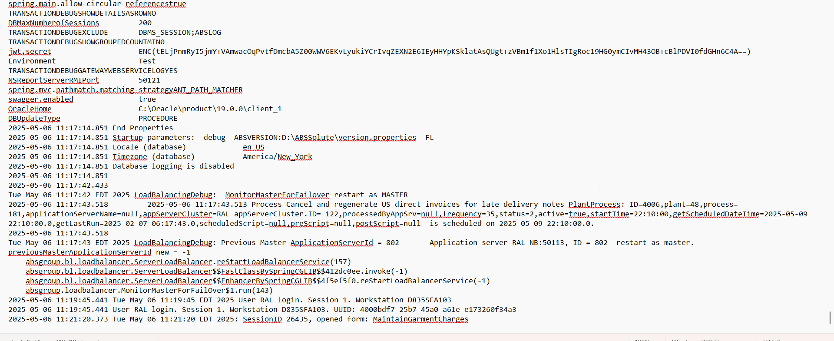
- Check there are no errors in Client Error Log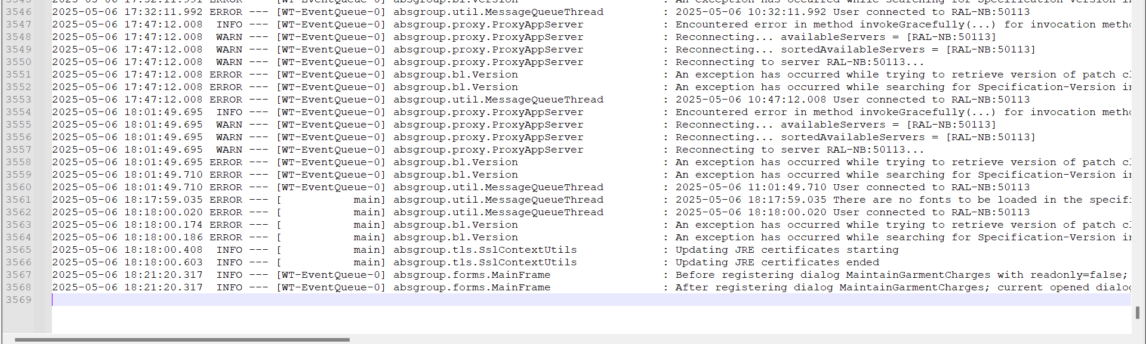

Test Case 3 – Exchange Charge – Tested OK
Expected behavior: Cancel Charge or Undo Cancel Charge should update only Status, System User and Timestamp.
Hash: bff01e8
- Do a Cancel Charge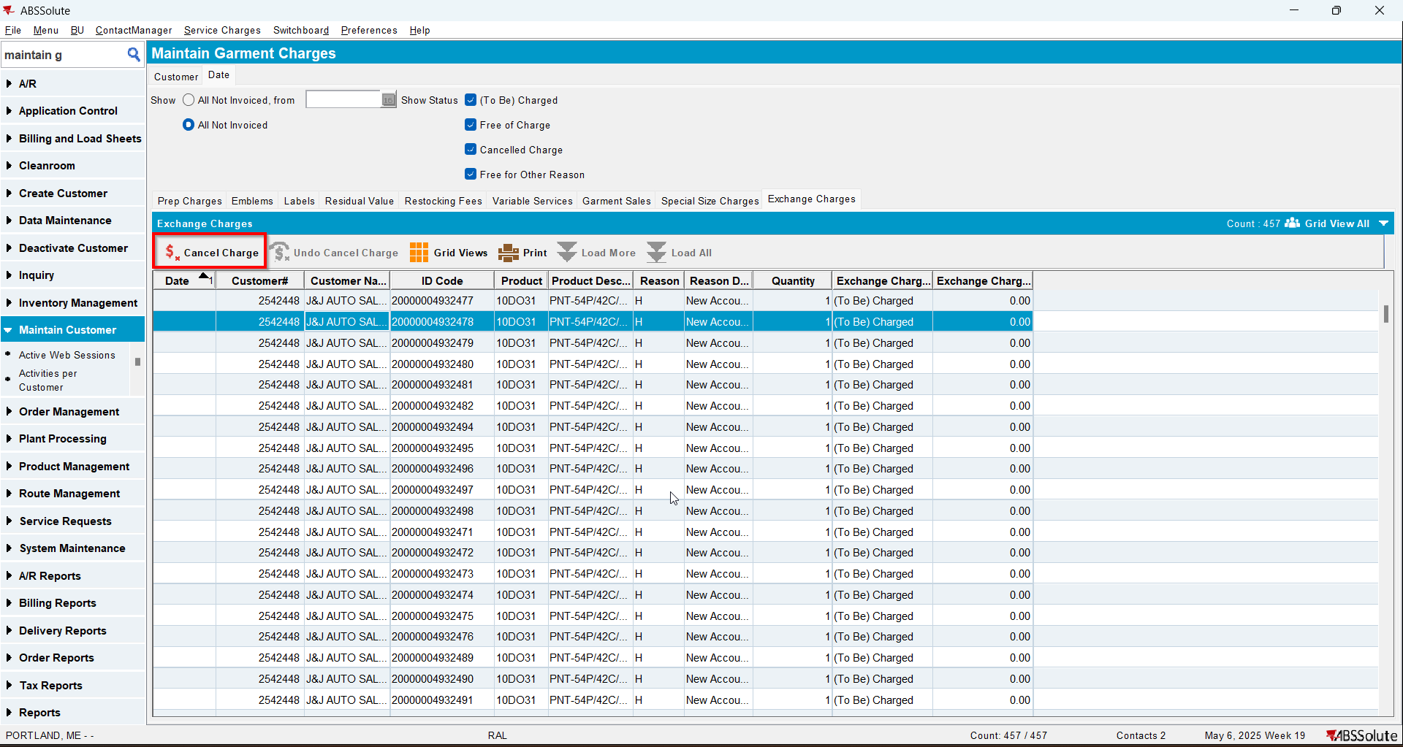
- Check the Executed Transactions for the update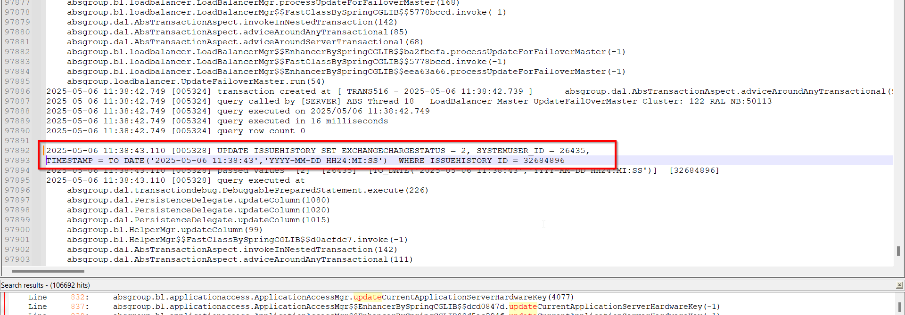
- Do an Undo Cancel Charge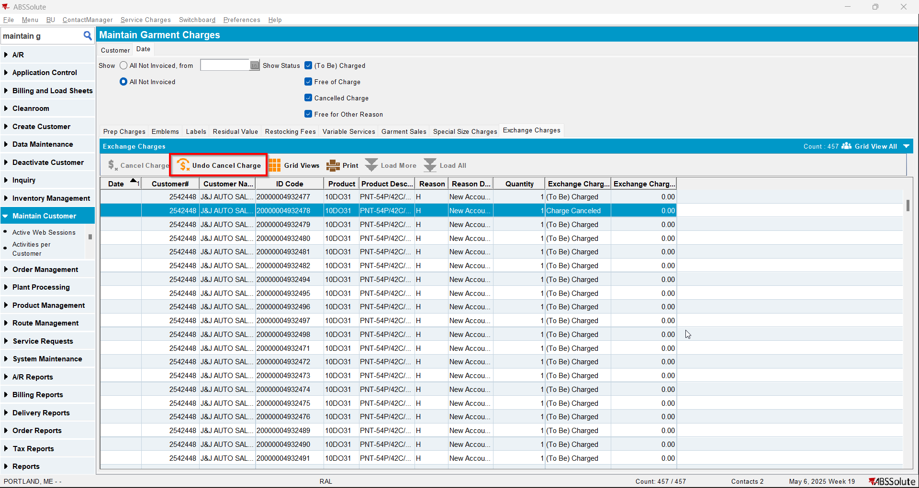
- Check the Executed Transactions for the update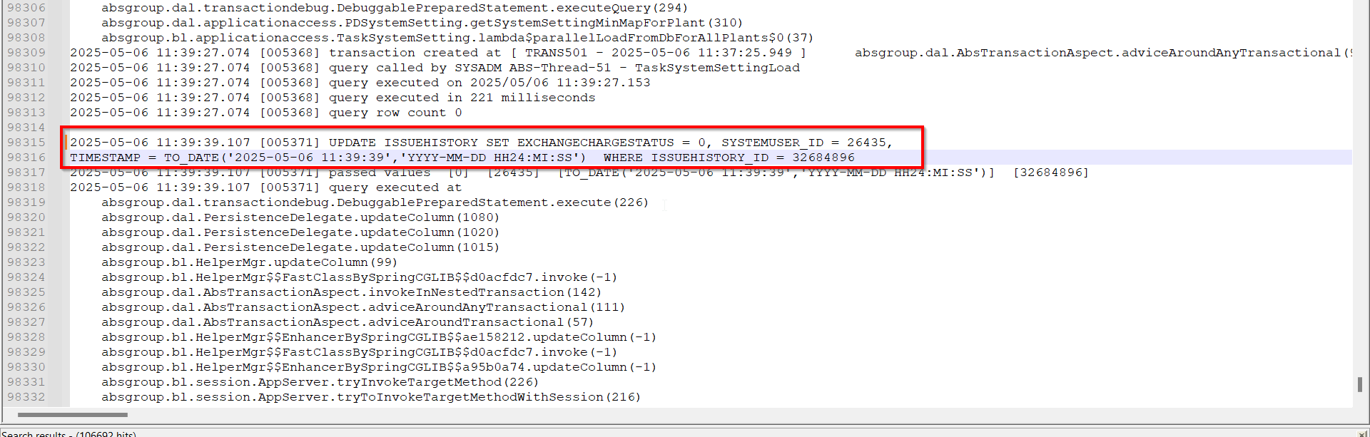
- Check there are no errors in Server Error Log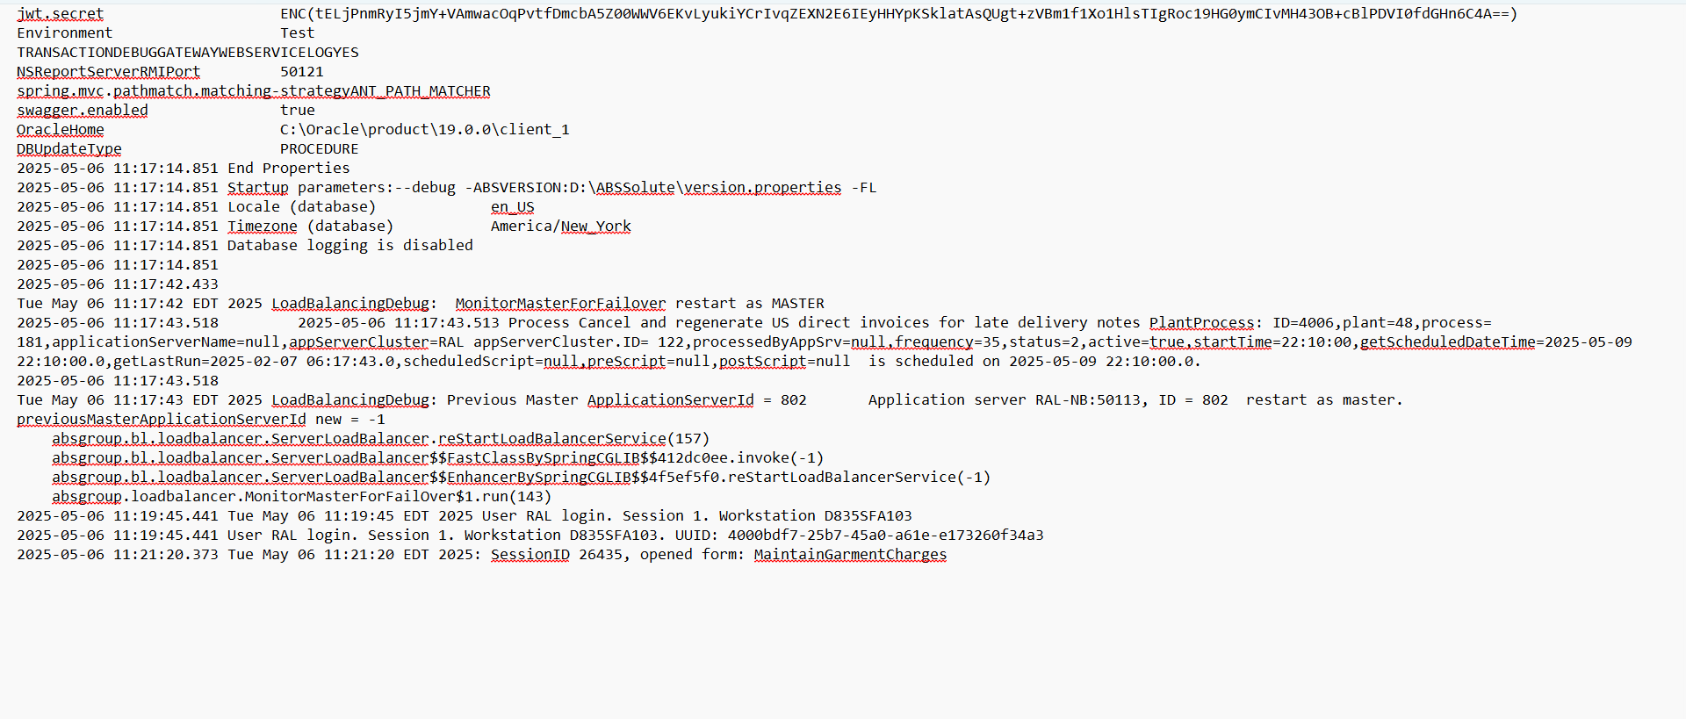
- Check there are no errors in Client Error Log