ABSN-2146 Maintain Garment Charges - Cancel charge buttons
Environment | Prerequisites
Version:9.07.00  DBServerName=abs-SRV20.internal.abslbs.com  DBSID=CUST24  DBUser=UNFDEV  DBPassword=UNFDEV  Environment=Test | - Module:  - System setting

Contents
Reproducing before fix 1
Current Behavior 1
Expected behavior 1
Test Case 1 – Residual value – Tested OK 1
Test Case 2 – Restocking fees – Tested OK 3
Test Case 3 – Garment Sales – Tested OK 5
Test Case 4 – Emblems – Tested OK 7
Test Case 5 – Labels – Tested OK 9
Test Case 6 – Repair History / Variable Services– Tested OK 11
Retest after fix 13
Test Case 1 – Residual value – Tested OK 13
Test Case 2 – Restocking fees – Tested OK 15
Test Case 3 – Garment Sales – Tested OK 17
Test Case 4 – Emblems – Tested OK 19
Test Case 5 – Labels – Tested OK 21
Test Case 6 – Repair History / Variable Services – Tested OK 23

Reproducing before fix

Current Behavior
Cancel Charge or Undo Cancel Charge updates the entire columns of the record.

Expected behavior
Cancel Charge or Undo Cancel Charge should update only Status, System User and Timestamp.

Test Case 1 – Residual value – Tested OK
Hash: 084efa3
- Do a Cancel Charge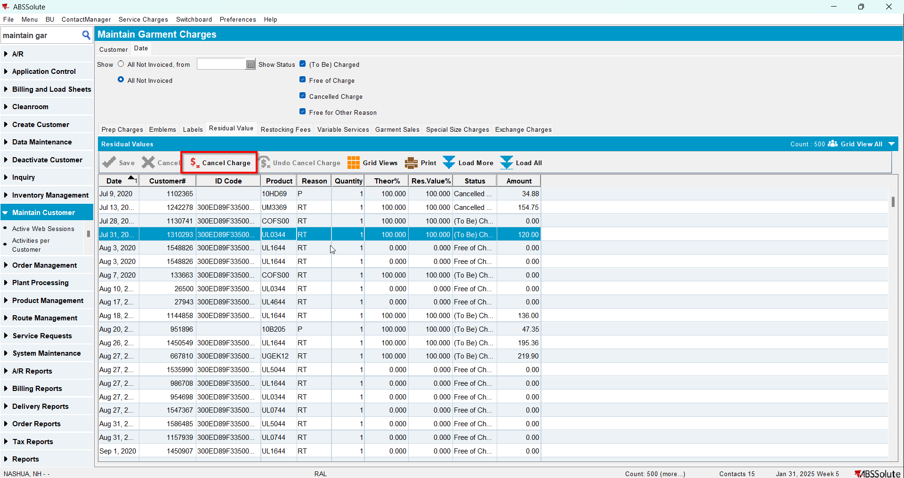
- Check the Executed Transactions for the update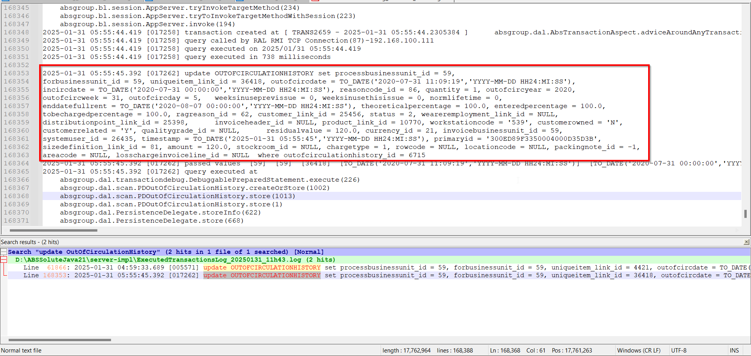
- Do an Undo Cancel Charge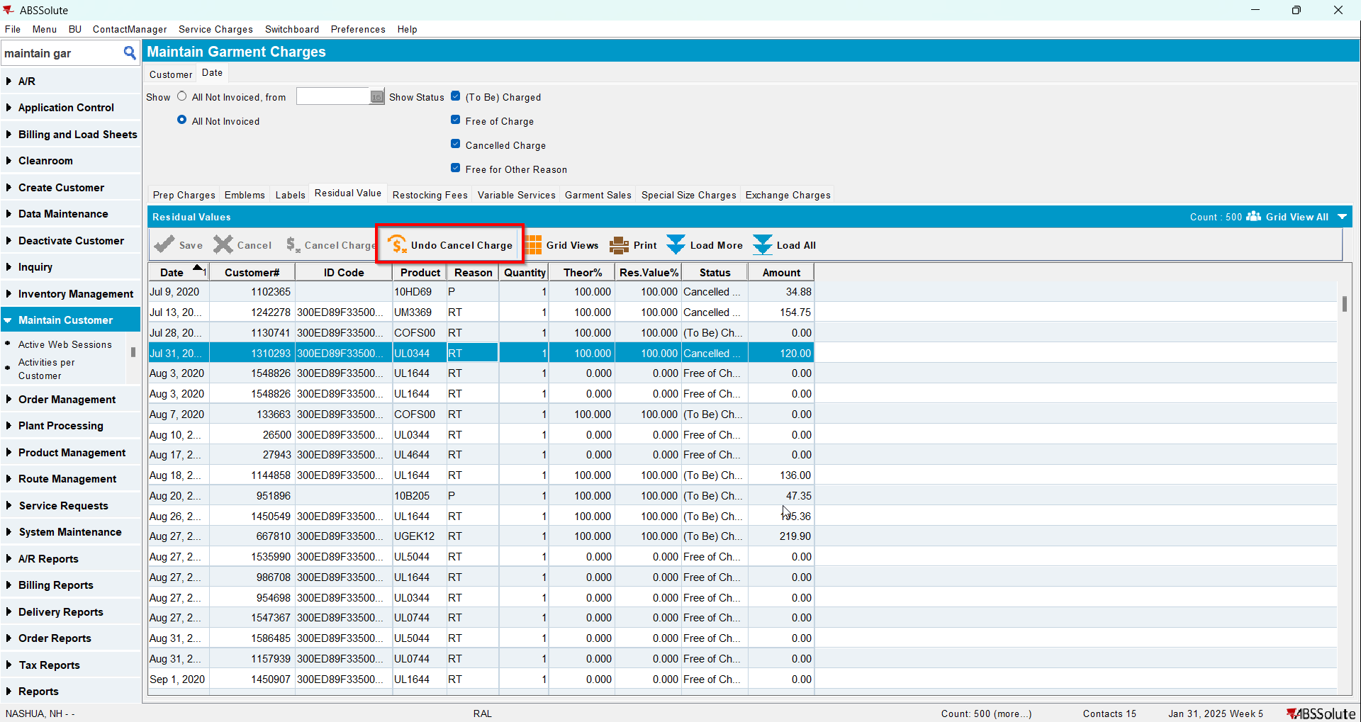
- Check the Executed Transactions for the update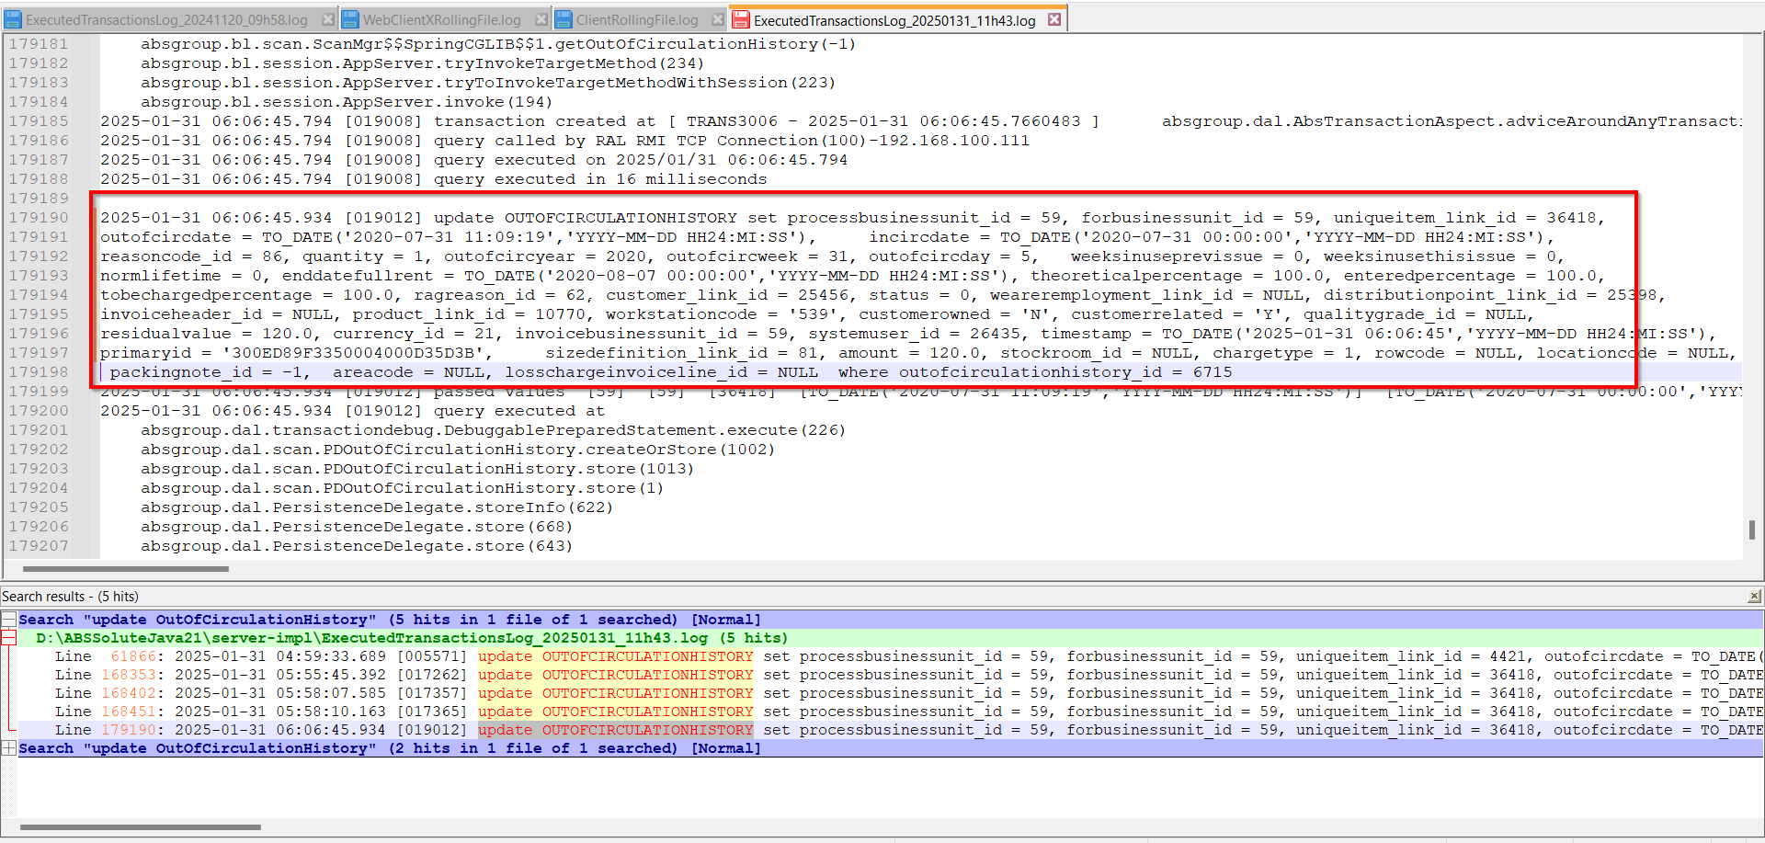

Test Case 2 – Restocking fees – Tested OK
Hash: 084efa3
- Do a Cancel Charge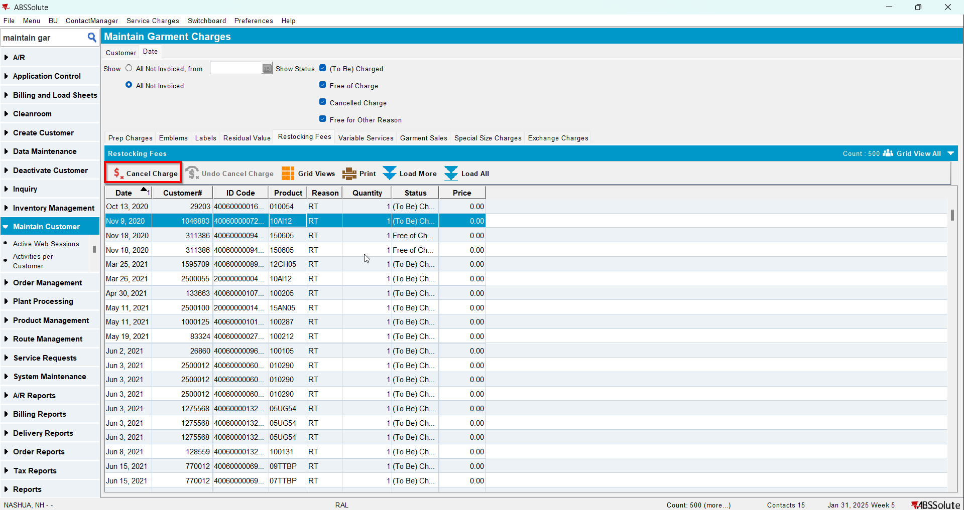
- Check the Executed Transactions for the update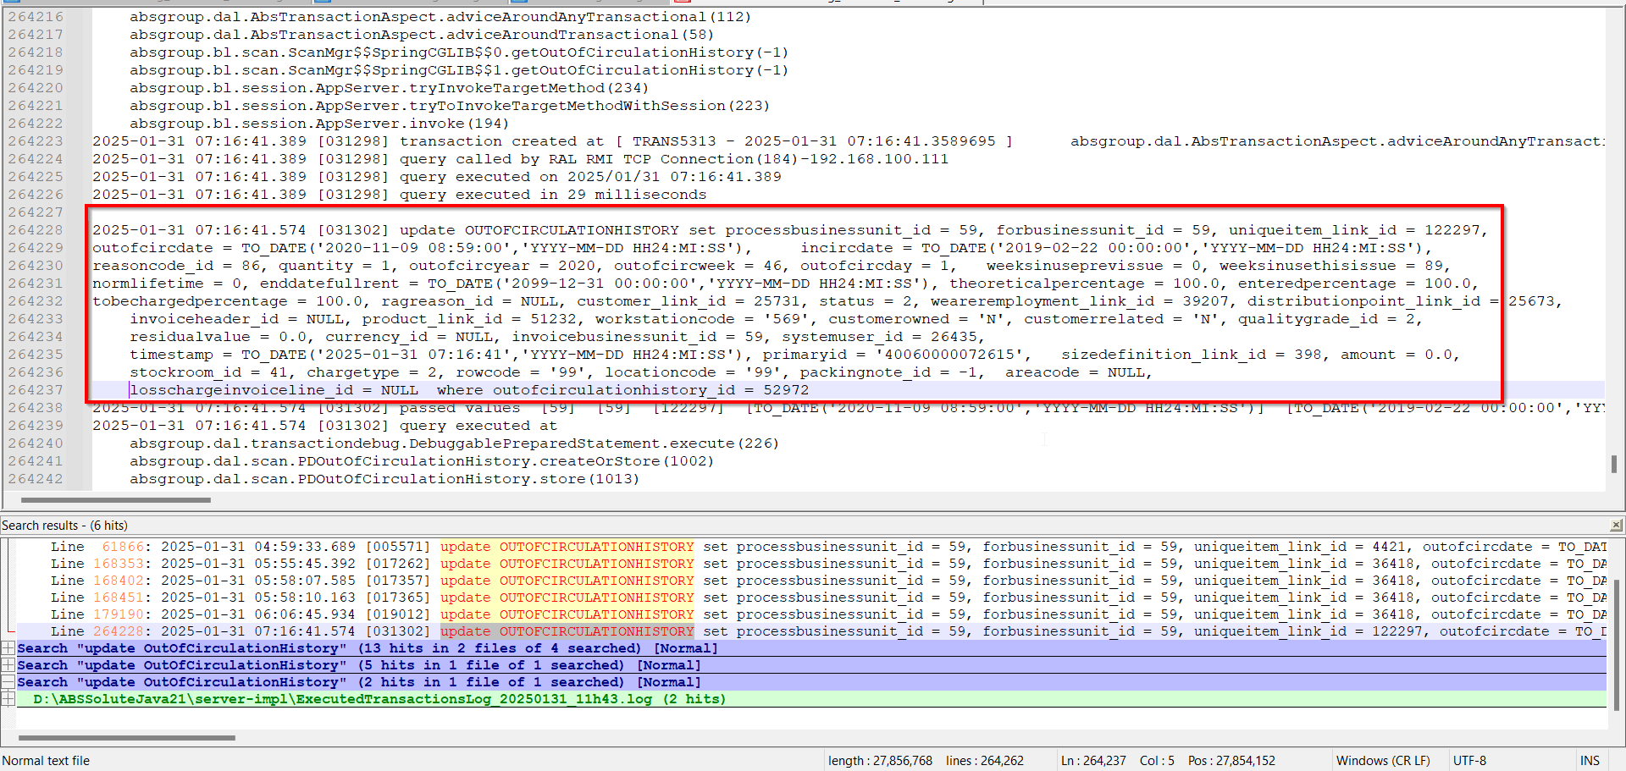
- Do an Undo Cancel Charge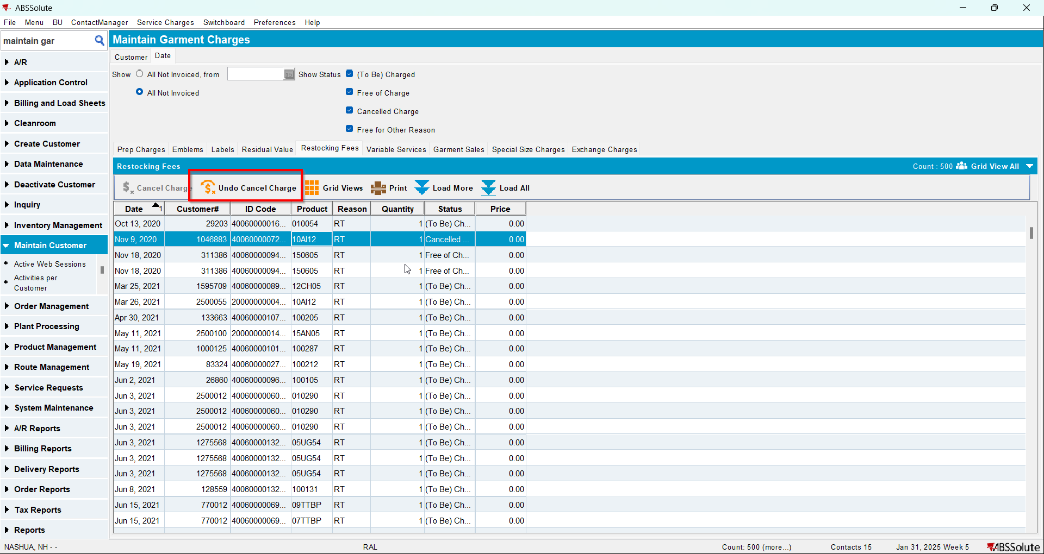
- Check the Executed Transactions for the update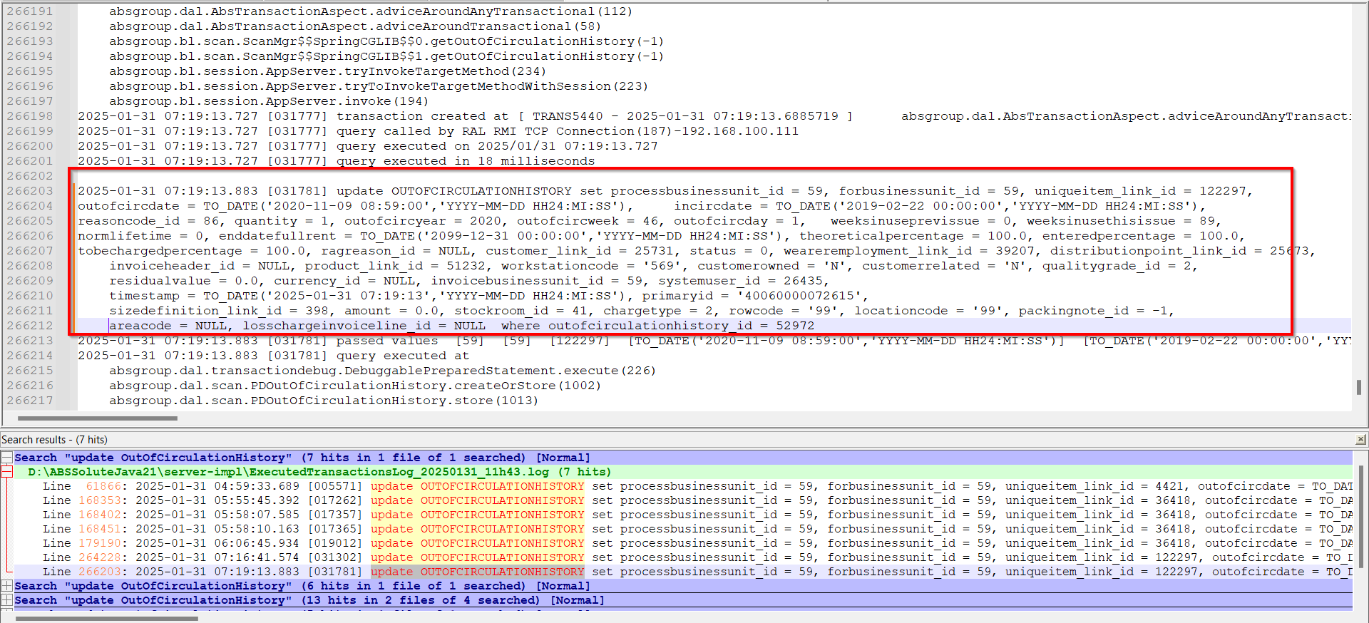

Test Case 3 – Garment Sales – Tested OK
Hash: 084efa3
- Do a Cancel Charge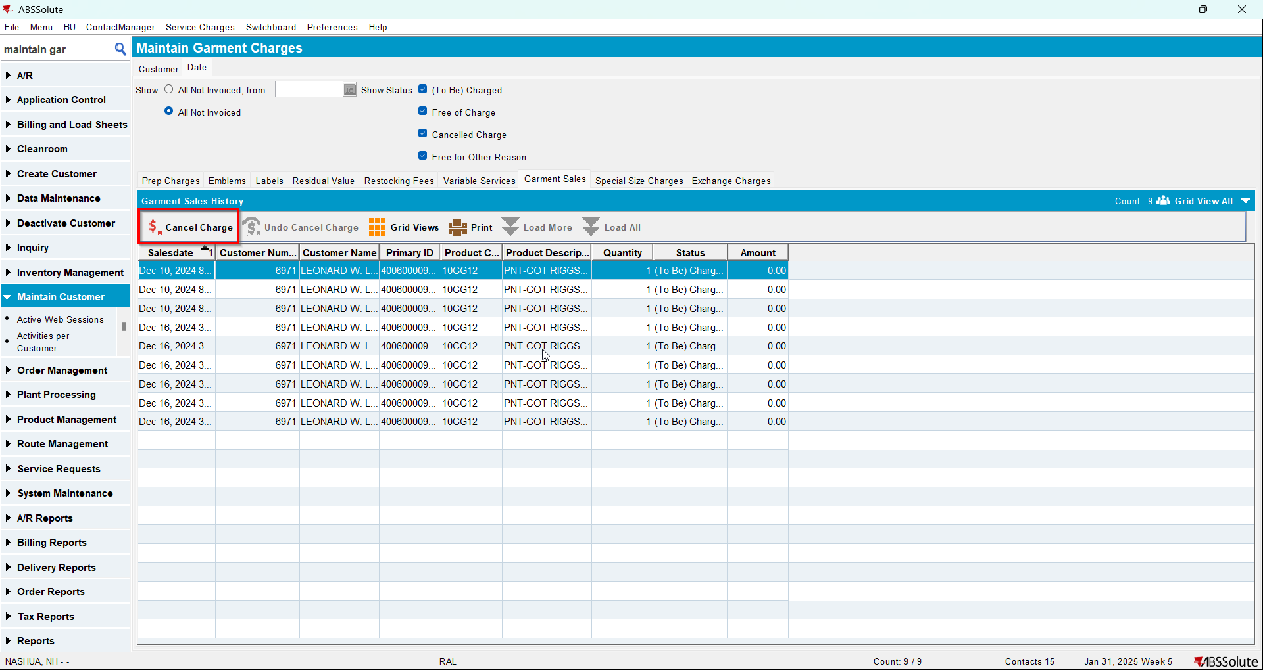
- Check the Executed Transactions for the update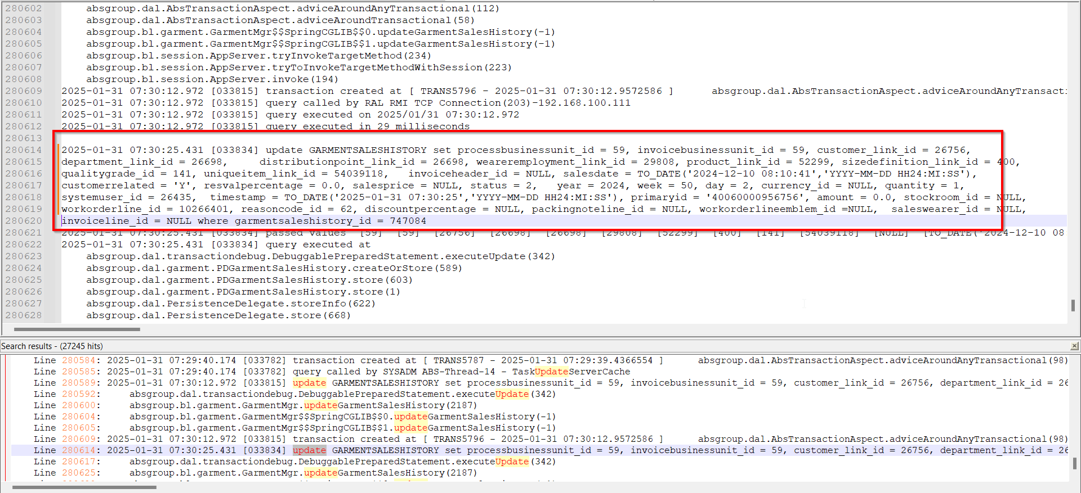
- Do an Undo Cancel Charge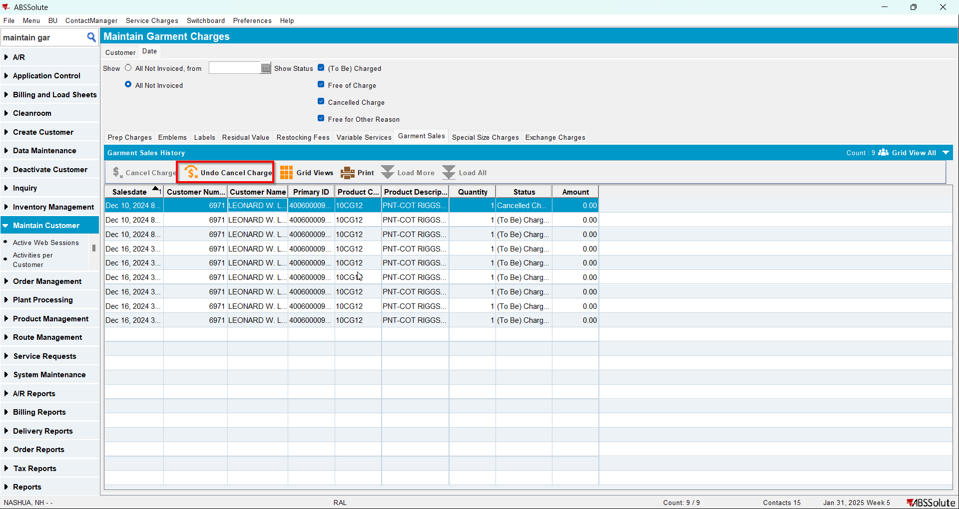
- Check the Executed Transactions for the update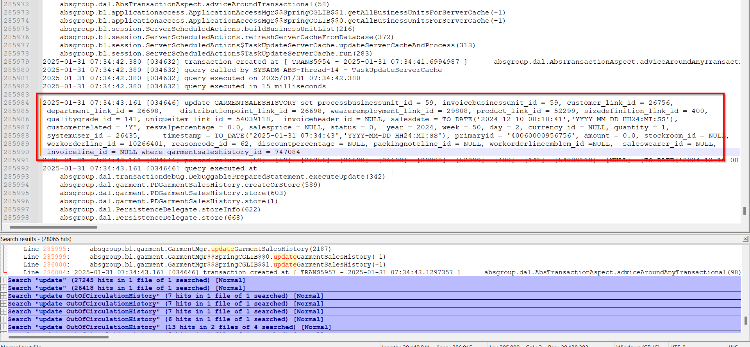

Test Case 4 – Emblems – Tested OK
Hash: 084efa3
- Do a Cancel Charge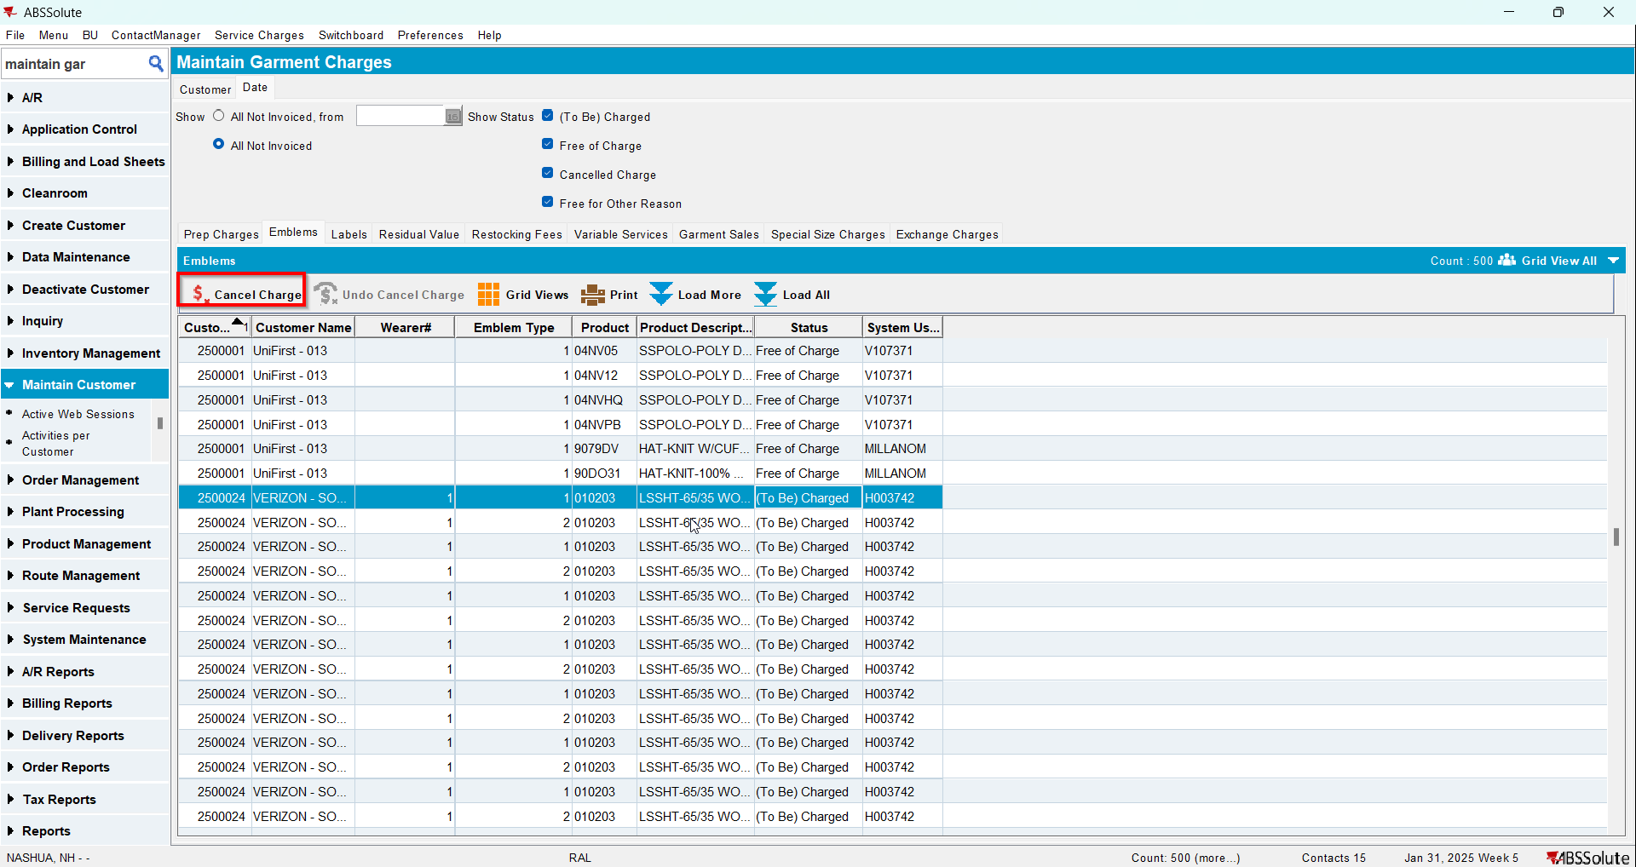
- Check the Executed Transactions for the update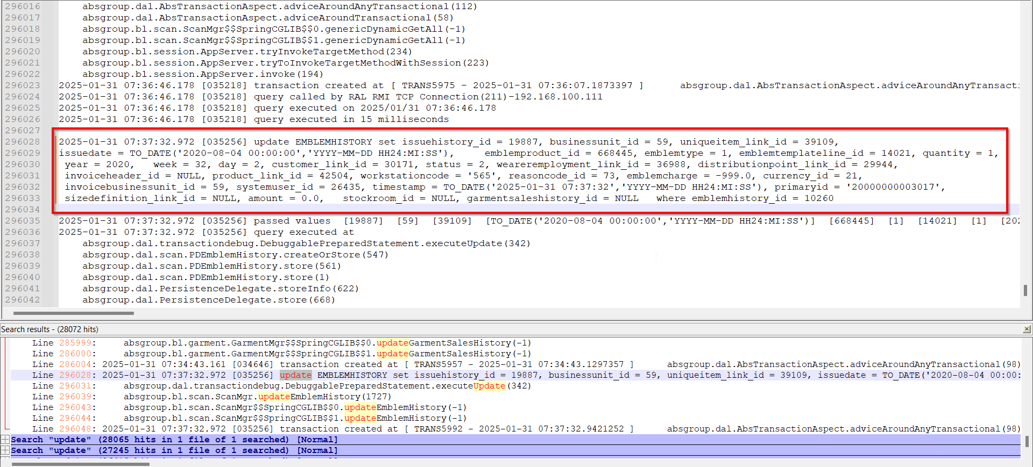
- Do an Undo Cancel Charge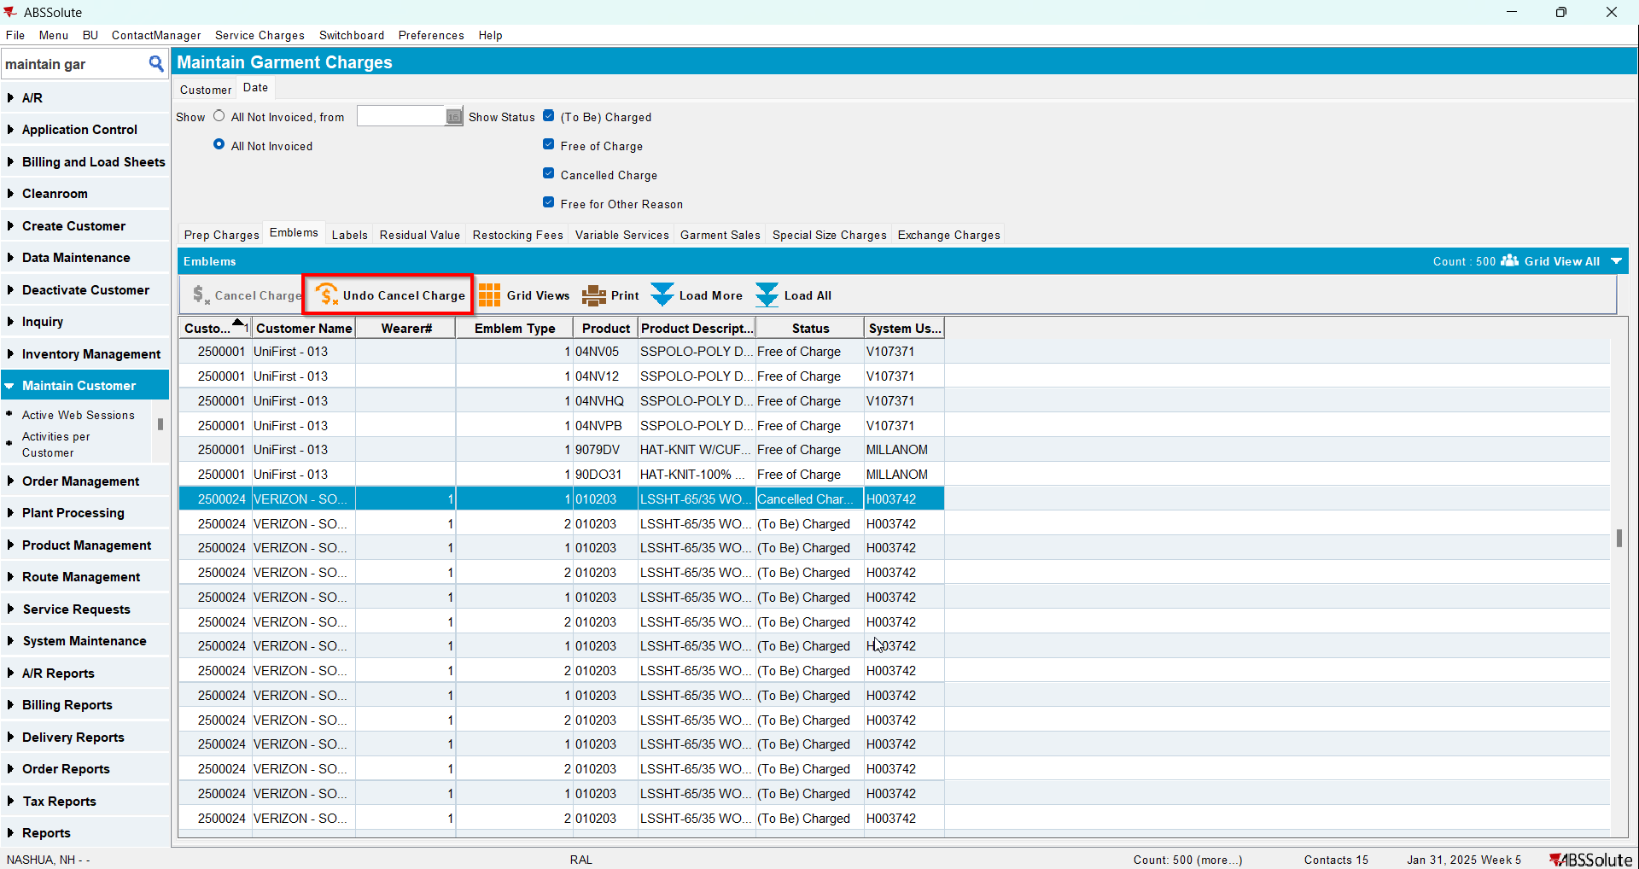
- Check the Executed Transactions for the update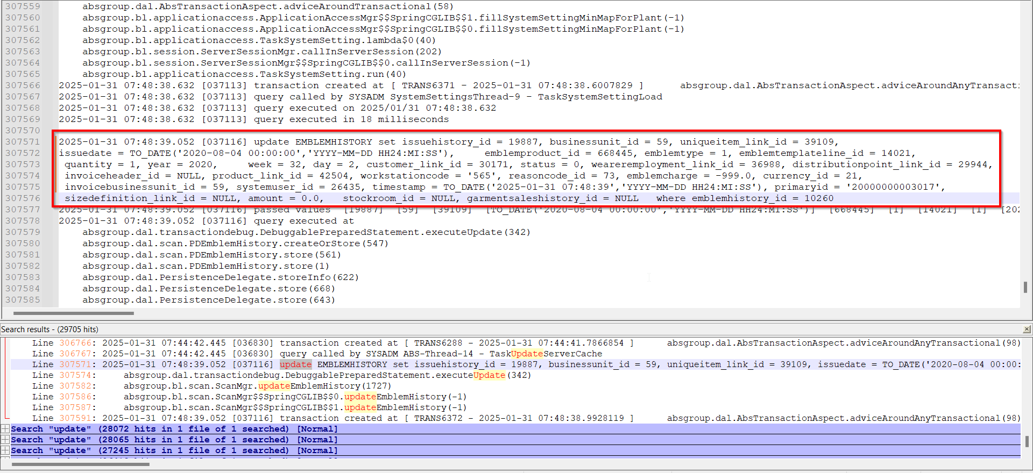

Test Case 5 – Labels – Tested OK
Hash: 084efa3
- Do a Cancel Charge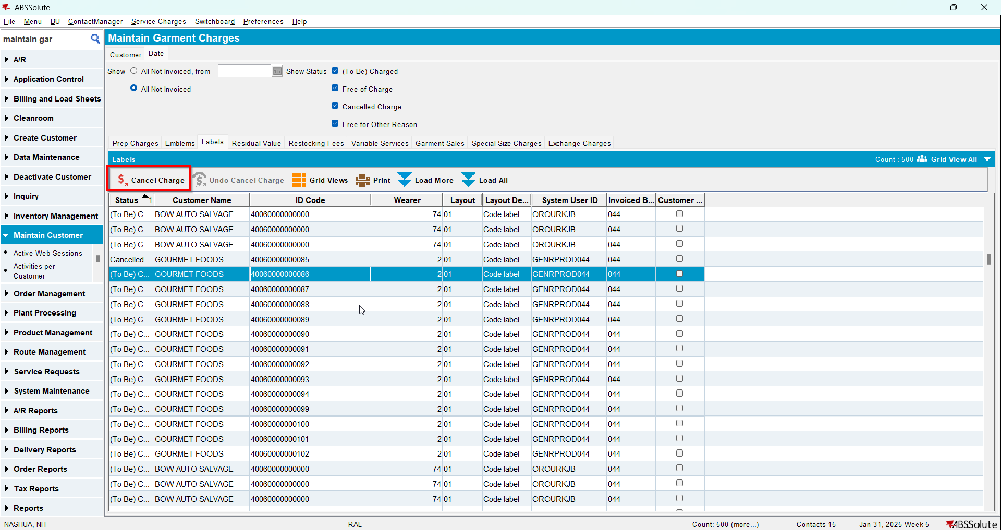
- Check the Executed Transactions for the update
- Do an Undo Cancel Charge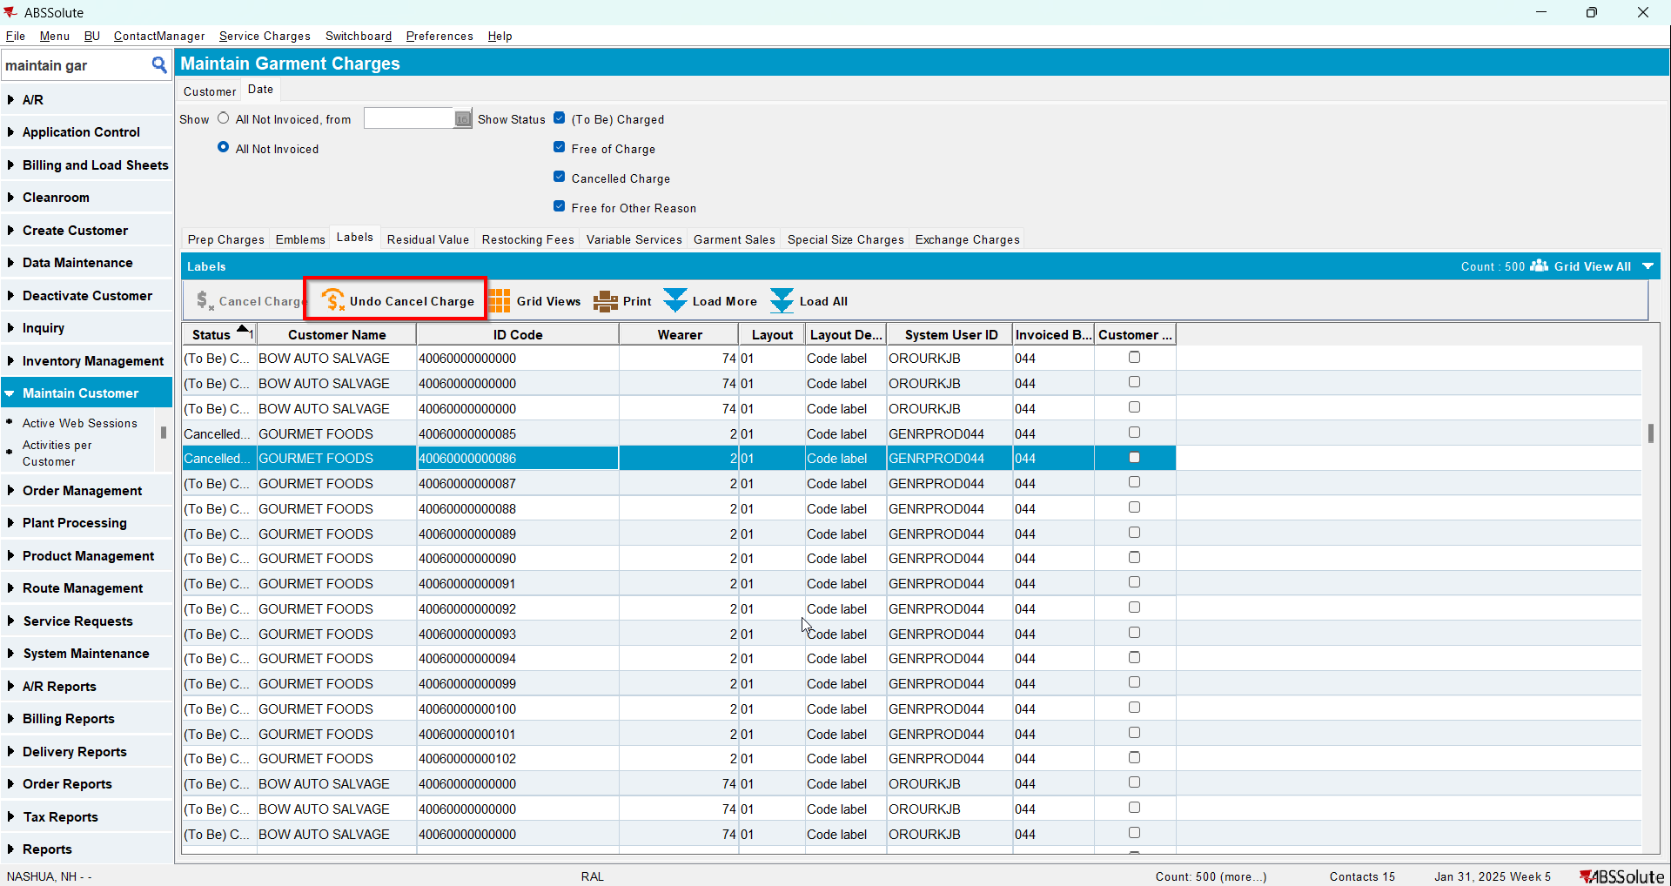
- Check the Executed Transactions for the update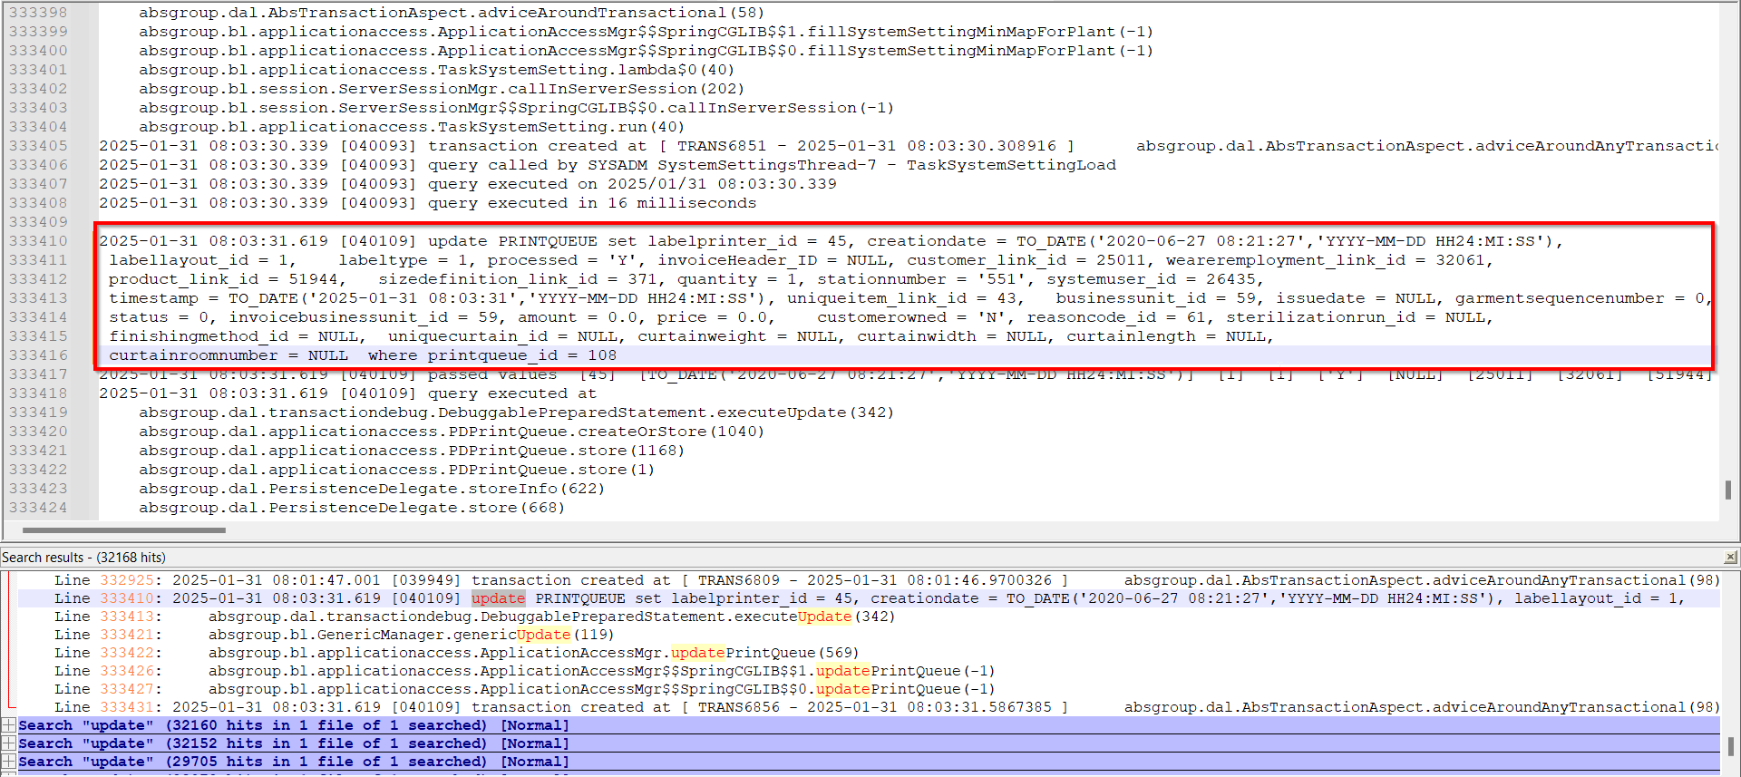

Test Case 6 – Repair History / Variable Services– Tested OK
Hash: 084efa3
- Do a Cancel Charge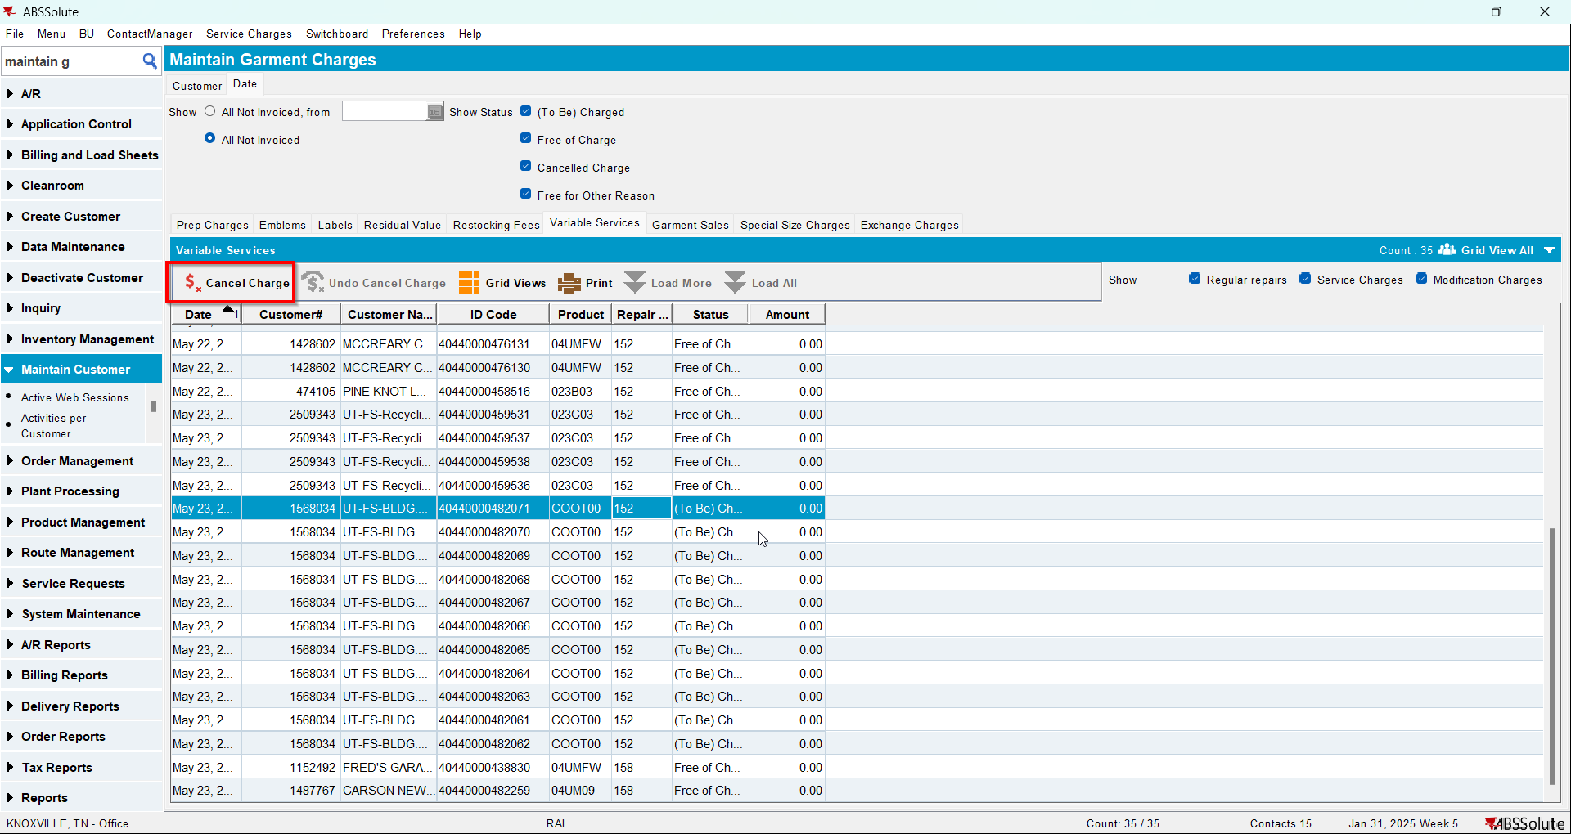
- Check the Executed Transactions for the update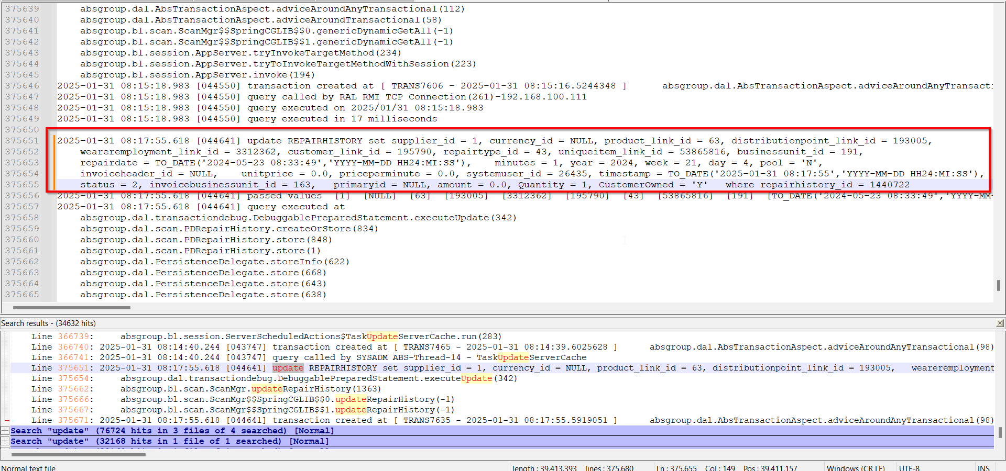
- Do an Undo Cancel Charge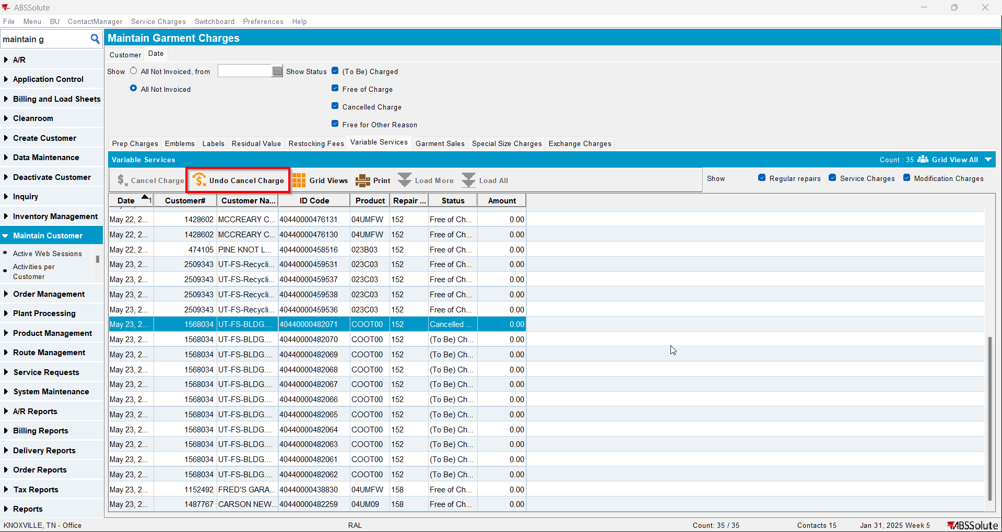
- Check the Executed Transactions for the update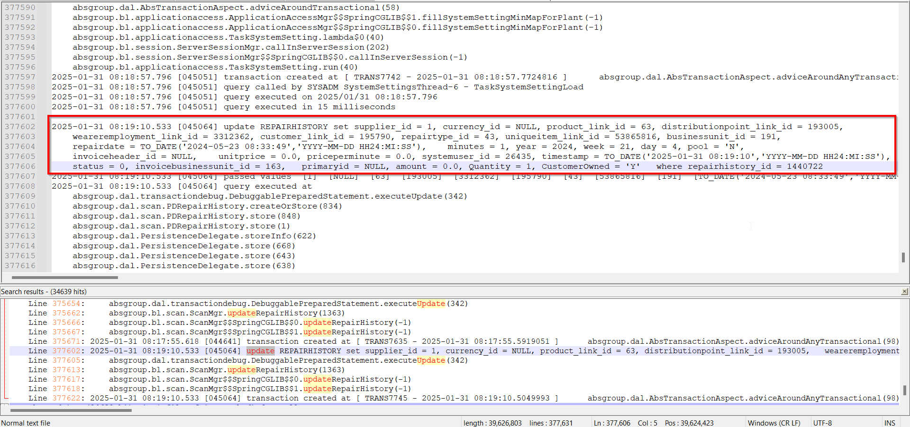

Retest after fix

Test Case 1 – Residual value – Tested OK
Expected behavior: Cancel Charge or Undo Cancel Charge should update only Status, System User and Timestamp.
Hash: 2960225
- Do a Cancel Charge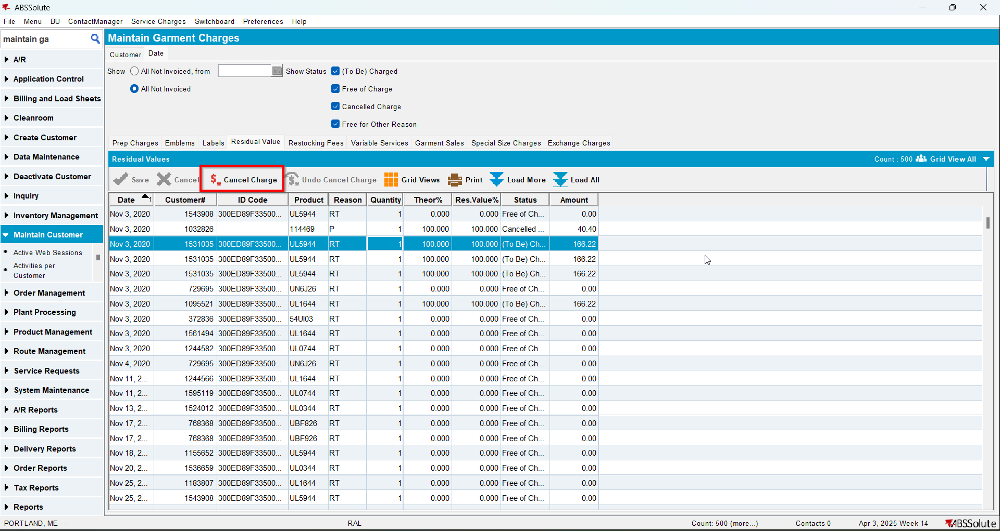
- Check the Executed Transactions for the update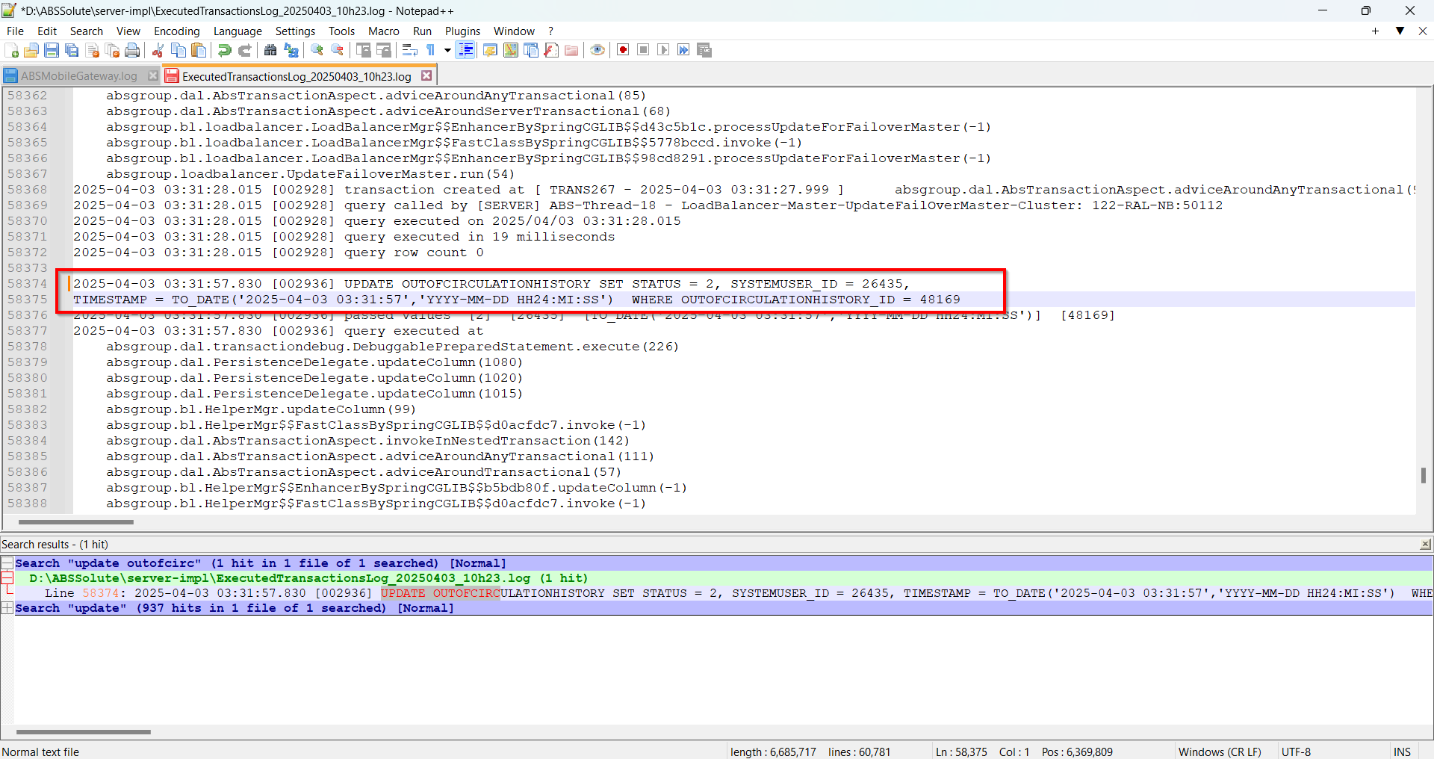
- Do an Undo Cancel Charge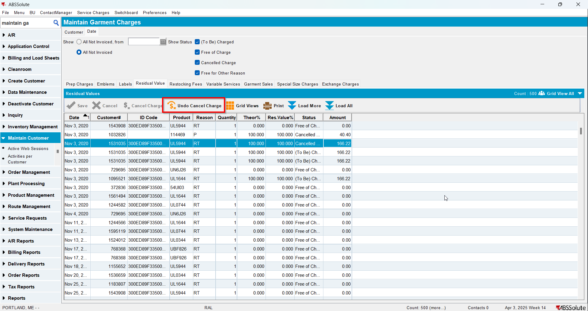
- Check the Executed Transactions for the update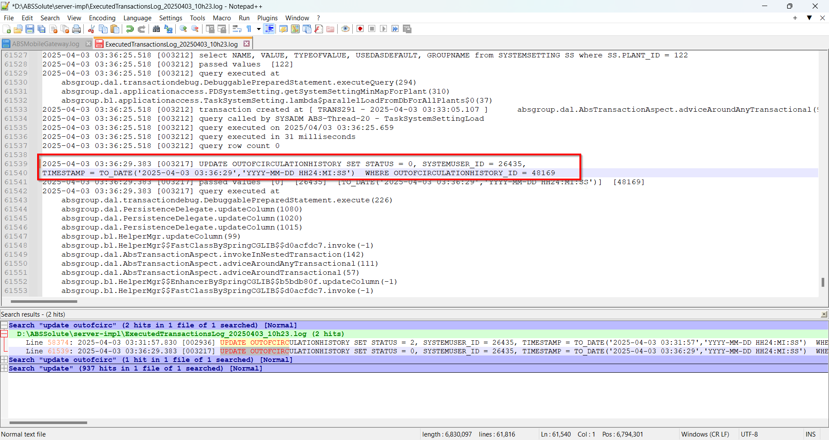

Test Case 2 – Restocking fees – Tested OK
Expected behavior: Cancel Charge or Undo Cancel Charge should update only Status, System User and Timestamp.
Hash: 2960225
- Do a Cancel Charge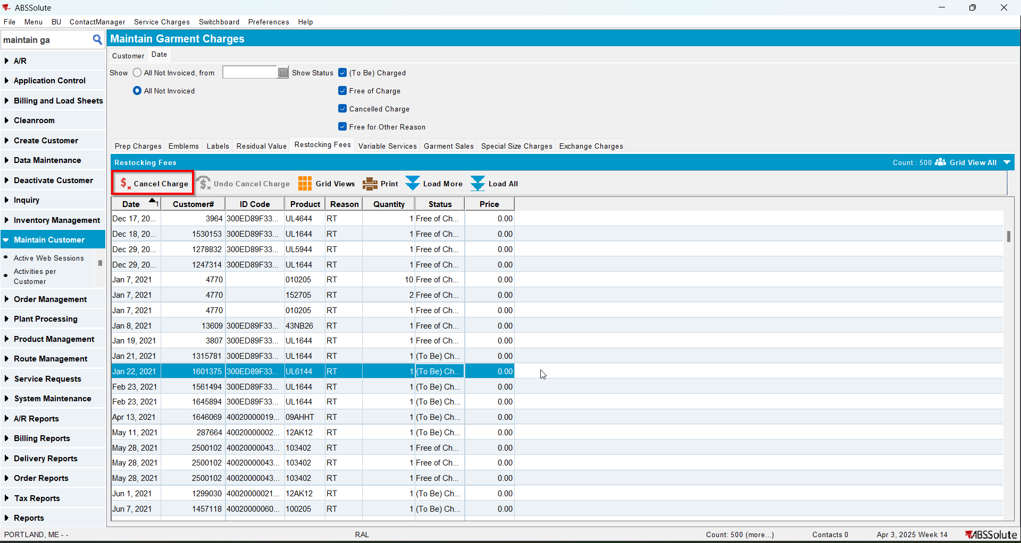
- Check the Executed Transactions for the update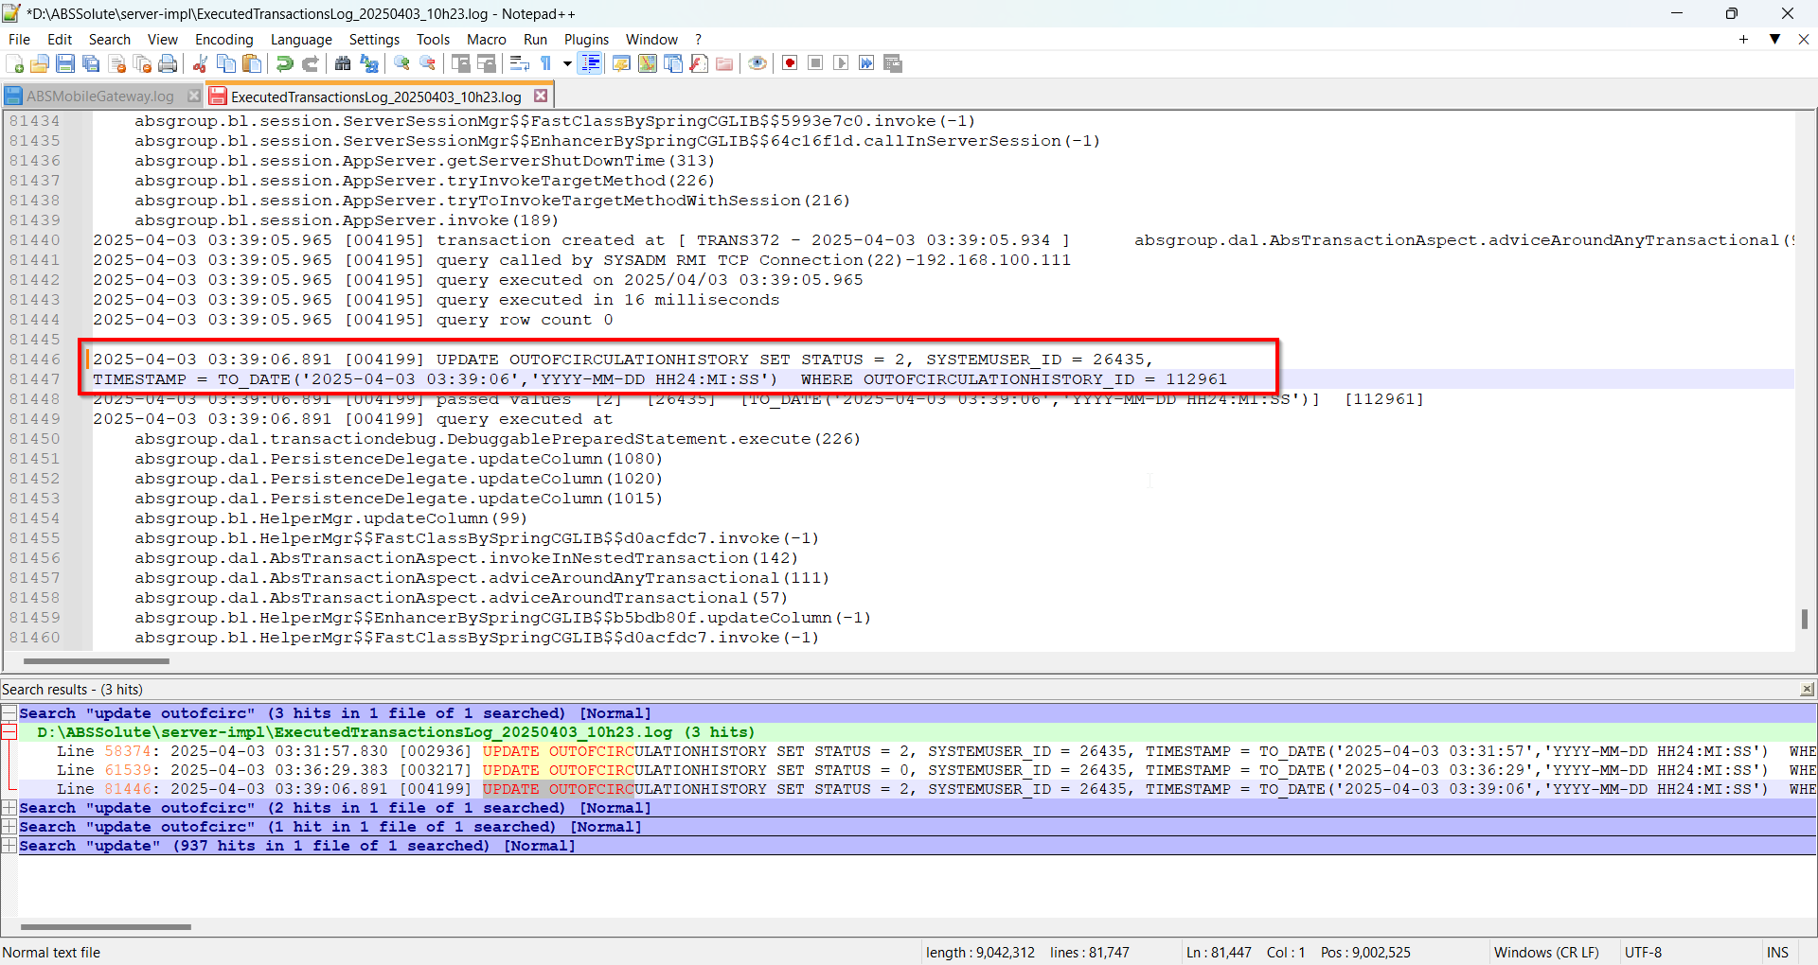
- Do an Undo Cancel Charge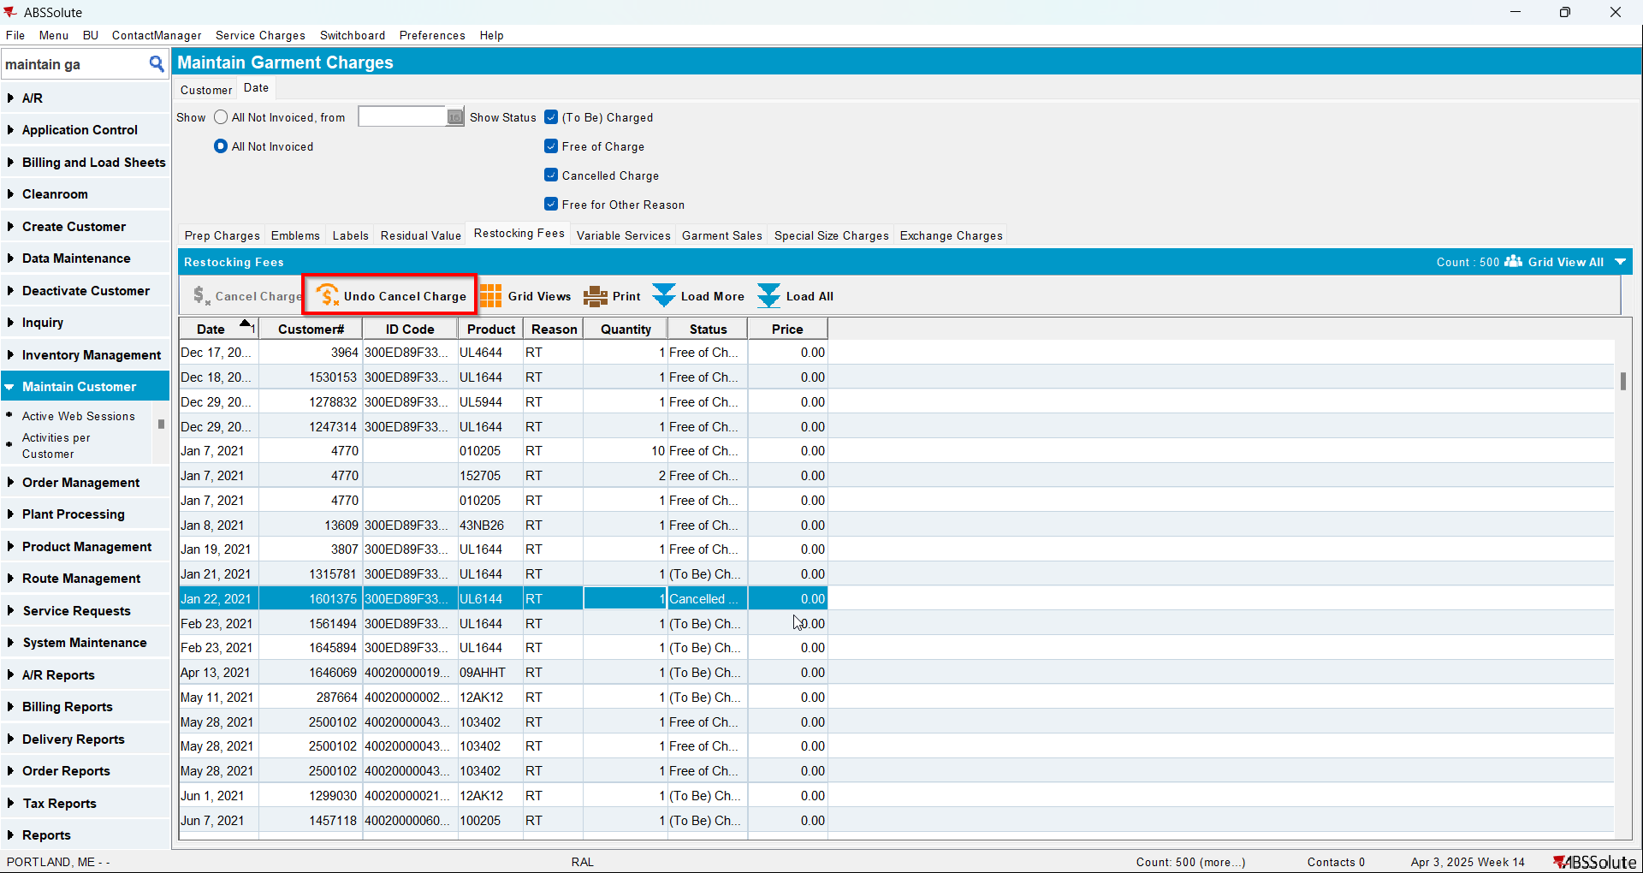
- Check the Executed Transactions for the update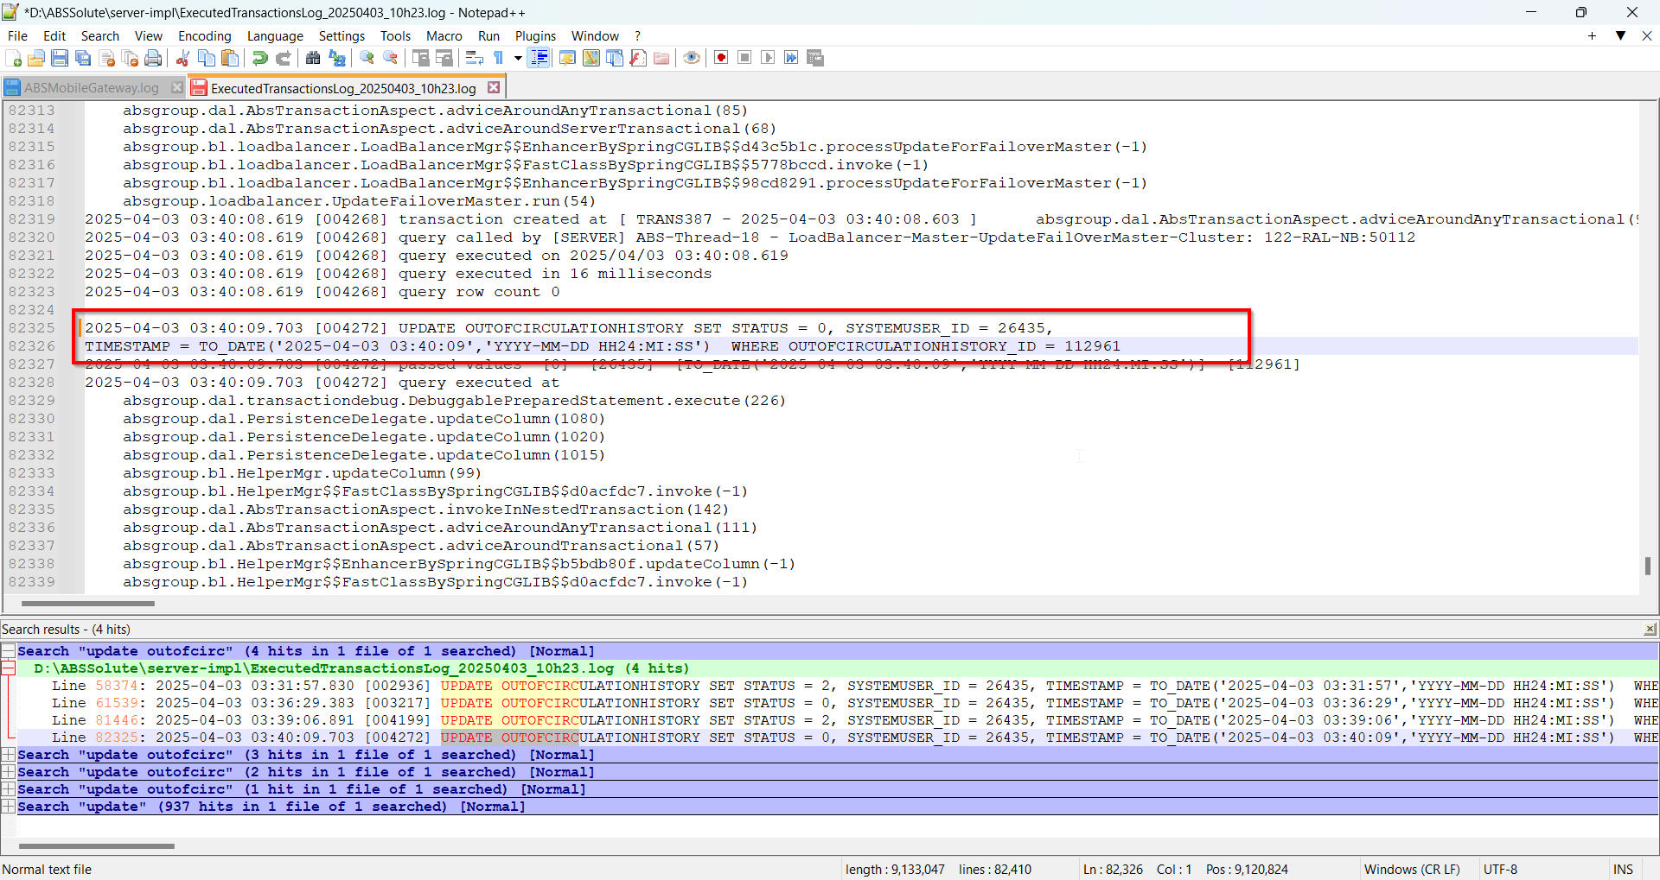

Test Case 3 – Garment Sales – Tested OK
Expected behavior: Cancel Charge or Undo Cancel Charge should update only Status, System User and Timestamp.
Hash: 2960225
- Do a Cancel Charge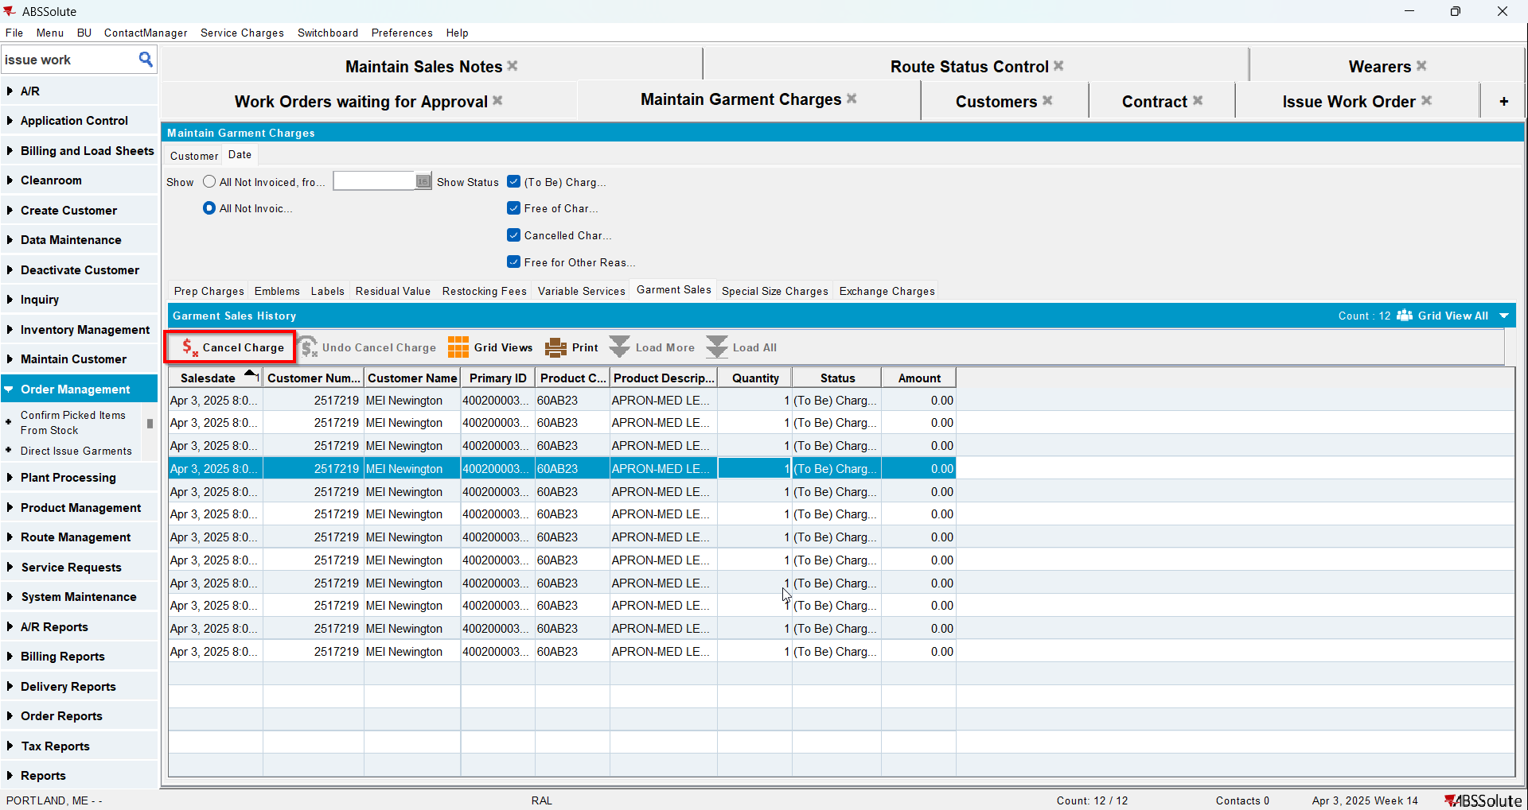
- Check the Executed Transactions for the update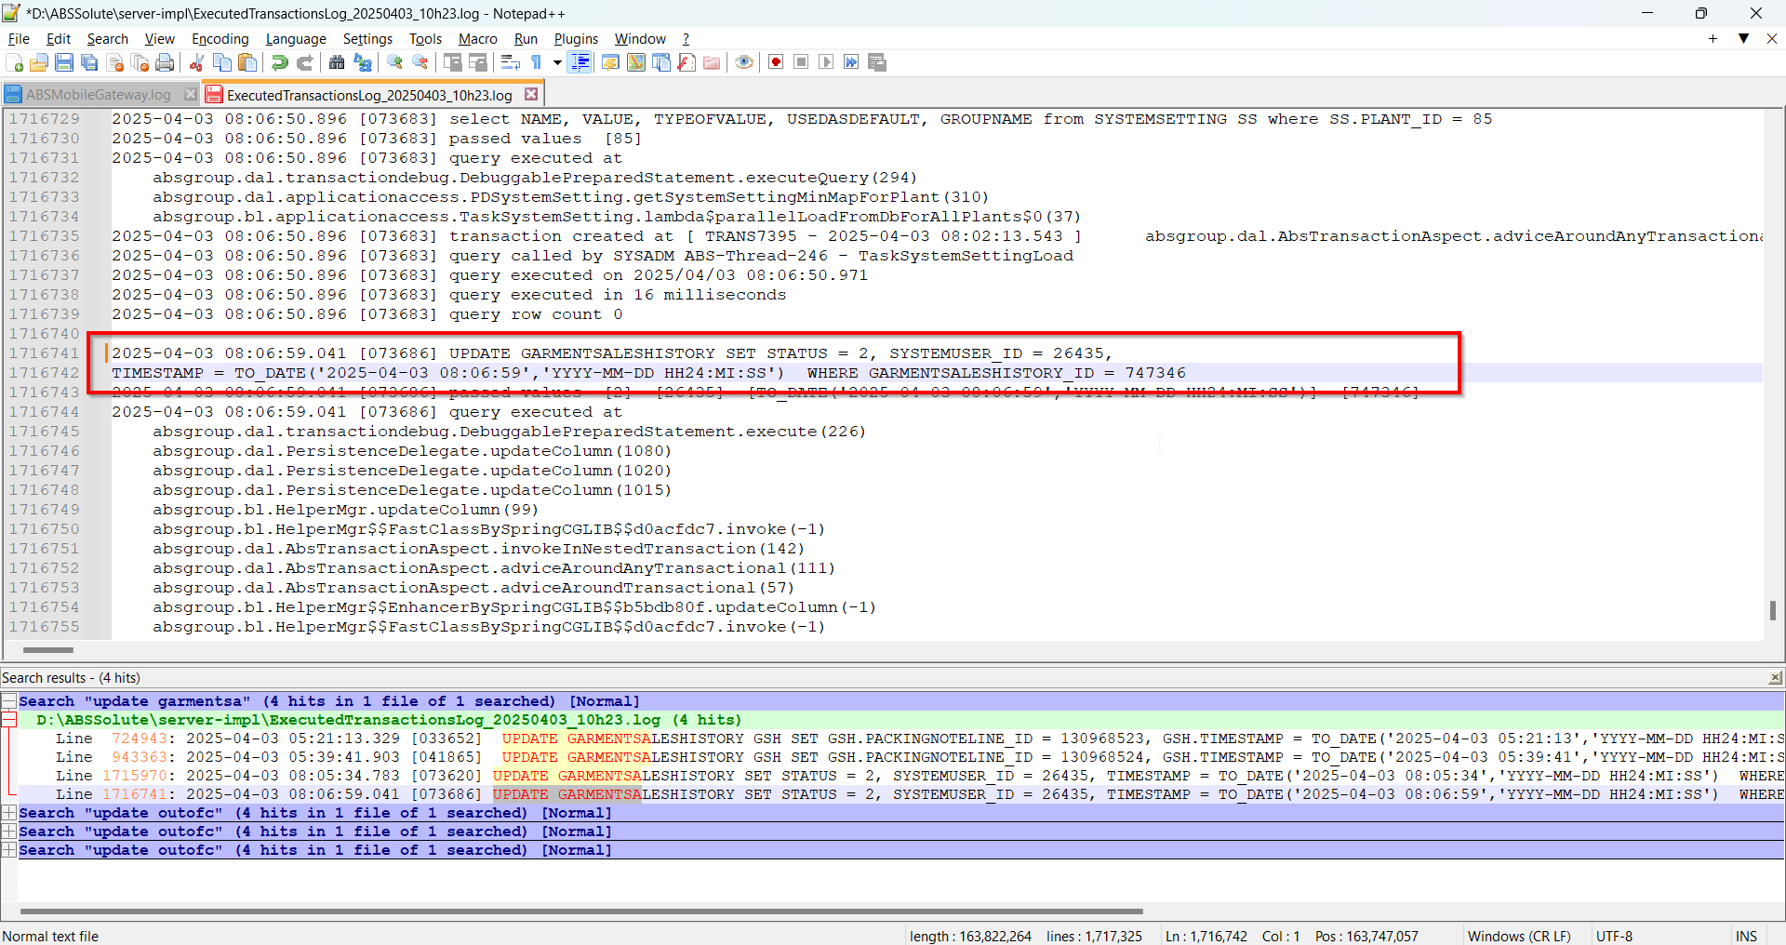
- Do an Undo Cancel Charge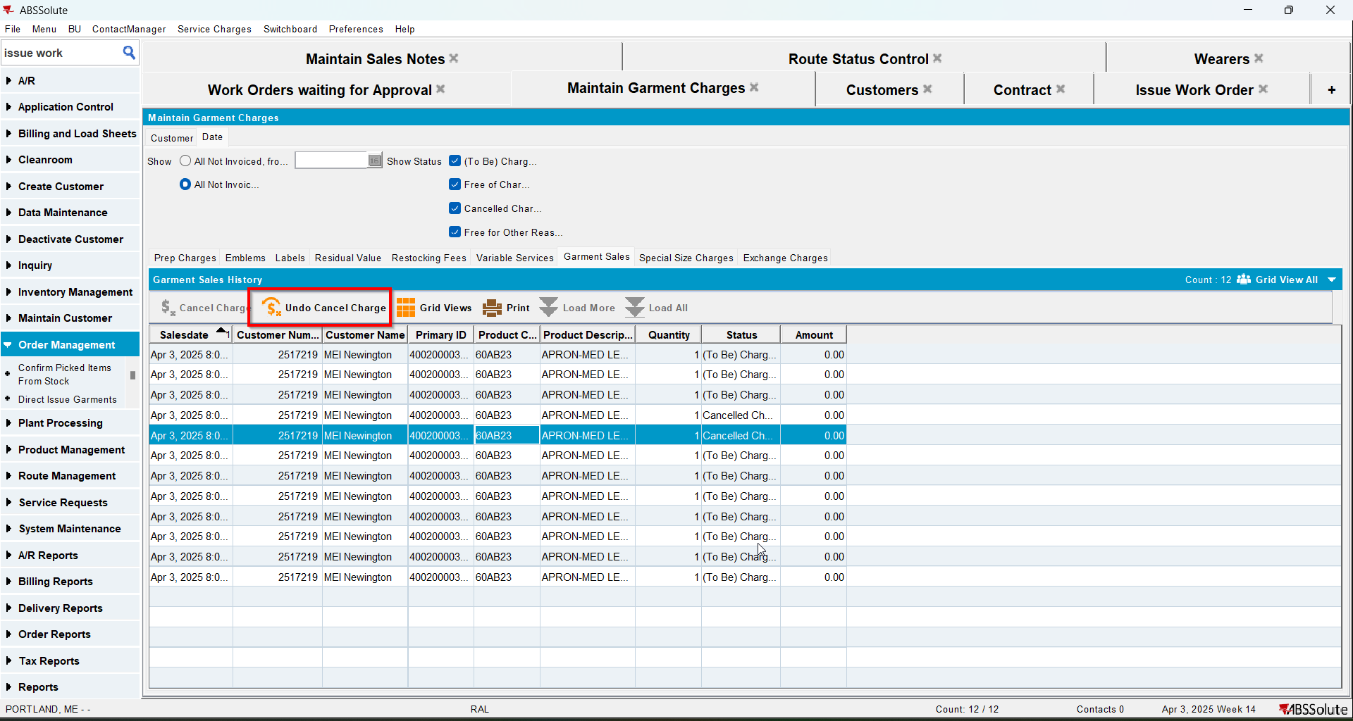
- Check the Executed Transactions for the update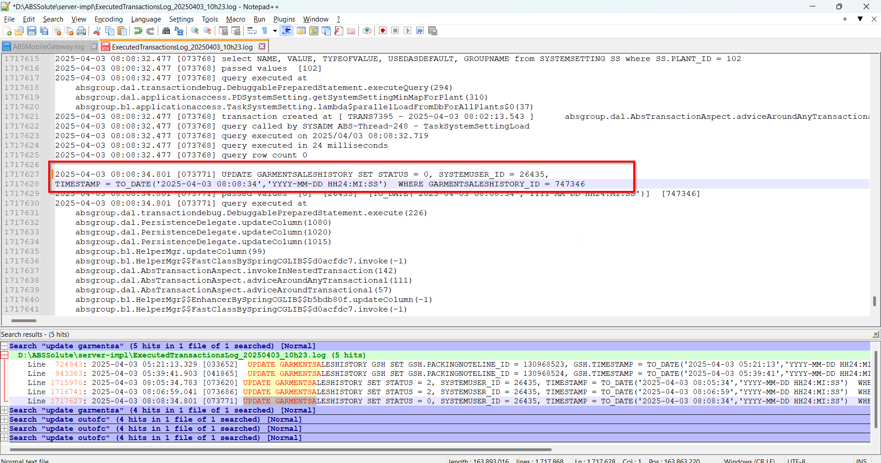

Test Case 4 – Emblems – Tested OK
Expected behavior: Cancel Charge or Undo Cancel Charge should update only Status, System User and Timestamp.
Hash: 2960225
- Do a Cancel Charge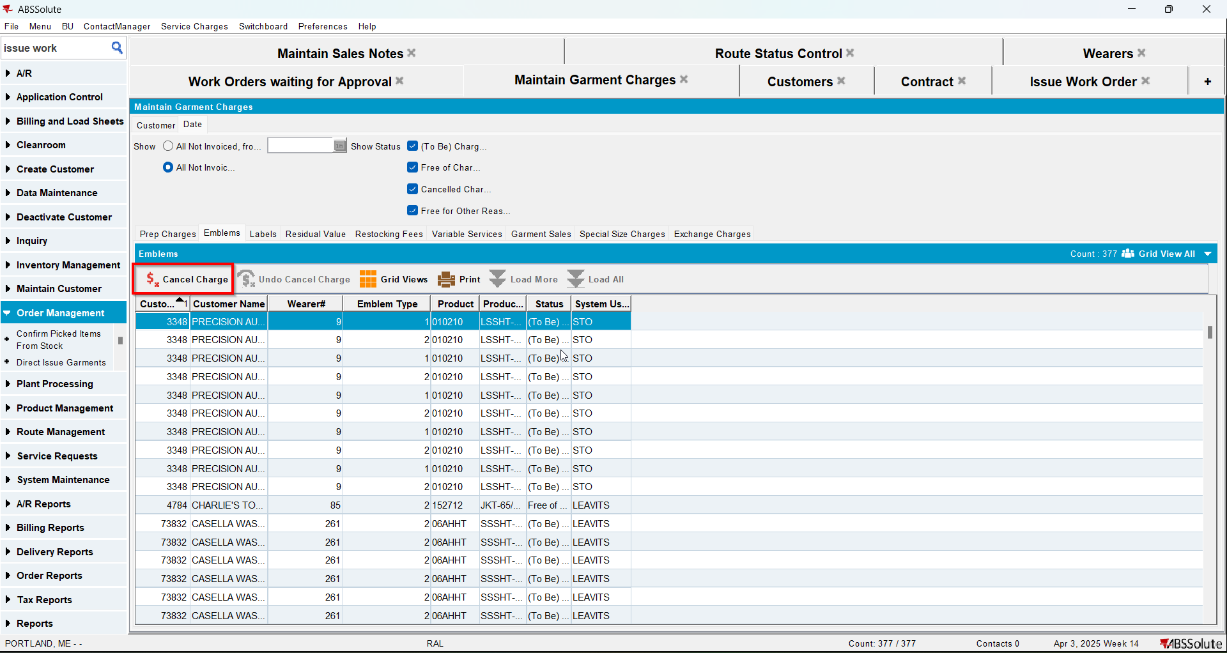
- Check the Executed Transactions for the update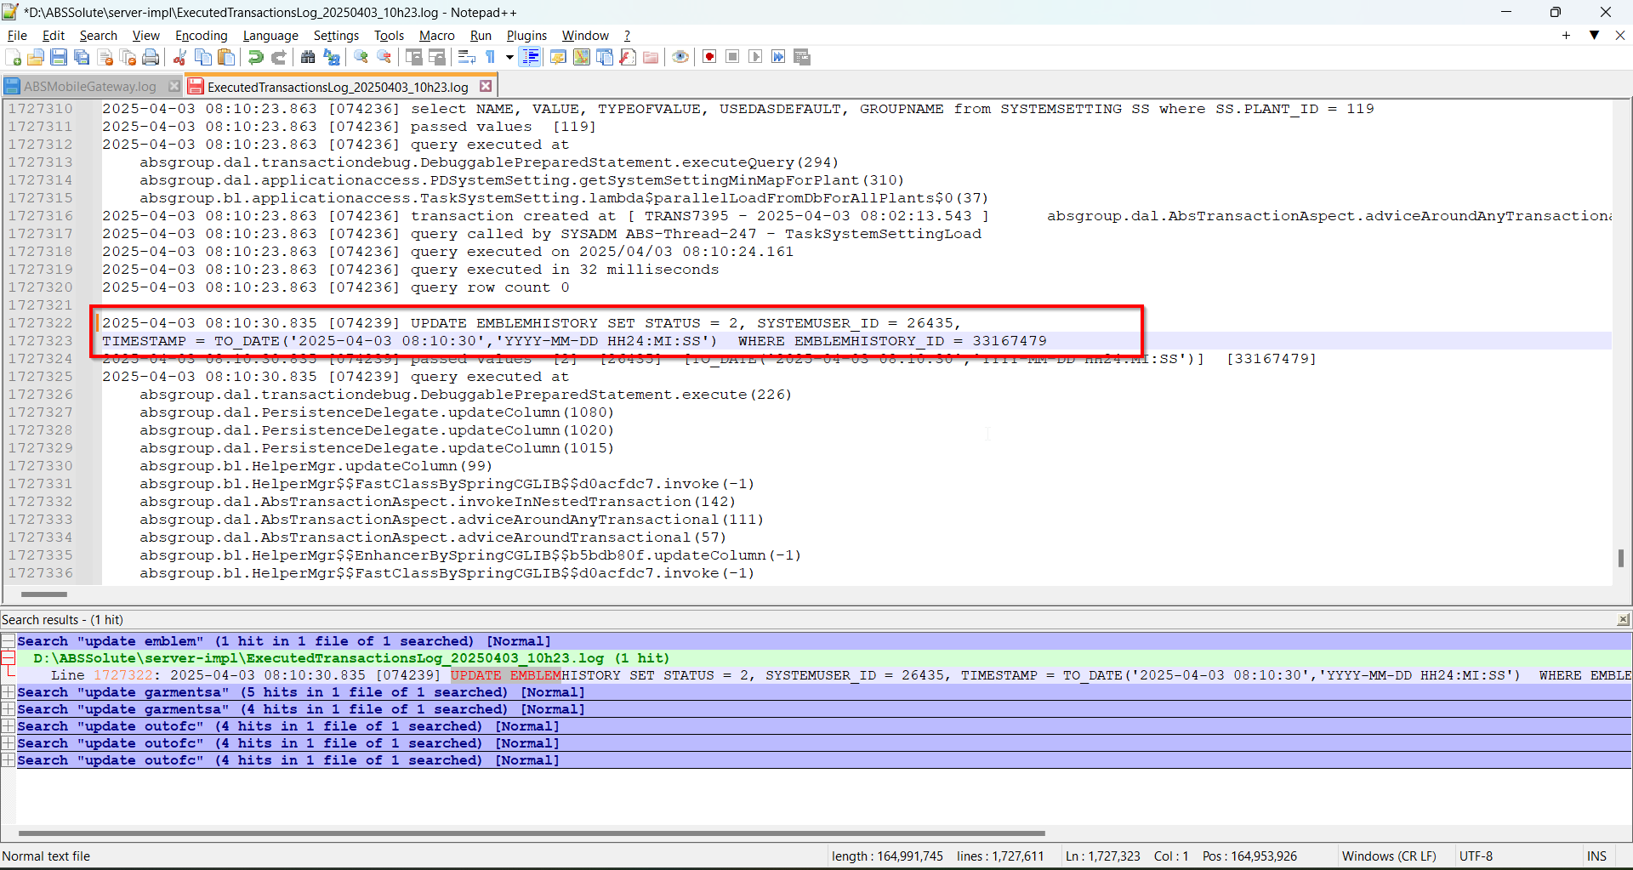
- Do an Undo Cancel Charge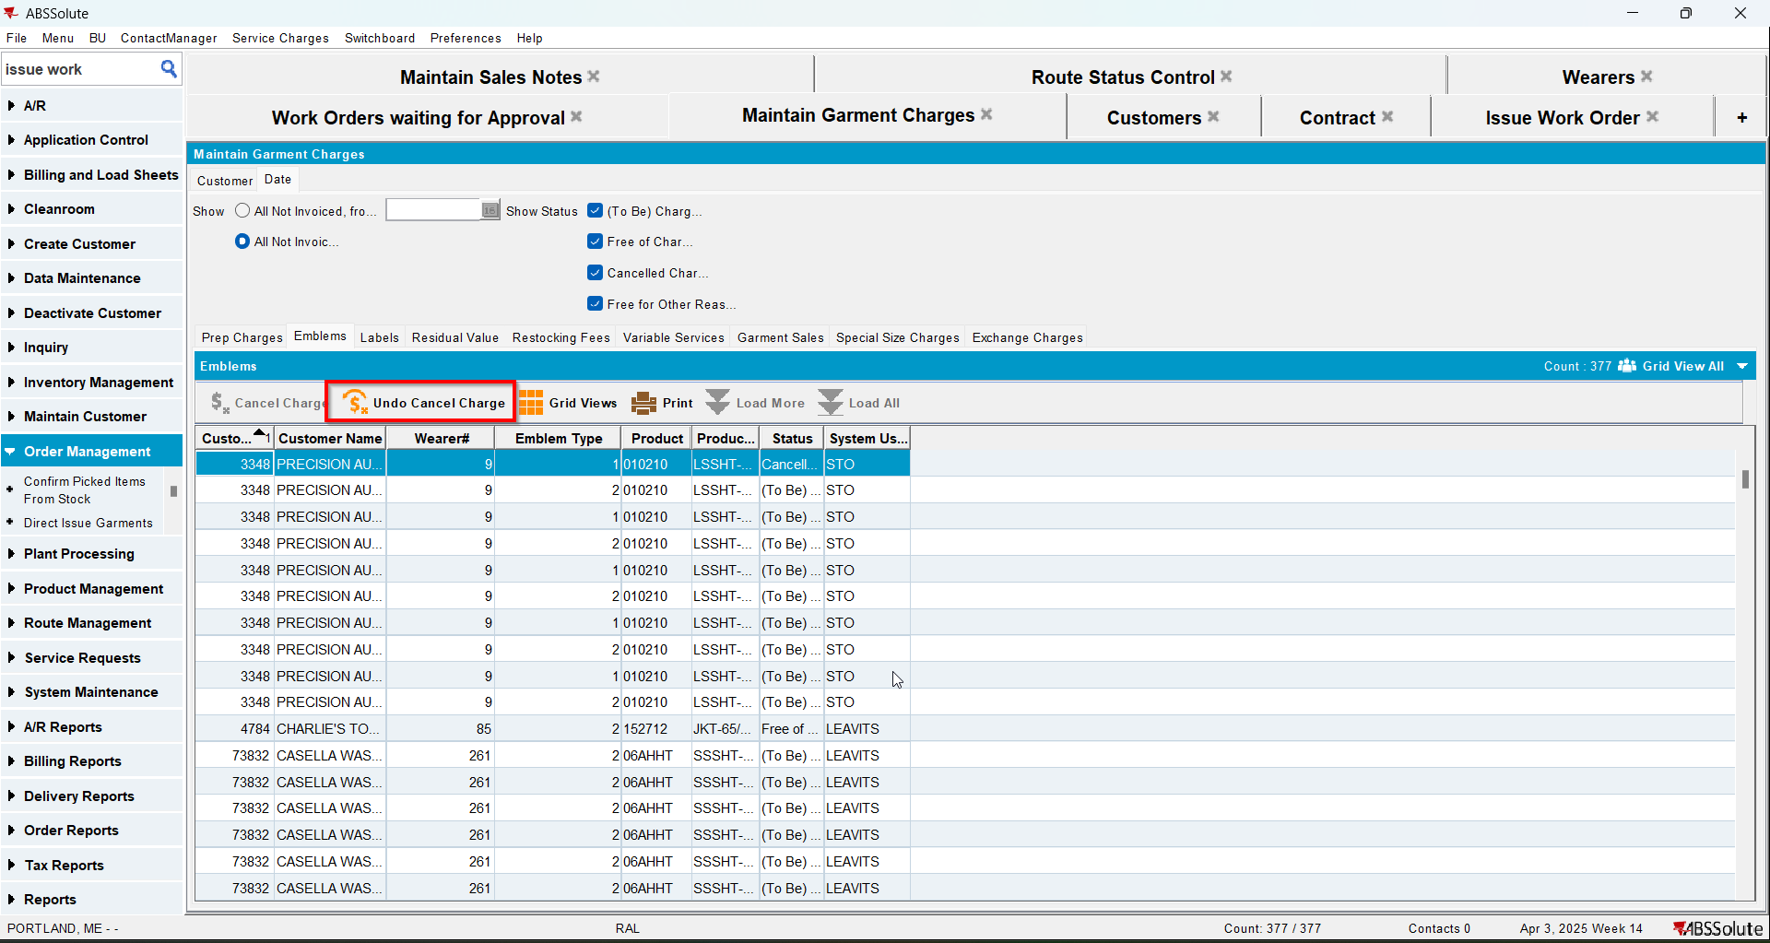
- Check the Executed Transactions for the update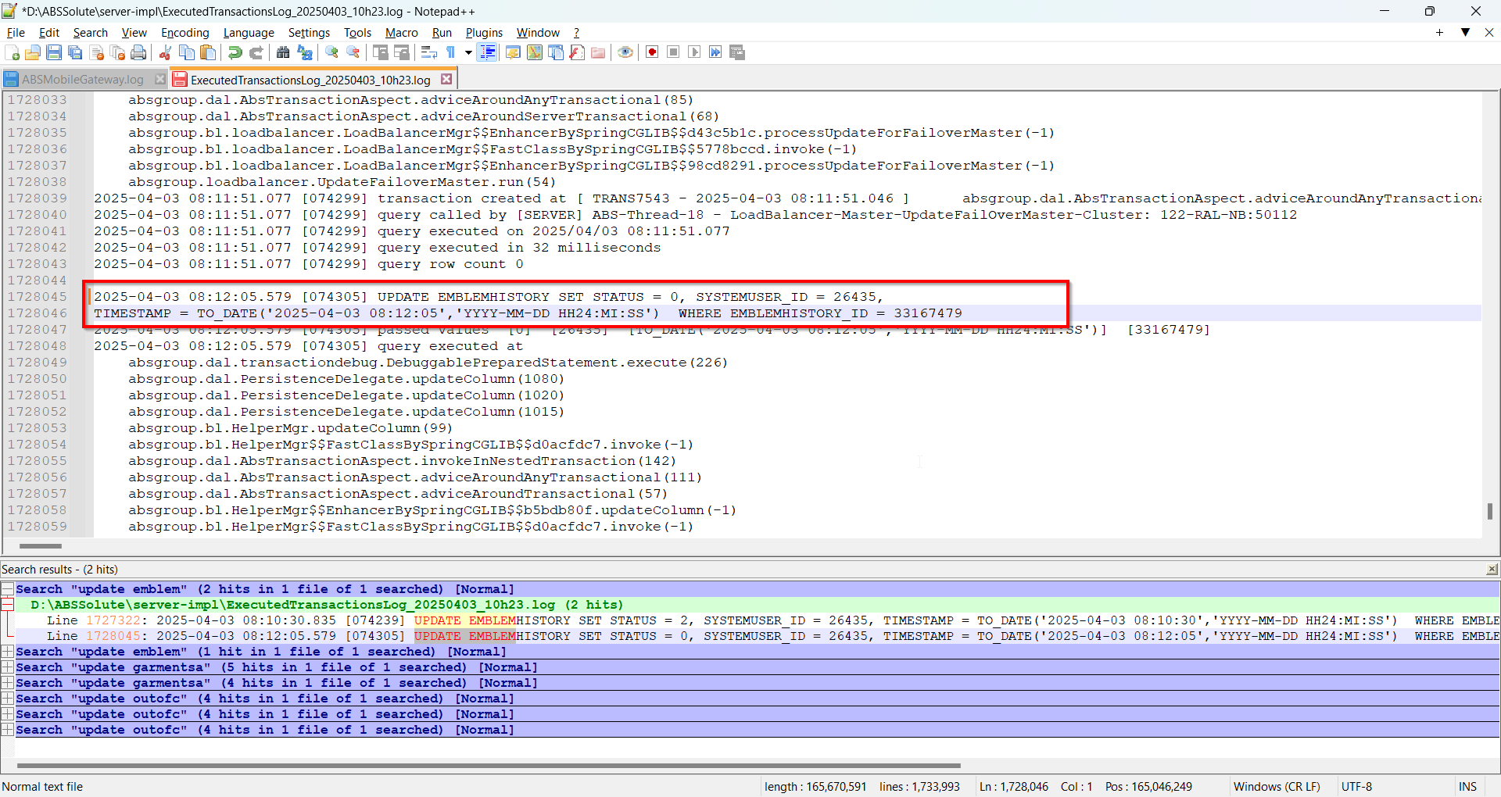

Test Case 5 – Labels – Tested OK
Expected behavior: Cancel Charge or Undo Cancel Charge should update only Status, System User and Timestamp.
Hash: 2960225
- Do a Cancel Charge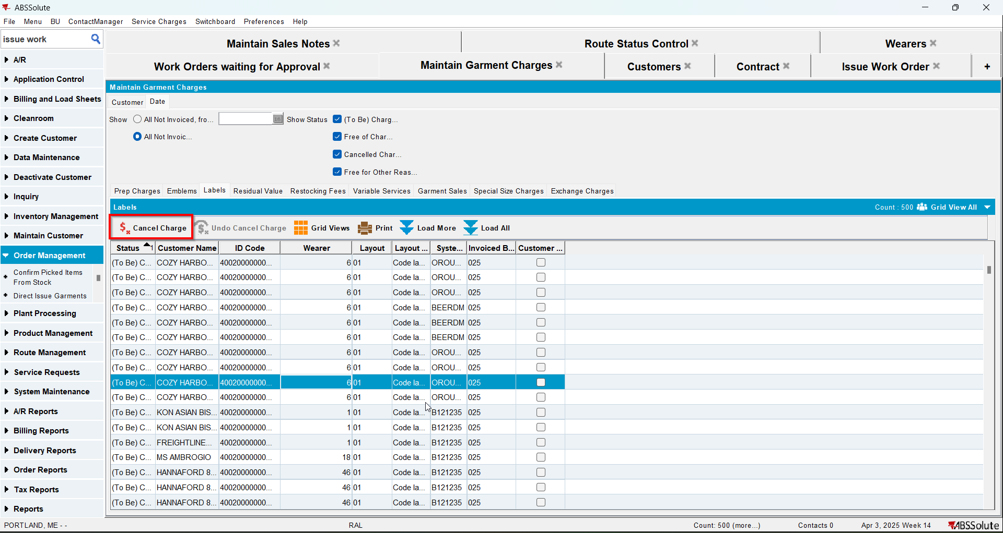
- Check the Executed Transactions for the update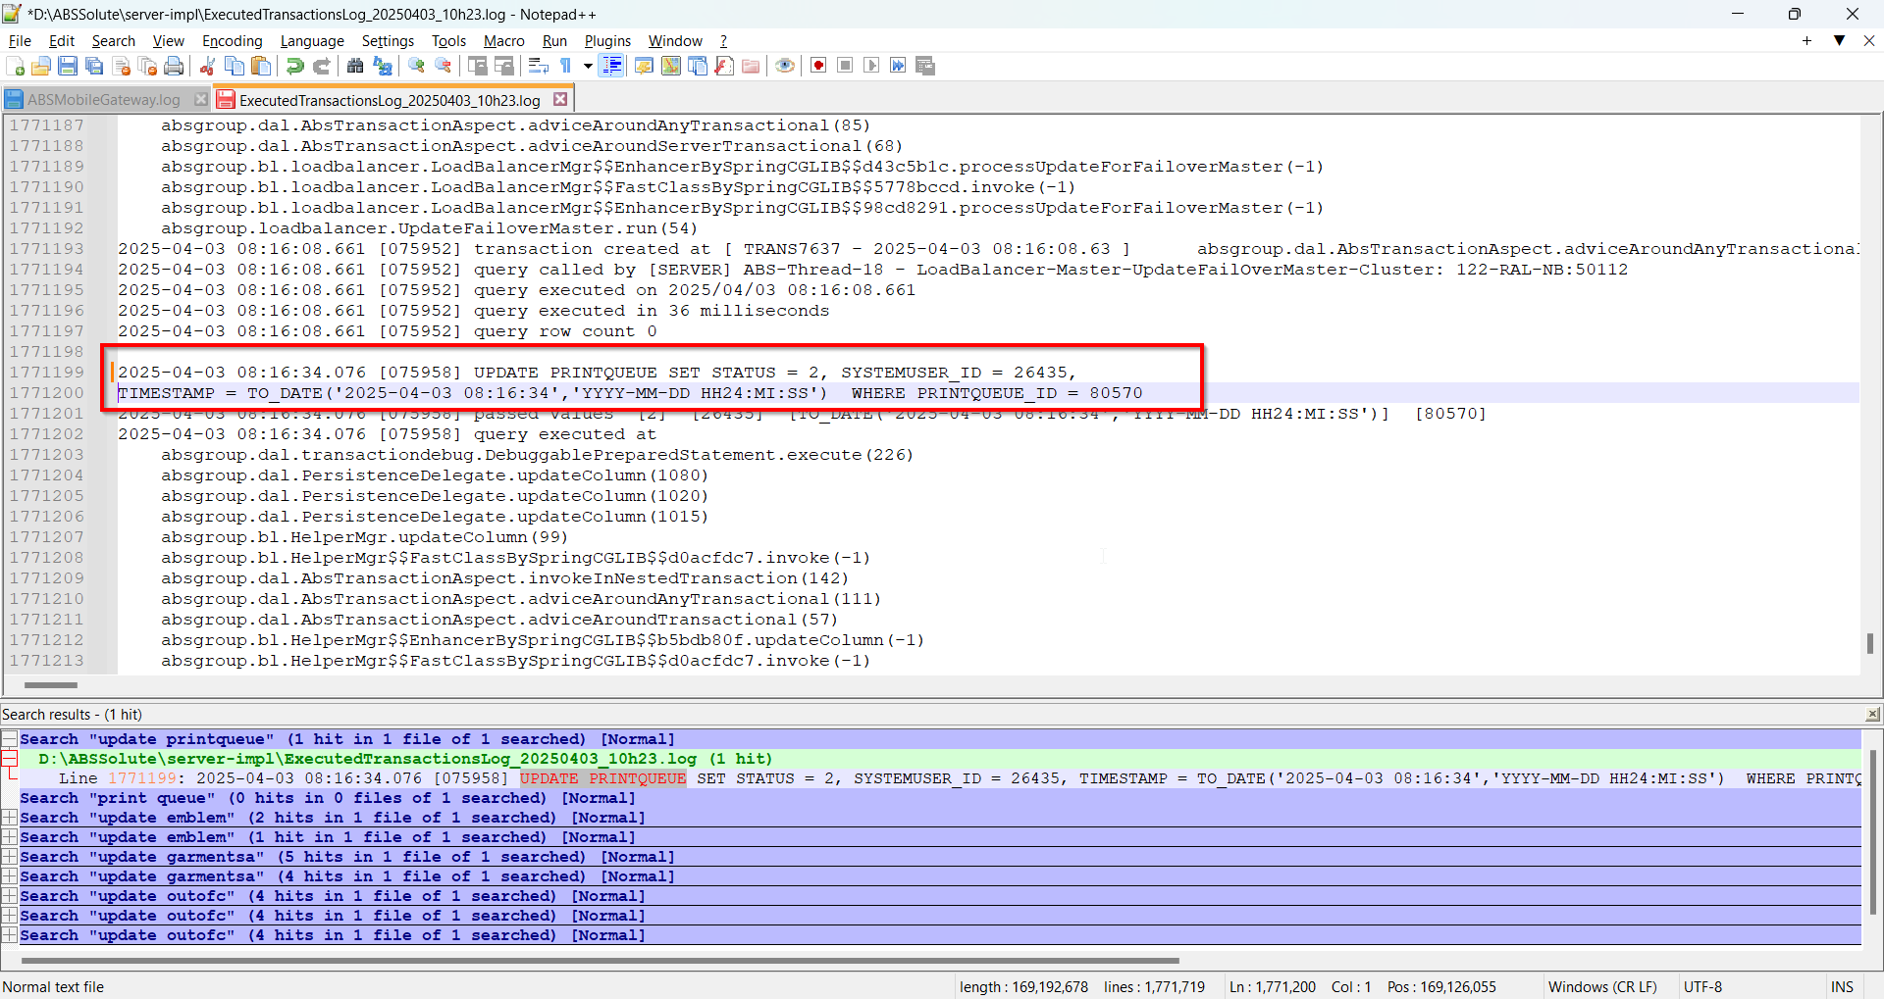
- Do an Undo Cancel Charge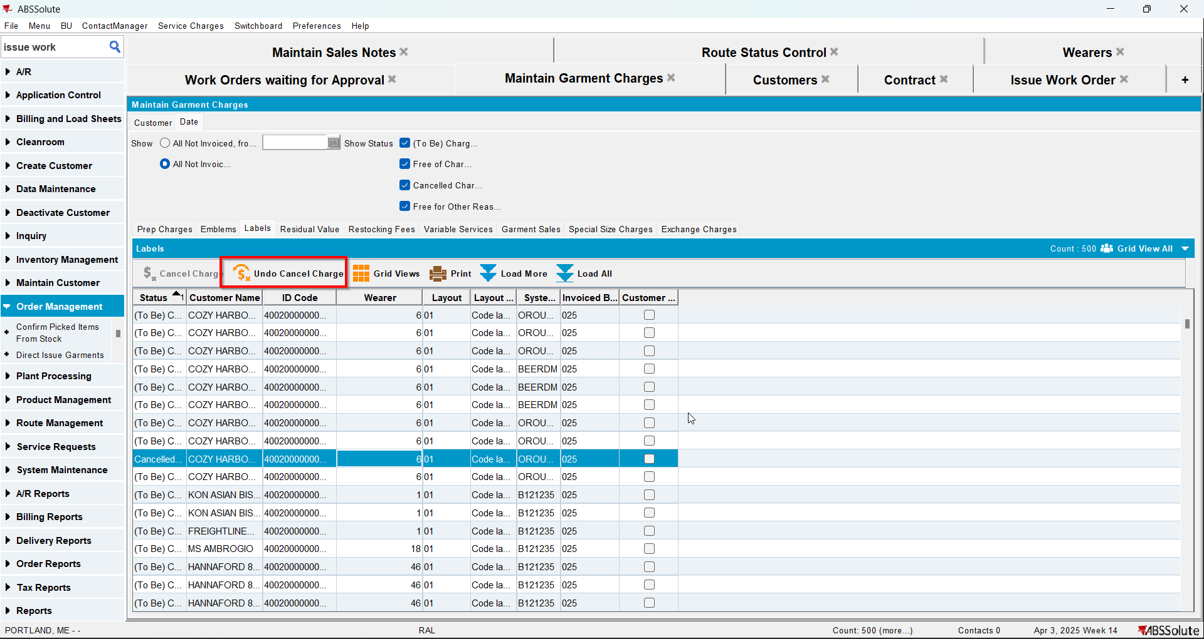
- Check the Executed Transactions for the update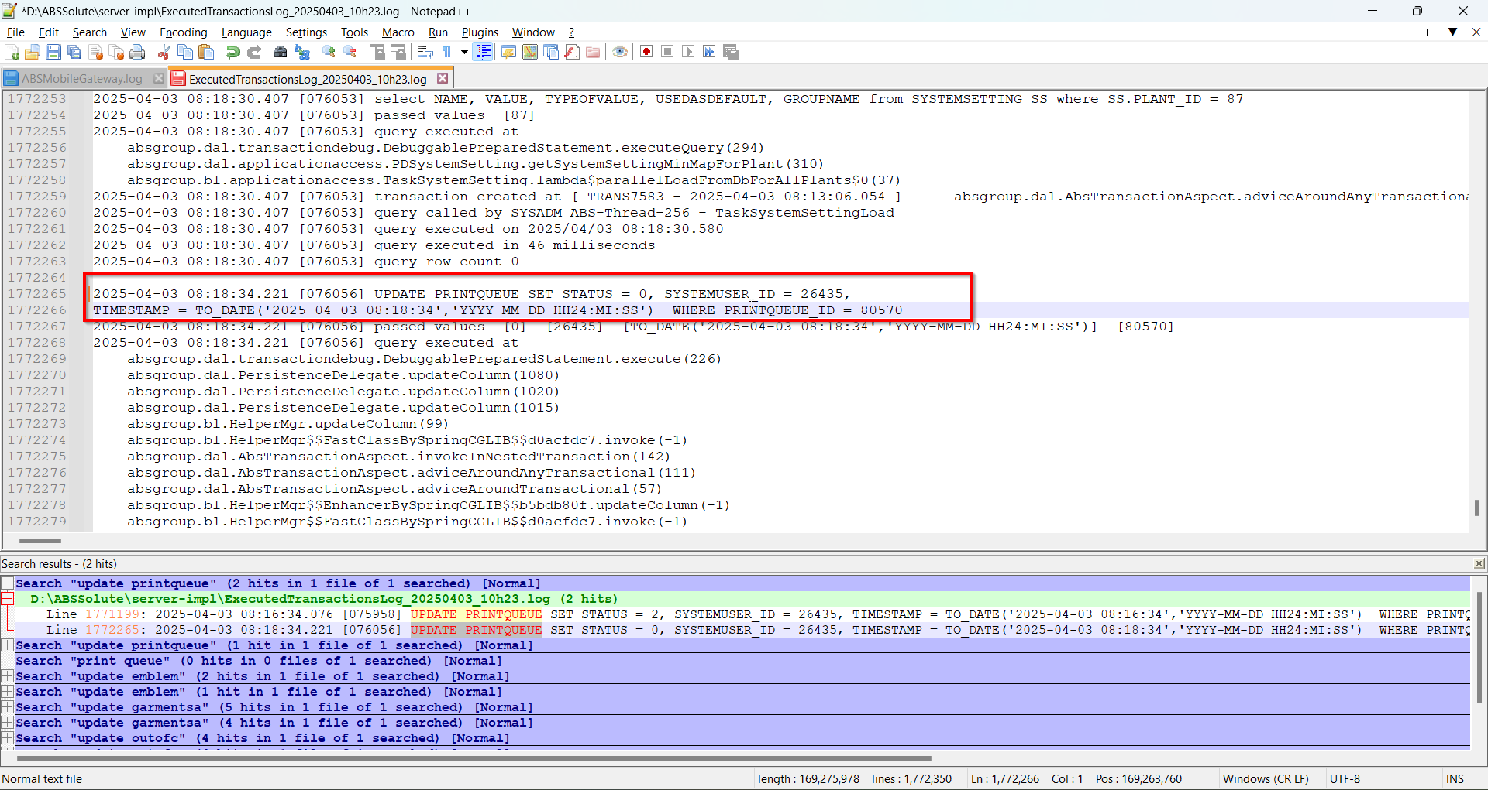

Test Case 6 – Repair History / Variable Services – Tested OK
Expected behavior: Cancel Charge or Undo Cancel Charge should update only Status, System User and Timestamp.
Hash: 2960225
- Do a Cancel Charge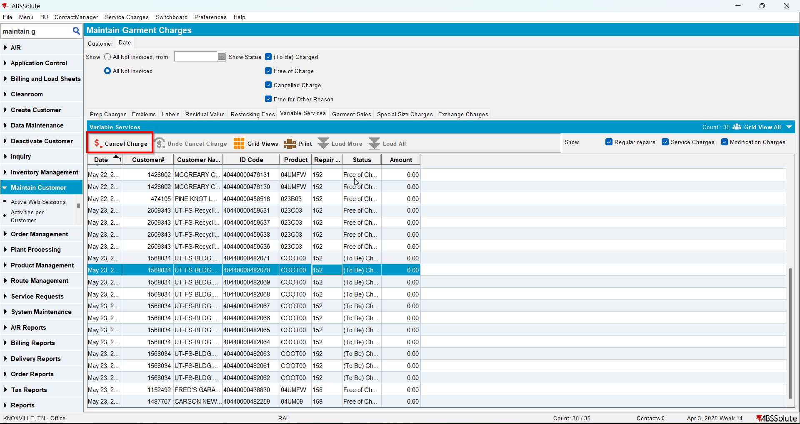
- Check the Executed Transactions for the update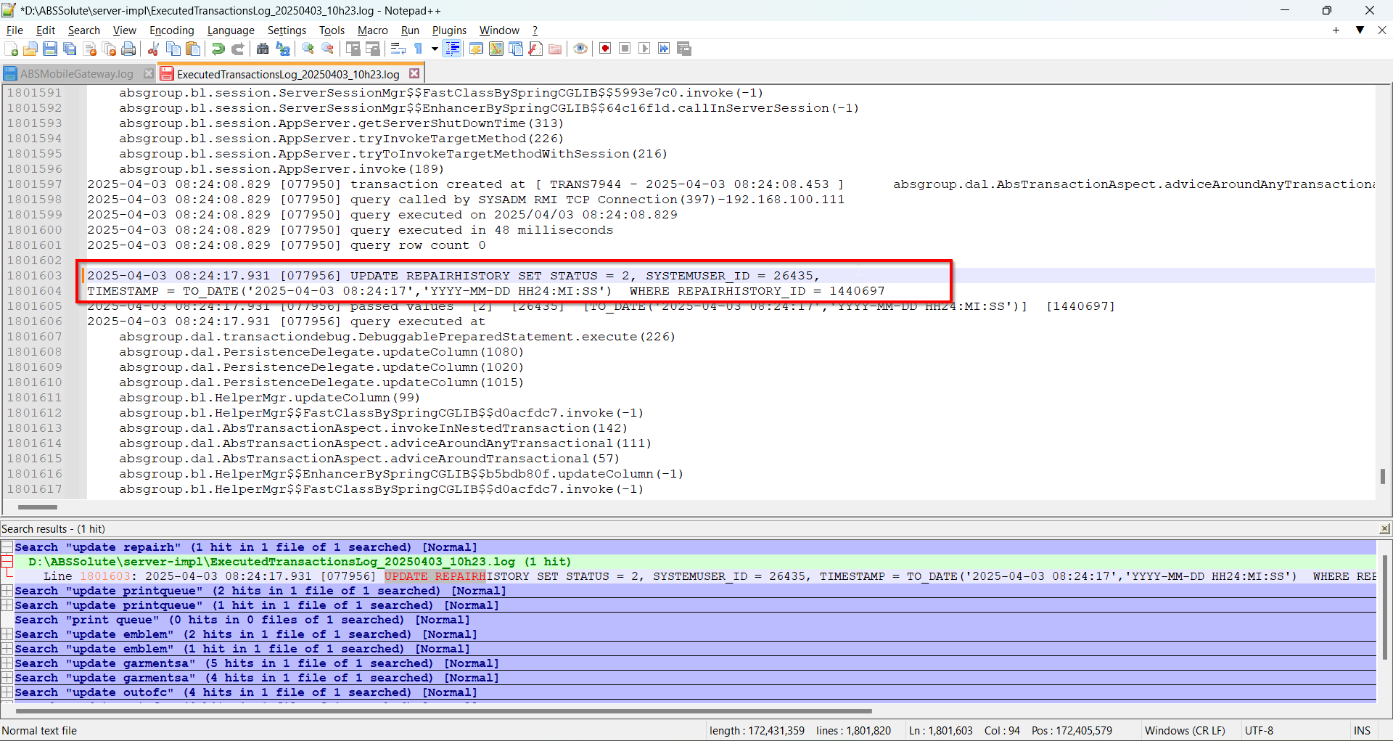
- Do an Undo Cancel Charge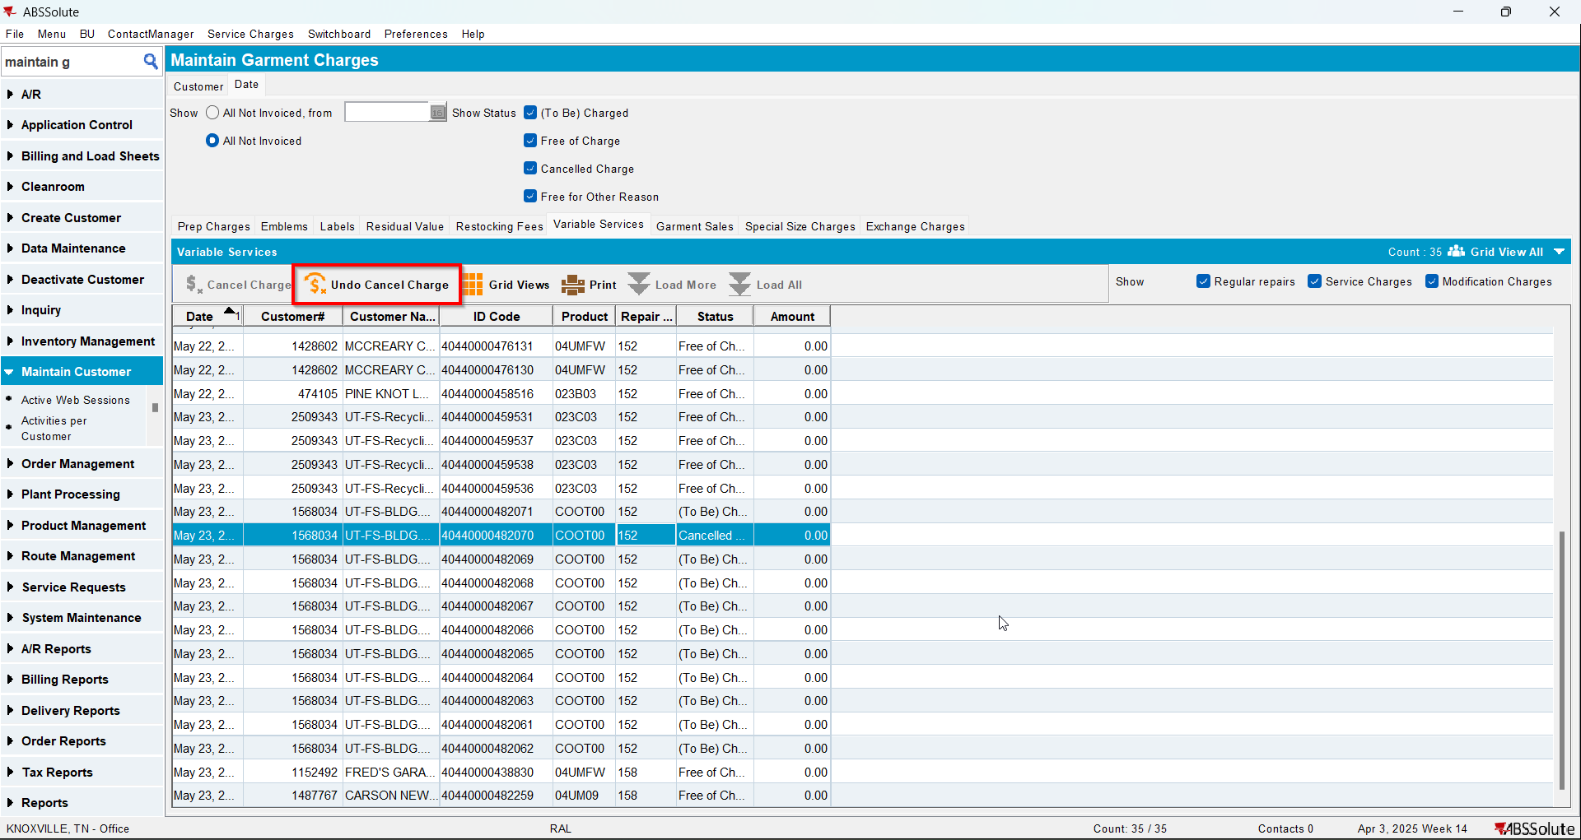
- Check the Executed Transactions for the update