ABSN-2053 Contract - Emblem prices not copied to customer
Environment | Prerequisites
Version:9.07.00  DBServerName=abs-SRV20.internal.abslbs.com  DBSID=CUST24  DBUser=UNFDEV  DBPassword=UNFDEV  Environment=Test | - Module:  - System setting

Contents
Retest after fix 1
Test Case 1 – SS PriceControlAccess=1 add emblem for a customer with no emblem price lists – Tested OK 1

Retest after fix

Test Case 1 – SS PriceControlAccess=1 add emblem for a customer with no emblem price lists – Tested OK
Expected behavior: The emblem price is added to the customer
Hash: 529d0c2
- Set SS PriceControlAccess=1 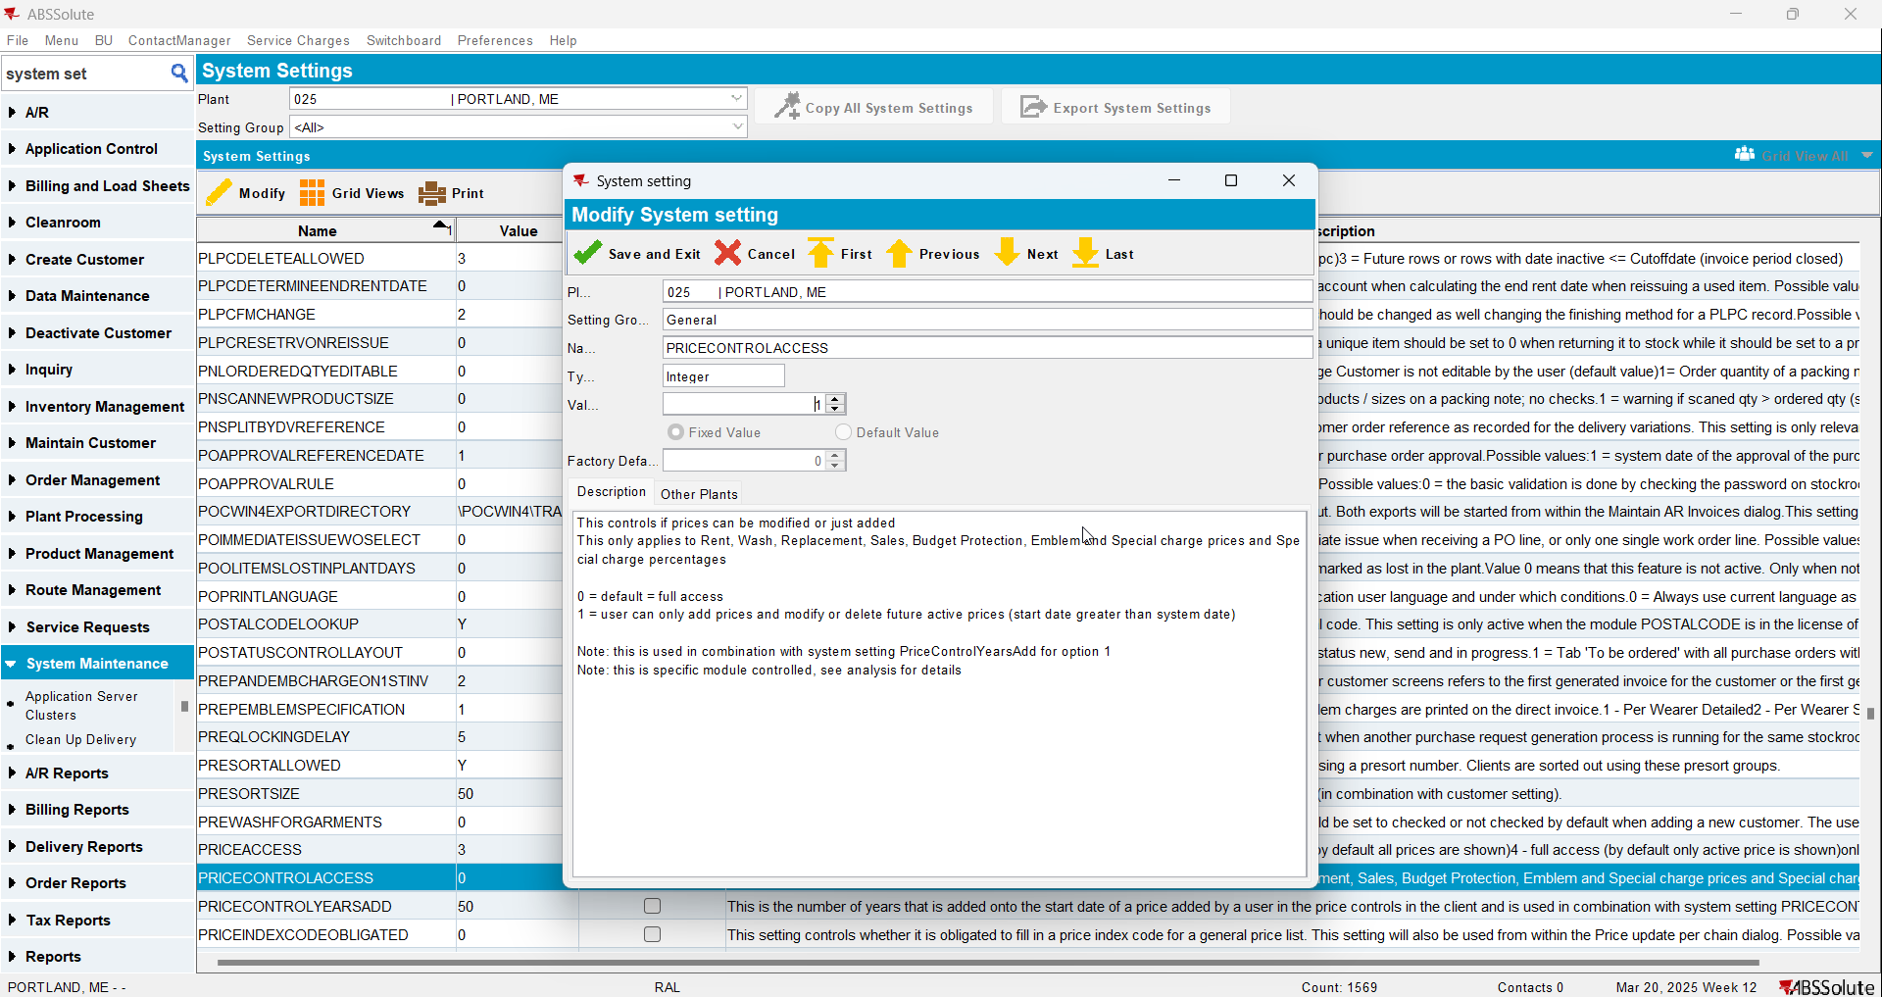
- Check that the customer does not have emblem price lists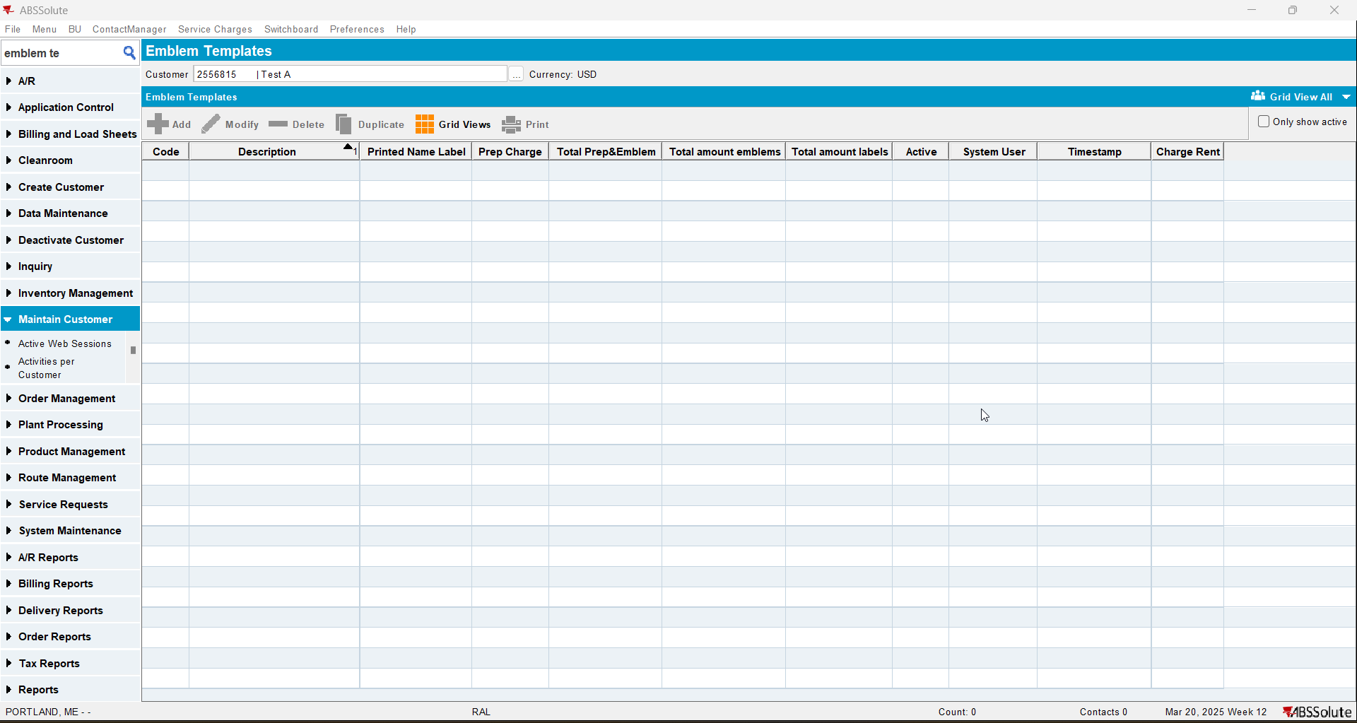
- Check there is no Emblem price list on the contract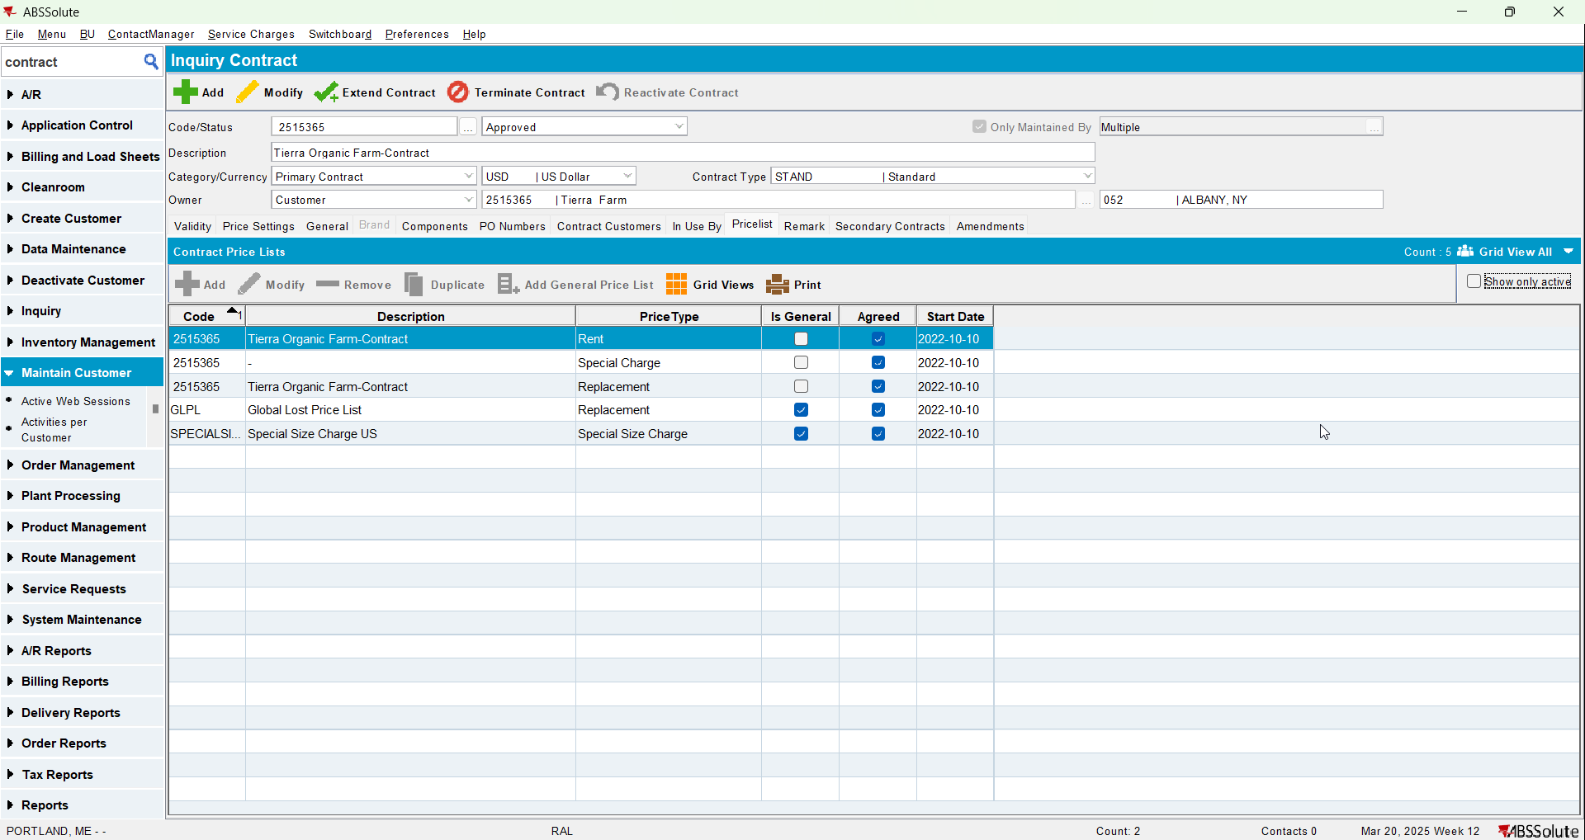
- Add a emblem with Predefine Product with a price(check that the price start date is in the future)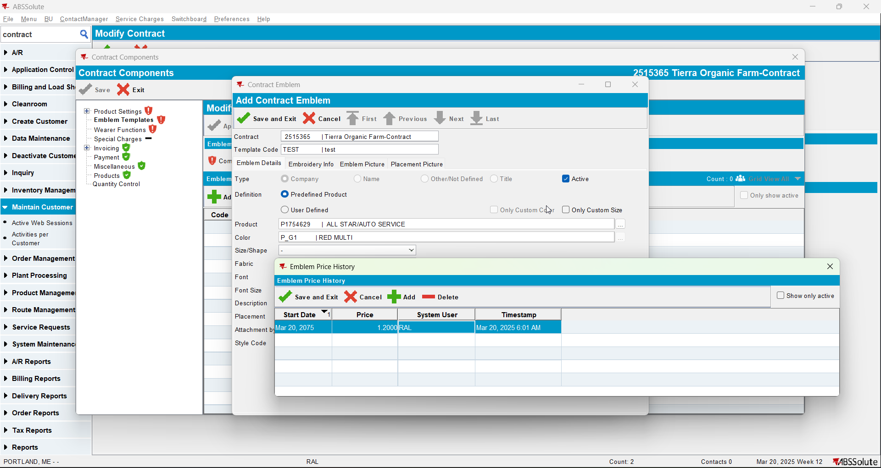
- Copy the emblem to the customer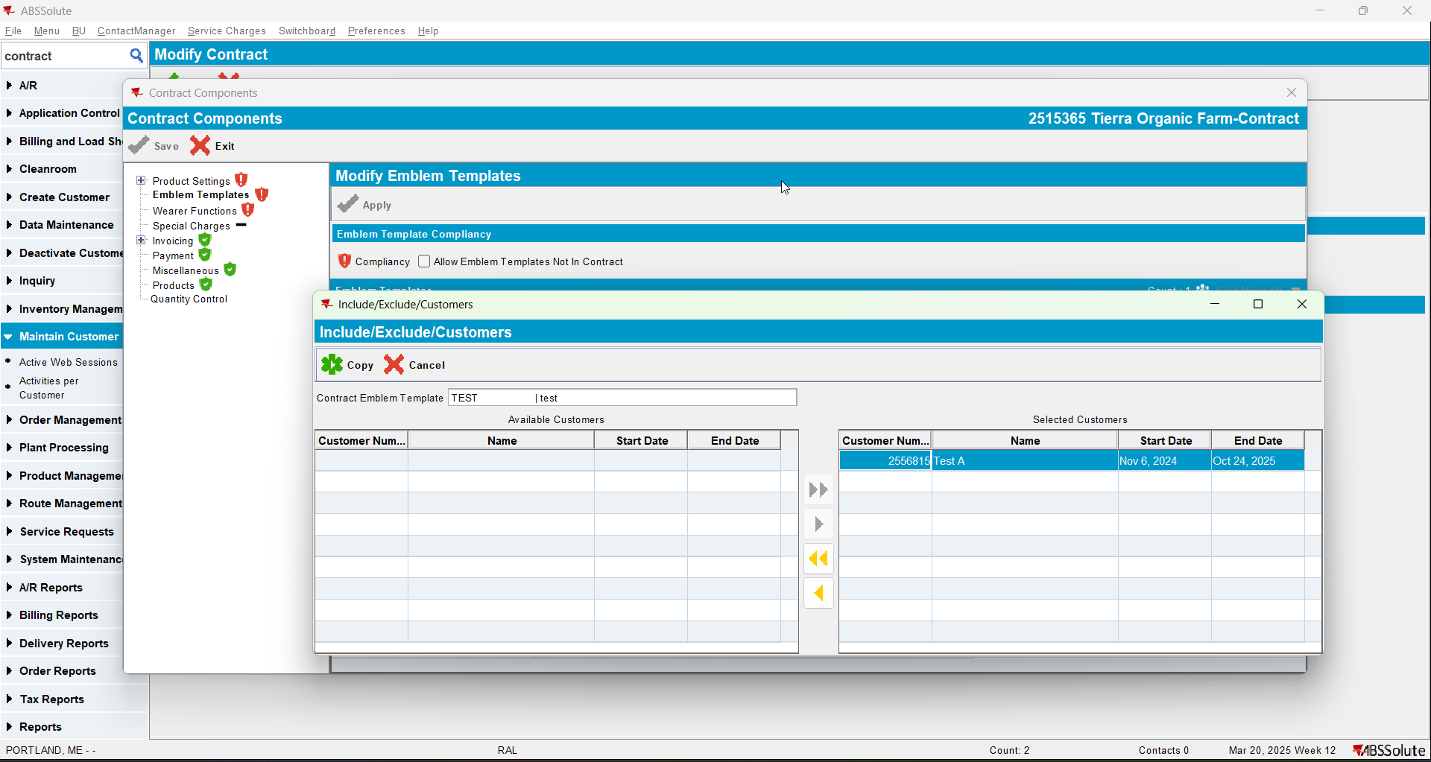
- Check that the emblem was added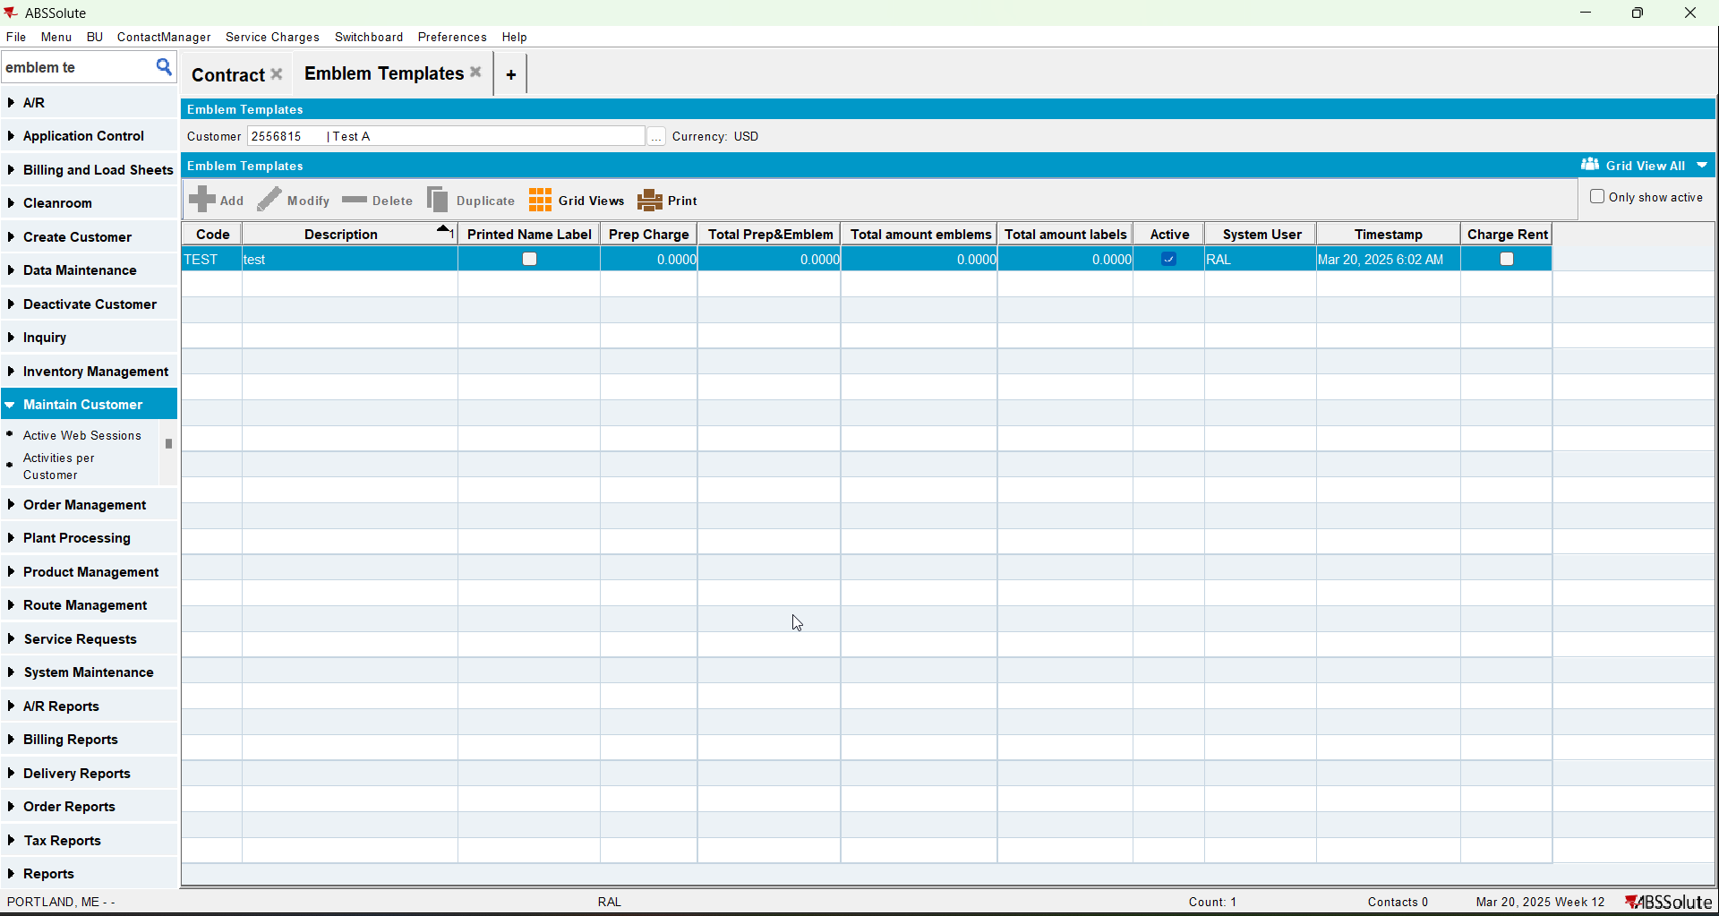
- Check that the price was added to the customer