ABSN-1981 - Adding a new type of price list to an existing contract with customer and products already in use
Environment | Prerequisites
Version: 9.07.00.UNF19  DBServerName=abs-SRV20.internal.abslbs.com  DBSID=CUST24  DBUser=UNFDEV  DBPassword=UNFDEV  Environment=Test | - Module:  - System setting

Contents
Reproducing before fix 1
Steps to reproduce 1
Current Behavior 4
Expected behavior 5
Retest after fix 5
Test Case 1 – Add the first budget protection price to an existing contract – Tested OK 5
Test Case 2 – Add the first sales price to an existing contract – Tested OK 9
Test Case 3 – Add the first sales price to an existing contract but your Contract Customer is ended – Tested OK 12

Reproducing before fix

Steps to reproduce
- Find a contract that does not have a budget protection price list using the following select:
select distinct co.code
from contract co
where not exists (
select 1 from contractpricelist cpl
where cpl.contract_id = co.contract_id and cpl.pricetype = 9)
and exists (
select 1 from contractcustomer cc
join customer c on c.customer_id = cc.customer_link_id
where cc.contract_id = co.contract_id and cc.enddate > sysdate and c.dateinactive > sysdate)
and co.enddate > sysdate
- Load the contract
- Contract > Pricelist: check that there is no insurance price list
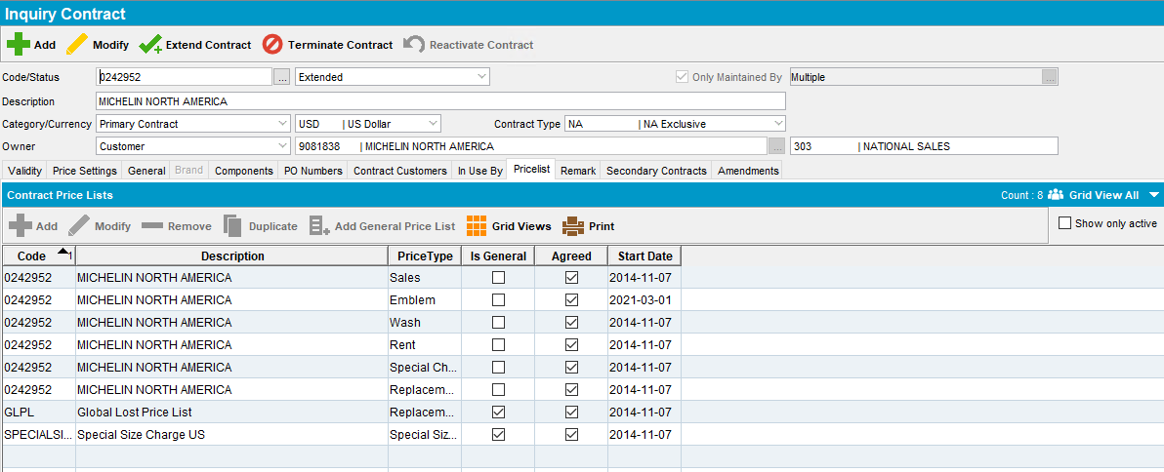
- Contract->Modify->Components load compliancy-> product settings -> add at least one budget protection like GSP
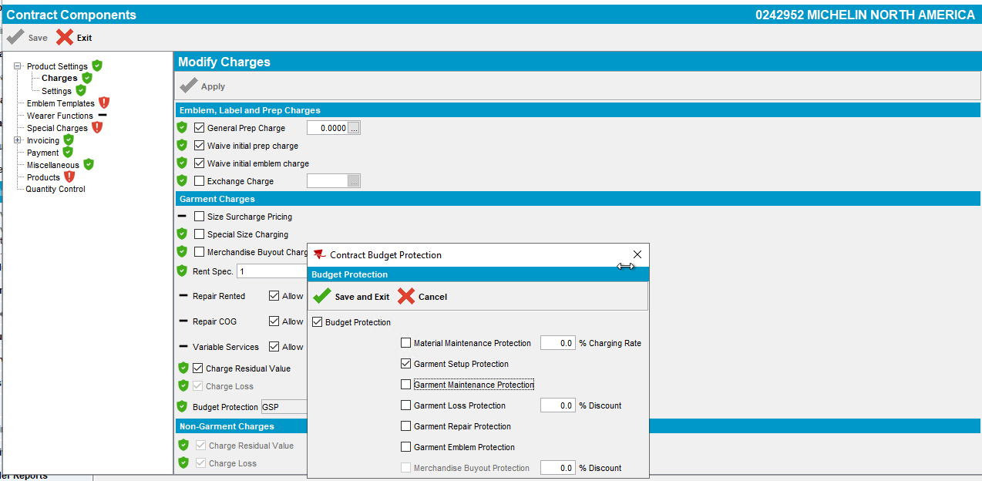
- Enforce the Budget Protection to the contract customers
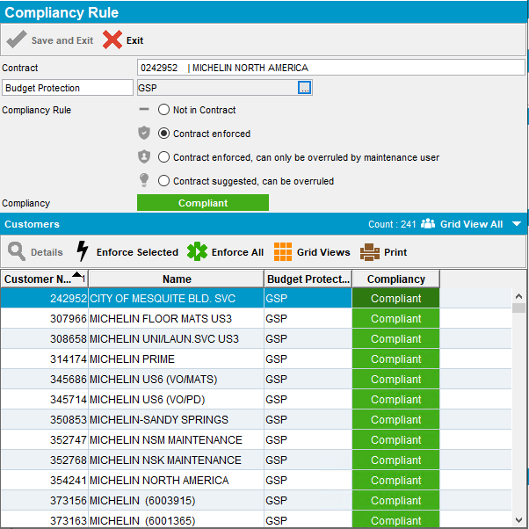
- Go to Products: Select a garment contract product
- Enable GSP budget protection and add a price
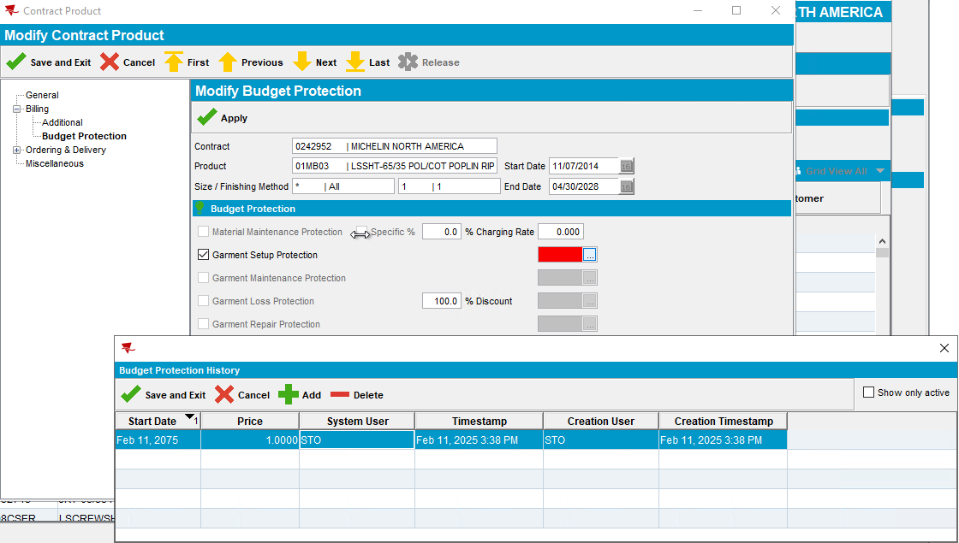
- Save and apply
- Check that the Contract Price list for PriceType = Insurance was added
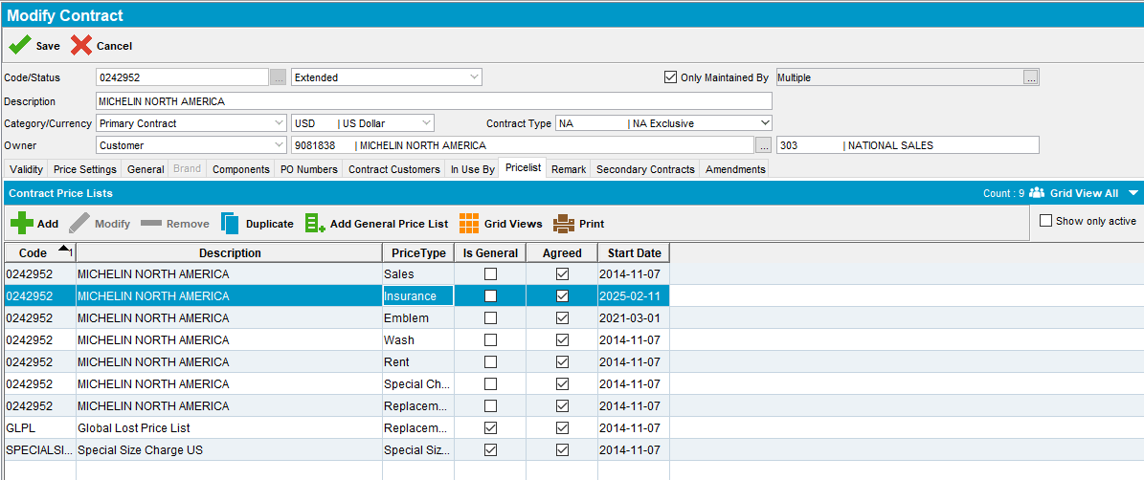
- Contract > Contract Customers: find an active contract customer
- Price List per customer DLG: load the customer (example: 242952)
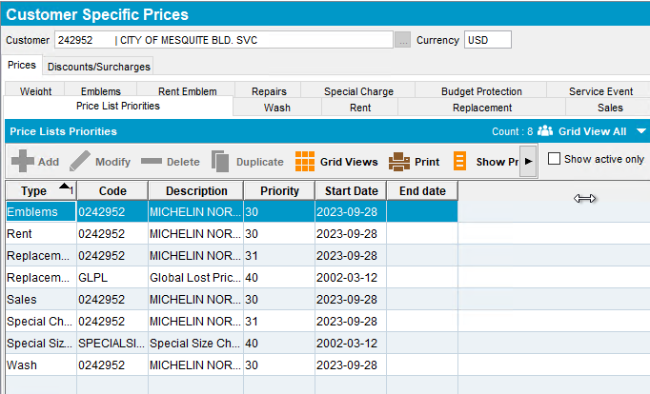
REPRODUCED OK.

Current Behavior
The PRICELISTPERCUSTOMER entry will not be created when a new price type is entered on an existing contract product for active contract customers.

Expected behavior
When the first budget protection price is entered there is a new entry in GENERALPRICELIST table for pricetype = 9 (Garment Insurance) then a link to the contract in CONTRACTPRICELIST for the new GENERALPRICELIST_ID and lastly an entry in the PRICELISTPERCUSTOMER table for all active or future active Contract Customers.

Retest after fix

Test Case 1 – Add the first budget protection price to an existing contract – Tested OK
Expected behavior: When the first budget protection price is entered there is a new entry in GENERALPRICELIST table for pricetype = 9 (Garment Insurance) then a link to the contract in CONTRACTPRICELIST for the new GENERALPRICELIST_ID and lastly an entry in the PRICELISTPERCUSTOMER table for all active or future active Contract Customers.
Hash: 40366e9201a
- Find a contract that does not have a budget protection price list using the following select:
select distinct co.code
from contract co
where not exists (
select 1 from contractpricelist cpl
where cpl.contract_id = co.contract_id and cpl.pricetype = 9)
and exists (
select 1 from contractcustomer cc
join customer c on c.customer_id = cc.customer_link_id
where cc.contract_id = co.contract_id and cc.enddate > sysdate and c.dateinactive > sysdate)
and co.enddate > sysdate
- Load the contract
- Contract > Pricelist: check that there is no insurance price list
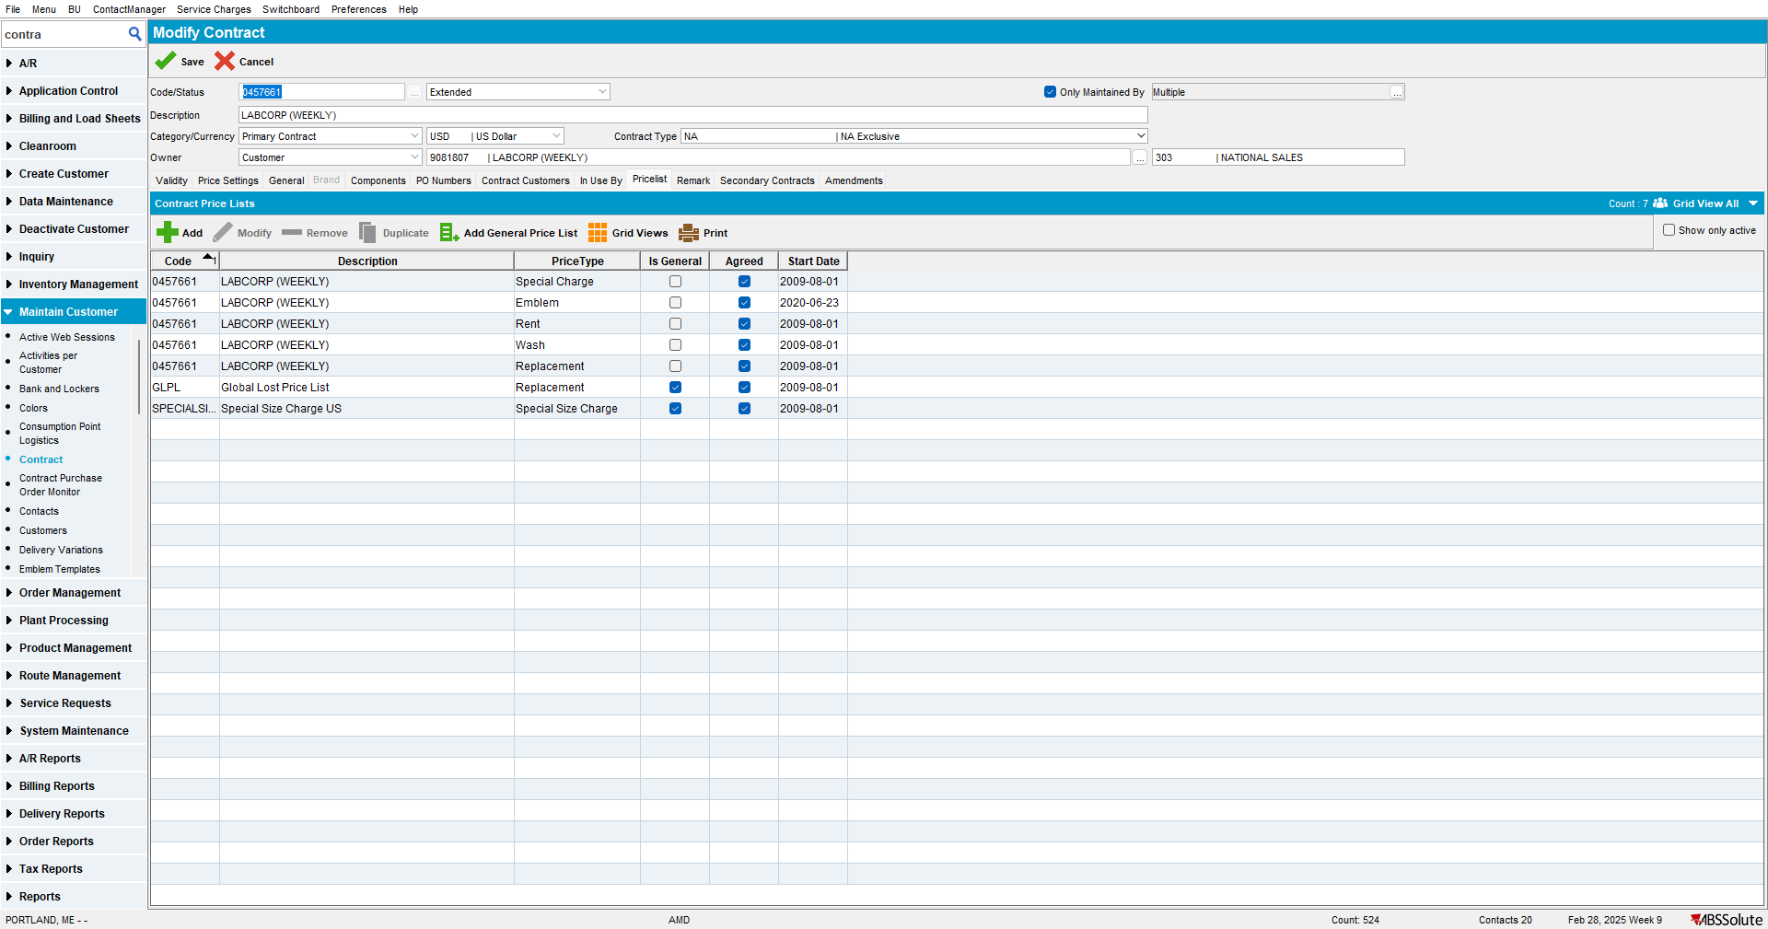

- Contract->Modify->Components load compliancy-> product settings -> add at least one budget protection like GSP
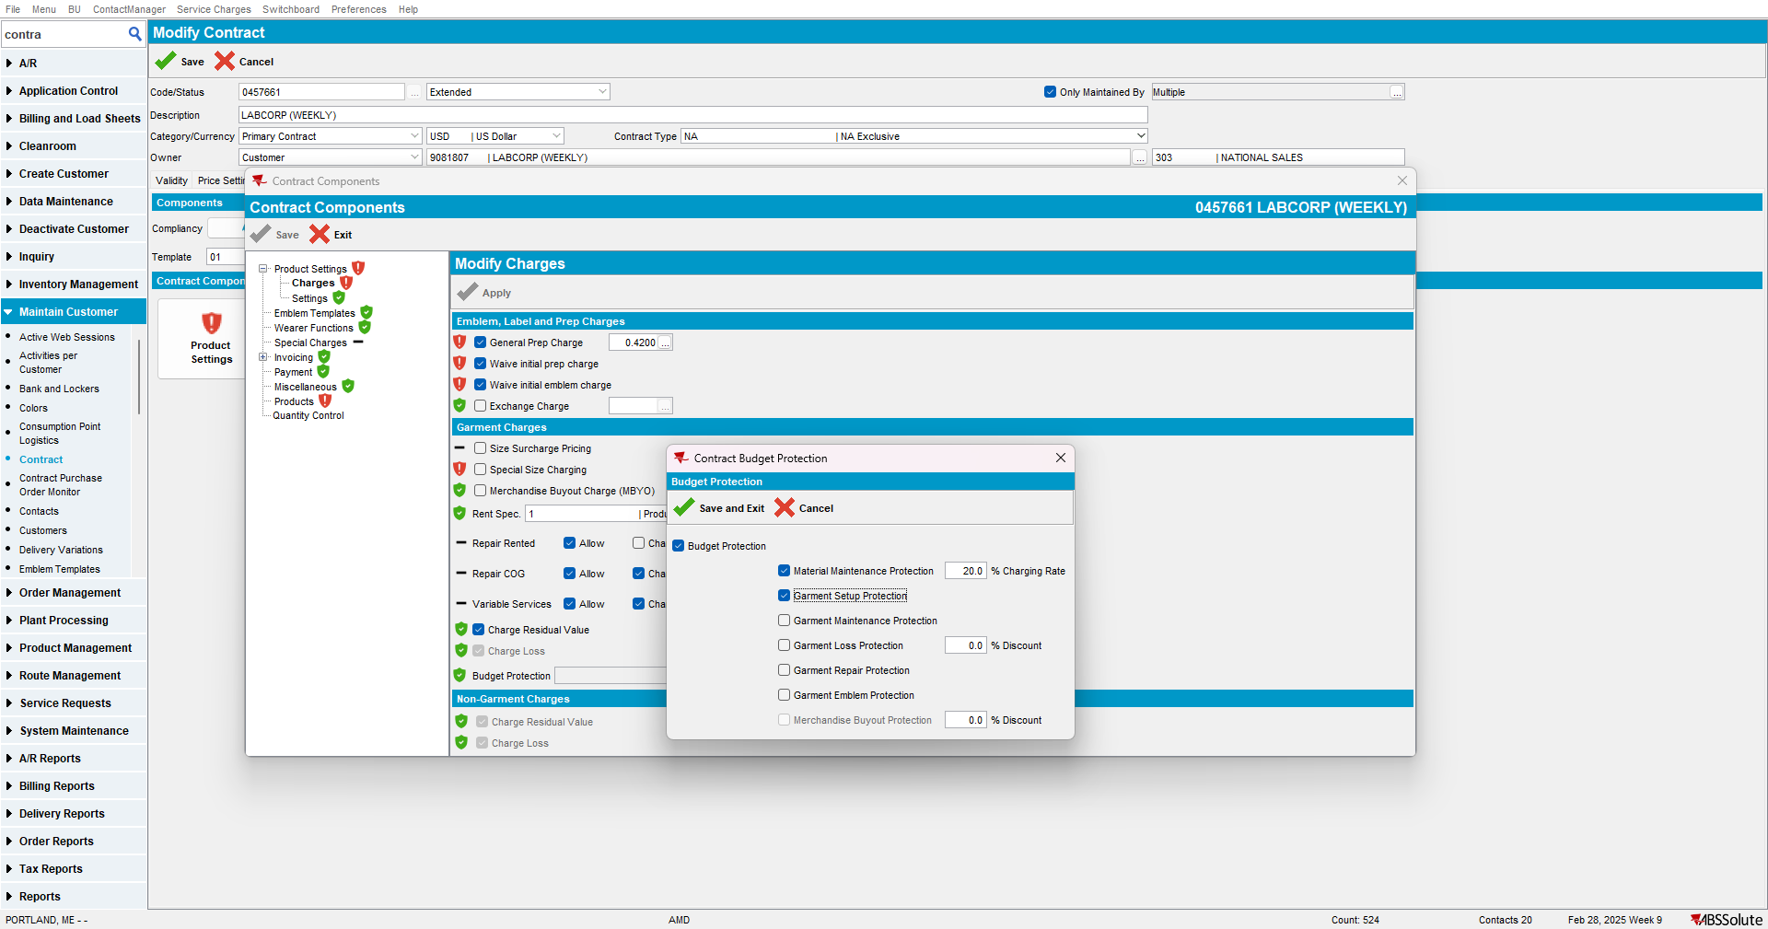

- Enforce the Budget Protection to the contract customers
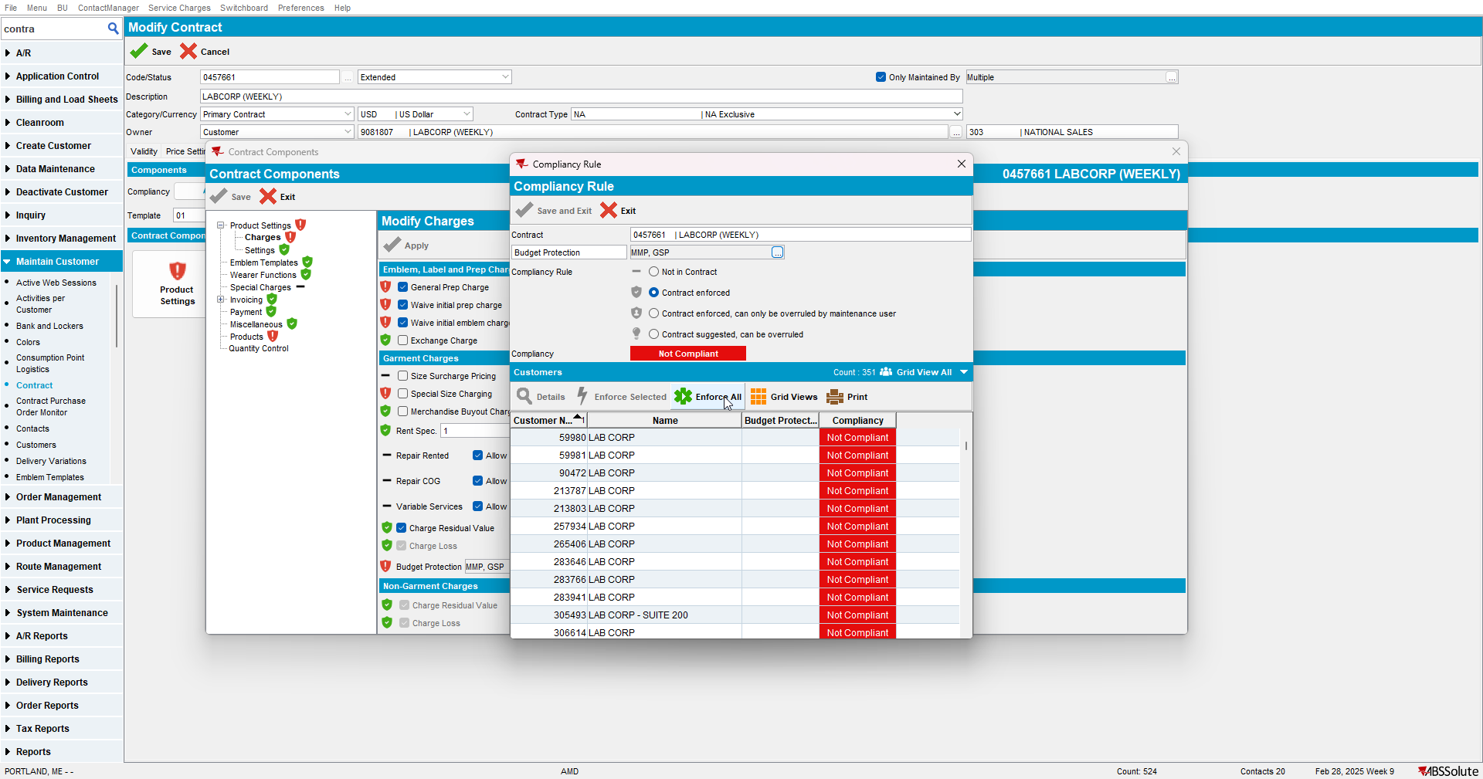

- Go to Products: Select a garment contract product
- Enable GSP budget protection and add a price
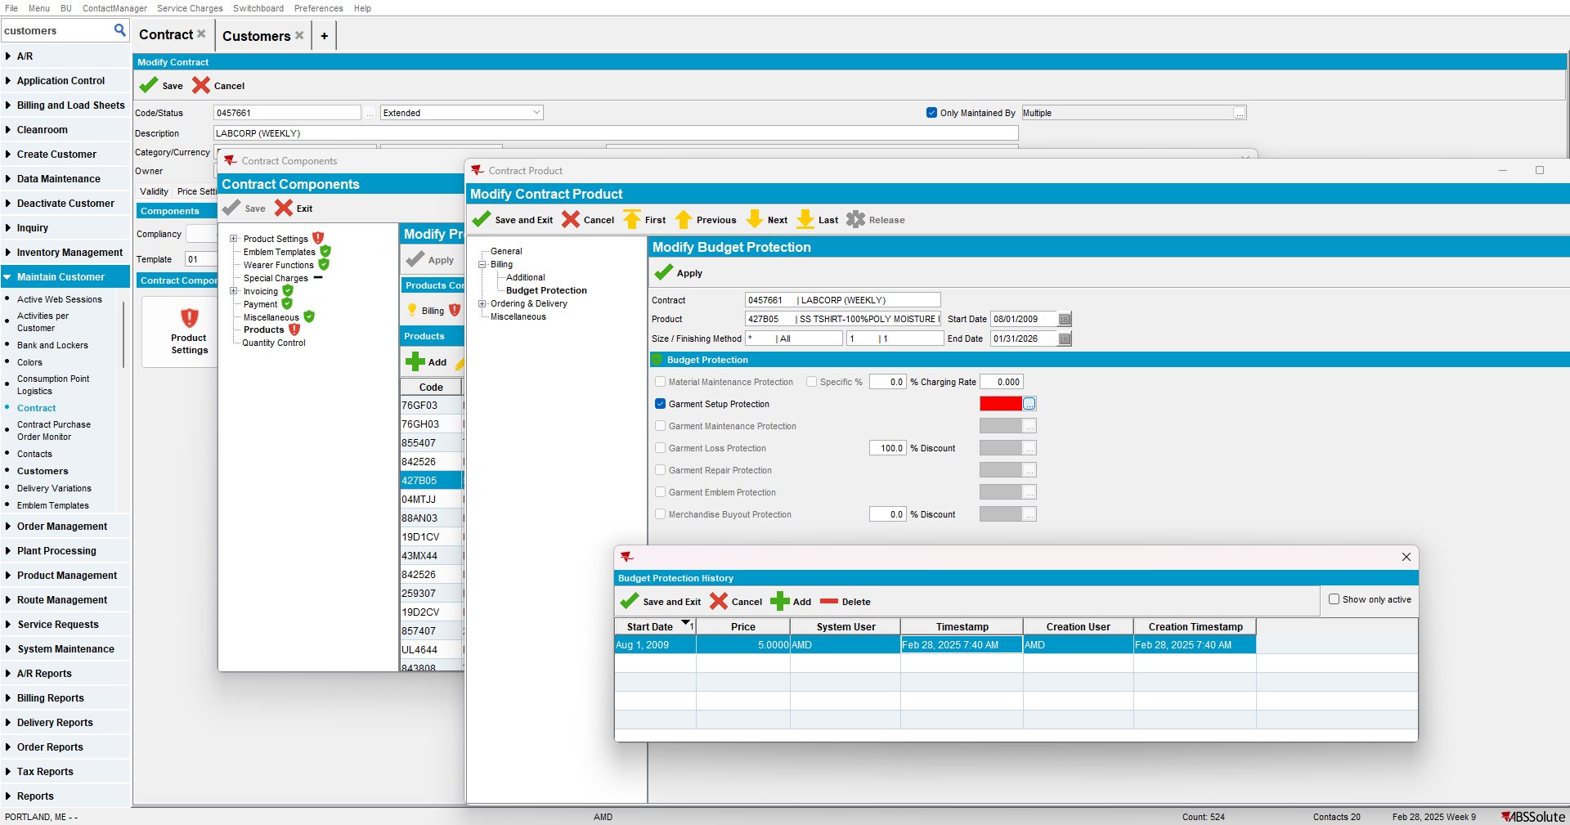
- Save and apply
- Check that the Contract Price list for PriceType = Insurance was added
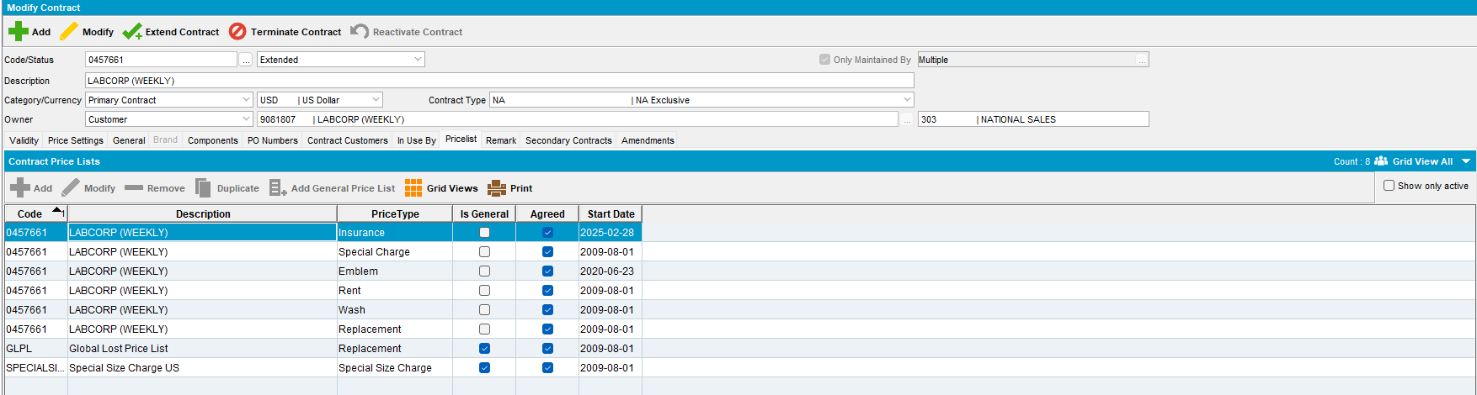
- Contract > Contract Customers: find an active contract customer
- Price List per customer DLG: load the customer (example: 59980)
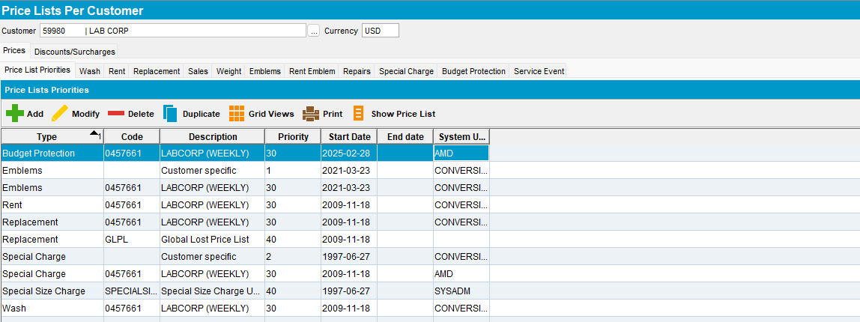
Verify that PriceListPerCustomer entry for the Budget Protection price type was added that links to the GeneralPriceList from the contract.
Tested OK

Test Case 2 – Add the first sales price to an existing contract – Tested OK
Expected behavior: When the first sales price is entered there is a new entry in GENERALPRICELIST table for pricetype = 4 (sales) then a link to the contract in CONTRACTPRICELIST for the new GENERALPRICELIST_ID and lastly an entry in the PRICELISTPERCUSTOMER table for all active or future active Contract Customers.
Hash: 40366e9201a
- Find a contract that does not have a sales price list using the following select:
select distinct co.code
from contract co
where not exists (
select 1 from contractpricelist cpl
where cpl.contract_id = co.contract_id and cpl.pricetype = 4)
and exists (
select 1 from contractcustomer cc
join customer c on c.customer_id = cc.customer_link_id
where cc.contract_id = co.contract_id and cc.enddate > sysdate and c.dateinactive > sysdate)
and co.enddate > sysdate
- Load the contract
- Contract > Pricelist: check that there is no sales price list
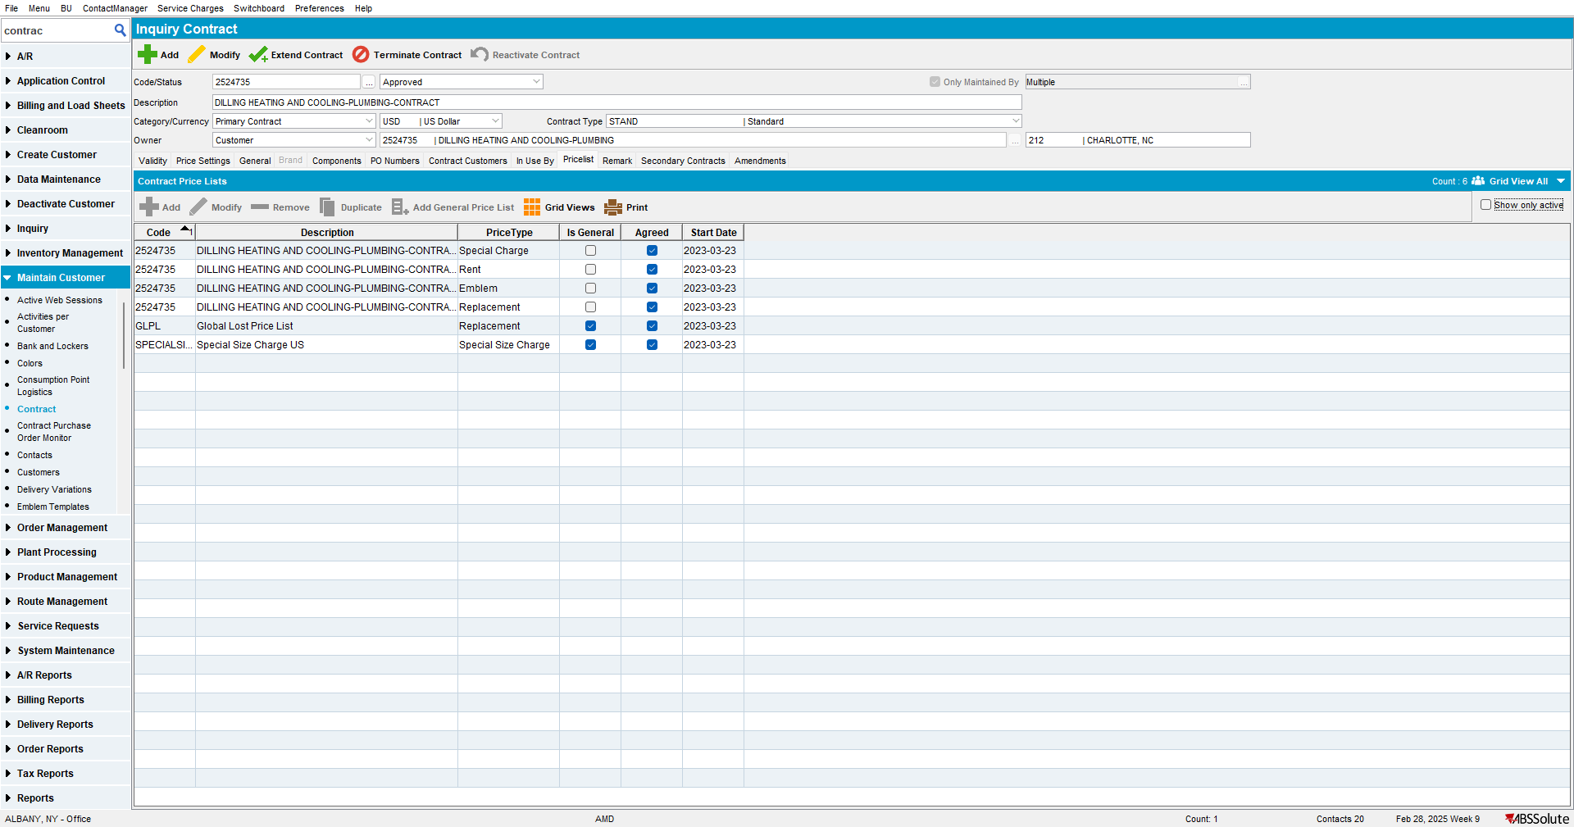

- Go to Products: Select a garment contract product that only has a rent price
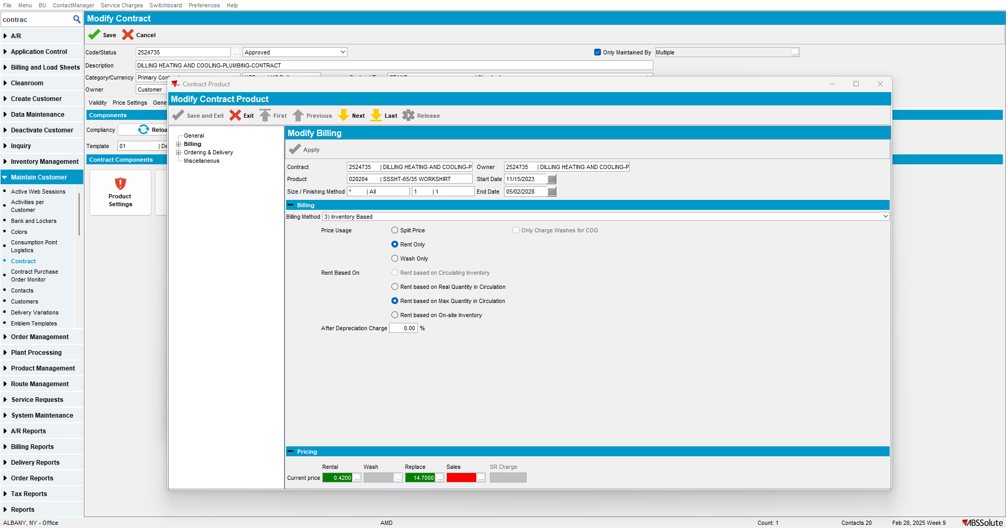
- Add a sales price to the product
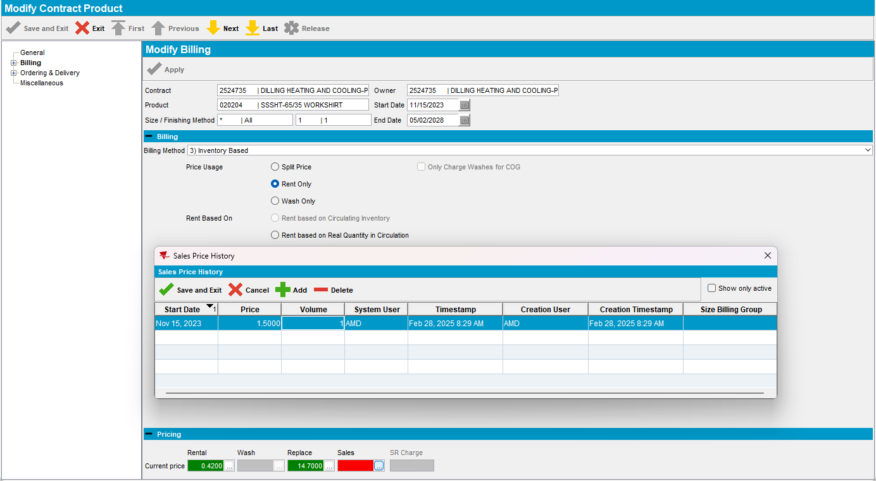
- Save and apply
- Check that the Contract Price list for PriceType = Sales was added
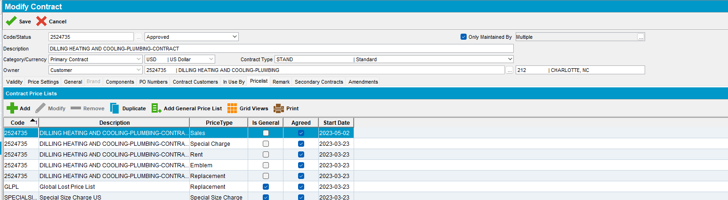
- Contract > Contract Customers: find an active contract customer
- Price List per customer DLG: load the customer (example: 2524735)
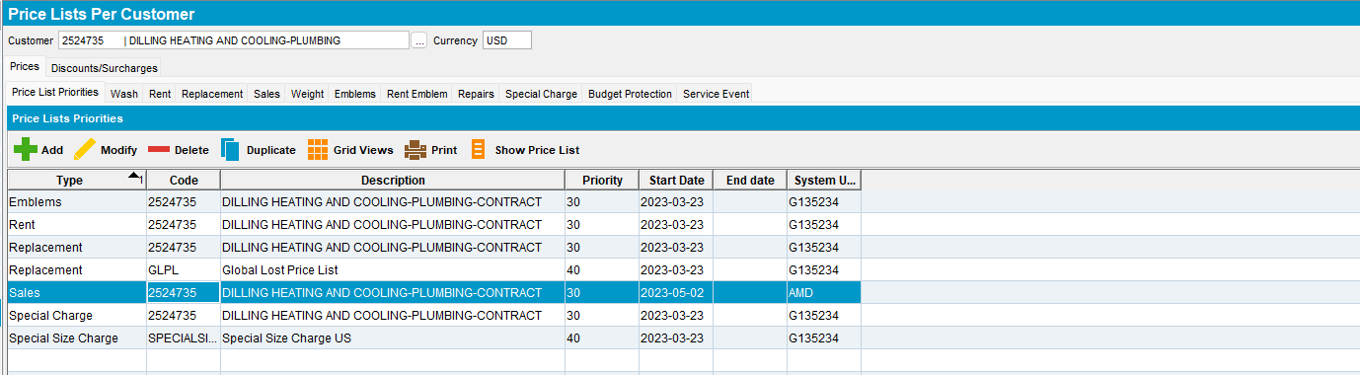
Verify that PriceListPerCustomer entry for the Sales price type was added that links to the GeneralPriceList from the contract.
Tested OK

Test Case 3 – Add the first sales price to an existing contract but your Contract Customer is ended – Tested OK
Expected behavior: When the first sales price is entered there is a new entry in GENERALPRICELIST table for pricetype = 4 (sales) then a link to the contract in CONTRACTPRICELIST for the new GENERALPRICELIST_ID and lastly an entry in the PRICELISTPERCUSTOMER table for all active or future active Contract Customers.
Hash: 40366e9201a
- Find a contract that does not have a sales price list using the following select:
select distinct co.code
from contract co
where not exists (
select 1 from contractpricelist cpl
where cpl.contract_id = co.contract_id and cpl.pricetype = 4)
and exists (
select 1 from contractcustomer cc
join customer c on c.customer_id = cc.customer_link_id
where cc.contract_id = co.contract_id and cc.enddate > sysdate and c.dateinactive > sysdate)
and co.enddate > sysdate
- Load the contract
- Contract > Pricelist: check that there is no sales price list
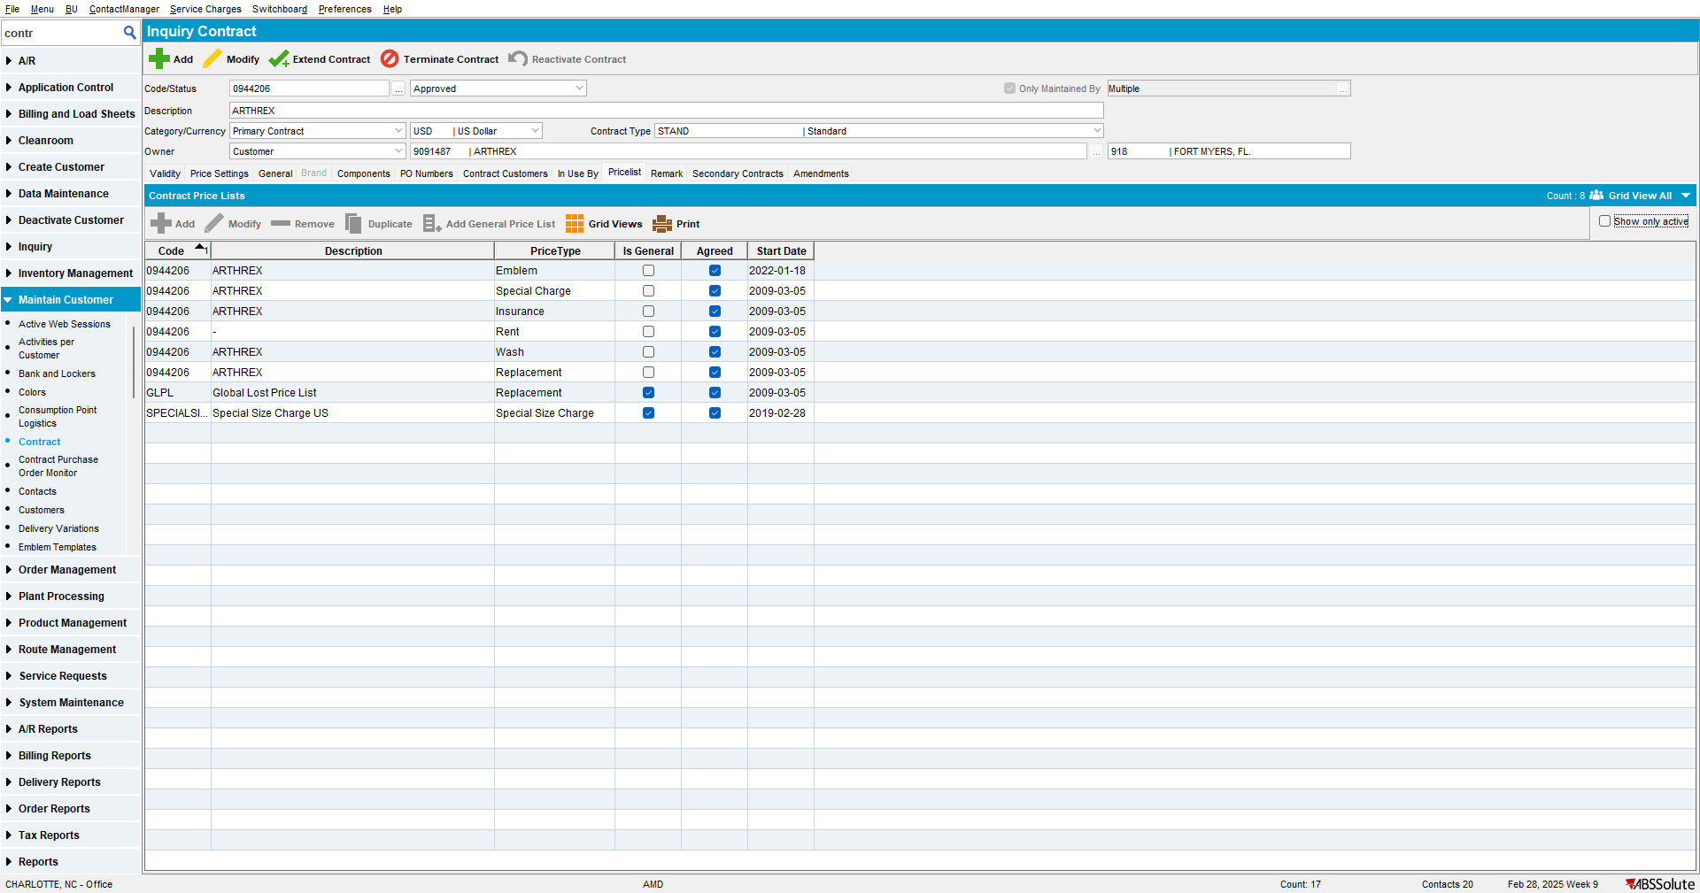

- Go to Products: Select a garment contract product that does not have a sales price
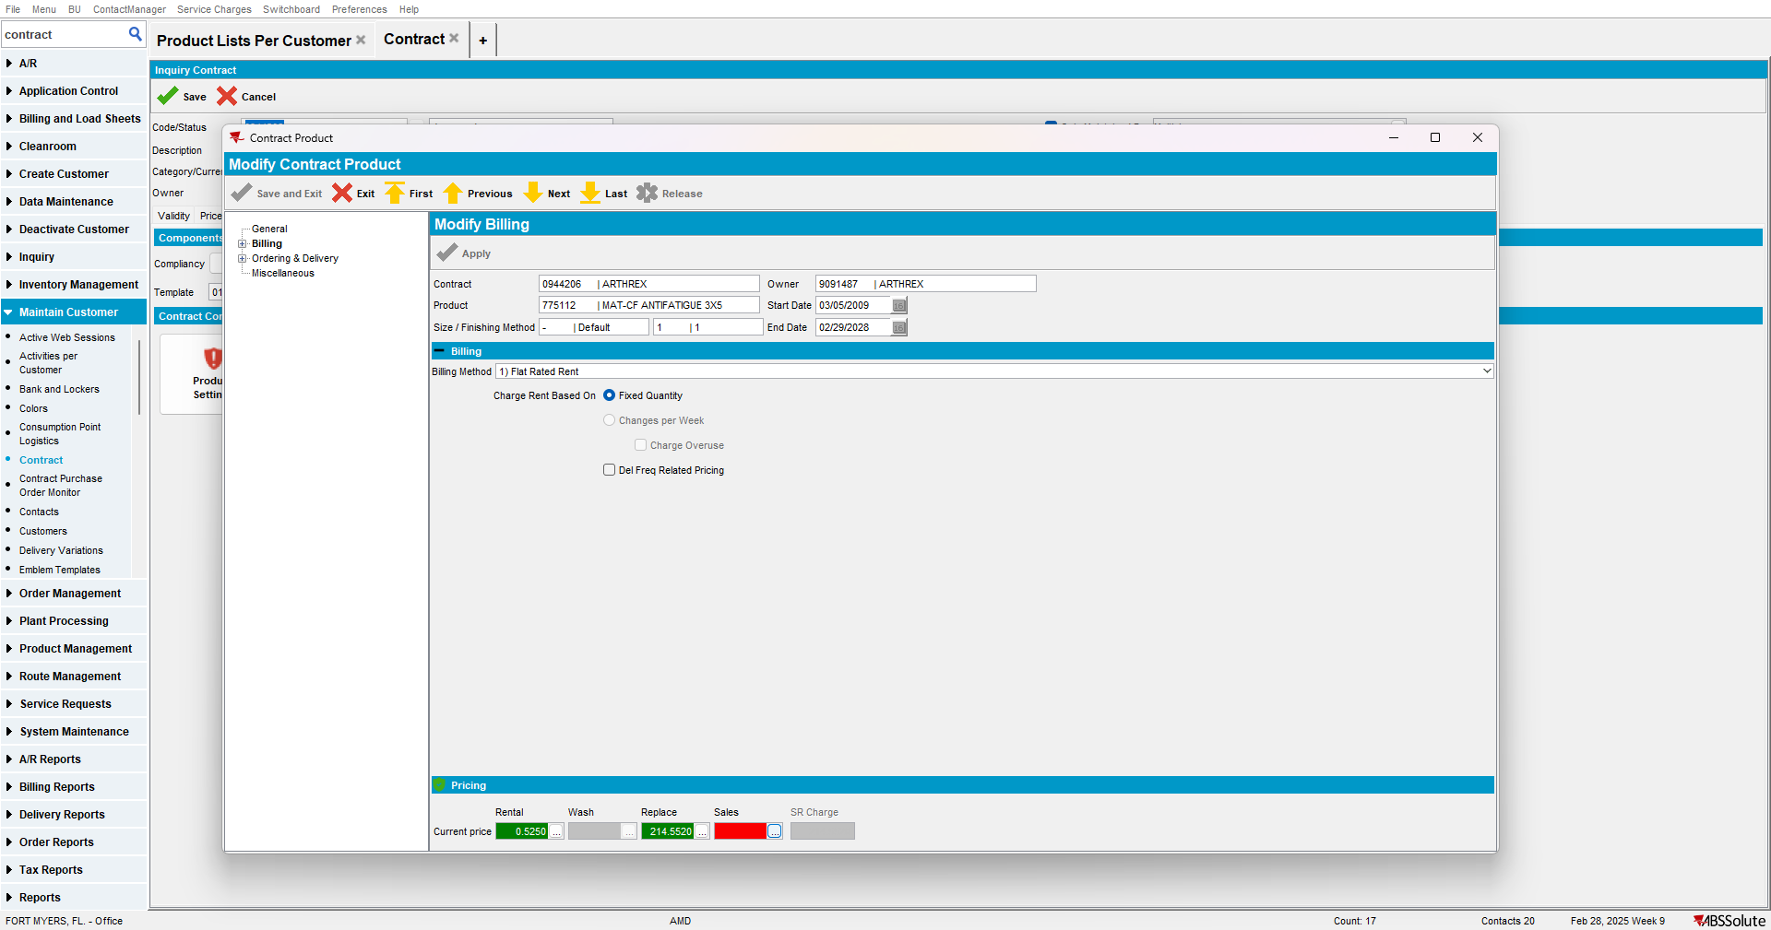
- Add a sales price to the product
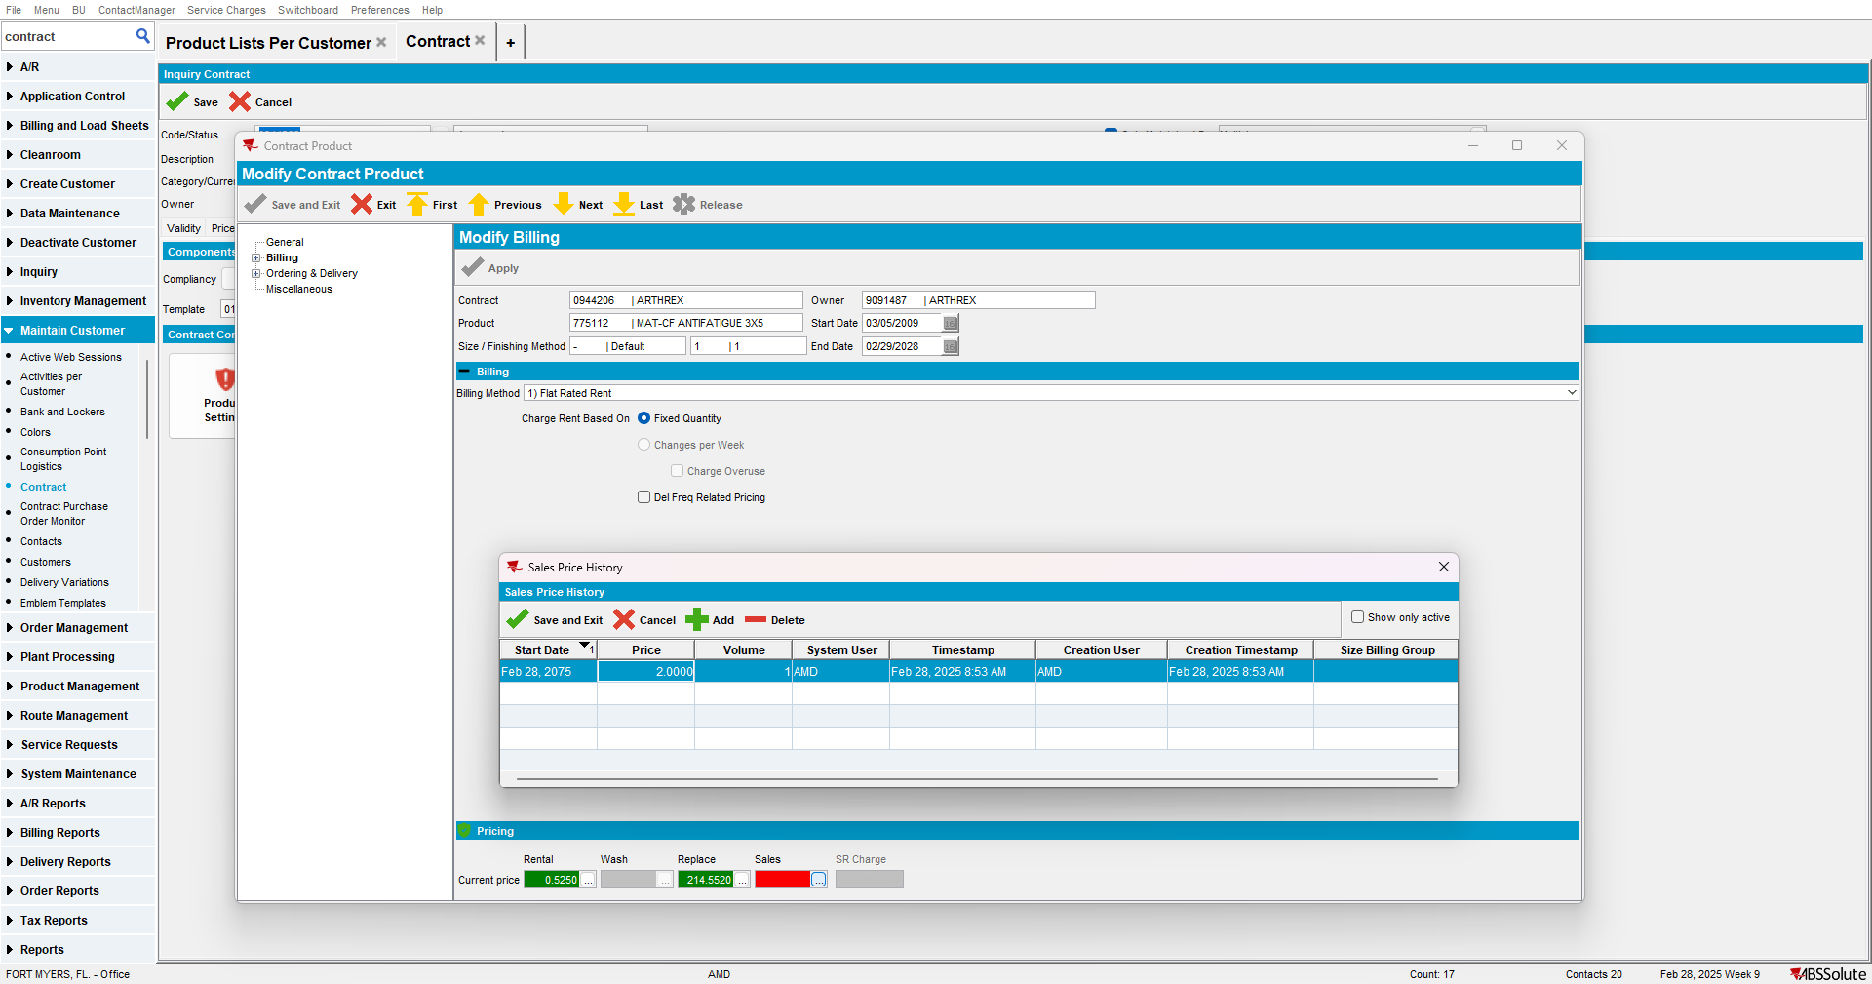
- Save and apply
- Check that the Contract Price list for PriceType = Sales was added
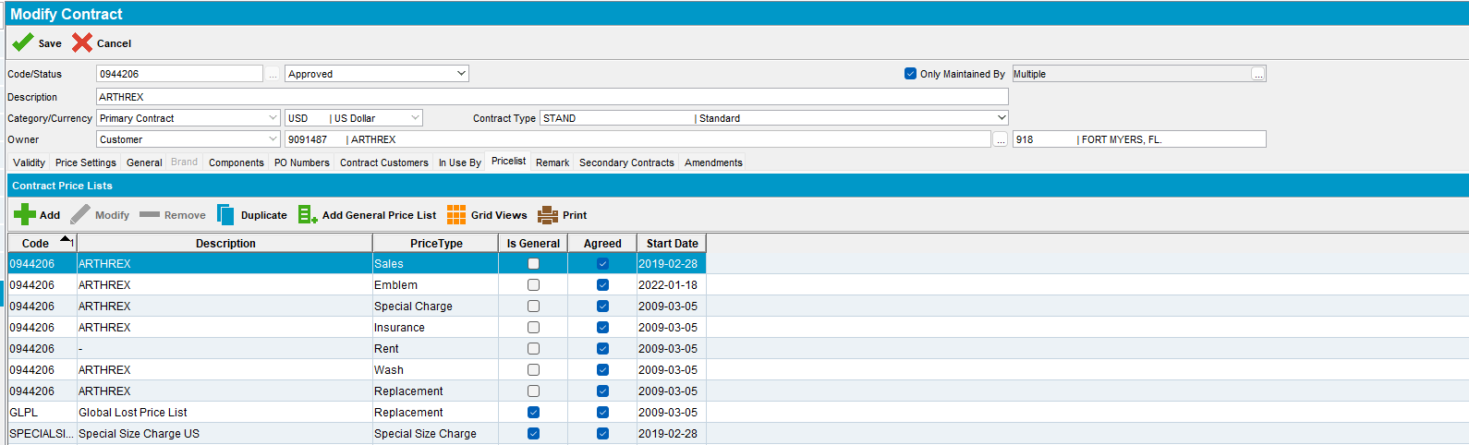

- Contract > Contract Customers: find an inactive contract customer that has the product in their product list
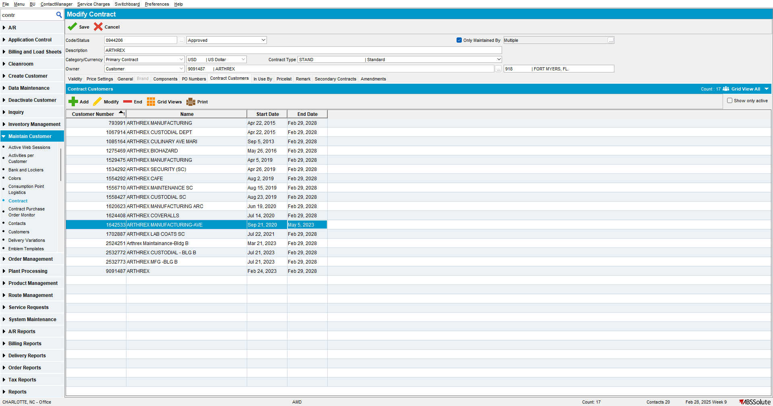
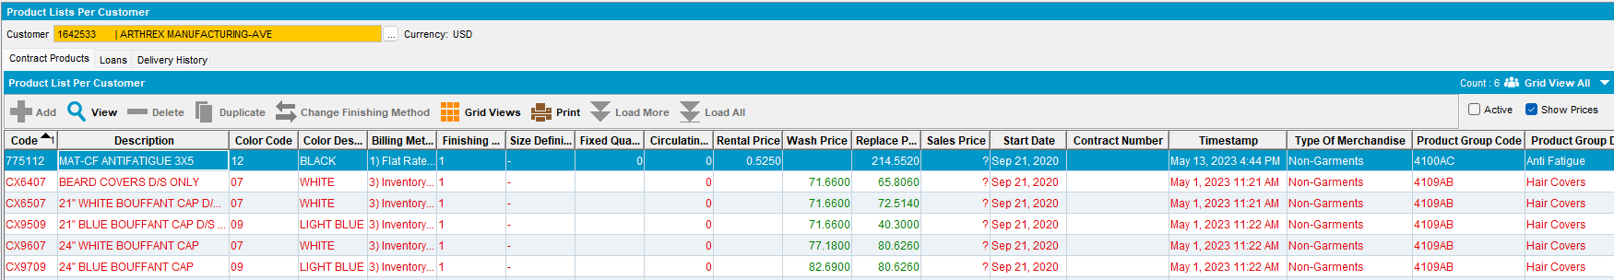

- Price List per customer DLG: load the customer
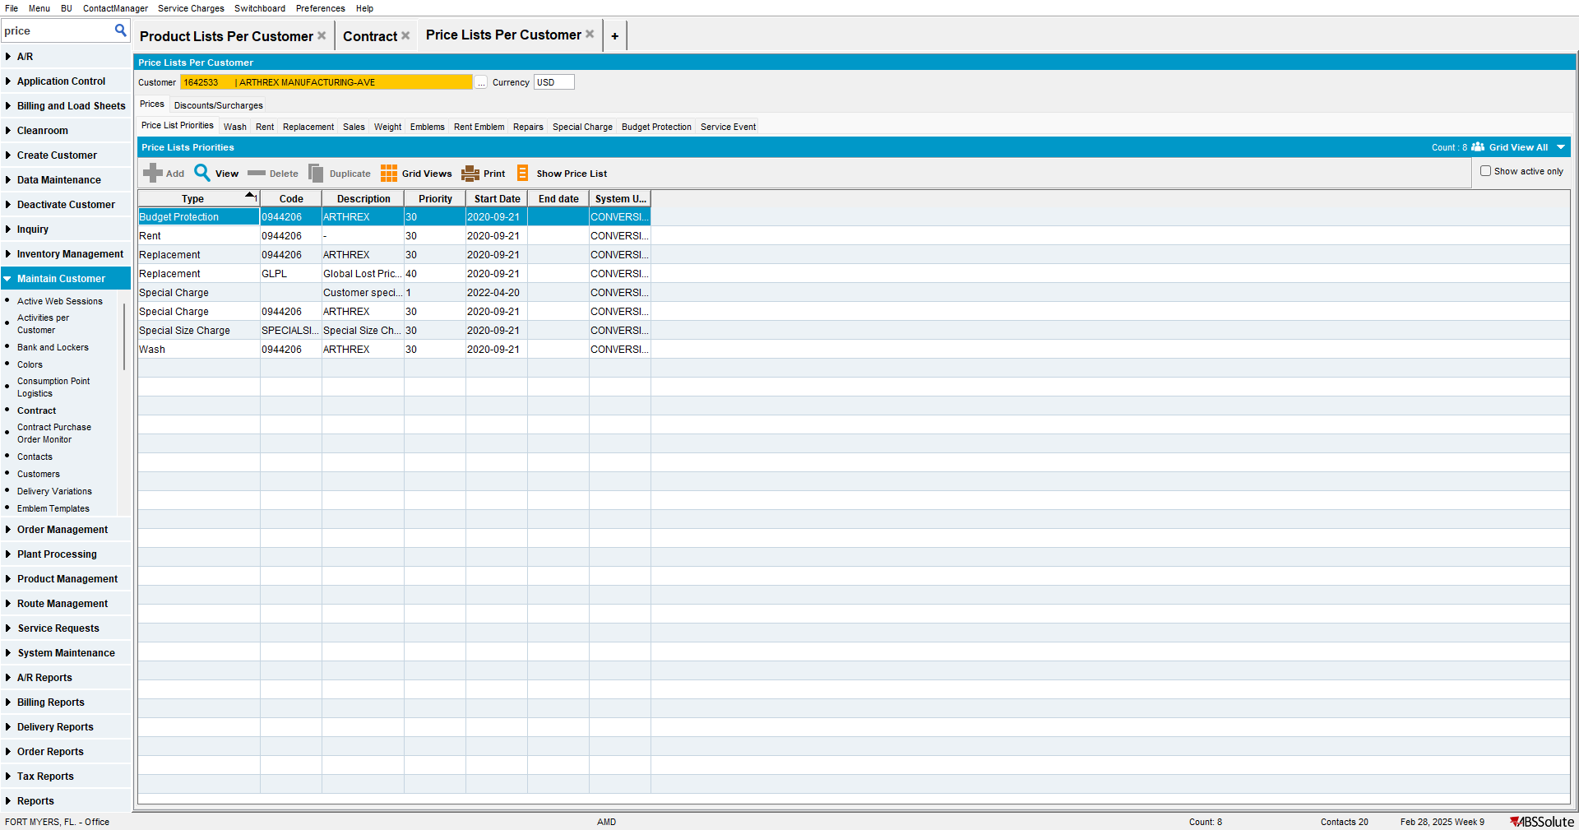
Verify that PriceListPerCustomer entry for the Sales price type was NOT added that links to the GeneralPriceList from the contract.
Tested OK

