ABSN-1850 Bug DEV-3153 Error while sending email invoice
Environment | Prerequisites
Version: 9.07.00.UNF19  DBServerName= abs-srv19.internal.abslbs.com  DBSID=CUST24  DBUser=UNFDEV  DBPassword=UNFDEV  Environment=Production | - Module:  - System setting

Contents
Reproducing before fix 1
Test after fix 2
Test Case 1 – Generate statement from CFD 2
Test Case 2 – Process Scheduler 3
PROCESS_GENERATE_AND_PRINT_STATEMENTS 3
PROCESS_EMAIL_STATEMENTS 4
PROCESS_EMAIL_DIRECT_INVOICES 4
Test Case 3 – Route Assistant 5
Test Case 4 – Generate statements form 6
Test Case 5 – Maintain sales notes 8
Test Case 6 – Route Status Control 10
Test Case 7 – Invoices from Switchboard 11

Reproducing before fix
Hash: a0f791757c38
- Process Scheduler dlg: Run “Email Direct Invoices” process
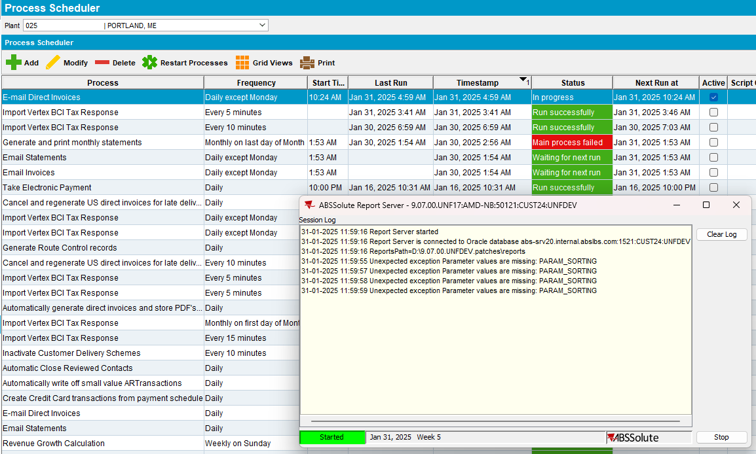

Test after fix
Hash: e23520ca3fb6

Test Case 1 – Generate statement from CFD

- Customer Financial Details dlg: Select your customer then go to Statements tab
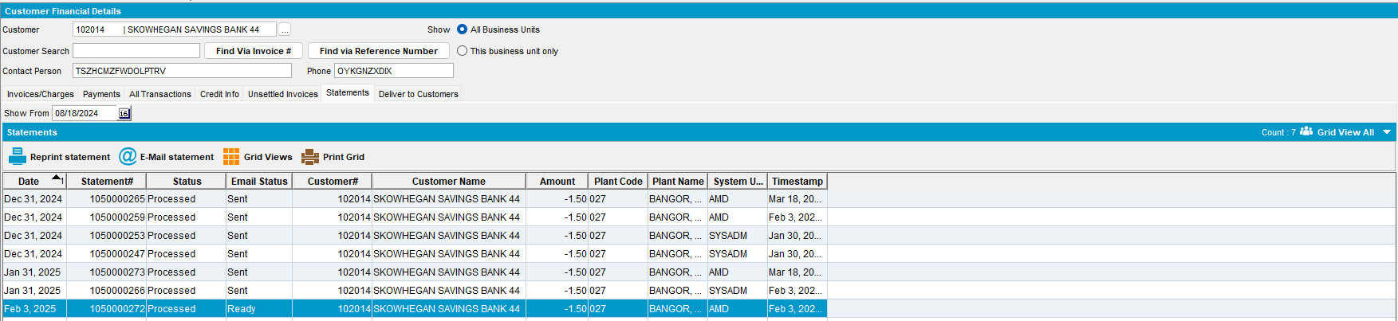

- Customer Financial Details dlg: Select a statement and press “E-Mail Statement” button.
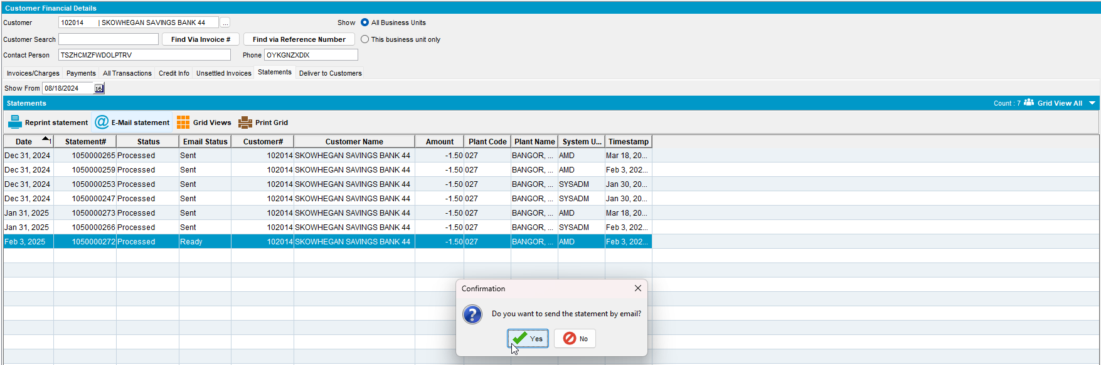
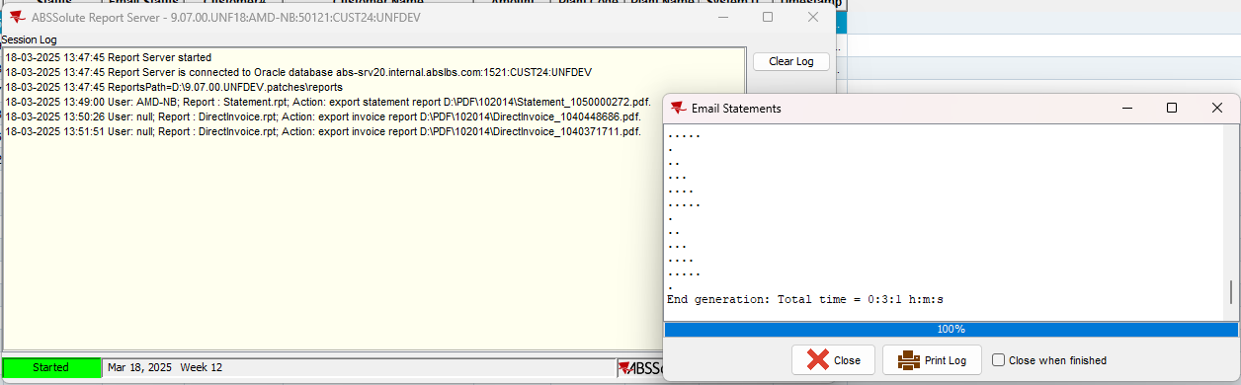
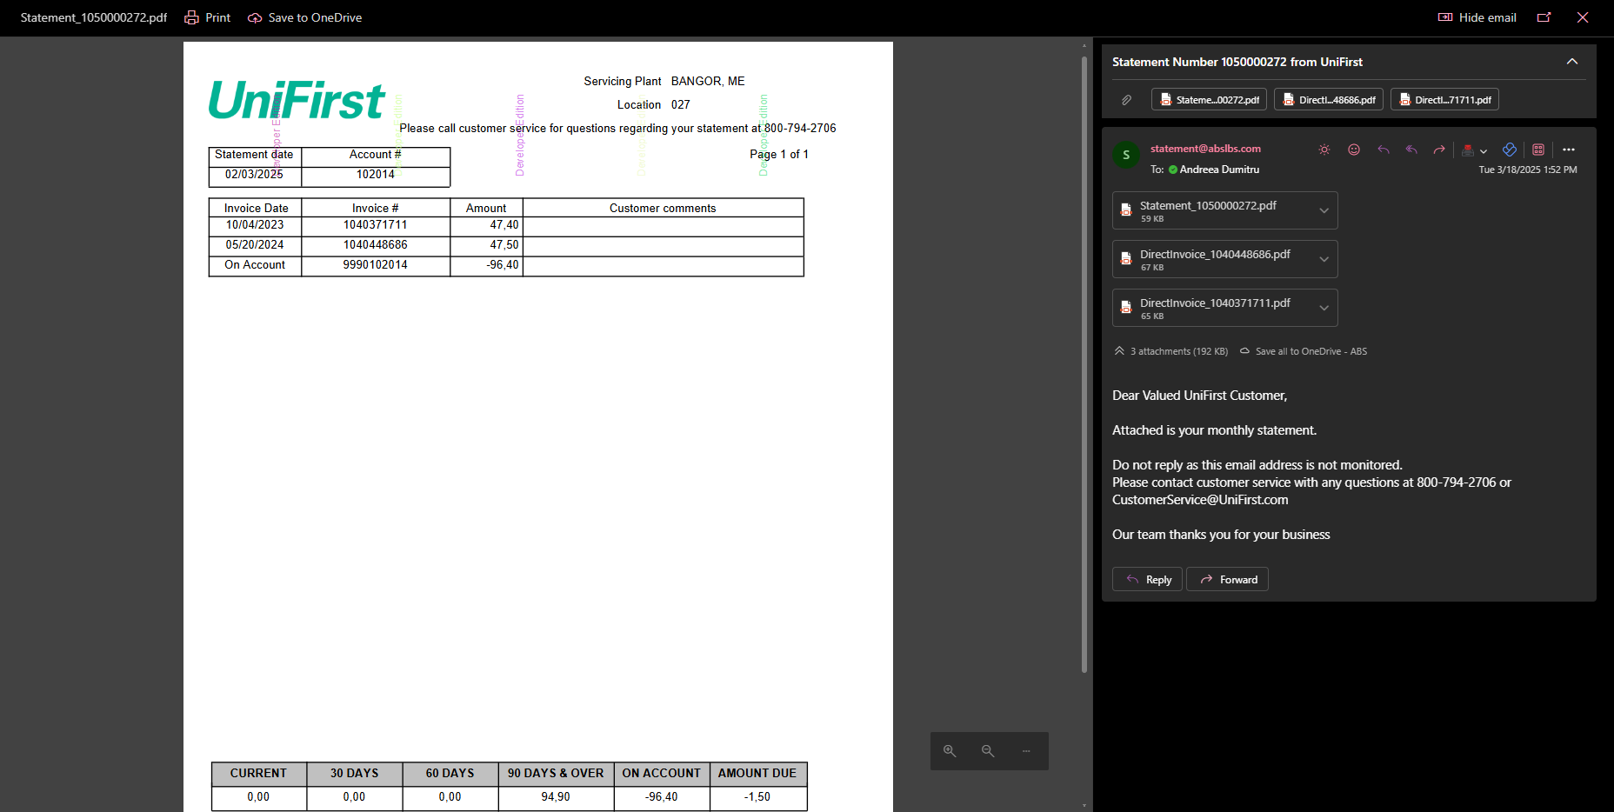

Test Case 2 – Process Scheduler

PROCESS_GENERATE_AND_PRINT_STATEMENTS
- Process Scheduler dlg: Run “Generate and print monthly statements” process
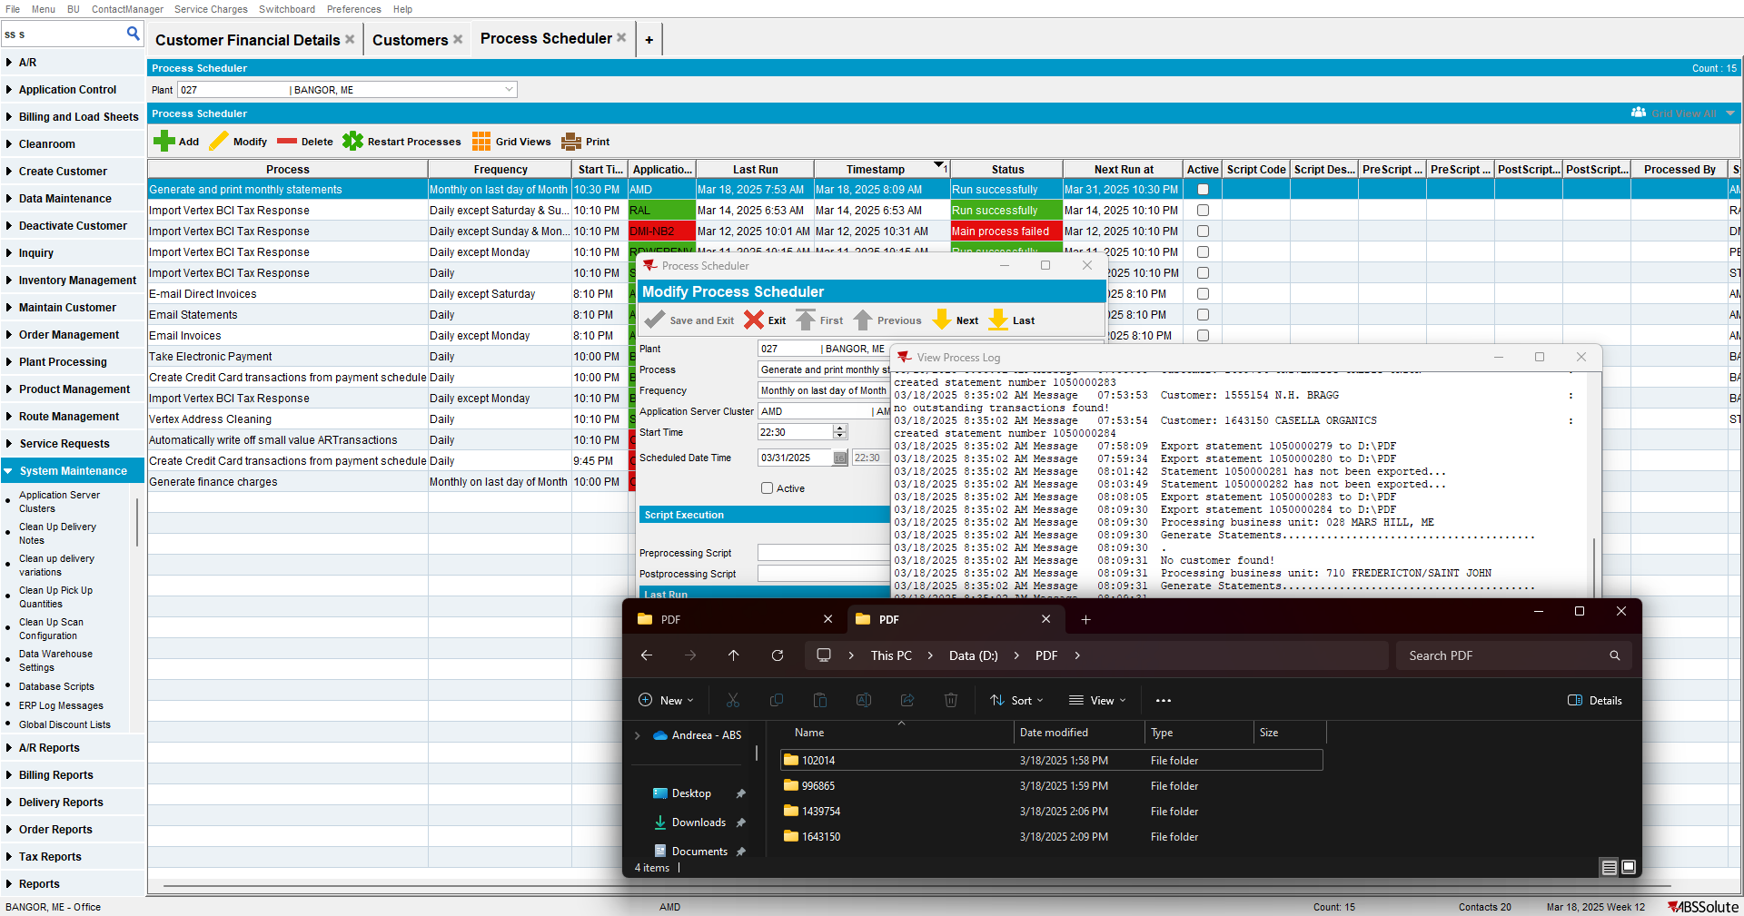

PROCESS_EMAIL_STATEMENTS
- Process Scheduler dlg: Run “Email Statements” process
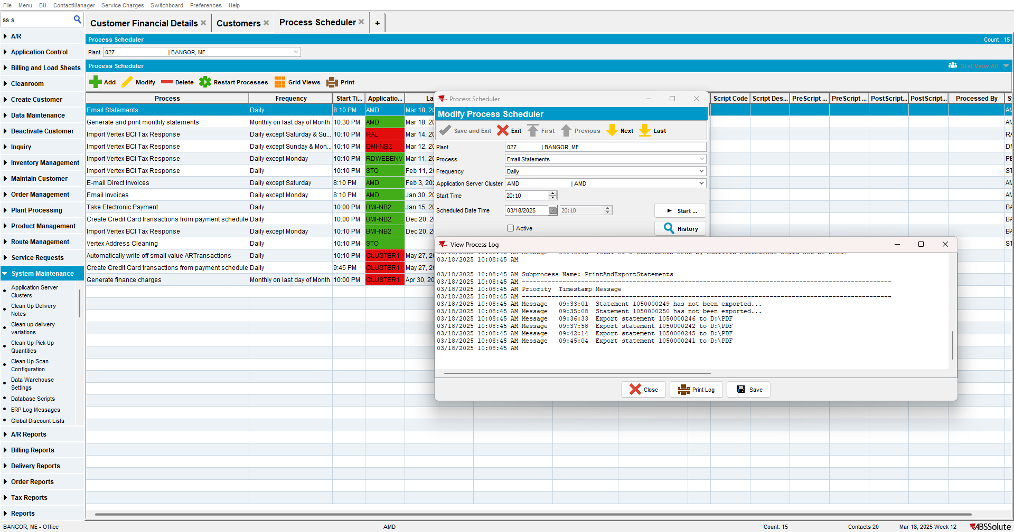
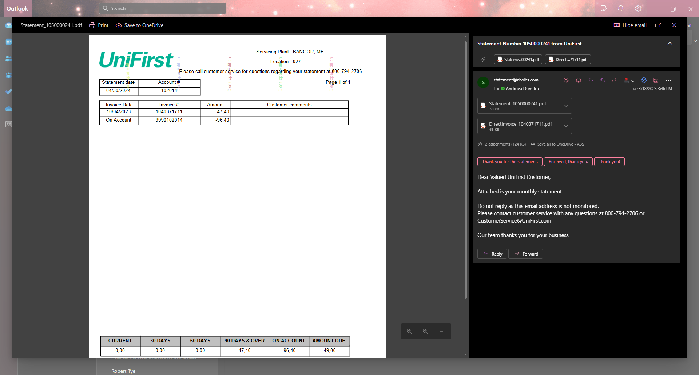

PROCESS_EMAIL_DIRECT_INVOICES
- Process Scheduler dlg: Run “Email Direct Invoices” process
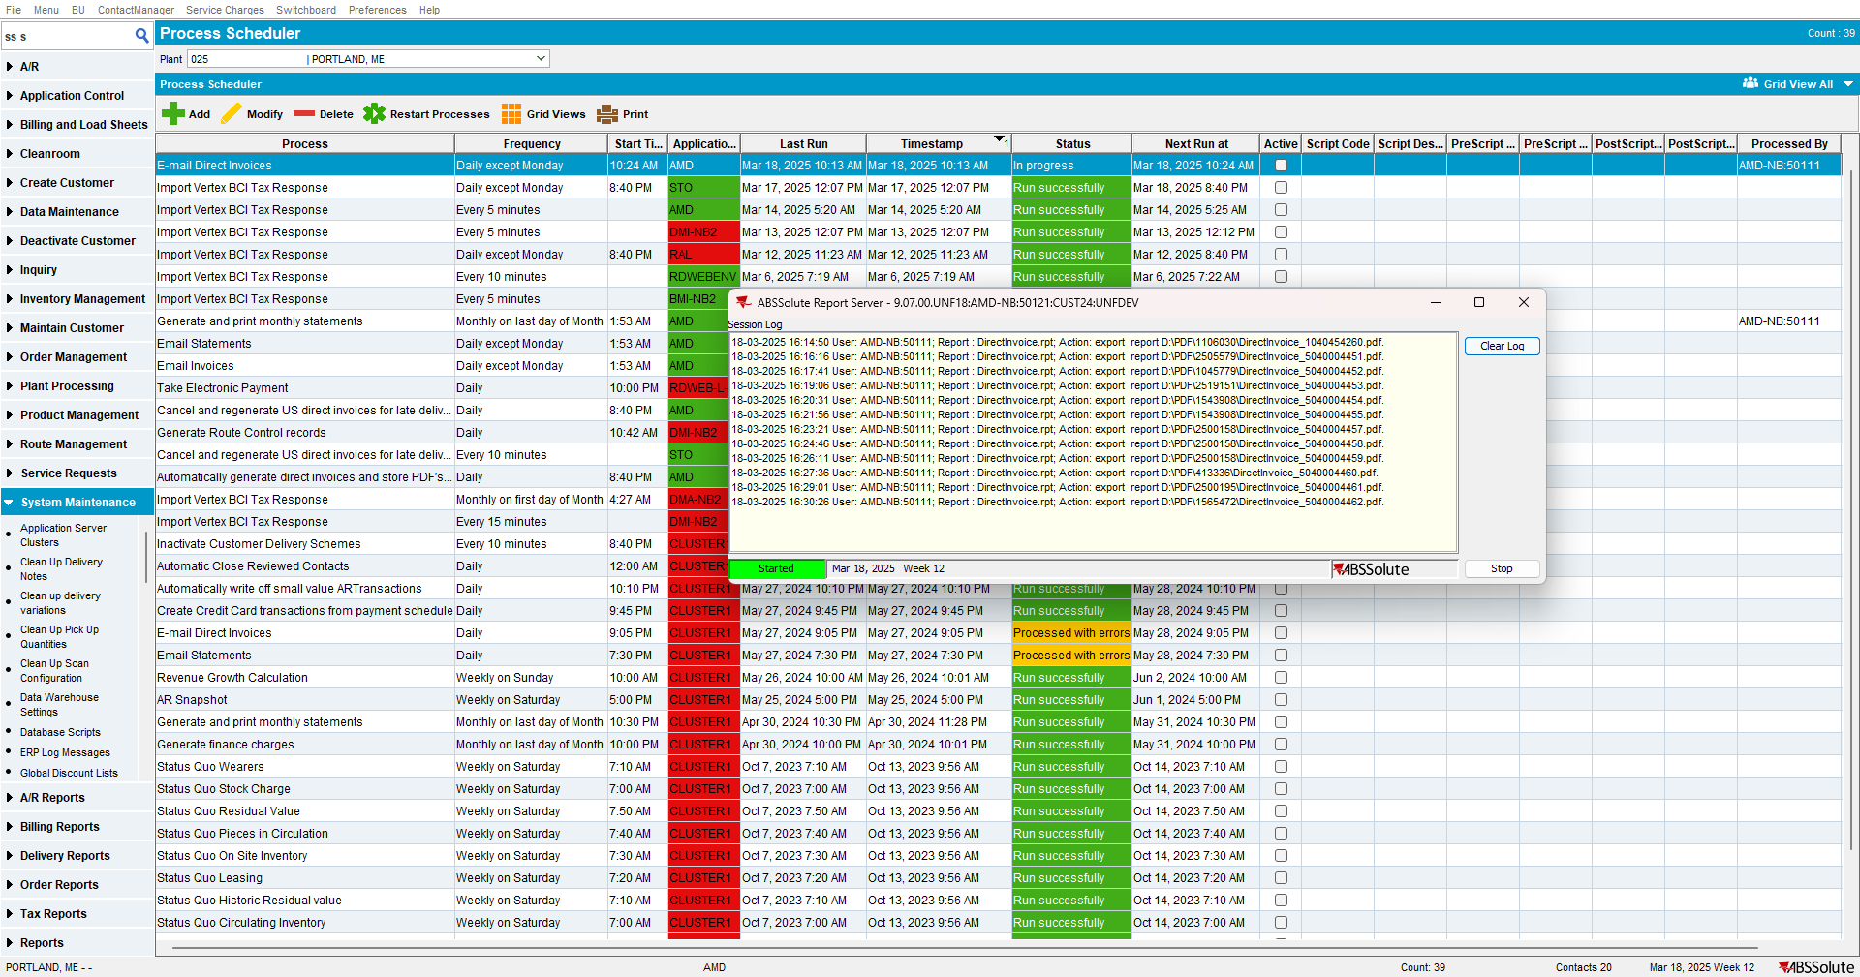

Test Case 3 – Route Assistant
- Create a Route and transfer it to PDA
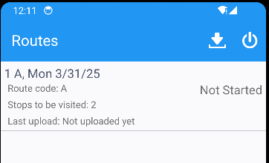

- Go to Financial Details, All Open Invoices
- Select some invoices and email them
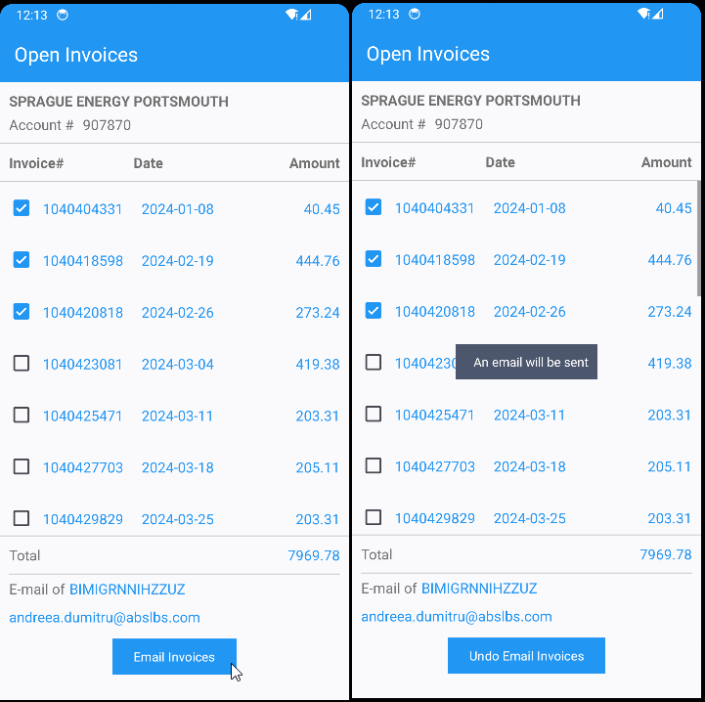

Test Case 4 – Generate statements form
- Generate Statements dlg: Select your customer and generate the statements
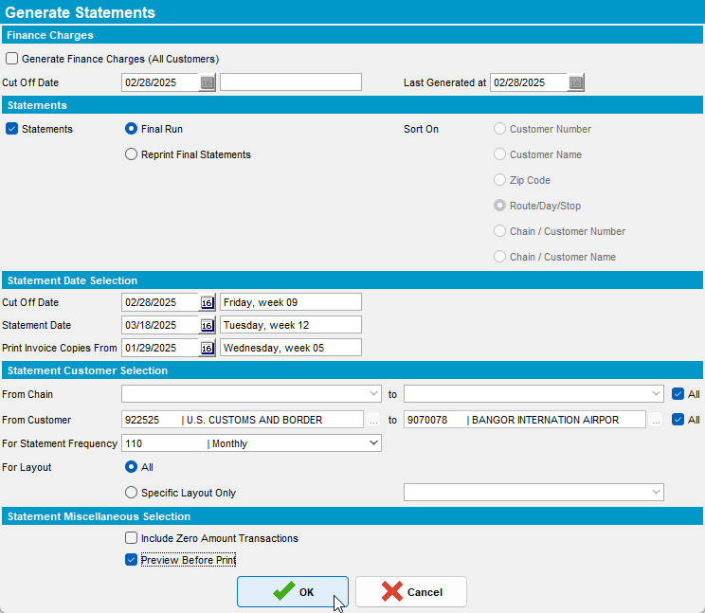
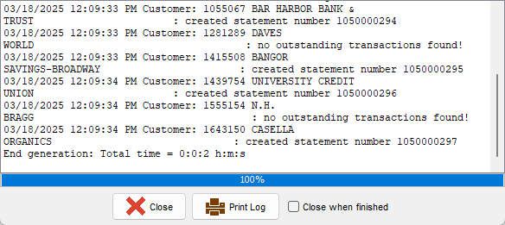
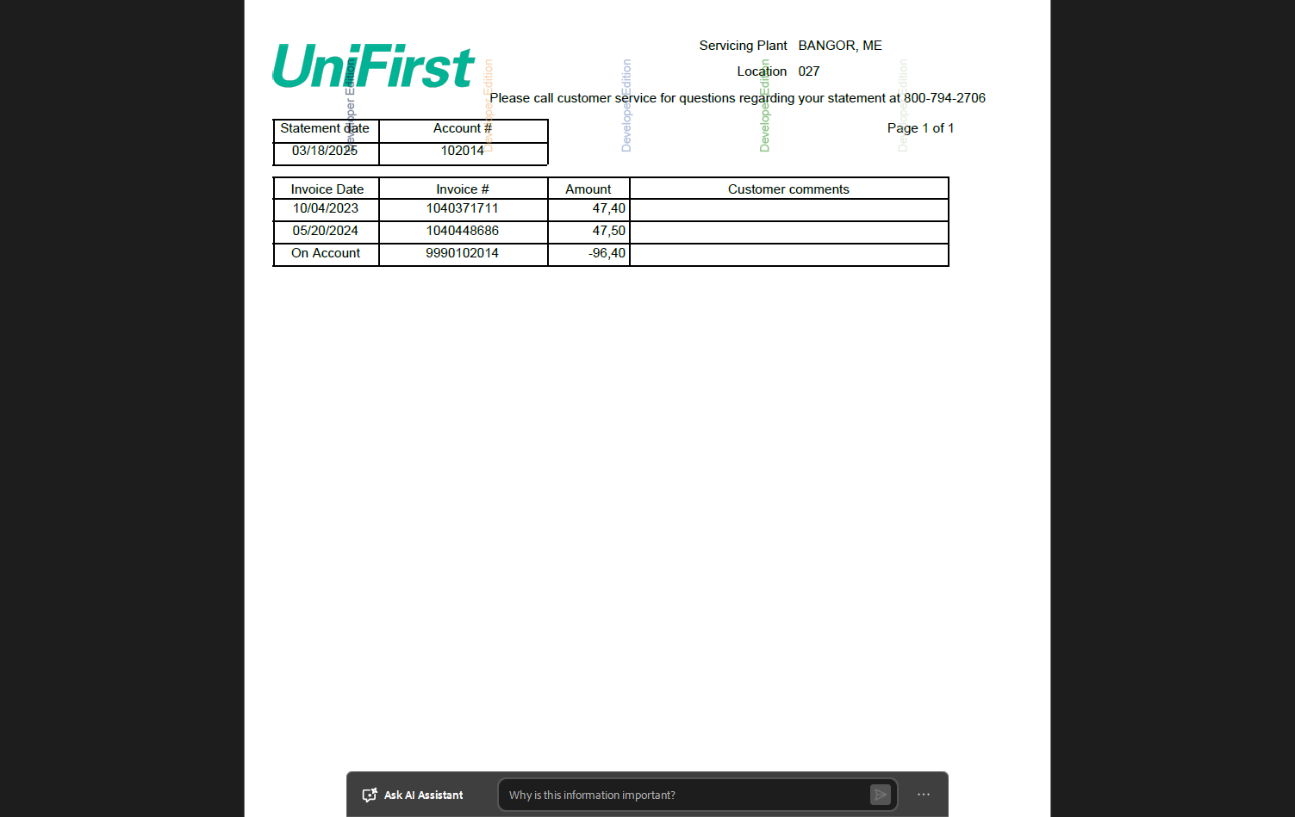

Test Case 5 – Maintain sales notes
- Maintain Sales Notes dlg: Select your customer and open the sales note
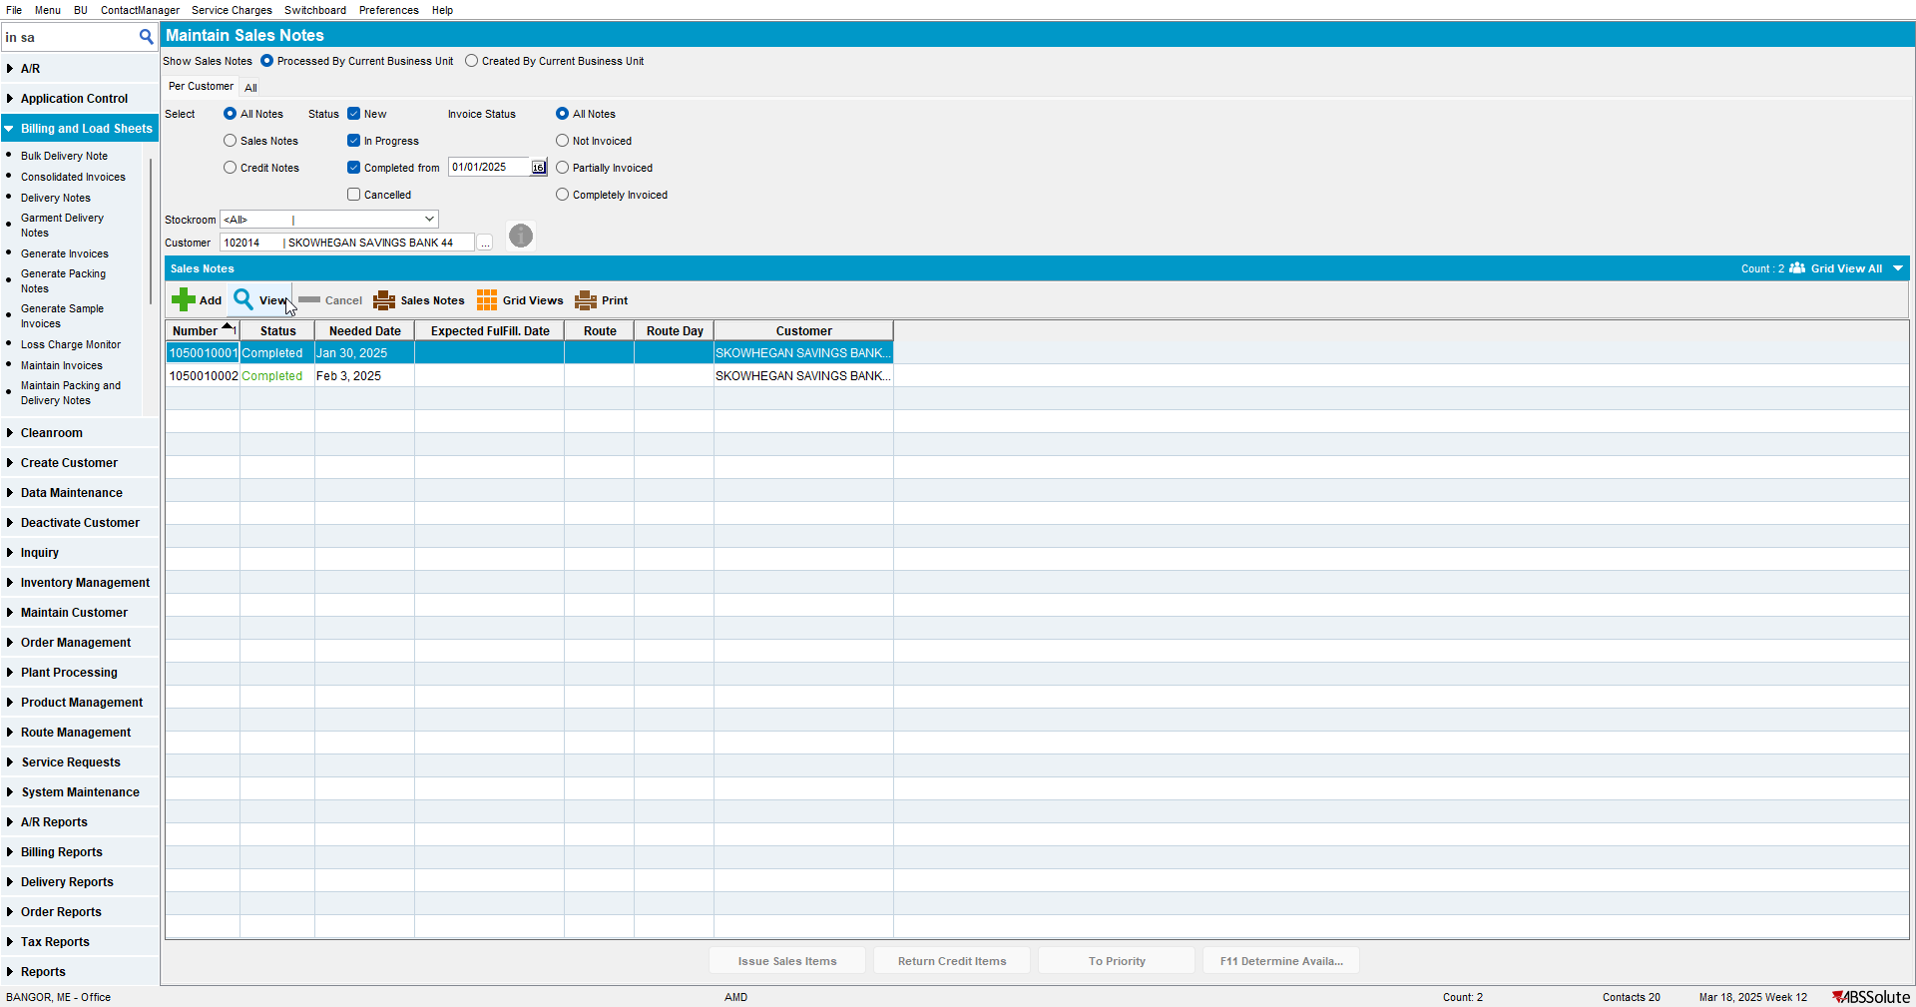

- Go to Deliveries Tab and generate the Invoice
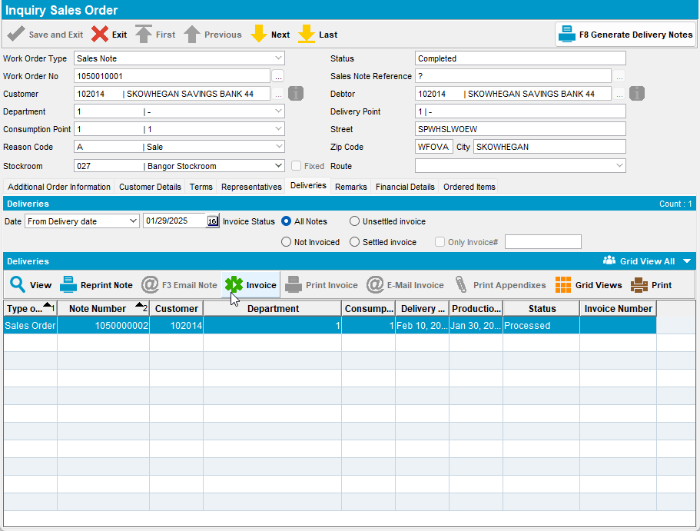
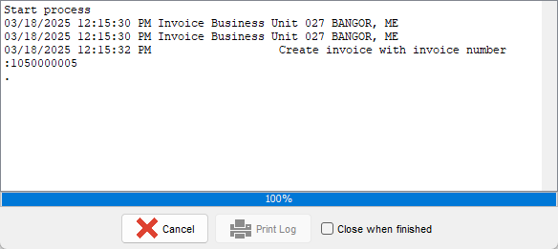
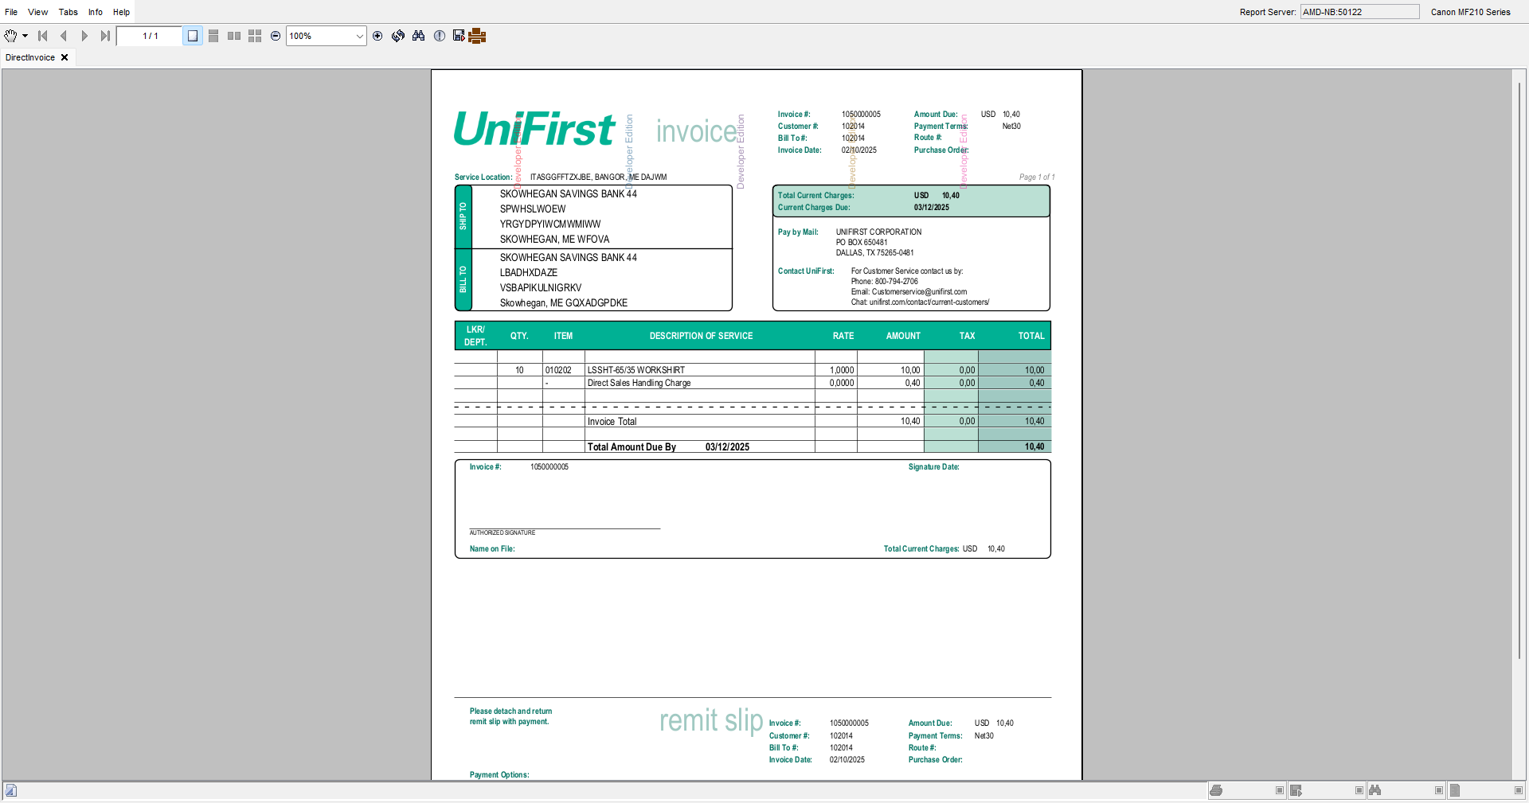

Test Case 6 – Route Status Control
- Route Status Control dlg: Add a route and generate the invoices
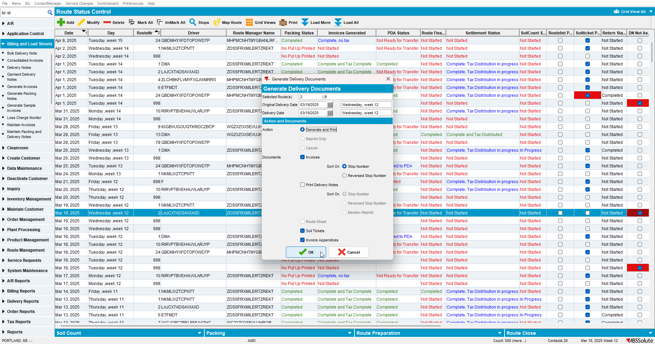
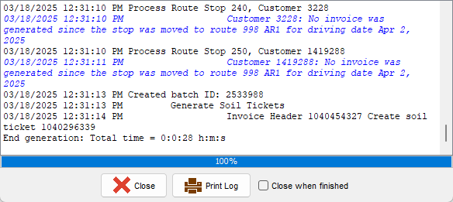

Test Case 7 – Invoices from Switchboard
- Go to Switchboard and select your customer
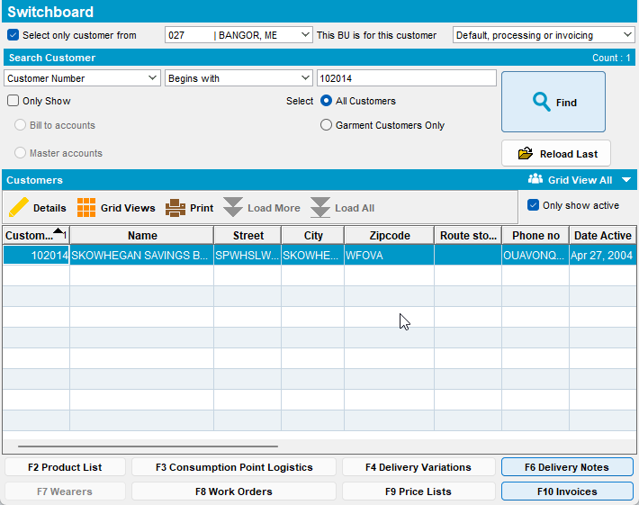

- Press F10 Invoices then press Print Invoice
