ABSN-1825 - WebX - negative invoice adjustments from RA causing issues in WebX
Environment | Prerequisites
Version: 9.07.00.UNF19  DBServerName= abs-srv20.internal.abslbs.com  DBSID=CUST24  DBUser=UNFDEV  DBPassword= UNFDEV  Environment=Test | - Module:  - System setting

Contents
Retest after fix 1
Test Case 1 – Invoice Adjustments with different codes but the same description as Reason Code 1
Test Case 2 – Undeliverable Stops on WebX codes but the same description as Reason Code 1

Retest after fix

Test Case 1 – Invoice Adjustments with different codes but the same description as Reason Code
Hash: 9b746106152e
- Route transaction category DLG: Have 2 Reason codes with the same description for one Minus Adjustments and
one for Plus Adjustments
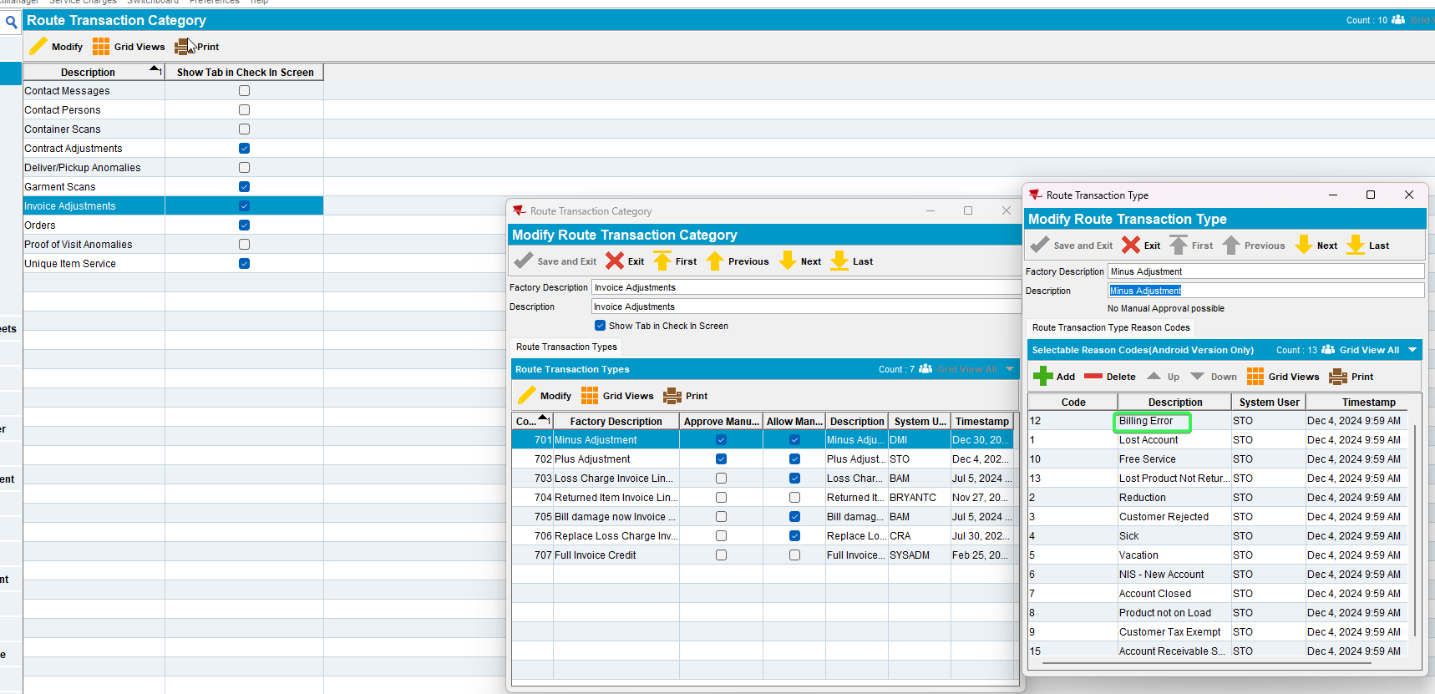
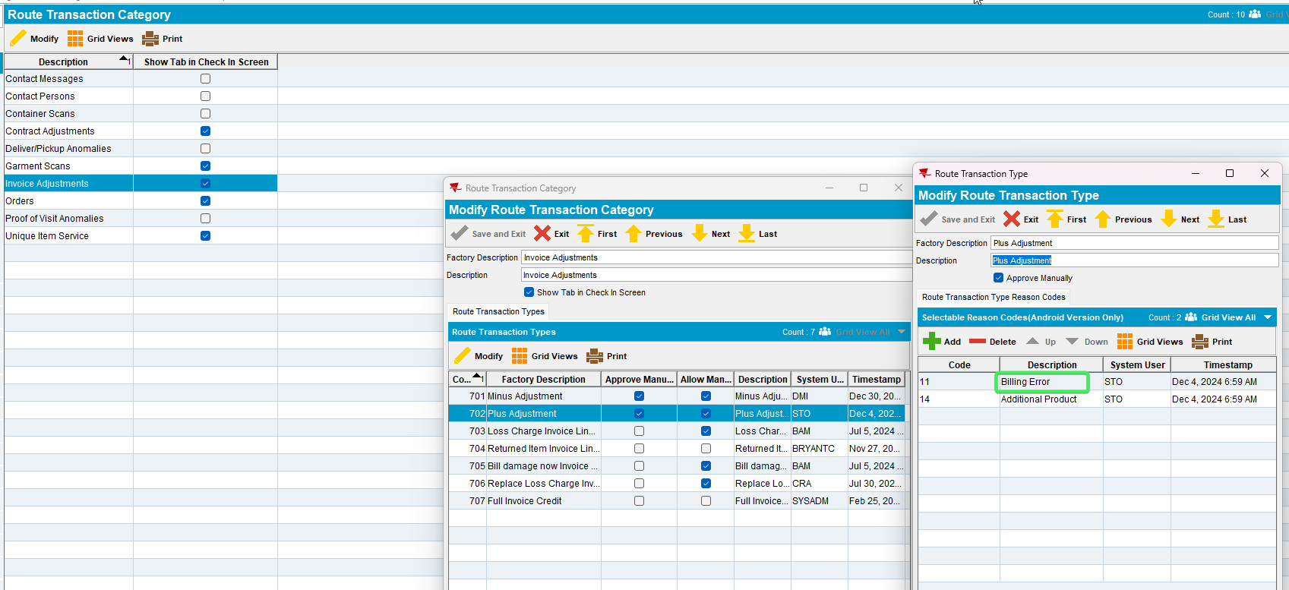
- RSC: Create a new Route with a customer on it
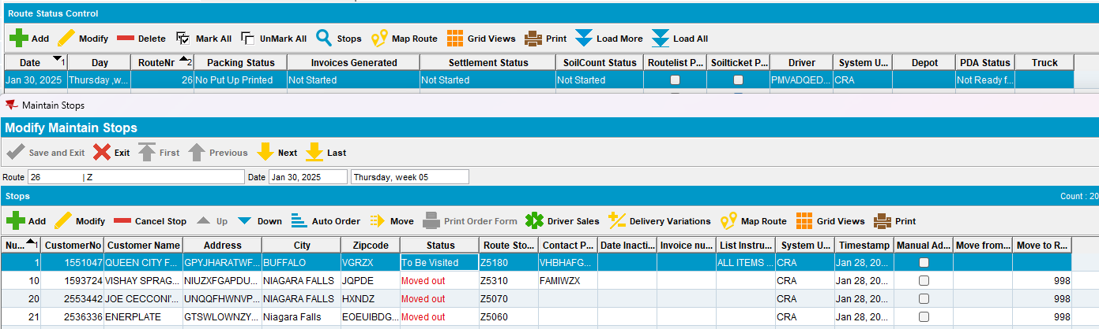
- Generate Invoices and script taxes
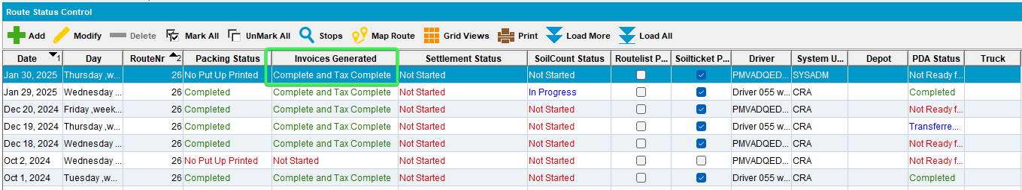
- Send the Route to RA
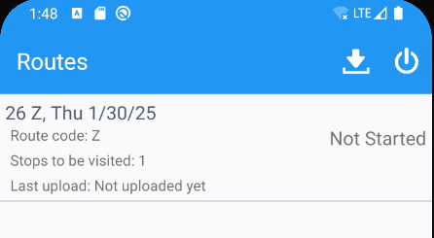
- Arrive at the Customer and perform a Minus invoice adjustment and a Plus invoice adjustment each time selecting the Reason code with the same description (Billing Error)
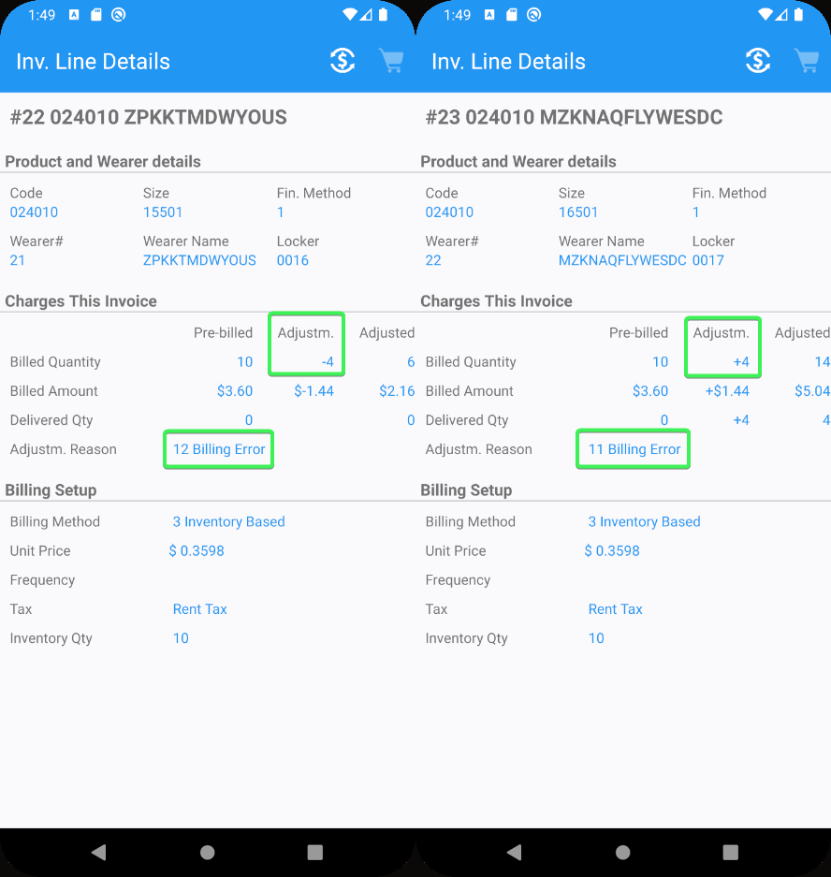
- Settle, finish and upload the data
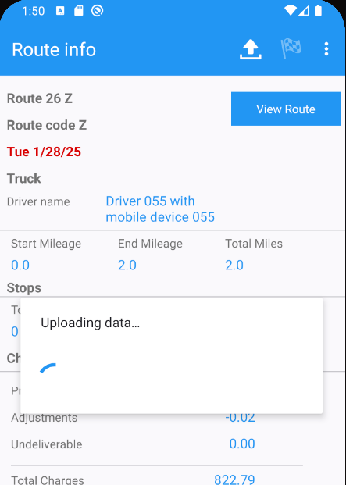
- WebX: Find your Route and complete Start My day
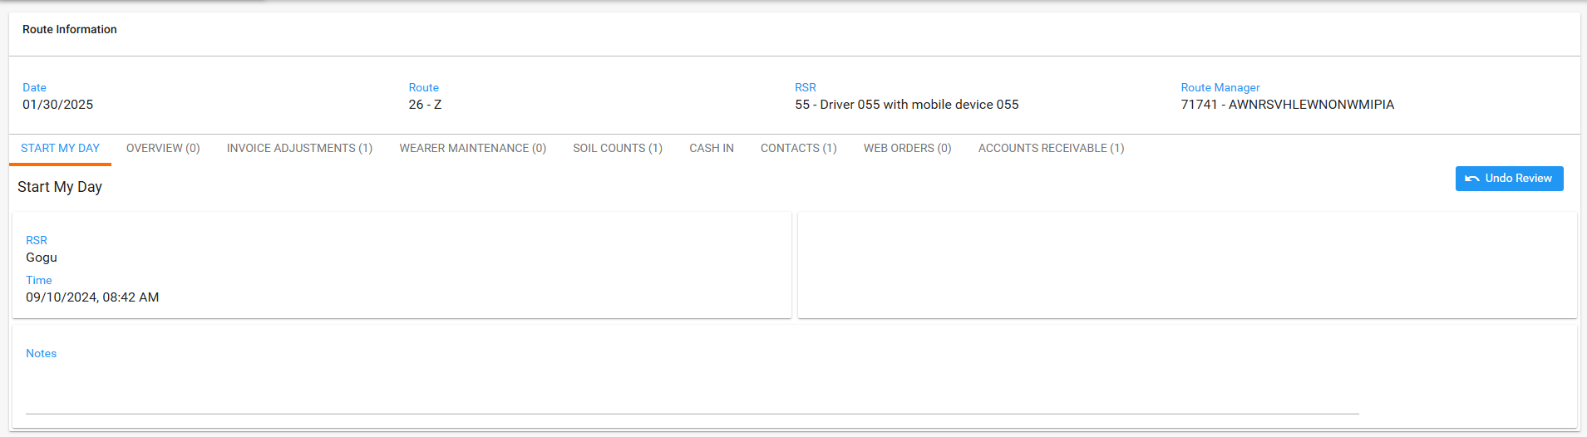
- Go to Invoice adjustments tab
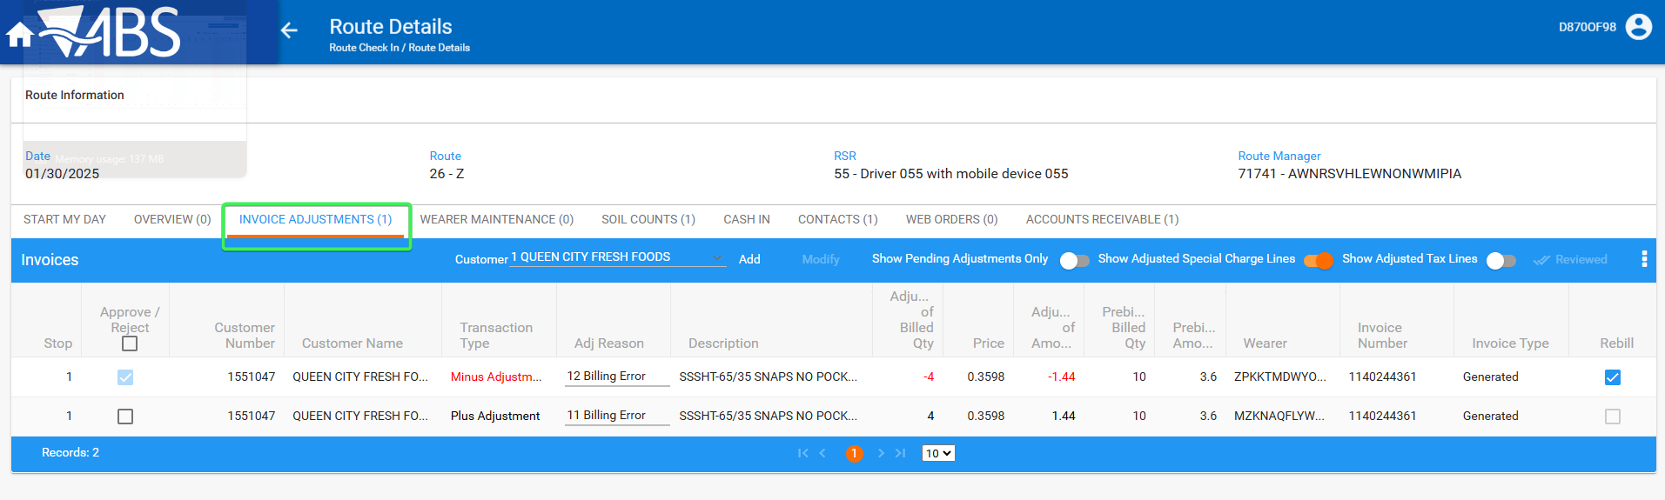
- Try performing any action like navigating away to another tab
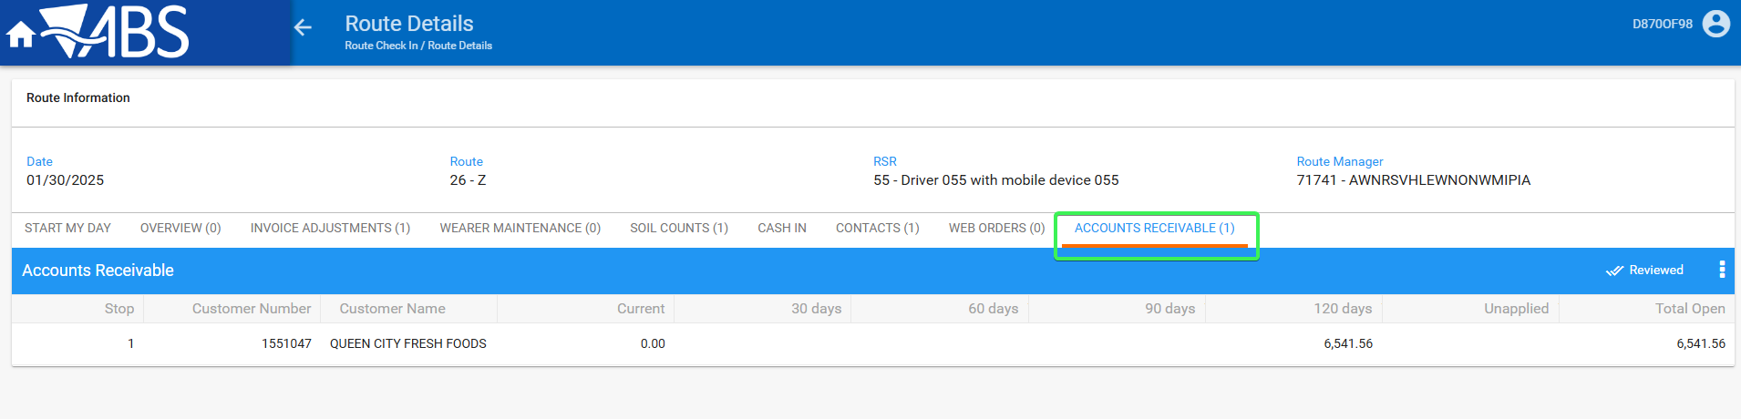
- Invoice Adjustments Tab: Approve the Plus Adjustment that came from RA and press save, see that the action is saved
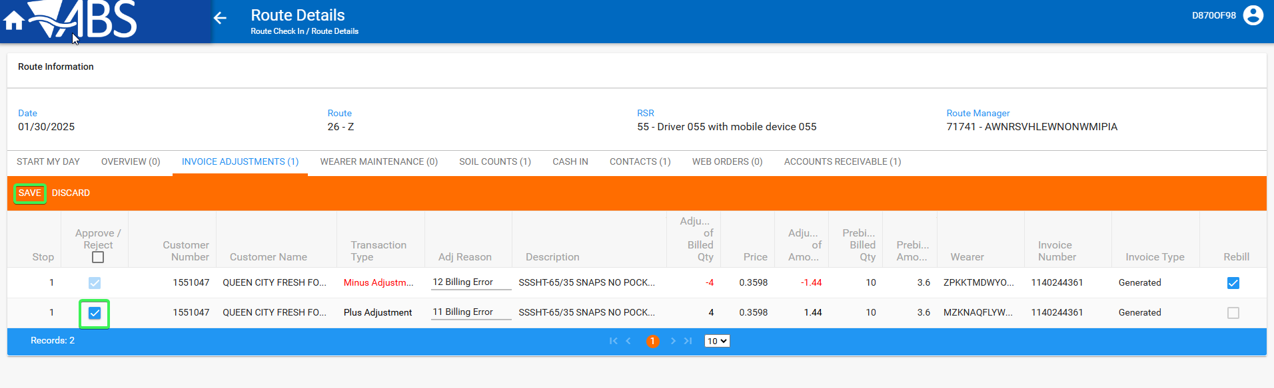
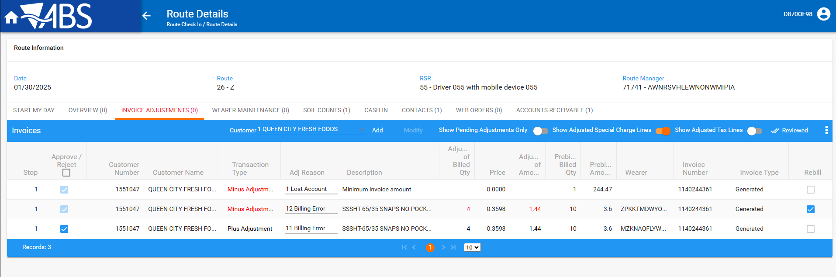
Tested OK

Test Case 2 – Undeliverable Stops on WebX codes but the same description as Reason Code
Hash: 9b746106152e
- Reason Codes DLG: Have 2 Undeliverable reason Codes with the same description
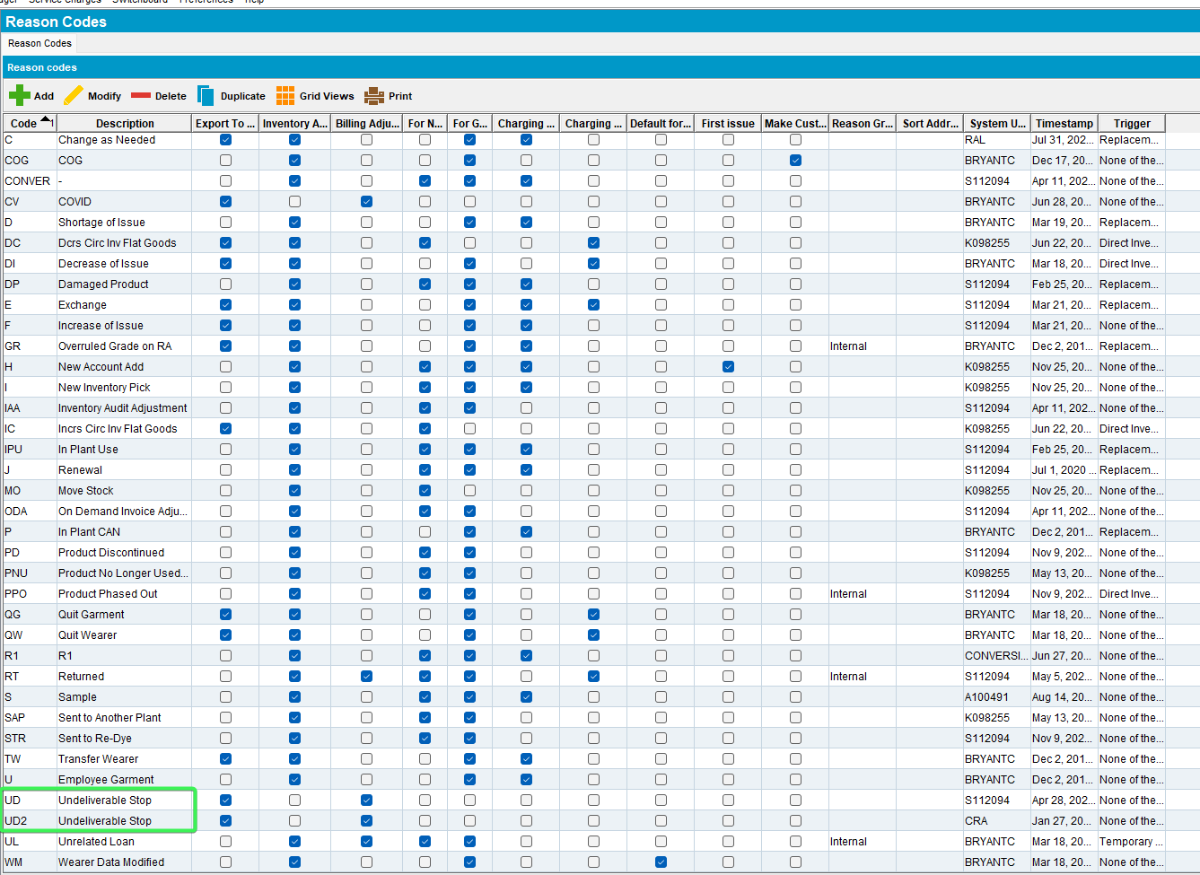
- RSC: Add a new route that has 2 customers on it
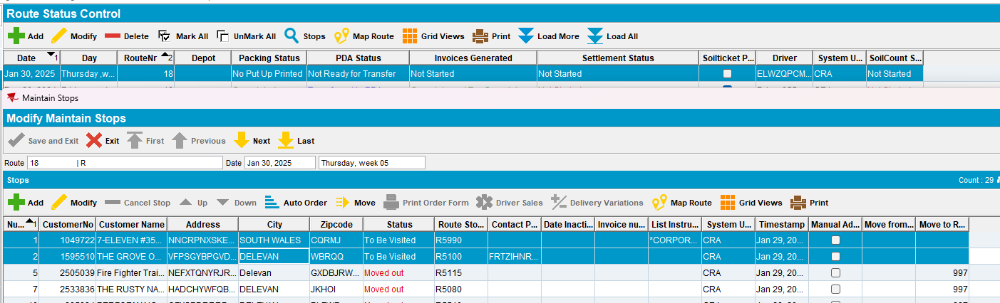
- Generate invoices and script the taxes
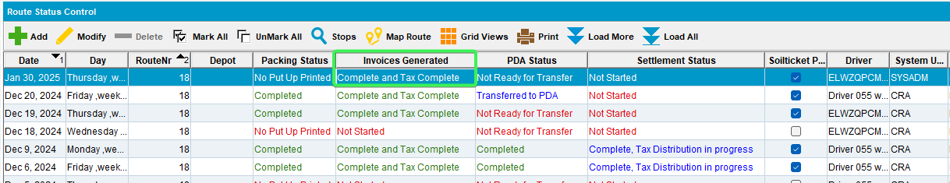
- Send the Route to RA
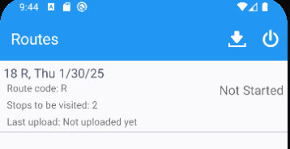
- Arrive at the customers and full credit their invoices
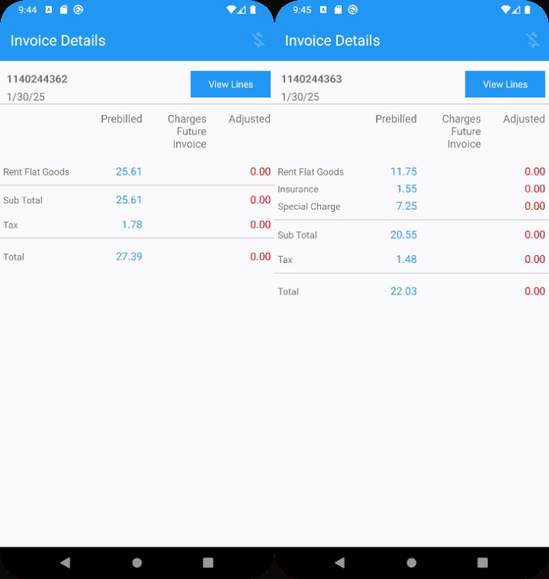
- Finish and upload the data
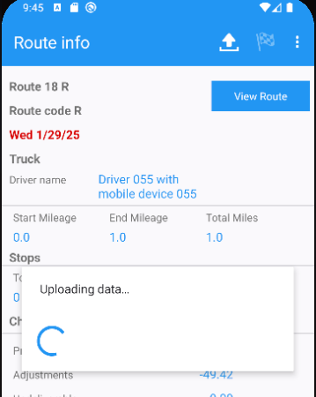
- WebX: Find your route and complete “Start my day”
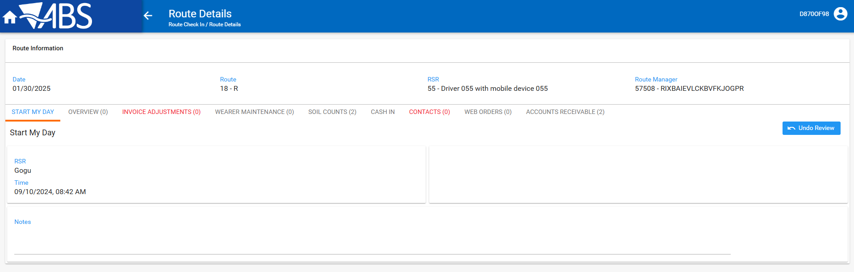
- Overview tab: select the first customer and change the visit status to Undeliverable, Select reason code UD
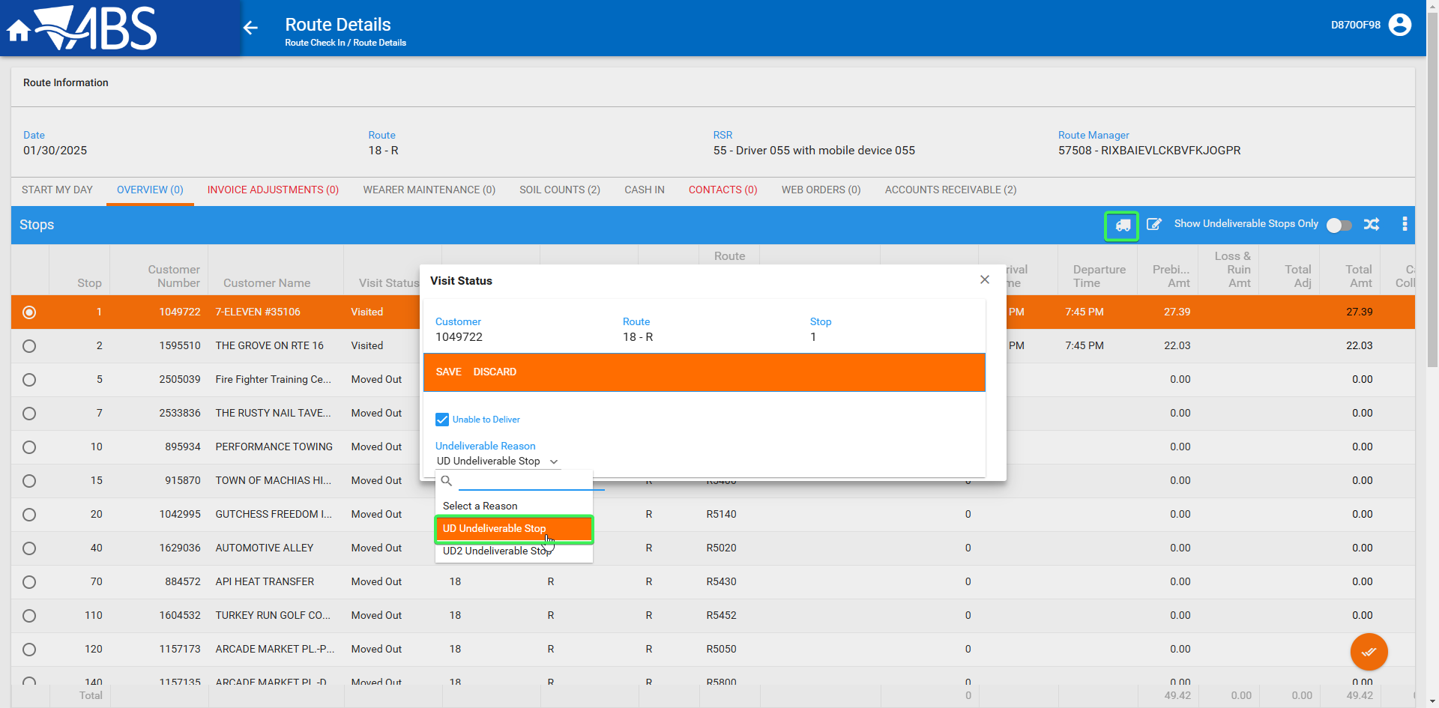
- Overview tab: Select the second customer and change the visit status to Undeliverable, Select reason code UD2
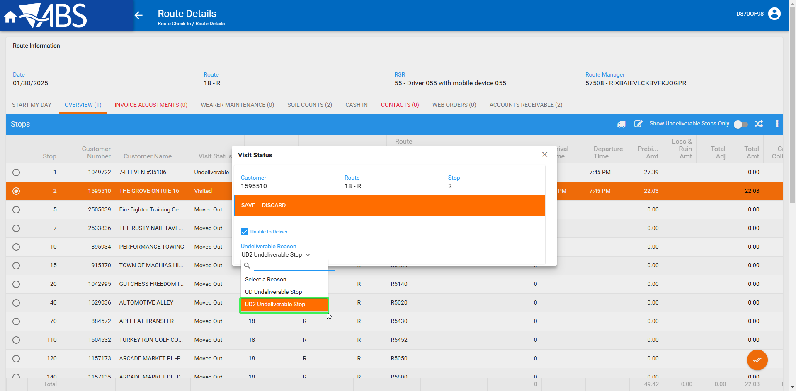
- Navigate to Invoice adjustments tab > try to review the tab or navigate away to a different tab
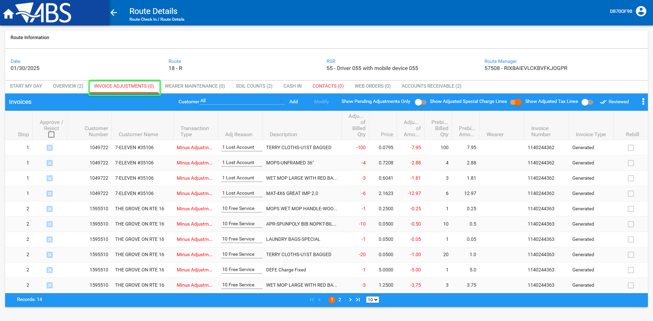
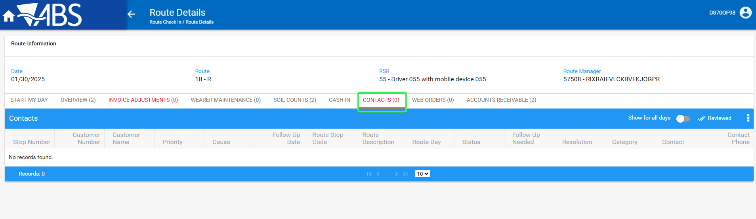
Tested OK

