ABSN-1775 D_UBS_1617 Contact - By Route not displayed when Attachment is shown
Environment | Prerequisites
Version: 9.07.00.UNF19  DBServerName= abs-srv20.internal.abslbs.com  DBSID=CUST24  DBUser=UNFDEV  DBPassword=UNFDEV  Environment=Production | - Module:

Contents
Reproducing before fix 1
Retest after fix 3

Reproducing before fix
Hash: af2f59b1e36
- Open “Contact Monitor” dialog, select a contact and press “View” button.
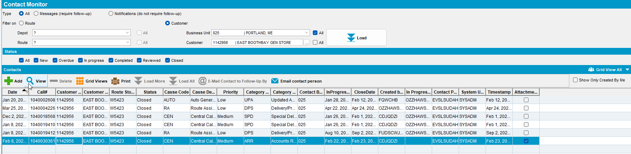

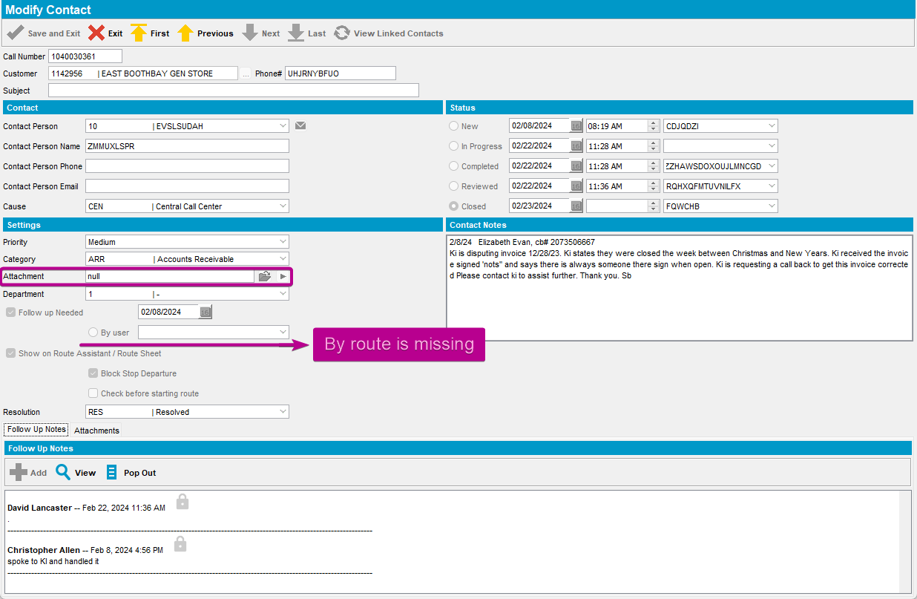

Retest after fix
Hash: 732e018d5ae
- Open “Contact Monitor” dialog, select a contact and press “View” button.
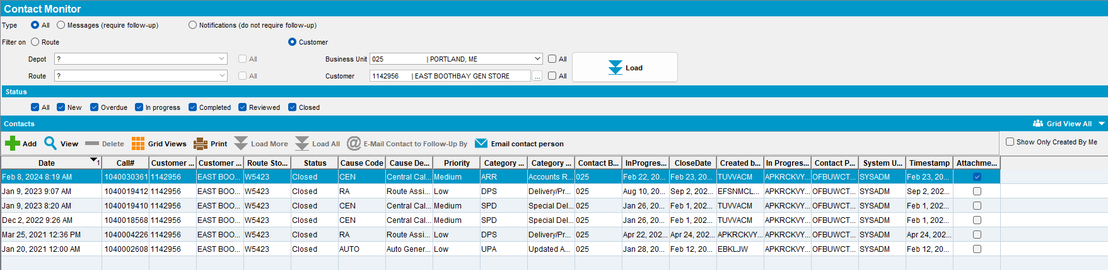

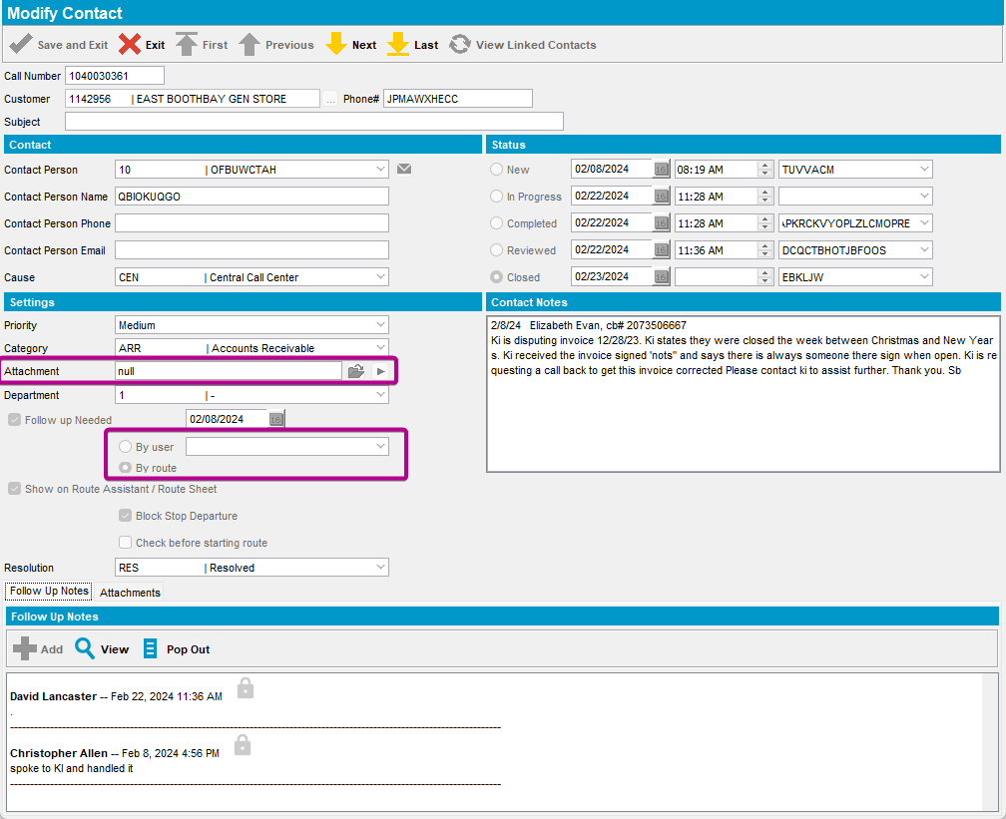

TESTED OK. 💚

