ABSN-1659 Assigning untaxed invoice to a route with vertex in the license
Environment | Prerequisites
Version: 9.07.00.UNF19  DBServerName= abs-srv20.internal.abslbs.com  DBSID=CUST24  DBUser=UNFDEV  DBPassword=UNFDEV  Environment=Production | - Module:

Contents
Reproducing before fix 1
Retest after fix 3

Reproducing before fix
Hash: 1ad070e0062
- Maintain Invoices dlg: Open dialog and make sure the first line is an invoice with tax error.
- Maintain Invoices dlg: Try to Assing it to a route.
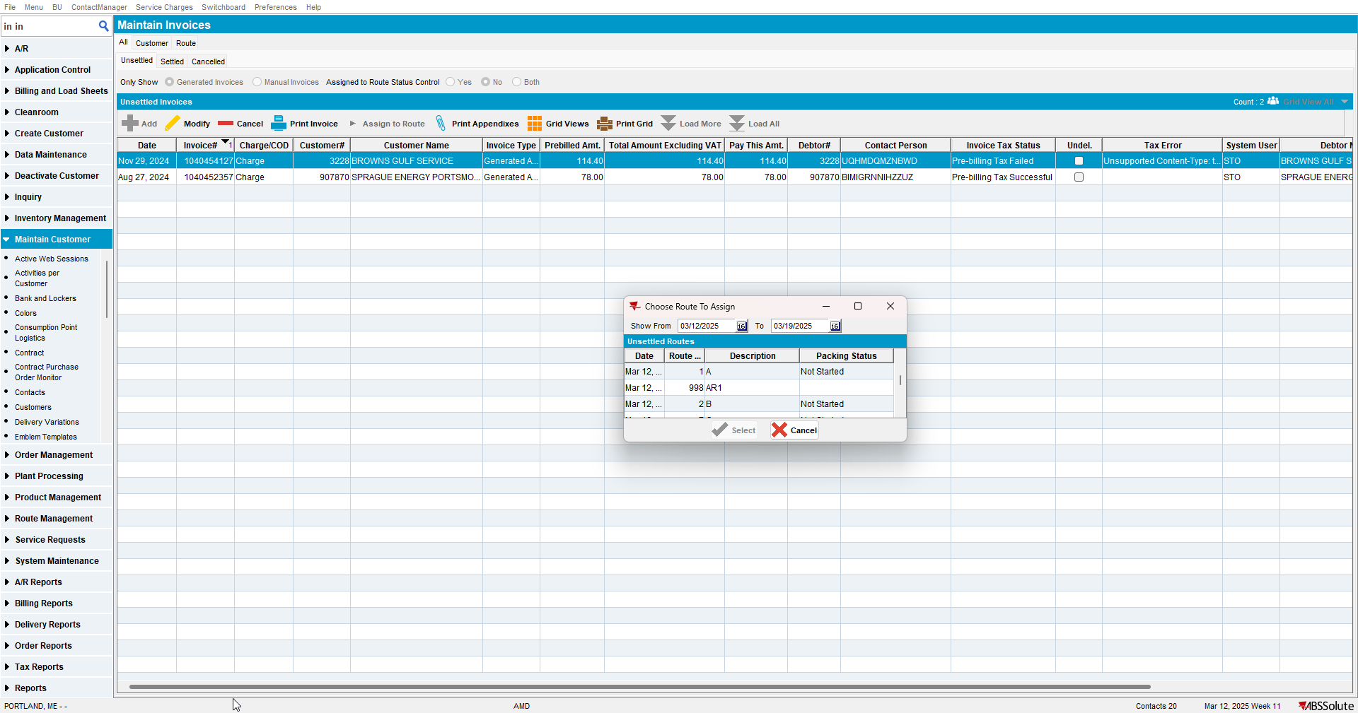
Assign to Route button is enabled and we can assign it even if it has a tax error.

Retest after fix
Hash: e96edc19e0a
- Maintain Invoices dlg: Open dialog and make sure the first line is an invoice with tax error.
- Maintain Invoices dlg: Try to Assing it to a route.
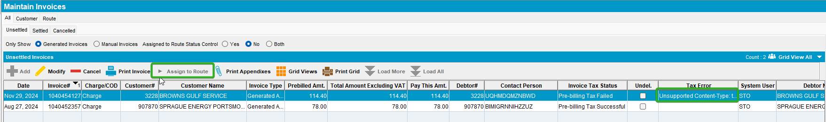
Assign to Route button is disabled.

TESTED OK

