ABSN-1600 Route Finalization not processing routes with moved in stops
Environment | Prerequisites
Version: 9.07.00.UNF19  DBServerName= abs-srv20.internal.abslbs.com  DBSID=CUST24  DBUser=UNFDEV  DBPassword=UNFDEV  Environment=Test | - Module:  - System setting

Contents
Reproduction before fix 1
Retest after fix 6

Reproduction before fix
Hash: c57a2e44dc5

- Add route 87 for Friday - this is an empty route, with no stops.
- Add route 23 for Monday.
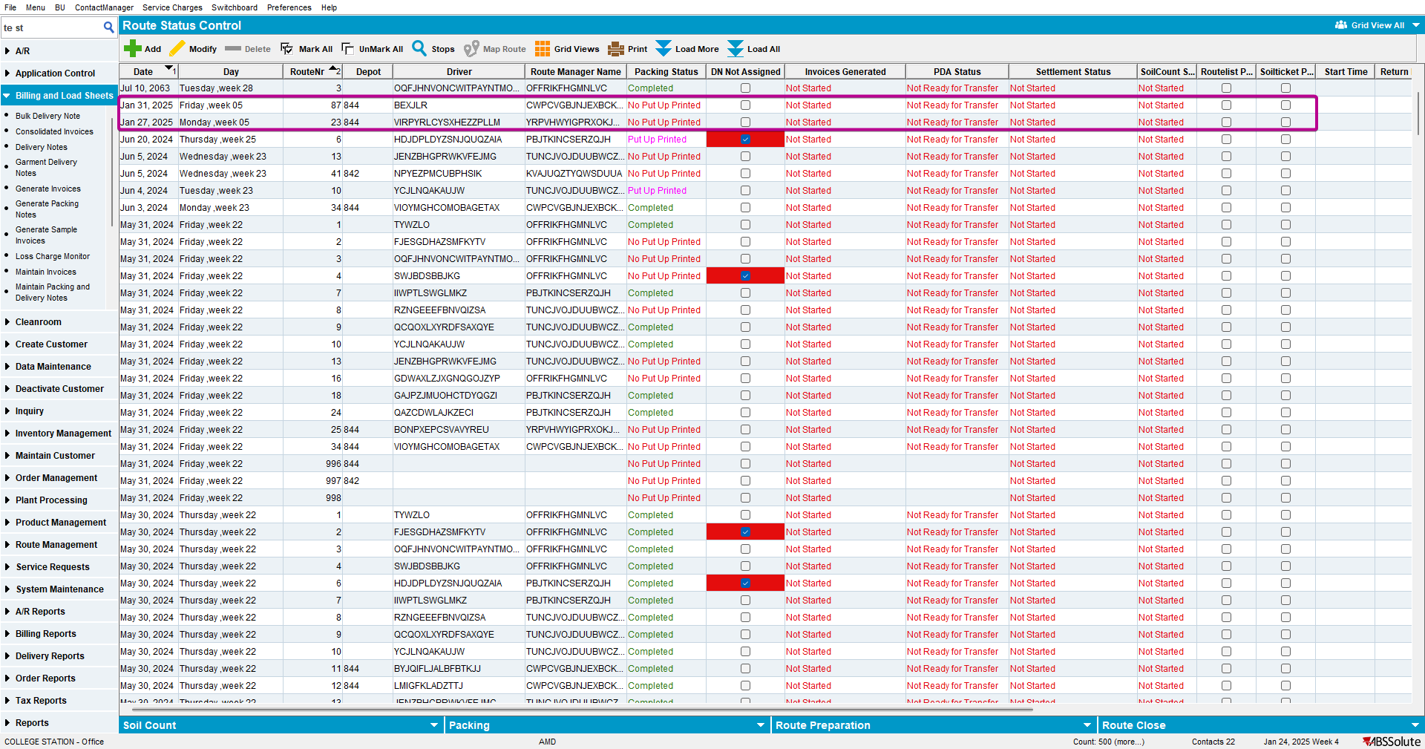

- Move some customers from route 23 to route 87.
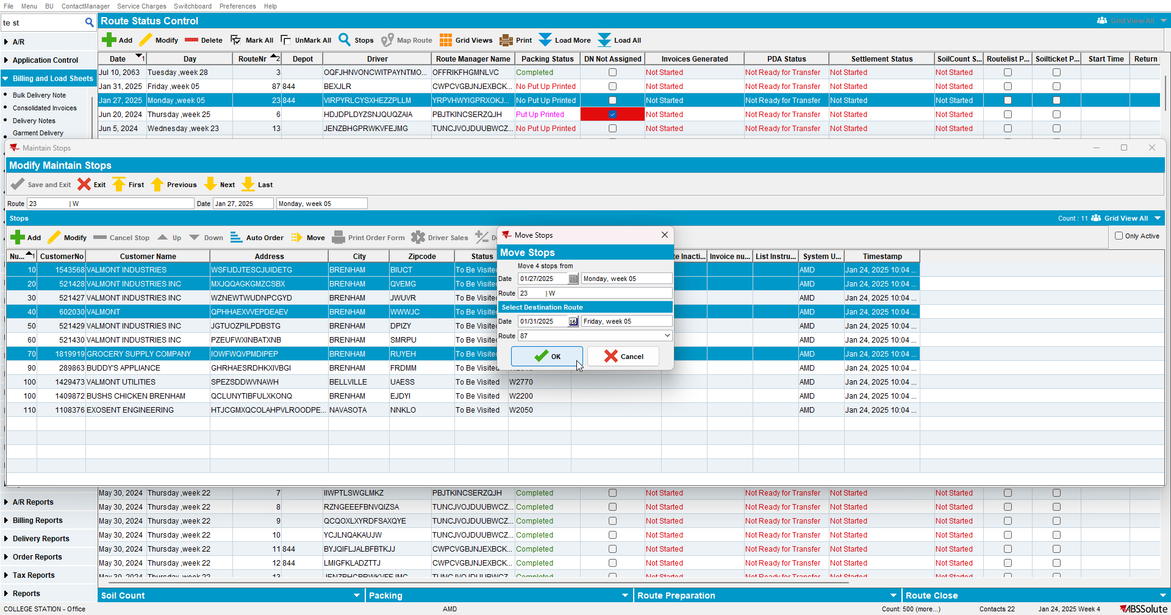

- Generate invoices for route 87, update BCI records and run BCI import scheduled process.
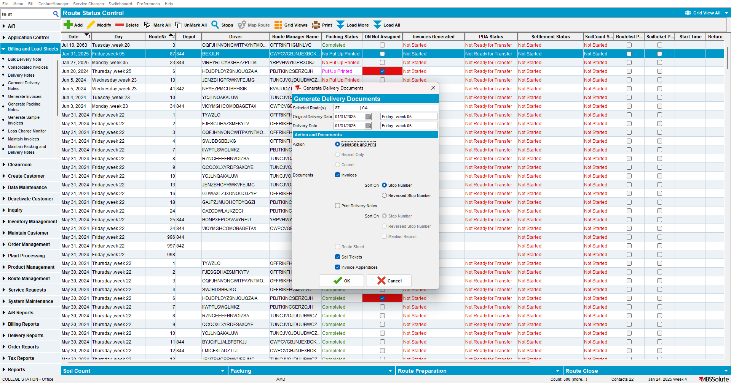

- Run scheduled process Cancel and regenerate US direct invoices for late delivery notes.
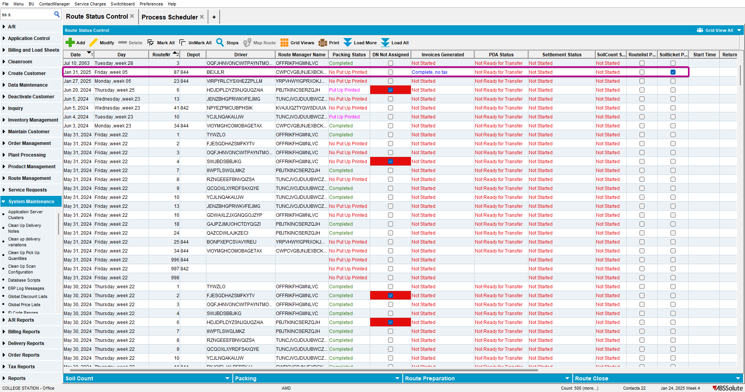
Current behavior:
Route 87 is not picked up by Cancel and regenerate process, therefore the Route Finalization status remains Not Started and PDA status is Not Ready to be transferred to RA.
Expected behavior:
Route 87 is picked up by the scheduled process, Route Finalization status is set to Complete, PDA status is set to Ready for Transfer.

Retest after fix
Hash: 429b3b5a54eb

- Add route 82 for Friday - this is an empty route, with no stops.
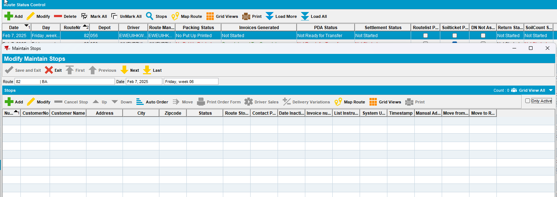
- Add route 14 for Monday.
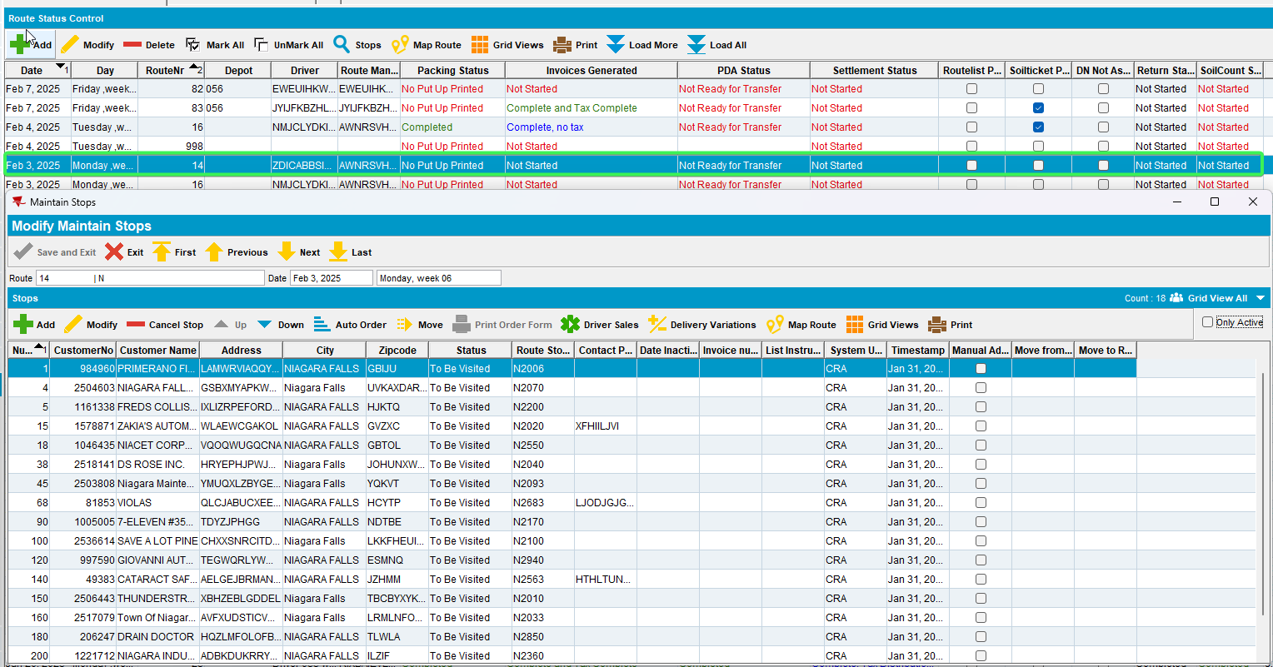
- Move some customers from route 14 to route 82.
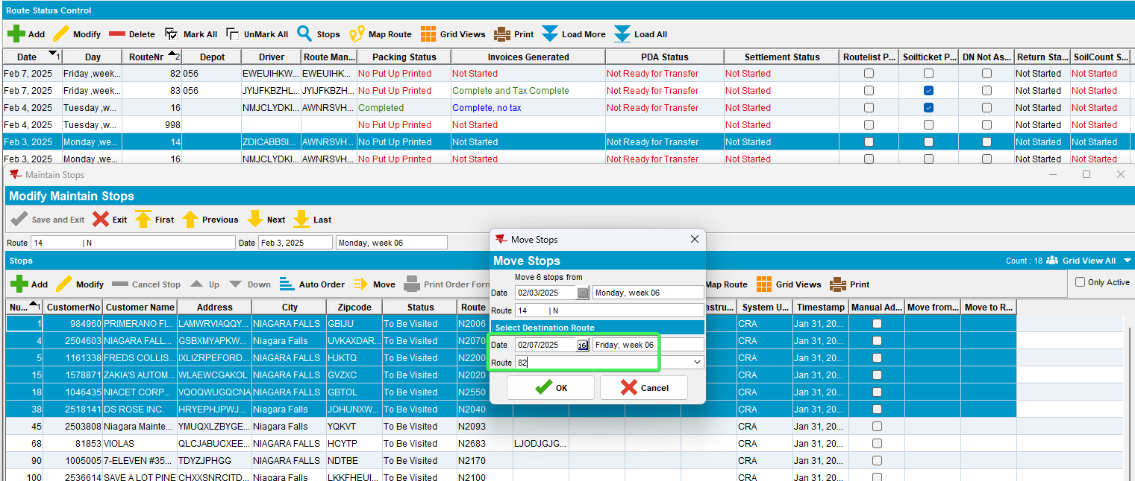
- Generate invoices for route 82, update BCI records and run BCI import scheduled process.
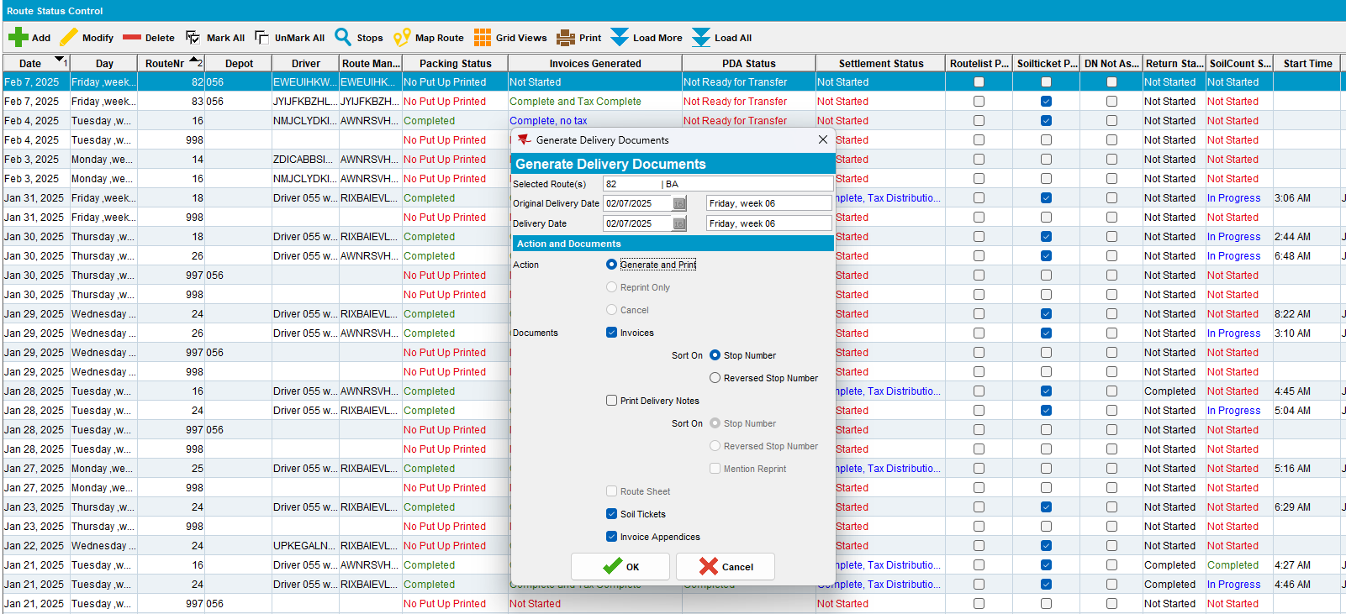
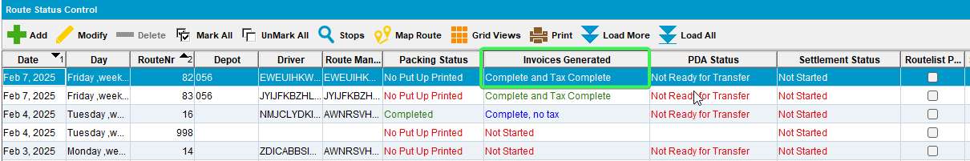
- Run scheduled process Cancel and regenerate US direct invoices for late delivery notes.
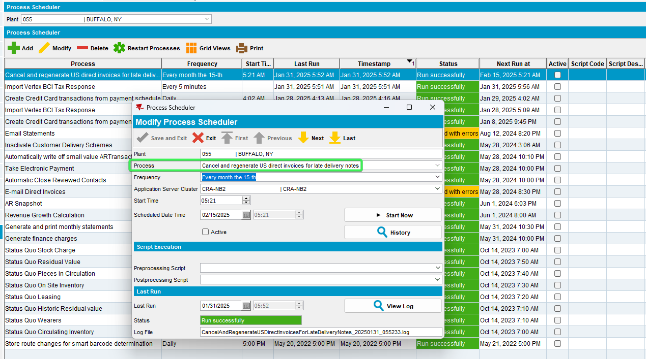
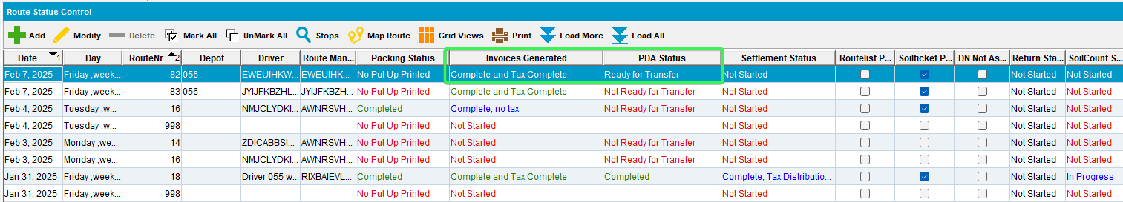
Tested OK

