ABSN-1561 D_UBS_2605 Tax from loss charges billed using Bill Loss Now is not included in the Invoice Total
Environment | Prerequisites
Version: 9.07.00.UNF19  DBServerName=abs-SRV20.internal.abslbs.com  DBSID=CUST24  DBUser=UNFDEV  DBPassword=UNFDEV  Environment=Test | - Module:  - System setting

Contents
Retest after fix 1
Test Case 1 – Bill loss now when there are no tax lines on pre-bill – Tested OK 1
Test Case 2 – Invoice with no 0 amount tax on pre-bill with no bill-loss now 7

Retest after fix

Test Case 1 – Bill loss now when there are no tax lines on pre-bill – Tested OK
Expected behavior: When tax in pre-bill is 0$ but there is a bill-loss now on the RA the additional tax from the RA gets charged to the RA and included in the final paythisamount.
Hash: 9b746106152
- Go to BU 087
- Find customer 1574043
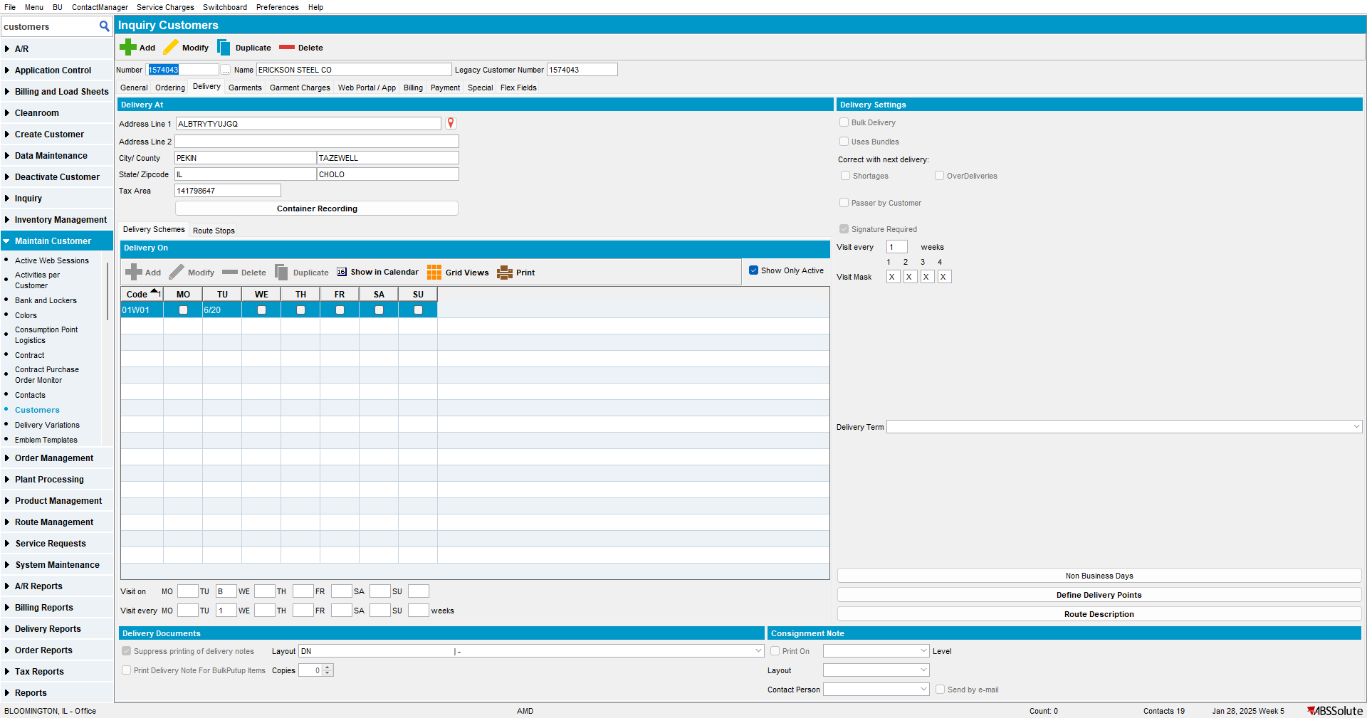
- RSC DLG: Add the next Tuesday’s route 6
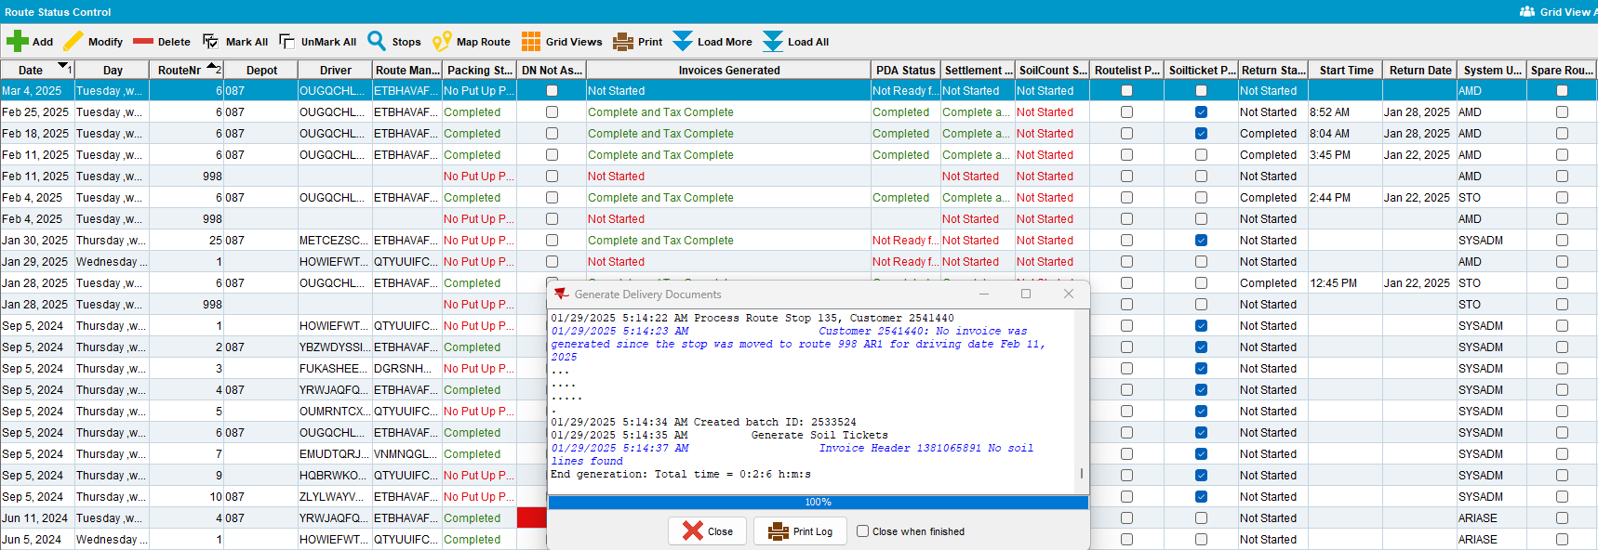
- Script in the BCI data like so:
UPDATE VERTEXTRANSACTIONLOG VTL
SET VTL.EXPORTID = NULL,
VTL.STATUS = 2,
VTL.TAXAREAID = VTL.DESTINATIONTAXAREAID
WHERE VTL.BATCHID IN (2533524)
AND VTL.TRANSACTIONTYPE = 'RENTAL';
UPDATE VERTEXTRANSACTIONLOG VTL
SET VTL.EXPORTID = NULL,
VTL.STATUS = 2,
VTL.TAXAREAID = VTL.DESTINATIONTAXAREAID
WHERE VTL.BATCHID IN (2533524)
AND VTL.TRANSACTIONTYPE = 'SALE';
UPDATE VERTEXTRANSACTIONLOG VTL
SET VTL.EXPORTID = NULL,
VTL.STATUS = 2,
VTL.TAXAREAID = VTL.DESTINATIONTAXAREAID,
VTL.COMBINEDRATE = 0.5
WHERE VTL.BATCHID IN (2533524)
AND VTL.DOCUMENTNUMBER LIKE '%LD';
UPDATE VERTEXBATCHCONTROL VBC
SET VBC.BATCHSTATUS = 3
WHERE VBC.BATCHID IN (2533524);
- Run the process scheduler for Vertex Tax
- Maintain Invoices DLG: Verify that the invoice generated is taxed but has one tax line with 1 qty and 0 amount
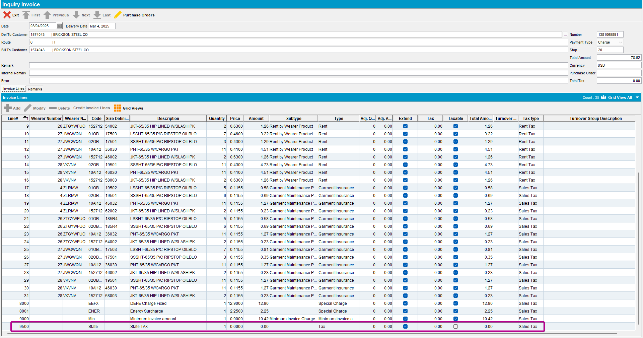

- Send the route to RA
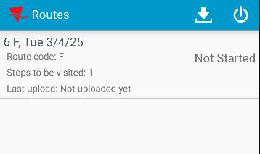

- RA: Quit a wearer and a DOI and bill loss now for both
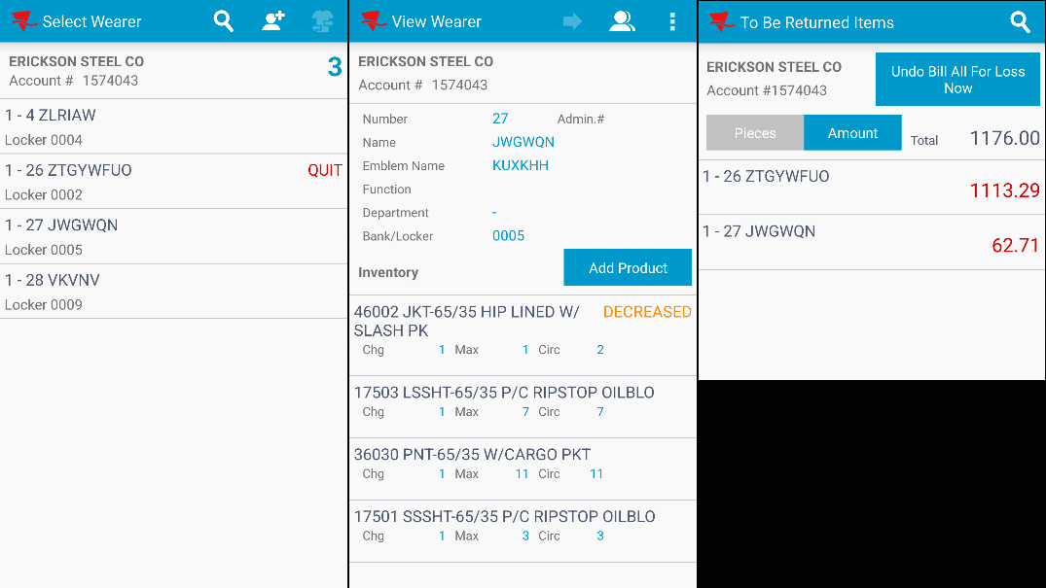

- RA: Finish route and upload
- WebX: Check that you have an adjustment on the tax line
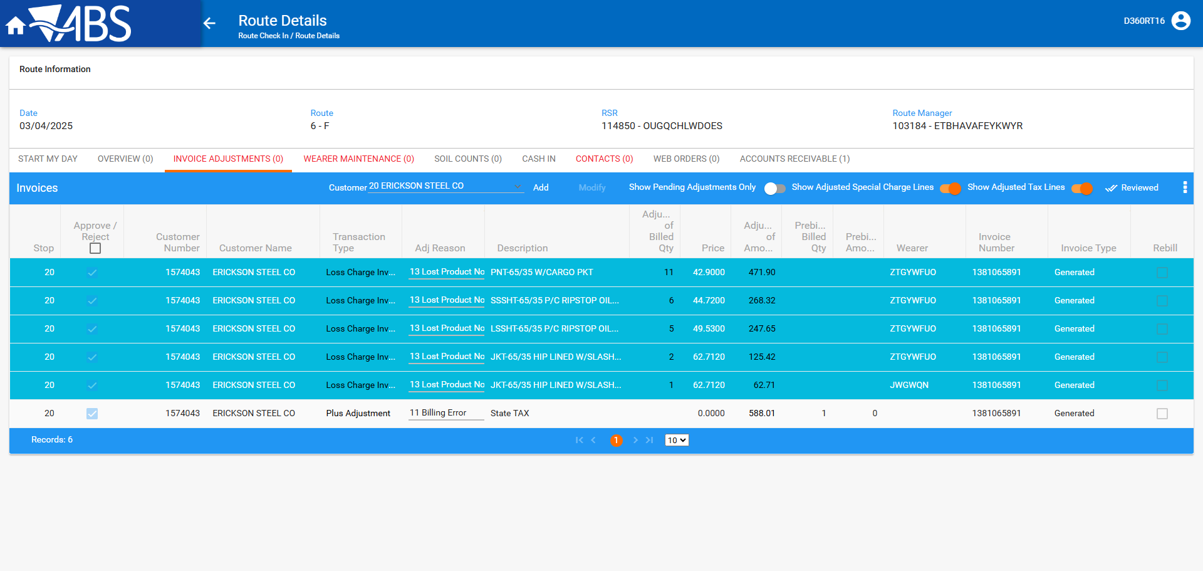
- Review all tabs and settle the route
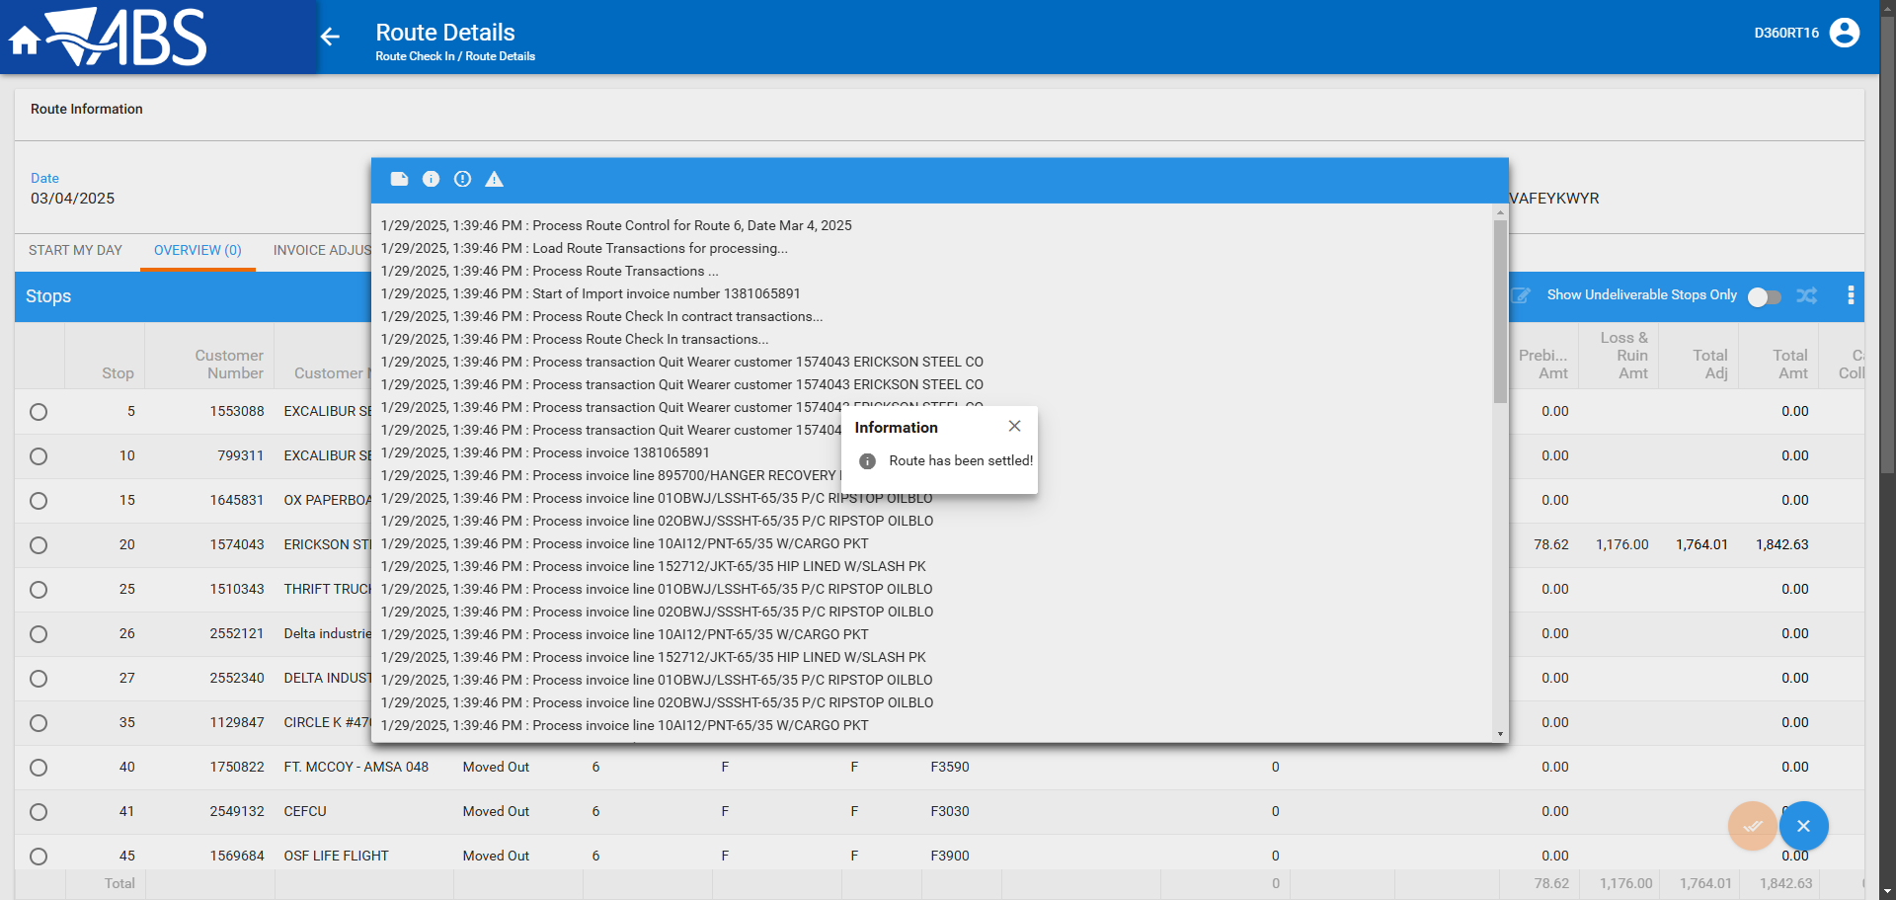

- Run this modified version of the BCI Script on the TaxDistribution batch
--SETTLEMENT
UPDATE VERTEXTRANSACTIONLOG VTL
SET VTL.EXPORTID = NULL,
VTL.STATUS = 2,
VTL.TAXAREAID = VTL.DESTINATIONTAXAREAID
WHERE VTL.BATCHID IN (2533527)
AND VTL.TRANSACTIONTYPE = 'RENTAL';

UPDATE VERTEXTRANSACTIONLOG VTL
SET VTL.EXPORTID = NULL,
VTL.STATUS = 2,
VTL.TAXAREAID = VTL.DESTINATIONTAXAREAID,
VTL.TOTALLINEITEMTAX = ROUND(VTL.INPUTTOTALTAX, 2),
VTL.COMBINEDRATE = 0.05,
VTL.TOTALMAINDIVISIONTAX = ROUND(VTL.INPUTTOTALTAX, 2)
WHERE VTL.BATCHID IN (2533527)
AND VTL.TRANSACTIONTYPE = 'SALE';

UPDATE VERTEXBATCHCONTROL VBC
SET VBC.BATCHSTATUS = 3
WHERE VBC.BATCHID IN (2533527);

- Run the process scheduler for Vertex Tax

- Maintain Invoices DLG: Check that the IH.PayThisAmount = IH.TotalAmountExclVat + SUM(ILEI.TotalTax)* and that the tax line now contains the tax amount from the loss charge lines
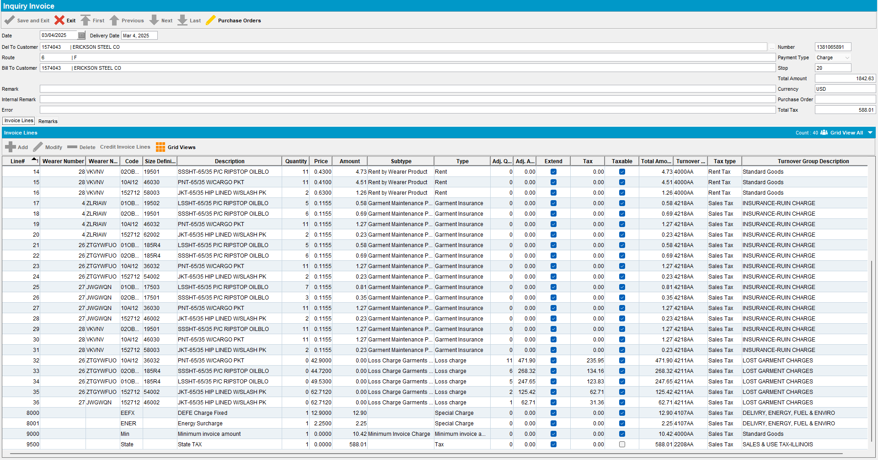
select sum(ile.totaltax),
ih.paythisamount,
ih.totalamountexclvat,
sum(ile.totaltax) + ih.totalamountexclvat,
ar.amount
from invoiceheader ih
join invoiceline il
on ih.invoiceheader_id = il.invoiceheader_id
join invoicelineextrainfo ile
on ile.invoiceline_id = il.invoiceline_id
join customer c
on c.customer_id = ih.deltocustomer_link_id
join artransaction ar
on ar.invoiceheader_id = ih.invoiceheader_id
where ih.invoicenumber = 1381065891
group by ih.paythisamount,
ih.totalamountexclvat,
ar.amount;

Test Case 2 – Invoice with no 0 amount tax on pre-bill with no bill-loss now
Expected behavior: We get a 0 amount tax line on prebill but when the TAXDISTRIBUTION is processed the 0 amount tax line is removed
Hash: 9b746106152
- Go to BU 087
- Find customer 1574043

- RSC DLG: Add the next Tuesday’s route 6
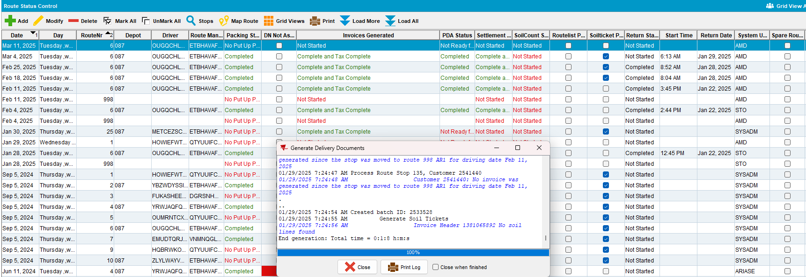

- Script in the BCI data to simulate 0% tax for all lines except the LD lines
UPDATE VERTEXTRANSACTIONLOG VTL
SET VTL.EXPORTID = NULL,
VTL.STATUS = 2,
VTL.TAXAREAID = VTL.DESTINATIONTAXAREAID
WHERE VTL.BATCHID IN (2533528)
AND VTL.TRANSACTIONTYPE = 'RENTAL';
UPDATE VERTEXTRANSACTIONLOG VTL
SET VTL.EXPORTID = NULL,
VTL.STATUS = 2,
VTL.TAXAREAID = VTL.DESTINATIONTAXAREAID
WHERE VTL.BATCHID IN (2533528)
AND VTL.TRANSACTIONTYPE = 'SALE';
UPDATE VERTEXTRANSACTIONLOG VTL
SET VTL.EXPORTID = NULL,
VTL.STATUS = 2,
VTL.TAXAREAID = VTL.DESTINATIONTAXAREAID,
VTL.COMBINEDRATE = 0.05
WHERE VTL.BATCHID IN (2533528)
AND VTL.DOCUMENTNUMBER LIKE '%LD';
UPDATE VERTEXBATCHCONTROL VBC
SET VBC.BATCHSTATUS = 3
WHERE VBC.BATCHID IN (2533528);
- Run the process scheduler for Vertex Tax
- Maintain Invoices DLG: Verify that the invoice generated is taxed but has one tax line with 1 qty and 0 amount
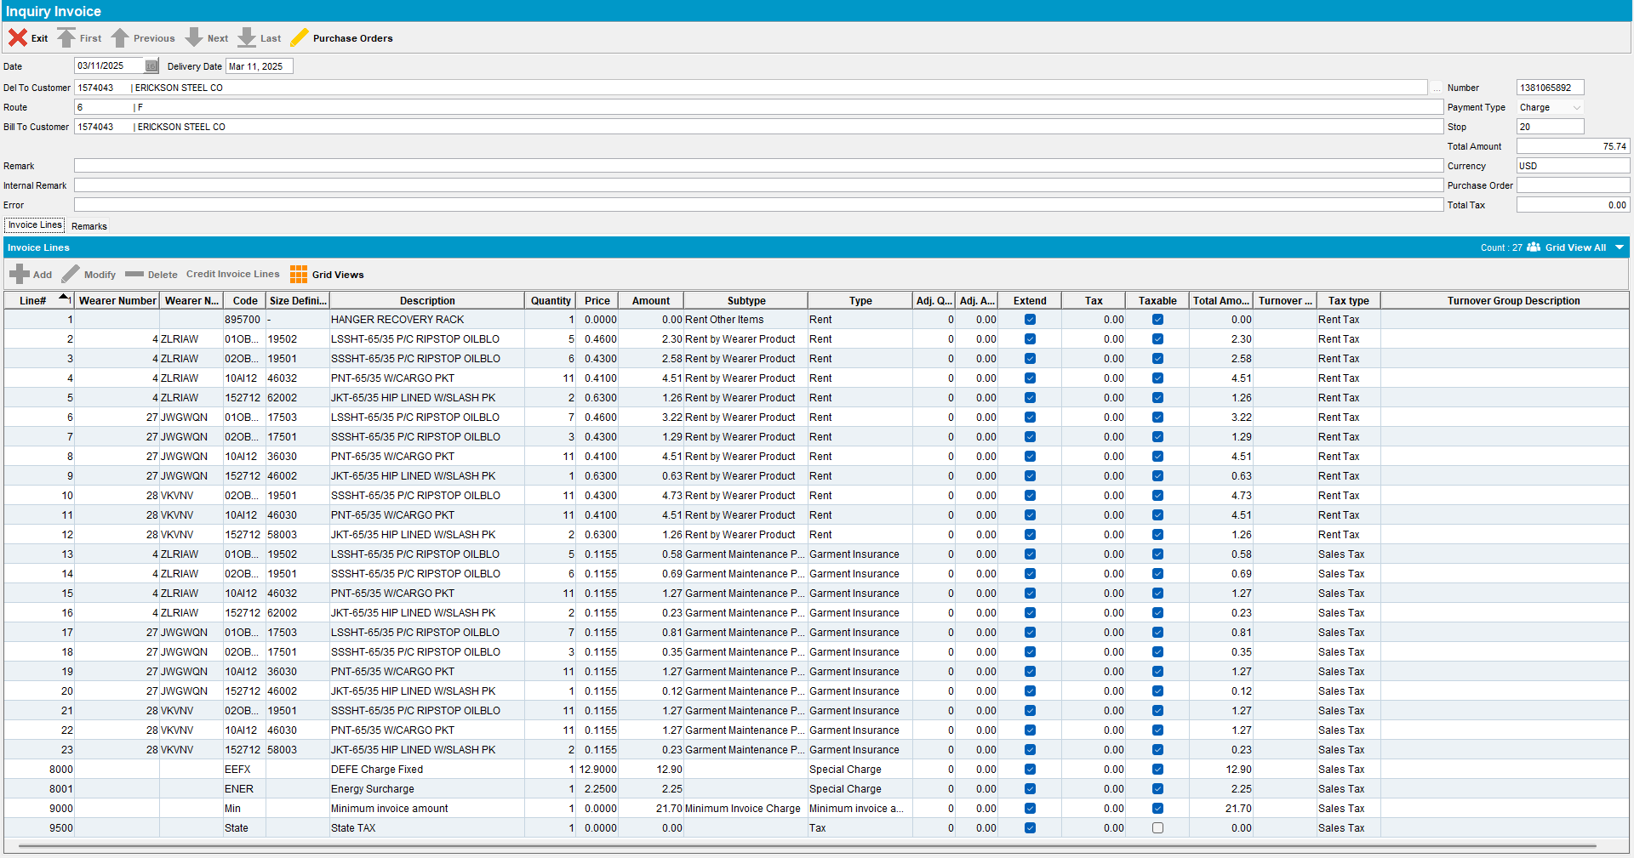

- Send the route to RA
- RA: Adjust two invoice lines
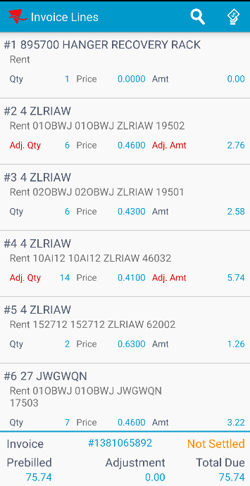
- RA: Finish route and upload

- WebX: Check that you have no adjustment on the tax line
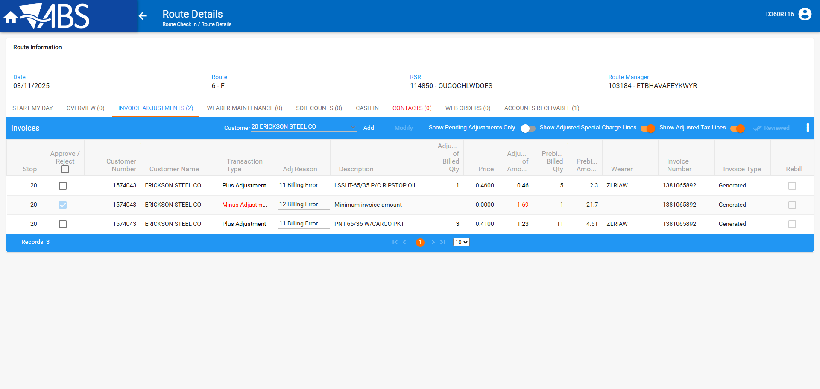

- Review all tabs and settle the route
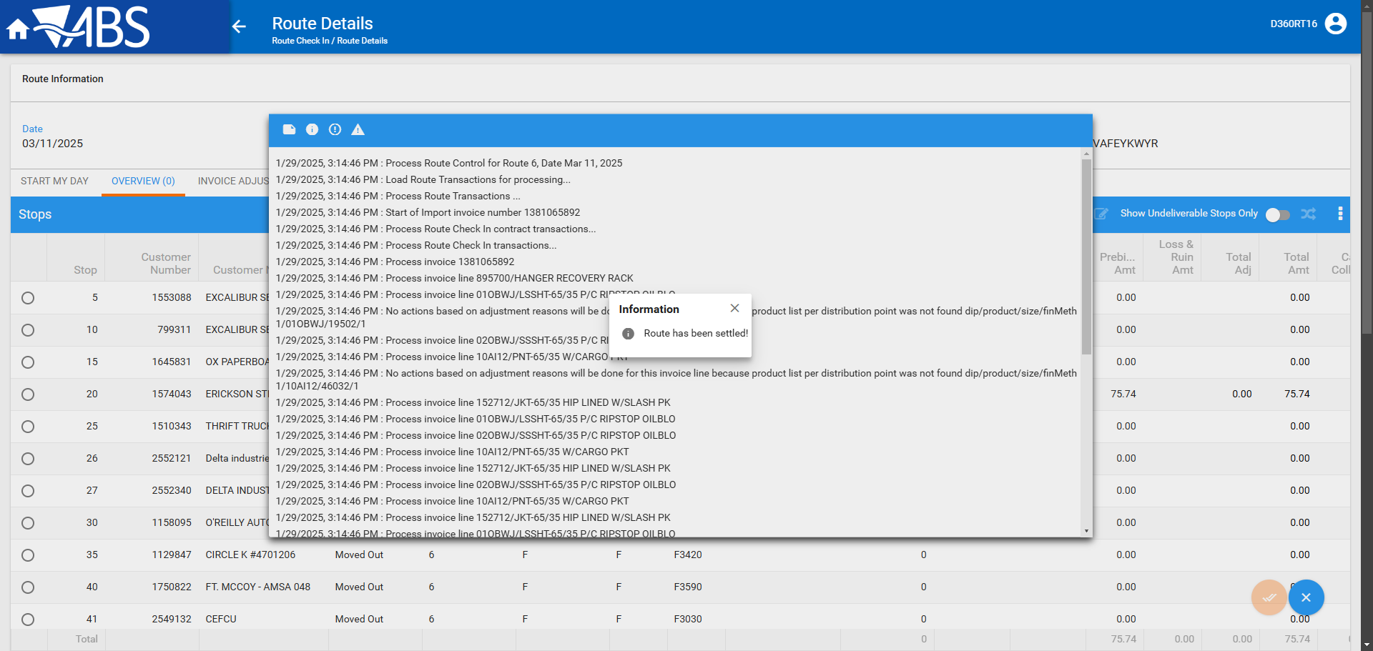
- Run this modified version of the BCI Script on the TaxDistribution batch
--SETTLEMENT
UPDATE VERTEXTRANSACTIONLOG VTL
SET VTL.EXPORTID = NULL,
VTL.STATUS = 2,
VTL.TAXAREAID = VTL.DESTINATIONTAXAREAID
WHERE VTL.BATCHID IN (2533529)
AND VTL.TRANSACTIONTYPE = 'RENTAL';

UPDATE VERTEXTRANSACTIONLOG VTL
SET VTL.EXPORTID = NULL,
VTL.STATUS = 2,
VTL.TAXAREAID = VTL.DESTINATIONTAXAREAID,
VTL.TOTALLINEITEMTAX = ROUND(VTL.INPUTTOTALTAX, 2),
VTL.COMBINEDRATE = 0.05,
VTL.TOTALMAINDIVISIONTAX = ROUND(VTL.INPUTTOTALTAX, 2)
WHERE VTL.BATCHID IN (2533529)
AND VTL.TRANSACTIONTYPE = 'SALE';

UPDATE VERTEXBATCHCONTROL VBC
SET VBC.BATCHSTATUS = 3
WHERE VBC.BATCHID IN (2533529);

- Run the process scheduler for Vertex Tax
- Maintain Invoices DLG: Check that the IH.PayThisAmount = IH.TotalAmountExclVat + SUM(ILEI.TotalTax)* and that the tax line is not there anymore
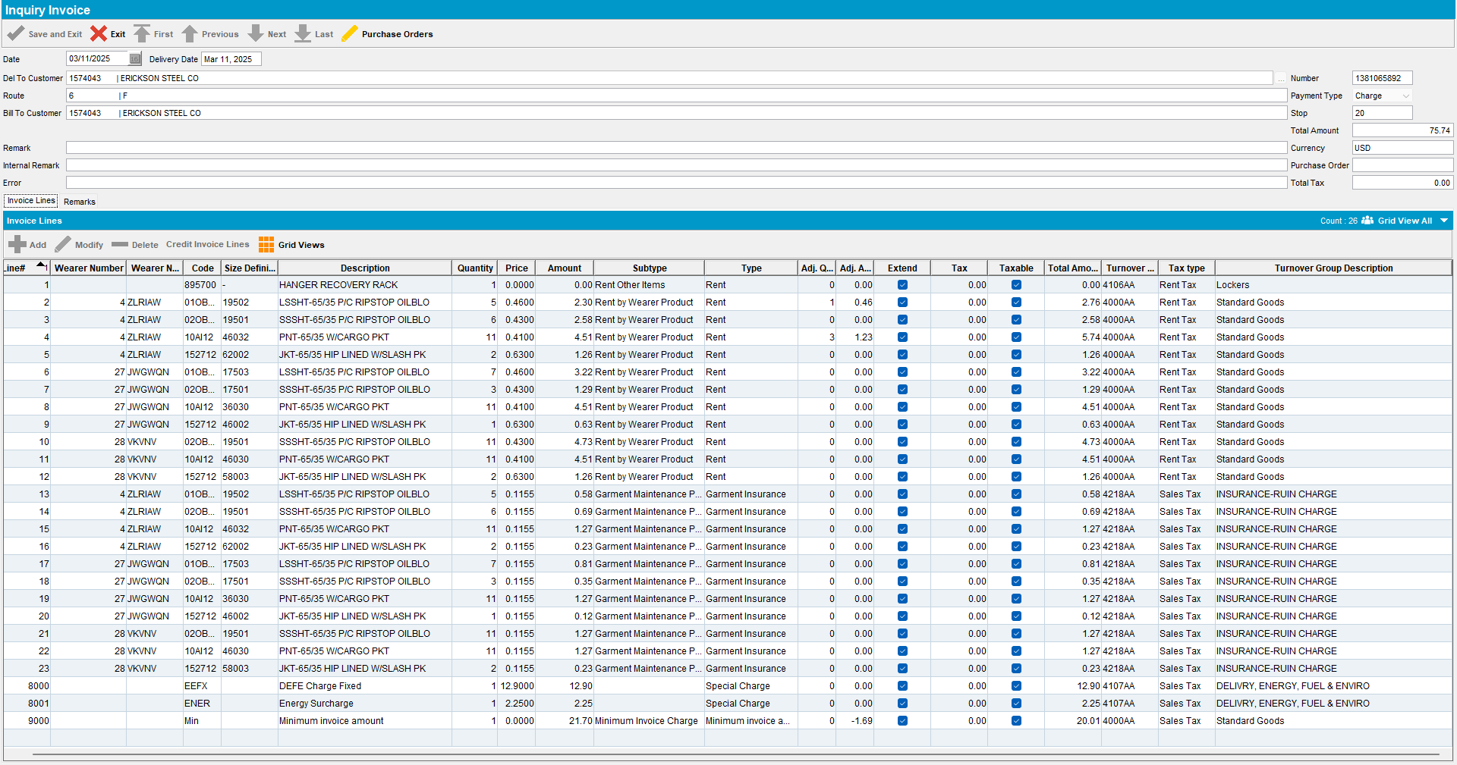
select sum(ile.totaltax),
ih.paythisamount,
ih.totalamountexclvat,
sum(ile.totaltax) + ih.totalamountexclvat,
ar.amount
from invoiceheader ih
join invoiceline il
on ih.invoiceheader_id = il.invoiceheader_id
join invoicelineextrainfo ile
on ile.invoiceline_id = il.invoiceline_id
join customer c
on c.customer_id = ih.deltocustomer_link_id
join artransaction ar
on ar.invoiceheader_id = ih.invoiceheader_id
where ih.invoicenumber = 1381065892
group by ih.paythisamount,
ih.totalamountexclvat,
ar.amount;

Tested OK

