ABSN-1339 WebX - Update Route Transactions when changing the approval status of one adjustment after a full credit
Environment | Prerequisites
Version: 9.07.00.UNF19  DBServerName= abs-srv20.internal.abslbs.com  DBSID=CUST24  DBUser=UNFDEV  DBPassword=UNFDEV  Environment=Production | - Module:

Contents
Retest after fix 1

Retest after fix
Hash: 40366e9201a
Data preparation
- Customer 1 – Generated Invoice
  - Have at least 2 wearers each with 2 garments
  - Have garment protection charges for garments
  - Percentage special charge on invoice line type rent
  - Minimum Invoice amount higher than invoice total (generate invoice then modify or add min inv amount that is higher than paythisamount, then re-generate invoice)
  - Use separate tax percentages for *BCI data
- Customer 2 – Sales Note Invoice
  - TRADESALESWEARER Sales Note invoice
  - At least 2 wearers with emblem charges
  - Direct Handling Charge
- Customer 2 – Generated Invoice
  - Have at least 2 wearers each with 2 garments
  - Have garment protection charges for garments
  - Percentage special charge on invoice line type rent
  - Use separate tax percentages for *BCI data
- Customer 3 – Manual Invoice
  - Manual invoice rent and sales lines
  - Special percentage special charge that applies to rent
  - Minimum invoice amount that is higher than the invoice total

Test Steps:
- Generate invoices for Customer 1, 2, and 3
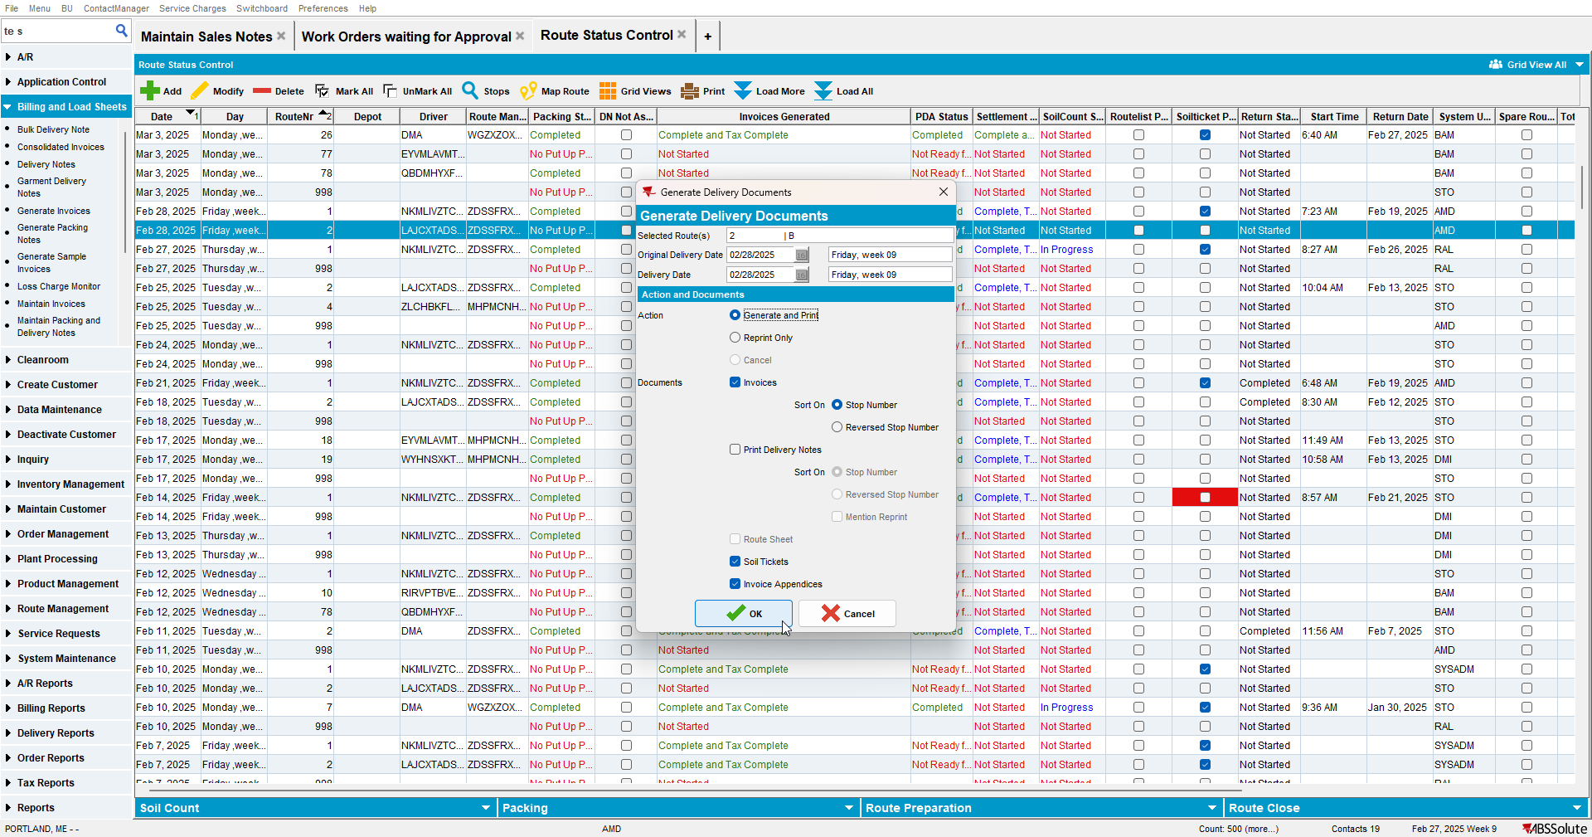

- Send route to RA
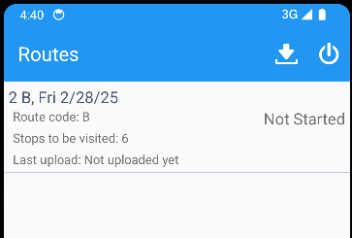
- Settle route on RA and upload data
- WebX: Customer 1 – Full credit invoice
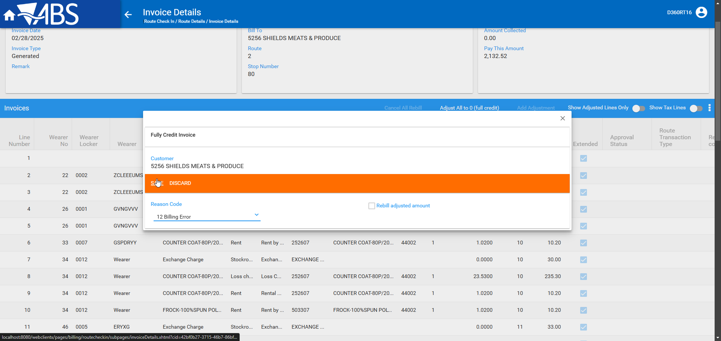

- WebX: Reject adjustments on one sales and one rent line and save
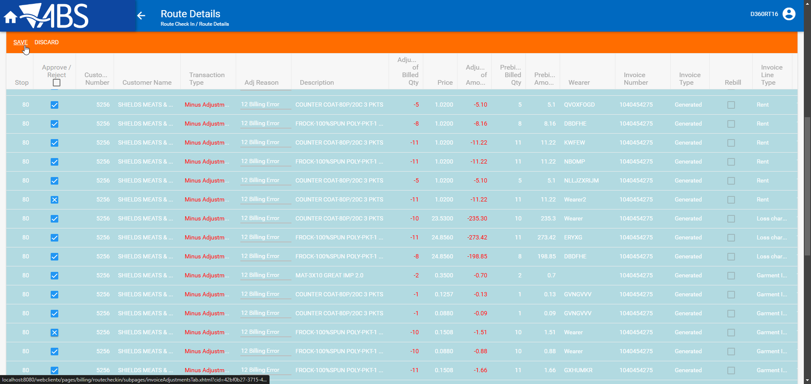

- WebX: On a different sale line update status to pending and then modify from a full to a partial adjustment
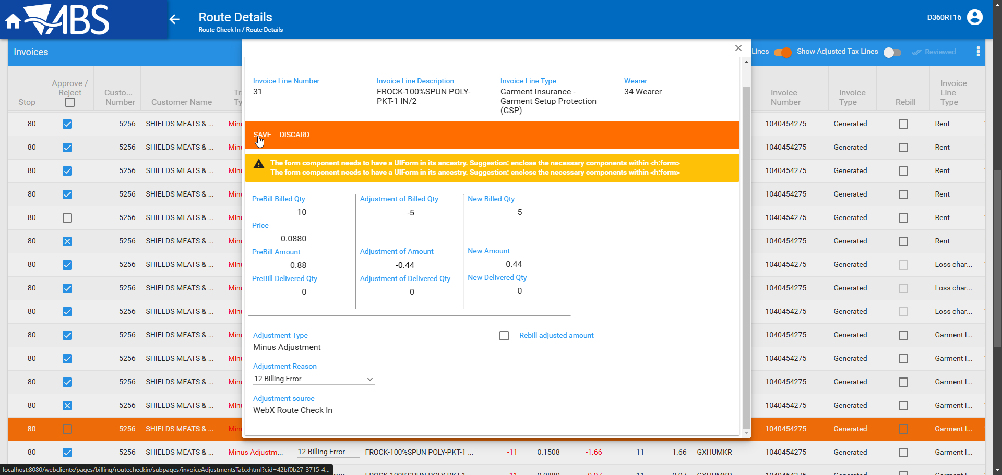
- WebX: On a different rent line update status to pending and then modify from a full to a partial adjustment
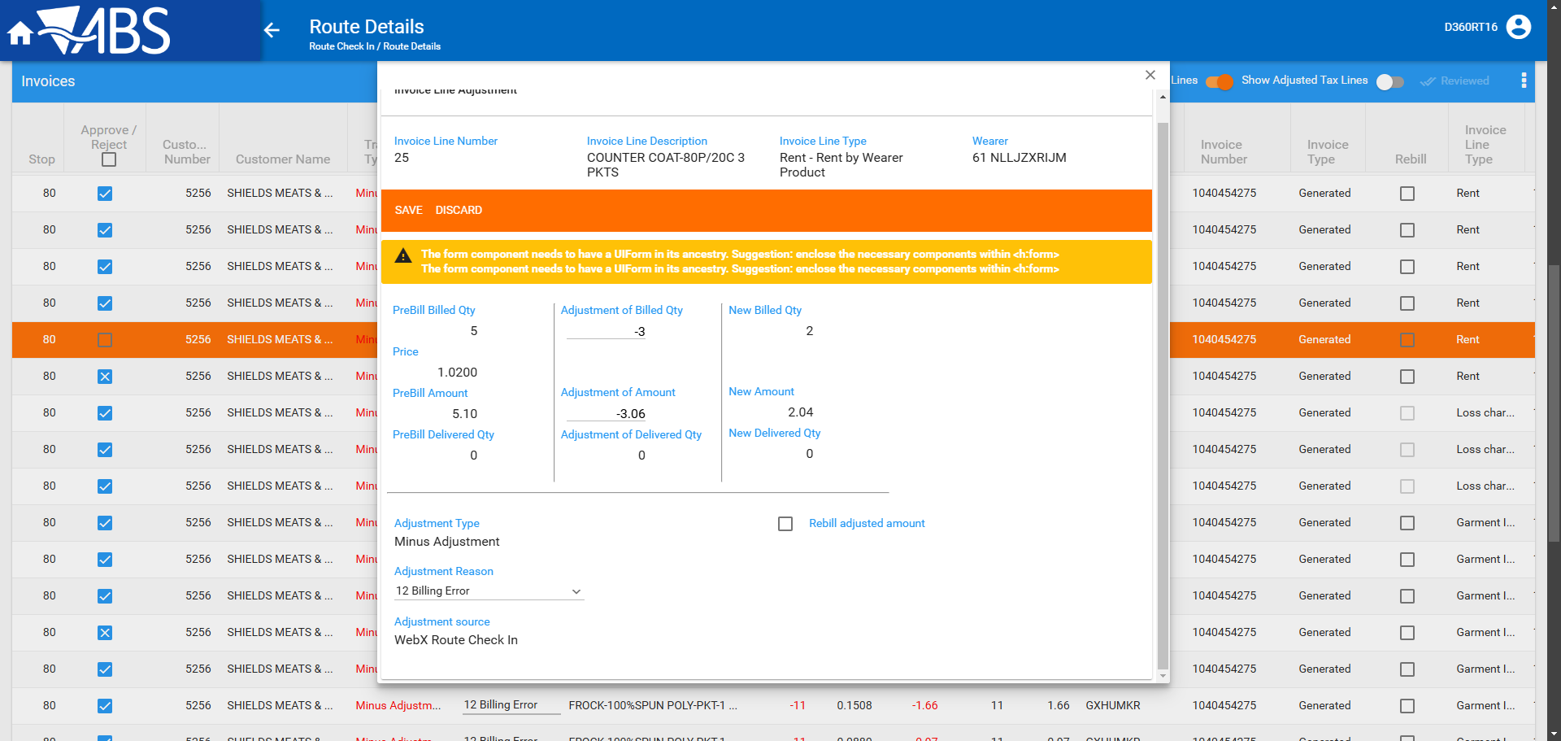
- WebX: Check route transactions
- WebX: Customer 2 – Full credit invoice
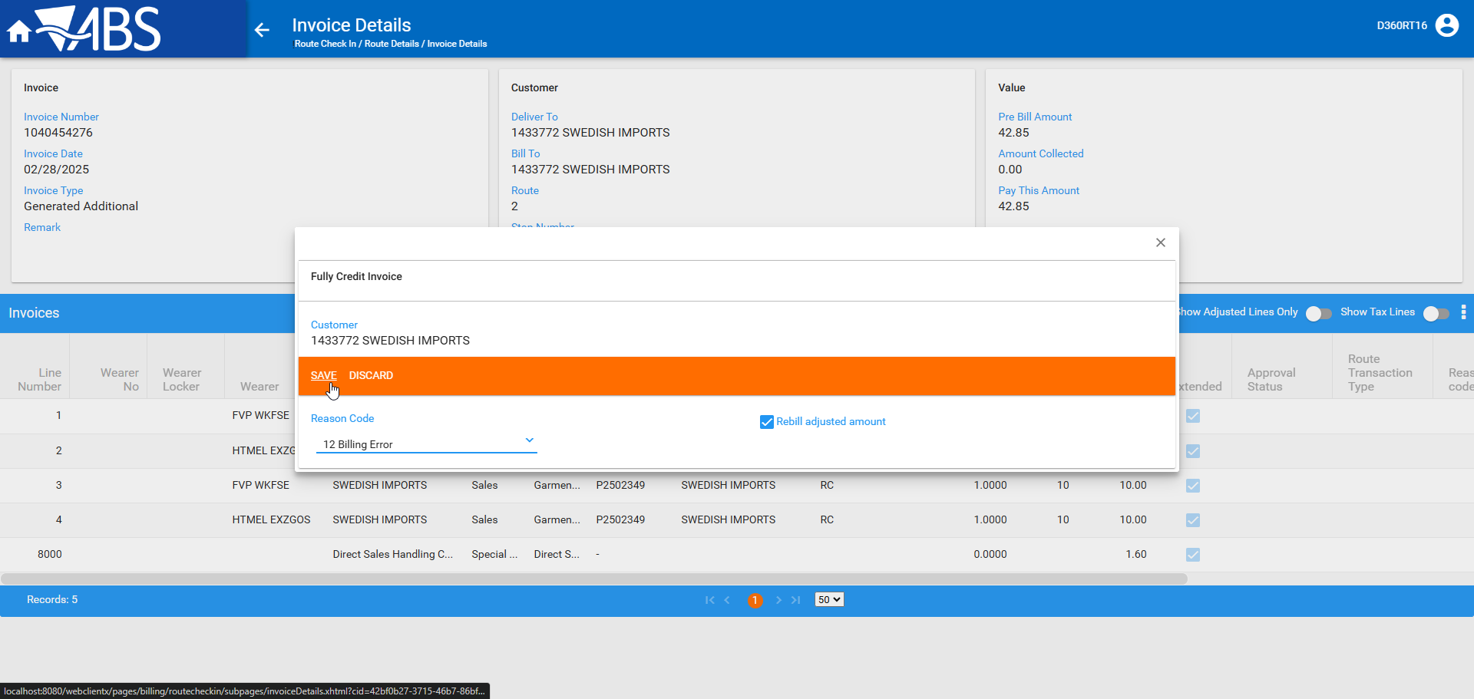
- WebX: Reject adjustments on half of the sale lines
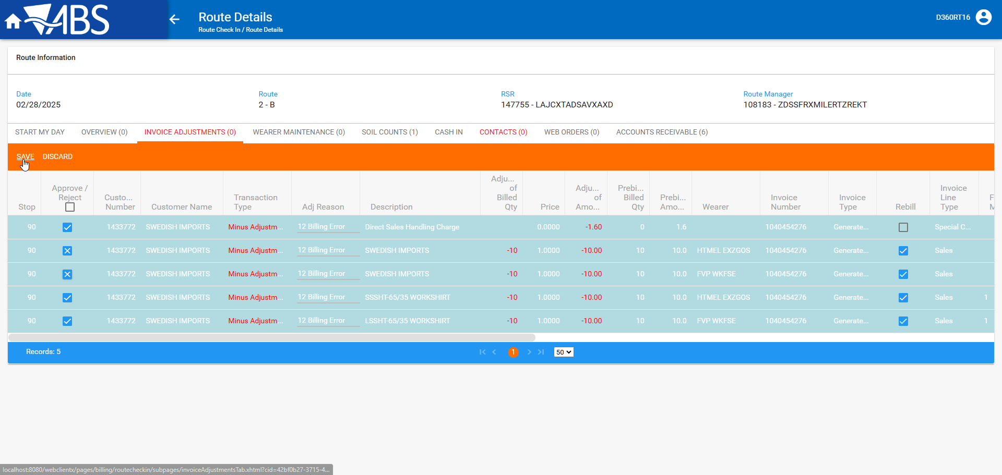
- WebX: Check route transactions
- WebX: Customer 2 – Full credit invoice
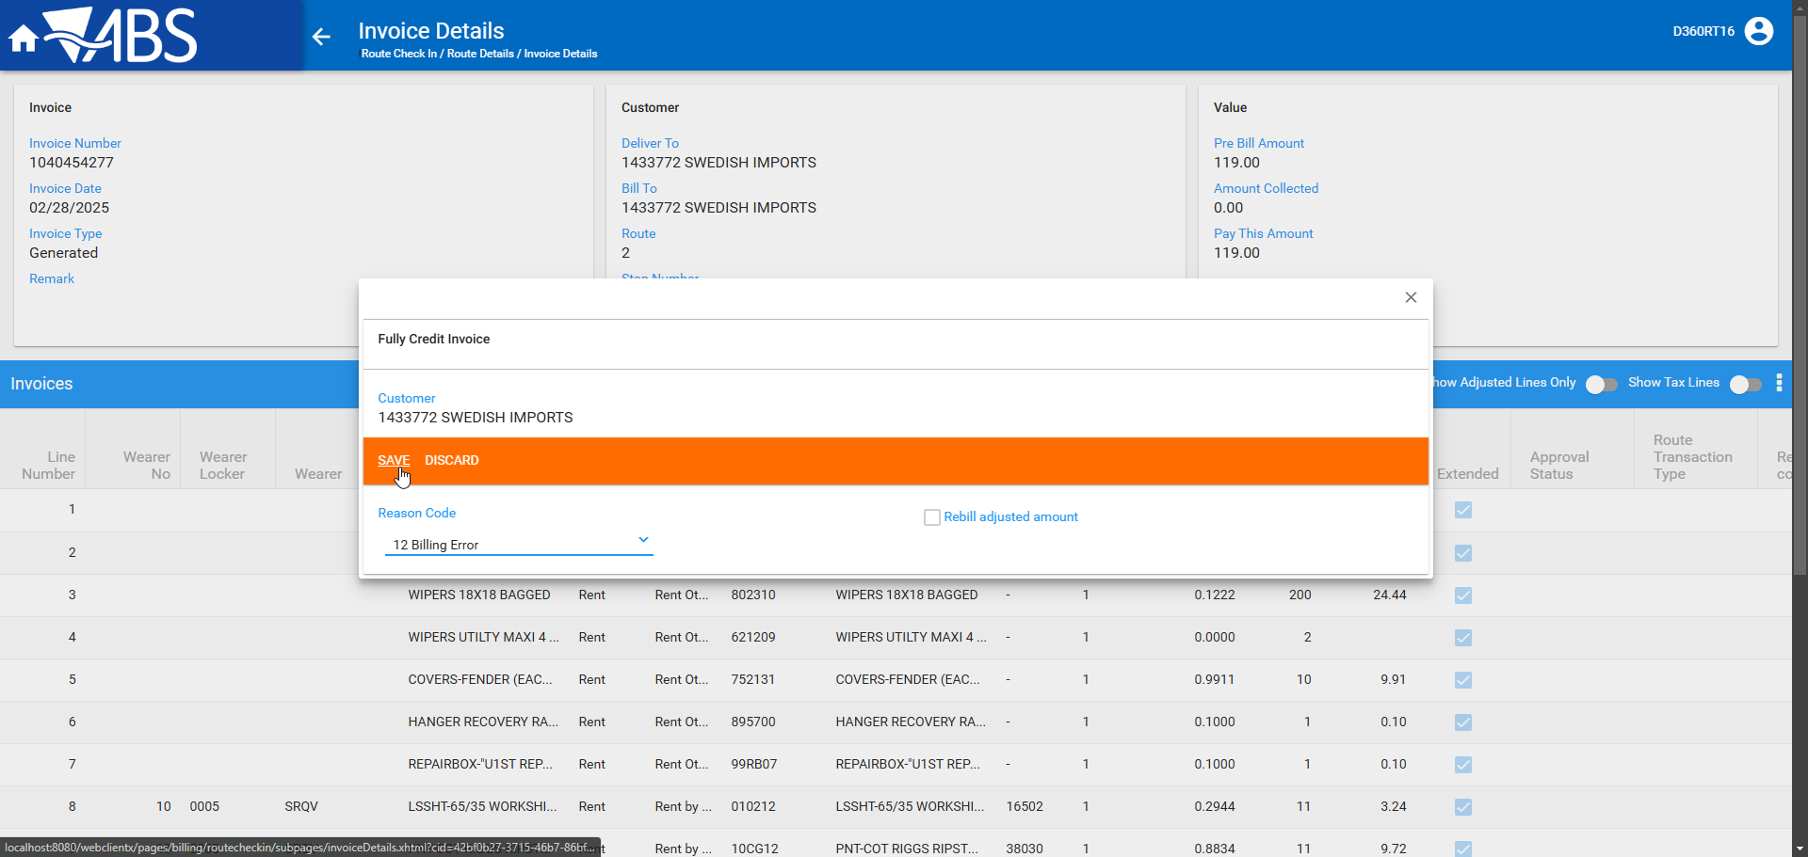
- WebX: Reject adjustments on one sales and one rent line and save
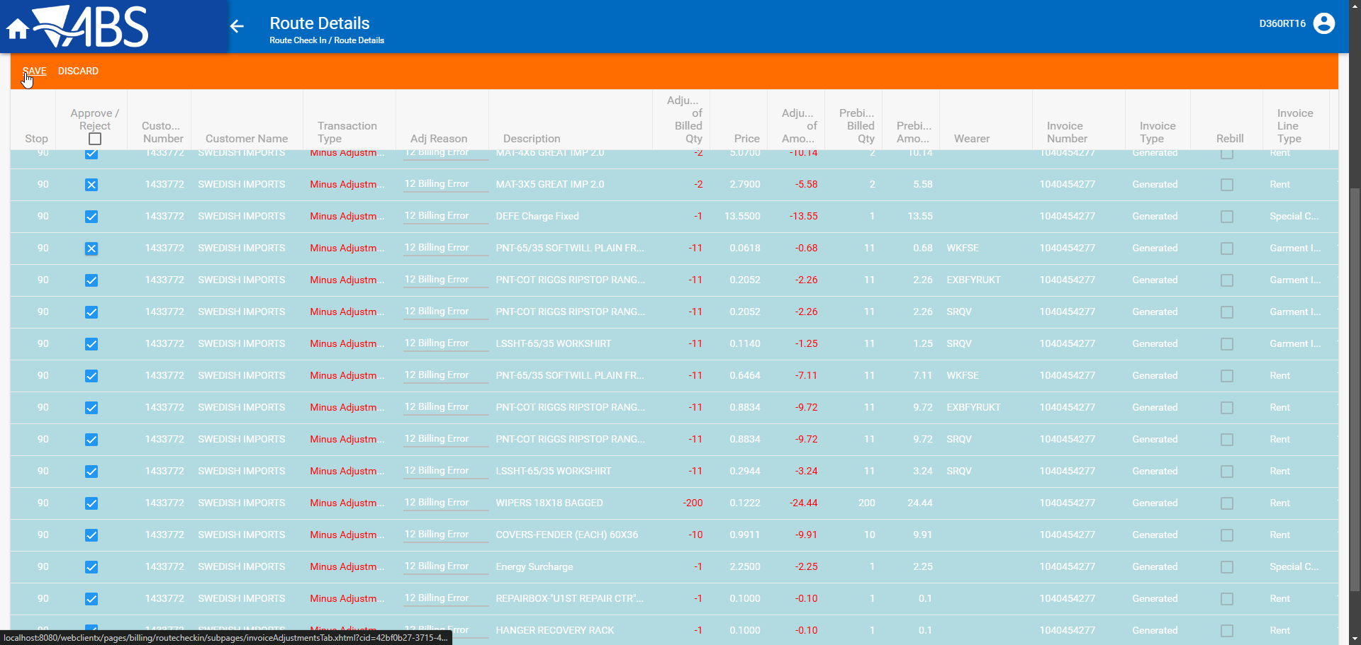
- WebX: Check route transactions

- WebX: Customer 3 – Full credit invoice
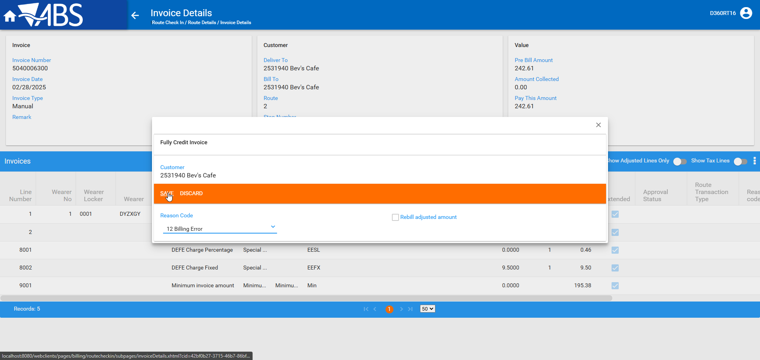
- WebX: Reject adjustments on one sales and one rent line and save
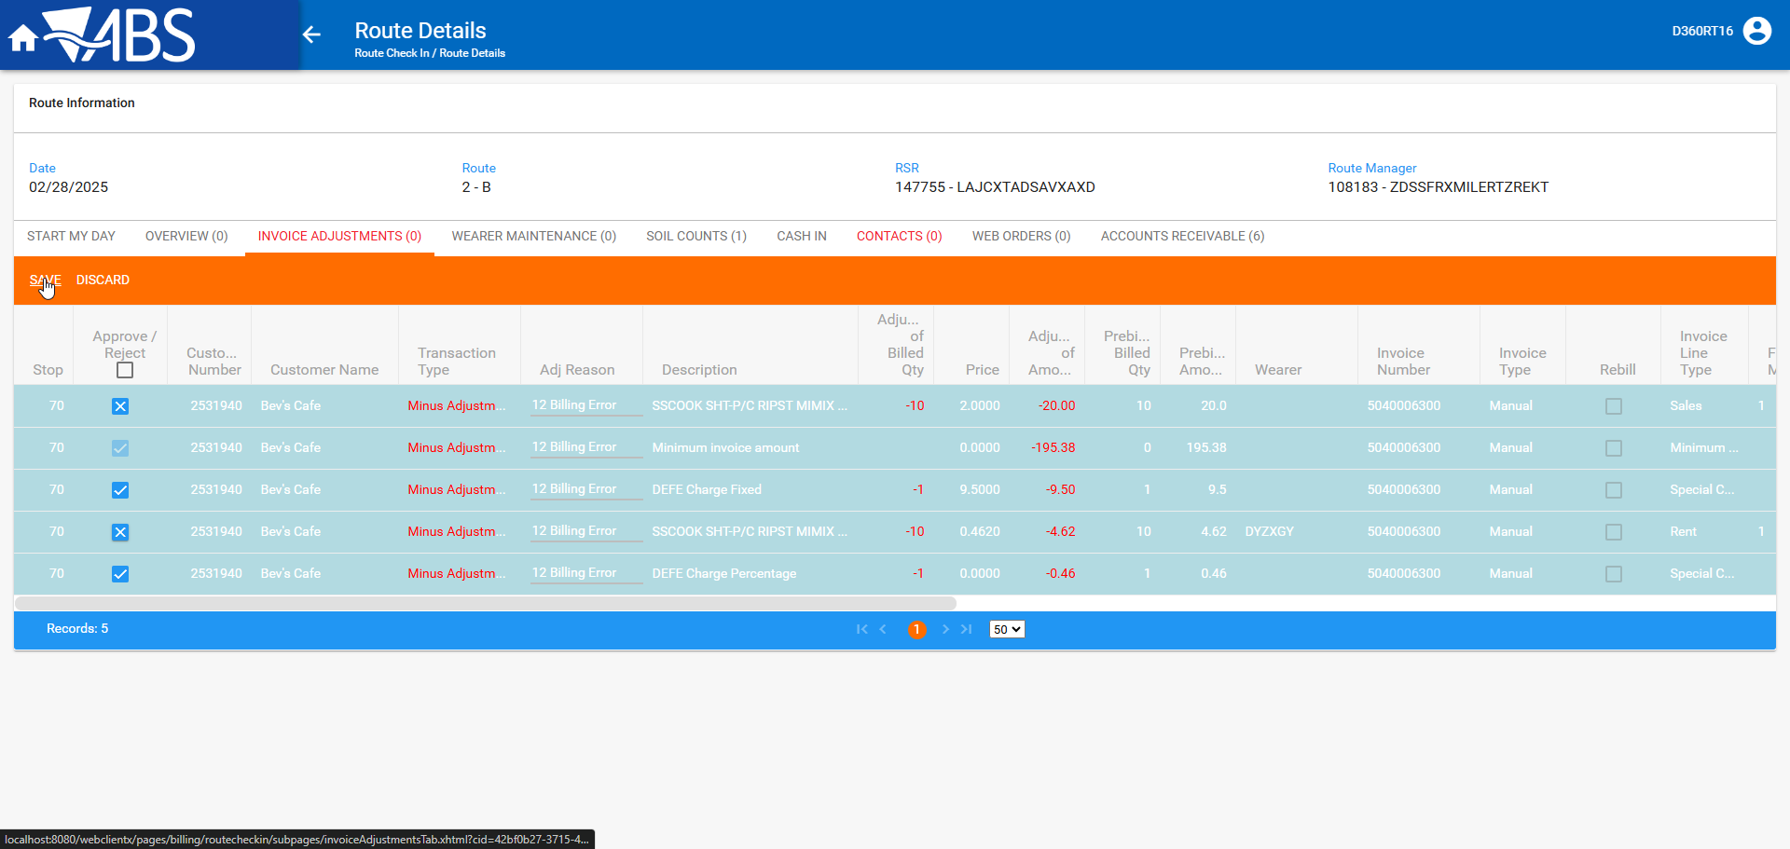

- Settle
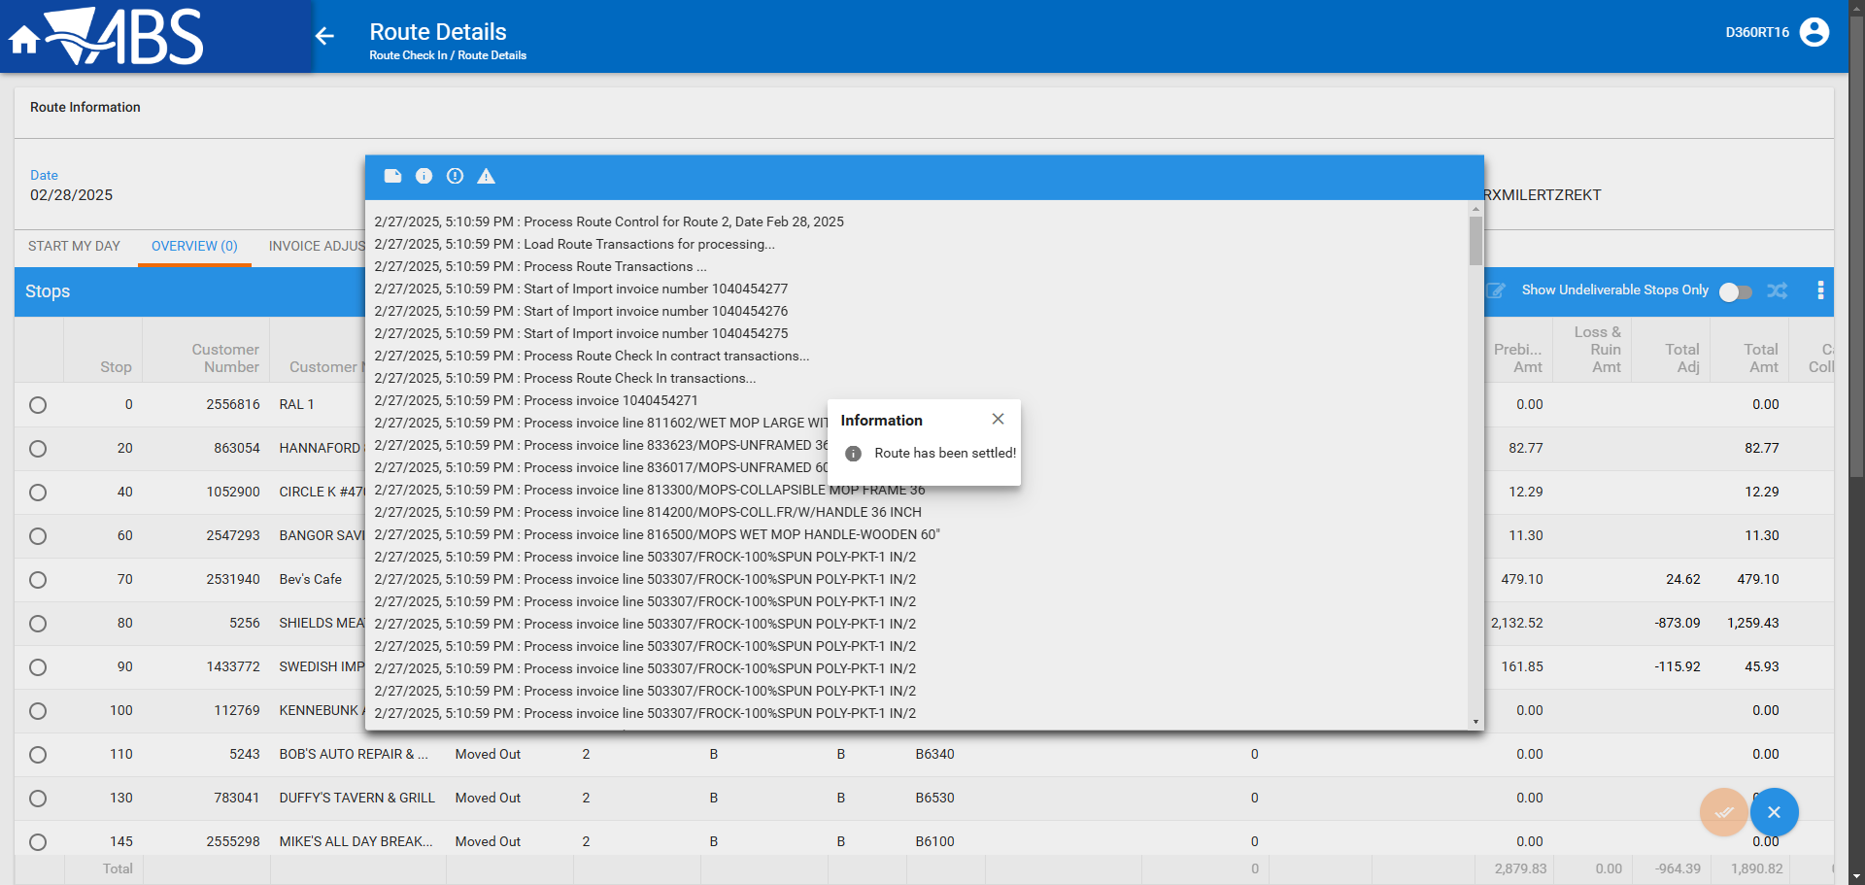

Expected behavior:
Check in Maintain Invoices
- Customer 1 – Generated Invoice
  - Invoice lines that had their respective adjustments rejected have no adjustments to quantity or amount
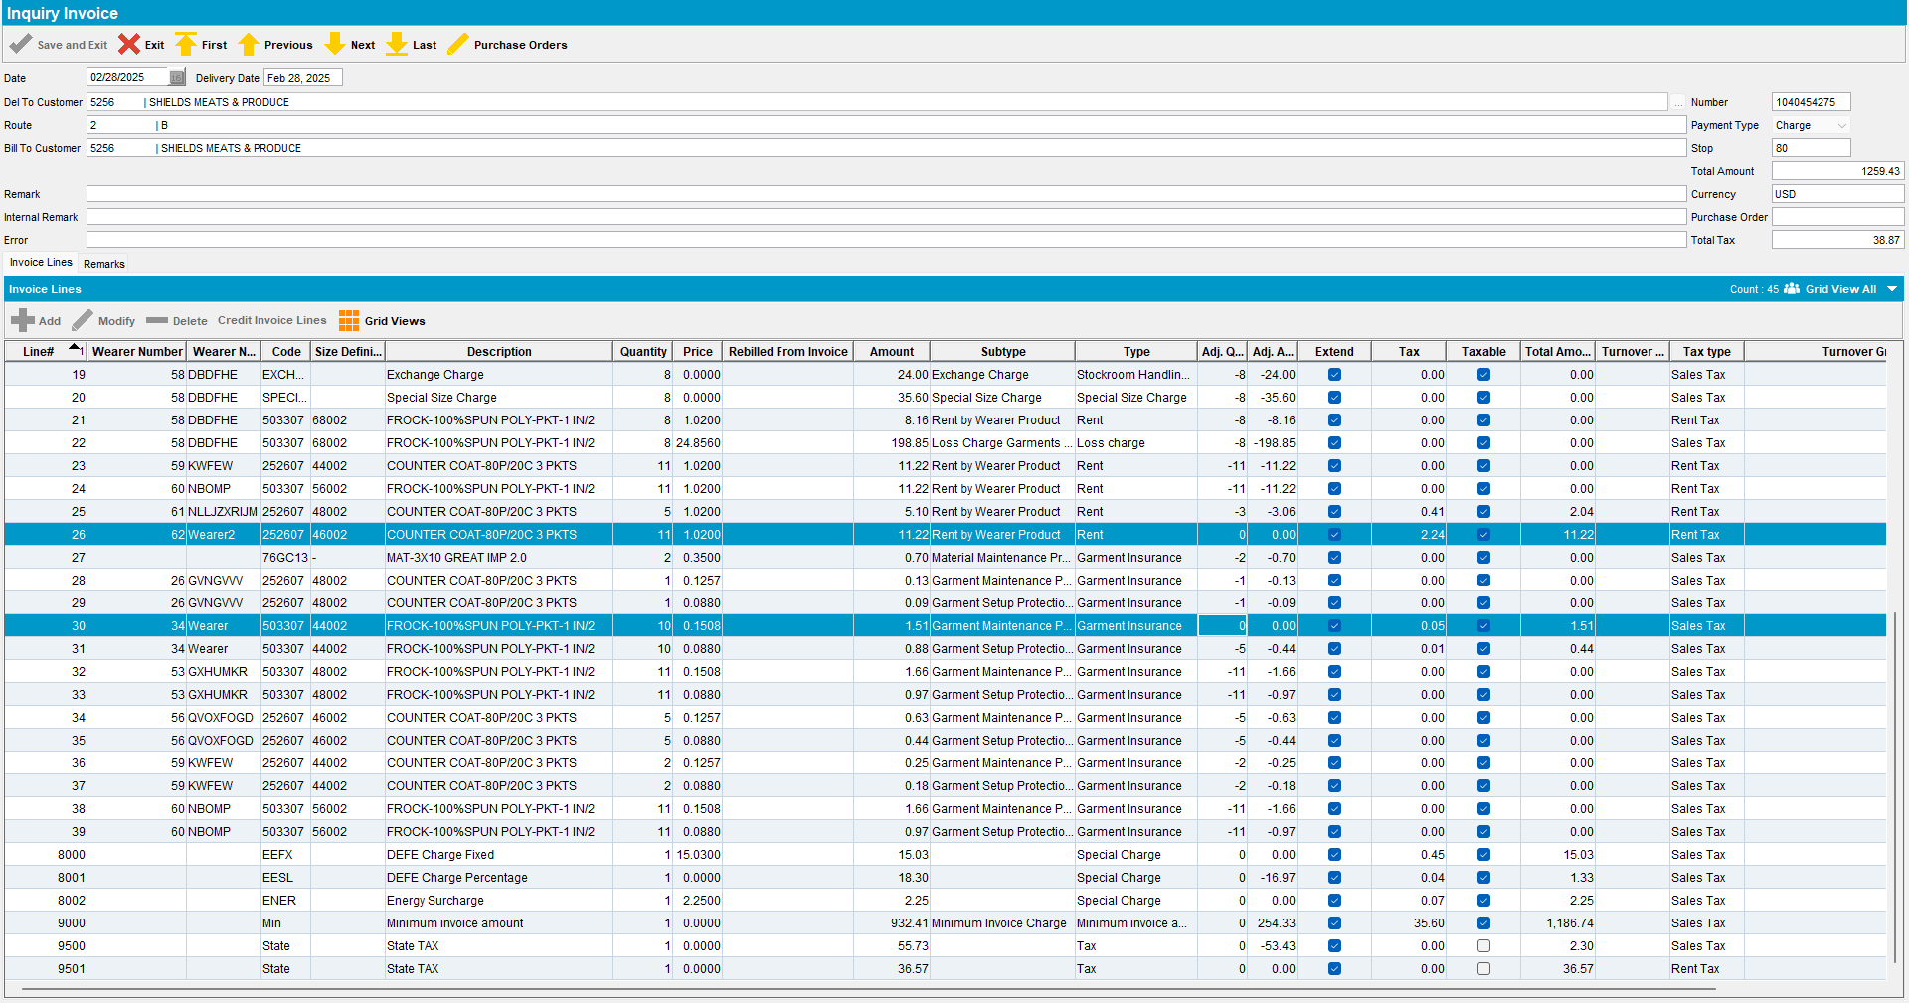

  - Invoice lines that were partially adjusted have the correct adjusted qty and amount
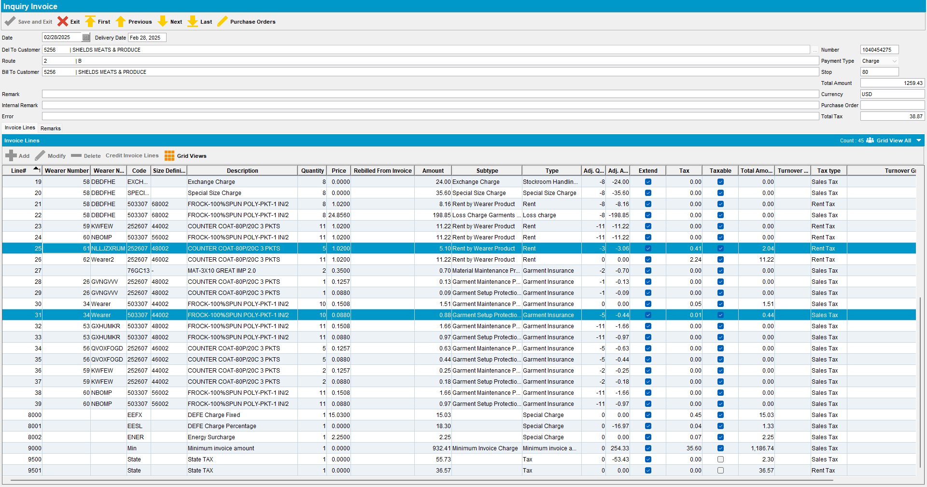
  - Check that the recalculation of the percentage special charge was correctly updated to reflect the new amounts (add column Total Amount and invoiceline type and add all Rent entries in Total Amount and multiply by special charge percentage)
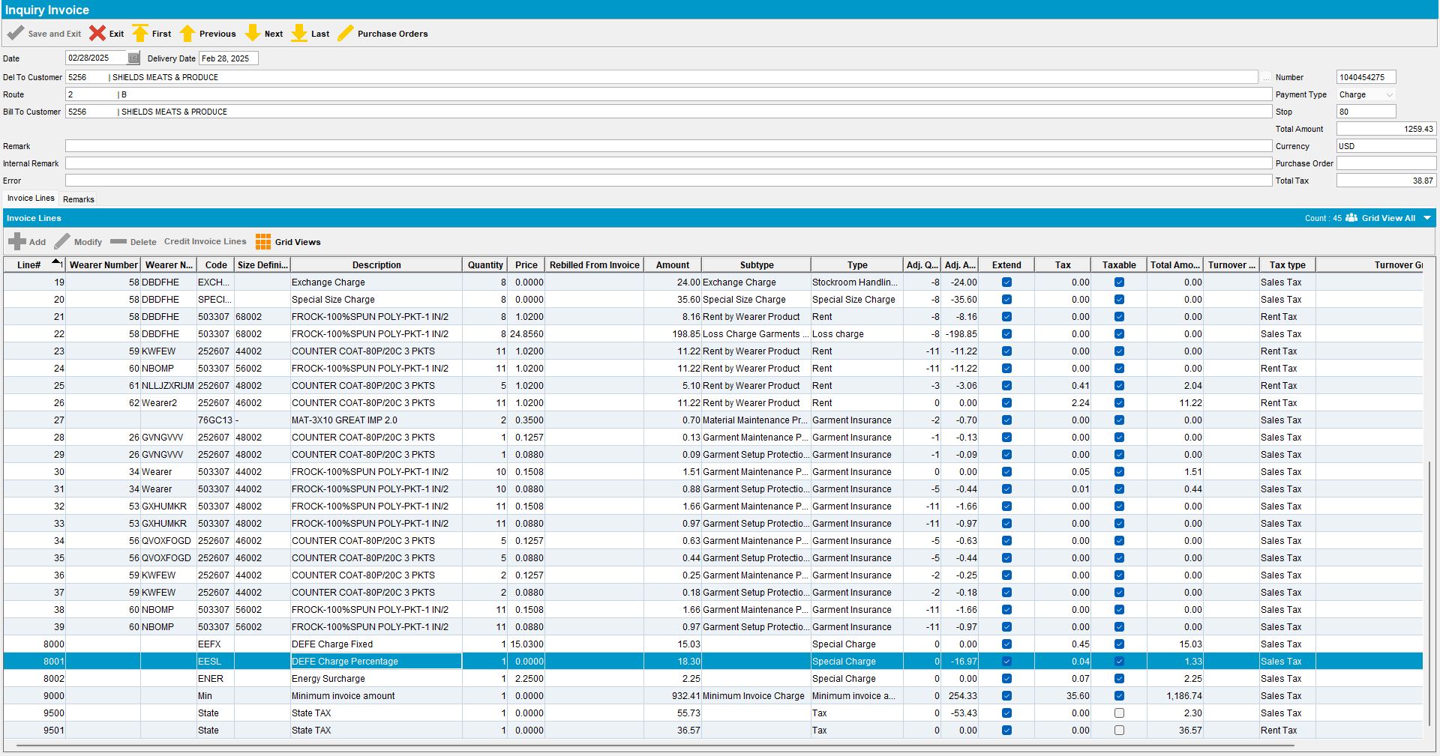

  - Min Invoice amount is recalculated against the Total Amount from Rent lines
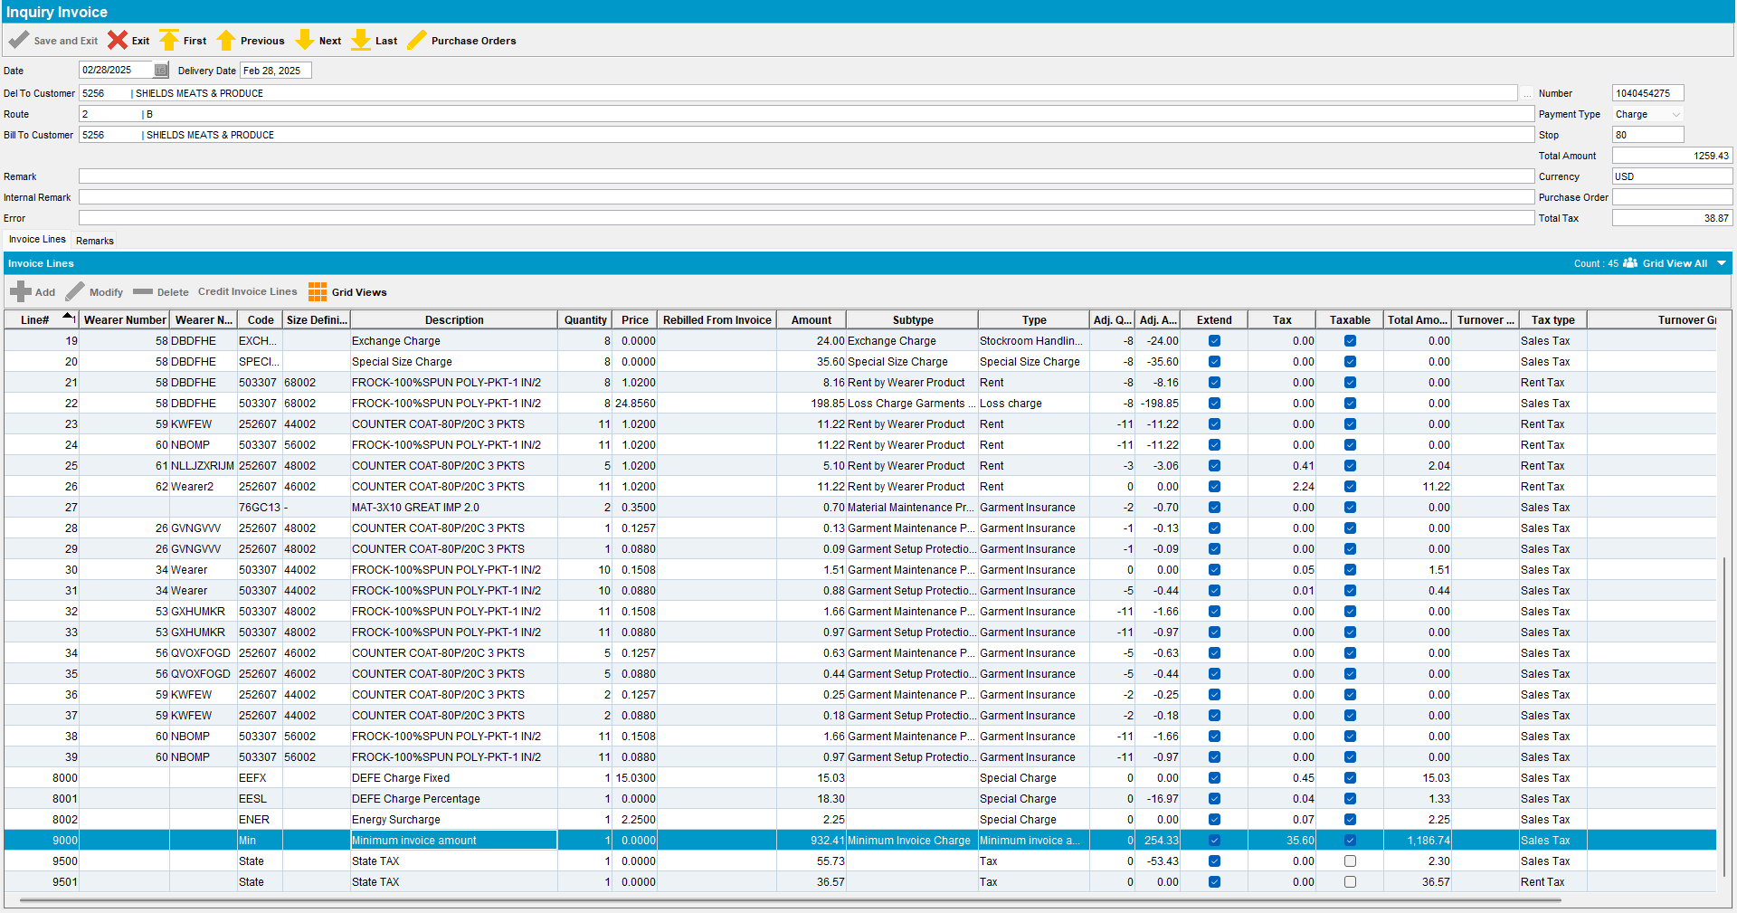
  - Taxes are not re-calculated (should be the same as before since min. inv amount makes the paythisamount equal to the prebillamount)
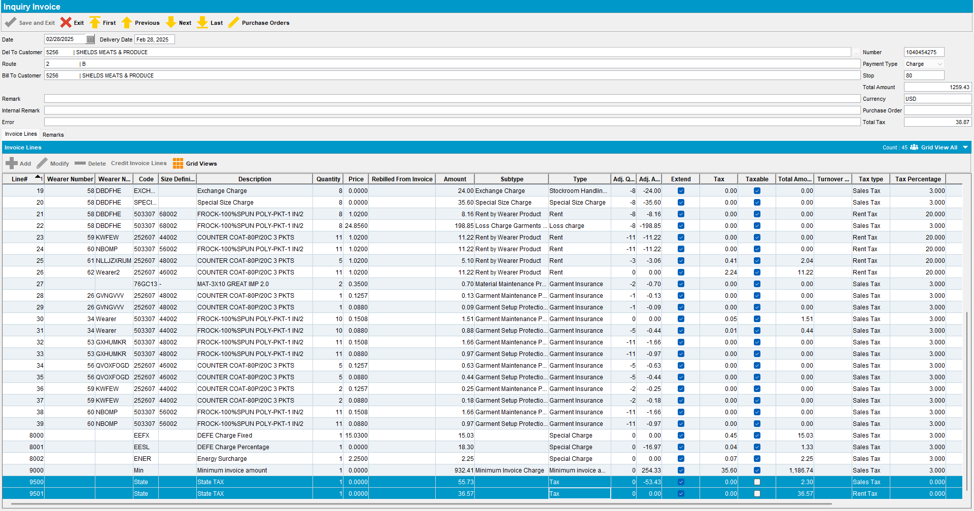

- Customer 2 – Sales Note Invoice
  - Invoice lines that had their respective adjustments rejected have no adjustments to quantity or amount
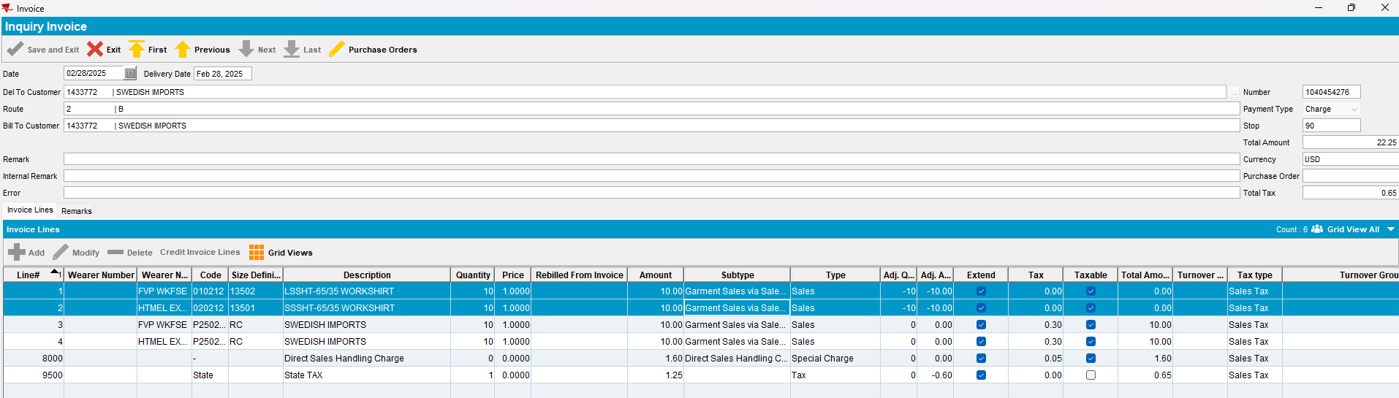
  - Taxes are recalculated - Check this by adding up values on Total Amount column and multiplying with the sales tax percentage used during BCI scripting
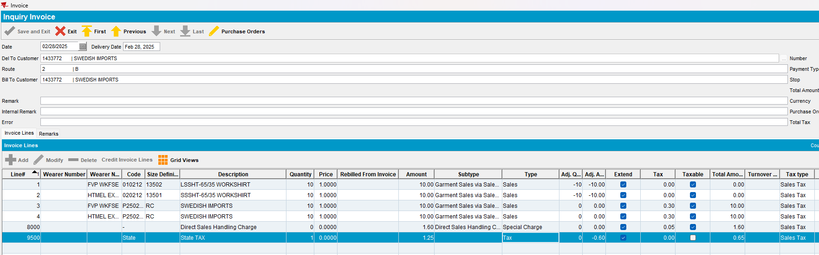
10+10+1.60 = 21.6
21.6 * 0.03 = 0.65
- Customer 2 – Generated Invoice
  - Invoice lines that had their respective adjustments rejected have no adjustments to quantity or amount
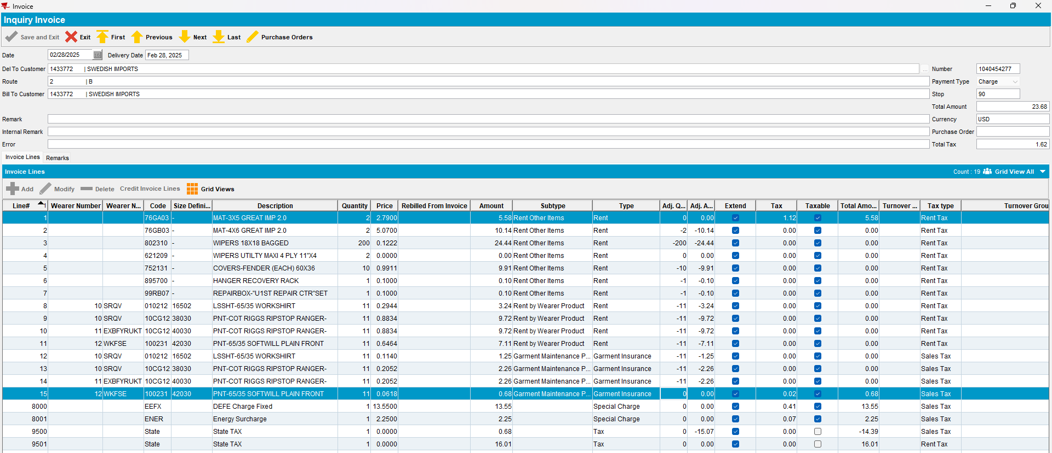
  - Check that the recalculation of the percentage special charge was correctly updated to reflect the new amounts (add column Total Amount and invoiceline type and add all Rent entries in Total Amount)
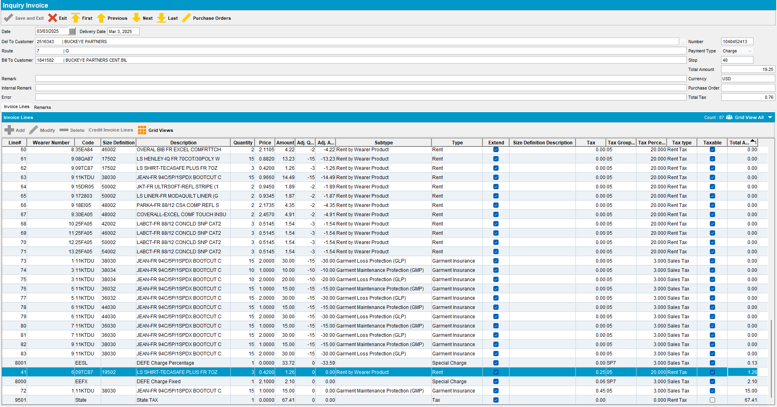
  - Taxes are recalculated - Check this by adding up values on Total Amount column and multiplying with the sales tax percentage used during BCI scripting
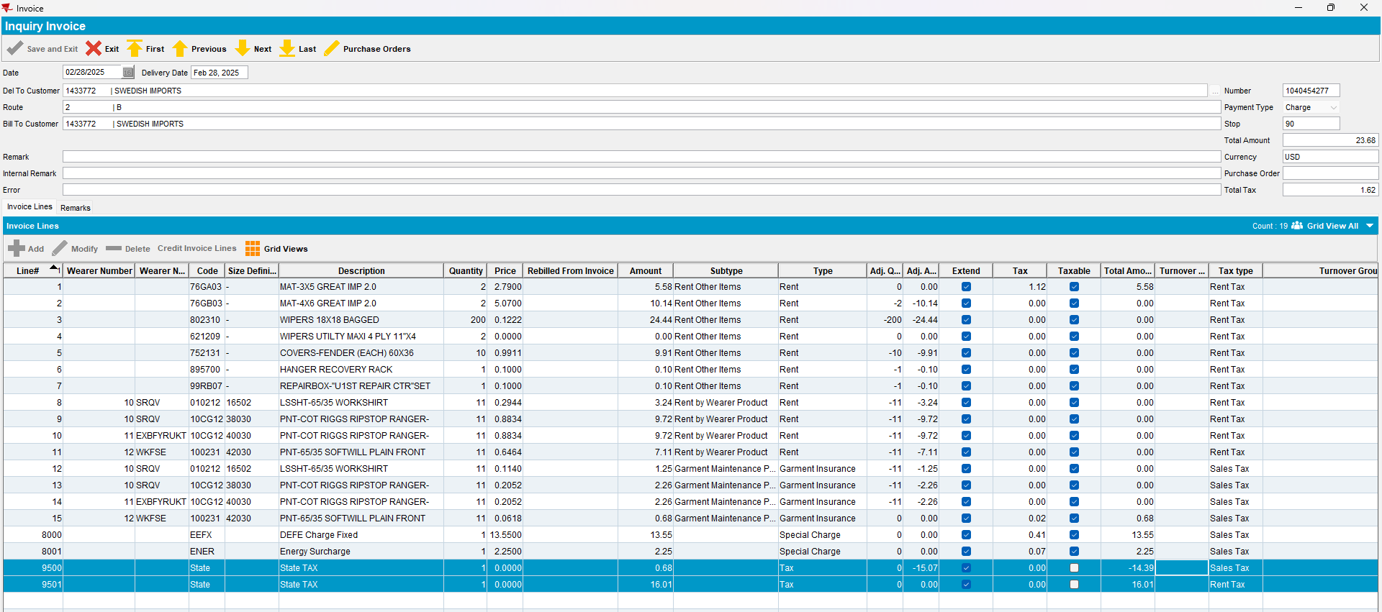

- Customer 3 – Manual Invoice
  - Invoice lines that had their respective adjustments rejected have no adjustments to quantity or amount
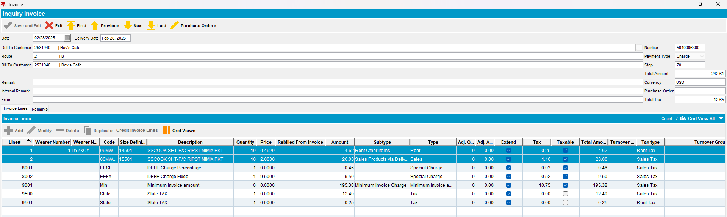
  - Check that the recalculation of the percentage special charge was correctly updated to reflect the new amounts (add column Total Amount and invoiceline type and add all entries in Total Amount, except Minimum Amount and taxes and multiply by special charge percentage)
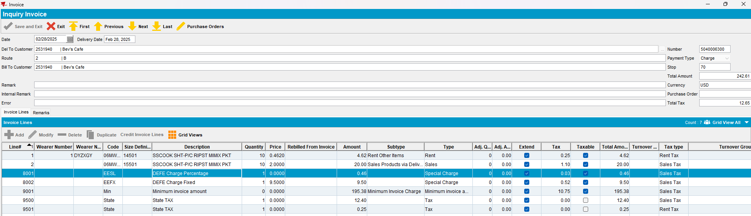
  - Min Invoice amount is recalculated against the Total Amount from all lines added up including special charges/rent/sales but not taxes)
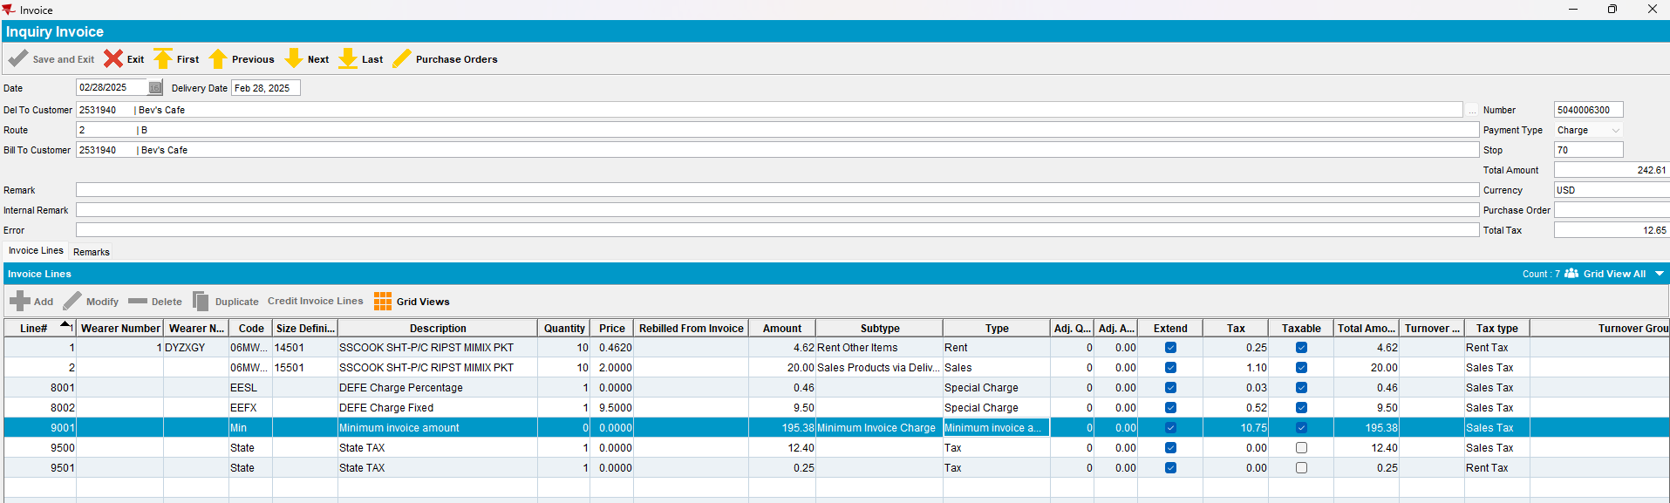

  - Taxes are not re-calculated (should be the same as before since min. inv amount makes the paythisamount equal to the prebillamount)
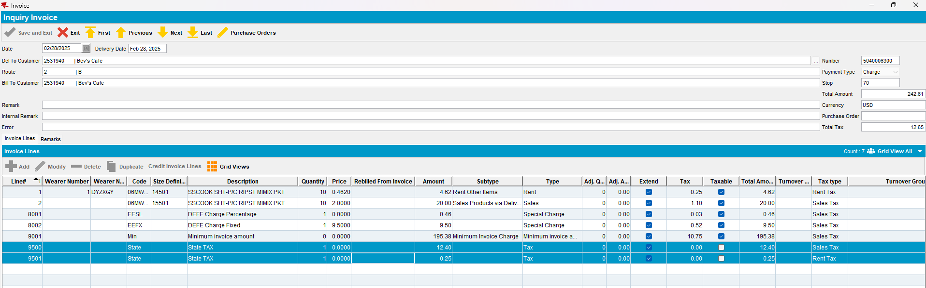
Use the following select to verify that: the paythisamount = IH.TOTALAMOUNTEXCLVAT+ SUM(ILEI.TOTALTAX) and that paythisamount = AR.amount
SELECT C.NAME, IH.INVOICETYPE, IH.PAYTHISAMOUNT, SUM(ILEI.TOTALTAX), IH.TOTALAMOUNTEXCLVAT, AR.AMOUNT FROM INVOICEHEADER IH
JOIN CUSTOMER C ON C.CUSTOMER_ID = IH.DELTOCUSTOMER_LINK_ID
JOIN INVOICELINE IL ON IL.INVOICEHEADER_ID = IH.INVOICEHEADER_ID
JOIN INVOICELINEEXTRAINFO ILEI ON ILEI.INVOICELINE_ID = IL.INVOICELINE_ID
LEFT JOIN ARTRANSACTION AR ON AR.INVOICEHEADER_ID = IH.INVOICEHEADER_ID
WHERE IH.STATUS_ID = 2
AND IH.ROUTECONTROL_ID = (select rc.routecontrol_id
from routecontrol rc
join route r
on r.route_id = rc.route_id
join plant p
on p.plant_id = r.plant_id
where rc.drivingdate = to_date('28/02/2025', 'dd/mm/yyyy')
and r.routenumber = 2
and p.code = '025')
GROUP BY C.NAME, IH.INVOICETYPE, IH.PAYTHISAMOUNT, IH.TOTALAMOUNTEXCLVAT, AR.AMOUNT;
