ABSN-1247 - Customer on temporary rent stop bills rental on calendar day not highlighted in green indicating no delivery
Environment | Prerequisites
Version: 9.07.00.UNF19  DBServerName= abs-srv20.internal.abslbs.com  DBSID=CUST24  DBUser=UNFDEV  DBPassword= UNFDEV  Environment=Test | - Module:  - System setting

Contents
Reproducing before fix 1
Steps to reproduce 1
Current Behavior 3
Expected behavior 3
Retest after fix 3
Test Case 1 – Customer on temporary rent stop bills rental on calendar day not highlighted in green indicating no delivery 3

Reproducing before fix

Steps to reproduce
- Go to BU 091
- Find customer 1687253 and click on modify
- Go to tab Garment Charges and add Temporary Rent stop like below
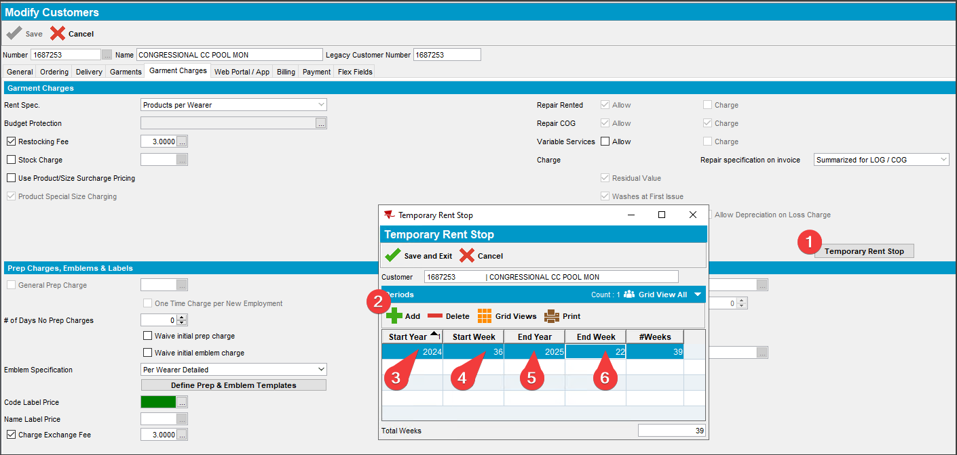
- Route Status Control DLG: Generate invoices for the route on the last week of 2024
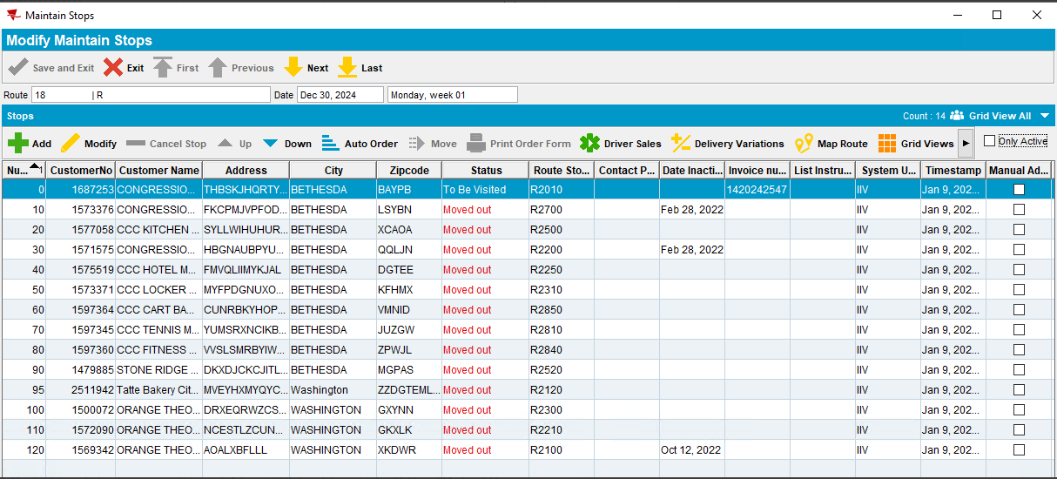
- Maintain Invoices DLG: Find the invoice you just generated
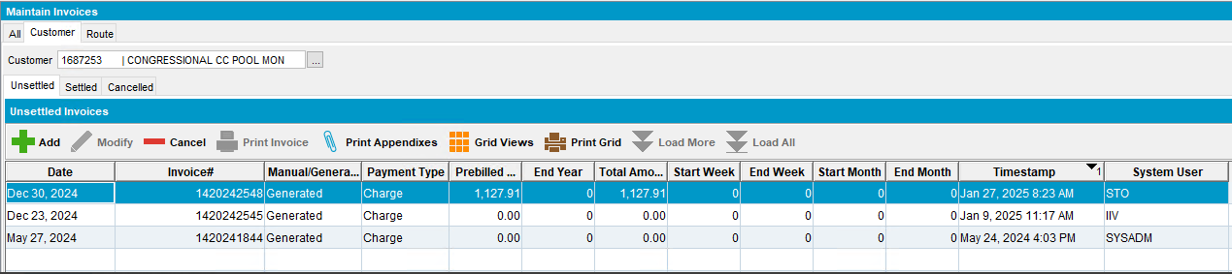
- Customer DLG: Check the Show Calendar for your route stop
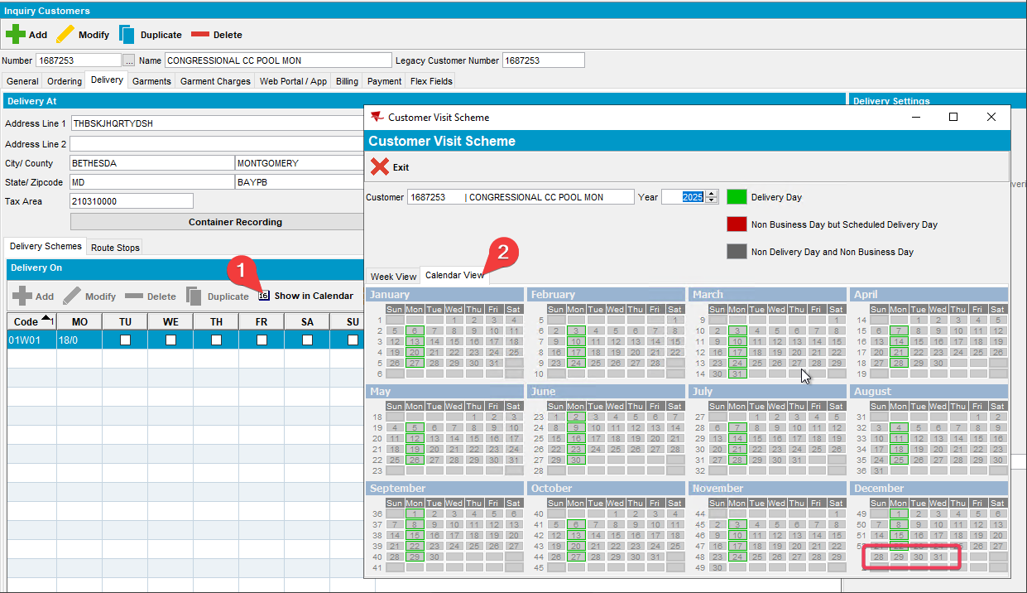
REPRODUCED OK.

Current Behavior
There are two issues:
1. During invoicing the invoice is not 0$ as there is a rent stop
2. On the Show Calendar pop-up last week of 2024 should have a green outline for the delivery date and it does not

Expected behavior
1. During invoicing the invoice should be 0$ since there is a rent stop
2. On the Show Calendar pop-up last week of 2024 should have a green outline for the delivery date.

Retest after fix

Test Case 1 – Customer on temporary rent stop bills rental on calendar day not highlighted in green indicating no delivery
Hash: 317995a57a14
Expected behavior:
- Invoice value should be 0$
- The delivery day which is scheduled in the previous year but is part of week 1 has a green outline around it
- Go to BU 091
- Find customer 1687253 and click on modify
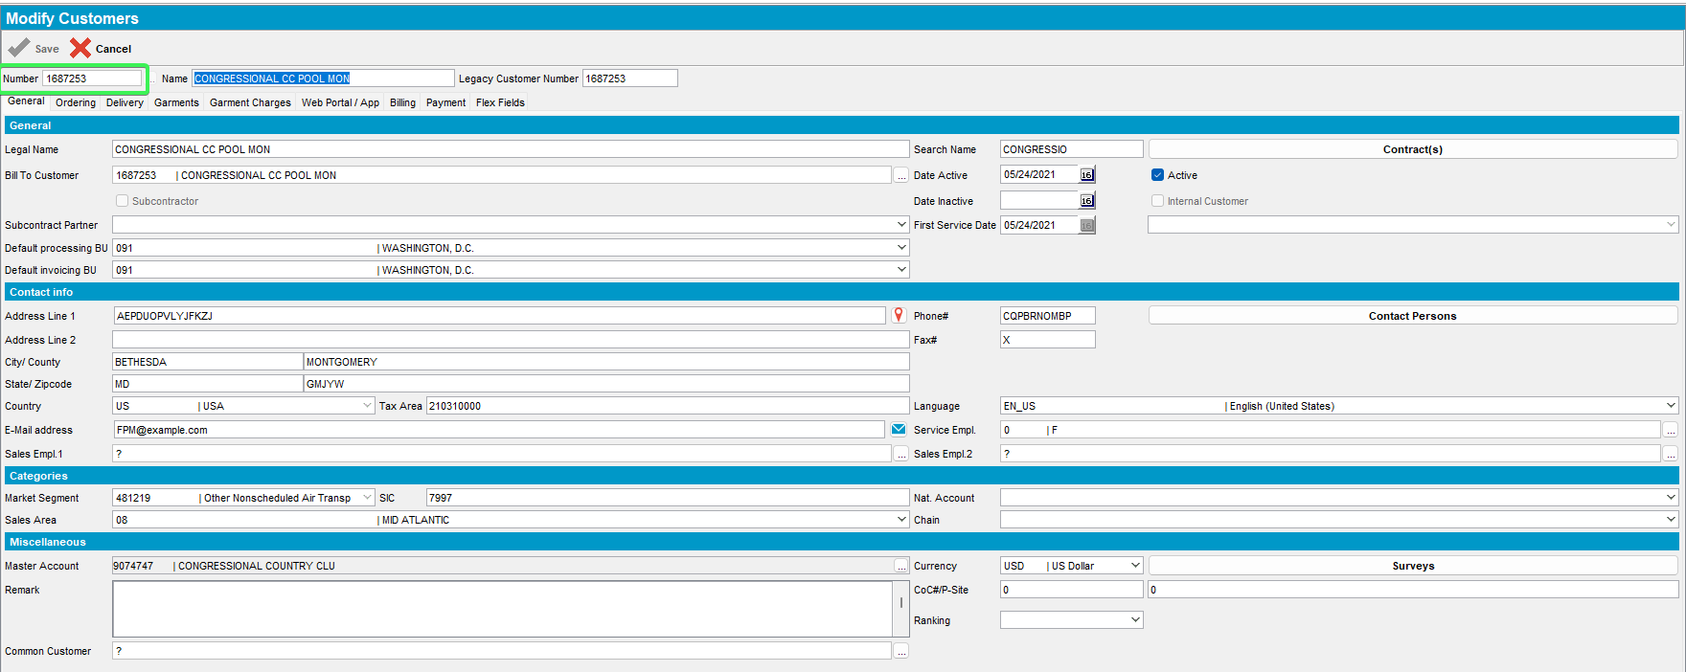
- Go to tab Garment Charges and add Temporary Rent stop like below
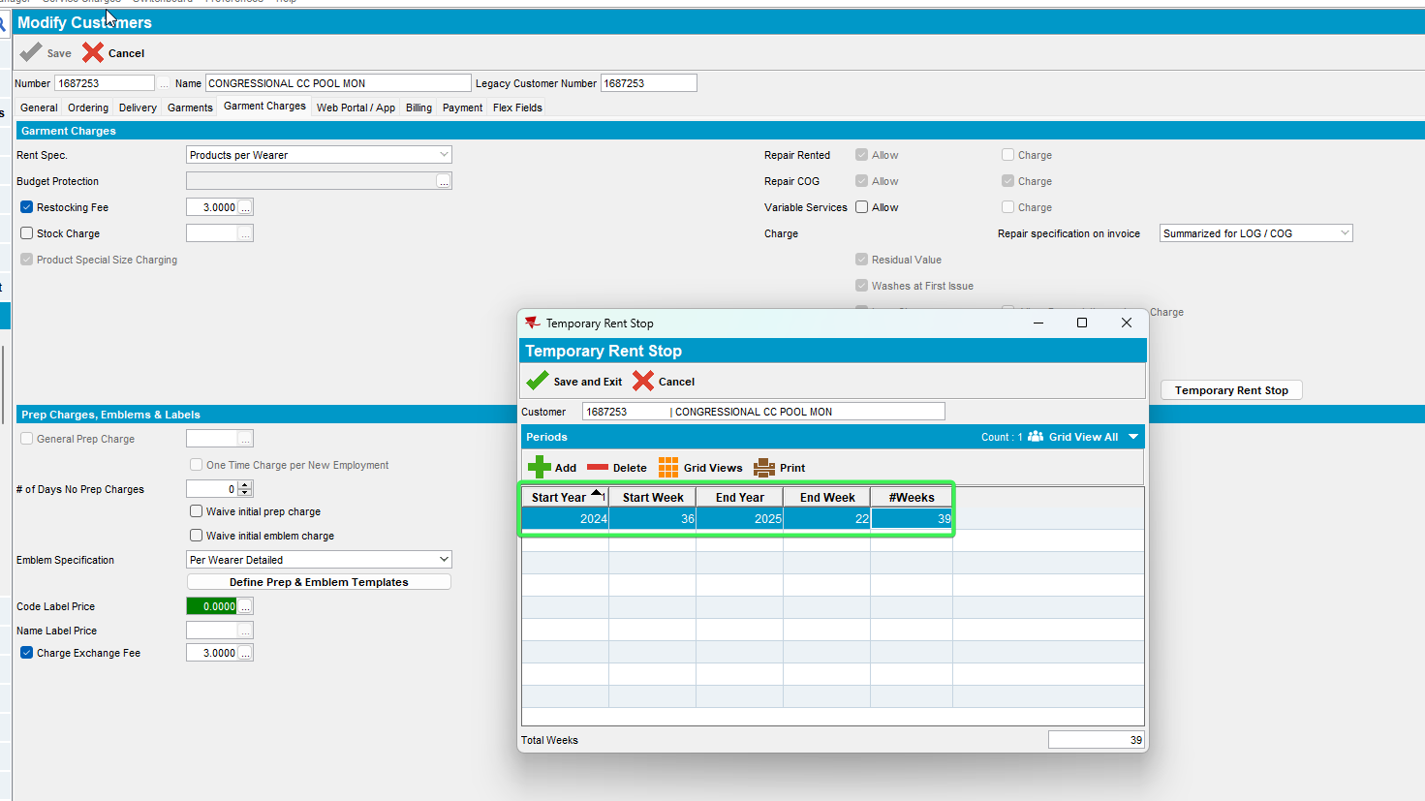
- Route Status Control DLG: Generate invoices for the route on the last week of 2024
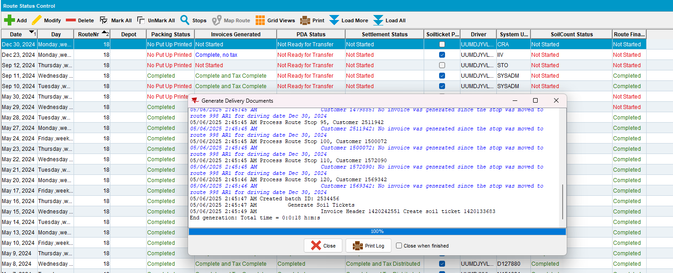
- Maintain Invoices DLG: Find the invoice you just generated
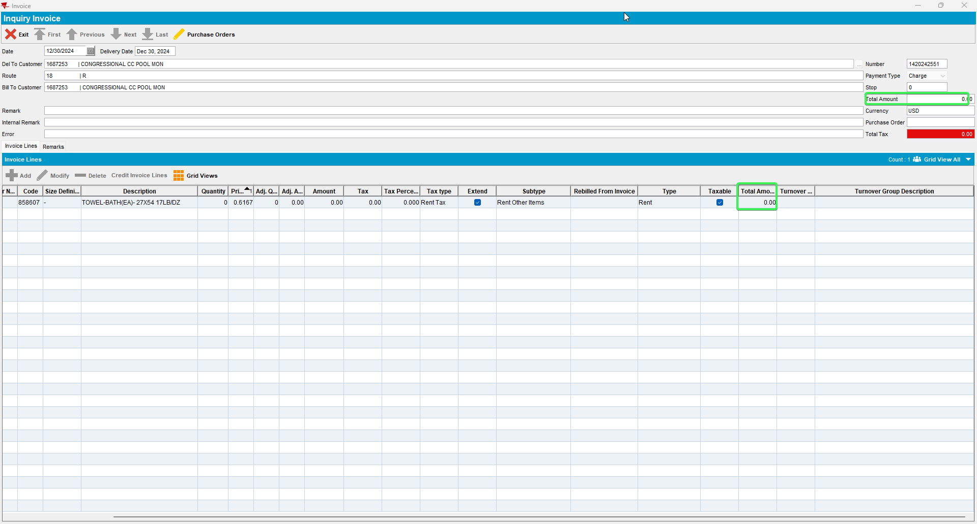
- Customer DLG: Check the Show Calendar for your route stop
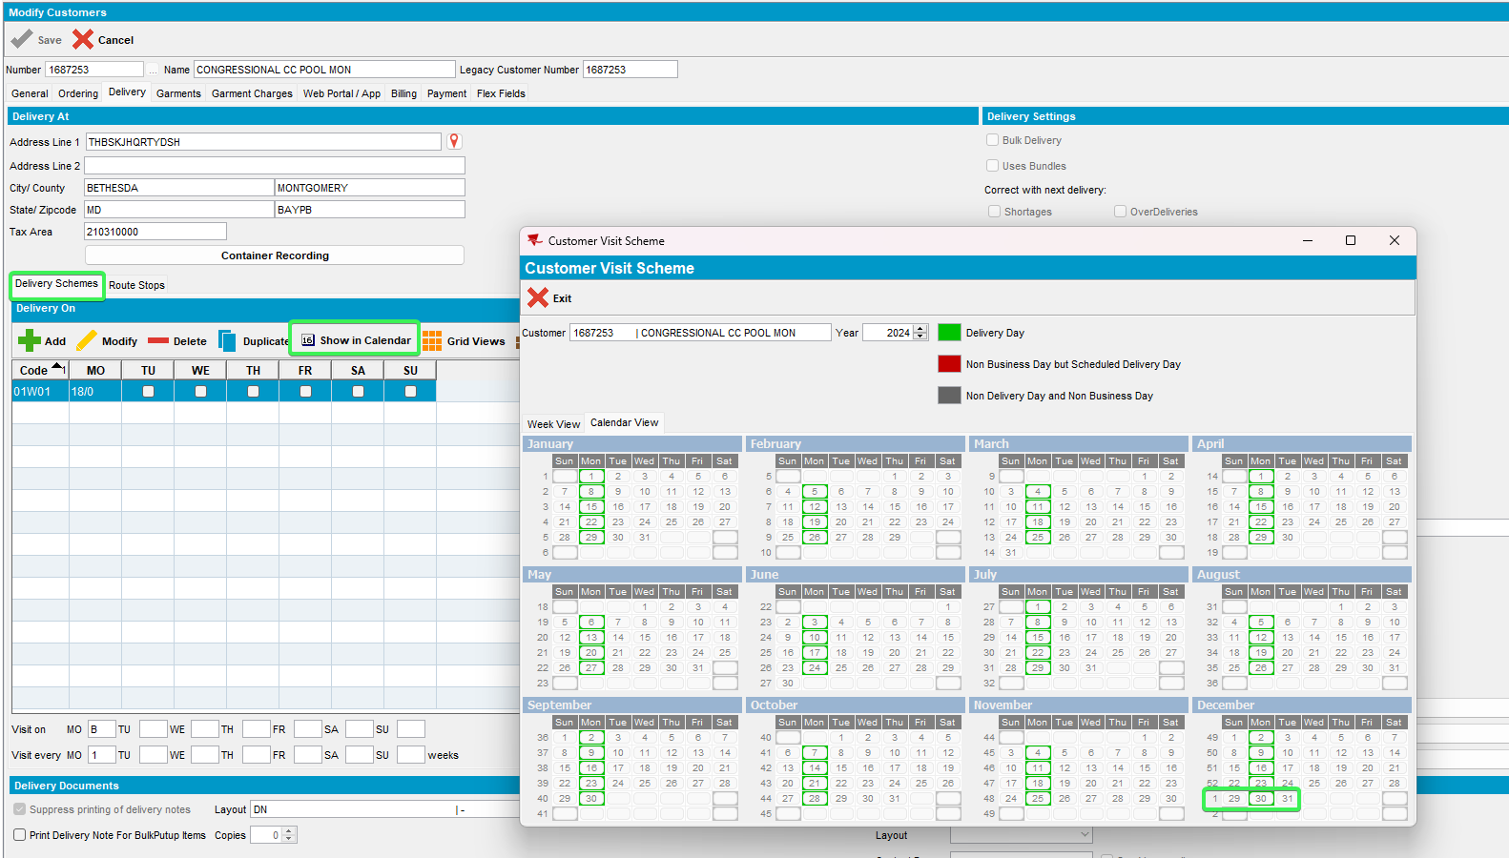
Tested OK

