ABSN-1245 - Settlement - No ARTransaction is generated if invoice is fully credited on WebX and then only part of the adjustments are rejected
Environment | Prerequisites
Version: 9.07.00.UNF19  DBServerName= abs-srv20.internal.abslbs.com  DBSID=CUST24  DBUser=UNFDEV  DBPassword= UNFDEV  Environment=Test | - Module:  - System setting

Contents
Reproducing before fix 1
Data preparation 1
Steps to reproduce 1
Current Behavior 4
Expected behavior 4
Retest after fix 4
Data Preparation 4
Test Case 1 – Full credit each type of invoice on WebX and check that the approve/reject checkbox is approved and disabled (customer 2 and 3) 4
Test Case 2 – INVOICELINEADJVALUERULE = 1 and INVOICELINEADJMODIFYRULE = 2 4
Test Case 3 – Full credit invoices on WebX and then cancel the full credit and then settle and check the ARTransaction was created. Cancel the full credit for all invoices on Customer 3 and on Customer 2 leave the full credit for the Generated invoice 4

Reproducing before fix

Steps to reproduce
1. Find or create a route that has at least one invoice that was settled on RA (preferably without any invoice adjustments) but not settled on WEBX.
SELECT RC.DRIVINGDATE, P.CODE, R.ROUTENUMBER, RC.ROUTECONTROL_ID FROM ROUTECONTROL RC
JOIN ROUTE R ON R.ROUTE_ID = RC.ROUTE_ID
JOIN PLANT P ON P.PLANT_ID = R.PLANT_ID
WHERE RC.POCKETPCSTATUS = 2
AND RC.SETTLEMENTSTATUS = 1;
2. WebX: Open route
3. WebX Invoice Adjustments: Click on add button and select an invoice
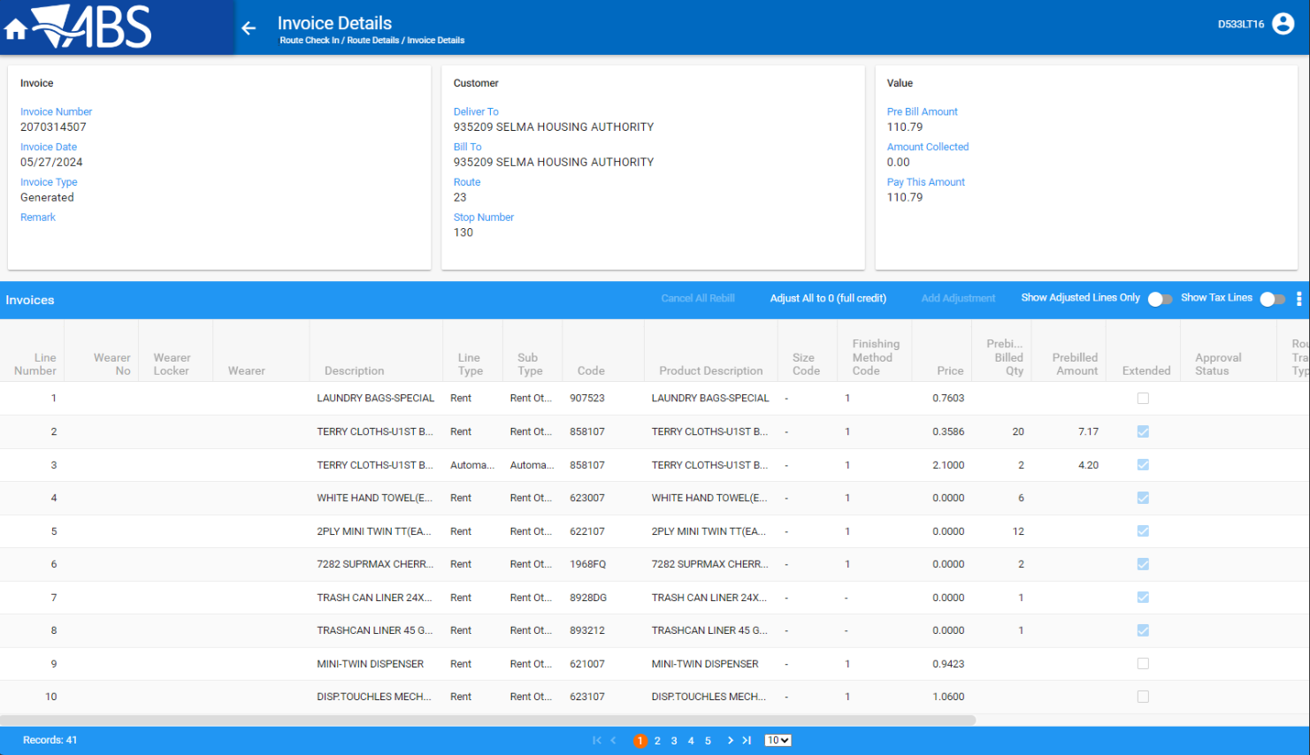
4. WebX Invoice details: Full credit the invoice
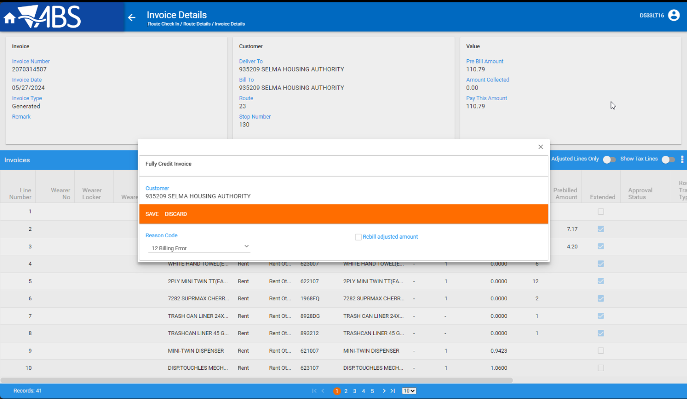
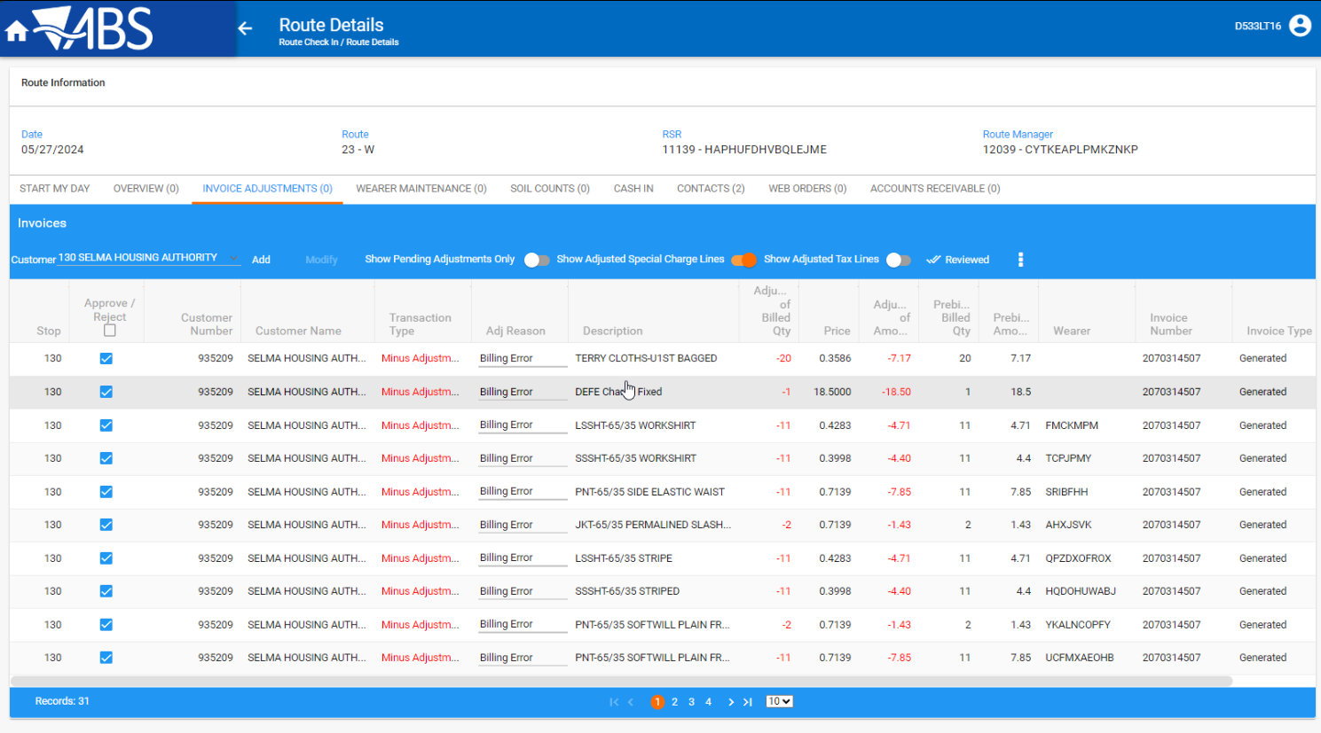
5. WebX Invoice adjustments: Click on the approve/reject checkbox and set all invoice adjustments that you just created as rejected and save
6. WebX Invoice Adjustments: Click on one of the rejected invoice adjustments and set it as approved
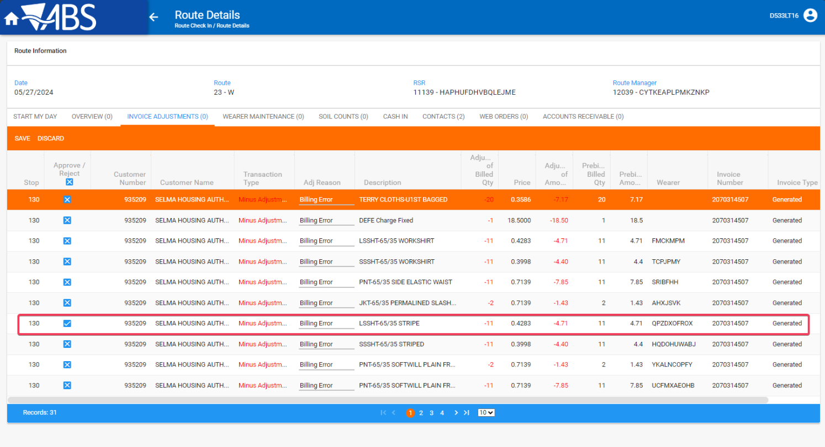
7. WebX: Settle the route
8. Check that the invoice(s) you added adjustments for DO NOT have ARTransactions:
SELECT RC.TIMESTAMP, P.CODE AS PLANT, R.ROUTENUMBER, RC.DRIVINGDATE, IH.PAYTHISAMOUNT, IH.STOP_ID, IH.* FROM INVOICEHEADER IH
JOIN ROUTECONTROL RC ON RC.ROUTECONTROL_ID = IH.ROUTECONTROL_ID
JOIN ROUTE R ON RC.ROUTE_ID = R.ROUTE_ID
JOIN PLANT P ON P.PLANT_ID = R.PLANT_ID
WHERE NOT EXISTS (SELECT 1 FROM ARTRANSACTION AR
WHERE AR.INVOICEHEADER_ID = IH.INVOICEHEADER_ID
AND AR.DEBITCREDIT = 'D')
AND IH.INVOICENUMBER IN (2070314507, 2070314519);

REPRODUCED OK.

Current Behavior
Settlement process treats these invoices as if the ih.paythisamount = 0 and does not create an ARTransaction

Expected behavior
Settlement process should create ARTransactions for these invoices

Retest after fix

Data Preparation
On the same route have multiple customers with different invoices as specified below:
Customer 1 - Generated invoice only (Full credit on RA)
Customer 2 - Generated and manual invoice
Customer 3 - Generated and Generated additionally (sales note invoice)
Customer 4 - Generated and manual invoice (Full credit on RA for just the manual invoice)
Steps:
- Route Status Control: Create a new RC with 4 customers on it
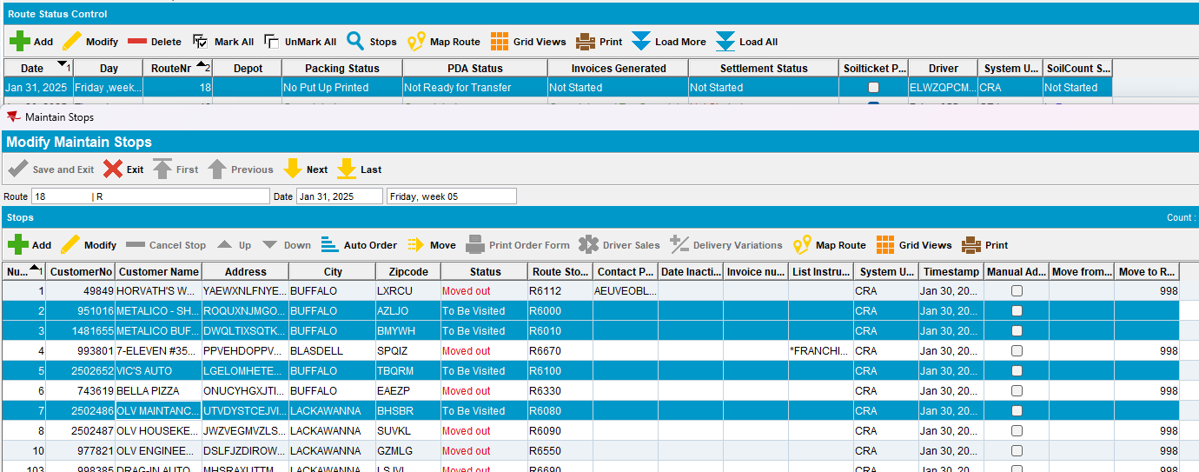
- Maintain Invoices DLG: Create a manual invoice for customer 2 (1481655)
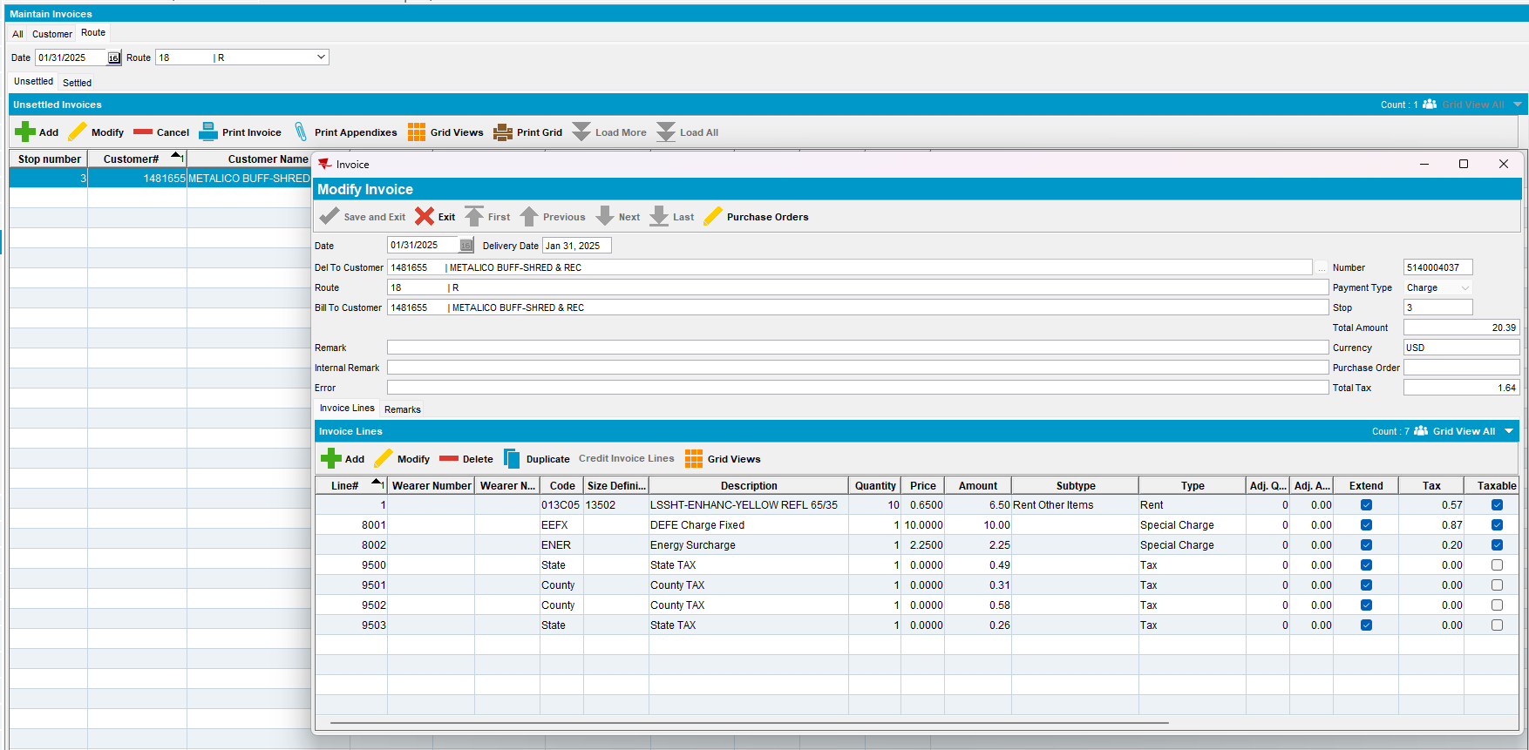
- Maintain Sales Notes DLG: Add a new Sales Note to Customer 3 (2502652)
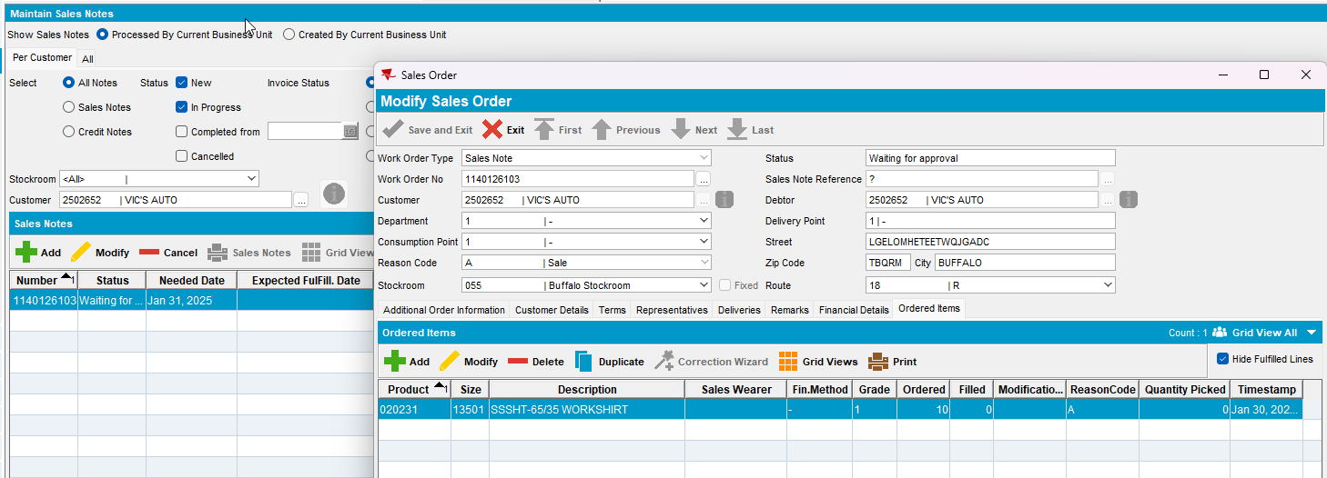
- Work Orders Waiting for approval DLG: Approve the Sales note
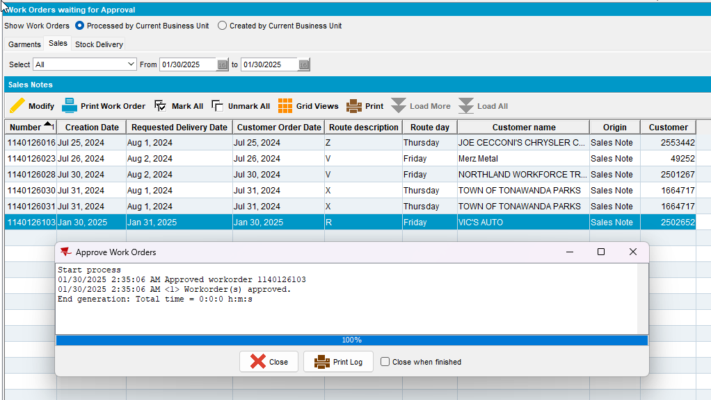
- Maintain Sales Notes DLG: Issue all items > Generate Delivery note for the date of the route at setp 1
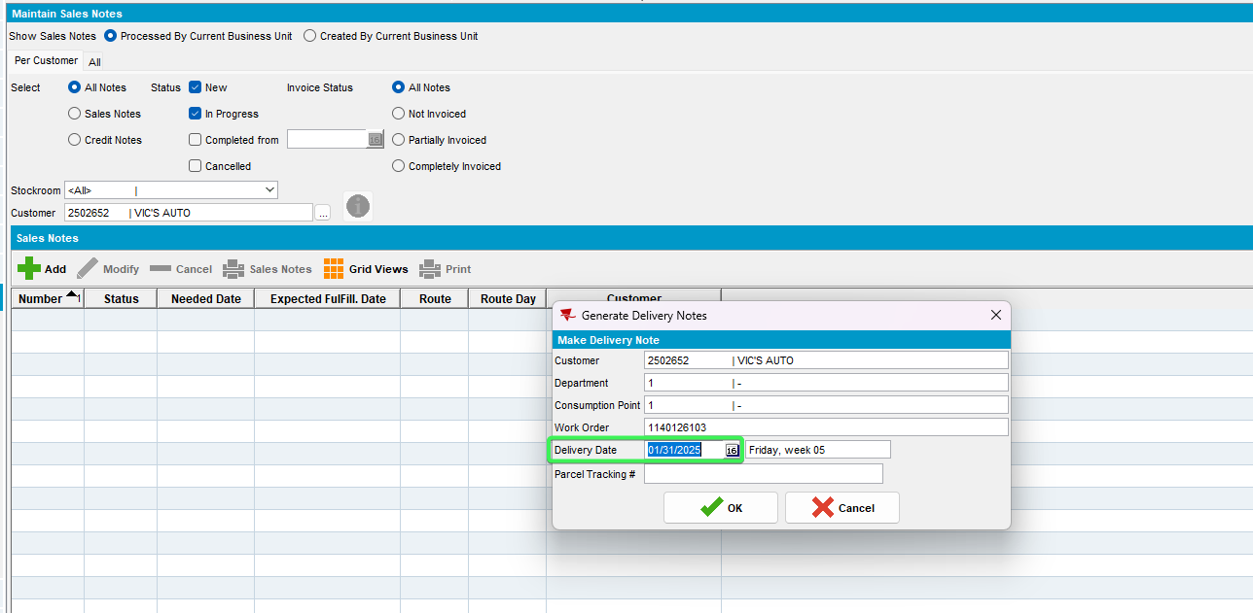
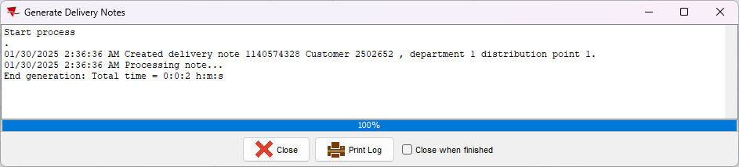
- Maintain Invoices DLG: Add a new manual invoice to Customer 4 (2502486)
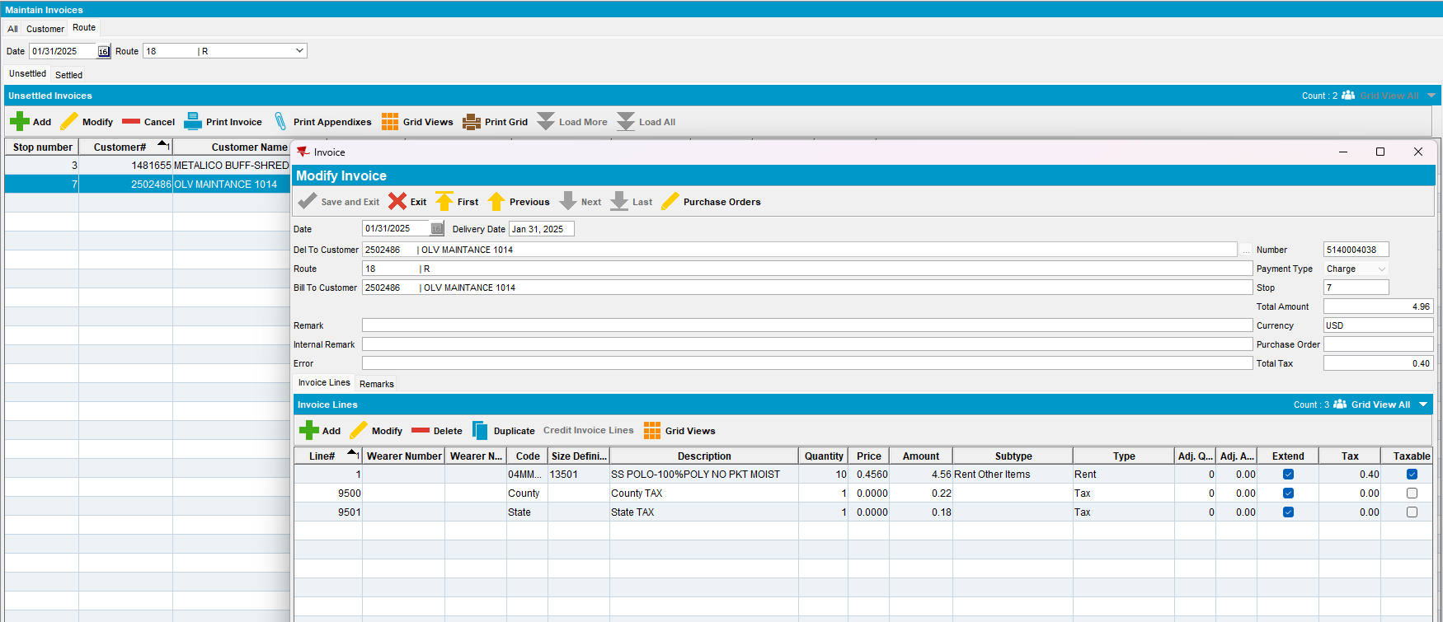
- RSC DLG: Generate Invoices for your route and script taxes
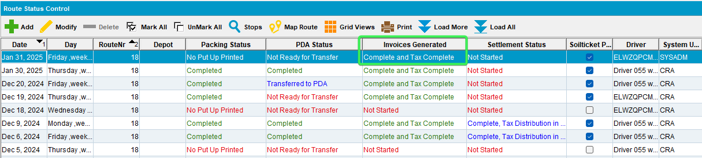
- Transfer the Route to PDA
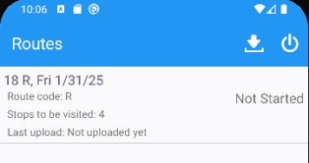
- Perform the following actions on RA:
- Customer 1 Full credit the Generated Invoice
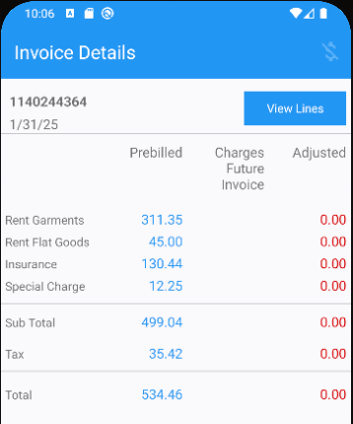
- Customer 4 Full Credit the Manual Invoice
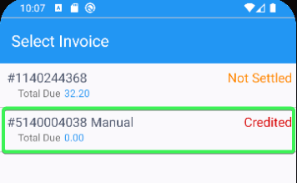

- Settle all customers on route > Depart and Upload the Data
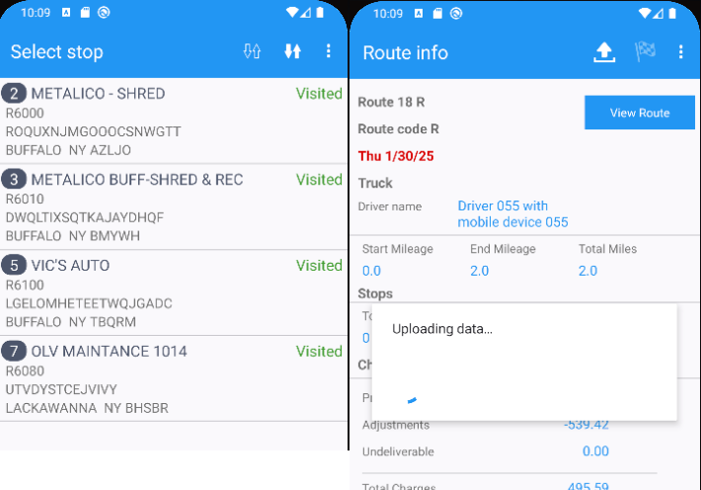

Test Case 1 – Full credit each type of invoice on WebX and check that the approve/reject checkbox is approved and disabled (customer 2 and 3)
Hash: 429b3b5a54eb
Expected Behavior: Approve / Reject checkbox remain approved and disabled after performing a full credit on WebX
And the “Adjust All to 0” button changes label to Remove Full Credit and vice versa.
- WebX: Find your route and complete start my day
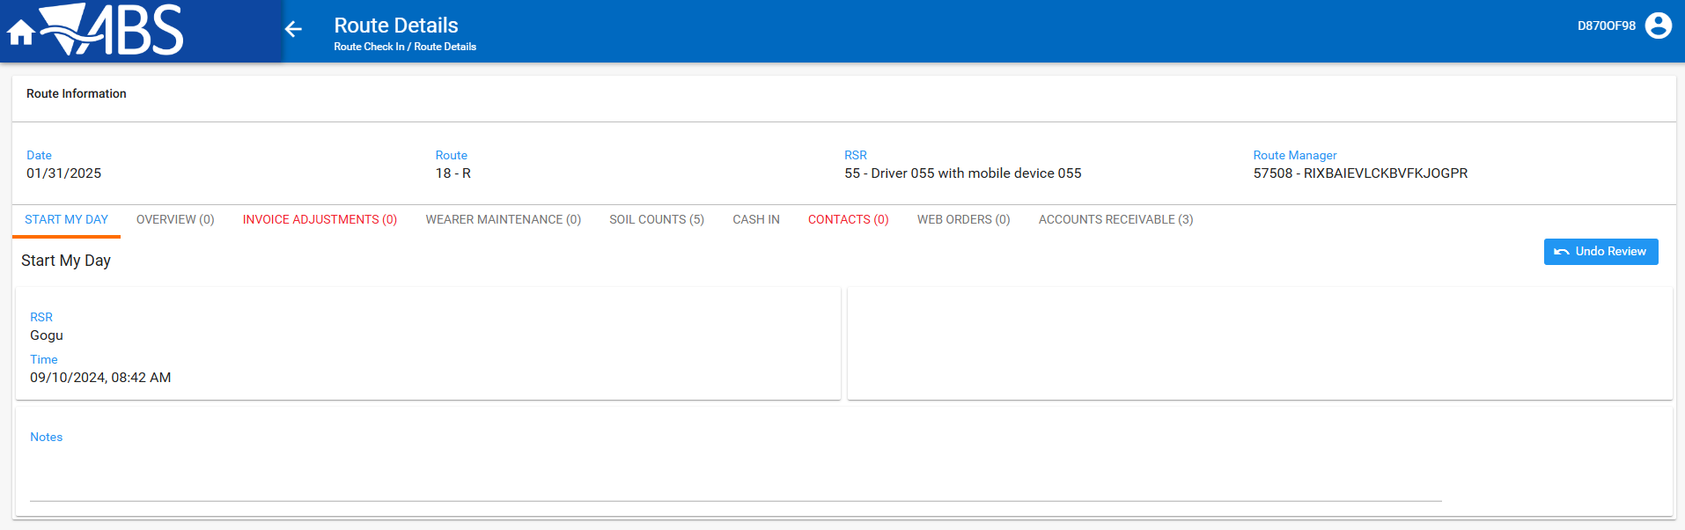
- Invoice adjustments Tab: press Add button for Customer’s 2 Generated and Manual invoice > Full credit the invoice by pressing Adjust All to 0 button
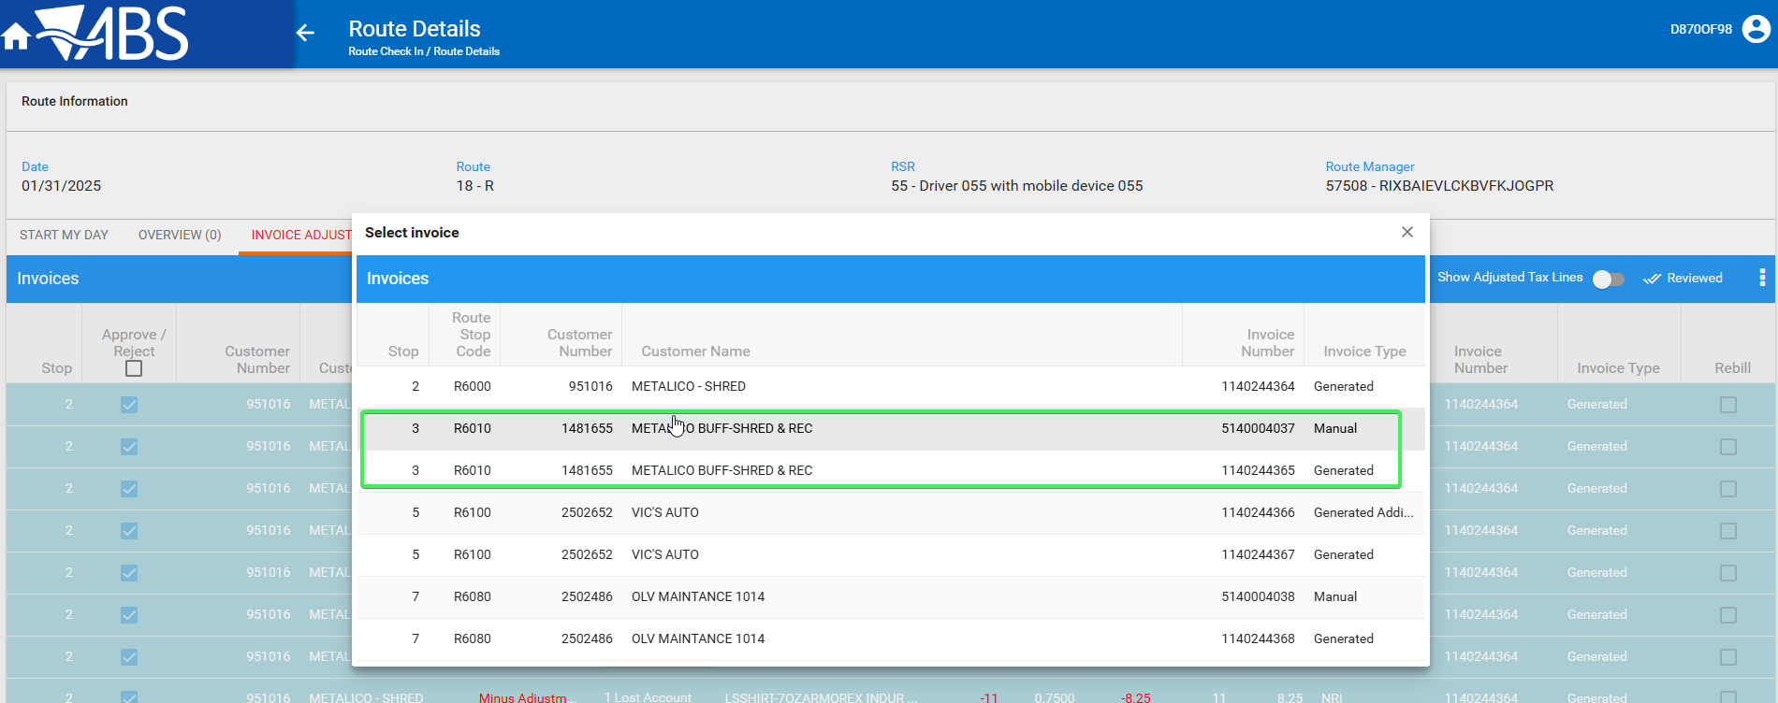
- Check that the Minus adjustments have been made and that the Approve / Reject check box is Approved and Disabled
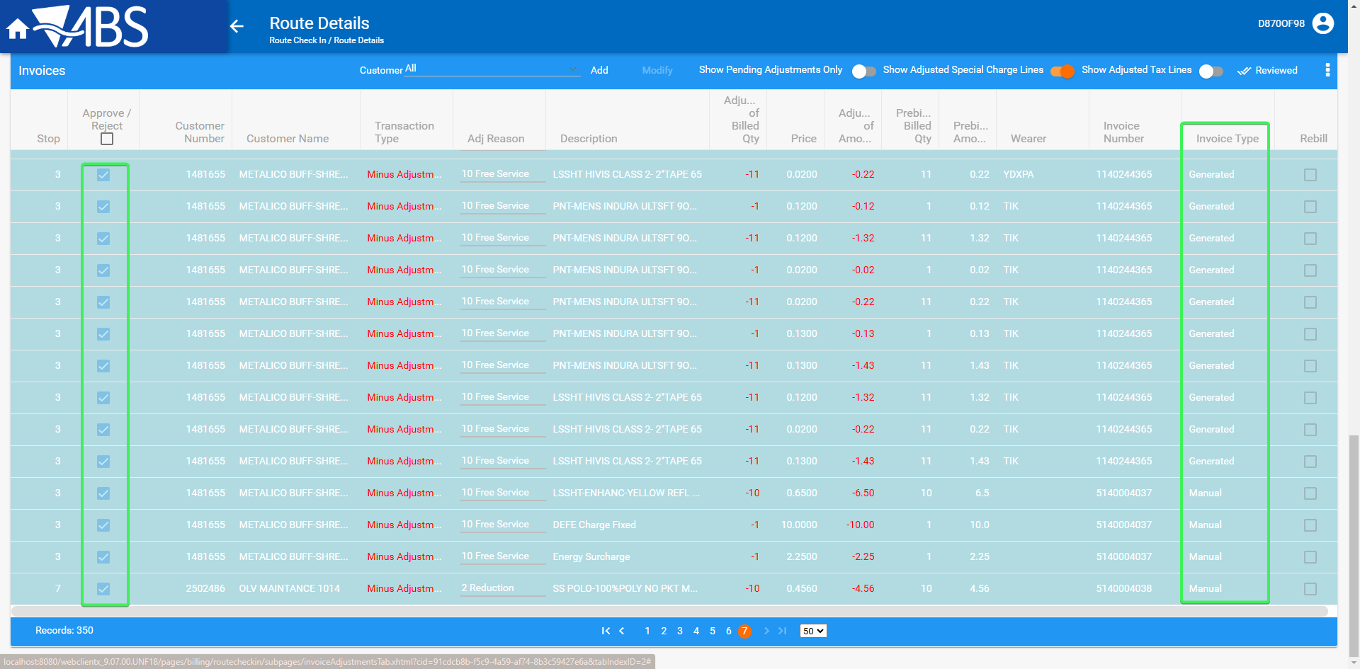
- Press Add button again and remove the full credit for both invoices
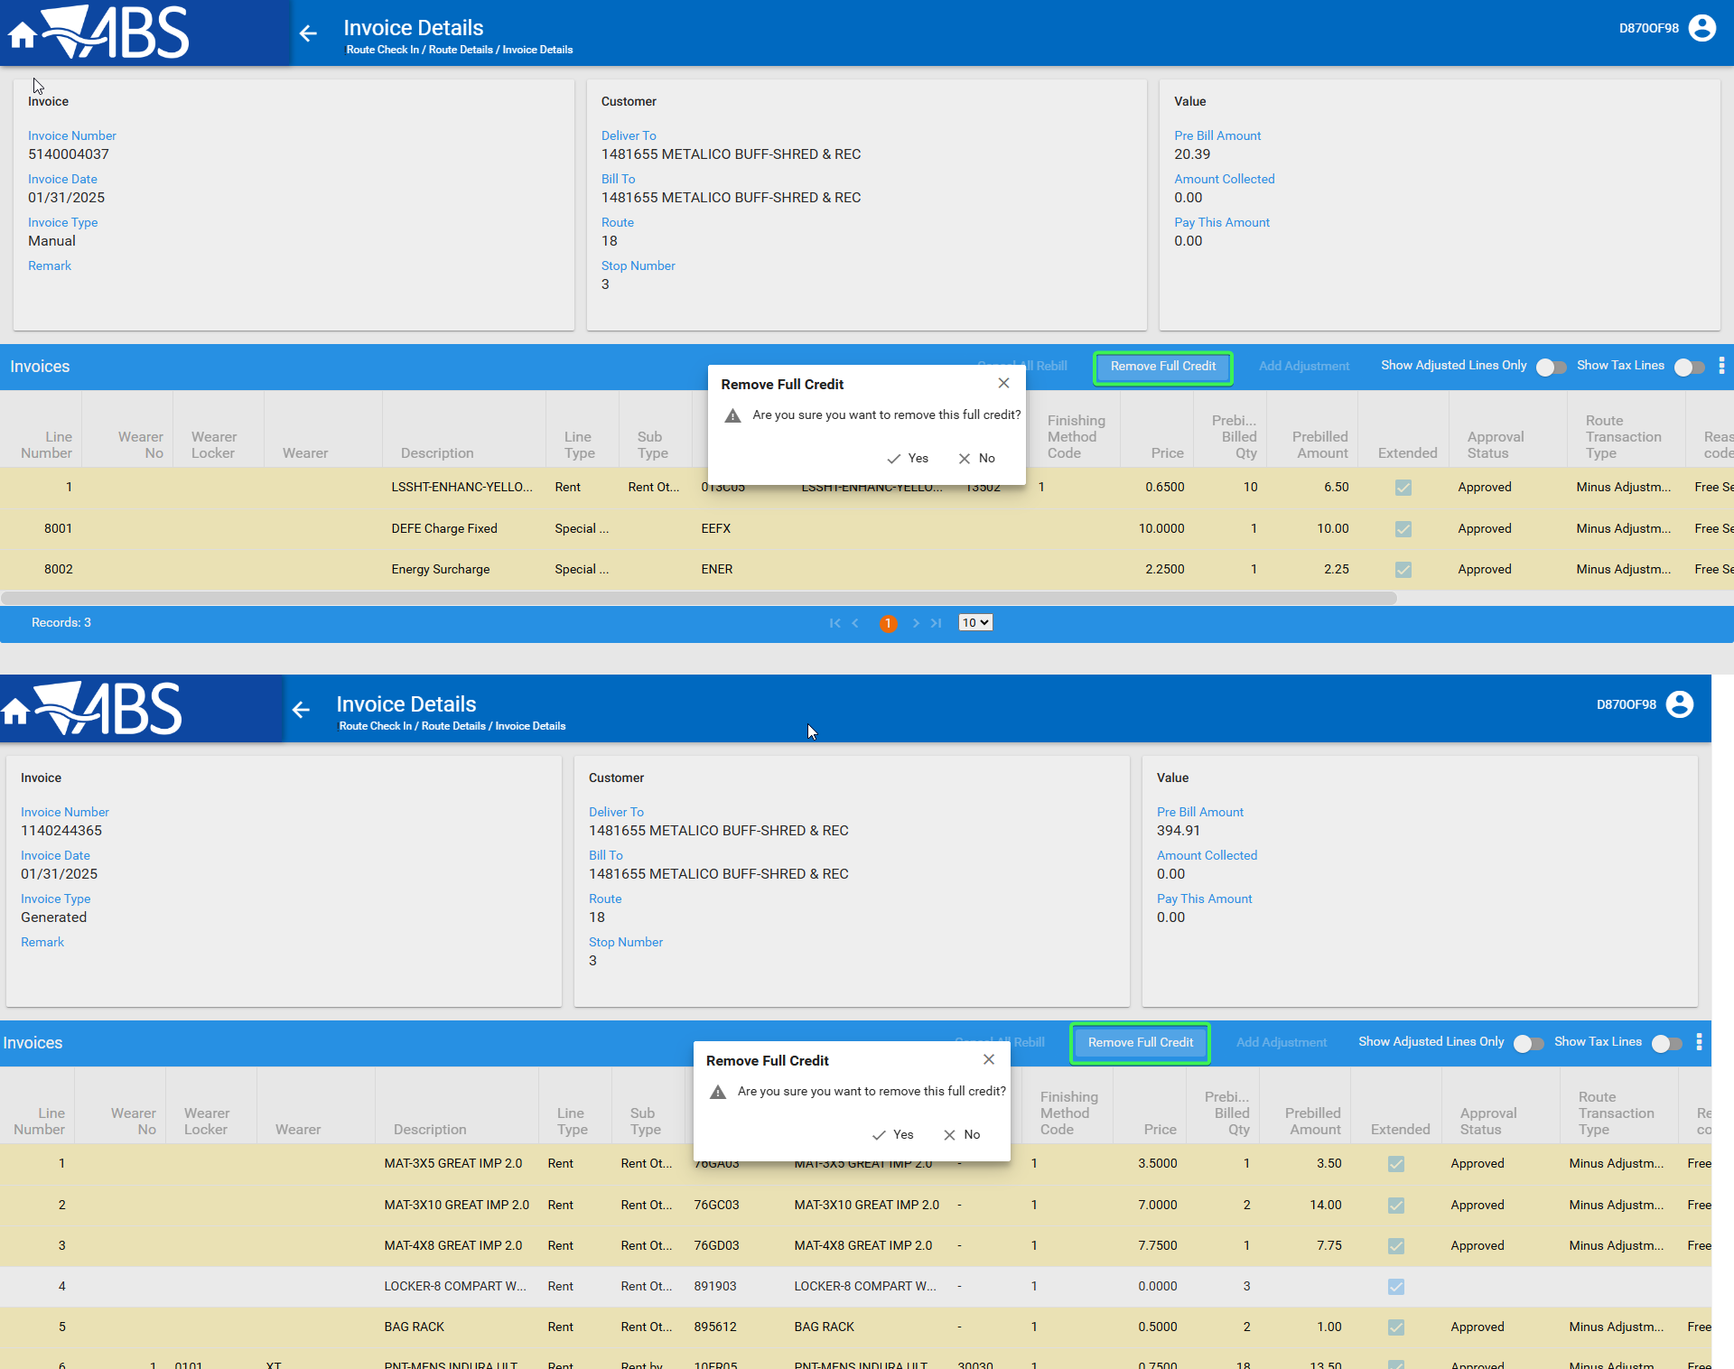
- Check that all invoice adjustments for Customer 2 are no longer present in the Invoice adjustments tab
Customer 2 is no longer present in the Invoice adjustments tab
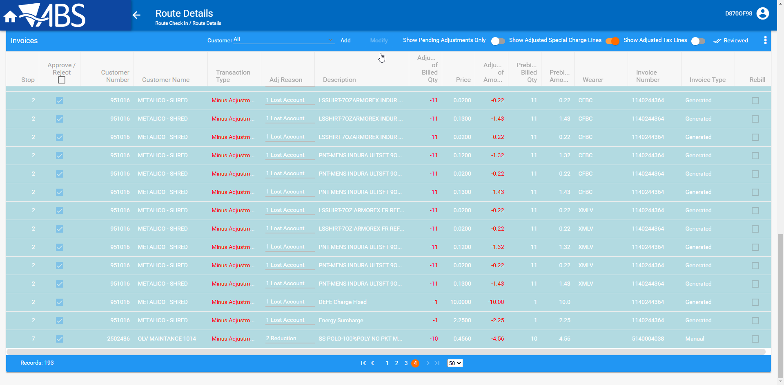

- Press Add button and for Customer 3 Generated Invoice and Generated Additional > Full credit the invoices by pressing Adjust All to 0 button
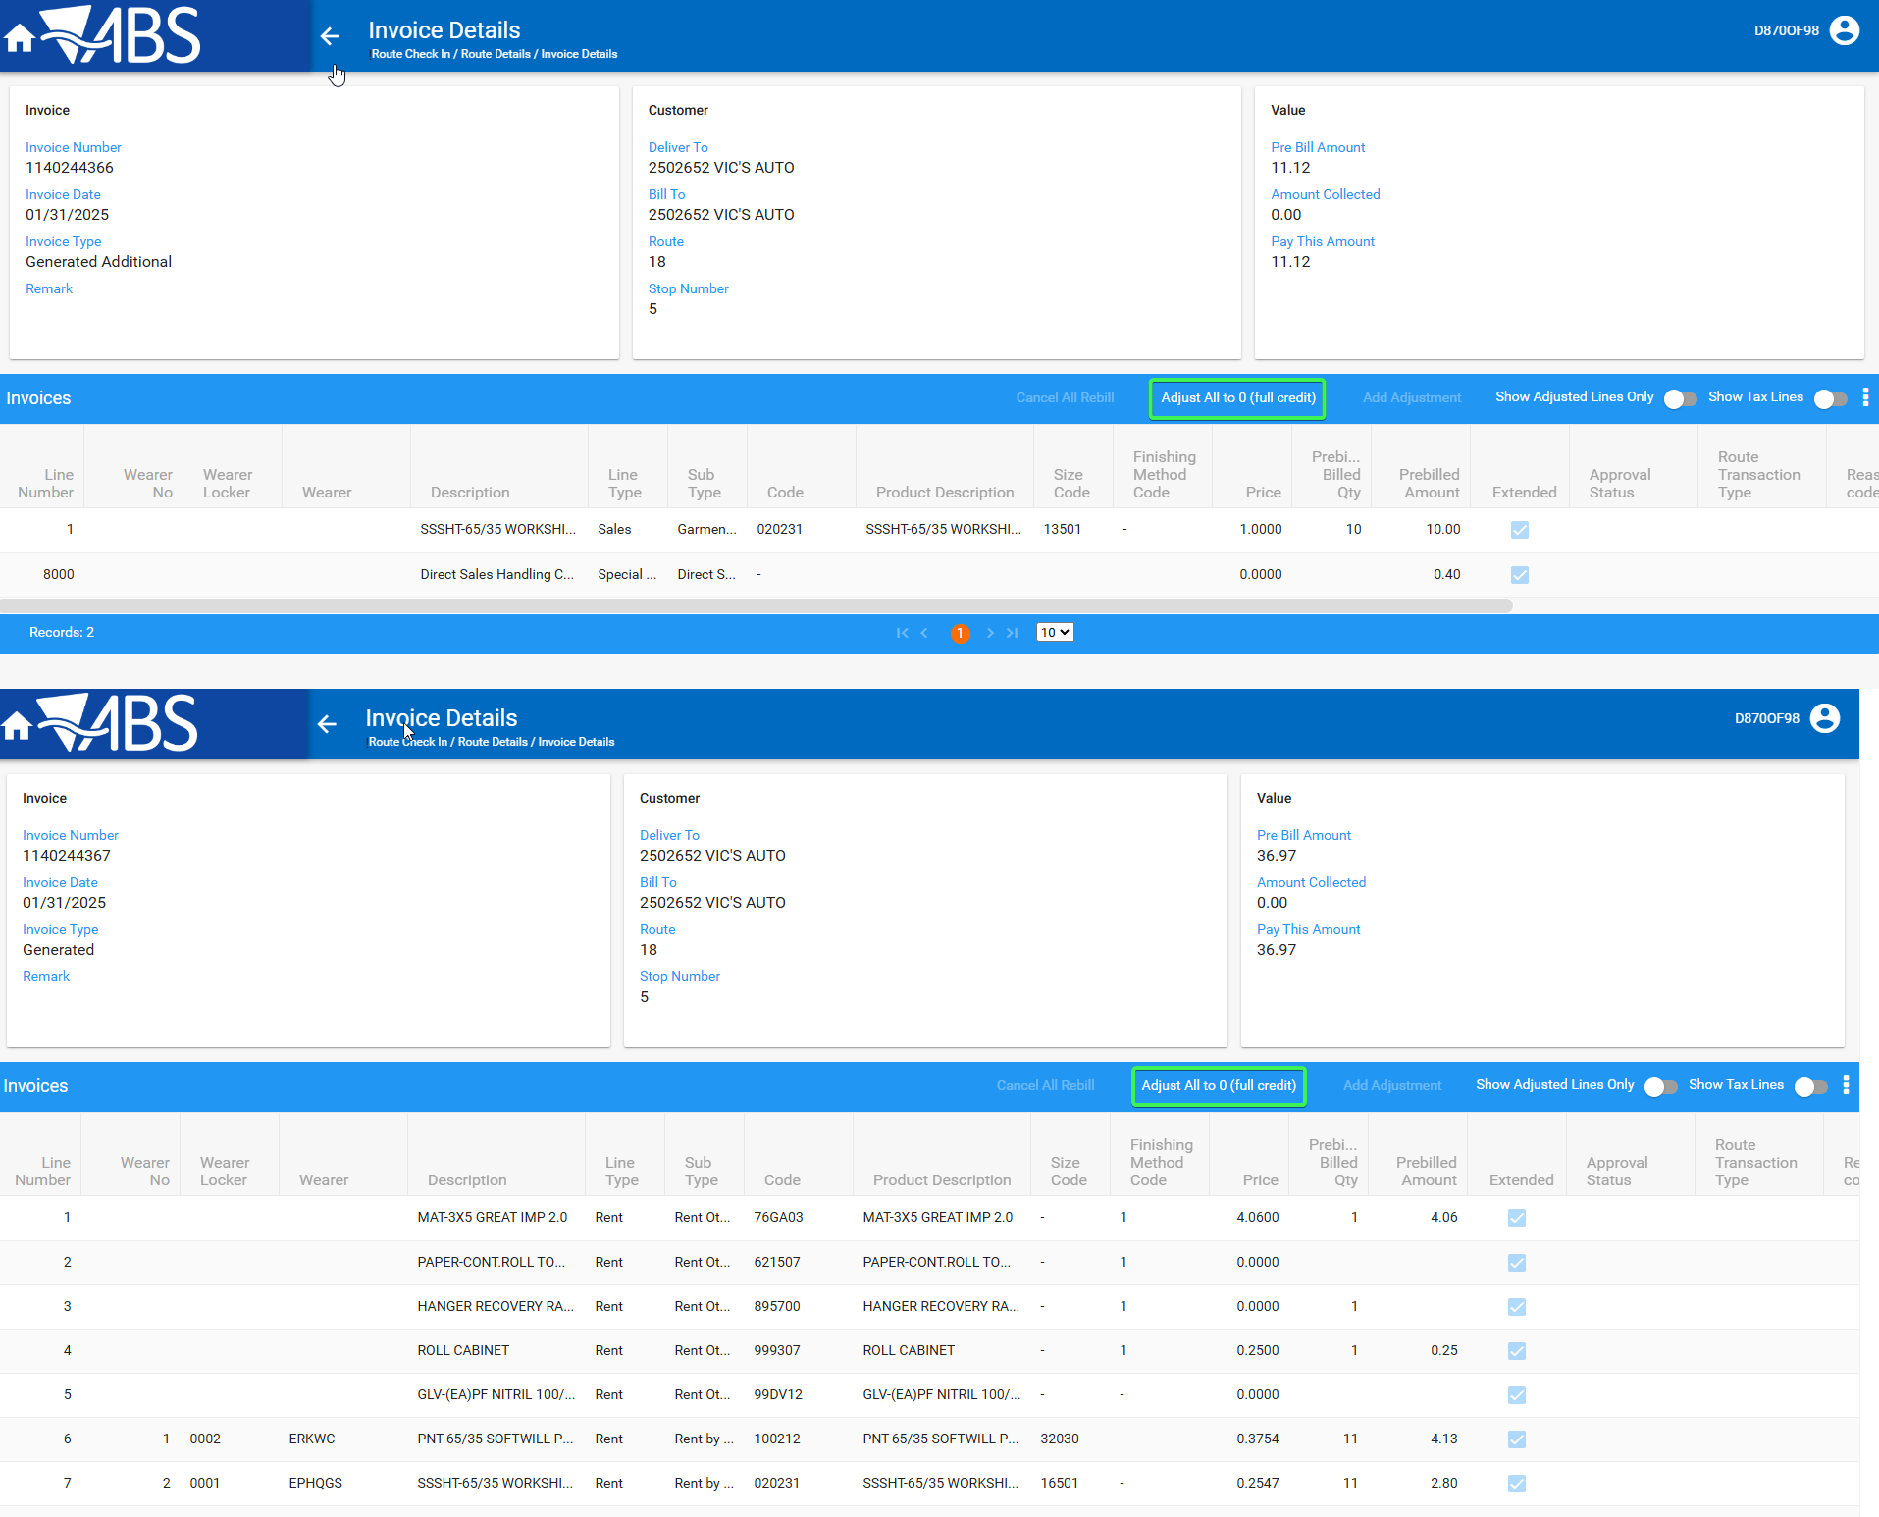
- Check that the Minus adjustments have been made and that the Approve / Reject check box is Approved and Disabled
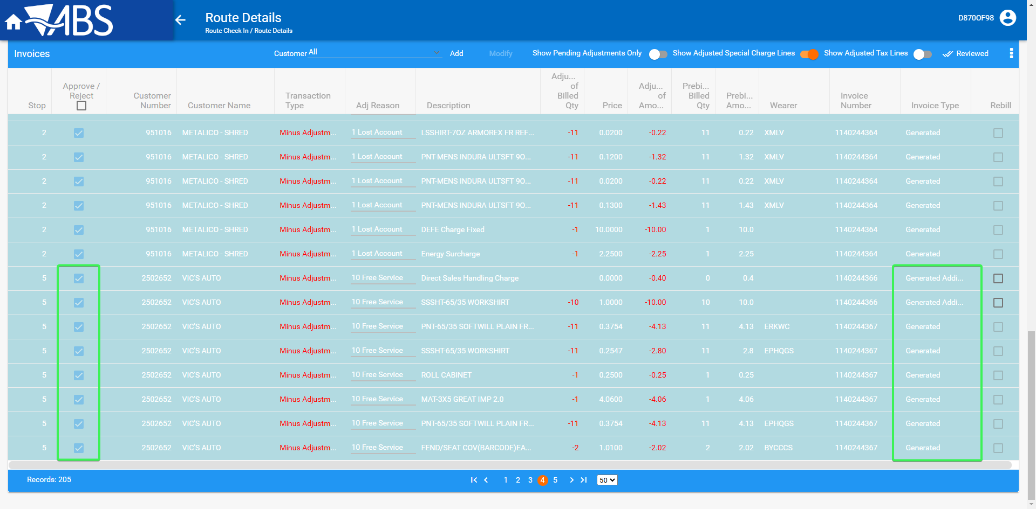
- Press Add button again and remove the full credit for Customer’s 3 invoices
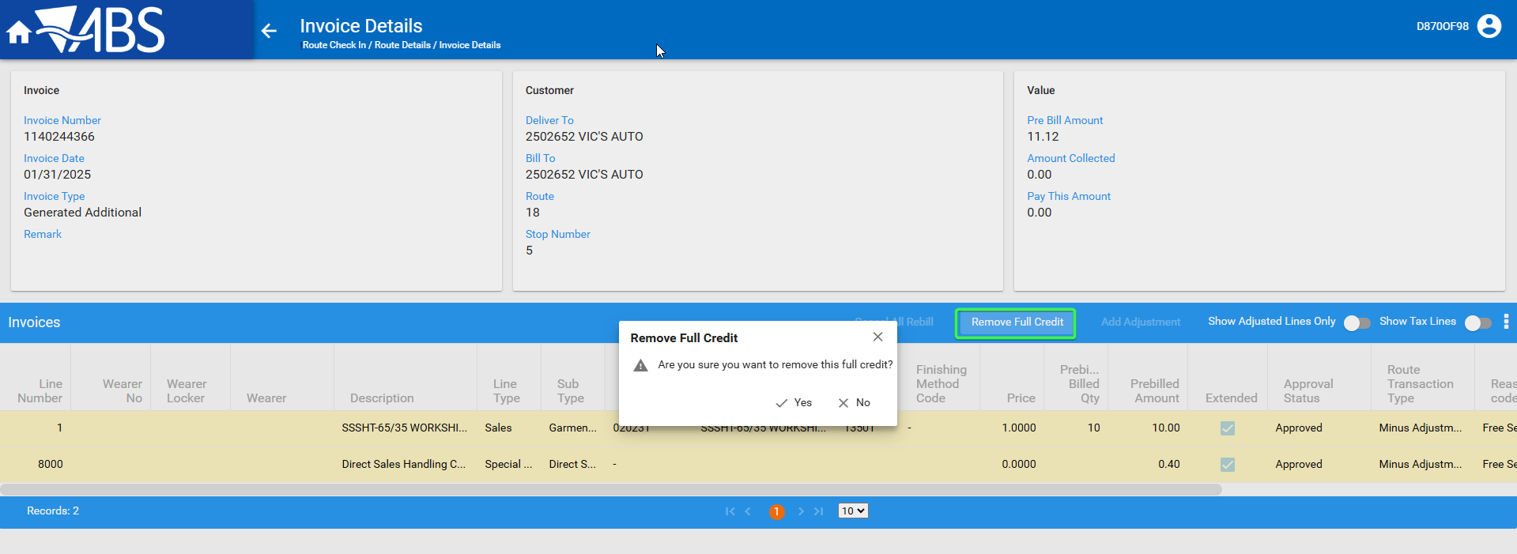
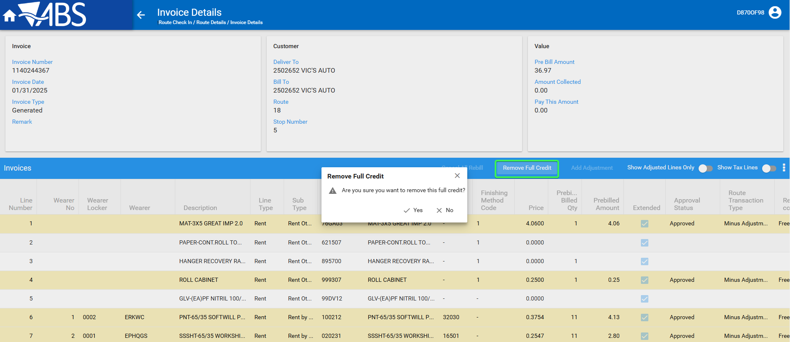

- Check that all invoice adjustments for Customer 3 are no longer present in the Invoice adjustments tab
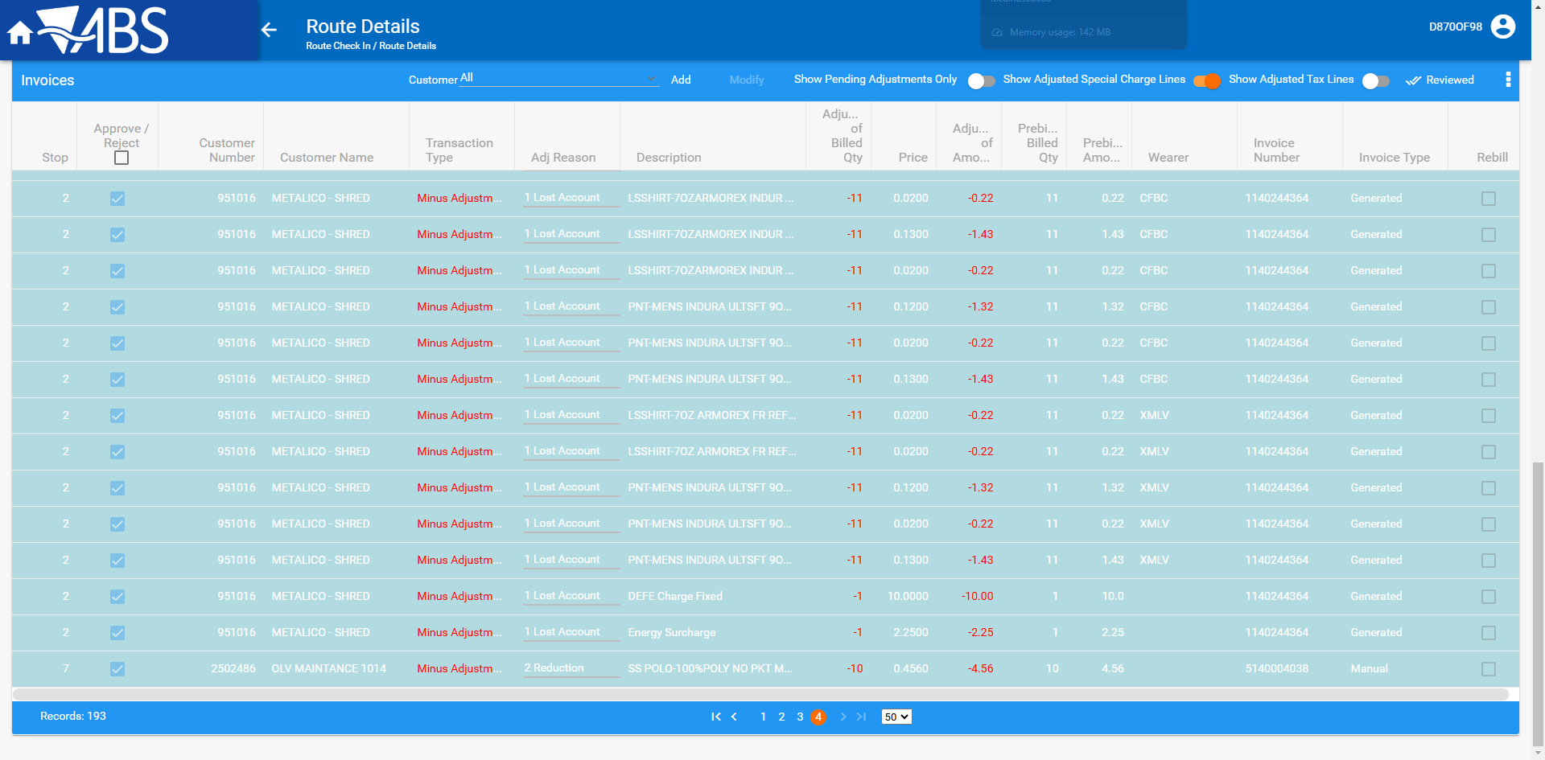
- Check that the button for all transaction types has switched its label back to “Adjust All to 0 (full credit)”
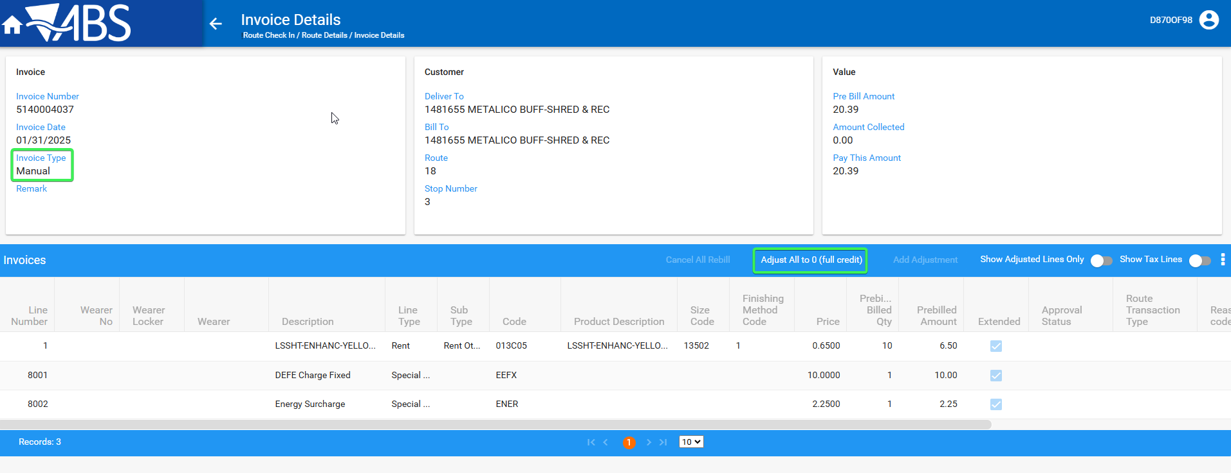
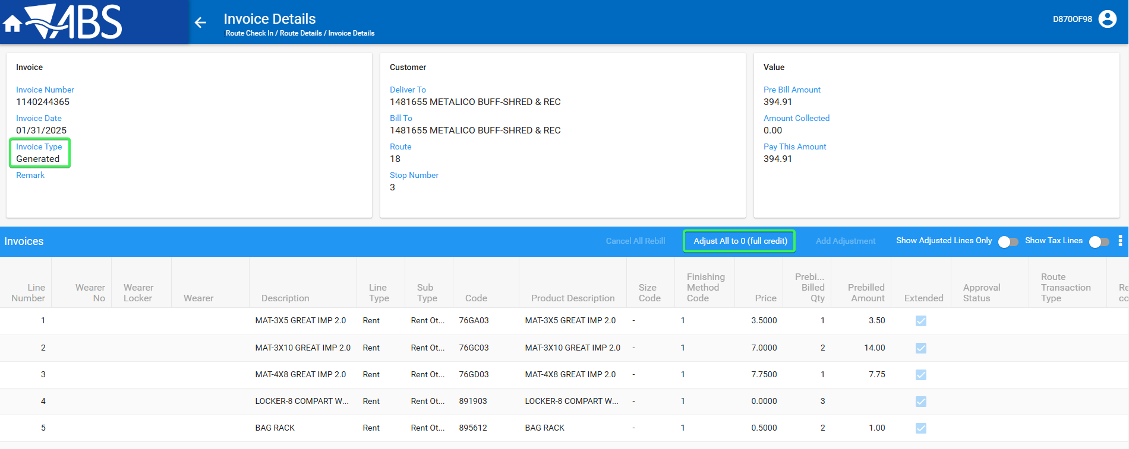
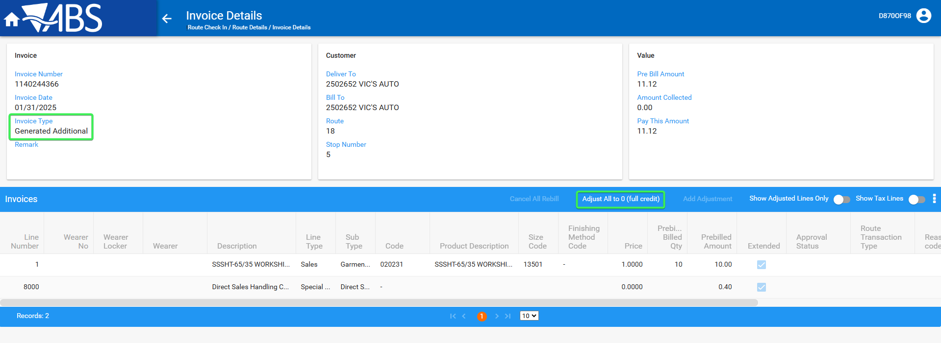
Tested OK

Test Case 2 – INVOICELINEADJVALUERULE = 1 and INVOICELINEADJMODIFYRULE = 2
Hash: 429b3b5a54eb
Expected Behavior: “Remove Full Credit” is only enabled if the full invoice credit was created in WebX route check in (RT.MobileDevice_ID is NULL)
When pressed show a popup “Are you sure you want to remove the full credit”
The “Remove Full Credit” button is shown and NOT enabled for any of the invoices that were fully credited on RA (Customer 1 and Customer 4)

- System Settings DLG: Have SS INVOICELINEADJVALUERULE = 1 and INVOICELINEADJMODIFYRULE = 2
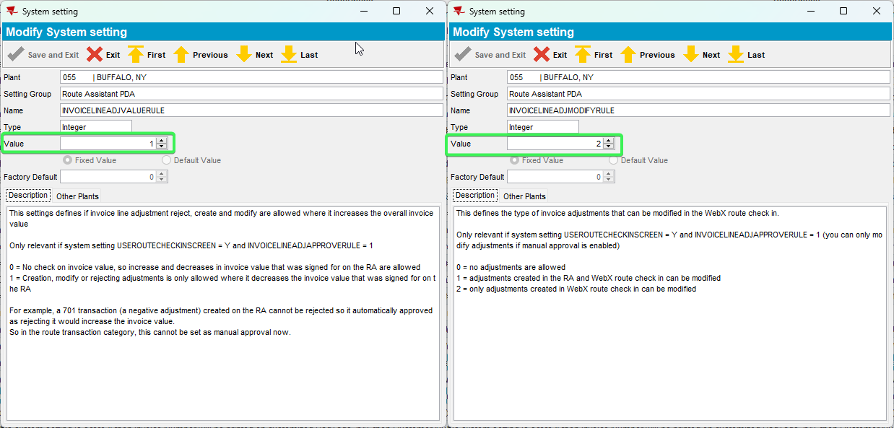
- WebX: Find the route made in Data preparation
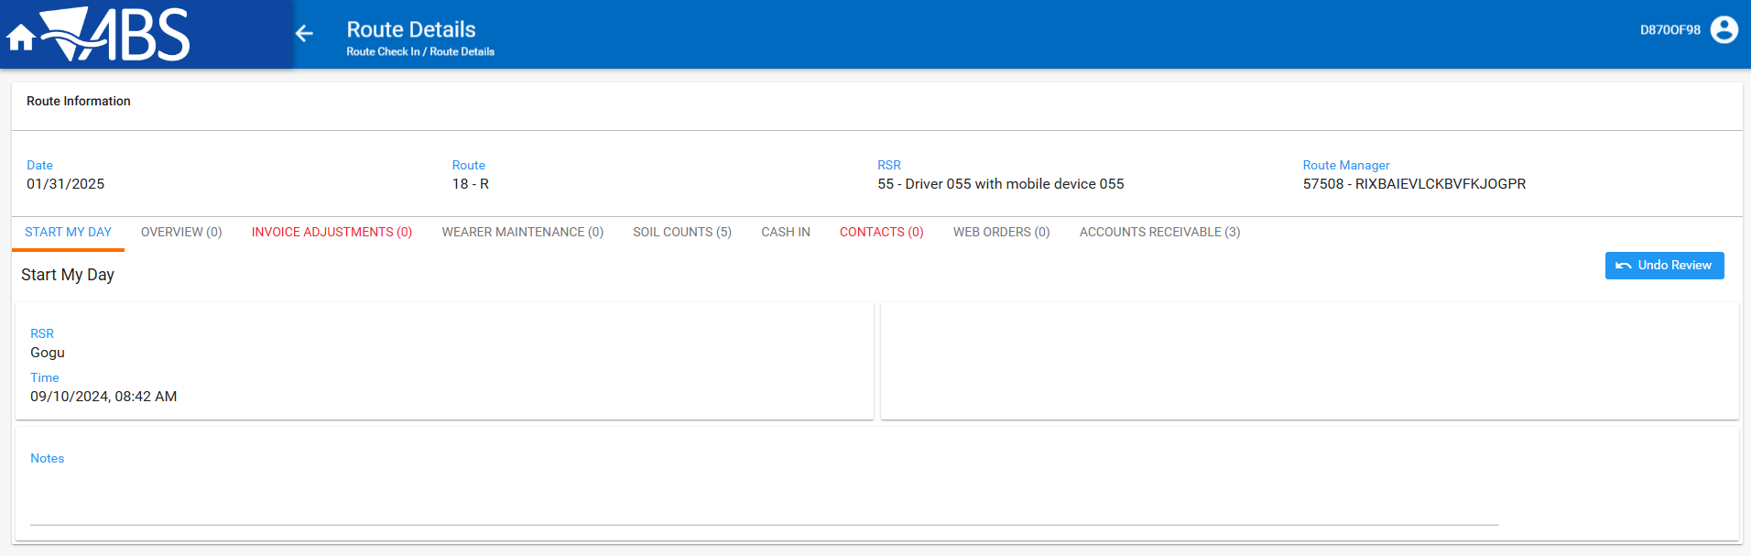
- Invoice Adjustments tab: Press Add button and for customers 2 and 3 > perform full credit of their invoices Generated, Manual and Generated Additional
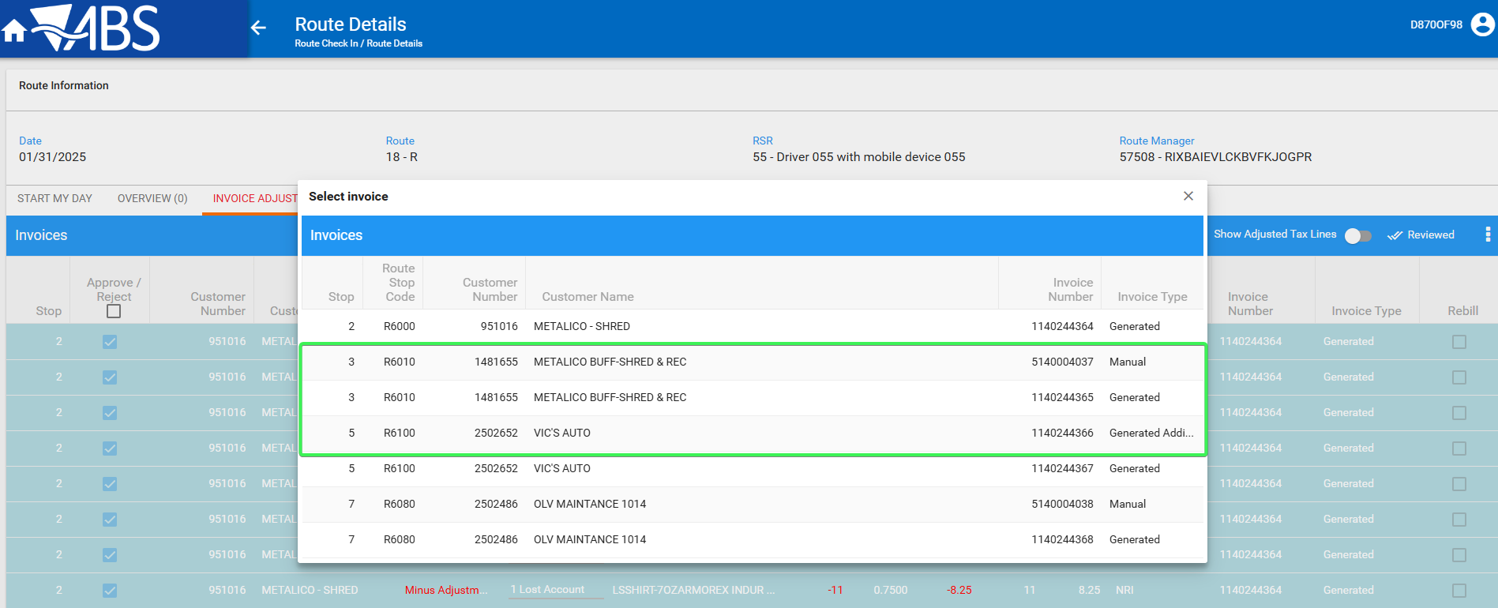

- Check that for each of the invoice type the “Adjust All to 0 (full credit)” button label has changed in to “Remove Full Credit” and when pressed you get a message asking you if you want to remove the Full Credit
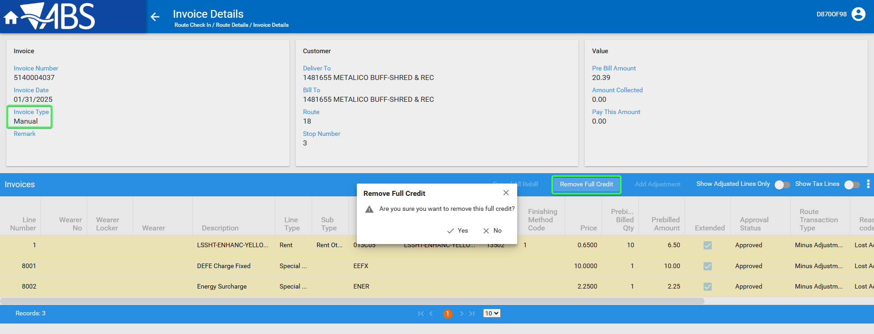
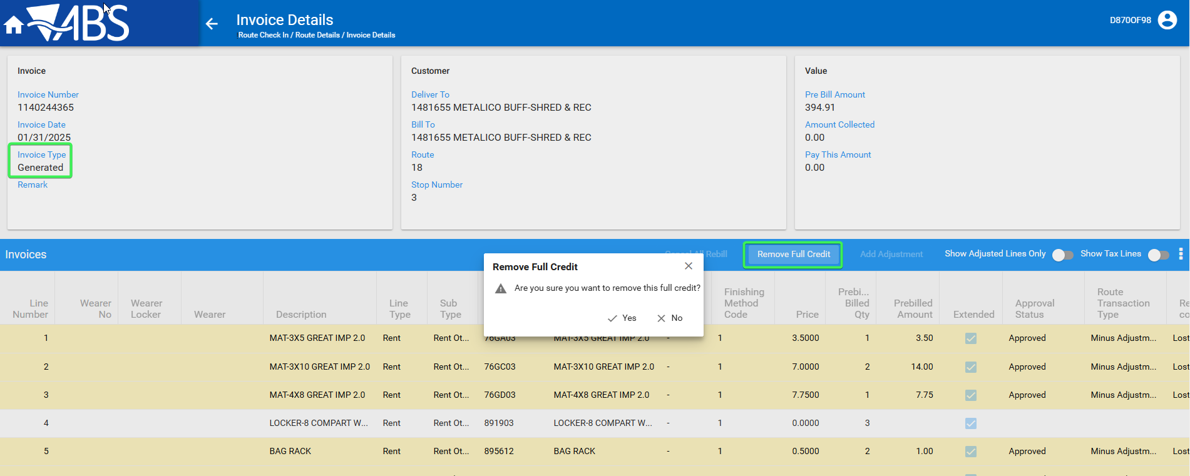
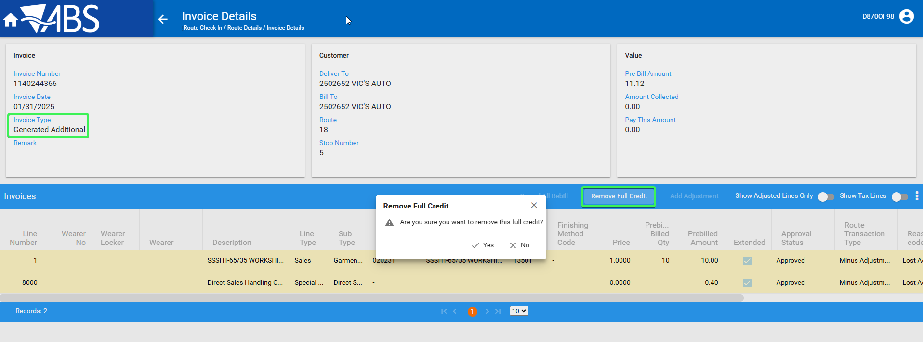
- Press Add button again and check that for customers 1 and 4 the button label is “Remove Full Credit” and is disabled
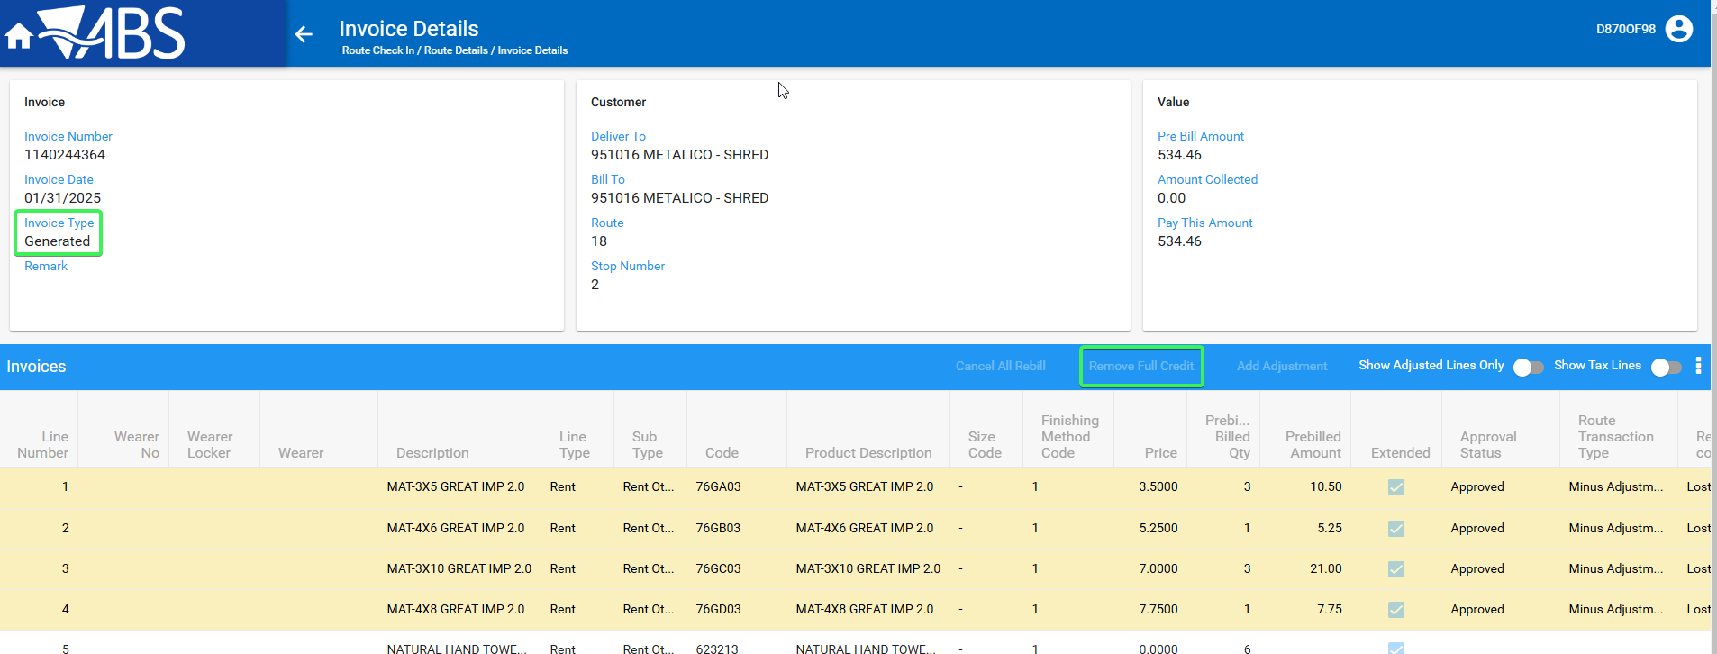

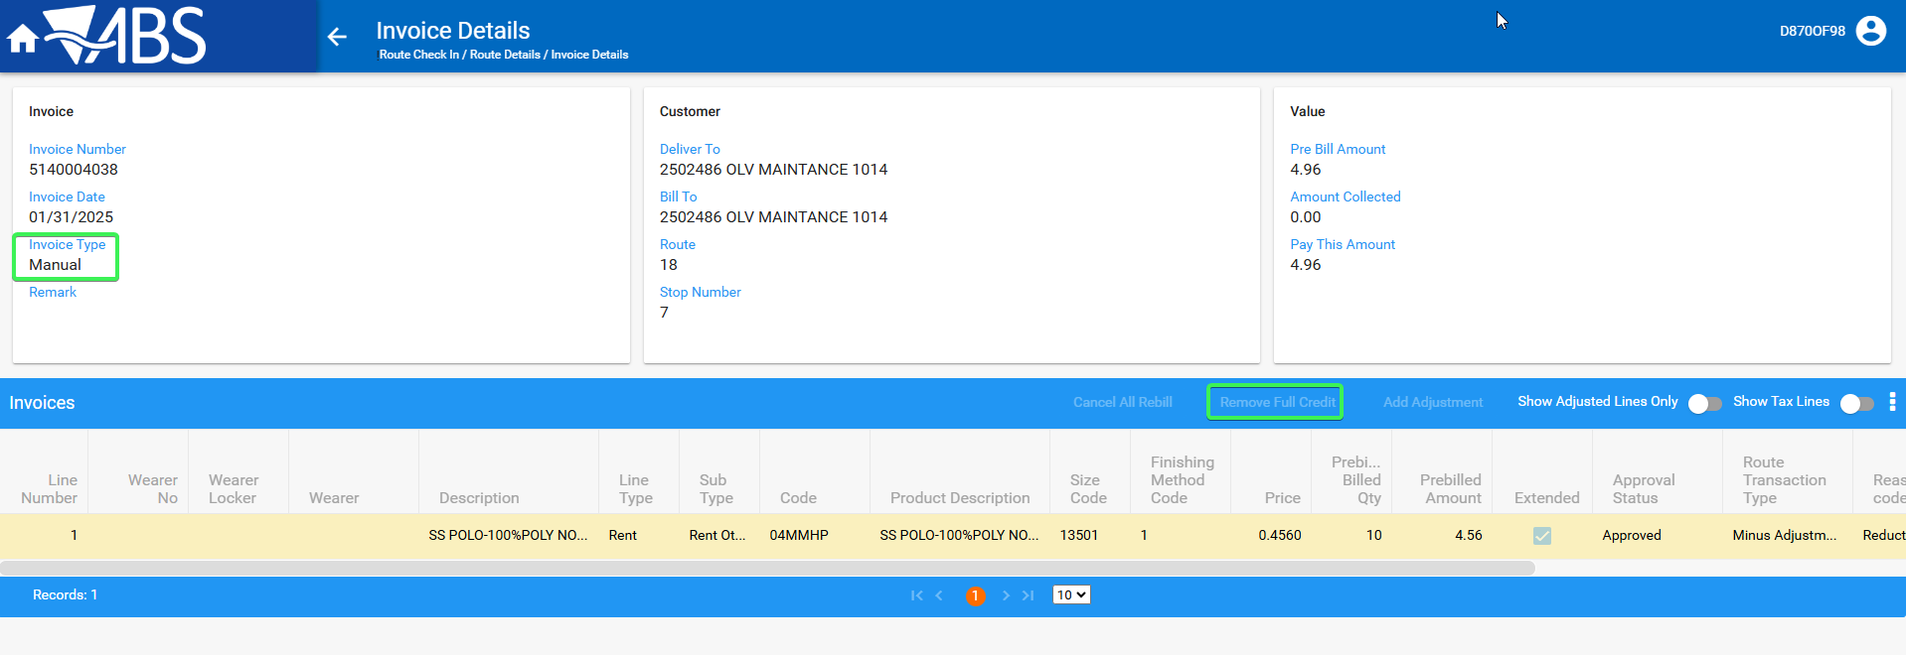
Tested OK

Test Case 3 – Full credit invoices on WebX and then cancel the full credit and then settle and check the ARTransaction was created. Cancel the full credit for all invoices on Customer 3 and on Customer 2 leave the full credit for the Generated invoice
Hash: 429b3b5a54eb
Expected Behavior: Only the invoices that were left as full credit from RA or WebX should have NULL in the ARTRANSACTION_ID column all the others should have a value there
SELECT C.CUSTOMERNUMBER, IH.INVOICENUMBER, IH.PAYTHISAMOUNT, AR.ARTRANSACTION_ID, COUNT(RT.ROUTETRANSACTION_ID) FROM INVOICEHEADER IH
JOIN ROUTETRANSACTION RT ON RT.INVOICEHEADER_ID = IH.INVOICEHEADER_ID
JOIN CUSTOMER C ON C.CUSTOMER_ID = IH.DELTOCUSTOMER_LINK_ID
LEFT JOIN ARTRANSACTION AR ON AR.INVOICEHEADER_ID = IH.INVOICEHEADER_ID
WHERE RT.ROUTETRANSACTIONTYPE_ID = 701
AND IH.ROUTECONTROL_ID = (select rc.routecontrol_id
from routecontrol rc
join route r
on r.route_id = rc.route_id
join plant p
on p.plant_id = r.plant_id
where rc.drivingdate = to_date('21/01/2025', 'dd/mm/yyyy')
and r.routenumber = 24
and p.code = '055')
GROUP BY C.CUSTOMERNUMBER, IH.INVOICENUMBER, IH.PAYTHISAMOUNT, AR.ARTRANSACTION_ID;

- WebX: Find the route created in Data Preparation
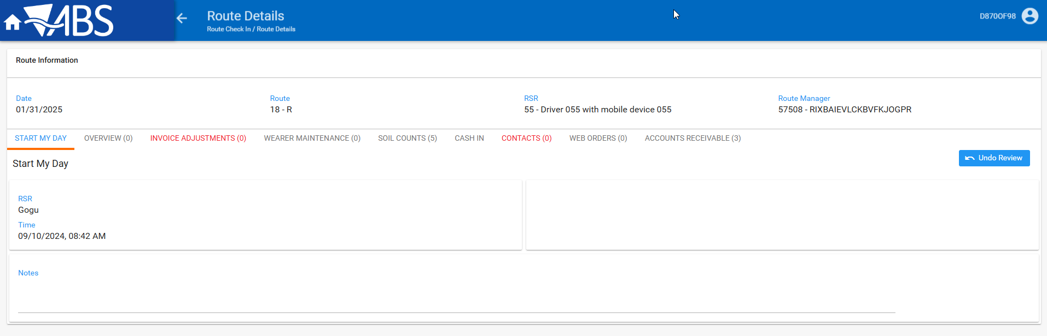
- Invoice Adjustments tab: Press the add button and Full credit all the Invoice types for all customers
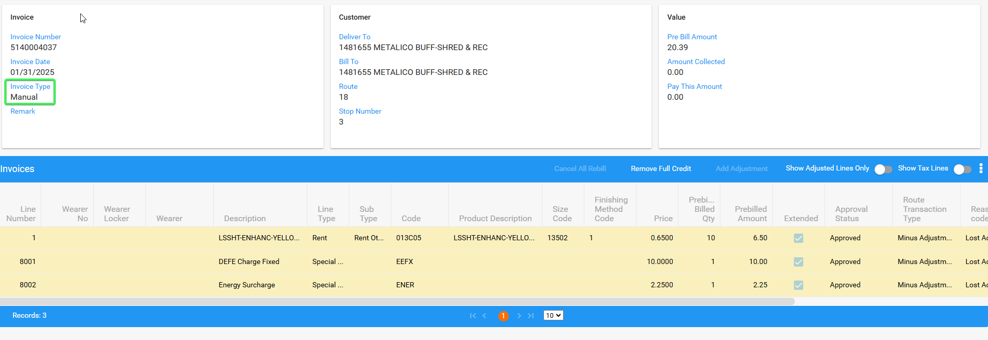
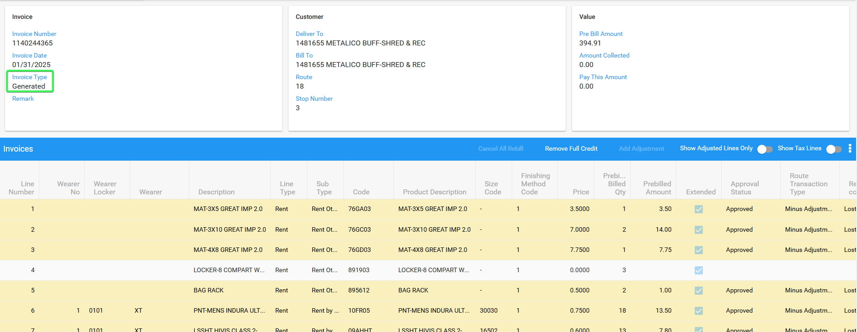
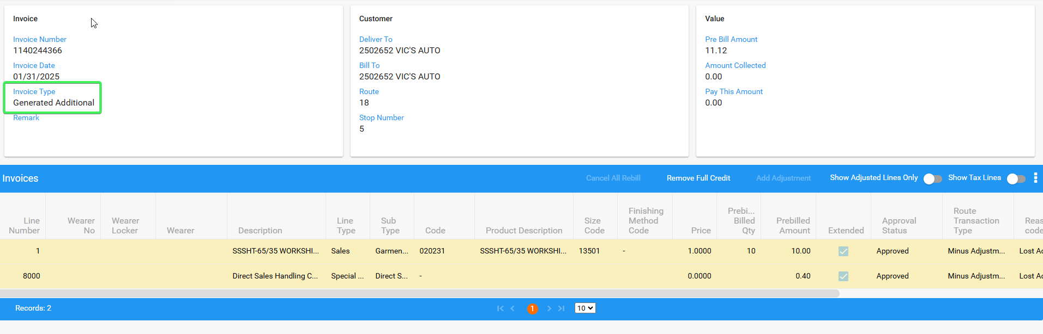
- Cancel the full credit for all invoices on Customer 3 and on Customer 2 leave the full credit for the Generated invoice (Customer 4)
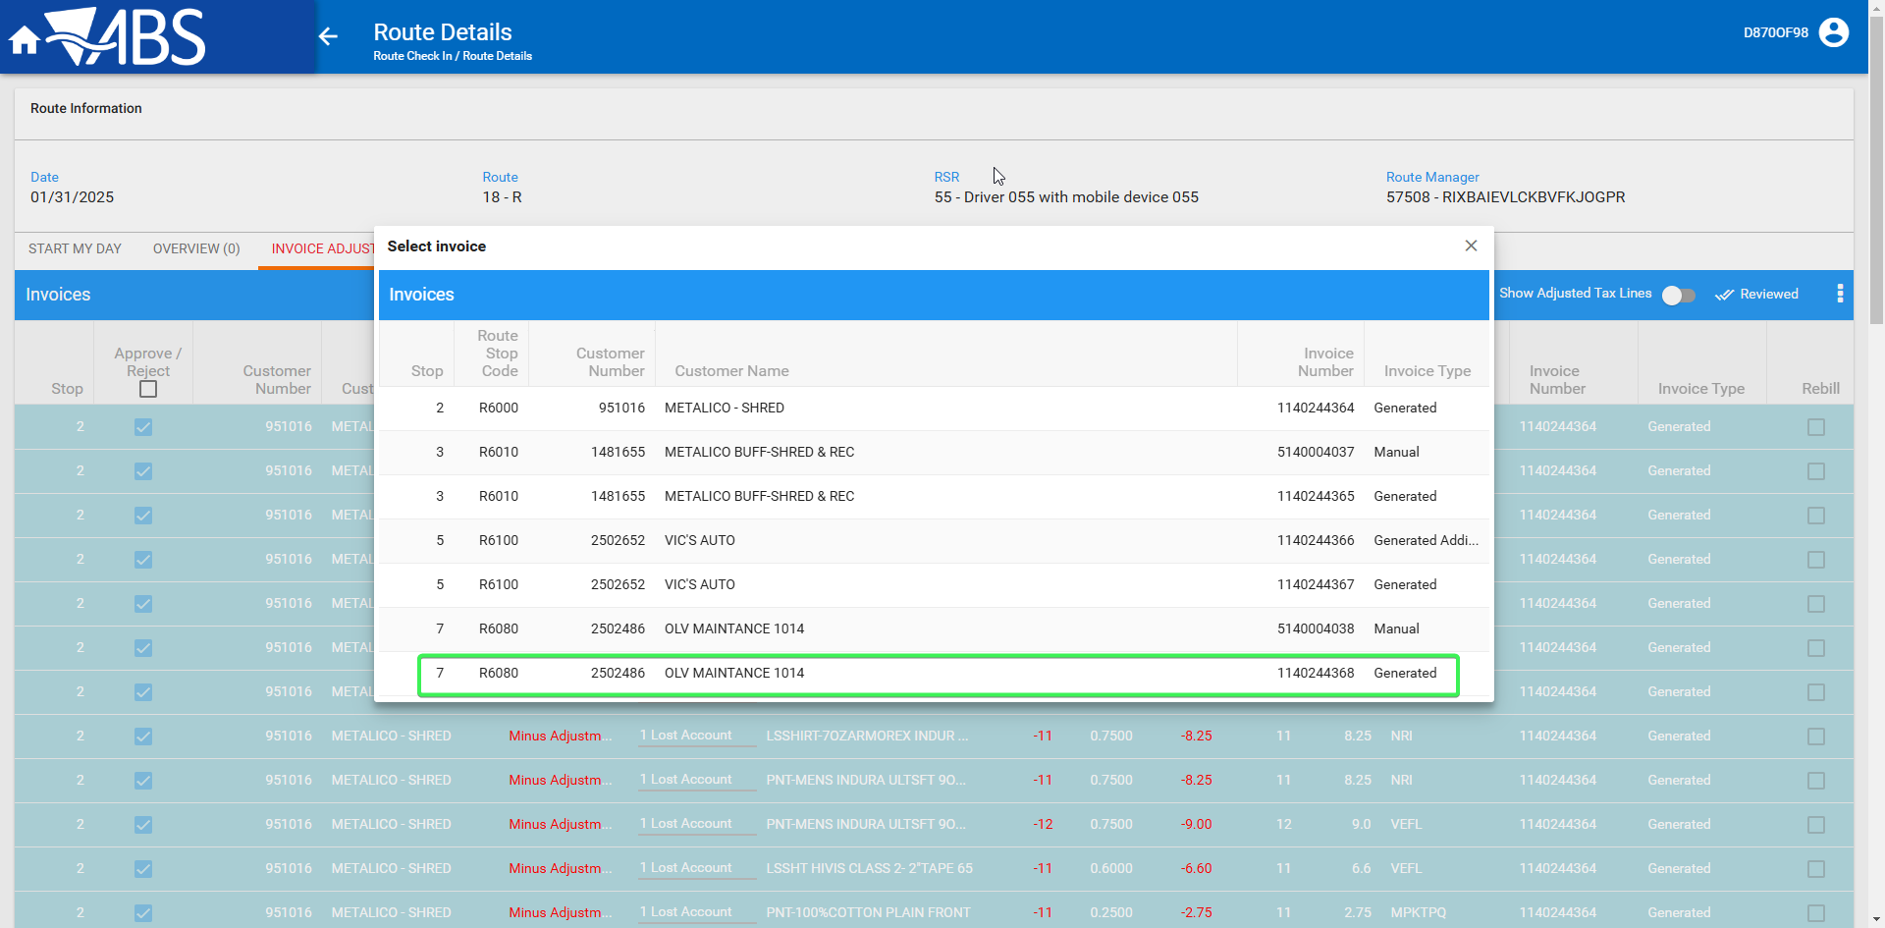
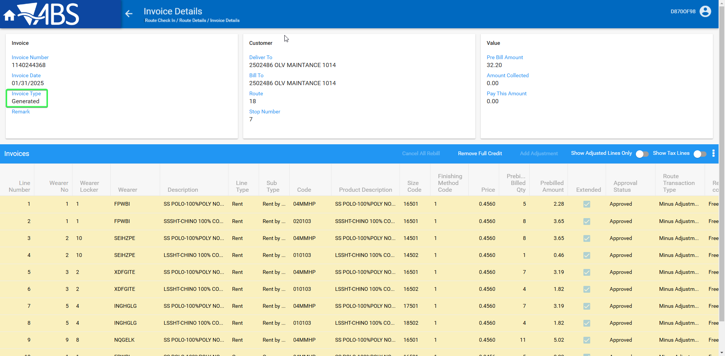
- Review all the tabs of the invoice
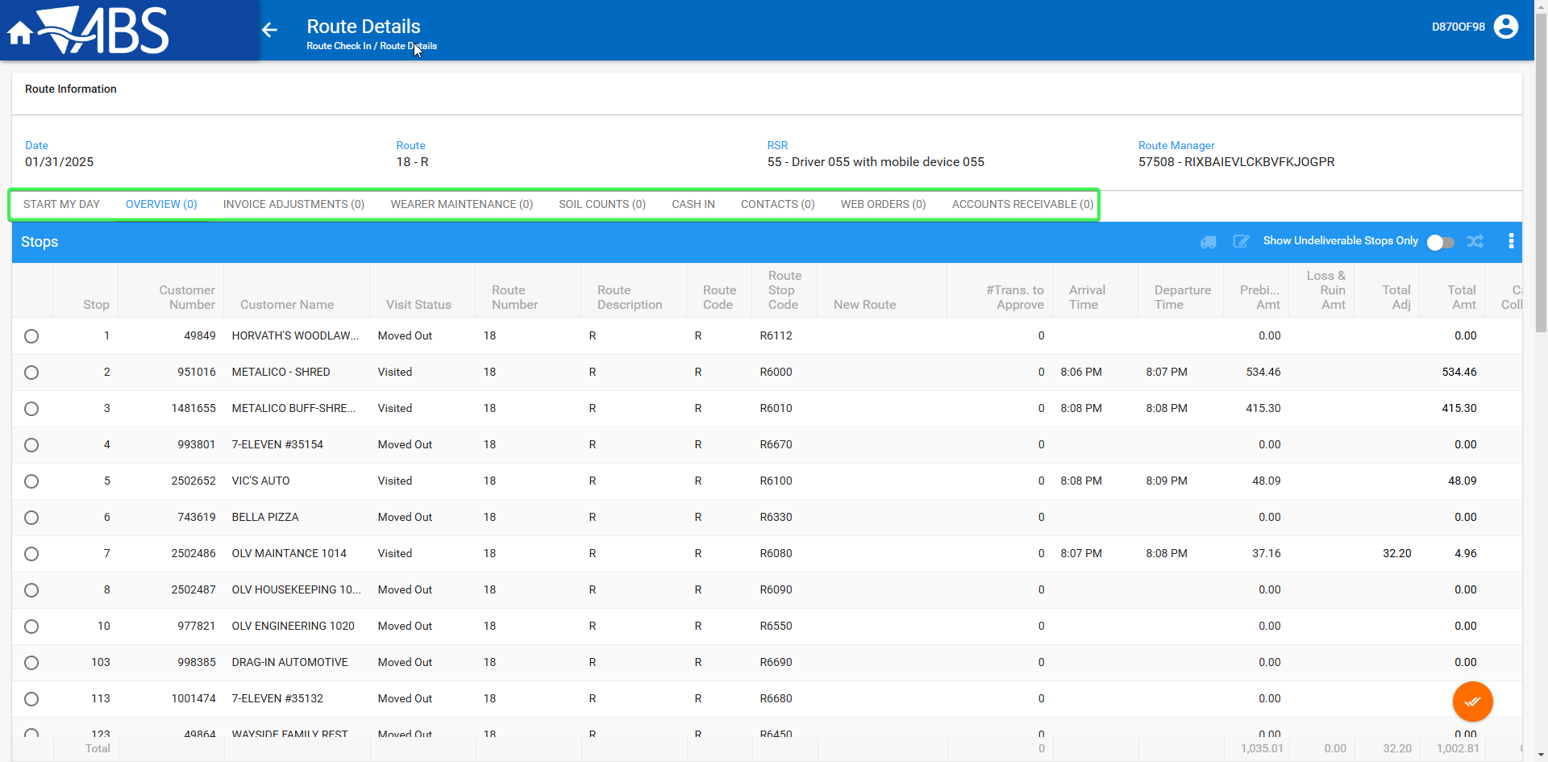
- Settle the Route
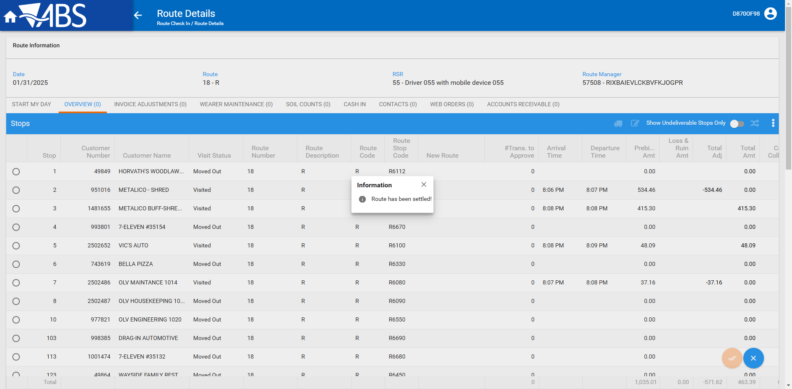
- Check that Only the invoices that were left as full credit from RA or WebX should have NULL in the ARTRANSACTION_ID column all the others should have a value there
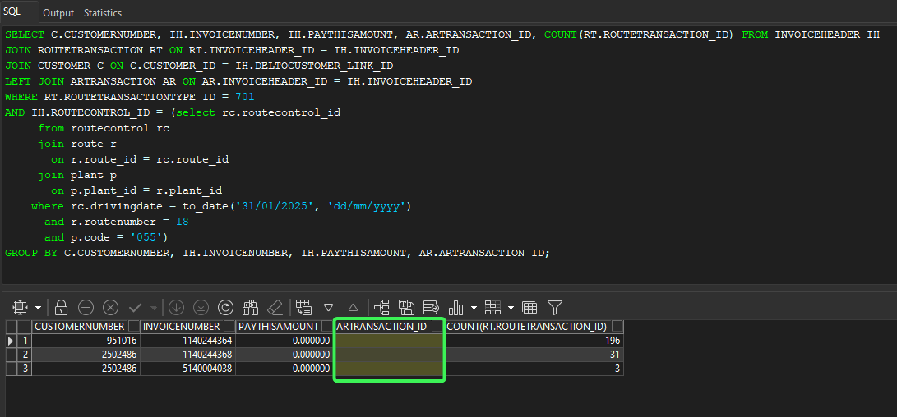
- Check that ARTRANSACTION have been created for the customers where the full credit was removed for their invoices
Customer 2 –A manual and a Generated invoice
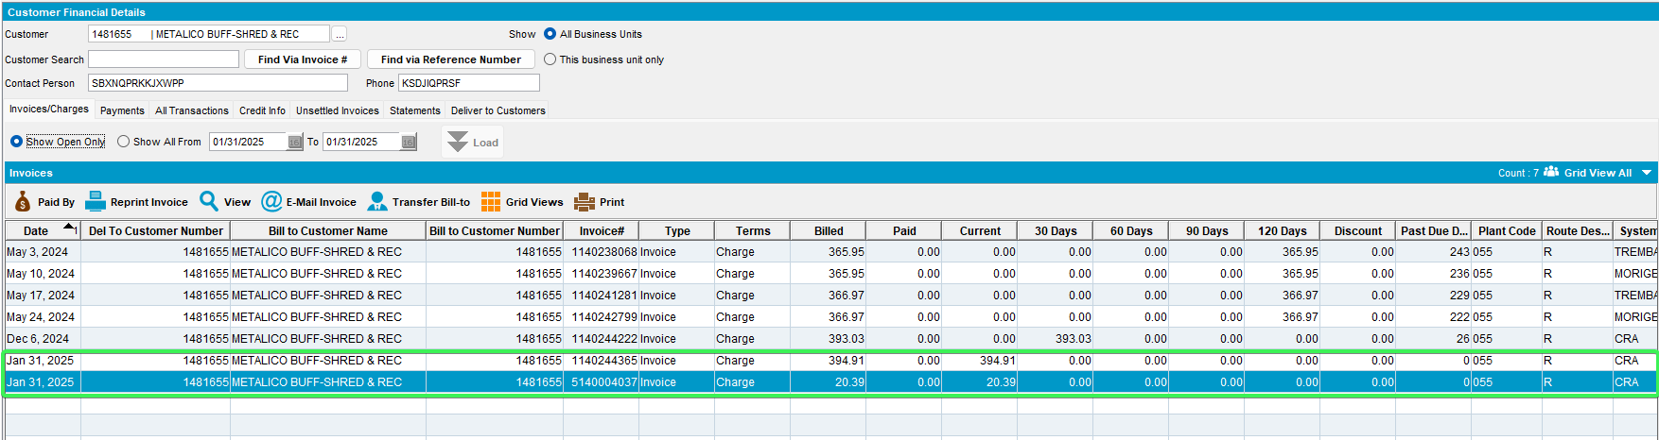
Customer 3 – One Generated additional and one Generated invoices
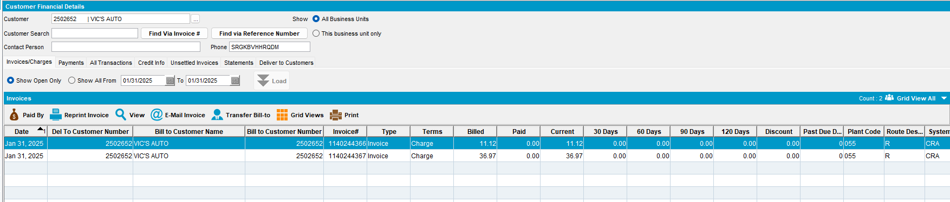
Tested OK

