ABSN-102 Route Returns - Add a system setting to disable unexpected returns
Environment | Prerequisites
Version: 9.09.00.RC1  DBServerName= abs-srv20.internal.abslbs.com  DBSID=CUST24  DBUser=UNFA  DBPassword=UNFA  Environment=Production | - Module:  - System setting

Contents
Test Case 1 - ROUTERETURNSUNEXPECTED = 1 scan a serialized unique item that does not have an 804 RT on this route control 1
Test Case 2 - ROUTERETURNSUNEXPECTED = 1 scan a serialized unique item twice that does have an 804 RT on this route control 5
Test Case 3 - ROUTERETURNSUNEXPECTED = 1 scan a SMARTBARCODE that does not have an 804 RT on this route control 8
Test Case 4 - ROUTERETURNSUNEXPECTED = 1 scan a SMARTBARCODE item twice that does have an 804 RT on this route control 11
Test Case 5 - ROUTERETURNSUNEXPECTED = 1 scan a serialized unique item that does not have an 804 RT on this route control 14
Test Case 6 - ROUTERETURNSUNEXPECTED = 0 scan a SMARTBARCODE that does not have an 804 RT on this route control 17
Test Case 7 - ROUTERETURNSUNEXPECTED = 0 scan a SMARTBARCODE item twice that does have an 804 RT on this route control 20

Test Case 1 - ROUTERETURNSUNEXPECTED = 1 scan a serialized unique item that does not have an 804 RT on this route control
Hash: e6279ab8980

- SS: ROUTERETURNSUNEXPECTED = 1
- Generate an invoice for a wearer with serialized unique items in wearer inventory.
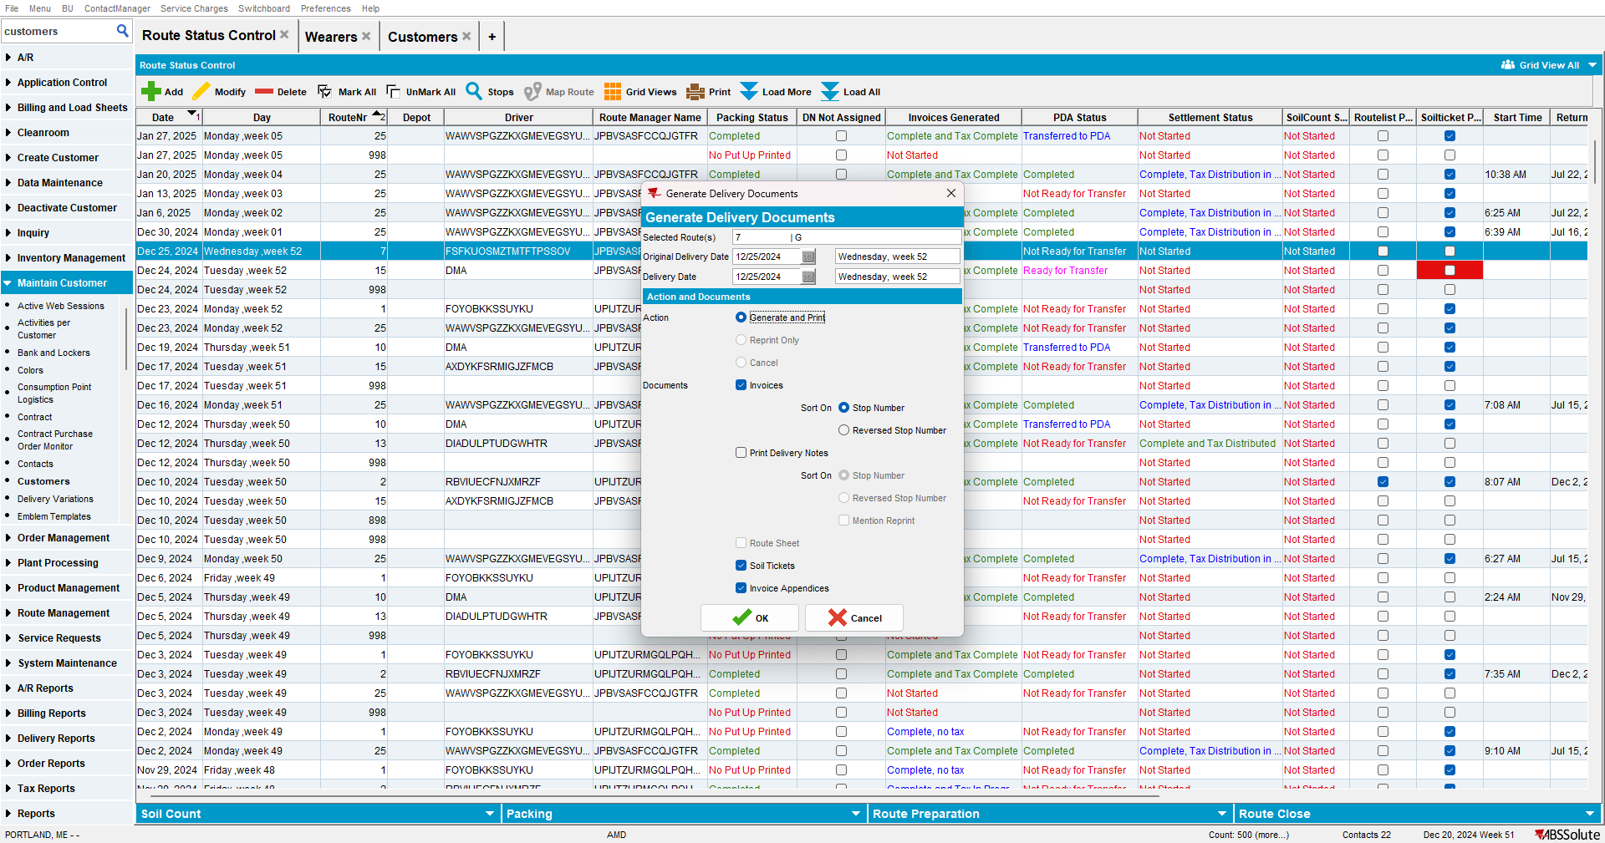

- RA: Quit the wearer.
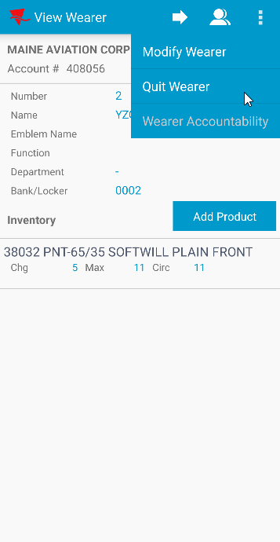

- RR: Scan a serialized unique item that was not scanned on RA.
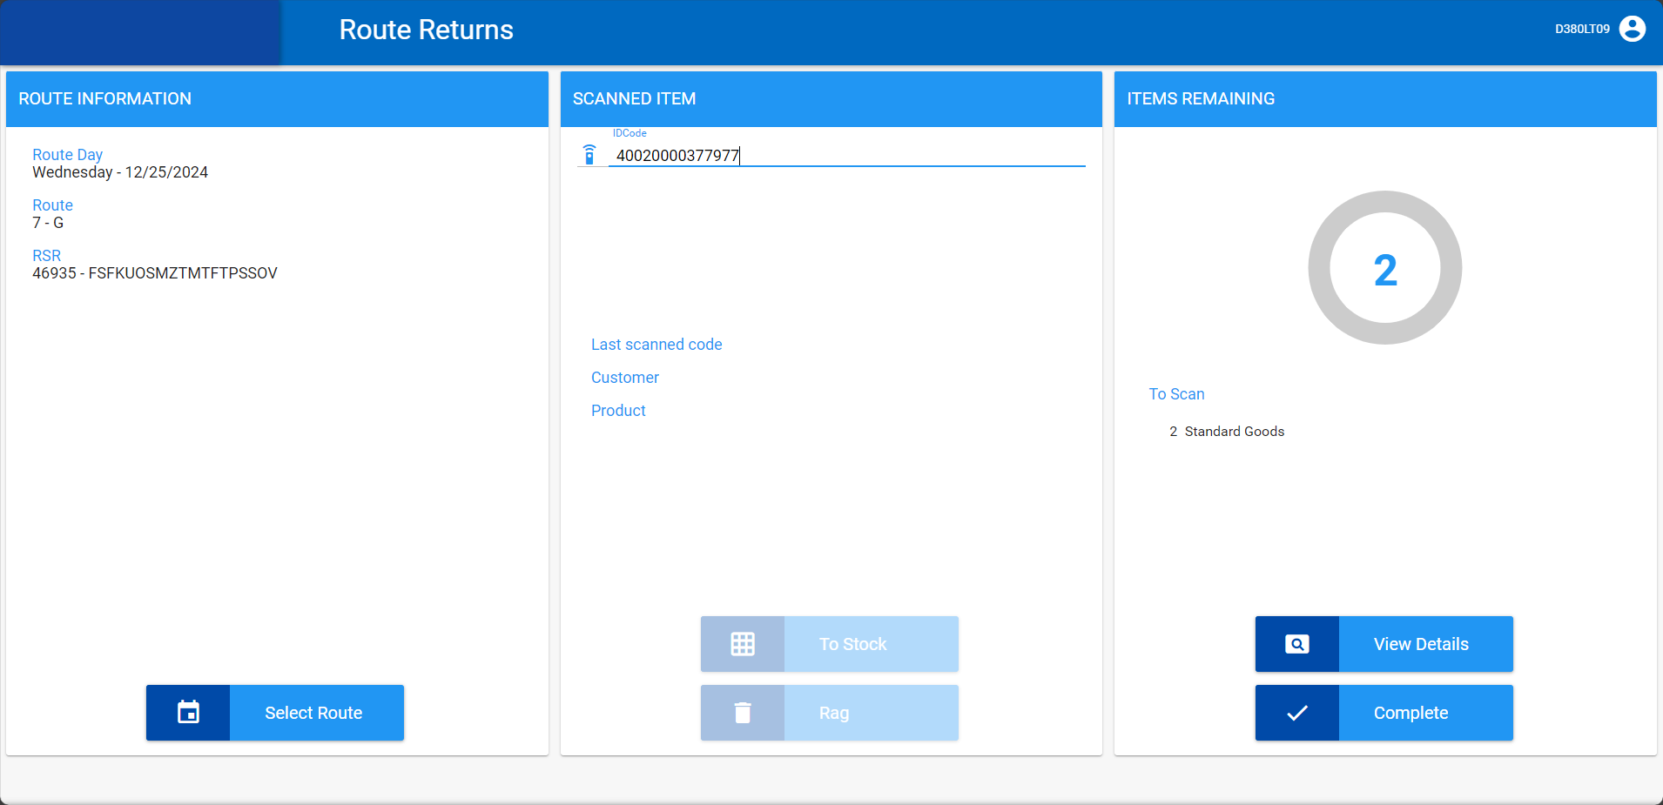
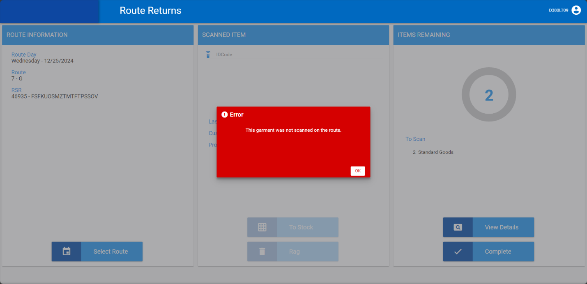

Expected behavior: Error and scan is refused
Actual behavior: Error and scan is refused

TESTED OK 💚

Test Case 2 - ROUTERETURNSUNEXPECTED = 1 scan a serialized unique item twice that does have an 804 RT on this route control
Hash: e6279ab8980

- SS: ROUTERETURNSUNEXPECTED = 1
- Generate an invoice for a wearer with serialized unique items in wearer inventory.

- RA: Quit the wearer.
- RA: Scan a serialized unique item.
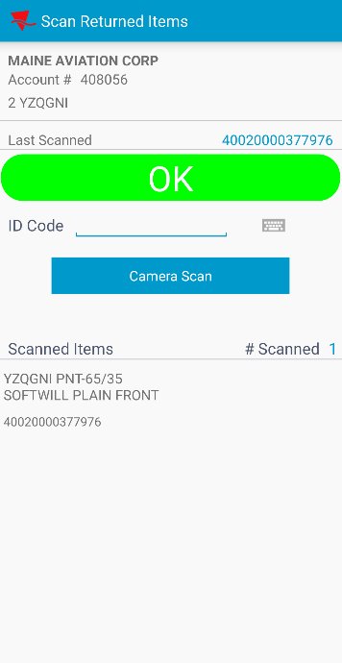

- RR: Scan a serialized unique item that was scanned on RA.
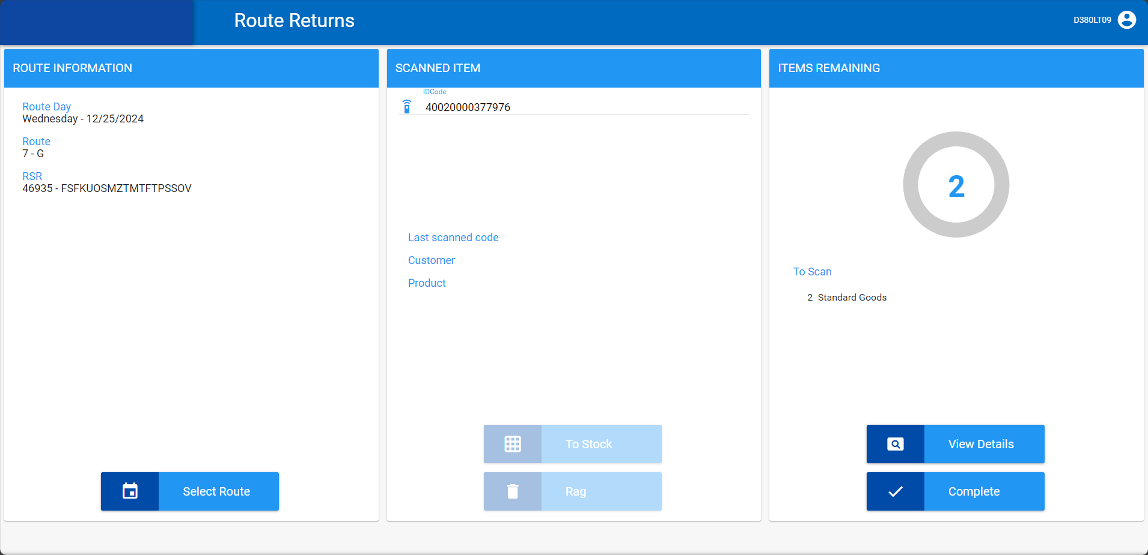
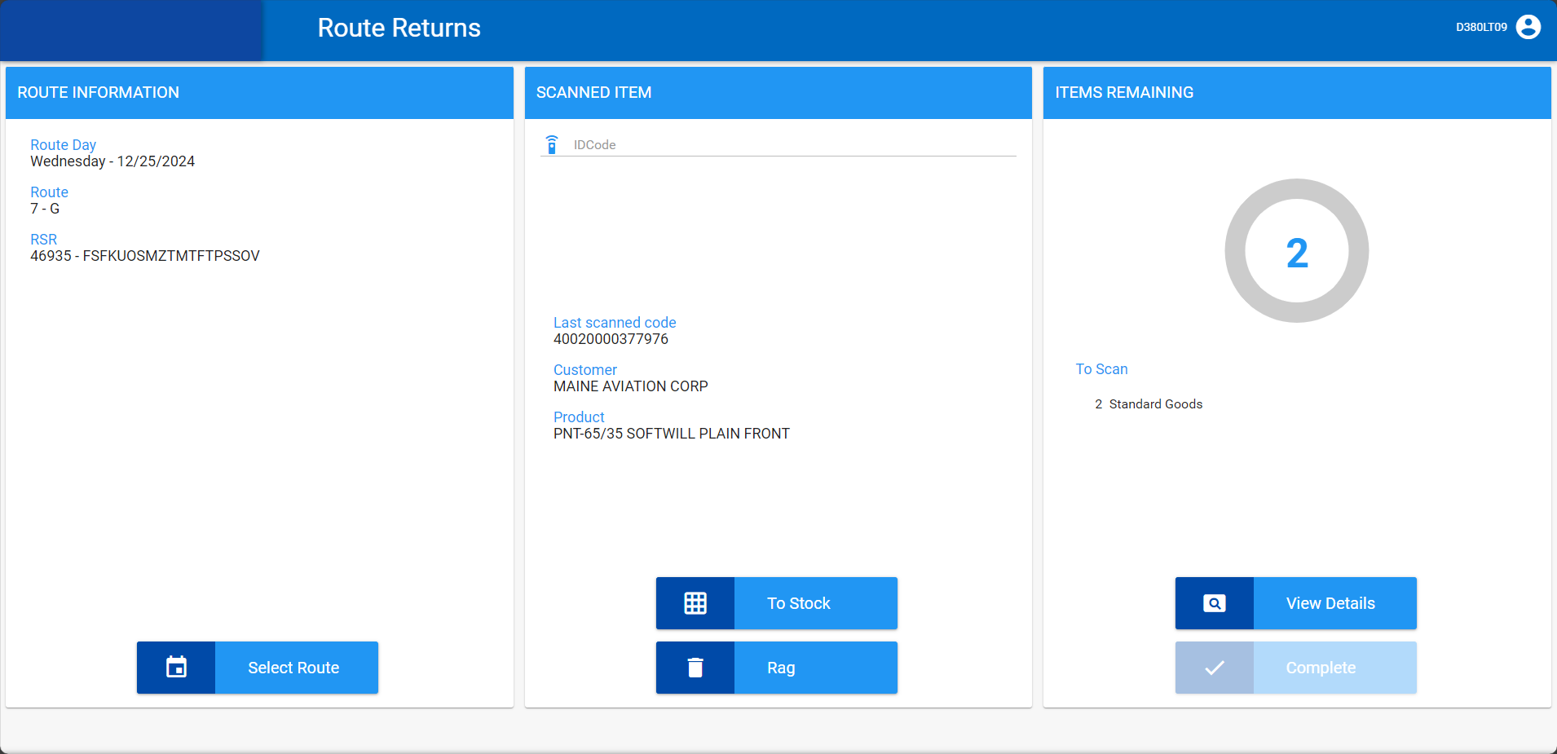

- Scan it again.
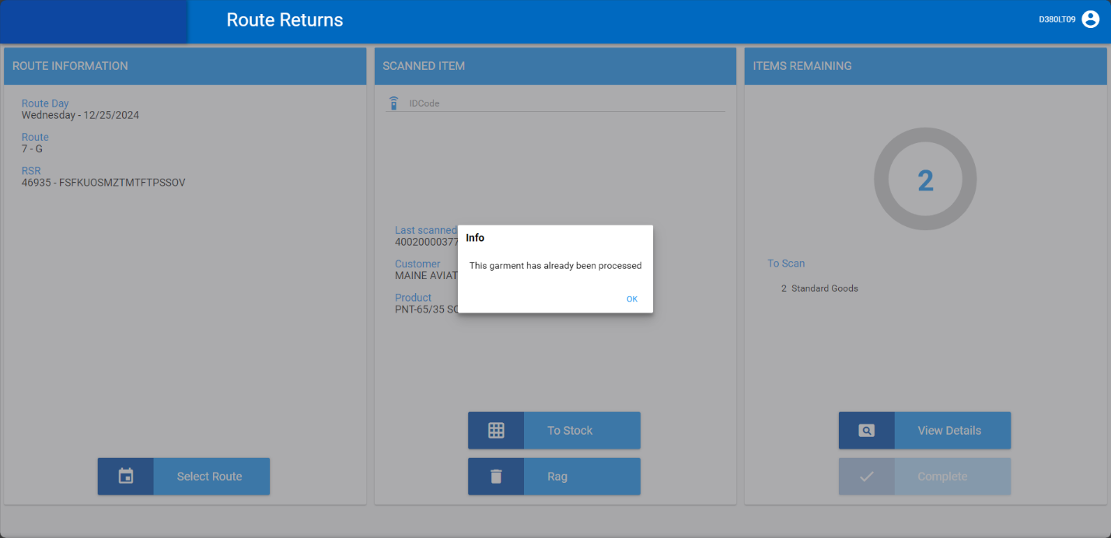

Expected behavior: Error and scan is refused the second time
Actual behavior: Error and scan is refused the second time

TESTED OK 💚

Test Case 3 - ROUTERETURNSUNEXPECTED = 1 scan a SMARTBARCODE that does not have an 804 RT on this route control
Hash: e6279ab8980

- SS: ROUTERETURNSUNEXPECTED = 1
- Generate an invoice for a wearer with smartbarcodes in wearer inventory.

- RA: Quit the wearer.

- RR: Scan a SMARTBARCODE that was not scanned on RA.
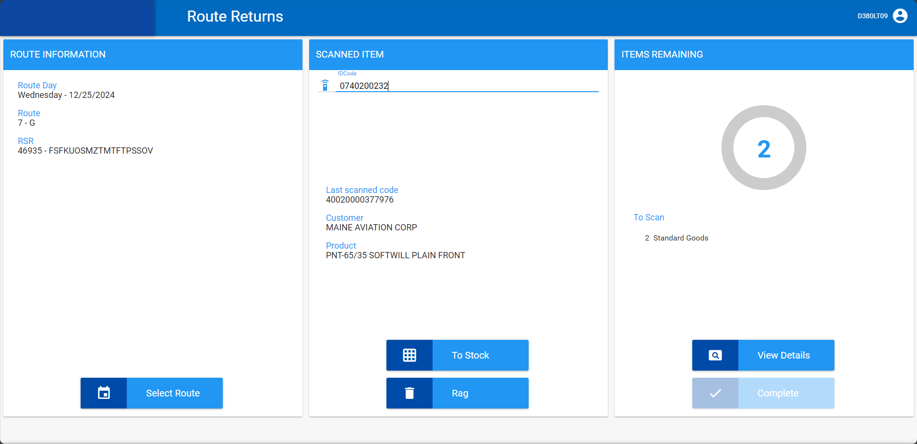
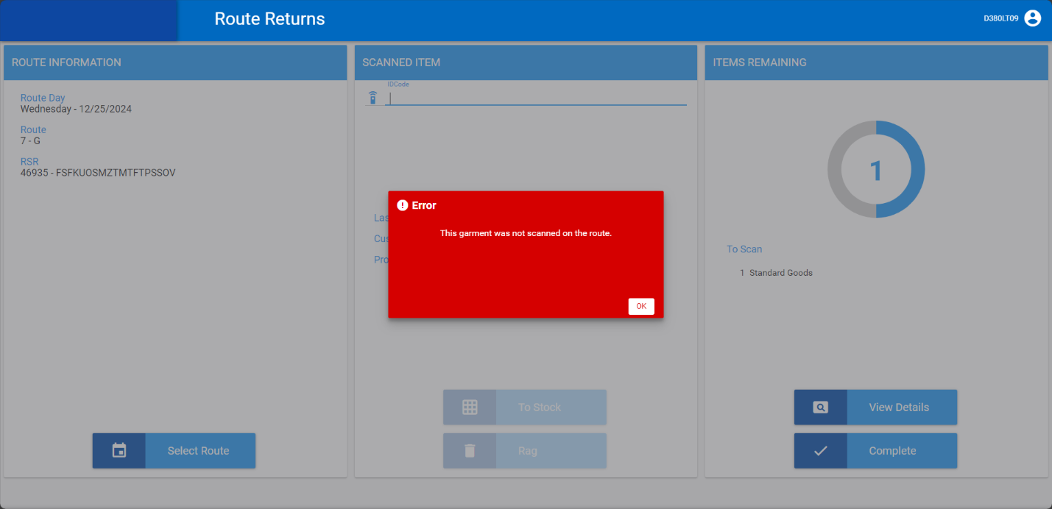

Expected behavior: Error and scan is refused
Actual behavior: Error and scan is refused

TESTED OK 💚

Test Case 4 - ROUTERETURNSUNEXPECTED = 1 scan a SMARTBARCODE item twice that does have an 804 RT on this route control
Hash: e6279ab8980

- SS: ROUTERETURNSUNEXPECTED = 1
- Generate an invoice for a wearer with smartbarcodes in wearer inventory.

- RA: Quit the wearer.
- RA: Scan a smartbarcode.
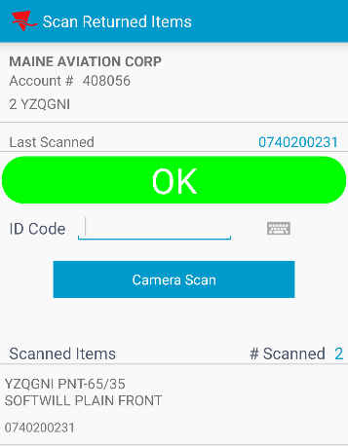

- RR: Scan a smartbarcode that was scanned on RA.
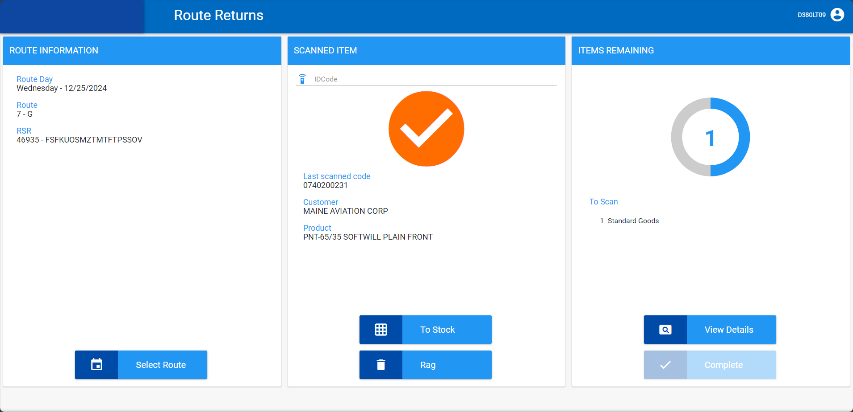

- Scan it again.
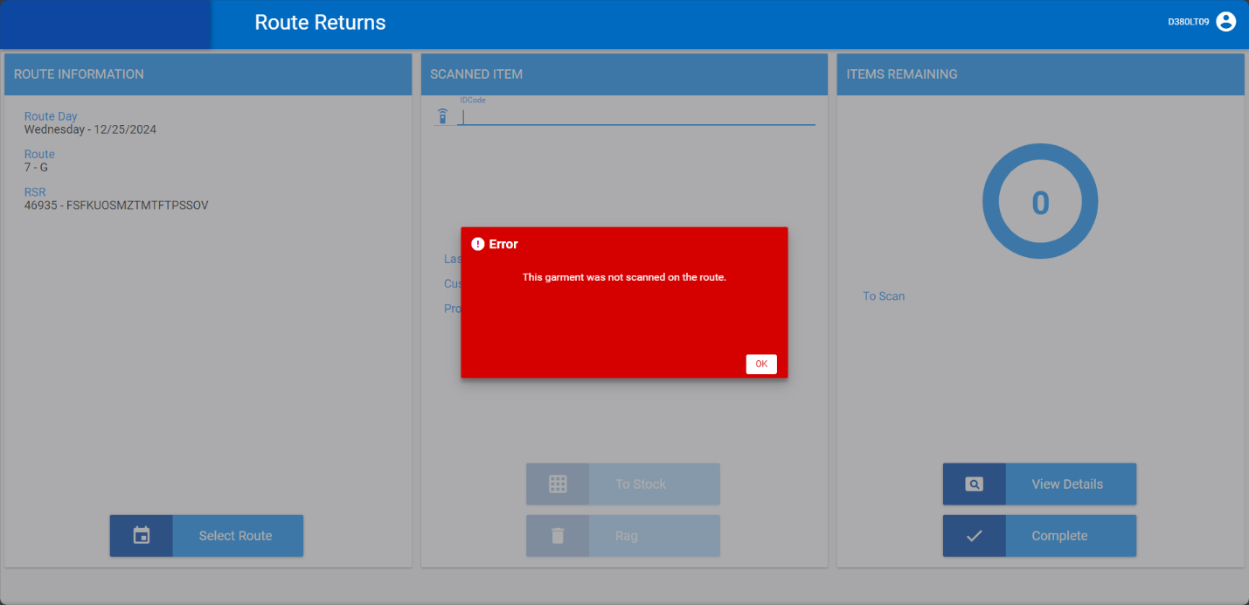

Expected behavior: Error and scan is refused the second time
Actual behavior: Error and scan is refused the second time

TESTED OK 💚

Test Case 5 - ROUTERETURNSUNEXPECTED = 0 scan a serialized unique item that does not have an 804 RT on this route control
Hash: e6279ab8980

- SS: ROUTERETURNSUNEXPECTED = 0
- Generate an invoice for a wearer with serialized unique items in wearer inventory.
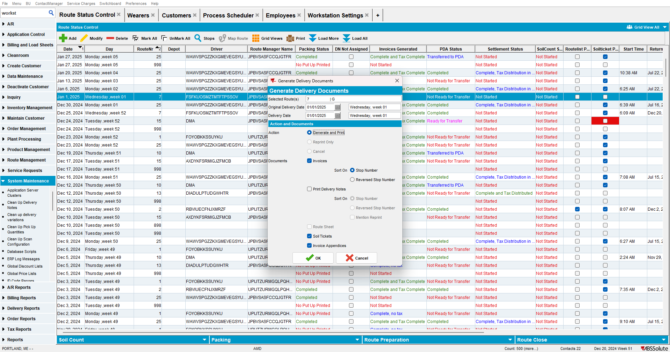

- RA: Quit the wearer.
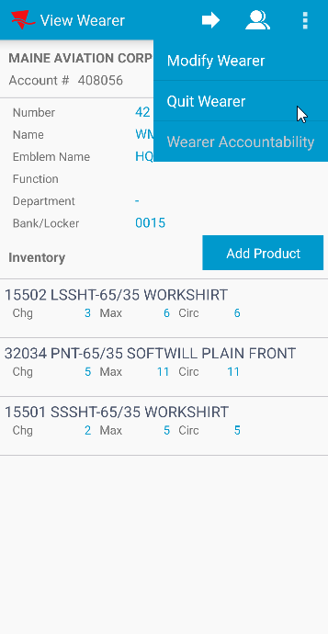

- RR: Scan a serialized unique item that was not scanned on RA.
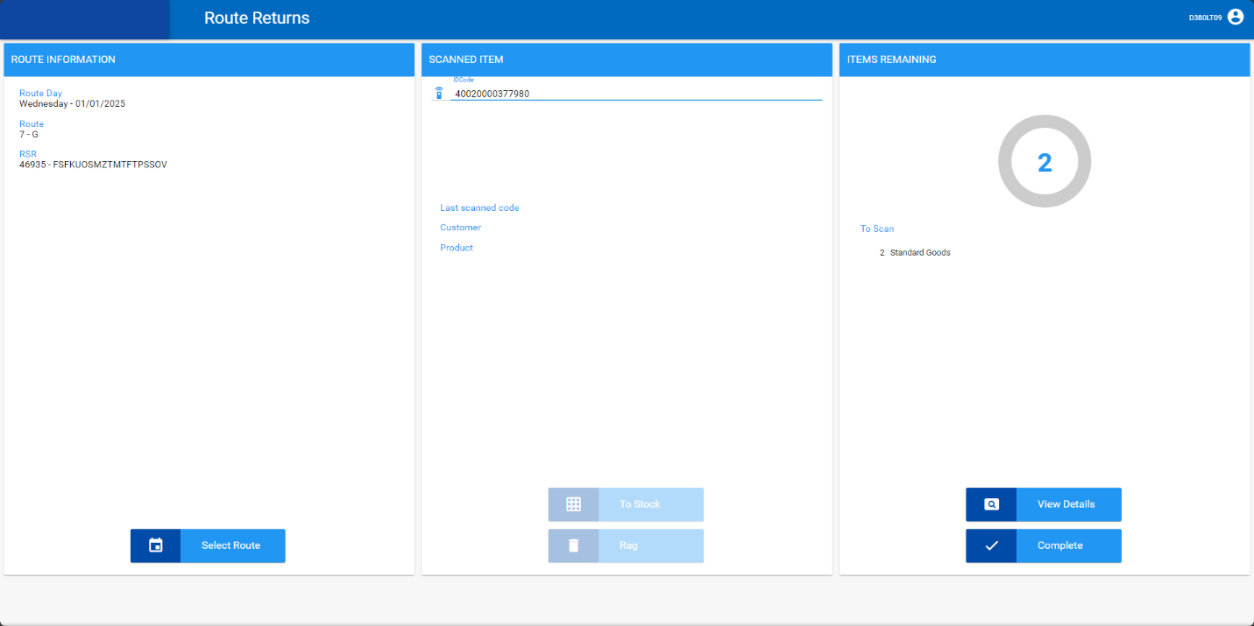
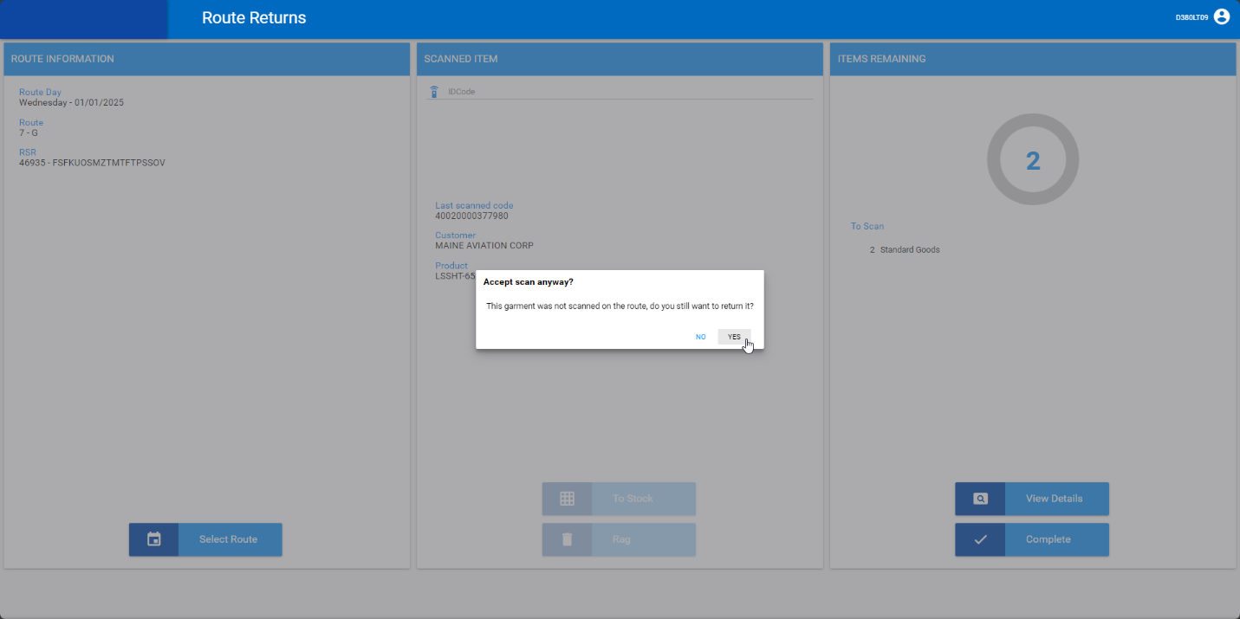
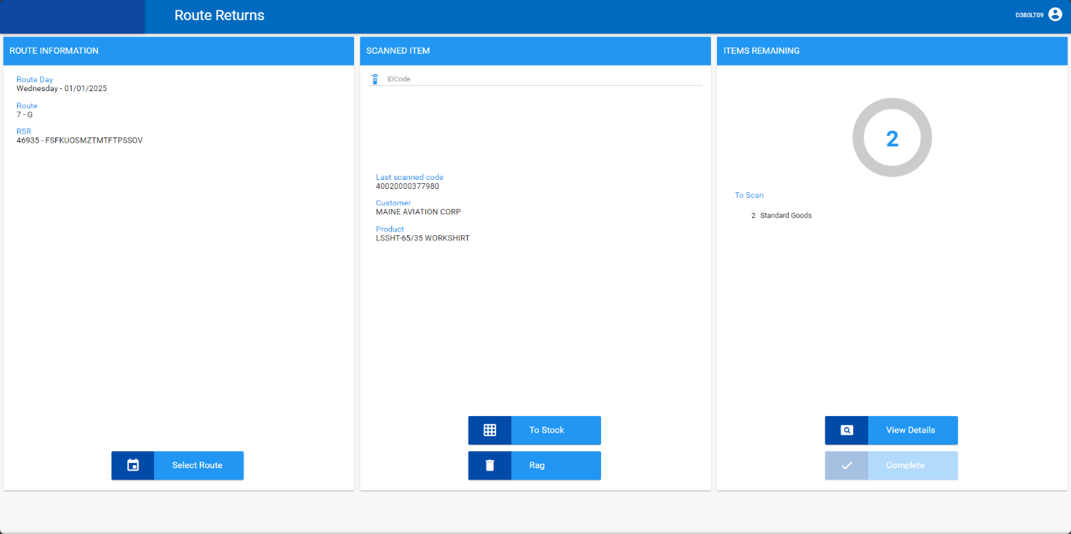

Expected behavior: Warning and if user selects yes scan is accepted
Actual behavior: Warning and if user selects yes scan is accepted

TESTED OK 💚

Test Case 6 - ROUTERETURNSUNEXPECTED = 0 scan a SMARTBARCODE that does not have an 804 RT on this route control
Hash: e6279ab8980

- SS: ROUTERETURNSUNEXPECTED = 0
- Generate an invoice for a wearer with smartbarcodes in wearer inventory.

- RA: Quit the wearer.

- RR: Scan a SMARTBARCODE that was not scanned on RA.
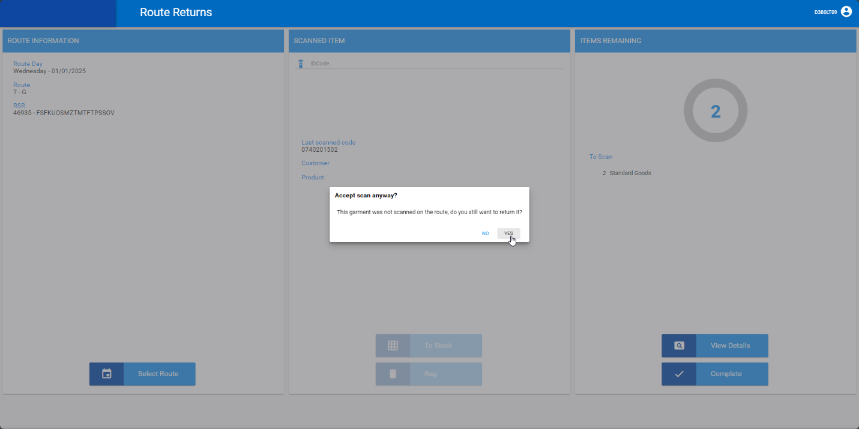
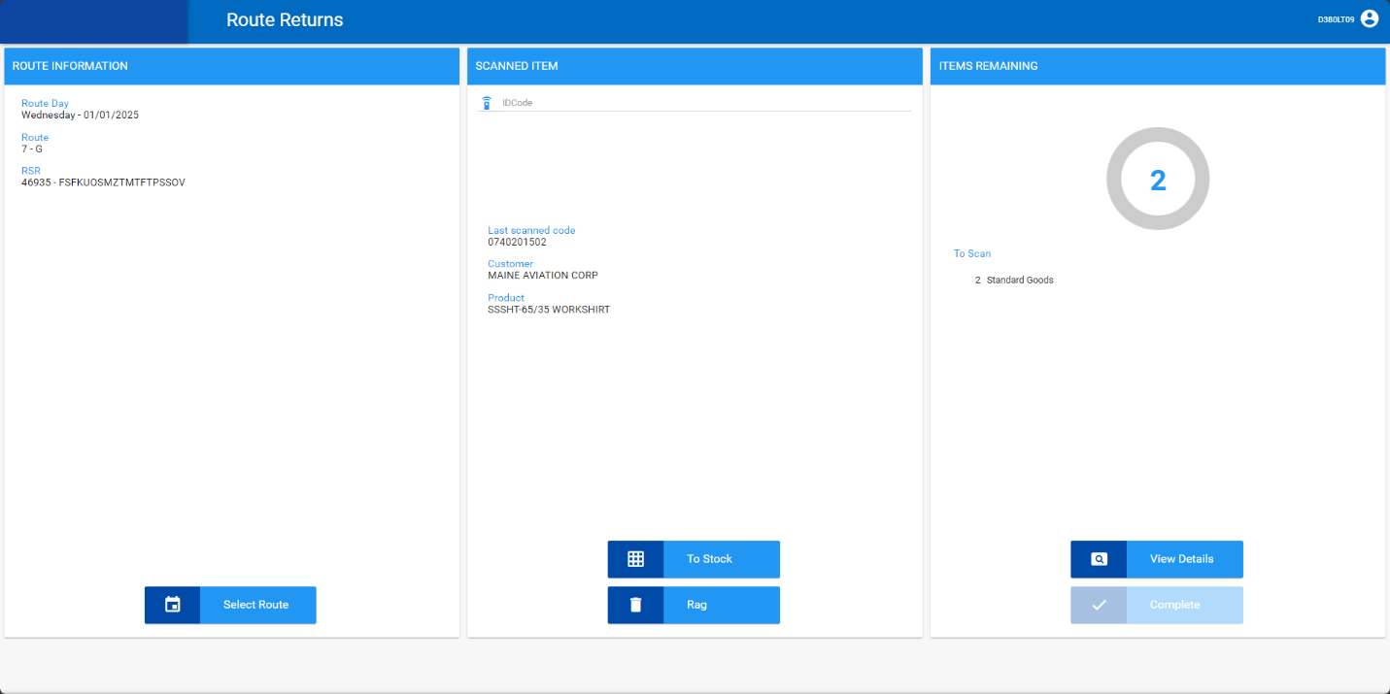

Expected behavior: Warning and if user selects yes scan is accepted
Actual behavior: Warning and if user selects yes scan is accepted

TESTED OK 💚

Test Case 7 - ROUTERETURNSUNEXPECTED = 0 scan a SMARTBARCODE item twice that does have an 804 RT on this route control
Hash: e6279ab8980

- SS: ROUTERETURNSUNEXPECTED = 0
- Generate an invoice for a wearer with smartbarcodes in wearer inventory.

- RA: Quit the wearer.
- RA: Scan a smartbarcode.
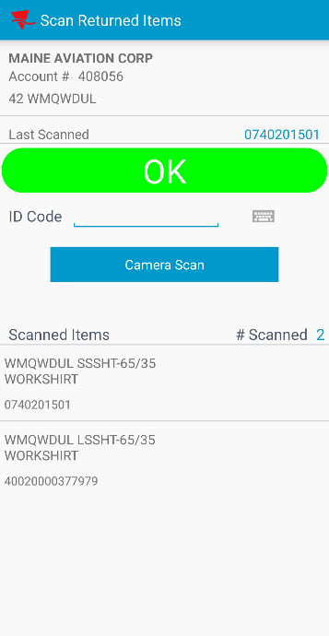

- RR: Scan a smartbarcode that was scanned on RA.
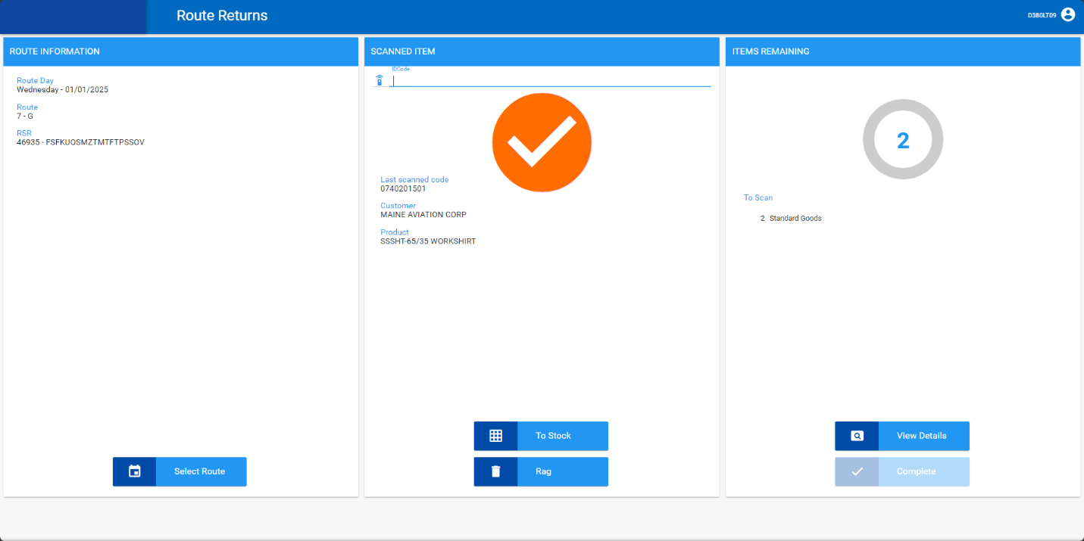

- Scan it again.
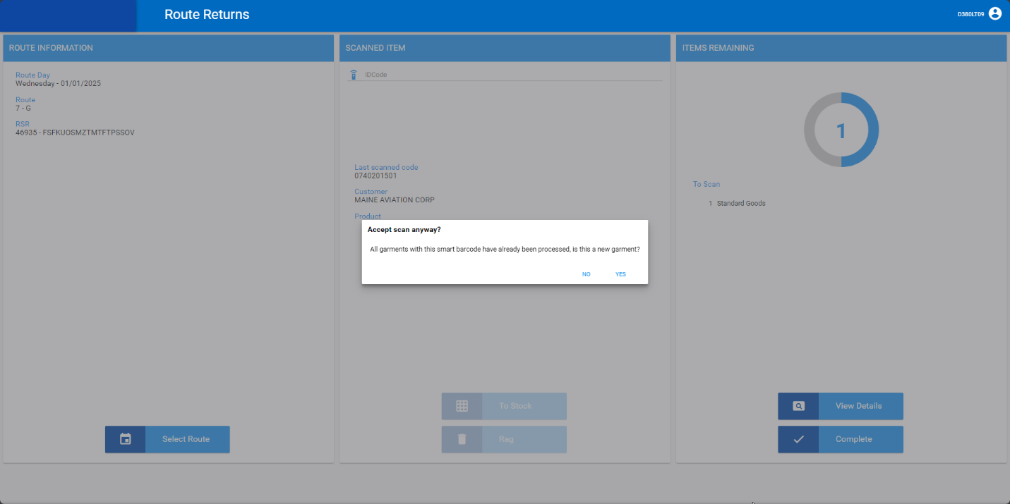
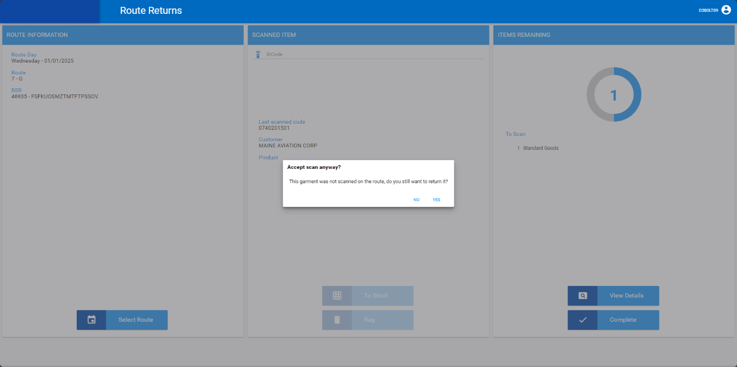
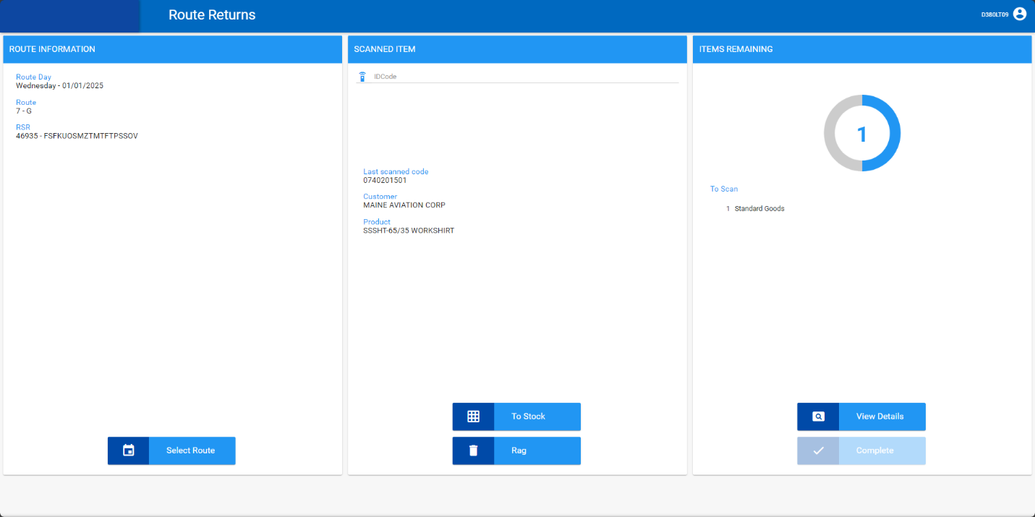

Expected behavior: Warning and if user selects yes scan is accepted
Actual behavior: Warning and if user selects yes scan is accepted

TESTED OK 💚

