ABSN-101 Changes to Freedom Pay take payment call for Canada
Environment | Prerequisites
Version: 9.07.00.UNF17.p02_UNF  DBServerName=abs-srv16.internal.abslbs.com  DBSID= CUST24  DBUser= UNFDEV  DBPassword= UNFDEV  Environment=Production | - Module:  - System setting

Contents
Retest after fix 1
Data Preparation: 2
Test Case 01 – Invalid ss value, credit card VISA – Tested OK 6
Steps to reproduce 6
1.1 Verify Transaction & create token 7
1.2 Verify transaction 9
1.3 Payment Transaction 13
Test Case 02 – Invoice is attached to a route that belongs to a depot – Tested OK 16
Expected behavior: 16
Steps to reproduce: 16
Test Case 03 – Invoice is attached to a route that does not belongs to a depot – Tested OK 19
Expected behavior: 19
Steps to reproduce: 19
Test Case 04 – Credit Card is AMEX, Bill-to=Del-to payment triggered from Credit Card Transactions – Tested OK 21
4.1 Verify Transaction & create token 21
4.2 Verify transaction 26
4.3 Payment Transaction 28
Test Case 05 - AMEX Bill-to = Del-to , payment triggered from Take Electronic Payment process scheduler – Tested OK 35
Test Case 06 - AMEX Bill-to<>Del-to and from different BU payment triggered from Credit Card Transactions – Tested OK 41
Test Case 07 - AMEX Bill-to<>Del-to and from different BU payment triggered from Take Electronic Payment process scheduler – Tested OK 51
Test Case 08 - VISA Bill-to=Del-to & Bill-to <> Del-to, payment triggered from Credit Card Transactions – Tested OK 56
Test Case 09 - VISA Bill-to=Del-to & Bill-to <> Del-to, payment triggered from Take Electronic Payment process scheduler – Tested OK 60

Retest after fix

Data Preparation:

- STATES DLG: Add the correct tax jurisdiction codes like so for CANADA
- STATES DLG: Under each state add a county named CANADA like so for each region:
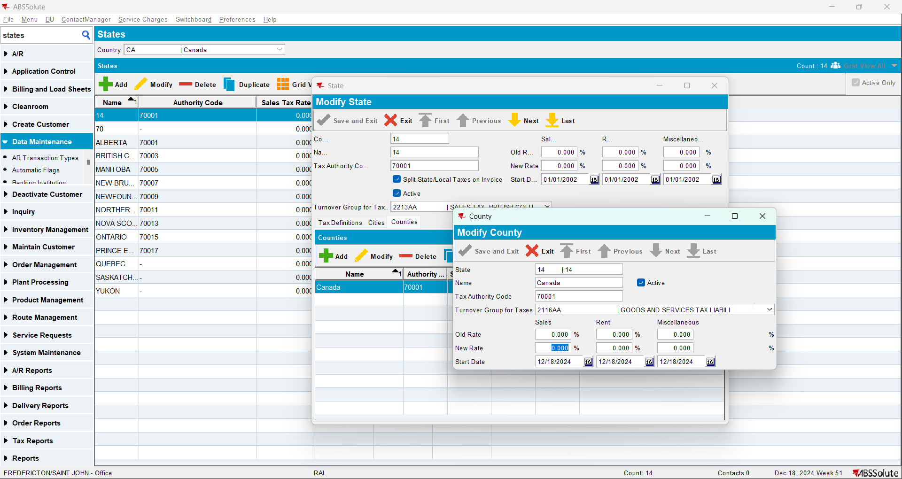
- Go to a BU like 710.
- CUSTOMERS DLG: Select one of the customers such as 9102366 and add a delivery point for it.
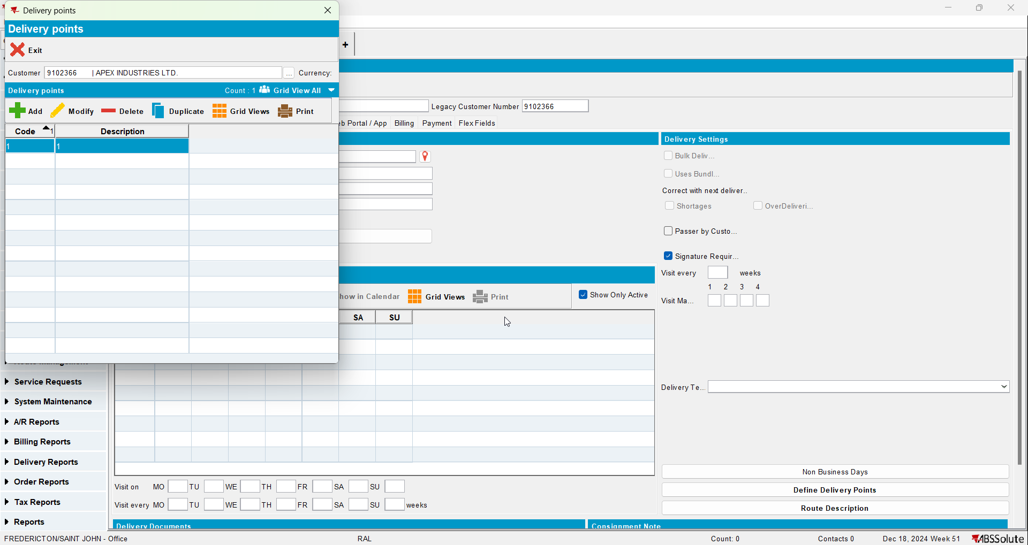
- DEPARTMENT DLG: Add a cost center and department for 9102366
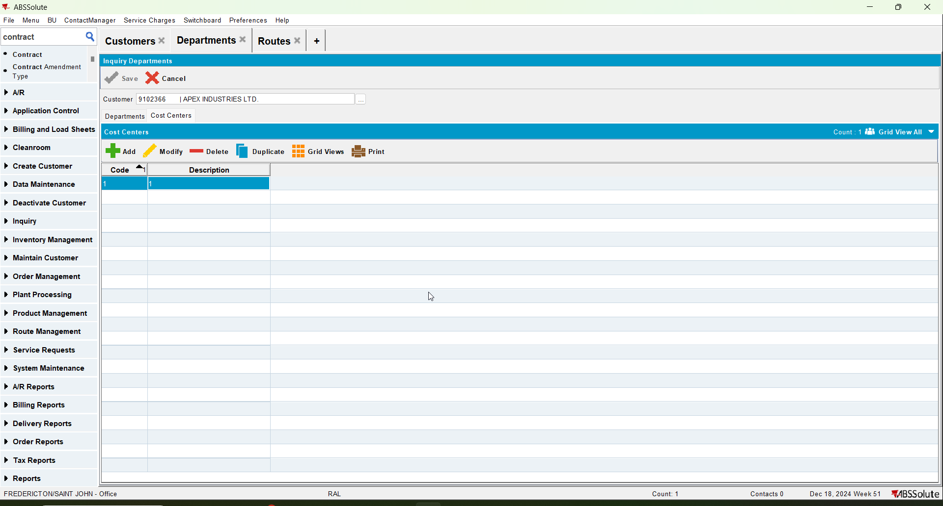
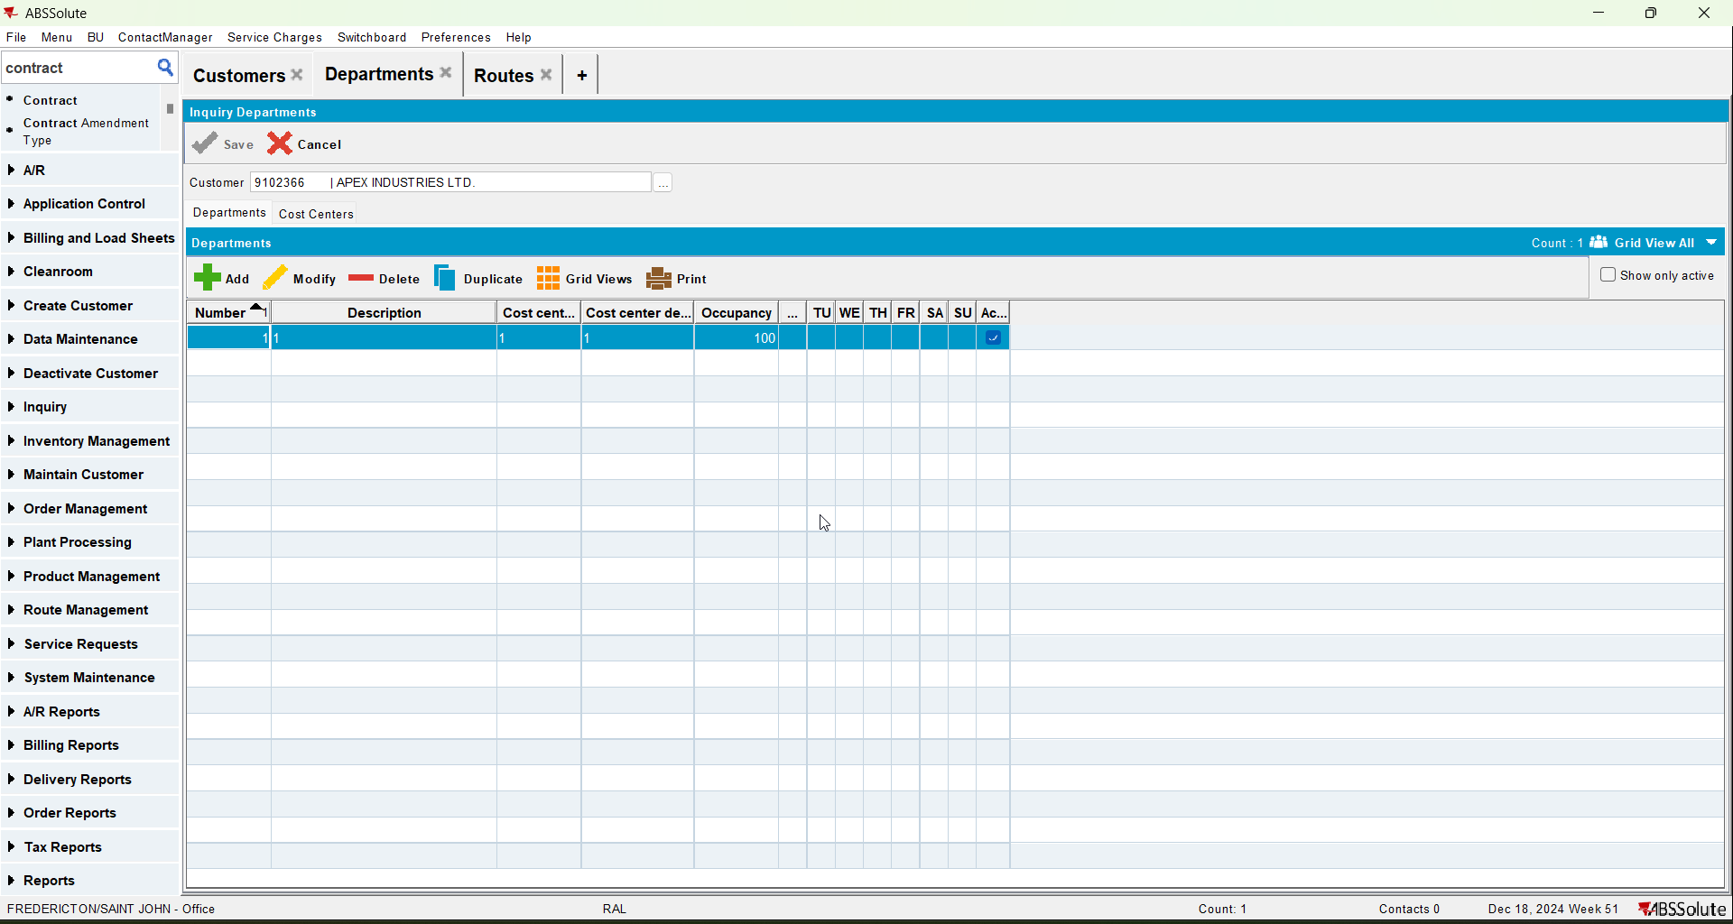
- Plants DLG: Add a district to Plant 027
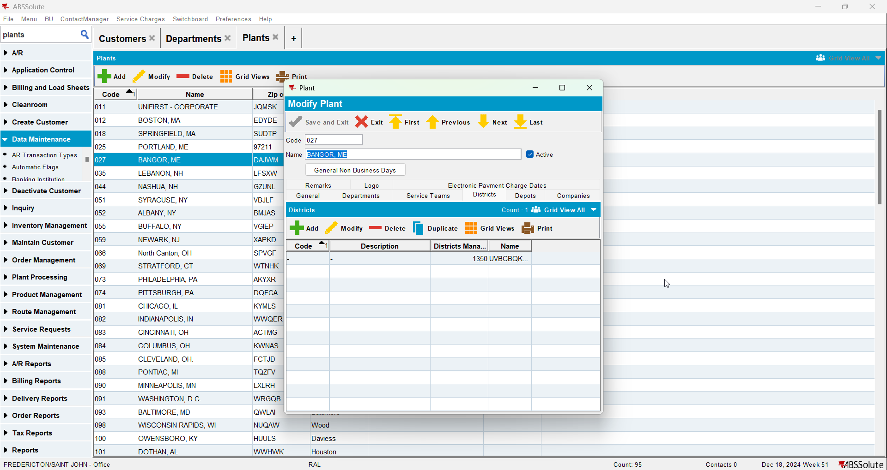
- Routes DLG: Add routes for each weekday
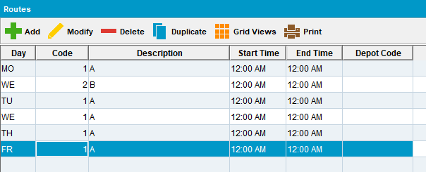
- Customers DLG: Add a route stops for customer 9102366
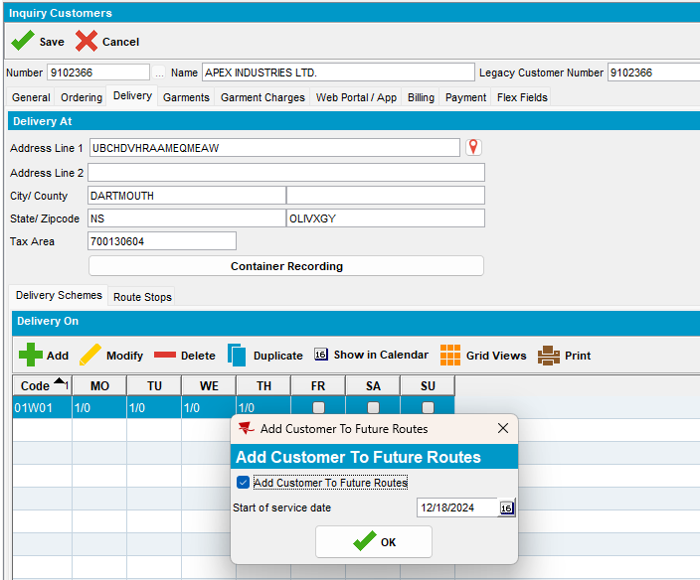
- Contract DLG: Add a new contract with Currency = CAD (start date needs to be yesterday) and with at least one released garment product on it
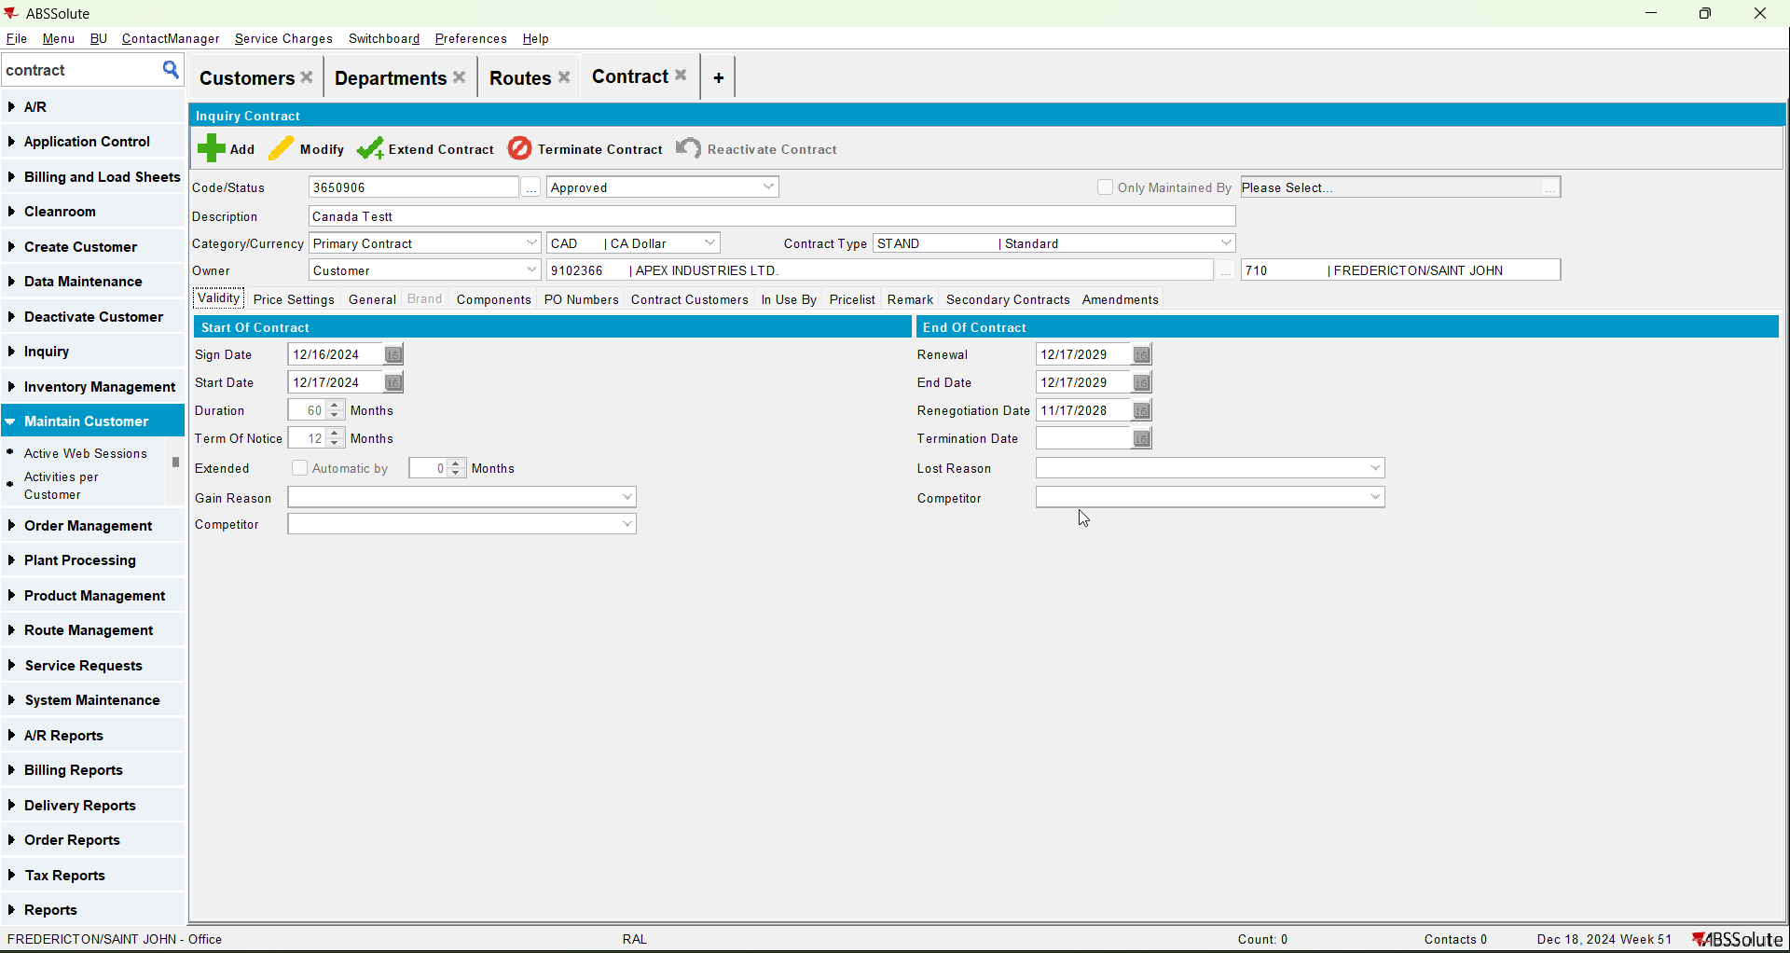

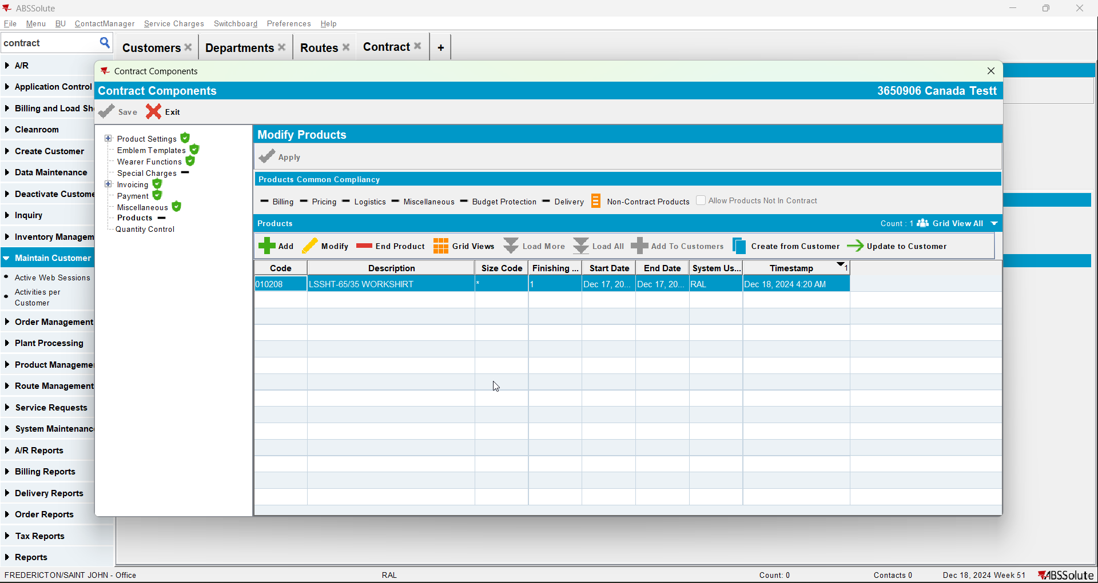
- Contract DLG: Add customer 9102366 to the contract (start date needs to be today or yesterday)
- Lockers DLG: Add lockers for 9102366
- Stockroom DLG: Add a stockroom for 710 by duplicating an existing stockroom.
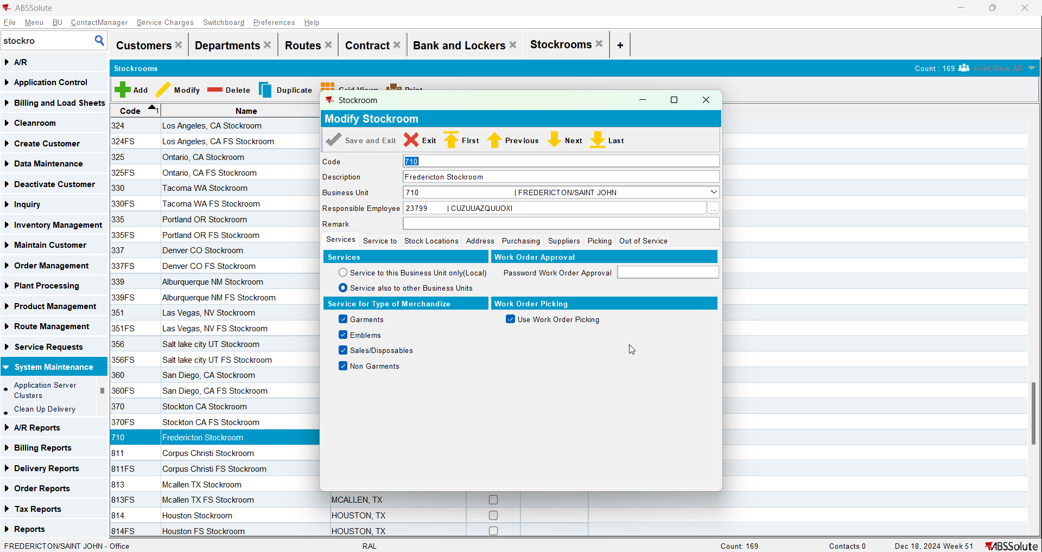
- Wearers DLG: Add at least one wearer with a wearer inventory and generate the WORKORDER with Start Rent = 'Day of issue'
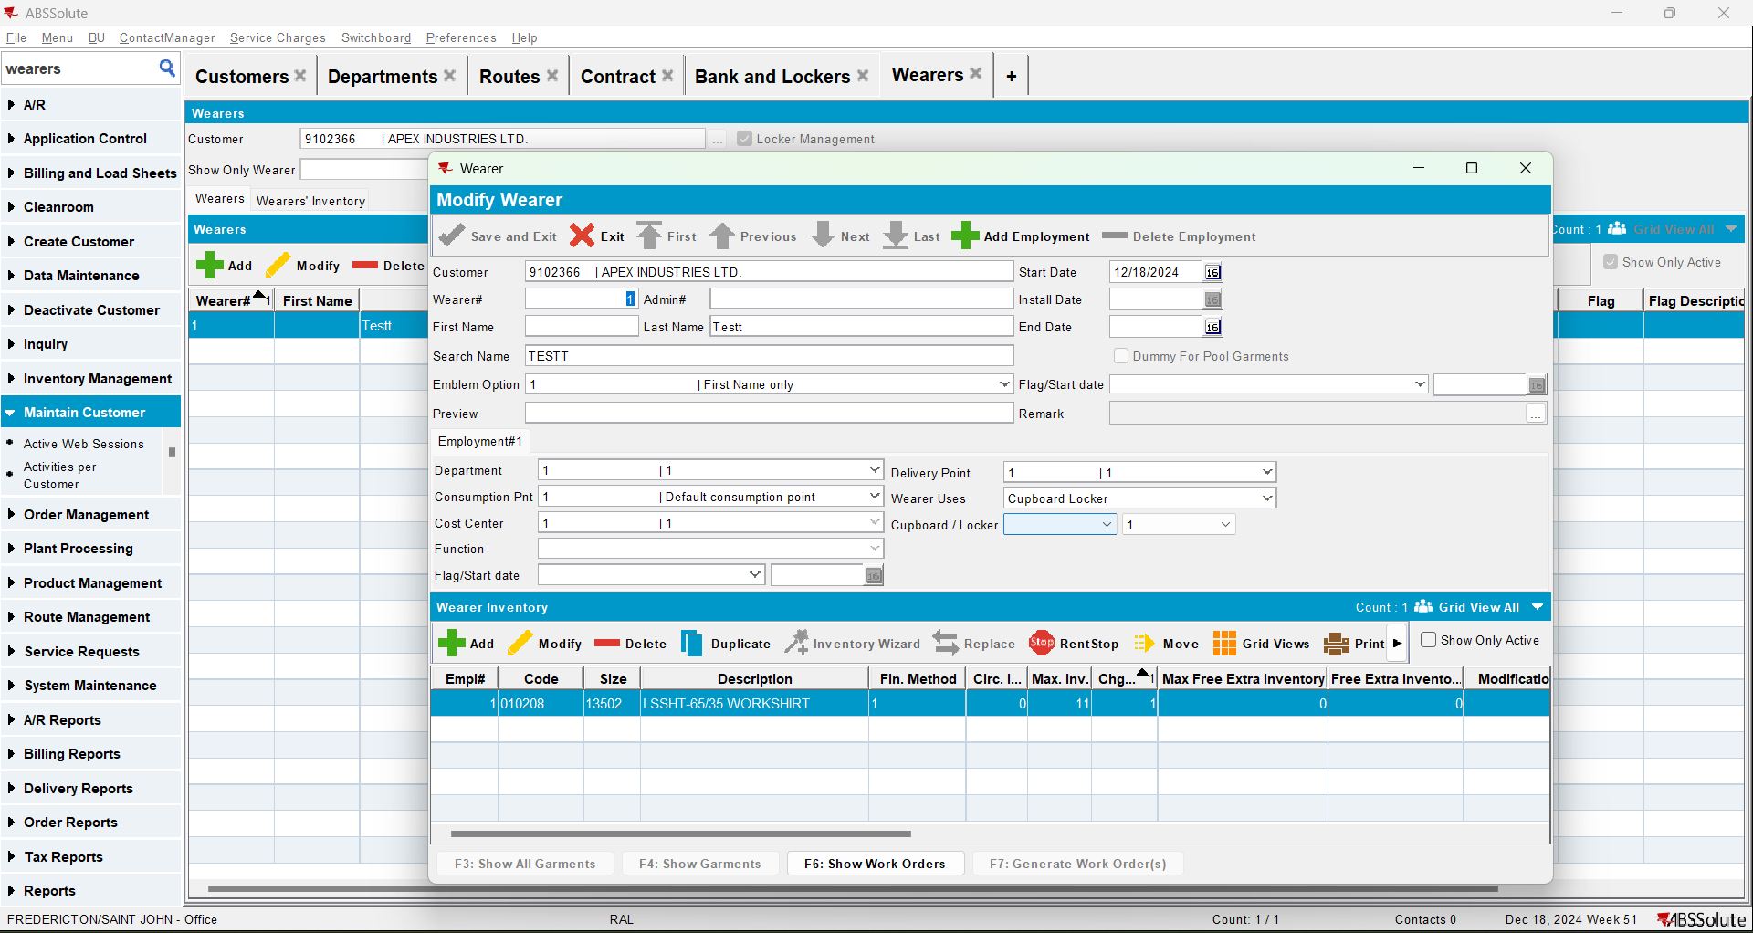
- ID Code Ranges DLG: Add a 14 digit range for Unique Items
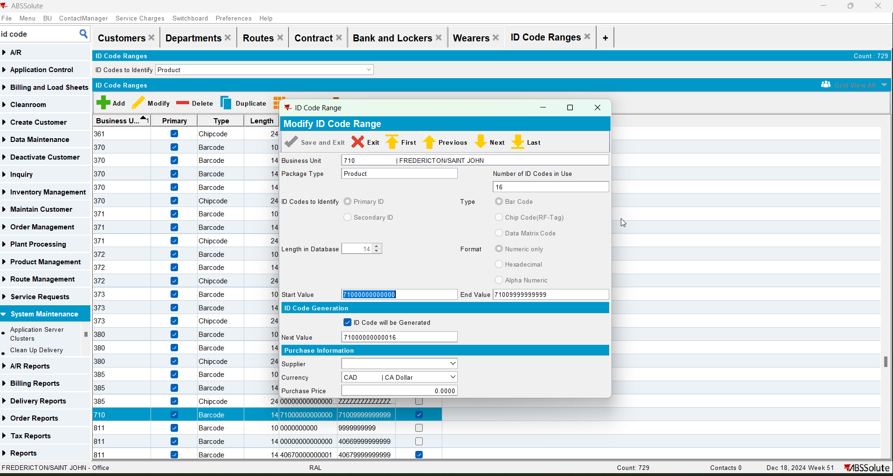
- Issue Work Order DLG: Issue all garments and generate items and then generate the Delivery Note

Test Case 01 – Invalid ss value, credit card VISA – Tested OK
Hash: 9.07.00.UNF17.p02 hash: 75c045d74ee7
BU: 710 FREDERICTON/SAINT JOHN

Steps to reproduce
- System Settings dlg: For the plant where our customer is present. Check the ss CREDITCARDAMEXSTOREIDCA, CREDITCARDSTOREIDCA, CREDITCARDTERMINALIDCA . See that there is no value present.
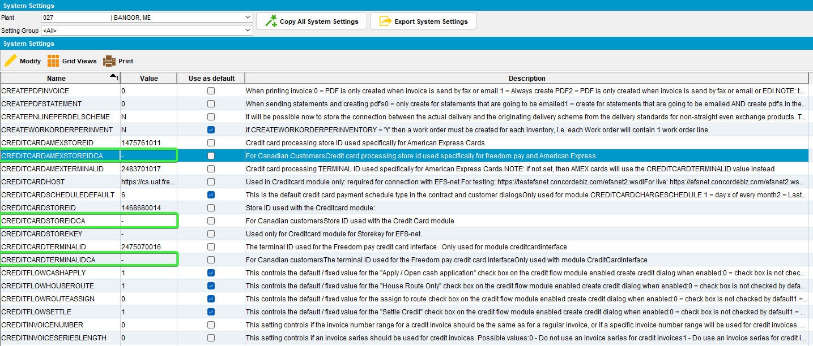

1.1 Verify Transaction & create token

Expected behavior
This is used when a new card is created via the ID Tech device and we want to convert the ID Tech data into a token for reuse and process a zero-value transaction on the card to make sure its valid.
storeID | If the Bill To customer’s county is not Canada, then  If card type is American Express (CustomerCreditCard.MaskedCardNumber starts with 34 or 37 and is length 15) and system setting CREDITCARDAMEXSTOREID is not blank, - or NULL  Then use CREDITCARDAMEXSTOREID  Else use System setting CREDITCARDSTOREID  If the Bill To customer’s county is Canada, then  If card type is American Express (CustomerCreditCard.MaskedCardNumber starts with 34 or 37 and is length 15) and system setting CREDITCARDAMEXSTOREIDCA is not blank, - or NULL  Then use CREDITCARDAMEXSTOREIDCA  Else use System setting CREDITCARDSTOREIDCA
terminalID | If the Bill To customer’s county is not Canada, then  If the card type is American Express (CustomerCreditCard.MaskedCardNumber starts with 34 or 37 and is length 15) and system setting CREDITCARDAMEXTERMINALID is not blank, - or NULL  Then use CREDITCARDAMEXTERMINALID  Else use System setting CREDITCARDTERMINALI  If the Bill To customer’s county is Canada, then  If card type is American Express (CustomerCreditCard.MaskedCardNumber starts with 34 or 37 and is length 15) and system setting CREDITCARDAMXTERMINALIDCA is not blank, - or NULL  Then use CREDITCARDAMEXTERMINALIDCA  Else use System setting CREDITCARDTERMINALIDCA  Note The Canadian version of the system setting CREDITCARDAMEXTERMINALID is spelt slightly differently (AMX not AMEX) due to field length limits

- Customers dlg: Load customer 9102366 and put the following card string from a VISA
CARD BRAND : VISA
CARD NUMBER : 4020956729331588
NAME : Karolina Crutchfield
COUNTRY : UNITED STATES
CVV/CVC : 958
EXPIRY : 08/2030
02A600C0170018008292;4020********1588=3008?*2B4ABDC89C69D6B588317981FE7CA3B0EC94393DD463AA55000000000000000000000000000000000000000038333054393633393730FFFF987654001B000140625C03

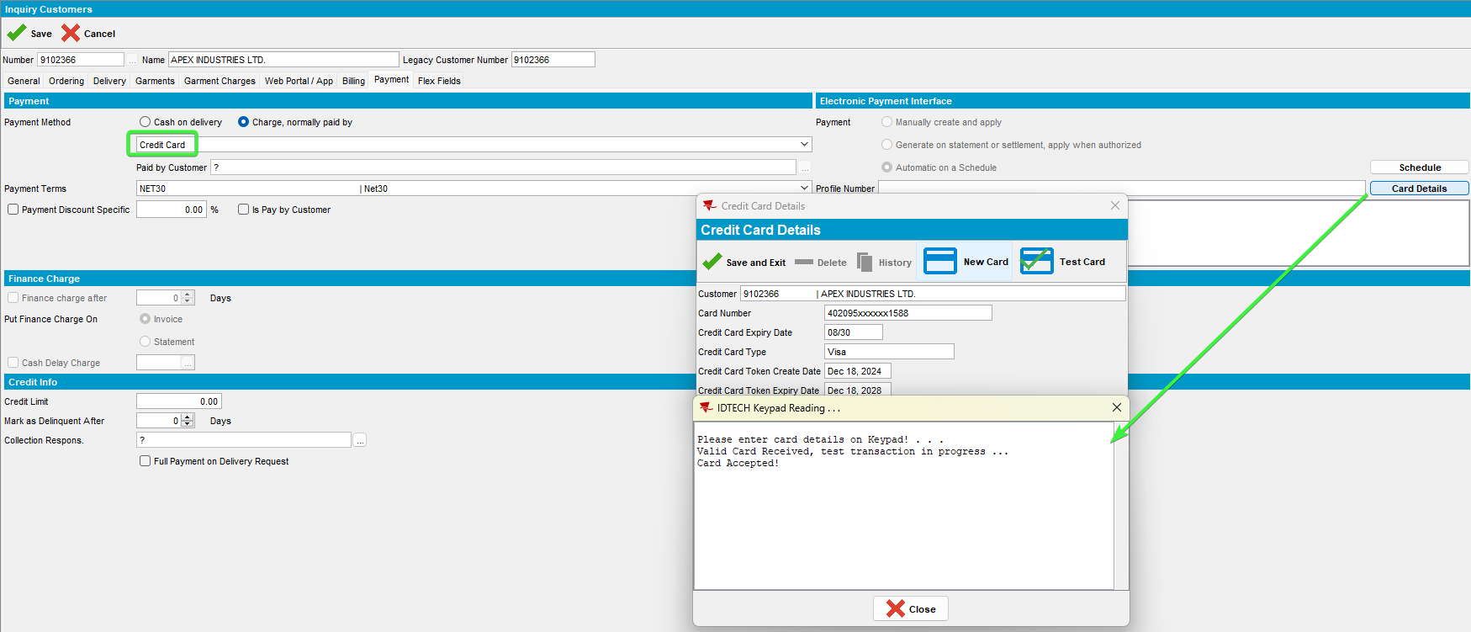

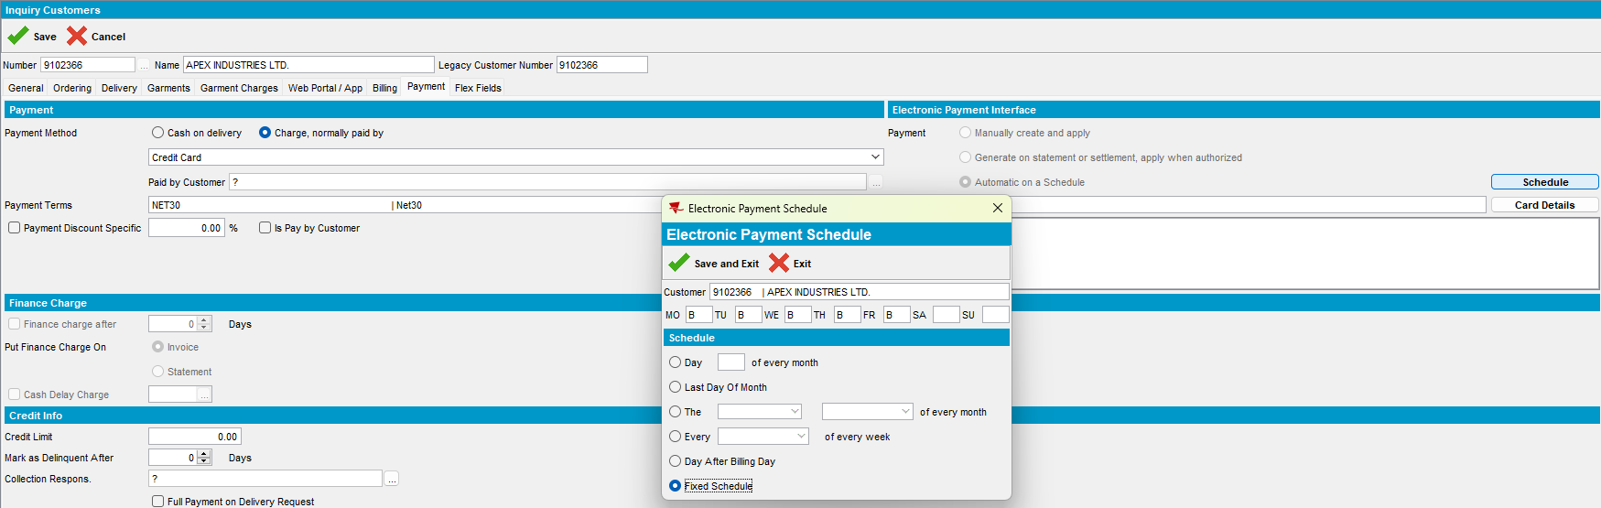
- Check the WebService Log
select * from webservicelog wsl
where wsl.customer = 9102366
and wsl.requesttimestamp >= TO_DATE('2024-12-19 00:00:00', 'YYYY-MM-DD HH24:MI:SS')
order by wsl.requesttimestamp desc;

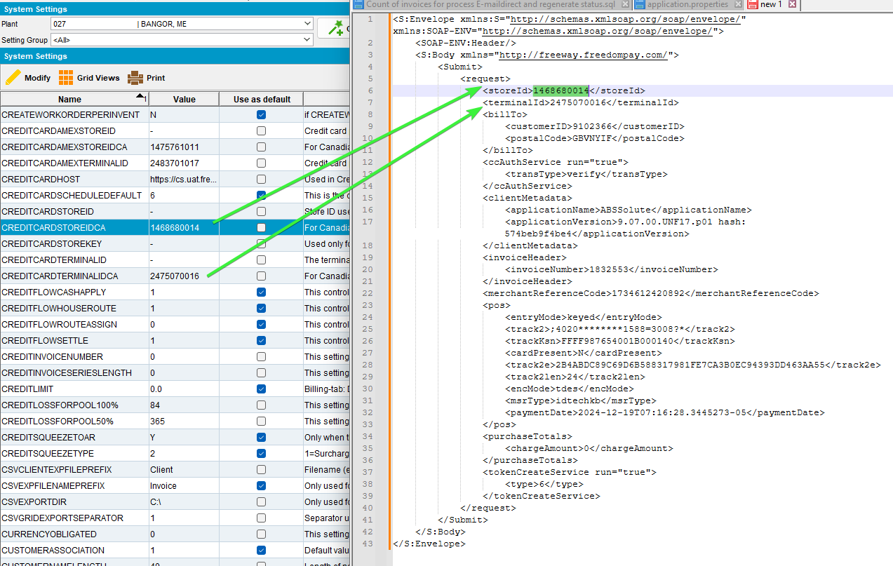

1.2 Verify transaction

Expected behavior
This is used by the “test card” button and processes a zero value transaction on the card to make sure its valid. This can also be used to update the token so if the token expiry date is in the grace period (expiry date > system date -30 days) then a new token will automatically be returned in the response.
- Test the card.
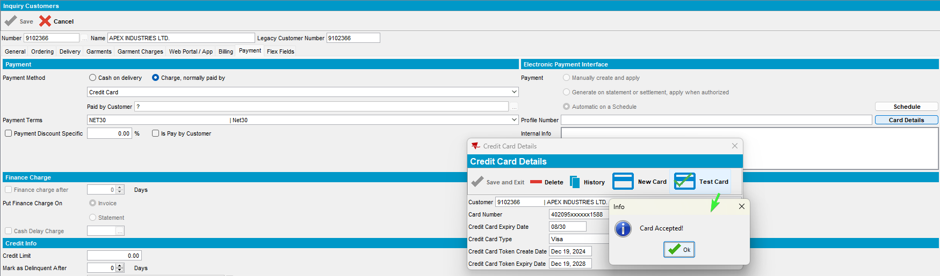
- Check the WebServiceLog.
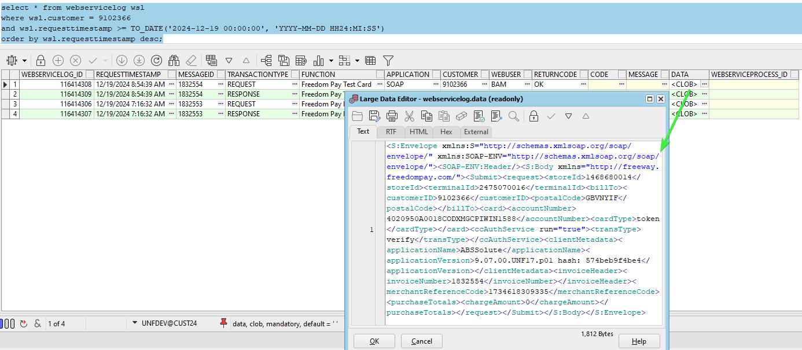
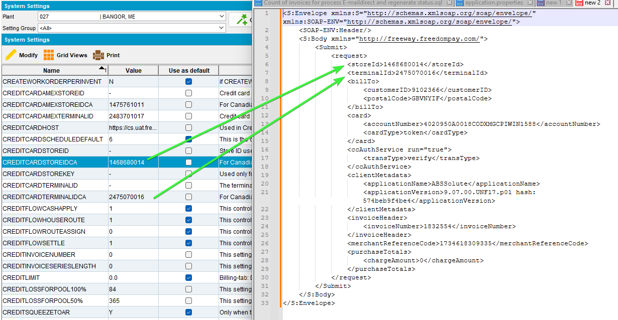

- RSC dlg: Add a route in the past.
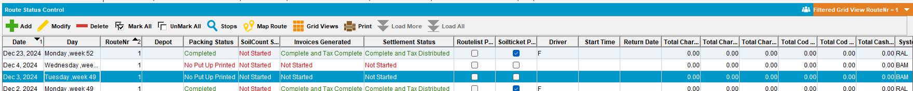
- Maintain Invoices dlg: Add a manual invoice for the customer for that route.
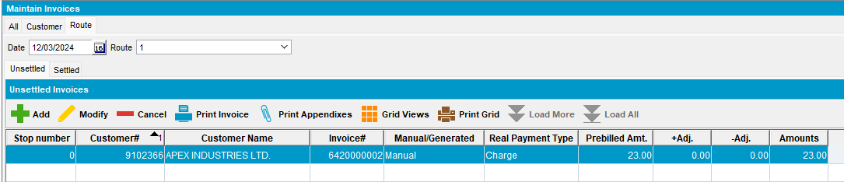
- RSC dlg: Generate invoices. Settle the route.
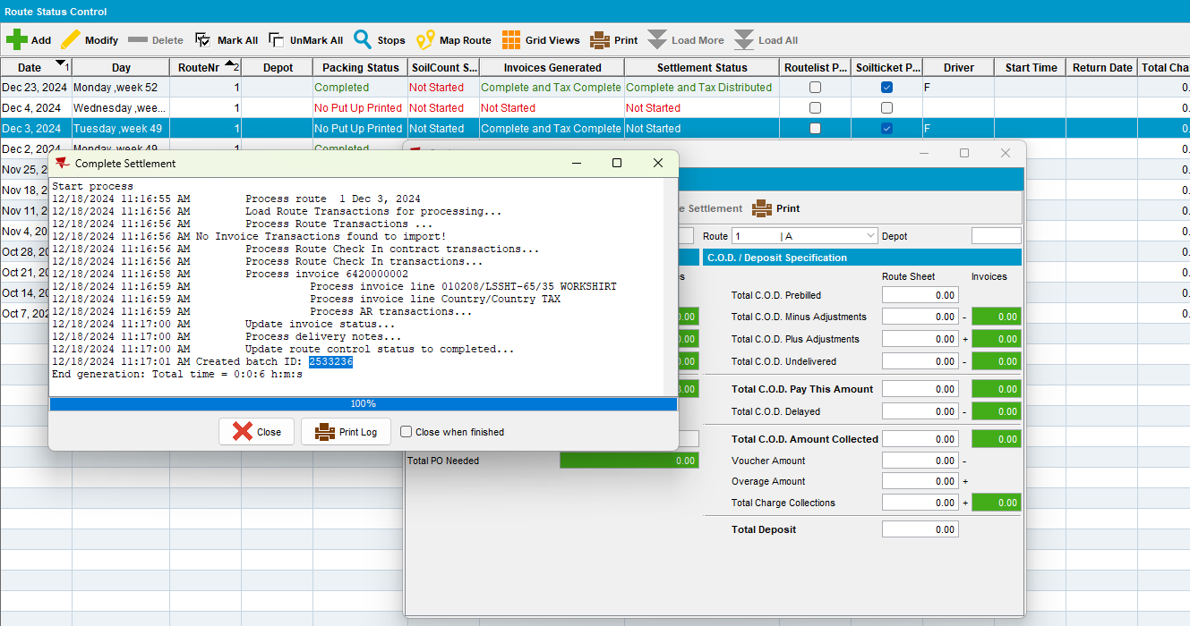
- Process Scheduler dlg: Run Import Vertex Tax BCI.

- Process Scheduler dlg: Create Credit Card transactions from payment schedule
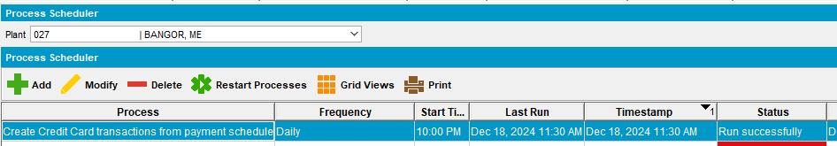
- Credit Card Transactions dlg: Settle the transaction
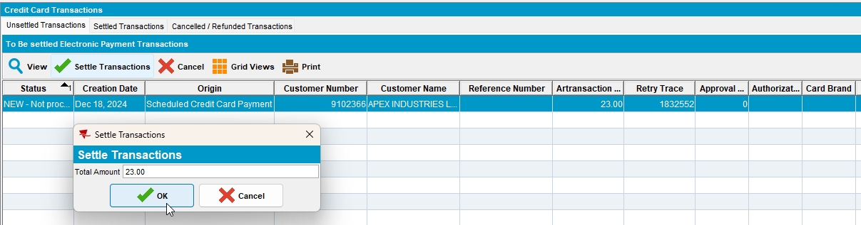
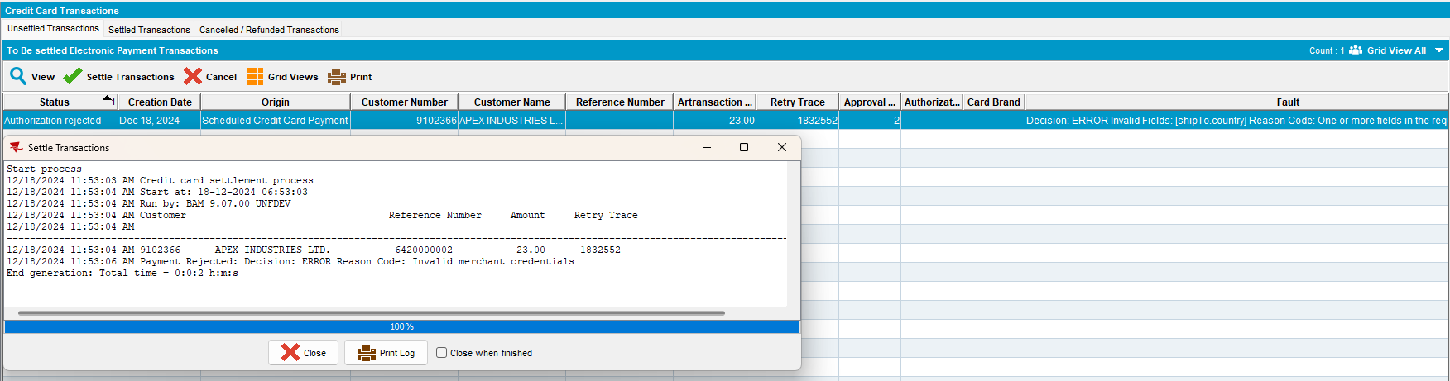
The error occurred of the incorrect ss values.
- System Settings dlg: Change the ss CREDITCARDAMEXSTOREIDCA, CREDITCARDSTOREIDCA, CREDITCARDTERMINALIDCA , CREDITCARDAMEXTERMINALID with correct value. Switch the ones from US to the Canada.

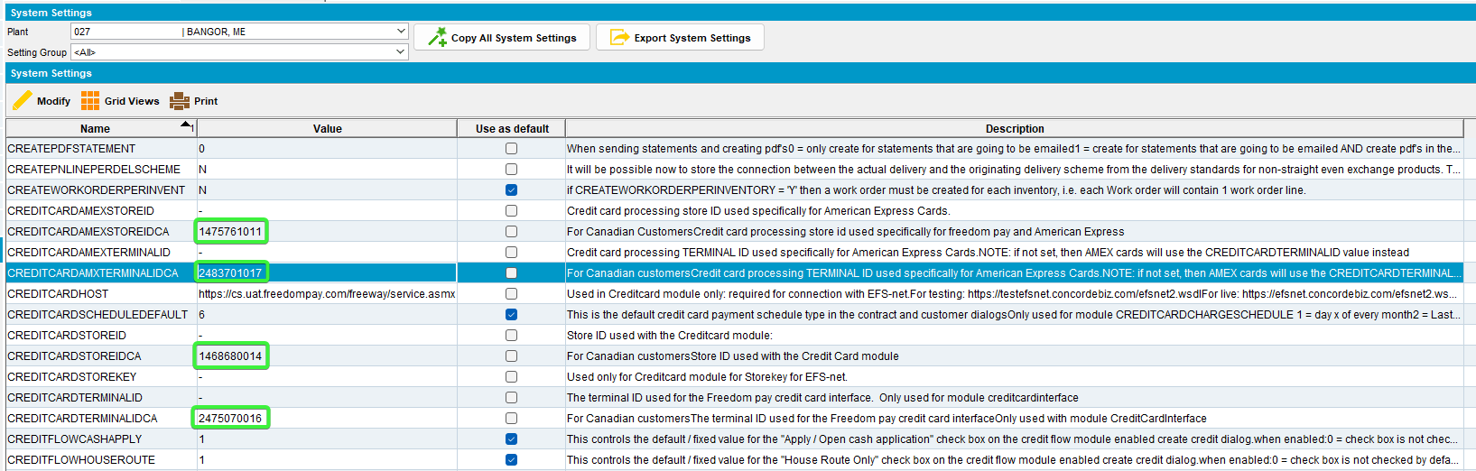

1.3 Payment Transaction

Expected behavior
This is a regular payment transaction and is called from the ProcessCreditCardTransactions when a scheduled payment is due.
section | field | value
 | storeID | If the Bill To customer’s county is not Canada, then  If card type is American Express (CustomerCreditCard.MaskedCardNumber starts with 34 or 37 and is length 15) and system setting CREDITCARDAMEXSTOREID is not blank, - or NULL  Then use CREDITCARDAMEXSTOREID  Else use System setting CREDITCARDSTOREID  If the Bill To customer’s county is Canada, then  If card type is American Express (CustomerCreditCard.MaskedCardNumber starts with 34 or 37 and is length 15) and system setting CREDITCARDAMEXSTOREIDCA is not blank, - or NULL  Then use CREDITCARDAMEXSTOREIDCA  Else use System setting CREDITCARDSTOREIDCA
 | terminalID | If the Bill To customer’s county is not Canada, then  If the card type is American Express (CustomerCreditCard.MaskedCardNumber starts with 34 or 37 and is length 15) and system setting CREDITCARDAMEXTERMINALID is not blank, - or NULL  Then use CREDITCARDAMEXTERMINALID  Else use System setting CREDITCARDTERMINALID  If the Bill To customer’s county is Canada, then  If card type is American Express (CustomerCreditCard.MaskedCardNumber starts with 34 or 37 and is length 15) and system setting CREDITCARDAMXTERMINALIDCA is not blank, - or NULL  Then use CREDITCARDAMEXTERMINALIDCA  Else use System setting CREDITCARDTERMINALIDCA  Note The Canadian version of the system setting CREDITCARDAMEXTERMINALID is spelt slightly differently (AMX not AMEX) due to field length limits
ShipFrom | postalCode | f the route of the invoice (invoiceheader.route_id) has a depot (route.depot_id) then take the zip code from the depot address (depot.address_id.zipcode)  If the route of the invoice (invoiceheader.route_id) does not have a depot (route.depot_id is null) then take the zip code from the plant of the route (plant.address_id.zipcode)  If the invoice has no route (invoiceheader.routecontrol_id is NULL) then take the zip code from the plant of the invoice business unit (invoiceheader.invoicebusinessunit.plant.address.zipcode)

- Credit Card Transactions dlg: Try to settle the transaction again.
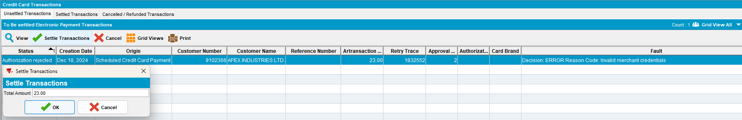

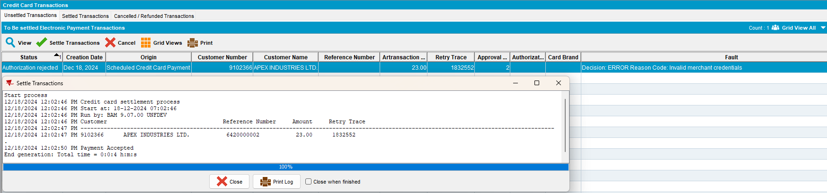
- PLSQL: Check the webservice log for the request.
select * from webservicelog wsl
where wsl.customer = 9102366
and wsl.requesttimestamp >= TO_DATE('2024-12-18 00:00:00', 'YYYY-MM-DD HH24:MI:SS')
order by wsl.requesttimestamp desc;
- Check the CLOB data for the request
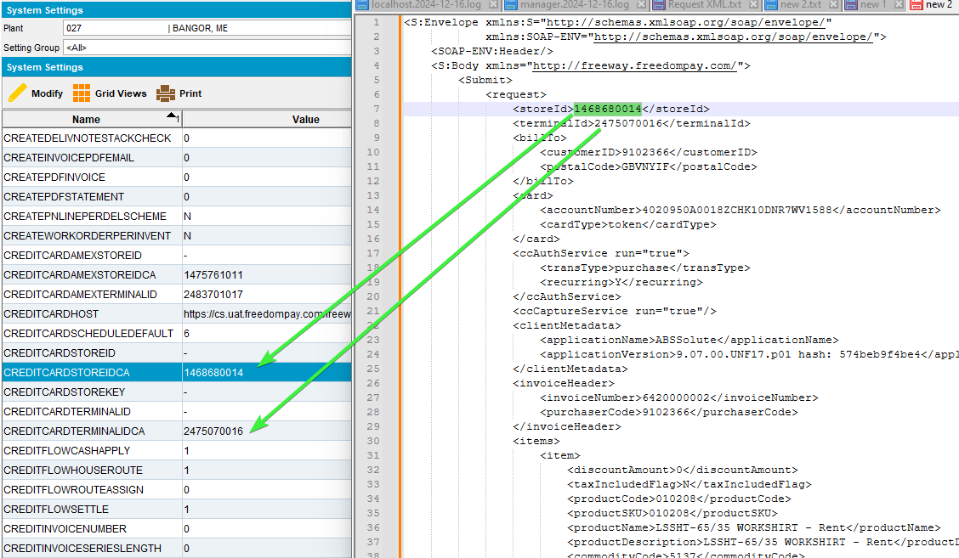
- Take the invoice number and check the zipcode of the invoice.
select ih.route_id, r.depot_id, a.zipcode DEPOTzipcode, ad.zipcode PLANTzipcode, ih.* from invoiceheader ih
left join route r on r.route_id = ih.route_id
left join depot d on d.depot_id = r.depot_id
left join plant p on p.plant_id = r.plant_id
left join address a on a.address_id = d.address_id
left join address ad on ad.address_id = p.address_id
where ih.invoicenumber = 6420000002;
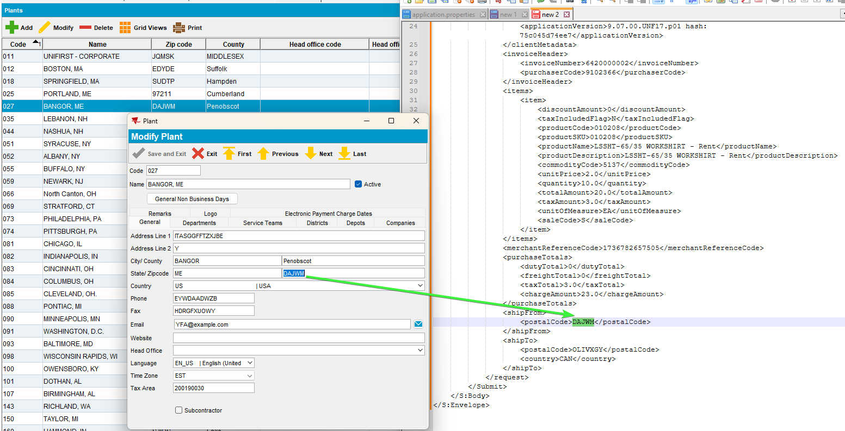
- Cash Application dlg: Go to Applied Credits, load the customer and UnApply the credit.
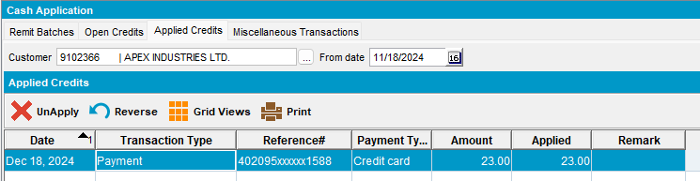

Tested OK

Test Case 02 – Invoice is attached to a route that belongs to a depot – Tested OK
Hash: 9.07.00.UNF17.p02 hash: 75c045d74ee7
BU: 013 Warwick

Expected behavior:
If the route of the invoice (invoiceheader.route_id) has a depot (route.depot_id) then take the zip code from the depot address (depot.address_id.zipcode)

Steps to reproduce:
- BU: Load a business unit that is from a different plant code, eg 013 have plant 044.
- Credit Card Transactions dlg: Find a customer with unsettled Transactions which is invoiced on a different bu.
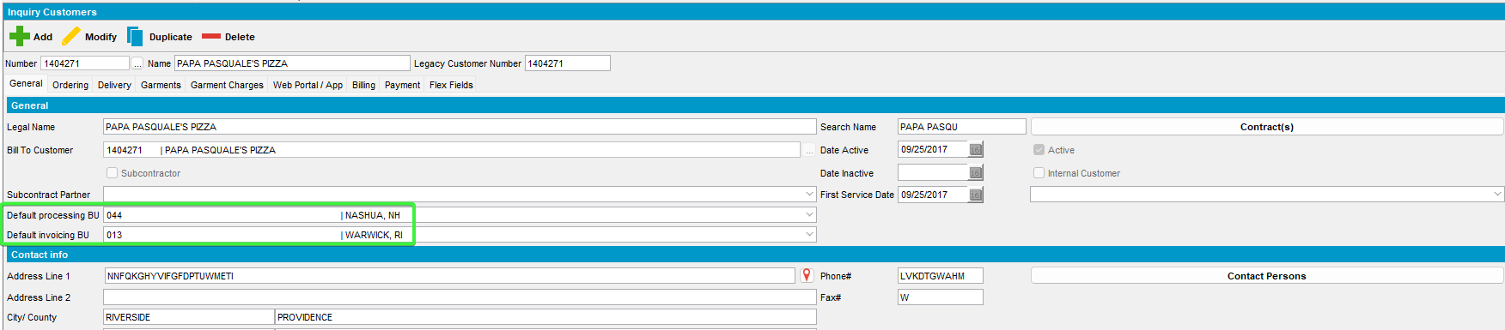
- Cash Applications dlg: Applied credits tab and unapply a credit.
- Customers dlg: Payment tab, switch to payment method credit card and add a card, eg:
02A600C0170018008292;4020********1588=3008?*2B4ABDC89C69D6B588317981FE7CA3B0EC94393DD463AA55000000000000000000000000000000000000000038333054393633393730FFFF987654001B000140625C03
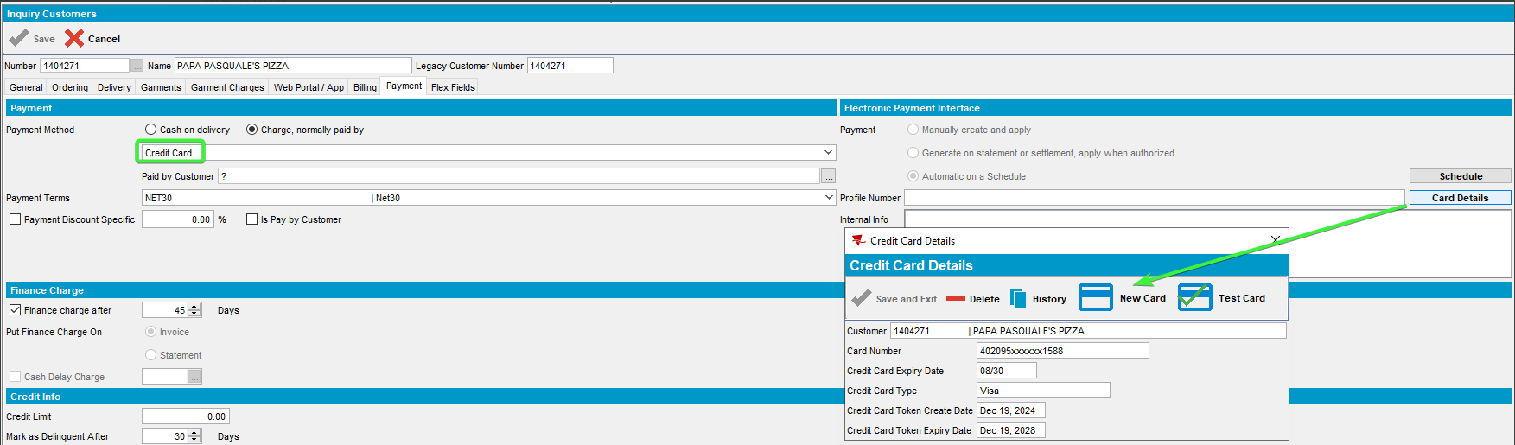
- Save and exit.
- Cash Application dlg: Applied credits, load the customer 1404271 and UnApply a credit.
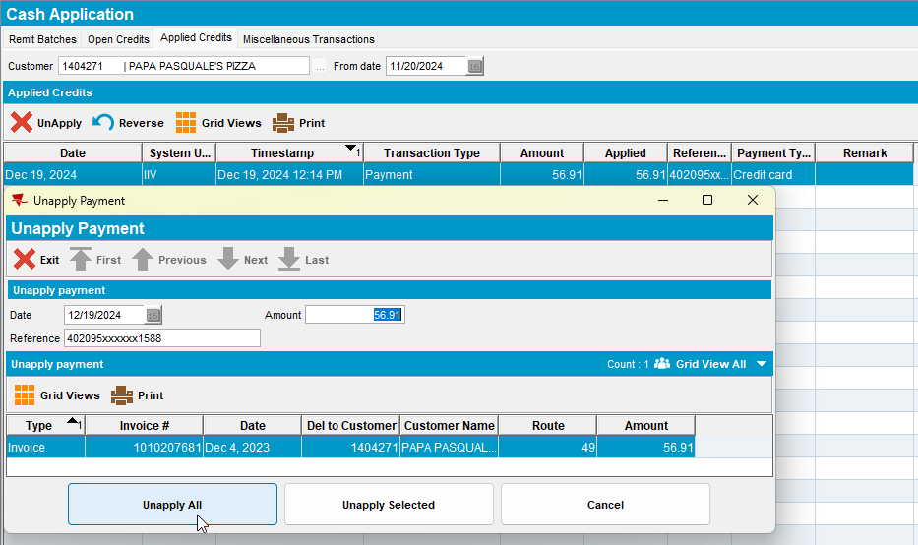
Or find an unsettled transaction
- Credit Card Transactions dlg: Unsettled Transactions tab for customer 1404271 and settle the transaction for invoice 1010209992
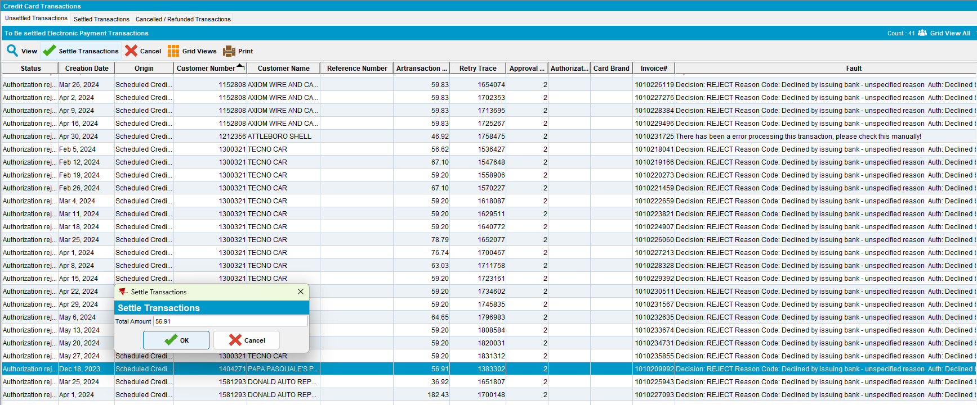
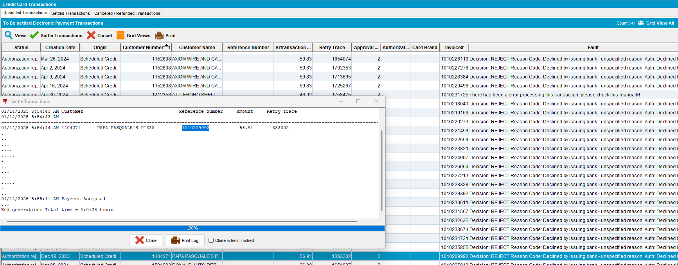
- Check that the invoice have a route_id.

select ih.route_id, r.depot_id, a.zipcode DEPOTzipcode, ad.zipcode PLANTzipcode, ih.* from invoiceheader ih
left join route r on r.route_id = ih.route_id
left join depot d on d.depot_id = r.depot_id
left join plant p on p.plant_id = r.plant_id
left join address a on a.address_id = d.address_id
left join address ad on ad.address_id = p.address_id
where ih.invoicenumber = 1010209992;

- Check for the entry in the WebServiceLog table
select * from webservicelog wsl
where wsl.customer = '1404271'
and wsl.requesttimestamp >= TO_DATE('2025-01-14 00:00:00', 'YYYY-MM-DD HH24:MI:SS')
order by wsl.requesttimestamp desc;

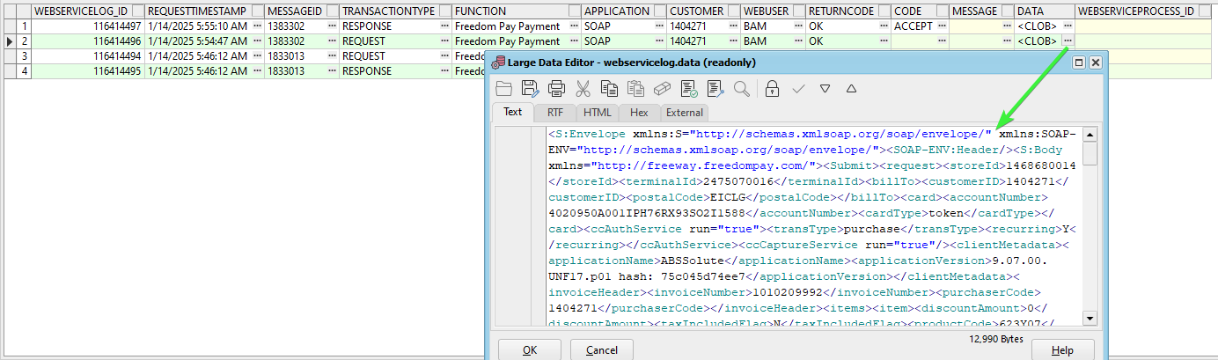
- Copy the Clob data in a notepad and format it in xml.
- Plants dlg: Open the plant 044 and check the depots for the customer invoicing bu 013. Compare with the <shipFrom> from the request.
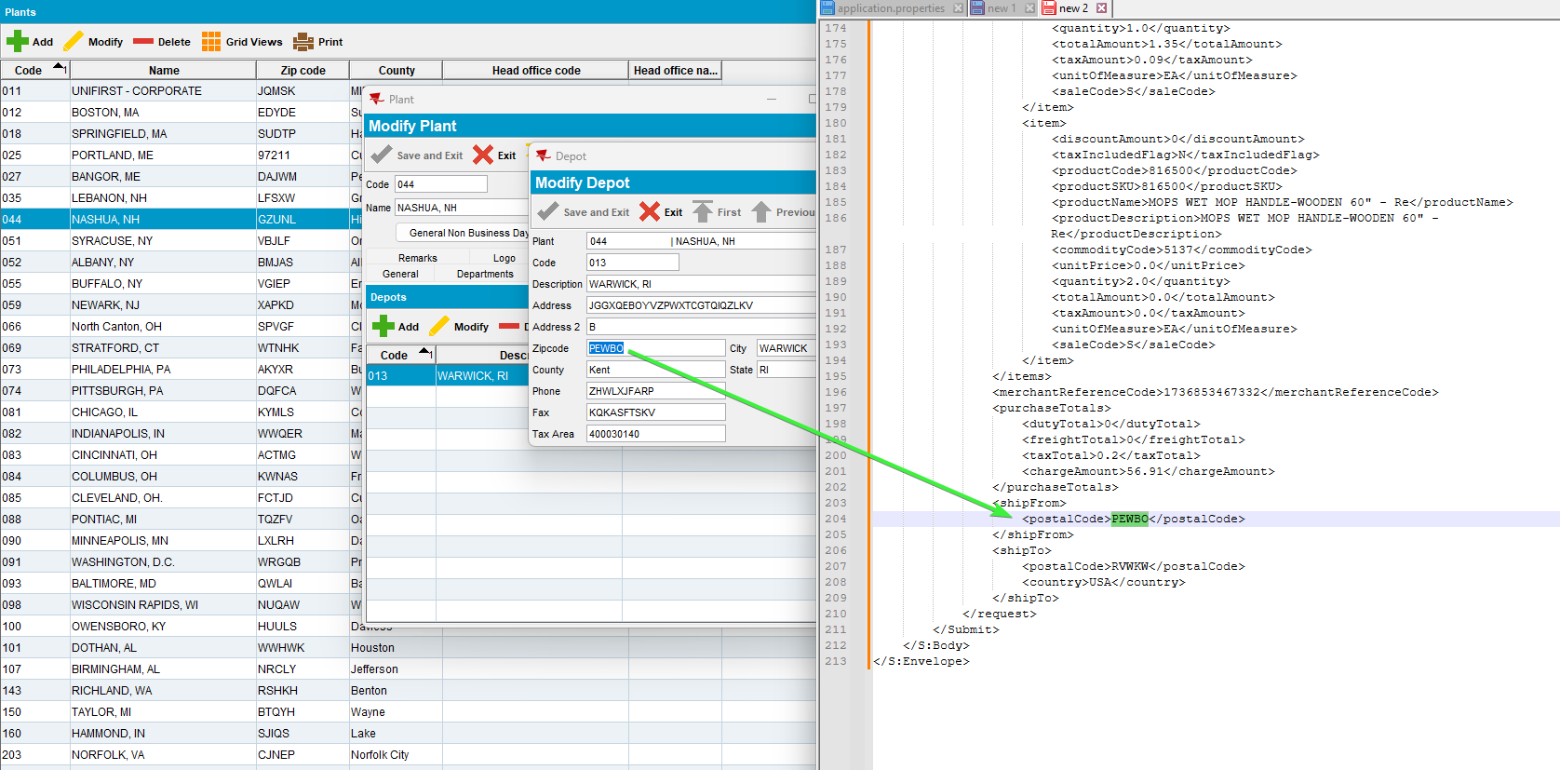
Tested OK

Test Case 03 – Invoice is attached to a route that does not belongs to a depot – Tested OK
Hash: 9.07.00.UNF17.p02 hash: 75c045d74ee7

Expected behavior:
If the route of the invoice (invoiceheader.route_id) does not have a depot (route.depot_id is null) then take the zip code from the plant of the route (plant.address_id.zipcode)

Steps to reproduce:
- Find a customer 2539491 that is invoiced on the bu of a plant.
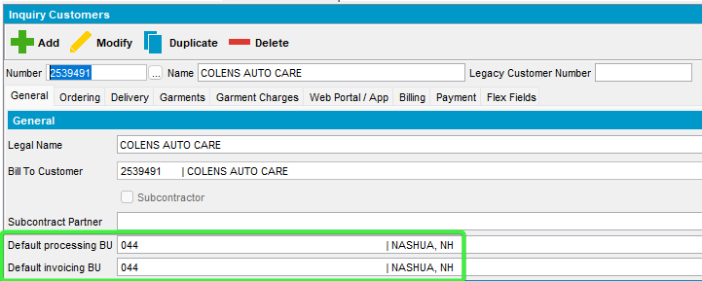
- Credit Card Transactions dlg: Find an invoice related to the customer.
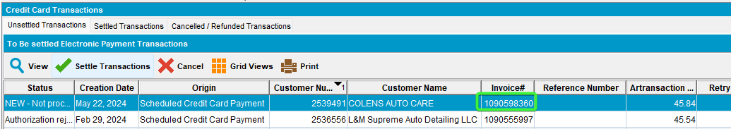
- Check that it doesn’t have a depot_id
select ih.route_id, r.depot_id, a.zipcode DEPOTzipcode, ad.zipcode PLANTzipcode, ih.* from invoiceheader ih
left join route r on r.route_id = ih.route_id
left join depot d on d.depot_id = r.depot_id
left join plant p on p.plant_id = r.plant_id
left join address a on a.address_id = d.address_id
left join address ad on ad.address_id = p.address_id
where ih.invoicenumber = 1090598360;

- Customers dlg: Configure the payment with a valid card. Payment tab, switch to payment method credit card and add a card, eg:
02A600C0170018008292;4020********1588=3008?*2B4ABDC89C69D6B588317981FE7CA3B0EC94393DD463AA55000000000000000000000000000000000000000038333054393633393730FFFF987654001B000140625C03
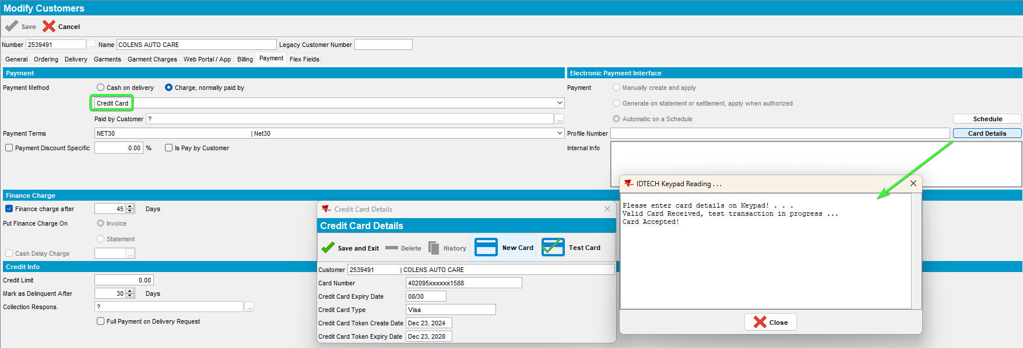
- Save and exit.
- Credit Card Transactions dlg: Settle an invoice from our customer.
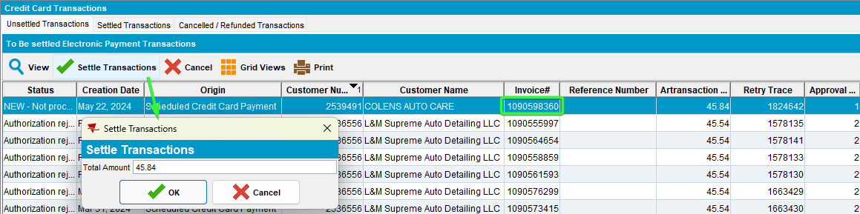
- PLSQL check the webservicelog
select * from webservicelog wsl
where wsl.customer = '2539491'
and wsl.requesttimestamp >= TO_DATE('2024-12-23 00:00:00', 'YYYY-MM-DD HH24:MI:SS')
order by wsl.requesttimestamp desc;
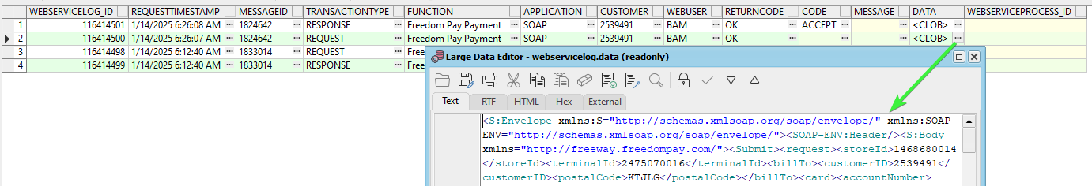
- Check the request clob data and look for the shipFrom field to have the zipcode of the plant.
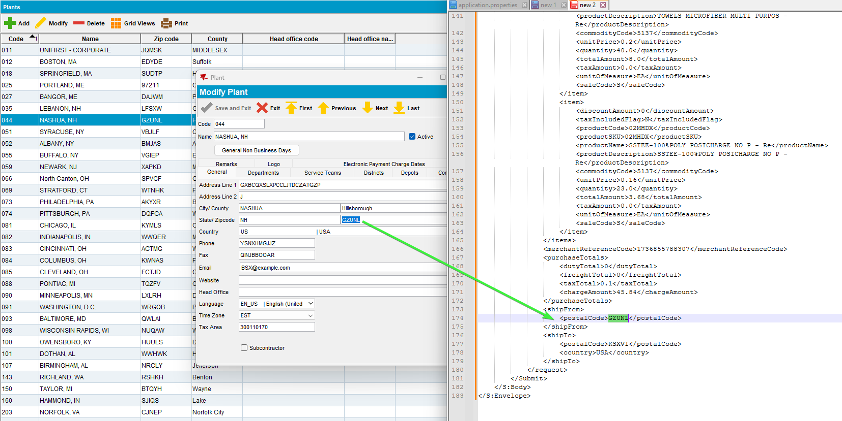
Tested OK

Test Case 04 – Credit Card is AMEX, Bill-to=Del-to payment triggered from Credit Card Transactions – Tested OK
Hash: 9.07.00.UNF17.p02 hash: 75c045d74ee7
BU: 710 FREDERICTON/SAINT JOHN

4.1 Verify Transaction & create token

Expected behavior
This is used when a new card is created via the ID Tech device and we want to convert the ID Tech data into a token for reuse and process a zero-value transaction on the card to make sure its valid.
storeID | If the Bill To customer’s county is not Canada, then  If card type is American Express (CustomerCreditCard.MaskedCardNumber starts with 34 or 37 and is length 15) and system setting CREDITCARDAMEXSTOREID is not blank, - or NULL  Then use CREDITCARDAMEXSTOREID  Else use System setting CREDITCARDSTOREID  If the Bill To customer’s county is Canada, then  If card type is American Express (CustomerCreditCard.MaskedCardNumber starts with 34 or 37 and is length 15) and system setting CREDITCARDAMEXSTOREIDCA is not blank, - or NULL  Then use CREDITCARDAMEXSTOREIDCA  Else use System setting CREDITCARDSTOREIDCA
terminalID | If the Bill To customer’s county is not Canada, then  If the card type is American Express (CustomerCreditCard.MaskedCardNumber starts with 34 or 37 and is length 15) and system setting CREDITCARDAMEXTERMINALID is not blank, - or NULL  Then use CREDITCARDAMEXTERMINALID  Else use System setting CREDITCARDTERMINALI  If the Bill To customer’s county is Canada, then  If card type is American Express (CustomerCreditCard.MaskedCardNumber starts with 34 or 37 and is length 15) and system setting CREDITCARDAMXTERMINALIDCA is not blank, - or NULL  Then use CREDITCARDAMEXTERMINALIDCA  Else use System setting CREDITCARDTERMINALIDCA  Note The Canadian version of the system setting CREDITCARDAMEXTERMINALID is spelt slightly differently (AMX not AMEX) due to field length limits

- Customers dlg: Load customer 9102366, remove the card and add an AMEX card.
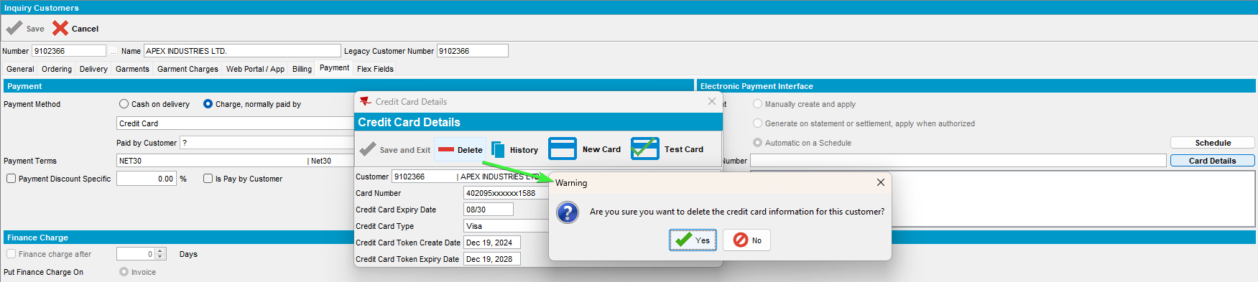
- Customers dlg: Add an AMEX card
CARD BRAND : AMERICAN EXPRESS
CARD NUMBER : 371149403659671
NAME : Shinta Finckh
COUNTRY : UNITED STATES
CVV/CVC : 1374
EXPIRY : 06/2030
02A500C0170017008292;3711*******9671=3006?*70132EDB349FA5486067D15A6AD6F7474DD0AD9480F698B3000000000000000000000000000000000000000038333054393633393730FFFF987654001B0001423C0403
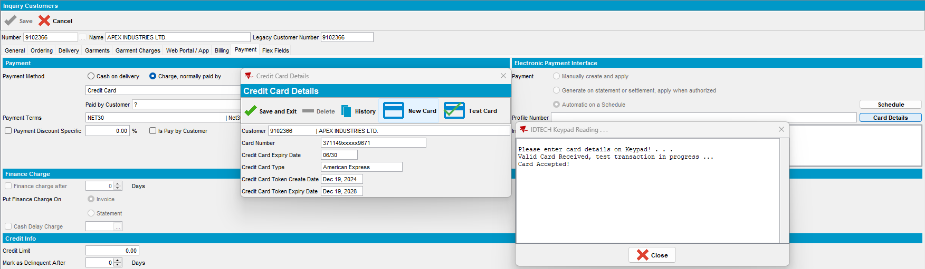
- Check in PLSQL
select * from webservicelog wsl
where wsl.customer = 9102366
and wsl.requesttimestamp >= TO_DATE('2024-12-19 00:00:00', 'YYYY-MM-DD HH24:MI:SS')
order by wsl.requesttimestamp desc;
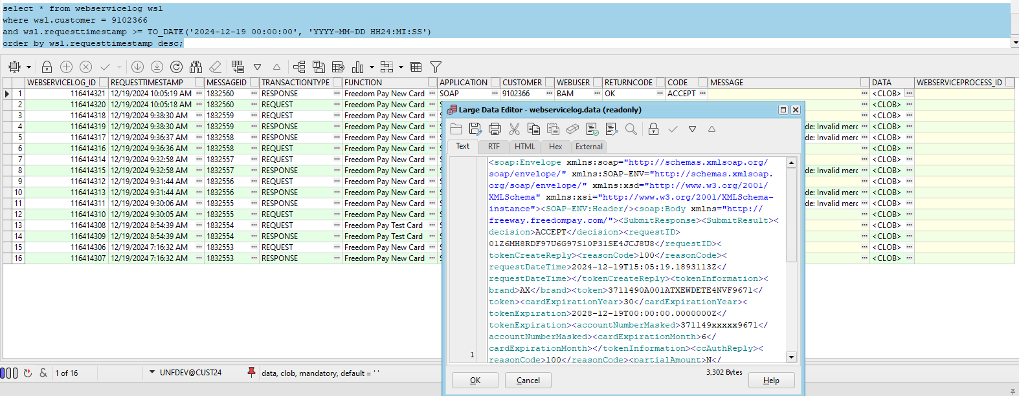

Check the Request entry.
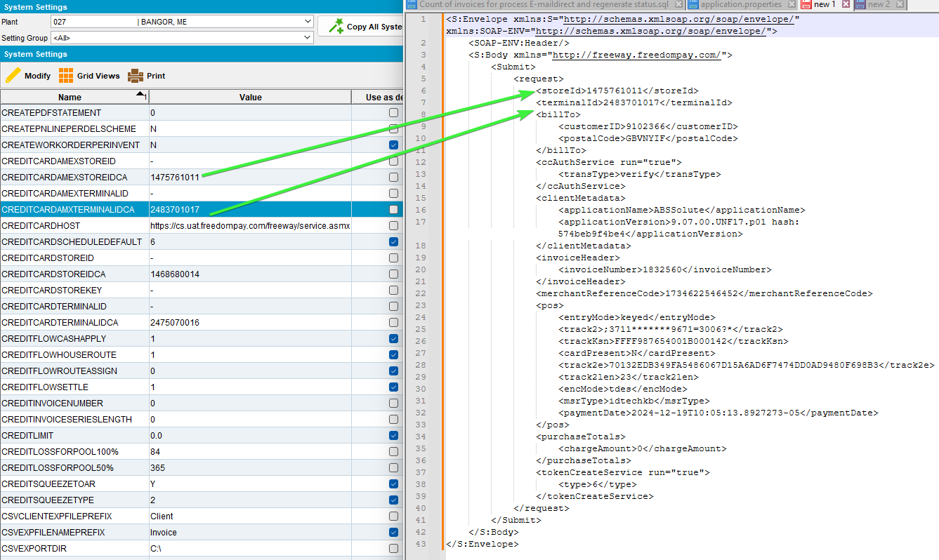
- System Settings dlg: Change the CREDITCARDAMEXSTOREIDCA – 1475761011 and CREDITCARDAMXTERMINALIDCA – 2483701017 to have null value
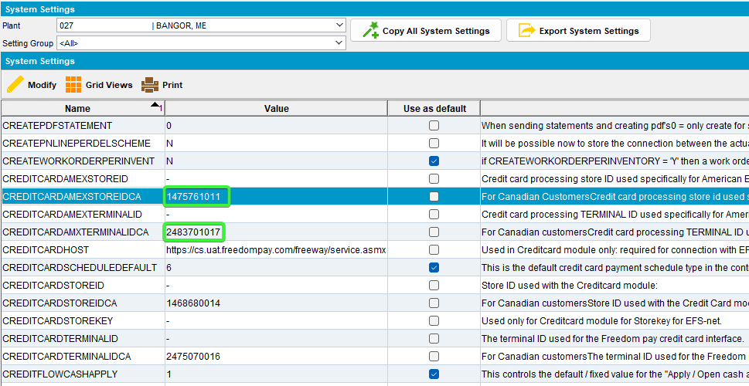

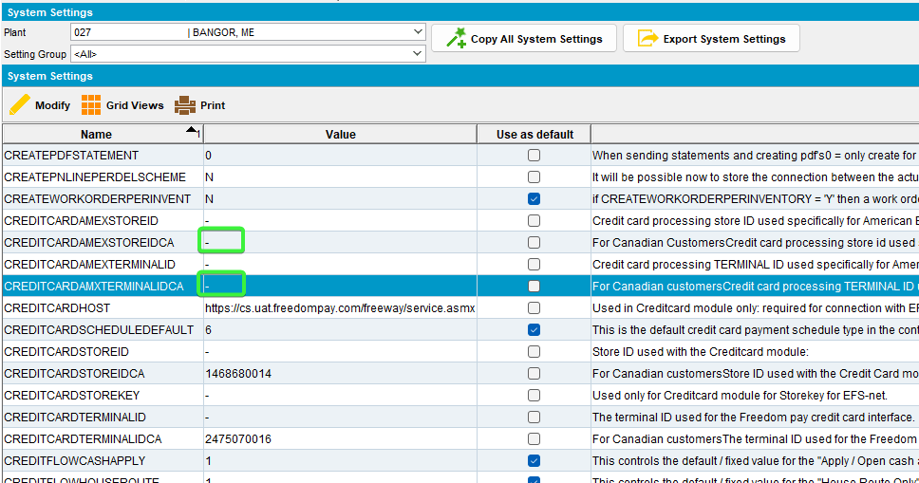

- Customers dlg: Remove the credit card and add it again.
CARD BRAND : AMERICAN EXPRESS
CARD NUMBER : 371149403659671
NAME : Shinta Finckh
COUNTRY : UNITED STATES
CVV/CVC : 1374
EXPIRY : 06/2030
02A500C0170017008292;3711*******9671=3006?*70132EDB349FA5486067D15A6AD6F7474DD0AD9480F698B3000000000000000000000000000000000000000038333054393633393730FFFF987654001B0001423C0403
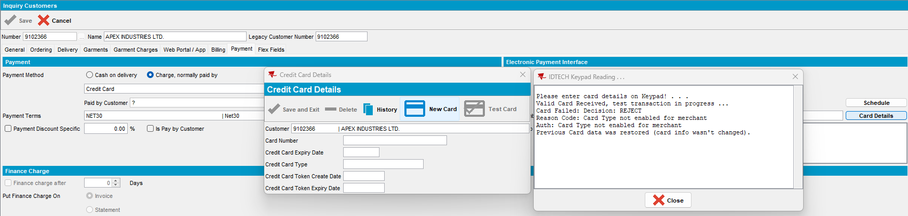
- Check the request.
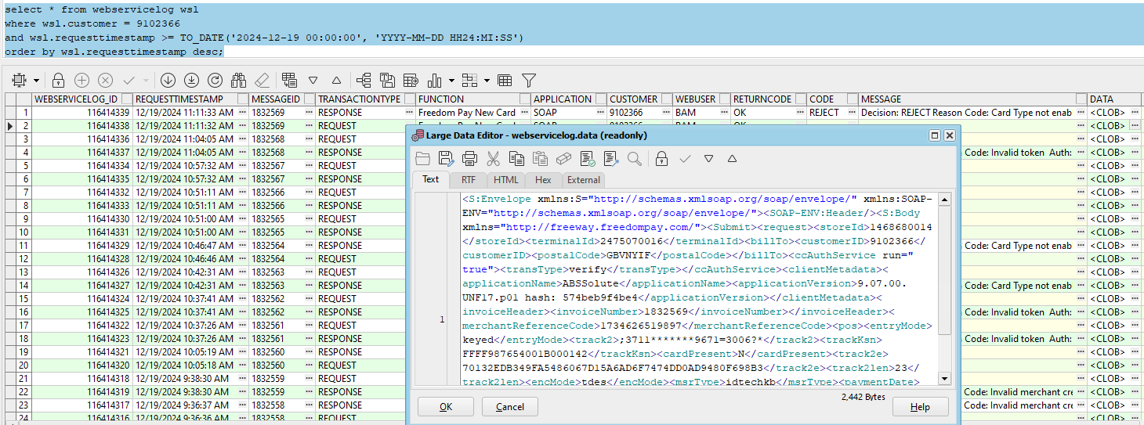
- Check the request the storeId and terminalId were reverted from AMEX ss to non AMEX CA

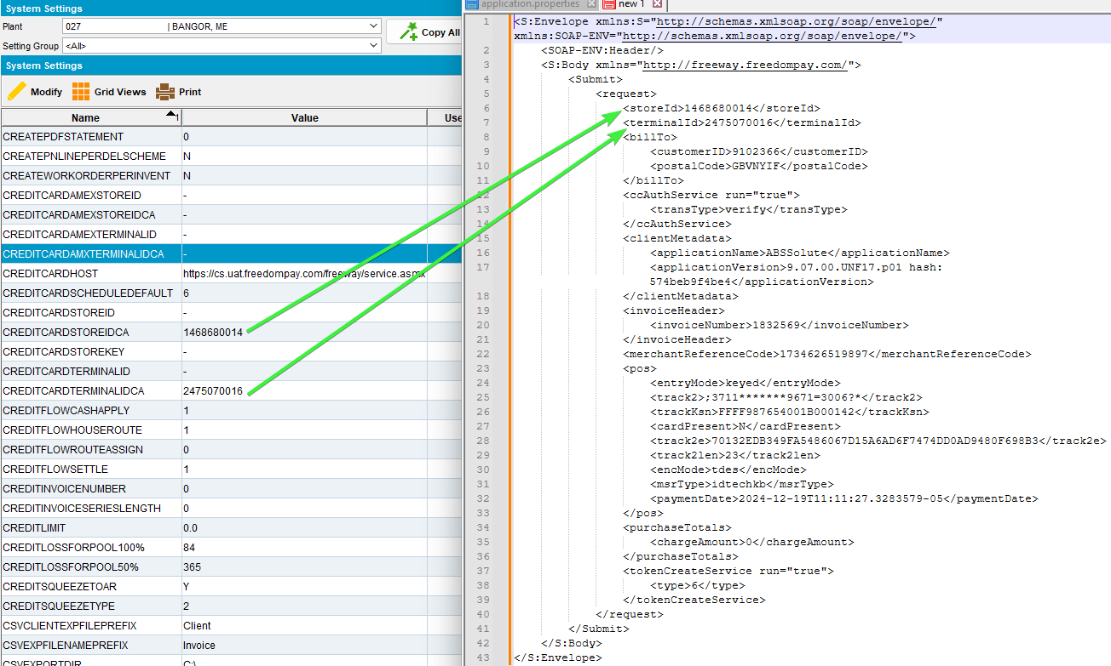

4.2 Verify transaction

Expected behavior
This is used by the “test card” button and processes a zero value transaction on the card to make sure its valid. This can also be used to update the token so if the token expiry date is in the grace period (expiry date > system date -30 days) then a new token will automatically be returned in the response.
- System Settings dlg: Make sure you put back the ss values CREDITCARDAMEXSTOREIDCA – 1475761011 and CREDITCARDAMXTERMINALIDCA – 2483701017
- Customers dlg: Test the Card
02A500C0170017008292;3711*******9671=3006?*70132EDB349FA5486067D15A6AD6F7474DD0AD9480F698B3000000000000000000000000000000000000000038333054393633393730FFFF987654001B0001423C0403
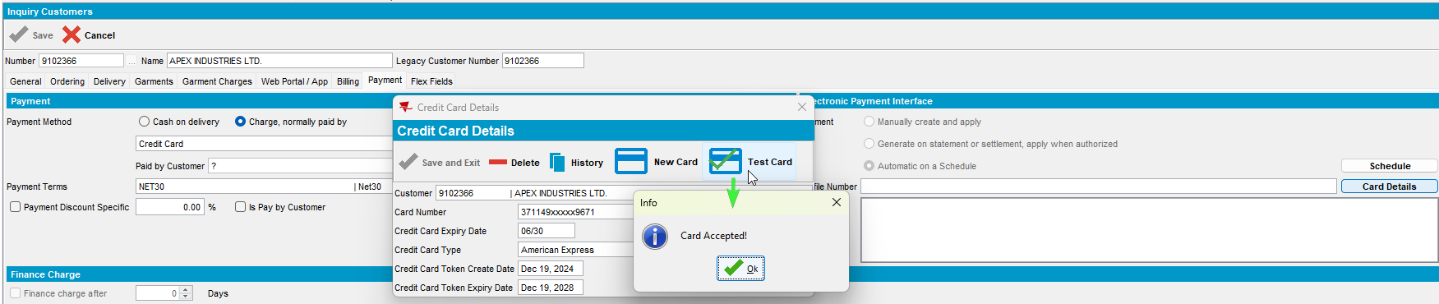
- Check the PLSQL the request.
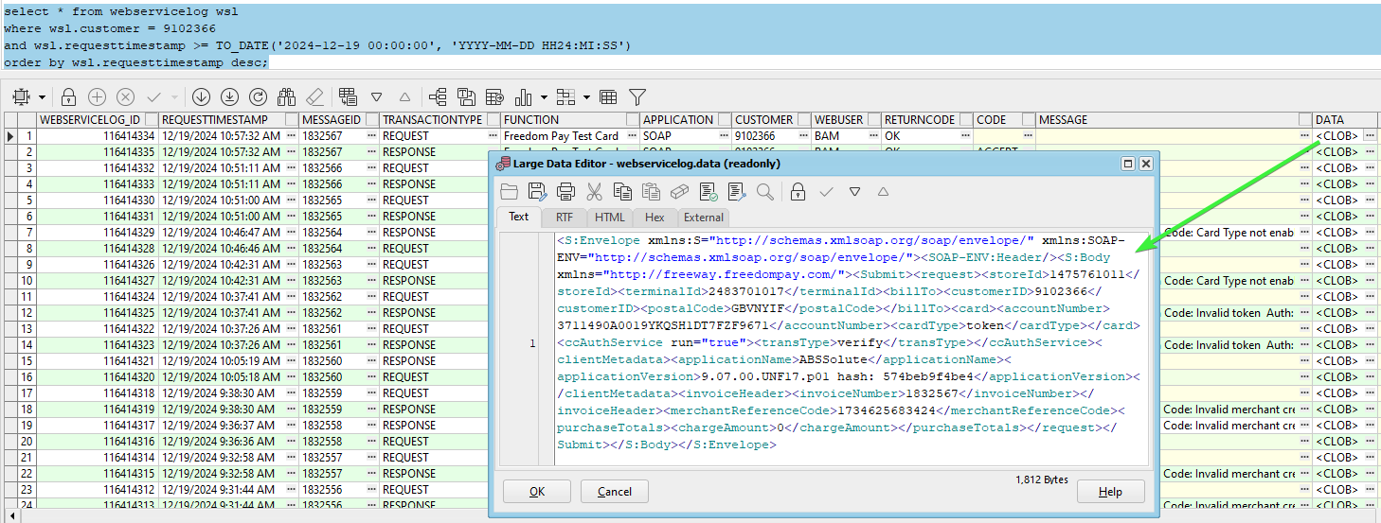
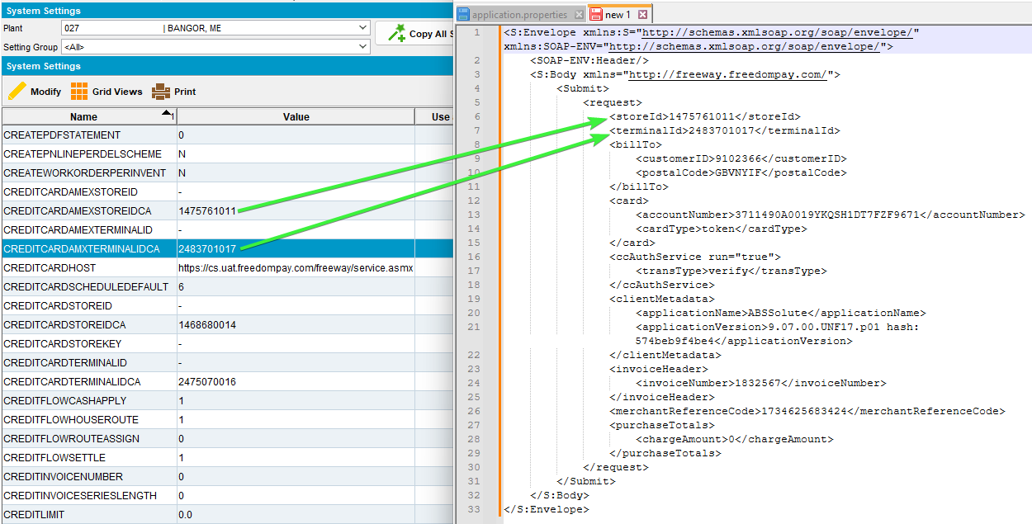
- System Settings dlg: Change the CREDITCARDAMEXSTOREIDCA – 1475761011 and CREDITCARDAMXTERMINALIDCA – 2483701017 to have null value

- Customers dlg: Test the card.
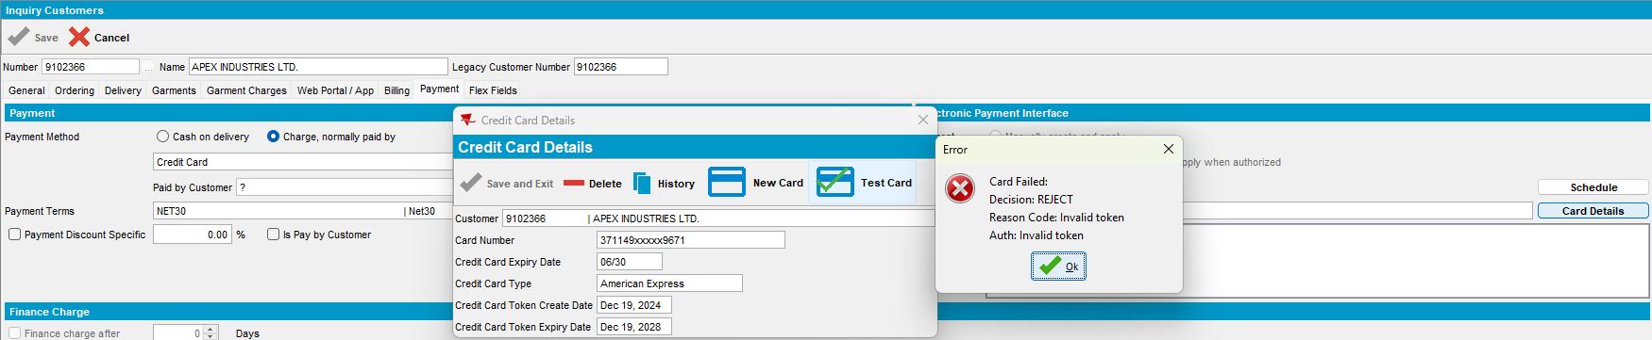
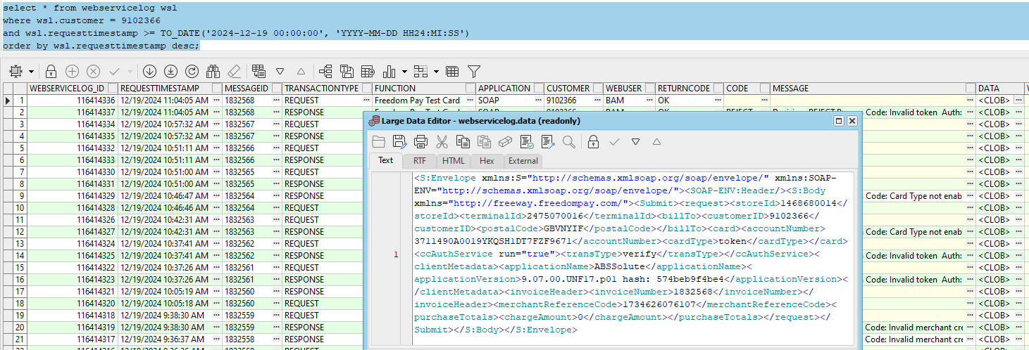
- Check the request the storeId and terminalId were reverted from AMEX ss to non AMEX CA
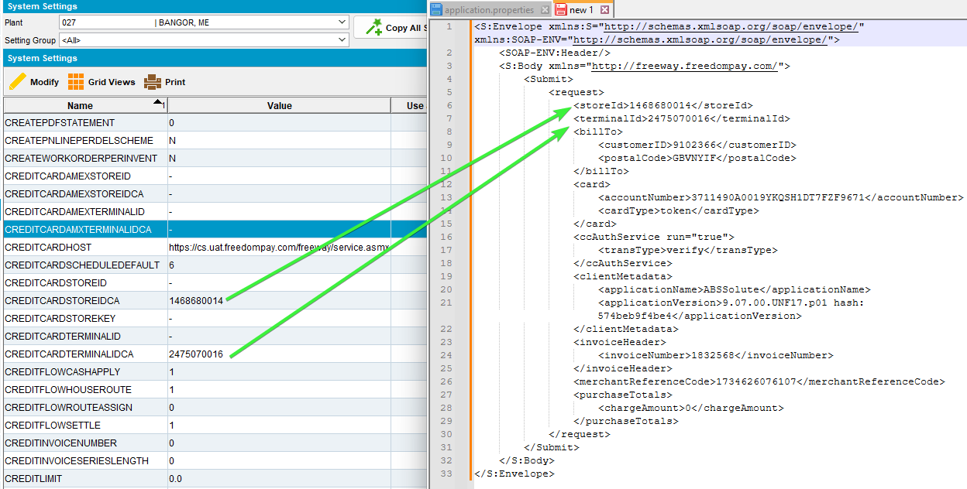

4.3 Payment Transaction

Expected behavior
This is a regular payment transaction and is called from the ProcessCreditCardTransactions when a scheduled payment is due.
storeId / TerminalID
If the Bill To customer’s county is Canada, then
If card type is American Express (CustomerCreditCard.MaskedCardNumber starts with 34 or 37 and is length 15) and system setting CREDITCARDAMEXSTOREIDCA is not blank, - or NULL
Then use CREDITCARDAMEXSTOREIDCA
Else use System setting CREDITCARDSTOREIDCA

shipFrom
If the route of the invoice (invoiceheader.route_id) has a depot (route.depot_id) then take the zip code from the depot address (depot.address_id.zipcode)
If the route of the invoice (invoiceheader.route_id) does not have a depot (route.depot_id is null) then take the zip code from the plant of the route (plant.address_id.zipcode)
If the invoice has no route (invoiceheader.routecontrol_id is NULL then take the zip code from the plant of the invoice business unit (invoiceheader.invoicebusinessunit.plant.address.zipcode)
- System Settings dlg: Make sure you put back the ss values CREDITCARDAMEXSTOREIDCA – 1475761011 and CREDITCARDAMXTERMINALIDCA – 2483701017
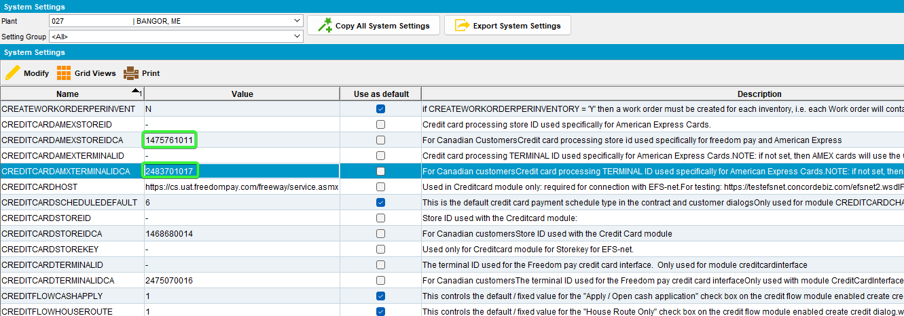
- Customers dlg: Put back the AMEX card.
02A500C0170017008292;3711*******9671=3006?*70132EDB349FA5486067D15A6AD6F7474DD0AD9480F698B3000000000000000000000000000000000000000038333054393633393730FFFF987654001B0001423C0403
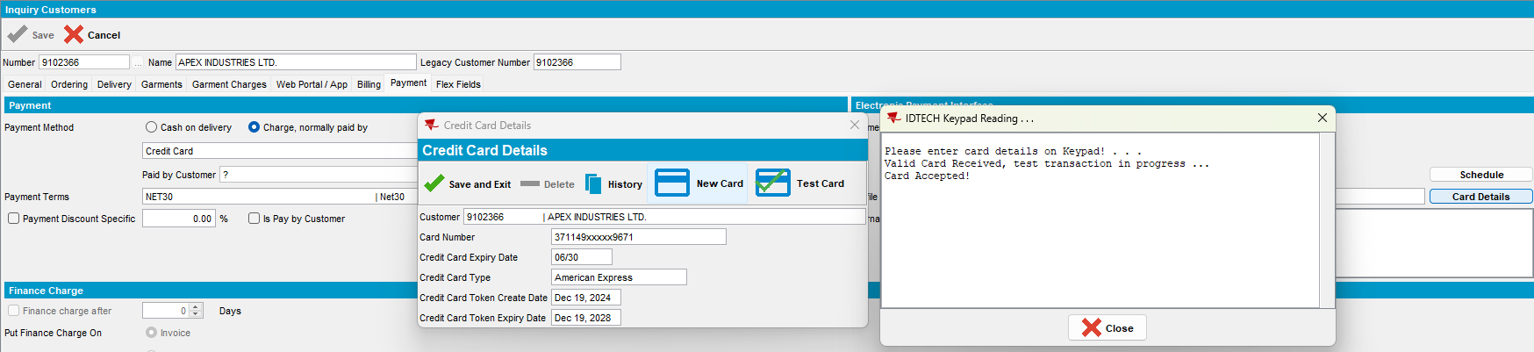
- Cash application dlg: Un-apply the used credit.
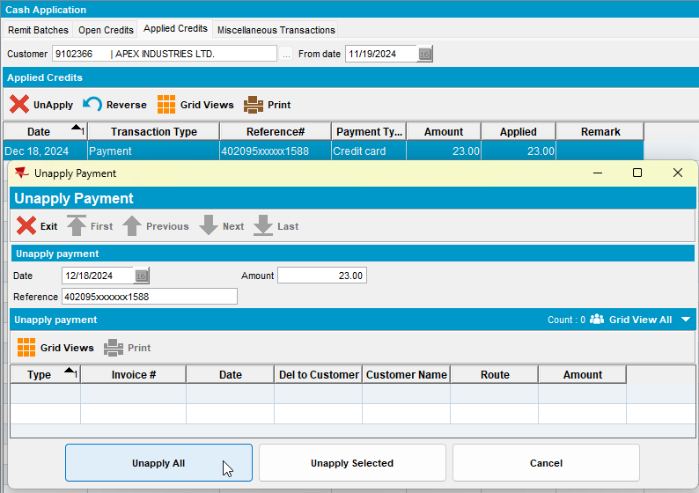
- Credit Card Transactions dlg: Settle again the transaction for the customer.
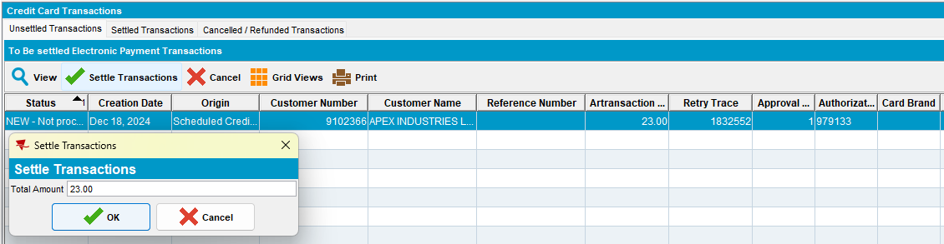

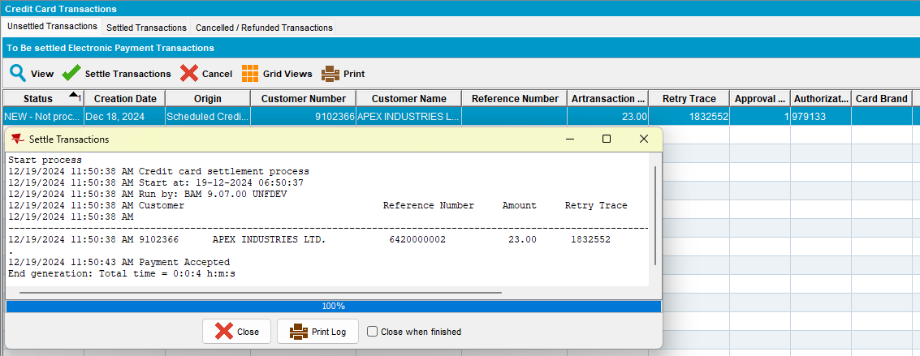
- PLSQL: Check the webservice log for the request.
select * from webservicelog wsl
where wsl.customer = 9102366
and wsl.requesttimestamp >= TO_DATE('2024-12-19 00:00:00', 'YYYY-MM-DD HH24:MI:SS')
order by wsl.requesttimestamp desc;
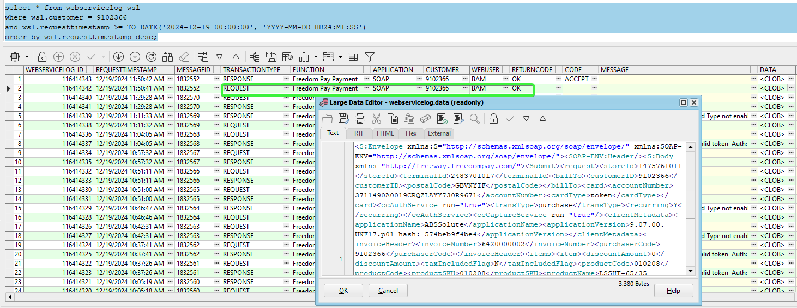
- Check the CLOB data for the request
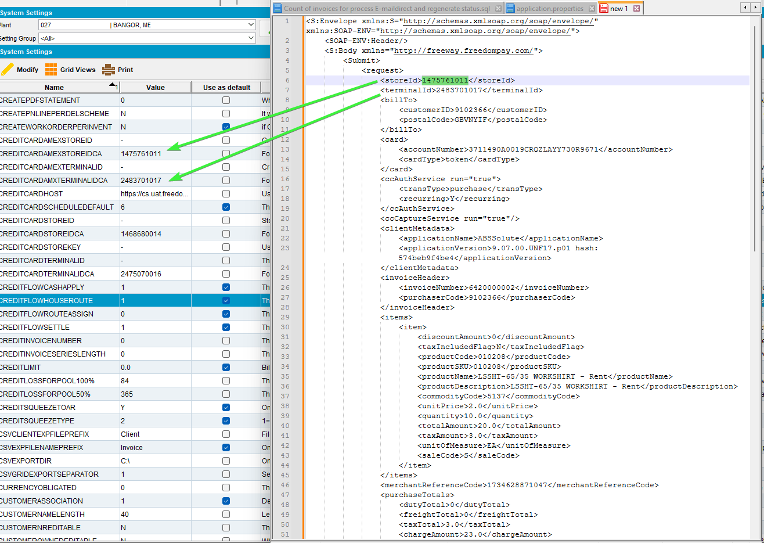
- Take the invoice number and check the zipcode of the invoice.
select ih.route_id, r.depot_id, a.zipcode DEPOTzipcode, ad.zipcode PLANTzipcode, ih.* from invoiceheader ih
left join route r on r.route_id = ih.route_id
left join depot d on d.depot_id = r.depot_id
left join plant p on p.plant_id = r.plant_id
left join address a on a.address_id = d.address_id
left join address ad on ad.address_id = p.address_id
where ih.invoicenumber = 6420000002;

- Cash Application dlg: Go to Applied Credits, load the customer and UnApply the credit.
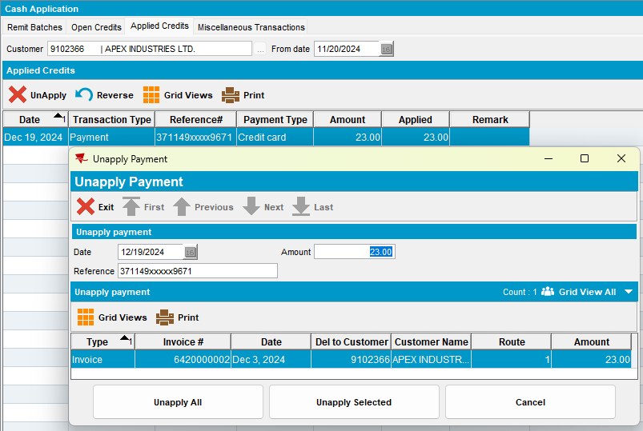
- System Settings dlg: Change the CREDITCARDAMEXSTOREIDCA – 1475761011 and CREDITCARDAMXTERMINALIDCA – 2483701017 to have null value

- Credit Card Transactions dlg: Settle again the transaction for the customer.
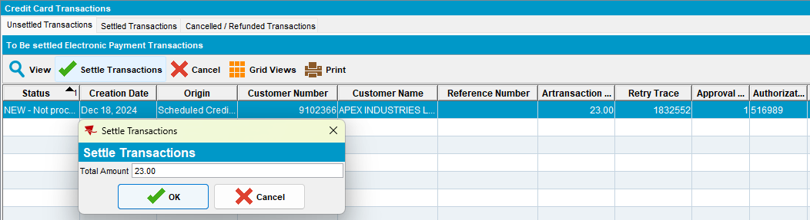

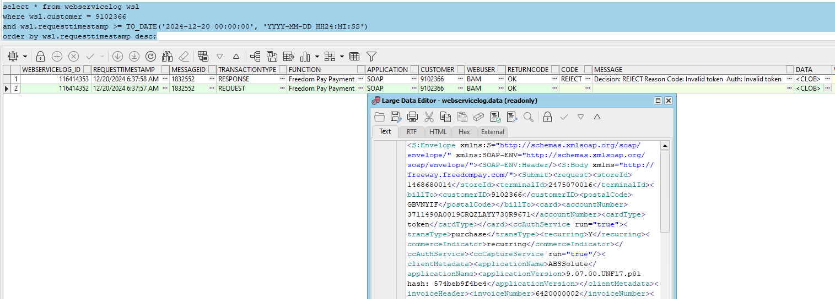
- Check the request the storeId and terminalId were reverted from AMEX ss to non AMEX CA
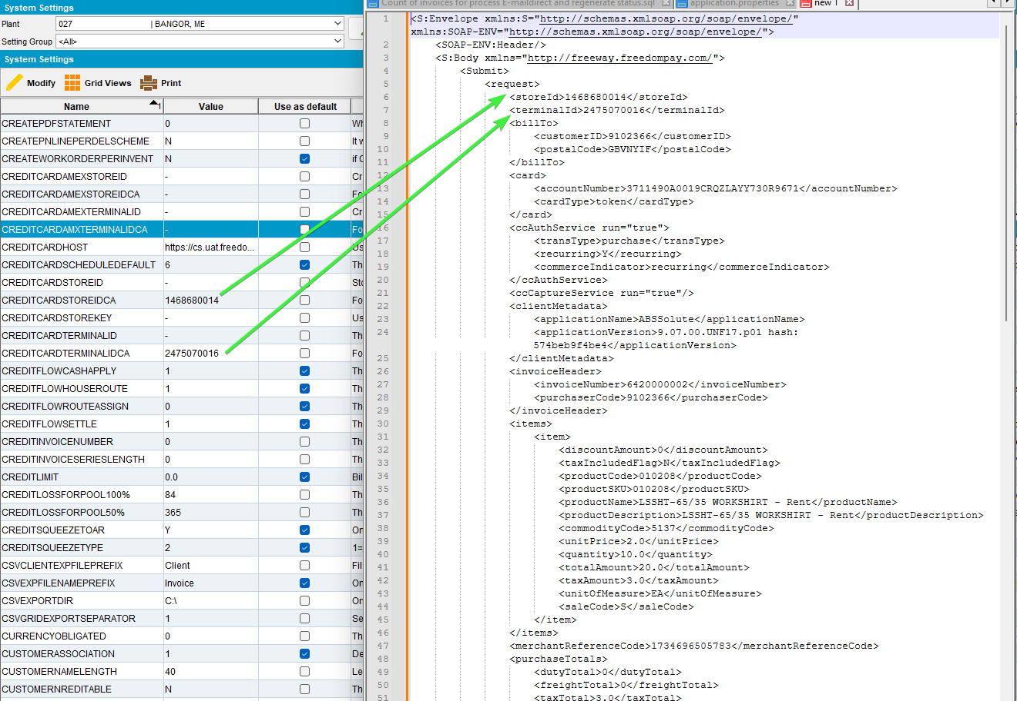
- Take the invoice number and check the zipcode of the invoice.
select ih.route_id, r.depot_id, a.zipcode DEPOTzipcode, ad.zipcode PLANTzipcode, ih.* from invoiceheader ih
left join route r on r.route_id = ih.route_id
left join depot d on d.depot_id = r.depot_id
left join plant p on p.plant_id = r.plant_id
left join address a on a.address_id = d.address_id
left join address ad on ad.address_id = p.address_id
where ih.invoicenumber = 6420000002;

- System Settings dlg: Change ss to the original values, the CREDITCARDAMEXSTOREIDCA – 1475761011 and CREDITCARDAMXTERMINALIDCA – 2483701017
Tested OK

Test Case 05 - AMEX Bill-to = Del-to , payment triggered from Take Electronic Payment process scheduler – Tested OK
Hash: 9.07.00.UNF17.p02 hash: 75c045d74ee7

Expected behavior
This is a regular payment transaction and is called from the ProcessCreditCardTransactions when a scheduled payment is due.
storeId / TerminalID
If the Bill To customer’s county is Canada, then
If card type is American Express (CustomerCreditCard.MaskedCardNumber starts with 34 or 37 and is length 15) and system setting CREDITCARDAMEXSTOREIDCA is not blank, - or NULL
Then use CREDITCARDAMEXSTOREIDCA
Else use System setting CREDITCARDSTOREIDCA
shipFrom
If the route of the invoice (invoiceheader.route_id) has a depot (route.depot_id) then take the zip code from the depot address (depot.address_id.zipcode)
If the route of the invoice (invoiceheader.route_id) does not have a depot (route.depot_id is null) then take the zip code from the plant of the route (plant.address_id.zipcode)
If the invoice has no route (invoiceheader.routecontrol_id is NULL then take the zip code from the plant of the invoice business unit (invoiceheader.invoicebusinessunit.plant.address.zipcode)
- Customers dlg: Use the same customer, make sure is the AMEX card.
02A500C0170017008292;3711*******9671=3006?*70132EDB349FA5486067D15A6AD6F7474DD0AD9480F698B3000000000000000000000000000000000000000038333054393633393730FFFF987654001B0001423C0403
- Cash application dlg: Un-apply the used credits.
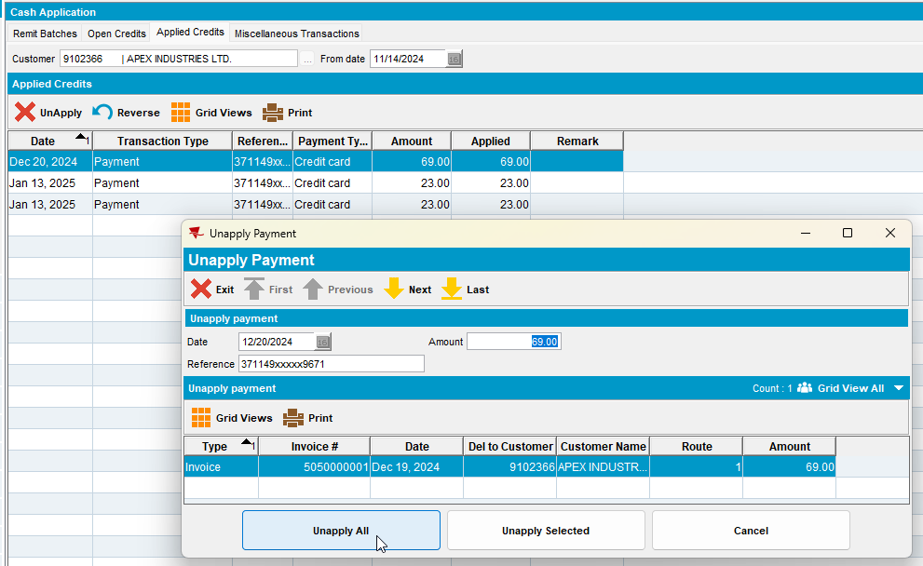
- Process Scheduler dlg: Run Take Electronic Payment process.
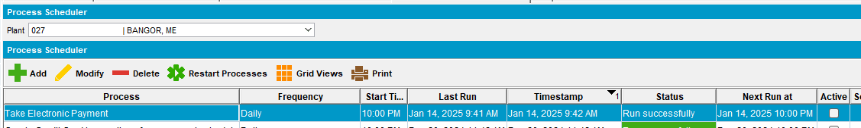
- Cash Application dlg: Check the applied credits for our customer.
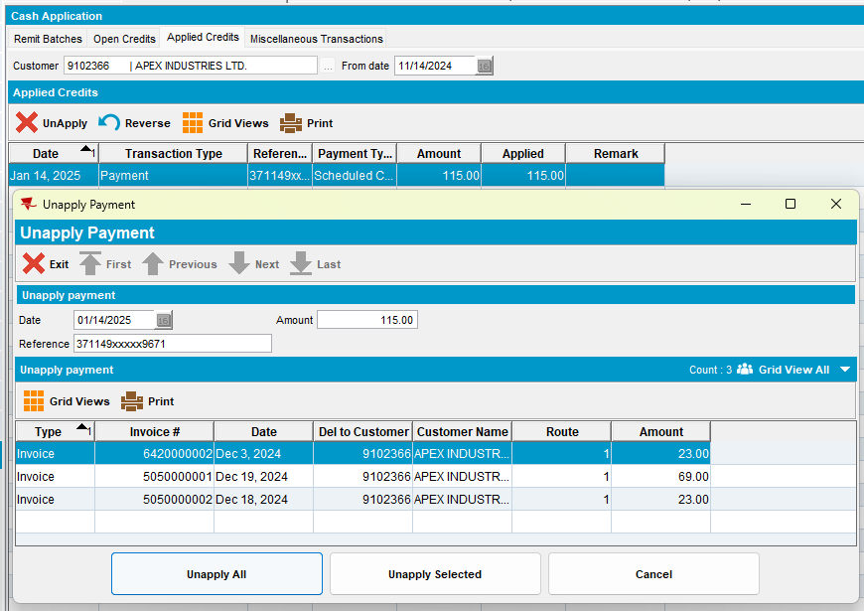
- PLSQL: Check the webservice log for the request.
select * from webservicelog wsl
where wsl.customer = '9102366'
and wsl.requesttimestamp >= TO_DATE('2025-01-14 00:00:00', 'YYYY-MM-DD HH24:MI:SS')
order by wsl.requesttimestamp desc;

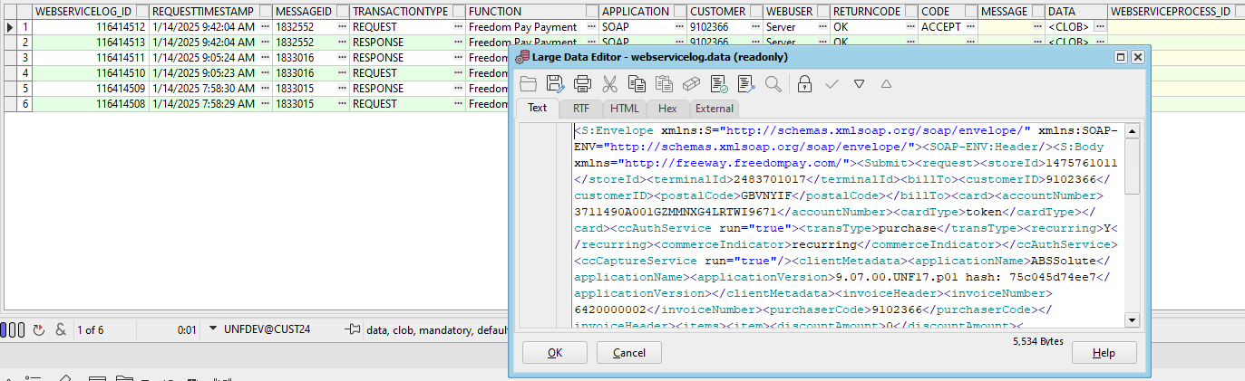
- Check the CLOB data for the request
- Take the invoice number and check the zipcode of the invoice.
select ih.route_id, r.depot_id, a.zipcode DEPOTzipcode, ad.zipcode PLANTzipcode, ih.* from invoiceheader ih
left join route r on r.route_id = ih.route_id
left join depot d on d.depot_id = r.depot_id
left join plant p on p.plant_id = r.plant_id
left join address a on a.address_id = d.address_id
left join address ad on ad.address_id = p.address_id
where ih.invoicenumber in (6420000002, 5050000001, 5050000002);

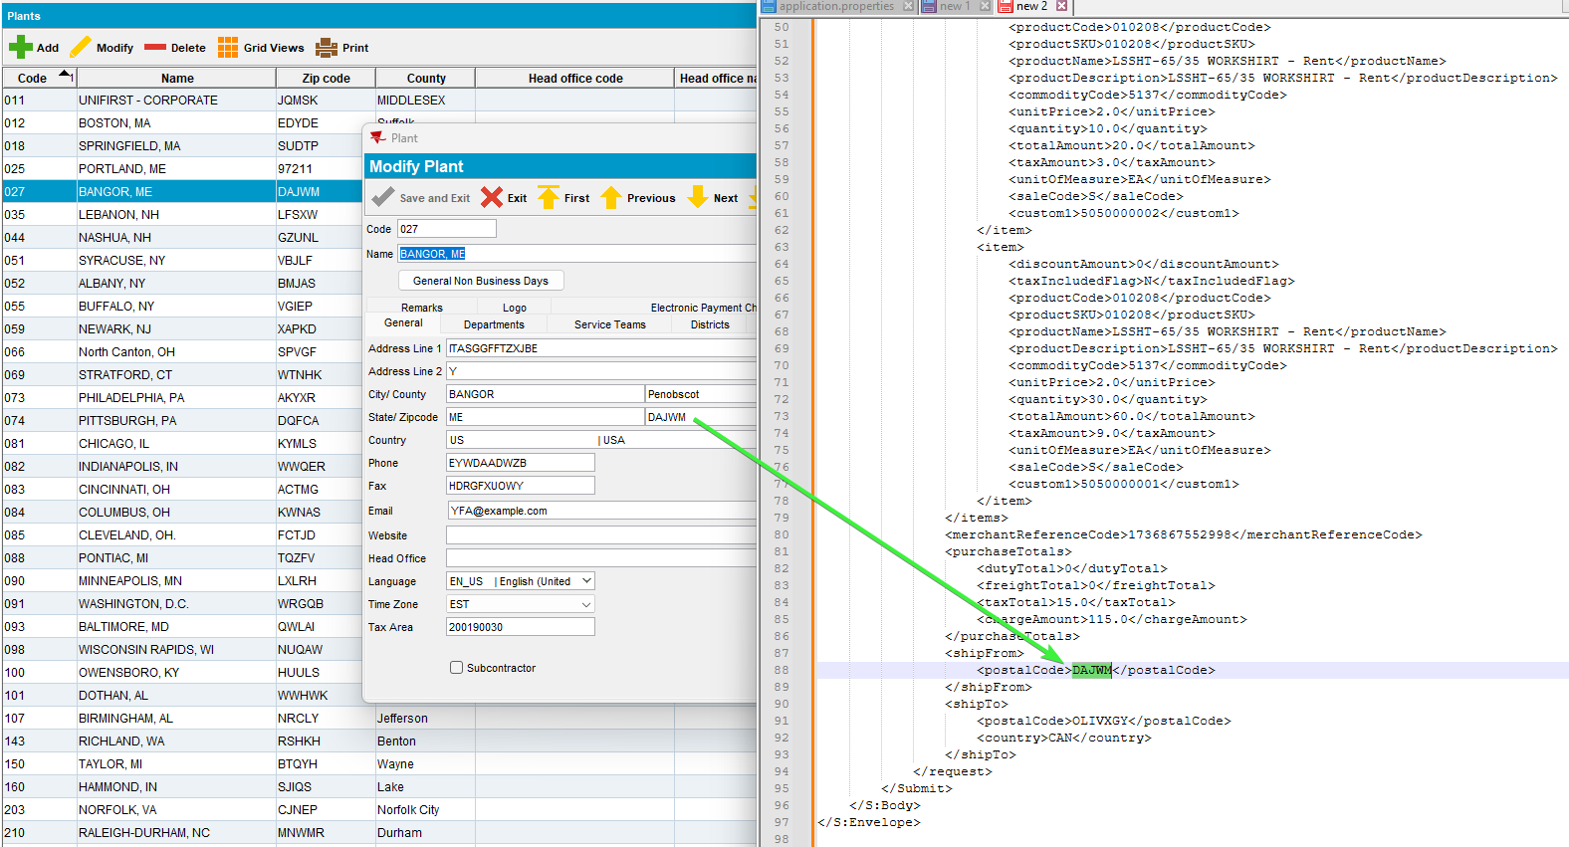
- Cash Application dlg: Go to Applied Credits, load the customer and UnApply the credit.
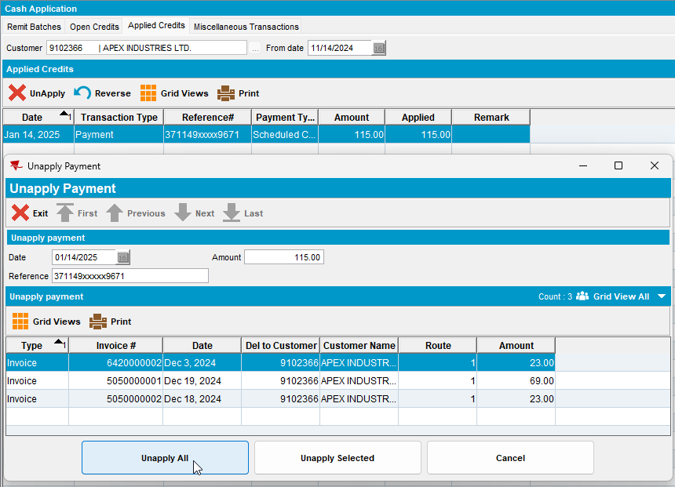
- System Settings dlg: Change the CREDITCARDAMEXSTOREIDCA – 1475761011 and CREDITCARDAMXTERMINALIDCA – 2483701017 to have null value

- Process Scheduler dlg: Run process Take Electronic Payment again.
- PLSQL: Check the webservice log for the request.
select * from webservicelog wsl
where wsl.customer = '9102366'
and wsl.requesttimestamp >= TO_DATE('2025-01-14 00:00:00', 'YYYY-MM-DD HH24:MI:SS')
order by wsl.requesttimestamp desc;
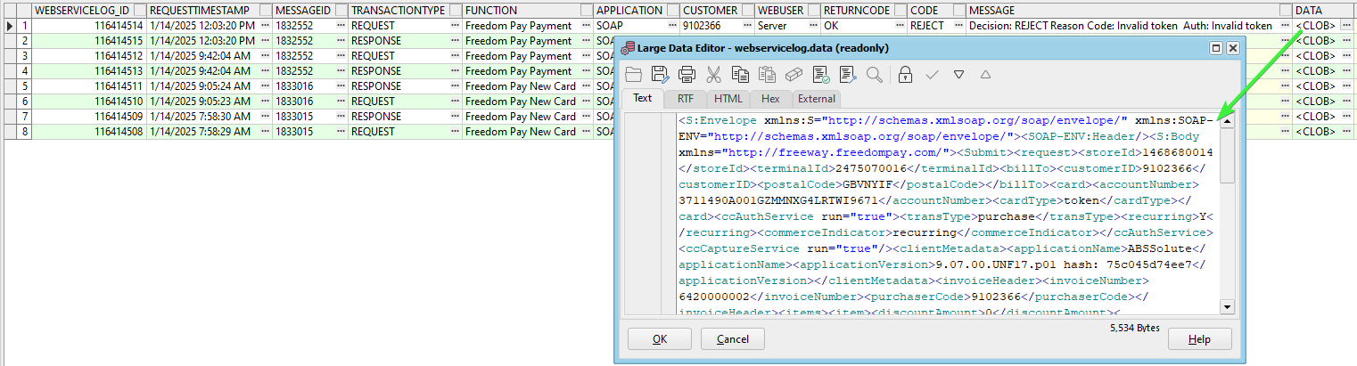
- Check the request the storeId and terminalId were reverted from AMEX ss to non AMEX CA
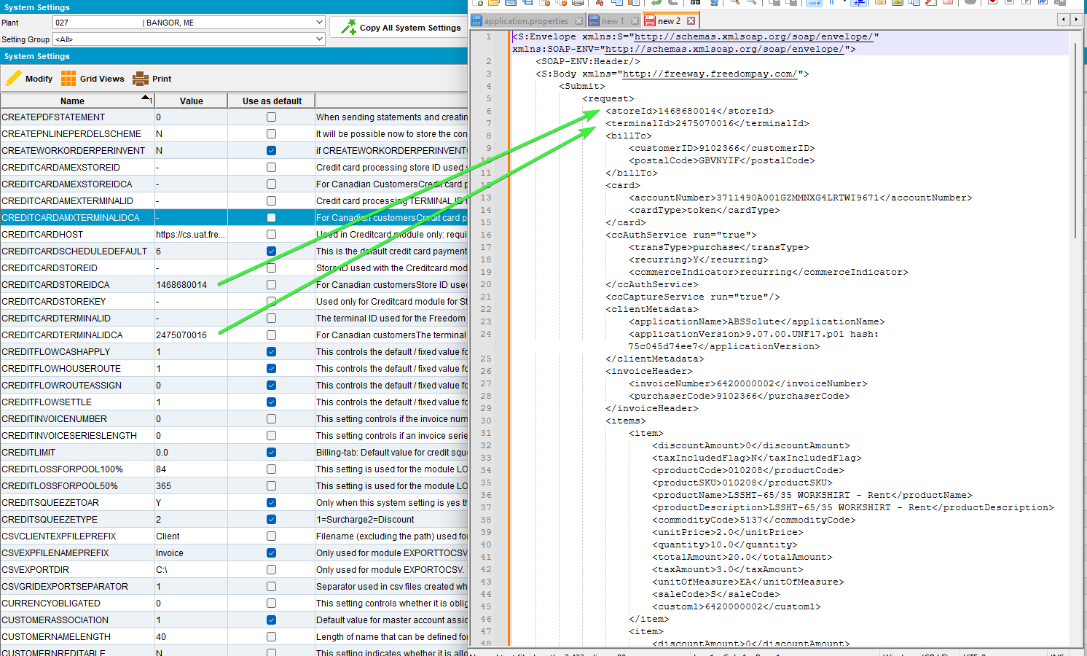
- Take the invoice number and check the zipcode of the invoice.
- Take the invoice number and check the zipcode of the invoice.
select ih.route_id, r.depot_id, a.zipcode DEPOTzipcode, ad.zipcode PLANTzipcode, ih.* from invoiceheader ih
left join route r on r.route_id = ih.route_id
left join depot d on d.depot_id = r.depot_id
left join plant p on p.plant_id = r.plant_id
left join address a on a.address_id = d.address_id
left join address ad on ad.address_id = p.address_id
where ih.invoicenumber in (6420000002, 5050000001, 5050000002);

- System Settings dlg: Change ss to the original values, the CREDITCARDAMEXSTOREIDCA – 1475761011 and CREDITCARDAMXTERMINALIDCA – 2483701017
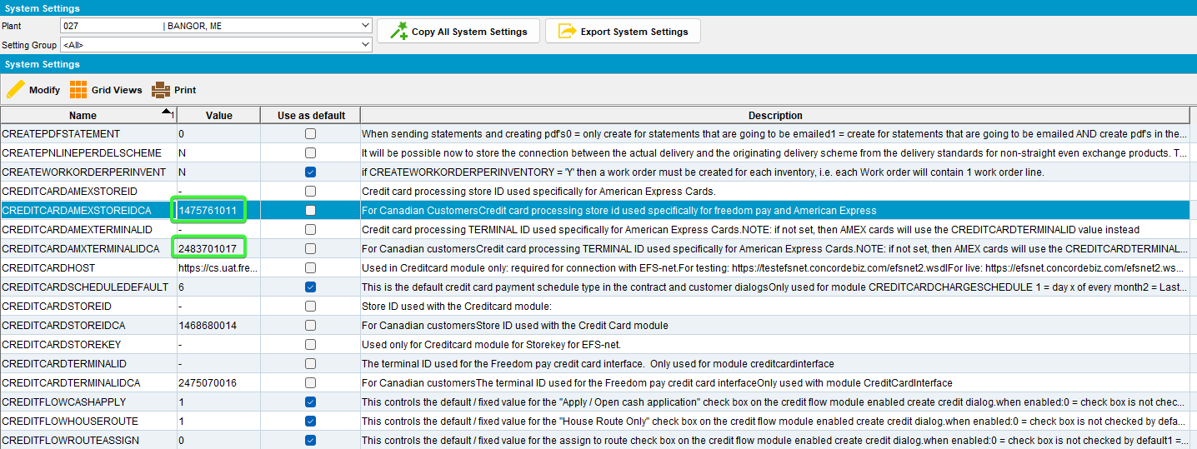
Tested OK

Test Case 06 - AMEX Bill-to<>Del-to and from different BU payment triggered from Credit Card Transactions – Tested OK
Hash: 9.07.00.UNF17.p02 hash: 75c045d74ee7

Expected behavior:
section | field | value
 | storeID | If the Bill To customer’s county is not Canada, then  If card type is American Express (CustomerCreditCard.MaskedCardNumber starts with 34 or 37 and is length 15) and system setting CREDITCARDAMEXSTOREID is not blank, - or NULL  Then use CREDITCARDAMEXSTOREID  Else use System setting CREDITCARDSTOREID  If the Bill To customer’s county is Canada, then  If card type is American Express (CustomerCreditCard.MaskedCardNumber starts with 34 or 37 and is length 15) and system setting CREDITCARDAMEXSTOREIDCA is not blank, - or NULL  Then use CREDITCARDAMEXSTOREIDCA  Else use System setting CREDITCARDSTOREIDCA
 | terminalID | If the Bill To customer’s county is not Canada, then  If the card type is American Express (CustomerCreditCard.MaskedCardNumber starts with 34 or 37 and is length 15) and system setting CREDITCARDAMEXTERMINALID is not blank, - or NULL  Then use CREDITCARDAMEXTERMINALID  Else use System setting CREDITCARDTERMINALID  If the Bill To customer’s county is Canada, then  If card type is American Express (CustomerCreditCard.MaskedCardNumber starts with 34 or 37 and is length 15) and system setting CREDITCARDAMXTERMINALIDCA is not blank, - or NULL  Then use CREDITCARDAMEXTERMINALIDCA  Else use System setting CREDITCARDTERMINALIDCA  Note The Canadian version of the system setting CREDITCARDAMEXTERMINALID is spelt slightly differently (AMX not AMEX) due to field length limits
ShipFrom | postalCode | If the route of the invoice (invoiceheader.route_id) has a depot (route.depot_id) then take the zip code from the depot address (depot.address_id.zipcode)  If the route of the invoice (invoiceheader.route_id) does not have a depot (route.depot_id is null) then take the zip code from the plant of the route (plant.address_id.zipcode)  If the invoice has no route (invoiceheader.routecontrol_id is NULL) then take the zip code from the plant of the invoice business unit (invoiceheader.invoicebusinessunit.plant.address.zipcode)

Steps to reproduce:
- Switch to plant 027 and create a new customer 2556826 with bill-to customer 9102366. Making this customer also for Canada.
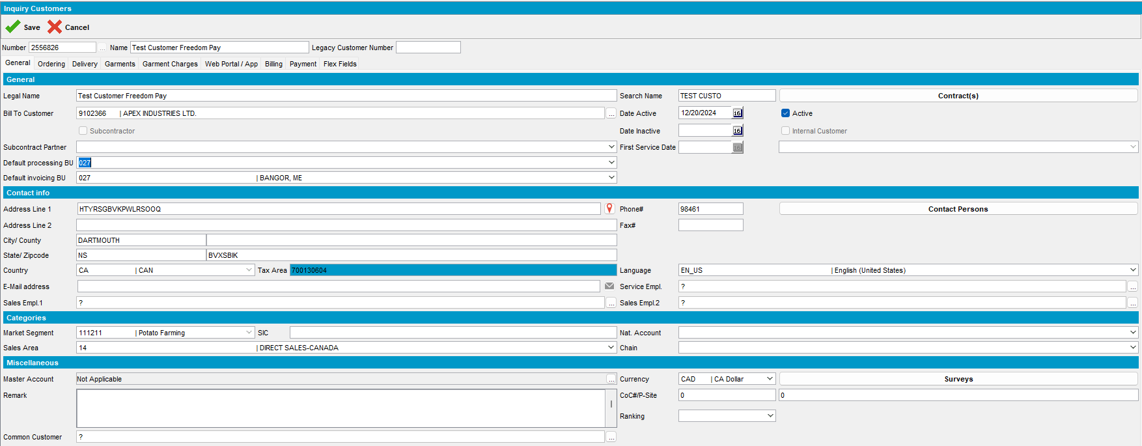
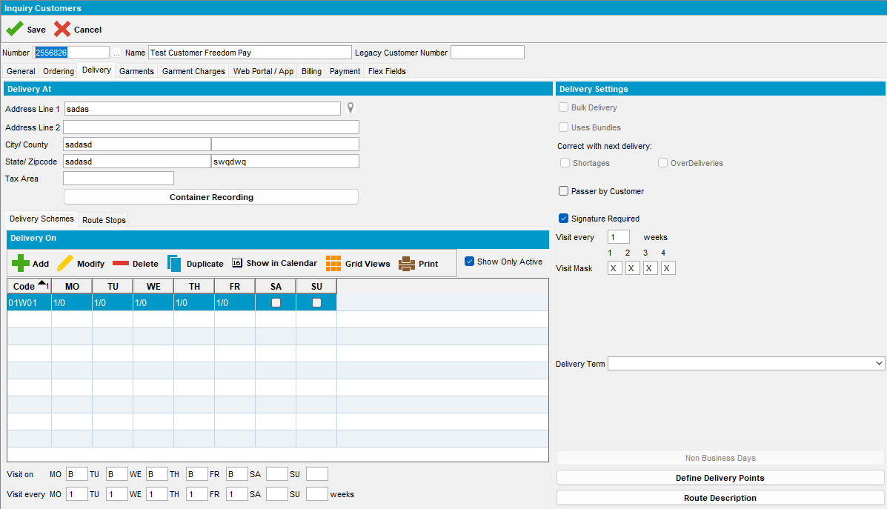
- Contract DLG: Add a new contract with Currency = CAD (start date needs to be yesterday) and with at least one released garment product on it

- Contract DLG: Add customer 2556826 to the contract (start date needs to be today or yesterday)
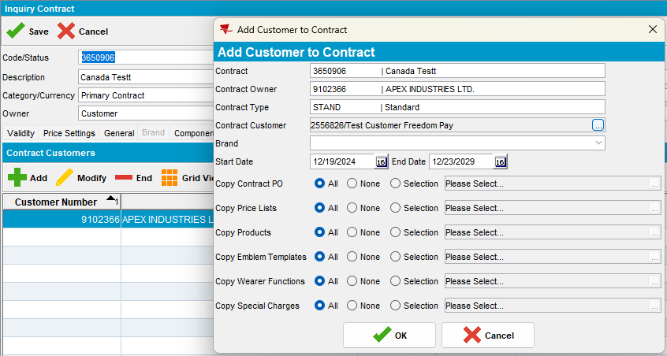
- Lockers DLG: Add lockers for 2556826
- Wearers DLG: Add at least one wearer with a wearer inventory and generate the WORKORDER with Start Rent = 'Day of issue'
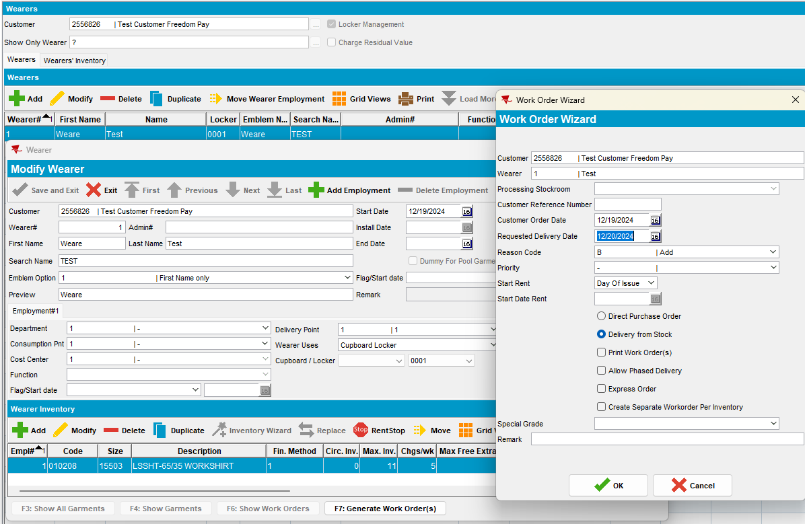
- Issue Work Order DLG: Issue all garments and generate items and then generate the Delivery Note
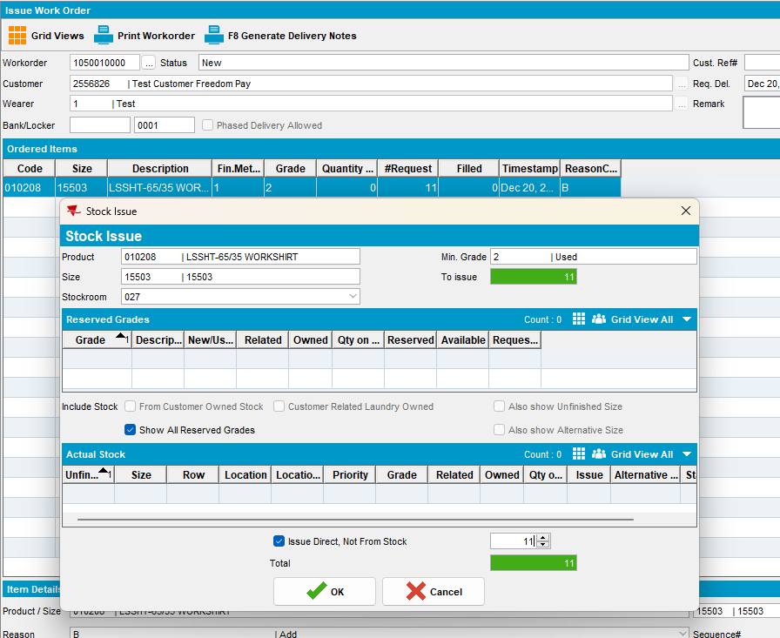
- RSC dlg: Add a new route 1 day in the past containing our customer 2556826
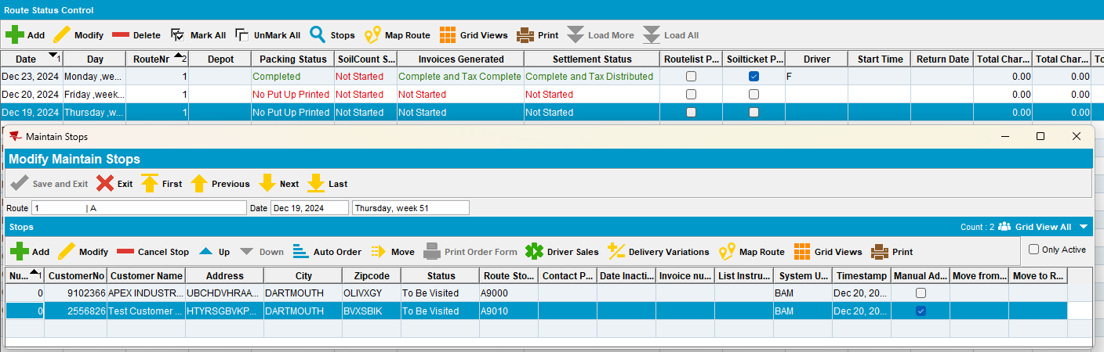
- Maintain Invoices dlg: Add a manual invoice for customer 2556826 to the route, make sure the date is in the past.
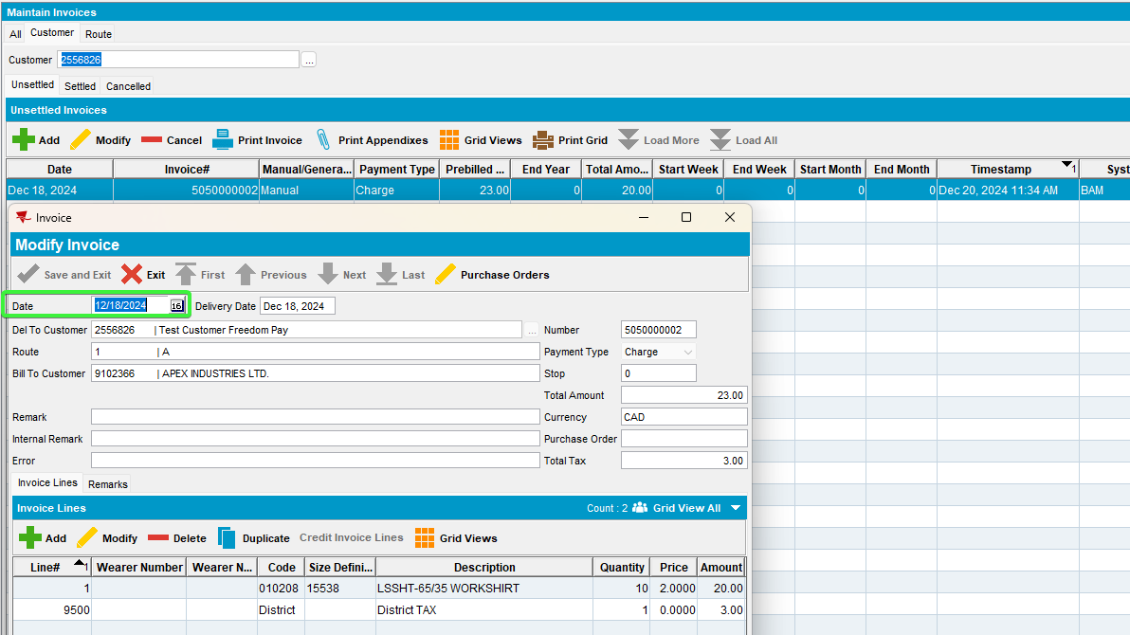

- RSC dlg: Generate invoices and settle the route.
- Process Scheduler dlg: Run Import Vertex TAX BCI process
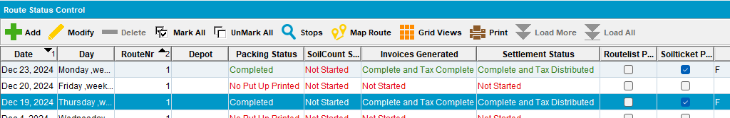
- Process Scheduler dlg: Run Create Credit Card transactions from payment scheduler.
- Switch back to the BU of the bill-to.
- Credit Card Transactions dlg: Check the transactions.
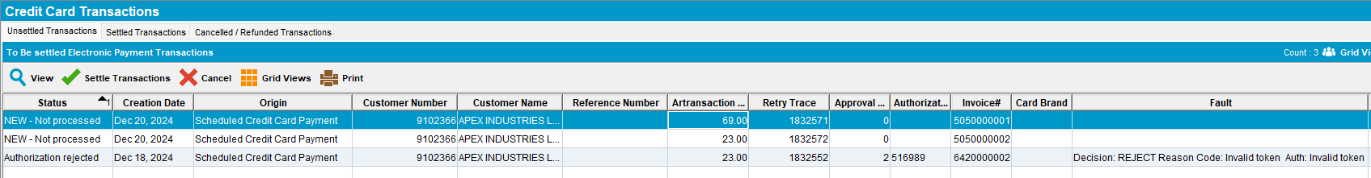
- Credit Card Transactions dlg: Settle a transaction.
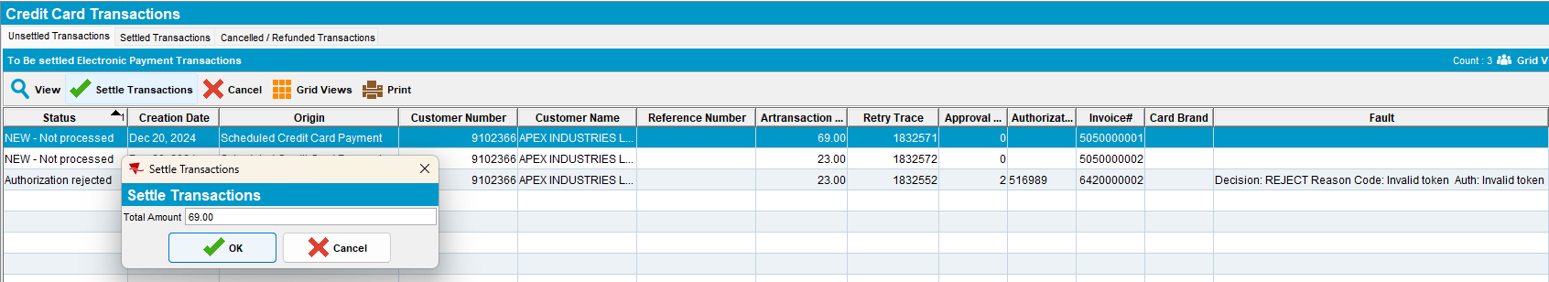
- PLSQL: Check the webservice log
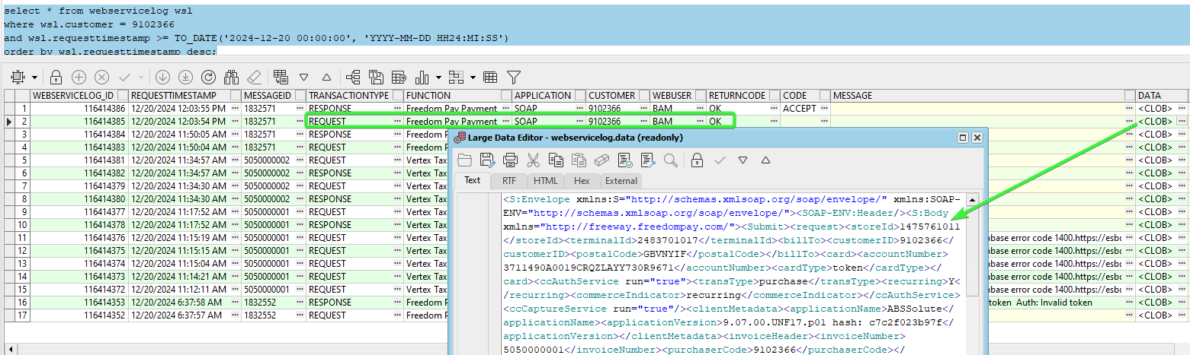
The AMEX storeId and terminalId values from the correct ss
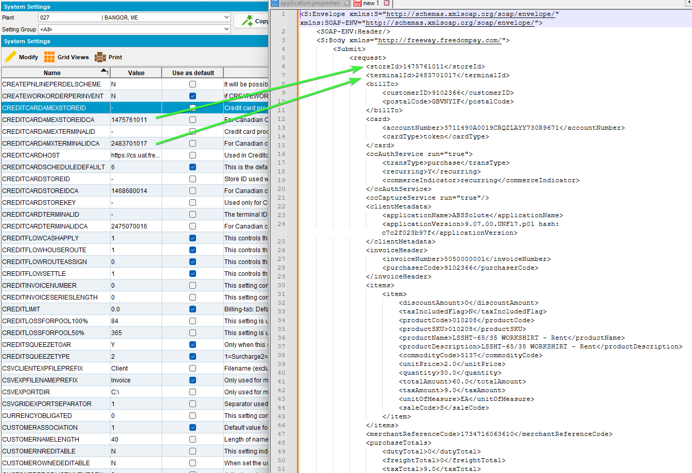
The BU zip code of the del-to
select ih.route_id, r.depot_id, a.zipcode DEPOTzipcode, ad.zipcode PLANTzipcode, ih.* from invoiceheader ih
left join route r on r.route_id = ih.route_id
left join depot d on d.depot_id = r.depot_id
left join plant p on p.plant_id = r.plant_id
left join address a on a.address_id = d.address_id
left join address ad on ad.address_id = p.address_id
where ih.invoicenumber = 5050000001;
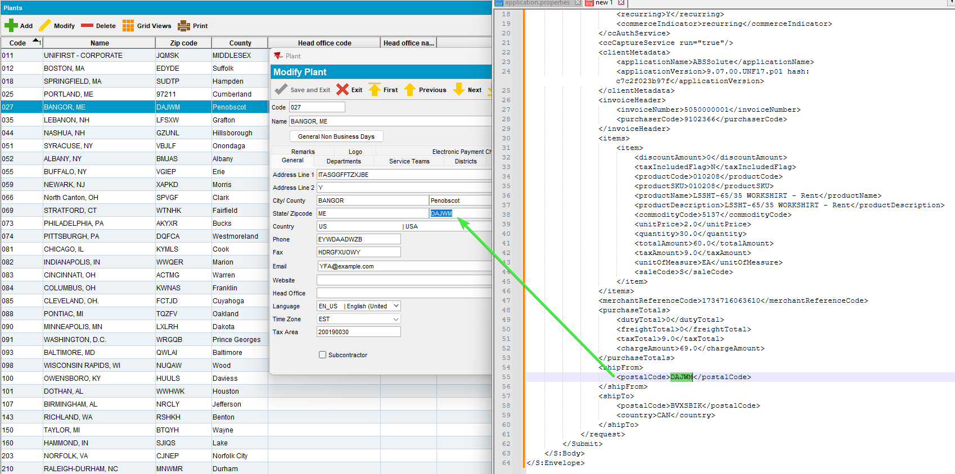
Tested OK
- Cash Application dlg: Go to Applied Credits, load the customer and UnApply the credit.
- System Settings dlg: Change the CREDITCARDAMEXSTOREIDCA – 1475761011 and CREDITCARDAMXTERMINALIDCA – 2483701017 to have null value

- Credit Card Transactions dlg: Settle a transaction.
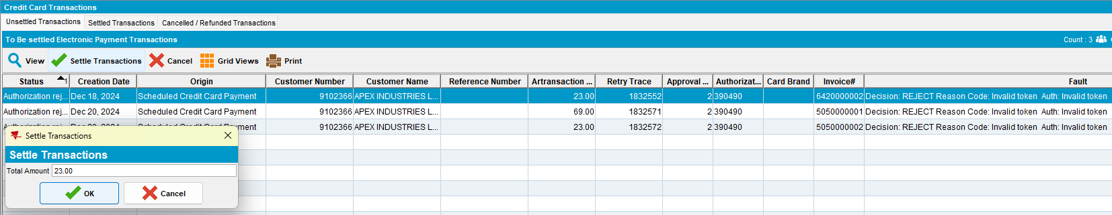
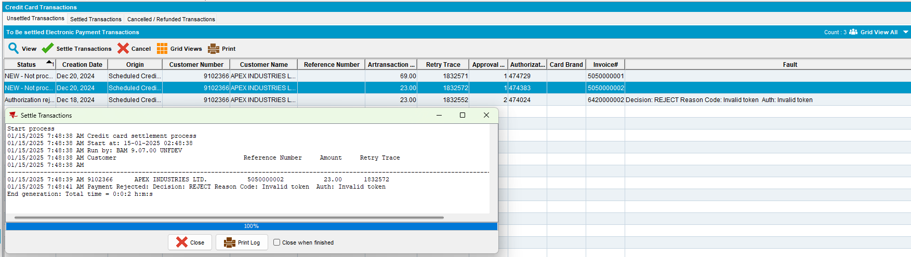
- PLSQL: Check the webservice log for the request.
select * from webservicelog wsl
where wsl.customer = '9102366'
and wsl.requesttimestamp >= TO_DATE('2025-01-14 00:00:00', 'YYYY-MM-DD HH24:MI:SS')
order by wsl.requesttimestamp desc;
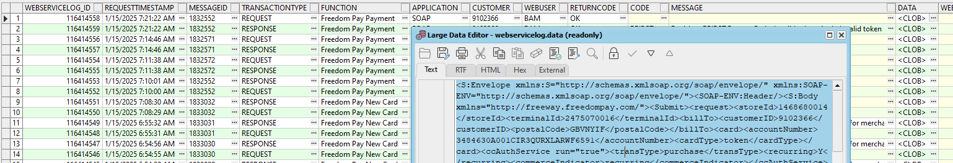
- The settlement of the transaction didn’t worked. In the request body, the storeId and terminalId were reverted from AMEX ss to non AMEX CA
- System Settings dlg: Change ss to the original values, the CREDITCARDAMEXSTOREIDCA – 1475761011 and CREDITCARDAMXTERMINALIDCA – 2483701017
Tested OK

Test Case 07 - AMEX Bill-to<>Del-to and from different BU payment triggered from Take Electronic Payment process scheduler – Tested OK
Hash: 9.07.00.UNF17.p02 hash: 75c045d74ee7

Steps to reproduce:
- Using the same customers 2556826 with bill-to customer 9102366 and same invoices.
- Make sure you are still switched to the BU of the bill-to, 710.
- Cash Application dlg: Unapply any applied credits
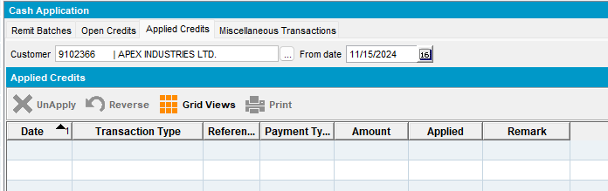
- Process Scheduler dlg: Run Take Electronic payments
- PLSQL: Check the webservice log
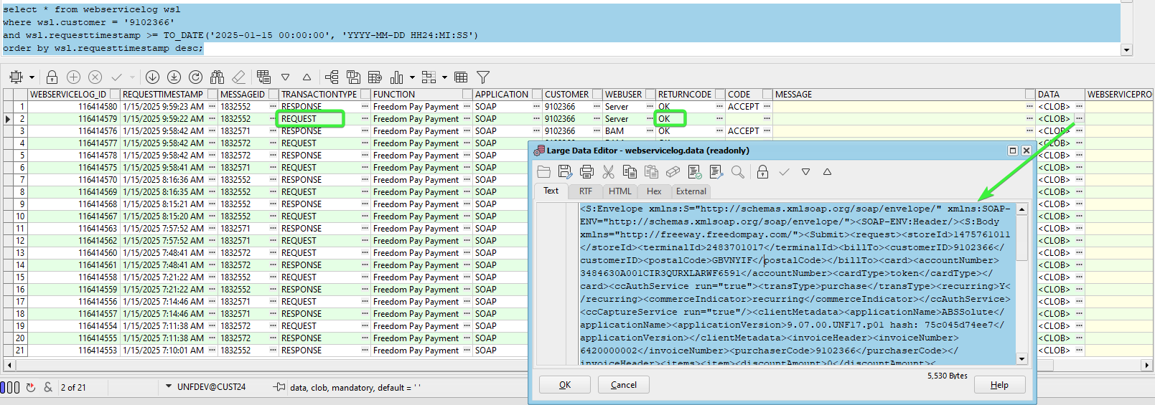
The AMEX storeId and terminalId values from the correct ss
The BU zip code of the del-to
select ih.route_id, r.depot_id, a.zipcode DEPOTzipcode, ad.zipcode PLANTzipcode, ih.* from invoiceheader ih
left join route r on r.route_id = ih.route_id
left join depot d on d.depot_id = r.depot_id
left join plant p on p.plant_id = r.plant_id
left join address a on a.address_id = d.address_id
left join address ad on ad.address_id = p.address_id
where ih.invoicenumber in (6420000002, 5050000001, 5050000002);

Tested OK
- Cash Application dlg: Go to Applied Credits, load the customer and UnApply the credit.
- System Settings dlg: Change the CREDITCARDAMEXSTOREIDCA – 1475761011 and CREDITCARDAMXTERMINALIDCA – 2483701017 to have null value

- Process Scheduler dlg: Run process Take Electronic Payment again. No log lines were processed.
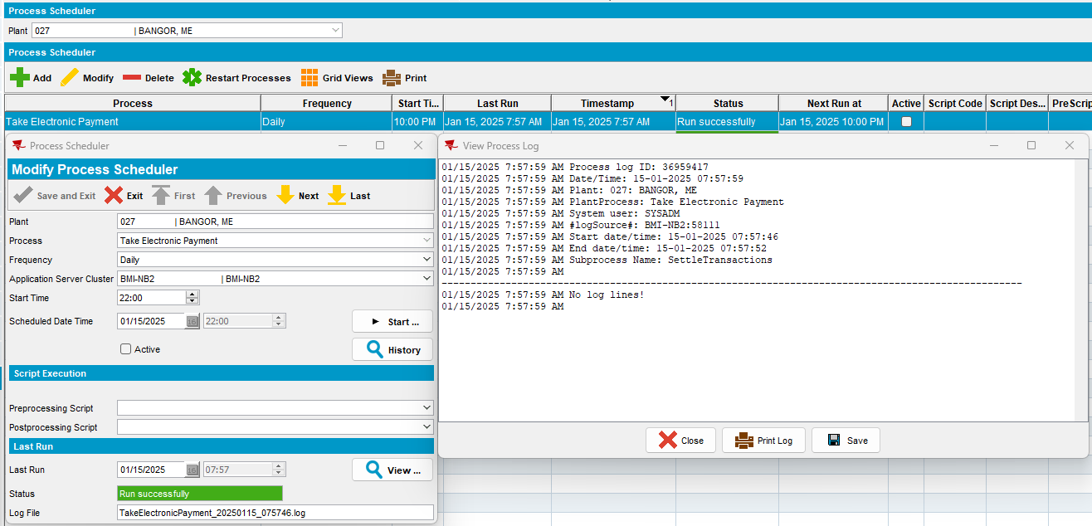
- PLSQL: Check the webservice log for the request.
select * from webservicelog wsl
where wsl.customer = '9102366'
and wsl.requesttimestamp >= TO_DATE('2025-01-15 00:00:00', 'YYYY-MM-DD HH24:MI:SS')
order by wsl.requesttimestamp desc;

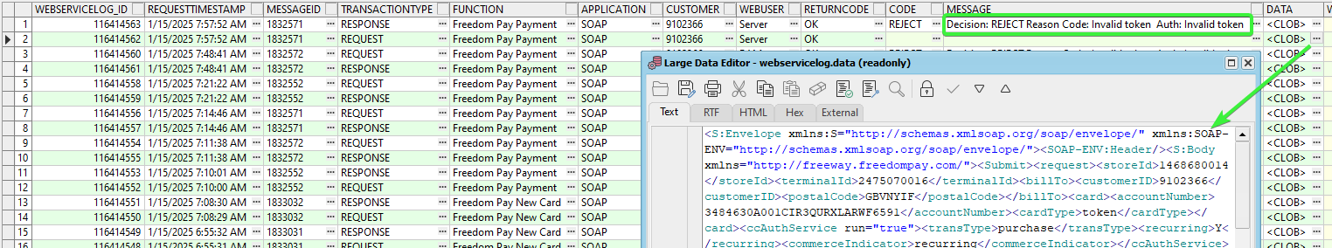
- The settlement of the transaction didn’t worked. In the request body, the storeId and terminalId were reverted from AMEX ss to non AMEX CA
- Take the invoice number and check the zipcode of the invoice.
select ih.route_id, r.depot_id, a.zipcode DEPOTzipcode, ad.zipcode PLANTzipcode, ih.* from invoiceheader ih
left join route r on r.route_id = ih.route_id
left join depot d on d.depot_id = r.depot_id
left join plant p on p.plant_id = r.plant_id
left join address a on a.address_id = d.address_id
left join address ad on ad.address_id = p.address_id
where ih.invoicenumber in (6420000002, 5050000001, 5050000002);

- System Settings dlg: Change ss to the original values, the CREDITCARDAMEXSTOREIDCA – 1475761011 and CREDITCARDAMXTERMINALIDCA – 2483701017
Tested OK

Test Case 08 - VISA Bill-to=Del-to & Bill-to <> Del-to, payment triggered from Credit Card Transactions – Tested OK
Hash: 9.07.00.UNF17.p02 hash: 75c045d74ee7

Steps to reproduce:
- Using the same customer 9102366 which is his own bill-to and also bill-to for 2556826 and same invoices.
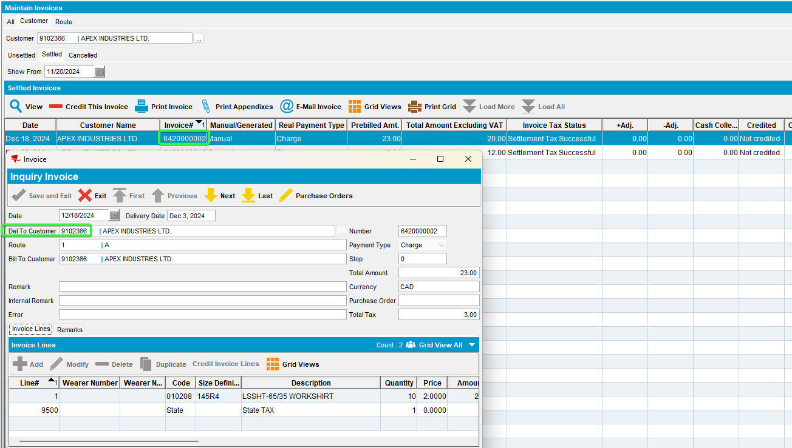
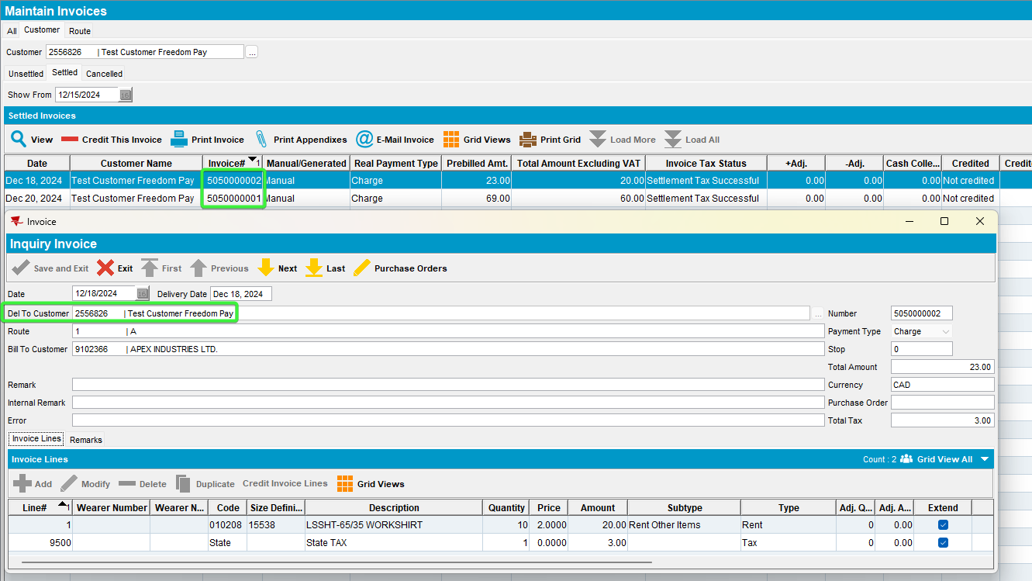
- Make sure you are still switched to the BU of the bill-to, 710.
- Customers dlg: Load customer 9102366 and change the AMEX card with a VISA card.
02A600C0170018008292;4020********1588=3008?*2B4ABDC89C69D6B588317981FE7CA3B0EC94393DD463AA55000000000000000000000000000000000000000038333054393633393730FFFF987654001B000140625C03
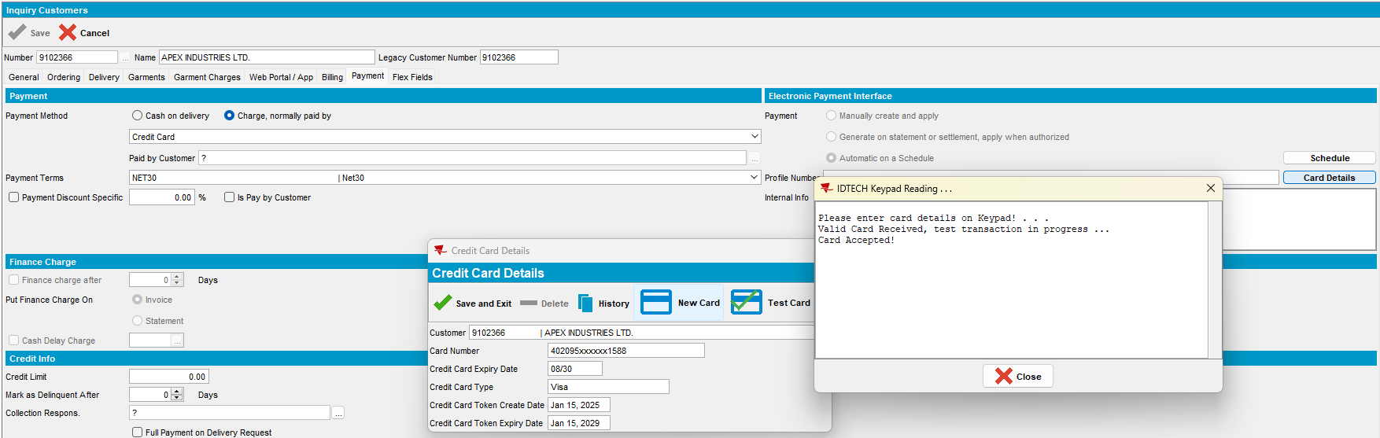
- Cash Application dlg: Unapply the applied credits
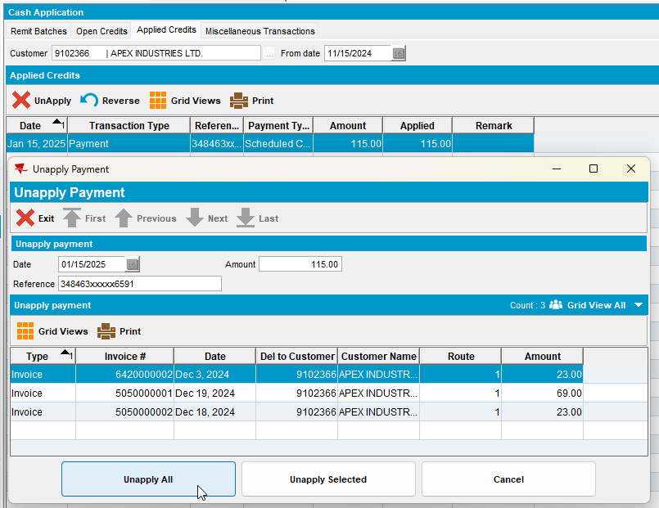
- Credit Card Transactions dlg: Settle the invoices
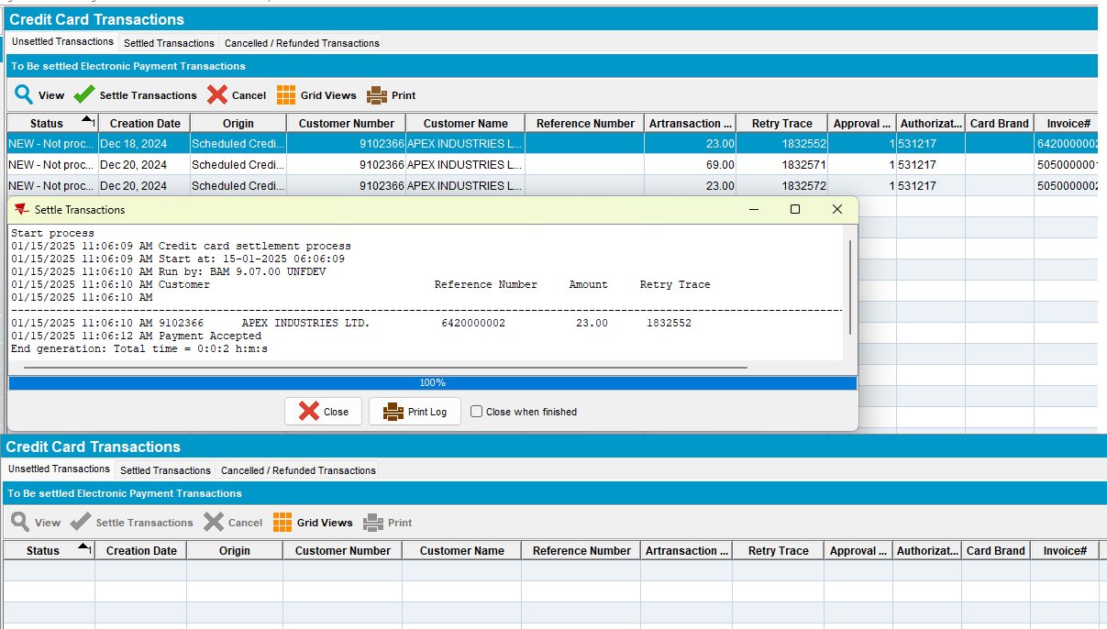
- PLSQL: Check the webservice log for the 3 invoices, the 3 requests.
select * from webservicelog wsl
where wsl.customer = '9102366'
and wsl.requesttimestamp >= TO_DATE('2025-01-15 00:00:00', 'YYYY-MM-DD HH24:MI:SS')
order by wsl.requesttimestamp desc;
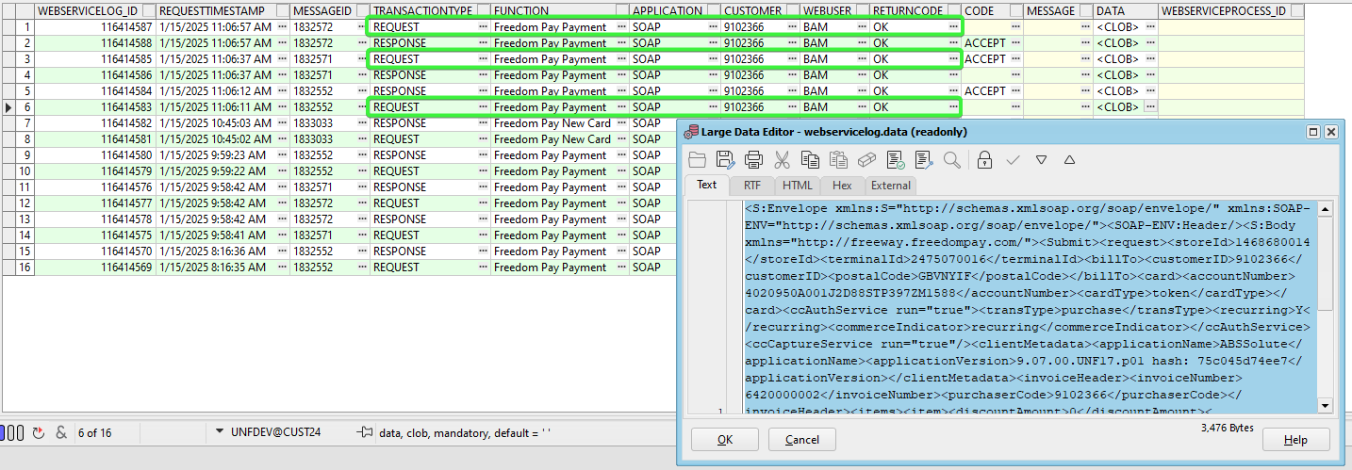

The CA storeId and terminal Id values from the correct ss
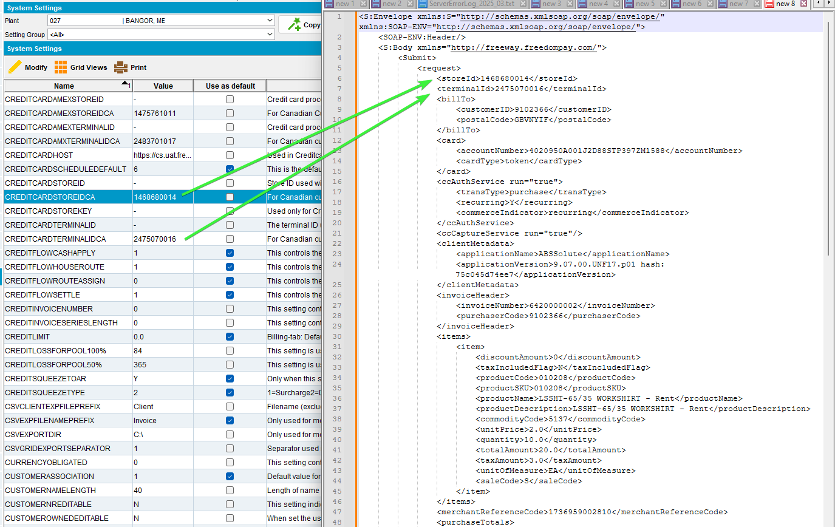

Check the depot zip code and the plant zip code of the invoices
select ih.route_id, r.depot_id, a.zipcode DEPOTzipcode, ad.zipcode PLANTzipcode, ih.* from invoiceheader ih
left join route r on r.route_id = ih.route_id
left join depot d on d.depot_id = r.depot_id
left join plant p on p.plant_id = r.plant_id
left join address a on a.address_id = d.address_id
left join address ad on ad.address_id = p.address_id
where ih.invoicenumber in (6420000002, 5050000001, 5050000002);

Tested OK

Test Case 09 - VISA Bill-to=Del-to & Bill-to <> Del-to, payment triggered from Take Electronic Payment process scheduler – Tested OK
Hash: 9.07.00.UNF17.p02 hash: 75c045d74ee7

Steps to reproduce:
- Using the same customer 9102366 which is his own bill-to and also bill-to for 2556826 and same invoices.
- Cash Application dlg: Unapply the applied credits
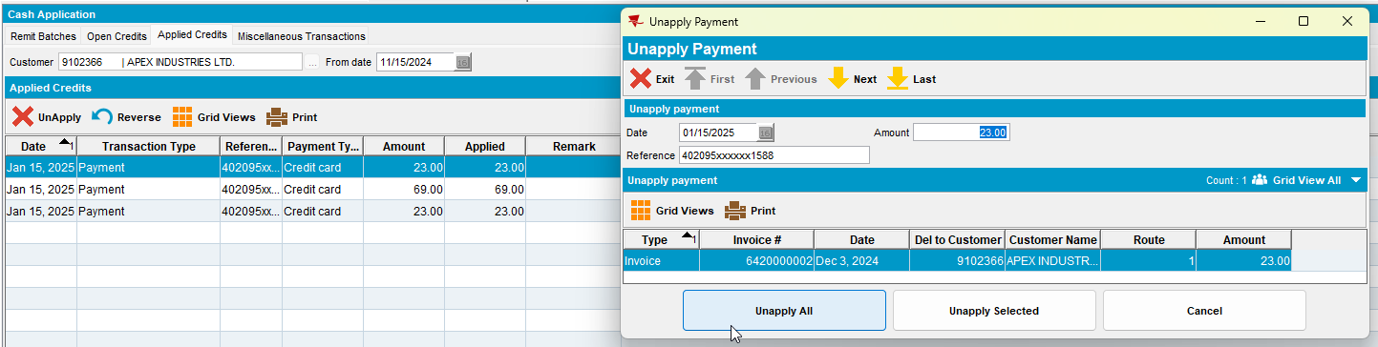
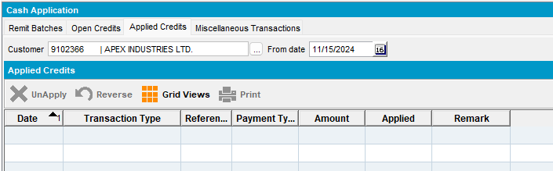
- Process Scheduler dlg: Run Take Electronic Payments process.
- PLSQL: Check the webservice log
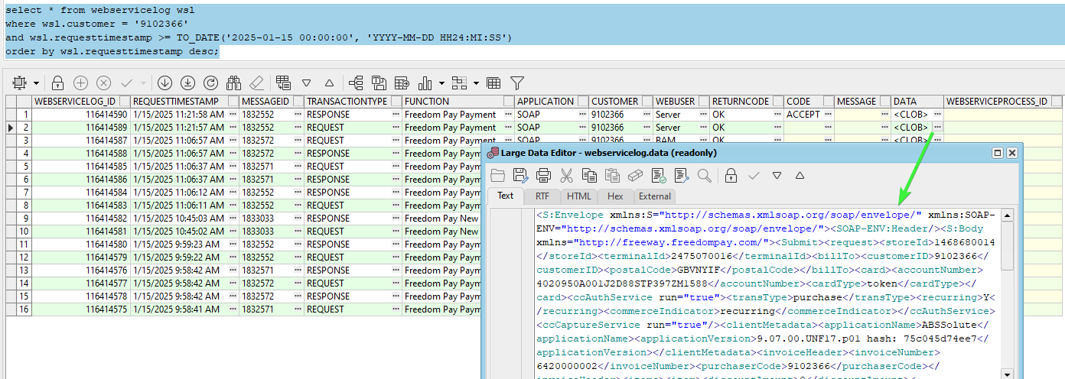

The CA storeId and terminal Id values from the correct ss

Check the depot zip code and the plant zip code of the invoices
select ih.route_id, r.depot_id, a.zipcode DEPOTzipcode, ad.zipcode PLANTzipcode, ih.* from invoiceheader ih
left join route r on r.route_id = ih.route_id
left join depot d on d.depot_id = r.depot_id
left join plant p on p.plant_id = r.plant_id
left join address a on a.address_id = d.address_id
left join address ad on ad.address_id = p.address_id
where ih.invoicenumber in (6420000002, 5050000001, 5050000002);

Tested OK

