ABS-171461 GenerateInvoicesFromFinaliseRoutesProcess log is not associated with routecontrol_id
Environment | Prerequisites
Version: 9.07.00.UNF18  DBServerName= abs-srv20.internal.abslbs.com  DBSID=CUST24  DBUser=UNFDEV  DBPassword=UNFDEV  Environment=Production | - Module:

Contents
Retest after fix 1

Retest after fix
Hash: 413ad78ec90
- RSC DLG: Generate put-up docs and invoices.
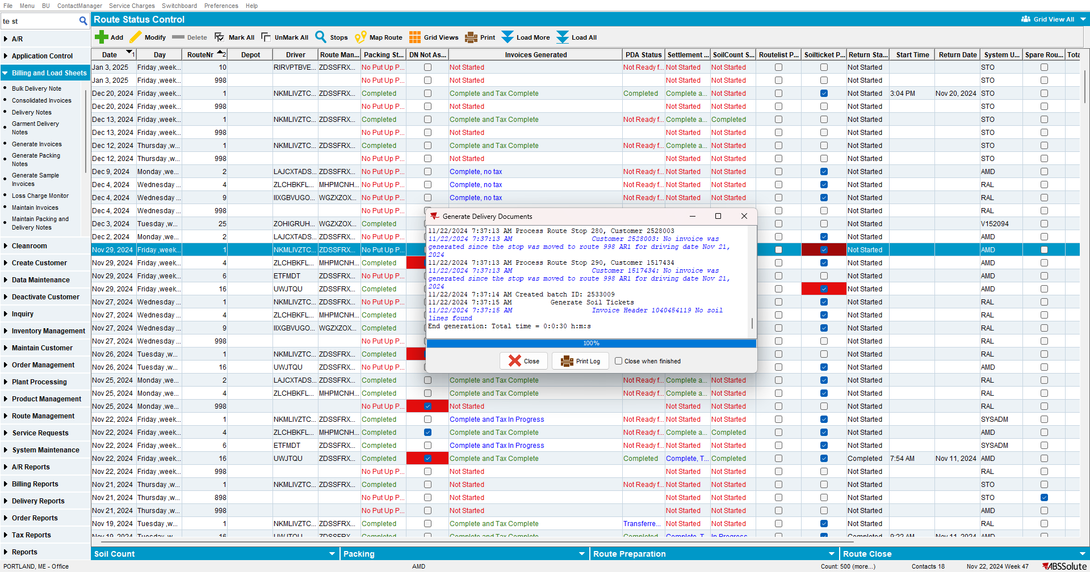

- Tax the invoices
- Delivery Note DLG: Add a manual delivery note for the customer with a soil ticket.
- Delivery Note DLG: Set a delivery date that is in the future but before the driving date for the route control from step 1
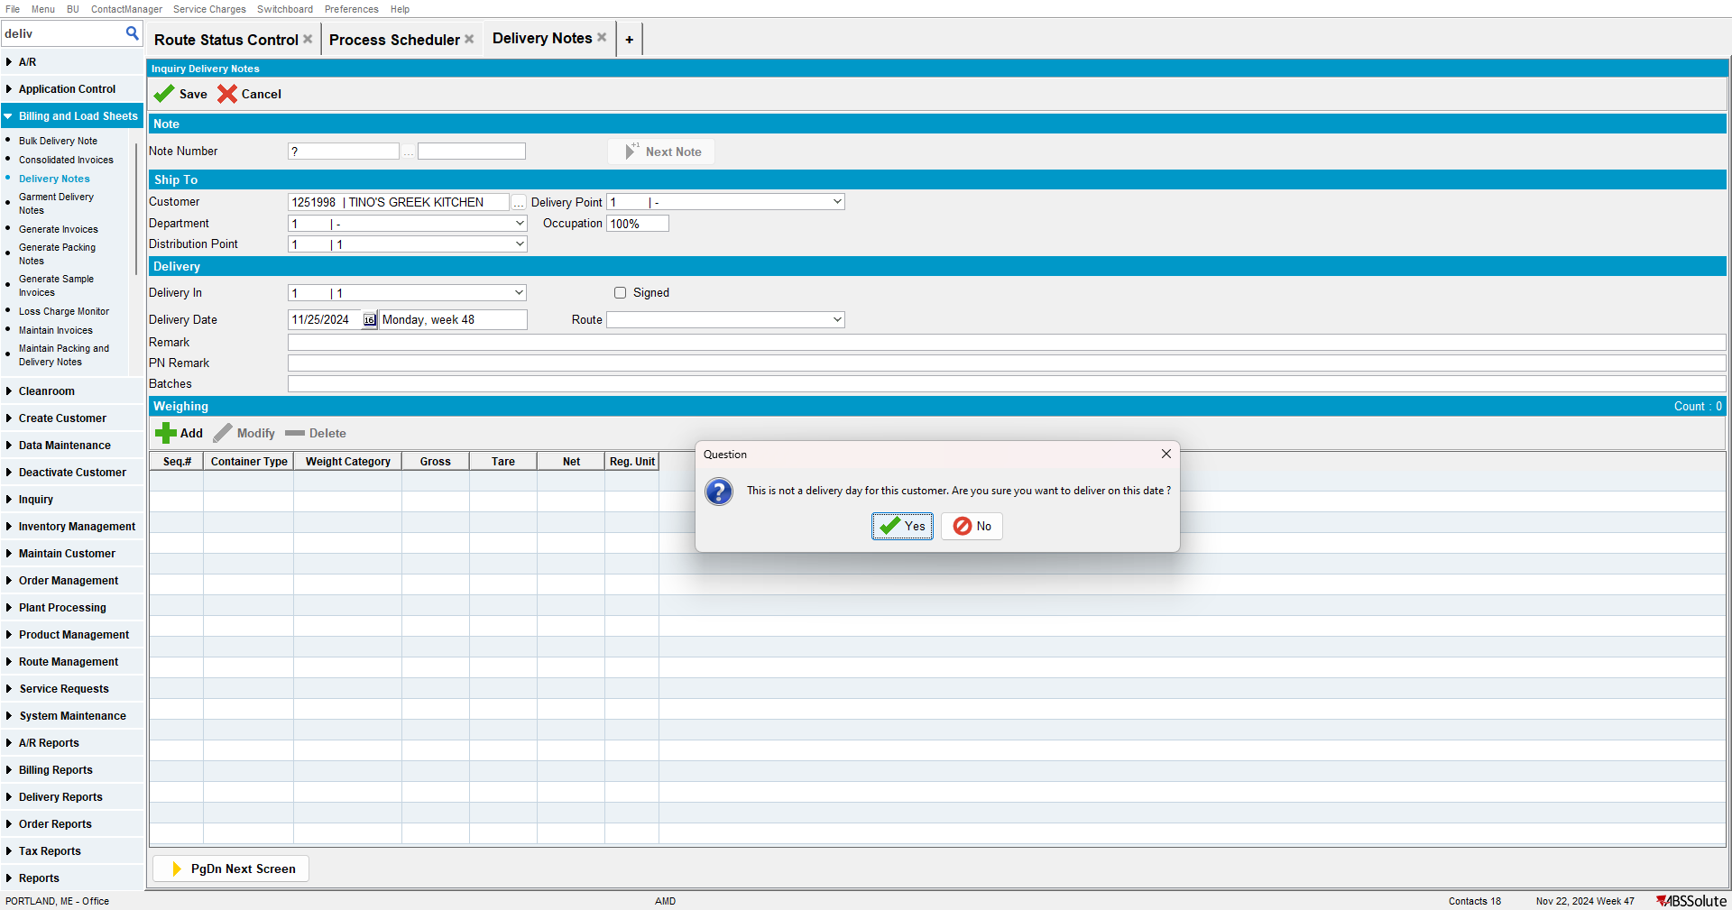

- Delivery Note DLG: Add any product with a quantity > 0 on the del note
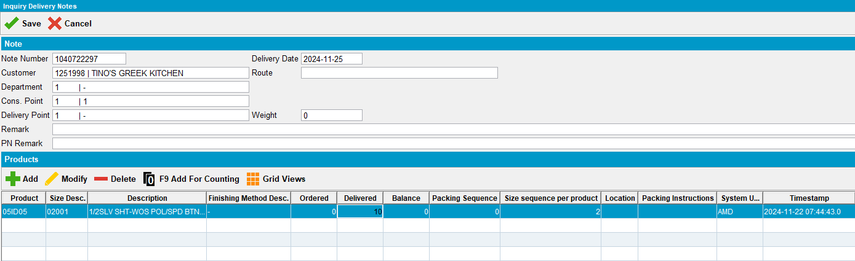

- RSC DLG: Check that the route control from step 1 now has the checkbox for PN not assigned
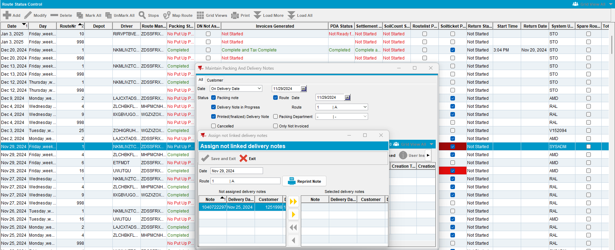
- Process Scheduler DLG: Run the Cancel and regenerate US direct invoices for late delivery notes
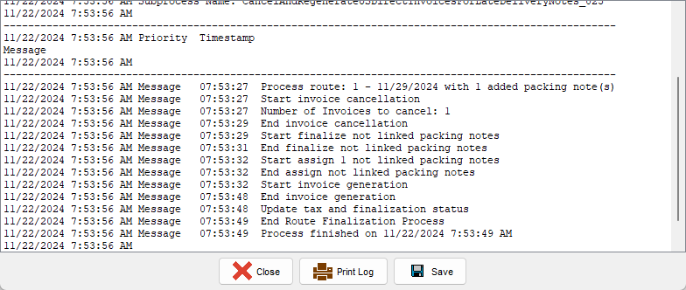

- View Process Log DLG: Check if the GenerateInvoicesFromFinaliseRoutesProcess log is present for the route.
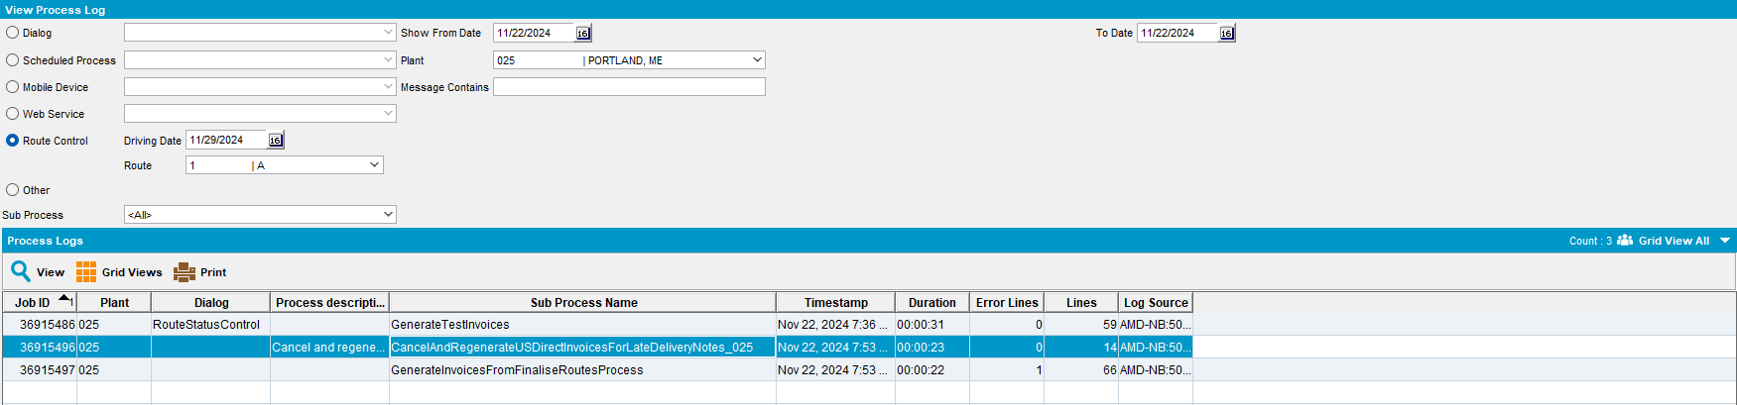

TESTED OK. 💚

