ASD-65480 D_UBS_2576 Webex RCI Overview stops to be reassigned count
Environment | Prerequisites
Version:9.09.00.RC1  DBServerName=abs-srv20.internal.abslbs.com  DBSID= CUST24  DBUser= UNFA  DBPassword= UNFA  Environment=Production | - Module:  - System setting

Contents
Reproducing before fix 1
Steps to reproduce 1
Expected behavior 5
Retest after fix 5
Expected behavior 5
Test Case 01 – ss WEBWORKORDERRESERVATION is on 2 5
Steps to reproduce 5
Test Case 02 – ss WEBWORKORDERRESERVATION is on 1 – NOT OK 9
Steps to reproduce 9
Test Case 03 – with module WEBORDERSUPERVISORAPPROVAL 13
Steps to reproduce 13

Reproducing before fix
9.09.00.RC1 hash: d4339ab52f0f
BU: 088 PONTIAC

Steps to reproduce

Problem 1
- Open WebX and load a route that has fully credited invoices on RA, you can find data with this select:
SELECT RC.DRIVINGDATE, R.ROUTENUMBER, P.CODE, S.STOPNUMBER, RC.ROUTECONTROL_ID FROM ROUTECONTROL RC
JOIN STOP S ON S.ROUTECONTROL_ID = RC.ROUTECONTROL_ID
JOIN ROUTETRANSACTION RT ON RT.ROUTECONTROL_ID = RC.ROUTECONTROL_ID AND S.STOP_ID = RT.STOP_ID
JOIN ROUTE R ON RC.ROUTE_ID = R.ROUTE_ID
JOIN PLANT P ON P.PLANT_ID = R.PLANT_ID
WHERE RC.Settlementstatus = 1
AND RC.POCKETPCSTATUS = 2
AND RT.ROUTETRANSACTIONTYPE_ID = 707
AND RT.MOBILEDEVICE_ID IS NOT NULL;
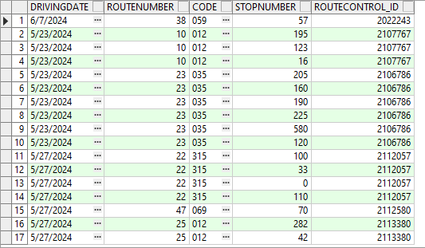

- Select a row that has a full credit on it in Overview tab
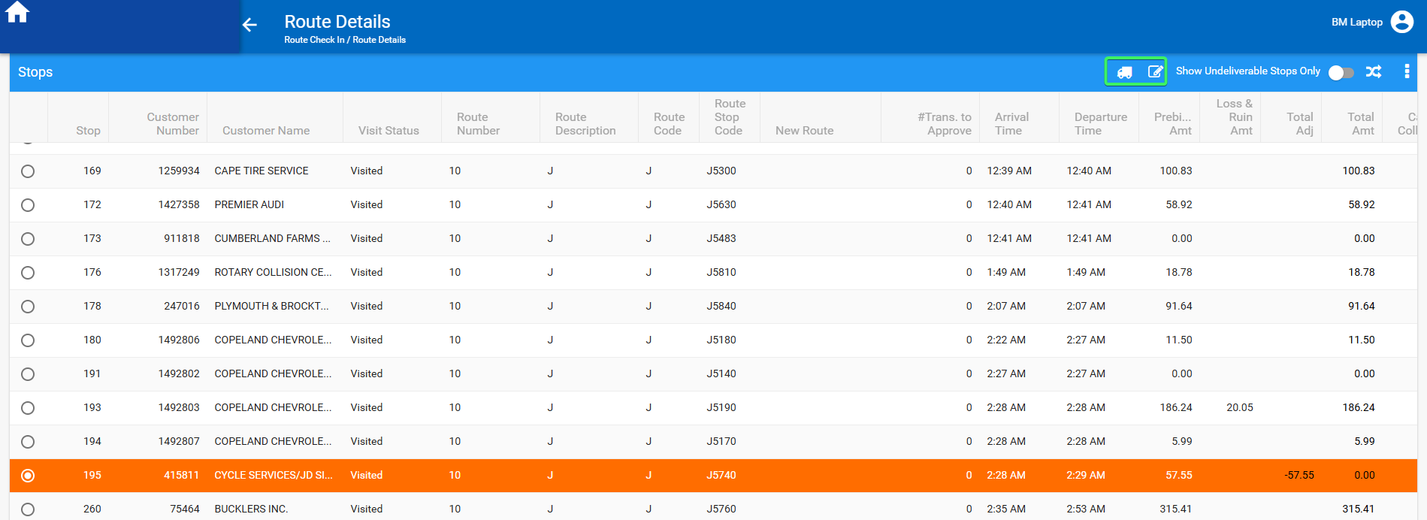
- Click on the Change visit status button
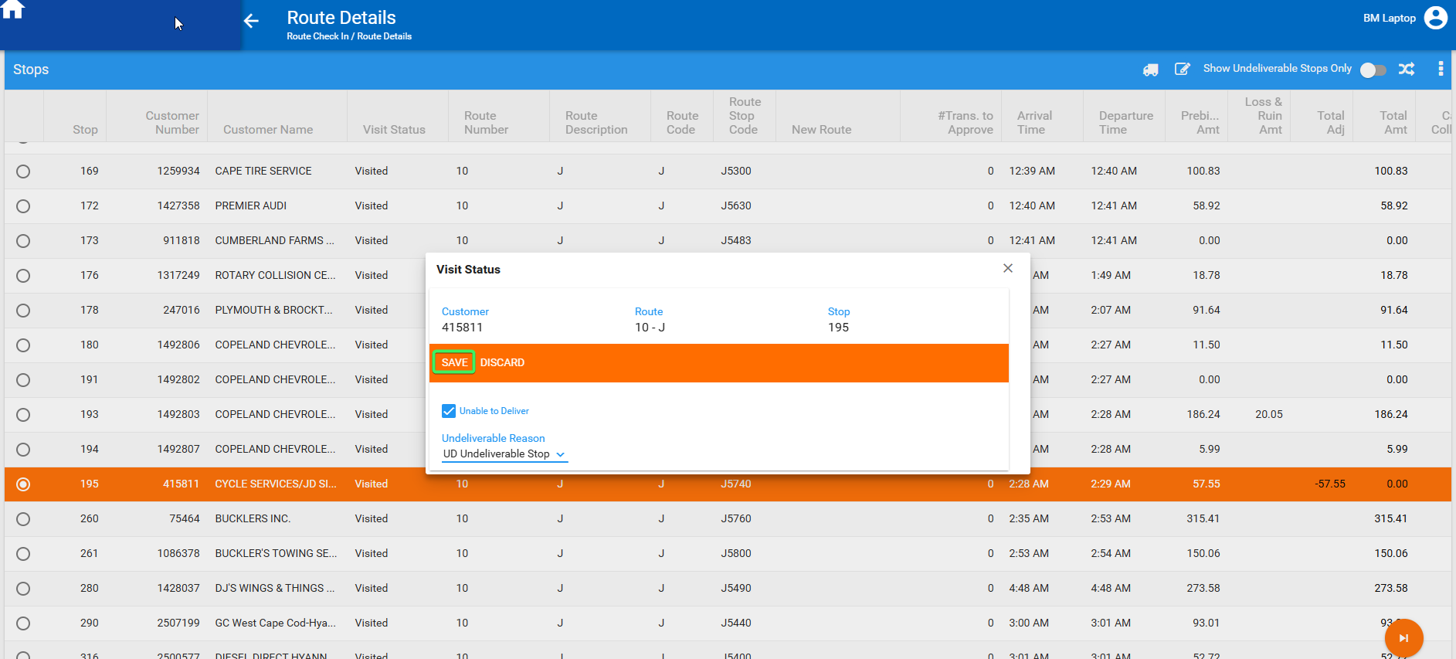
- Select Undeliverable checkbox and a reason code
- Click save
- Observe that the two buttons: Change Visit status and View signature are not reloaded
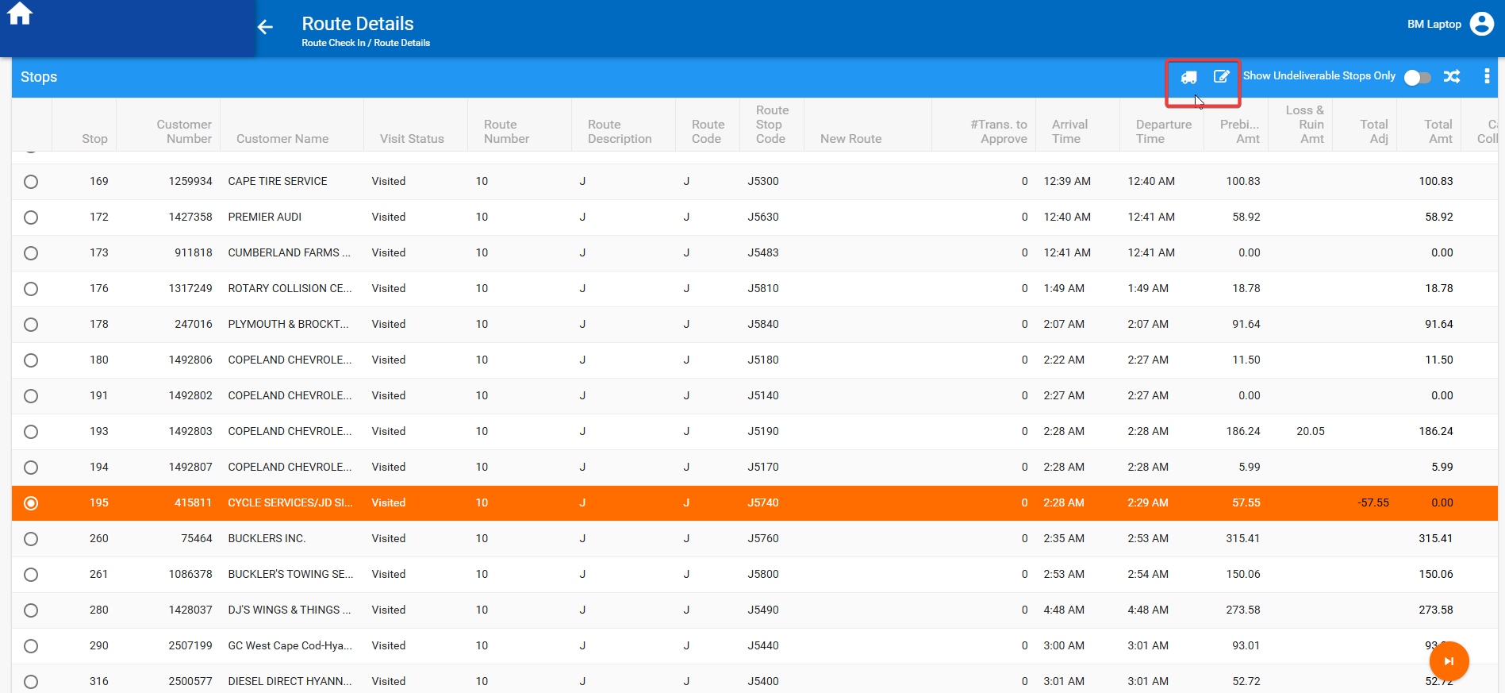

REPRODUCED OK.

Problem 2
- Open WebX and load a route that has at least 2 fully credited invoices on RA, you can find data with this select:
SELECT RC.DRIVINGDATE, R.ROUTENUMBER, P.CODE, S.STOPNUMBER, RC.ROUTECONTROL_ID FROM ROUTECONTROL RC
JOIN STOP S ON S.ROUTECONTROL_ID = RC.ROUTECONTROL_ID
JOIN ROUTETRANSACTION RT ON RT.ROUTECONTROL_ID = RC.ROUTECONTROL_ID AND S.STOP_ID = RT.STOP_ID
JOIN ROUTE R ON RC.ROUTE_ID = R.ROUTE_ID
JOIN PLANT P ON P.PLANT_ID = R.PLANT_ID
WHERE RC.Settlementstatus = 1
AND RC.POCKETPCSTATUS = 2
AND RT.ROUTETRANSACTIONTYPE_ID = 707
AND RT.MOBILEDEVICE_ID IS NOT NULL;
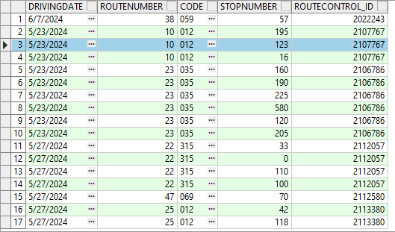
- Select a row that has a full credit on it in Overview tab
- Change visit status on one of the stops with a full credit to undeliverable
- Select a different stop with a full credit and click on the Undeliverable only switch
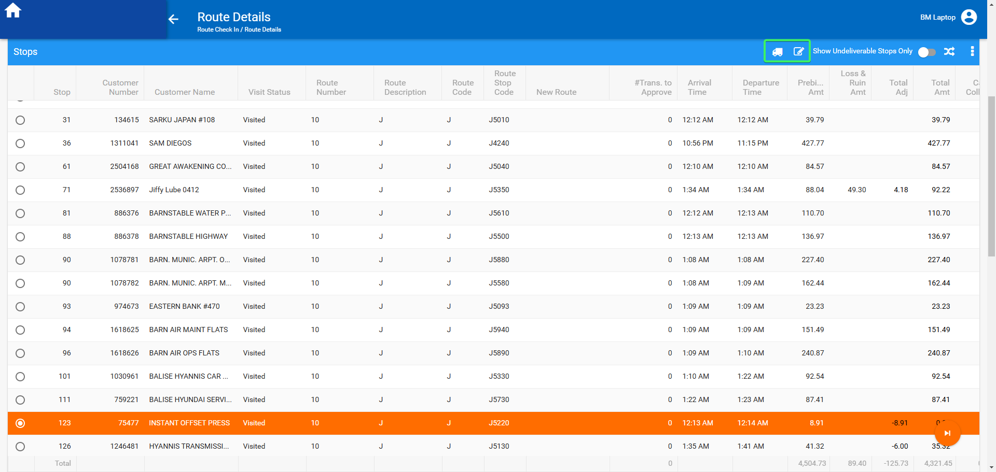
- Observe that the two buttons: Change Visit status and View signature are not reloaded
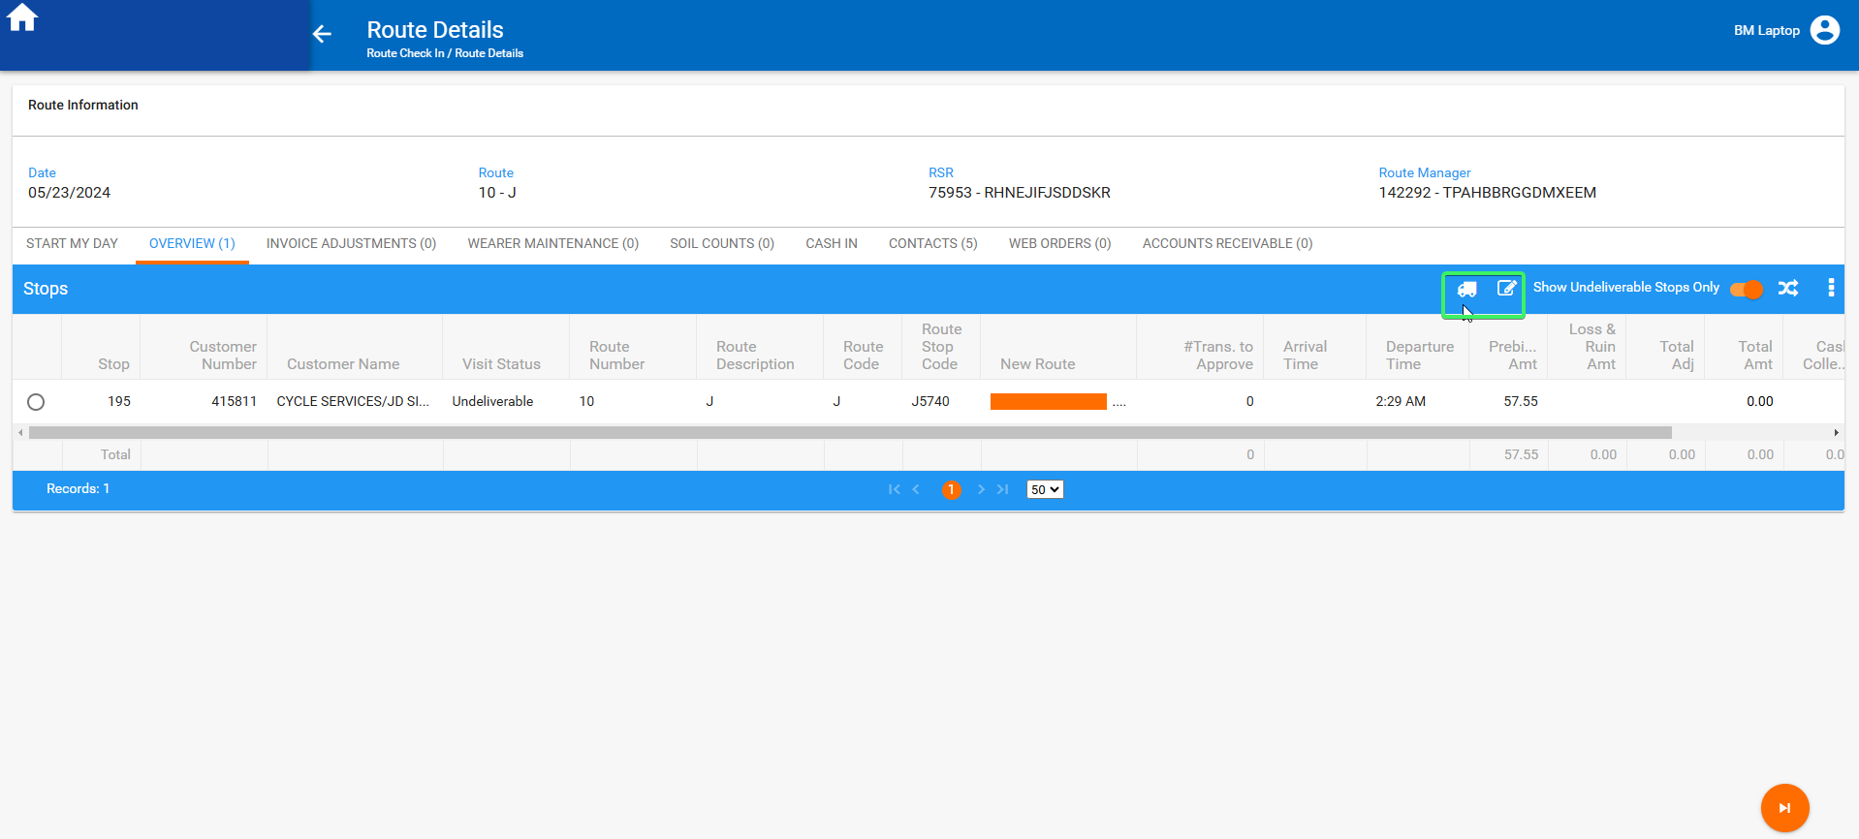

Expected behavior
The two buttons: Change Visit status and View signature are not reloaded, they should be disabled.

Retest after fix
Hash: 9.07.00.UNF18 hash: f3ab373ceadf

BU: 315

Expected behavior
The ss value WEBWORKORDERRESERVATION should be taken into consideration.

Steps to reproduce

Problem 1
- Open WebX and load a route that has fully credited invoices on RA, you can find data with this select:
SELECT RC.DRIVINGDATE, R.ROUTENUMBER, P.CODE, S.STOPNUMBER, RC.ROUTECONTROL_ID FROM ROUTECONTROL RC
JOIN STOP S ON S.ROUTECONTROL_ID = RC.ROUTECONTROL_ID
JOIN ROUTETRANSACTION RT ON RT.ROUTECONTROL_ID = RC.ROUTECONTROL_ID AND S.STOP_ID = RT.STOP_ID
JOIN ROUTE R ON RC.ROUTE_ID = R.ROUTE_ID
JOIN PLANT P ON P.PLANT_ID = R.PLANT_ID
WHERE RC.Settlementstatus = 1
AND RC.POCKETPCSTATUS = 2
AND RT.ROUTETRANSACTIONTYPE_ID = 707
AND RT.MOBILEDEVICE_ID IS NOT NULL;
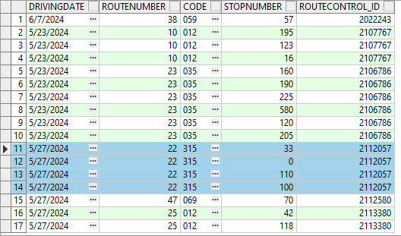

- Select a row that has a full credit on it in Overview tab
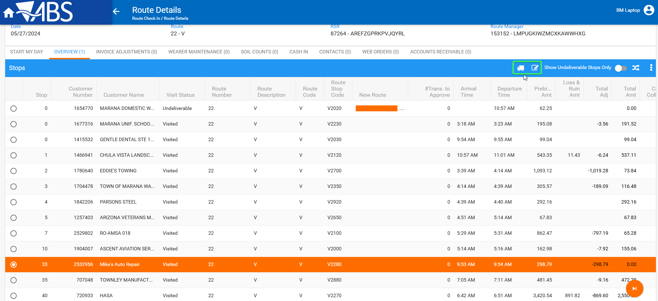
- Click on the Change visit status button
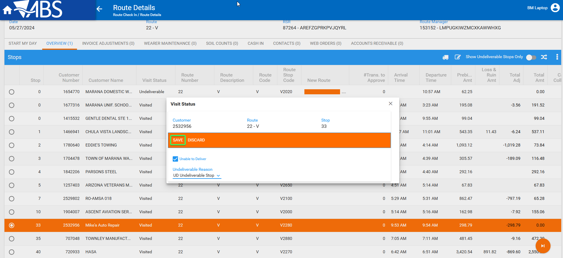
- Select Undeliverable checkbox and a reason code
- Click save
- Observe that the two buttons: Change Visit status and View signature were reloaded
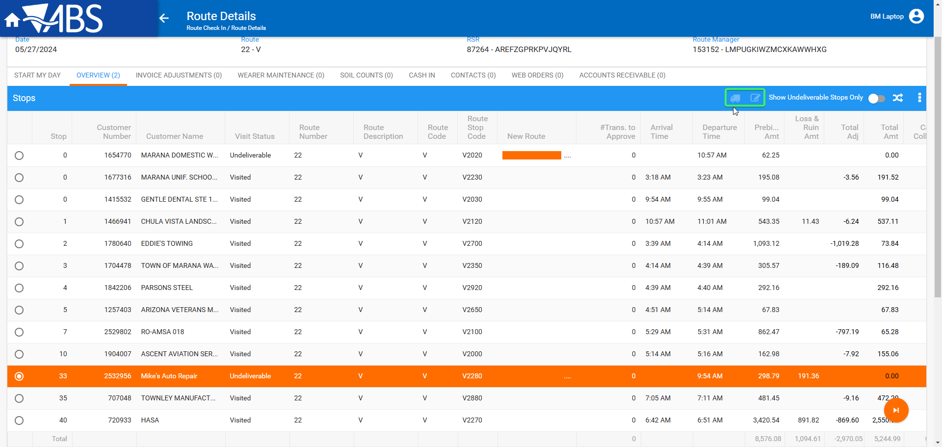
Tested OK

Problem 2
- Open WebX and load a route that has at least 2 fully credited invoices on RA, you can find data with this select:
SELECT RC.DRIVINGDATE, R.ROUTENUMBER, P.CODE, S.STOPNUMBER, RC.ROUTECONTROL_ID FROM ROUTECONTROL RC
JOIN STOP S ON S.ROUTECONTROL_ID = RC.ROUTECONTROL_ID
JOIN ROUTETRANSACTION RT ON RT.ROUTECONTROL_ID = RC.ROUTECONTROL_ID AND S.STOP_ID = RT.STOP_ID
JOIN ROUTE R ON RC.ROUTE_ID = R.ROUTE_ID
JOIN PLANT P ON P.PLANT_ID = R.PLANT_ID
WHERE RC.Settlementstatus = 1
AND RC.POCKETPCSTATUS = 2
AND RT.ROUTETRANSACTIONTYPE_ID = 707
AND RT.MOBILEDEVICE_ID IS NOT NULL;
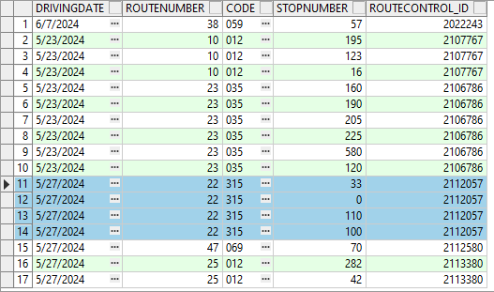
- Select a row that has a full credit on it in Overview tab
- Change visit status on one of the stops with a full credit to undeliverable
- Select a different stop with a full credit and click on the Undeliverable only switch
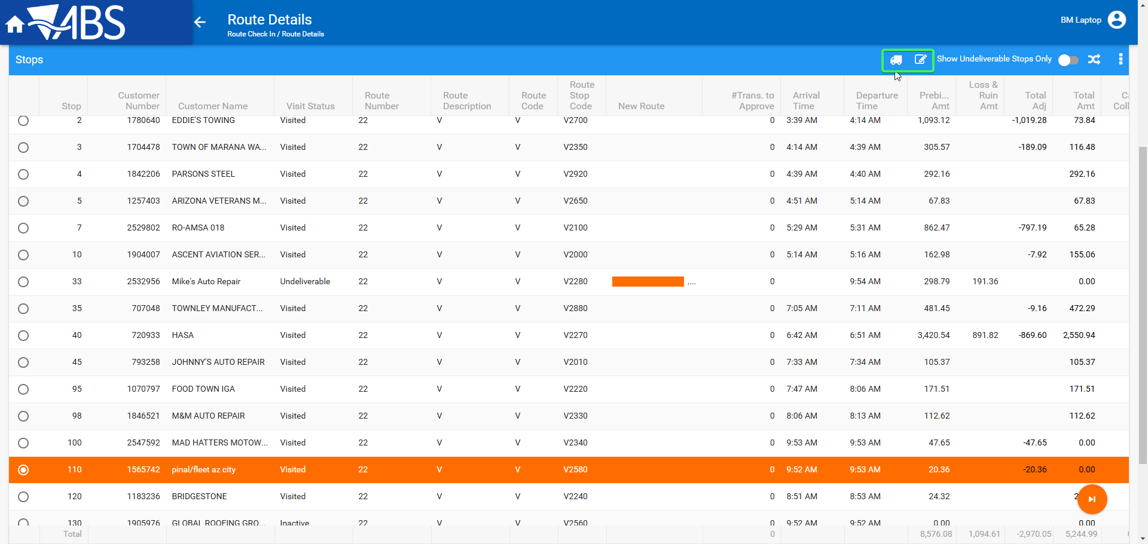
- Observe that the two buttons: Change Visit status and View signature are not reloaded.
- Select the route and observe that the buttons were disabled.
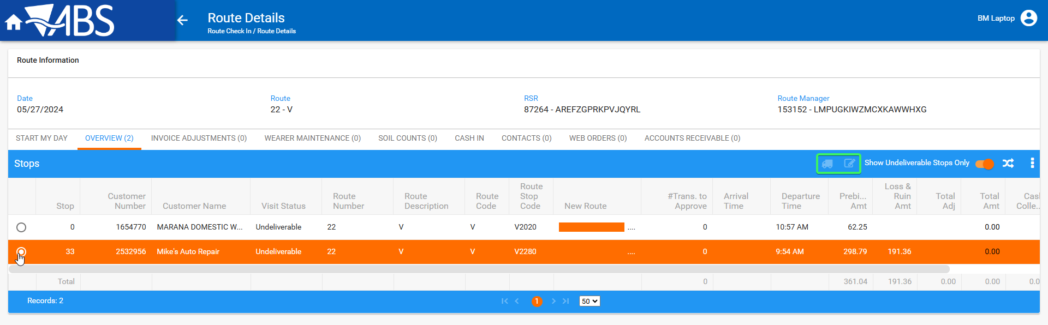
Tested OK

