ABS-171426 - D_UBS_2556 Settling a credited a loss line causing garments to be flagged DOI
Environment | Prerequisites
Version: 9.07.00.UNF18  DBServerName= abs-srv20.internal.abslbs.com  DBSID=CUST24  DBUser=UNFDEV  DBPassword=UNFDEV  Environment=Production | - Module:  - System setting

Contents
Reproducing before fix 1
Steps to reproduce 1
Current Behavior 7
Expected behavior 7
Retest after fix 7
Test Case 1 – Crediting a loss line of subtype DOI with flag first scanned 7
Test Case 2 – Adjusting on Route Assistant a Loss Charge Line for DOI with garments scanned 8

Reproducing before fix
Reproduced on 9.09.00.RC1 hash: 46b57c1ad1d5
UNFA@CUST24

Steps to reproduce
- Wearers DLG: Find a customer with active wearers and wearer inventories.
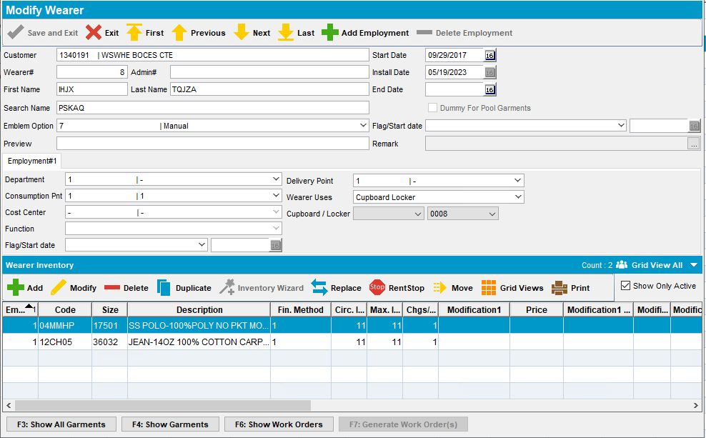
- Wearers DLG: Decrease max inventory and select return first show up in laundry
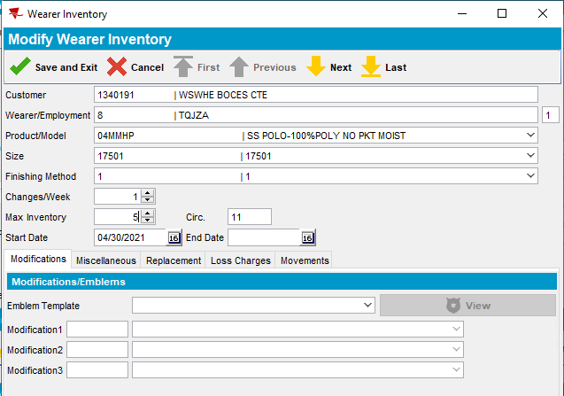
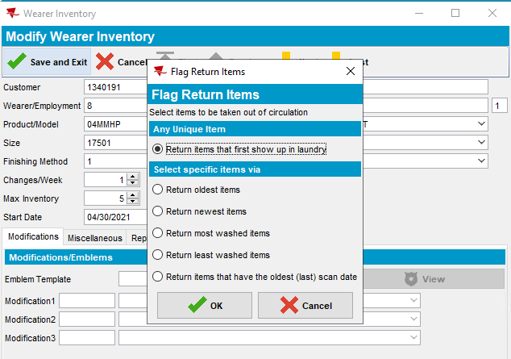
- Inscan DLG –> Normal -> OK: Scan 3 garments from the wearer inventory that you
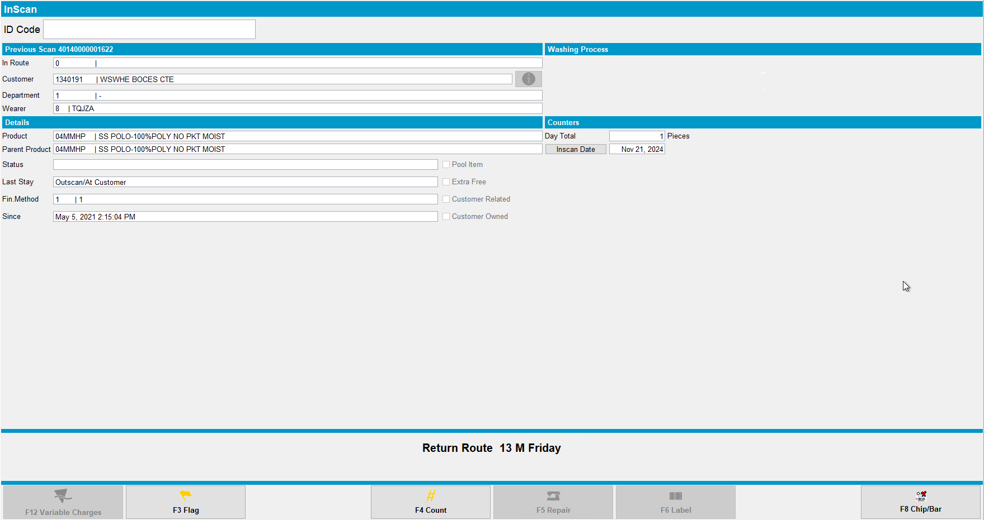
- PLSQL: Check WI. QTYTOBERETURNEDDECREASEMAX
SELECT WI.QTYTOBERETURNEDDECREASEMAX FROM WEARERINVENTORY WI
JOIN WEAREREMPLOYMENT WE ON WE.WEAREREMPLOYMENT_ID = WI.WEAREREMPLOYMENT_ID
JOIN WEARER W ON W.WEARER_ID = WE.WEARER_ID
JOIN CUSTOMER C ON C.CUSTOMER_ID = W.CUSTOMER_ID
JOIN PRODUCT P ON P.PRODUCT_ID = WI.PRODUCT_ID
JOIN SIZEDEFINITION SD ON SD.SIZEDEFINITION_ID = WI.SIZEDEFINITION_ID
WHERE C.CUSTOMERNUMBER = 1340191
AND W.WEARERNUMBER = 8
AND P.CODE = '04MMHP'
AND SD.CODE = '17501';
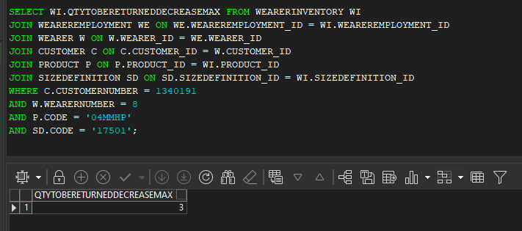
- Route Status Control DLG: Add a route control 3 weeks into the future and generate invoices for your customer
- Maintain Invoices DLG: Check that the invoice has a loss charge of subtype Decrease max
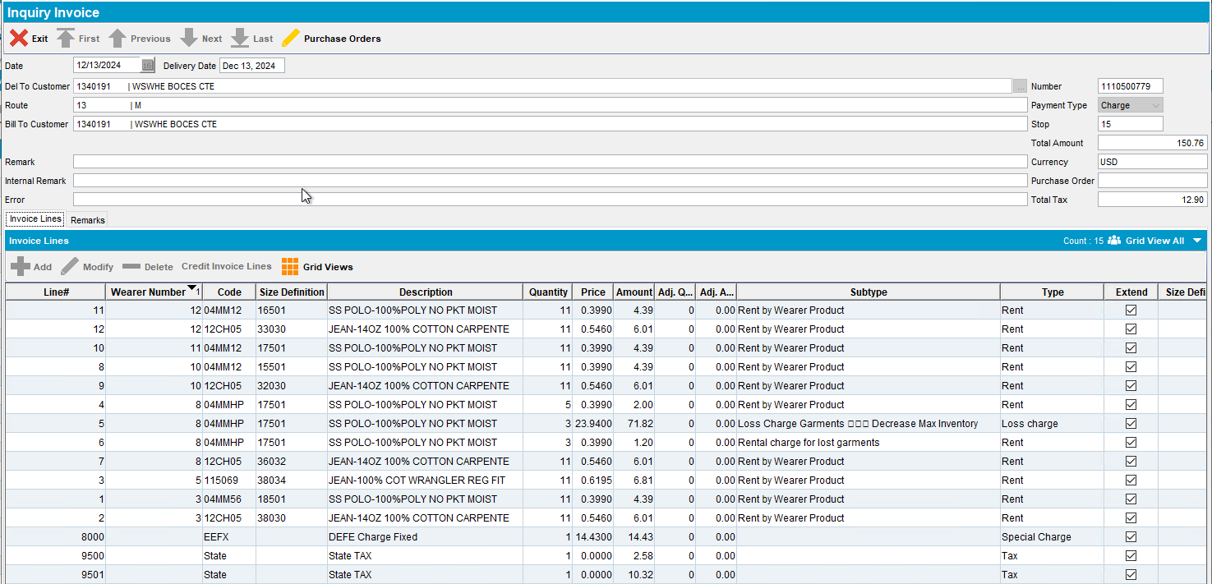
- Settle the route
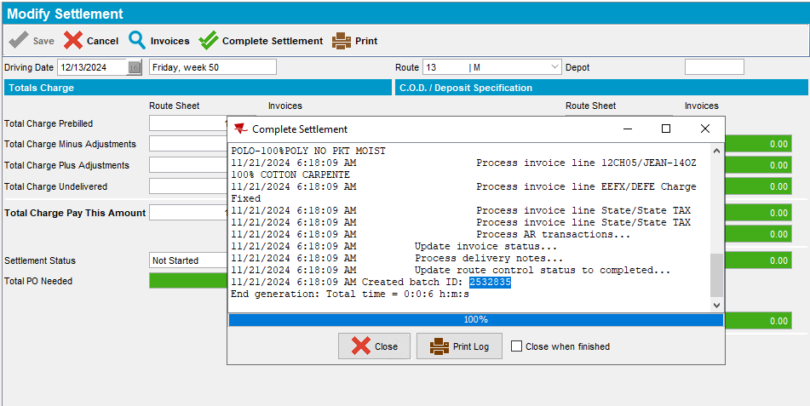
- Script in the BCI tax data and run the process on the Vertex Tax batch
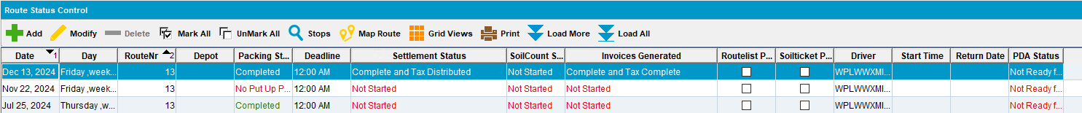
- PLSQL: Check the WI.QTYTOBERETURNEDDECREASEMAX – should be 0
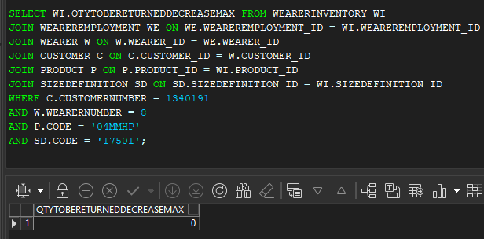
- Maintain Invoices DLG > Settled Invoices: Credit the invoice line
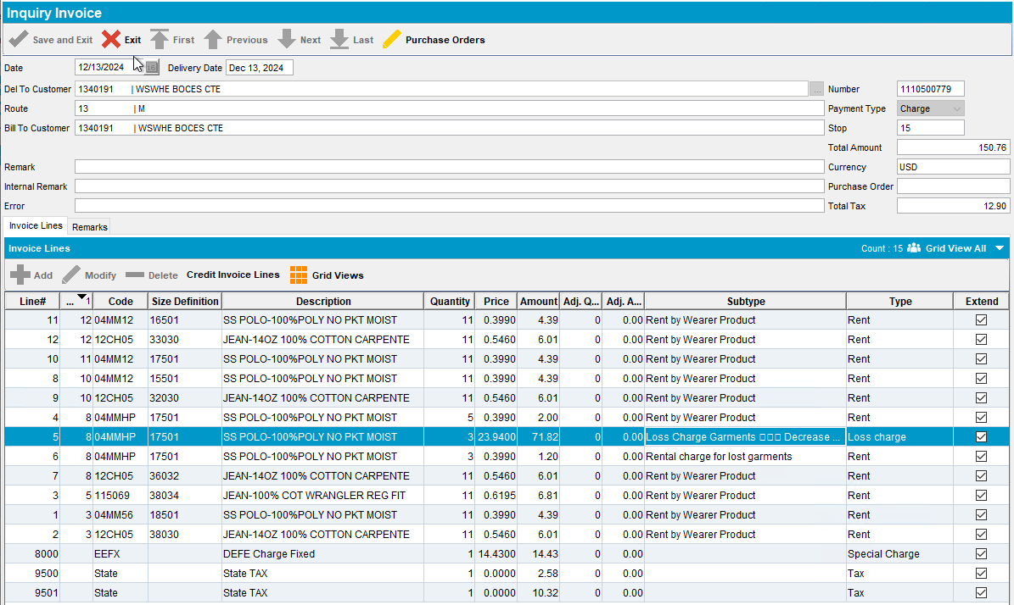
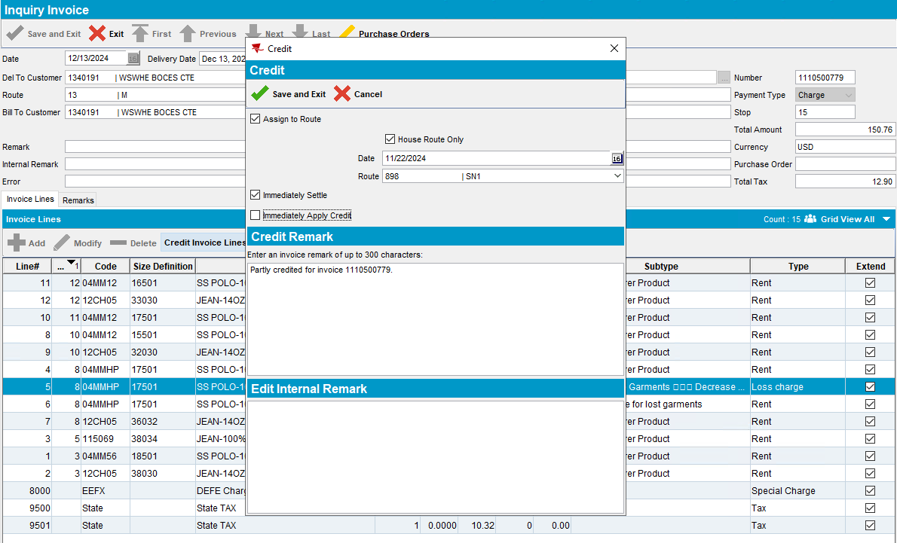
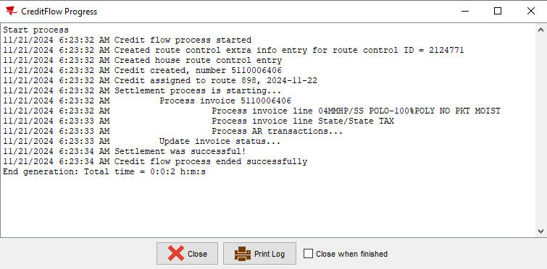
- PLSQL: Check the WI.QTYTOBERETURNEDDECREASEMAX – It’s now back up to 3 (should be 0)
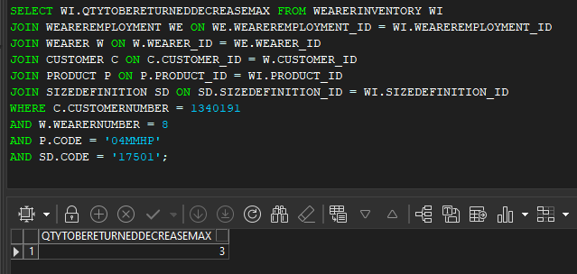

REPRODUCED OK.

Current Behavior
When crediting the loss line and settling the credit invoice WI.QTYTOBERETURNEDDECREASEMAX is updated back to the original value.

Expected behavior
When crediting the loss line and settling the credit invoice WI.QTYTOBERETURNEDDECREASEMAX should not be updated.

Retest after fix
Hash: 9.07.00. UNF18 hash: f3ab373ceadf

Test Case 1 – Crediting a loss line of subtype DOI with flag first scanned
- Wearers DLG: Find a customer with active wearers and wearer inventories.
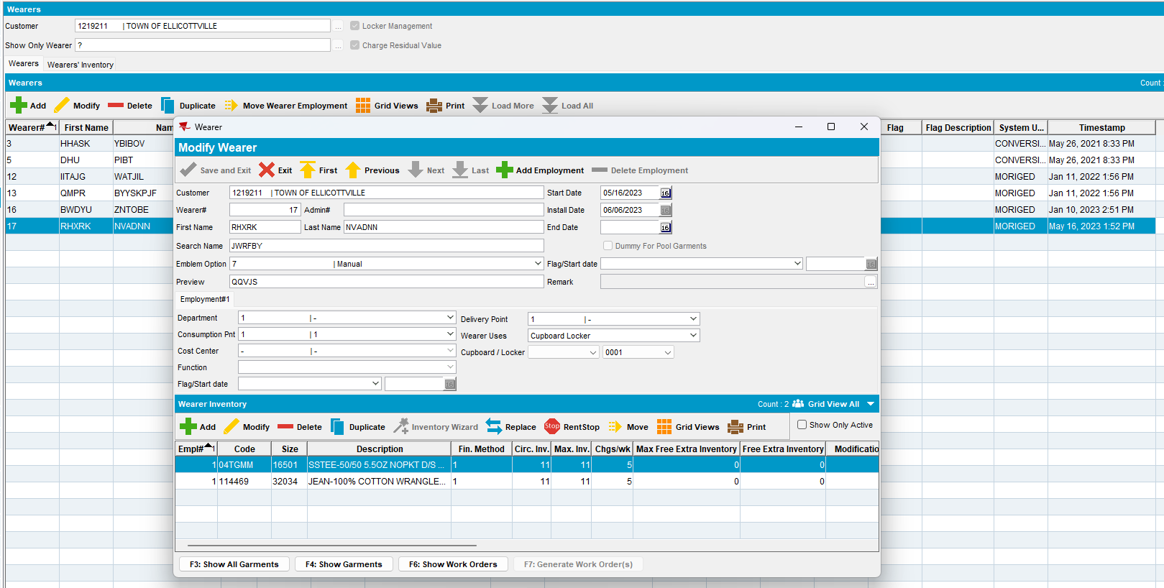
- Wearers DLG: Decrease max inventory and select return first show up in laundry
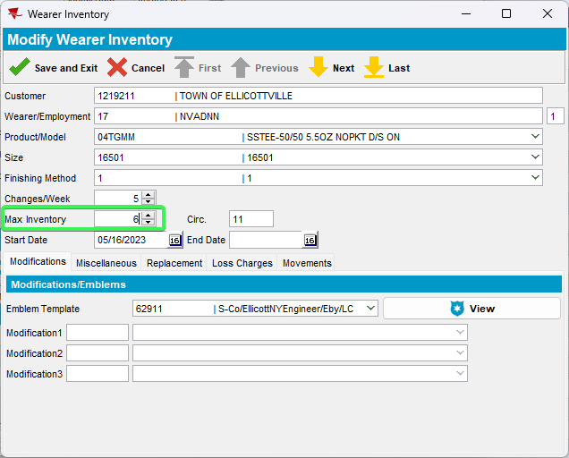
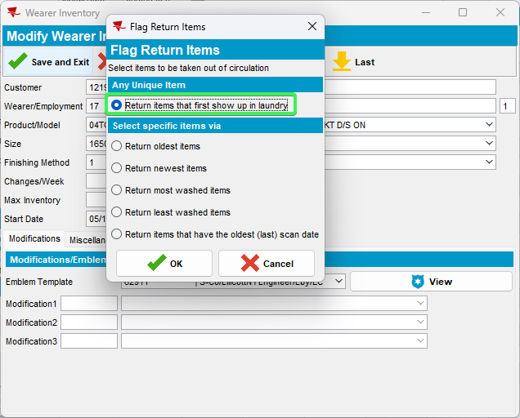
- Inscan DLG –> Normal -> OK: Scan 2 garments from the wearer inventory that you decreased
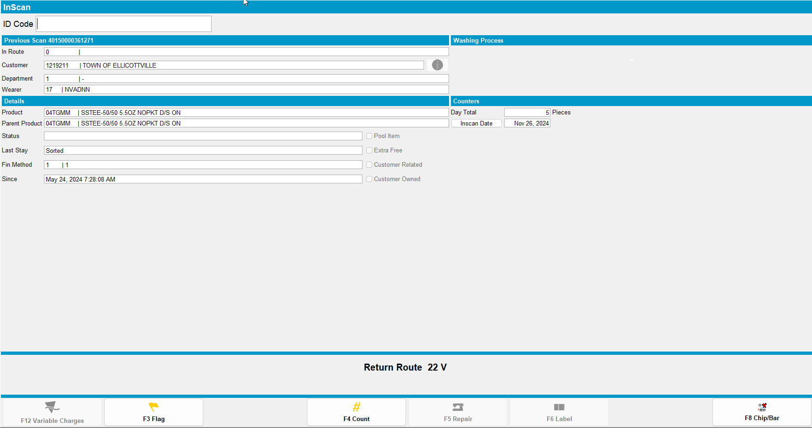
- PLSQL: Check WI. QTYTOBERETURNEDDECREASEMAX
SELECT WI.QTYTOBERETURNEDDECREASEMAX FROM WEARERINVENTORY WI
JOIN WEAREREMPLOYMENT WE ON WE.WEAREREMPLOYMENT_ID = WI.WEAREREMPLOYMENT_ID
JOIN WEARER W ON W.WEARER_ID = WE.WEARER_ID
JOIN CUSTOMER C ON C.CUSTOMER_ID = W.CUSTOMER_ID
JOIN PRODUCT P ON P.PRODUCT_ID = WI.PRODUCT_ID
JOIN SIZEDEFINITION SD ON SD.SIZEDEFINITION_ID = WI.SIZEDEFINITION_ID
WHERE C.CUSTOMERNUMBER = 1219211
AND W.WEARERNUMBER = 17
AND P.CODE = '04TGMM'
AND SD.CODE = '16501';
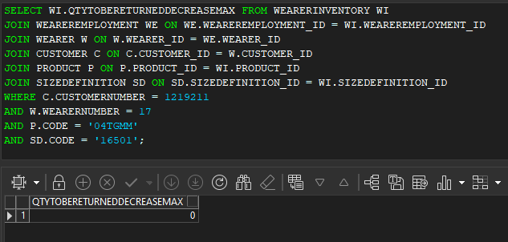
- Route Status Control DLG: Add a route control 3 weeks into the future and generate invoices for your customer
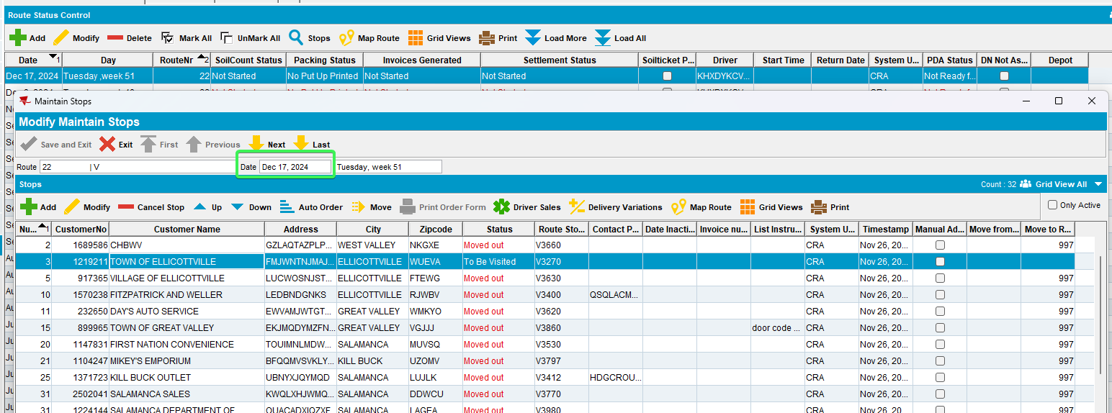
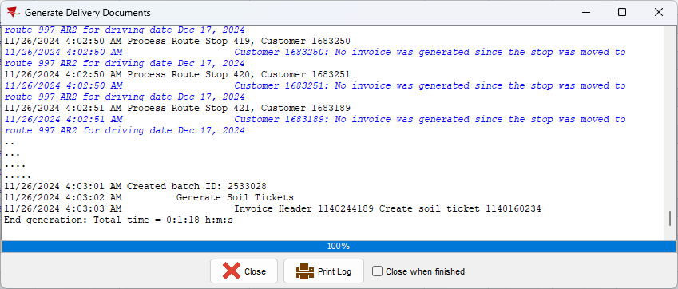
- Maintain Invoices DLG: Check that the invoice has a loss charge of subtype Decrease max
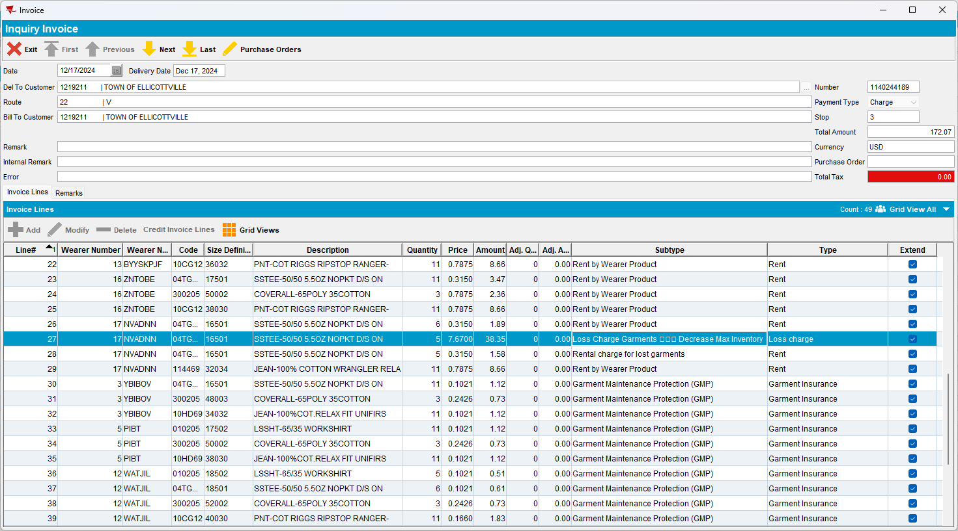
- Settle the route
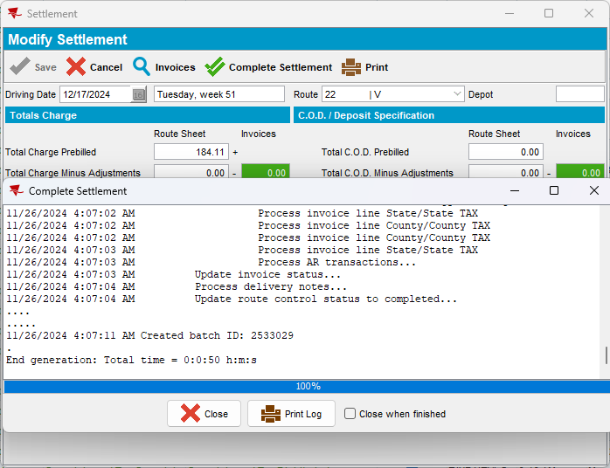
- Script in the BCI tax data and run the process on the Vertex Tax batch
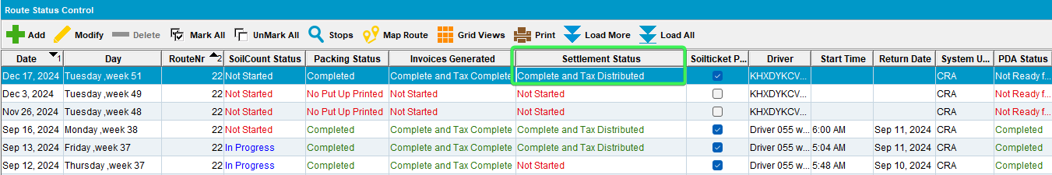
- PLSQL: Check the WI.QTYTOBERETURNEDDECREASEMAX – should be 0
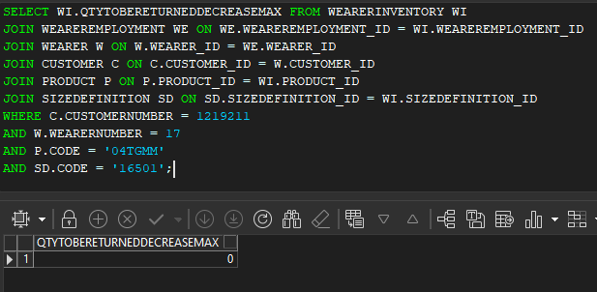
- Maintain Invoices DLG > Settled Invoices: Credit the invoice line
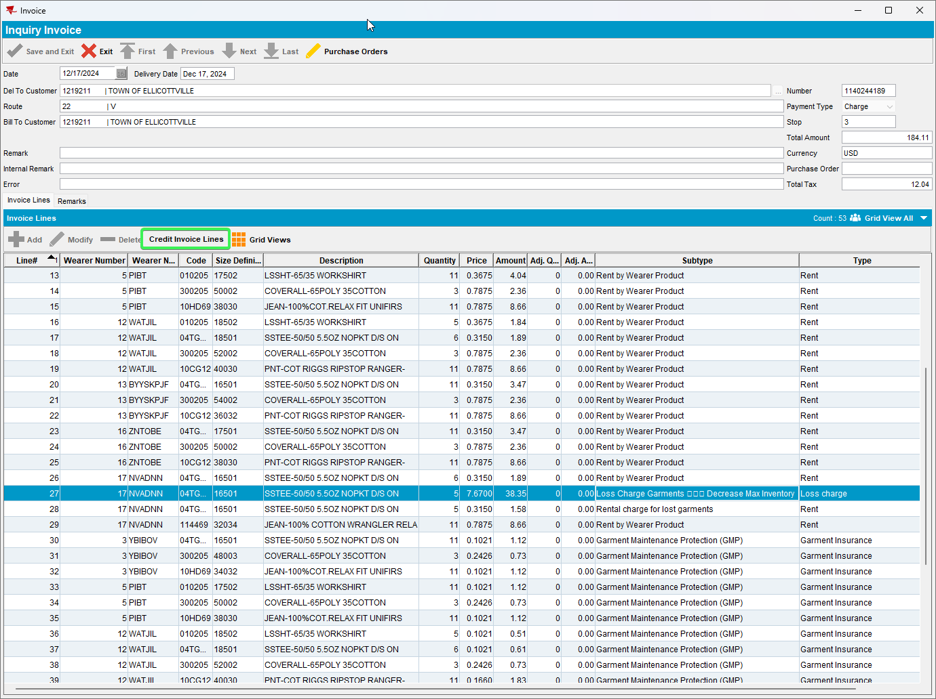
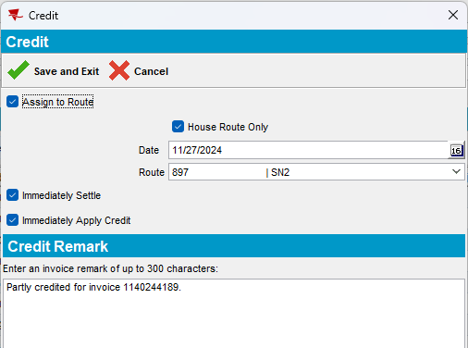
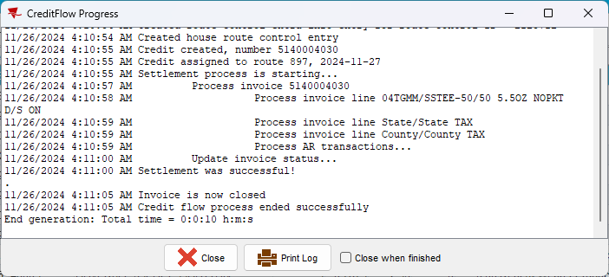
- PLSQL: Check the WI.QTYTOBERETURNEDDECREASEMAX – It’s still 0
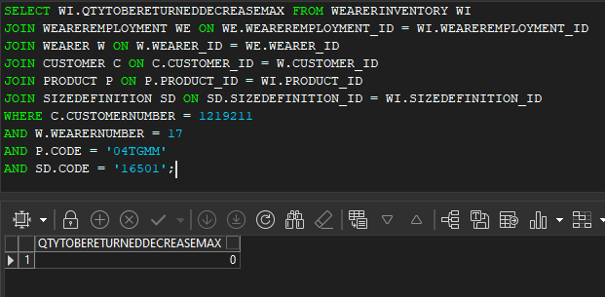
Tested OK

Test Case 2 – Adjusting on Route Assistant a Loss Charge Line for DOI with garments scanned
- Wearers DLG: Find a customer with active wearers and wearer inventories.
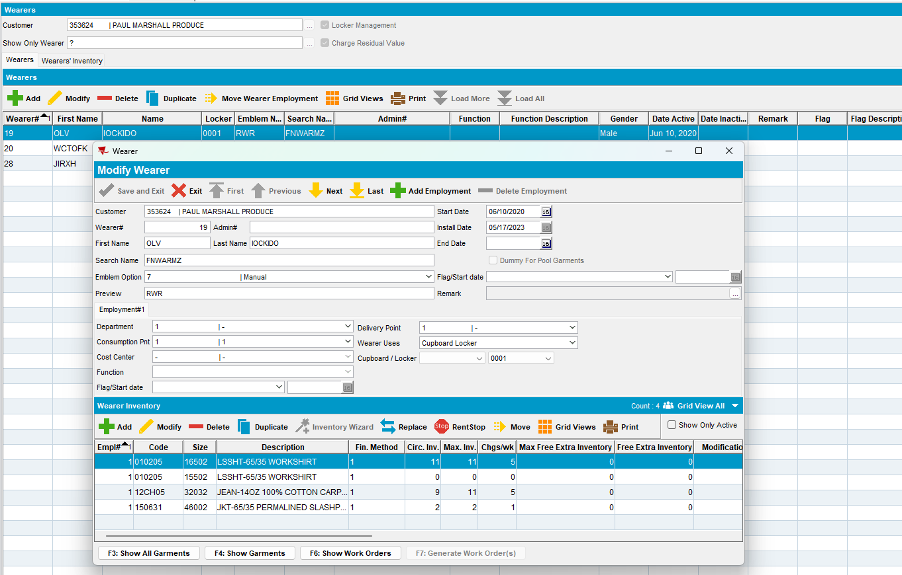
- Wearers DLG: Decrease max inventory and select return first show up in laundry

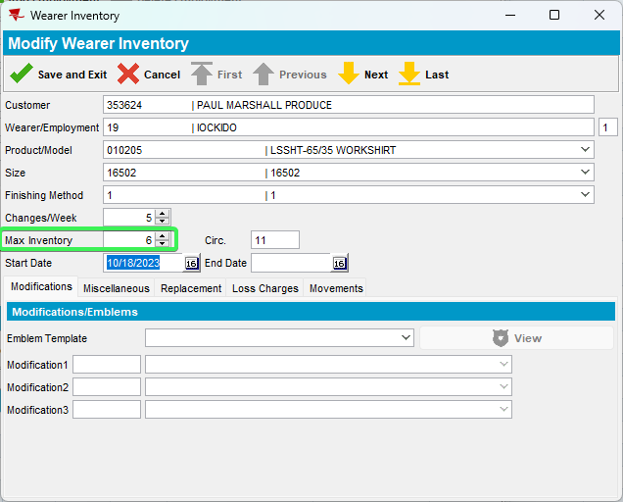
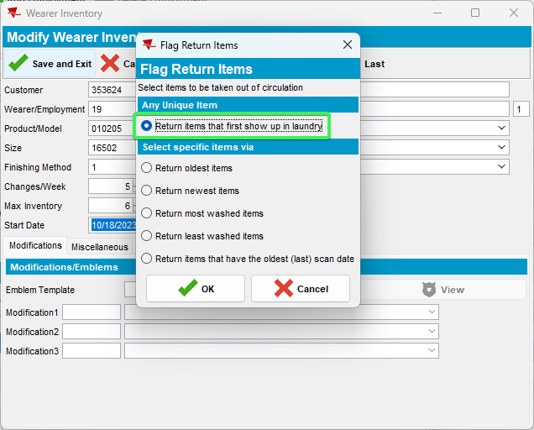
- Inscan DLG –> Normal -> OK: Scan 5 garments from the wearer inventory that you
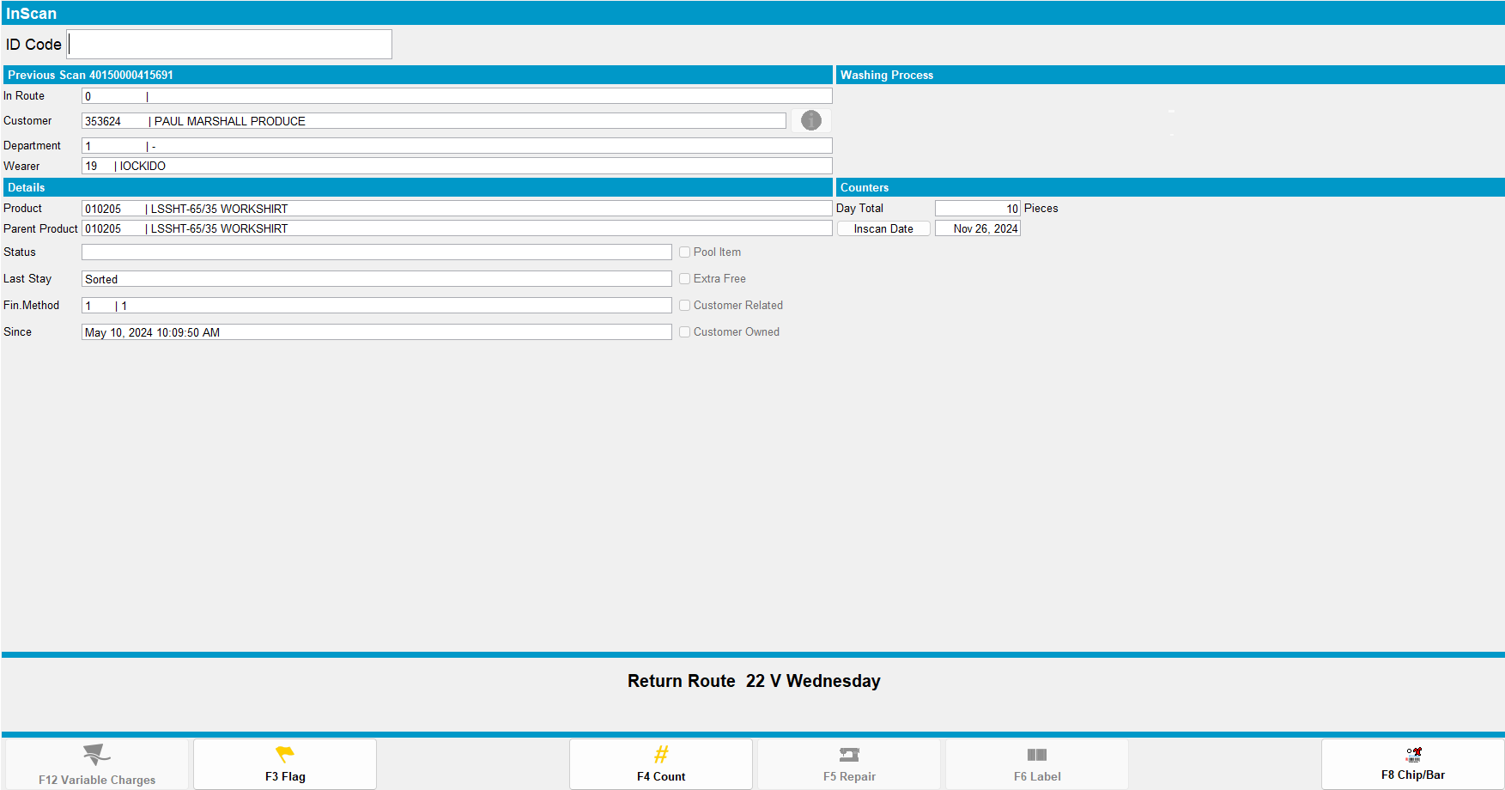
- PLSQL: Check WI. QTYTOBERETURNEDDECREASEMAX
SELECT WI.QTYTOBERETURNEDDECREASEMAX FROM WEARERINVENTORY WI
JOIN WEAREREMPLOYMENT WE ON WE.WEAREREMPLOYMENT_ID = WI.WEAREREMPLOYMENT_ID
JOIN WEARER W ON W.WEARER_ID = WE.WEARER_ID
JOIN CUSTOMER C ON C.CUSTOMER_ID = W.CUSTOMER_ID
JOIN PRODUCT P ON P.PRODUCT_ID = WI.PRODUCT_ID
JOIN SIZEDEFINITION SD ON SD.SIZEDEFINITION_ID = WI.SIZEDEFINITION_ID
WHERE C.CUSTOMERNUMBER = 353624
AND W.WEARERNUMBER = 19
AND P.CODE = '010205'
AND SD.CODE = '16502';
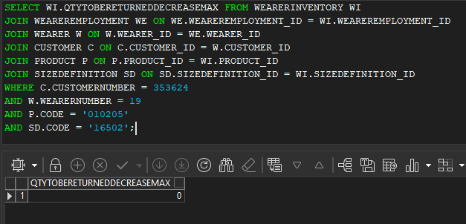
- Route Status Control DLG: Add a route control 3 weeks into the future and generate invoices for your customer
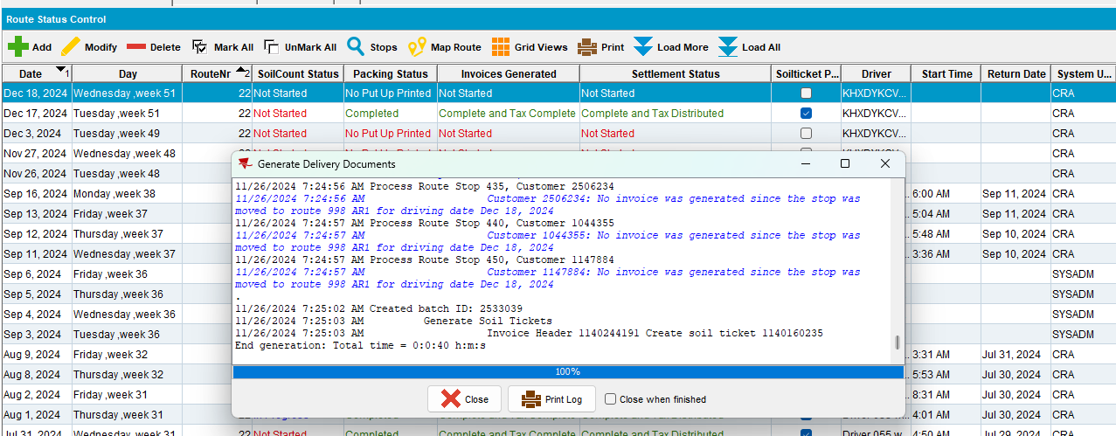
- Maintain Invoices DLG: Check that the invoice has a loss charge of subtype Decrease max
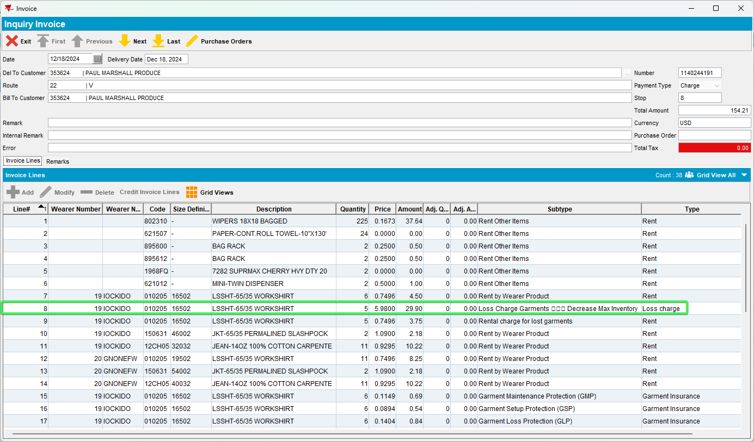
- RA: Download the route and adjust the loss charge down by -3
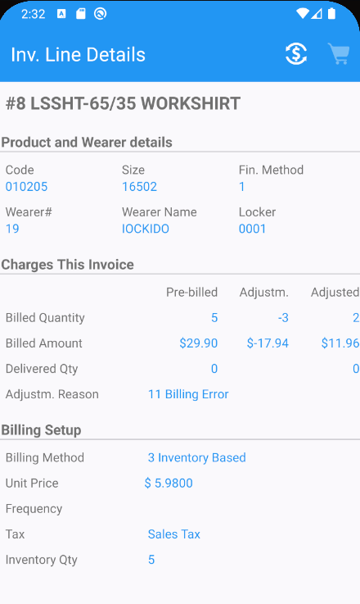
- WebX: Approve the invoice adjustments
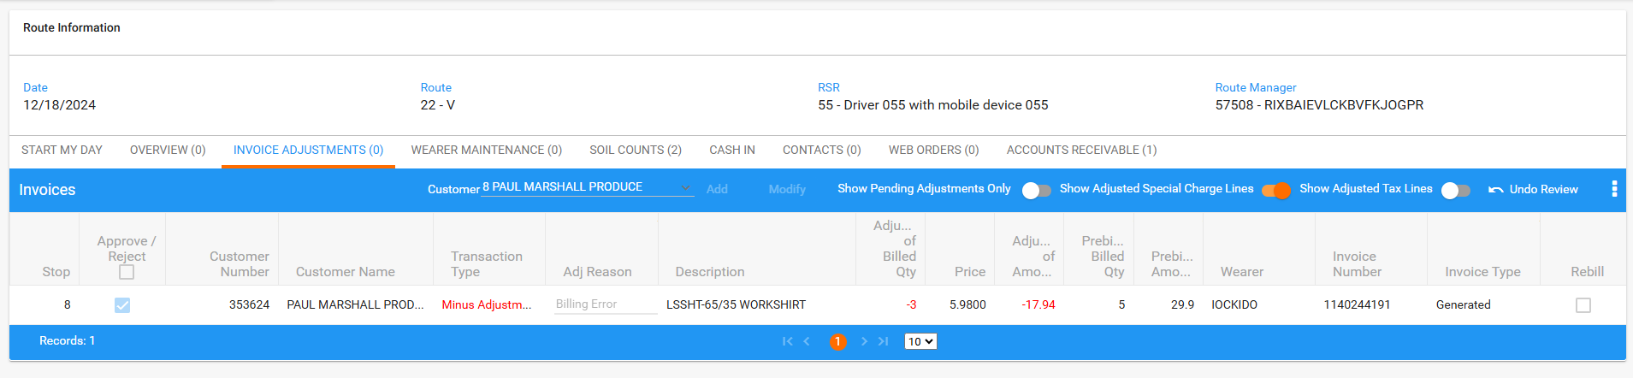
- WebX: Settle the route
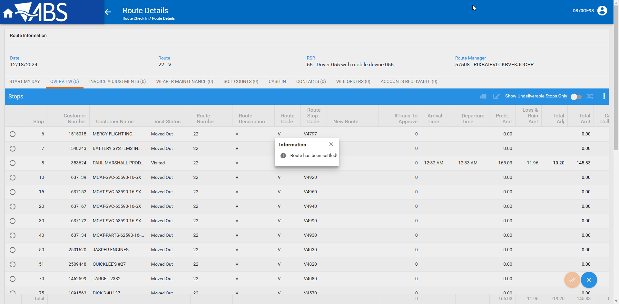
- PLSQL: Check WI. QTYTOBERETURNEDDECREASEMAX
SELECT WI.QTYTOBERETURNEDDECREASEMAX FROM WEARERINVENTORY WI
JOIN WEAREREMPLOYMENT WE ON WE.WEAREREMPLOYMENT_ID = WI.WEAREREMPLOYMENT_ID
JOIN WEARER W ON W.WEARER_ID = WE.WEARER_ID
JOIN CUSTOMER C ON C.CUSTOMER_ID = W.CUSTOMER_ID
JOIN PRODUCT P ON P.PRODUCT_ID = WI.PRODUCT_ID
JOIN SIZEDEFINITION SD ON SD.SIZEDEFINITION_ID = WI.SIZEDEFINITION_ID
WHERE C.CUSTOMERNUMBER = 353624
AND W.WEARERNUMBER = 19
AND P.CODE = '010205'
AND SD.CODE = '16502';
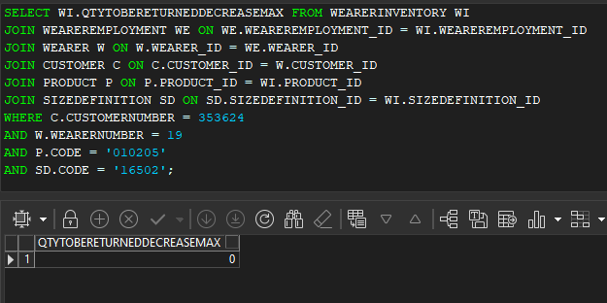
- Maintain Invoices DLG: Do a line credit on the loss charge invoice line.
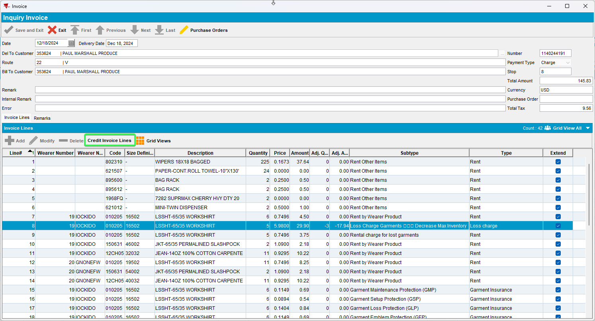
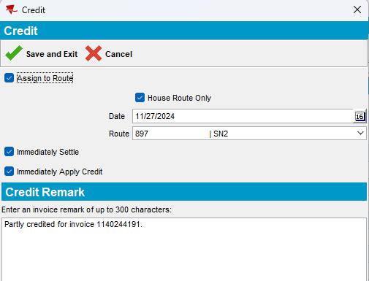
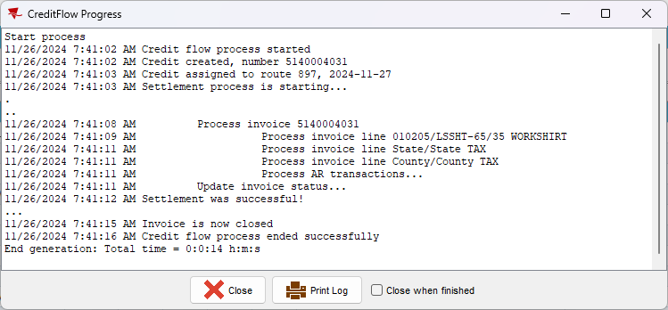
- PLSQL: Check WI. QTYTOBERETURNEDDECREASEMAX
SELECT WI.QTYTOBERETURNEDDECREASEMAX FROM WEARERINVENTORY WI
JOIN WEAREREMPLOYMENT WE ON WE.WEAREREMPLOYMENT_ID = WI.WEAREREMPLOYMENT_ID
JOIN WEARER W ON W.WEARER_ID = WE.WEARER_ID
JOIN CUSTOMER C ON C.CUSTOMER_ID = W.CUSTOMER_ID
JOIN PRODUCT P ON P.PRODUCT_ID = WI.PRODUCT_ID
JOIN SIZEDEFINITION SD ON SD.SIZEDEFINITION_ID = WI.SIZEDEFINITION_ID
WHERE C.CUSTOMERNUMBER = 353624
AND W.WEARERNUMBER = 19
AND P.CODE = '010205'
AND SD.CODE = '16502';
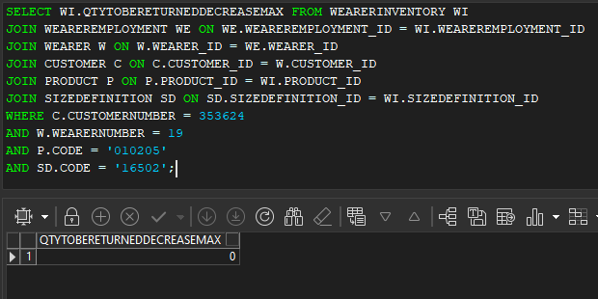
Tested OK

