ASD-65481 UNF: D_UBS_2577 ABS 165920 Route Transactions being cancelled
Environment | Prerequisites
Version:9.07.00  DBServerName=abs-srv20.internal.abslbs.com  DBSID= CUST24  DBUser= UNFDEV  DBPassword= UNFDEV  Environment=Production | - Module:  - System setting

Contents
Reproducing before fix 1
Steps to reproduce 1
Expected behavior 3
Retest after fix 3
Test Case 1 - Set Undeliverable on WebX a stop without wearer maintenance transactions 3
Expected behavior 3
Steps to reproduce 4
Test Case 2 - Set Undeliverable on WebX a stop without wearer maintenance transactions 10
Expected behavior 10
Steps to reproduce 10

Reproducing before fix
9.09.00.RC1 hash: 579182236a66
BU: 044

Steps to reproduce
- RSC dlg: Create a route containing 2 customers with garment delivery days. Generate invoices and send the route to PDA.
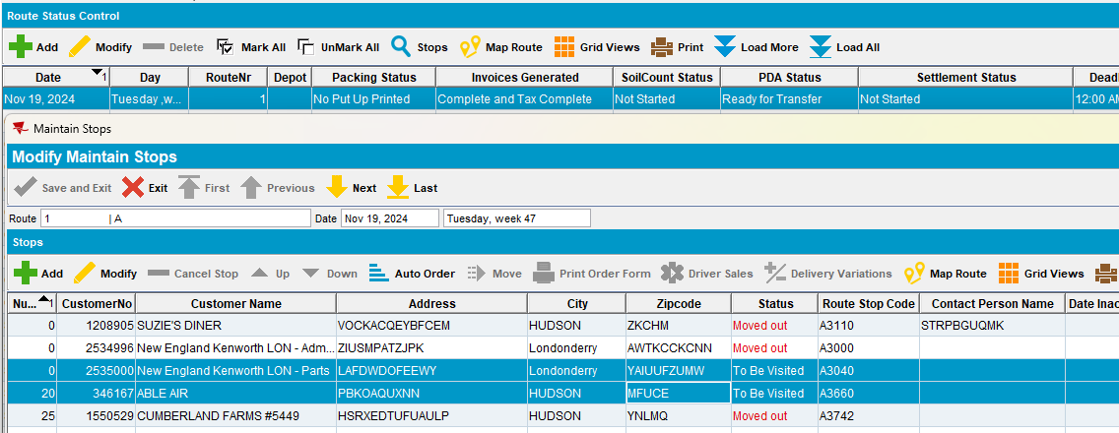
- RA: Download the route and arrive at the first customer. Full Credit the invoice.
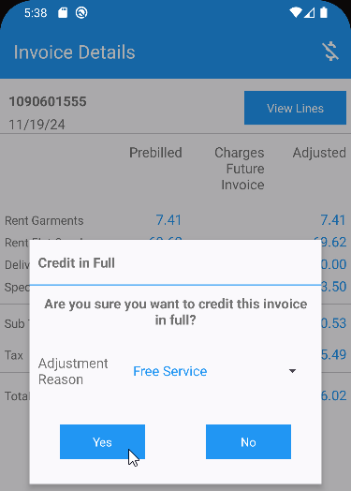
- RA: Settle and depart.
- RA: Arrive at the second customer and add a new wearer inventory, Scan replace some garments, add a new wearer, increase the wearer inventory.
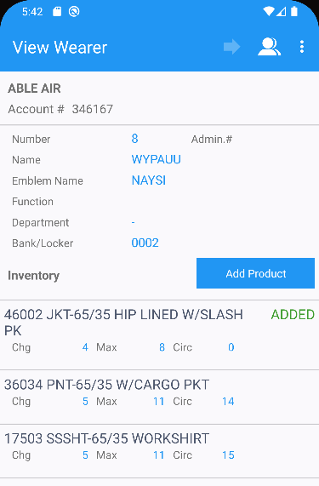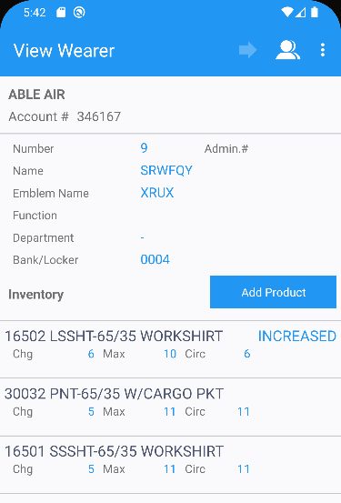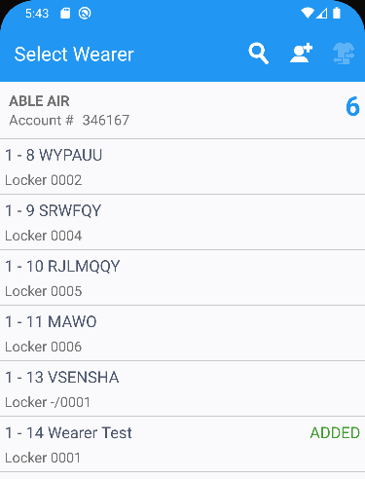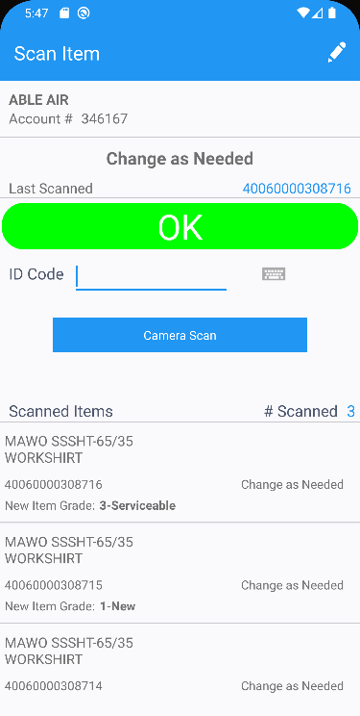
- RA: Settle and depart from customer.
- RA: Finish and upload the route.
- WebX: Complete the start my day.
- WebX: On the Overview, select the first stop and select the change visit status and mark it as Undeliverable.
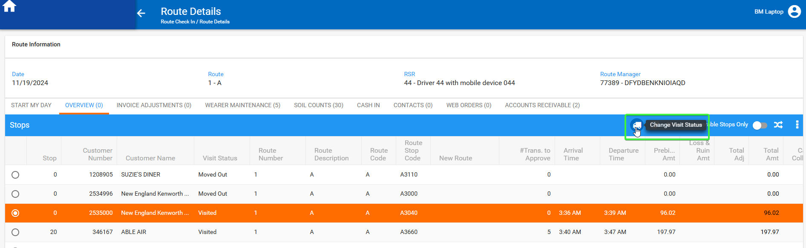
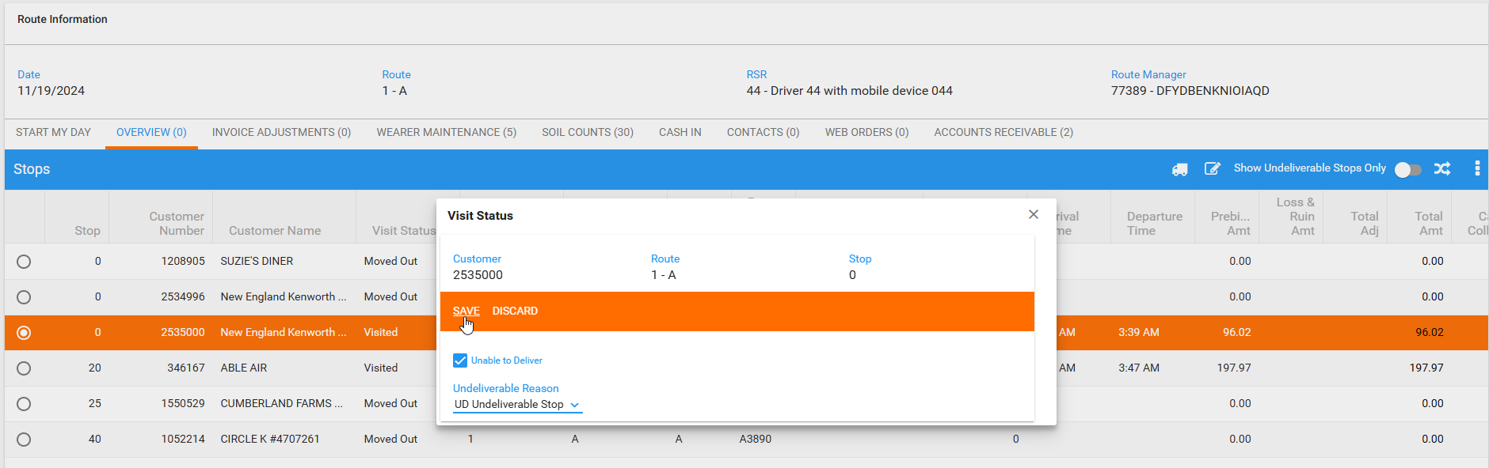
- WebX: Observe the pop-up after the save.
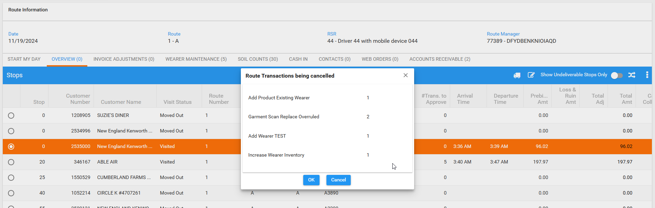

REPRODUCED OK.

Expected behavior
When a stop is set as undeliverable, there should be no pop-up to show canceled wearer maintenance.

Retest after fix
Hash: 9.07.00 hash: 6d6958b
BU: 052

Test Case 1 - Set Undeliverable on WebX a stop without wearer maintenance transactions

Expected behavior
When stop 1 is set as undeliverable there is no pop-up to show canceled wearer maintenance

- stop 1 has no wearer maintenance route transactions but has full credit on RA
- stop 2 has wearer maintenance route transactions

Steps to reproduce
- RSC dlg: Create a route containing 2 customers with garment delivery days. Generate invoices and send the route to PDA.
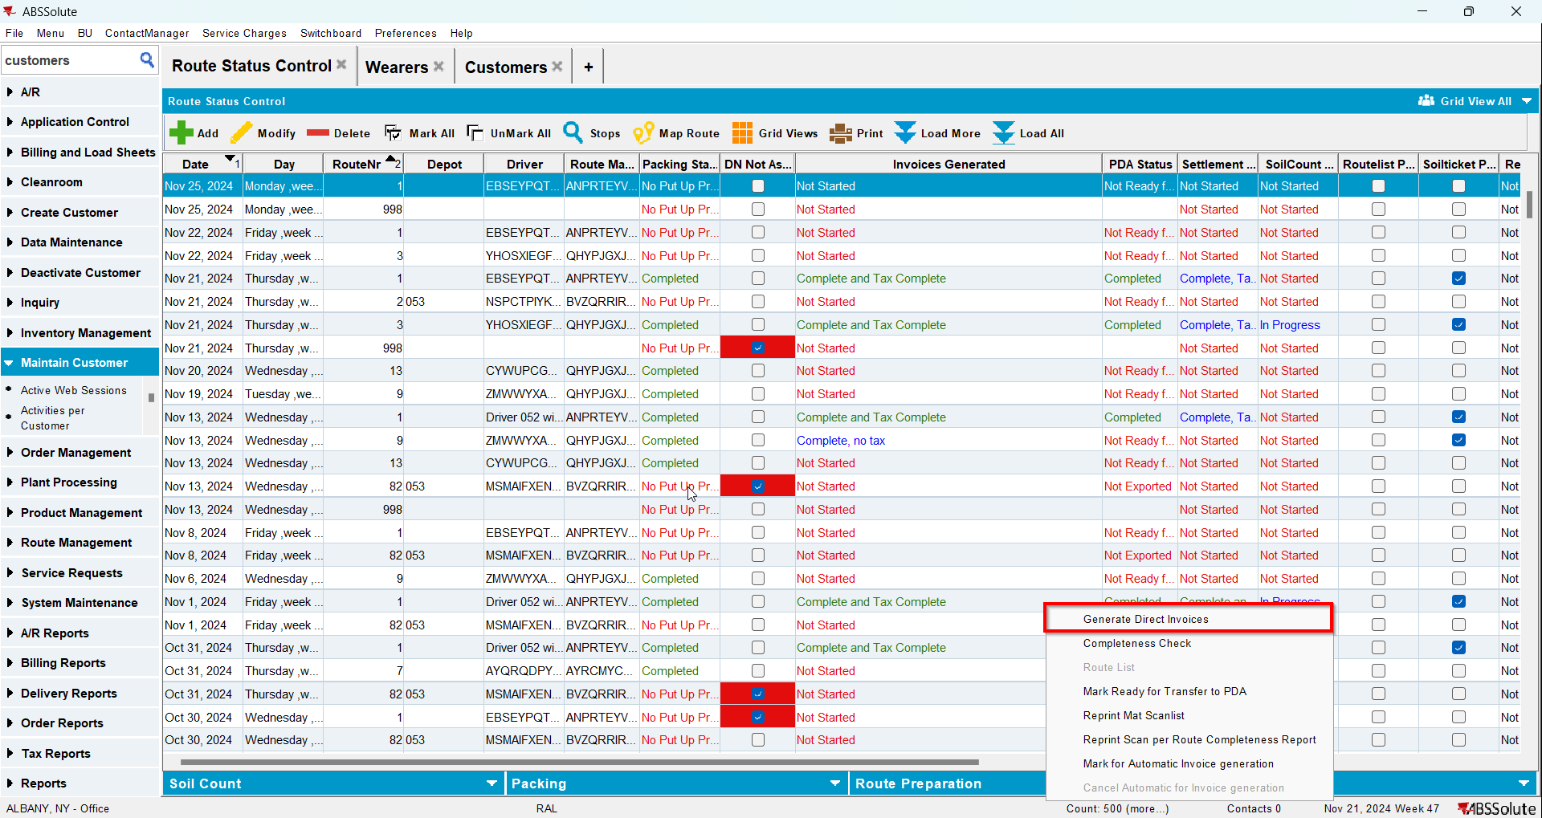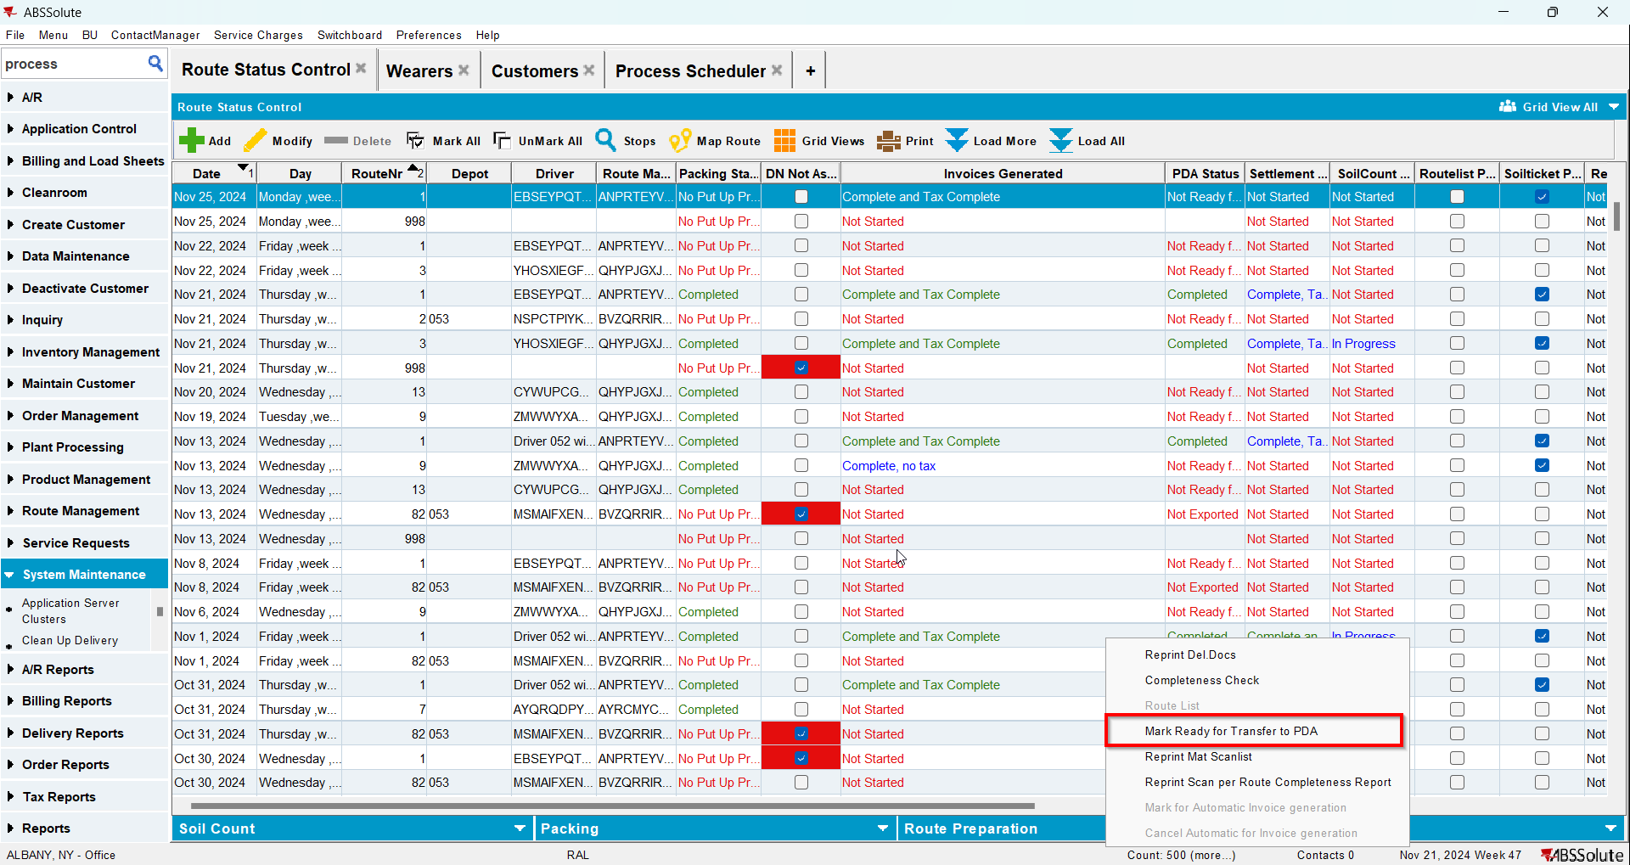
- RA: Download the route and arrive at the first customer. Full Credit the invoice.
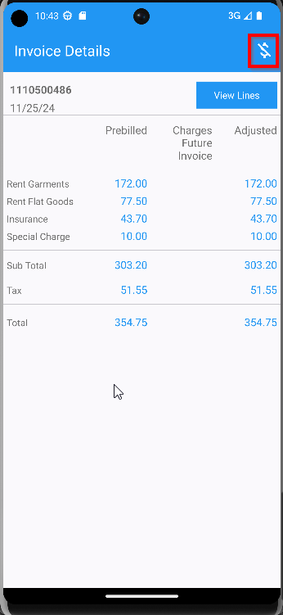
- RA: Settle and depart.
- RA: Arrive at the second customer and add a new wearer inventory, Scan replace some garments, add a new wearer, increase the wearer inventory.
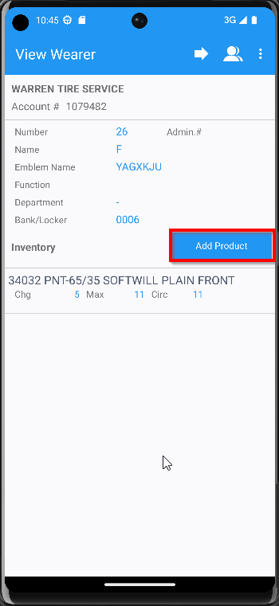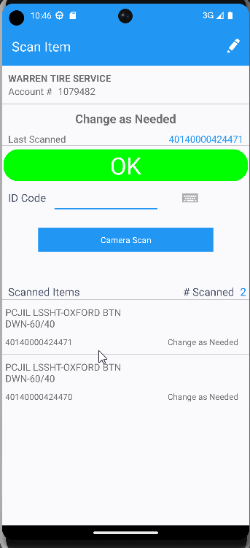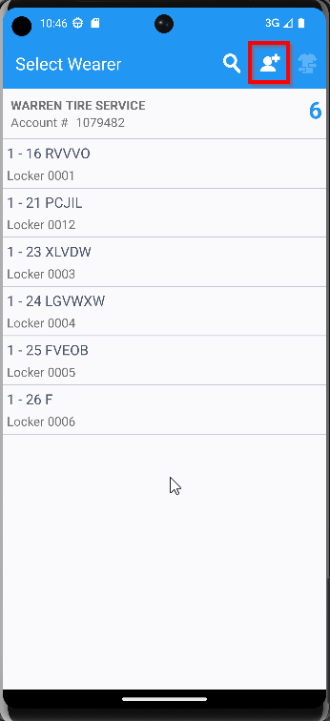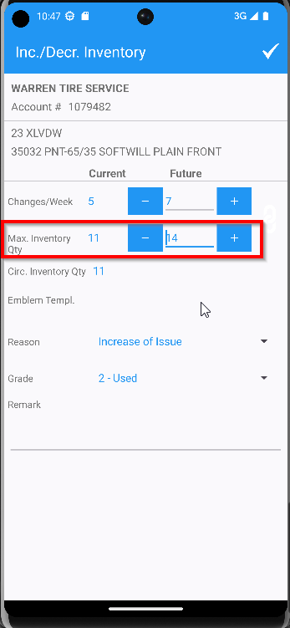
- RA: Settle and depart from customer.
- RA: Finish and upload the route.
- WebX: Complete the start my day.
- WebX: On the Overview, select the first stop and select the change visit status and mark it as Undeliverable.

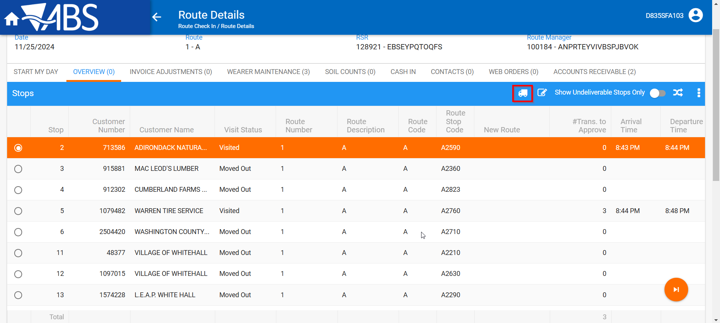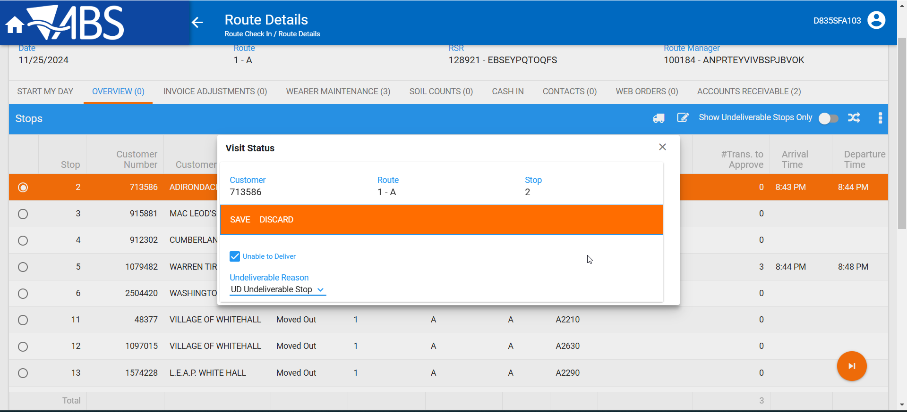

- WebX: No pop-up is presented
- WebX: Approve everything
- WebX: Move the undeliverable to a new route and settle the route.
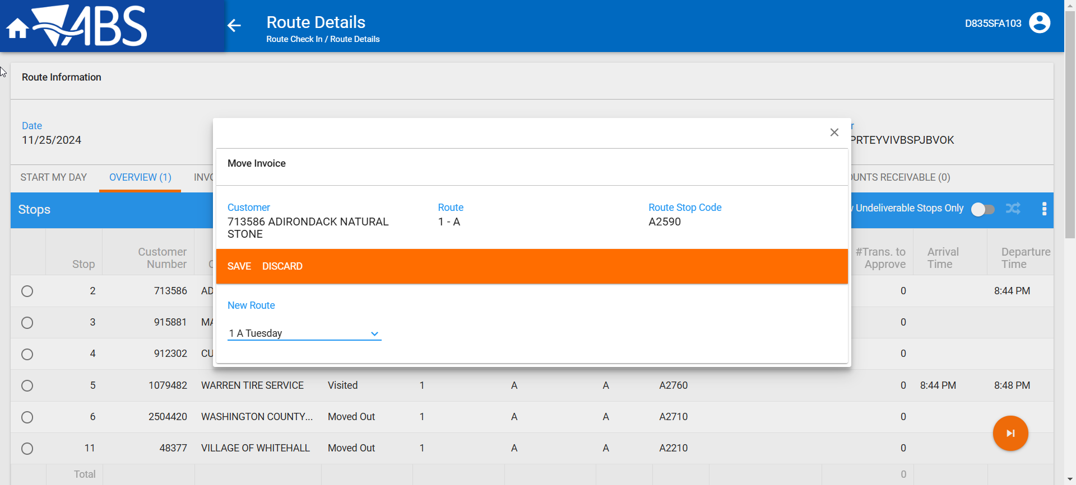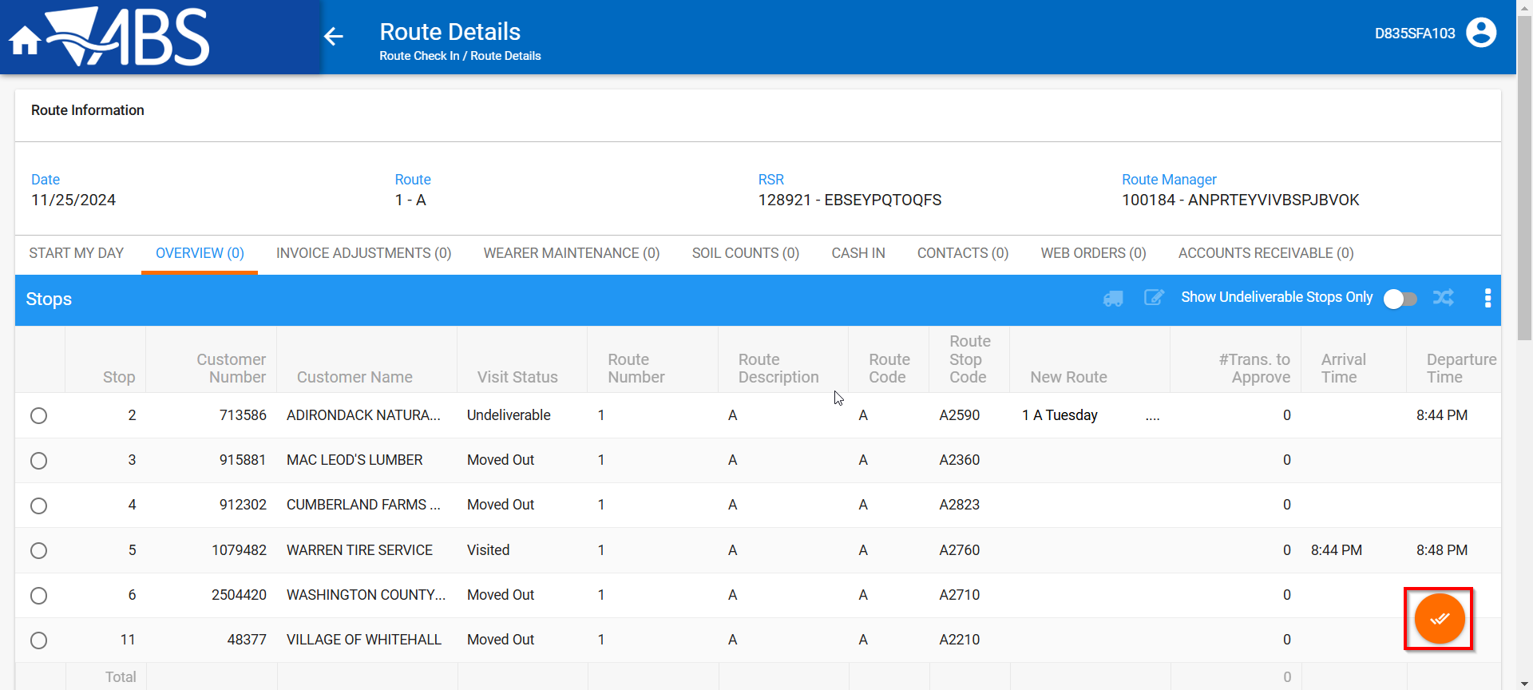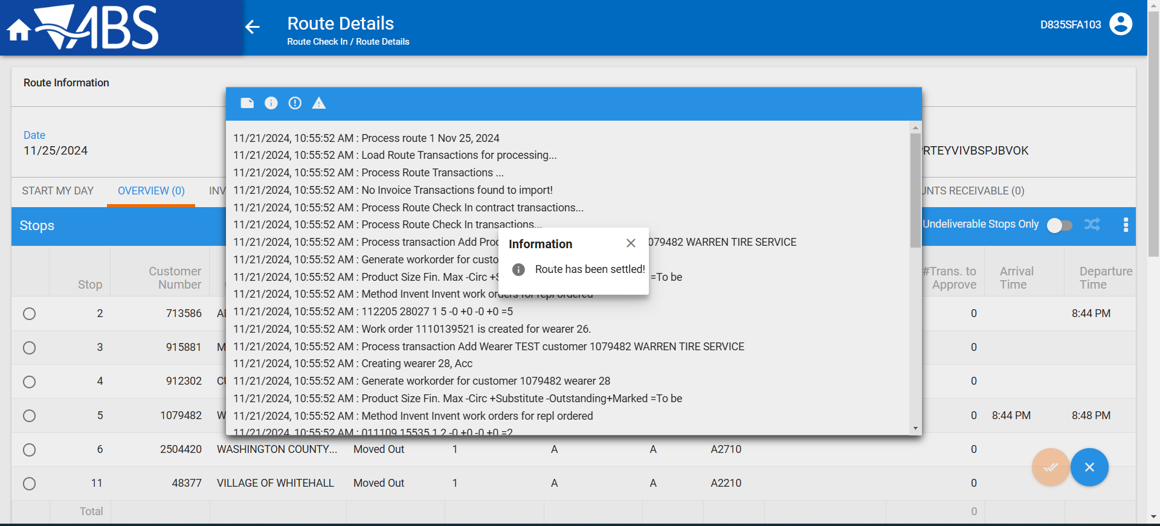

Tested OK

Test Case 2 - Set Undeliverable on WebX a stop without wearer maintenance transactions

Expected behavior
When stop 1 is set as undeliverable and there is a pop-up to show canceled wearer maintenance but ONLY for stop 1 wearer transctions.
- stop 1 has wearer maintenance route transactions AND has full credit on RA
- stop 2 has wearer maintenance route transactions

Steps to reproduce

- RSC dlg: Create a route containing 2 customers with garment delivery days. Generate invoices and send the route to PDA.
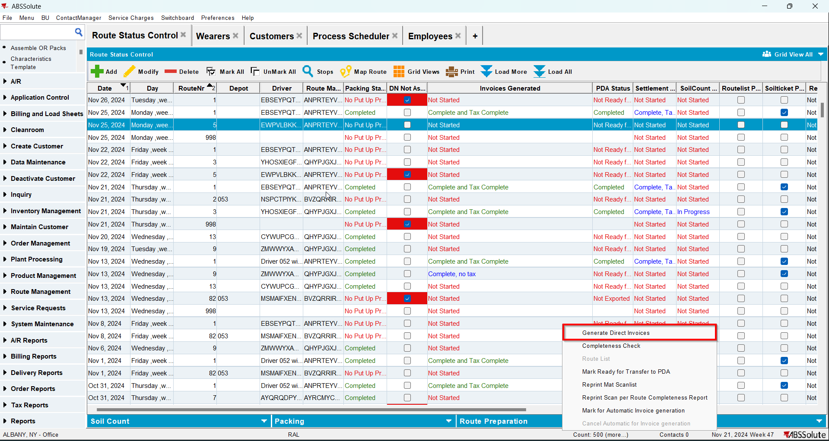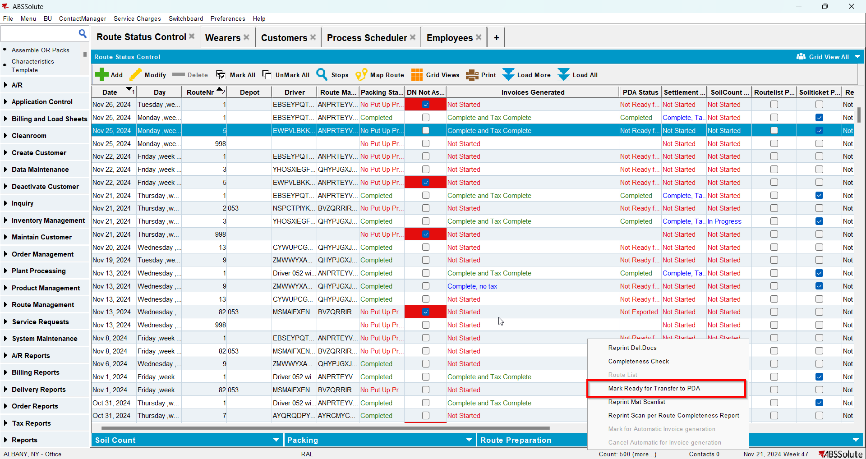
- RA: Download the route and arrive at the first customer and add a new wearer inventory, Scan replace 3 garments (one scan with default grade, the next 2 garments with different grades), add a new wearer, increase the wearer inventory.
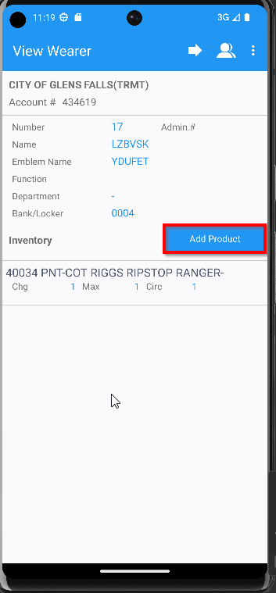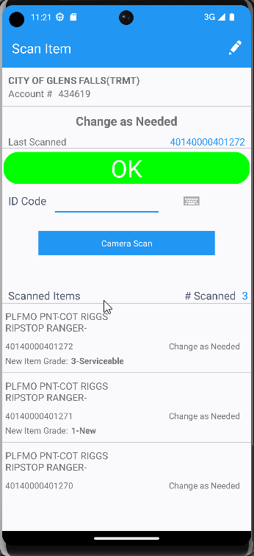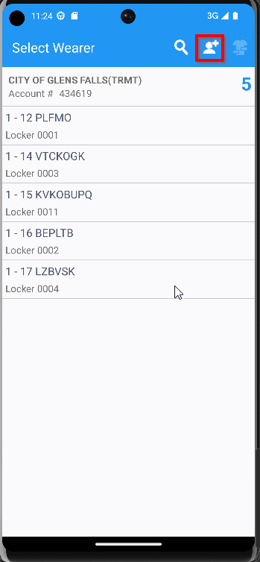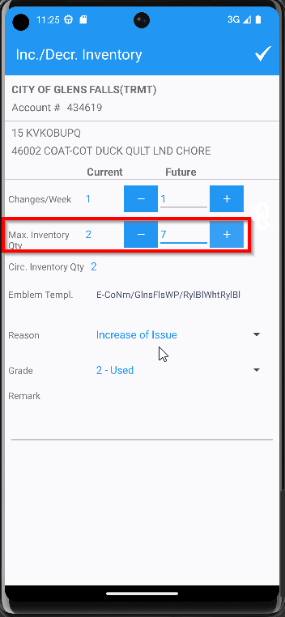
- RA: Full Credit the invoice.
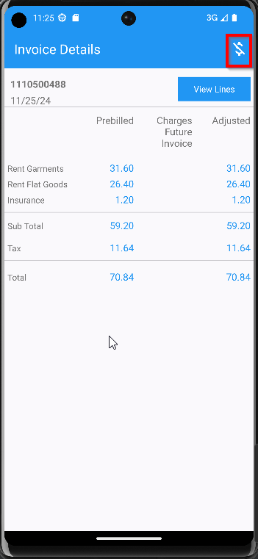
- RA: Settle and depart.
- RA: Arrive at the second customer and add 2 new wearer inventory, Scan replace 4 garments, add a new wearer, decrease the wearer inventory.
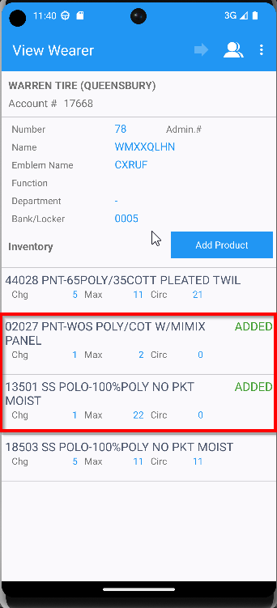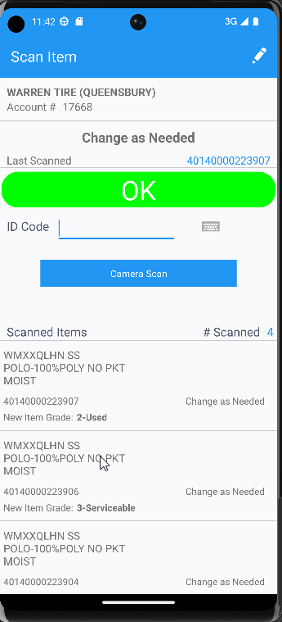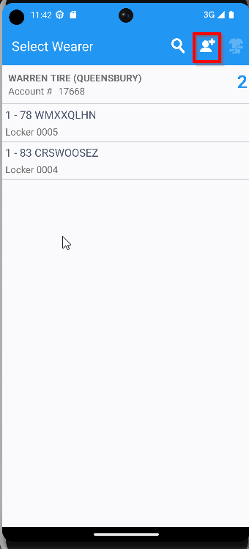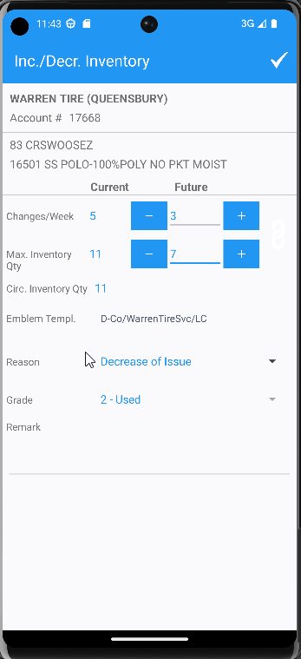
- RA: Settle and depart from customer.
- RA: Finish and upload the route.
- WebX: Complete the start my day.
- WebX: On the Overview, select the first stop and select the change visit status and mark it as Undeliverable.
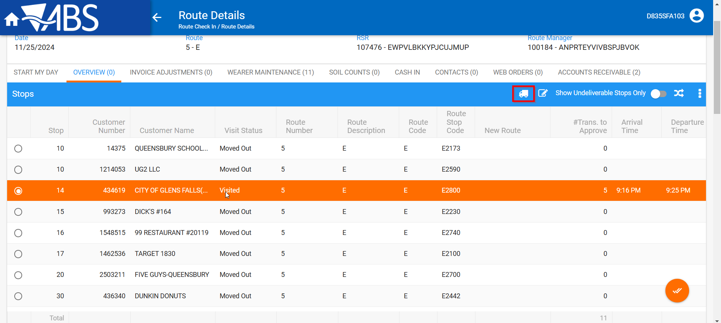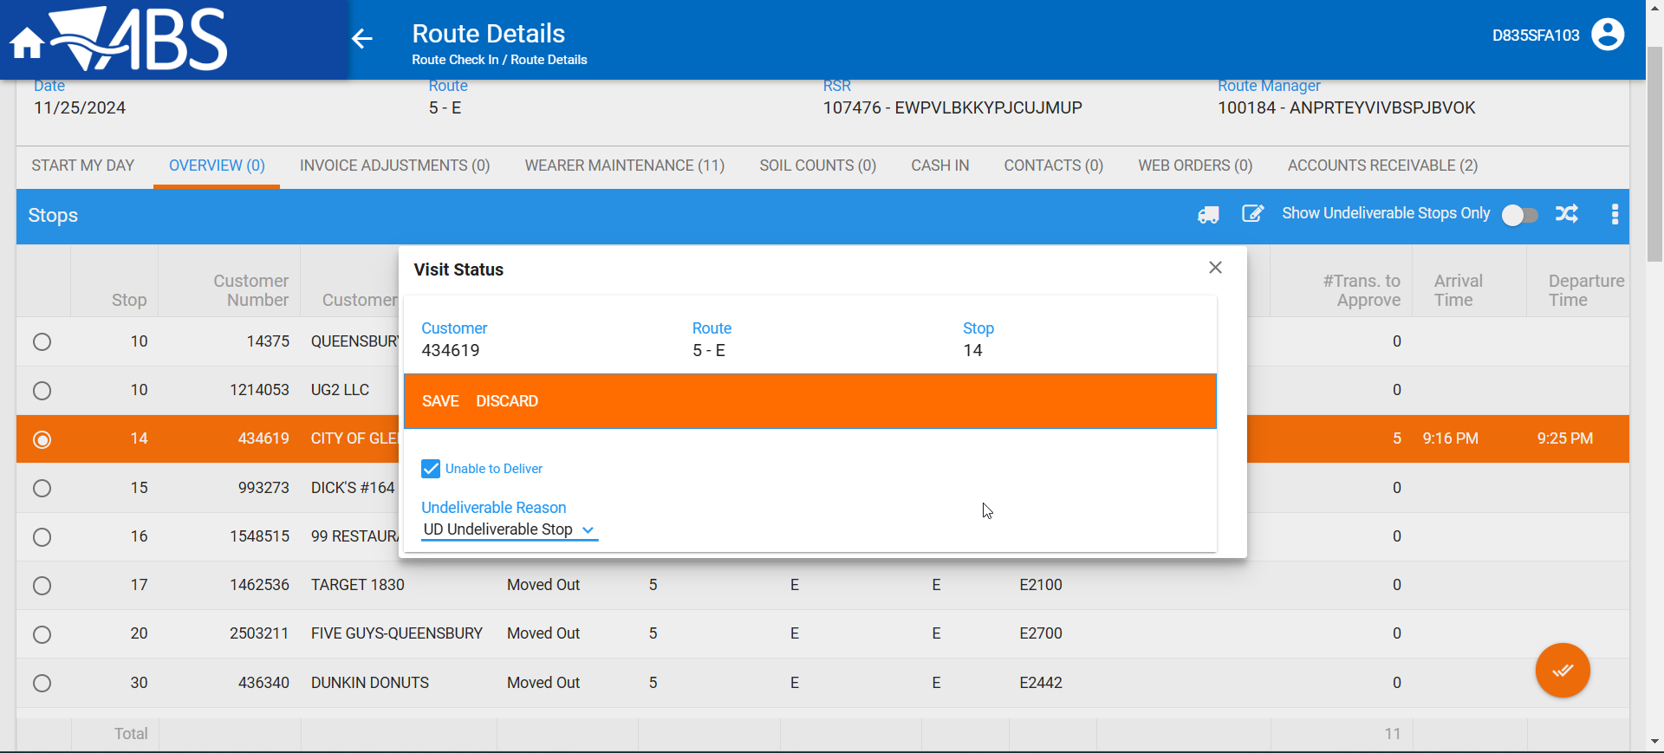

- WebX: Observe the pop-up.

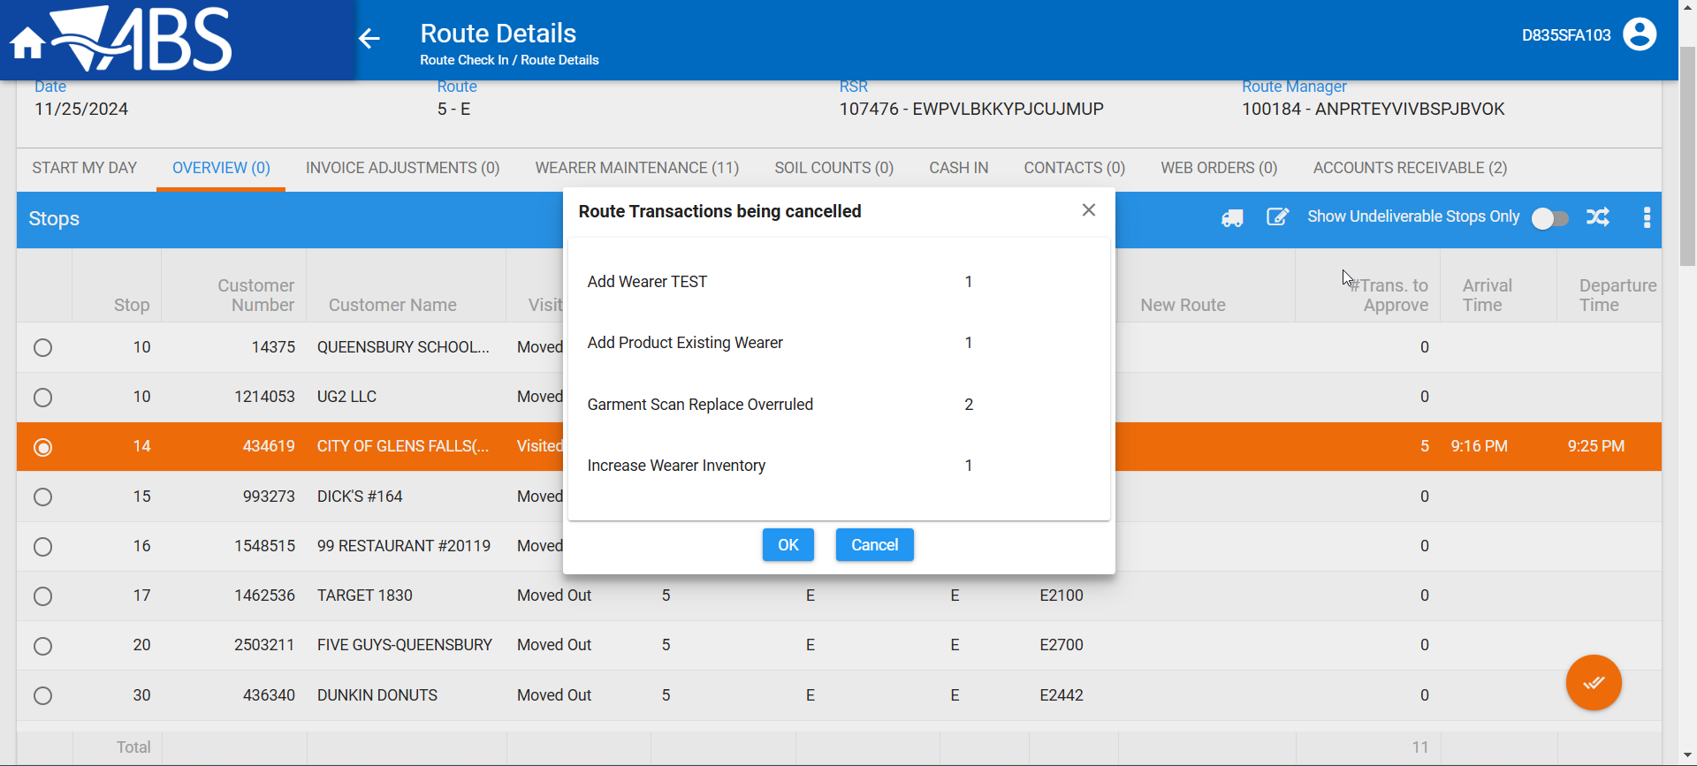
As we can see, these transactions are only from stop 1 where we did one add new wearer, one add new wi, one increase and scan garments 3 but only 2 with different grades changed
- WebX: Approve everything
- WebX: Move the undeliverable to a new route 5 and settle the route.
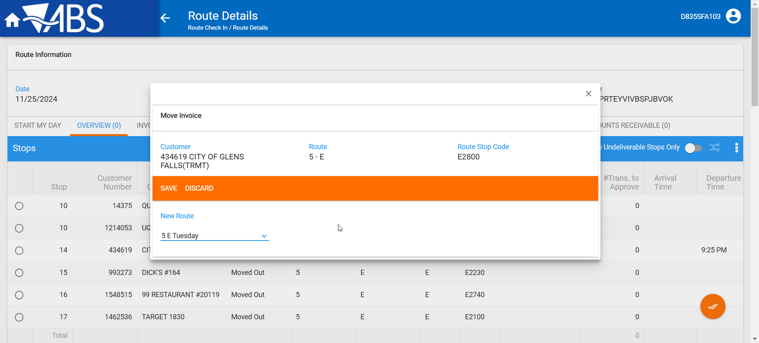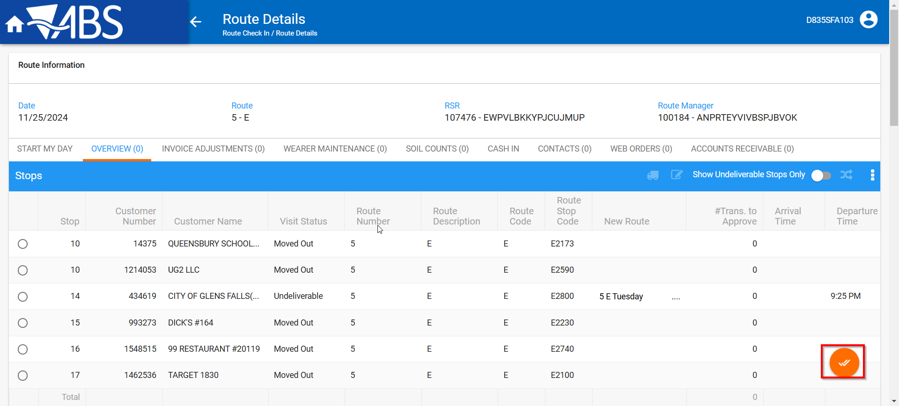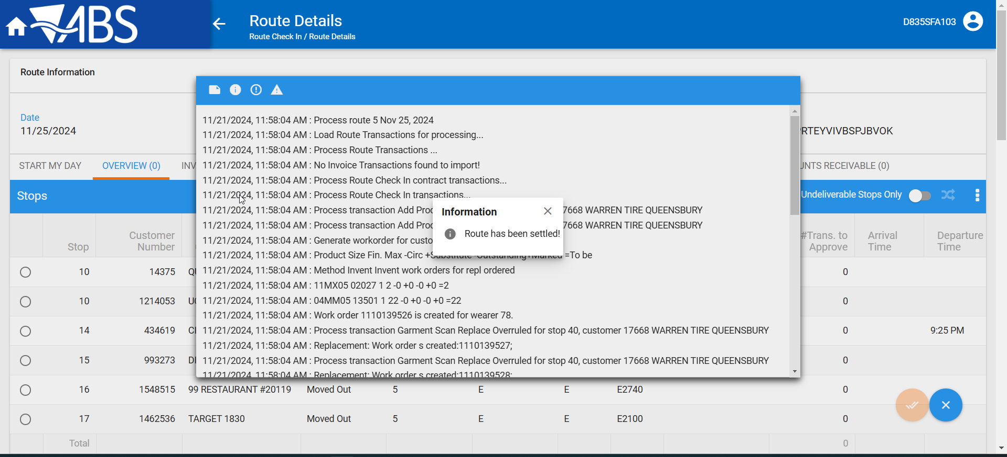

Tested OK

