ABS-171192 Soil Tickets not completed during Packing Notes generation
Environment | Prerequisites
Version:9.07.00  DBServerName=abs-SRV20.internal.abslbs.com  DBSID=CUST24  DBUser=UNFDEV  DBPassword=UNFDEV  Environment=Test | - Module:  - System setting

Contents
Test after fix 1
Test Case 1 – AUTOMATICSOILPROCESSING = 1 and last week's RouteControl has RC.ReturnStatus = 3 (Complete)– Tested OK 1
Test Case 2 – AUTOMATICSOILPROCESSING = 1 and last week's RouteControl has RC.ReturnStatus = 2 (In Progress)– Tested OK 3
Test Case 3 – AUTOMATICSOILPROCESSING = 1 and last week's RouteControl has RC.ReturnStatus = 1 (Not Started)– Tested OK 5
Test Case 4 – AUTOMATICSOILPROCESSING = 0 and last week's RouteControl has RC.ReturnStatus = 3 (Completed) (Mark Complete soil count manually and Generate packing Notes)– Tested OK 7

Test after fix

Test Case 1 – AUTOMATICSOILPROCESSING = 1 and last week's RouteControl has RC.ReturnStatus = 3 (Complete)– Tested OK
Expected behavior: The soil tickets are completed
Hash: 74876eb
- Set SS AUTOMATICSOILPROCESSING=1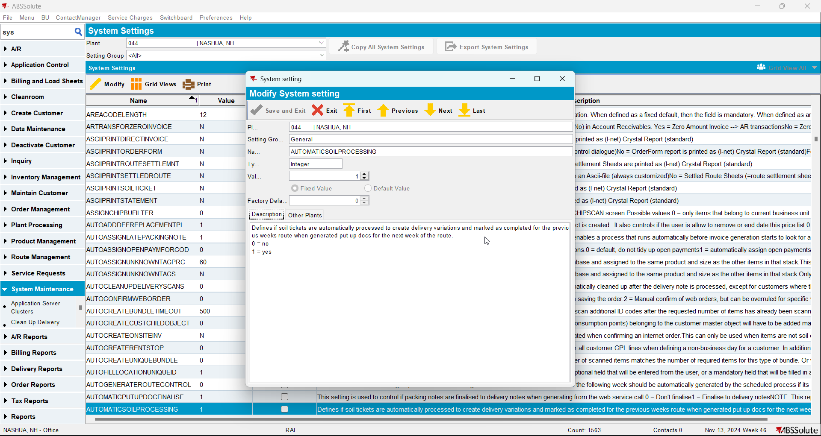
- Find a route where Soil Count is In Progress and Return Status is Completed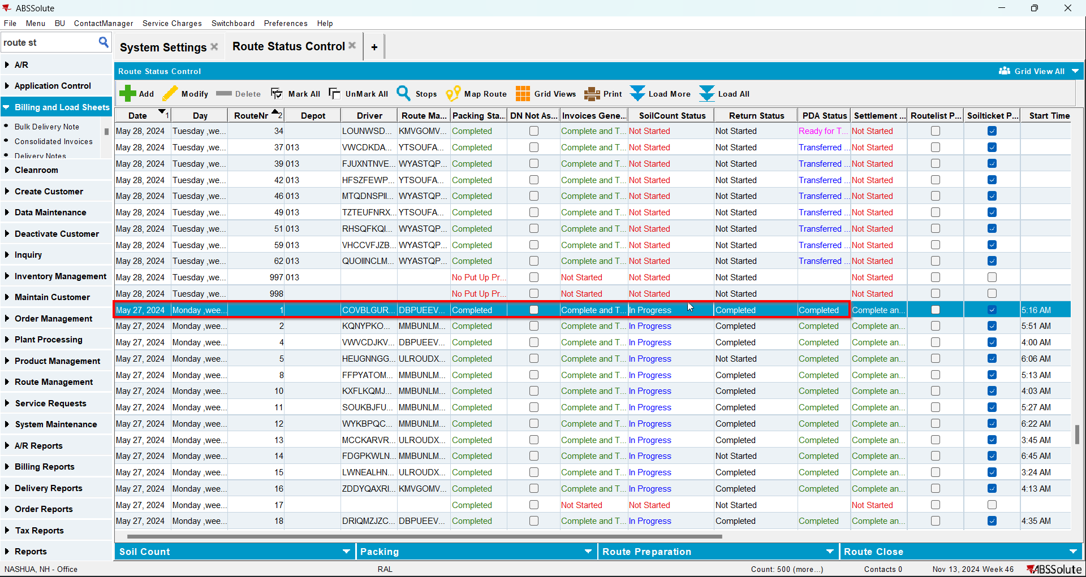
- Go to the route for the next week and generate packing notes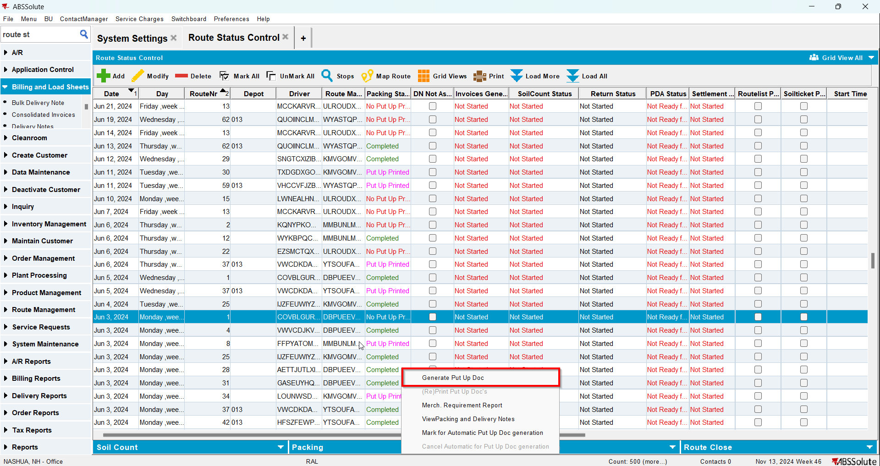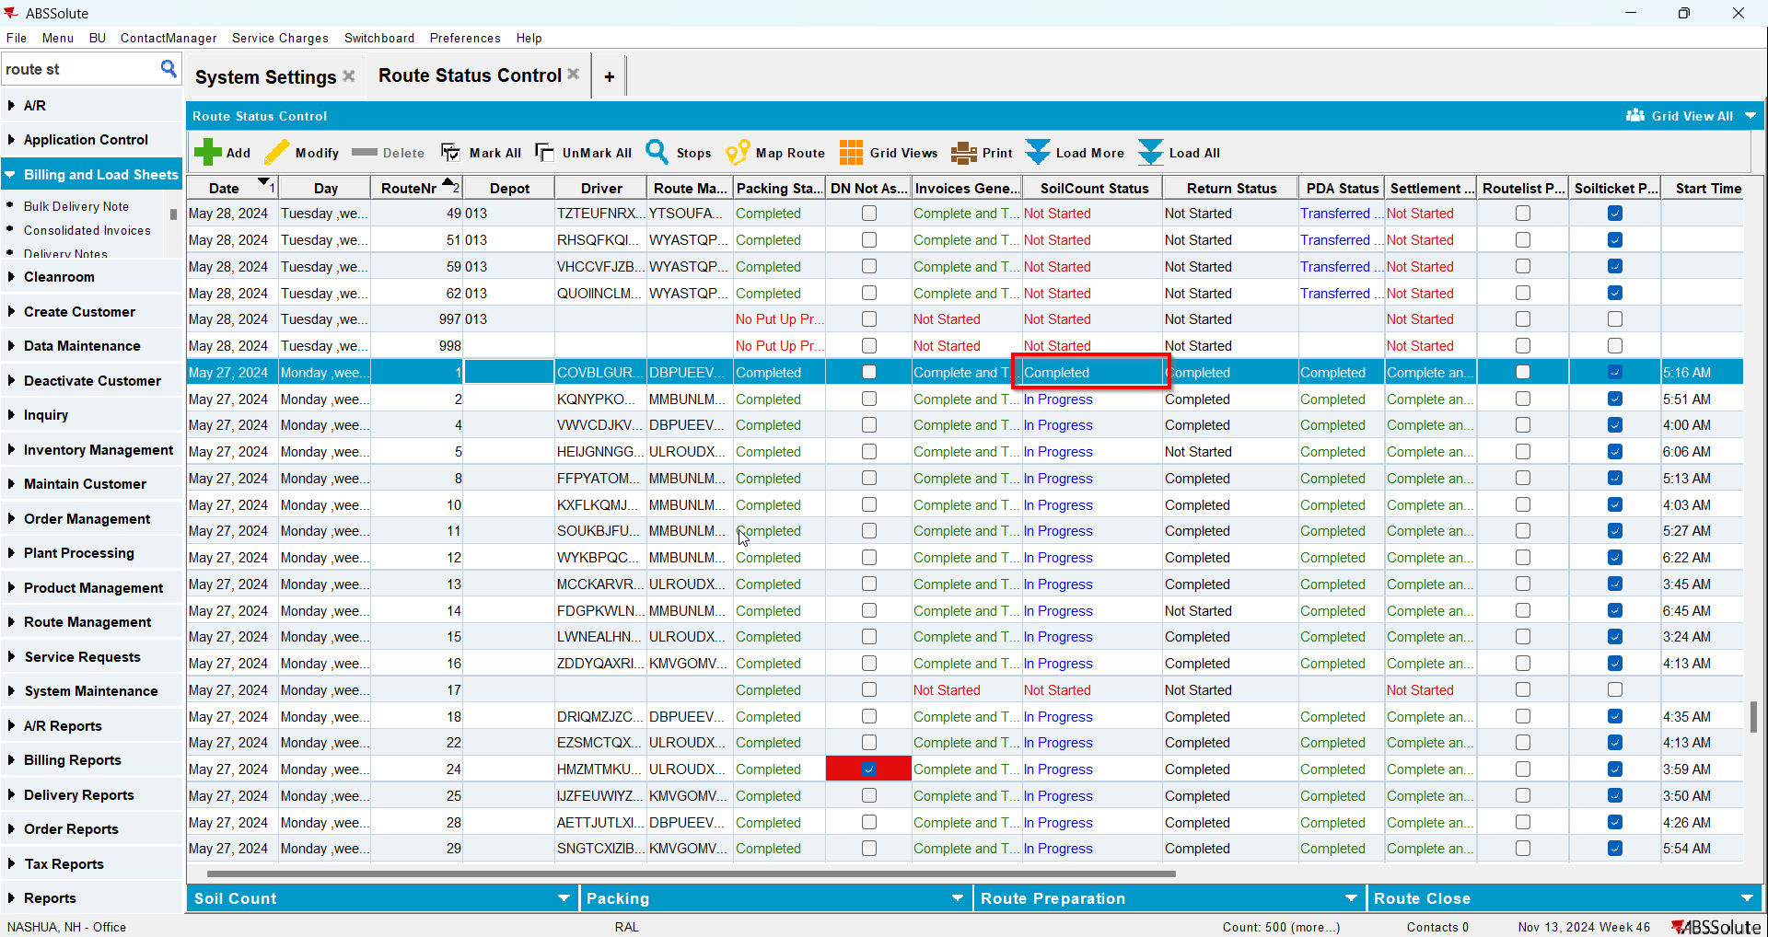

Test Case 2 – AUTOMATICSOILPROCESSING = 1 and last week's RouteControl has RC.ReturnStatus = 2 (In Progress)– Tested OK
Expected behavior: The soil tickets are completed
Hash: 74876eb
- Set SS AUTOMATICSOILPROCESSING=1
- Find a route where Soil Count is In Progress and Return Status is In Progress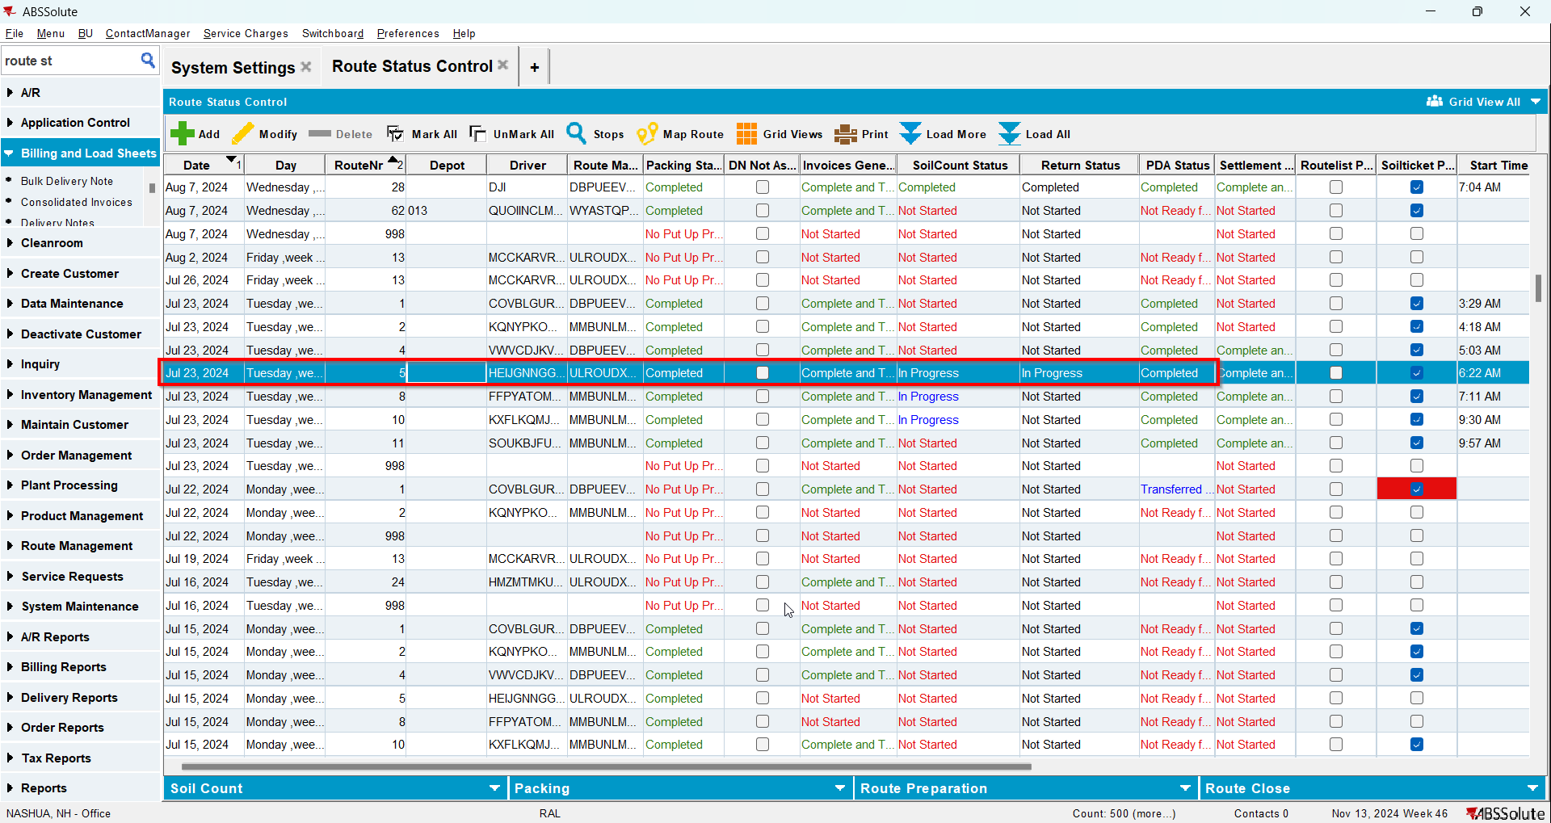
- Go to the route for the next week and generate packing notes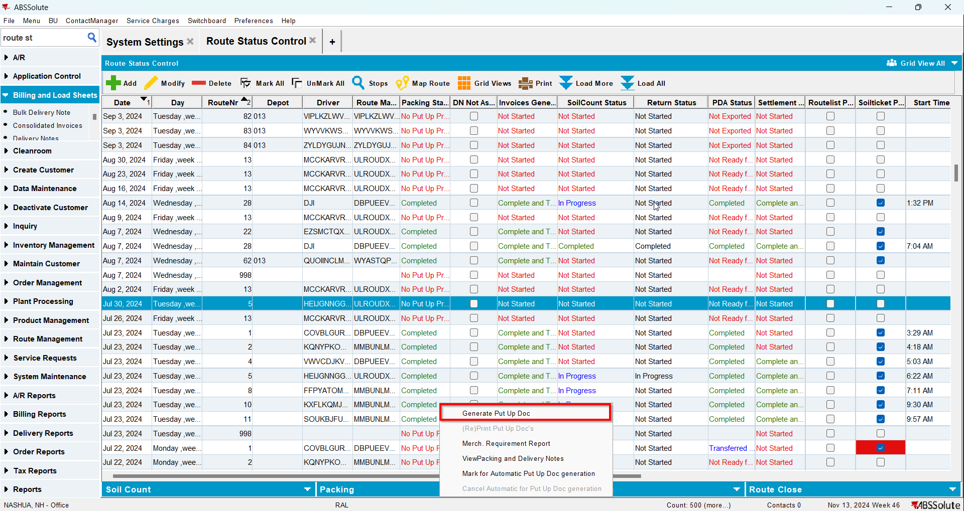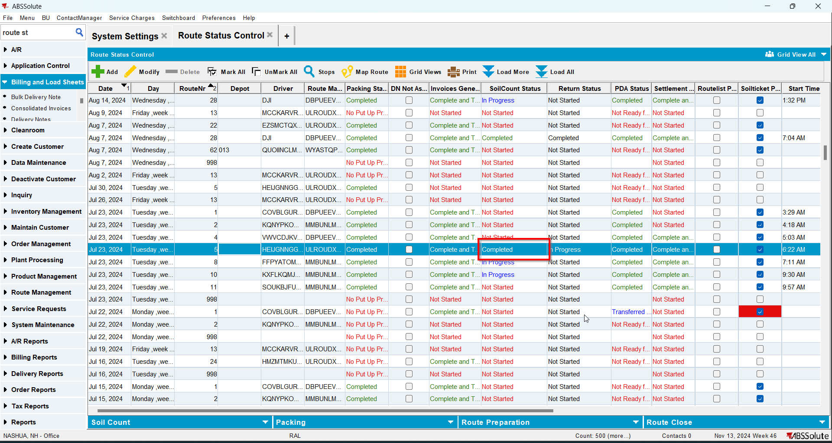

Test Case 3 – AUTOMATICSOILPROCESSING = 1 and last week's RouteControl has RC.ReturnStatus = 1 (Not Started)– Tested OK
Expected behavior: The soil tickets are completed
Hash: 74876eb
- Set SS AUTOMATICSOILPROCESSING=1
- Find a route where Soil Count is In Progress and Return Status is Not Started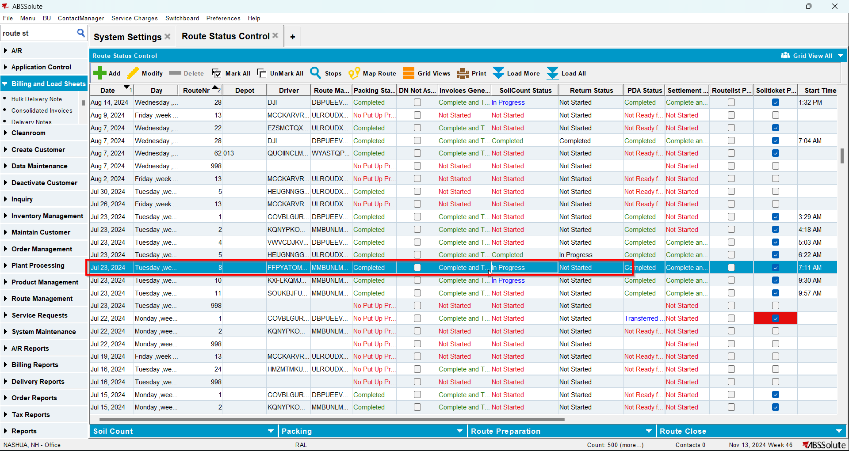
- Go to the route for the next week and generate packing notes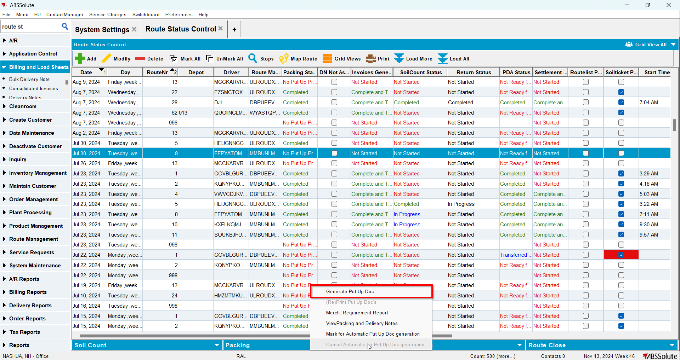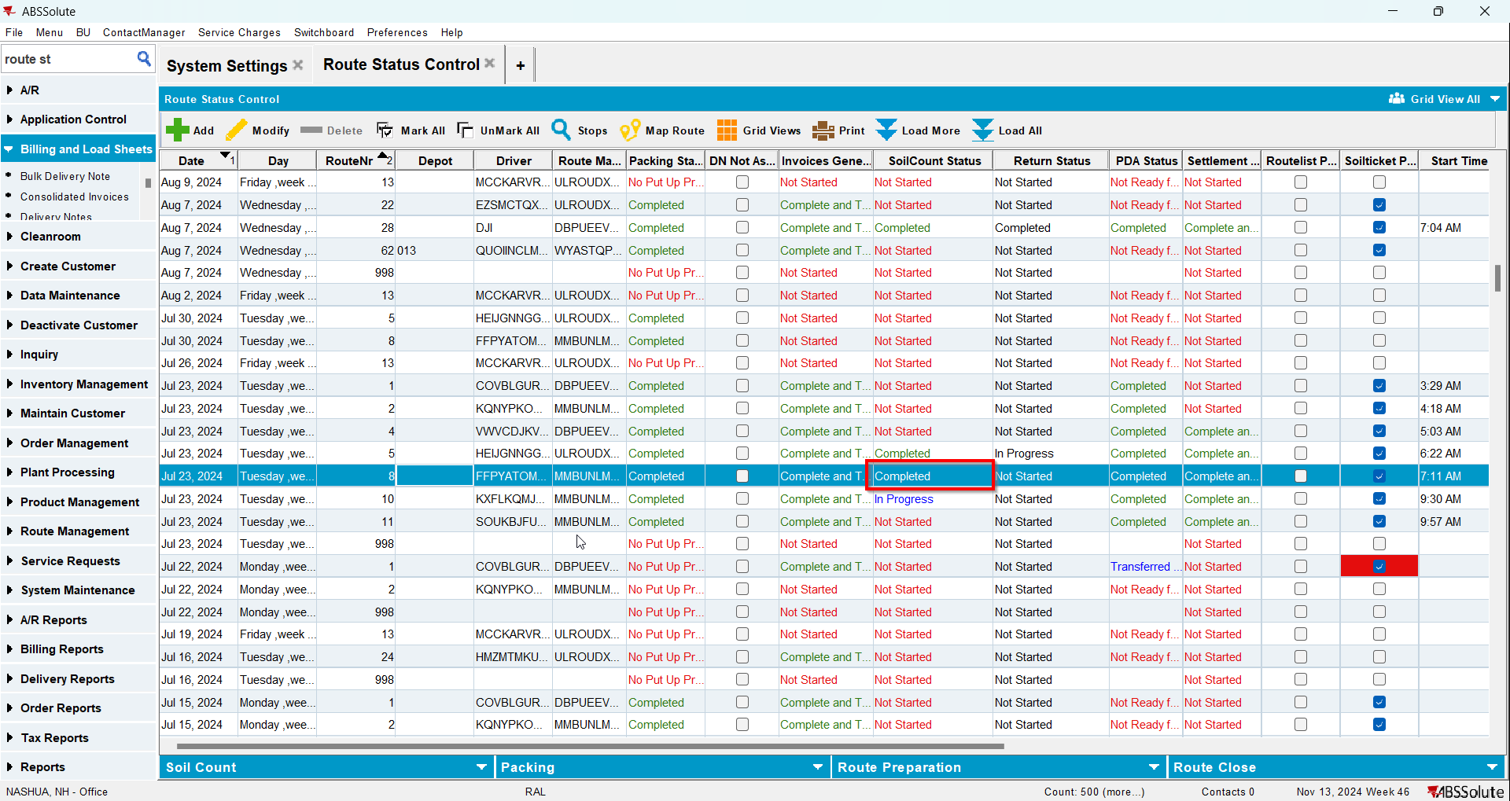

Test Case 4 – AUTOMATICSOILPROCESSING = 0 and last week's RouteControl has RC.ReturnStatus = 3 (Completed) (Mark Complete soil count manually and Generate packing Notes)– Tested OK
Expected behavior The soil tickets are completed and packing notes are generated
Hash: 74876eb
- Set SS AUTOMATICSOILPROCESSING=0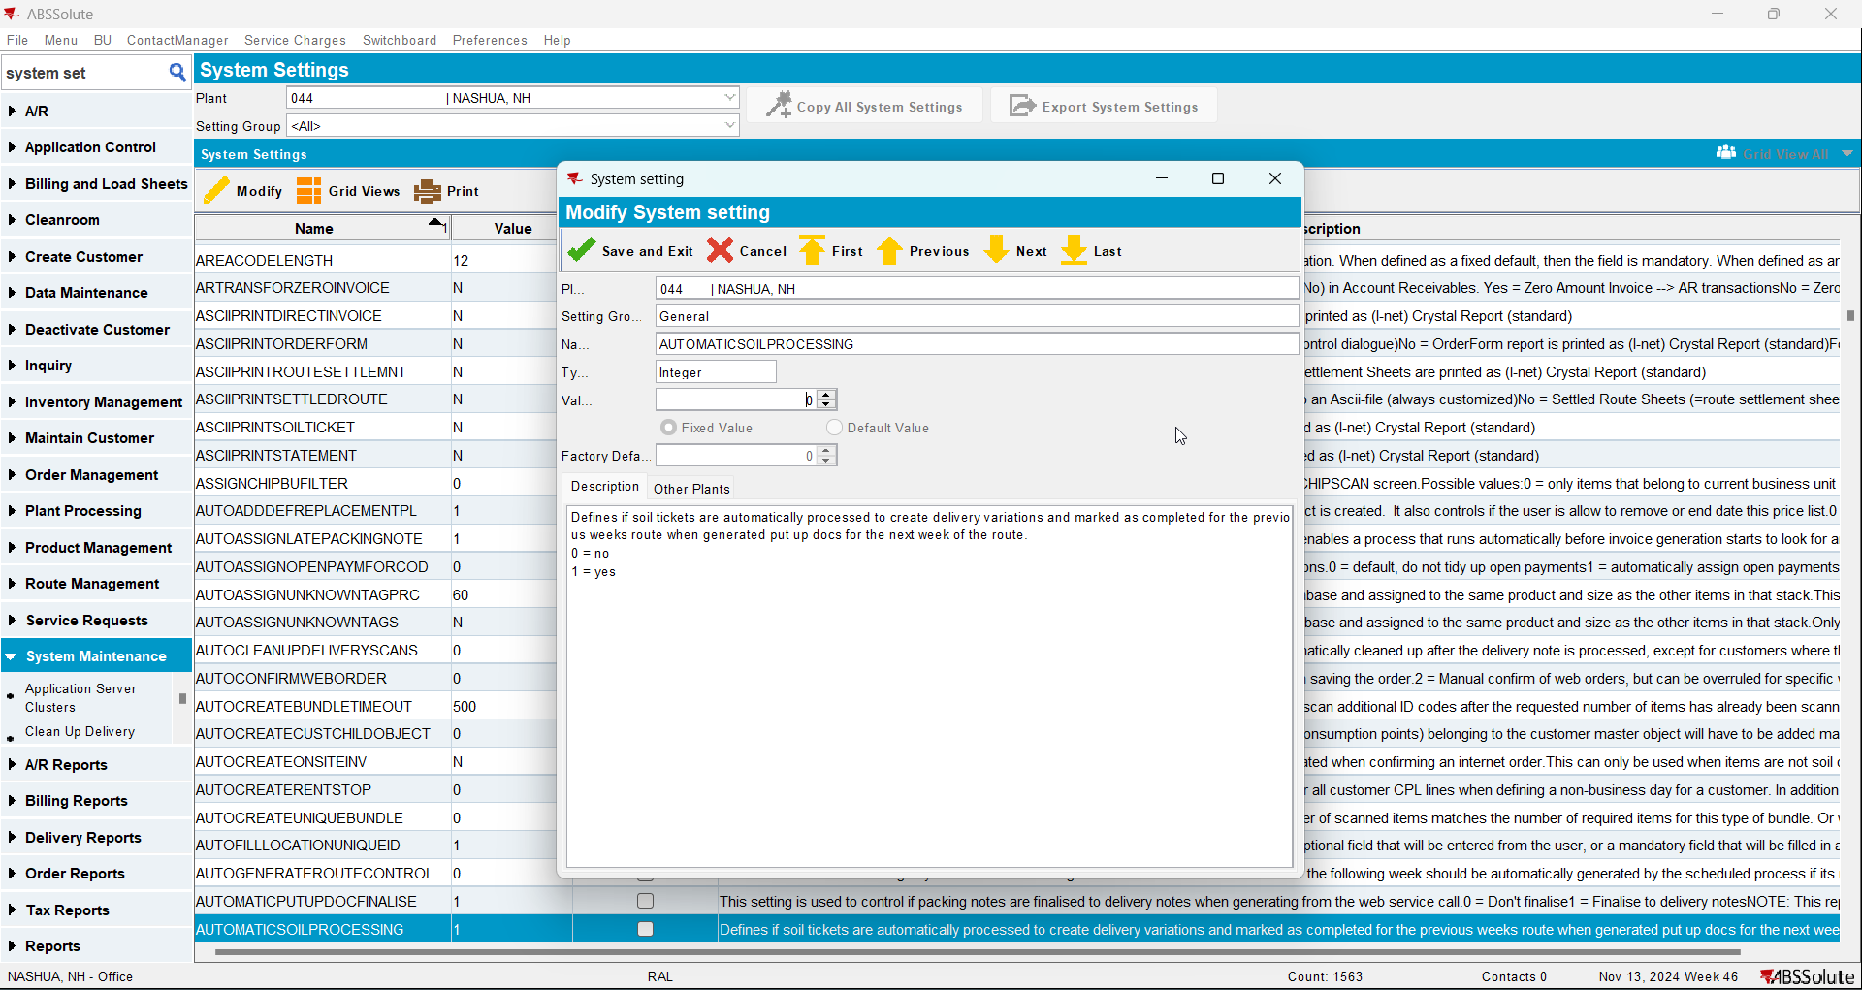
- Find a route where Soil Count is In Progress and Return Status is Completed
- Mark the soil completed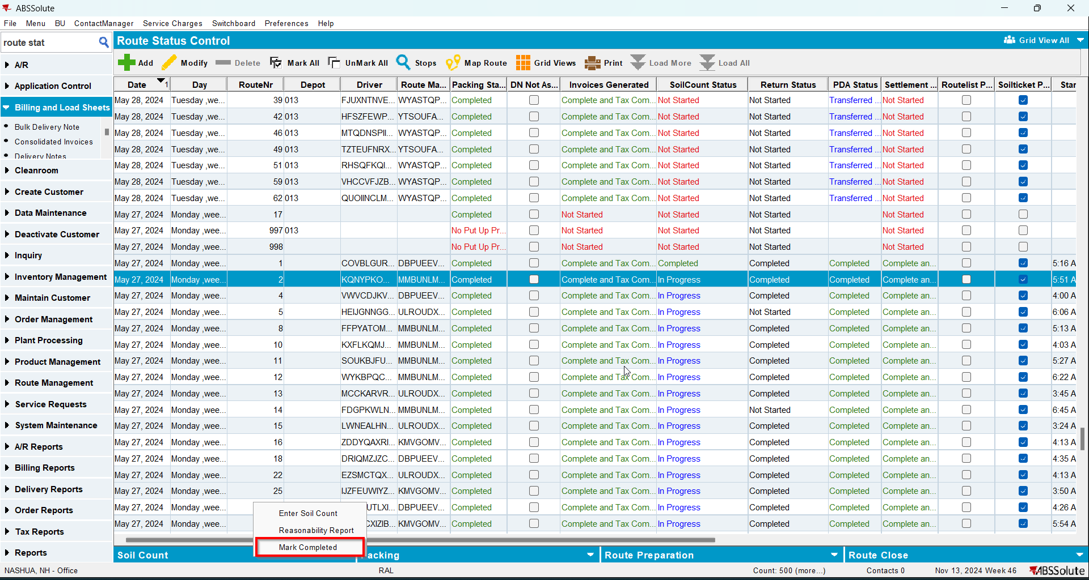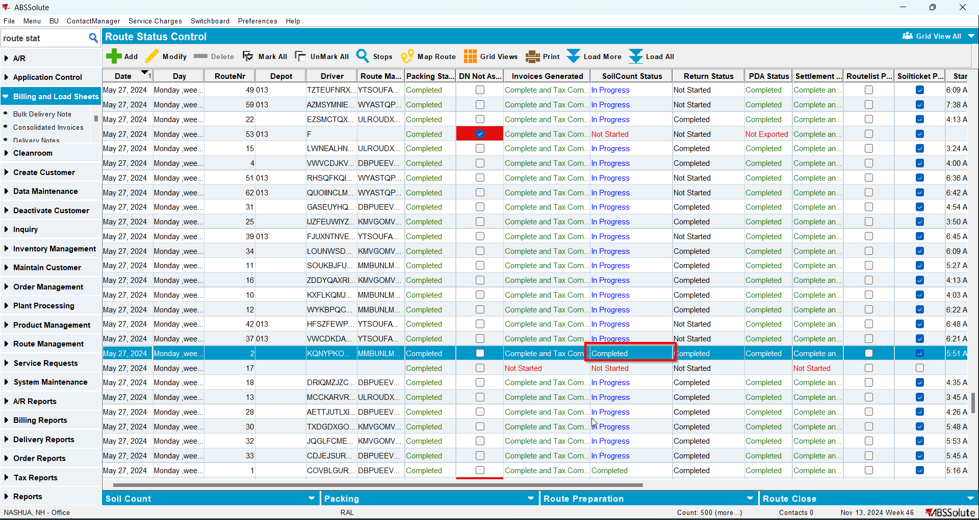
- Go to the route for the next week and generate packing notes